
v

JA More than Money Presenter Notes
The Presenter Notes have been developed using references from the digital classroom presentation and should be used in combination with the printed Student Portfolio V-2023.
Tips for Setting Up Your Classroom
- Arrive 15 minutes early and check in at the office.
- Connect with the teacher for the program materials and organize them as needed.
- Hand out student portfolios and name tags/cards.
- Set up presentation (check audio and internet connection are working).
- Write your name on the board.
- Ask the teacher to write student names on program certificates.
- Check in with the teacher about school schedule, tips for getting students' attention, any specific student needs & behaviours you should be aware of and ask for help with encouraging student participation, as well as monitoring and managing the class

Planning Guide
LESSON 5 (Slides 98 – 115) 45 MIN
GLOBAL SUCCESS
Core Activities:
- Trading around the world (15 min)
- Countries connect (20 min)
- Summary and review (5 min)
- Extended learning (Optional)

WRAP UP (Slides 116 – 118) 5 MIN
CONGRATULATIONS!
Core Activities:
- Awarding certificates of accomplishment (5 min)

LESSON 3 (Slides 55 – 81) 45 MIN
BUILD A BUSINESS
Core Activities:
- 5W’s of business planning? (10 min)
- Build a business plan (20 min)
- Follow the rules (10 min)
- Summary and review (5 min)
- Extended learning (Optional)
LESSON 4 (Slides 82 – 97) 45 MIN
RUN A BUSINESS
Core Activities:
- Decisions about loans (20 min)
- The business board game (20 min)
- Summary and review (5 min)
Extended learning (Optional)

LESSON 2 (Slides 31 – 54) 45 MIN
CREATE A BUSINESS
Core Activities:
- BizWhiz basics (15 min)
- Giving back (5 min)
- Business board game (20 min)
- Summary and review (5 min)
- Extended learning (Optional)
LESSON 1 (Slides 6 – 30) 45 MIN
THE MONEY GARDEN
Core Activities:
- Earn, save, spend (15 min)
- Money on the move (25 min)
- Summary and review (5 min)
- Extended learning (Optional)

GETTING STARTED – GETTING TO KNOW YOU (Slides 1 – 5) 5 MIN

Introduction
Slide 1 – More Than Money   | Navigation Tips  - Navigate through the slides using the next or previous buttons (bottom right), clicking or tapping on the slide, or using the navigation menu (left)  - Look for slide specific instructions in the presenter notes below
Slide 2 – Welcome to JA!   | Suggested time: 3 minutes  Ask: Has anyone heard of Junior Achievement before?  Play the video for students to introduce them to JA!
Slide 3 – More than Money Program  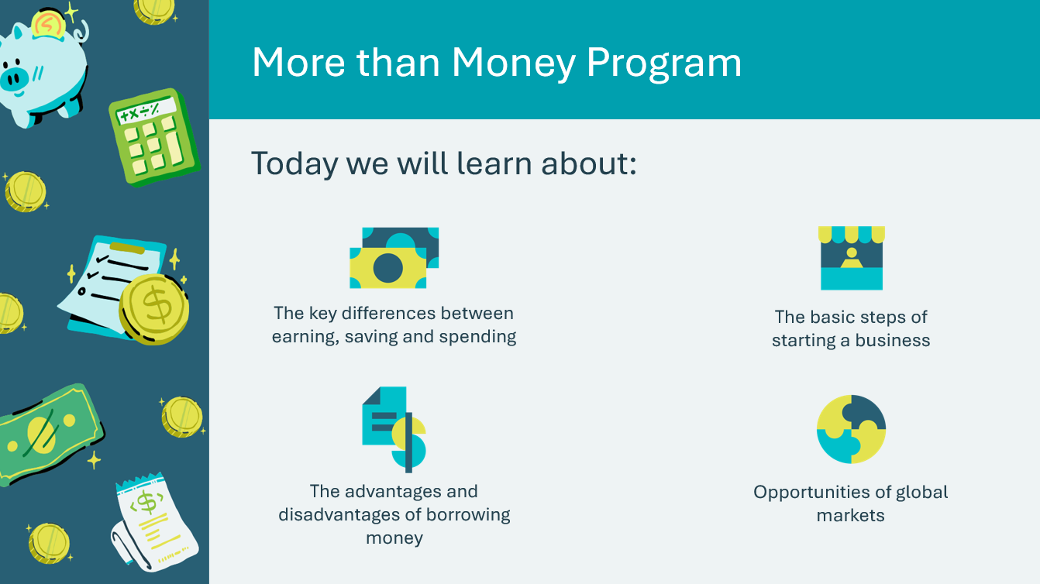  Slide 4 – Symbol Legend  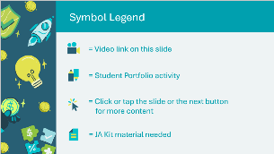 | Suggested time: 3-5 minutes  Introduce the program and yourself!  Tell the students a little about you; your education, and your career path until this point. Explain why you chose to volunteer in their classroom today.  The symbols will help guide the learning experience. Explain to students that they will see these symbols throughout the program.
Slide 5 – Main Menu  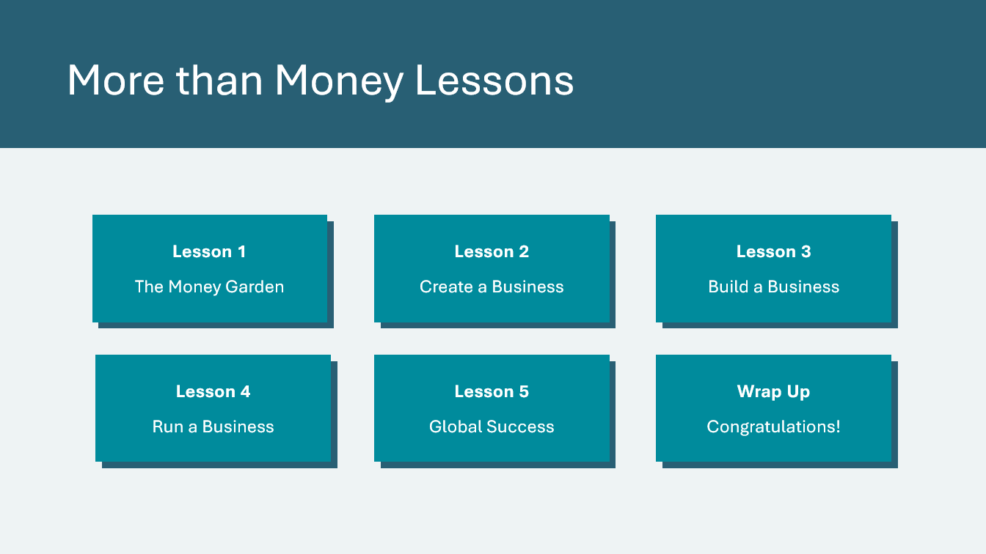 | *Select the button to navigate to the lesson.  After you have completed a lesson, you can select the Return to Main Menu button from the Lesson Activity Menu to return to this slide.

Lesson 1: The Money Garden
Program Kit Materials | Vocabulary Flash Cards (a-h) Earn, Save, Spend Bingo Cards    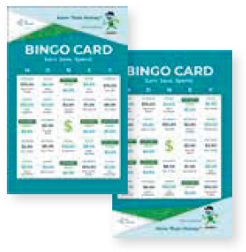
Slide 6 – Lesson 1  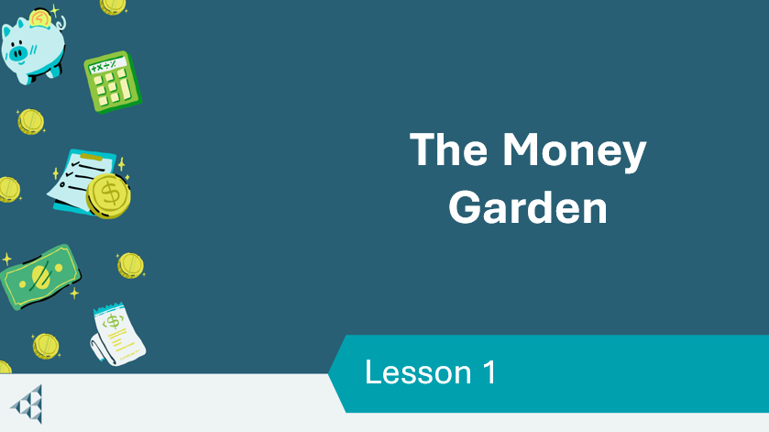 | Lesson 1: The Money Garden
Slide 7 – Objectives  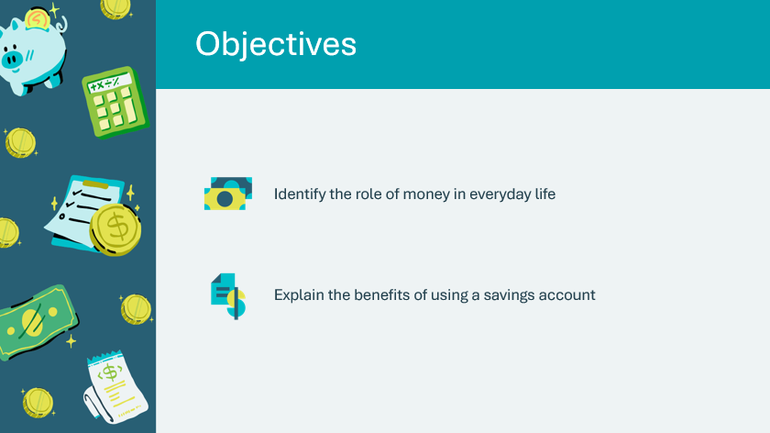 | Optional – review the learning objectives for the lesson
Slide 8 – Introduction  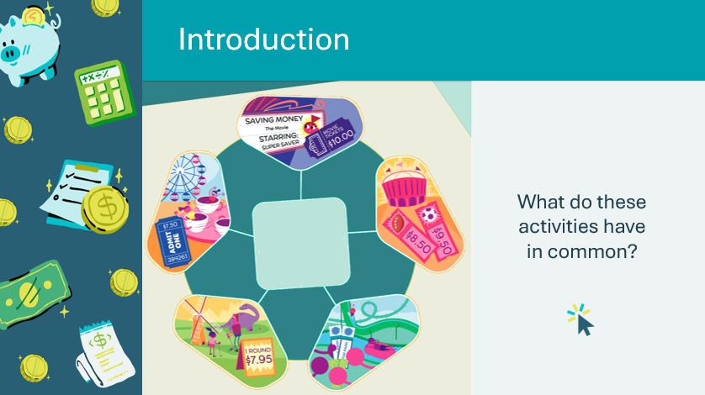 | Introduce the lesson by asking students if they have done any of the activities pictured on the slide, or something like them, recently.  What do these activities (going to a water park, a movie, a festival, a miniature golf course, and a sporting event) have in common?  Possible answers:  - They are fun to do  - They are a great way to relax or spend time with friends  - They all require money to do  *Click or tap to reveal the word “money” in the center of the graphic  Explain that we use money for a lot of things. Today we will explore how money works.
Slide 9 – Lesson 1 Activity Menu  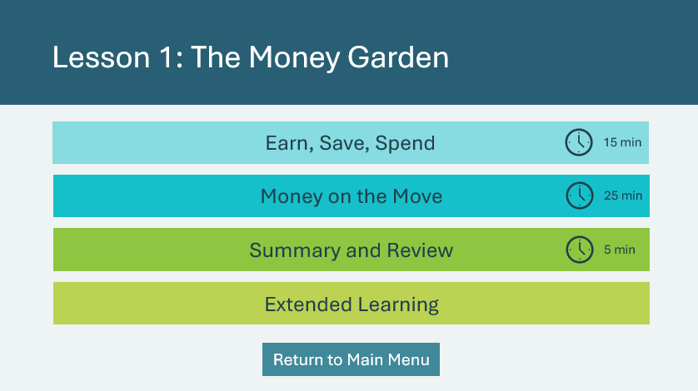 | *Select the button to navigate to the activity.  After you have completed an activity, you will be redirected back to the activity menu.  *Click or tap the Return to Main Menu button to return to the Lessons (Slide 5)
Earn, Save, Spend 15 min
Slide 10  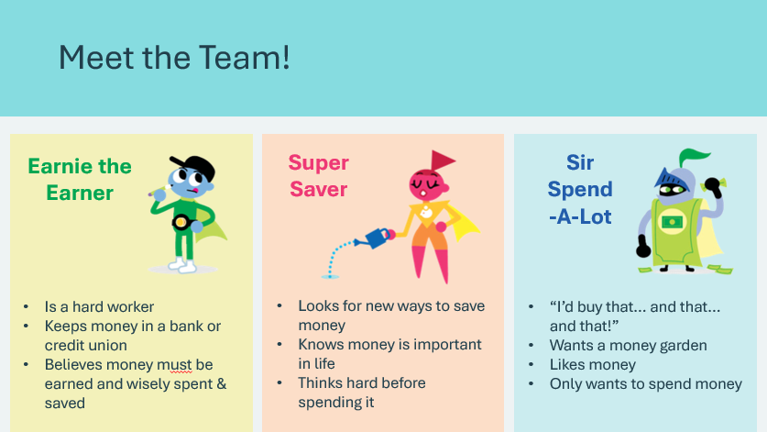 | Suggested time: 3 minutes  Let students know they will meet various characters that will help teach them about money and business. Introduce the students to the first three characters. Ask them to think about what each character might be like.  *Click or tap to reveal their qualities
Slide 11  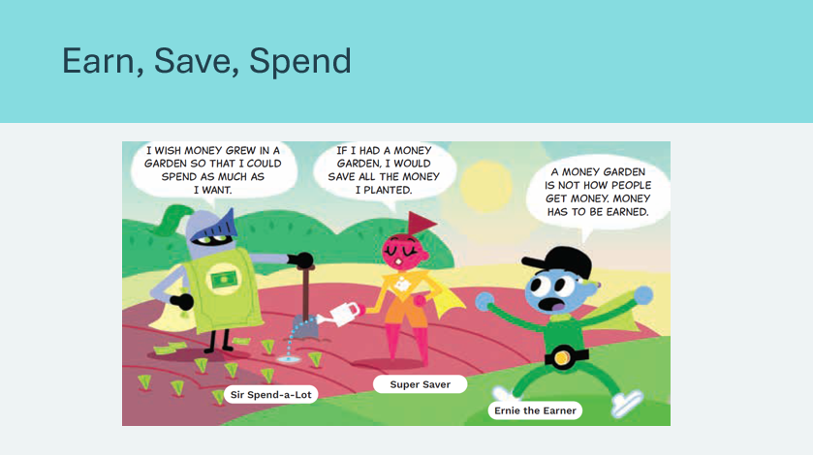 | Suggested time: 2 minutes  Ask for volunteers to read each character’s part aloud.
Slide 12  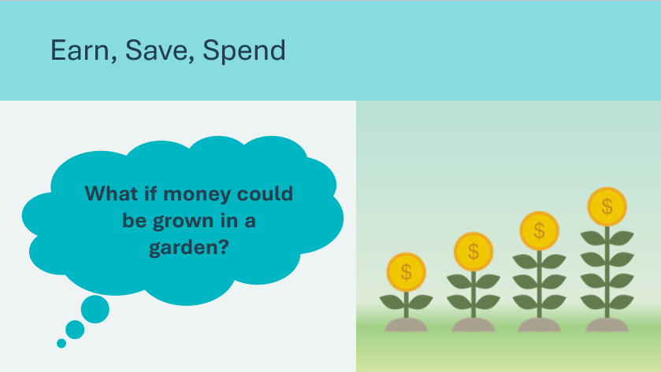 | Suggested time: 2 minutes  Ask students, what would the world be like if money could be grown in a garden?  Possible answers:  - Everyone would have a lot of it  - It would be easy to buy things  Acknowledge that money can’t be grown in a garden.
Slide 13  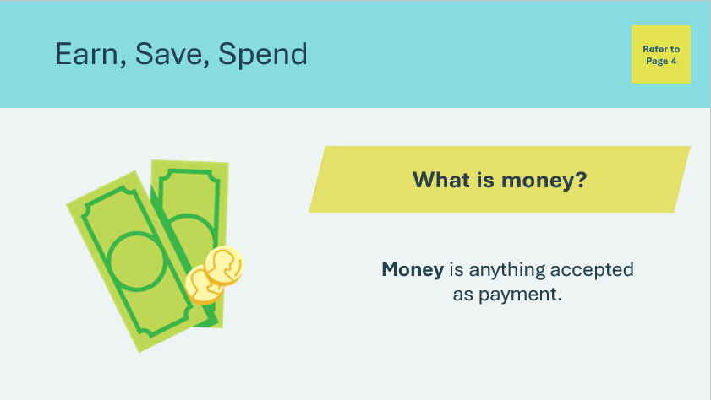 | Suggested time: 2 minutes  Ask who can define what money is. Invite a few students to share their responses.  *Click or tap to reveal the definition  Read the definition and ask students to find the word in their student portfolio and circle it. The definition can be found in the Vocabulary section in their student portfolio, page 4.
Slide 14  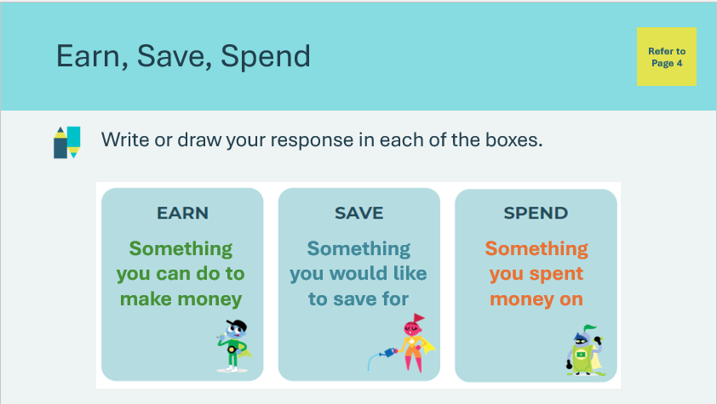 | Suggested time: 3 minutes  Draw students’ attention to the three columns in their student portfolio, page 4. Ask students to consider how they earn, save, and spend.  Tell students to write the following in each column. *Click or tap to display each prompt.  - In the EARN column, a job they would like to do now or in the future to earn money.  - In the SAVE column, something they would like to save for.  - In the SPEND column, something they have spent money on recently  Invite students to share some of the things they wrote on their paper. Remind students of the discussion between Ernie, Super Saver and Sir Spend-A-Lot. Acknowledge that it would be nice if money grew in a garden, but it doesn’t.
Program Kit Materials | For slide 15, you can also use the vocabulary cards from the program kit (optional).
Slide 15  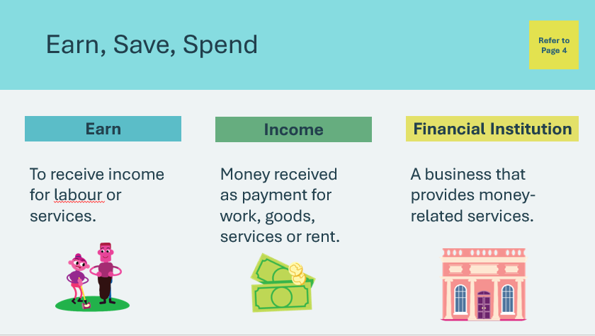  Vocabulary Cards    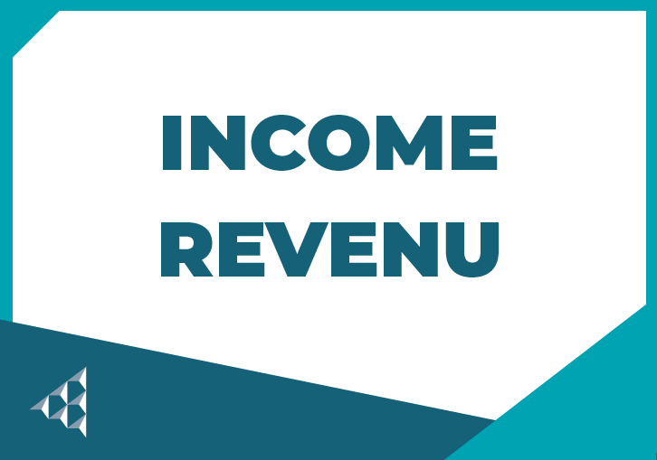   | Suggested time: 3 minutes  Invite a few students to respond to the prompt about ways to earn money.  Possible answers: allowance, gifts, jobs.  Review each of the terms on the slide.  Read the definition for Earn and Income and ask students to circle it in their student portfolio, page 4.  Ask students to consider where people put their income or the money they earn. Allow a few students to share their responses, some might suggest piggy banks or in the bank. Read the definition for the term Financial Institution. Ask students to circle this long term in their student portfolio, page 4.  Point to the word institution and explain that an institution is a group or business that does a particular type of work or service. Ask students to consider why people use financial institutions.  Possible answers: a place to keep money safe, to get a loan for a house or car.  Tell students that there are different kinds of financial institutions, and two are banks and credit unions. Credit unions are a lot like banks in that their main job is to keep people’s money safe.  Explain that banks come in all shapes and sizes and can be found everywhere, from shopping centers to street corners to grocery stores and even online. Around the world, people use mobile banks if there is no building. Ask students what banks are in their area.  Facilitator tip: Make a list of financial institutions to share with the students.
Money on the Move 25 min
Slide 16  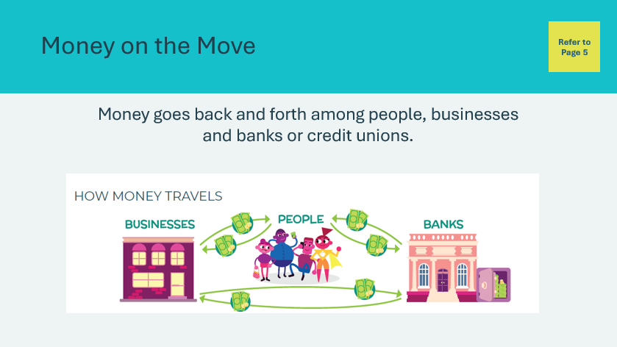 | Suggested time: 2 minutes  Draw students’ attention to the How Money Travels diagram in their student portfolio, page 5. Remind students that banks and credit unions work mostly the same way; their main job is to keep people’s money safe.  Money can be in the form of physical objects, such as the bills and coins a person uses to buy something at a carnival or a garage sale. But more often, money is moved electronically.
Slide 17  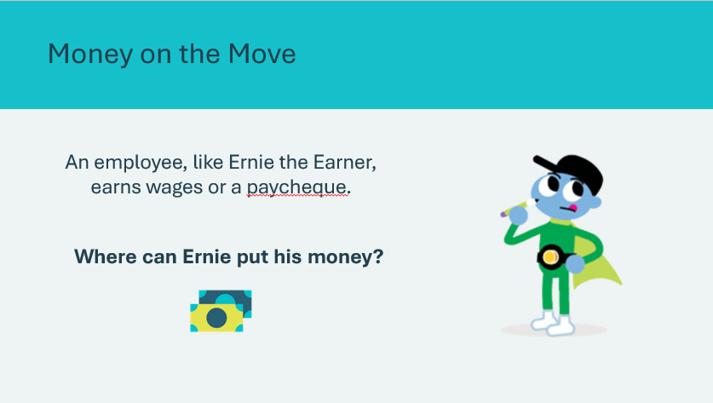 | Suggested time: 2 minutes  Explain that an employee, like Ernie the Earner, either owns or works for a business and earns wages or a paycheque.  Invite students to share their responses to the prompt.  Possible answers: bank, wallet.
Program Kit Materials | For slides 18-19, you can also use the vocabulary cards from the program kit (optional).
Slide 18  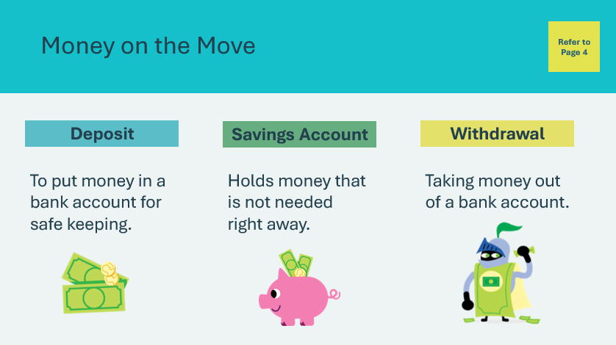  Vocabulary Cards  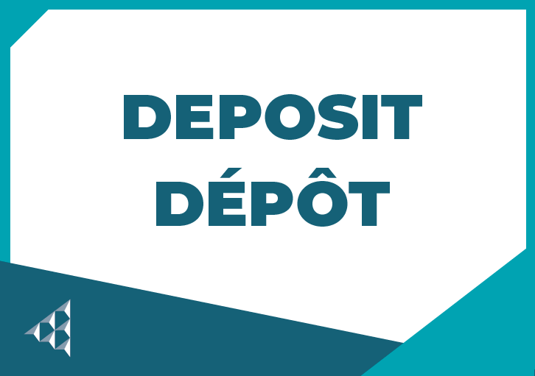  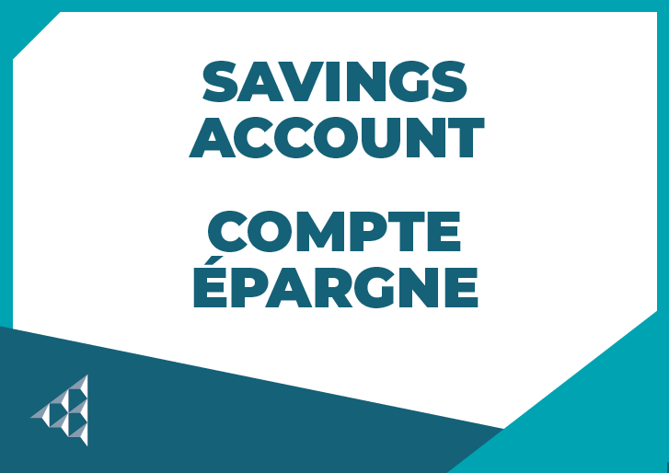  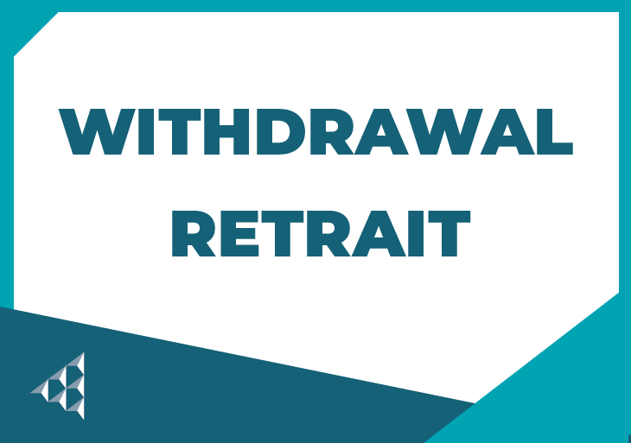 | Suggested time: 2 minutes  Introduce the term deposit and read the definition. Ask students to circle it in their student portfolio, page 4. Explain that with the money in the bank, the person or business owner doesn’t have to worry about it being lost or stolen.  Read the definition for the term savings account. Ask students to circle it in their student portfolio, page 4. Explain that there are different kinds of accounts at banks, and one is a savings account. Savings accounts are used to hold money safely that is not needed right away. Ask students what character they think would like a savings account (Answer: Super Saver).  Ask the students what Sir Spend-A-Lot needs. Guide them to see he needs a way to get the money out of his account. Read the definition for the term withdrawal. Ask students to circle it in their student portfolio, page 4. Explain that Sir Spend-A-Lot, or anyone who has money in a financial institution, can take the money out by making a withdrawal.
Slide 19  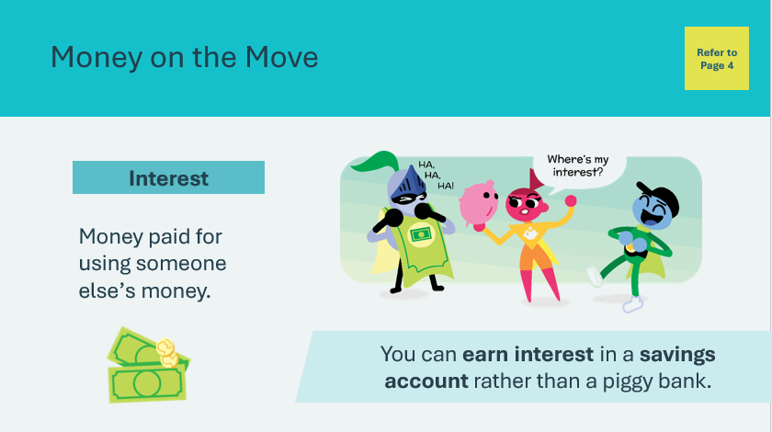  Vocabulary Card   | Suggested time: 2 minutes  Ask students if they have heard of the term interest. Explain that this kind of interest is a way to “grow” money, which is different from when you have an interest in something.  Read the definition for the term interest. Ask students to circle it in their student portfolio, page 4. Tell students that the money in your bank account remains there until you need it. But someone else might need it before you do. So, the bank borrows your money to lend it to another person and pays you interest for using it. That’s one reason for putting money in a savings account rather than a piggy bank.
Slide 20  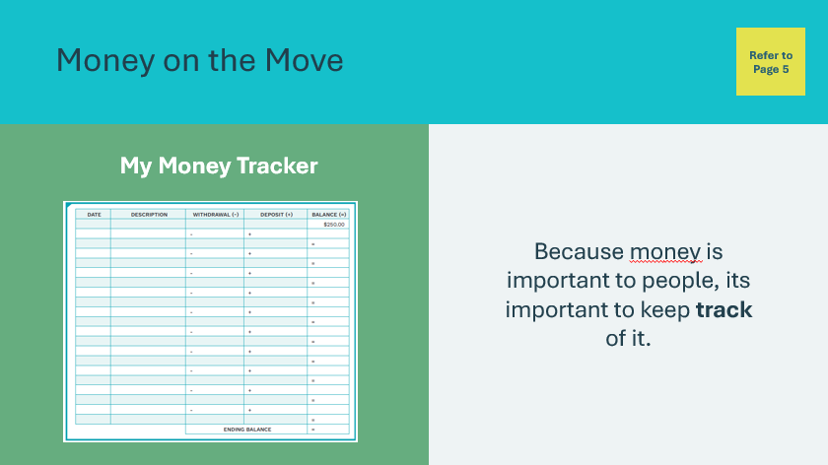 | Suggested time: 2 minutes  Explain that because money is important to people, it’s important to keep track of. Even though the bank keeps track of a person’s money, it’s important that they do too.  Many people use a register to manage their money, which is like a spending diary or money tracker. Draw students’ attention to the My Money Tracker in their student portfolio, page 5.
Slide 21   | Suggested time: 3 minutes  Show the How to Fill in Your Money Tracker instructional video.  Following the video, explain that students will start with $250.00 in their accounts and that this is called a balance. A balance is how much money people have in their bank accounts or the act of figuring out how much they have in an account.  Explain that a deposit (or earnings) is entered and added to the balance, whereas withdrawals will be subtracted from the balance.  Facilitator tip: Write deposit, withdrawal and balance on the board and show students the addition and subtraction.
Slide 22  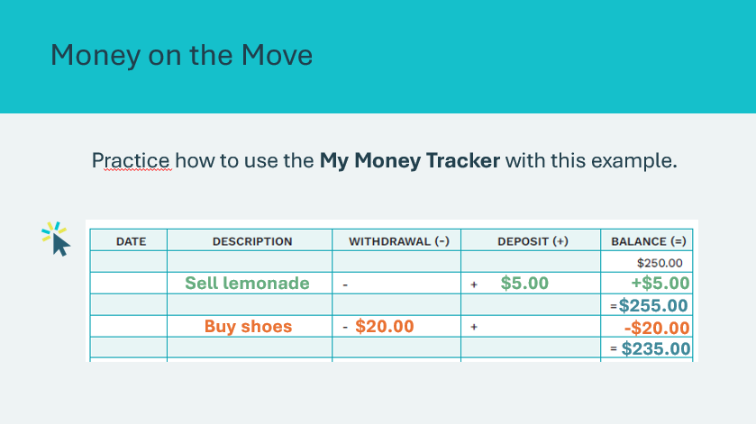 | Suggested time: 2 minutes - Optional  Depending on the group of students, you may wish to review the additional example of how to fill in the tracker.  Review the practice example by asking the following questions:  - I have $250 in my account. I sell lemonade and earn $5.00. To add $5.00, what column will I put it in?  *Click or tap to display the $5.00 added to the Deposit column  - What is my new balance?  *Click or tap to display the $5.00 being added to the balance for a new balance of $255.00  - There is now $255 in my account. I spend $20.00 buying shoes, where do I mark that $20.00?  *Click or tap to display the $20.00 in the Withdrawal column.  - What is my remaining balance?  *Click or tap to display the $20.00 being subtracted from the balance to display the remaining balance of $235.00
Program Kit Materials | For slide 23, you will need to use the Bingo Game Cards from the program kit.
Slide 23  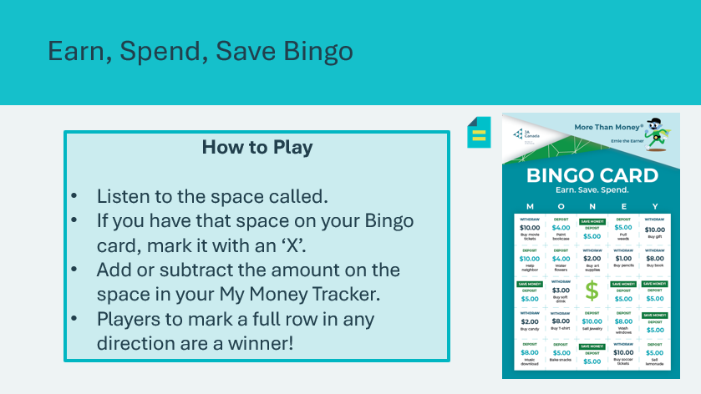  Bingo Game Cards | Suggested time: 10-12 minutes  Tell students they will play a game where they will practice recording bank deposits and withdrawals in their My Money Trackers. Explain that the game will be played like traditional bingo. Students will mark the spaces on their Bingo cards as they are called.  Review how to play as a class. Note: multiple winners are probable.  Once you have handed out the Bingo cards, share an example with the students before getting started:  “For example, I will say, “Deposit $5.00 for pulling weeds. Find the ‘Deposit $5.00 pull weeds’ space on your card and mark it off with an X. Then make a entry in the My Money Tracker in your portfolio.”  Remind students that after marking a space, they also need to add or subtract the amount in their My Money Tracker in their student portfolio, page 5, as you showed them in the video and/or the example on the previous slide.  *Click or tap to display a blank money tracker. You can use the smartboard to record the deposits and withdrawals as you play to help students keep track.  Facilitator tip: Allow students to lay a rule or paper under each line of their tracker so they can more easily see where they will need to write their deposits and withdrawals. Walk around the room as you play to offer help calculating the balances.  Read the withdraw and deposit actions, listed below, in any order. Allow the students a few minutes to play until someone calls Bingo. Continue to play and acknowledge winners. After 10 minutes of total play, instruct students to balance their My Money Trackers.  Earn, Save, Spend Bingo Call Statements
  Withdraw $10.00; buy gift | Withdraw $2.00; buy art supplies
  Withdraw $8.00; buy book | Save Money! Deposit $5.00!
  Save Money! Deposit $5.00! | Withdraw $10.00; buy soccer tickets
  Withdraw $3.00; buy soft drink | Withdraw $1.00; buy pencils
  Withdraw $8.00; download music | Withdraw $8.00; but T-shirt
  Deposit $6.00; sell lemonade | Deposit $5.00; pull weeds
  Save Money! Deposit $5.00! | Save Money! Deposit $5.00!
  Deposit $4.00; water flowers | Deposit $10.00; sell jewelry
  Withdraw $2.00; buy candy | Withdraw $10.00; buy movie tickets
  Deposit $5.00; bake snacks | Deposit $4.00; paint bookcase
  Save Money! Deposit $5.00! | Save Money! Deposit $5.00!
  Deposit $10.00; help neighbour | Deposit $8.00; wash windows
  Deposit $4.00; help neighbour | Withdraw $2.00; buy soft drink
  Withdraw $8.00; wash windows | Deposit $5.00 sell lemonade
  Deposit $8.00; music download | Withdraw $8.00; buy art supplies
  Withdraw $8.00; buy soft drink | Withdraw $4.00; buy art supplies
Summary and Review 5 min
Slide 24  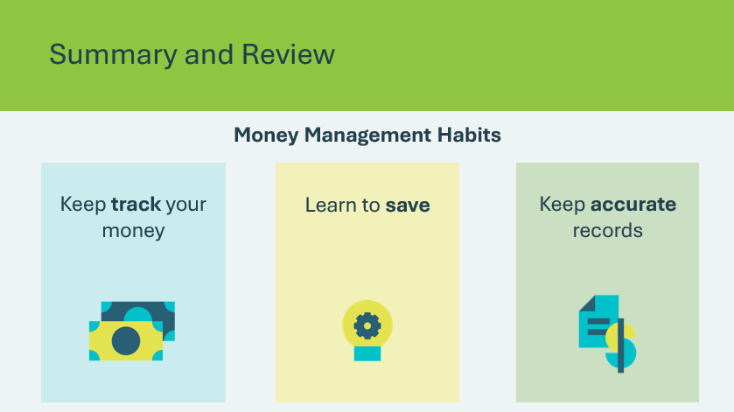 | Suggested time: 5 minutes  Review the key money management habits learned in the lesson.  Ask students:  - What tool can be used to keep track of your money?  - A money tracker  - What can you use to help you save?  - A savings account  - How can you keep accurate records?  - Record your deposits and withdrawals on your money tracker to calculate your balance
Extended Learning
Slide 25  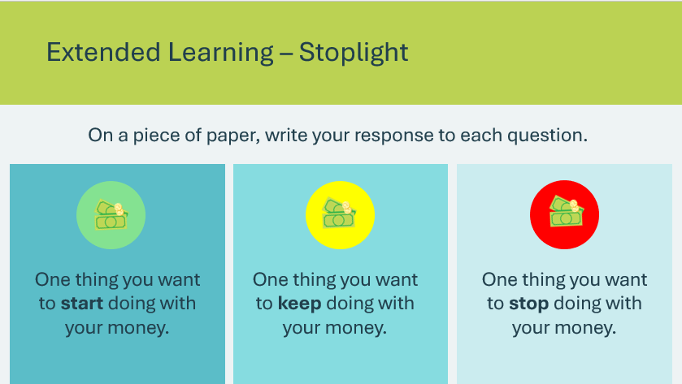 | Suggested time: Optional – consider this activity if your lesson ends early and you have extra time.  Provide a paper for the students. Have them write one thing they want to start doing with their money, one thing they want to keep doing, and one thing they want to stop doing.
Slide 26   | Suggested time: Optional – consider this activity if your lesson ends early and you have extra time.  Have students consider creating an innovative business that would solve a problem to meet a younger child’s need. For example, they can create a product, an app or a gameboard to help younger students remember math facts, or they can create a tutoring service to help other students learn a new language.
Slide 27  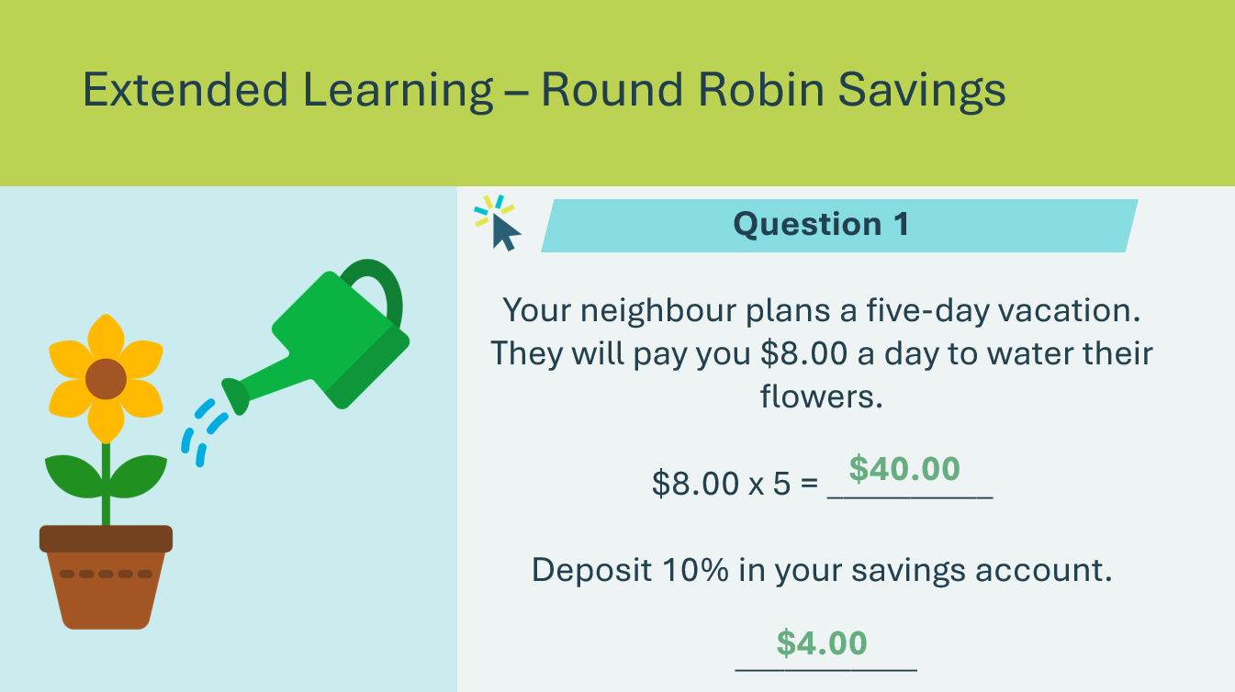 | Suggested time: Optional – consider this activity if your lesson ends early and you have extra time.  Students will solve a series of problems. Have students pair up to solve the first problem. Then, on your cue, students will find a new partner to solve the next problem. Students continue switching partners until all problems are solved.  Review the problem and have students find a partner. Allow a few minutes for students to solve the problem before reviewing the answers.  *Click or tap to reveal the answers to the problem.
Slide 28  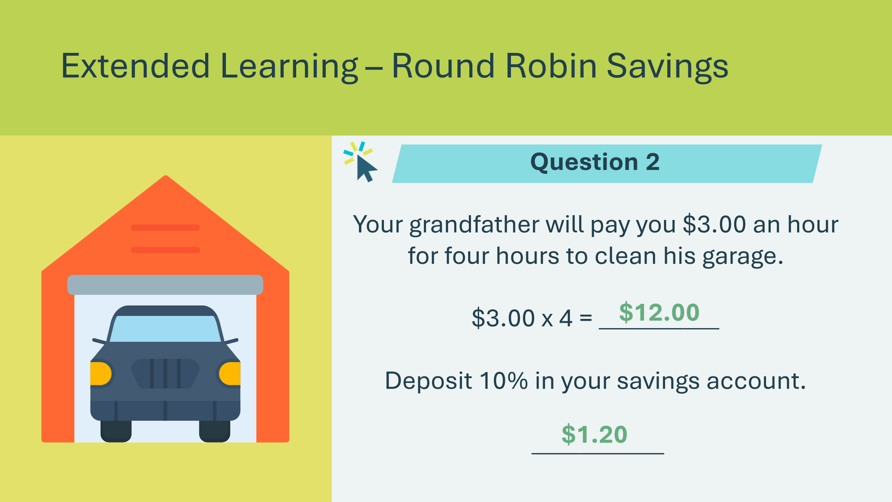 | Review the problem and have students find a new partner. Allow a few minutes for students to solve the problem before reviewing the answers.  *Click or tap to reveal the answers to the problem.
Slide 29  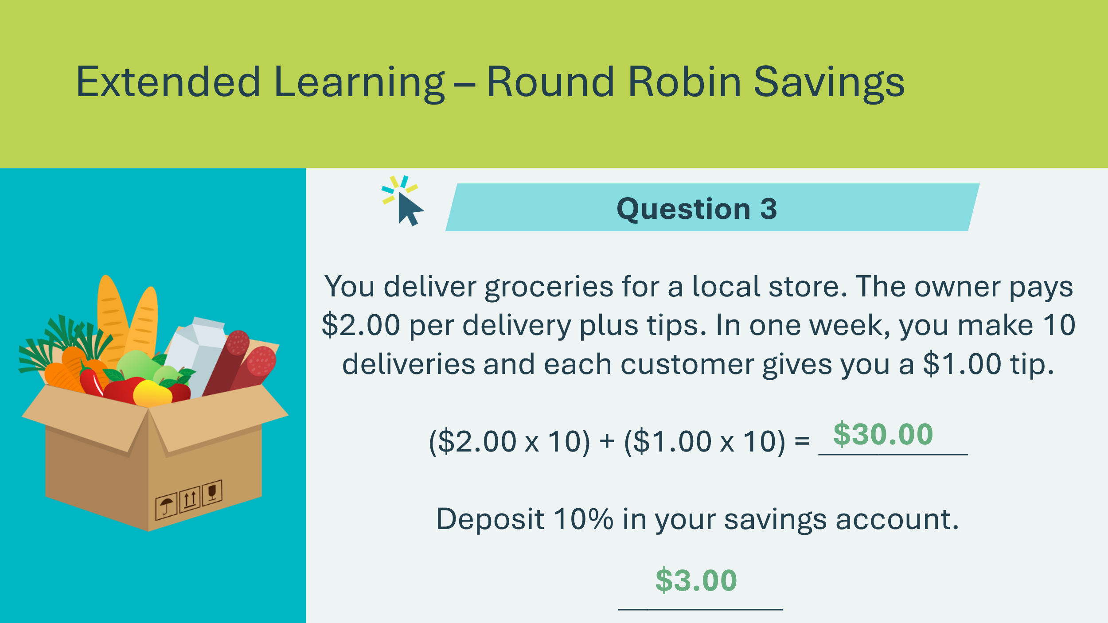 | Review the problem and have students find a new partner. Allow a few minutes for students to solve the problem before reviewing the answers.  *Click or tap to reveal the answers to the problem.
Slide 30  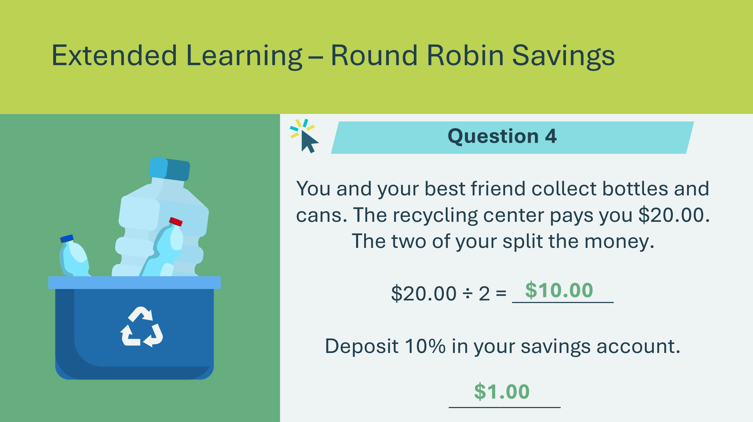 | Review the problem and have students find a new partner. Allow a few minutes for students to solve the problem before reviewing the answers.  *Click or tap to reveal the answers to the problem.

Lesson 2: Create a Business
Program Kit Materials | Vocabulary Flash Cards (i-m) Business Game Boards (Side 1)  Playing pieces and dice  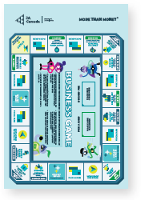  Create a Business Cards  
Slide 31 – Lesson 2 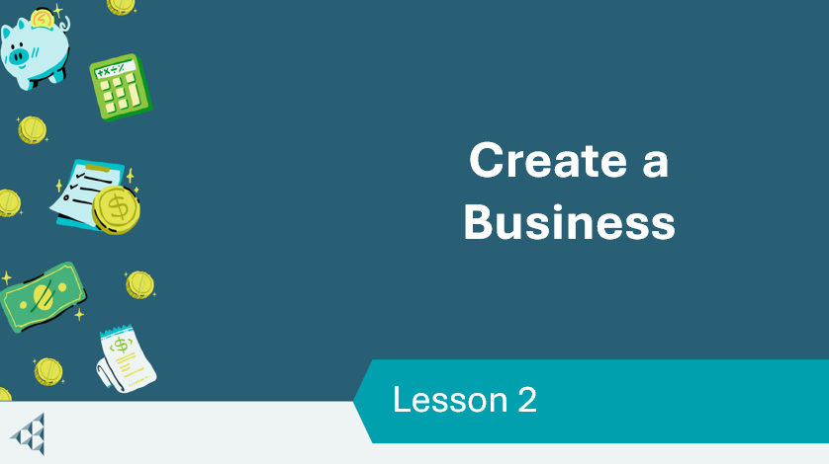 | Lesson 2: Create a Business
Slide 32 – Objectives  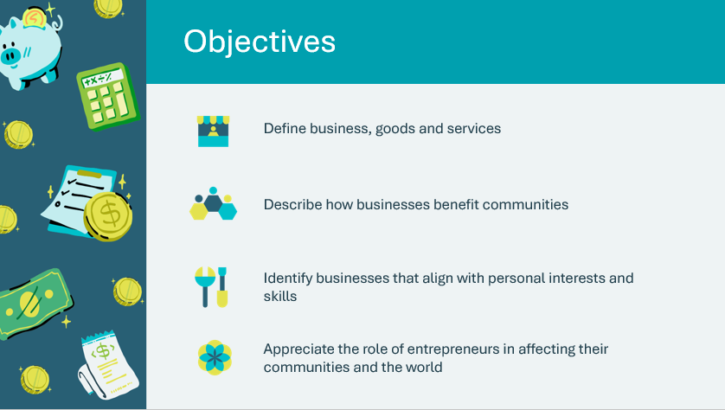 | Optional – review the learning objectives for the lesson
Slide 33 – Introduction  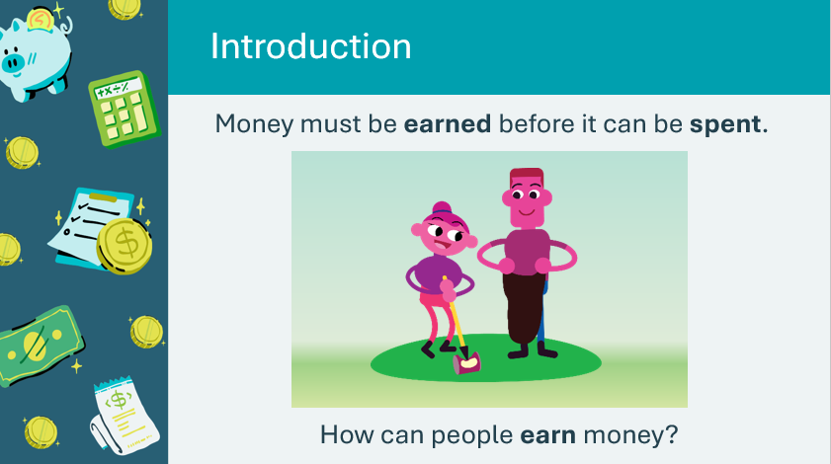 | Introduce the lesson by reminding students that money must be earned before it can be spent. Invite a few students to respond to the prompt and share their ideas about ways people can earn money.  Explain that in this lesson, students will explore one important way people earn money – opening a business and earning a profit.
Slide 34 – Activity Menu  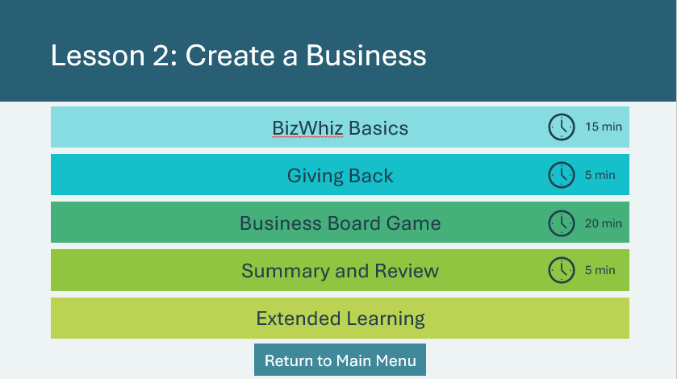 | *Select the button to navigate to the activity.  After you have completed an activity, you will be redirected back to the activity menu.  *Click or tap the Return to Main Menu button to return to the Lessons (Slide 5)
BizWhiz Basics 15 min
Program Kit Materials | For slide 38, you can also use the vocabulary cards from the program kit (optional).
Slide 35  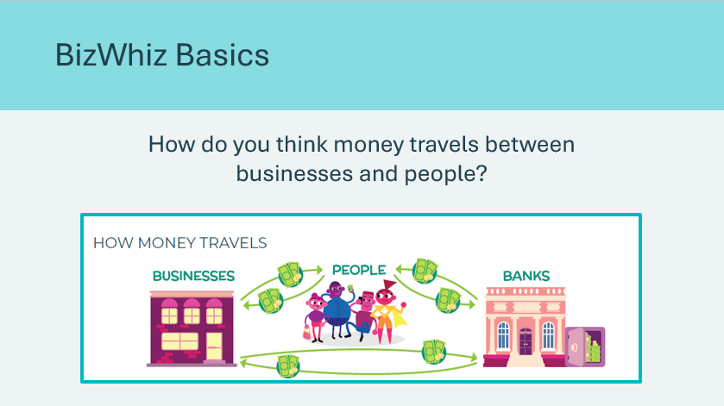  Slide 36  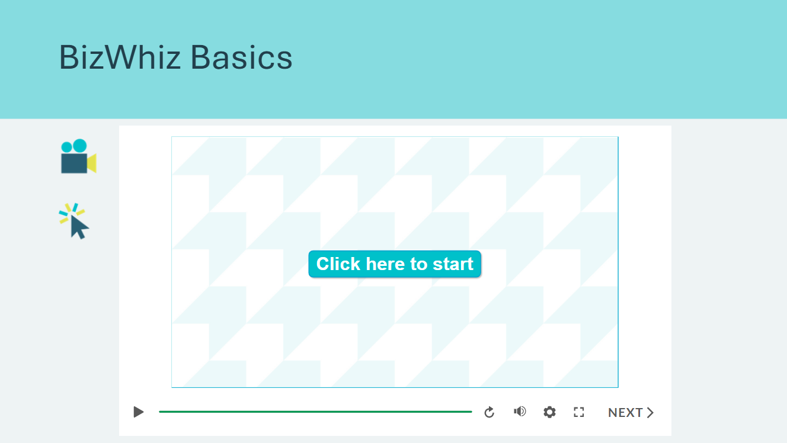  Slide 37  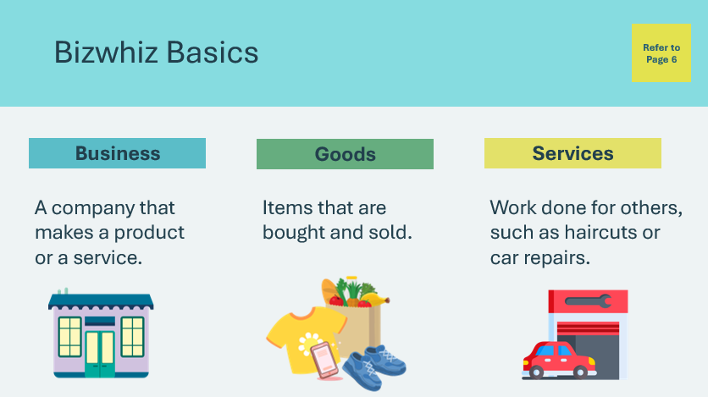  Vocabulary Cards        Slide 38  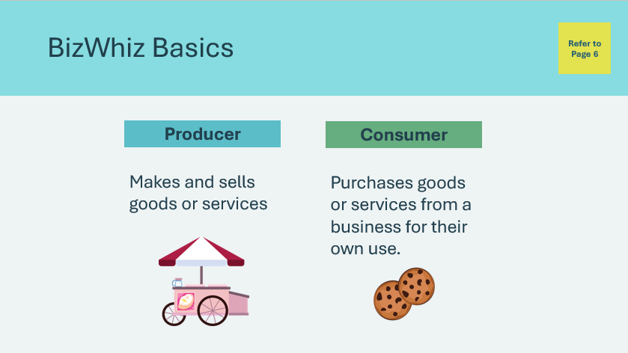 | Suggested time: 5-10 minutes  Remind students of the How Money Travels picture in their student portfolio, page 5. Explain that in the first lesson, we talked about how money travels between people and banks. Ask the prompt on the slide and invite a few students to share their ideas.  Possible answers: people pay money to buy items; businesses use money to make more items, advertise, and pay staff  Explain to students that they are going to watch a short video to learn about businesses and how they benefit communities.  *Click or tap to play the interactive video.  Review the terms learned from the interactive video with students. Have them underline the vocabulary words in their student portfolios, page 6.  Review the remaining terms learned from the interactive video with students. Have them underline the vocabulary words in their student portfolios, page 6.  Call on students to offer examples of businesses and explain if they produce goods or services for people to buy.  Ask students to think back to Kim’s art and sign business. In what way was her business both a consumer and a producer?  Possible answers: her business had to purchase art supplies and computers to produce art and signs.
Slide 39  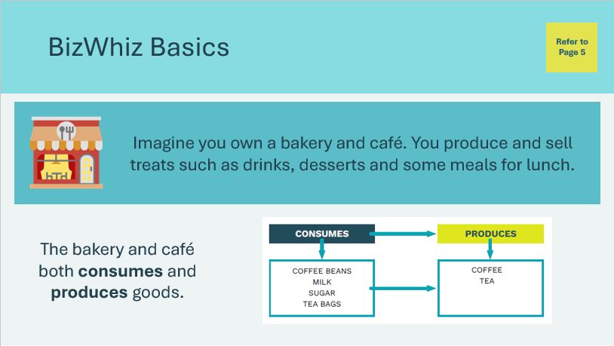  Slide 40  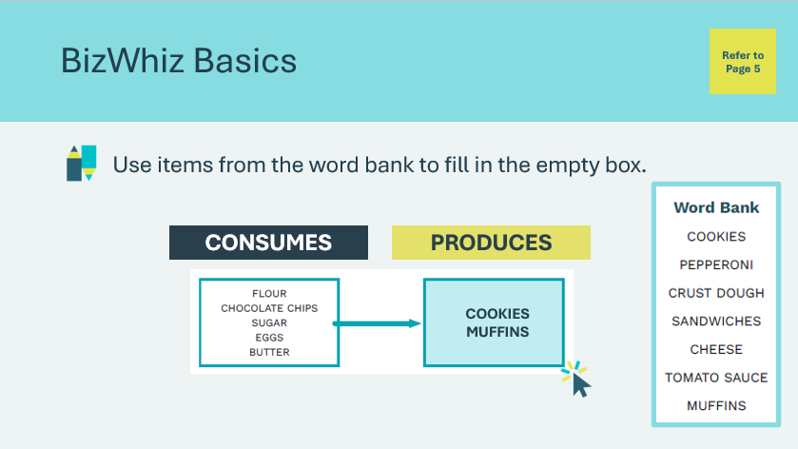  Slide 41  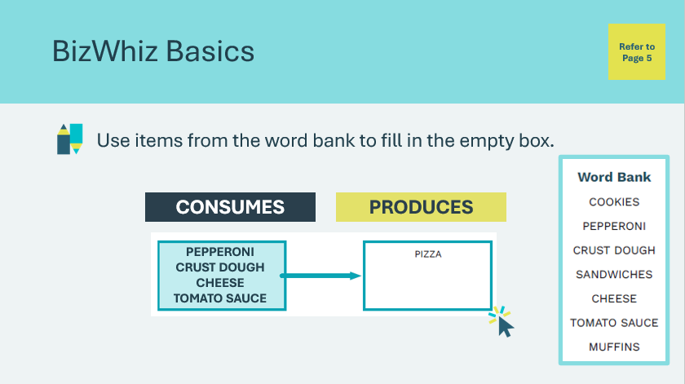  Slide 42  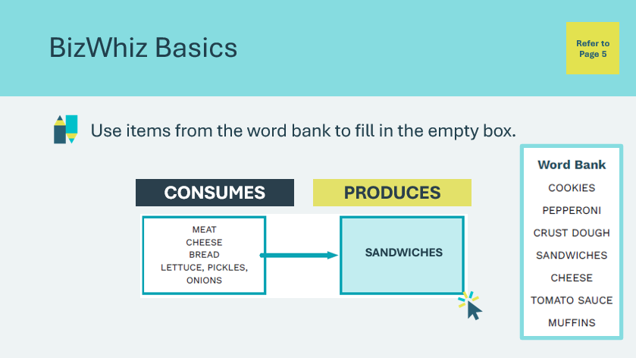  Slide 43  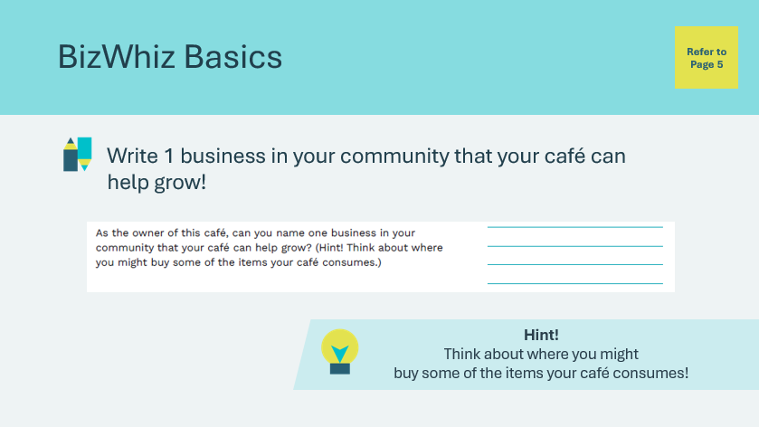 | Suggested time: 5 minutes  Explain that sometimes, it’s easy to think of a business as being only a producer of goods and services to sell. But think back to Kim’s “Sign Me Up!” business. Her business produces art and signs, but it also consumes goods and services from other businesses, such as computers, paper, art supplies, desks and phones. Kim’s business needed to buy these goods and services so it could produce items to sell.  Students will imagine they own a bakery and café. Using words from the word bank, work together as a class to fill in the boxes and show how the café both consumes and produces goods.  Discuss with students what words from the word bank would fit in the box.  *Click or tap to display answers.  Students will write the words in the box in their student portfolio, page 7.  Discuss with students what words from the word bank would fit in the box.  *Click or tap to display answers.  Students will write the words in the box in their student portfolio, page 7.  Discuss with students what words from the word bank would fit in the box.  *Click or tap to display answers.  Students will write the words in the box in their student portfolio, page 7.  Wrap up the activity by having students list 1 business their café could support on the lines at the bottom of their student portfolio, page 7.
Program Kit Materials | For slide 44, you can also use the vocabulary cards from the program kit (optional).
Slide 44  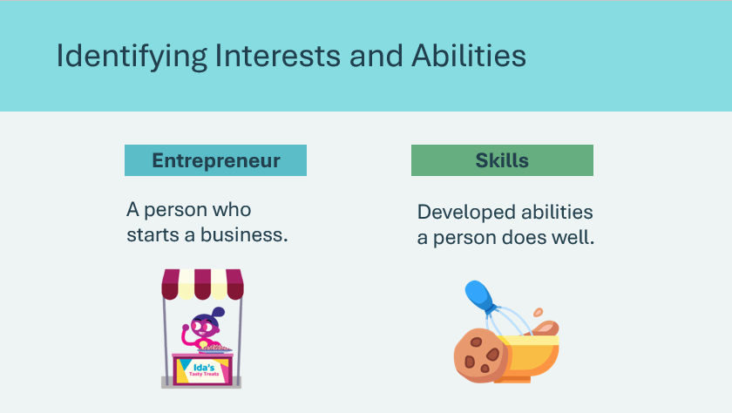  Vocabulary Cards      Slide 45  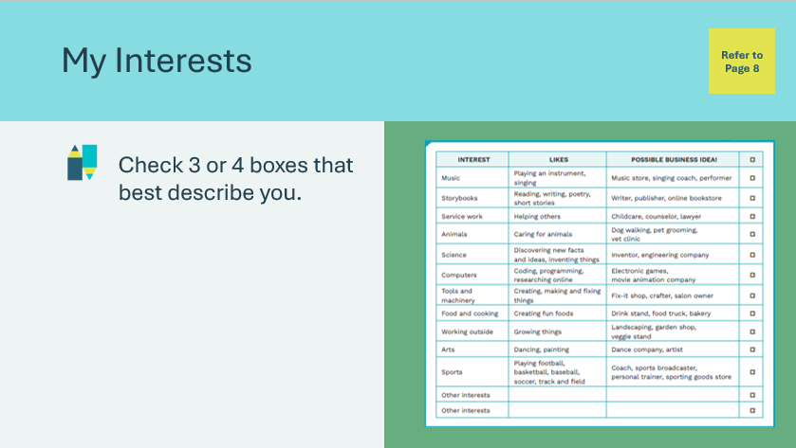  Slide 46  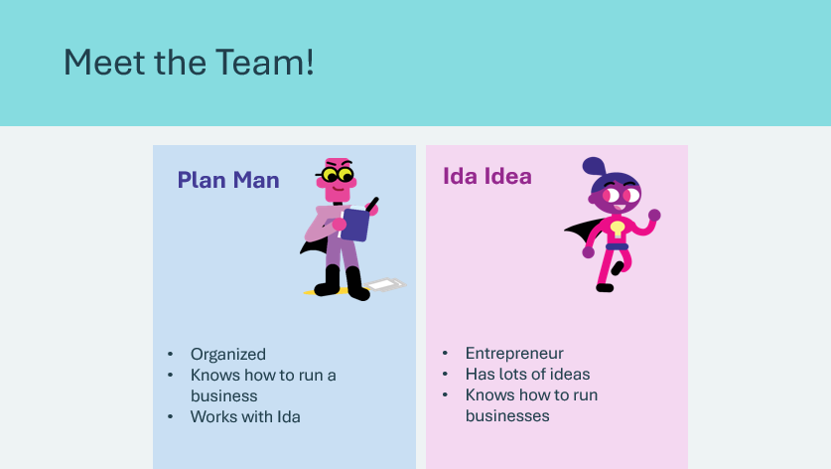  Slide 47  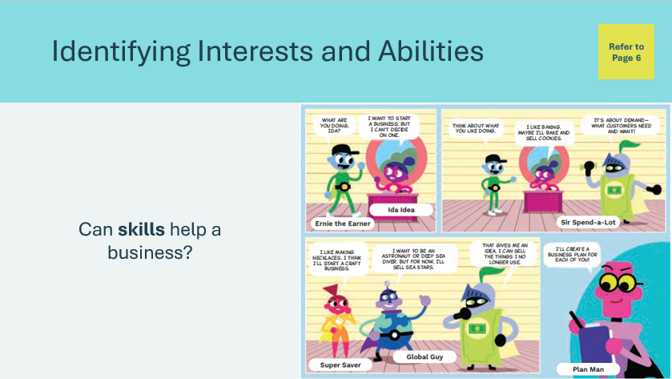  Slide 48  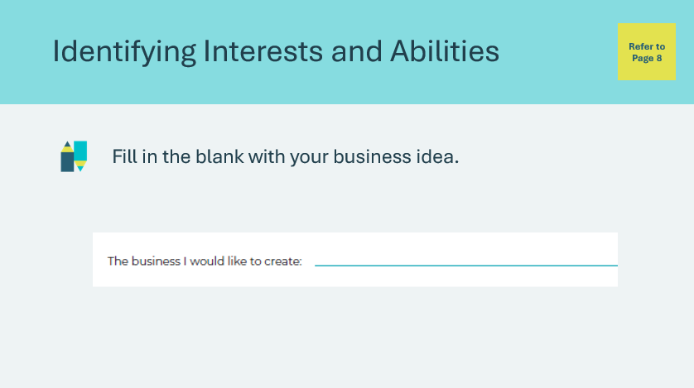 | Suggested time: 5-10 minutes  Define the term entrepreneur. Students can underline the term in their student portfolio, page 6. Explain that entrepreneurs often create businesses based on the things they like to do or the abilities they have.  Explain that we all have interests, or things we like to do. Those interests can develop into skills. Define the term skills. Students can underline the term in their student portfolio, page 6.  For example, someone might be good with tools. Another person might be wonderful with children. A person can put these abilities to work as a skilled handyman or a childcare worker.  An entrepreneur also needs strong business skills, such as being willing to work hard or able to think through problems.  Students will complete the activity in their student portfolio, page 8.  Explain that your interests are things you like and enjoy doing. Ask students to consider what they are interested in.  - What do you do in your free time? Do you enjoy music, talking with friends, helping others, or selling things?  Ask students to review the page and check off three or four boxes that best describe them.  Emphasize that students should make their selections carefully, choosing only their top three or four choices. Provide them with about 5 minutes before calling their focus back.  Introduce the students to the two new characters. Ask them to think about what each character might be like.  *Click or tap to reveal their qualities  Ask students to consider if skills can help a business. Direct students’ attention to the comic in their student portfolio, page 6. Choose students to read aloud the conversation bubbles or read the comic aloud to the class.  Ask students to write on their My Interests page a business they might like to create based on their interests and abilities.
Giving Back 5 min
Slide 49  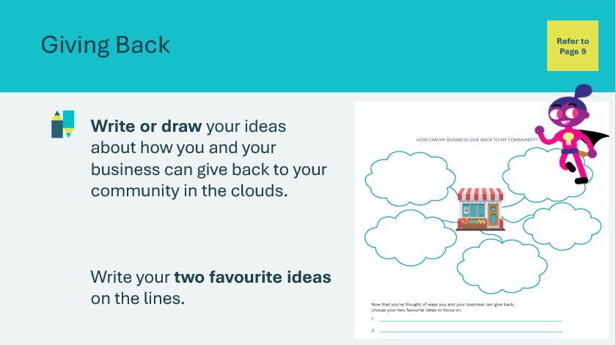 | Suggested time: 5 minutes  Explain that owning a business can mean a lot more than just earning money. It also means giving back to your community.  Now that students have thought about what kind of business they might like to start based on their interests and skills, they will consider how it could give back to the community. Students will fill in the clouds in their student portfolio, page 9, with their ideas.  Facilitator tip: Remind students that giving back doesn’t always have to mean giving money. It can also mean volunteering or coaching others to help them start their own businesses.  Possible ideas: helping an animal shelter, a seniors home, a specific charity or cause, volunteering, etc.  Give students a few minutes to complete the activity and choose their two favourite ideas.  If time allows, invite a few students to share their ideas.
Business Board Game 20 min
Program Kit Materials | For slides 50-51, you will need to use the Business Game Board, Create a Business Cards, playing pieces and dice from the program kit.
Slide 50    Business Game Board (side 1)  Create a Business Cards | Suggested time: 5 minutes  Tell students they will play a game and keep track of the money they earn.  Play the video on the slide to explain the game rules.  Facilitator tip: Game rules are also written in Appendix A of this document.  Direct their attention to the My Money Tracker in their student portfolio, page 10. Students will start the game with a balance of $250.  Facilitator tip: Review how to use the My Money Tracker if needed.  Review how to play and then break the students into groups of 4. Distribute to each group a Business Game Board, create a Business Game Card Sheet and a set of tokens and dice.
Slide 51  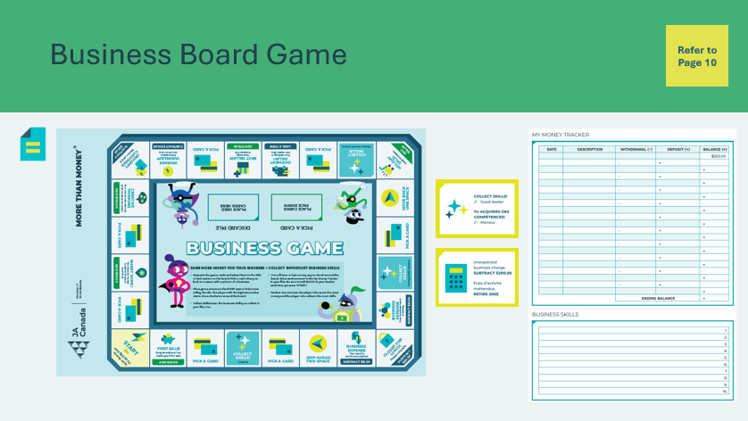 | Suggested time: 15 minutes  Play for about 15 minutes or until time is called. Remind students that the two winners are the student with the most money and the student with the most skills.  Facilitator tip: A few students may show negative balance during the first rounds of game play. Tell students to continue to play for the opportunity to increase both sales and profit. Help students with their calculations where necessary.
Summary and Review 5 min
Slide 52  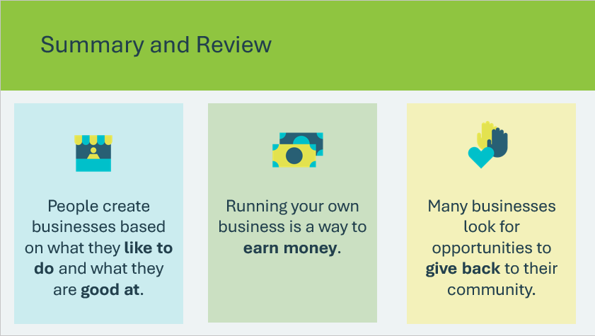 | Suggested time: 5 minutes  Review the key concepts learned in the lesson.
Extended Learning
Slide 53  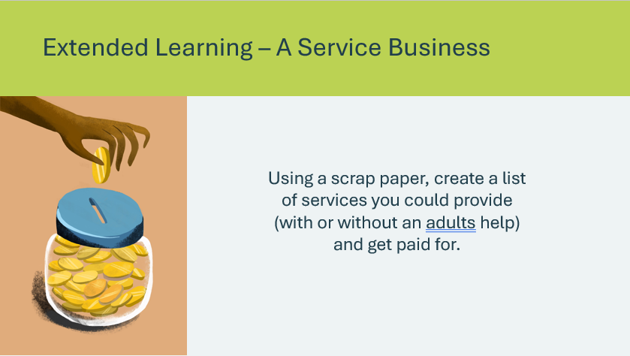 | Suggested time: Optional – consider this activity if your lesson ends early and you have extra time.  Review that a service is work done for others. Ask students to create a list of ways a young person, with an adult’s help, may provide a service for others and get paid for it.  Possible ideas:  - Be a tutor to help someone learn how to use a computer or smartphone  - Organize birthday parties for younger children  - Make meals  - Help a neighbour run a garage sale  - Offer to recycle cans and bottles for a friend  - Help plant and tend to a garden  - Teach music lessons  - Collect mail or newspapers for someone on vacation
Slide 54  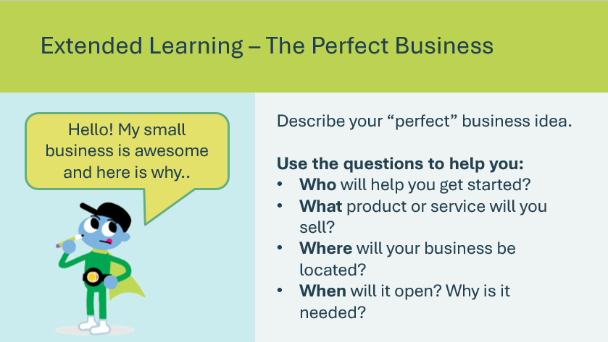 | Suggested time: Optional – consider this activity if your lesson ends early and you have extra time.  Ask students to describe their perfect business idea to a classmate using the five key elements of a narrative or story.  Students can start with the prompt in the speech bubble, and answer the other question prompts to help them describe their perfect business idea.

Lesson 3: Build a Business
Program Kit Materials | Vocabulary Flash Cards (n-p) Business Description Cards  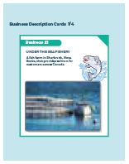  Business Rules Cards  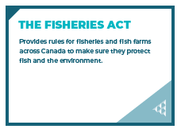
Slide 55 – Lesson 3  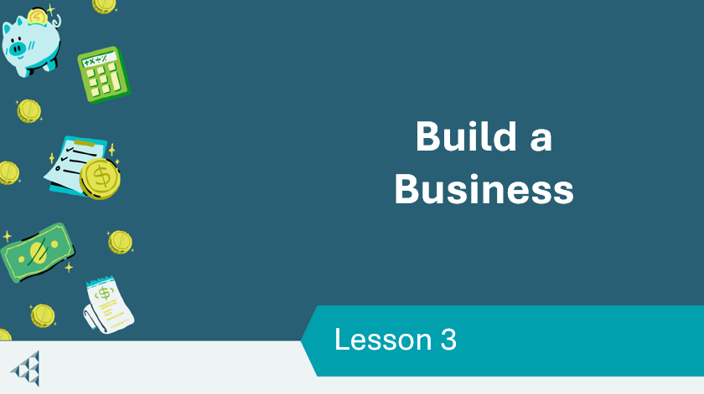 | Lesson 3: Build a Business
Slide 56 – Objectives  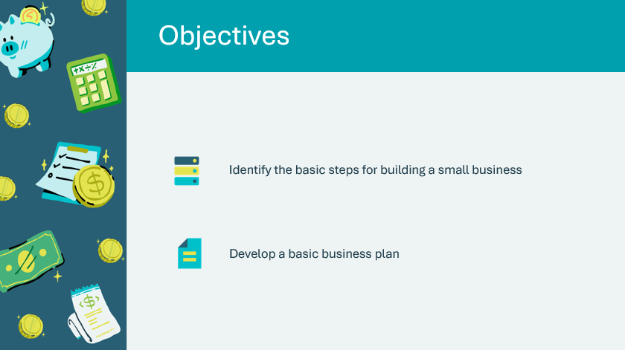 | Optional – review the learning objectives for the lesson
Slide 54 – Introduction  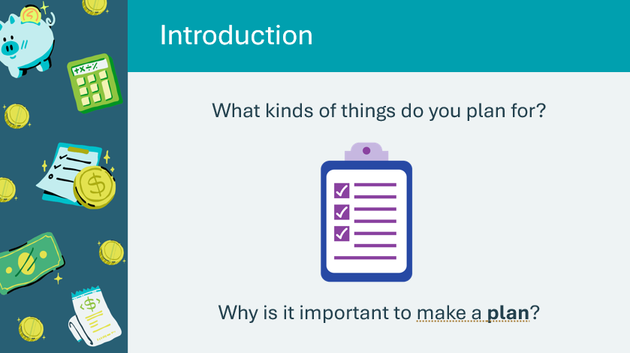 | Introduce the lesson by discussing the idea of planning with students. Explain that people create a plan for all sorts of goals, from as simple as a shopping list to as complex as their plans for the future.  Ask the prompt on the slide and invite a few students to share their responses.  Possible answers:  - Plans for a party  - Plans for the weekend  - Plans for what to bring on a trip  - It’s important to make a plan so you have what you need  - A plan keeps things organized and running smoothly  - A plan helps people accomplish a goal
Slide 57 – Activity Menu  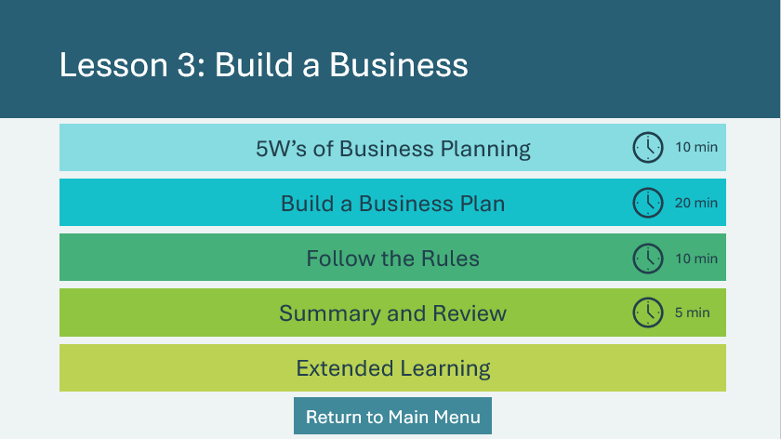 | *Select the button to navigate to the activity.  After you have completed an activity, you will be redirected back to the activity menu.  *Click or tap the Return to Main Menu button to return to the Lessons (Slide 5)
5W’s of Business Planning 10 min
Program Kit Materials | For slide 59, you can also use the vocabulary cards from the program kit (optional).
Slide 59  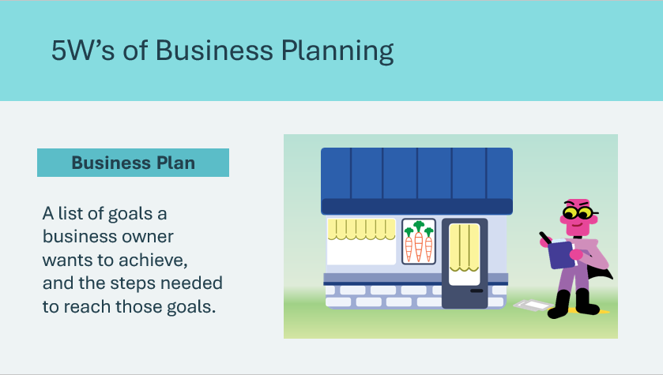  Vocabulary Cards   | Suggested time: 2 minutes  Explain to students that just as they make plans to be sure they have what they need for a party, a business needs a plan to help it do well.  Define the term business plan and explain that a business plan is a good tool for a new business to have. With a business plan, a business has a much better chance of growing and earning money.  Ask students to recall the business ideas they had from Lesson 2. Ask students to consider what it would require to make those plans happen and invite students to share their thinking.  Facilitator tip: If students don’t remember their business ideas, suggest they consider what all businesses need to be successful.  Use the question prompts to generate discussion:  - What is needed to start a business?  - What do you need to know about?  Possible answers: customers, money, a product or service, a community store, an online store plan.  Facilitator tip: Identify some local small businesses that students may be familiar with, and which sectors they belong to.
Slide 60  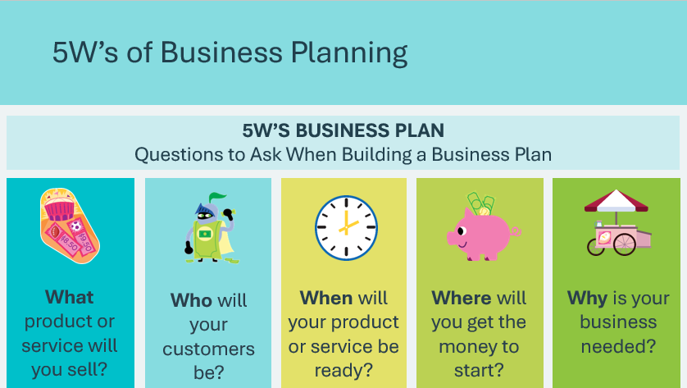 | Suggested time: 2 minutes  Tell students that whether a business is large or small, there are certain questions that need to be answered to get it started. We can think of these questions as the 5W’s.  *Click or tap to display each of the 5W’s.
Slide 61  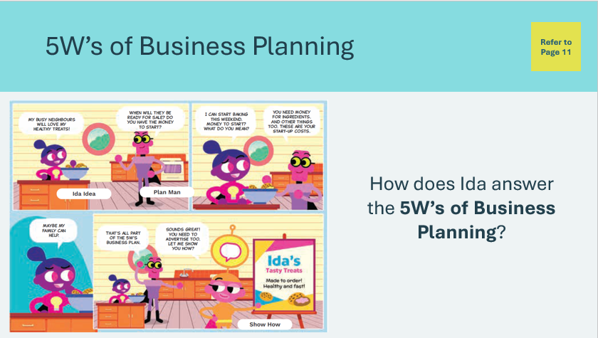 | Suggested time: 2 minutes  Direct students to the comic strip in their student portfolio, page 11. Ask students to read aloud the comic strip or read it to them.  Remind students that, like Ida, they had an idea for a business at the end of Lesson 2. Their ideas were based on something they liked to do or an interest they had.  Discuss how Ida answers the 5W’s of business planning.  - What product or service will you sell? Ida baked tasty treats like cookies.  - Who will your customers be? Ida sold to their neighbours.  - When will your product or service be ready? Ida started baking on the weekend.  - Where will you get the money to start? Ida’s parents helped them get started.  - Why is your business needed? Everyone likes tasty treats now and then.
Slide 62  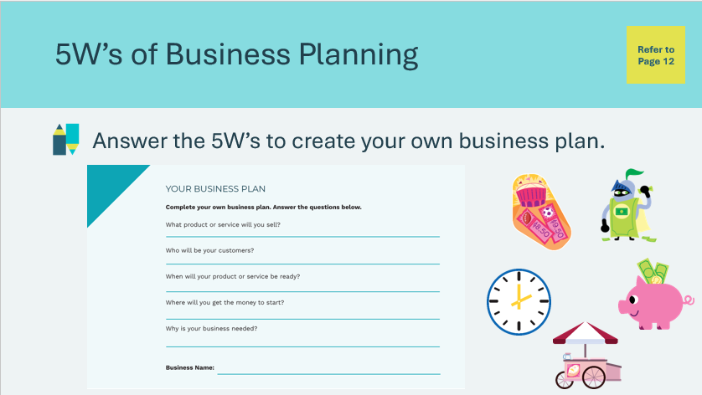 | Suggested time: 2 minutes  Tell students they will answer the same questions as Ida, about their own business, in their student portfolio, page 12. Provide the students with a few minutes to work.  Facilitator tip: Circulate the classroom and provide support as needed.
Program Kit Materials | For slide 63, you can also use the vocabulary cards from the program kit (optional).
Slide 63  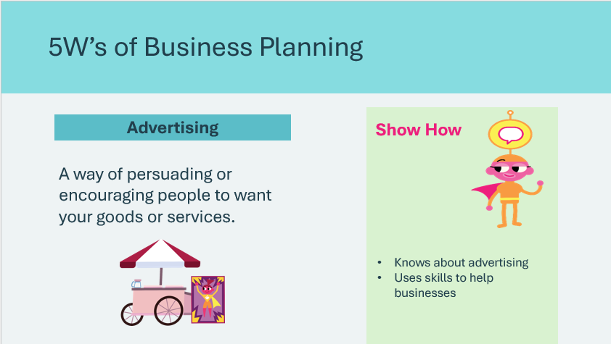  Vocabulary Cards   | Suggested time: 2 minutes  Emphasize that businesses need a plan that includes advertising.  Define the term and have students recall the new character introduced in the comic strip, Show How, who is responsible for advertising.
Build a Business Plan 20 min
Slide 64  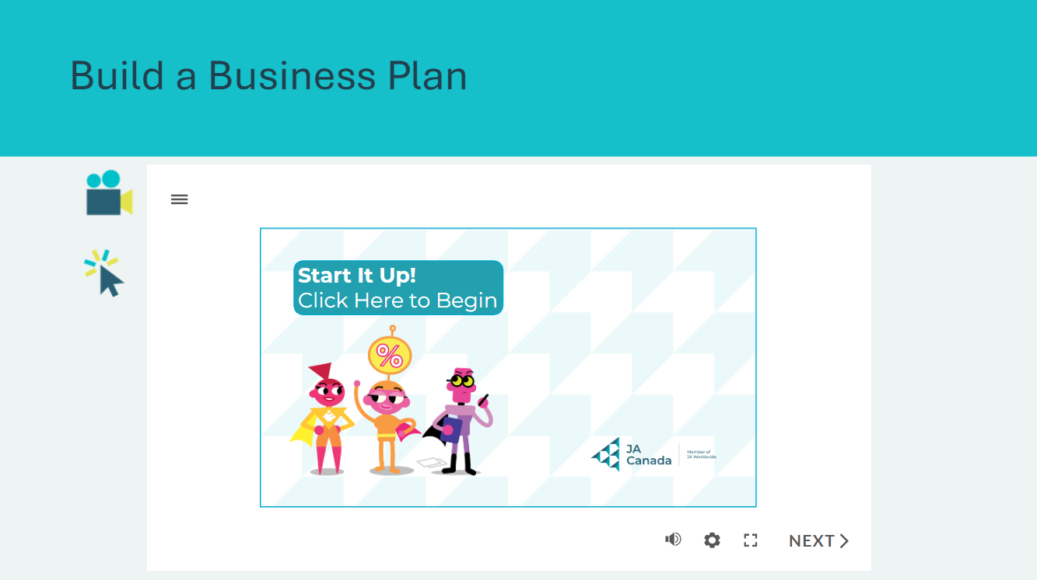 | Suggested time: 3 minutes  Explain that now that students have completed the 5W’s or the basics of business planning, they need to think more about how to get their businesses started.  Tell students they will watch a video about starting a business. Play the interactive video, Start It Up! When the video is over, take time to answer any questions students may have about Ida’s business plan.
Program Kit Materials | For slide 65, you can also use the vocabulary cards from the program kit (optional).
Slide 65  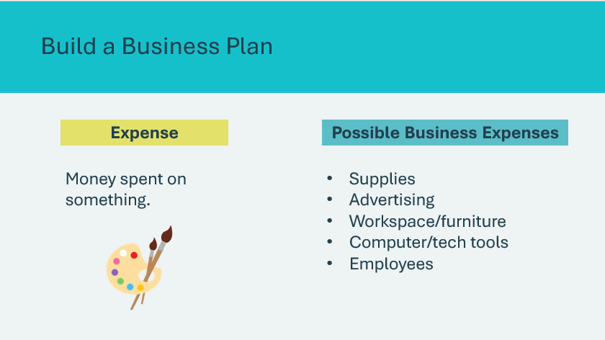  Vocabulary Cards  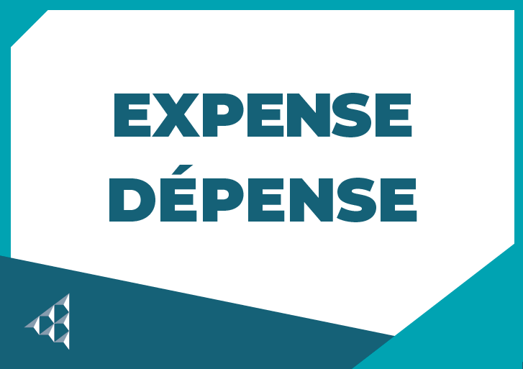 | Suggested time: 2 minutes  Explain that to produce their goods or services, businesses need to spend money.  The money spent on things for the business are called expenses. It’s important to consider the expenses you will have when getting your business started.
Slide 66  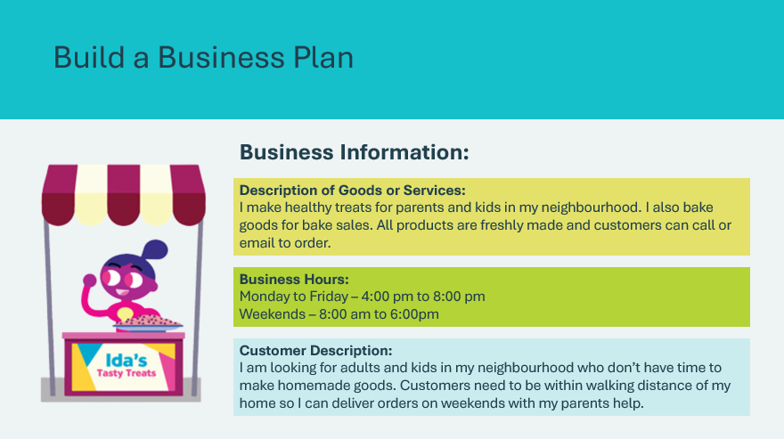 | Suggested time: 5 minutes  Explain that a good business plan includes important business information, too. Some important details to include are a description of the goods or services you will provide and what your business hours will be.  Review the example from Ida’s business plan.
Slide 67  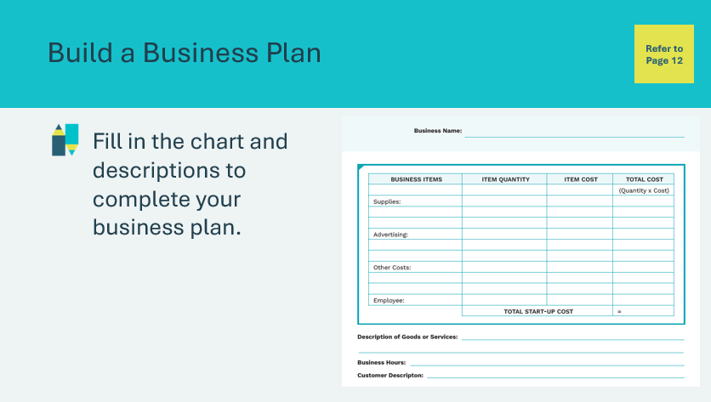 | Suggested time: 10 minutes  Students will complete the business plan activity in their student portfolio, page 12, with information based on the business they would like to build. Remind students to fill in the name of their business on the page.  Students will identify the items their business will need, along with the quantity and cost and calculate the total to get their total start-up cost.  When they have completed the chart, students can finish their plans with a description of the goods or services their business provides, business hours, and a description of their customers.  Facilitator tip: Circulate the room while students work and provide support as needed.
Follow the Rules 10 min
Slide 68  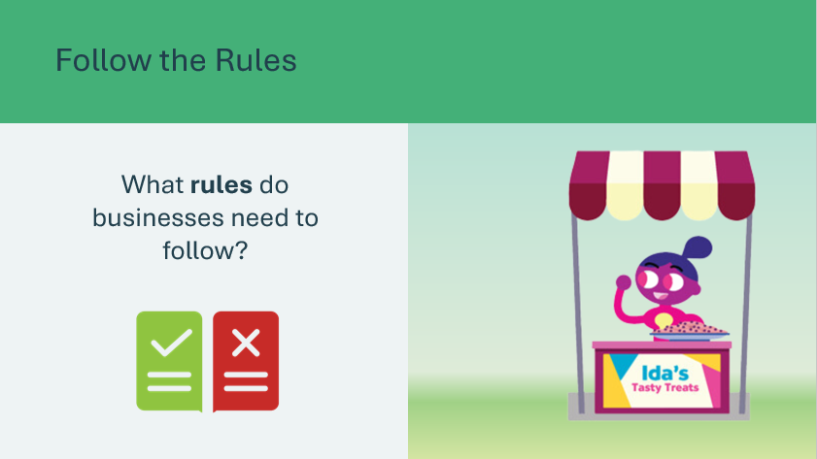 | Suggested time: 2 minutes  Now that students have their business plan and know their start-up costs, ask them to consider if entrepreneurs can run a business any way they want.  Ask the prompt and invite a few students to share their answers.  Possible answers:  - They can’t break the law or treat employees badly  - They need to follow national and provincial laws that protect workers’ health and safety and the environment
Slide 69  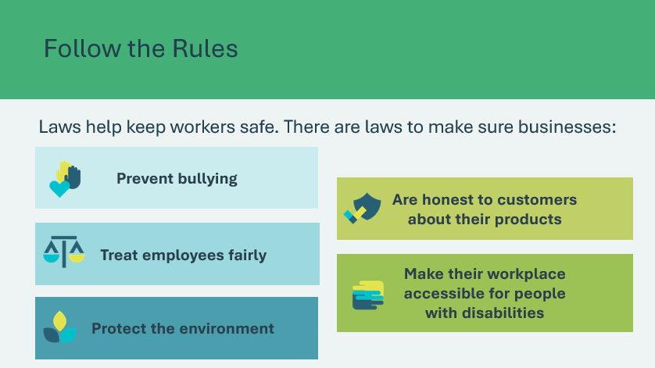 | Suggested time: 2 minutes  Explain that some businesses involve very dangerous work, such as an electrical maintenance business, a factory that has big machines, or a window washing company. Laws help to keep workers safe. These are sometimes called regulations, standards, codes or acts.  *Click or tap to display examples of laws  Review the different types of laws that businesses must follow. Ask students if they know who might make the laws to keep workers safe?  Possible answers: students may offer suggestions that the owner of the business makes the rules.  Explain that many rules are made by provincial or federal governments. This means some laws are different in each province, and others are the same across all of Canada. Explain that these are just a few of the laws that businesses must follow and as an entrepreneur, you need to know which laws apply to your business.
Program Kit Materials | For slides 70-79, you can choose to use the Business Description Cards and Business Rules Cards from the program kit or use the slides.
Slide 70  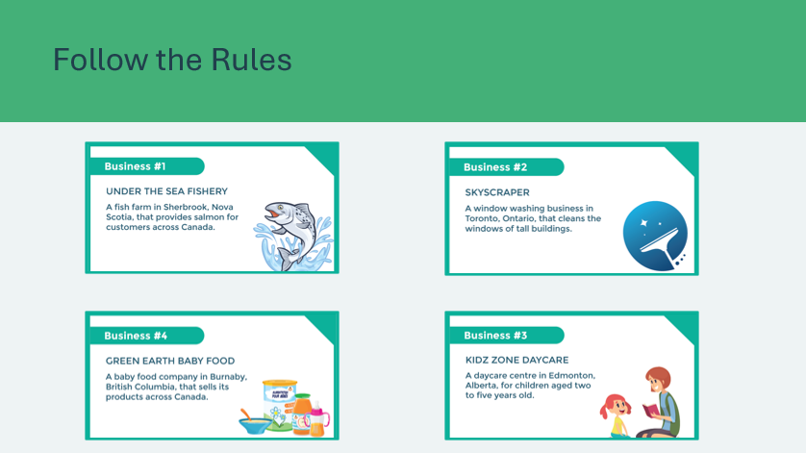  Business Description Cards  Business Rules Cards  Slide 71  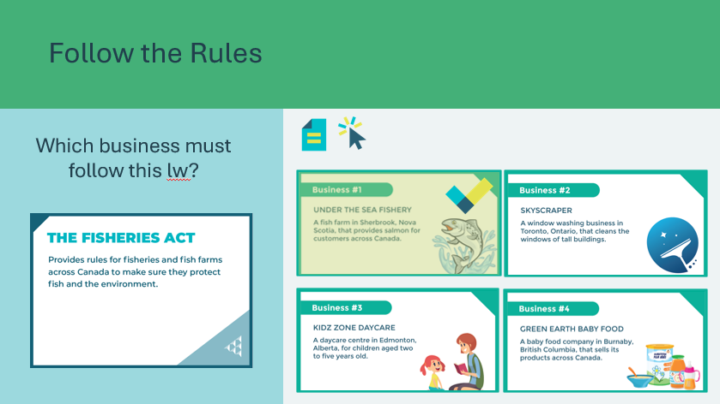  Slide 72  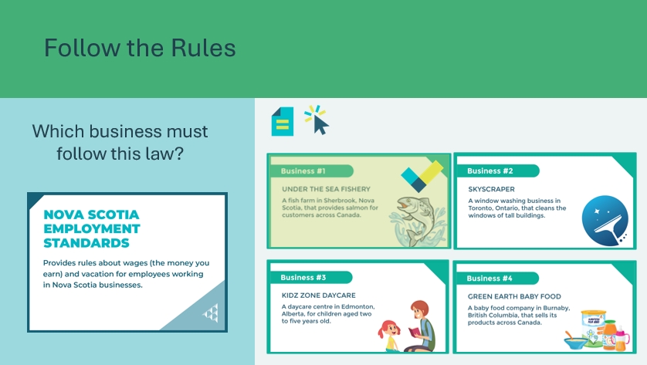  Slide 73  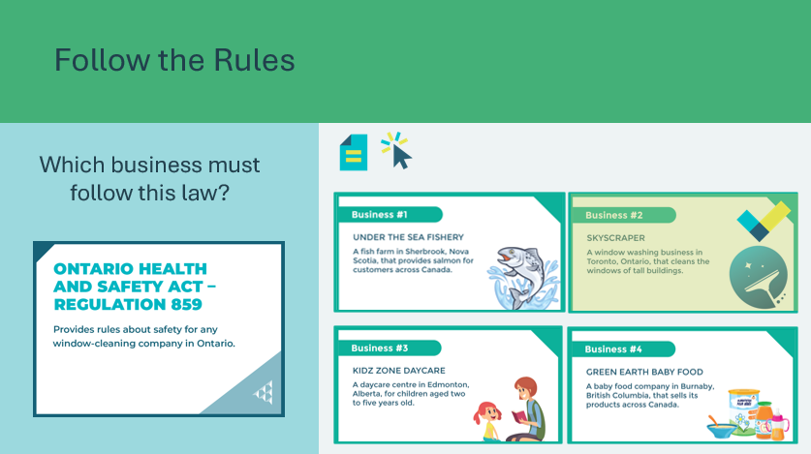  Slide 74  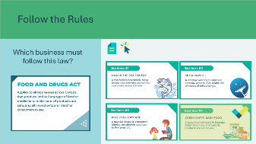  Slide 75  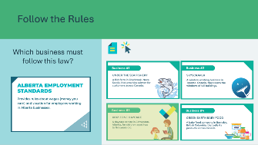  Slide 76  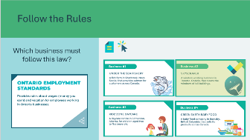  Slide 77  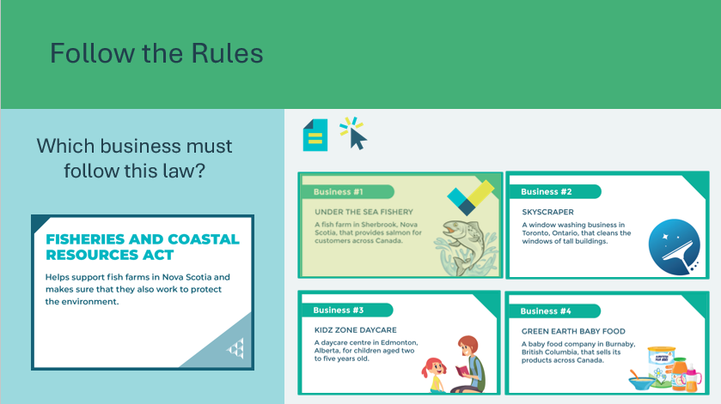  Slide 78  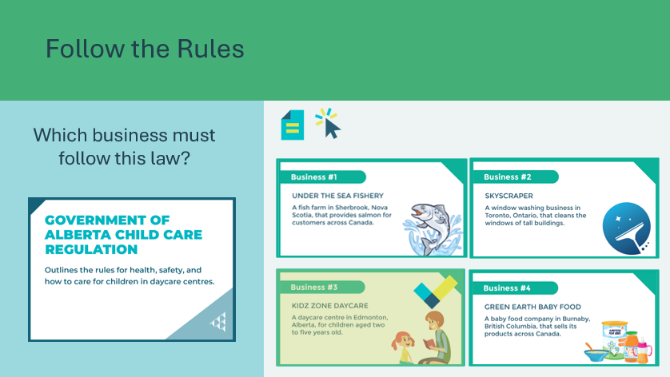  Slide 79  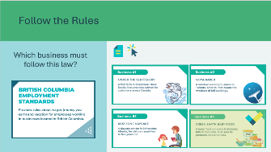 | Suggested time: 6 minutes  To practice thinking about which laws a business may need to follow, students will consider the following scenarios. Before you begin, review each of the business descriptions to help students learn about each business.  The goal of the activity is for students to recognize there are many rules and regulations every business must follow.  Use the following slides to complete the activity as a class with the students remaining in their seats.  The Business Description cards and Business rules cards are also available in the printed kit materials. Alternatively, you can place the four Business Description cards around the room. Ask nine volunteers to participate, or have students work in groups or 2 or 3 depending on class size to have everyone participate. Each student volunteer or group will receive one Business Rules card that displays the name and description of an act or regulation. Their task is to find the business that needs to follow the act or regulation described on their card and place it beside the correct business descriptions card.  To practice thinking about which laws a business may need to follow, students will consider 4 scenarios. Read the business rule (on the left of the screen) and ask students to identify which business (on the right of the screen) would need to follow that law.  *Click or tap to display answer (Business #1)  Read the business rule (on the left of the screen) and ask students to identify which business (on the right of the screen) would need to follow that law.  *Click or tap to display answer (Business #1)  Read the business rule (on the left of the screen) and ask students to identify which business (on the right of the screen) would need to follow that law.  *Click or tap to display answer (Business #2)  Read the business rule (on the left of the screen) and ask students to identify which business (on the right of the screen) would need to follow that law.  *Click or tap to display answer (Business #4)  Read the business rule (on the left of the screen) and ask students to identify which business (on the right of the screen) would need to follow that law.  *Click or tap to display answer (Business #3)  Read the business rule (on the left of the screen) and ask students to identify which business (on the right of the screen) would need to follow that law.  *Click or tap to display answer (Business #2)  Read the business rule (on the left of the screen) and ask students to identify which business (on the right of the screen) would need to follow that law.  *Click or tap to display answer (Business #1)  Read the business rule (on the left of the screen) and ask students to identify which business (on the right of the screen) would need to follow that law.  *Click or tap to display answer (Business #3)  Read the business rule (on the left of the screen) and ask students to identify which business (on the right of the screen) would need to follow that law.  *Click or tap to display answer (Business #4)
Summary and Review 5 min
Slide 80  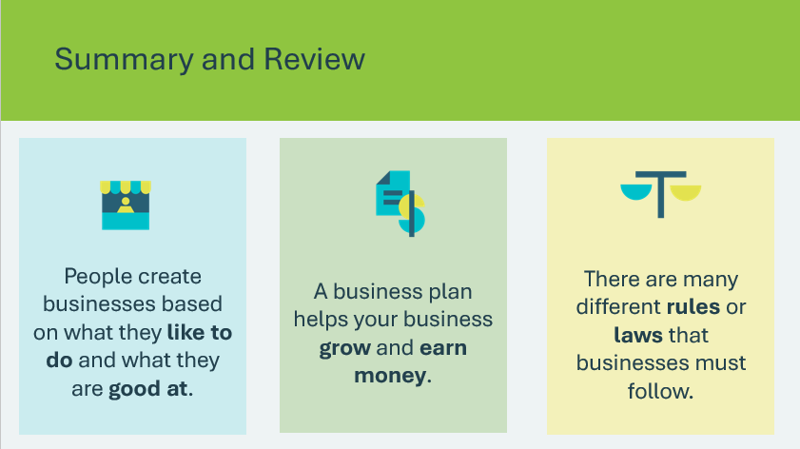 | Suggested time: 5 minutes  Invite students to share what they learned while filling out their business plan. Have them share additional categories that should be included in a business plan that were not listed in their portfolio.  Invite students to share what they learned about how government laws can affect their businesses.
Extended Learning
Slide 81   | Suggested time: Optional – consider this activity if your lesson ends early and you have extra time.  Distribute sheets of blank paper and markers or pencil crayons, and have students design an advertisement for their business.  Present some examples of business logos.  Students will brainstorm ways they could message their business to the community. Students can choose to design a business logo and insert it on a portfolio or web homepage. They can create a slogan or jingle.  Post the completed sheets around the classroom and invite students on a “gallery walk” to view the variety of ideas. Students could also create video commercials if tech allows, or by drawing out the various scenes.

Lesson 4: Run a Business
Program Kit Materials | Vocabulary Flash Cards (q-u) Run a Business Game Cards  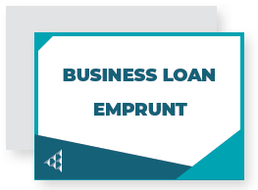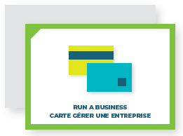  Business Game Boards (Side 2)  Game pieces and dice  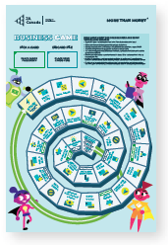
Slide 82 – Lesson 4  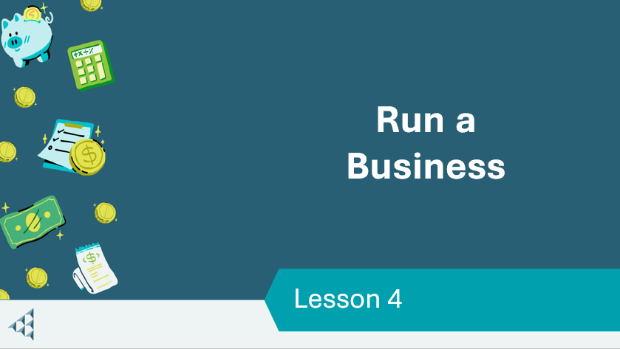 | Lesson 4: Run a Business
Slide 83 – Objectives  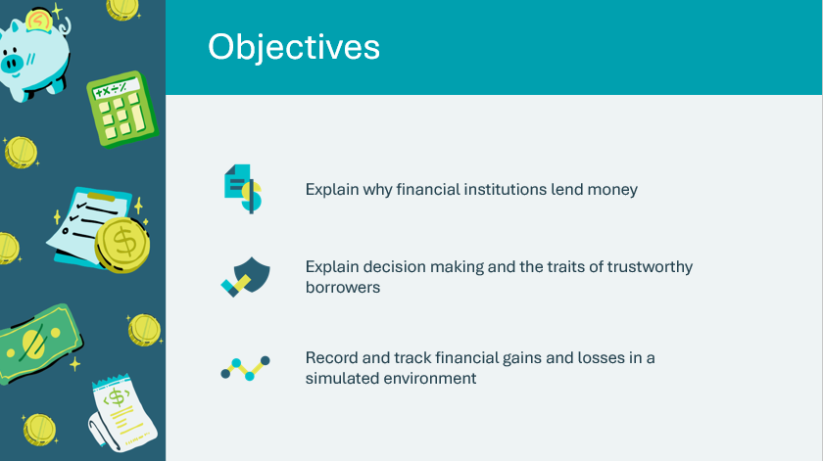 | Optional – review the learning objectives for the lesson
Slide 84 – Introduction  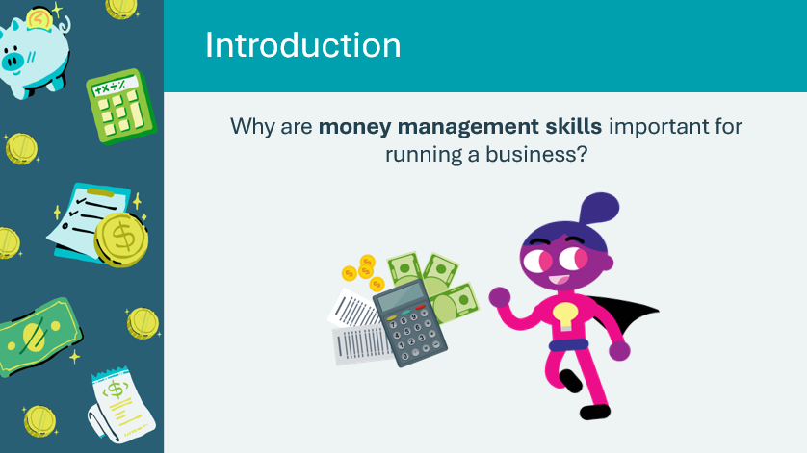 | Introduce the lesson by telling students that in this lesson they will continue to practice running a business and using their money management skills.  Ask the prompt and invite a few students to share their thinking.  Possible answers:  - Businesses need money to get started  - Businesses need to make a profit  - Businesses have expenses they must pay for  - Businesses might need to pay employees’ wages or a salary  Volunteer connection: Share a reflection about an experience you’ve had in running a business, and/or how money management skills have been important in your life.
Slide 85 – Activity Menu  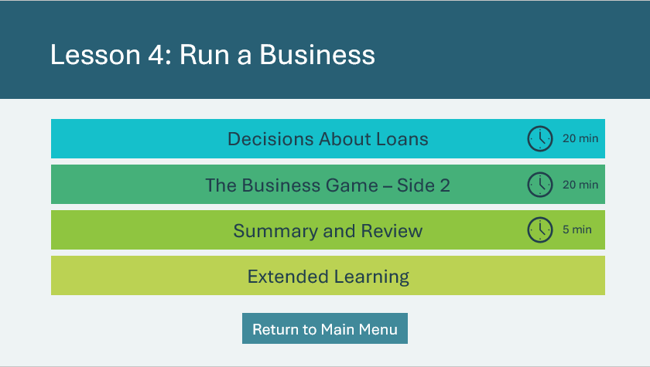 | *Select the button to navigate to the activity.  After you have completed an activity, you will be redirected back to the activity menu.  *Click or tap the Return to Main Menu button to return to the Lessons (Slide 5)
Decisions About Loans 20 min
Program Kit Materials | For slide 86, you can also use the vocabulary cards from the program kit (optional).
Slide 86  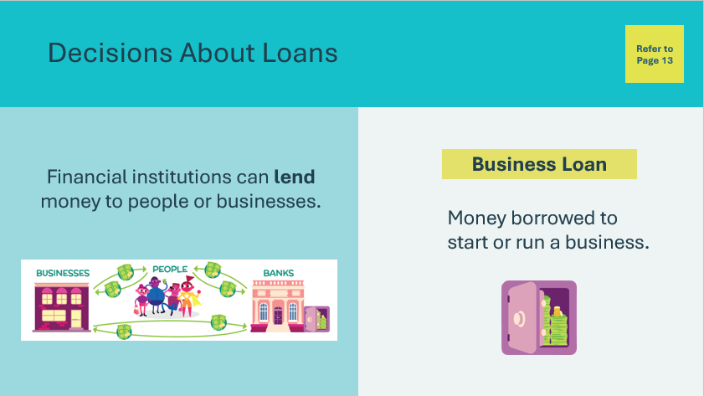  Vocabulary Cards  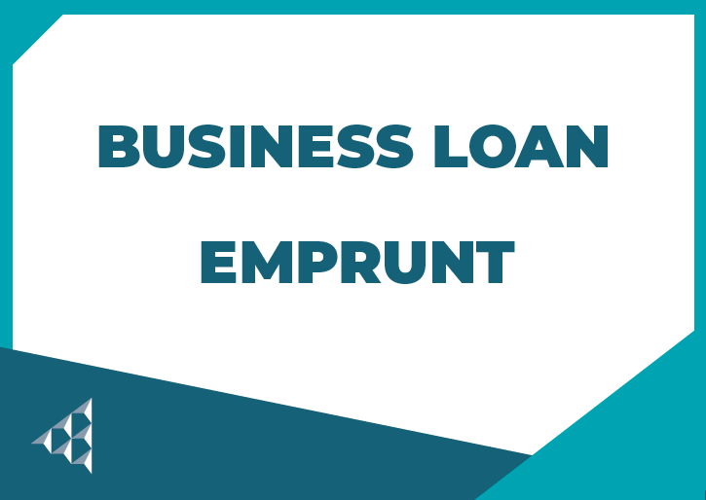 | Suggested time: 2 minutes  Introduce the activity by asking students to look at the vocabulary section in their student portfolio, page 13, and underline the words as they are discussed.  Ask students to recall what they learned about financial institutions in Lesson 1. Invite multiple students to respond to get a complete answer.  Possible answers:  - A financial institution is a business that provides money-related services.  - Banks and credit unions are two types of financial institutions  Direct students' attention to the money diagram. Review that money travels back and forth among people, businesses and financial institutions, and one of the jobs of financial institutions is to keep money safe. People deposit money in banks and later withdraw it.  Explain that banks, mobile banks, and credit unions work with the money that people deposit and sometimes lend that money to other people or businesses. With loans, businesses have an opportunity to earn even more money through increased sales.  Define the term business loan. Explain that a business loan can be used to start a business, or also to expand or grow a business. Remind the students that Ida Idea needed money to start their Tasty Treats business.
Slide 87  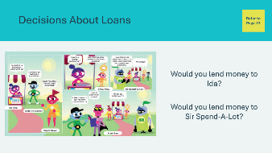 | Suggested time: 2 minutes  Direct students’ attention to the comic in their student portfolio, page 13. Choose students to read aloud the characters’ speech bubbles or read them aloud to the class.  After reading the comic, ask the prompts and invite a few students to share their thinking.  Possible answers:  - Ida has worked hard to grow the business. They’ll likely work hard to pay back the loan.  - Sir Spend-A-Lot doesn’t pay it back.
Program Kit Materials | For slide 88, you can also use the vocabulary cards from the program kit (optional).
Slide 88  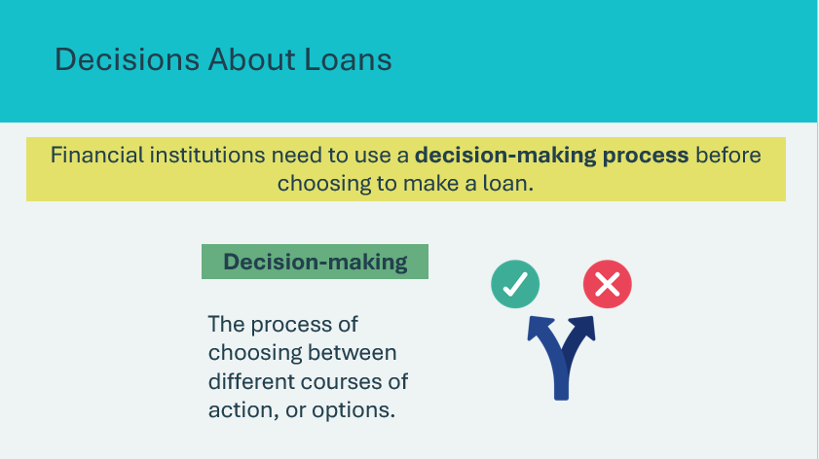  Vocabulary Cards   | Suggested time: 2 minutes  Explain that because Sir Spend-A-Lot doesn’t pay back money, you wouldn’t want to risk your money by lending it to them.  Explain that financial institutions need to consider a number of things before making a loan. Define the term decision-making.  Ask students what types of things financial institutions might consider before making a business loan. Invite a few students to share their ideas.
Slide 89  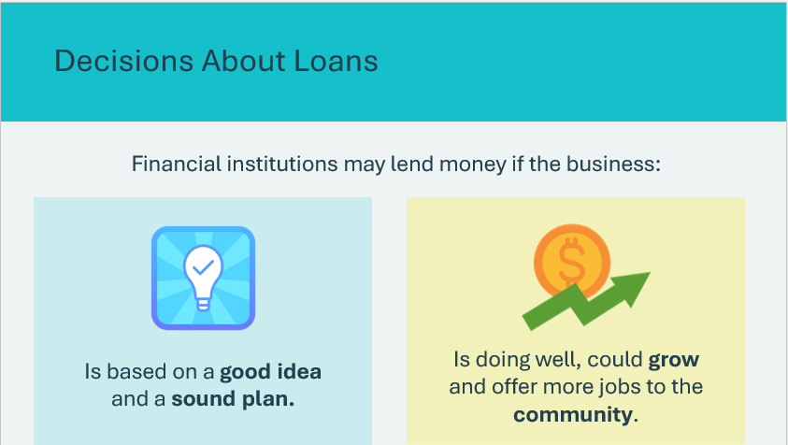 | Suggested time: 2 minutes  Review and discuss the factors banks weigh when deciding to make a loan to a business.  Stress that people can go to a bank for a loan, and that making loans is good business for banks.  Share that there are other funding options, besides business loans. Crowdfunding or microlending are two ways “people ask people” (instead of a financial institution) for money for a project or business venture. A person with a good idea shares it online so that many people can see it. The people who like the idea donate money to fund it.  Volunteer connection: Based on your industry  knowledge/experience, share examples of how a business may convince a bank to make a loan, or examples of how banks decide which businesses to lend money to. Share an example of a crowdfunded business or product that students in your area may recognize.
Slide 90  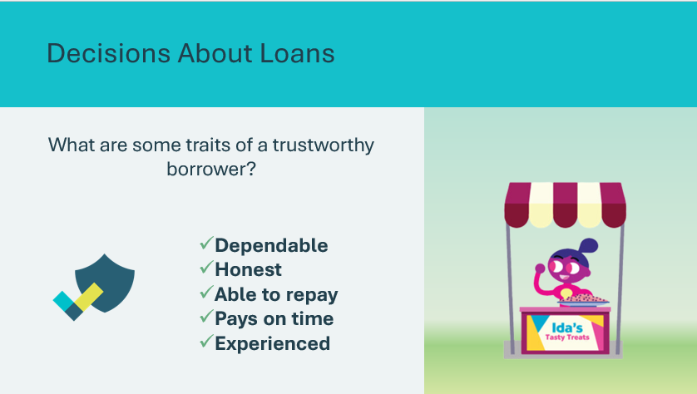 | Suggested time: 2 minutes  Ask the prompt and invite students to share their ideas on what makes a good borrower.  *Click or tap to display the traits
Slide 91  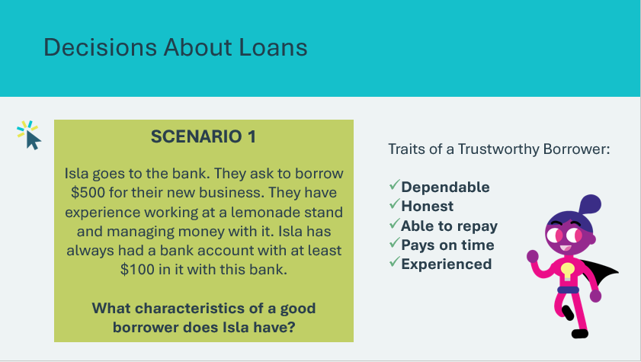 | Suggested time: 5 minutes  Tell students they will look at scenarios of different borrowers and identify the characteristics that would make the borrower trustworthy.  *Click or tap to display each of the 4 scenarios  Ask one or two students to share their answers and reason for their decisions. Discuss their answers.  Explain that banks make decisions like these every day. Banks must decide if people who ask to borrow money seem trustworthy and will repay the loans.
Slide 92  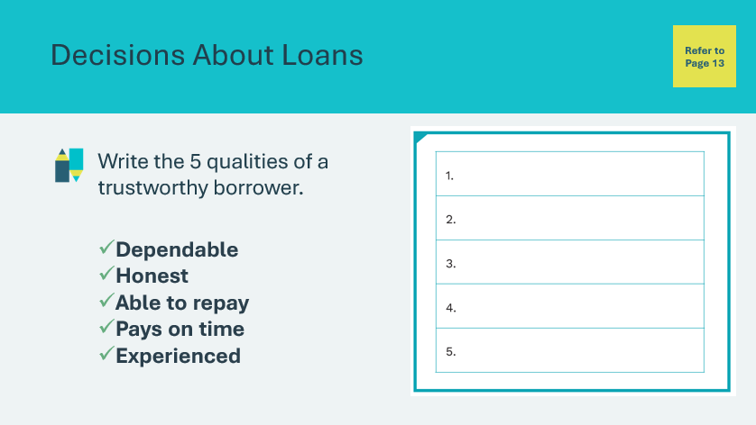 | Suggested time: 5 minutes  Wrap up the activity by having students write the 5 qualities of a trustworthy borrower in their student portfolio, page 13.
Program Kit Materials | For slide 93, you can also use the vocabulary cards from the program kit (optional).
Slide 93  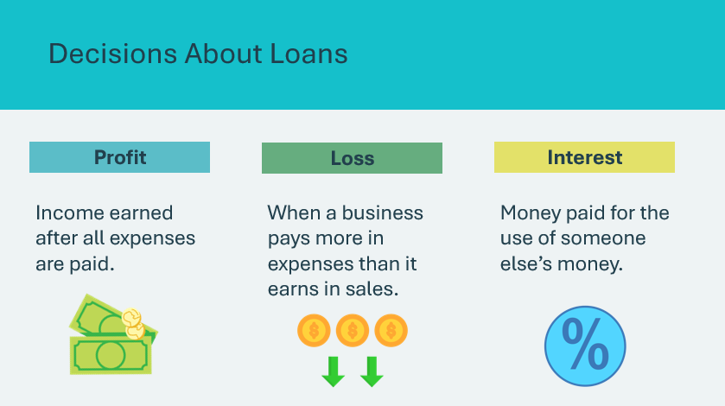  Vocabulary Cards  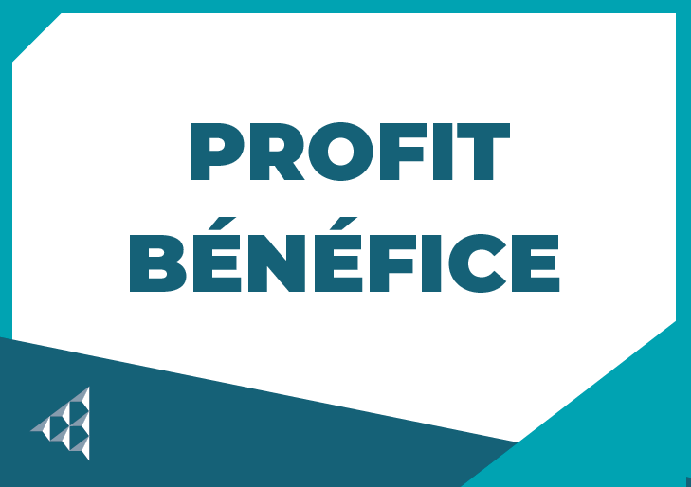  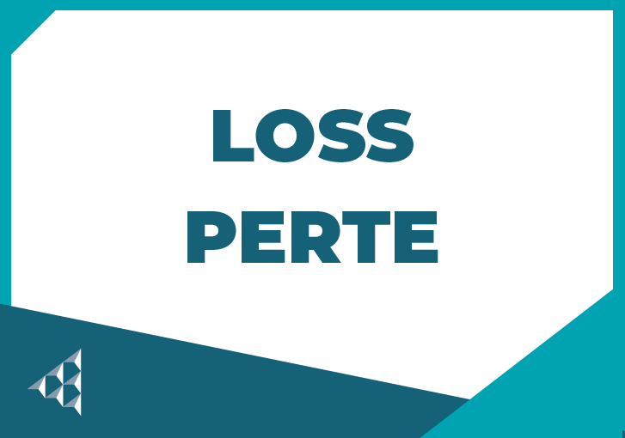   | Suggested time: 2 minutes  Explain that business owners get the money to pay back a loan from the money they make running the business, their profits. Define the term profits.  Explain that sometimes a business spends more than it makes. Define the term loss. Explain that if a business is experiencing a loss, it will be harder to pay back the loan, but the loan must still be paid back.  Have students recall the term interest. Explain that loans must be paid back with interest. This means the original amount borrowed must be paid back, plus interest, which is a fee for using someone else’s money. For example, if you borrow $100, but you owe 10% interest on the loan, you will have to pay back $110. That’s the original $100 loan, plus $10, which is the 10% interest.  Facilitator tip: The concept of interest is not common to all cultures. In fact, some cultures do not allow interest to be calculated. If the concept of interest is not appropriate for the students, adjust the content accordingly.
Business Board Game – Side 2 20 min
Program Kit Materials | For slides 94-95, you will need to use the Business Board Game, Run a Business Game Cards, playing pieces and dice from the program kit.
Slide 94  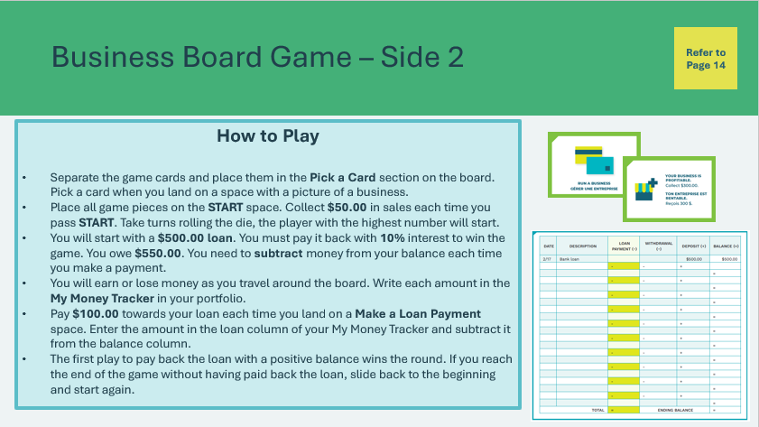  Business Board Game  Run a Business Game Cards   | Suggested time: 5 minutes  Students will play the business game board game, side 2.  Explain that the objective of the game is to earn the most money for a new business and pay back a loan. They will keep track of money they earn and make payments on a business loan using the My Money Tracker in their student portfolio, page 14. Explain that the My Money Tracker has an additional column for a business loan. In this game, they will need to keep track of a loan.  Review how to play before handing out the game materials. Once students understand how to play, break them into groups of four and distribute a Business Game Board, Run a Business Game Cards, a die, and game pieces.  Facilitator tip: You may wish to demonstrate how to use the My Money Tracker, or circulate the room while students play to provide support as needed.
Slide 95  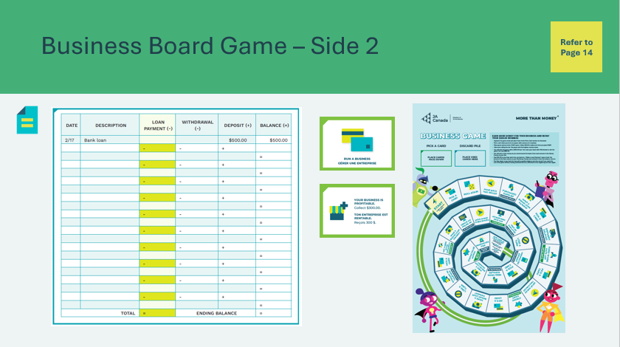 | Suggested time: 15 minutes  Provide students with time to play.  Facilitator tip: Circulate the room while students play to answer questions and provide support as needed.  When time is up, ask a few students to share what they learned from playing the game and congratulate any winners. Have students clean up the game materials.  Review by telling students that running a business means making lots of decisions.  Wrap up the activity with the following discussion question:  - What roles do financial institutions and other lenders play in helping businesses to run?  - They provide business loans and help business owners manage their money
Summary and Review 5 min
Slide 96  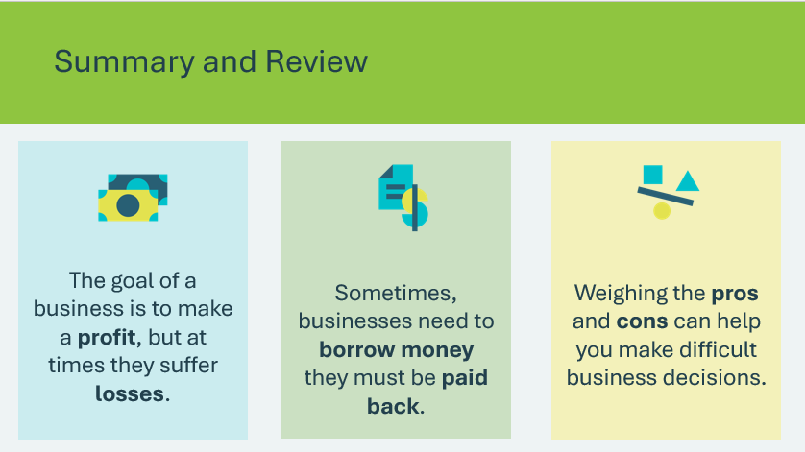 | Suggested time: 5 minutes  Repeat that the goal of a business is to make a profit, but at times businesses suffer losses.  Remind students that at times businesses need to borrow money that must be paid back and that financial institutions are there to help.  Emphasize that making business decisions can be difficult, but it’s often helpful to first weigh the pros and cons of an issue.
Extended Learning
Slide 97  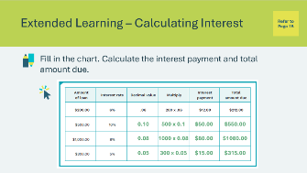 | Suggested time: Optional – consider this activity if your lesson ends early and you have extra time.  Explain that to calculate the interest owed, you must multiply the interest rate by the amount of money borrowed. Ask students to open to the Calculating interest activity in their student portfolio, page 15.  Review with them how the first problem was solved, converting a percent to a decimal, then calculating the interest. Explain that if you borrow $200.00 and the interest rate is 6 percent, you must multiply 200 by .06 to determine how much interest you owe. Allow students to complete the three remaining problems on the chart.  Facilitator tip: You may need to explain how to convert a percentage to a decimal. Explain that a percentage is a part of 100 percent. Thus, 10 percent is .10. Tell students that they need to move the decimal point.  Review the answers as a class.  *Click or tap to display the answers for each box in the table.

Lesson 5: Global Success
Program Kit Materials | Vocabulary Flash Cards (v-y) Import/Export Trading Cards  
Slide 98 – Lesson 5   | Lesson 5: Global Success
Slide 99 – Objectives  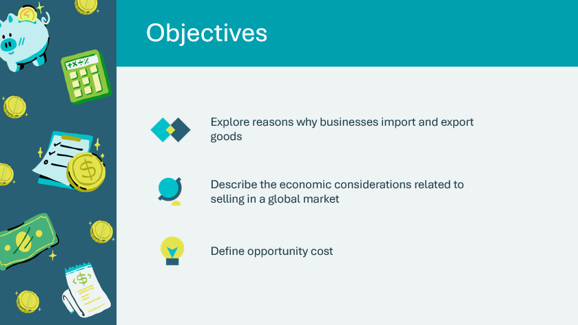 | Optional – review the learning objectives for the lesson
Slide 100 – Introduction  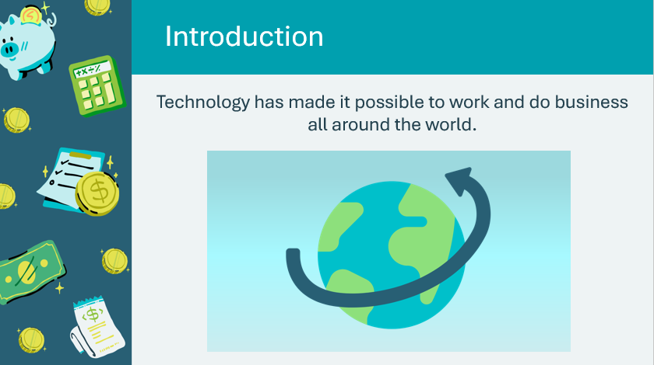 | Introduce the lesson by explaining that advances in technology have made it easier to connect with others around the world. Global connections affect daily life for people everywhere.  Tell students they will start to think globally and explore how their entrepreneurial businesses might fare in places around the world.
Slide 101 – Activity Menu  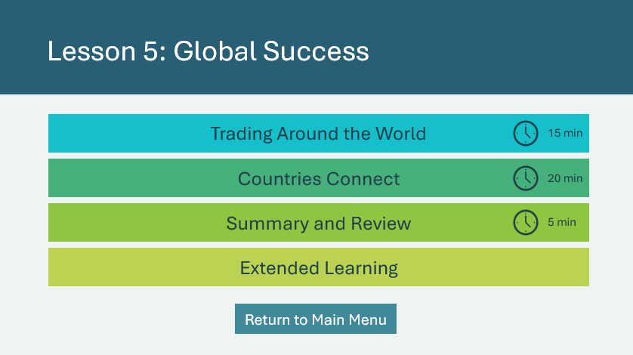 | *Select the button to navigate to the activity.  After you have completed an activity, you will be redirected back to the activity menu.  *Click or tap the Return to Main Menu button to return to the Lessons (Slide 5)
Trading Around the World 15 min
Slide 102  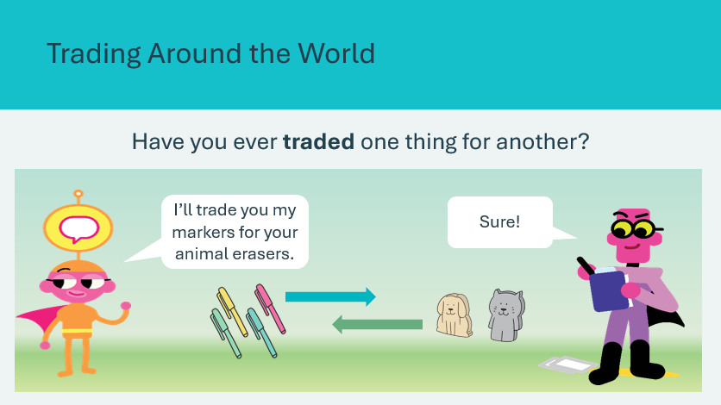 | Suggested time: 2 minutes  Encourage students to think about things they may have traded with a friend or family member. Invite a few students to share their responses. As a follow-up question, ask if the trade they’ve described was fair. Encourage them to share their thinking.  Explain that the practice of exchanging one thing for another is called barter and has been around for a long time.  Today, barter is not used as much; most goods and services are bought using money. However, barter or any other form of buying, selling, or exchanging goods and services is called trade.
Program Kit Materials | For slide 103, you can also use the vocabulary cards from the program kit (optional).
Slide 103  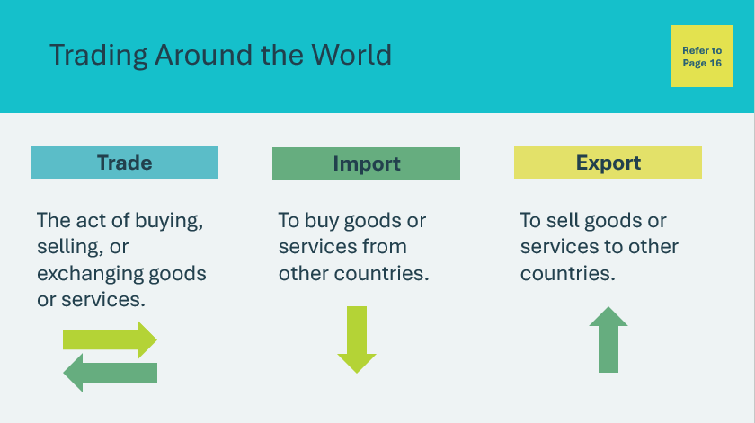  Vocabulary Cards    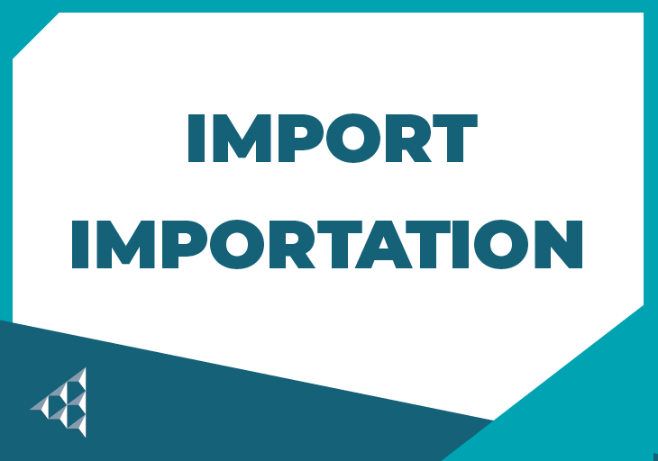   | Suggested time: 3 minutes  Define the term trade and ask students to find and circle it in the vocabulary section of their student portfolio, page 16. Tell students that countries often trade their “extras” for what they don’t have enough of. In this way, both countries are better off.  Ask: If a country has extra grain but not enough fuel to heat people’s homes or power their cars and trucks, what might the country do?  Possible answer: The country with the extra grain should try to trade the grain with a country that has extra fuel.  Explain that the country with the extra grain needs to find a country with extra fuel and trade with that country. Define the terms import and export. Explain that this example shows how a country with extra grain and a country with extra fuel can both benefit from trading. Both countries import something, and both export something. Students can find and circle the terms in their student portfolio as they are discussed.  Facilitator tip: You may wish to further the discussion by sharing that generally, countries export more to big economies than they do to smaller ones. Countries also tend to trade more with their neighbours than with countries farther away.
Slide 104  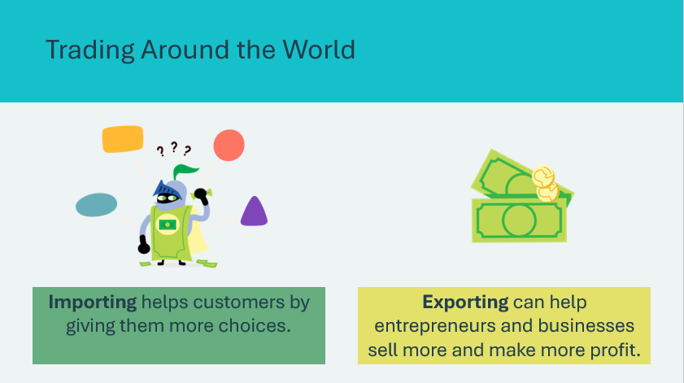 | Suggested time: 2 minutes  Emphasize that both large and small businesses import and export goods and services.  Tell students that to become a future competitor in a global market, business owners need to be creative, have strong skills and expertise, and be willing to take risks.  Have students consider whether they would like to see their business “do business” with other countries around the world. If so, what challenges might they face?
Slide 105   | Suggested time: 2 minutes  Explain that deciding whether to sell outside of their country is a big decision for many businesses to make. Play The Global Marketplace video.
Slide 106  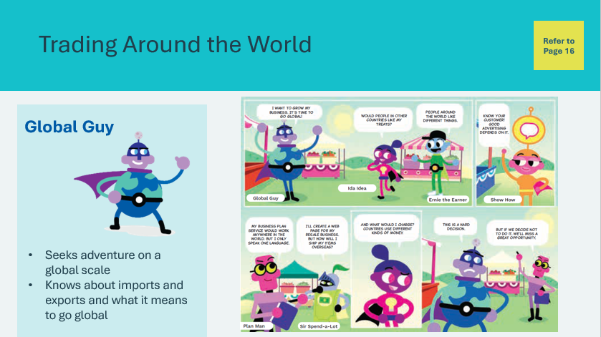 | Suggested time: 3 minutes  Introduce Global Guy and read the comic found in the student portfolio, page 16. Ask a few students to read each character’s part or read it aloud to the class.  As you read the comic, ask students to consider some of the things they might need to think about in a global marketplace. After reading the comic, invite students to share their ideas.  Possible answers:  - Will people in other countries want or need the product or service?  - If they have access to a similar product or service in their own country, will it be successful?  - Does the product or service offer something different or better than what’s already available?
Slide 107   | Suggested time: 3 minutes  Play the next part of the video, The Global Marketplace – Should You Go Global?  After the video, ask students to think about Ida Idea’s business. Do they have the right product to sell in the global marketplace? Why or why not? Invite students to share their thinking.
Countries Connect 20 min
Program Kit Materials | For slides 108-112, you will need to use the Import/Export Trading Cards from the program kit.
Slide 108  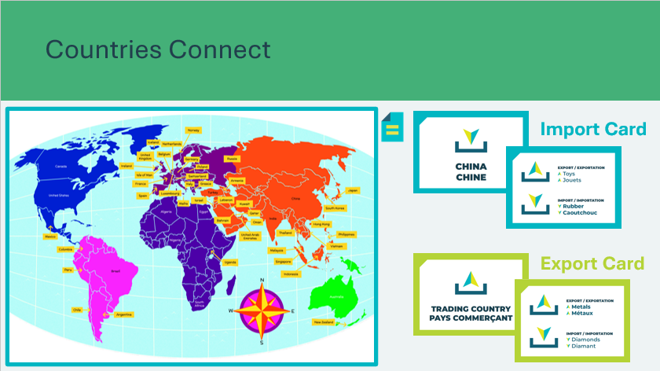  Import/Export Trading Cards   | Suggested time: 5 minutes  Tell students that countries connect through trade. Ask them to open the world map in their student portfolio, pages 18-19.  Explain that they will use their maps to locate specific countries with which they might like to trade.  Prepare the Import/Export Trading Cards so all matches can be made.  Hand each student one Export card and one Import card. Hand out extra cards to students who want them. Have students read the information on the cards.
Slide 109  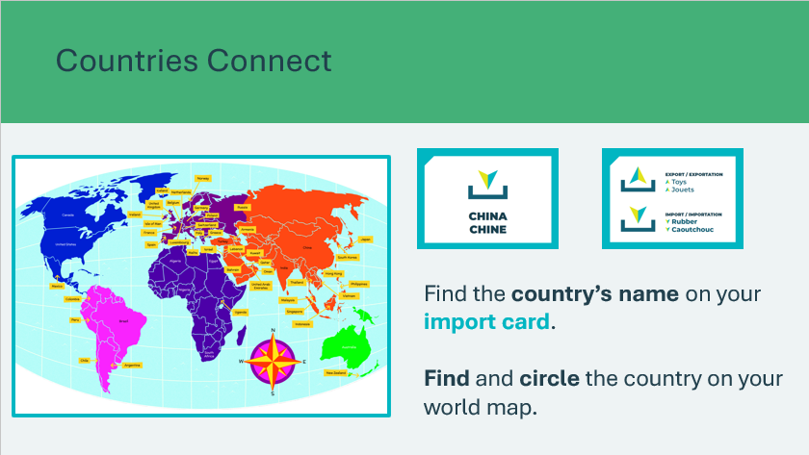  Import/Export Trading Cards | Suggested time: 3 minutes  Direct students to find the country’s name on their Import card. Each Import card has a different country printed on it.  Instruct students to find and then circle the country on the map in their portfolios. Encourage students to help each other if anyone is having difficulty finding his or her country.  Facilitator tip: Depending on your group of students, consider having them locate additional trading countries on the map in their portfolios. Use the World Map on the slide to point out countries that are important to your country or region, and have students locate and circle those countries in their portfolios.  You may also wish to explain free trade. Some countries band together and agree not to charge entrepreneurs fees and taxes to sell their goods to customers in partner countries. Some countries have stores specializing in free trade products. Many free trade products are available online too.
Slide 110  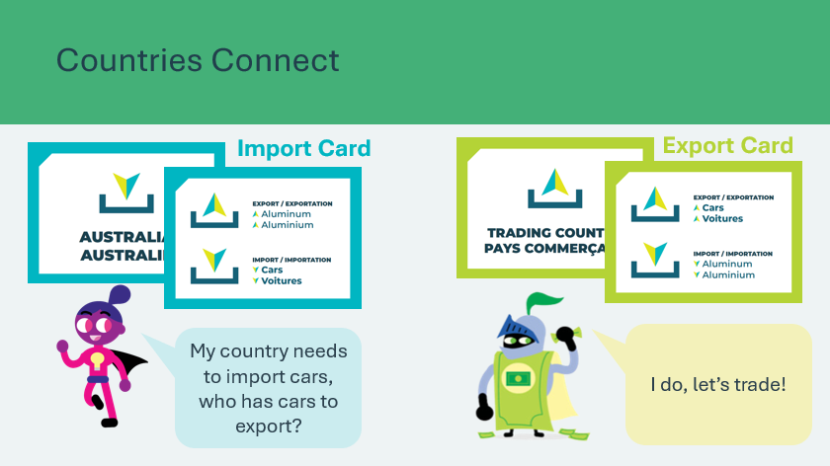  Import/Export Trading Cards | Suggested time: 2 minutes  Tell students that they will now get the chance to trade their cards for resources their country needs and give away resources their country has a lot of. Have students study their cards.  Explain that the yellow-green card is your Export card. It shows what you have. The blue card is your Import card. It shows what you need. A classmate has a resource you need, and you have a resource he or she needs. You must find each other and trade your cards.  Review the example starting with an import card as a class.
Slide 111  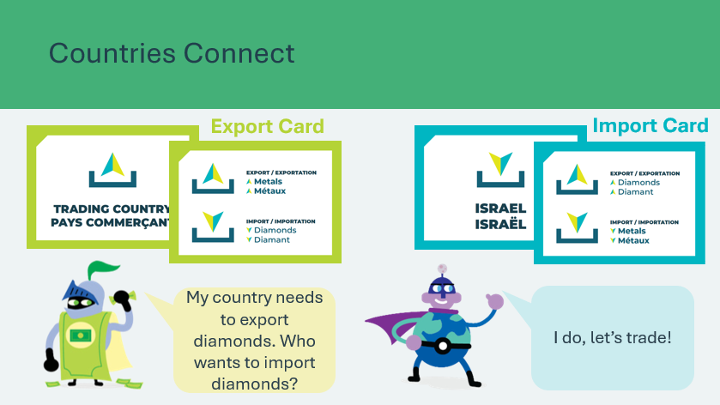 | Suggested time: 2 minutes  Review the example starting with the export card.
Slide 112  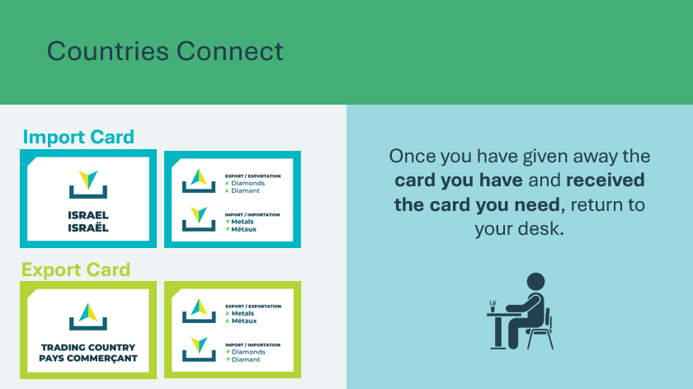  Import/Export Trading Cards | Suggested time: 8 minutes  Once students understand how to trade the cards, explain that when you give the signal, students will mix with their classmates to collect the blue import card they need (the resource is highlighted in bold on the card) while exporting a product that their country has a lot of (the resource is also in bold on the blue card).  Instruct students that once they have given away the card they have and received the card you need, they will return to their desk.  Give the signal. Students will move among their classmates to find their matches. At the end of trading, students will have given away their original cards for new ones.
Summary and Review 5 min
Slide 113  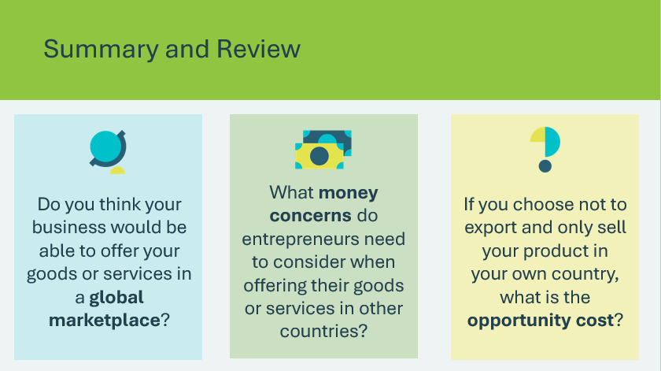 | Suggested time: 5 minutes  Review the learning from this lesson by asking the discussion prompts. Invite students to share their responses.
Extended Learning
Slide 114  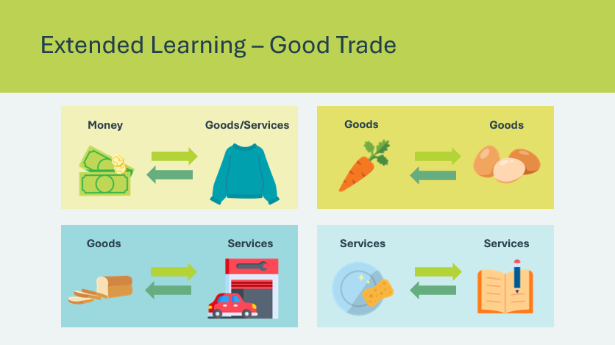 | Suggested time: Optional – consider this activity if your lesson ends early and you have extra time.  Explain that people around the world trade in many ways. Share with students that trade often includes exchanging money for goods or services, such as paying for a sweater or haircut with bills and coins. However, that is not the only way people trade for the things they need and want.  - People may trade goods for other goods. For example, a farmer may trade their livestock, vegetables, or honey for cheese and eggs.  - People may trade goods for services. For example, a baker may trade a week’s worth of fresh bread for a much-needed car or truck repair.  - Services also can be traded for other services, such as trading a week’s worth of washing dishes for a week’s worth of help with homework.  Have students share trading examples with the class.
Slide 115  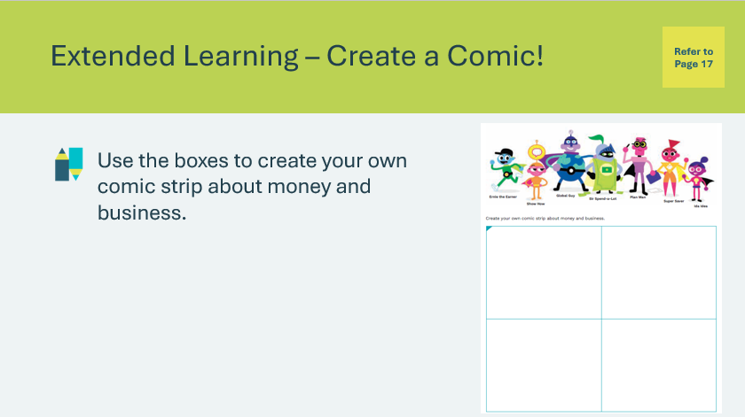 | Suggested time: Optional – consider this activity if your lesson ends early and you have extra time.  Students can design their own comic strip about money and business using what they’ve learned in the More Than Money program by drawing and writing in the boxes provided in their student portfolio, page 17.  Facilitator tip: You may wish to brainstorm as a class some ideas and concepts learned that students could use to create their comics.

Wrap Up
Program Kit Materials | Certificates of Accomplishment  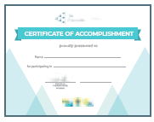
Slide 116 – Wrap Up   | Wrap Up
Program Kit Materials | For slide 117, you will need to use the Certificates of Accomplishment from the program kit.
Slide 117 – Congratulations!  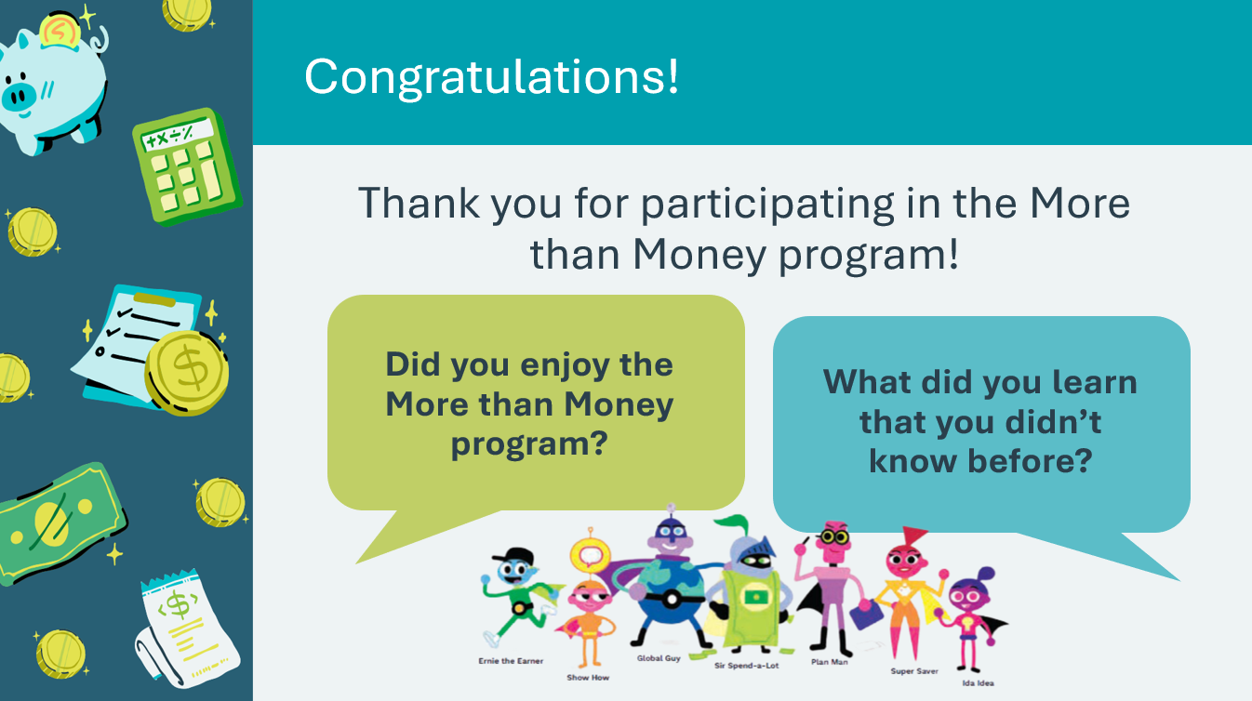  Certificates of Accomplishment | Suggested time: 5 minutes  Wrap up the program with the discussion prompts.  Additional wrap-up discussion prompts:  - Can you name 3 things you learned about money and creating businesses?  - What topic would you like to know more about?  - What resources in the classroom or library can help you discover more?  Direct the students to take their completed portfolio home to share with their family. Encourage students to share what they have learned with their family or caregivers.  Share what you have learned during your visit(s), if time permits. Ask a few students to share something they will remember about their JA experience.  Distribute the Certificates of Accomplishment. Congratulate students and shake their hands. Tell students that good money management is “key” to a successful business.
Slide 118   | Invite students to visit jacampus.org for additional information and learning.

Appendix A
Lesson 2 — Business Board Game
How to Play
- Separate the yellow Create a Business game cards and place them in the Pick a Card section on the board. You will pick a card when you land on a space with a picture of a business.
- Place all game pieces on the START space. The player with the closest birthday starts. Follow the arrow and move clockwise around the board.
- You will earn or lose money as you travel around the board. Write each amount in the My Money Tracker in your student portfolio.
- Be sure to add $50.00 to your tracker each time you pass START.
- Collect skills! Write the business skills you collect in your student portfolio.
- There will be two winners: the player who earns the most money and the player who collects the most skills.

