

25

JA Our Business World Presenter Notes
The Presenter Notes have been developed using references from the digital classroom presentation and should be used in combination with the printed Student Portfolio V2026.
Tips for Setting Up Your Classroom
- Arrive 15 minutes early and check in at the office.
- Connect with the teacher for the program materials and organize them as needed.
- Hand out student portfolios and name tags/cards.
- Set up presentation (check audio and internet connection are working).
- Write your name on the board.
- Ask the teacher to write student names on program certificates.
- Check in with the teacher about school schedule, tips for getting students' attention, any specific student needs & behaviours you should be aware of and ask for help with encouraging student participation, as well as monitoring and managing the class

Planning Guide
WRAP UP – CONGRATULATIONS! (Slide 86 – 89) 5 MIN
LESSON 3 (Slides 51 – 66) 75 MIN
WHY DO BUSINESSES CHANGE
Core Activities:
- Made in Canada (40 min)
- What’s their story? (20 min)
- Business Bingo (15 min)
Extended Activity (Optional):
- What did I learn? (5 min)

LESSON 4 (Slides 67 – 85) 55 MIN
COULD I BE AN ENTREPRENEUR
Core Activities:
- What is innovation? (20 min)
- What is a start-up? (20 min)
- Business Bingo (15 min)
Extended Activity (Optional):
- What did I learn? (5 min)

LESSON 2 (Slides 32 – 50) 60 MIN
HOW DO BUSINESSES BENEFIT COMMUNITIES
Core Activities:
- Positive impacts! (30 min)
- Business Benefit Bonanza (30 min)
Extended Activity (Optional):
- What did I learn? (5 min)
LESSON 1 (Slides 6 – 31) 75 MIN
WHAT IS A BUSINESS
Core Activities:
- What’s the business need? (15 min)
- Where do customers come from? (25 min)
- What is profit? (20 min)
Extended Activities (Optional):
- What did I learn? (5 min)
- What am I? (15 min)
GETTING STARTED – GETTING TO KNOW YOU (Slides 1 – 5) 5 MIN
Introduction
Slide 1 – Our Business World   | Navigation Tips  - Navigate through the slides using the next or previous buttons (bottom right), clicking or tapping on the slide, or using the navigation menu (left)  - Look for slide specific instructions in the presenter notes below
Slide 2 – Welcome to JA!   | Suggested time: 3 minutes  Ask: Has anyone heard of Junior Achievement before?  Play the video for students to introduce them to JA!
Slide 3 – Our Business World Program    Slide 4 – Symbol Legend  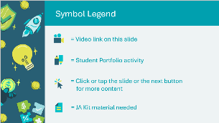 | Suggested time: 3-5 minutes  Introduce the program and yourself!  Tell the students a little about you; your education, and your career path until this point. Explain why you chose to volunteer in their classroom today.  The symbols will help guide the learning experience. Explain to students that they will see these symbols throughout the program.
Slide 5 – Main Menu  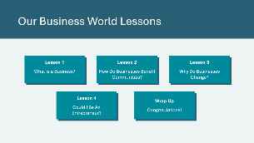 | *Select the button to navigate to the lesson.  After you have completed a lesson, you can select the Return to Main Menu button from the Lesson Activity Menu to return to this slide.

Lesson 1: What is a Business?
Program Kit Materials | Customer Strategies Scenario Cards  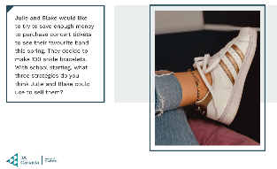  Employee or Self-Employed Business or Not a Business  Cards (extended activity) Cards (extended activity)  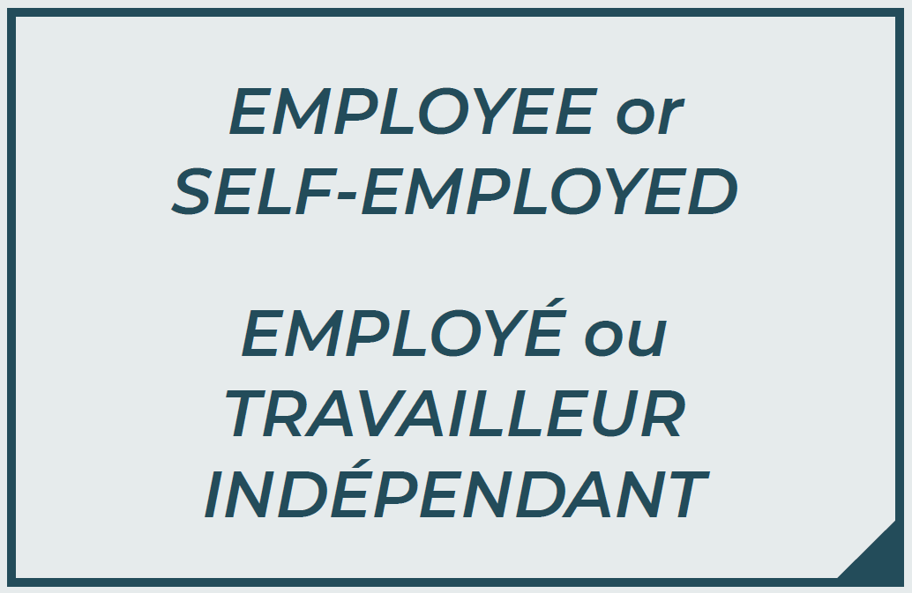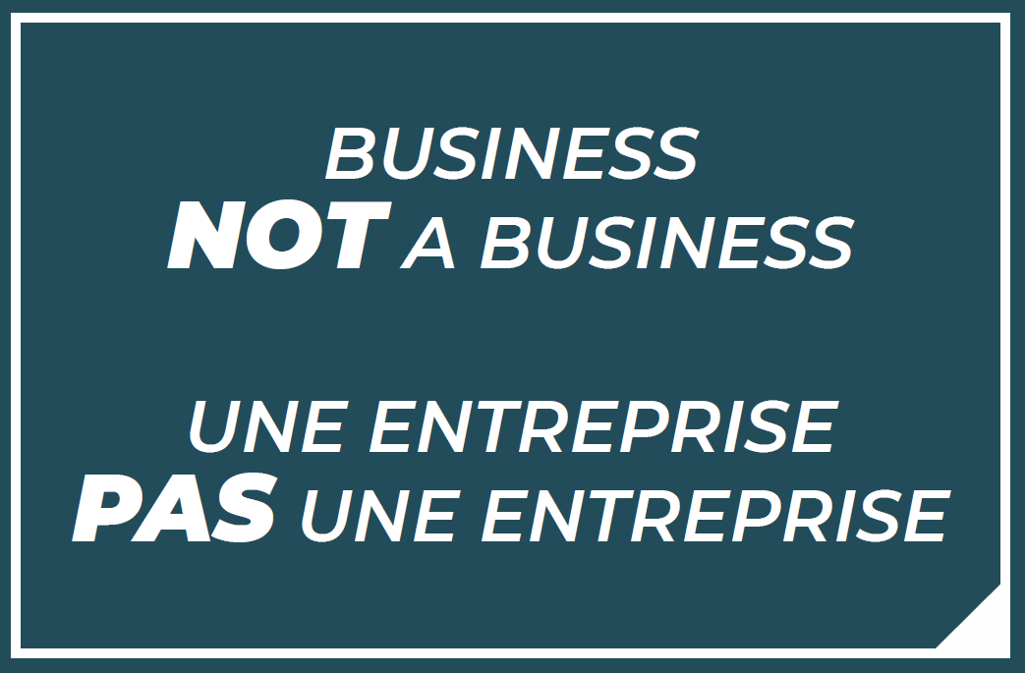
Slide 6 – Lesson 1   | Lesson 1: What is a Business?
Slide 7 – Objectives  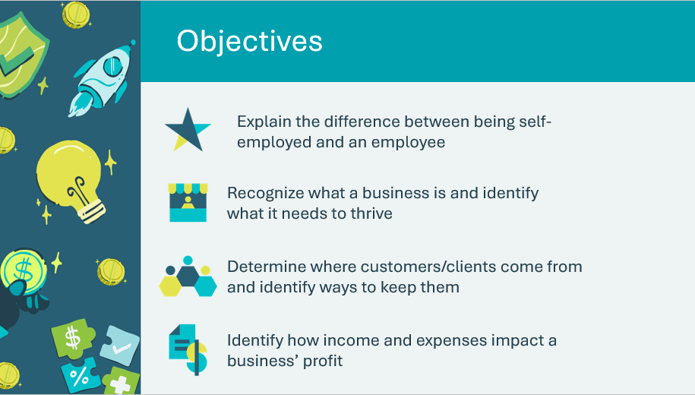 | Optional – review the learning objectives for the lesson
Slide 8 – Introduction  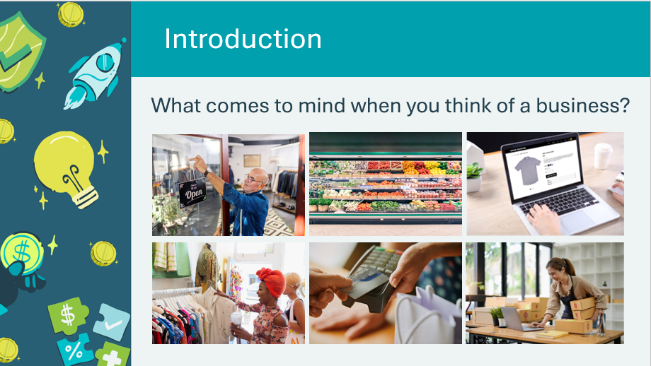 | Introduce the lesson by asking the prompt. Invite students to share ideas or understandings they have about businesses.  Explain to students that they will learn about what a business is and what a business needs in order to thrive or succeed.
Slide 9 – Lesson 1 Activity Menu  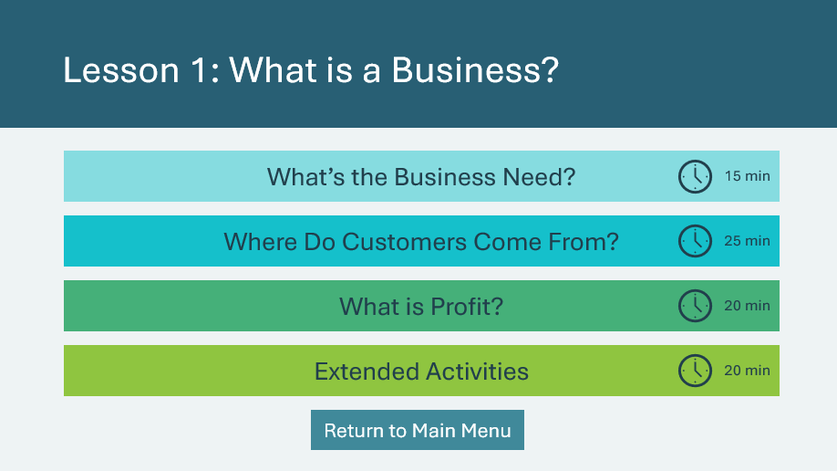 | *Select the button to navigate to the activity.  After you have completed an activity, you will be redirected back to the activity menu.  *Click or tap the Return to Main Menu button to return to the Lessons (Slide 5)
What’s the Business Need? 15 min
Slide 10   | Suggested time: 5 minutes  Explain to students that every business must serve a need.  *Click or tap to play the video.
Slide 11  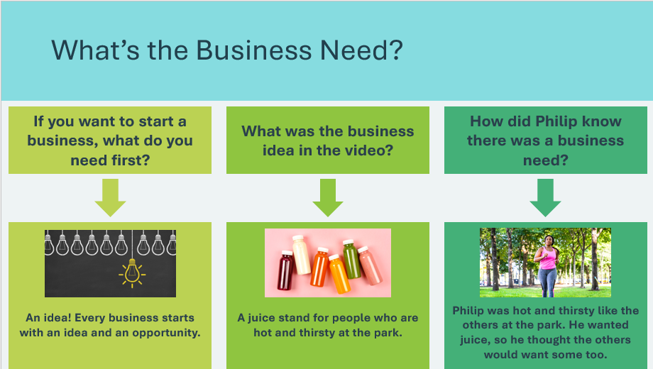 | Suggested time: 3 minutes  Ask students each of the discussion questions. Allow one or two students to answer each question.  *Click or tap to reveal each of the answers.  Explain to students that if you want to start a business based on your idea, you need to make sure you aren’t the only person who thinks your idea is a good one. You want to know that there is a need for the business.
Slide 12  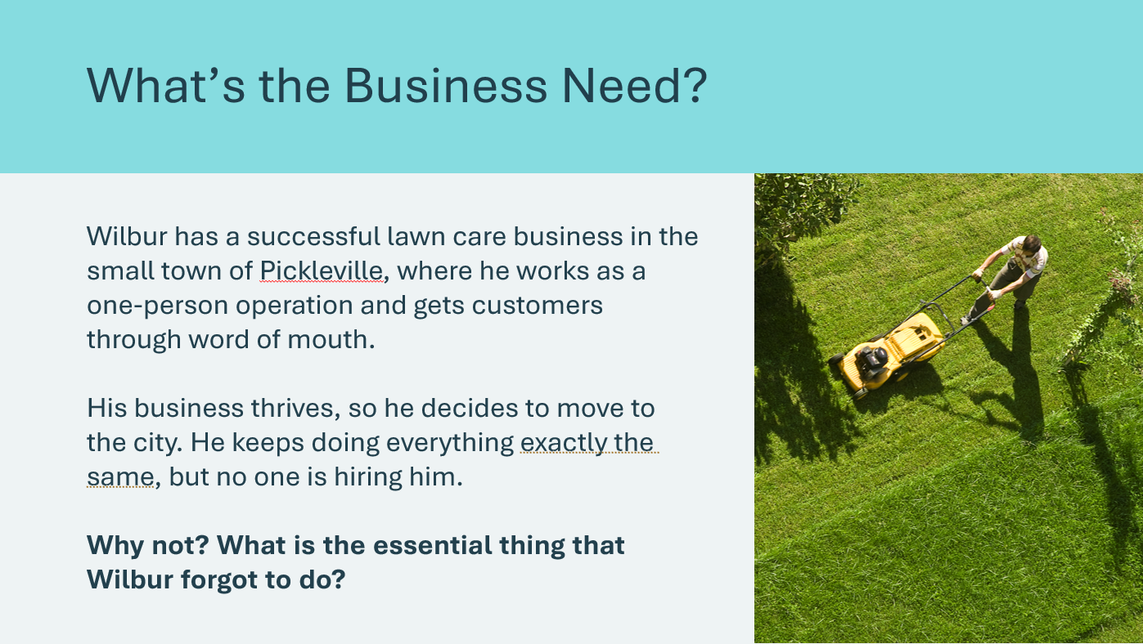 | Suggested time: 2 minutes  Review the scenario on the slide and invite students to share their thinking. Students should identify that:  - People in the city live in apartment buildings and don’t have lawns  - Wilbur forgot the essential condition for a business: that it must serve a need  - People living in apartments don’t need his service
Slide 13  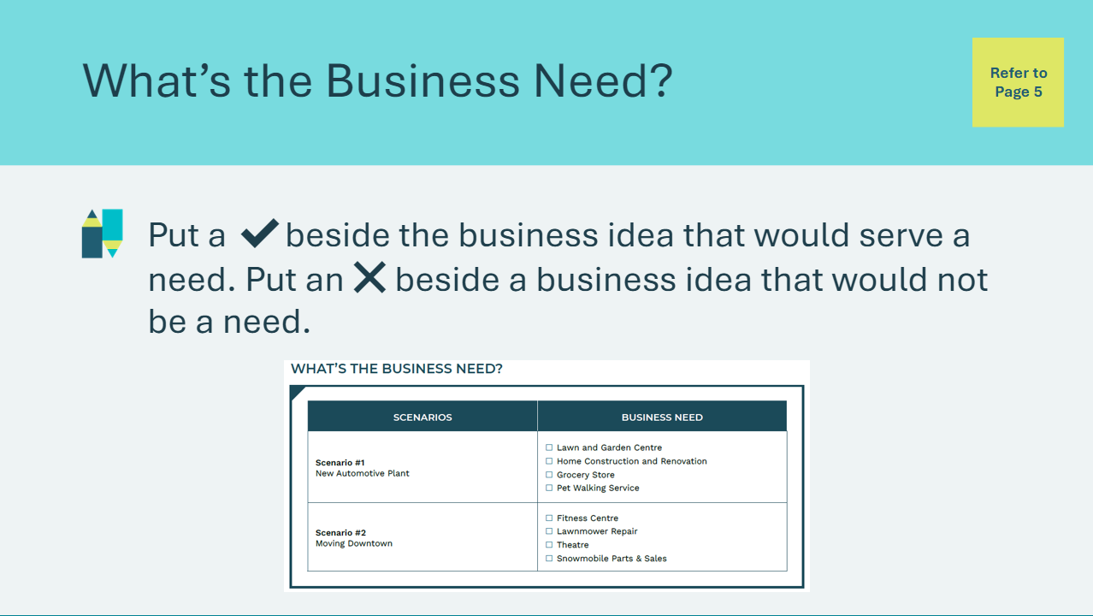 | Suggested time: 5 minutes  Students will complete the activity in their student portfolio, page 5.  Explain that you will read them a scenario, and they will decide which business would serve a need for the community and which would not. Students will place a check mark next to the idea that serves a need and an x next to one that does not.  Advance to the next slide for the scenarios.
Slide 14  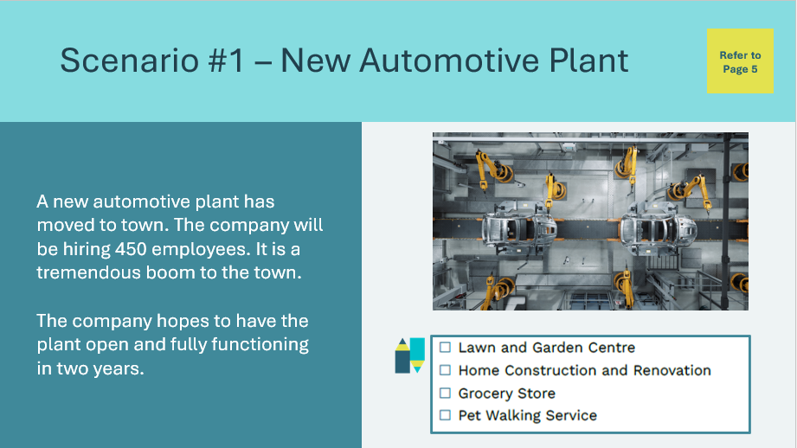 | Students will complete the activity in their student portfolio, page 5.  Read the scenario aloud to students and have them place a check mark next to the business idea that serves a business need and an x next to one that does not.  Allow a few students to share their responses. Accept all answers as long as students are able to explain how the business idea could be successful because it is needed by the community or how it might not be a success because it is not needed by the community.
Slide 15  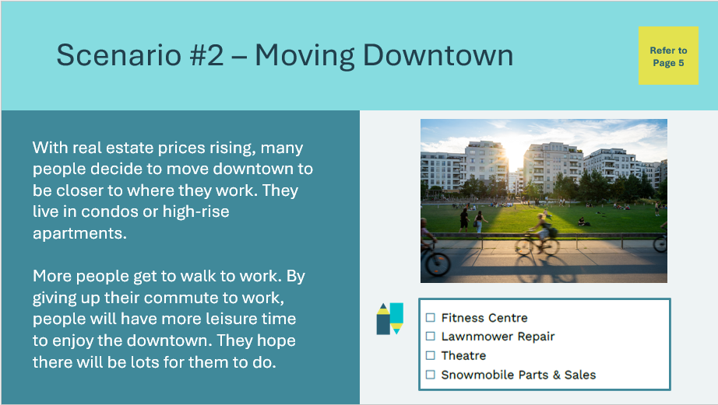 | Students will complete the activity in their student portfolio, page 5.  Read the scenario aloud to students and have them place a check mark next to the business idea that serves a business need and an x next to one that does not.  Allow a few students to share their responses. Accept all answers as long as students are able to explain how the business idea could be successful because it is needed by the community or how it might not be a success because it is not needed by the community.
Where do Customers Come From? 25 min
Slide 16  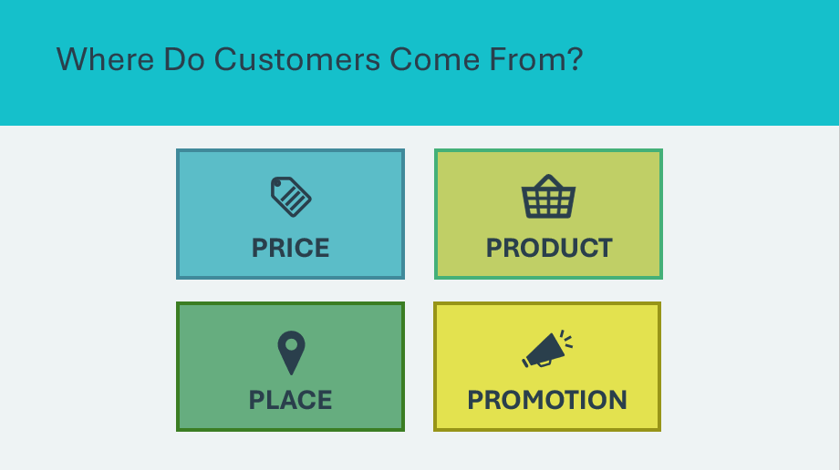 | Suggested time: 3 minutes  Introduce the activity by explaining that once you figure out if there is a need for your business, you then need to find customers.  Explore the concept of 4 P’s as a way to help find customers.  Ask the following discussion questions, allowing a student or two to respond to each question:  - How could price attract customers to a business? A low price might attract customers. But if the price is too low or too high, customers might not come.  - Example: Would everyone shop at the dollar store? Why or why not?  - How could product attract customers to a business? Businesses with products that are unique, hard to find or better quality might attract customers  - How could place attract customers to a business? A business with convenient hours, locations, or ways to purchase (online orders, home delivery, etc.) might attract customers  - Example: Game consoles, tablets and smartphones are designed so buying apps is very convenient  - How could promoting your business attract customers? If a business advertises, new customers might be more likely to hear about the business
Slide 17  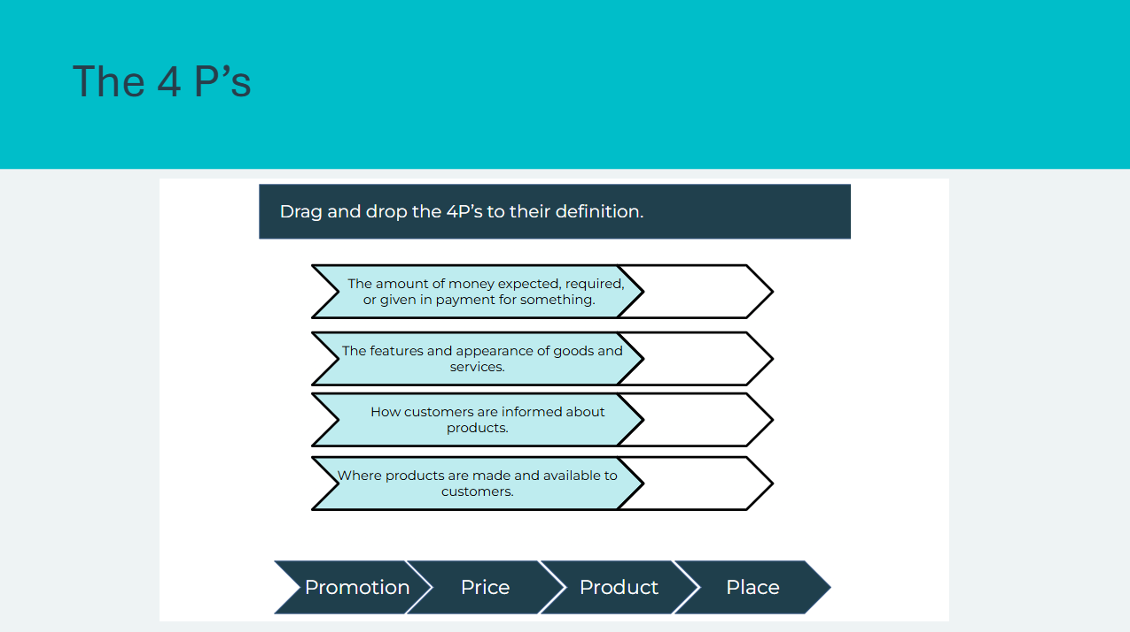 | Suggested time: 2 minutes  Complete the matching activity to review the definitions of each word.  *Drag and drop the word with its definition  Alternatively, you may simply read out the definition and ask students what term it describes.  Volunteer connection: Make connections between real life businesses that students may be aware of and how they use the 4 P’s to find customers.
Program Kit Materials | For slides 18-19, you will need to use the Customer Strategies Scenario Cards from the program kit.
Slide 18  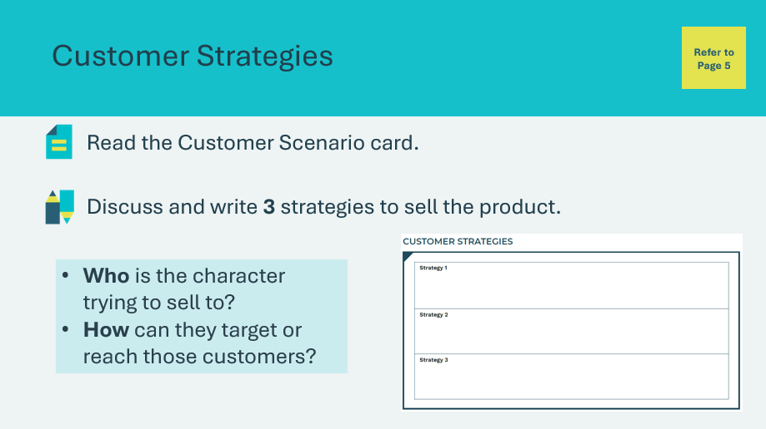  Customer Strategies Scenario Cards:  Slide 19  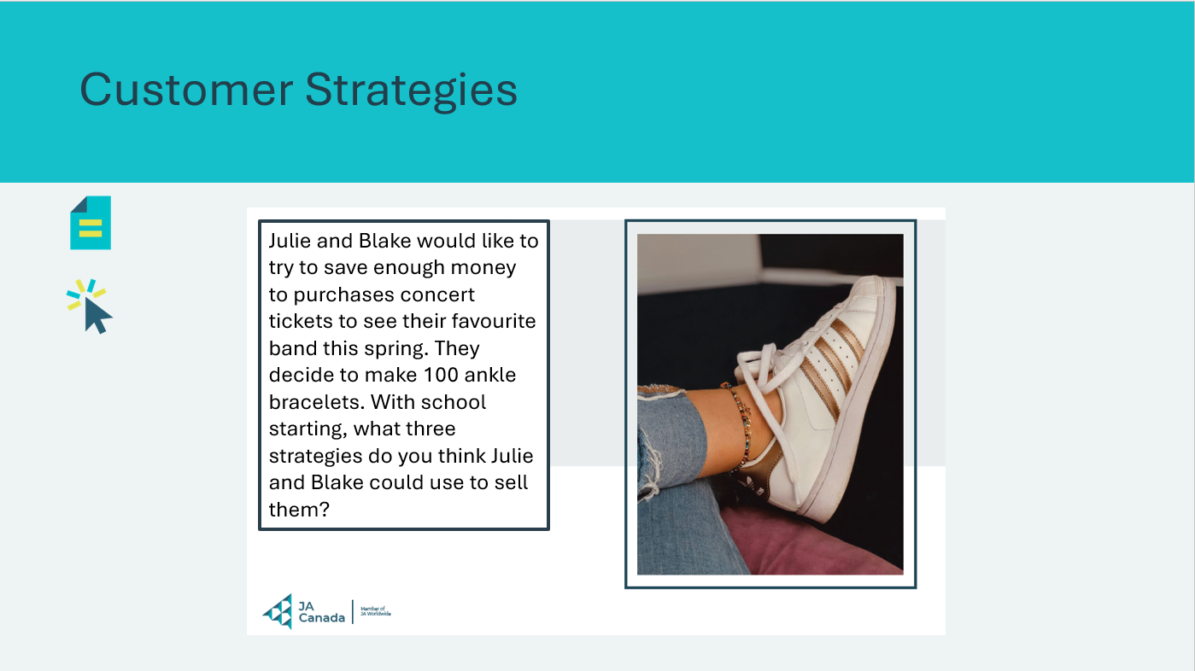  Customer Strategies Scenario Cards: | Suggested time: 15 minutes  Review the instructions as a class and complete the first scenario card on the next slide together as a group as an example.  Break students into groups and provide each with a Customer Scenario card, found in the kit materials. Students will complete the activity in their student portfolio, page 5, in their group.  Facilitator tip: As students work on their strategies, write the 4 P’s on the board, or display slide 16.  Facilitator tip: Some students will understand that TV commercials, billboards, websites or blogs are all potential advertising techniques. Other students may need a hint or two in order to begin. Circulate the class and provide support as needed.  Once the groups have finished, each group will present their scenario and 3 best strategies.  *Click or tap to display each of the scenario cards as students present (optional)
Slide 20  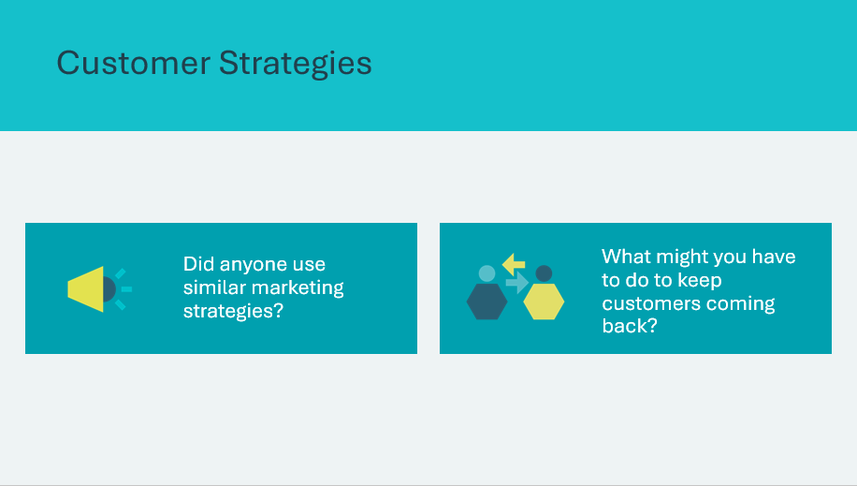 | Suggested time: 2 minutes  After all groups have presented, wrap up the activity with the discussion questions.  - Did anyone use similar marketing strategies?  - Have students reflect on the strategies shared by other groups and identify those that are alike, for example, social media.  - What might you have to do to keep customers coming back?  - Explain that marketing strategies are used to attract customers, but its important to keep them too. Providing a good service, having reliable products, fair pricing, being open on time, etc. are all ways to encourage returning customers.
Slide 21   | Suggested time: 3 minutes  Play the video. Afterwards, ask students to share what they think makes a good customer experience and why good customer service is important.
What is Profit? 20 min
Slide 22  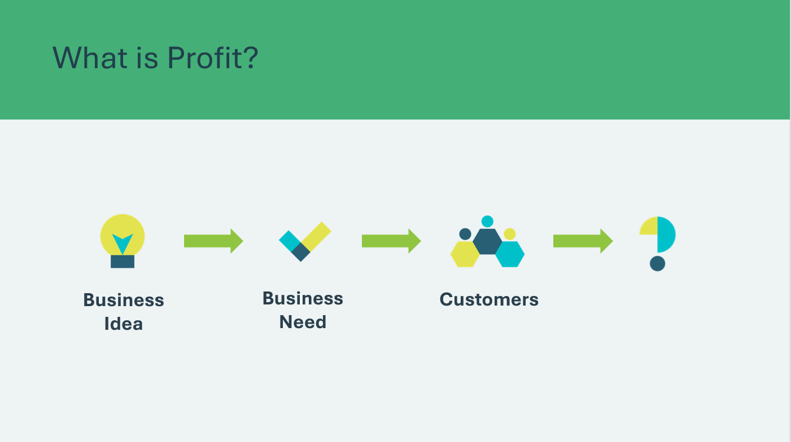 | Suggested time: 2 minutes  Introduce the activity by asking:  - We now know that once we have an idea for our business, there must be a need for the business, and we have to have customers. What do you think the next important condition is for a business to do well?  Allow students to make suggestions. Student(s) will likely say “make money”.  *Click or tap to reveal the answer
Slide 23  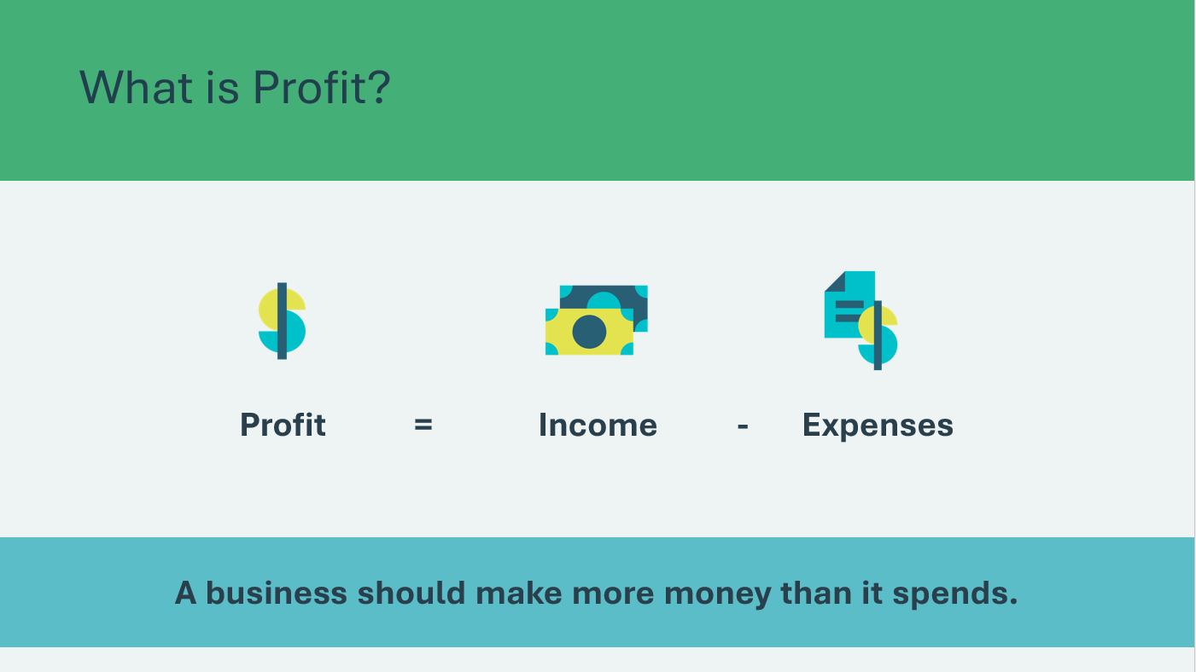 | Suggested time: 3 minutes  Explain that a business must consider its income (money earned) and its expenses (money spent) to determine its profit.  Highlight that for a business to be profitable, it needs to earn more money than it spends.  Facilitator tip: Using the formula, show an example on the board. Profit = Income – Expenses  Profit = $50 - $25  Profit = $25
Slide 24  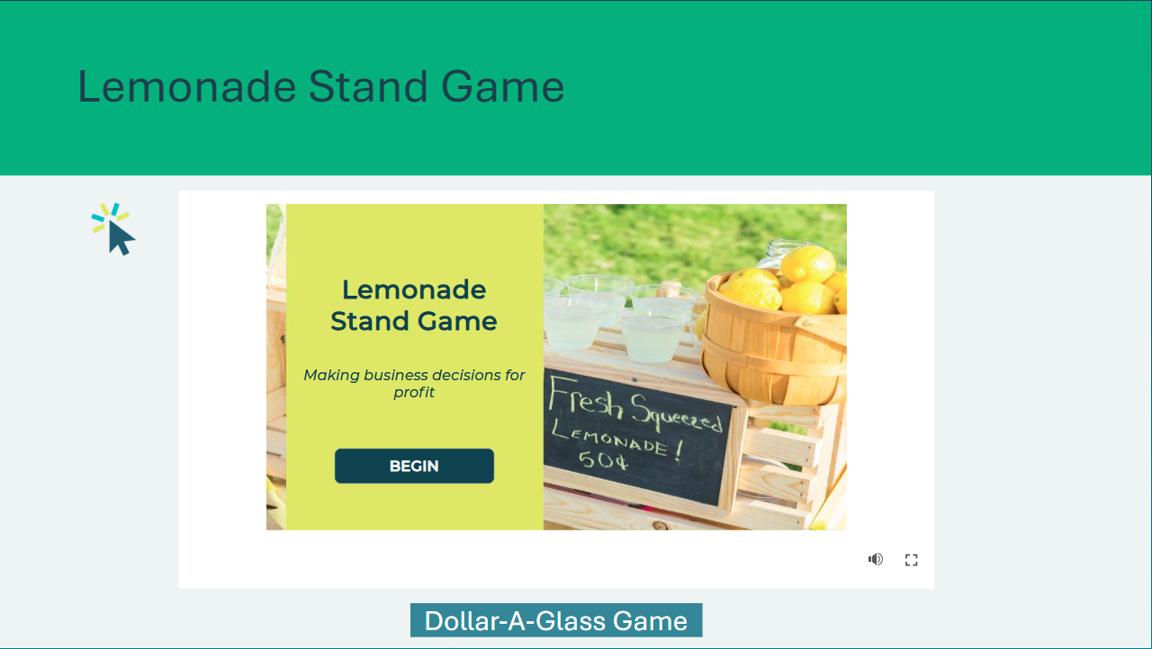 | Suggested time: 10 minutes  Tell students they will play the Lemonade Stand game or Dollar-A-Glass Game.  Lemonade Stand Game  *Click or tap the begin button to get started.  *Click or tap the audio icon to have slide content read aloud. You may also choose to read the slide content to the class yourself.  Invite students to raise their had to select a number from the grid, review the scenario and make a decision. Select a new student each time.  Dollar-A-Glass Game  *Click or tap the Dollar-A-Glass Game button at the bottom of the screen.  A web browser window will open. Begin the game and follow the instructions for play.  Invite students to come up to help run the stand. Read the prompts aloud to the group as they make decisions.  https://bizkids.com/games/dollar-a-glass
Slide 25  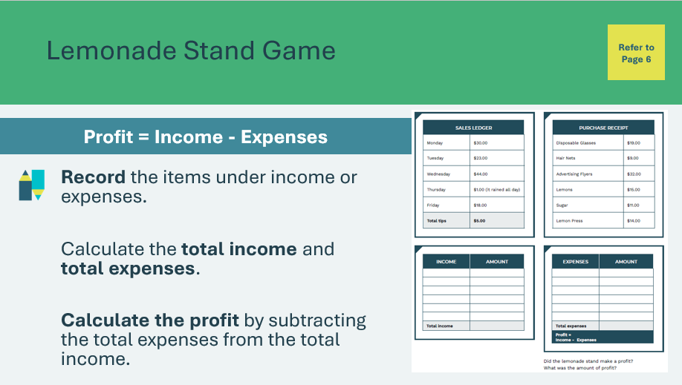 | Suggested time: 10 minutes  Following the game, explain that students will now imagine they are the owner of a Lemonade Stand. They will complete the activity in their student portfolio, page 6, by using the sample sales ledger and purchase receipt to determine if their lemonade stand made a profit.  - Calculate the total income by adding the items in the sales ledger together (Total = $121)  - Calculate the total expenses by adding the items in the purchase receipt together (Total = $100)  - Calculate the total profit by subtracting the total expenses from the total income (Total profit = $21)  If students have calculators available, they may use them. You may wish to have students do this activity as a class, in partners, or individually.  Wrap up the activity by asking:  - Did the lemonade stand make a profit?  - What was the amount of profit?
Slide 26  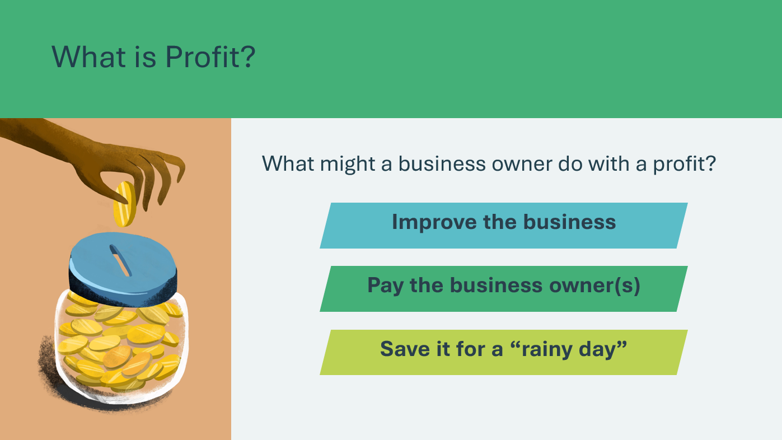 | Suggested time: 5 minutes  Ask what a business owner might do when their business earns a profit. Invite a few students to share their ideas.  *Click or tap to reveal answers  Emphasize that if a business doesn’t make a profit, then they aren’t likely to stay in business for very long.  Facilitator tip: Introduce the concept of a not-for-profit business (sometimes called a social profit business).  - Discuss with the class why these businesses exist and how they stay in business.  - Share personal experience you may have with a not-for-profit.  - Explain that when these businesses make a profit, it’s called a surplus and the money is usually used to further support the organization’s work.
Extended Activity – What Did I Learn? 5 min
Slide 27  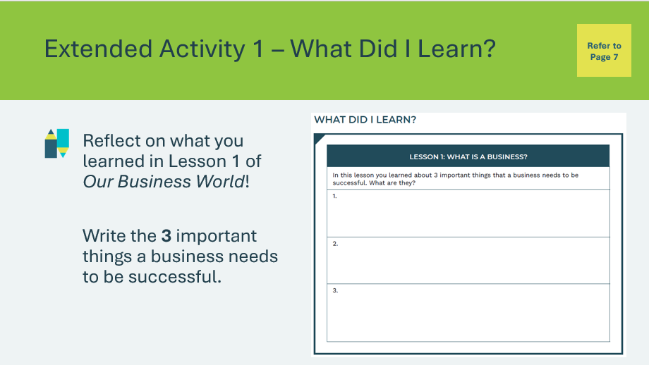 | Suggested time: 5 minutes  Students can complete the reflection in class if time allows, or independently later on.  Students will complete the reflection activity in their student portfolio, page 7. If completing the activity in class, you may wish to lead the class through a discussion to help them complete the exercise.  Three things a business needs to be successful:  - A business needs to start with an idea that meets a need.  - A business needs customers.  - A business needs to earn a profit.
Extended Activity – What Am I? 15 min
Program Kit Materials | For slide 28, you will need to use the Employee or Self-Employed Cards from the program kit.
Slide 28  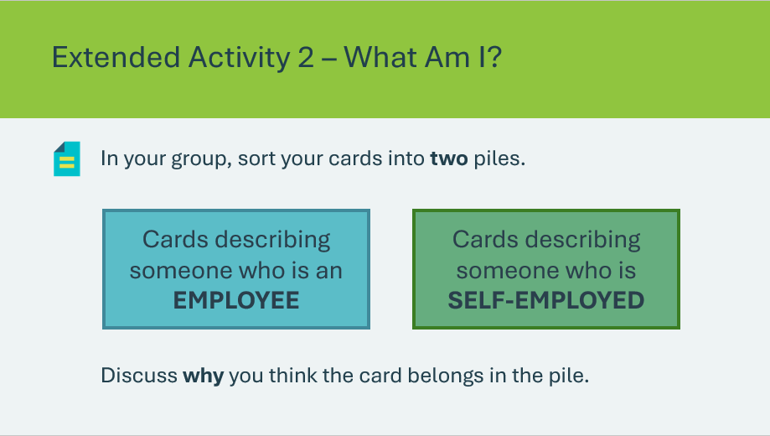  Employee or Self-Employed Cards | Suggested time: 5 minutes  Ask: Do you know anyone who is an employee? How do you know they are an employee?  Allow a few students to share responses. Explain that they will work with their group to sort out for themselves the difference between being an employee and being self-employed.  Break students into 6 groups and distribute one set of Employee/Self-Employed cards from the kit materials to each group. Students will work together in their groups to separate the cards into two piles.
Slide 29  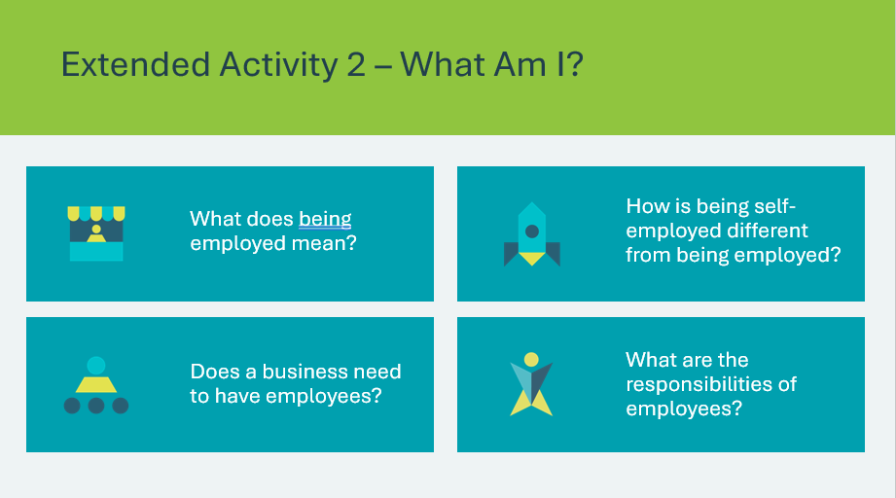 | Suggested time: 2-3 minutes  When most groups are finished, discuss the questions as a class. Encourage students to refer to the cards/piles throughout the discussion.  Sample answers:  - Being employed means working for someone else/another business  - Being self-employed means working for yourself/your own business  - No, a business doesn’t have to have employees  - Employees are responsible for helping the business be successful. The business owner is responsible for every aspect of the business, including the employees  Volunteer connection: Share information about your role as an employee, or if you are self-employed, expand on those responsibilities.
Program Kit Materials | For slide 30, you will need to use the Business or Not a Business Cards from the program kit.
Slide 30  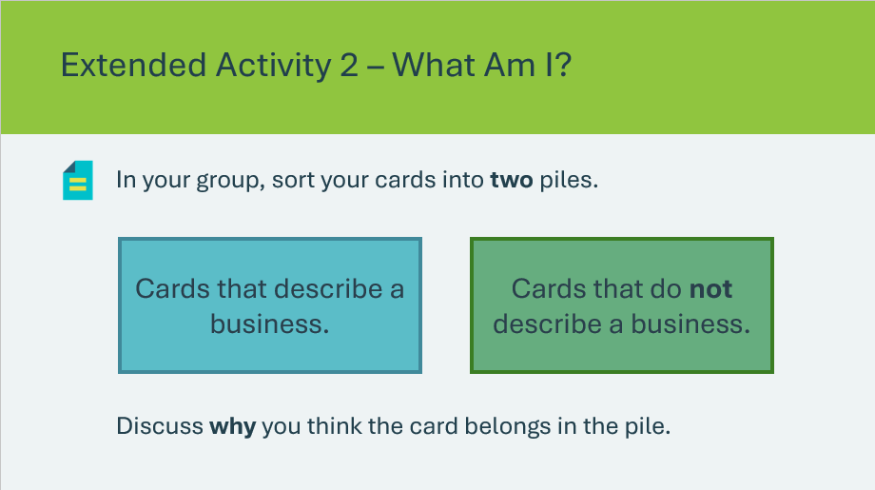  Business or not a Business Cards | Suggested time: 5 minutes  Tell students that now that they know what an employee is and what it means to be self-employed, we will explore what a business is.  Ask: What is a business? Allow a few students to share responses.  Break students into 6 groups and distribute one set of Business/Not a Business cards from the kit materials to each group. Students will work together in their groups to separate the cards into two piles. Some cards will be difficult to sort. The ambiguity is intentional and meant to encourage discussion.
Slide 31  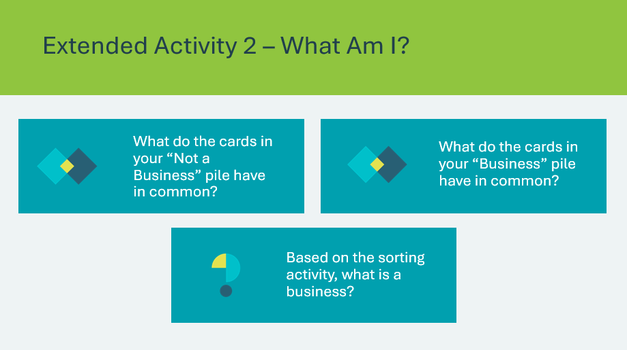 | Suggested time: 2-3 minutes  When most groups are finished, discuss the questions as a class. Encourage students to refer to the cards/piles throughout the discussion. The cards are numbered and can be singled out when discussing as a class.  The intention is not to formalize a definition of a business, but to provide students with an opportunity to share their ideas about what a business is and is not.

Lesson 2: How Do Businesses Benefit Communities?
Program Kit Materials | Business Benefit Bonanza game board, playing pieces and dice  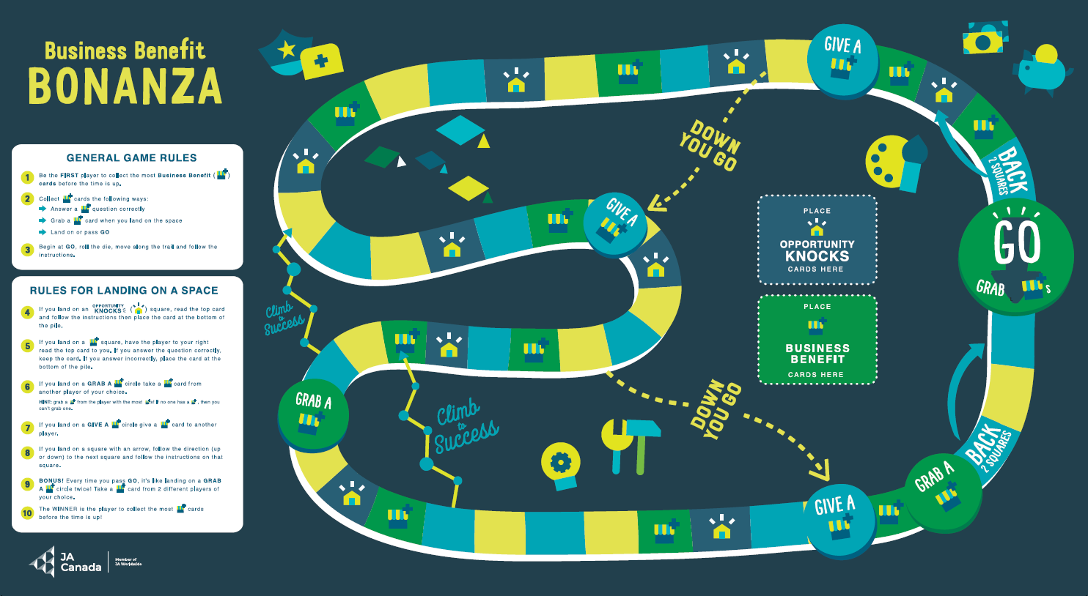  Opportunity Knocks Cards Business Benefit Cards  
Slide 32 – Lesson 2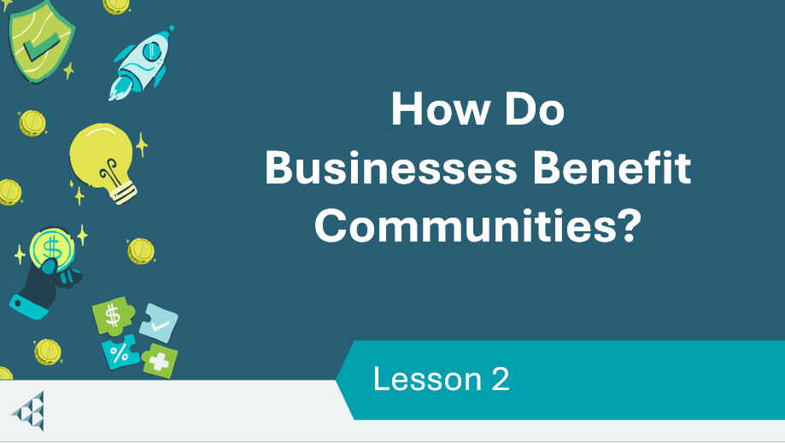 | Lesson 2: How Do Businesses Benefit Communities
Slide 33 – Objectives  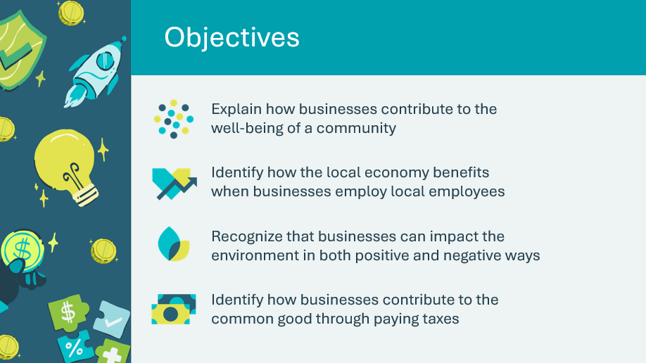 | Optional – review the learning objectives for the lesson
Slide 34 – Introduction  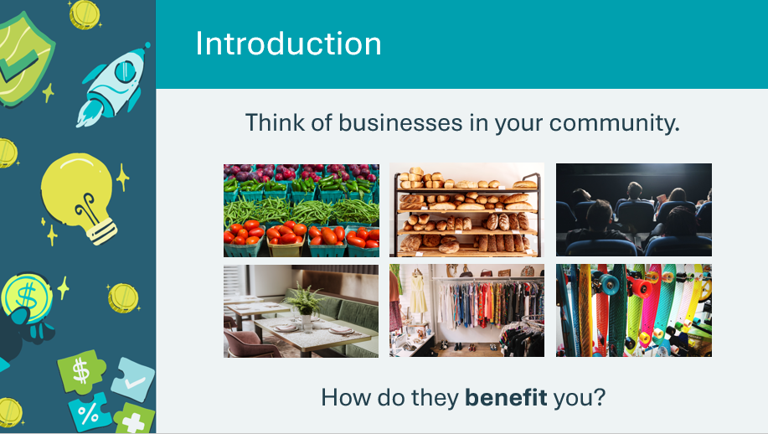 | Introduce the lesson by encouraging students to think of the businesses in their community.  - What products or services do they provide?  - How do those products or services benefit them or their community?
Slide 35 – Activity Menu  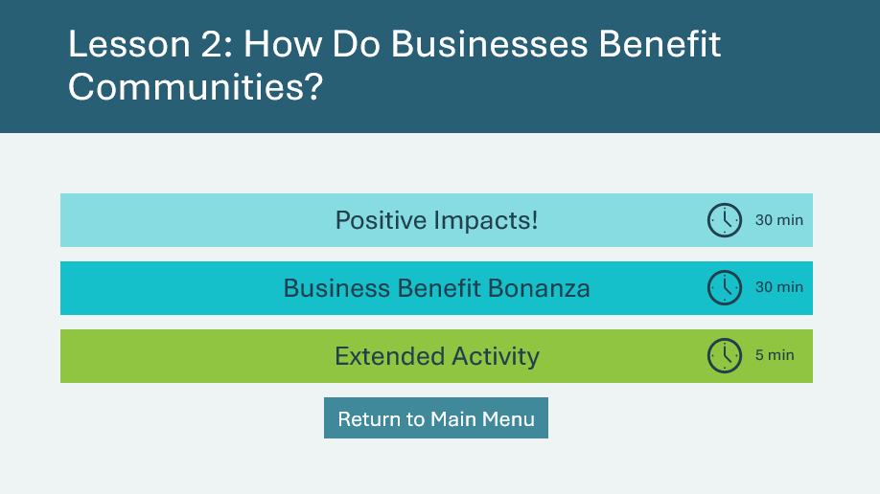 | *Select the button to navigate to the activity.  After you have completed an activity, you will be redirected back to the activity menu.  *Click or tap the Return to Main Menu button to return to the Lessons (Slide 5)
Positive Impacts 30 min
Slide 36  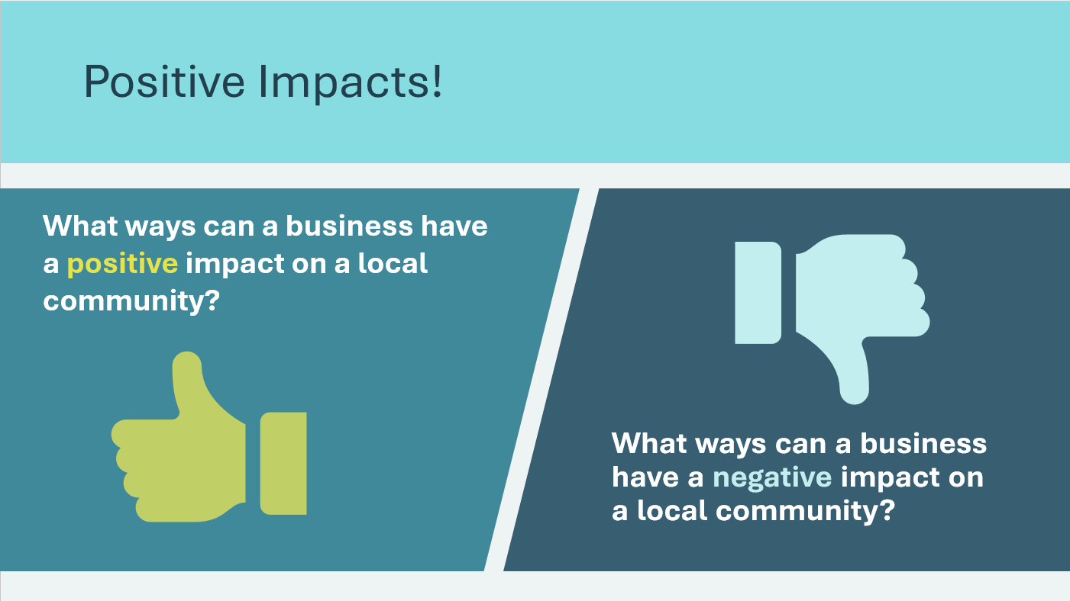 | Suggested time: 3 minutes  Remind students that in the first lesson, we learned about the importance of there being a need for the business, having customers, and making a profit. Explain that in this lesson, we will think about how a business can have a positive or negative impact on the community.  Ask the prompts on the slide and allow a few students to share their ideas and examples.  *Click or tap to reveal each prompt.
Slide 37  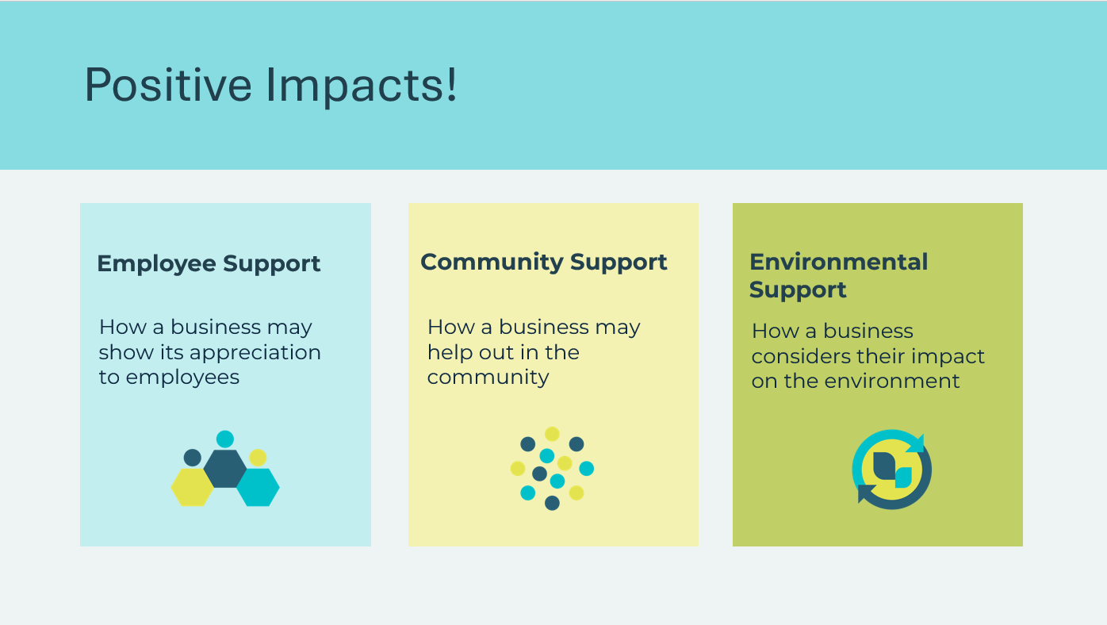 | Suggested time: 5 minutes  Explain that in this activity, students will look at 3 ways businesses can have a positive impact and provide support.  Review the types of support on the slide and provide an example of each.  - Employee support example – Health benefits  - Community support example – Tim Horton’s smile cookie sales are donated to charities and community groups  - Environmental support example – Roots clothing has a recycling program for old clothes
Slide 38  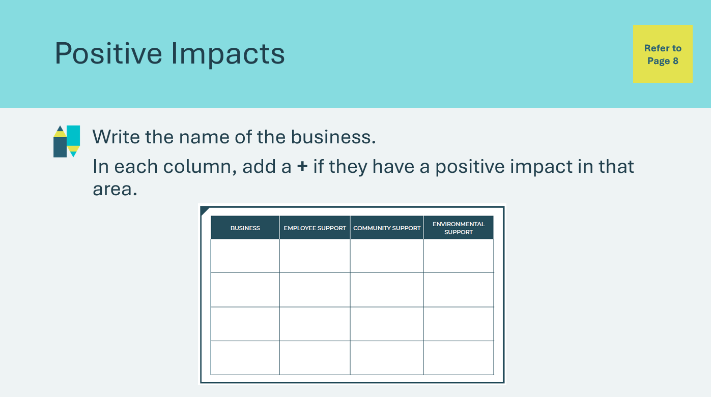 | Suggested time: 15 minutes (about 5 minutes per company)  Tell students they will complete an activity in their student portfolio, page 8.  They will learn about 4 different businesses in the next slides. As they learn about the businesses, they will fill in the chart with a +, indicating if a business had a positive impact in one of the areas. Students should be able to explain why they gave a business a +.
Slide 39   | Play the video to learn about Tim Hortons and provide students a few minutes to fill in a row of the chart in their student portfolio, page 8.  Answer Key:  + Community support
Slide 40   | Play the video to learn about Moment Energy and provide students a few minutes to fill in a row of the chart in their student portfolio, page 8.  Answer key:  + Environmental support
Slide 41   | Play the video to learn about Corus Entertainment and provide students a few minutes to fill in a row of the chart in their student portfolio, page 8.  Answer key:  +Environment support  +Employee support (slide)
Slide 42   | Play the video to learn about Earls Restaurants and provide students a few minutes to fill in a row of the chart in their student portfolio, page 8.  Answer key:  +Employee support
Slide 43  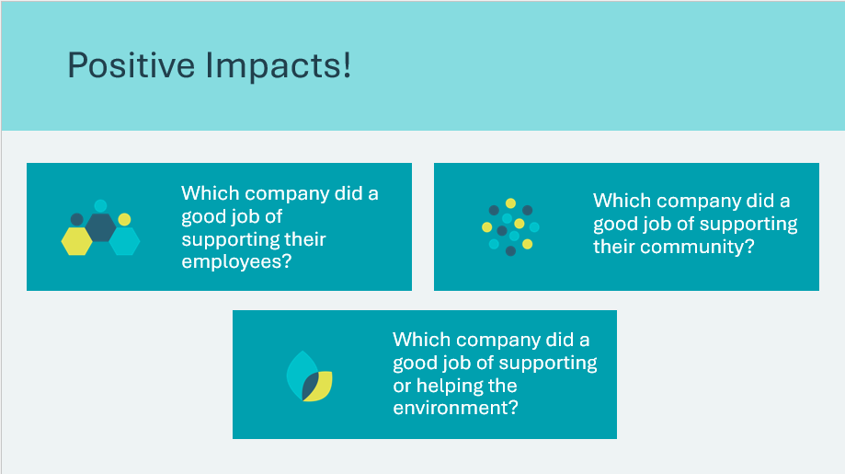 | Suggested time: 2 minutes  To wrap up the activity, use the discussion questions and allow a few students to share their responses.
Slide 44  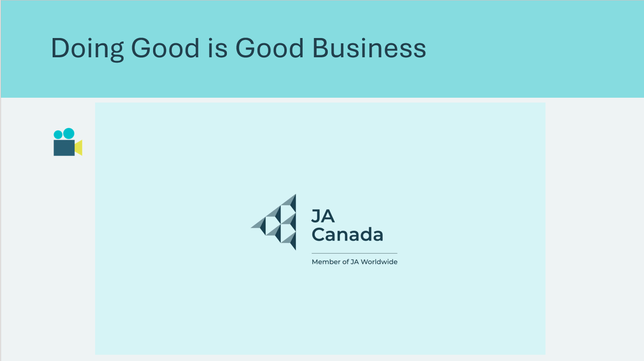 | Suggested time: 5 minutes  Play the video. Following the video, reinforce that all successful businesses come from good ideas and all businesses have the potential to do “good” in their communities.  Ask: How is Pat doing good through his business? What businesses do you know that give back or make a positive impact?  Remind students that it’s important to know that businesses can have a very positive effect on their communities, but in some cases, they can also have a very negative effect.
Business Benefit Bonanza 30 min
Slide 45  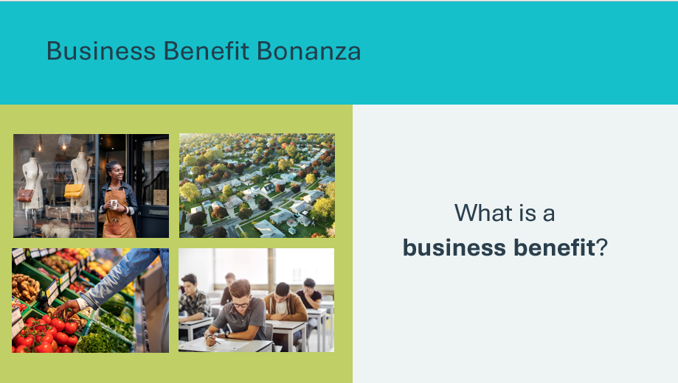 | Suggested time: 1-2 minutes  Use the prompt to facilitate a discussion with the class. Allow students to share their ideas and thinking.  What is a business benefit?  - Something that helps the community or others  - If a business hires employees from the local community, will it benefit the community?  - If people are working, they will have more money to buy things like houses and food.  - How could it help the community grow?  - More houses will be built and more groceries will be sold.  - A school might get built for the children of the employees, teachers will be needed for the school, etc.
Slide 46   | Suggested time: 1-2 minutes  Following the discussion, review the example. Ask students to raise their hand if they think the example shows a business benefiting the community.  Let them know they will be playing a game called Business Benefit Bonanza where they will pick up cards that ask questions. Like the example, they will need to decide whether what is being described on the card is a benefit or not a benefit.
Program Kit Materials | For slides 47-48, you will need to use the Business Benefit Bonanza game board, playing pieces, Opportunity Knocks Cards and Business Benefit Cards from the program kit.
Slide 47  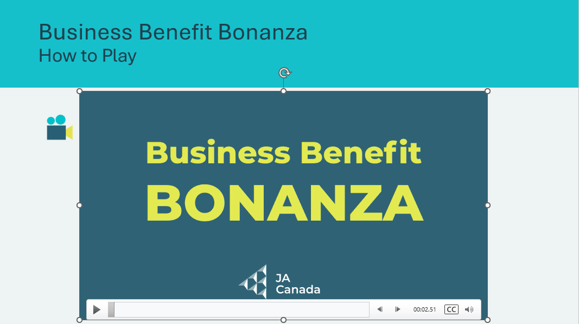  Business Benefit Bonanza game board and playing pieces  Opportunity Knocks and Business Benefit Cards | Suggested time: 5 minutes  Play the video to review the rules for how to play as a class.  If you are unable to play the video, review the game rules in the appendix.  Following the video, invite students to ask any questions they might have about the rules.  Break students into 6 groups or allow them to make their own groups.  Hand out a game board, die, playing pieces, and set of Business Benefit and Opportunity Knocks cards to each group.
Slide 48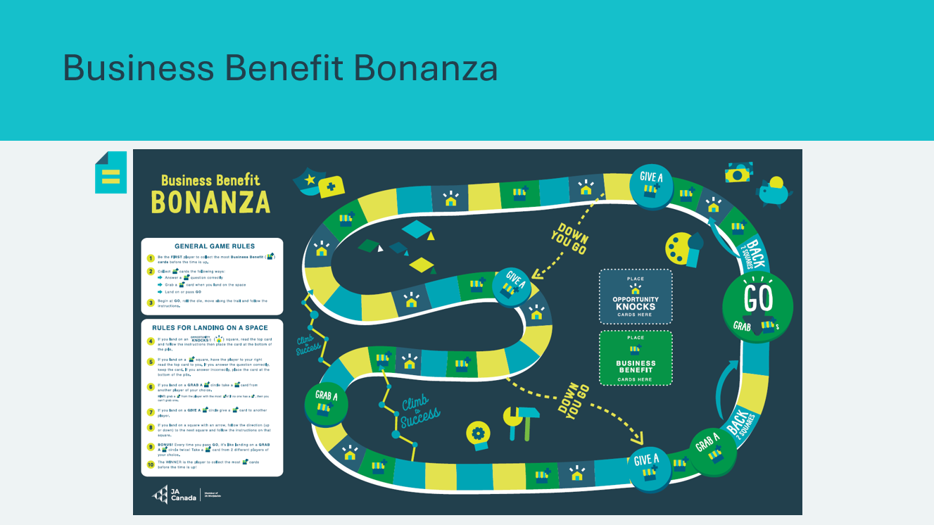  Business Benefit Bonanza game board and playing pieces  Opportunity Knocks and Business Benefit Cards | Suggested time: 20 minutes  As students play the game, circulate the room to make sure they understand how to play and are reading the cards thoroughly.  Remember to reserve a few minutes at the end of the lesson to acknowledge the winners, collect the game materials, and have a wrap up discussion to review the concepts learned.
Slide 49  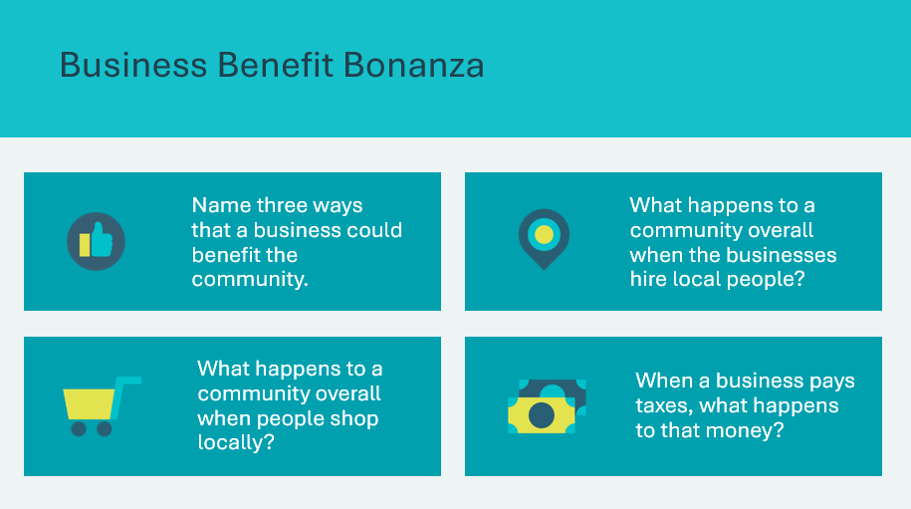 | Suggested time: 3 minutes  Wrap up the game by facilitating a discussion using the question prompts.  Name three ways that a business could benefit the community  - Employee support – example: health benefits  - Community support – example: community garden  - Environment support – example: land restoration initiatives  What happens to a community overall when the businesses hire local people?  - Local people have jobs  - People with jobs have money to spend at businesses in their community  What happens to a community overall when people shop locally?  - Local business earn a profit and can grow  - As businesses grow, they can hire more people from the community  - With more customers, local shops can offer better products and services  When businesses pay taxes, what happens to that money?  - The government collects the taxes, and the money helps the whole community to pay for schools, parks, libraries, roads, emergency services, hospitals, etc.
Extended Activity – What did I learn? 5 min
Slide 50  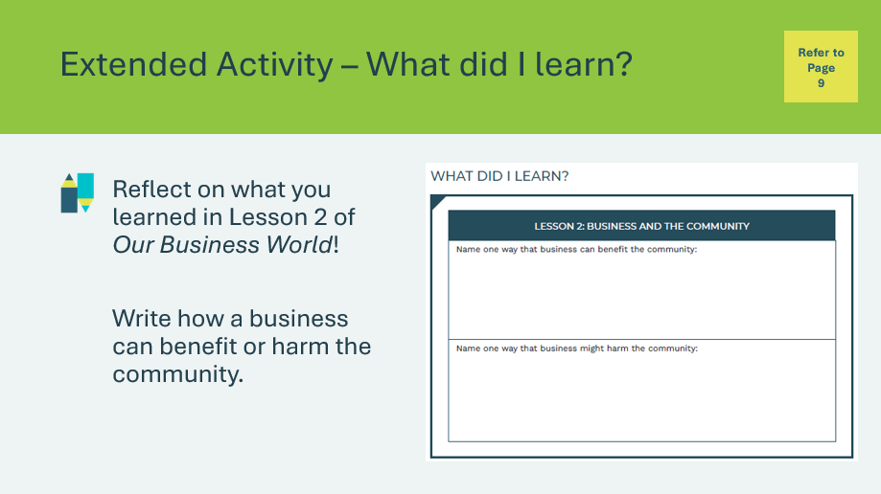 | Suggested time: 5 minutes  Students can complete the reflection in class if time allows, or independently later on.  Students will complete the reflection activity in their student portfolio, page 9. If completing the activity in class, you may wish to lead the class through a discussion to help them complete the exercise.

Lesson 3: Why Do Businesses Change?
Program Kit Materials | Businesses That No What’s Their Story? Cards  Longer Exist Cards  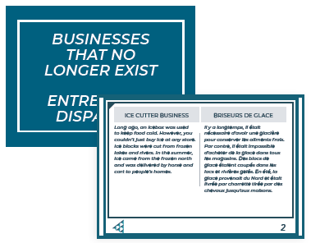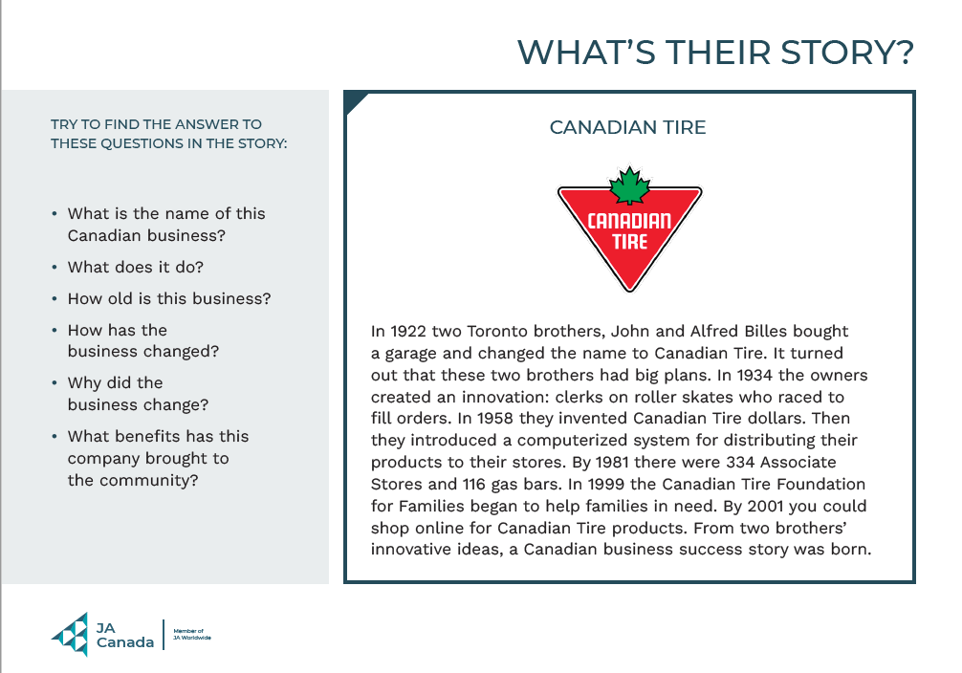
Slide 51 – Lesson 3   | Lesson 3: Why Do Businesses Change?
Slide 52 – Objectives  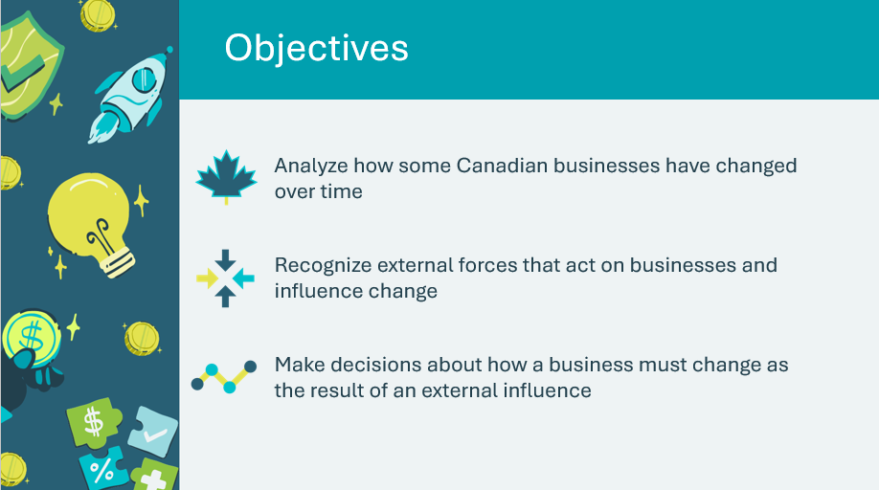 | Optional – review the learning objectives for the lesson
Slide 53 – Introduction  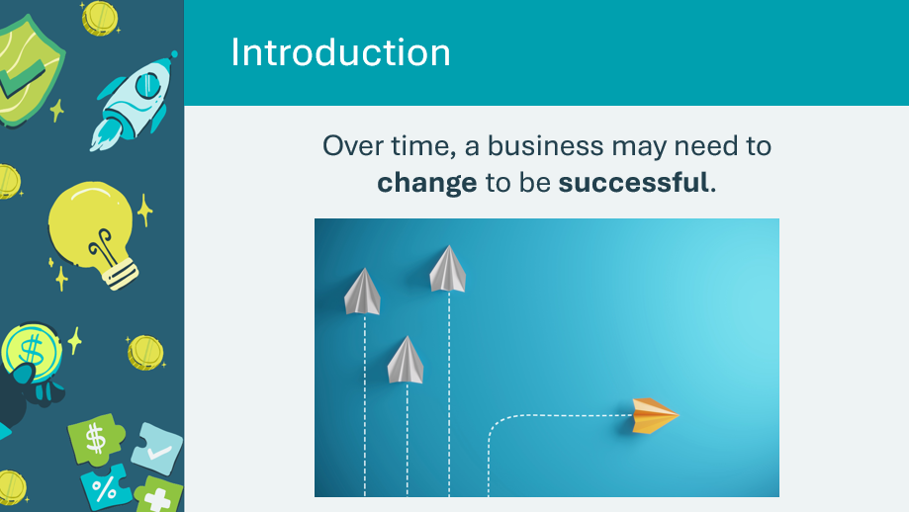 | Introduce the lesson by telling students that they will learn about some Canadian businesses and the ways they have changed over time to continue to be successful.
Slide 54 – Activity Menu  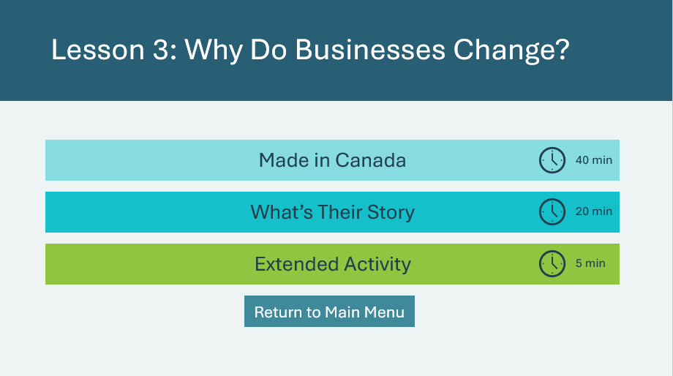 | *Select the button to navigate to the activity.  After you have completed an activity, you will be redirected back to the activity menu.  *Click or tap the Return to Main Menu button to return to the Lessons (Slide 5)
Made in Canada 40 min
Slide 55   | Suggested time: 3 minutes  Introduce the lesson by explaining that Canada has diverse geography – mountains, plains, valleys, farmland, forests, lakes and tundra, with three oceans that border our land.  Invite a few students to share their ideas on what “diverse” means. Make the connection that like our diverse geographical landscape, Canada has a diverse business landscape too that is home to many kinds of businesses.  Invite students to share the names of some Canadian businesses they know. Many students may think that some American businesses are Canadian because their products are sold in Canada and/or have offices in Canada.  - Canadian examples: Cineplex, Canadian Tire, Roots, Shoppers Drug Mart  Facilitator tip: Identify some local small businesses that students may be familiar with, and which sectors they belong to.
Slide 56  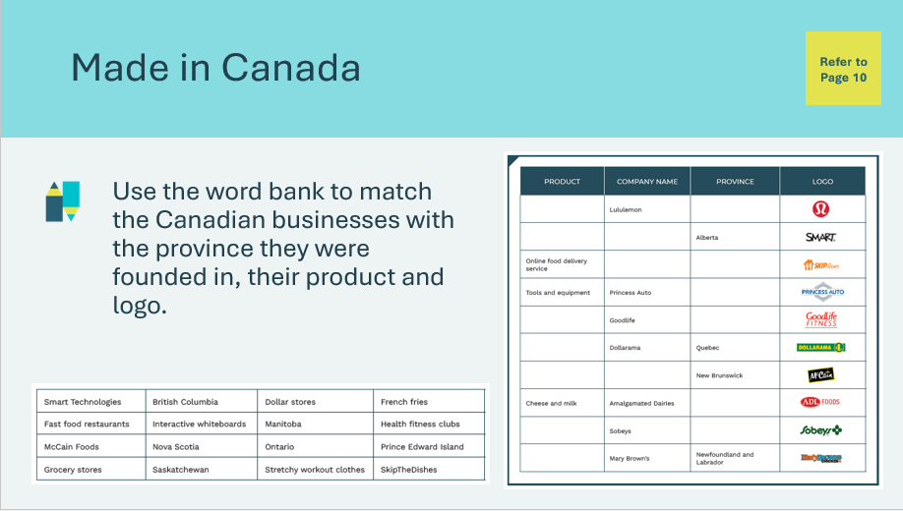 | Suggested time: 10 minutes  Students will complete the activity in their student portfolio, page 10 by using the word bank to fill in the table.  Facilitator tip: If a document camera is available, fill in the boxes with the students, allowing them to follow along as you complete the table together.  Alternatively, you can write the words for each box on the board.
Slide 57  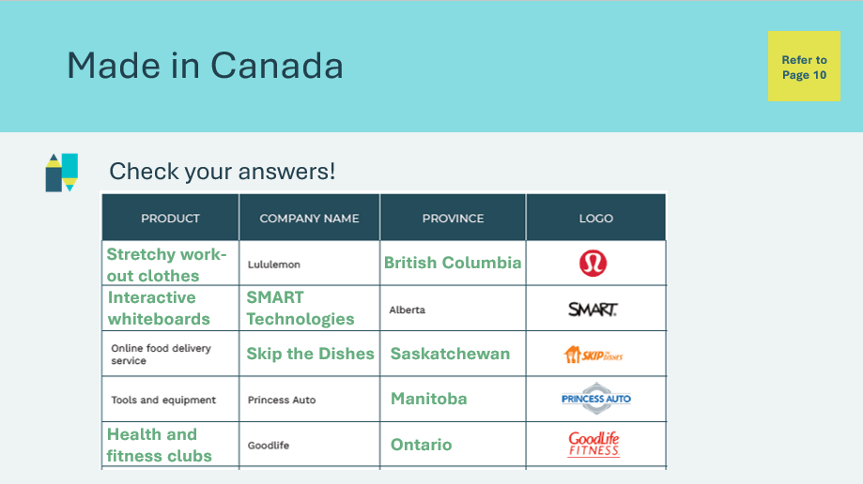  Slide 58  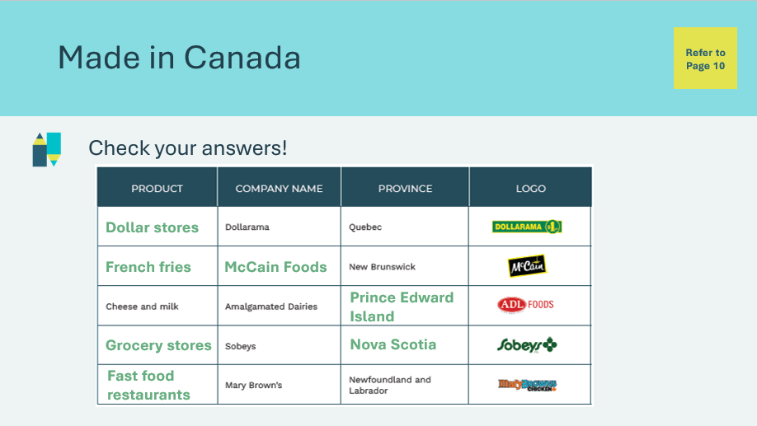  Slide 59  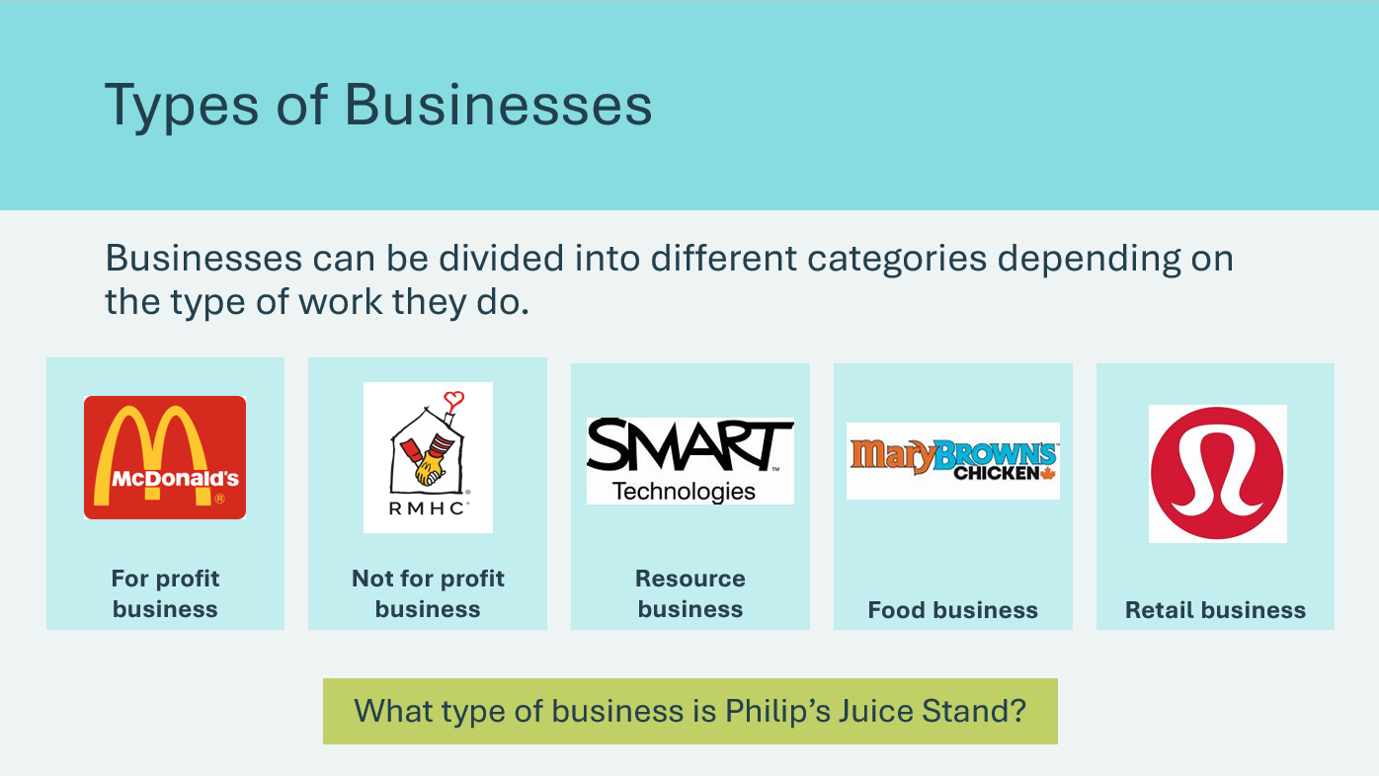 | Suggested time: 5 minutes  Review the correct answers when most students are finished.  *Click or tap to reveal each answer  Answers continued  Review the correct answers.  *Click or tap to reveal each answer  Remind students that businesses can be divided into “for profit” and “non profit”. Review the examples of ways businesses can be categorized.  Ask: What other businesses from the chart could fall into these categories? Allow a few students to share their ideas.  - Resource business – Princess Auto  - Food business – McCain  - Retail business – Dollarama  Ask: What type of business is Pat’s juice stand?  - A food business
Slide 60   | Suggested time: 2 minutes  Ask students to consider what Pat could do or change to grow their business?  Allow a few students to share their ideas then play the video.
Slide 61  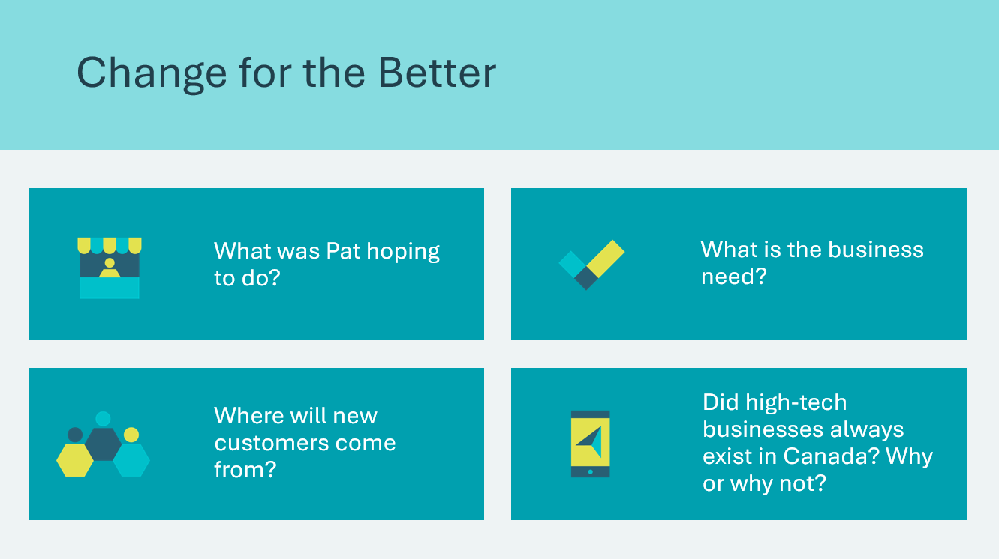 | Suggested time: 5 minutes  Facilitate a discussion about the video using the questions.  Sample responses:  - Pat was hoping to give customers more options for ordering juice  - If people are expecting to be at the park, they might want their juice to be ready when they arrive, so they don’t need to wait  - People may want to pay in advance using technology rather than with cash  - The product may appeal to more people because of the increased ordering and payment options. They might get more customers who appreciate the convenience of online ordering.  - High-tech businesses haven’t always existed because we did not yet have the knowledge.
Program Kit Materials | For slide 62, you will need to use the Businesses that No Longer Exist Cards from the program kit.
Slide 62  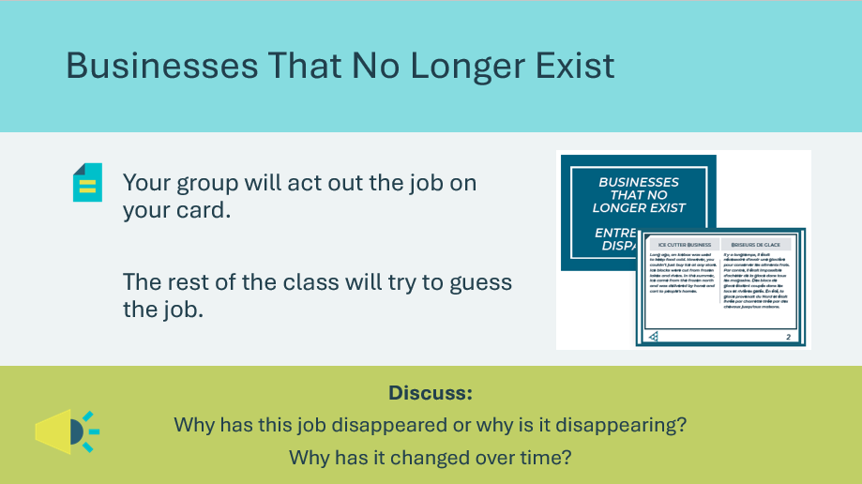  Businesses That No Longer Exist Cards  Slide 63  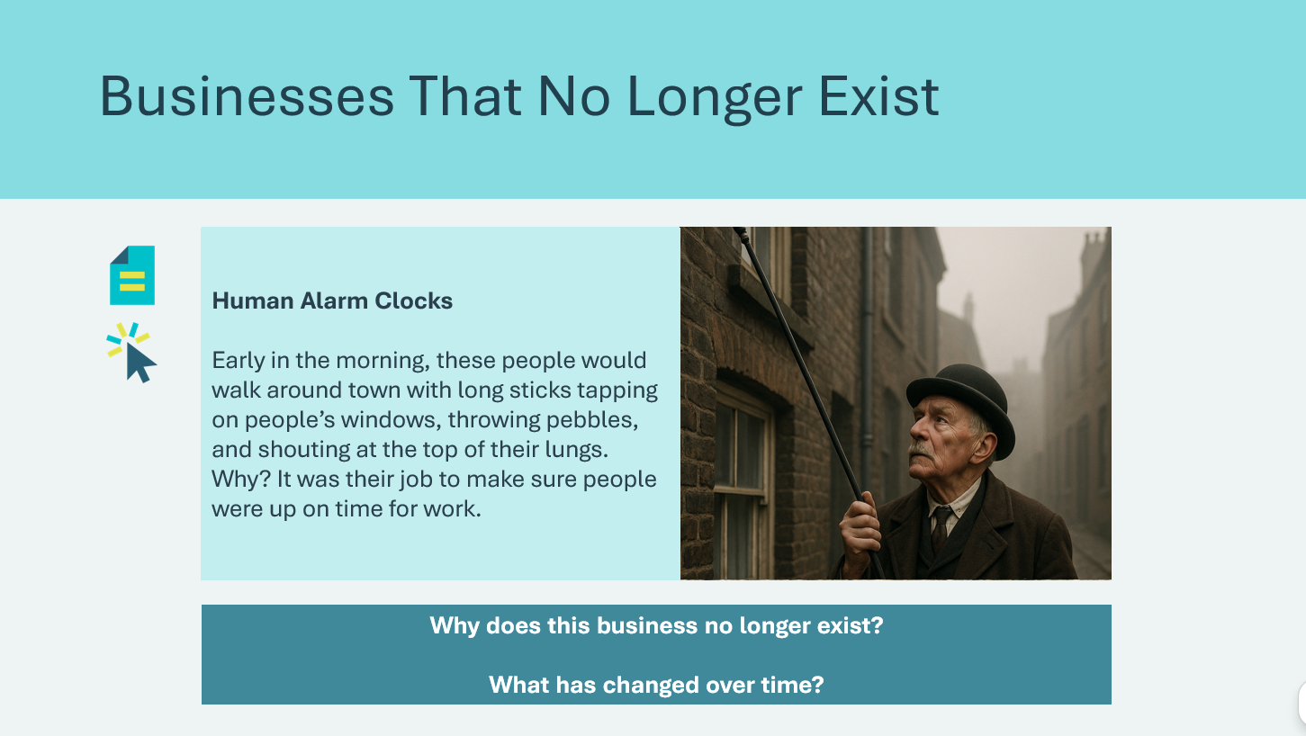 | Suggested time: 15 minutes  Explain that as time goes on, businesses must change or may need to close their doors forever. Students will see how this happens in this activity.  - Break students into 6 groups and give each group a Businesses That No Longer Exist card.  - They will act out the job/business while the rest of the class will guess what the job is and why it doesn’t exist anymore.  - Give students 3 minutes to read their card and plan how they will act it out. Adjust timing as needed  - Give each group a chance to present and encourage class discussion.  As students present their skits, discuss how things have changed, stressing the fact that business must adapt to changes in many areas such as technology, society, fashion, more competition, global trade and challenges across the world, such as the COVID 19 pandemic.  Use the following prompts to help guide the discussion:  - Why does this business no longer exist?  - What has changed over time?  Alternatively, rather than having students act out the cards, use this slide to review each business and discuss the prompts.
What’s Their Story? 20 min
Slide 64   | Suggested time: 3 minutes  Introduce the activity by reminding students that Canada has many kinds of businesses. Many of these began as small businesses. In fact, almost all businesses begin with only one or two people!  Volunteer connection: Use your own workplace as an example of how business is done in Canada. Explain the history of your business as an example for the upcoming activity.  - What is the name of the business?  - What does it do?  - How old is the business?  - How has the business changed over time?  - Why did the business change?  - What benefits has this company brought to the community?  - How do you think this company will be different in 100 years?
Program Kit Materials | For slide 65, you will need to use the What’s Their Story? Cards from the program kit
Slide 65  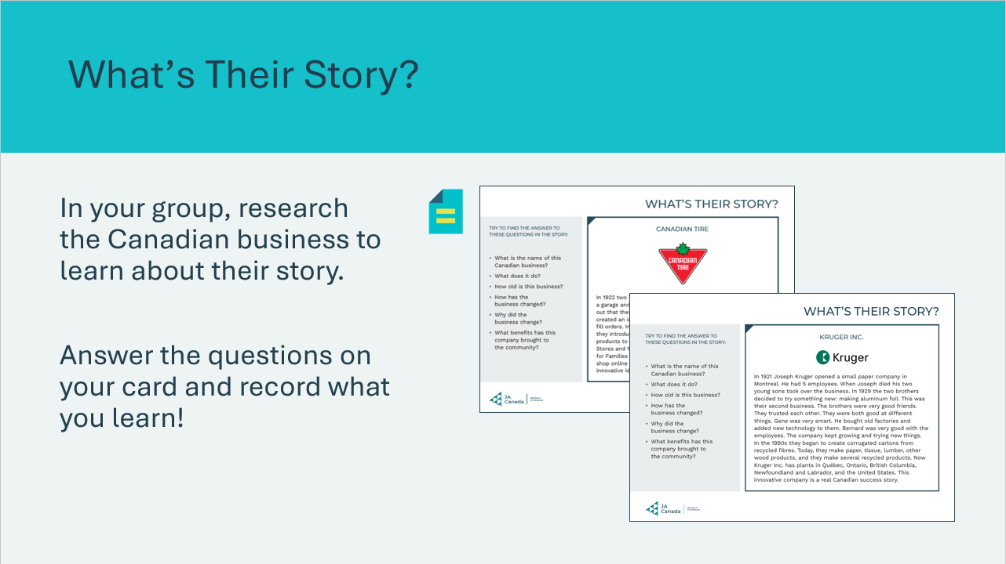  What’s Their Story? Cards | Suggested time: 17 minutes  Break students into groups (there are enough cards for up to 6 groups). Provide each group with a What’s Their Story? card and chart paper (if available) or regular paper.  - Students should title their paper as follows:  - What’s Their Story? – Business Name (ex. What’s Their Story? – Canadian Tire)  - As a group, students will read the business story on their card  - Students will attempt to answer the questions listed on the card based on the information they read and record their answers on their paper  Note: if students run out of time to finish their research charts, the activity can be left with the classroom teacher to finish on another day.
Extended Activity – What did I learn? 5 min
Slide 66  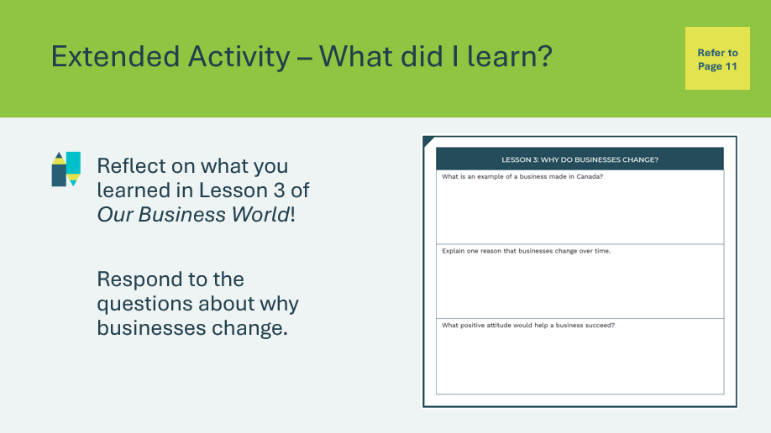 | Suggested time: 5 minutes  Students can complete the reflection in class if time allows, or independently later on.  Students will complete the reflection activity in their student portfolio, page 11. If completing the activity in class, you may wish to lead the class through a discussion to help them complete the exercise.

Lesson 4: Could I Be An Entrepreneur?
Program Kit Materials | Bingo Caller Cards  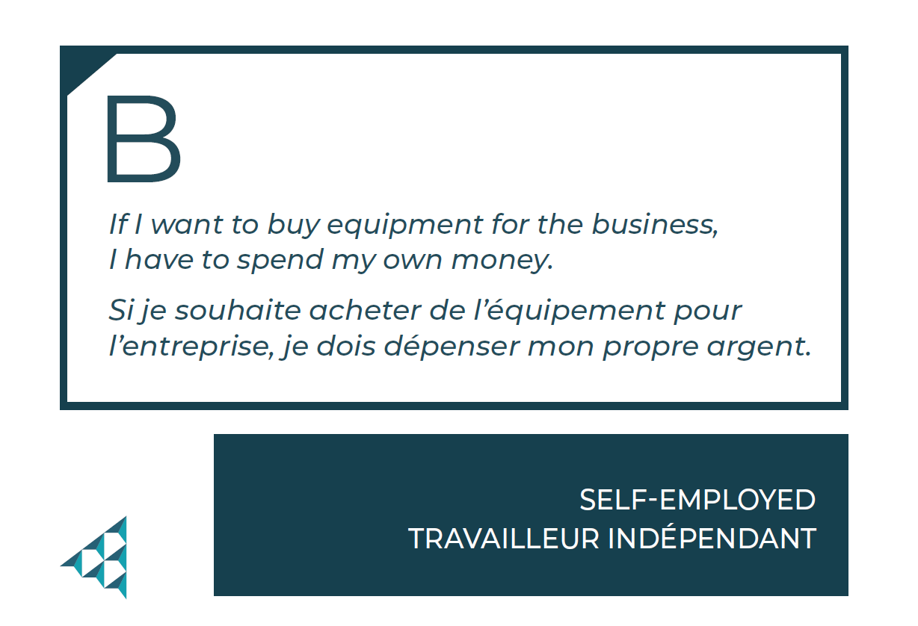  Bingo Cards  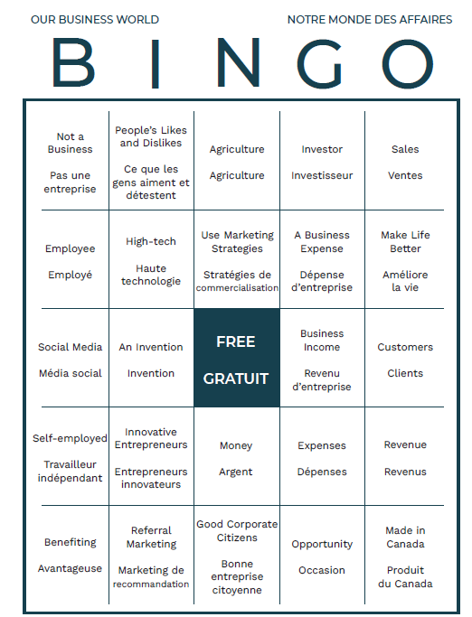
Slide 67 – Lesson 4   | Lesson 4: Could I Be An Entrepreneur?
Slide 68 – Objectives  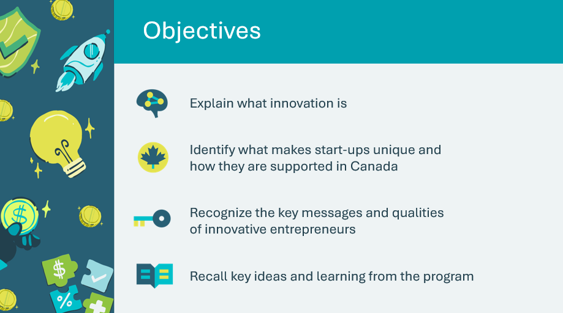 | Optional – review the learning objectives for the lesson
Slide 69 – Introduction  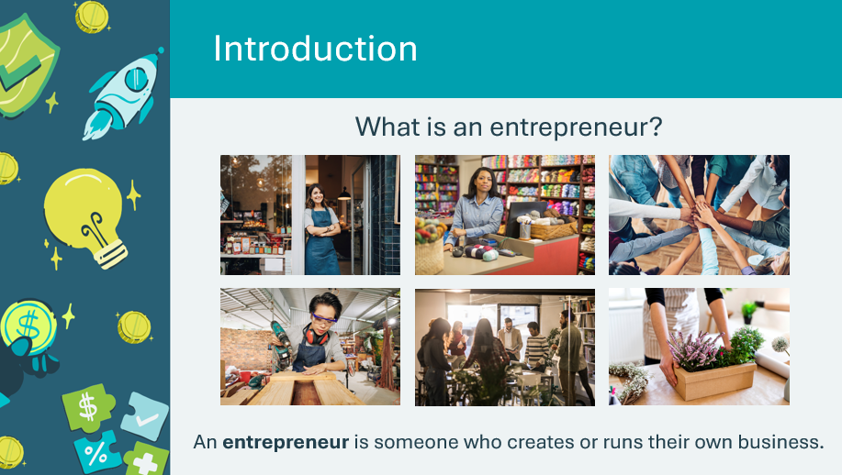 | Introduce the lesson by discussing what an entrepreneur is. Invite a few students to share their thoughts and ideas.  Facilitator tip: You may wish to use the images to encourage discussion about different types of businesses an entrepreneur might have.
Slide 70 – Activity Menu  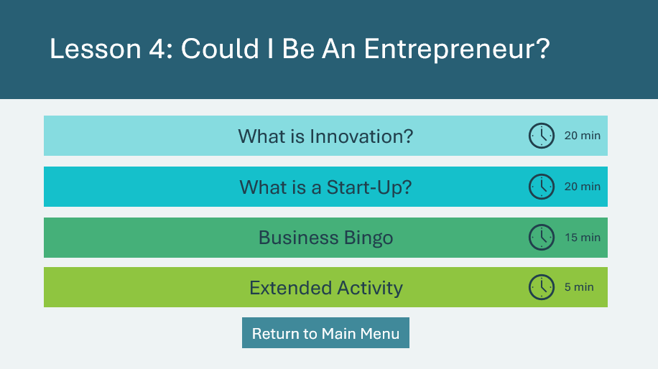 | *Select the button to navigate to the activity.  After you have completed an activity, you will be redirected back to the activity menu.  *Click or tap the Return to Main Menu button to return to the Lessons (Slide 5)
What is Innovation? 20 min
Slide 71  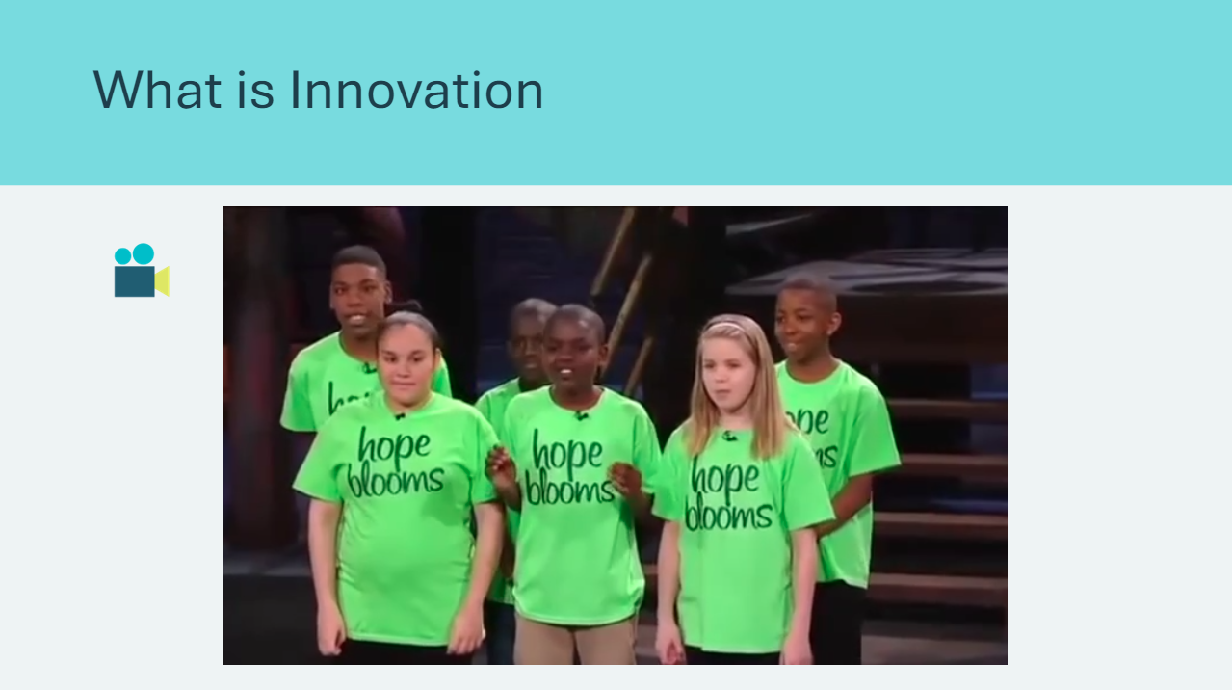 | Suggested time: 10 minutes  Have students recall the companies they learned about in the last lesson. Remind them that each company demonstrated something called an entrepreneurial mindset.  An entrepreneurial mindset is a set of attitudes and skills that helps you identify opportunities, overcome challenges, and learn from mistakes.  Invite a few students to share their thinking about how entrepreneurs can demonstrate an entrepreneurial mindset.  Sample responses:  - Willingness to try new things and take risks  - Finding new opportunities  - Desire to grow and improve over time  - Creative thinking and generating new ideas  - Learning from mistakes and adjusting plans  - Embracing technology to solve problems  Play the Hope Blooms video. While they watch, ask students to consider which elements of an entrepreneurial mindset they see demonstrated by the entrepreneurs.  Following the video, invite a few students to share examples of the entrepreneurial mindset attitudes or skills they noticed and how those helped the entrepreneurs succeed.
Slide 72  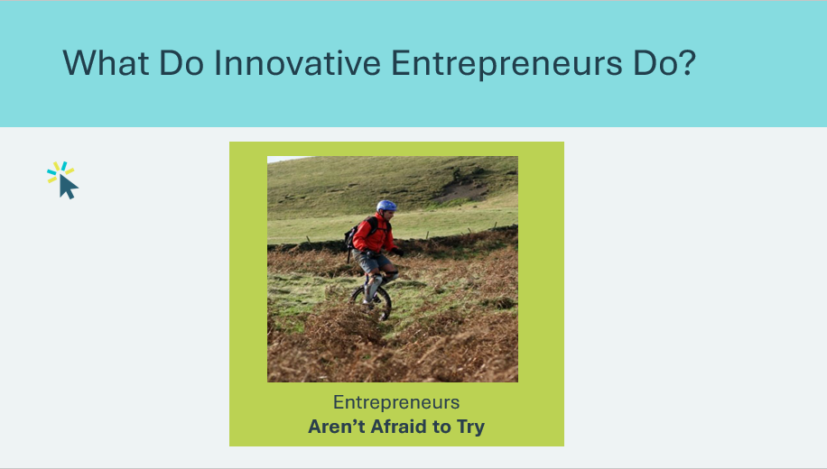 | Suggested time: 2 minutes  Review the innovative entrepreneur attitudes.  *Click or tap to display the next attitude
Slide 73  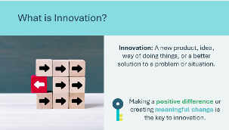 | Suggested time: 2 minutes  Review the definition of innovation and invite a few students to share ideas about what it means to be innovative.  Ask the following discussion questions:  - Do you think the kids in the video were innovative? Raise your hand if you do.  - How were they innovative?  Reinforce that the children in the video are making a positive difference in people’s lives. Making a positive difference is the key to innovation.
Slide 74  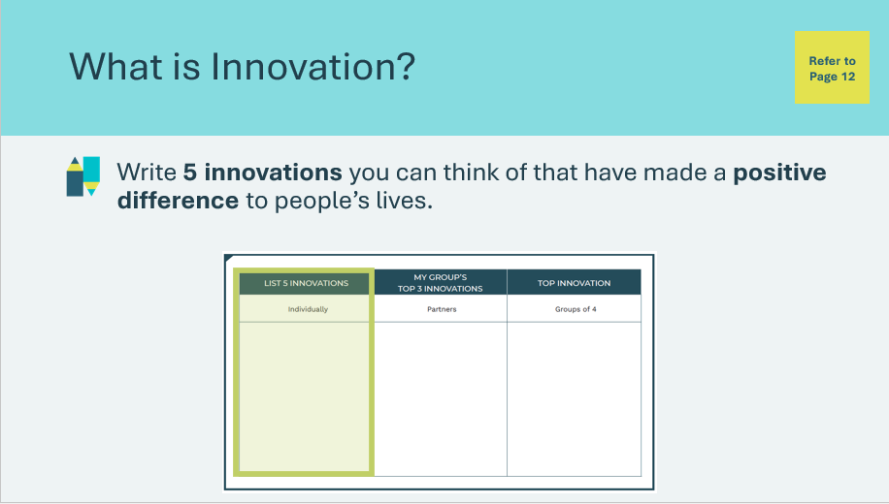  Slide 75  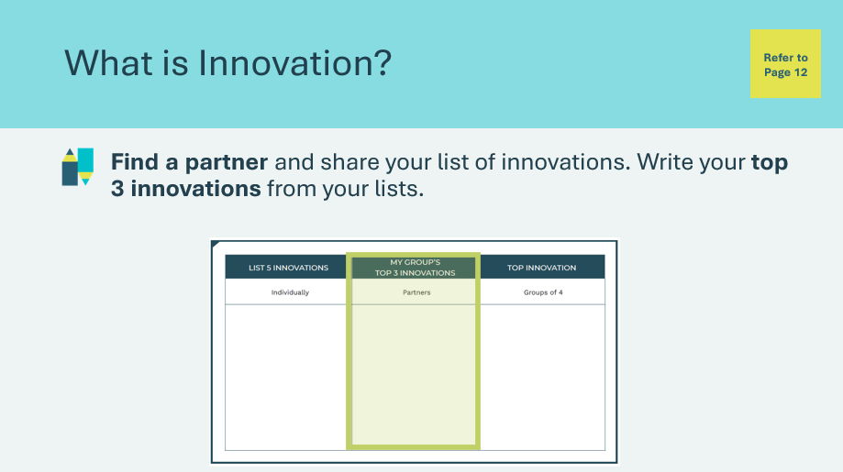  Slide 76  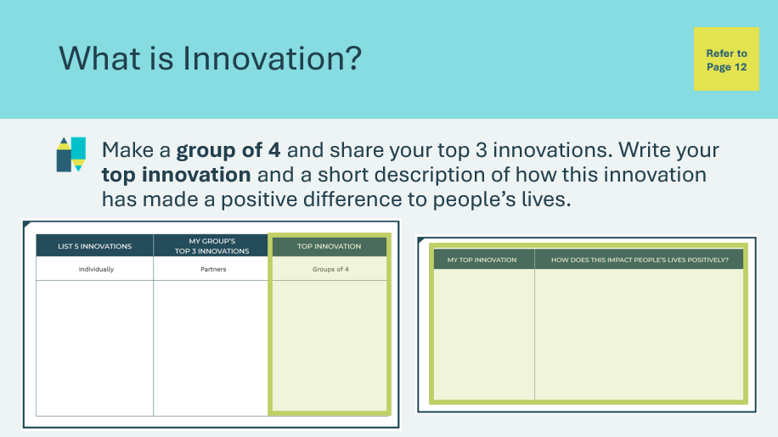 | Suggested time: 10 minutes  Students will complete the activity in their student portfolio, page 12, to reflect on innovations they know of.  Start by having students fill in the first column of the chart individually. Give them a few moments to write 5 innovations on their own.  Facilitator tip: You may wish to provide a few examples or allow a few students to share their ideas to get others started.  Some examples include:  - Technology innovations – tablets/iPads, smartphones, smartwatches, AI  - Learning innovations – platforms like Google Classroom, Smartboards  - Green innovations – electric cars, solar panels  Once everyone has written their 5 innovations, explain to students that they will fill in the second column with a partner.  - They will each share the 5 innovations they wrote.  - From these 10 innovations, they will choose their top 3 and write them in the second column.  Once the partners have chosen their top 3 innovations, they will join another set of partners to create a group of four. Out of the final 6 innovations, they will choose the top innovation that has made a positive impact on people’s lives.  They will write their top innovation and a short description of how it has made a positive difference in the third column.  After most students are finished, invite each group to share their top innovation and reason for choosing it.
Slide 77  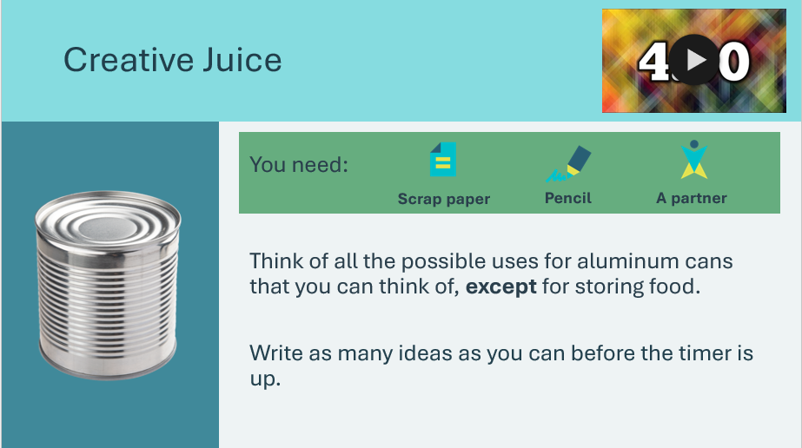 | Suggested time: 5 minutes  Ask: Do you think you could be an entrepreneur?  - If yes, raise your hand all the way  - If not sure, raise your hand halfway  Tell students they will get their creative juices flowing and find out with this activity!  Review the instructions and allow students a few moments to get their scrap paper and find a partner.  *Click or tap the timer to start, students will have 4 minutes to write as many ideas as they can on their scrap paper.  - Note: an alarm sound signals the end of the timer, lower the volume if necessary.  Facilitator tip: Remind them to write down all ideas, even if they don’t think they are very good.
Slide 78  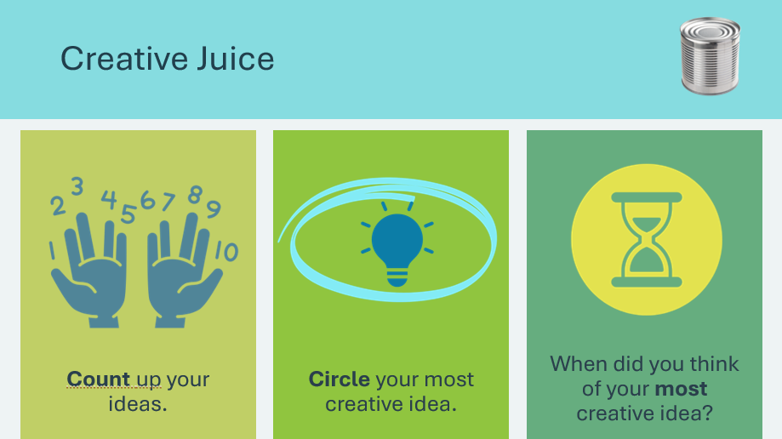 | Suggested time: 2 minutes  Wrap up the activity with the discussion questions/prompts:  *Click or tap to reveal each prompt.  - Count up your ideas. Raise your hand if you had 20 or more ideas. Raise your hand if you have 5-10.  - Congratulate the students for their creative thinking!  - Put a circle around the idea you think is most creative and most unusual (the idea you don’t think anyone else has)  - Allow students a few moments to circle their idea. Ask a few pairs to share their idea.  - When did you think of your most creative idea? Right away or after a few minutes?  - Allow students to share their experience.  - Explain that often our most creative ideas aren’t the ones we think of first. Research shows that we must get the “clutter” in our brain swept away before we can really think creatively.
Slide 79   | Suggested time: 2 minutes  Explain that before an egg can hatch it must be incubated, or kept warm, safe and protected.  Like a fragile egg, new businesses with an innovative idea often go through a process of “incubation”. Usually, an experienced mentor takes the young company under their wing to provide support, resources, help and advice to the new business. The incubation period might be a few weeks or months long.  Facilitator tip: Remind the students of how the business in the Hope Blooms video was incubated.
What is a Start-Up? 20 min
Slide 80   | Suggested time: 2 minutes  Introduce the activity by telling students that all over the world, there are new businesses trying to compete in the market called “start-ups”.  Ask students to raise their hand if they have heard of the term start-up.
Slide 81  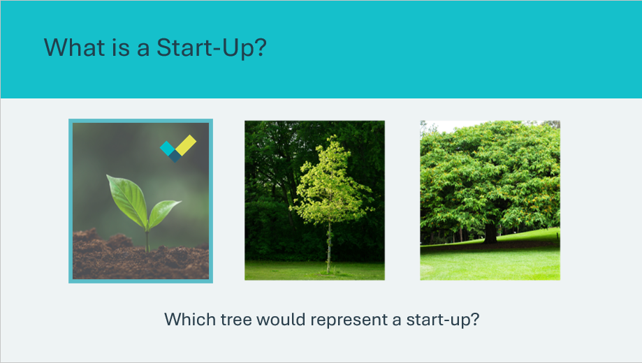 | Suggested time: 3 minutes  Tell students that if these trees were businesses, only one would be a start-up. Allow students to guess, but don’t confirm.  Ask: What if I asked you which tree had the most protection from natural disasters? Would you know which one was a start-up? Allow students to continue guessing.  Explain that start-ups aren’t focused on defending themselves but are all about growing. They don’t have large root systems to protect themselves. They are small and quick to grow. Allow students to guess one more time.  *Click or tap to reveal answer.
Slide 82  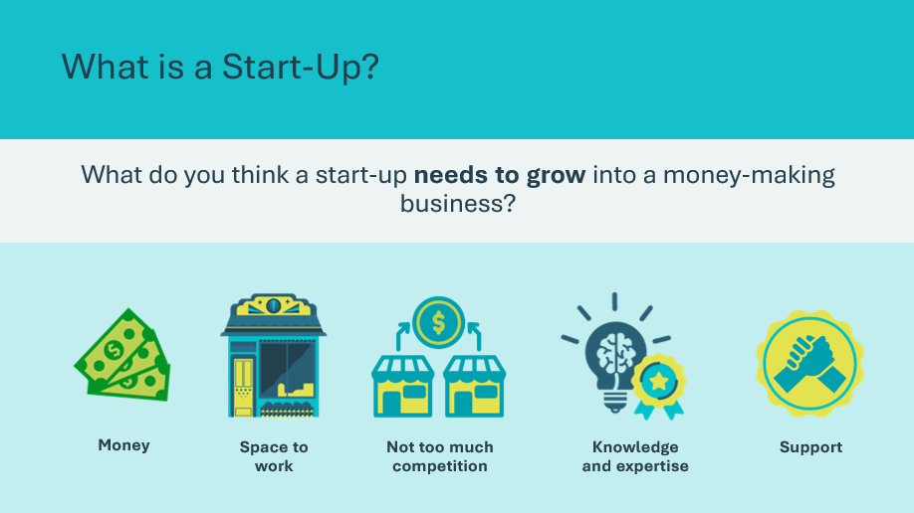 | Suggested time: 5 minutes  Ask students the prompt on the slide and encourage them to use the pictures to guide their responses.  *Click or tap to reveal text labels  Once students have discussed the images, ask them to consider where money could come from. Guide them to identify sources such as investors, family and friends, crowd funding and government programs.  Facilitator tip: Share the story of a start-up that you are familiar with and how it got started. If you are familiar with funding programs that support Canadian start-ups, share this with students as well.
Slide 83  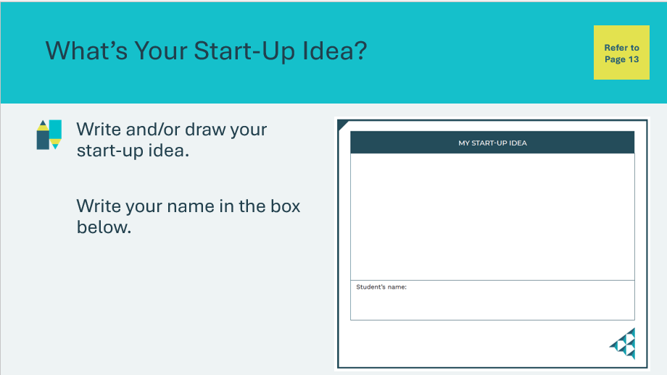 | Suggested time: 10 minutes  Ask: Why do you think I wanted to tell you about start-ups? Invite a few students to share their thinking.  Explain that it’s possible that many students in the room will someday be creating their own job by creating their own business.  Ask: Think about your future self. What is one idea you’d love to develop into a business one day, allowing you to become an entrepreneur?  Encourage them to think about the things they have learned today.  Students will complete the activity in their student portfolio, page 13. You may wish to arrange with the teacher for students to cut their start-up idea out of their portfolio and hang them up in the classroom.
Business Bingo 15 min
Program Kit Materials | For slide 84, you will need to use the Bingo Caller Cards and Bingo Game Cards from the program kit.
Slide 84  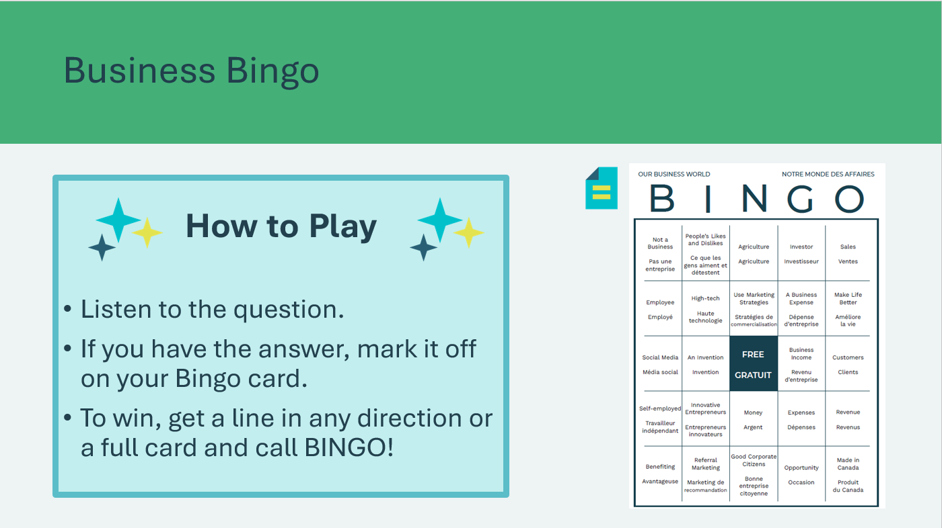  Bingo Caller Cards  Bingo Game Cards | Suggested time: 15 minutes  Wrap up the learning with a game of Bingo to review the concepts learned.  The game is played like traditional Bingo.  - Distribute the Bingo cards from the kit materials  - Read the questions from the Bingo Cards in the kit materials. Draw a question at random and read it to the class by saying e.g. “under the B…”  - Students who have the answer under the B will mark their card.  - The first student who gets five answers in a vertical, horizontal or diagonal row wins the game. You may also choose to play for the full card if time allows.  Facilitator tip: Students can work in pairs or groups of three if needed, so they have help finding the answers on their bingo cards.
Extended Activity – What did I learn? 5 min
Slide 85  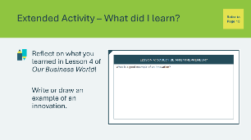 | Suggested time: 5 minutes  Students can complete the reflection in class if time allows, or independently later on.  Students will complete the reflection activity in their student portfolio, page 13. If completing the activity in class, you may wish to lead the class through a discussion to help them complete the exercise.

Wrap Up
Printed Kit Materials | Certificates of Accomplishment  
Slide 86 – Wrap Up   | Wrap Up
Slide 87 – Congratulations!  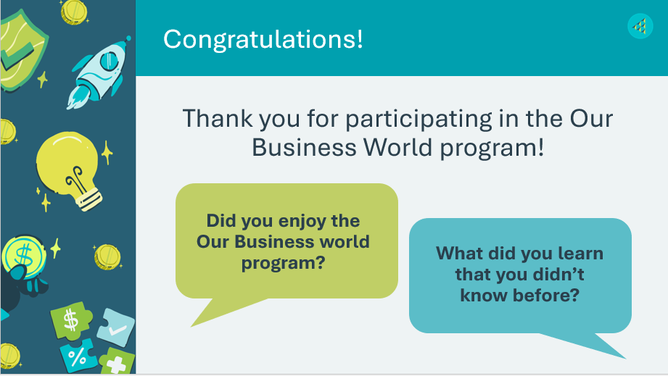 | Suggested time: 5 minutes  Wrap up the program with the discussion prompts.
Program Kit Materials | For slide 88, you will need to use the Certificates of Accomplishment from the program kit.
Slide 88    Certificates of Accomplishment | Suggested time: 5 minutes  Thank the students and teacher for their participation and distribute the Certificates of Accomplishment.  Tell the students you enjoyed spending the time with them and congratulate them on a job well done!
Slide 89   | Invite students to visit jacampus.org for additional information and learning.

Appendix
Business Benefit Bonanza – How to Play
Getting Started:
- To get started, you'll need the game board, business benefits cards, opportunity knocks cards, playing pieces, and dice.
- Place the stack of business benefit cards and opportunity knocks cards face down on the gameboard.
- Place your playing piece on the GO space and take turns rolling the dice to move around the gameboard.
General Game Rules:
- Each player starts with 2 business benefit cards.
- Be the player who collects the most Business Benefit cards before the time is up, to win.
- You can collect a Business Benefit card by answering the question on the back of the card correctly, by landing on the Grab a Business Benefit card space or collect two when you pass GO.
Rules for Landing on a Space:
- As you move around the gameboard, there are certain spaces that have specific rules.
- If you land on an Opportunity Knocks space, read the top card and follow the instructions. Then place the card at the bottom of the pile.
- If you land on a Business Benefit space, have the player to your right reed the top card to you. If you answer the question correctly, keep the card. If you answer incorrectly, place the card at the bottom of the pile.
- If you land on a grab a business benefit space, take a card from another player of your choice. If you land on a give a business benefit card space, give a card to another player.
- If you land on a space with an arrow, follow the direction up or down. Follow the instructions for the space you land on.
- Bonus! Every time you pass go, it's like landing on a grab a business benefit space twice! Take a business benefit card from two different players of your choice.
- The winner is the player to collect the most Business Benefit cards before the time is up!

