

JA Personal Finance Presenter Notes
The Presenter Notes have been developed using references from the digital classroom presentation and should be used in combination with the printed Student Portfolio V2026.
Tips for Setting Up the Classroom
- Arrive 15 minutes early and check in at the office.
- Connect with the teacher for the program materials and organize them as needed.
- Hand out student portfolios and name tags/cards.
- Set up presentation (check audio and internet connection are working).
- Write your name on the board.
- Ask the teacher to write student names on program certificates.
- Check in with the teacher about school schedule, tips for getting students attention, any specific student needs & behaviors you should be aware of and ask for help with encouraging student participation, as well as monitoring and managing the class.

Planning Guide
WRAP UP (Slides 92 – 94) 45 MIN
- Introduction (10 min)
- Activity (30 min)
- Summary & Review (5 min)

LESSON 5 (Slides 79 – 91) 45 MIN
SAVVY CONSUMER
- Introduction (10 min)
- Activity (30 min)
- Summary & Review (5 min)

LESSON 4 (Slides 66 – 78) 45 MIN
CREDIT CHOICES
- Introduction (10 min)
- Activity (30 min)
- Summary & Review (5 min)

LESSON 2 (Slides 26 – 50) 45 MIN
SAVING FOR LIFE
- Introduction (10 min)
- Activity (30 min)
- Summary & Review (5 min)

LESSON 3 (Slides 51 – 65) 45 MIN
THE BUDGET GAME
- Introduction (10 min)
- Activity (30 min)
- Summary & Review (5 min)

GETTING STARTED – GETTING TO KNOW YOU (Slides 1 – 5) 5 MIN
LESSON 1 (Slides 6 – 25) 45 MIN
PLAN TO EARN
- Introduction (10 min)
- Activity (30 min)
- Summary & Review (5 min)

Introduction
Slide 1 – Personal Finance  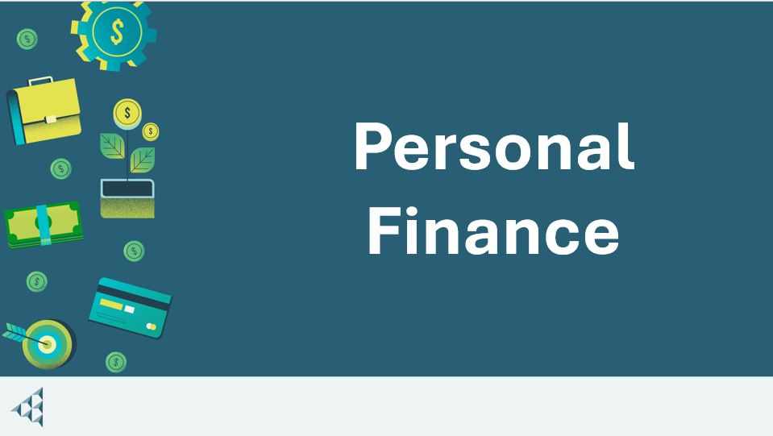 | Navigation Tips  - Navigate through the slides using the next or previous buttons (bottom right), clicking or tapping on the slide, or using the navigation menu (left)  - Look for slide specific instructions in the presenter notes below
Slide 2 – Welcome to JA!   | Suggested time: 3 minutes  Ask: Has anyone heard of Junior Achievement before?  Play the video for students to introduce them to JA!
Slide 3 – Personal Finance Program  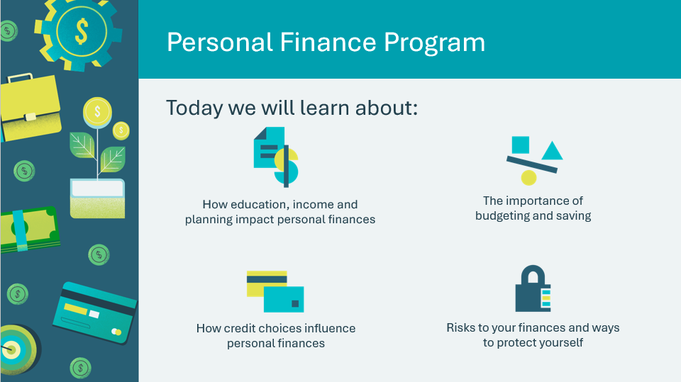  Slide 4 – Symbol Legend  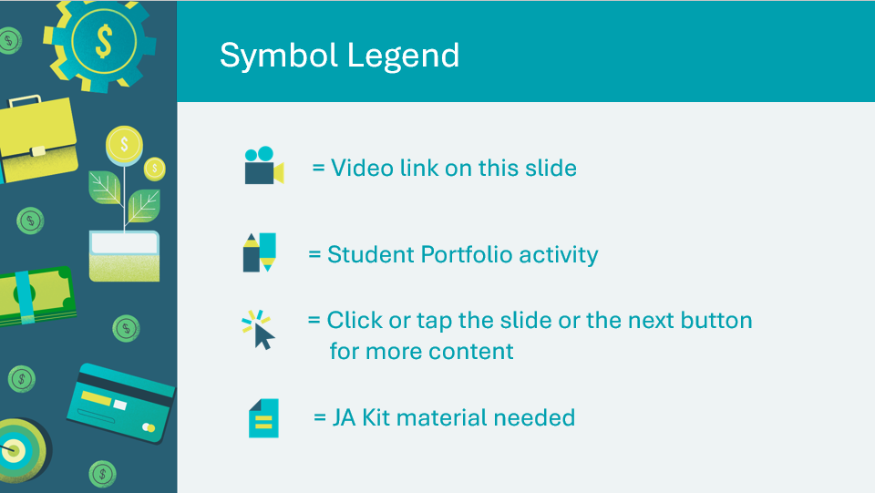 | Suggested time: 3-5 minutes  Introduce the program and yourself!  Tell the students a little about you, your education, and your career path until this point. Explain why you chose to volunteer in their classroom today.  The symbols will help guide the learning experience. Explain to students that they will see these symbols throughout the program.
Slide 5 – Main Menu  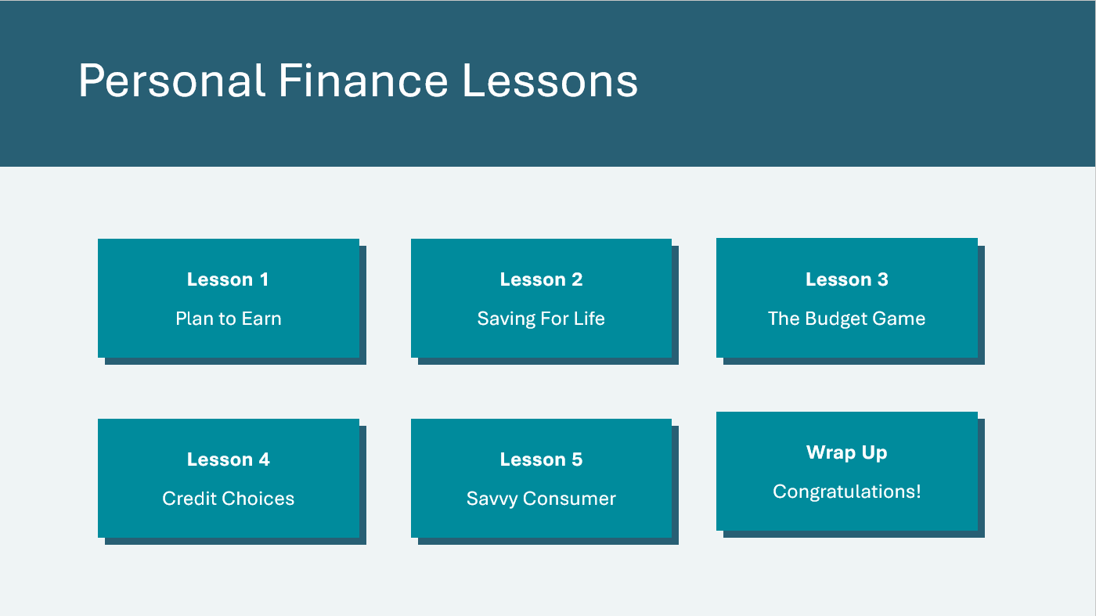 | *Select the button to navigate to the lesson.  After you have completed a lesson, you can select the Return to Main Menu button from the Lesson Activity Menu to return to this slide.

Lesson 1: Plan to Earn
Program Kit Materials | Job Cards  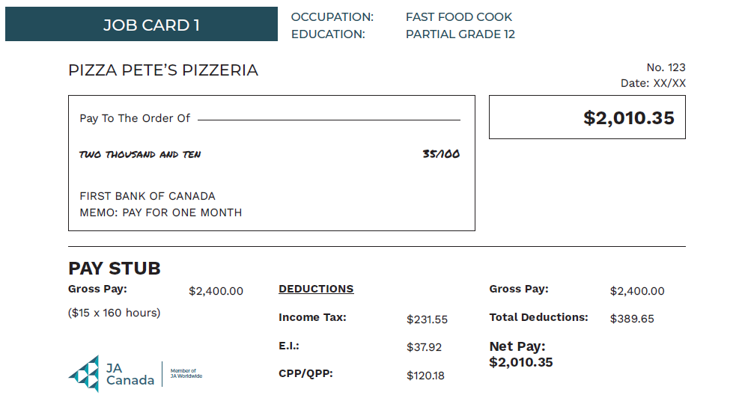
Slide 6 – Lesson 1  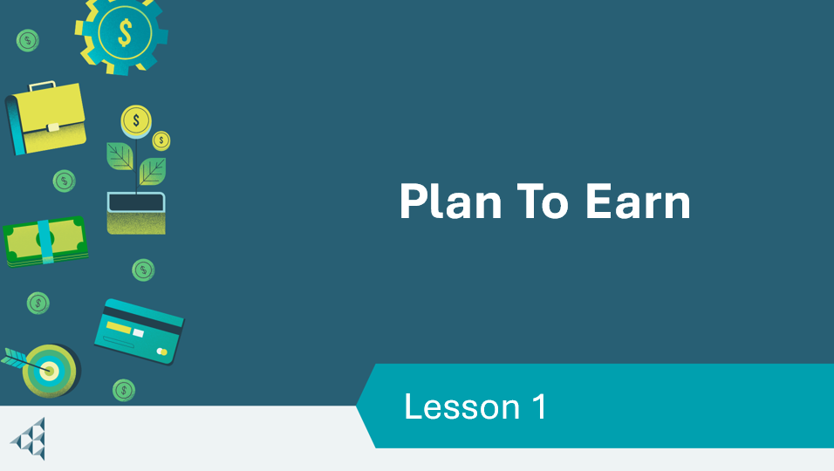 | Lesson 1: Plan to Earn
Slide 7 – Objectives  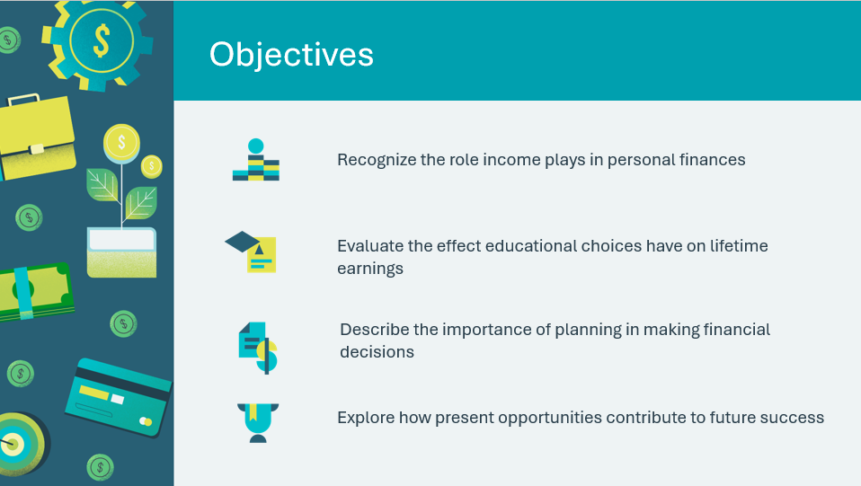 | Optional – review the learning objectives for the lesson
Slide 8 – Introduction  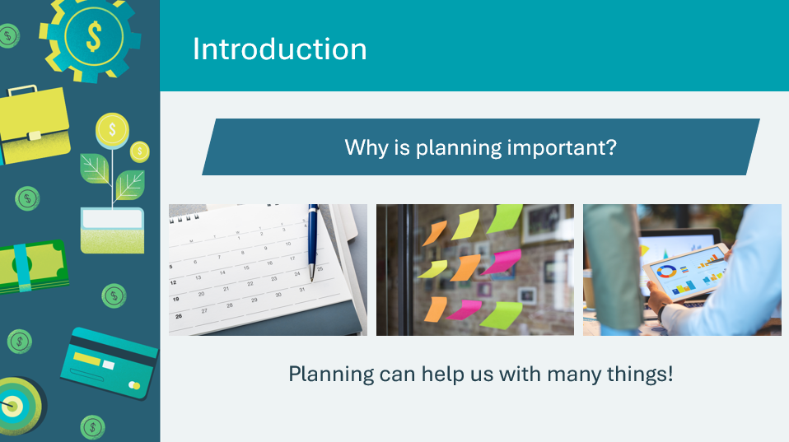 | Introduce the lesson by using the prompts to generate a discussion about why planning is important, and what ways planning can be helpful. Invite a few students to share their responses.  Volunteer connection: Share an example of a time when planning helped you be successful, or a time when a lack of planning posed challenges.  Explain that students will discover more about how important planning is important for both financial goals and personal goals.
Slide 9 – Lesson 1 Activity Menu  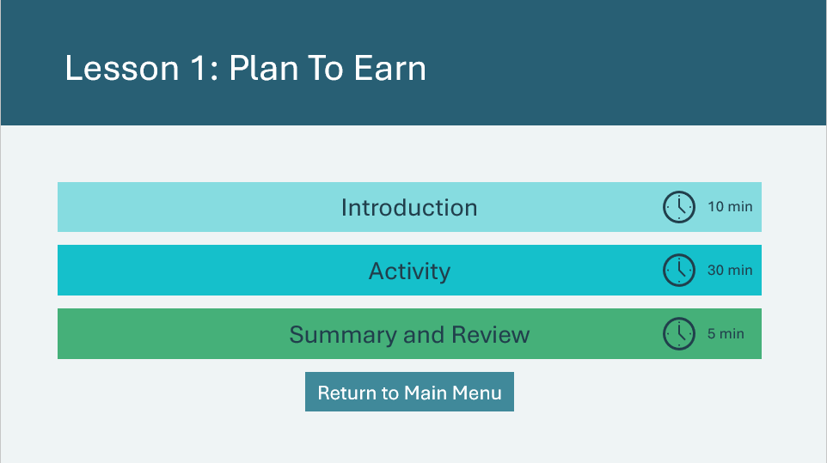 | *Select the button to navigate to the activity.  After you have completed an activity, you will be redirected back to the activity menu.  *Click or tap the Return to Main Menu button to return to the Lessons (Slide 5)
Introduction 10 min
Slide 10   | Suggested time: 2 minutes  Ask students to imagine themselves building something complex, such as a house, a phone, or an airplane. Is it better to design a plan and work from the plan or just start building and see how it goes?  Invite a few students to share their ideas and reasoning.
Slide 11   | Suggested time: 2 minutes  Explain to the students that building a life is a complex project. There will be thousands of design decisions to make along the way. Many of those decisions will expand or limit your next set of choices.  For example, if your first decision when building a house, airplane, or cell phone is to make it out of duct tape instead of standard materials, that decision will limit all your other design choices.  The same is true in life. The decisions you make about jobs, schooling, or savings will limit or expand all the other choices you will make in life.
Slide 12  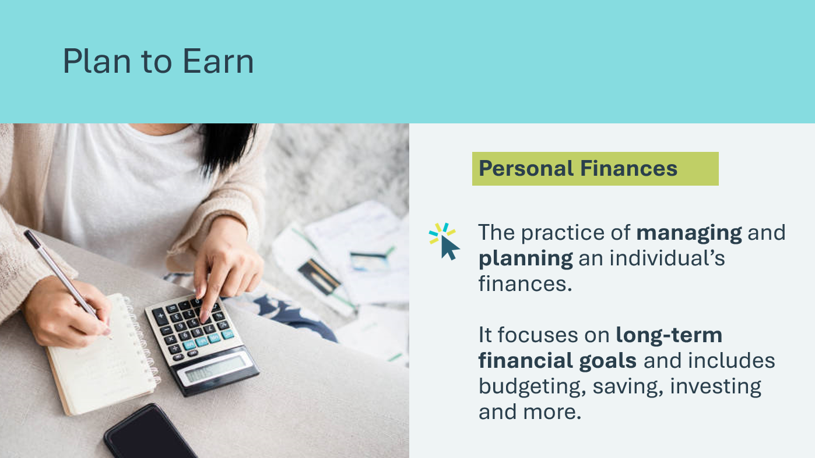 | Suggested time: 1 minute  Explain that on the next few slides, you will define some terms that will be important to know for this lesson.  Ask if anyone knows what personal finances are.  *Click or tap to reveal the definition.  Read the definition of personal finances aloud to the class or invite a student volunteer to do so. Ask students if they have a financial goal for the future (saving for a car, grad trip, etc.).
Slide 13  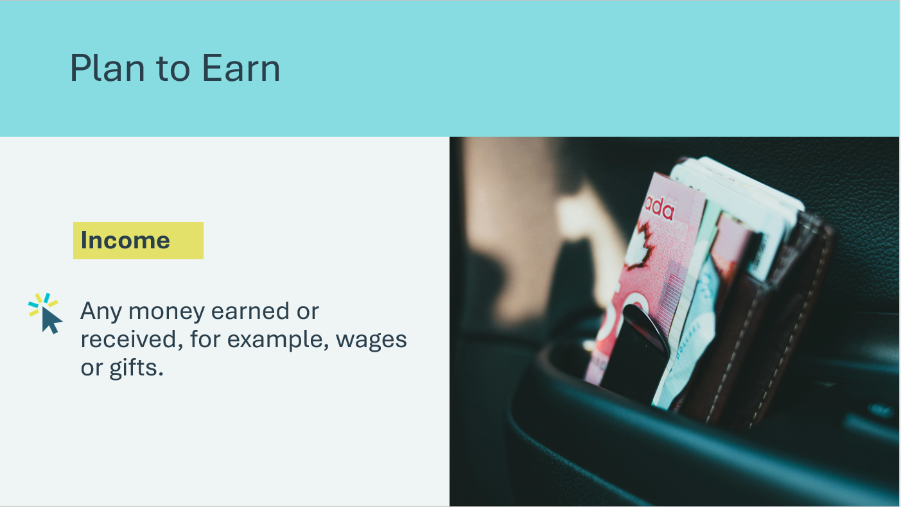 | Suggested time: 1 minute  Ask if anyone knows what income means.  *Click or tap to reveal the definition.  Read the definition of income aloud to the class or invite a student volunteer to do so. Ask the students if they have received money as a gift or from a part-time job, etc. or what they know about income.
Slide 14  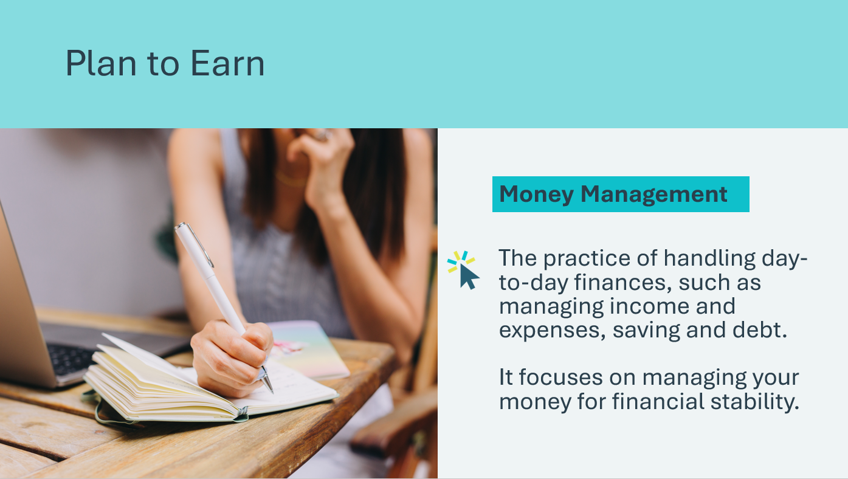 | Suggested time: 2 minutes  Ask if anyone knows what money management means.  *Click or tap to reveal the definition.  Read the definition of money management aloud to the class or invite a student volunteer to do so. Ask the students what they know about managing money or if they have any habits that help them with spending and saving.  Volunteer connection: Share an example of a money management strategy you use or have used in the past, such as tracking spending in an app, or setting up automatic transfers for monthly saving.
Slide 15  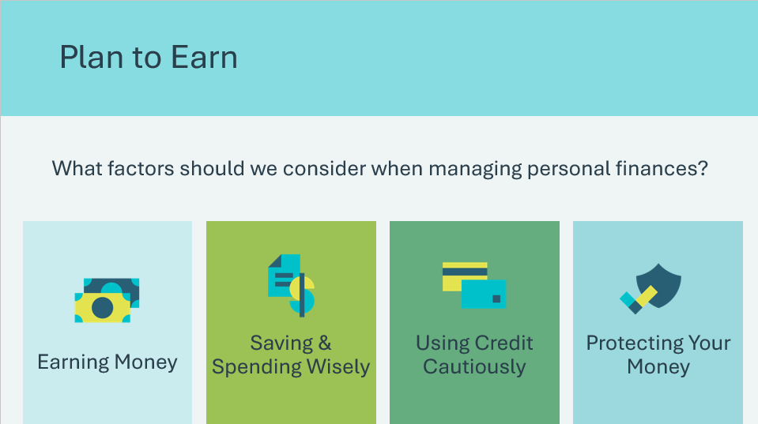 | Suggested time: 2 minutes  Explain that many people go through life without a plan for their personal finances. But just like building a cell phone from duct tape, decisions made without planning will affect other choices.  Ask the prompt on the slide.  *Click or tap to reveal each of the considerations  Volunteer connection: Provide a personal or local example of a time when planning helped with personal finances—or would have helped.  Explain that the Personal Finance program is an opportunity for students to think about and begin planning for some of these basic aspects of personal finance.  Tell students that the first step in personal finances is determining one’s needs and goals for the future. It’s only when you know what you’re planning for that you can begin to plan well.
Activity 30 min
Slide 16  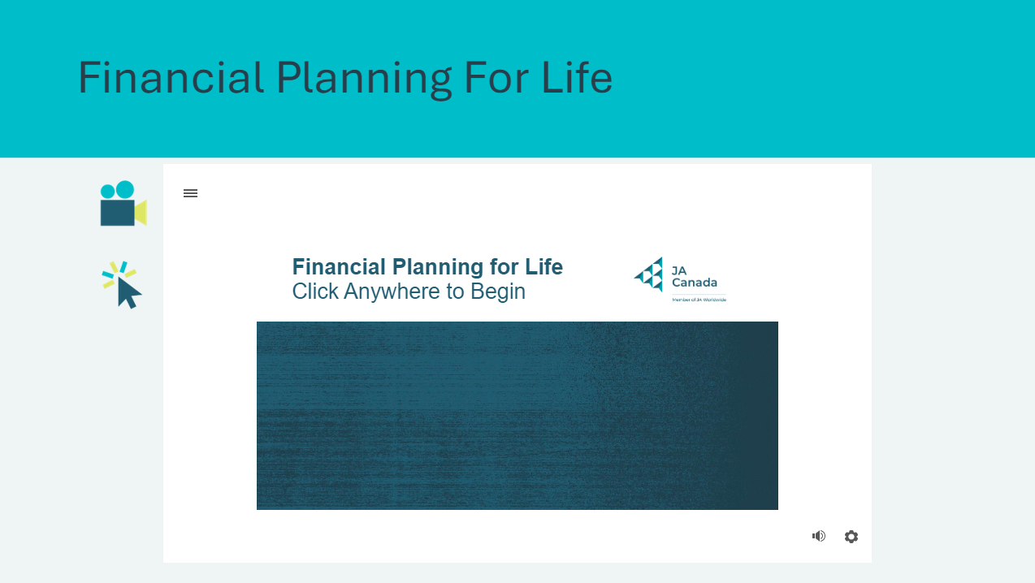 | Suggested time: 5 minutes  Tell students they will watch a video exploring 5 topics that will have a significant impact on personal finances throughout the course of one's life, including:  - Earning income  - Becoming a couple  - Starting a family  - Living independently  - Everything else  Play the Financial Planning for Life interactive video.  After the video, ask the following questions:  - Did any information come as a surprise to anyone?  - Students may be surprised about how much it costs to raise a family or didn’t realize all the things they need to financially plan for in a lifetime.  - How do you think the size of your income affects your spending decisions and ability to make a financial plan for life?  - Students may respond that someone earning a small salary will have a harder time saving for big purchases or retirement than someone earning a larger salary.
Slide 17  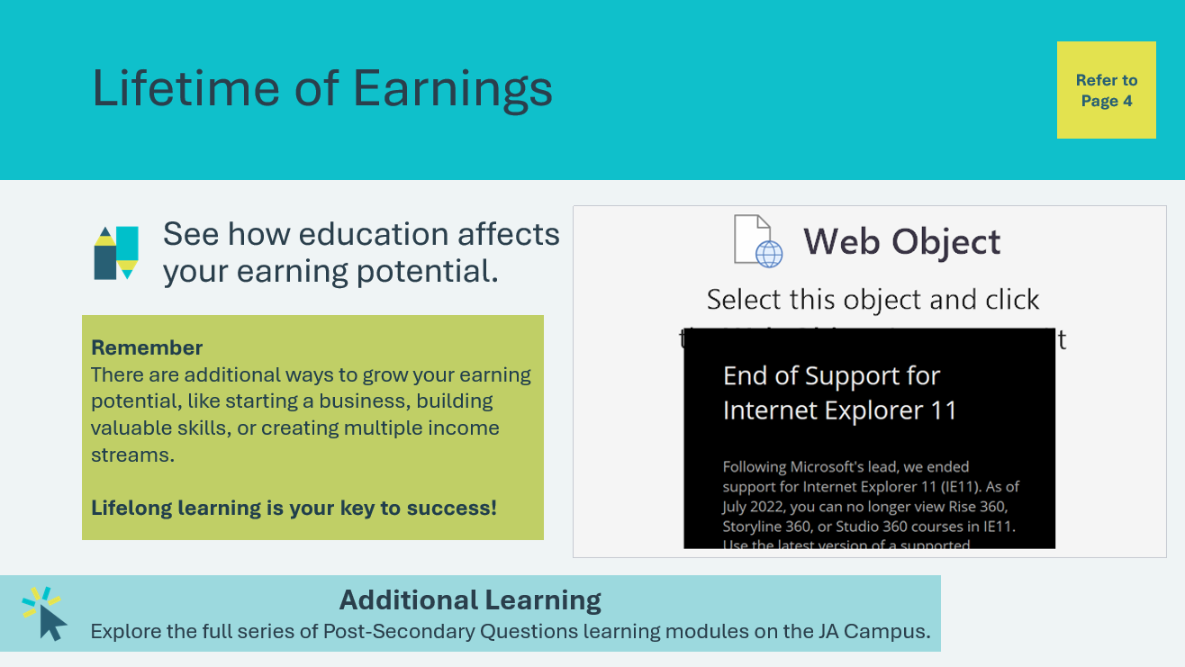 | Suggested time: 5 minutes  Students will open their Student Portfolio, page 4, and review the Lifetime Earnings chart.  Discuss with students that seeing these large sums of money can sometimes lead to a false sense of security.  - For example, when we see a high school dropout can earn $1.32 million over a lifetime, it may look like we don’t have to worry too much about education.  - Remind students that while traditional education can be a strong predictor of higher income, it’s not the only path. There are many ways to grow your earning potential and what matters most is staying curious and continuing to learn and build your skills over time.  Explain to students they are going to participate in a short activity to see what lifetime earnings look like as a monthly paycheque.  Before they do so, explore the interactive Income Predictor tool to see how post-secondary and other factors, such as where you live, impact your earning potential.  Facilitator tip: Use full screen mode while exploring the tool.  Additional Learning:  Visit the JA Campus Post-Secondary Questions Learning Modules and explore the full module, Module 4: How can post-secondary impact my future income?  *Click or tap on the Additional Learning box to open the modules in a new browser tab.  https://www.jacampus.org/post-secondary-questions/#post-secondary-income
Program Kit Materials | For slides 18-21, you will need to use the Job Cards from the program kit.
Slide 18  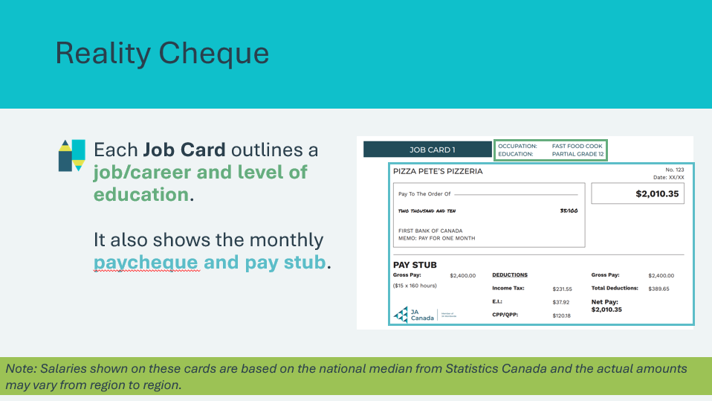  Job Cards | Suggested time: 5 minutes  Give each student a number from one to six (or place the students in six small groups). Distribute one job card to each group.  Explain to students that each Job Card represents a different type of employment and level of education. It also shows the monthly paycheque and pay stub associated with the job.  Explain the salary (or monthly wages) shown on these cards reflect a national median from Statistics Canada and actual amounts may vary from region to region. You can also mention that minimum wage varies from province to province and indicate the current minimum wage in your province. Instruct students to look at the pay stub.  Provide a few moments for the students to look at their job card.  Ask: Can anyone guess why there are deductions from your pay? Do you know where that money goes?  - Some students who already have a job may be familiar with tax deductions, but they may not fully know where the money goes or how it is used.
Slide 19  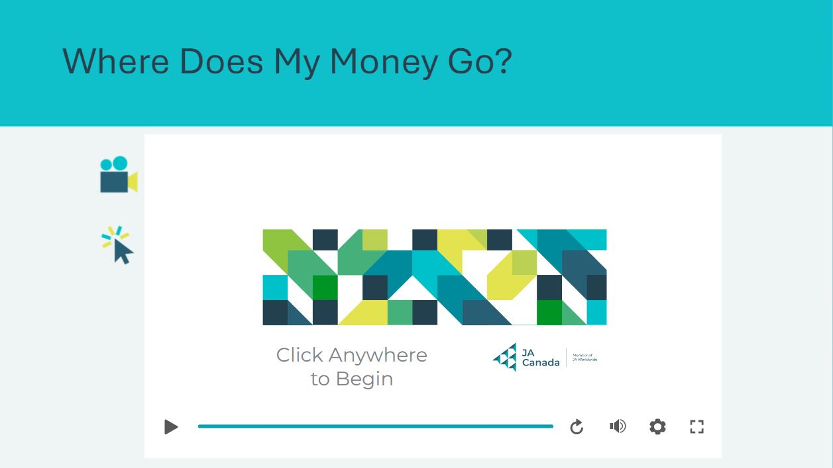 | Suggested time: 5 minutes  Explain to students you’re going to explore together the reason why some of your lifetime earnings aren’t yours to put in the bank.  Show the interactive video Where Does My Money Go?  After the video, students will refer again to the Lifetime Earnings chart in their student portfolio, page 4. Explain the lifetime earnings amounts shown reflect gross pay.
Slide 20  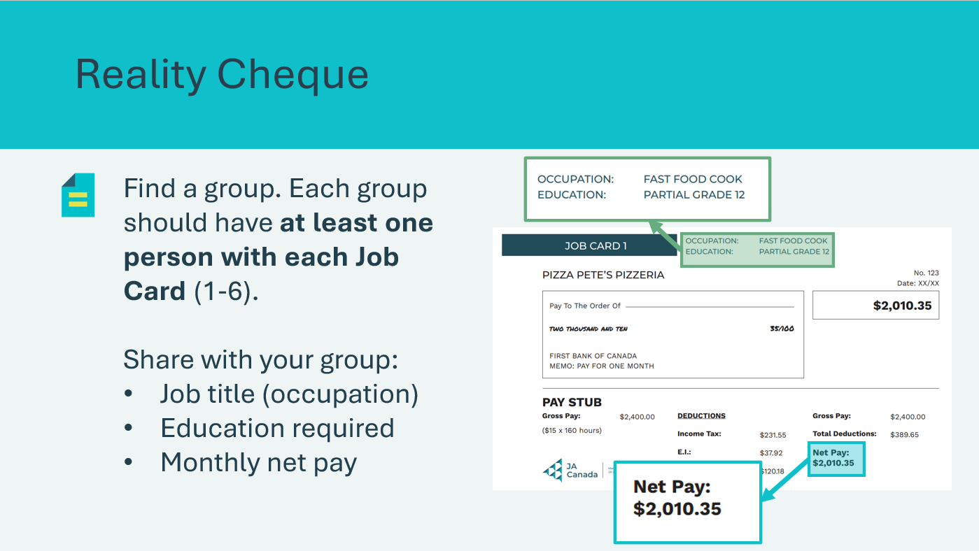  Job Cards | Suggested time: 5 minutes  Ask the students to form groups. Make sure that each group has roughly the same number of students and has at least one student with Job Cards 1 through 6 (hand out additional job cards as needed).  Provide students a few minutes to share the information on their job cards with the others in their group.
Slide 21  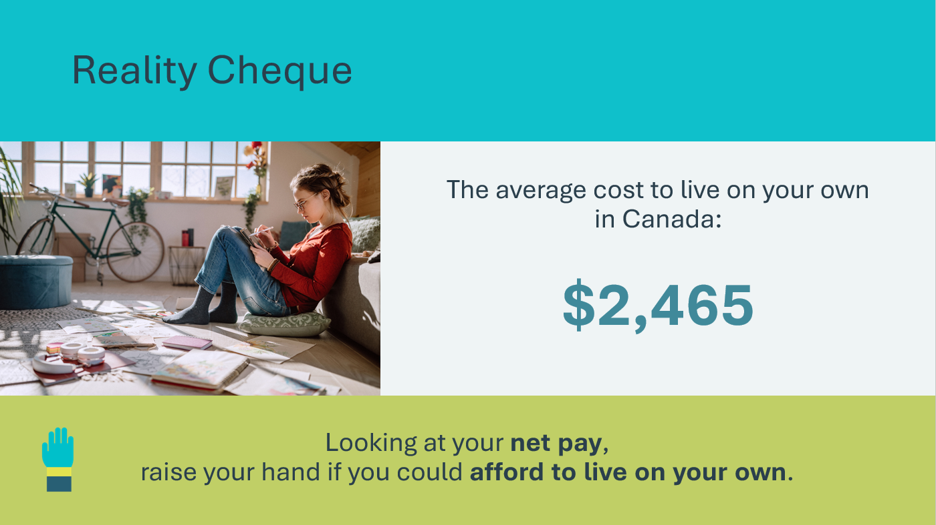  Job Cards | Suggested time: 3 minutes  Once students have had a chance to share in their groups, review the statistic about the average cost to live on your own in Canada.  Explain to students this amount includes costs such as rent for a one-bedroom apartment, groceries, internet, phone, transportation, etc. Be sure to mention this amount should only be used as a rough guideline as costs vary considerably across Canada depending on where you live and your lifestyle.  Using the net pay on their job card, ask for a show of hands of how many could afford to live on their own. For those who raise their hands, ask them to share the career on their Job Card.
Slide 22  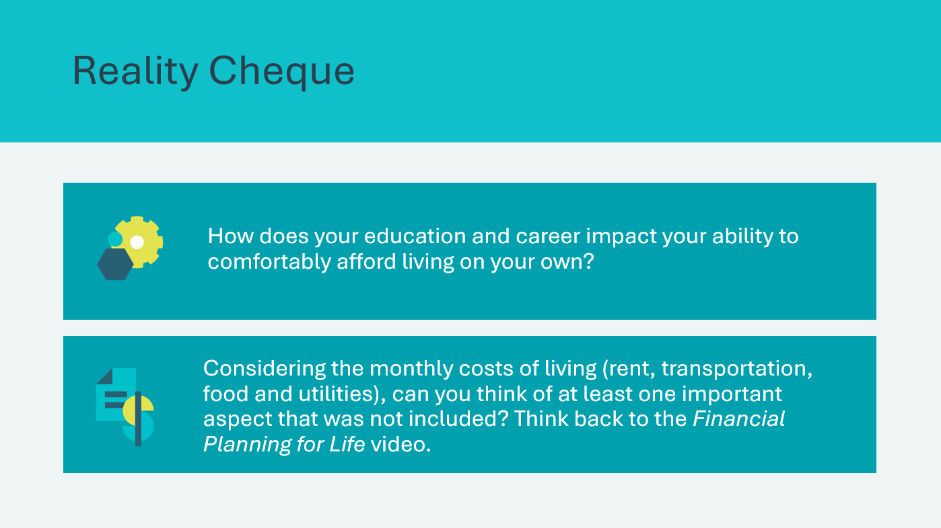 | Suggested time: 2 minutes  Wrap up the activity using the discussion questions.  Sample Answers:  - Students may offer the idea that the more education you have, the bigger the possibility you will earn more to live comfortably.  - Reassure students that just because they may earn a lower income with some jobs, it doesn’t mean they can’t afford to survive. It just means they may have to make different decisions, such as living with a roommate or choosing an apartment in the suburbs versus one in a city centre.  - Students may offer the suggestion that saving for big life milestones, such as retirement or starting a family, were not included.
Summary and Review 5 min
Slide 23  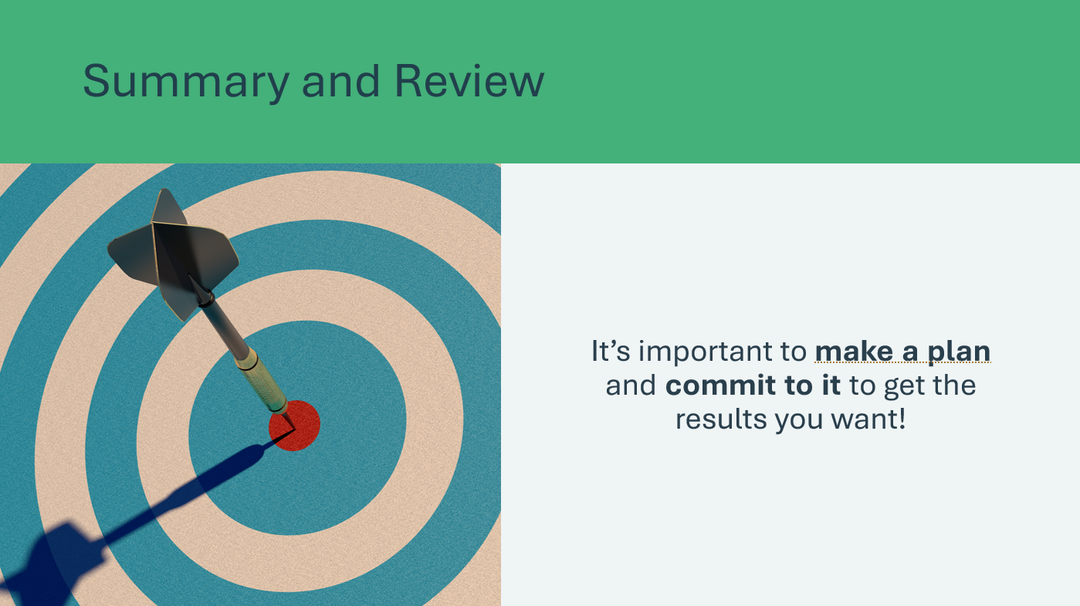 | Suggested time: 5 minutes  Explain that although the basics of financial planning are easy to understand (earn money, save money, and spend wisely), many Canadians live month-to-month. This means they have just enough to pay for their monthly living expenses. They may be in debt or have little or no savings for a rainy day.  It’s not enough to understand the right thing to do. You must make a plan and commit to that plan to get the results you want.  Remind the students that financial decisions are something that we all learn to make and that the lessons learned by others can often be invaluable.  Facilitator Tip: Encourage students to speak with older family members about their early financial decisions and what they learned from their experiences.  Volunteer Connection: You may wish to share a personal story about an early financial decision you made and what you learned.
Slide 24  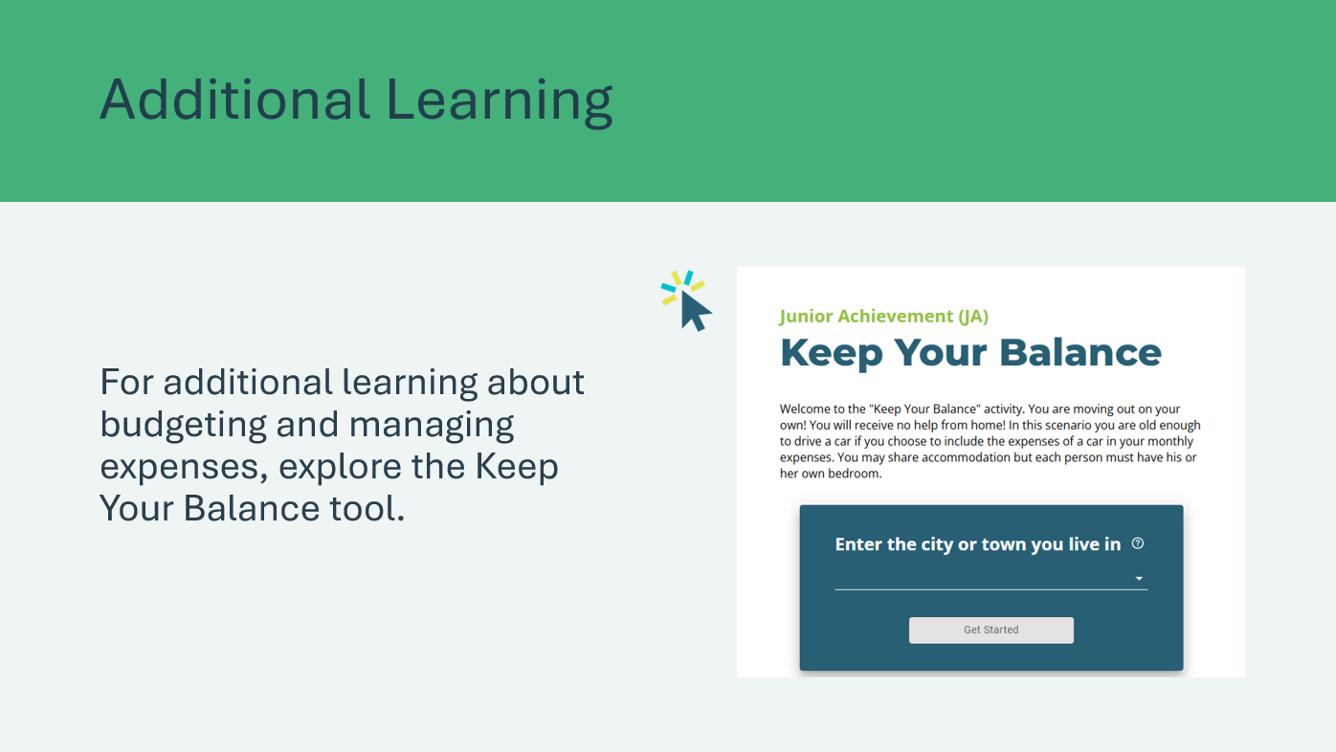 | Suggested time: Optional  *Click or tap the image to open in a new browser tab.  Encourage students to use Junior Achievement’s Keep Your Balance interactive online budgeting tool  https://jacanada.org/keep-your-balance-app/.
Slide 25  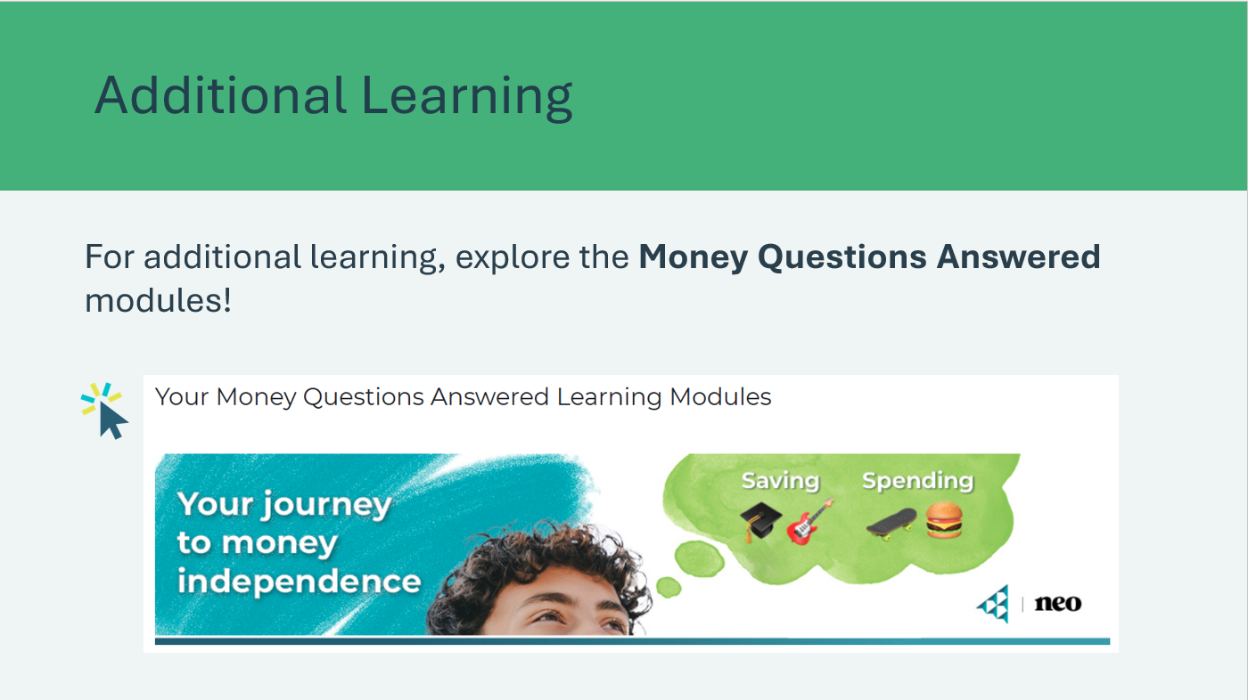 | Suggested time: Optional  For additional learning, explore the Money Questions Answered learning modules.  https://www.jacampus.org/money-questions-answered/

Lesson 2: Saving for Life
Slide 26 – Lesson 2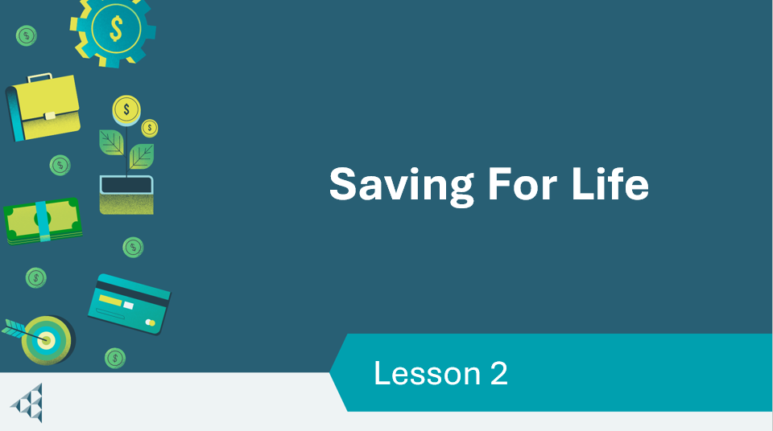 | Lesson 2: Saving for Life
Slide 27 – Objectives  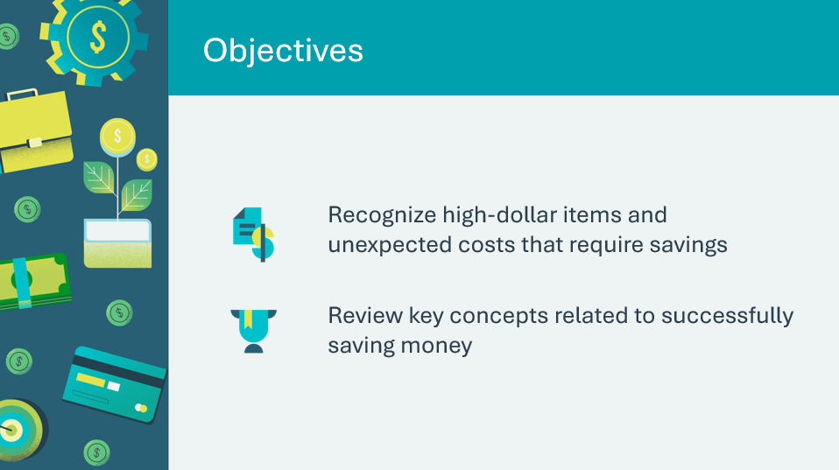 | Optional – review the learning objectives for the lesson
Slide 28 – Introduction  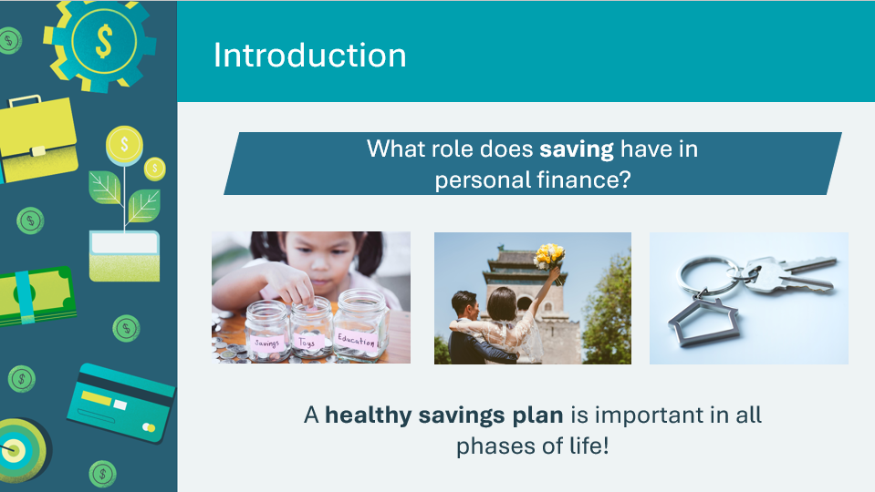 | Introduce the lesson by explaining that saving is an important part of financial planning. Invite students to share saving strategies they use.  Volunteer connection: Share a story about how having a savings plan has helped you throughout the course of your life.
Slide 29 – Activity Menu  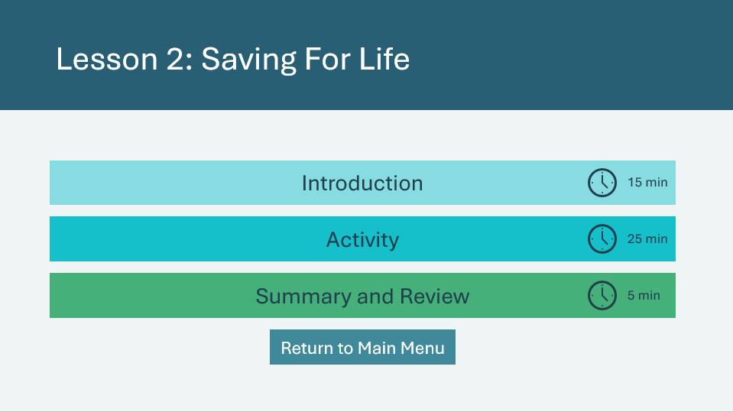 | *Select the button to navigate to the activity.  After you have completed an activity, you will be redirected back to the activity menu.  *Click or tap the Return to Main Menu button to return to the Lessons (Slide 5)
Introduction 15 min
Slide 30  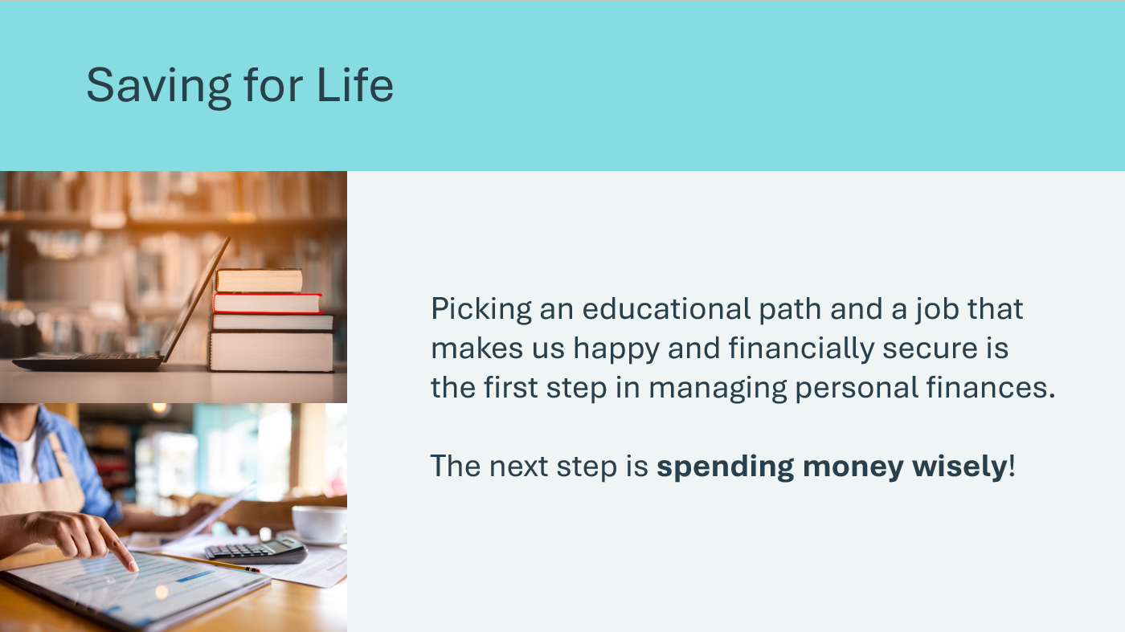 | Suggested time: 2 minutes  Review the prompt on the slide. Tell the students that budgeting is the key to spending wisely. They will explore the first step to any good budget— saving money.
Slide 31  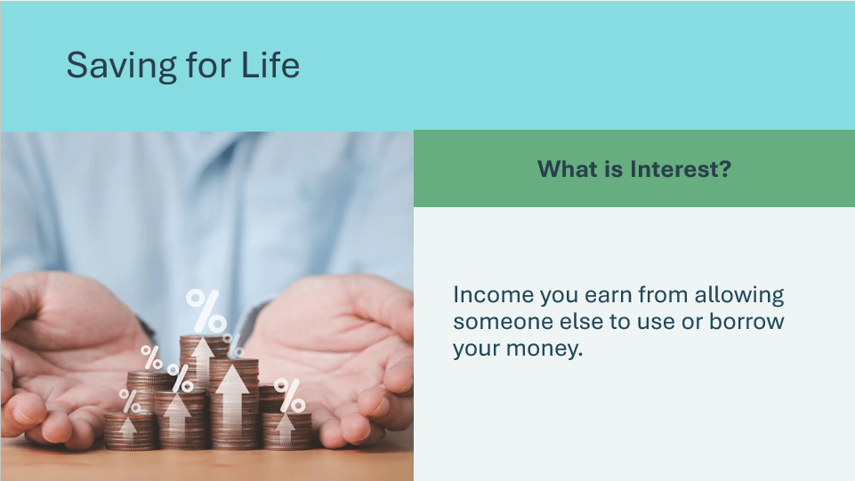  Slide 32  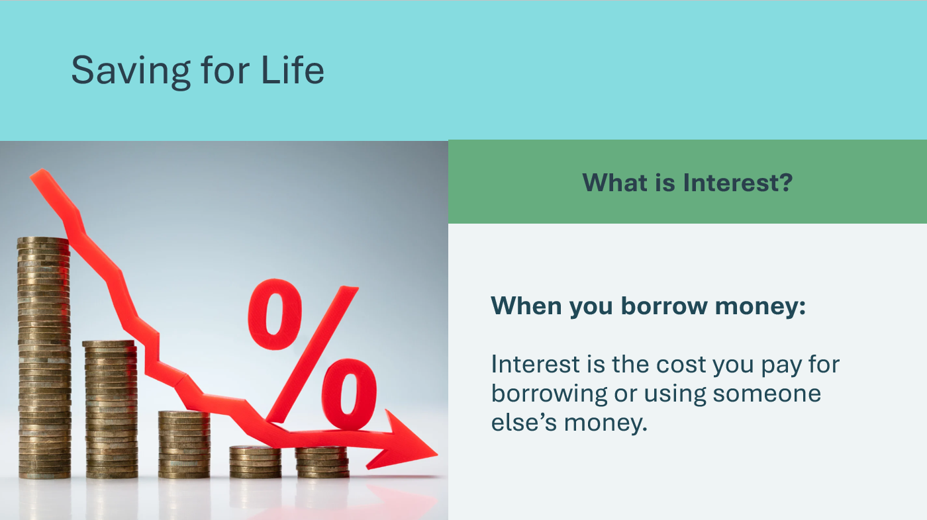 | Suggested time: 2 minutes  Tell students you will define a few key terms that will be important in this lesson. Being with defining interest.  When You Save Money:  - Think of interest as a bonus you get for keeping your money in a savings account.  - For example, if you deposit $100 in a savings account with a 5% annual interest rate, the bank will give you an extra $5 after a year. So, you end up with $105. The interest is like a thank-you gift from the bank for letting them use your money  Remind students that interest can be income earned from letting someone borrow or use your money, but if you are the one borrowing money, it’s a cost you pay.  When You Borrow Money:  - Interest is the cost you pay for borrowing money. If you take out a loan, you have to pay back not just the amount you borrowed but also some extra money.  - For example, if you borrow $100 at a 9% interest rate, you might end up paying $109 in total. The extra $9 is interest, that the lender charges you for letting you use their money.
Slide 33  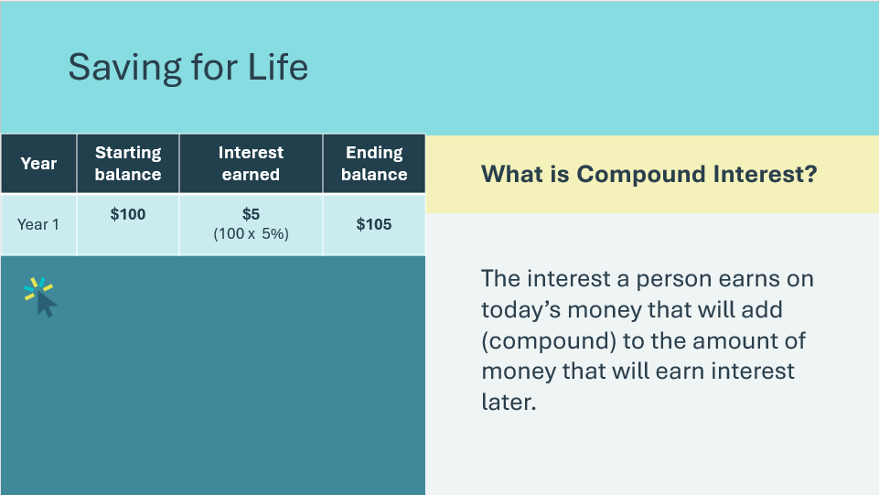 | Suggested time: 3 minutes  Define compound interest. The students may be confused about the definition of compound interest. Further explain that compound interest is a way your money grows over time, and it’s like earning interest on interest.  Use the table to demonstrate how compound interest words.  *Click or tap to reveal each row in the table.  - Suppose you put $100 in a savings account with a 5% annual interest rate. At the end of the first year, you’d earn $5 in interest, so you now have $105.  - In the second year, you earn 5% interest on $105, not just the original $100. So you get $5.25 in interest that year. Your total balance is now $110.25. Each year, the interest is calculated based on your new balance, which includes the interest earned previously.  In short, compound interest means your money grows faster because you’re earning interest on both the original amount and the interest that’s already been added. Over time, this can lead to significant growth, especially if you leave your money in the account and let it keep compounding.
Slide 34  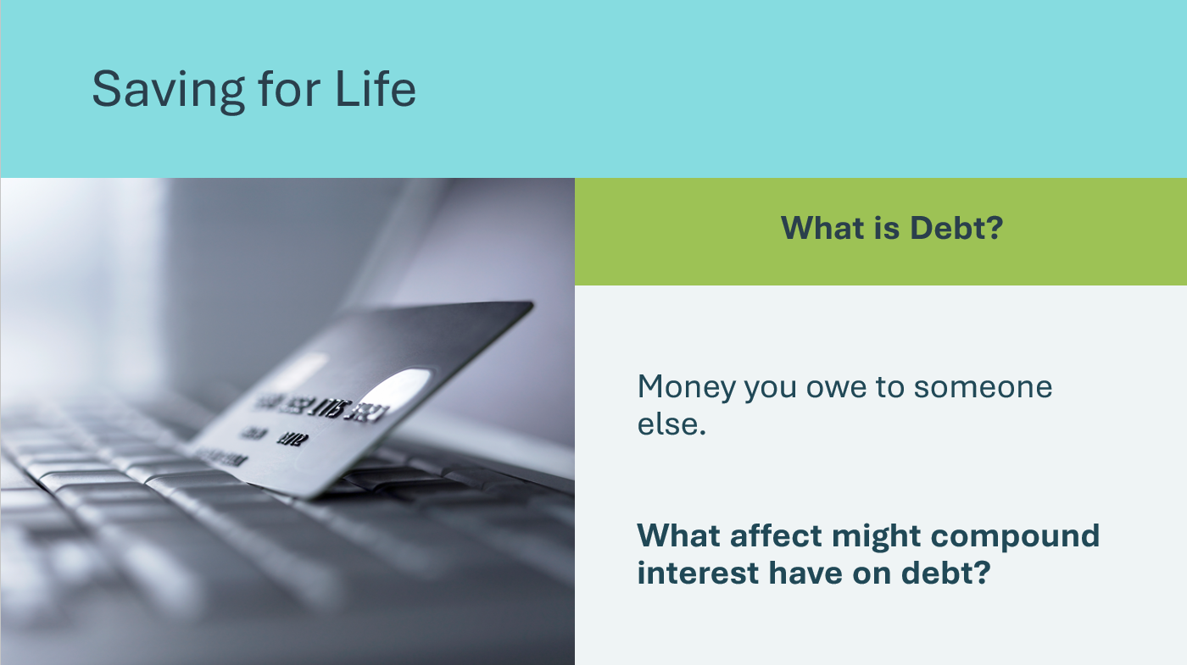 | Suggested time: 2 minutes  Define debt. Debt is like borrowing money from someone with the promise to pay it back later.  Example:  - Imagine you want to buy a new video game, but you don’t have enough money right now. If you ask a friend to lend you the money, you’re in debt to them because you owe them that amount.  - When you borrow money, you usually have to pay it plus interest.  - So, if you borrowed $50 to buy the game, your friend might want you to pay back $55 later. The extra $5 is the cost of borrowing.  Ask the prompt on the slide and remind students compound interest is calculated on the original amount and in the interest accumulated, meaning compound interest works against you when you’re in debt.
Slide 35  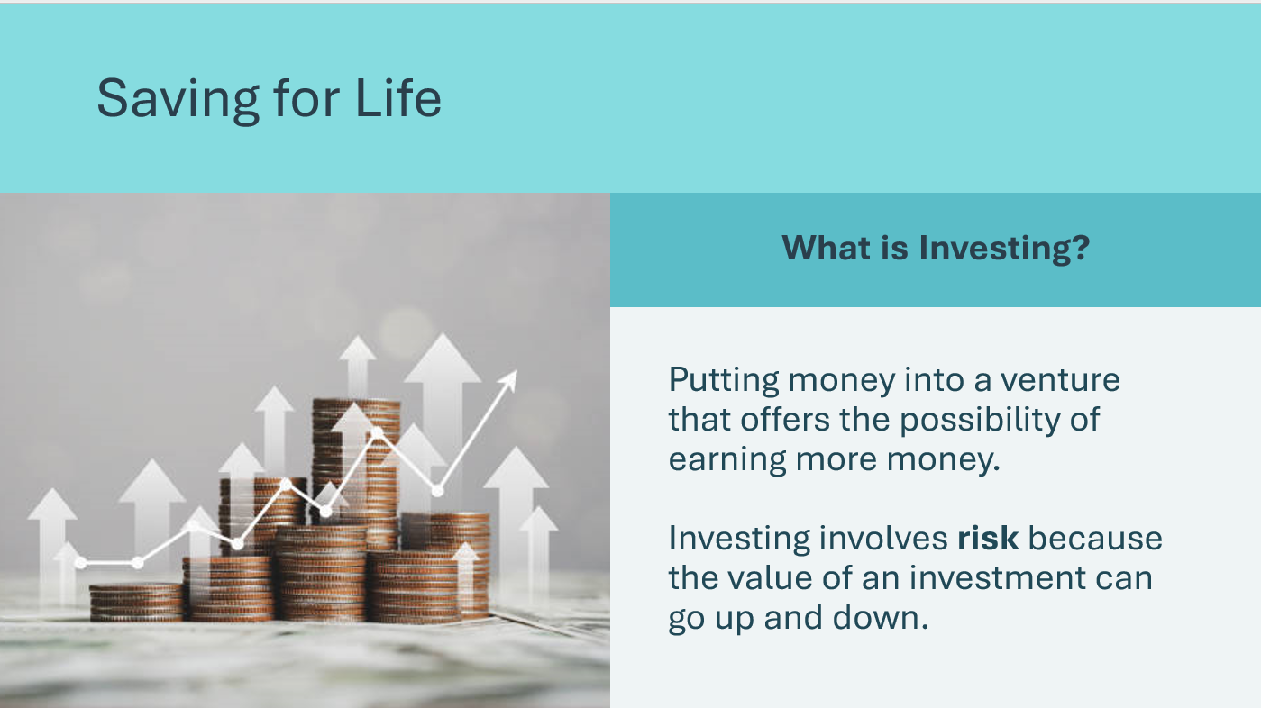 | Suggested time: 2 minutes  Define investing. The goal of investing is to grow your money over time. It’s different from just saving, where you keep money in a bank account and earn a small amount of interest. Investing usually involves taking a bit more risk, but it has the potential to earn higher returns.  It often involves taking some risks because the value of investments can go up and down. It’s important to research and understand what you’re investing in, and it can be helpful to start learning about different investment options as you get older.
Slide 36  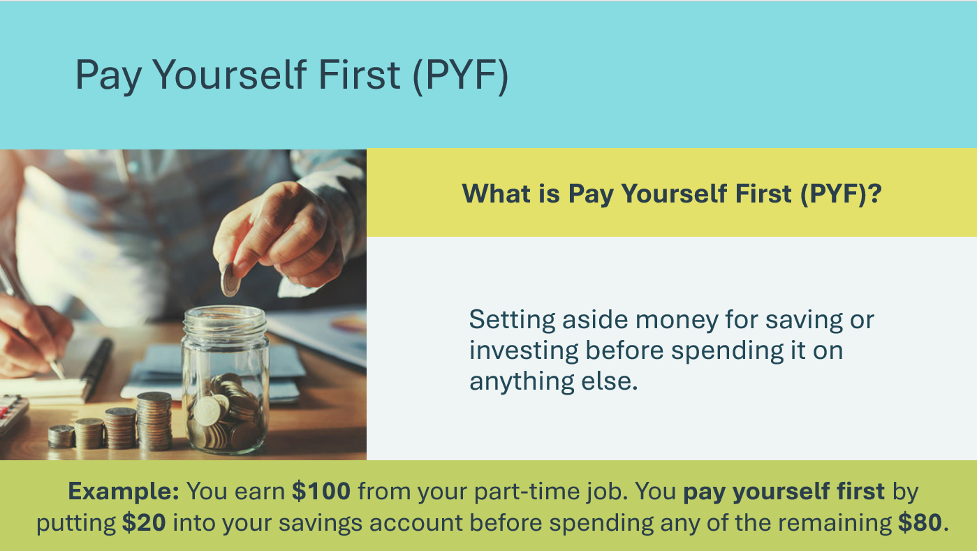 | Suggested time: 3 minutes  Define Pay Yourself First (PYF) as a money habit that involves setting aside some of your money for savings or investments before spending it on anything else.  You treat your savings like an important bill that you need to pay, just like you would pay for things like phone bills or food. This helps to ensure you're always saving a part of your money instead of spending everything and saving what’s left over.  You can set up automatic transfers from your checking account to your savings account, so you don’t have to think about it each time you get paid.  By paying yourself first, you build up your savings and investments over time, which can help you reach your financial goals and have money for things you want or need in the future.
Slide 37  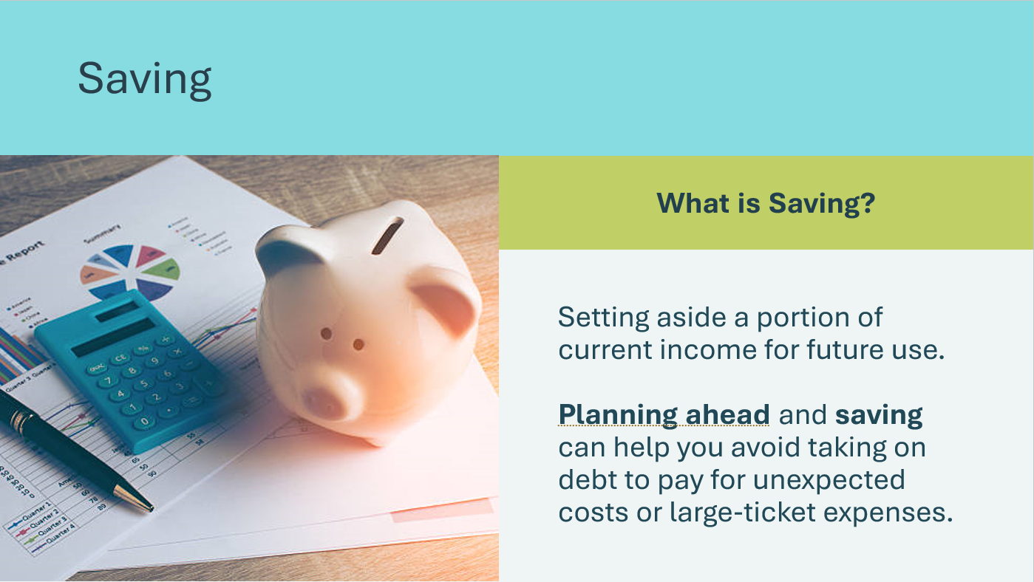 | Suggested time: 2 minutes  Define saving. Add that although most people know they should set aside money each month, many find it difficult to do.  Because people have unlimited wants but limited income, many people choose to indulge their wants now and worry later about future needs.  Without money in a savings account, people often choose to go into debt to pay for their wants. They pay interest to someone else instead of being paid interest on a savings account, like they would if they had planned ahead and saved.  To have healthy personal finances, people need to save for:  - Large-ticket items – such as a car, a refrigerator, or a major medical expense.  - Unexpected costs – such as an accident or an unplanned opportunity.  Volunteer connection: Provide personal examples of a time when having money in a savings account was needed for expensive or unexpected items.
Activity 25 min
Slide 38   | Suggested time: 2 minutes  Review the scenario as a class.
Slide 39  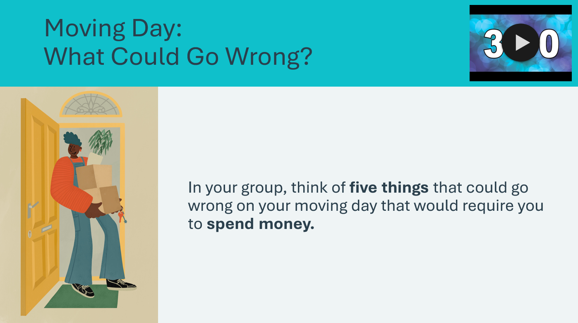 | Suggested time: 5 minutes  Ask the students to form groups of three or four. Alternatively, students can complete the activity independently at their desk.  Encourage the students to come up with unique ideas. Their ideas can be funny, but they should be school-appropriate and somewhat realistic.  Provide groups with 3 minutes to come up with their 5 ideas. You may wish to use the timer on the slide (Note: a chime sound will indicate the timer has reached 0:00). Afterwards, ask groups or individuals to share some of their ideas.
Slide 40  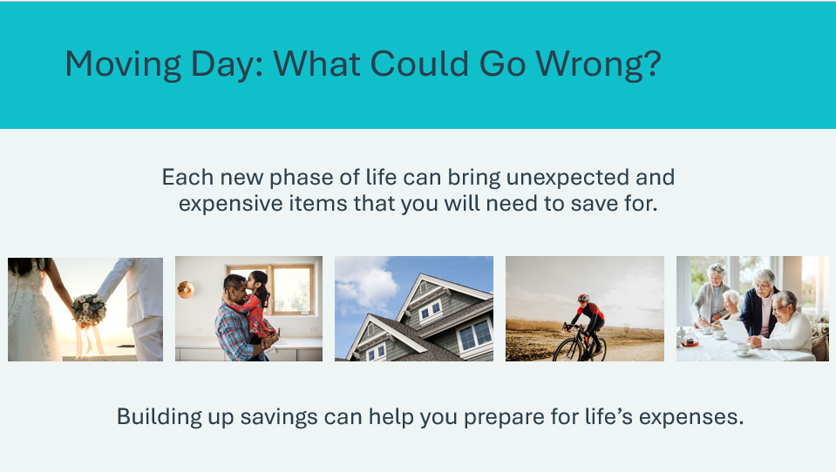 | Suggested time: 3 minutes  Explain to students that although their moving day may go smoothly, each new phase of life will bring unexpected and often high-dollar items they need to save for.  Having savings built up can help you be prepared for expenses such as cars, education, marriage, kids, housing, hobbies, and ultimately retirement, plus many unexpected costs along the way. If you wait until you have extra money to begin saving, you may never be ready for life’s financial challenges.  Volunteer connection: Describe a personal example of a time when a new phase of life brought unexpected or high-dollar expenses that required savings.
Slide 41  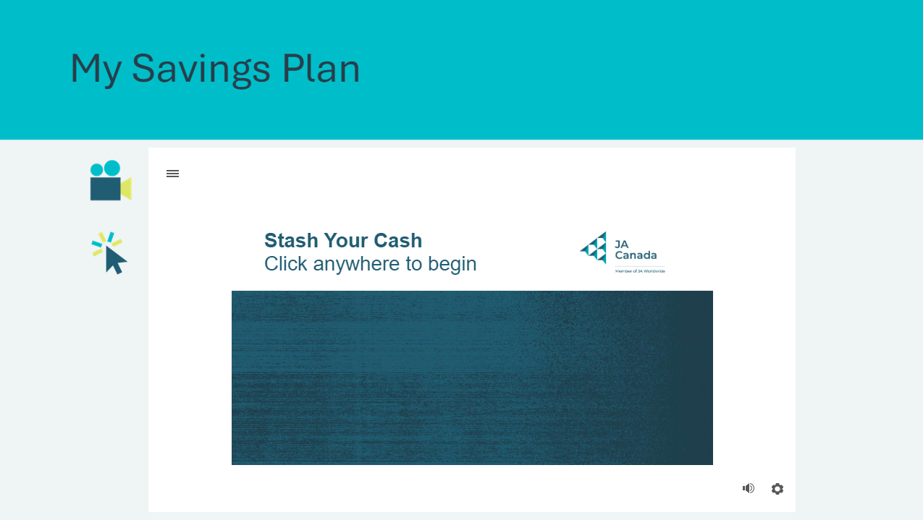 | Suggested time: 5 minutes  Show the Stash Your Cash interactive video.
Slide 42  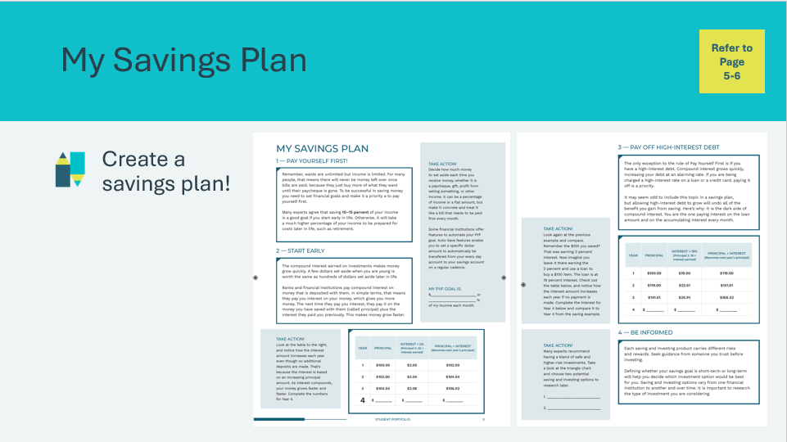 | Suggested time:10 minutes  Students will complete the “Take Action” portions of their Savings Plan in their student portfolio, page 5 & 6, as you review each section on the following slides.
Slide 43  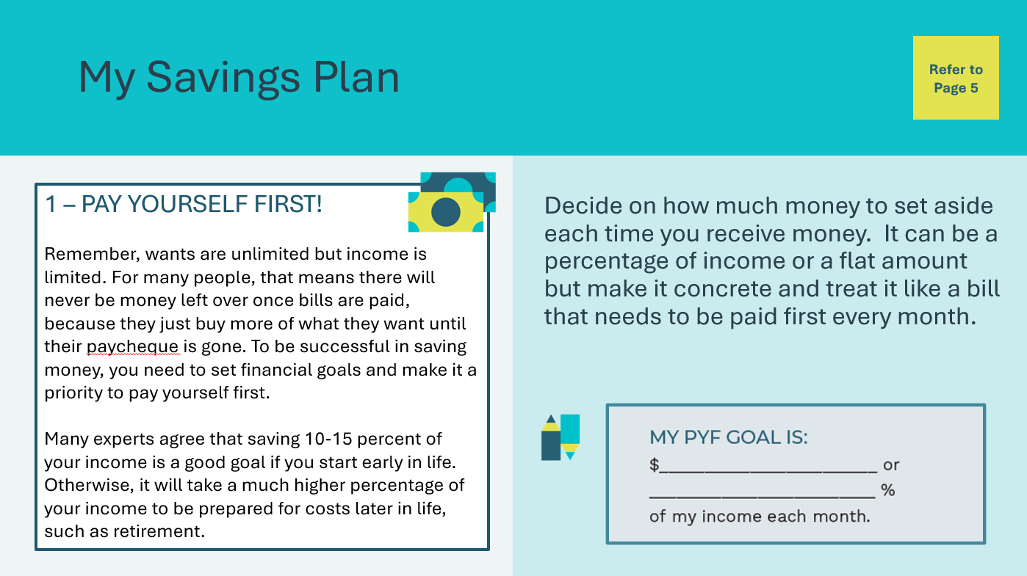 | Review the information on the slide and give students a few moments to fill in the blanks.  Facilitator tip: Invite a few student volunteers to read the information aloud.
Slide 44  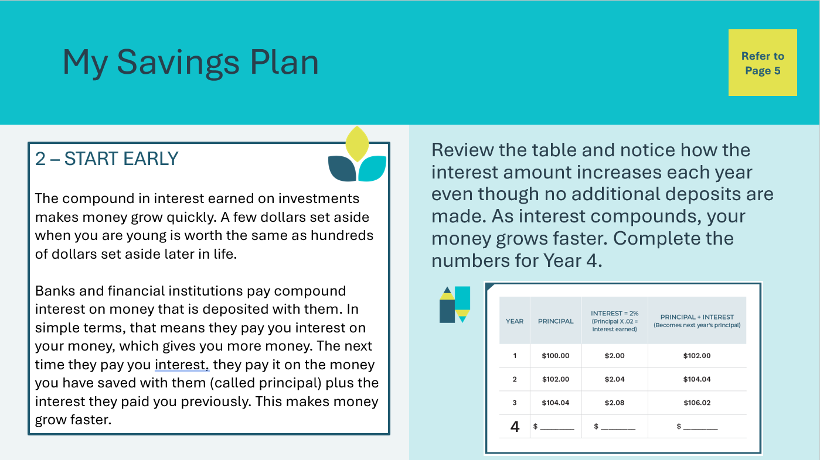 | Review the information on the slide and give students a few moments to fill in the blanks.  Facilitator tip: Invite a few student volunteers to read the information aloud.  Answer key:  - Principal: $106.02  - Interest: $2.12  - Principal + Interest: $108.14
Slide 45  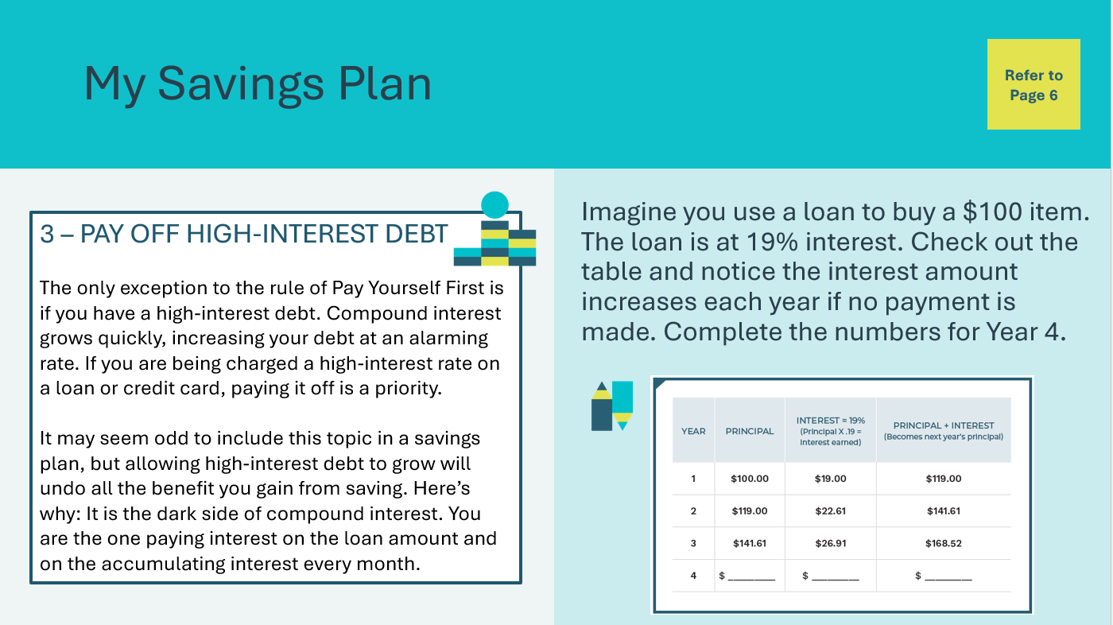 | Review the information on the slide and give students a few moments to fill in the blanks.  Facilitator tip: Invite a few student volunteers to read the information aloud.  Answer key:  - Principal: $168.52  - Interest: $32.01  - Principal + Interest: $200.54
Slide 46  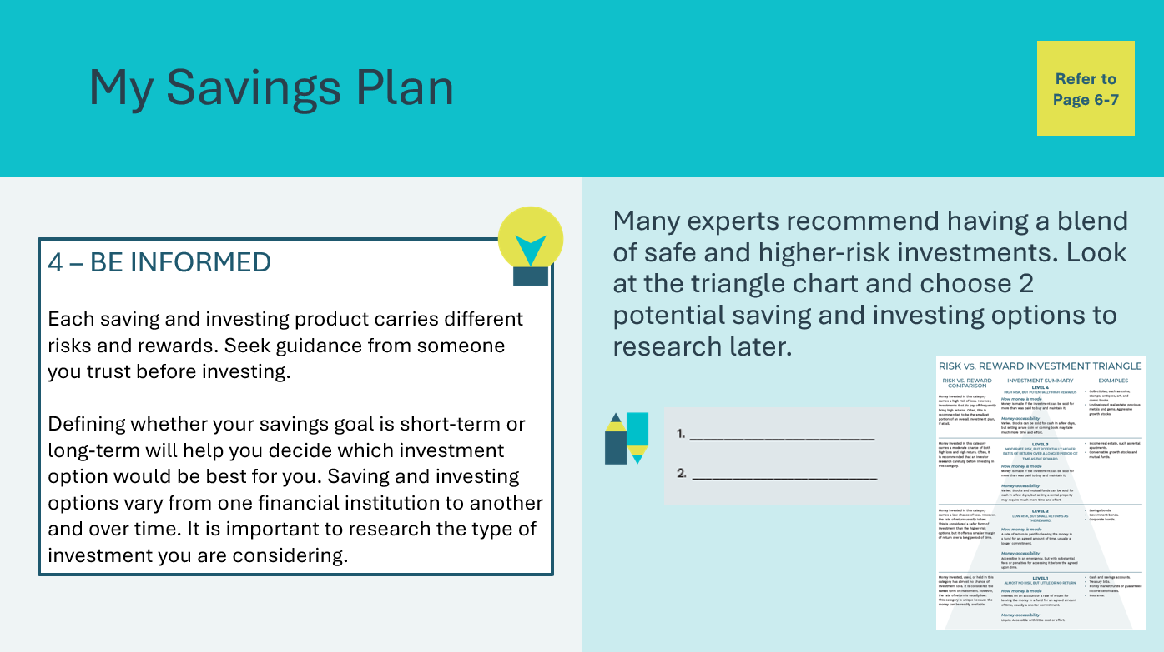 | Review the information on the slide and give students a few moments to fill in the blanks.  Facilitator tip: Invite a few student volunteers to read the information aloud.  Provide time for students to review the Risk vs. Reward Investment Triangle page. Students can review independently or with a partner.
Summary and Review 5 min
Slide 47  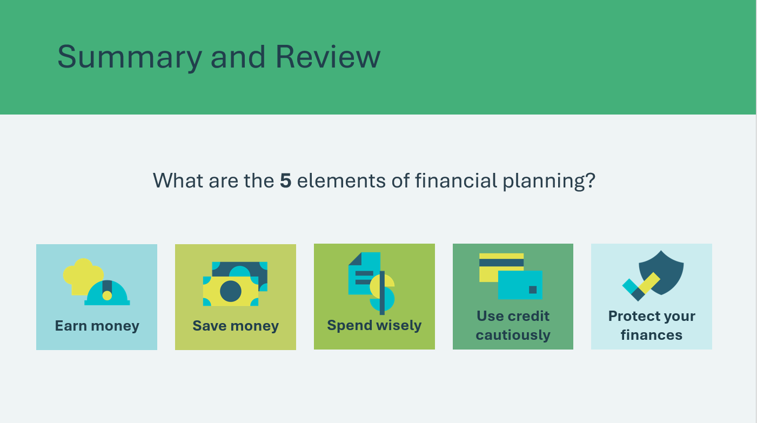 | Suggested time: 5 minutes  Remind the students of the five elements of financial planning in Personal Finance: Earn money, save money, spend wisely, use credit cautiously, and protect their finances.
Slide 48  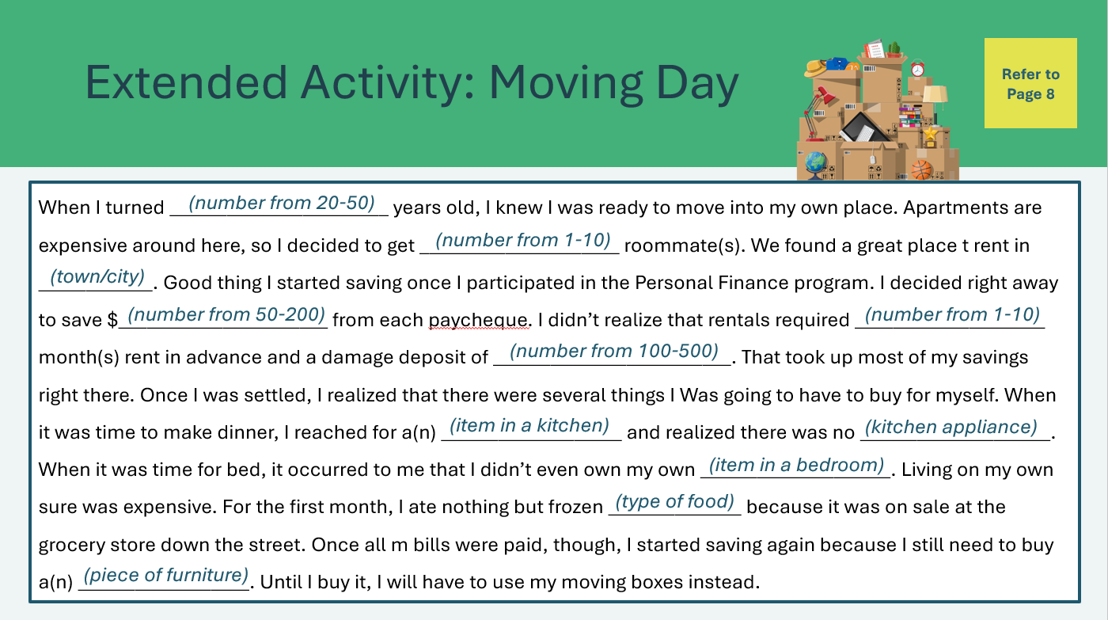  Slide 49  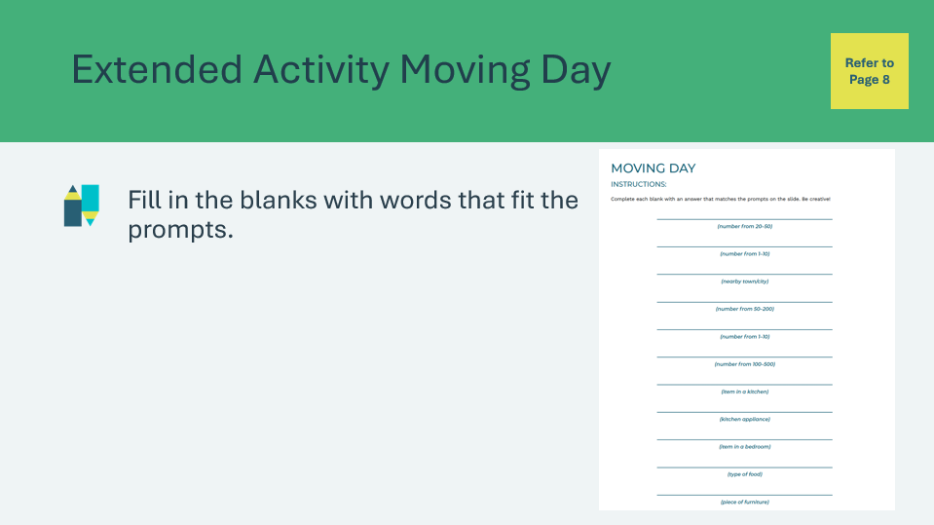 | Suggested time: Optional  Tell students they will help complete the story by coming up with part of it themselves! Read the story, emphasizing the blanks in each sentence.  Have the students fill in the blanks in their student portfolio, page 8, with words that fit each of the prompts. For example, if the prompt is Form of Transportation, the student might choose a car, boat, train or other accurate but funny mode of transportation, such as a donkey. Let students know their answers can be funny, but they should be school appropriate and correctly fit in the category listed.  Return to the previous slide and for each blank, ask student volunteers to give you their response. If possible, write them in the blanks, or simply verbally add to the story as you read it aloud.  Explain to the students that while some of the items in the story may be a bit absurd, it is realistic. Reread the story aloud and, based on your personal experience, describe costs the students might face when they move into their own place.  - Some examples are first and last month’s rent, small appliances, and food.  For additional learning on budgeting and preparing for life after high school, students can explore the Post-Secondary Learning Modules on the JA Campus.  https://www.jacampus.org/post-secondary-questions/
Slide 50  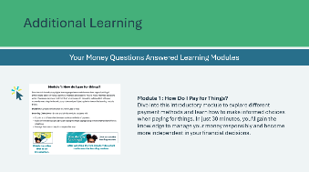 | Suggested time: Optional  *Click or tap on the image to open in a new browser tab.  For additional learning on methods of payment and making financial decisions, students can explore the Money Questions Answered Learning Modules – Module 1.

Lesson 3: The Budget Game
Program Kit Materials | Scenario cards Categories cards  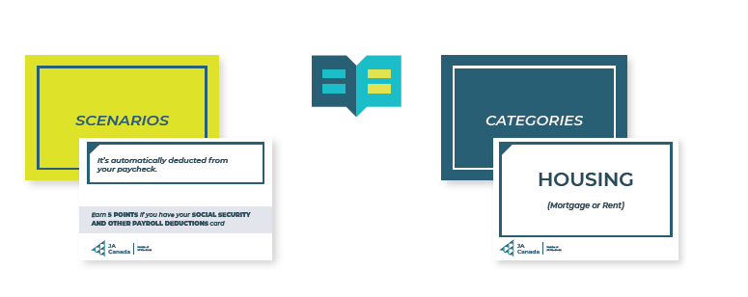
Slide 51 – Lesson 3  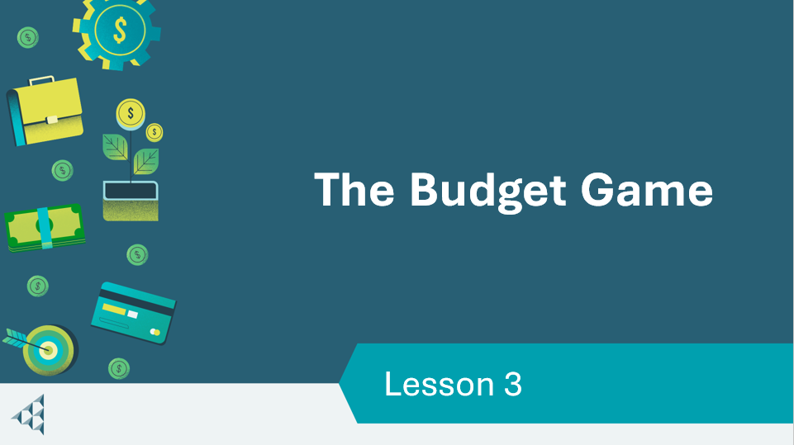 | Lesson 3: The Budget Game
Slide 52 – Objectives  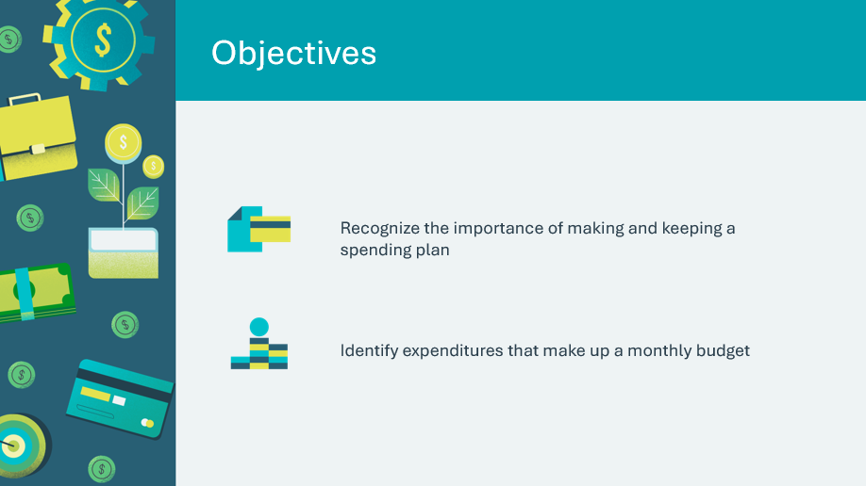 | Optional – review the learning objectives for the lesson
Slide 53 – Introduction  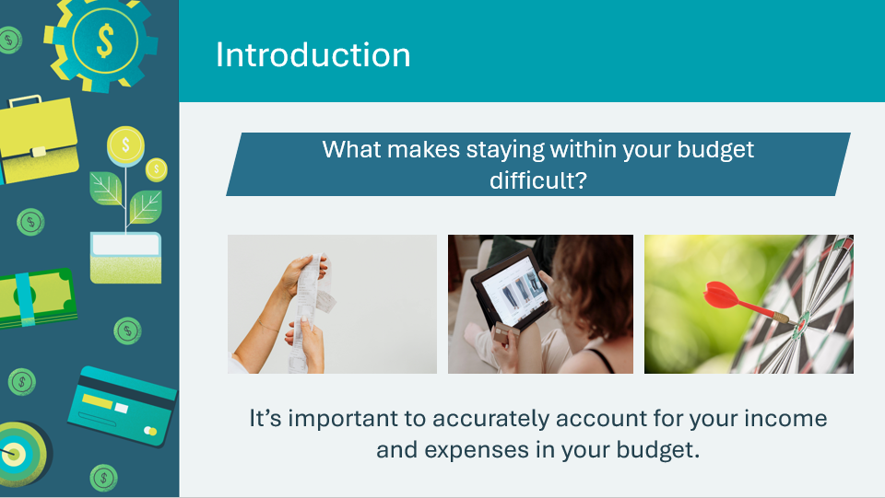 | Introduce the lesson by generating a discussion about the challenges of staying within a budget.  Use the prompt on the slide or the additional discussion prompts below:  - Think of a time when you thought you had enough money for a purchase, but it was more expensive that you expected.  - Think of a time when you wanted something but you knew you didn’t have the money to buy it.  Invite a few students to share their responses.  Volunteer connection: Share an example of a time you had difficulty sticking to your budget.
Slide 54 – Activity Menu  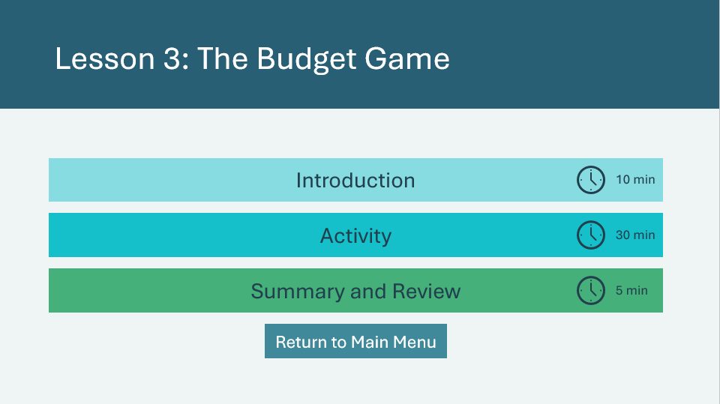 | *Select the button to navigate to the activity.  After you have completed an activity, you will be redirected back to the activity menu.  *Click or tap the Return to Main Menu button to return to the Lessons (Slide 5)
Introduction 10 min
Slide 55  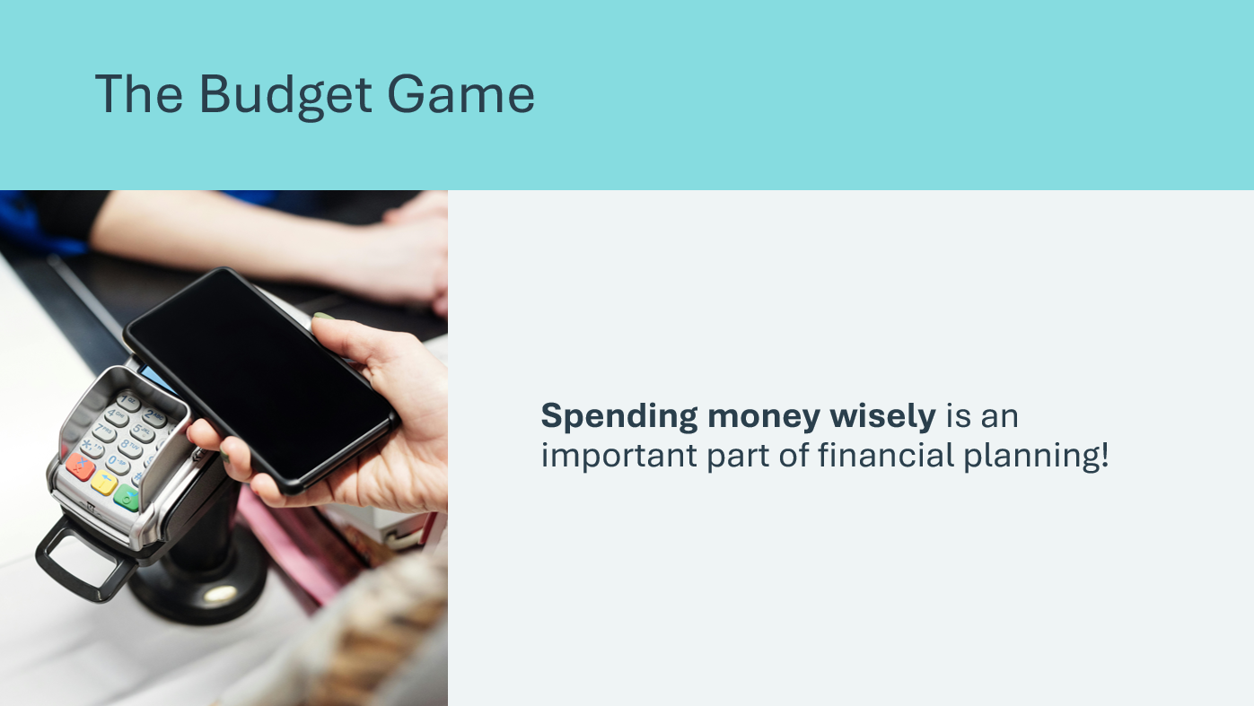 | Suggested time: 2 minutes  Read the prompt and recall the opening discussion about the challenges of sticking to a budget. Explain that individuals, families, cities, provinces/territories and even countries face these same challenges. Things often end up being more expensive that we anticipate, or we just don’t have enough money to get all the things we want and need.  Life is expensive, and that means tough choices have to be made, because if we spend more than we can afford, it leads to financial problems.
Slide 56 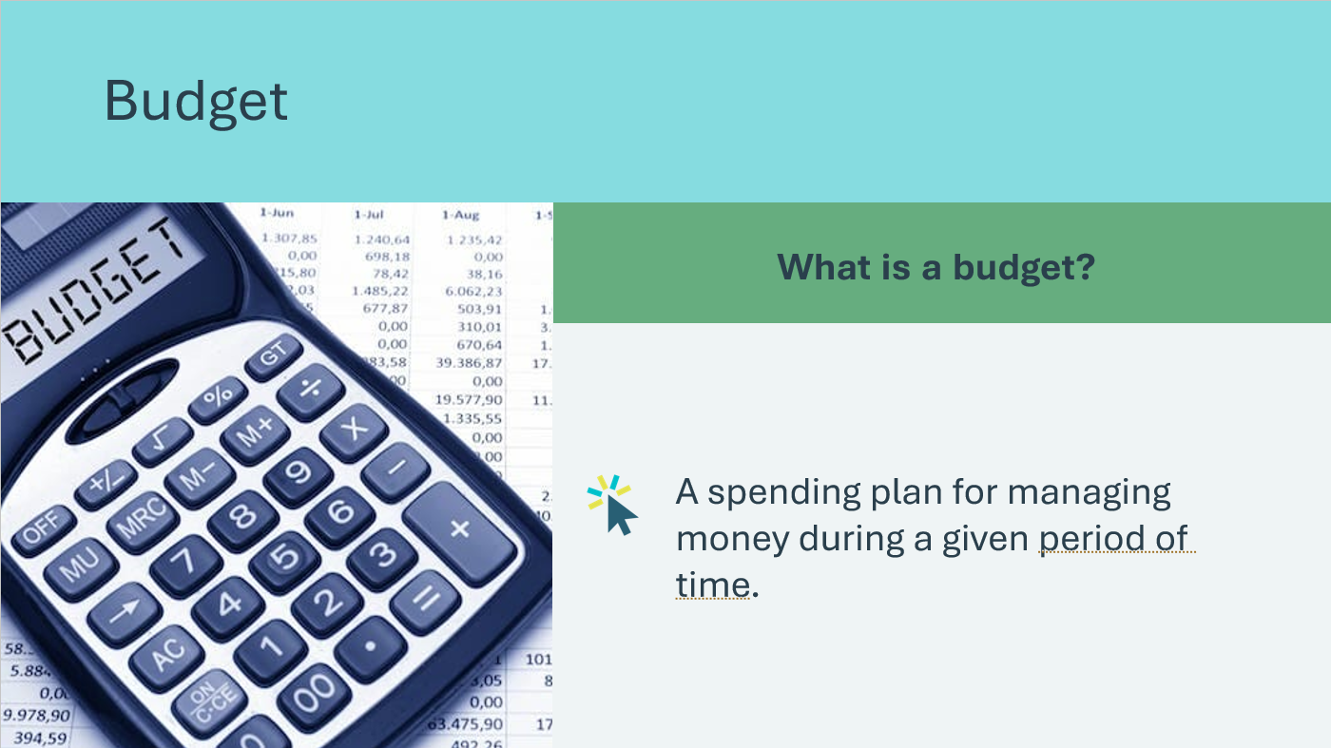 | Suggested time: 2 minutes  Ask: What is a budget? Invite a few students to share a response.  *Click or tap to reveal the definition.  Define budget. Explain that although it may be challenging to spend wisely, the solution is to make a realistic list of what expenses you have, build a budget, and stick to the budget – even if it requires a tough choice of giving up something you want.
Slide 57  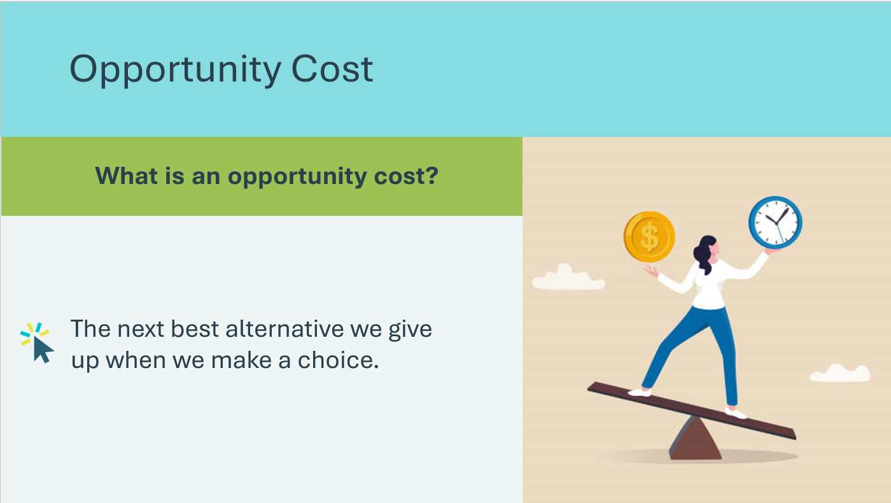  Slide 58  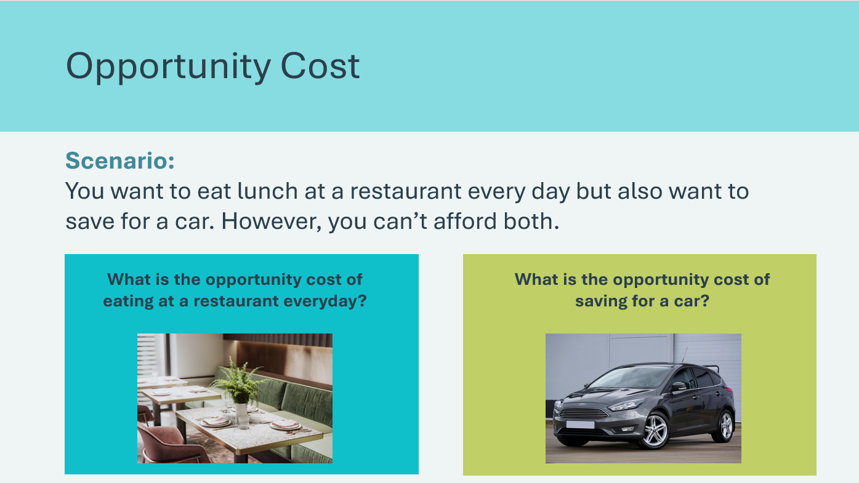 | Suggested time: 3 minutes  Ask: What is an opportunity cost? Invite a few students to share a response.  *Click or tap to reveal the definition.  Define opportunity cost. Explain that sometimes you have to make a choice between two options or opportunities. The cost of choosing one option is missing out on the other option.  Review the scenario as a class. Ask students to identify the opportunity cost of each option. If you want to eat lunch at a restaurant every day and also want to save for a car—but don’t have enough money for both—the one not chosen is the opportunity cost.  - If you choose to eat out everyday, the car becomes the opportunity cost of buying those lunches  - However, if you choose to save up for a car, the restaurant lunches become the opportunity cost.  So, when you make a budget and you have to make a choice about what to cut, the item you have to give up is the opportunity cost.
Slide 59  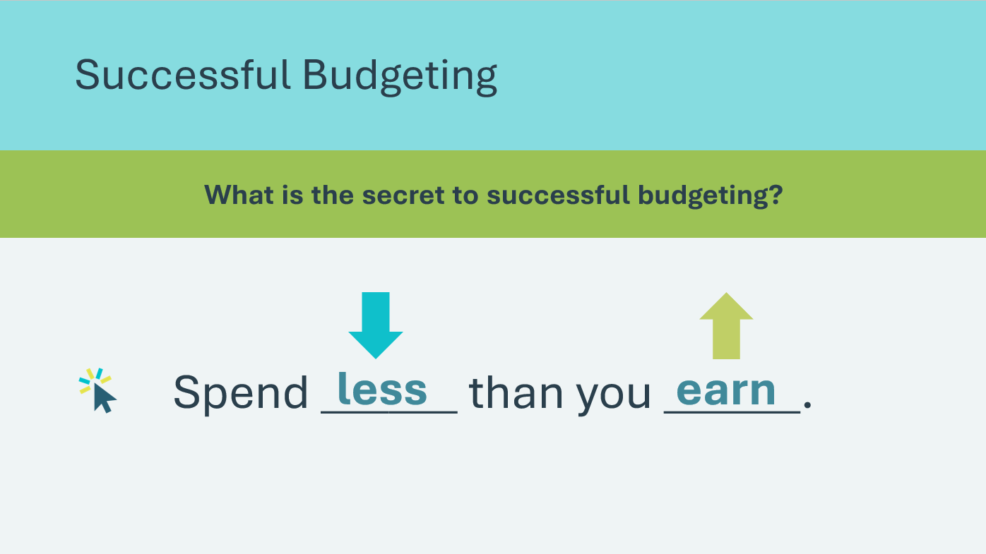 | Suggested time: 3 minutes  Allow students to make guesses about what the secret to successful budgeting is.  *Click or tap to reveal the words in the blanks.  The secret to successful budgeting can be summed up in a few simple words: Spend less than you earn.  Challenge the students by asking: If this process is so simple, why are so many people, cities, and even countries unable to stay within a budget, racking up debt and credit problems? Allow a few students to share their ideas.  According to the Financial Consumer Agency of Canada, about 60% of Canadians don’t have a budget. Many consumers try to find a way to pay for all the things they want, usually by over-extending their credit, causing even further problems with their long-term finances.  Explain that if you want to spend less than you earn, you will have to make a realistic budget that accounts for as many costs as possible. And you will have to stick to that budget even if it means you can’t have items you really want.  Volunteer connection: Describe a personal or local example of a time when a budget prevented a problem, or a lack of a budget led to a problem.
Activity 30 min
Program Kit Materials | For slide 60, you will need to use the Scenario Cards and Category Cards from the program kit.
Slide 60  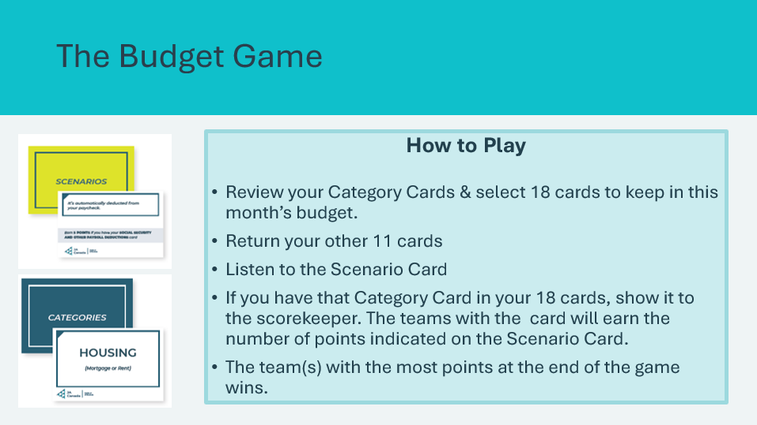  Scenario Cards  Category Cards | Suggested time: 18 minutes  Prepare for the game:  - Organize the students into teams of three or four.  - Distribute a set of Category Cards to the teams and ask them to separate the cards along the perforated lines.  - Assign each team a number or name for scoring purposes.  - Draw a scorecard on the board with each team labelled.  Facilitator tip: Ask the teacher or a student volunteer to be the score keeper.  Tell the students they will compete against their classmates to see which team is best at budgeting.  Review how to play the game:  - There are 29 Category Cards in a set. Each card is labeled with an item that costs money and should be considered when deciding on categories for a personal spending plan.  - Because of limited income, teams only have enough money to pay for 18 of the cards in this month’s budget.  - Teams decide which 11 cards to leave off the budget for the month. Teams turn in these cards to the teacher or volunteer to prevent cheating.  - The facilitator draws a Scenario Card at random from the container and reads it aloud to the class.  - Teams that still have that Category Card in their pile of 18 cards must show it to the scorekeeper. Those teams earn the number of points indicated on the Scenario Card. Since some expenses are more necessary than others, some cards are worth more points.  - Repeat the process by drawing a new card until 10 scenarios have been read.  - The team(s) with the most points at the end of the game wins.
Slide 61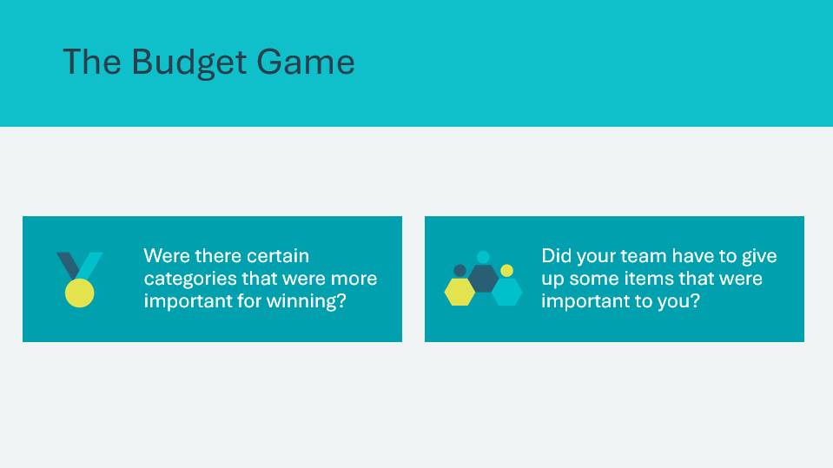 | Suggested time: 2 minutes  Ask the students to reflect on the outcomes of the game using the discussion questions.  Some teams may have chosen to cut categories that are essential, such as housing, or required by law, such as taxes.  Discuss the consequences people face when they make those choices in real life: foreclosure of their homes and fines and penalties for not paying taxes.  Remind students of the general theory behind budgeting: You must spend less than you make. Successful budgeting requires a realistic spending plan and a commitment to stick with the budget, even when tempted by something you really want.
Slide 62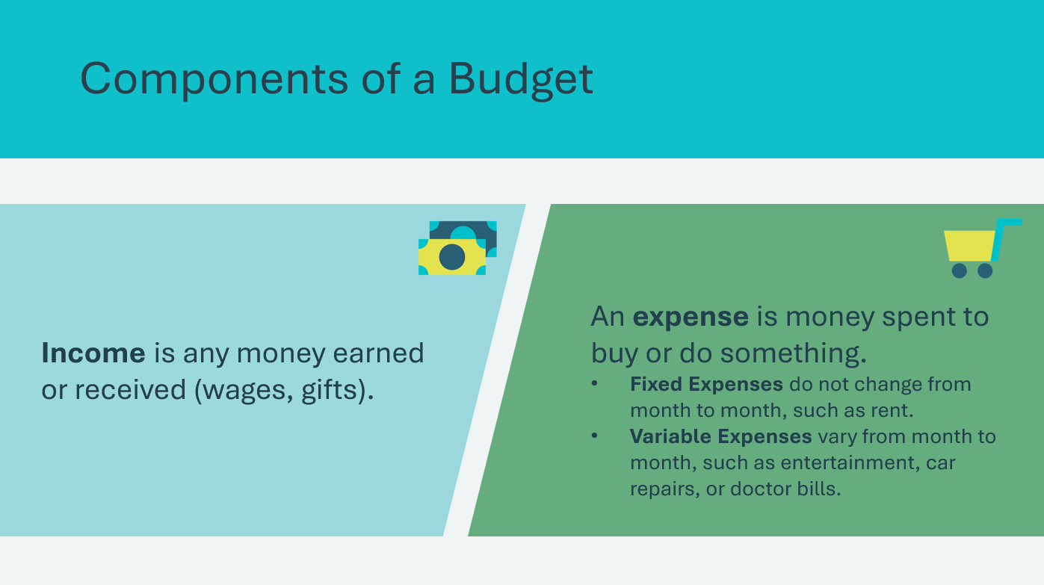 | Suggested time: 3 minutes  Tell students they will be completing a sample budget and discuss the components of a budget.  *Click or tap to reveal content  Income is the money you earn or receive. For a young person, income might come from a part-time job, allowance, gifts, or a side hustle.  An expense is any money you spend on things you need or want. Expenses can be fixed or variable.  - Tracking Expenses: Keeping track of what you spend helps you understand where your money goes and whether you’re staying within your budget.
Slide 63  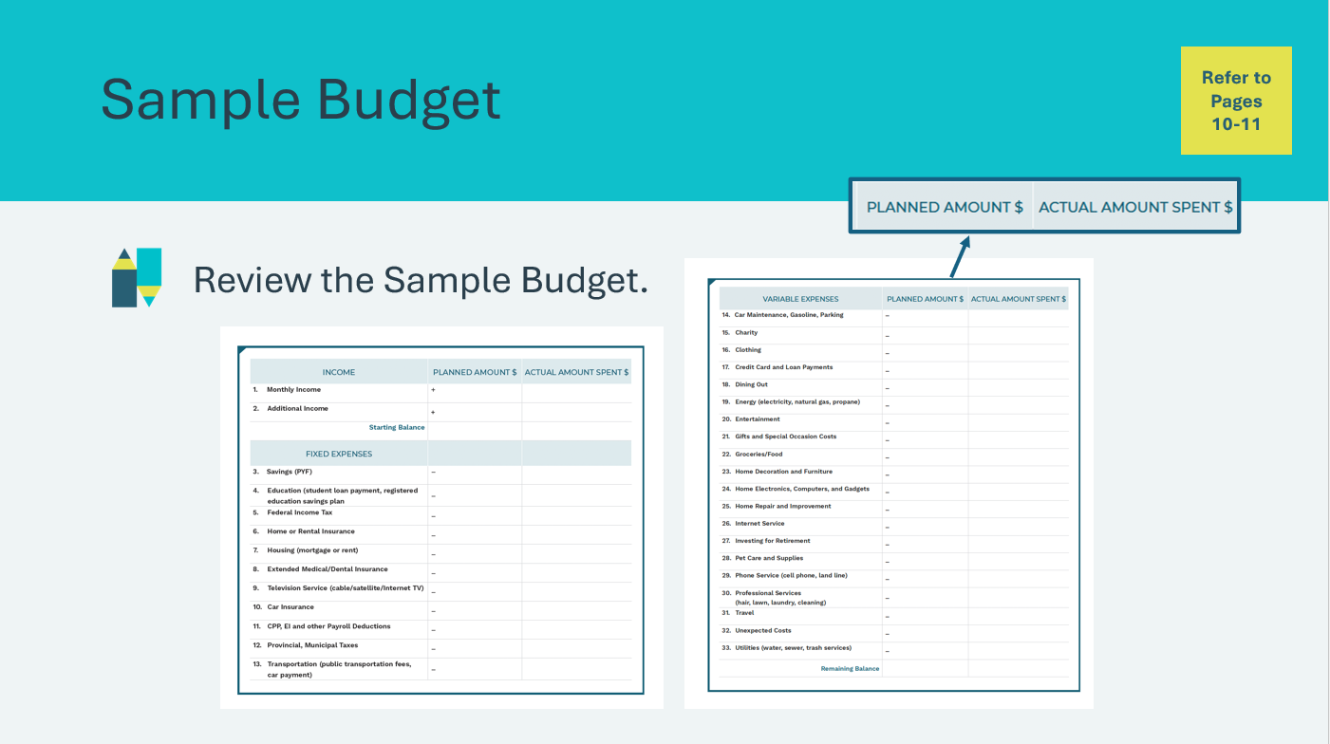 | Suggested time: 5 minutes  Students will review the Sample Budget in their student portfolio, page 10-11. Review the pages as a class and explain that this is a good starting template for analyzing potential expenses and income.  Point out that there is a column showing the amount students plan to spend and a column to track what they actually spend. It is necessary to perform both of these steps to know how to adjust your budget.  Emphasize to the students that most people will not need all of the categories listed because everyone has different wants and needs.
Summary and Review 5 min
Slide 64  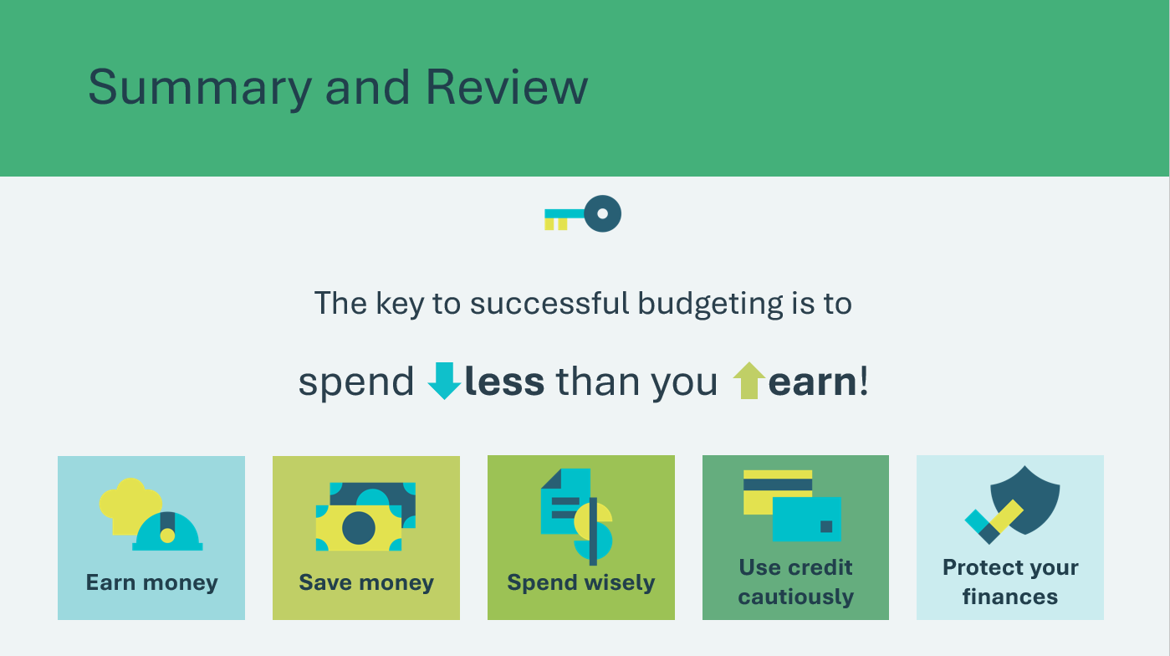 | Suggested time: 2 minutes  Review that the goal of budgeting is to spend less than you make. That means tracking your income and expenses and making tough choices when your needs and wants exceed your income.  Remind students of the five elements of financial planning in Personal Finance: Earn money, save money, spend wisely, use credit cautiously, and protect your finances.
Slide 65  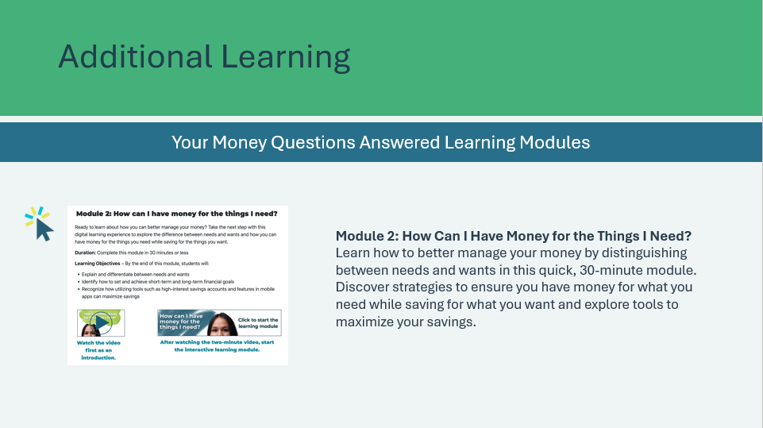 | Suggested time: Optional  *Click or tap on the image to open in a new browser tab.  For additional learning on managing your money, students can explore the Money Questions Answered Learning Modules – Module 2.

Lesson 4: Credit Choices
Program Kit Materials | Credit Fact Cards  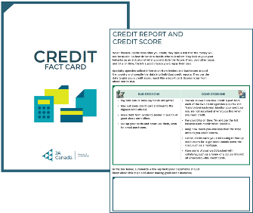
Slide 66 – Lesson 4  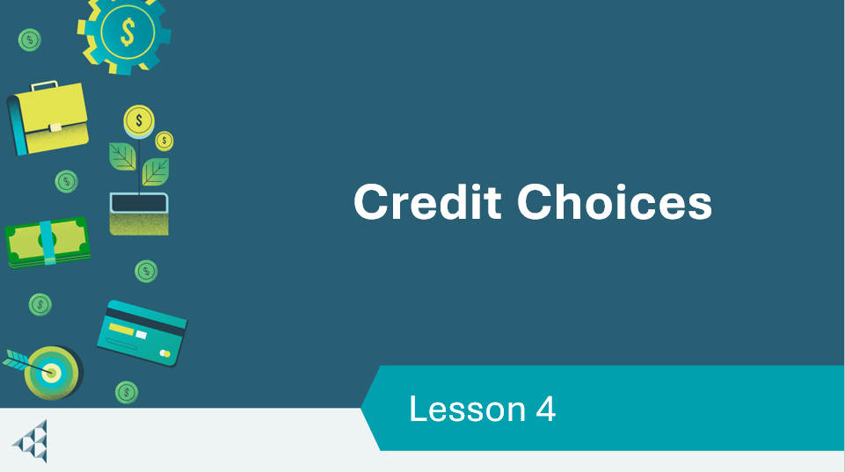 | Lesson 4: Credit Choices
Slide 67 – Objectives  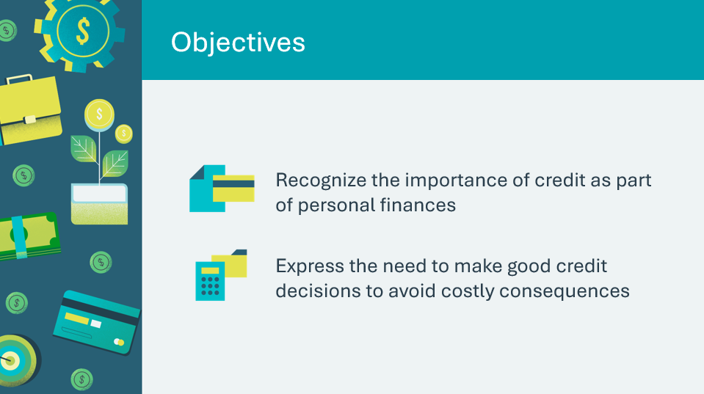 | Optional – review the learning objectives for the lesson
Slide 68 – Introduction  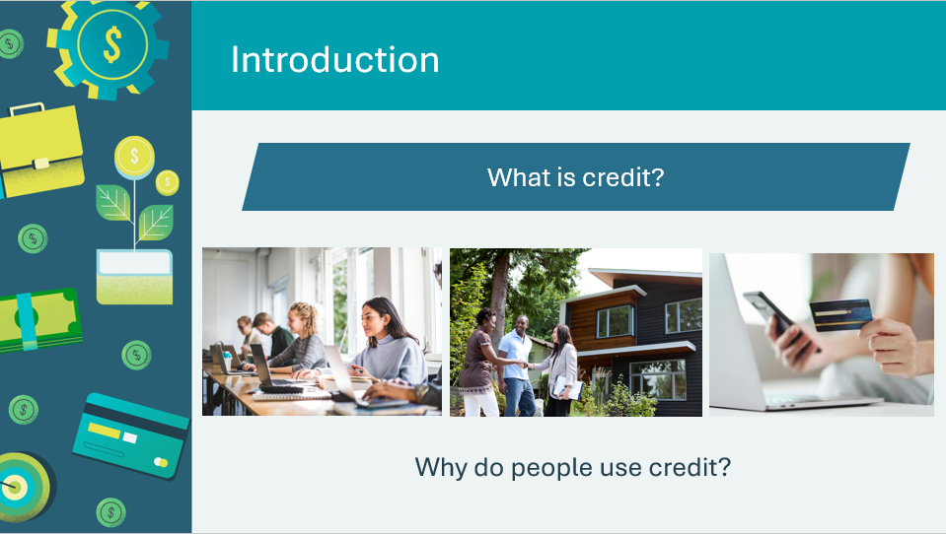 | Introduce the lesson by generating a discussion about ideas students may hold about credit. Invite a few students to share their thoughts and ideas.
Slide 69 – Activity Menu  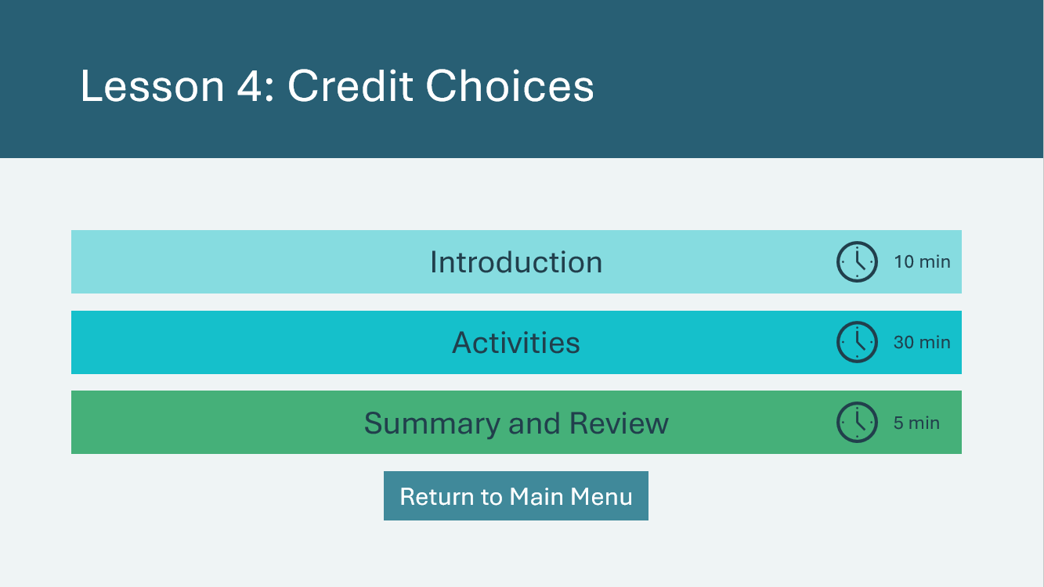 | *Select the button to navigate to the activity.  After you have completed an activity, you will be redirected back to the activity menu.  *Click or tap the Return to Main Menu button to return to the Lessons (Slide 5)
Introduction 10 min
Slide 70  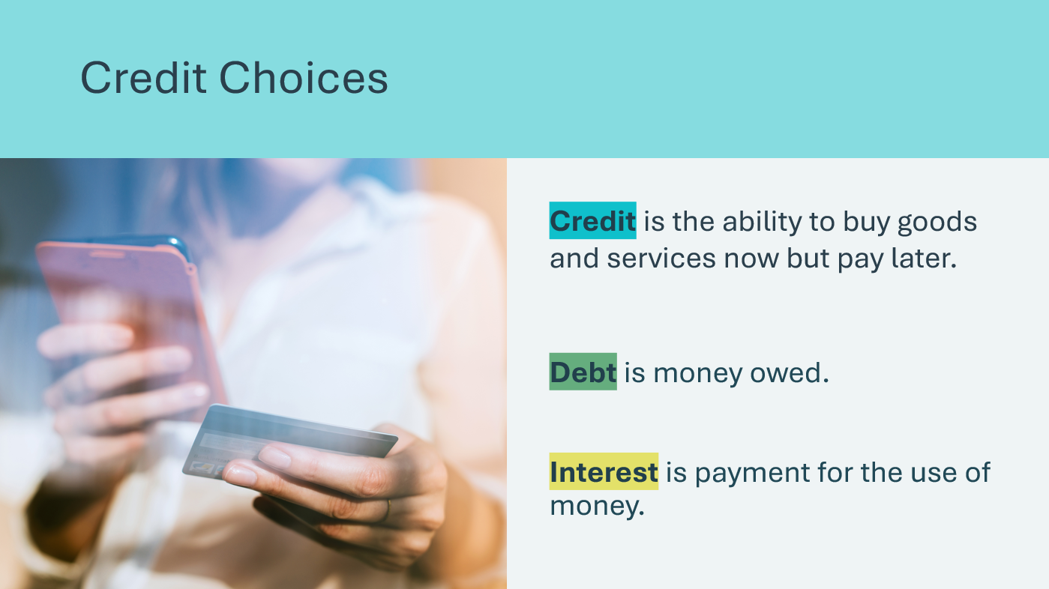 | Suggested time: 2 minutes  Review the definitions for credit, debt and interest.  Use the following points to help students see how each of the terms are related.  - Credit means borrowing money.  - Borrowed money becomes debt.  - You must repay your debt.  - If you don’t repay it on time, you may be charged interest.
Slide 71  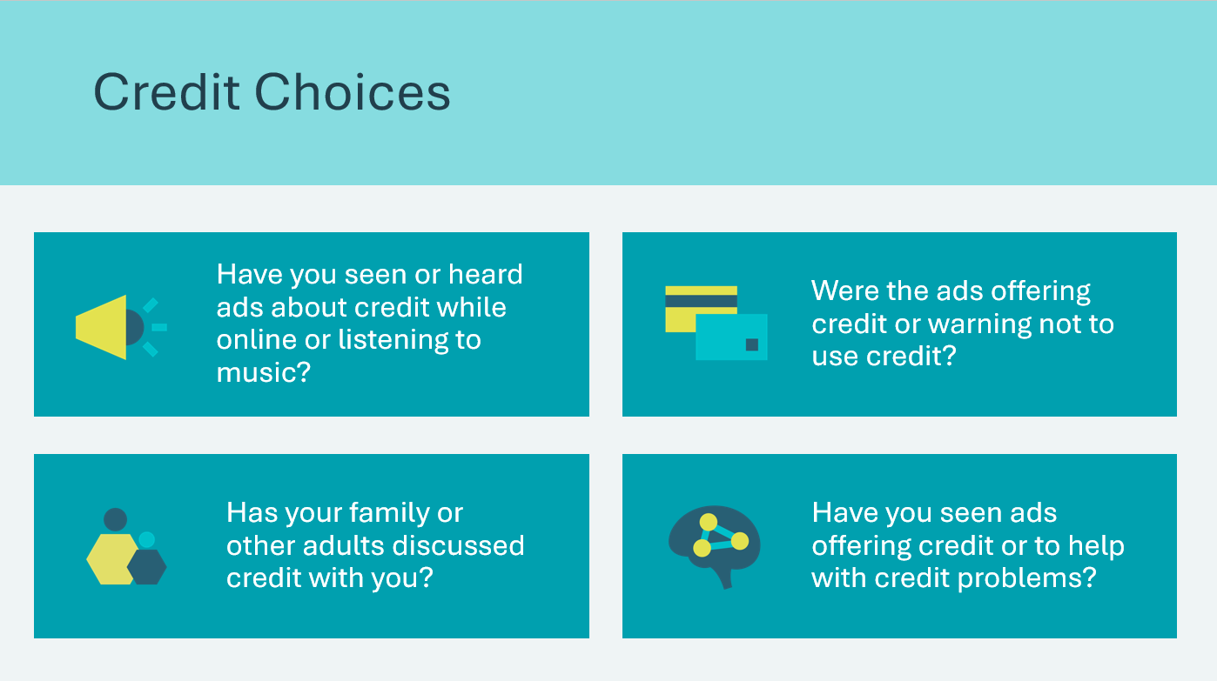 | Suggested time: 3 minutes  Ask students to share any facts they know about credit and where they learned those facts.  Use the questions to facilitate a discussion. Incorporate the following talking points and discuss with students how to use credit as part of their personal finance plan.  - There are mixed messages about whether using credit is good or bad  - There is a constant stream of advertising and information in the media and in the mail offering credit in one form or another  - There are conflicting messages warning about misusing credit and offering services and products to help with credit debt  - Maybe even people you know are struggling with credit problems or trying to pay off debt  Explain that although it can be complicated, knowing how to use credit is an important part of healthy personal finances.  Volunteer connection: Share an example that illustrates any of the discussion points listed.
Slide 72  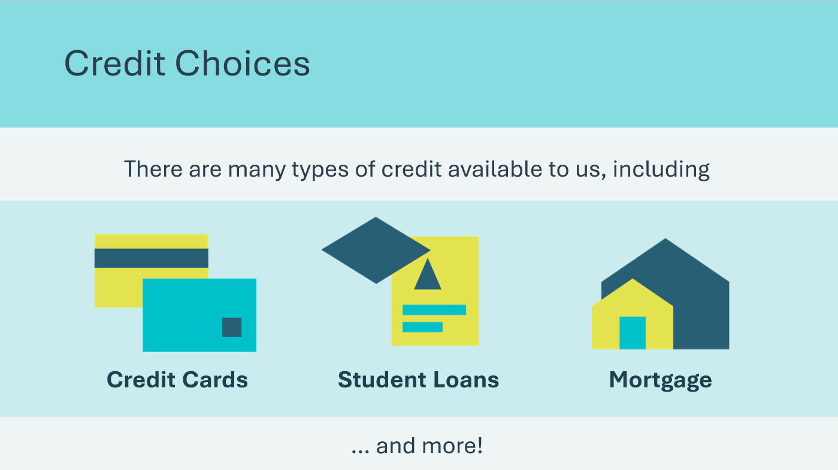 | Suggested time: 3 minutes  Discuss some of the different types of credits and explain that most people will need credit at some point in their life—to buy a car, a house, a large appliance, or other expensive items that cannot be purchased with cash at the time.  Credit itself is neither good nor bad. However, you can make good or bad choices about how to use credit in your life.  - If you make good choices, you will have the credit necessary to buy the things you want and need and the opportunity to pay for those items over time.  - If you make poor decisions, you will pay far more money than the original purchase price. That additional cost comes in the form of interest, fees, fines, and higher interest on future credit. You also could suffer consequences in other parts of your life that may seem unrelated, like not being able to get certain jobs or rent the place you would like to live.
Slide 73  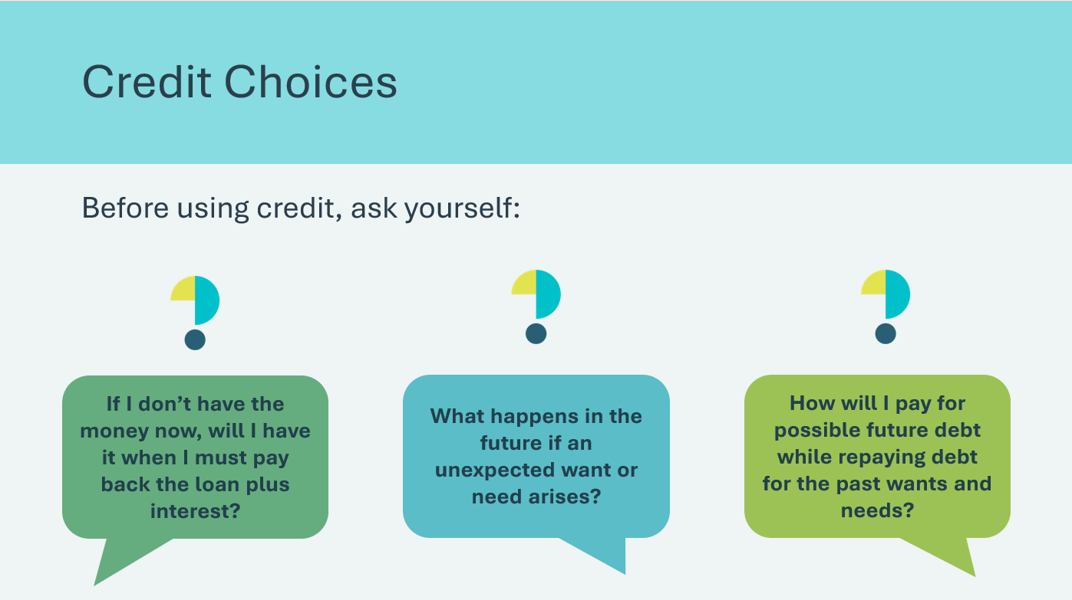 | Suggested time: 2 minutes  Tell students that using credit now really means committing future money to repay current debt plus interest. This tug of war between unlimited wants and limited income can have severe consequences, so it is important to use credit cautiously.  Tell students that in this lesson, they will learn about some potentially good and bad credit opportunities and dangers.
Activity 30 min
Program Kit Materials | For slides 74-76, you will need to use the Credit Fact Cards from the program kit.
Slide 74  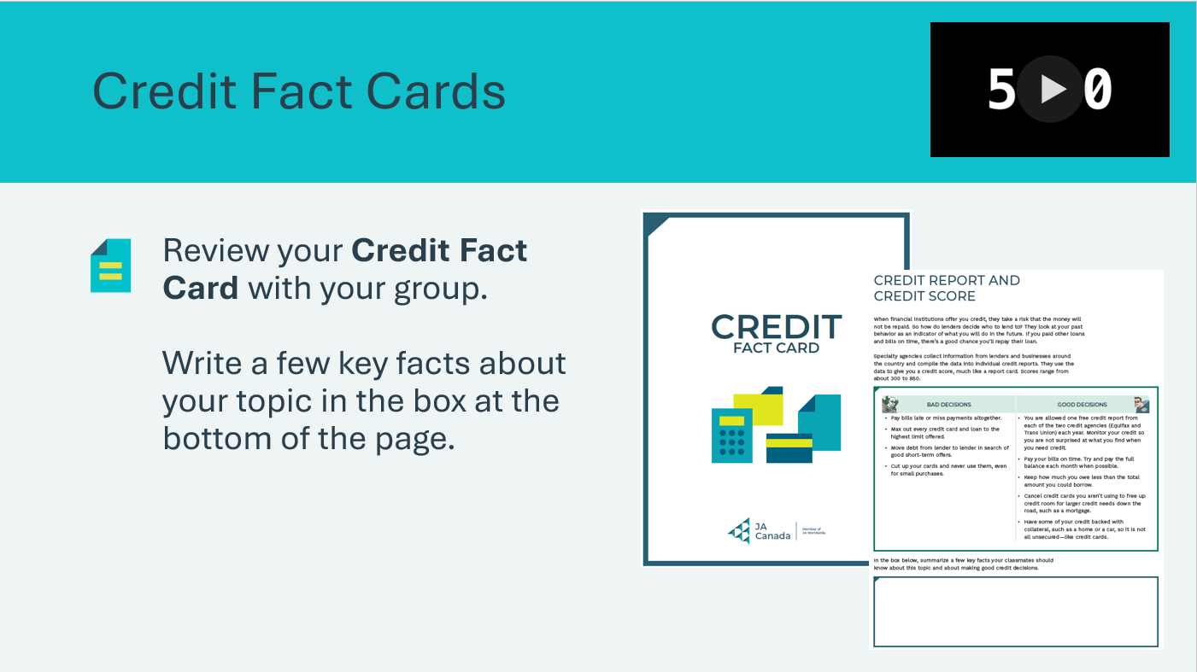  Credit Fact Cards | Suggested time: 10 minutes  Break the students into six groups. Assign each group a Credit Fact Card. There will be two left unassigned that you can discuss as a class if time permits.  Tell students they will face frequent choices in their lives about using credit and accumulating debt. Remind them credit and debt are just tools—it’s the choices that have good or bad outcomes.  Explain that on each group’s card is a set of facts related to a credit topic. The groups’ task is to read the facts, and in the space provided on the card write a few key facts about the topic to teach their classmates. Allow the students five minutes to read the card and write their key facts.  *Click or tap on the video in the top right corner to start the timer (optional).
Slide 75  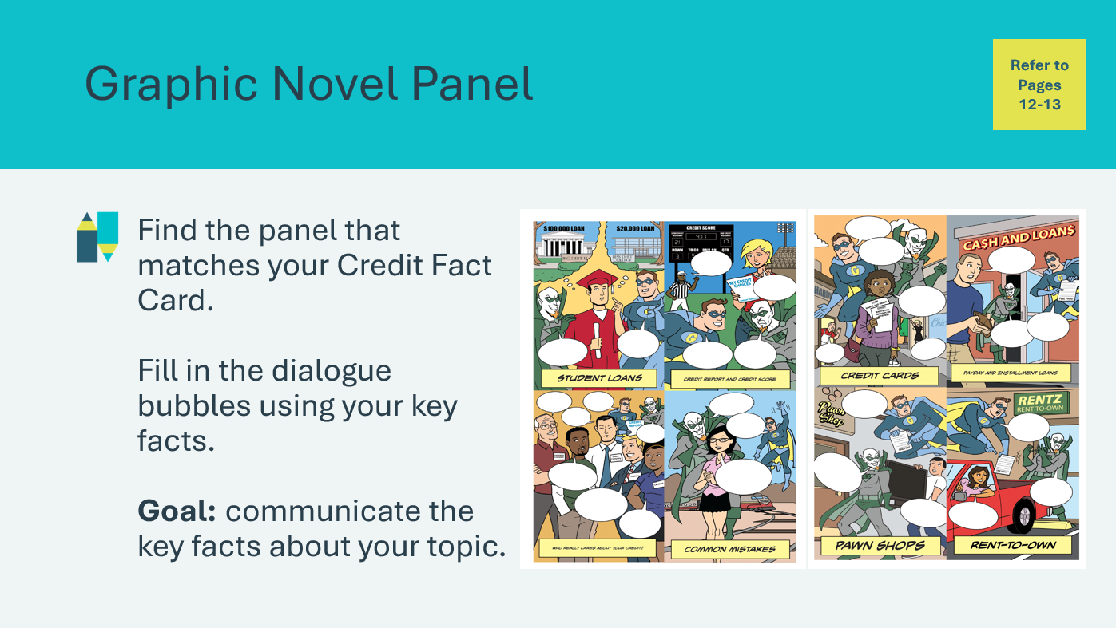  Credit Fact Cards | Suggested time: 10 minutes  Students will complete the Graphic Novel Panel for their topic in their student portfolio, page 12-13. Each card has a specific topic that matches one of the panels, ensure students are completing the appropriate panel.  Explain that each Graphic Novel Panel is a scene depicting a credit topic that has a Good Credit Decision character, a Bad Credit Decision character, and a Consumer character making a decision about credit. However, the character dialogue bubbles are blank and students will need to fill them in use their key facts to explain what’s going on in each scene.  Tell the students the goal of this activity is for each group to communicate key facts about its topic through the characters in its panel. Remind them that the hero and villain are trying to get the consumer to make either a good or bad choice related to credit. They may fill in all the blanks or not, and they may add more captions or pictures as necessary. Ask them to write in large letters so classmates can easily see their work when they present.  Tell the students that once the groups have completed their panels, each group will present. Allow five minutes for the groups to fill in their panels with the facts they summarized on the card.  Facilitator tip: Explain that graphic novels are often dramatic, so students can add information to make their story more interesting as long as the facts stay accurate.
Slide 76  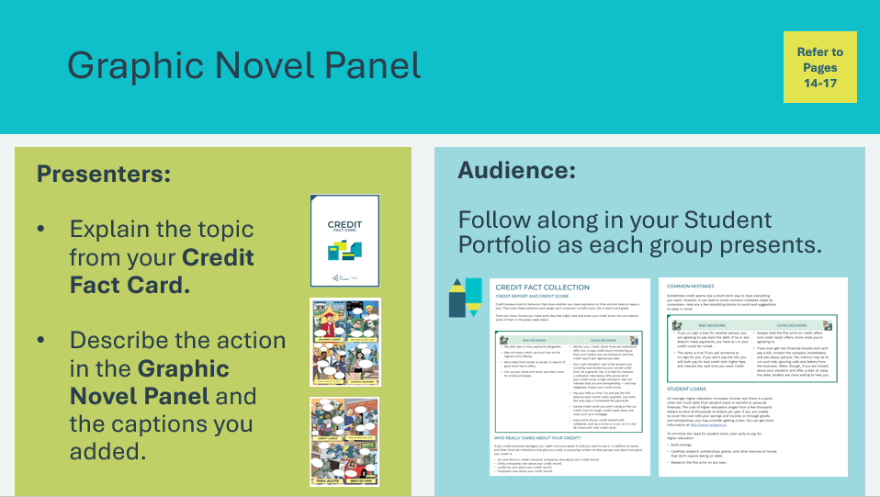  Credit Fact Cards | Suggested time: 10 minutes  Once all groups have completed their panels, each group will present. Students will follow along in their student portfolio, page 14-17, as each group presents their topic.  Facilitator tip: Be aware that some students may have used or seen family members use some of the alternative forms of credit, such as pawn shops or payday loans. It’s important to present the pros and cons in a factual, nonjudgmental manner.  After each group presents, offer current or personal examples of each of the topics. Selected talking points for each topic are listed as follows:  Credit Report and Credit Score: Credit bureaus look for behaviors that show whether you are likely to repay a loan. They track these behaviors and assign each consumer a credit score, like a report card grade. There are many ways to raise and lower your credit score. Some may be surprising.  Who Really Cares About Your Credit? The choices you make about credit affect many other areas of your personal finances and your life. A variety of companies review your credit before deciding whether to do business with you.  Common Mistakes: The reason there are so many commercials about raising credit scores and repairing credit is because a lot of Canadians struggle with their debt and don't use credit responsibly. There are some common mistakes that consumers can avoid.  Payday and Installment Loans: These types of loans can carry high interest rates and a short pay-back schedule that consumers need to be aware of. However, installment loans can be helpful for individuals to budget for larger purchases. It is important to use these loans wisely and read all the fine print in the contract so you know what you’re agreeing to.  Rent-to-Own: Furniture and appliances bought this way cost significantly more, sometimes two or three times more than buying the product outright.  Pawn Shops: For your loan, you will receive only a fraction of the value of the item you leave as collateral, and the shop owns your collateral if you fail to pay back the loan. It is important to read all the posted store policies and fine print in the contract so you know what you’re agreeing to.  Credit Cards: Credit cards are widely used as a tool in Canadians’ personal finances. They can be more convenient that cash and offer things that debit-based products cant including insurance, cashback and other perks. However, if the balance is not paid at the end of the month, you’ll be charged interest, making everything you buy cost more. When credit card bills are not paid off each month or a payment is late, they can have a negative effect on your credit and finances.  Student Loans: On average, higher education increases income, but there is a point when too much debt from student loans is harmful to personal finances. Make plans early to pay for education beyond high school. There are several consequences for failure to pay back student loans.
Summary and Review 5 min
Slide 77  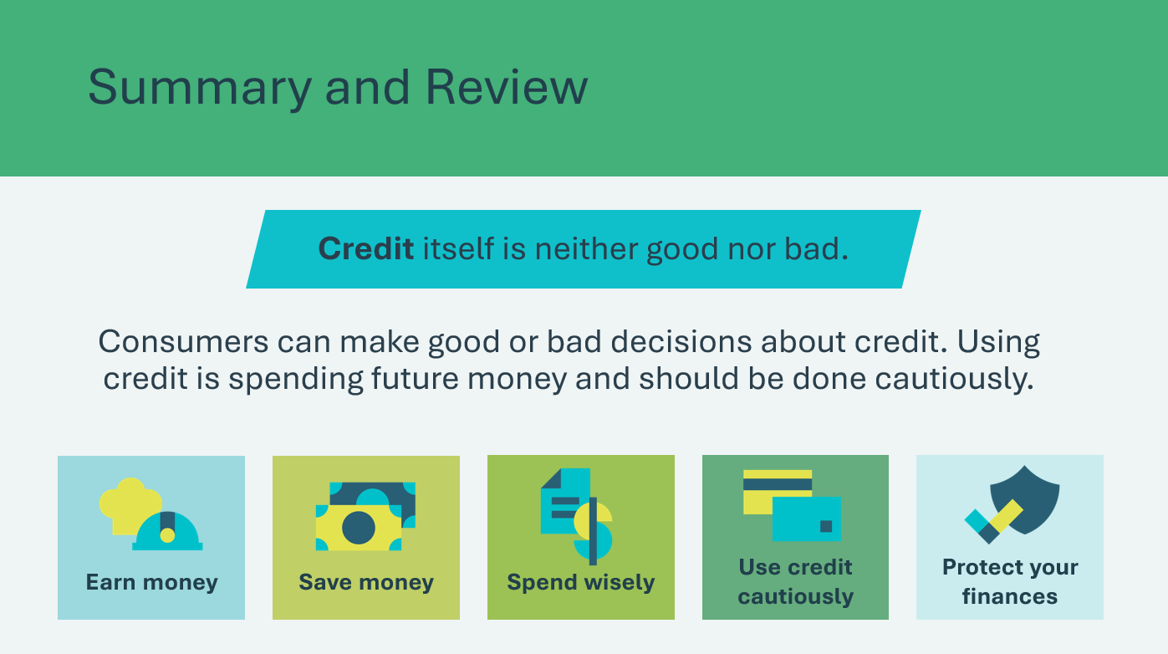 | Suggested time: 5 minutes  Review the prompts about credit and remind students that credit may be necessary for most people at some point in their lives. It’s important to know how to use it wisely.  Remind them of the five elements of financial planning in Personal Finance: Earn money, save money, spend wisely, use credit cautiously, and protect personal finances.  Facilitator tip: Ask the teacher to display the Graphic Novel Panels around the classroom to remind the students of good credit decisions.  Extended learning opportunity:  If time allows in the session—or in class at a later date—consider redistributing the Graphic Novel Panels and blank pieces of paper.  Have the students create the panel of the story that would have occurred immediately before or after the panel they added captions to. Ask them to include the dialogue that would describe what came before or after the events in the current panels.
Slide 78  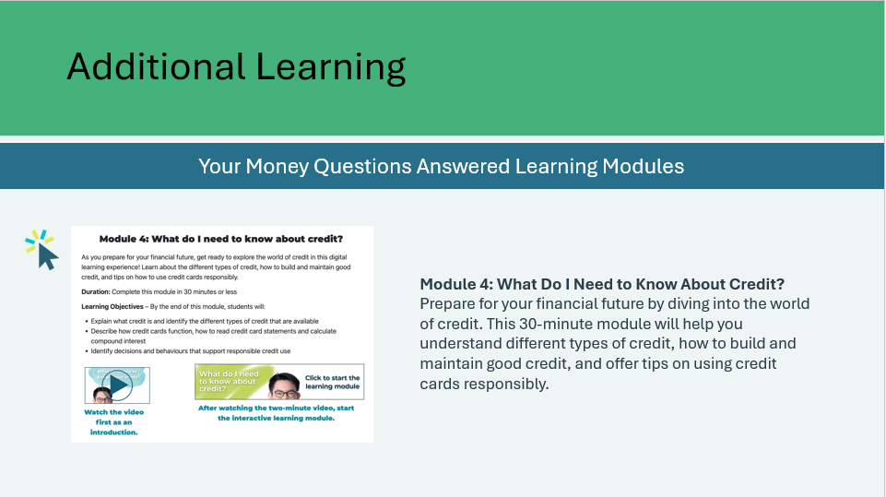 | Suggested time: Optional  *Click or tap on the image to open in a new browser tab.  For additional learning on using credit responsibly, students can explore the Money Questions Answered Learning Modules – Module 4.

Lesson 5: Savvy Consumer
Slide 79 – Lesson 5  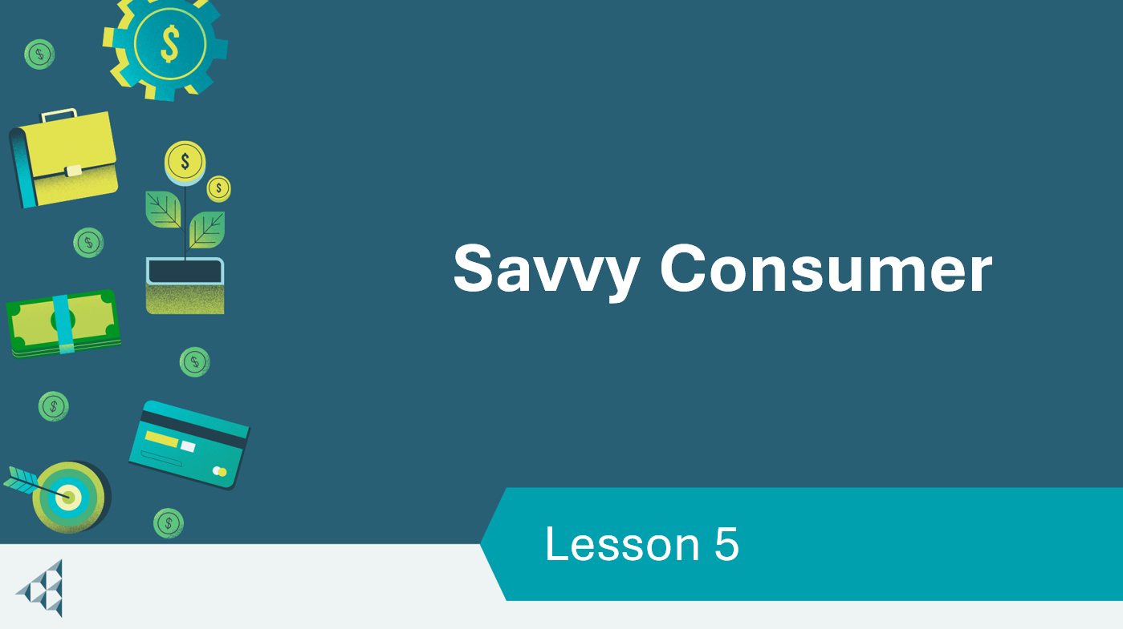 | Lesson 5: Savvy Consumer
Slide 80 – Objectives  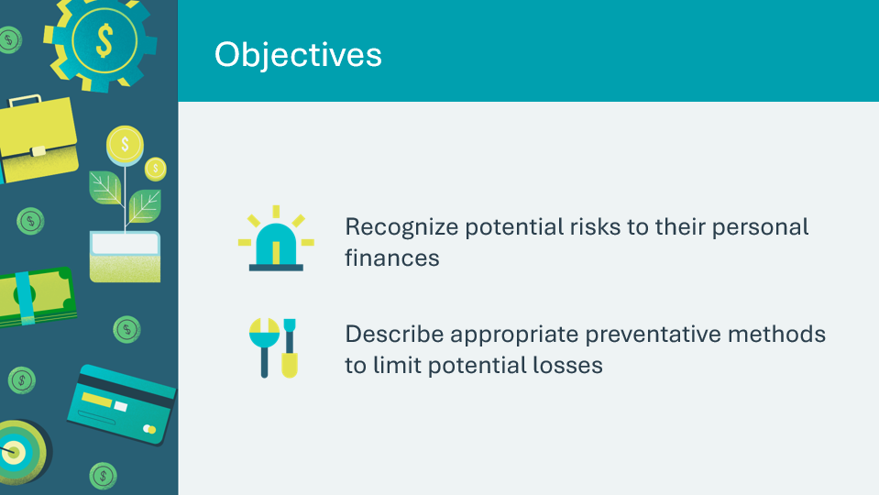 | Optional – review the learning objectives for the lesson
Slide 81 – Introduction  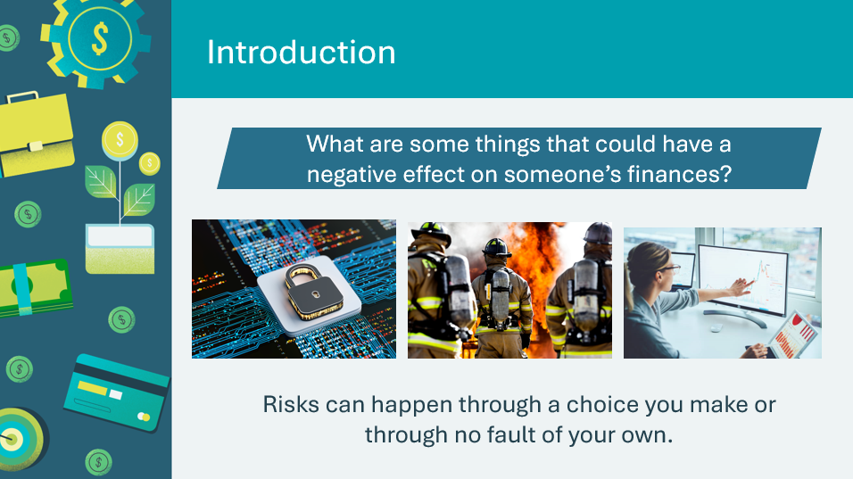 | Introduce the lesson by generating a discussion about things that could negatively impact someone’s finances. Invite a few students to share their responses.  If not mentioned, some examples could be:  - Emergencies (weather, medical, etc.)  - Theft  - Fraud  - Buying a bad product  - An accident  - Things like scams, car troubles and job losses can and do happen  Creating healthy personal finances takes a lot of time, attention and effort, with the payoff being a more stable and secure quality of life. It’s important to protect what you’ve worked hard to build!
Slide 82 – Activity Menu  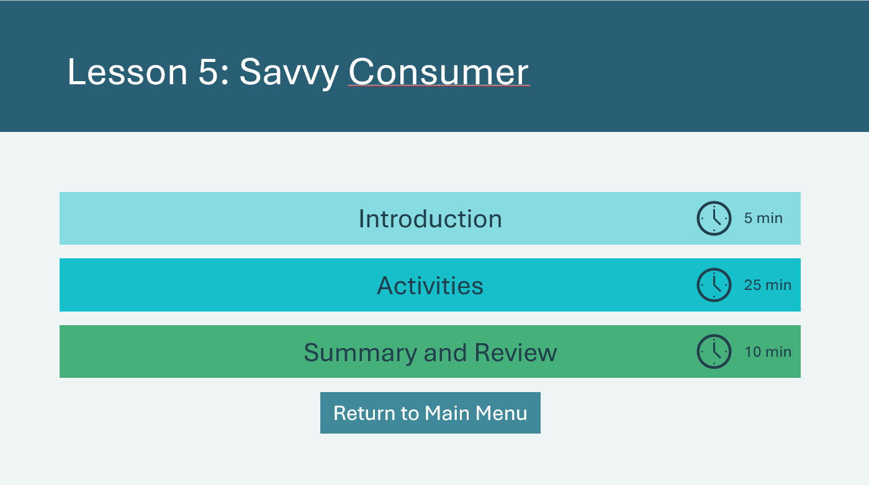 | *Select the button to navigate to the activity.  After you have completed an activity, you will be redirected back to the activity menu.  *Click or tap the Return to Main Menu button to return to the Lessons (Slide 5)
Introduction 5 min
Slide 83  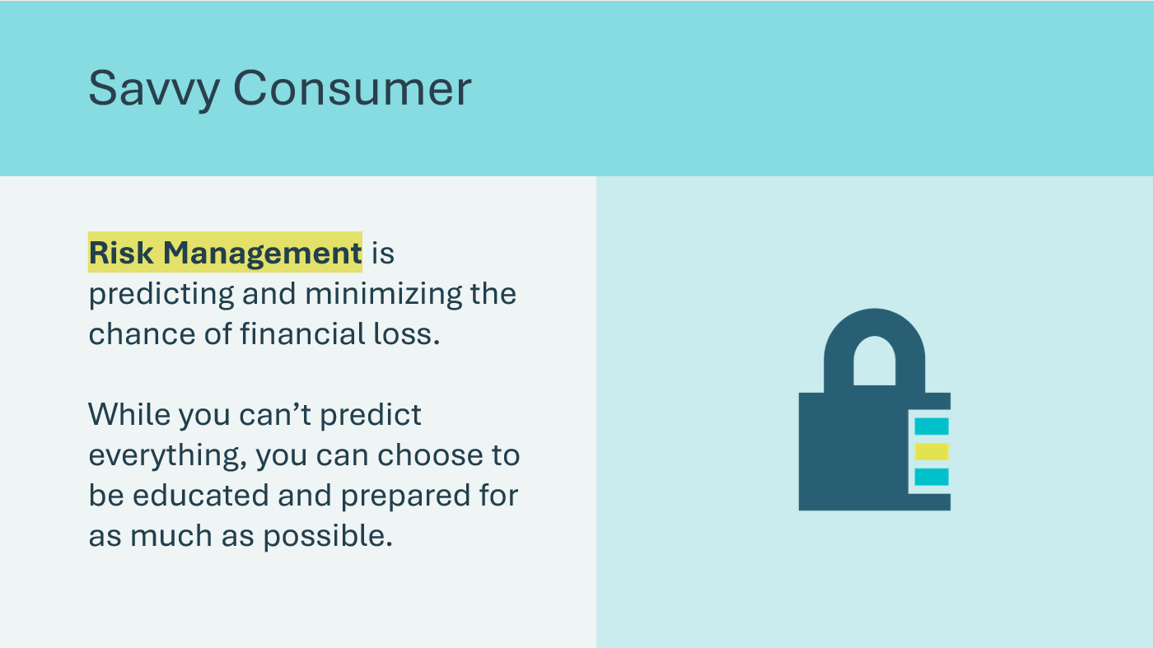 | Suggested time: 3 minutes  Define risk management. Discuss how all consumers potentially face the risk of financial loss and how important it is to be informed and prepared.  It is unpleasant to think about, but the risks you face as a consumer can have as big an impact on your finances as any of the other factors discussed during this program because the loss could be to your income, savings, or credit. Such losses could change your budget—and your life—significantly.
Slide 84  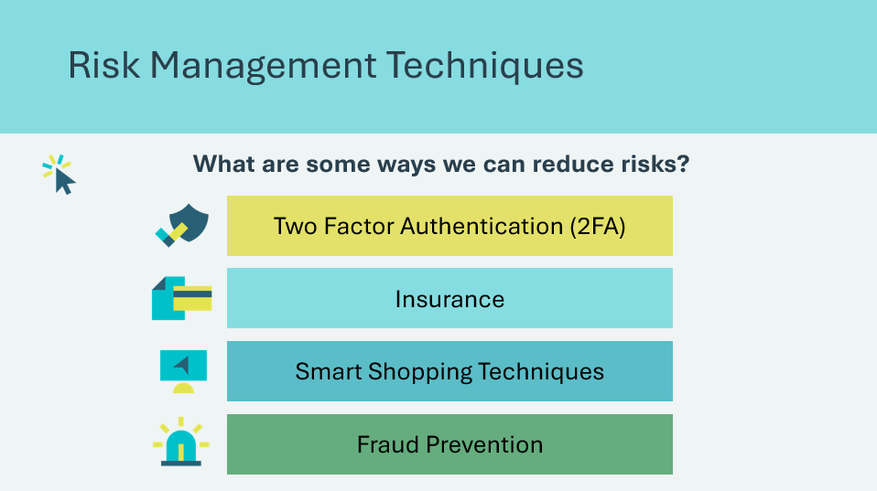 | Suggested time: 2 minutes  Ask students if they can think of any risk management techniques to protect their finances.  *Click or tap to reveal  Volunteer connection: Share an example of how you have used a risk management technique (insurance, fraud prevention or smart shopping techniques).  - Example: using biometrics and 2FA on your mobile banking app.  Tell students they will learn about some of these potential losses and explore ways to manage risks in their lives.
Activity 25 min
Slide 85  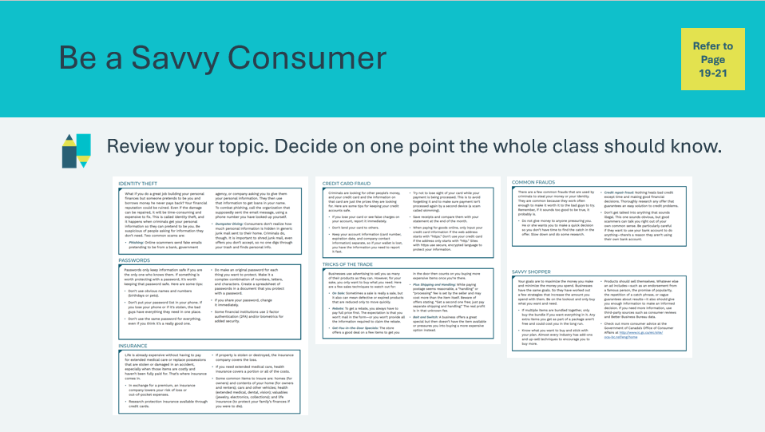 | Suggested time: 5 minutes  Organize the students into six groups. Assign each group a topic from pages 19–21 of the portfolio.  Ask each student to read the assigned topic and note any ideas that grab their attention.
Slide 86  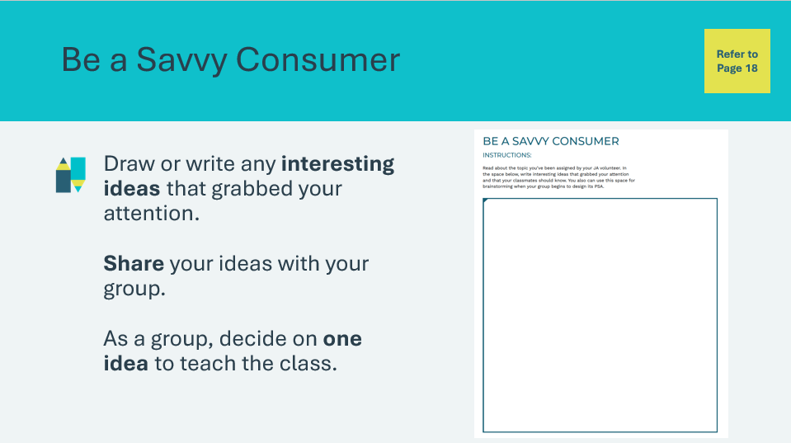 | Suggested time: 5 minutes  Students will write their ideas in their student portfolio, page 18.  Once students have written their ideas, ask them to share them with the other members of their group and then decide on one idea to teach the rest of the class.
Slide 87  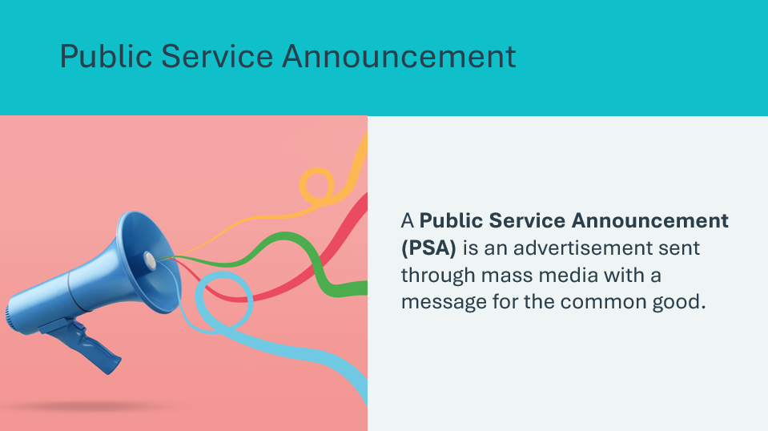 | Suggested time: 3 minutes  Define public service announcement. Ask students to recall videos or billboards they may have seen that offer a public announcement or try to persuade citizens to make healthy choices.  Explain that these are examples of a public service announcement and they can be found on TV, radio, the internet or in newspapers or magazines.  Common topics of PSAs include health related information (signs of stroke or getting an annual check up), public safety (if you see something say something), or environment (give a hoot, don’t pollute or only you can prevent forest fires).  Volunteer connection: Describe local examples of current PSAs.  Example: COVID-19 Awareness Campaigns  - During the Pandemic, the Canadian government released numerous PSAs about mask-wearing, social distancing and vaccination. These were broadcast across TV, radio and digital platforms.
Slide 88  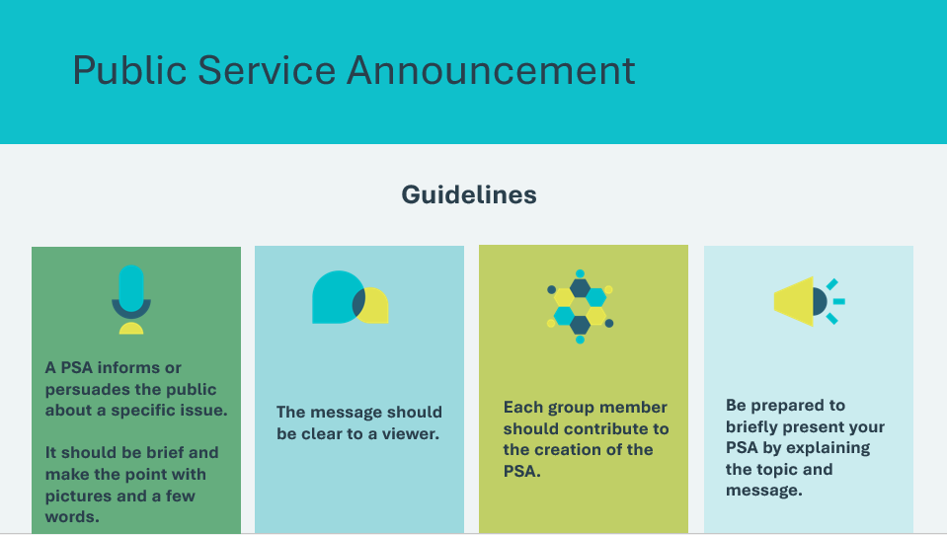 | Suggested time: 2 minutes  Tell the groups that they will each create a PSA based on the topic they chose to share with the class. Review the guidelines for creating their PSA.  *Click or tap to reveal  Distribute coloured pencils, markers and other supplies you and the teacher have agreed upon in advance. If the students have access to a device, they can also choose to record a video PSA.
Slide 89  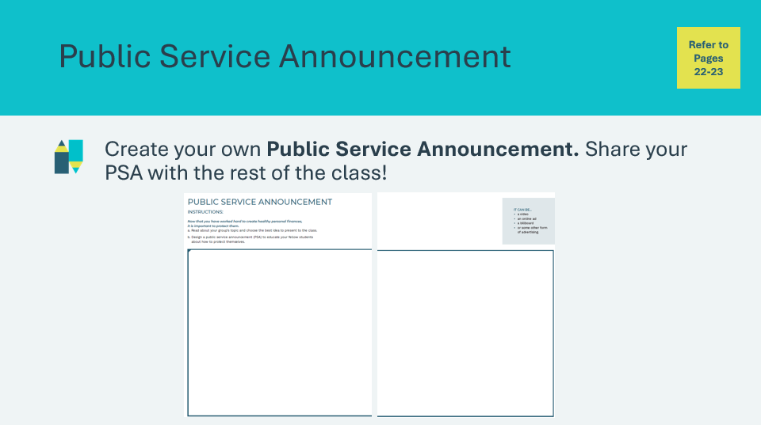 | Suggested time: 10 minutes  Allow 10 minutes for the students to create their PSAs.  Once complete, ask each group to share its PSA with the class while the other groups follow along using their portfolio.
Summary and Review 5 min
Slide 90  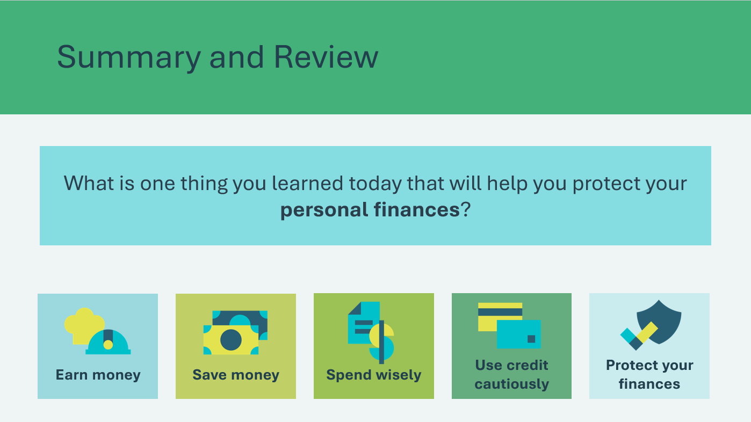 | Suggested time: 5 minutes  Ask student volunteers to name one thing they learned today that will help them protect their personal finances.  Review the five elements of financial planning in Personal Finance and how they are connected.
Slide 91  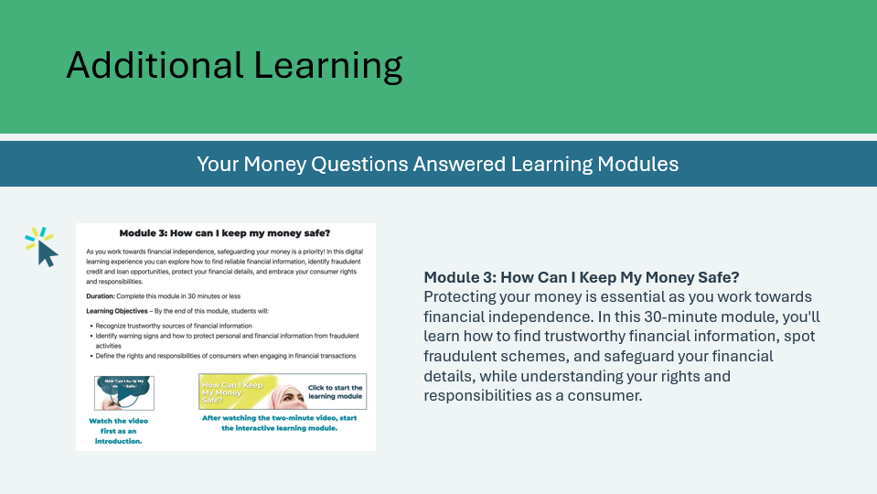 | Suggested time: Optional  *Click or tap on the image to open in a new browser tab.  For additional learning on protecting your finances, students can explore the Money Questions Answered Learning Modules – Module 3.

Wrap Up
Program Kit Materials | Certificate of Accomplishment  
Slide 92 – Wrap Up   | Wrap Up
Program Kit Materials | For slide 93, you will need to use the Certificates of Accomplishment from the program kit.
Slide 93 – Congratulations!  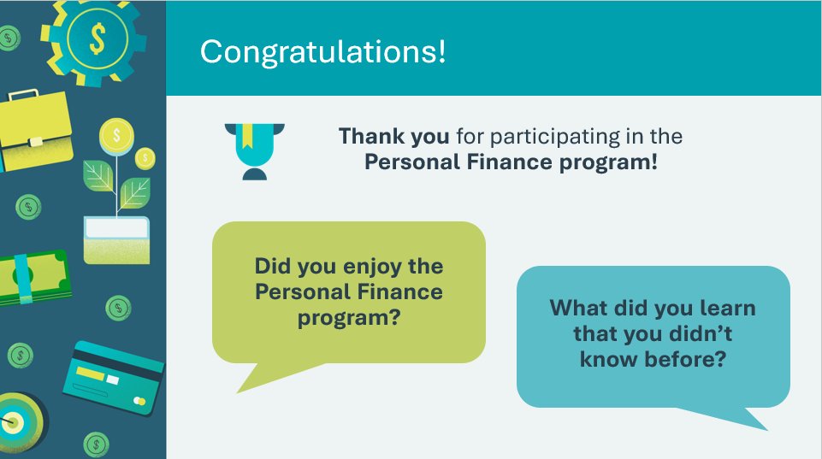  Certificate of Accomplishment | Suggested time: 5 minutes  Wrap up the program with the discussion prompts.  Distribute the Certificates of Accomplishment. Encourage the students to share them with their families and include them in their portfolio of high school accomplishments.  Share what you learned or will remember from your time with the students and invite students to relate their JA experience.
Slide 94   | Invite students to visit jacampus.org for additional information and learning.

