

JA Success Skills Presenter Notes
The Presenter Notes have been developed to align and be used in combination with the digital classroom presentation and printed Student Portfolio (2025).
Tips for Setting Up the Classroom
- Arrive 15 minutes early and check in at the office.
- Connect with the teacher for the program materials and organize them as needed.
- Hand out student portfolios and name tags/cards.
- Set up presentation (check audio and internet connection are working).
- Write your name on the board.
- Ask the teacher to write student names on program certificates.
- Check in with the teacher about the school schedule, tips for getting students' attention, any specific student needs & behaviours you should be aware of and ask for help with encouraging student participation, as well as monitoring and managing the class
Planning Guide
LESSON 2 (Slides 32 – 55) 75 MIN
GETTING YOUR POINT ACROSS
Core Activities:
- Communication literacy (15 min)
- What comfort zone are you in? (15 min)
- What is the best way to communicate? (20 min)
- Two Earns, One Mouth – Listening is twice as important as speaking (25 min)
- Reflection (Optional)
LESSON 4 (Slides 81 – 98) 45 MIN
THINK ABOUT IT!
Core Activities:
- The survival decision – Case study (15 min)
- Leveraging technology to solve problems (30 min)
- Reflection (Optional)
WRAP UP (Slides 114 – 117) 25 MIN
CONGRATULATIONS!
Core Activities:
- Success Skills Bingo (20 min)
- Awarding certificates of accomplishment (5 min)
LESSON 5 (Slides 99 – 113) 60 MIN
STAY CURIOUS – A SUPERPOWER!
Core Activities:
- I am curious about… (60 min)
- Reflection (Optional)
LESSON 3 (Slides 56 – 80) 75 MIN
BETTER TOGETHER
Core Activities:
- Am I a good collaborator? (10 min)
- What does collaboration look like? Effective and Ineffective (15 min)
- Negotiation – It’s about give and take! (20 min)
- Team building challenge (30 min)
- Reflection (Optional)
LESSON 1 (Slides 6 – 31) 75 MIN
SUCCESS STARTS WITH YOU!
Core Activities:
- How do you define success? (20 min)
- Skills in everyday life (20 min)
- Matching skills to learning (20 min)
- Long-term success plan (15 min)
- Reflection (Optional)

GETTING STARTED – GETTING TO KNOW YOU (Slides 1 – 5) 5 MIN

As a facilitator, it is important to recognize that you are not a mental health professional. While you may be leading discussions on mental well-being, it is crucial to approach the topic in a manner that does not claim to diagnose or treat any mental health conditions. It is recommended that participants seek professional help if they have concerns about their mental health. Please be mindful of your limitations and the boundaries of your role as a facilitator.
Introduction
Slide 1 – Success Skills  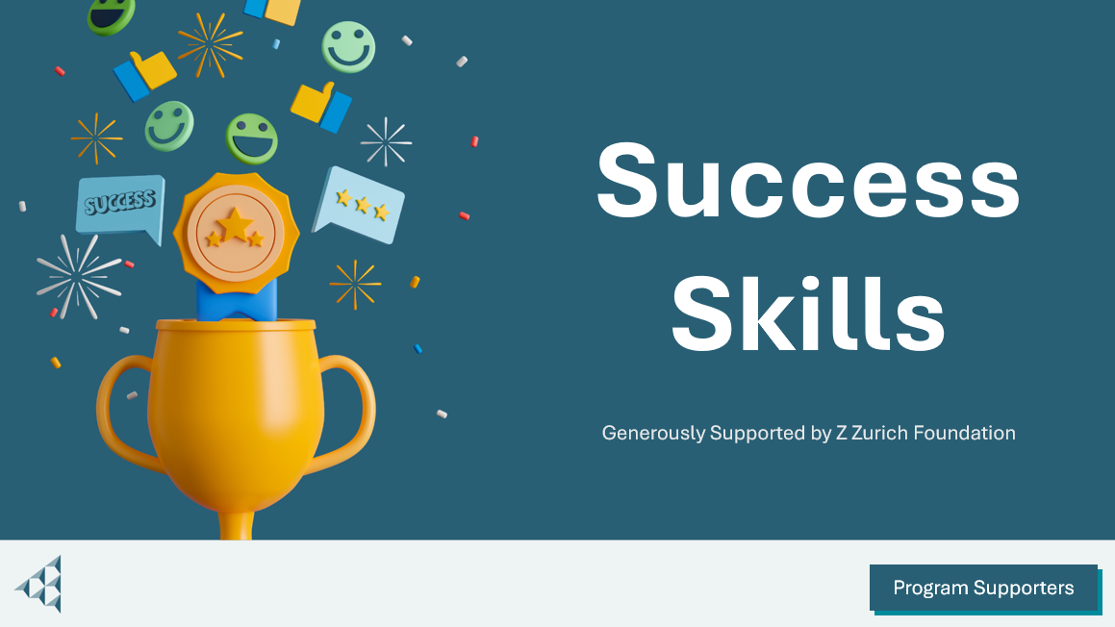 | Navigation Tips  - Navigate through the slides using the next or previous buttons (bottom right), clicking or tapping on the slide, or using the navigation menu (left)  - Look for slide specific instructions in the presenter notes below  Program Supporters  *If your local JA has asked you to display the Program Supporters recognition slide, select this button (bottom right).
Slide 2 – Welcome to JA!   | Suggested time: 3 minutes  Ask: Has anyone heard of Junior Achievement before?  Play the video for students to introduce them to JA!
Slide 3 – Success Skills Program  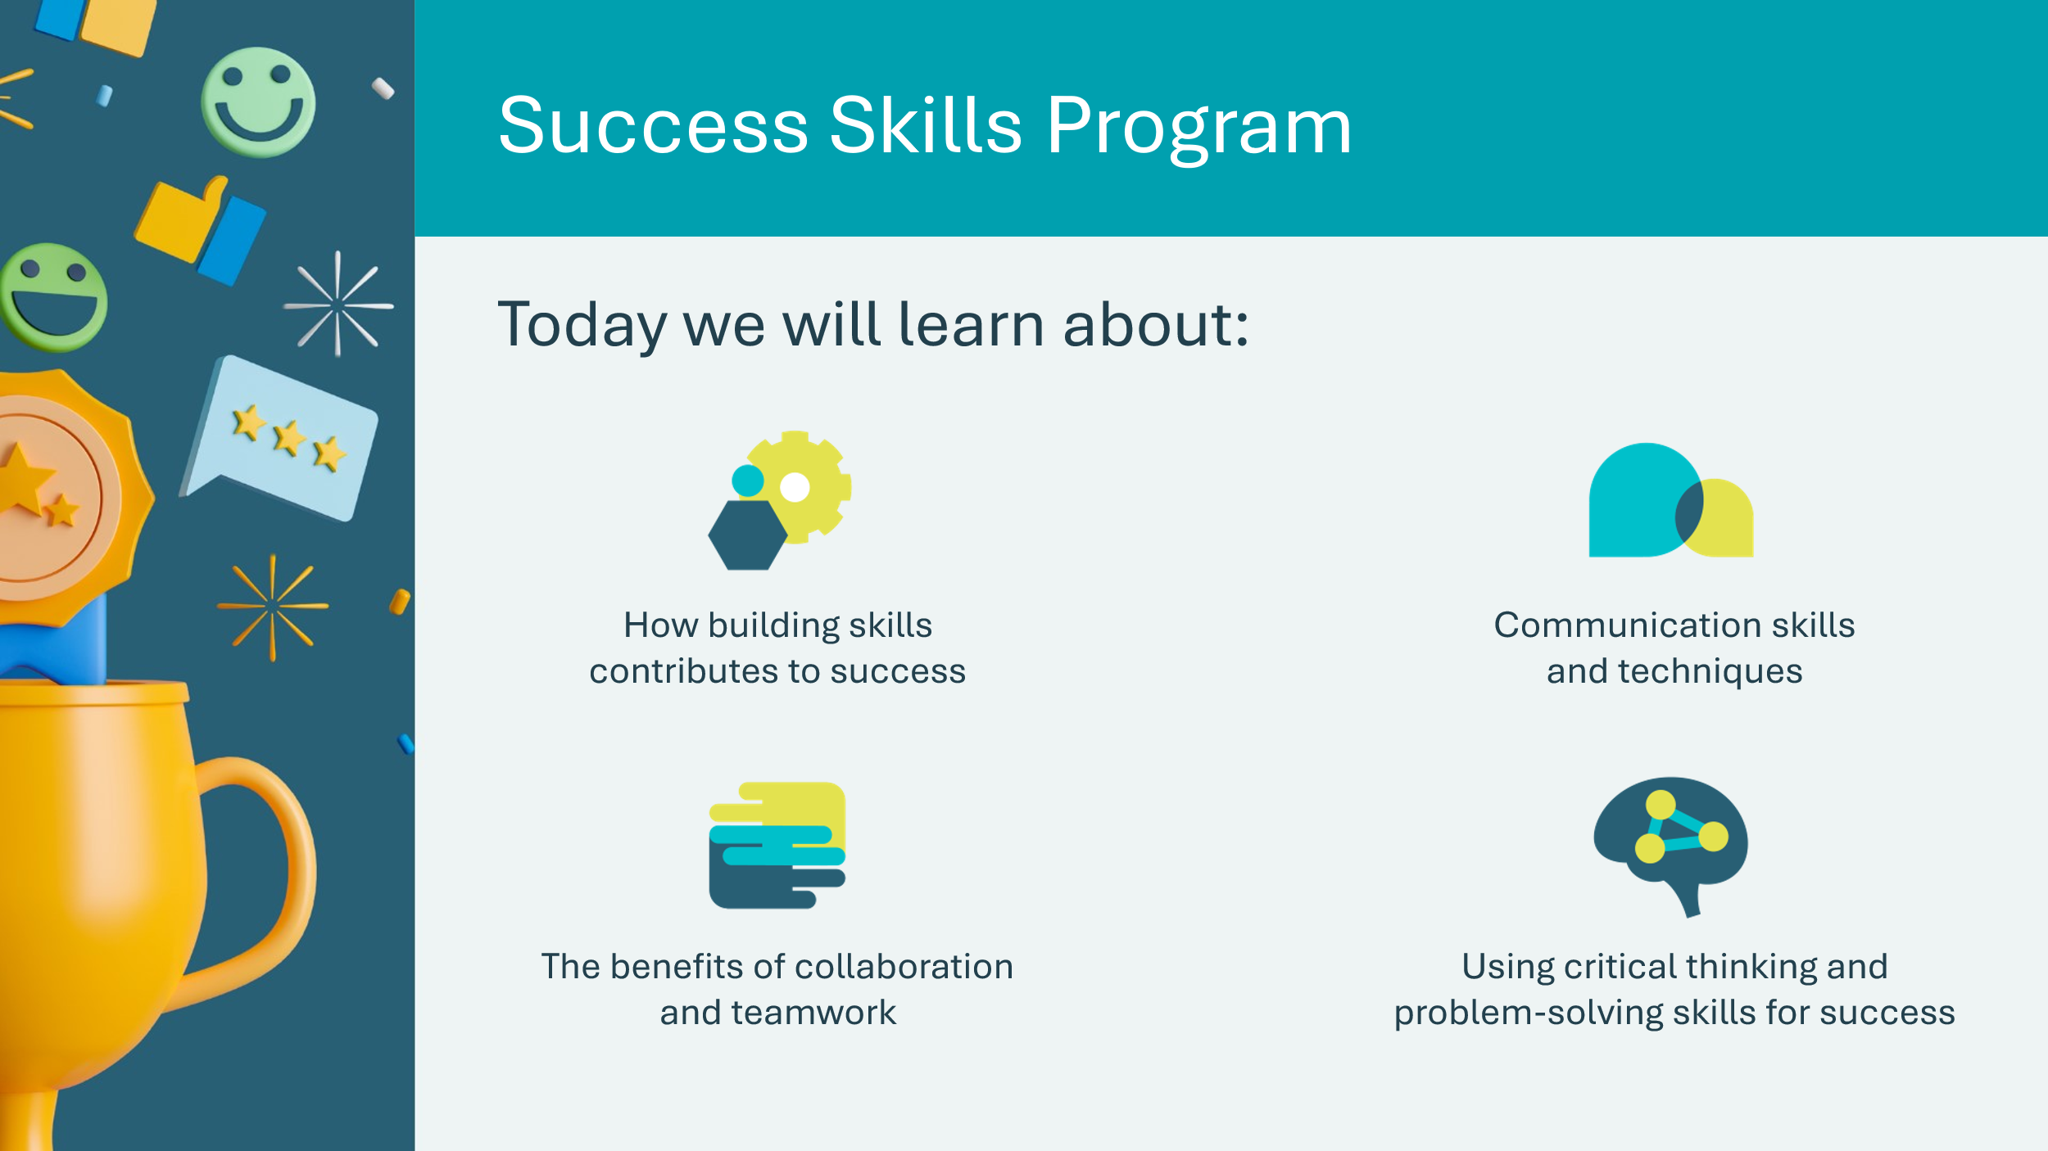  Slide 4 – Symbol Legend  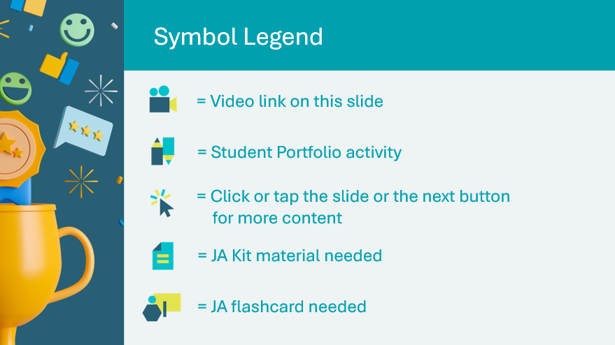 | Suggested time: 3-5 minutes  Introduce the program and yourself!  Tell the students a little about you; your education, and your career path until this point. Explain why you chose to volunteer in their classroom today.  The symbols will help guide the learning experience. Explain to students that they will see these symbols throughout the program.
Slide 5 – Main Menu  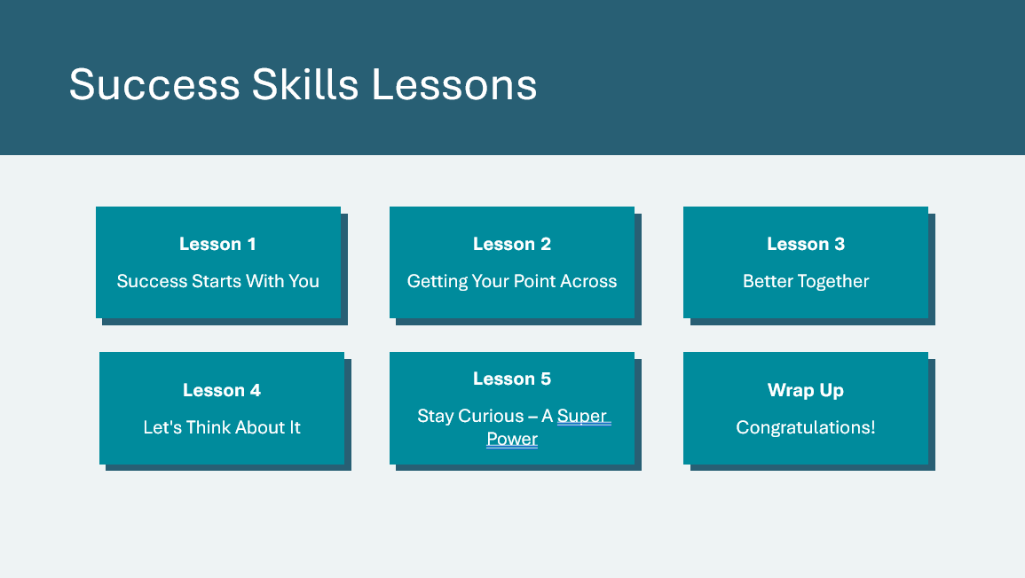 | *Select the button to navigate to the lesson.  After you have completed a lesson, you can select the Return to Main Menu button from the Lesson Activity Menu to return to this slide.

Lesson 1: Success Starts With You
Slide 6 – Lesson 1  | Lesson 1: Success Starts With You
Slide 7 - Objectives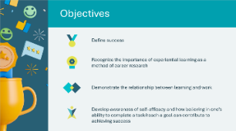 | Optional – review the learning objectives for the lesson
Slide 8 – Introduction  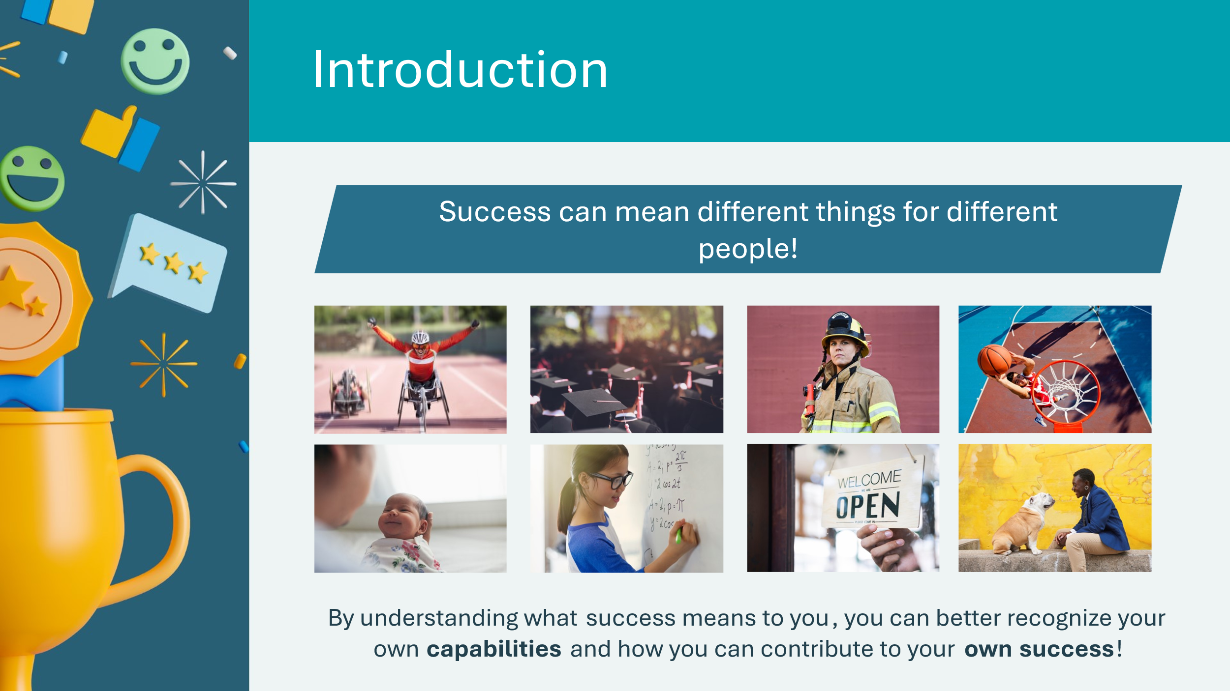 | Success can mean achieving a goal, learning and growing, overcoming challenges, feelings of happiness and fulfillment, and much more!  Success is different for everyone.  Ask: What do you think makes the people in these pictures feel successful? What makes you feel successful?
Slide 9 – Lesson 1 Activity Menu  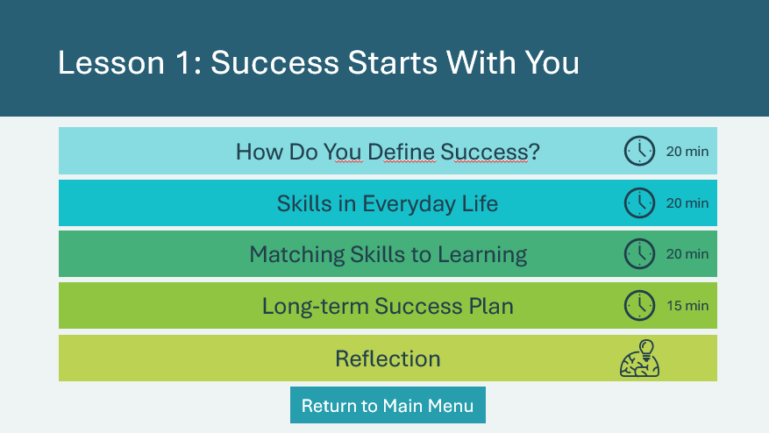 | *Select the button to navigate to the activity.  After you have completed an activity, you will be redirected back to the activity menu.  *Click or tap the Return to Main Menu button to return to the Lessons (Slide 5)
How do You Define Success? 20 min
Slide 10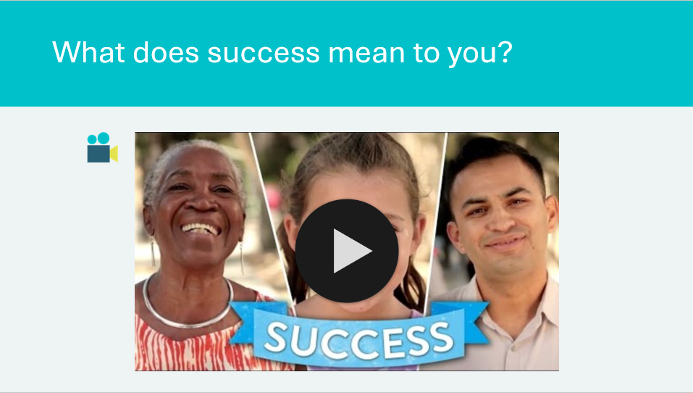 | Suggested time: 3 minutes  https://www.youtube.com/watch?v=ulShj4keKNw  *Click or tap the play icon to start the video.  Ask students to think of a personal success story, big or small, related to a goal they achieved, a skill they developed, or a positive experience they have had (academic or non-academic).  Invite students to share their success stories.  Facilitate the discussion by asking the following questions:  - What common themes or patterns do you notice in each other's stories?  - Were there any challenges that someone overcame in an unexpected way?  - How did determination, effort, or teamwork contribute to success in the stories?
Slide 11  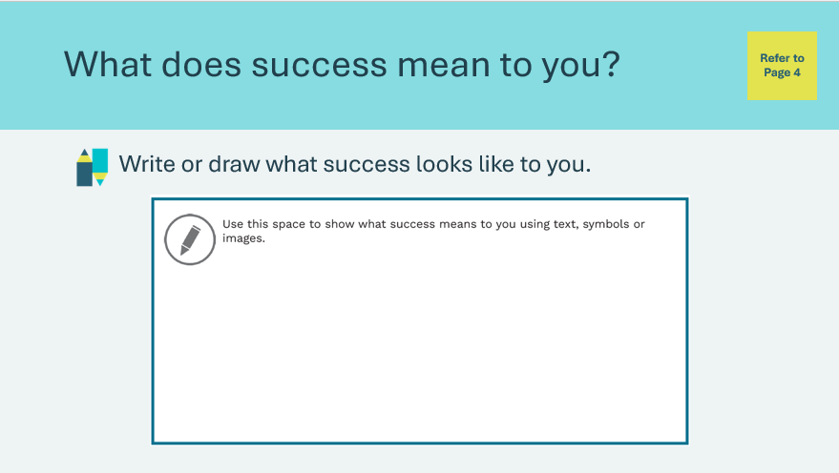 | Suggested time: 5 minutes  Students will complete the prompt in their student portfolio, page 4.  Facilitation tip: Be mindful of individual differences. Keep in mind that success means different things to different people.  Respect and acknowledge individual perspectives and experiences.  Optional follow-up discussion question:  What are some of the things you think you can do to achieve success?  1. Set Goals  2. Build skills  3. Practice mindfulness
Slide 12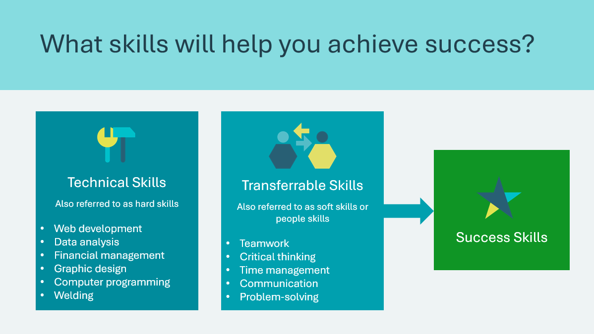  Slide 13  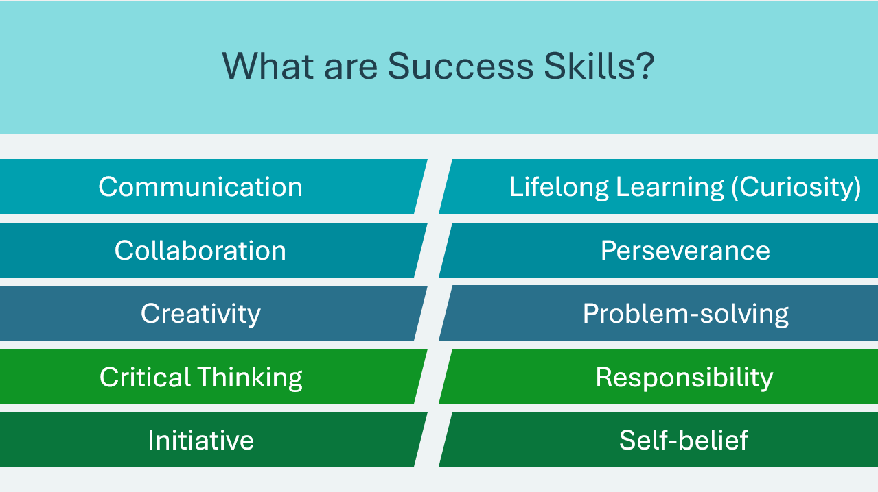 | Suggested time: 2 minutes  Discuss how developing skills to help you succeed is important *reference those in video and in education/learning  Some skills are technical such as web development, data analysis, financial management, graphic design, computer programming, welding. Others are referred to as soft skills, people skills, essential or power skills. In this program, we will refer to them as success skills. These skills are not specific to one job and can benefit you in any workplace.  Discuss types of skills and examples  - technical skills  - transferrable skills  Reinforce that transferrable skills = Success Skills  Today we will explore 10 different success skills and learn more about how you can build these skills to help you succeed now and in the future.  Ask: What do you think Success Skills are?  - Allow students to share a few answers  - *Click or tap to display the Success Skills
Slide 14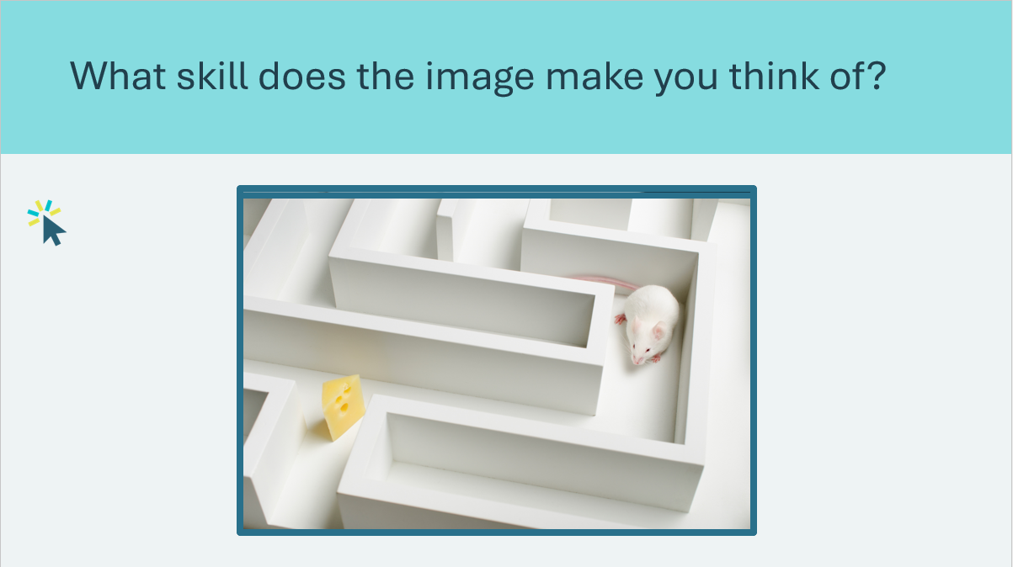 | Suggested time: 5 minutes  Optional activity to facilitate further discussion. There are no wrong answers, but below you'll find some possible interpretations.  Look at the 10 images on this slide. Each image will represent one of the 10 success skills. Invite students to guess which image represents each success skill.  *Click or tap to display next image  - Problem-solving – mouse navigating a maze  - Self-belief – person looking into mirror  - Communication – person wearing headphones for online meeting  - Responsibility – alarm clock  - Lifelong learning (curiosity) – person using magnifying glass  - Initiative – seeds, plants and garden tools  - Collaboration – hands together  - Critical thinking – puzzle pieces  - Creativity - thread  - Perseverance – person drinking water after workout
Slide 15  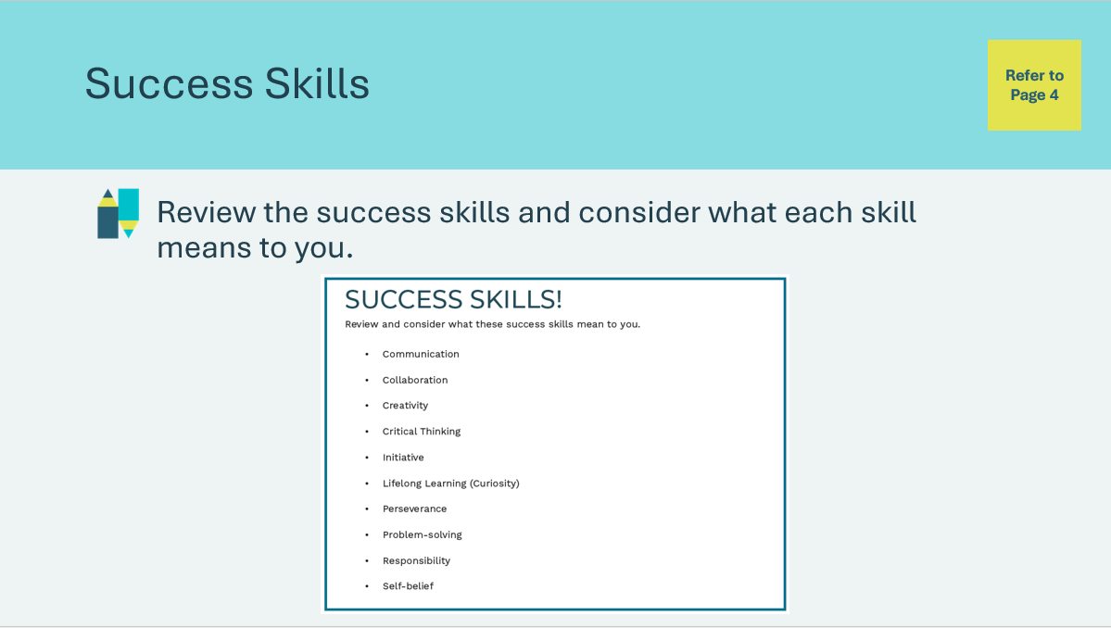 | Suggested time: 5 minutes  Ask students to review and consider what each of the success skills listed in their student portfolio, page 4, means to them.  Remind students that people can define success in different ways. Some people define success in terms of feelings, overcoming challenges or accomplishments. Regardless of how you define success, life skills play an important role in enabling you to succeed.
Skills in Everyday Life 20 min
Slide 16  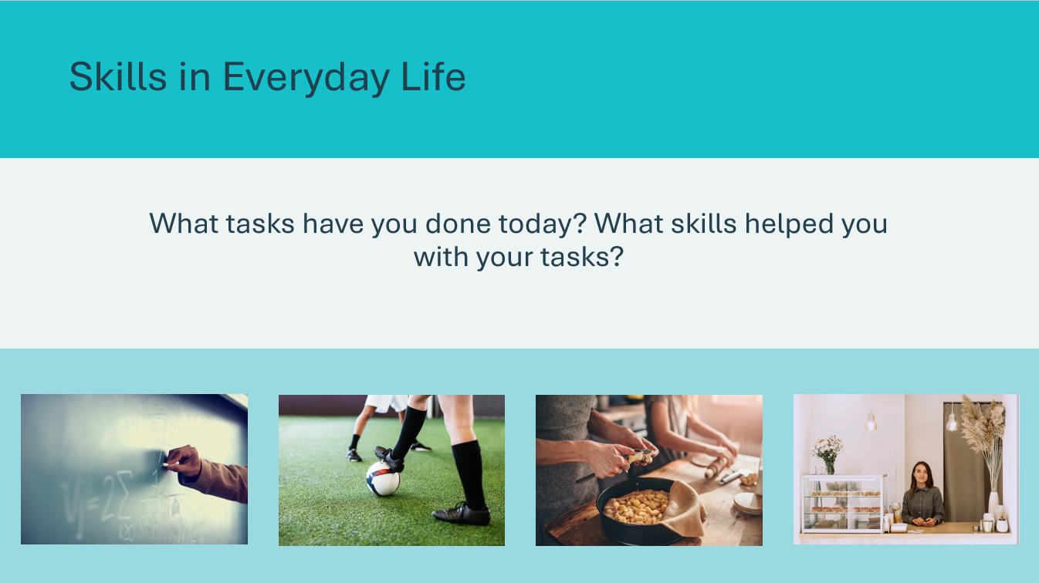 | Suggested time: 5 minutes  Ask the prompt on the slide to help students connect skills to everyday life. Encourage them to consider both technical and success skills. Invite students to share their thinking.  Sample Answers:  - Math homework – numeracy skills, problem-solving, responsibility, critical thinking  - Soccer game – dribbling, passing, shooting, running, perseverance, collaboration, self-belief  - Cooking – cutting, frying, measuring, creativity, perseverance  - Part-time job at café – customer service, math skills for managing payments, attitude, communication, responsibility
Slide 17  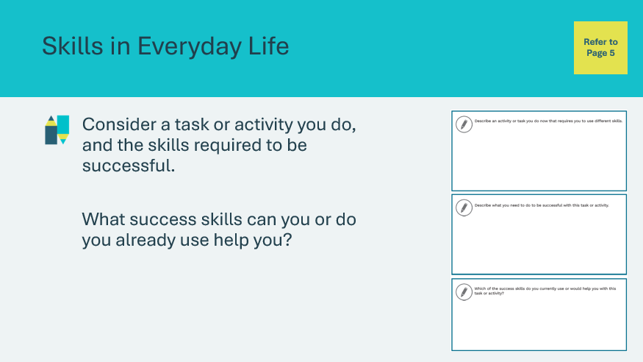 | Suggested time: 10 minutes  Tell students they will complete an activity that will demonstrate how building skills can help them to achieve successful outcomes.  Ask students to respond to the prompts in their student portfolio, page 5.  - They will begin by identifying a task or activity they do that requires them to use different skills  - Students will then describe what they need to do to be successful with the task or activity  - Lastly, students will make connections to the success skills by identifying success skills they already use or would like to use to help them succeed with this task or activity.  Students can complete the activity individually but are welcome to share ideas.  Once finished, invite a few students share their responses.
Slide 18  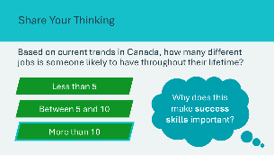 | Suggested time: 5 minutes  Wrap up the activity by making the connection between skills for everyday life and skills for work. Reinforce the idea that a common set of skills can support you in a variety of tasks or jobs.  Invite students to consider the question and respond by raising their hand for the answer they choose.  *Click or tap to reveal the correct answer.  *Click or tap to display the discussion question: Why does this make success skills important?  - Emphasize that success skills can be applied in various roles or career paths, even if individuals choose to switch professions at different points in their lives.  - Explain how this makes success skills very valuable in today’s rapidly changing job market, where individuals may change roles or career paths multiple times throughout their lifetime.
Matching Skills to Learning 20 min
Slide 19  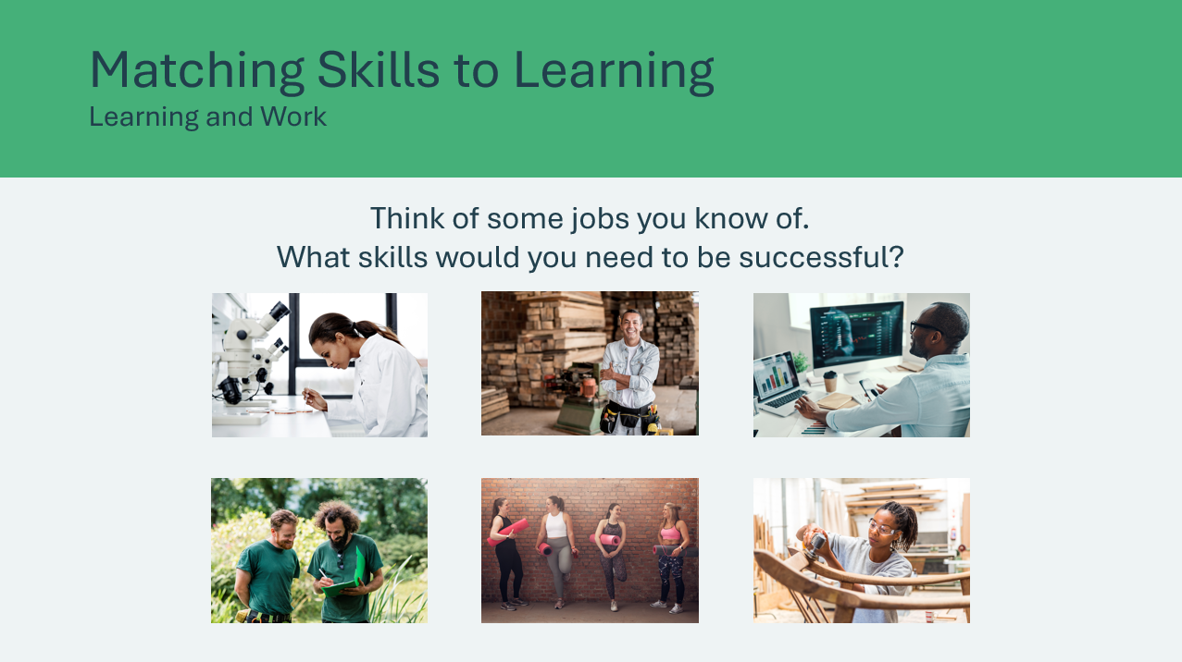  Slide 20  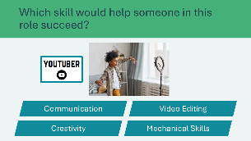  Slide 21  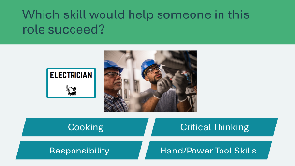  Slide 22  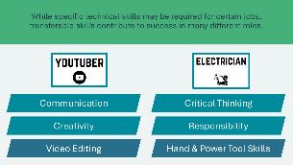 | Suggested time: 5 minutes  Introduce the relationship between learning and work by asking the prompt on the slide. Encourage students to consider how they could start learning these skills. Explain that building new skills today can help prepare you for future work in the future.  Volunteer connection: Share some skills you learned to help you succeed in your current role or previous roles.  Youtuber  Invite students to share their responses.  Encourage discussion by asking students to explain their thinking on how the skill(s) (technical or success skill) would or would not help someone succeed in the role. Accept all reasonable answers.  Electrician  Invite students to share their responses.  Encourage discussion by asking students to explain their thinking on how the skill(s) (technical or success skill) would or would not help someone succeed in the role. Accept all reasonable answers.  Highlight how technical skills can often be specific to a certain job, whereas transferable skills (i.e. success skills) can apply to a large number of roles.  Transition to next activity:  Encourage discussion by asking: how can you discover if you have the skills for a particular job?  Invite a few students to share answers.  Explain that job descriptions tell you what skills are needed for a certain job. Tell students that they will be looking at some job descriptions to practice identifying what skills are needed.
Slide 23  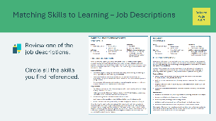 | Suggested time: 5 minutes  Invite students to look at the sample job descriptions in their student portfolio, page 6 & 7.  Ask: What sections of the job description do you think indicate the skills (technical skills and success skills) needed for this job?  Answer: Skills needed can be found within the description, responsibilities, and requirements sections.  Students will choose one of the job descriptions and circle all the skills they have identified.  Invite a handful of students to share and discuss the skills they found.
Slide 24  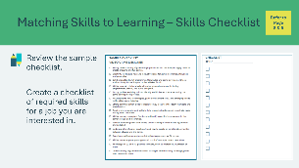 | Suggested time: 5 minutes  Ask students to find the sample checklist in their student portfolio, page 8.  Give students time to review the sample checklist and think about a job they would be interested in. Students will identify what skills would be required (success skills and technical skills). They will complete student portfolio, page 9, by filling in the job title and creating a checklist of the skills needed.
Slide 25  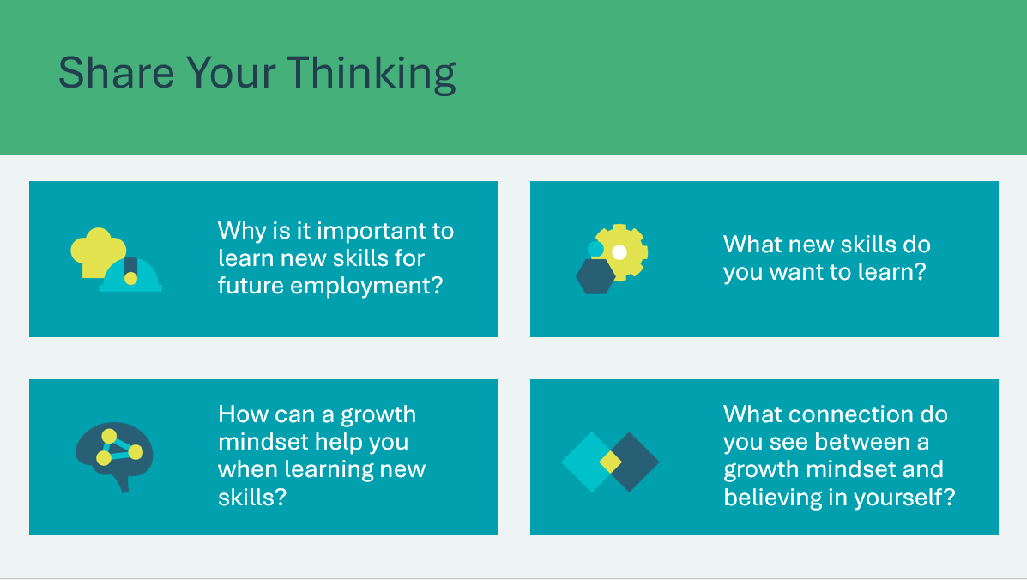 | Suggested time: 5 minutes  Wrap up the activity using the discussion questions (optional)  *Click or tap to reveal questions  Growth mindset: the belief that you can improve your abilities over time through effort, learning and persistence.  Ask: Can you think of a time when having a growth mindset helped you learn a new skill?  Believing in yourself and your ability to learn and grow when faced with challenges can help to manage your stress and improve your overall well-being.
Long-term Success Plan 15 min
Slide 26    Slide 27  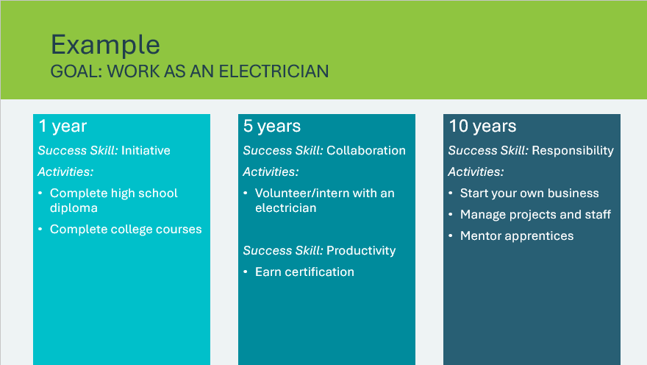 | Suggested time: 5 minutes  Thinking about all the skills you need to learn for your future might feel overwhelming.  Mental well-being connection: Breaking our larger goals down into short, medium and long-term goals can make things feel more manageable and help with stress.  *Click or tap to reveal each section of the timeline  Review the example to explore how building different success skills over time can help you achieve your goal and contribute to your success in the long term.  Emphasize that skills are learned and improved over time.
Slide 28  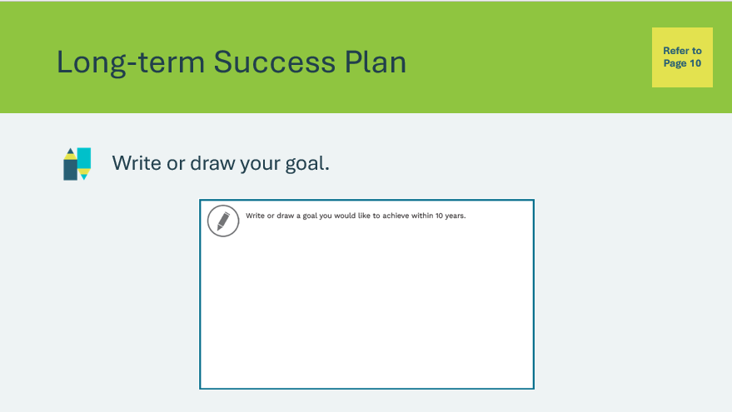 | Suggested time: 5 minutes  Students will complete the activity in their student portfolio, page 10. They can choose an education, career or other life goal that is important to them.
Slide 29  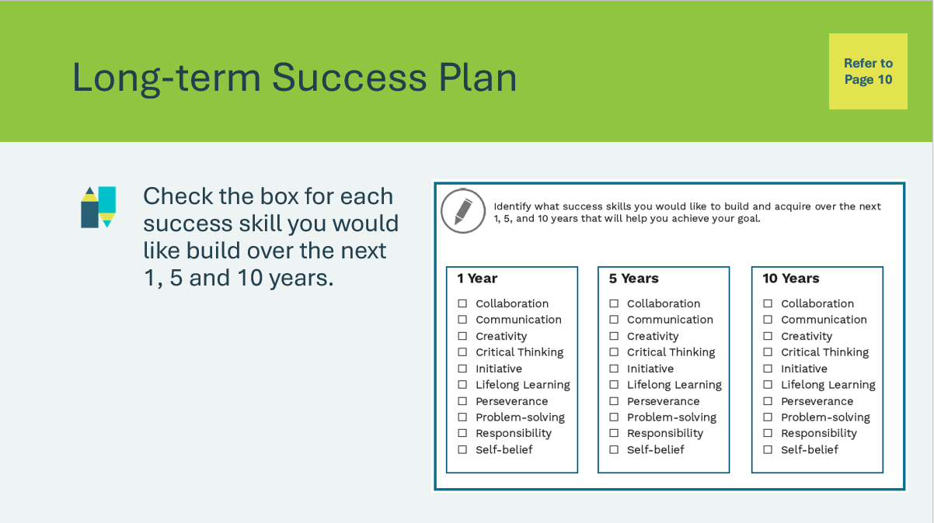 | Suggested time: 5 minutes  Students will complete the activity in their student portfolio, page 10.  Encourage them to consider their goal for the future as they select the skills they would like to build.  Remind students that success skills are transferable skills that can help them be successful in achieving a variety of goals.  Volunteer connection: Share how certain skills helped contribute to achieving your goals (education, career or other).
Reflection
Slide 30  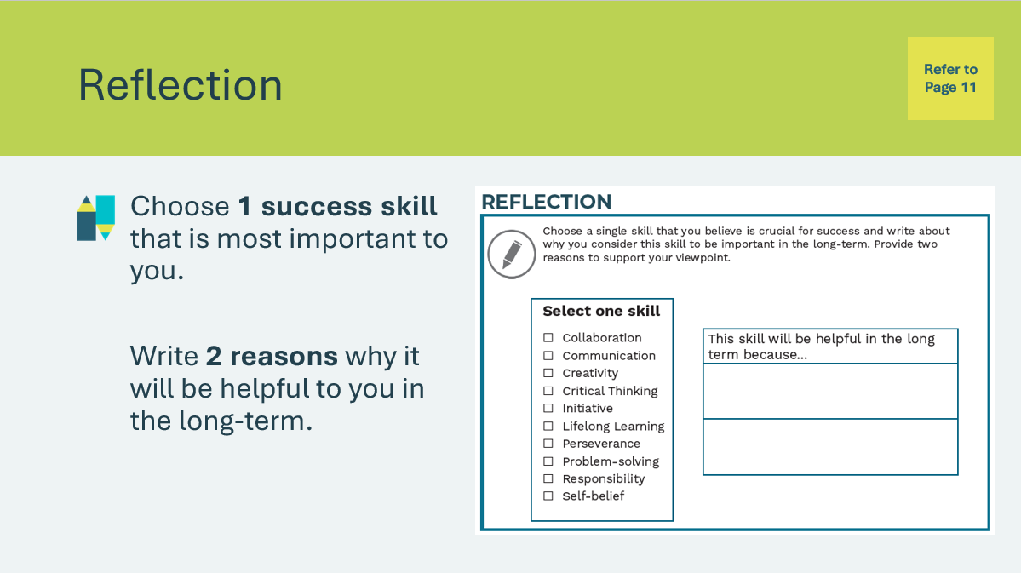 | Suggested time: Students can complete the reflections in class if time allows, or independently later on.  Encourage students to consider the success skills they have learned about. As we start to better understand how skills can help us succeed, it’s important to reflect on how defining success and thinking about skill building in the short and long-term makes us feel. Having a healthy mindset and taking good care of yourself are a very important part of being successful in anything you aspire to do.  Students will complete the first activity in their student portfolio, page 11, by choosing one skill they think is crucial for success. They will list two reasons why this skill will be helpful in the long-term.  Invite students to share their responses if time allows.  Volunteer connection: Share a success skill that has been most valuable to you in your career over the long-term.
Slide 31  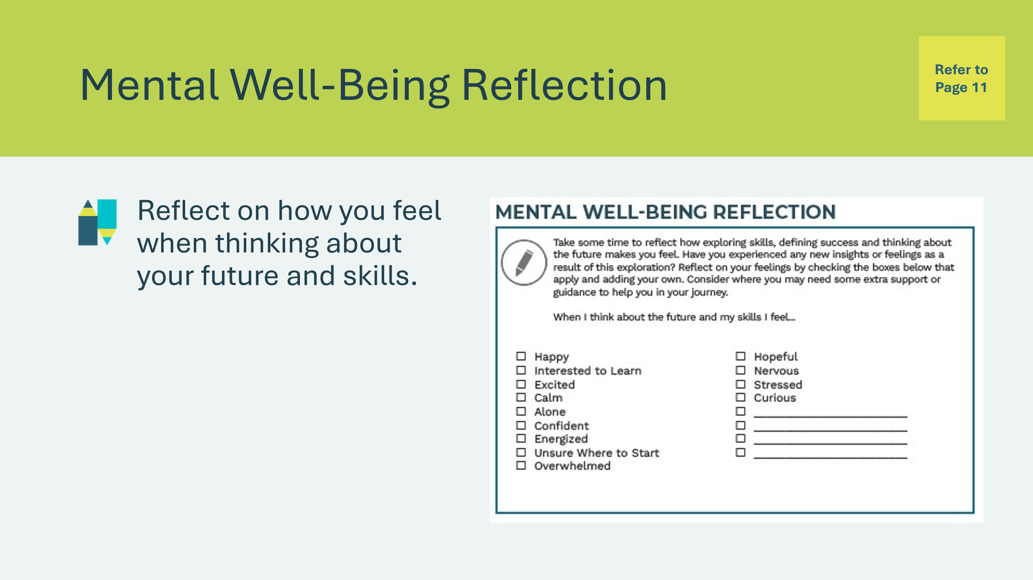 | Suggested time: Students can complete the reflections in class if time allows, or independently later on.  Students will complete the second activity in their student portfolio, page 11, by reflecting on how they feel about their skills and future.  Ask: Are you excited, nervous, calm, doubtful, confident?  Invite students to share their responses if time allows.

Lesson 2: Getting Your Point Across
Program Kit Materials | Active Listening Activity Illustration Cards (Appendix A)  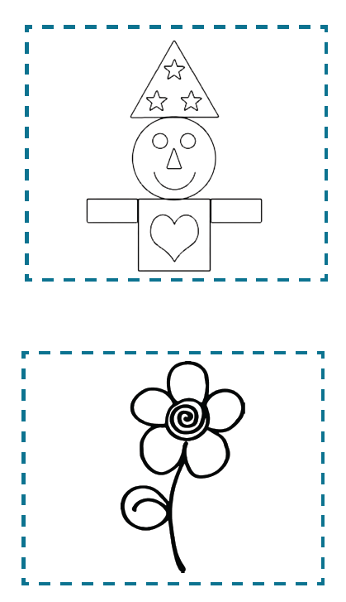
Slide 32 – Lesson 2   | Lesson 2: Getting Your Point Across
Slide 33 – Objectives  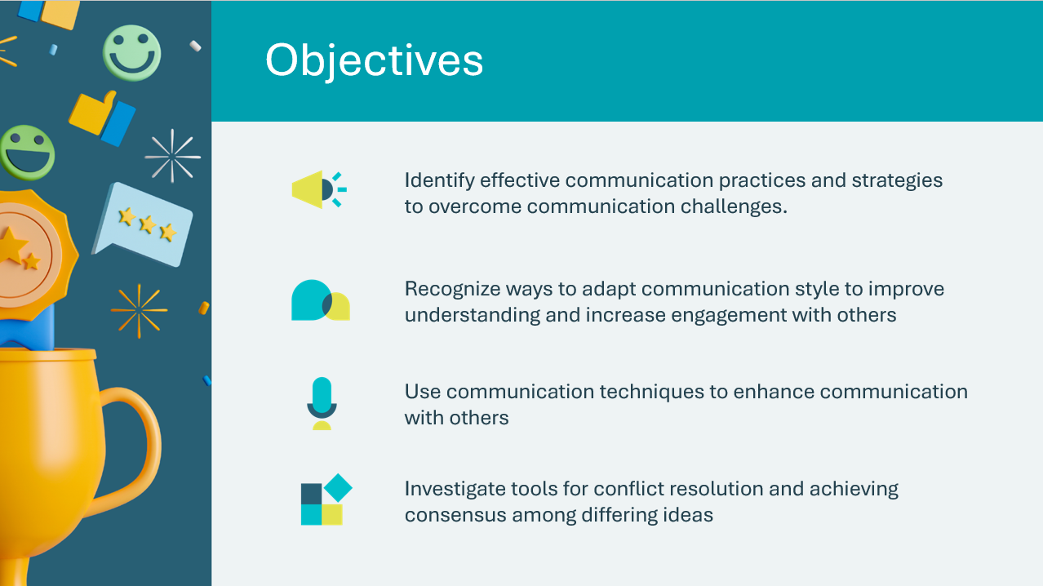 | Optional – review the learning objectives for the lesson
Slide 34 – Introduction  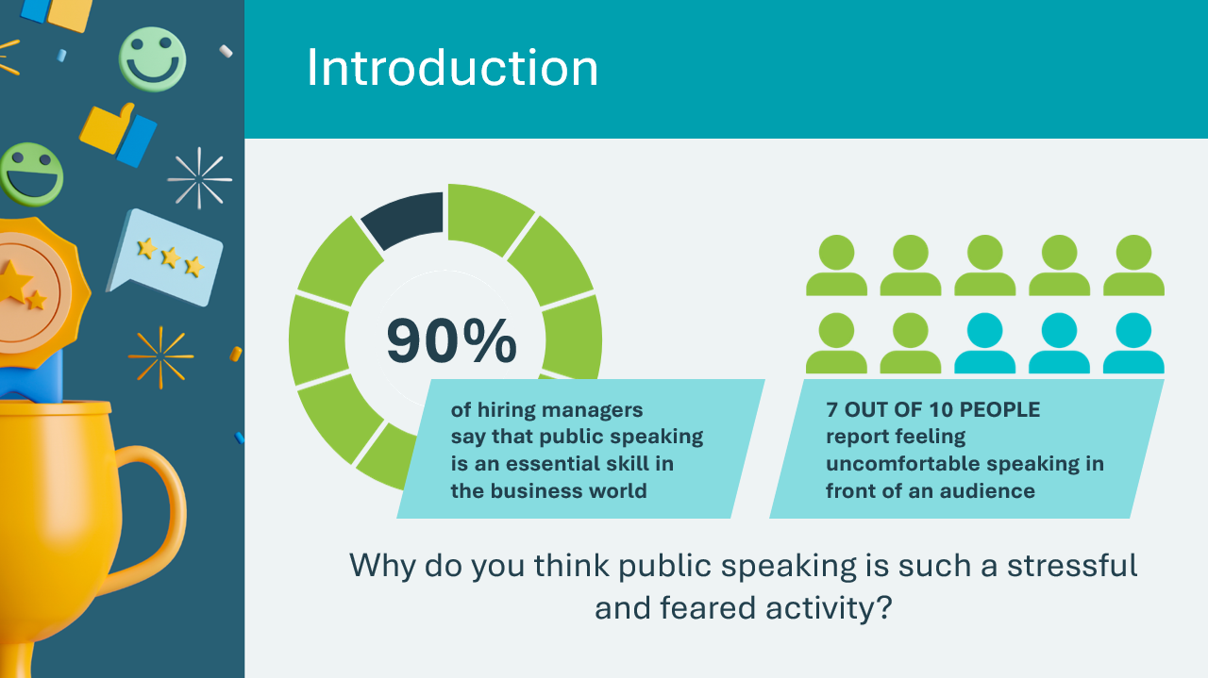 | Introduce the lesson by sharing the statistics shown in the infographics and asking the prompt on the slide. Allow a few students to share their answers.  Sharing our thoughts, ideas or feelings with others can make us feel vulnerable and afraid of being judged.  By building our communication skills, we can become more effective and confident communicators in all kinds of different situations, big or small!
Slide 35 – Activity Menu  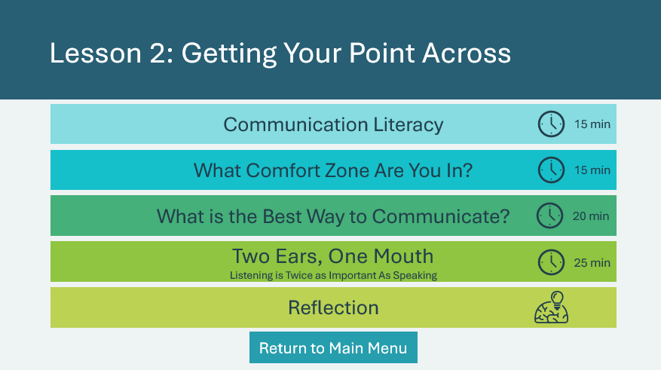 | *Select the button to navigate to the activity.  After you have completed an activity, you will be redirected back to the activity menu.  *Click or tap the Return to Main Menu button to return to the Lessons (Slide 5)
Communication Literacy 15 min
Slide 36  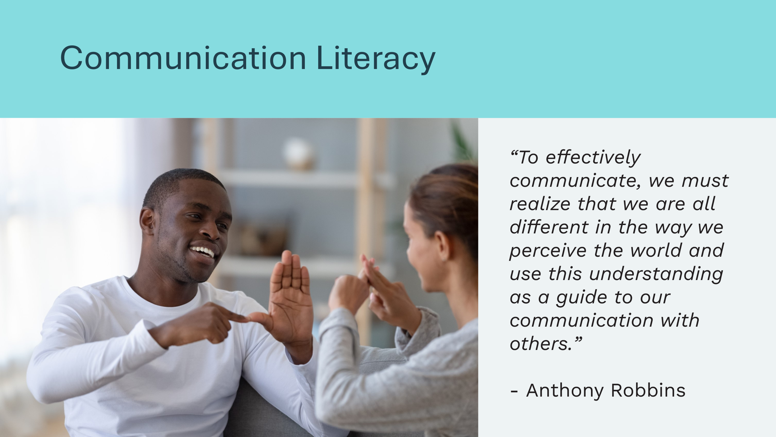 | Suggested time: 2 minutes  Read the quote to students.  Ask: Can you think of an example of how this quote might relate to your own life?  Example: My mother wants me to clean my room because she thinks it looks dirty if there are clothes lying around. I think it's a waste of time to put my clothes away, so I'll put them away later this week.  In this example, there are two different perspectives on the same subject: that of the young person and that of their mother.
Slide 37  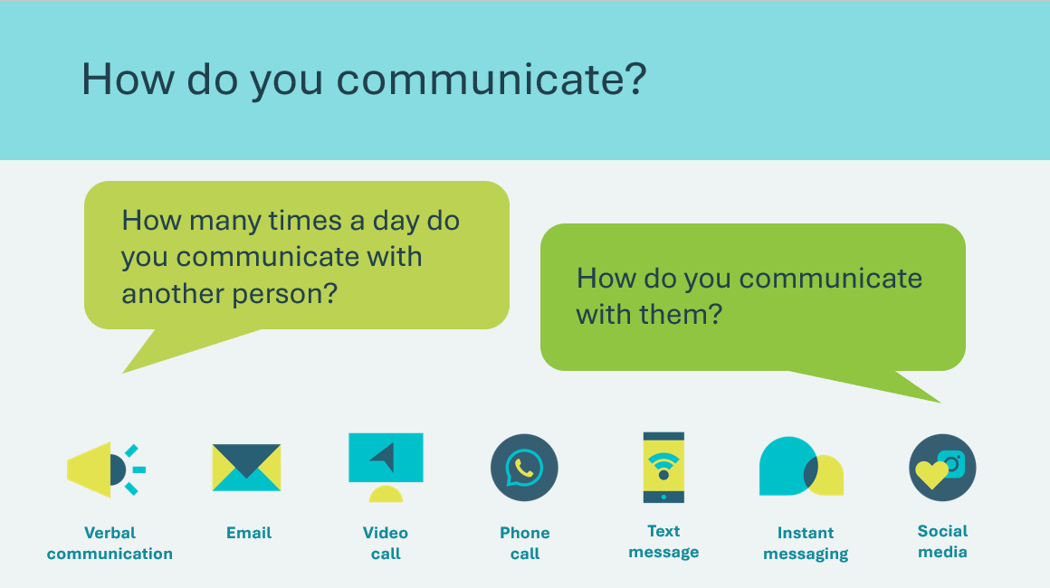 | Suggested time: 3 minutes  On average, we spend 80% to 90% of our day communicating with others!  Ask the question prompts and invite students to share answers.  *Click or tap to reveal the different communication methods  Communication can take many different forms!  - Verbal communications  - Email  - Video calls  - Phone calls  - Instant messaging or texting  - Social media  - Non-verbal communication/gestures  People use different styles and methods of communication. In this lesson, we will explore communication styles and identify our own individual communication style.  - Optional discussion question: What are your favourite ways to communicate and why?
Slide 38  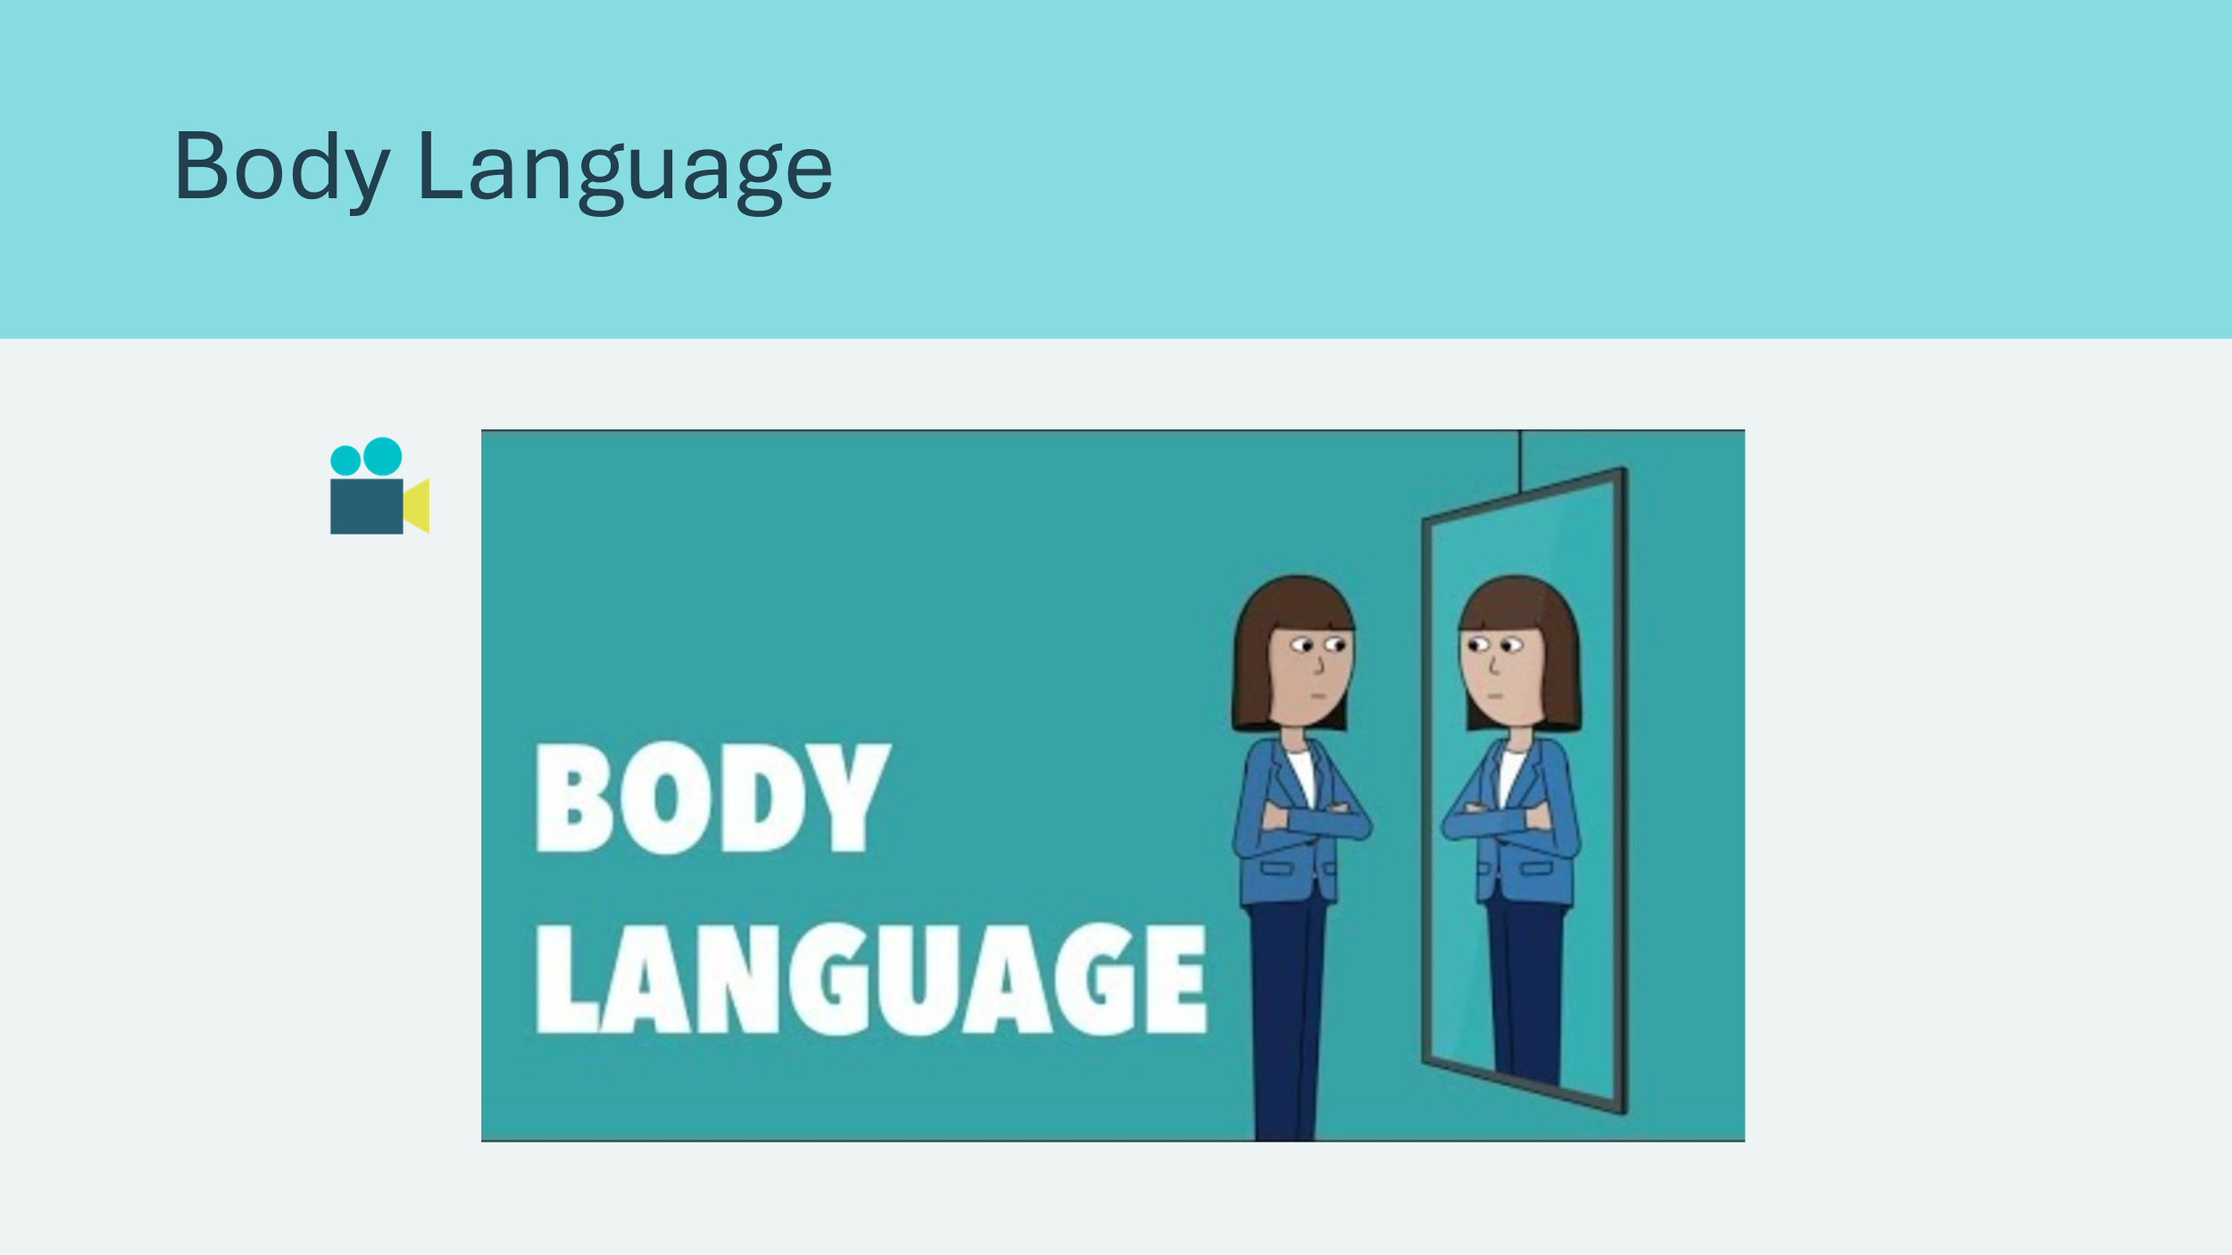 | Suggested time: 3 minutes  Play the video to introduce the concept of non-verbal communication.  Afterwords, ask:  - What forms of communication allow us to read body language?  - Why might this be important when choosing how you will communicate with someone?  Missing out on things such as facial expressions and tone of voice can sometimes lead to our messages being misunderstood.
Slide 39  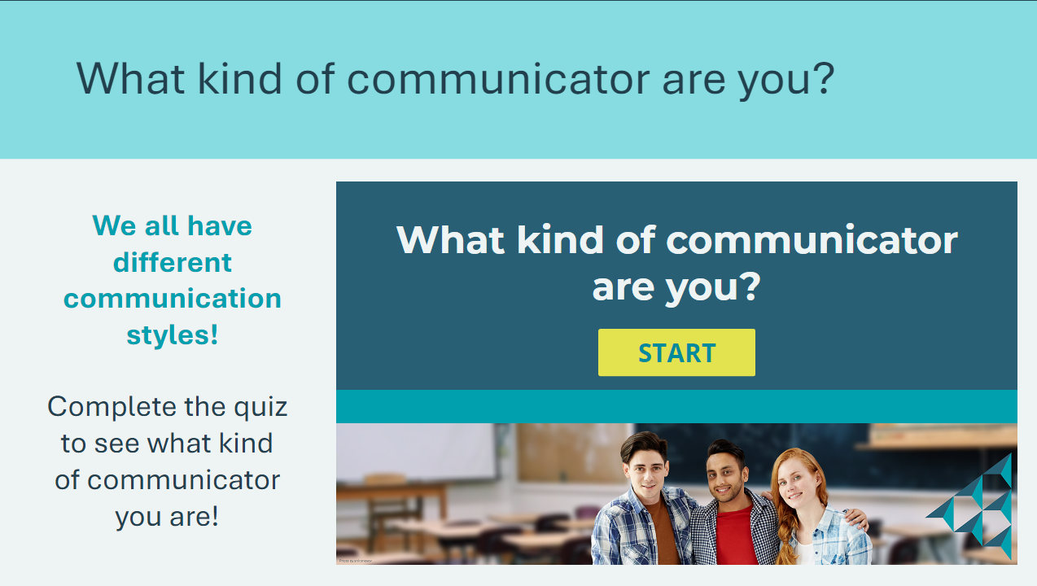 | Suggested time: 7 minutes  Complete the “What kind of communicator are you” quiz as a class. Ask students to write down their answers (A, B, C, etc.) for each answer.  After reviewing the results, encourage students to think critically about their communication style and how it impacts their relationships with others.  How might your communication style be perceived:  - In a job interview?  - When meeting new people?  Link to quiz on JA Campus:  What Kind of Communicator Are You?
Slide 40  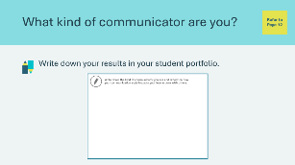 | Students will write down their results from the quiz in their student portfolio, page 12. Encourage them to reflect on how their communication style impacts the ways they interact with others.
What Comfort Zone Are You In? 15 min
Slide 41  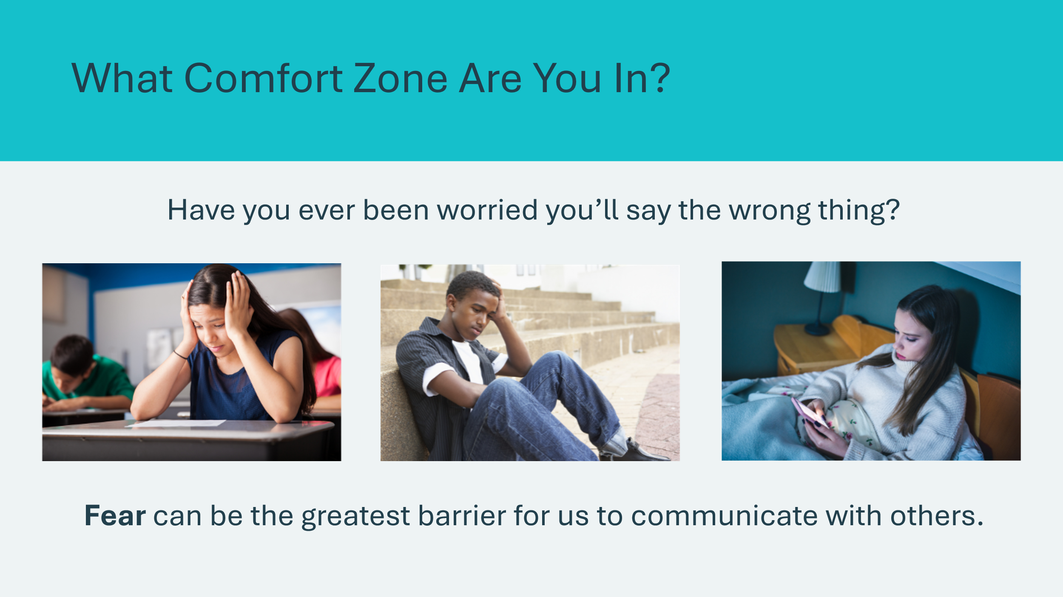  Slide 42  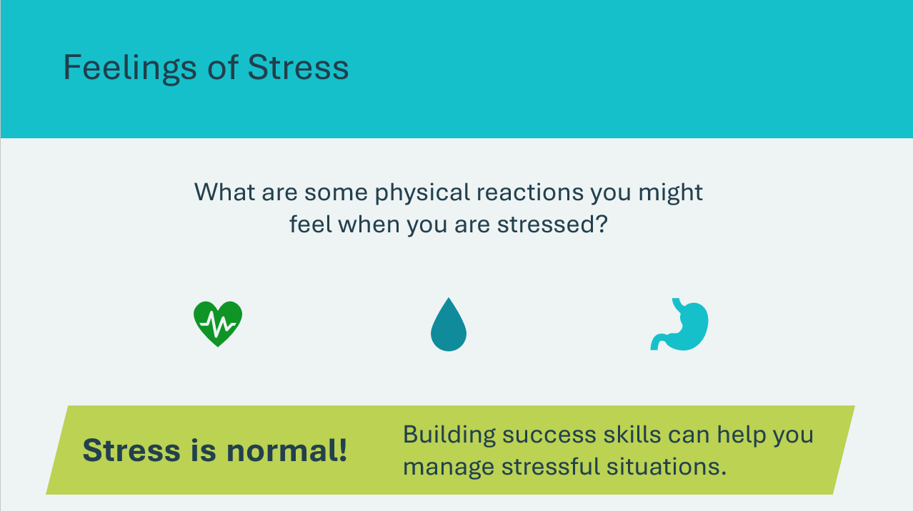 | Suggested time: 3 minutes  Introduce the activity by reading the prompts and inviting students to share examples of when they were worried about communicating with someone.  Volunteer connection: Share an example of a time you were worried you might say the wrong thing.  Ask the students to share some of the physical feelings they might feel when they are stressed. These could include a rapid heartbeat, sweating, or butterflies in your stomach.  Explain that when you are feeling afraid or worried about communicating with others, your body might experience a physical stress response.  These are all perfectly normal responses to stress! Recognizing stressful situations and feelings of stress can help us deal with them more effectively. Invite students to share things that help them calm down when they feel stressed or nervous.  Mental wellbeing connection: While too much stress can have negative effects on our health, a certain amount of stress can be necessary for growth, motivation and resilience in life.  Example: The stress of a challenging project or deadline can motivate you to work harder, develop new skills and achieve a sense of accomplishment and satisfaction upon completion.  Volunteer connection: Share a time when you experienced stress, but it helped you to achieve something positive.
Slide 43  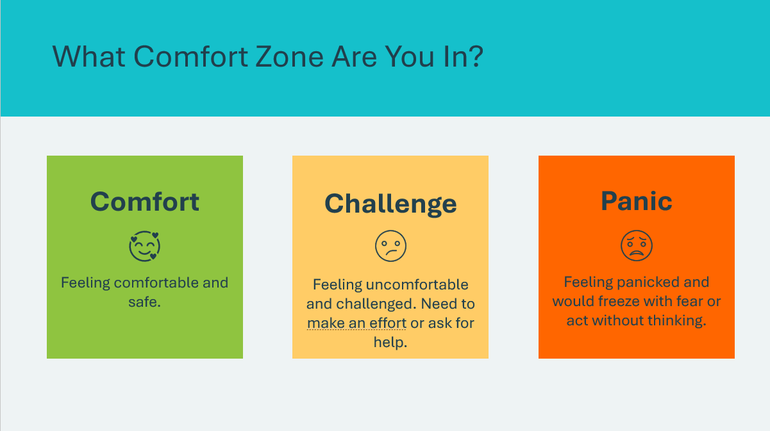  Slide 44  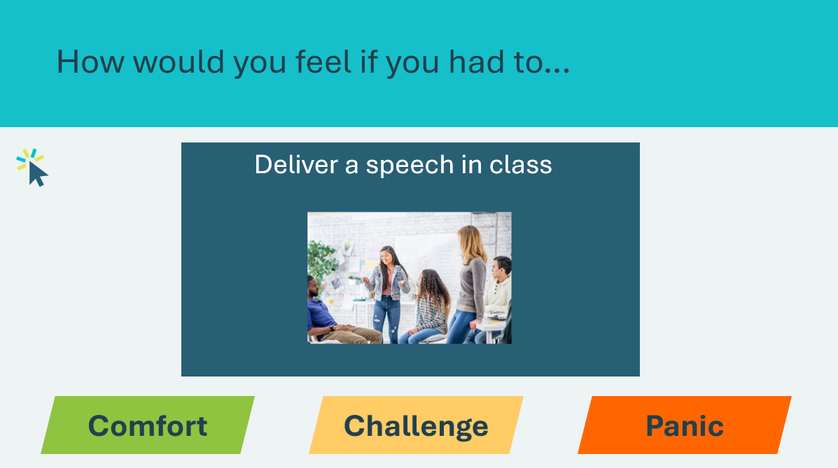 | Suggested time: 10 minutes  Designate two areas in the room  *This may require moving desks. If designating areas are not possible, students can remain seated and raise their hands when reading the scenarios  - One area will be the comfort zone – this is where one feels safe and comfortable. This area should be big enough to hold all participants  - The second area will be the panic zone – this is where one is frozen with fear or might act without thinking  - The area in between the comfort and panic zones is the challenge zone – this is where one needs to make an effort to develop and grow.  Explain to students that you will present some scenarios. They will decide how they would feel and move to that comfort zone. Remind students that different people may have different responses to each scenario based on their individual comfort levels.  Read each scenario and allow students time to move to their chosen comfort zone.  - Ask some participants to explain their choices and feelings  - If somebody goes to the panic zone, ask what could help in these situations to ease panic or stress  - Remind students as needed that responses may be different for everyone  *Click or tap to reveal additional scenarios
Slide 45  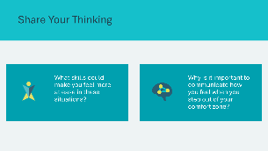 | Suggested time: 3 minutes  Wrap up the activity using the optional discussion questions.  *Click or tap to reveal questions
What is the Best Way to Communicate? 20 min
Slide 46  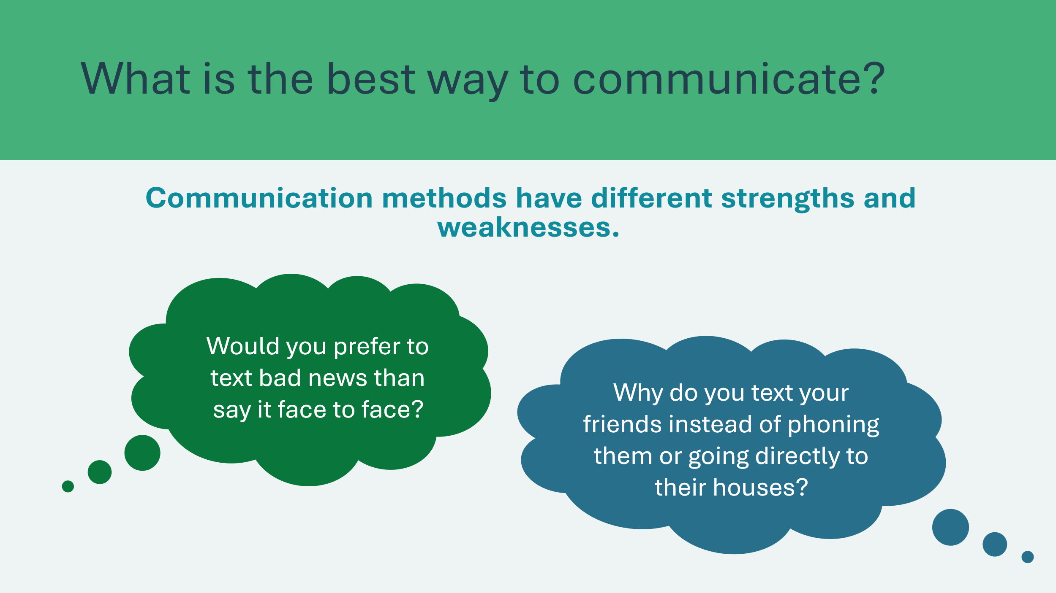 | Suggested time: 2 minutes  Invite a few students to share answers to prompts.  Ask: Would you prefer to text bad news than say it face to face?  - While it may be easier to text someone bad news, difficult conversations are better to have face to face.  - In-person communication is so powerful because we can communicate our emotions non-verbally  Ask: Why do you text your friends instead of phoning them or going directly to their houses?  - Communication speed is a luxury – sometimes it’s easier and more efficient to send a text message  It’s important to consider the situation when deciding what the best way to communicate is.
Slide 47  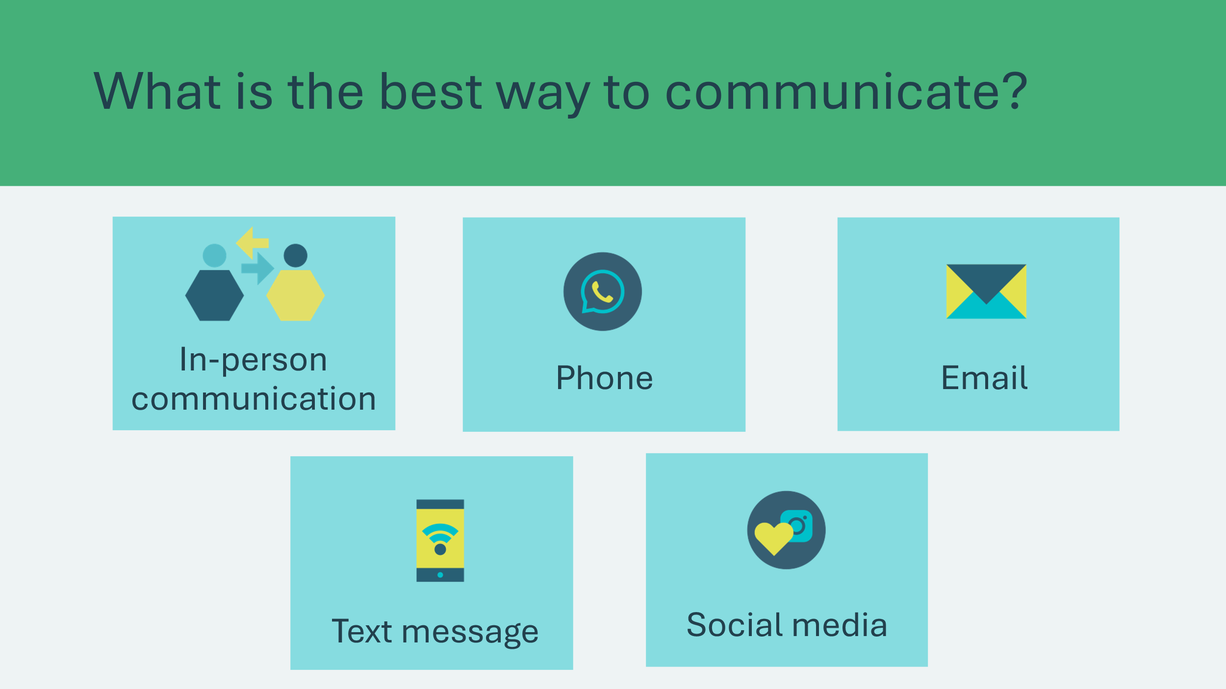 | Suggested time: 3 minutes  In-person communication is generally the most effective, followed by phone calls, email, text messages and social media.  Discuss the pros and cons of each communication method. Encourage students to come up with pros and cons and use the list below to help guide the discussion, if needed.  In person  - Pros: Nonverbal cues, immediate feedback, easier to discuss complex topics  - Cons: time consuming, requires coordinating schedules and being in the same location  Phone  - Pros: Real-time communication, tone of voice, convenient  - Cons: Lack of body language cues, receiving a phone call can be disruptive  Email  - Pros: Allows for documentation, convenient, professional  - Cons: Tone and intent can be misunderstood, delayed responses, people may feel they receive too many emails  Text Message  - Pros: Good for short messages, immediate responses, convenient  - Cons: Lack of context and emotion, informal, not enough information or detail  Social Media  - Pros: Wide reach, high engagement, supports visual communication  - Cons: Lack of privacy, distracting, messages can be misinterpreted  Explain that students will be presented with a handful of scenarios and will be deciding which of these communication methods is the best way to communicate.
Slide 48  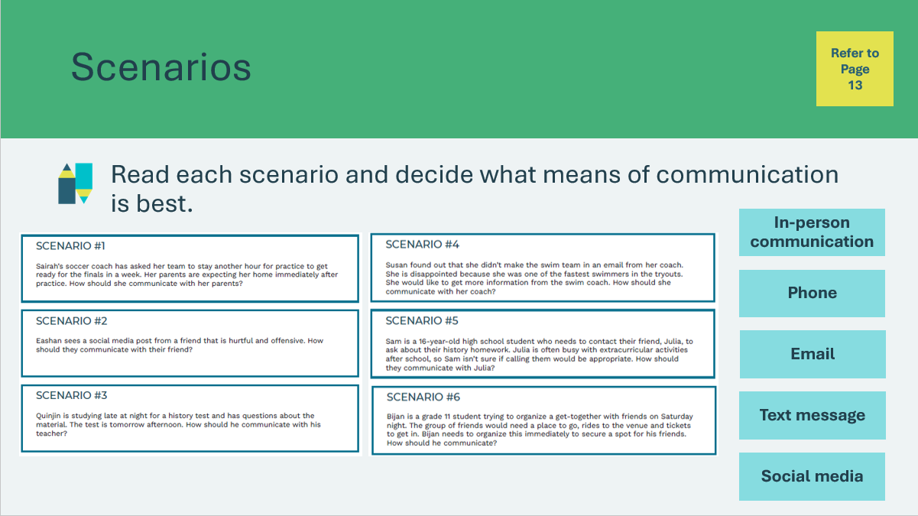 | Suggested time: 10 minutes  Discuss Scenario #1 as a class and decide which method of communication is best.  Organize the students in partners or small groups and have them open the scenario sheet in their student portfolio, page 13. In their partners or groups, students will take turns reading the scenarios and identifying the best method of communication.  Once complete, review each scenario as a class. Invite a different pair/group to share their thinking for each scenario.
Slide 49  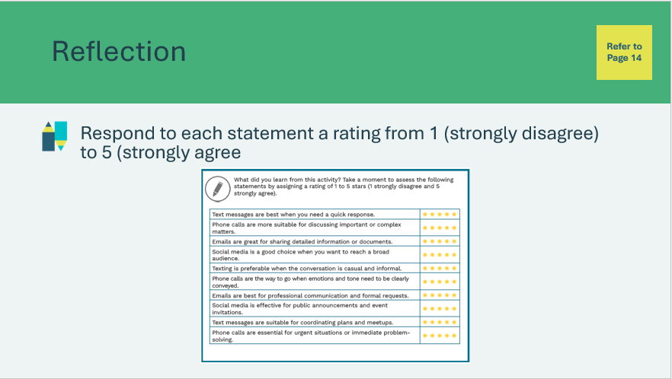 | Suggested time: 5 minutes  Students will read each statement in their student portfolio, page 14, and use the rating scale to indicate if they agree or disagree.  If time allows, read through each statement and allow a student to share their response.
Two Ears, One Mouth 25 min
Slide 50  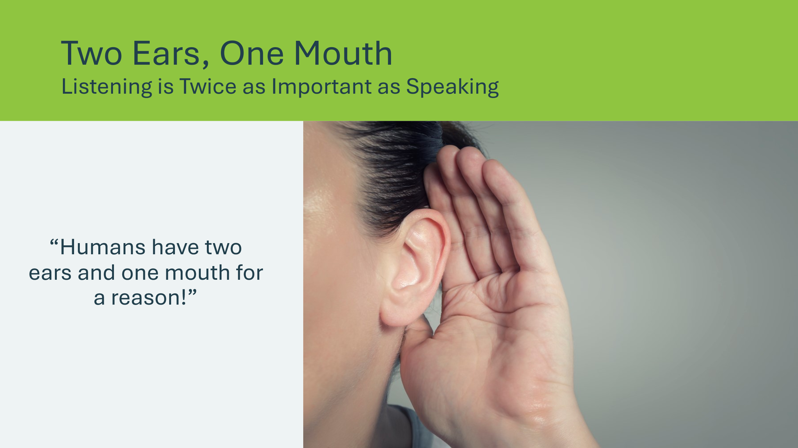  Slide 51  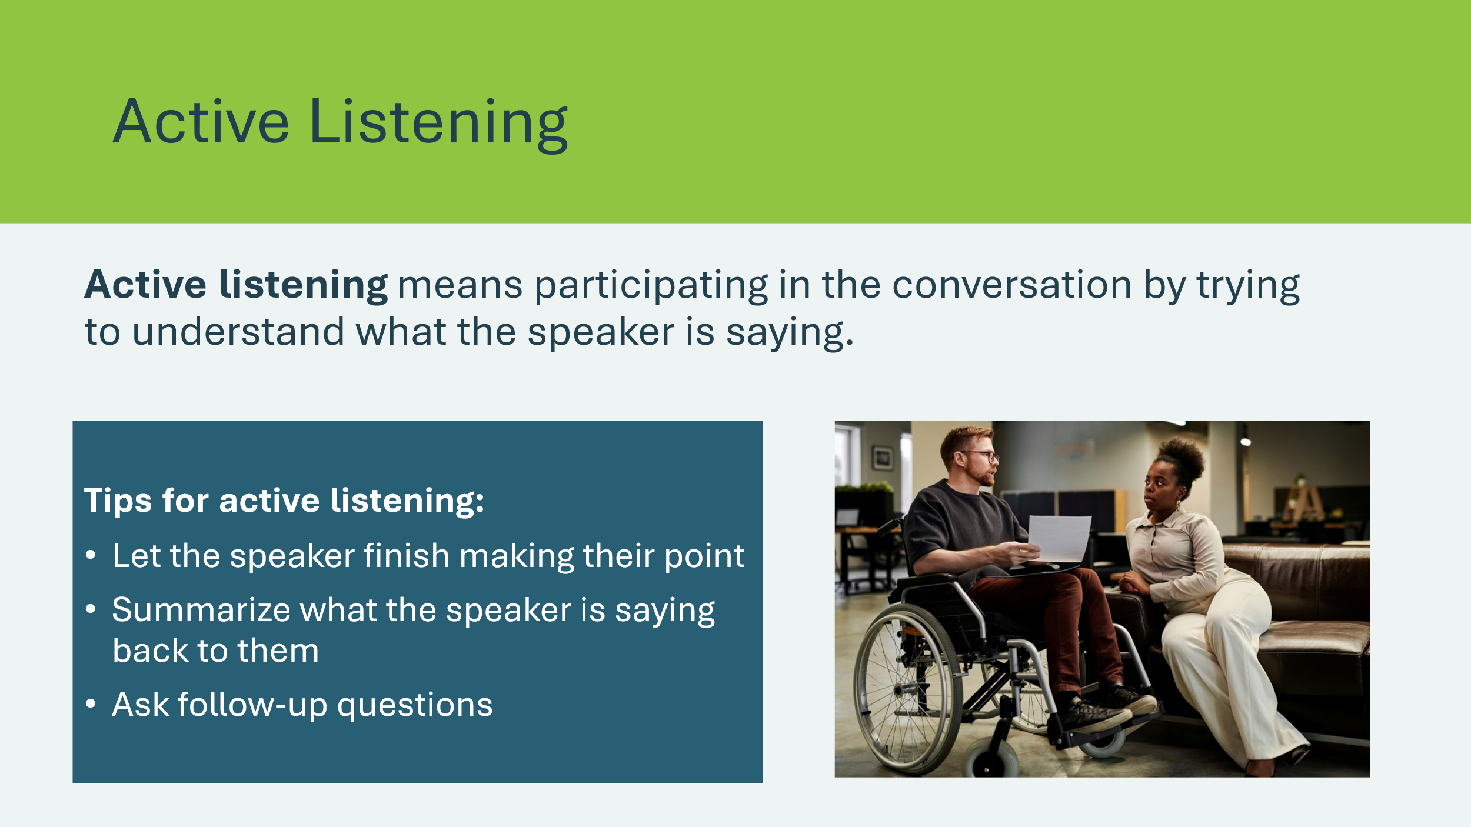 | Suggested time: 5 minutes  Read the quote on the slide and ask students what they think it means. Invite a few students to share their responses.  Explain that this saying means that we should listen twice as much as we talk. It’s important to be an active listener when we are in conversation with another person.  Read the definition for active listening.  Share the tips for active listening and invite students to suggest some other tips for being an active listener.
Program Kit Material | For slide 52, you will need to use the Active Listening Activity Illustration Cards from the program kit.
Slide 52  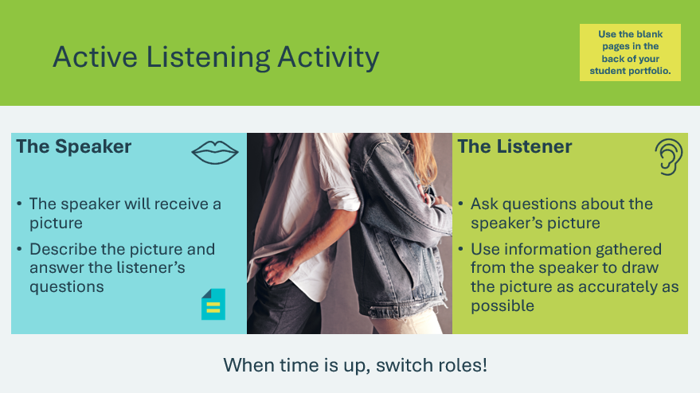  Active Listening Activity Illustration Cards | Suggested time: 20 minutes  - About 10 minutes per round *Adjust the timing as needed  Hand out a picture card to one student in each pair. Students can complete their drawing on the blank pages in the back of their student portfolio.  Following the first round, ask:  - What difficulties did you experience when communicating with each other?  - What active listening strategies could you use to overcome those difficulties?  Have students swap roles. Invite them to share their experience the second time around.
Reflection
Slide 53  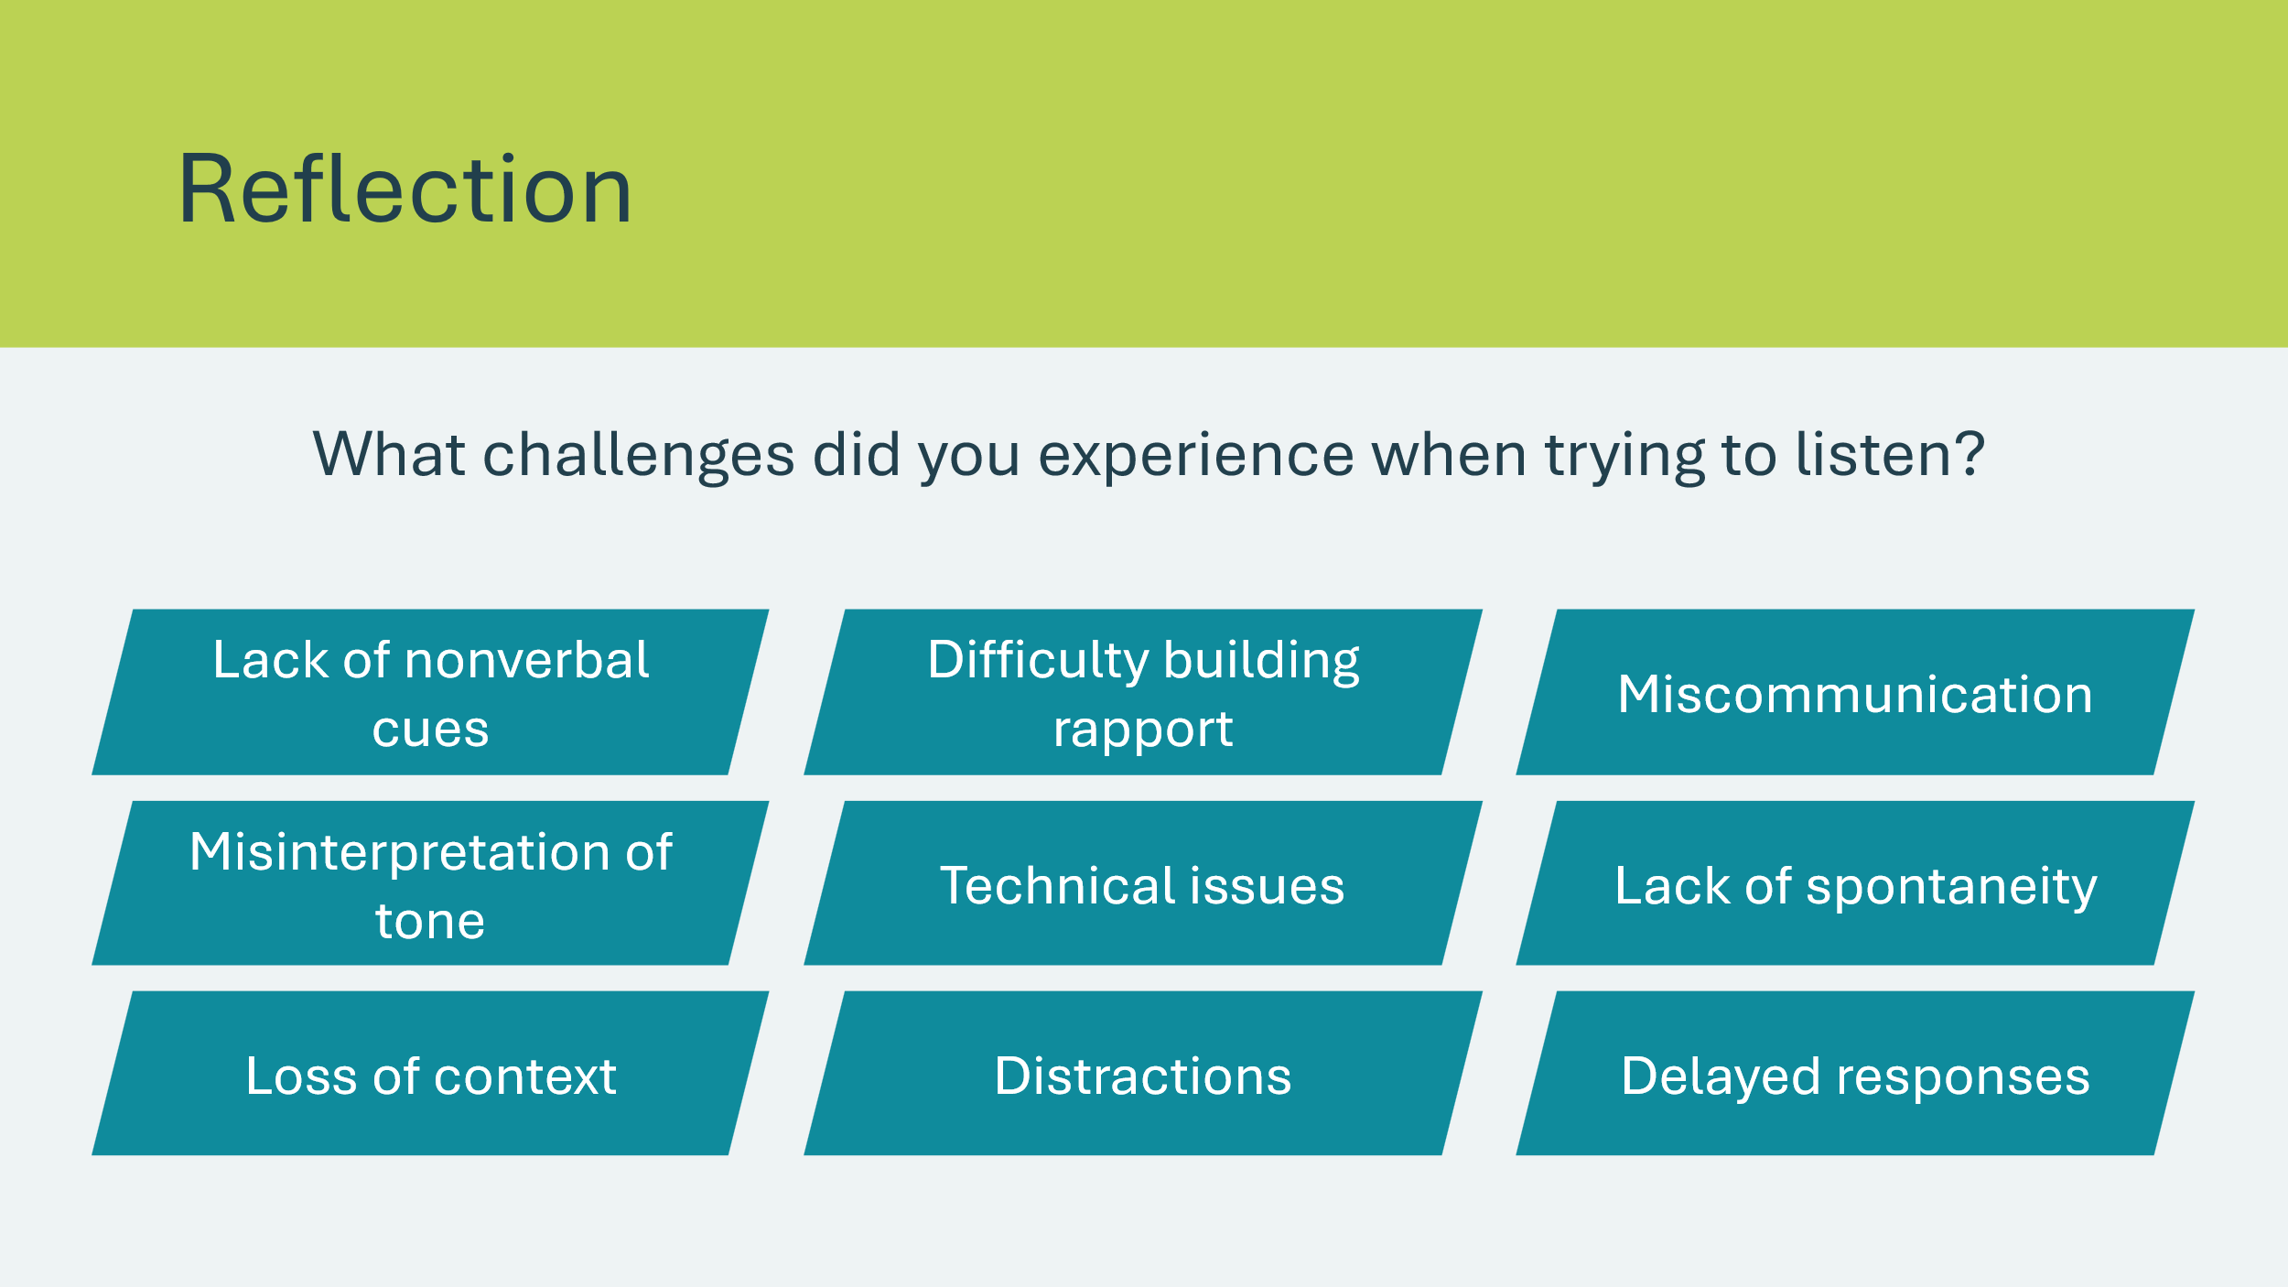 | Suggested time: Discuss if time allows (optional)  Discuss the challenges that students experienced during the active listening activity.  Students may share responses based on the examples listed or share additional challenges they experienced.
Slide 54  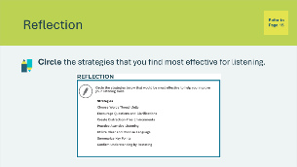 | Suggested time: Students can complete the reflections in class if time allows, or independently later on.  Students will complete the first activity in student portfolio, page 15, reflecting on active listening strategies they found most effective.  Invite students to share their responses if time allows.
Slide 55  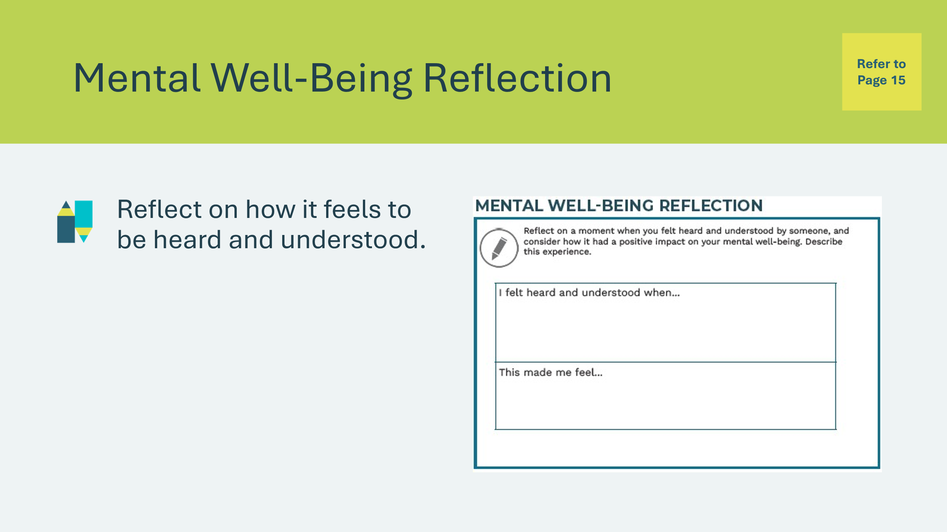 | Suggested time: Students can complete the reflections in class if time allows, or independently later on.  Students will complete the second activity in student portfolio, page 15, reflecting on a time they felt understood and how it made them feel.  Invite students to share their responses if time allows.  Volunteer connection: Share a time when you were heard and understood by someone and explain how it made you feel.

Lesson 3: Better Together
Program Kit Materials | Sample Negotiation Scenario (Appendix B)  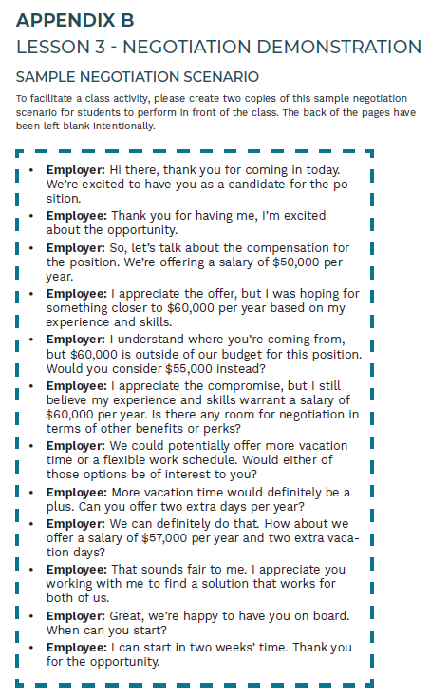  Negotiation Scenario Cards (Appendix C)  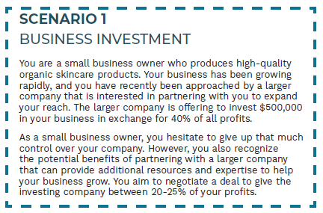
Slide 56 – Lesson 3  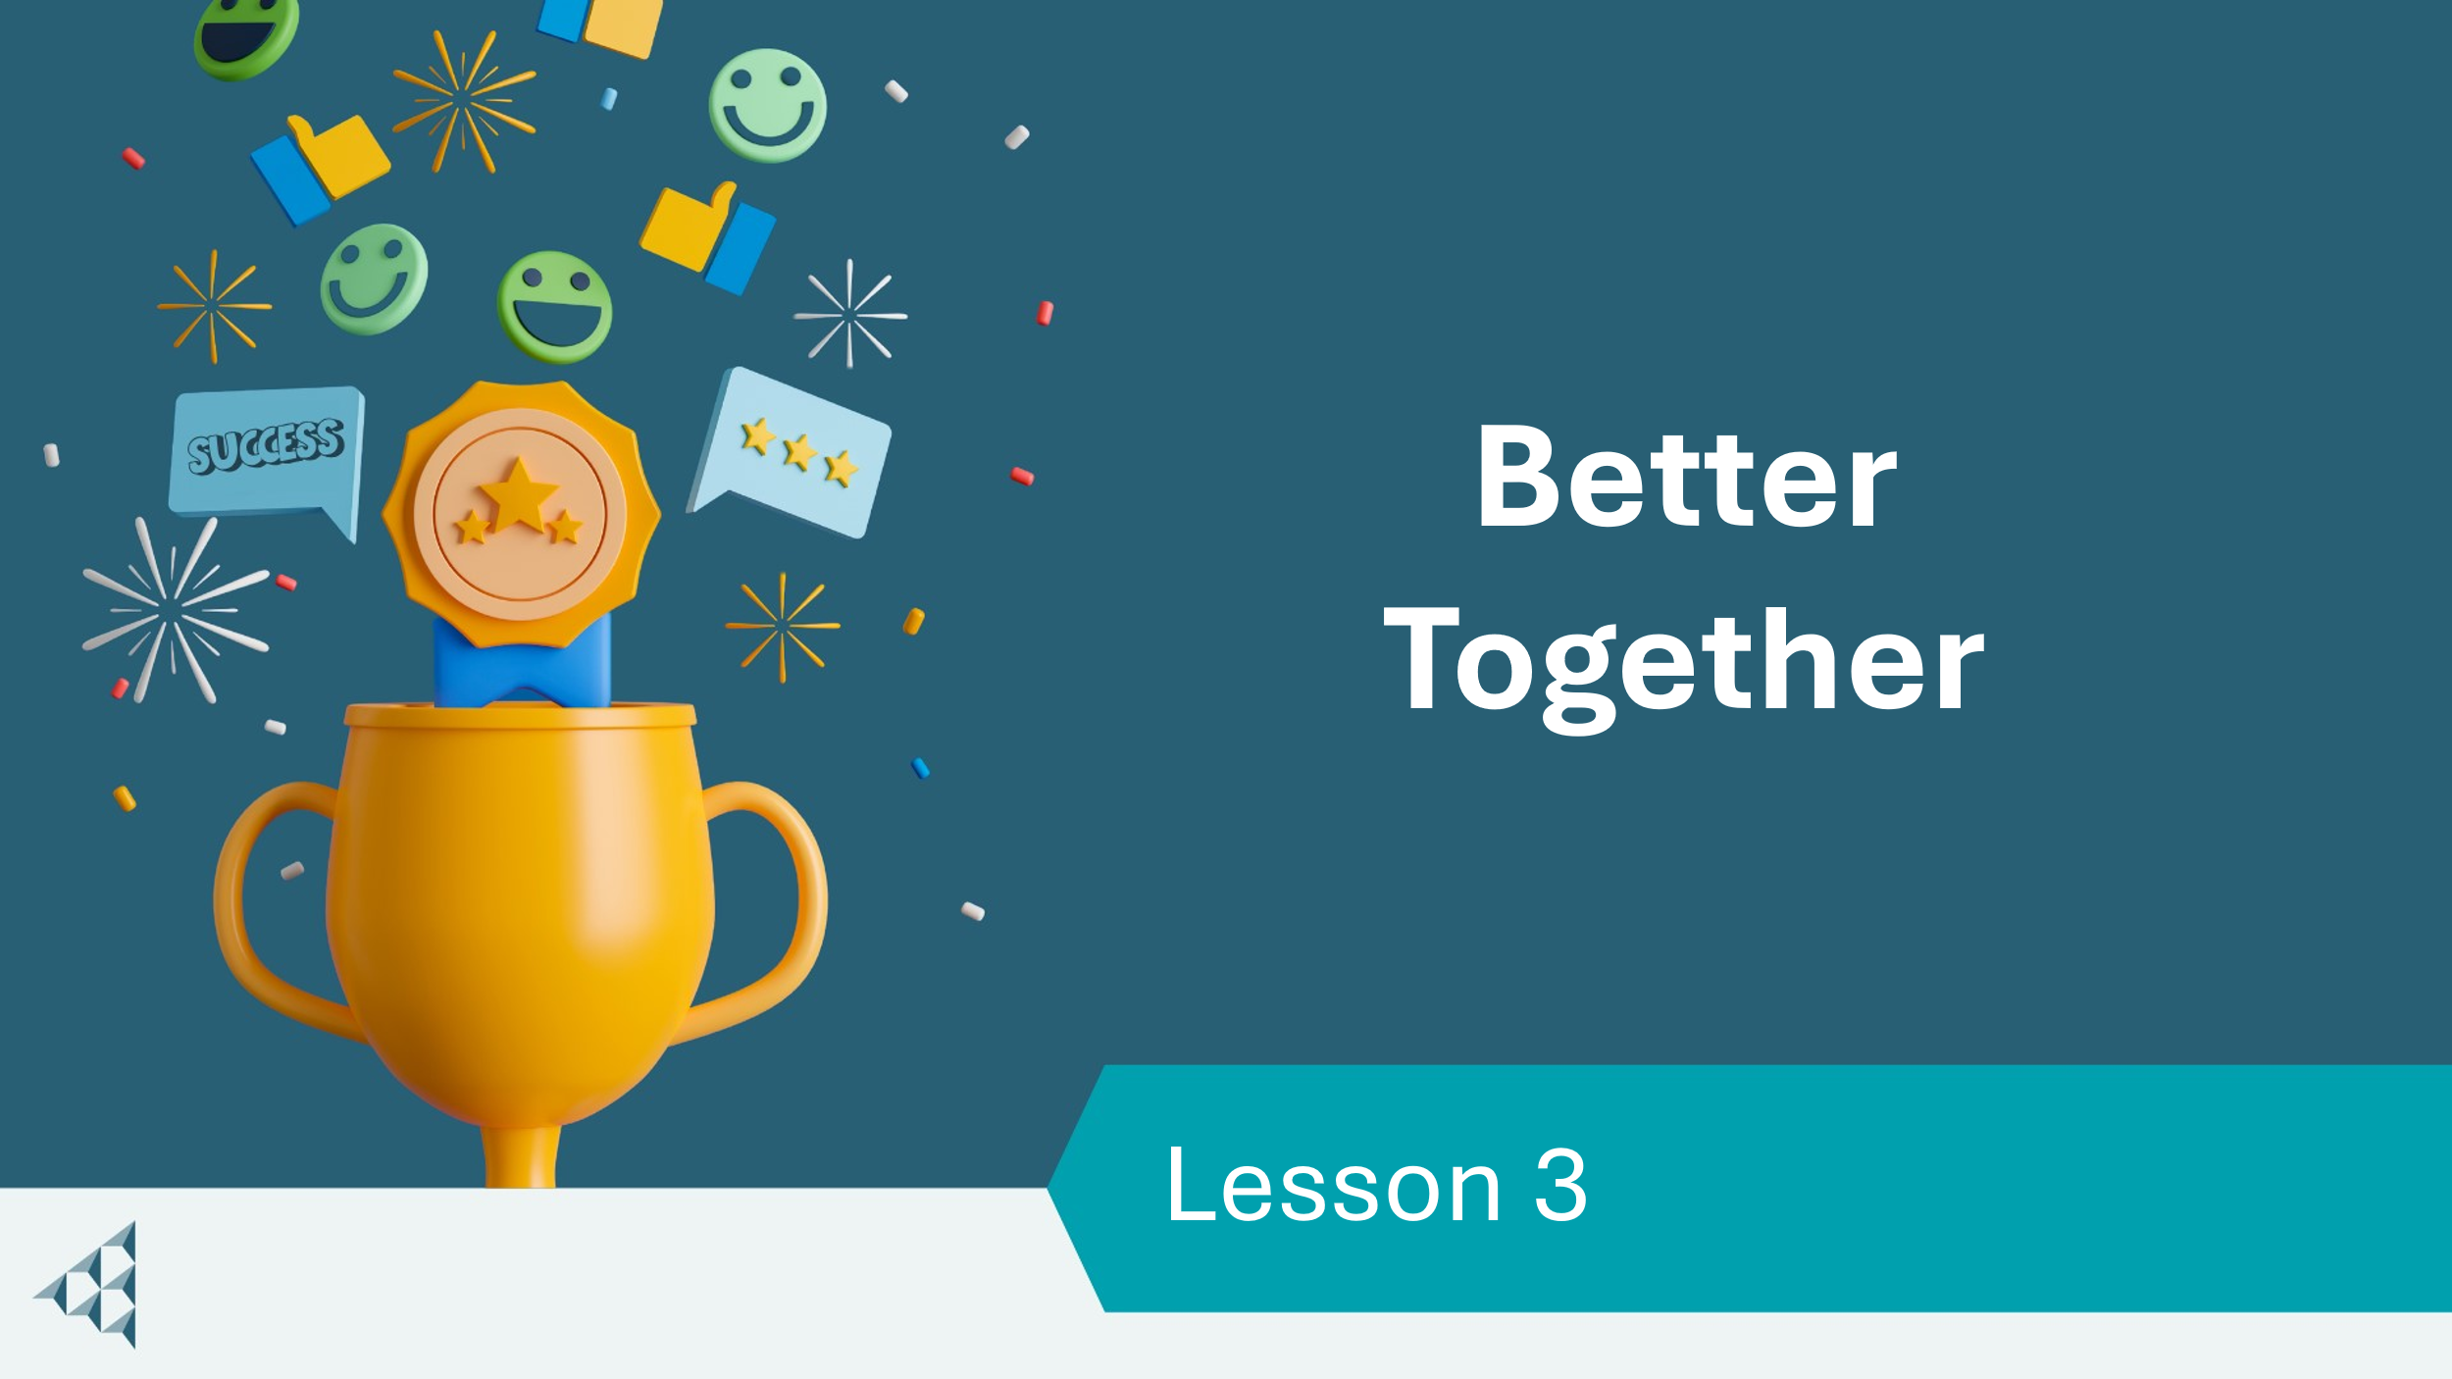 | Lesson 3: Better Together
Slide 57 – Objectives  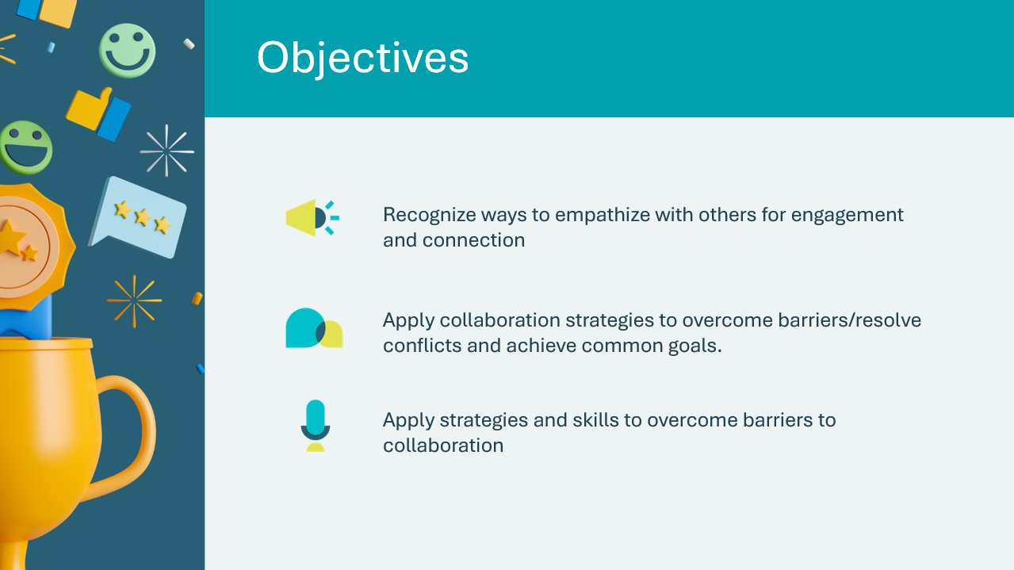 | Optional – review the learning objectives for the lesson
Slide 58 – Introduction  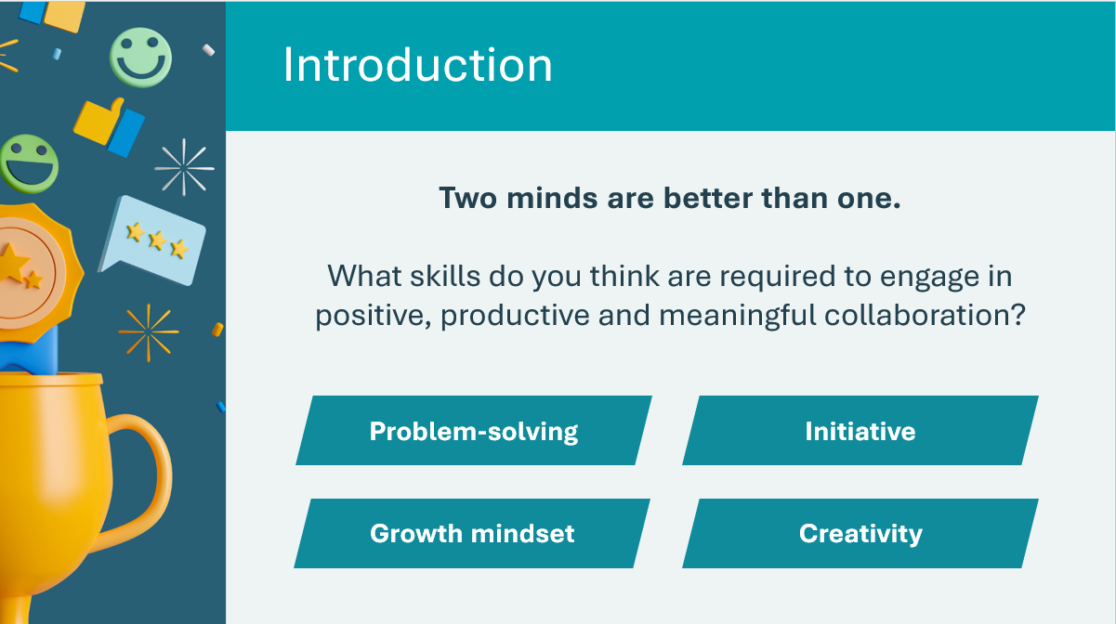 | Introduce the lesson by sharing the prompt. Discuss how the answers provided might help people resolve conflict and create compromises. Invite students to think of and share a few additional ideas.  *Click or tap to reveal examples of skills  Initiative: the skills of recognizing that hard work and effort are needed to achieve a stated goal.  Creativity: the skill where a person utilizes knowledge and abilities to create and adapt to change (the use of the imagination or original ideas).
Slide 59 – Activity Menu  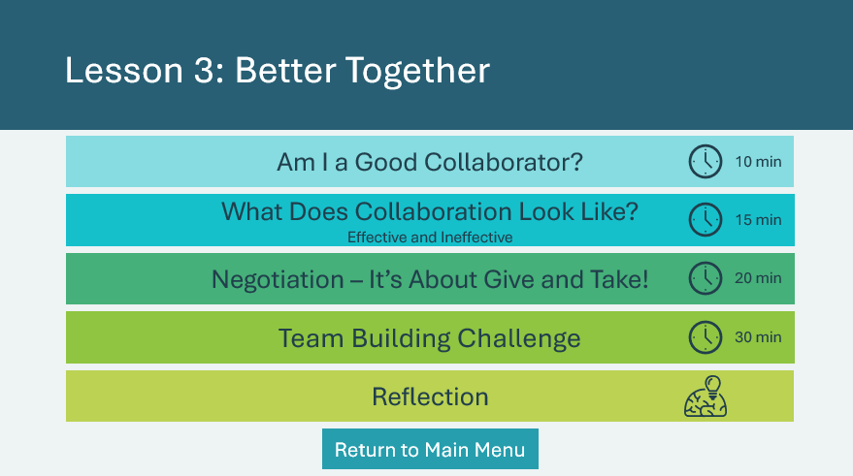 | *Select the button to navigate to the activity.  After you have completed an activity, you will be redirected back to the activity menu.  *Click or tap the Return to Main Menu button to return to the Lessons (Slide 5)
Am I a Good Collaborator? 10 min
Slide 60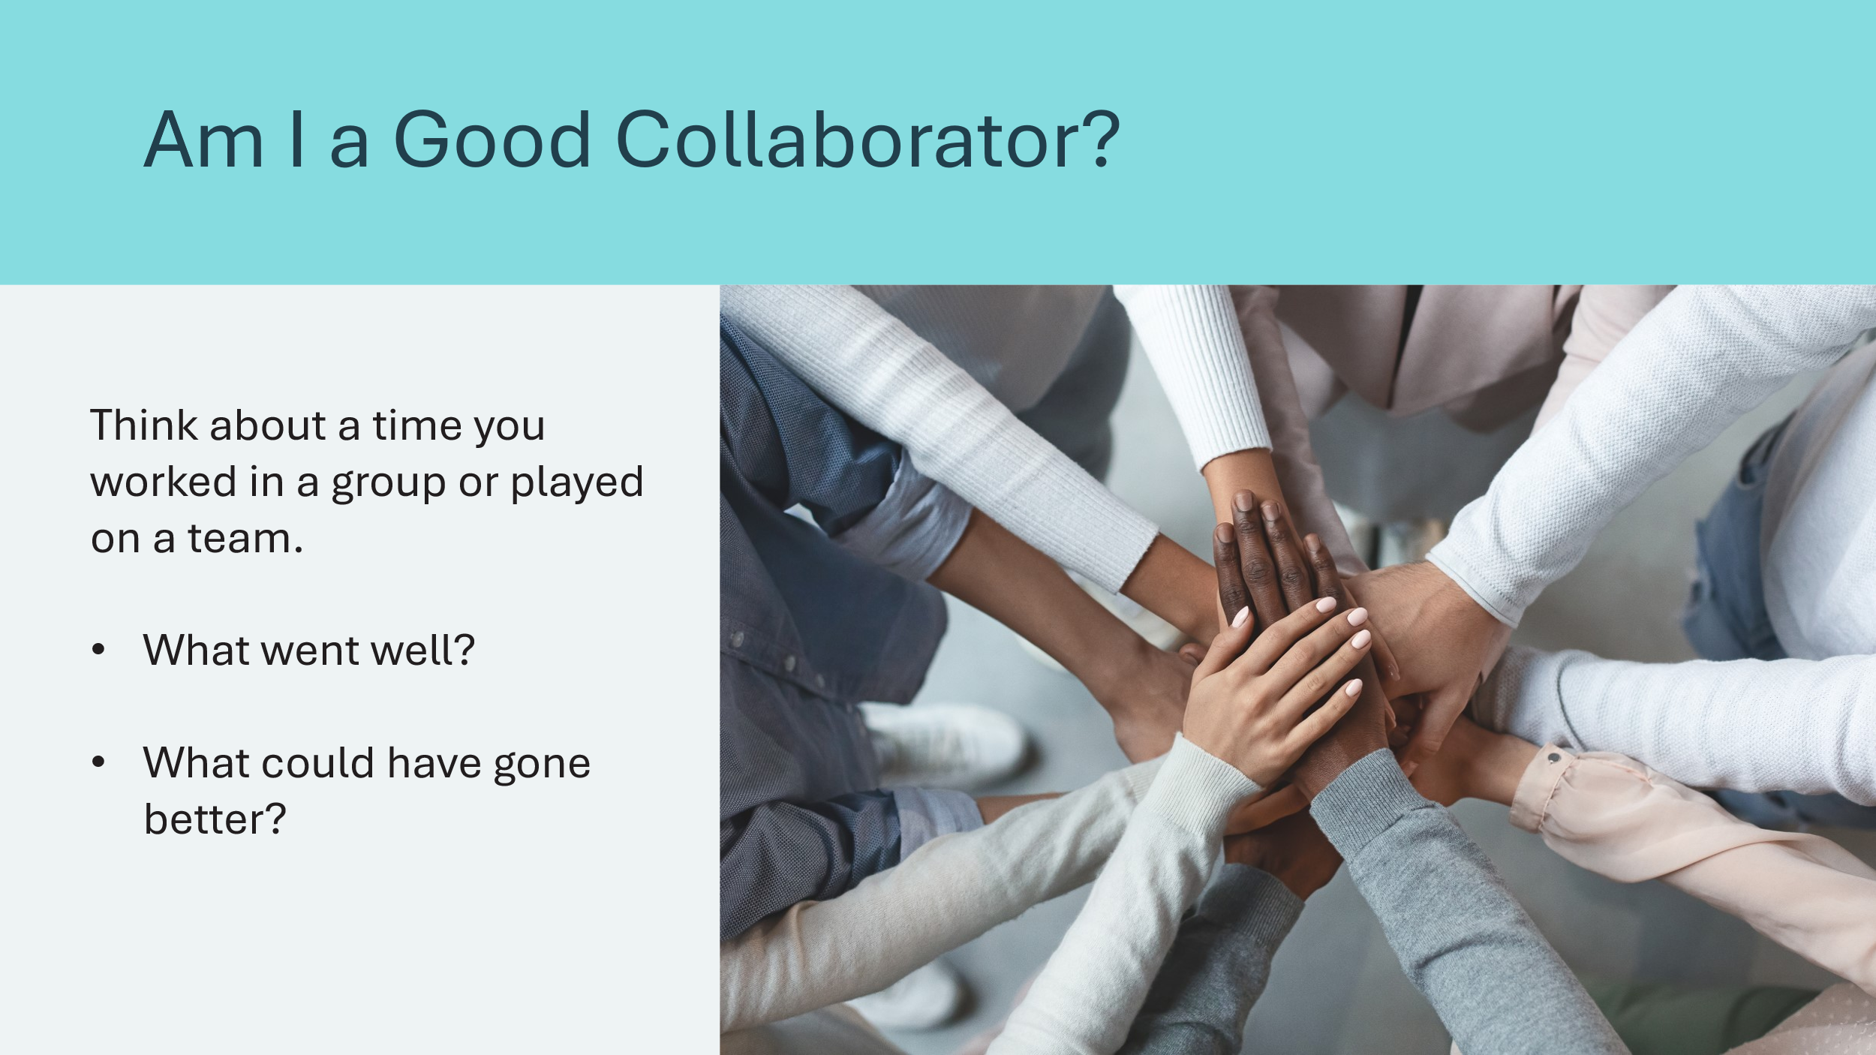 | Suggested time: 1-2 minutes  Begin the lesson by asking students to think about previous times they’ve participated in a group or team.  Volunteer connection: Share an experience you’ve had with group or teamwork and highlight the effective collaboration strategies that were used or could have been used.
Slide 61  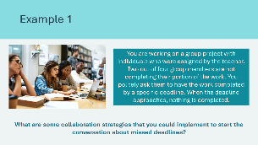  Slide 62  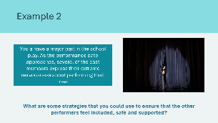 | Suggested time: 3-4 minutes  These optional examples can be used to help generate discussion, or you can skip ahead to slide 63 to provide students with more time to share their own experiences.  Read the example to the students and use the question prompt to facilitate the discussion about group and/or teamwork, and effective collaboration strategies.
Slide 63  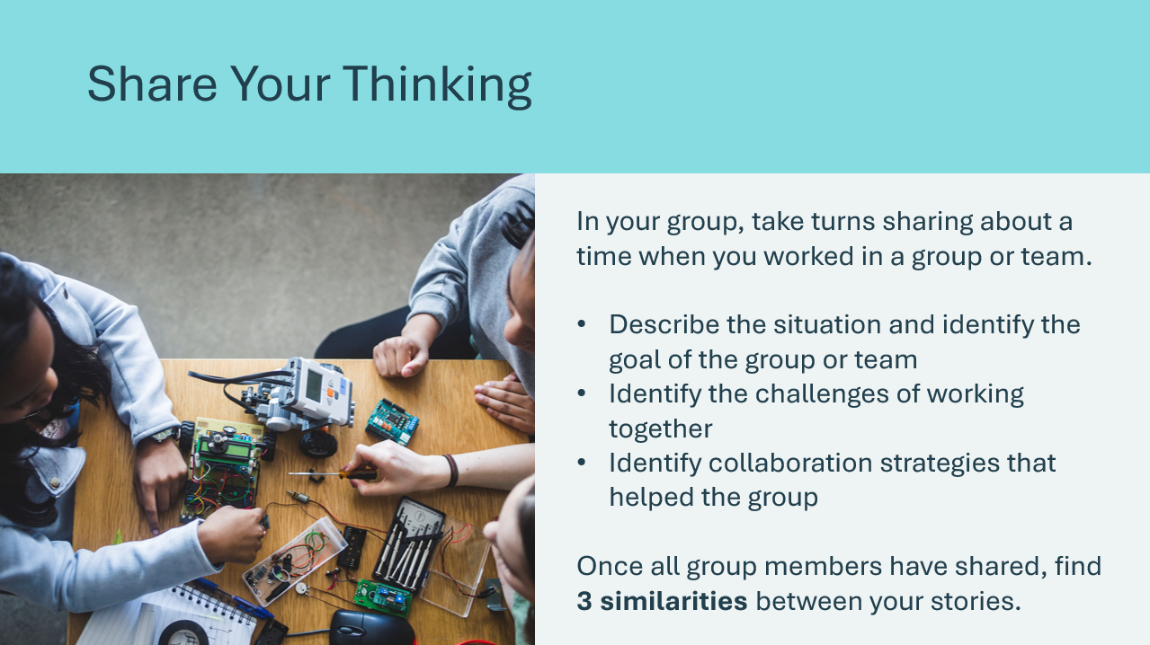 | Suggested time: 5 minutes  Break students into groups of 2 or 3, allow them time to discuss their own examples and find 3 similarities between their stories.  - Example: Good listening skills helped teams overcome their differences
What Does Collaboration Look Like? Effective and Ineffective 15 min
Slide 64  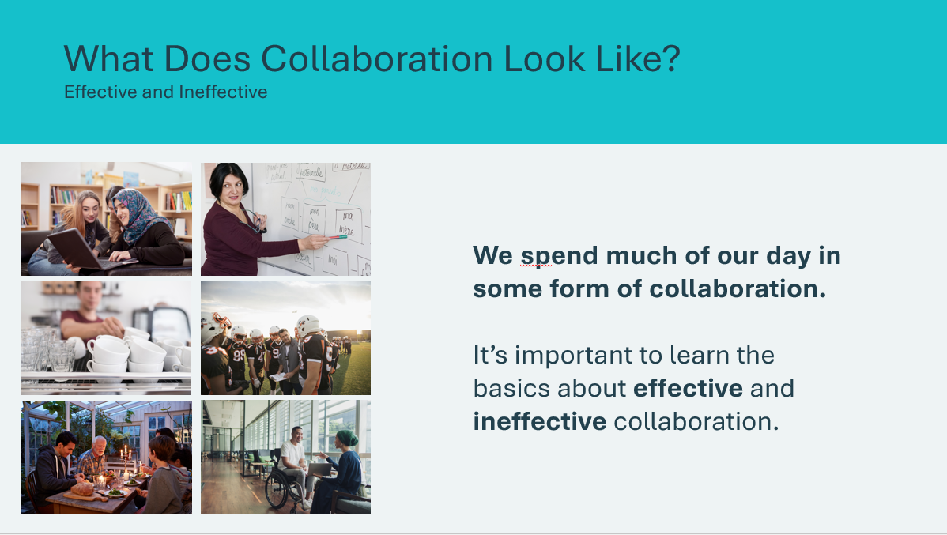 | Suggested time: 2 minutes  Discuss how at school, home or work, much of our day is spent working with or for someone. By knowing how to effectively collaborate, we can find success!  Facilitation Tip: Consider using the images to facilitate discussion or model effective communication strategies.  - Have a student describe one of the images. Demonstrate active listening by repeating what a student has said or asking follow-up questions to clarify their points.  - Take the perspective of a person in one of the images and demonstrate how collaboration could help them be successful.
Slide 65  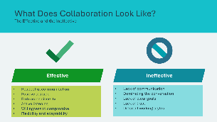 | Suggested time: 8 minutes  Break students into groups of 2 or 3. Ask students to brainstorm what contributes to effective and ineffective collaboration. Students can think of examples and write them on the board.  Discuss where groups agreed or had different perspectives. Review the examples on the slide and make connections to student responses.  *Click or tap to reveal the examples of effective and ineffective collaboration
Slide 66  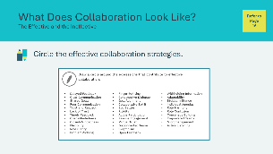 | Suggested time: 3 minutes  Students will circle the effective communication strategies in their student portfolio, page 16.
Slide 67  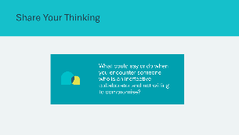 | Suggested time: 2 minutes  Wrap up the activity with the discussion question.  Sample responses:  - Repeat the person’s responses back to them to ensure understanding  - Ask questions about why they have taken their position and if there is any possibility they might change their mind  - Remain calm and ensure you are sharing your ideas clearly  - Take a break and return to the discussion later
Negotiation – It’s About Give and Take 20 min
Slide 68  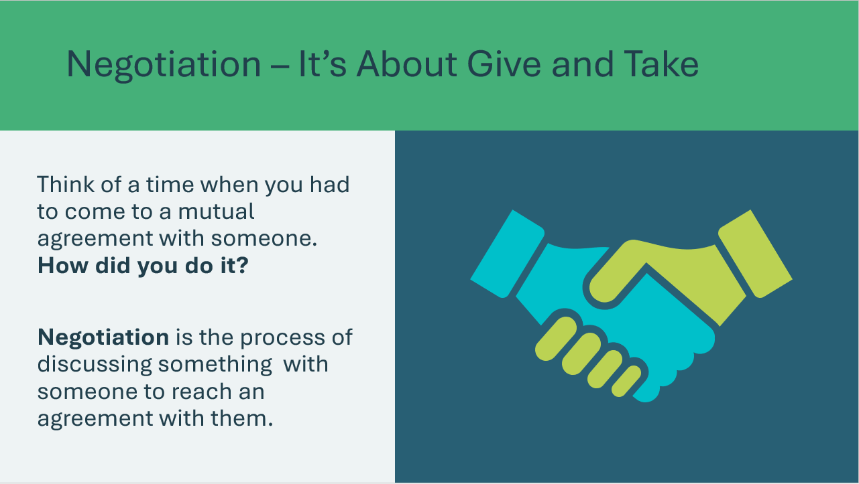  Slide 69  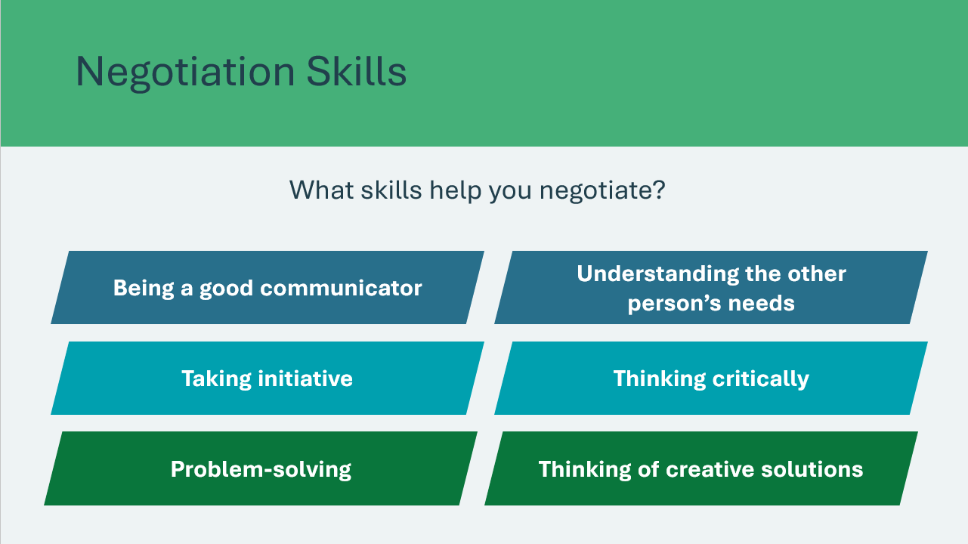 | Suggested time: 3 minutes  Introduce the lesson using the prompts on the slide. Invite students to share responses to the question.  Explain that negotiation requires a set of skills that take time, effort and practice to develop. Ask students to consider in what situations might learning to negotiate be valuable?  Negotiation is about give and take. Both parties usually enter negotiations with a specific goal in mind. However, they must also be willing to compromise on a result to achieve benefits to both parties.  Ask: What are some skills that would benefit a negotiator? Invite a few students to share responses.  *Click or tap to reveal skills  Volunteer connection: Share a story that demonstrates the importance of showing empathy and compassion when negotiating or how putting yourself in the other person’s shoes helped you find a solution.
Program Kit Materials | For slide 70, you can use the Sample Negotiation Scenario if you are unable to access the video.
Slide 70  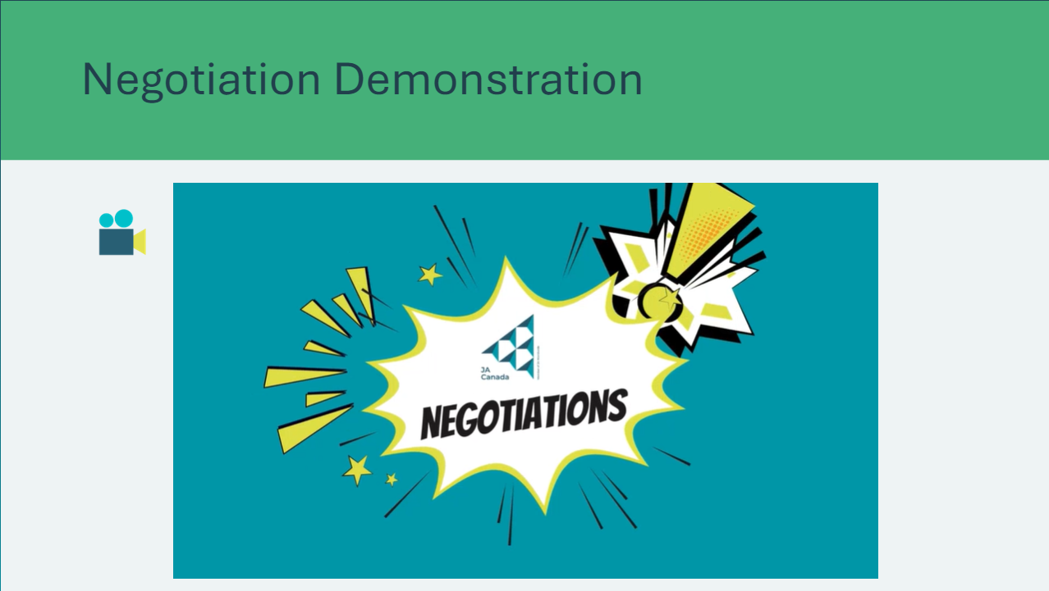  Sample Negotiation Scenario | Suggested time: 2 minutes  *Click or tap to play the negotiation demonstration video. Encourage students to consider what steps are needed for successful negotiation.
Program Kit Materials | For slide 71, you will need to use the Sample Negotiation Cards from the program kit.
Slide 71  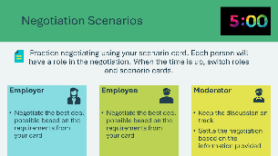  Negotiation Scenario Cards | Suggested time: 10 minutes  Divide the class into groups of 3. Hand out the scenario cards at random to each group.  *Scenario cards provided in JA kit materials  Allow the negotiations to take place for 5 minutes before switching roles. You may do this as many times as possible.  Facilitation Tip: This is a fun activity – allow the students to be playful and encourage them to come up with creative solutions!
Slide 72  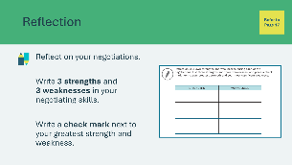 | Suggested time: 3 minutes  Students will reflect on the activity by writing about their strengths and weaknesses in their student portfolio, page 17.  If time allows, invite a few students to share their experiences with the class, discussing what worked well, what didn’t, and what their strengths and weaknesses were.
Slide 73  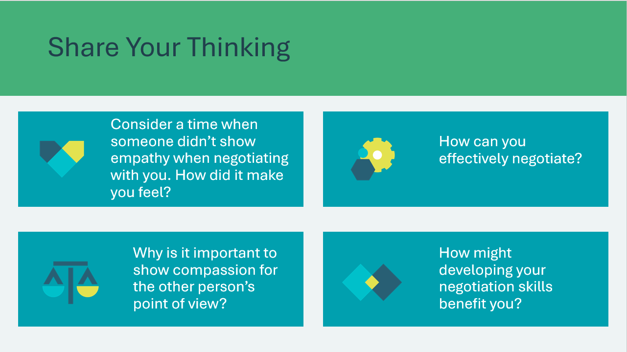 | Suggested time: 2 minutes  Wrap up the activity with the optional discussion questions.  *Click or tap to reveal discussion questions
Team Building Challenge 30 min
Slide 74  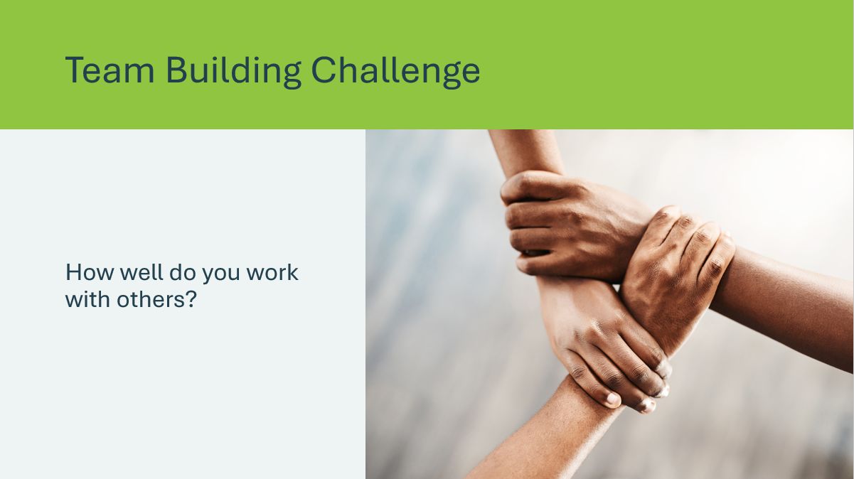  Slide 75  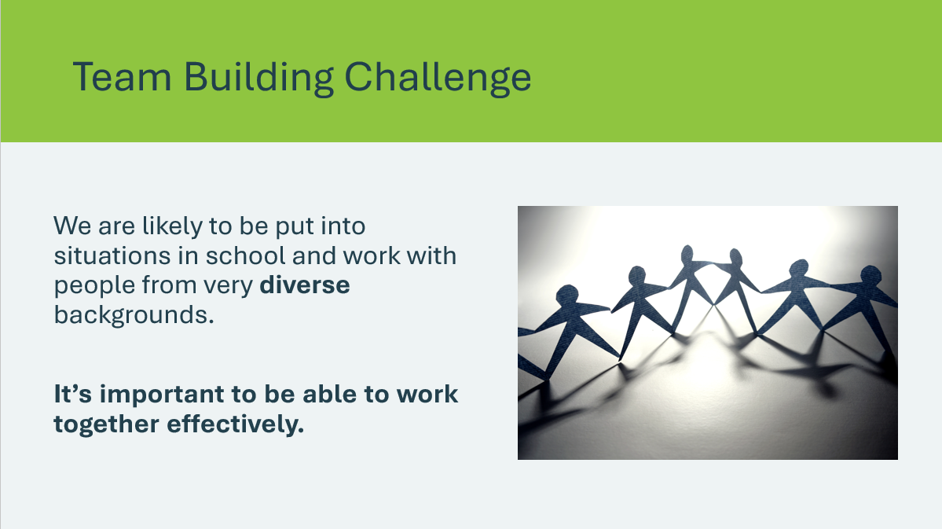 | Suggested time: 2 minutes  Introduce the activity by asking students to consider how well they work with others.  Many people overestimate their ability to cooperate in situations because of our natural biases towards ideas, people and results.  Sometimes, bias can help us overcome simple issues and help bring teams together. At other times, it can make it challenging for us to understand each other and work together.  By having collaboration skills, you’ll be able to work with others more effectively.
Slide 76  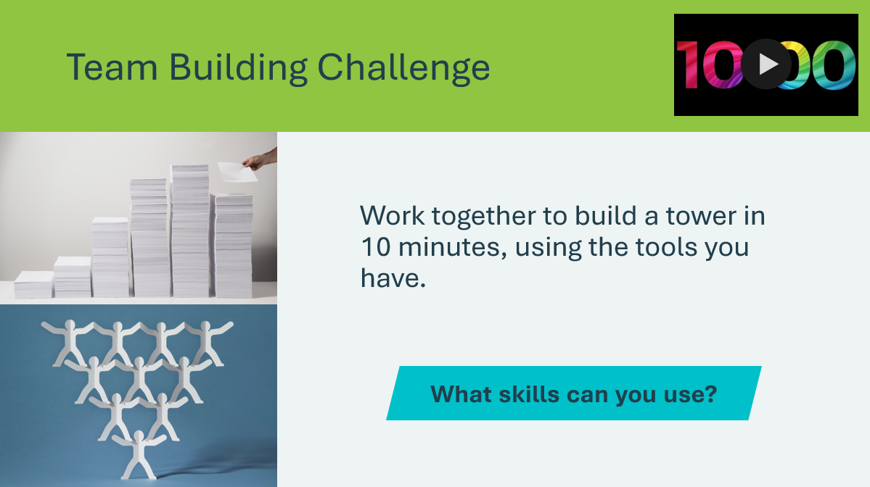 | Suggested time: 20 minutes  The intent of this activity is to have everyone demonstrate skills and collaboration.  Divide the class into teams of 3 or 4 and supply the teams with 12-16 sheets of paper.  - If additional paper is available, feel free to allow students to use it  - If tape is available, allow 1 metre per team  Set the timer for 10 minutes and allow students to collaborate and build their tower.  Optional: Designate one team member as the observer. Their job is to write down positive and negative examples of collaboration during the activity.  When the time is up, ask students how they felt the activity went.  - Students may think they did well or “won” because they built the tallest tower.  - Explain that building the tallest tower wasn’t actually part of the instructions. The goal of the activity was to showcase how students were able to put the skills they have learned about to use.  - For example, collaboration, creativity, problem-solving, etc.  - Make connections to active listening
Slide 77  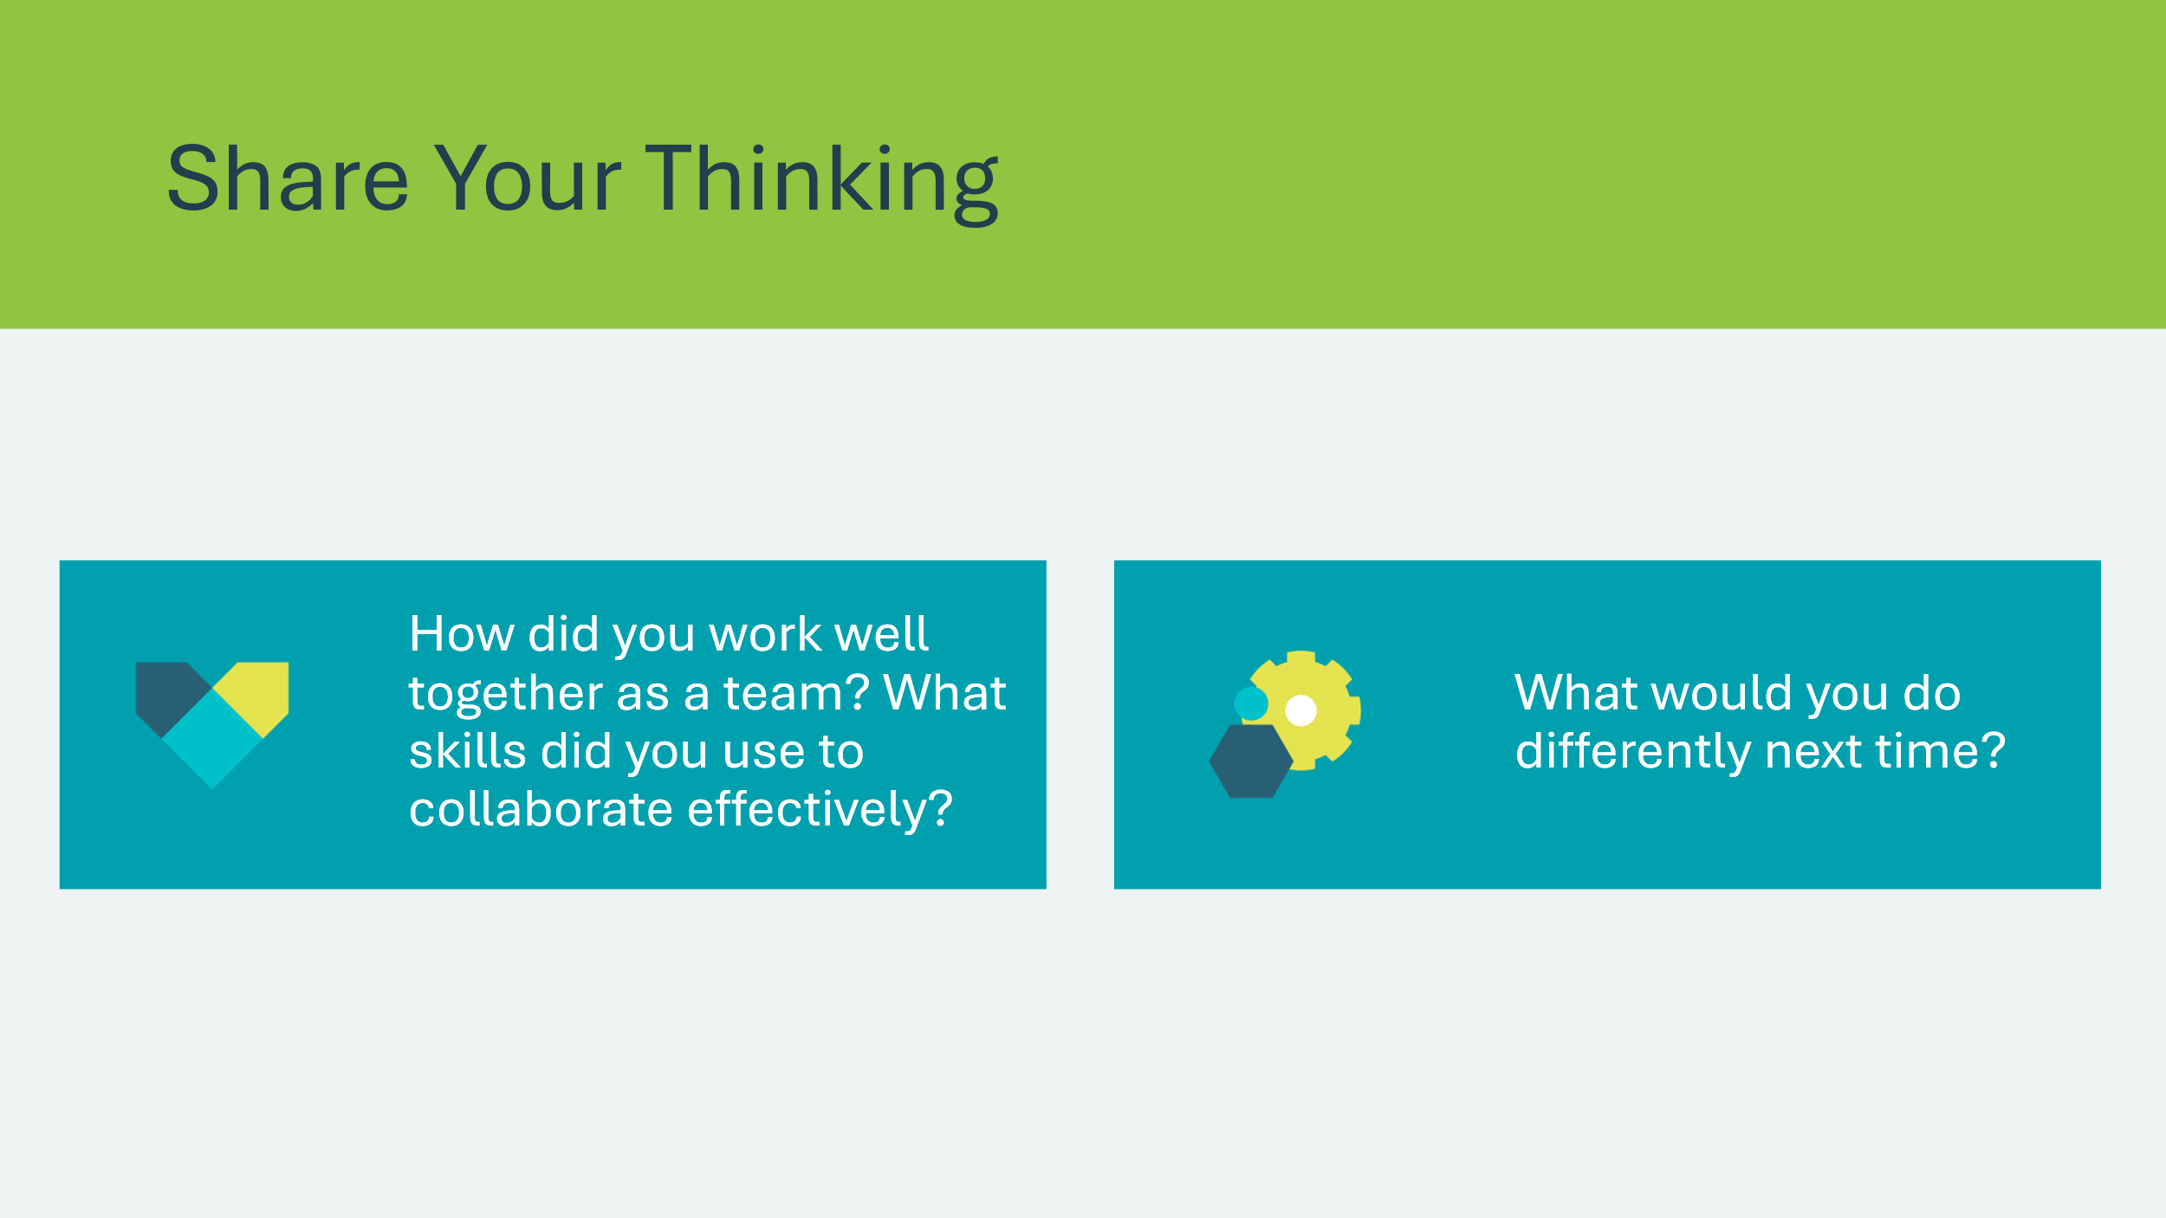 | Suggested time: 2-3 minutes  Provide the teams with time to reflect on the activity. Encourage them to focus on the collaboration aspect instead of the results.  Use the questions to facilitate the discussion. Invite a few teams to share their responses.  *Click or tap to reveal discussion questions
Slide 78  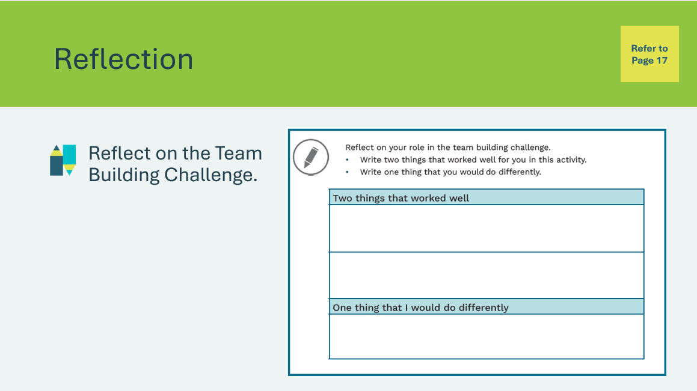 | Suggested time: 2-3 minutes  Students will complete the reflection in their student portfolio, page 17.
Reflection
Slide 79  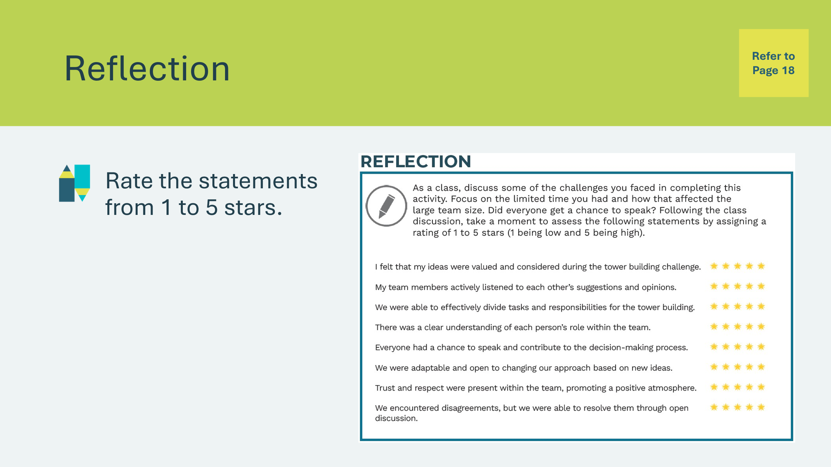 | Suggested time: Students can complete the reflections in class if time allows, or independently later on.  Encourage students to reflect on how their team collaborated during the challenge. Students will complete the activity by rating the statements from 1 to 5 stars in their student portfolio, page 18.
Slide 80  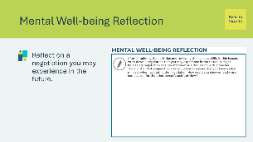 | Suggested time: Students can complete the reflections in class if time allows, or independently later on.  Students will complete the activity in student portfolio, page 19, reflecting on the following:  - What are effective strategies for conflict resolution when collaborating with others?  - How can you show empathy and compassion for the other person’s point of view?  Invite students to share their responses if time allows.

Lesson 4: Let’s Think About It!
Slide 81 – Lesson 4   | Lesson 4: Let’s Think About It!
Slide 82 – Objectives  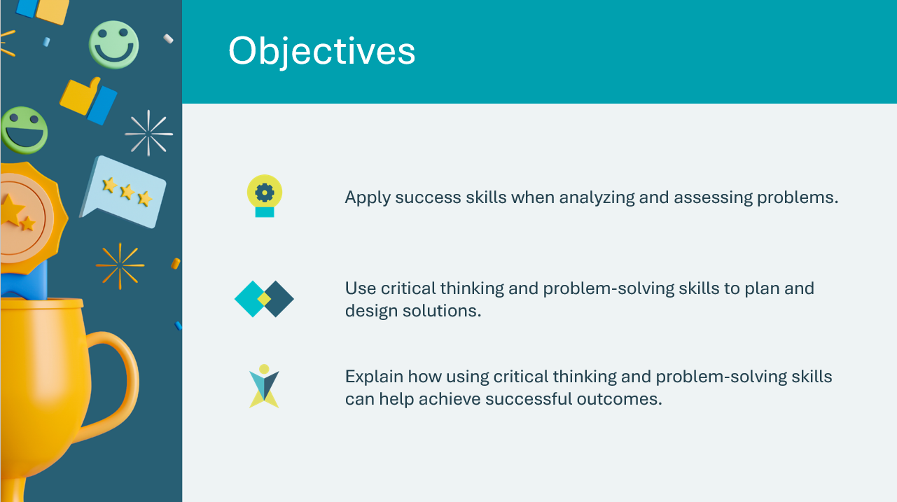 | Optional – review the learning objectives for the lesson
Slide 83 – Introduction  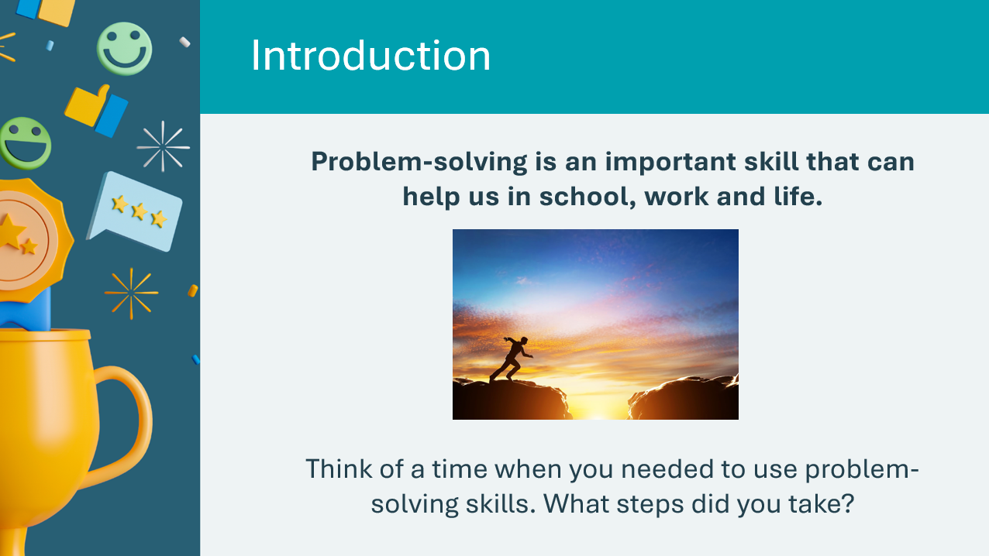 | Introduce the lesson to students using the prompts on the slide. Allow a few students to share responses.  Volunteer Connection: Share a time when you had to use problem-solving skills.
Slide 84  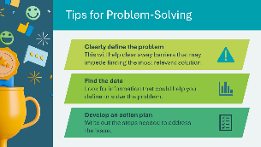 | Review the tips for problem-solving. Use the examples provided below or tie the steps to an example students shared during the discussion on the previous slide.  *Click or tap to reveal steps.  Clearly define the problem:  - Example: if you have trouble learning concepts in math, you might want to write down exactly what it is you don’t understand  Find the data:  - Example: In math example, what questions are you having issues with? Is there a pattern? Have you looked for more information outside of the textbook or your teacher?  Develop an action plan:  - Example: You might want to speak to your teacher or spend more time each night practicing the math concept.  Volunteer connection: Share an example of a time you needed to solve a problem and how you used the steps.  Critical thinking: the process of actively and skillfully conceptualizing, analyzing, synthesizing and/or evaluating information gathered from or generated by observation, experience, reflection, reasoning, and/or communication, as a guide to belief or action.  Resilience: Being able to acknowledge when things don’t go as planned, accepting those feelings and finding healthy ways to cope and move forward despite setbacks.  Interpersonal: the ability to communicate or interact with other people.
Slide 85 – Activity Menu  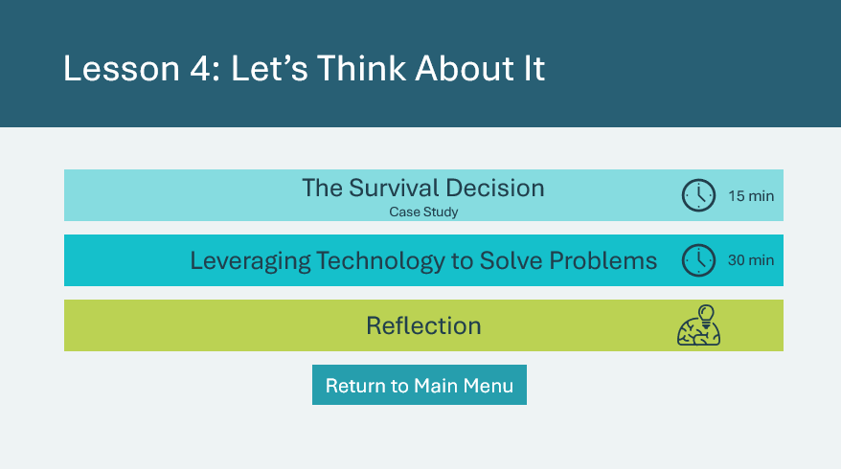 | *Select the button to navigate to the activity.  After you have completed an activity, you will be redirected back to the activity menu.  *Click or tap the Return to Main Menu button to return to the Lessons (Slide 5)
The Survival Decision 15 min
Slide 86  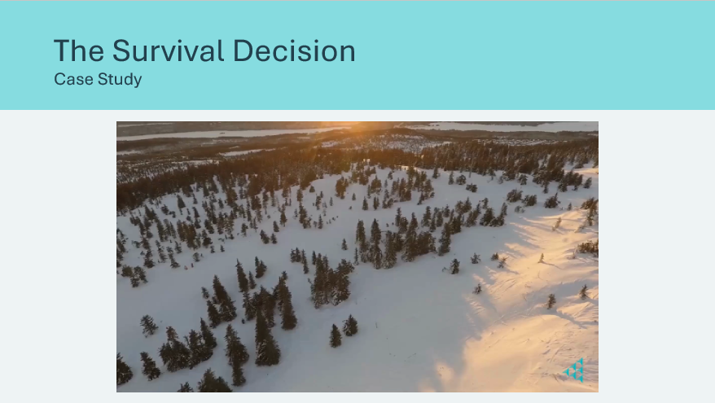  Slide 87  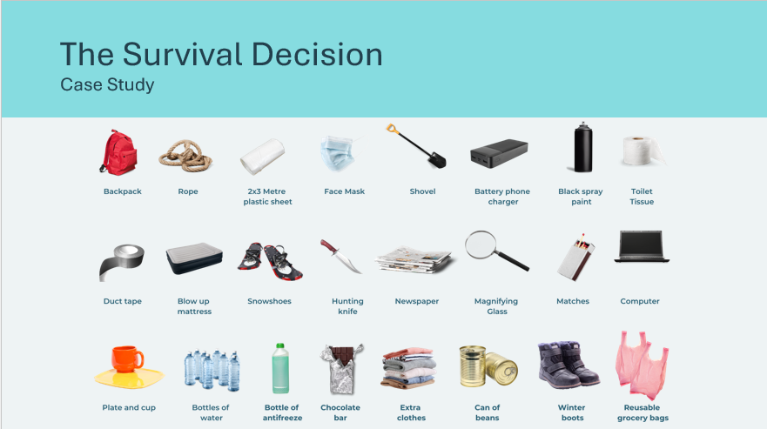 | Suggested time: 5 minutes  *Click or tap the video to play and/or pause it.  Tell students they will watch a short video of a scenario related to problem-solving and critical thinking. In the activity that follows, they will need to apply their problem-solving and critical thinking skills to make decisions based on the scenario.  Note: Students have a written copy of the scenario in their student portfolio, page 20, if needed.  Tell students that Ashley must choose from the pictured items. You may read each item or provide students a minute or so to review the items.  Invite them to begin considering what 6 items Ashley might want to bring with them and why.  After you have reviewed the activity instructions on the next slide, you may wish to return to this slide to display the items for students as they work through the activity.
Slide 88  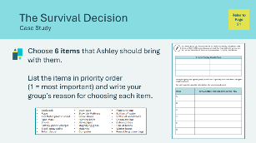 | Suggested time: 10 minutes  Break students into pairs or groups of 3.  In their groups, they will complete the activity in their student portfolio, page 21. Students will:  - Identify 6 items they think Ashley should bring. Students will write the items in the first table.  - Place items in priority order from most to least important and write a reason for choosing the item in the second table  If time allows, invite students to share their responses.
Leveraging Technology to Solve Problems 30 min
Slide 89  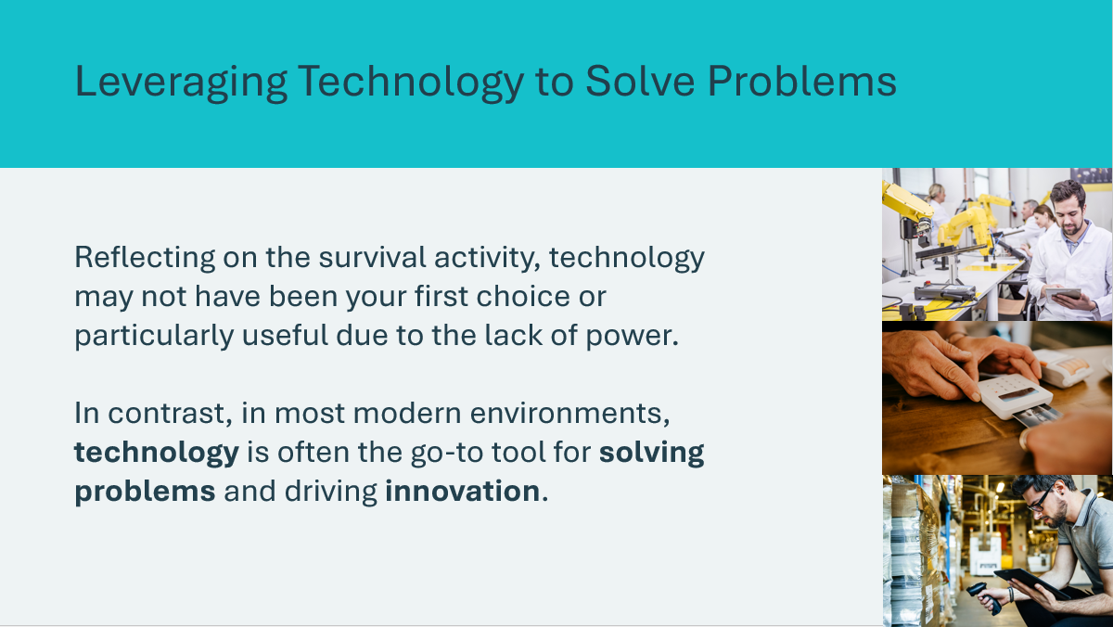 | Suggested time: 5 minutes  Introduce the activity by explaining that students will explore how existing technology or developing new technology can help solve problems.  Volunteer connection: Share an example of how you use technology in your career. Does it help solve any problems?
Slide 90   | Suggested time: 5 minutes  Explain to students that AI is becoming an increasingly popular technology tool that can be used to help solve problems. AI involves teaching computers to do things that usually need human smarts. AI learns from examples and gets better at figuring things out over time.  Discuss the question prompts. Encourage students to consider and share experiences they have had using AI.  Remind students that just like humans, AI systems can make mistakes. It’s important to test and validate a solution before implementing.
Slide 91  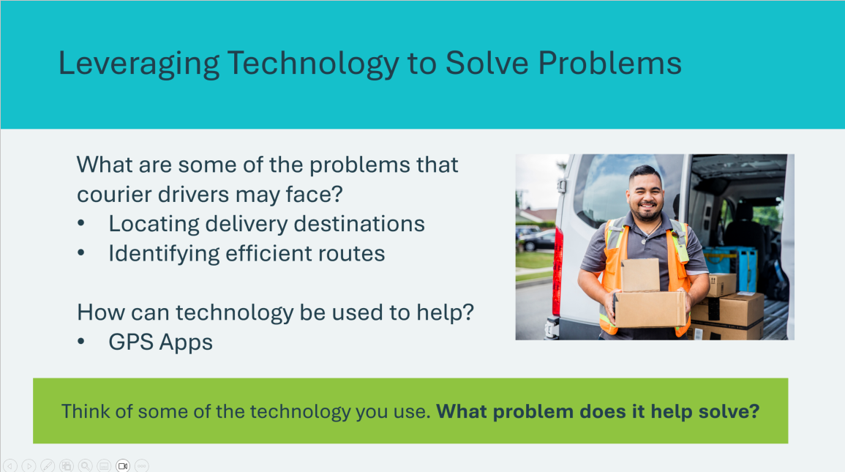 | Suggested time: 2 minutes  Review the example with students to get them thinking of challenges and how technology can be used to solve them.  Encourage students to generate some additional ideas (problems and tech solutions).  Sample answers:  - Real time tracking for customers – GPS technology  - Proof of delivery – electronic signatures, photo verification  - Safety and security – dashboard cameras and security apps  Ask the prompt on the slide and invite students to share how the technology they use helps solve problems.
Slide 92  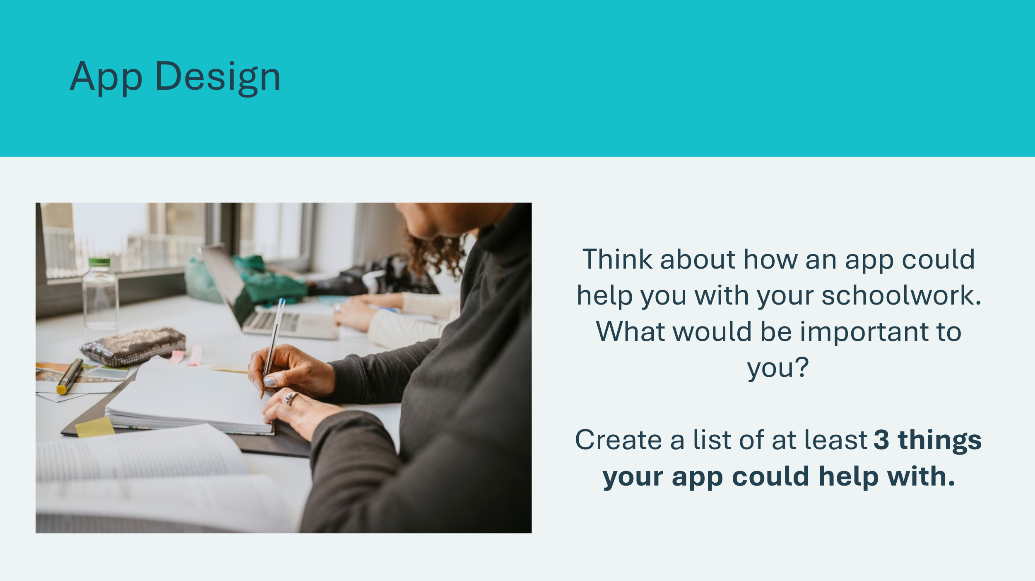 | Suggested time: 5 minutes  Apps can be used to help solve problems. Can you think of an app that solves a problem?  Possible answers:  - Skip the dishes – order food anytime, get it delivered anywhere, no need to cook, do dishes or leave the house  - Spotify – listen to music anywhere, don’t need to download songs to your device  - Uber – easily get a ride any time you need.  Explain to students that their challenge is to design an app to help them with their schoolwork. Allow students a few minutes to brainstorm and generate ideas on their own or in small groups. Students can use the blank pages at the back of their student portfolio to record their ideas.  Share the following ideas if students need help getting started:  - Forgetting homework  - Organizing notes  Come together as a group to share ideas and choose a few main ideas to consider for the app design.  Facilitation Tip: Provide feedback and guidance on their ideas and designs as they work through this activity. Help them identify areas for improvement and provide constructive criticism.
Slide 93  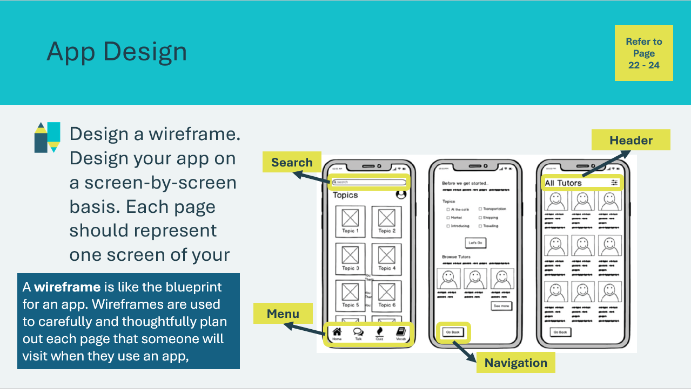 | Suggested time: 10 minutes  Students will choose a solution they feel is the strongest and design a wireframe or mockup of their app in their student portfolio, page 22-24.  Facilitator information: A wireframe is like the blueprint for an app. Wireframes are used to carefully and thoughtfully plan out each page that someone will visit when they use an app, for example, the login screen.  A good wireframe includes things like:  - Headers – to tell users what page they are on  - Navigation – to guide users through the different app pages  - Buttons – to help users interact with the app  - Input fields – places users can type information  Ask students to think about some of their favorite apps. What do they like about them? What makes them easy to use? What problem does the app solve?  Encourage them to think about how people will use their app and how it will solve the problem as they create their wireframes.  If time allows, students can review apps on their device or think of apps they’ve recently used to generate ideas.  Possibly technology to leverage for wireframing: Canva, Adobe XD, Apple KeyNote, Microsoft PowerPoint, Figma
Slide 94  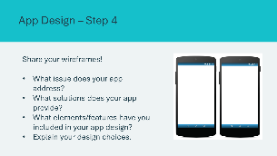 | Suggested time: 5 minutes  Students can present their app’s wireframes as a class or in small groups, depending on time and class size. Use the questions to guide the discussion.
Slide 95  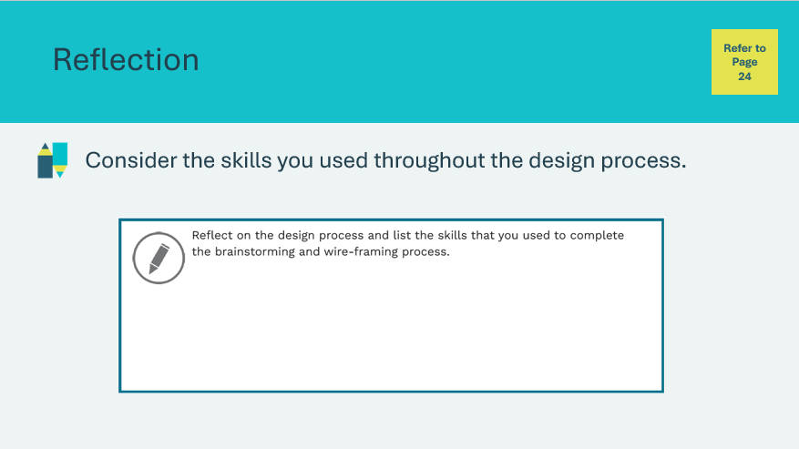 | Suggested time: Students can complete the reflections independently or as a class if time allows  Students will complete the reflection in their student portfolio, page 24.
Slide 96  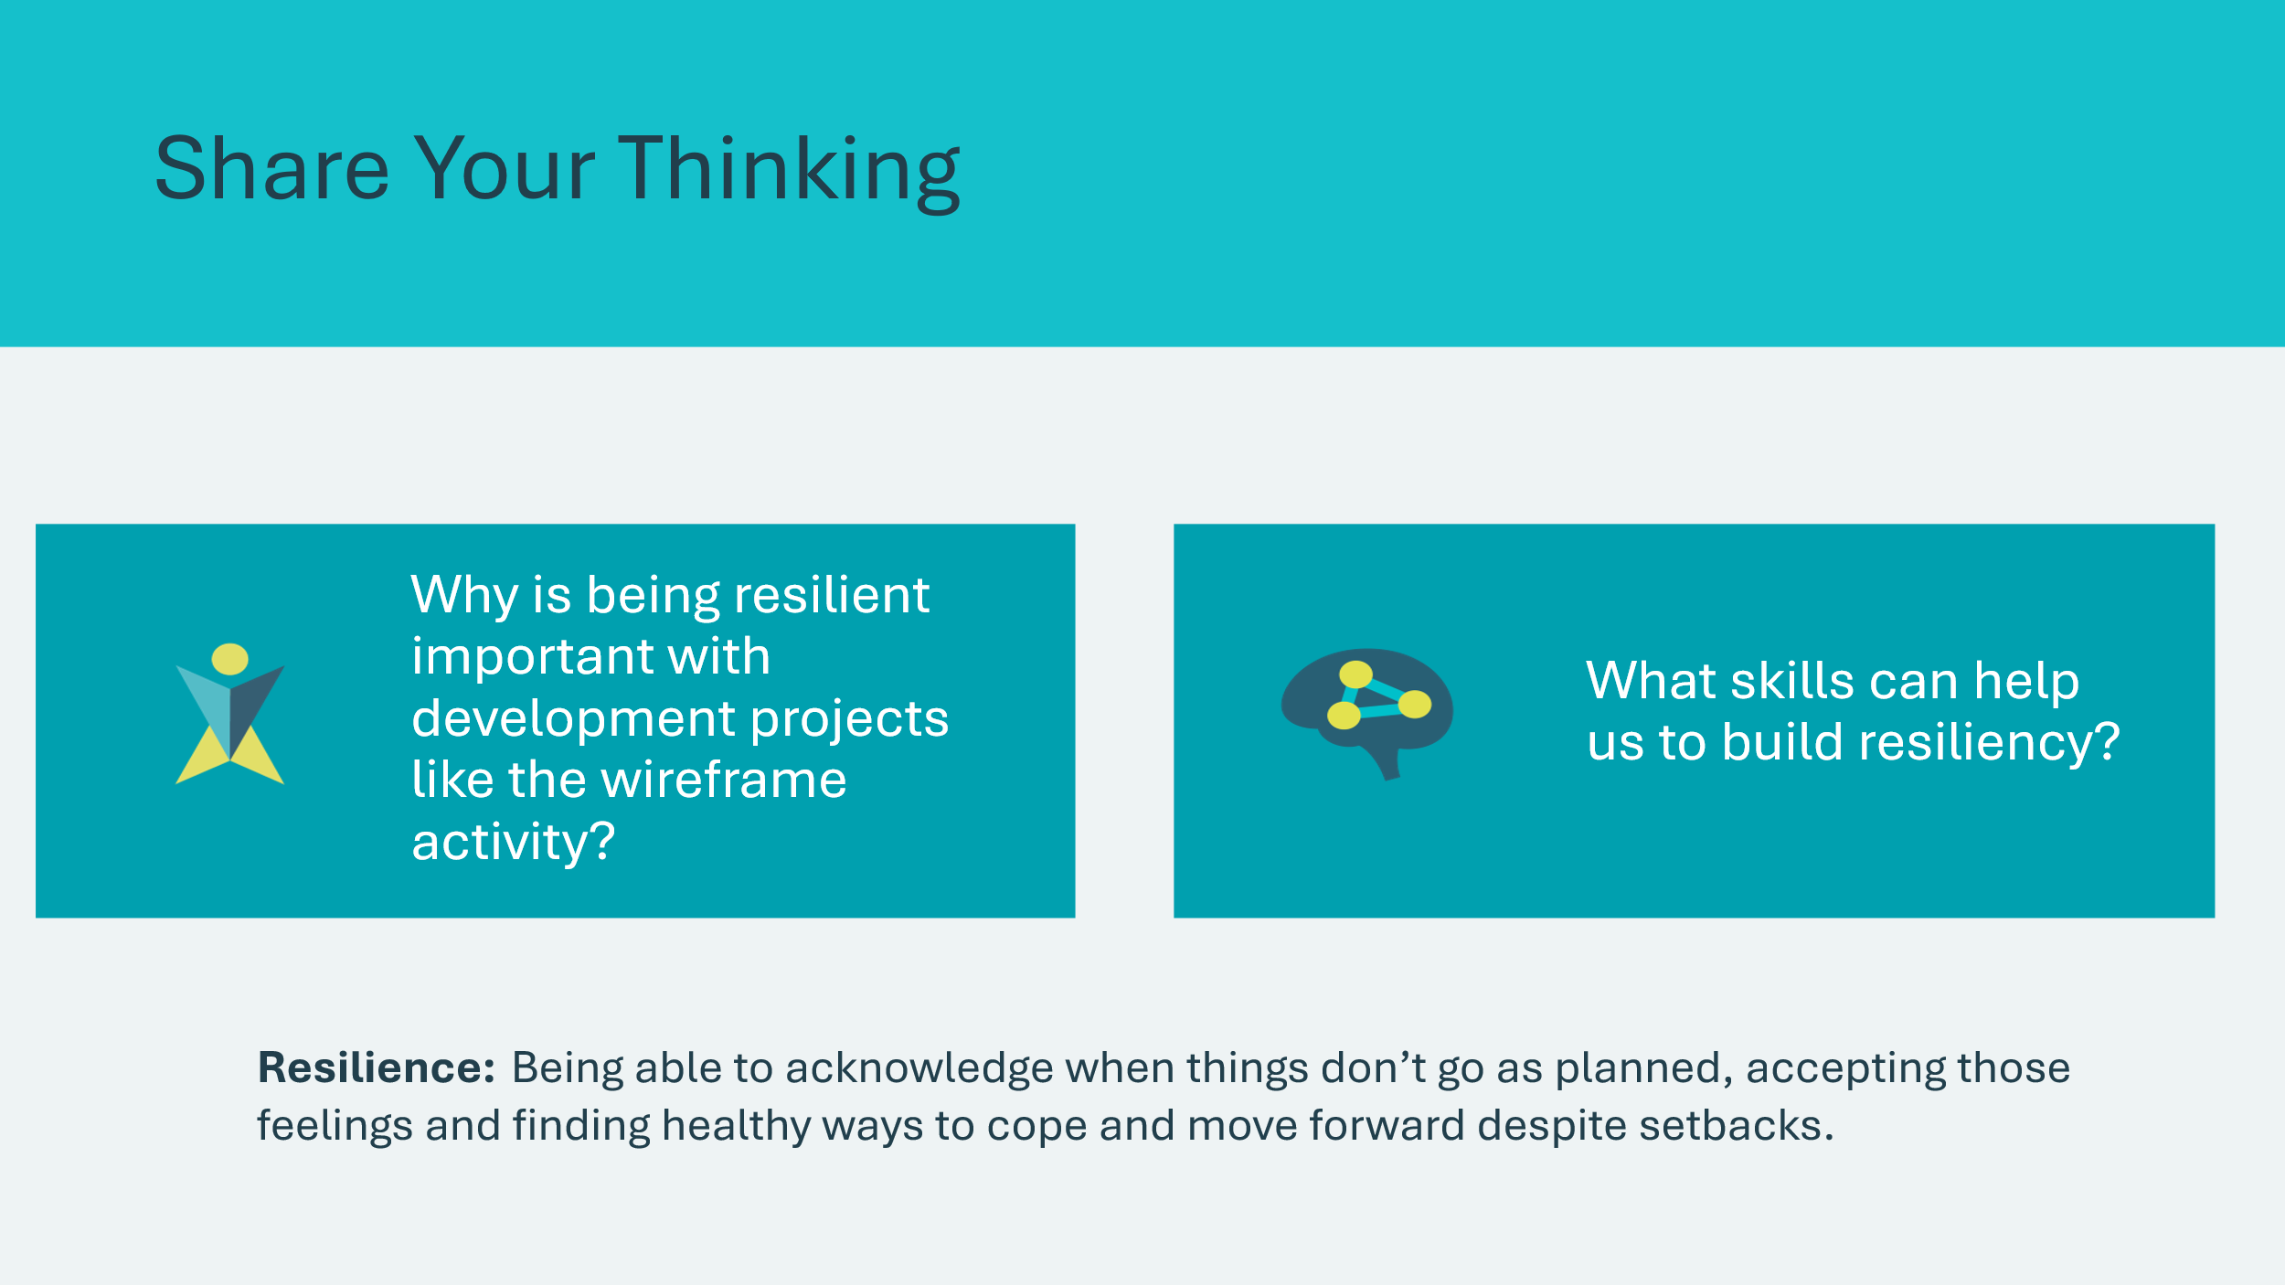 | Suggested time: 3 minutes  Wrap up the activity with the optional discussion questions.  *Click or tap to reveal questions.  Sample Responses:  - Resiliency can help me overcome setbacks and fatigue when completing complex tasks.  - Following through with an idea even though it might not be perfect allows me to build a foundation that can be reviewed and improved at a later stage.  Career connection: Many artists and designers often cite resilience as an important skill when completing great works!
Reflection
Slide 97  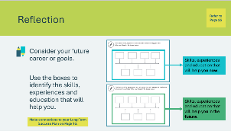 | Suggested time: Students can complete the reflections in class if time allows, or independently later on.  Students can fill in the boxes with the things they will need to achieve throughout their career journey in their student portfolio, page 25.  - In the top section, students can think of things that will help them now.  - In the bottom section, they can think of things that will help them in the future.  - Encourage them to review and make connections with the skills they included at 1, 5 and 10 years in their long-term success plan (reference slides 28 & 29 if needed).  If time allows, invite a few students to share their responses.  Volunteer connection: Share some of the skills, experiences and education that have helped you on your career path.
Slide 98  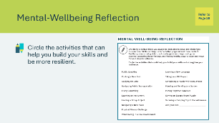 | Suggested time: Students can complete the reflections in class if time allows, or independently later on.  Explain how skills can help us to be better prepared and more resilient. Students can circle the skills that would help them become more resilient in their student portfolio, page 26.  If time allows, invite students to share their responses.

Lesson 5: Stay Curious – A Superpower
Slide 99 – Lesson 5  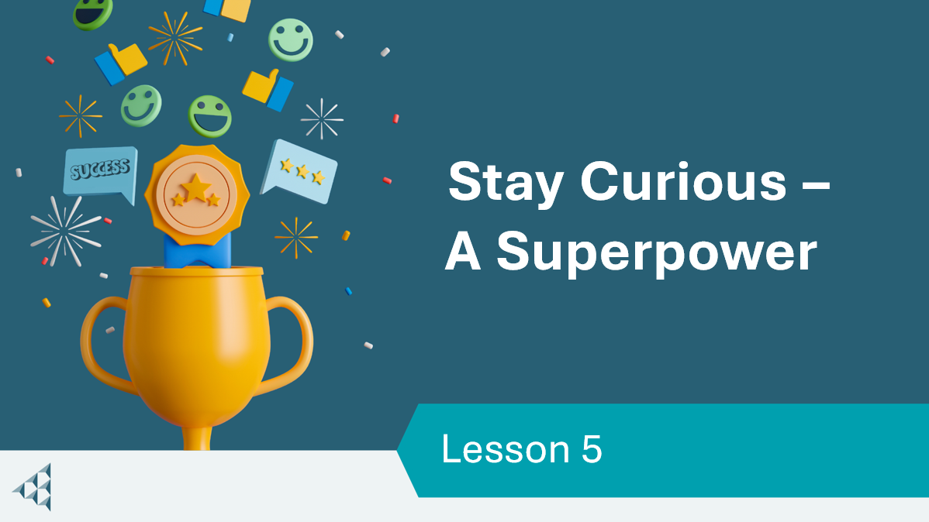 | Lesson 5: Stay Curious – A Superpower
Slide 100 – Objectives  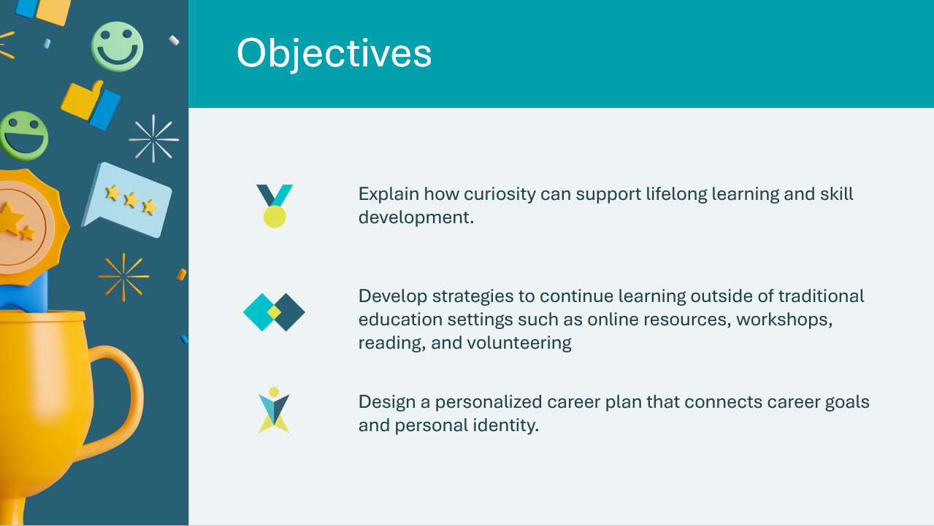 | Optional – review the learning objectives for the lesson
Slide 101 – Introduction  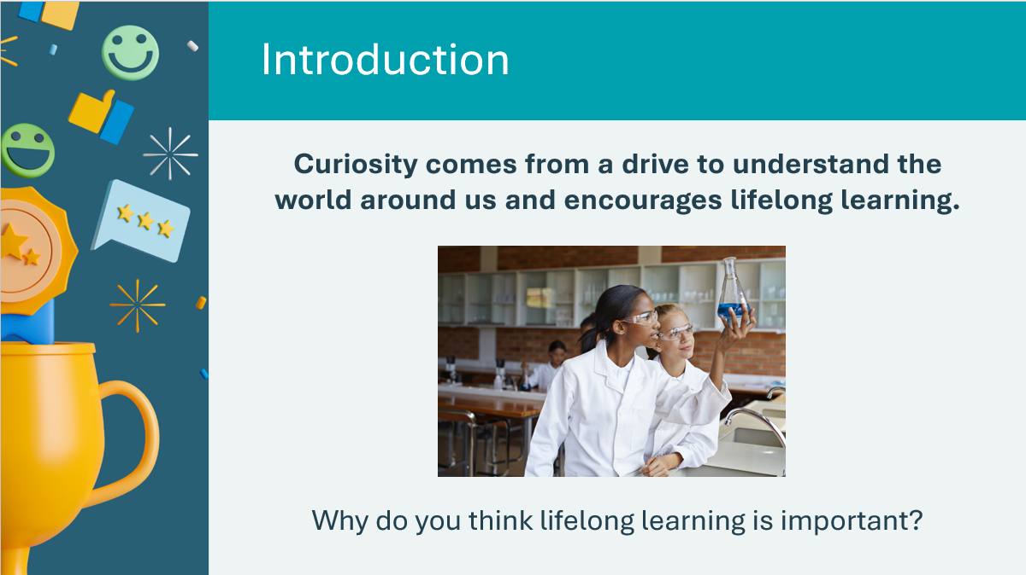 | Tell students we will wrap up our journey by exploring the need to stay curious.  Read students the prompt and accept a few responses. Facilitate the discussion by having students consider how other success skills might relate.  Ask: When has being curious helped you learn something new?  Curiosity: a quality related to inquisitive thinking such as exploration, investigation, and lifelong learning, evident by observation in humans and other animals  Lifelong Learning: the ongoing, voluntary and self-motivated pursuit of knowledge for either personal or professional reasons.  Lifelong learning is a key component to a healthy mind.
Slide 102 – Activity Menu  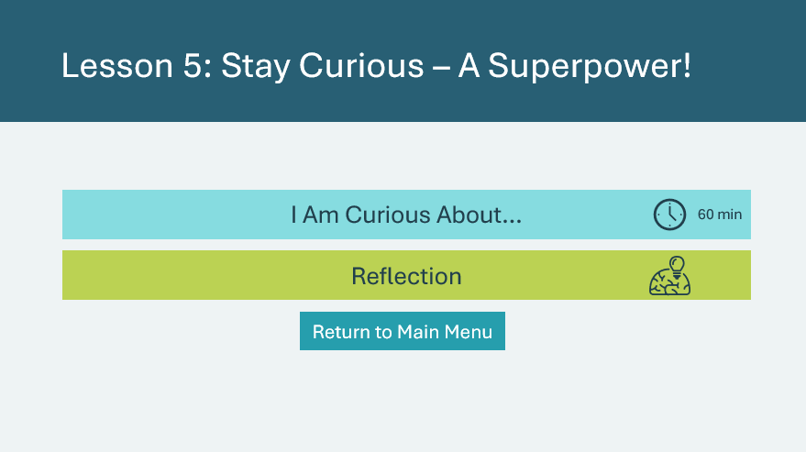 | *Select the button to navigate to the activity.  After you have completed an activity, you will be redirected back to the activity menu.  *Click or tap the Return to Main Menu button to return to the Lessons (Slide 5)
I Am Curious About… 35 min
Slide 103   | Suggested time: 2-3 minutes  Allow students to share things they are curious. Students can share responses related to school, work or personal hobbies/interests.
Slide 104   | Suggested time: 7 minutes  Explain that one way to develop curiosity is by asking meaningful questions. In this activity, students will work in groups to come up with a variety of questions on the topic of AI. Review the information on the slide about GenAI and allow students to share any examples or experiences they’ve had with GenAI.  Once the timer starts, students will jot down their questions as they come to mind. They can use scrap paper or the blank pages at the back of their student portfolio.  Encourage students to think broadly and deeply about the topic, considering various aspects such as its potential impact on society, ethics, technological advancements, challenges and opportunities.  If necessary, use the following guiding prompts to help students brainstorm questions.  - How might GenAI revolutionize various industries?  - What ethical considerations should be taken into account when developing GenAI?  - What are the potential risks and benefits?  - How might GenAI impact employment and the workforce?  - What are the current limitations and challenges in developing GenAI?  - How can GenAI help solve problems?  Tips for creating deeper questions:  - Avoid questions that have a simple yes or no answer. (e.g. is Canada a country?)  - Avoid questions that have a simple explanation (e.g. how many minutes are in an hour?)
Slide 105  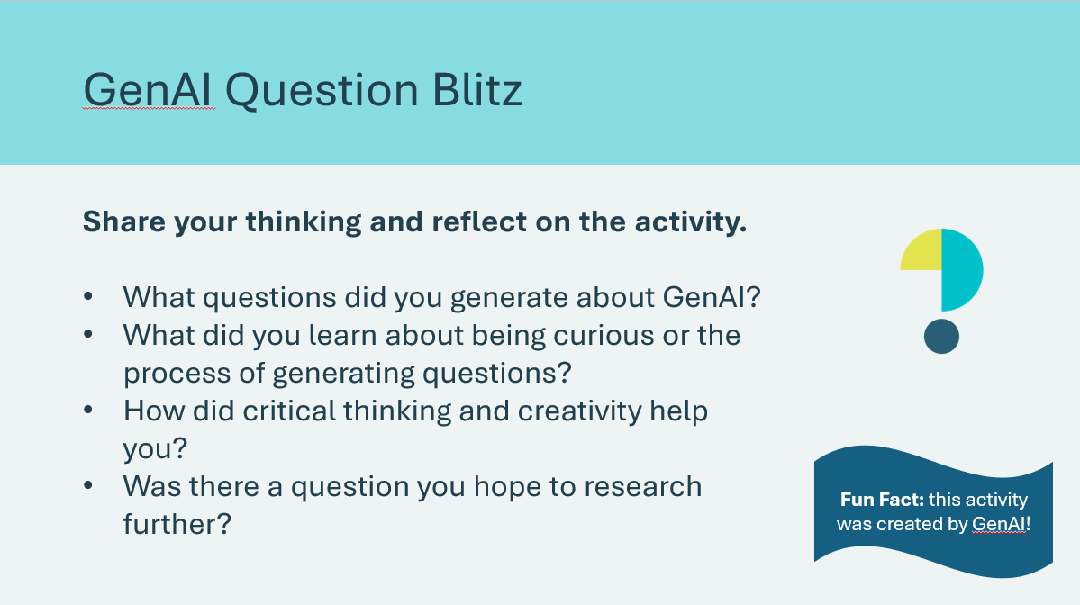 | Suggested time: 5-7 minutes  Invite students to share some of the questions they came up with.  As a group, discuss the questions, exploring different perspectives and insights. Conclude the activity with a brief reflection period by asking the remaining discussion questions.  Volunteer connection: If you use AI in your workplace, share how it’s used!
Slide 106  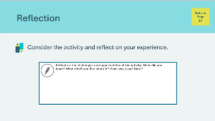 | Suggested time: 5 minutes  Students will complete the reflection in their student portfolio, page 27.
Slide 107  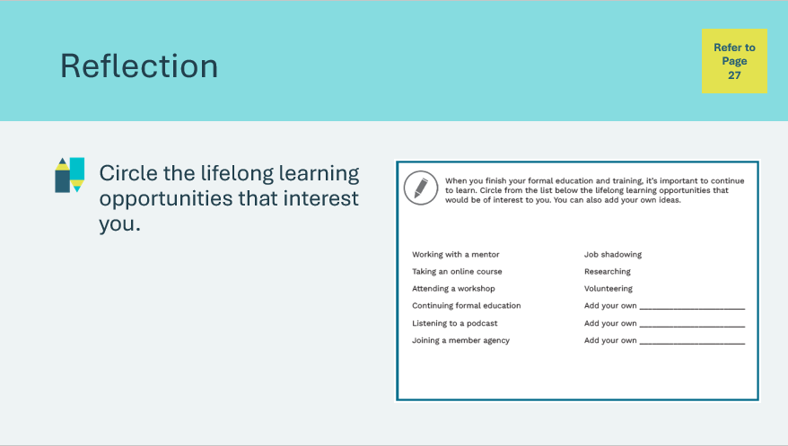 | Suggested time: 5 minutes  Encourage students to think about the ways they like to learn new things and explore new topics.  Students will complete the reflection in their student portfolio, page 27.
Slide 108  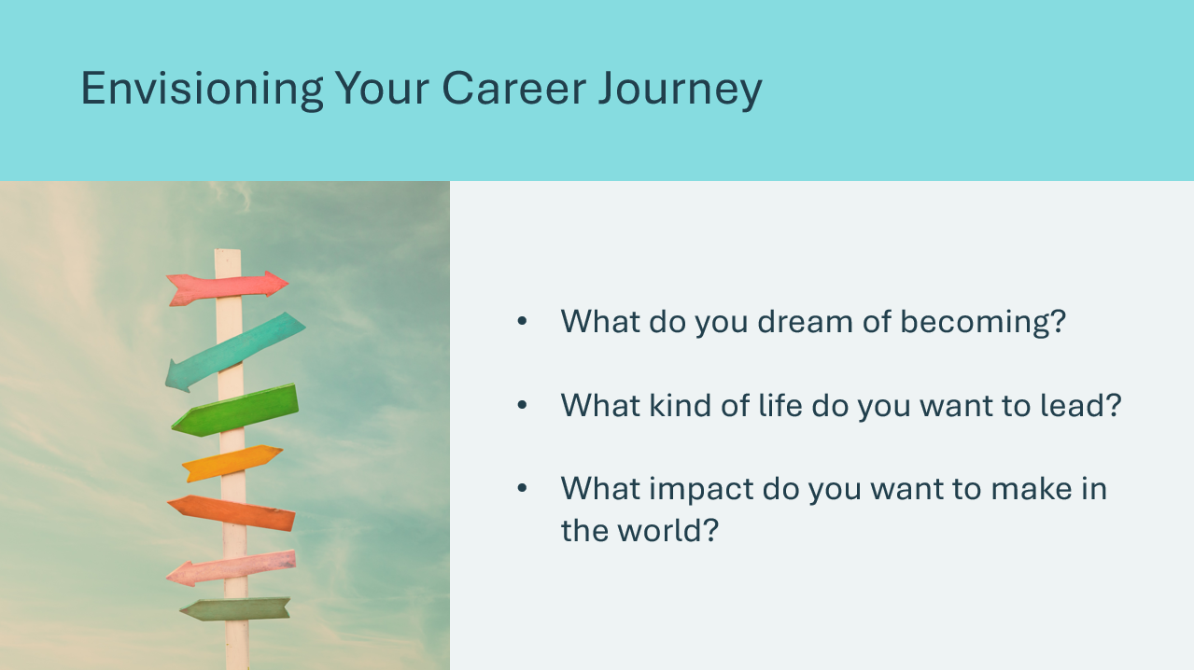  Slide 109   | Suggested time: 2-3 minutes  Introduce the next part of the activity by encouraging students to think about what their future might look like. Ask the prompts and invite students to share.  Encourage students to think about the things they spend time doing in their daily lives, and how those activities contribute to their identity.  Use the following prompts to help guide the discussion:  - What subjects or activities do you enjoy most?  - What are your strengths and talents  - What kind of work environment do you imagine yourself thriving in?  Volunteer connection: Share connections between your career and your identity.
Slide 110  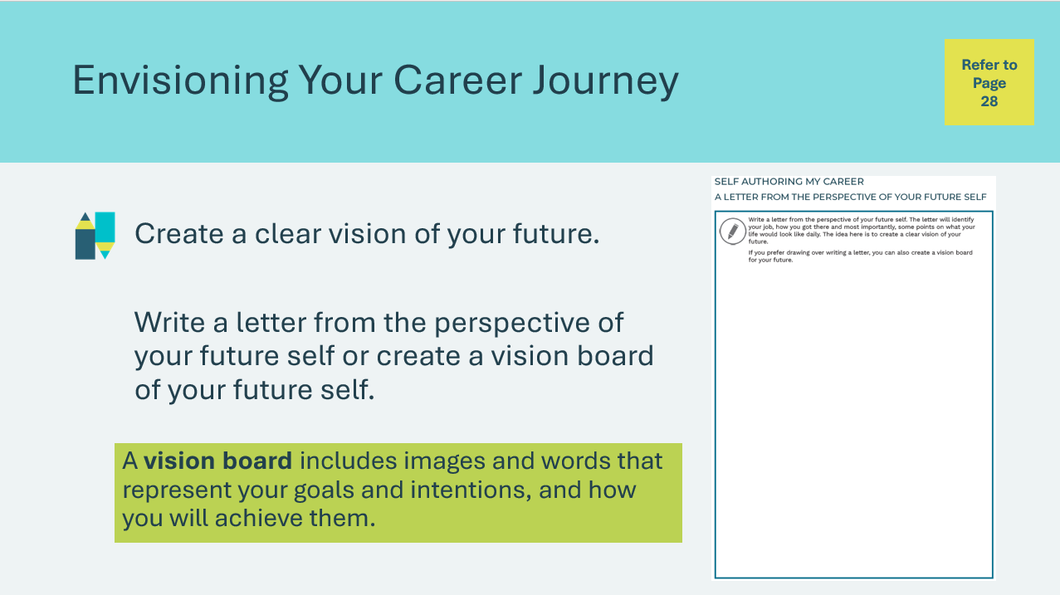 | Suggested time: 20 minutes  Students will complete the activity in their student portfolio, page 28. Whether writing or drawing, students should depict what their job is, how they got there, and some points on what their daily life would be like.  Use the following prompts to help guide students if needed:  - Imagine it’s 10 or 20 years from now. Where are you? What are you doing?  - What does a day in your life look like?  - What steps did you take to get there?  After students have completed their letter or vision board, prompt them to revisit their long-term success plan from  Lesson 1. Students can:  - Analyze the similarities and differences between their envisioned future and their long-term success plan  - Assess the progression of their future vision throughout their engagement with the Success Skills program.
Slide 111  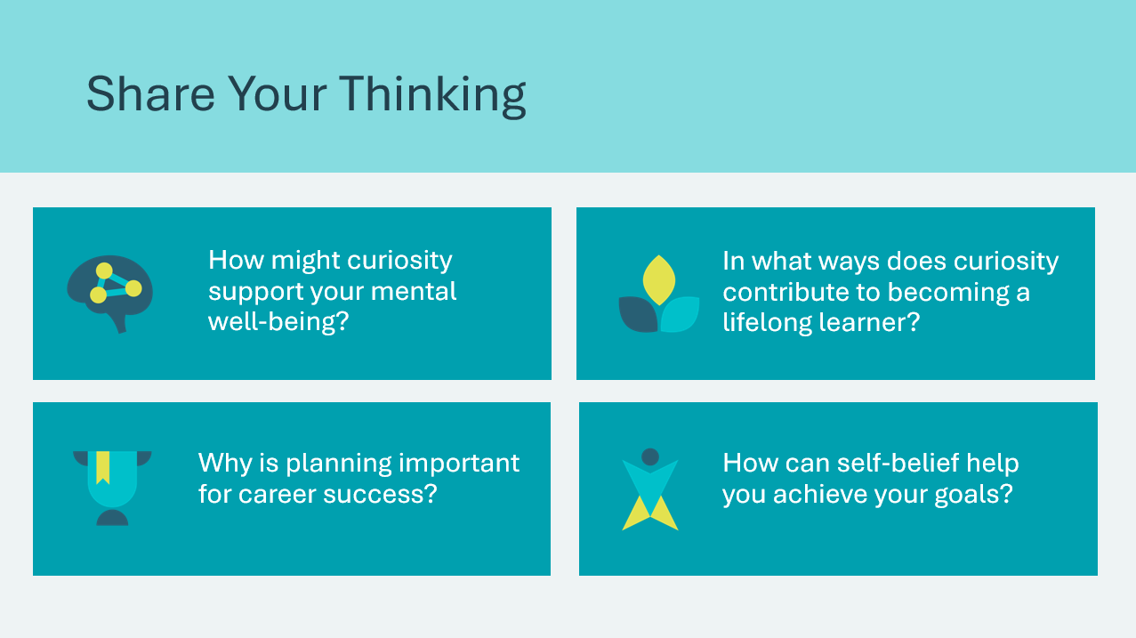 | Suggested time: 5 minutes  Wrap up the activity with the optional discussion questions.  *Click or tap to reveal discussion questions  Sample answers:  - Curiosity helps us be motivated to learn new things  - The brain releases dopamine and other feel-good chemicals when we encounter new things – being curious and learning makes us happy!  - Planning your career journey can help identify the steps you need to take  - Self-belief can help you push through challenges because you know you can learn and improve
Reflection
Slide 112  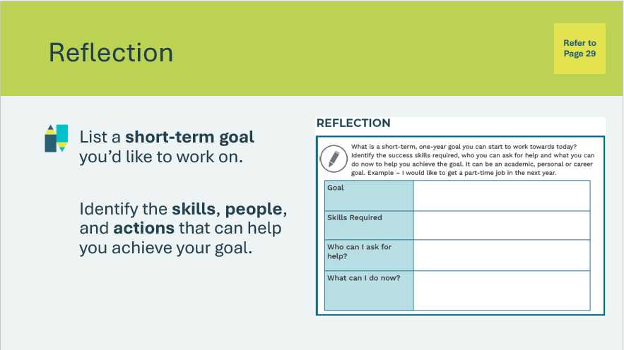 | Suggested time: Students can complete the reflections in class if time allows, or independently later on.  Students will complete the reflection in their student portfolio, page 28.  If time allows, invite a few students to share their responses.  Volunteer connection: Share a short-term goal you have achieved, and some of the skills, people and actions that helped you be successful in achieving your goal.
Slide 113  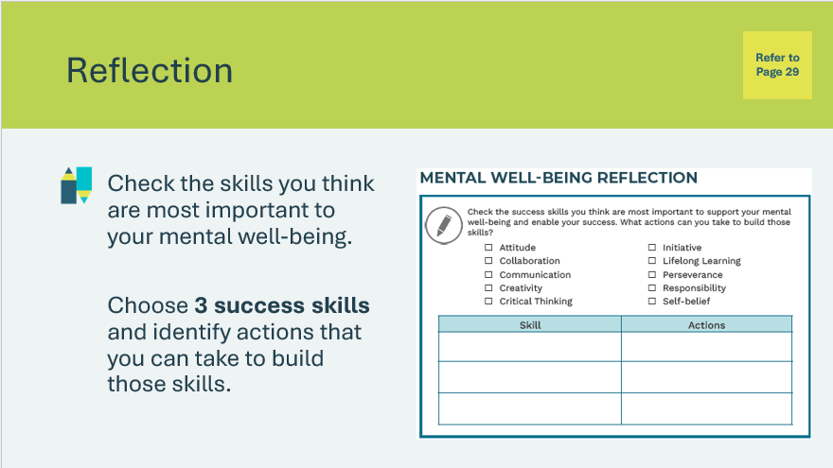 | Suggested time: Students can complete the reflections in class if time allows, or independently later on.  Students will complete the second reflection in their student portfolio, page 29.  If time allows, invite a few students to share their responses.

Wrap Up
Program Kit Materials | Certificate of Accomplishment  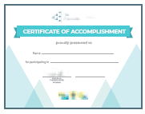
Slide 118 – Congratulations!  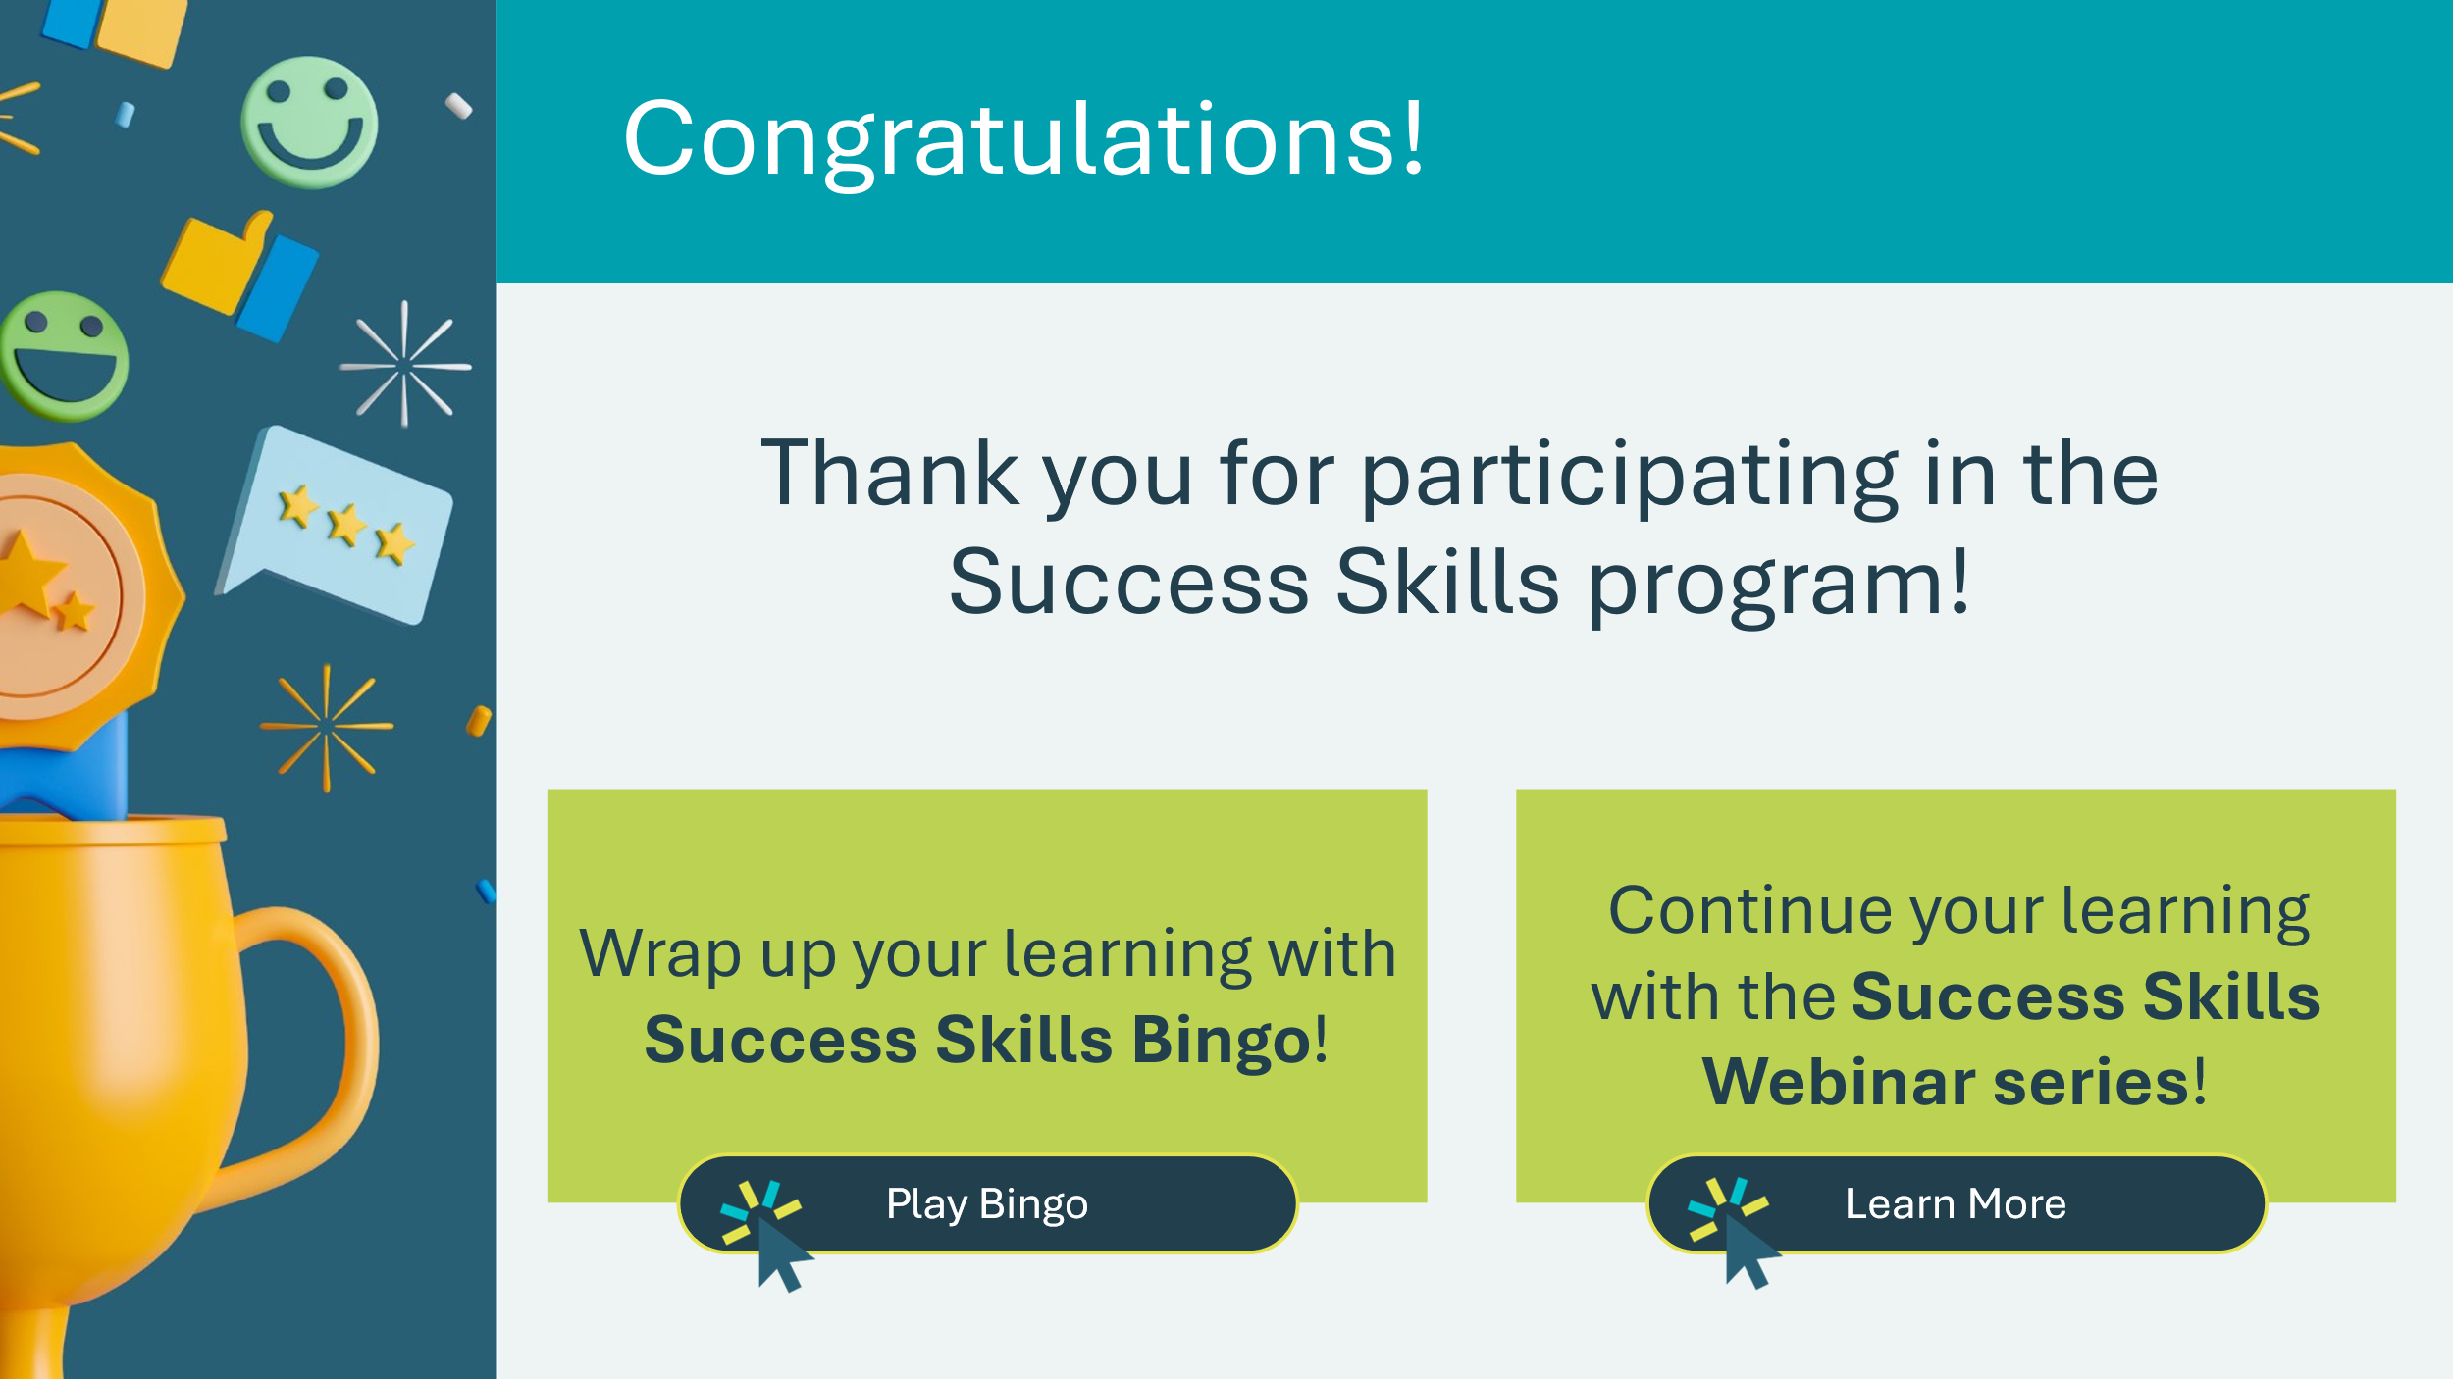 | Depending on time available, wrap up the learning experience with Success Skills Bingo, or continue the learning with the Success Skills Webinar series.  *Click or tap one of the buttons to proceed to Bingo or Webinars. You may also choose to end the delivery here.  Wherever you choose to end the learning, conclude the program by handing out student Certificates of Accomplishment!
Slide 119 – Bingo  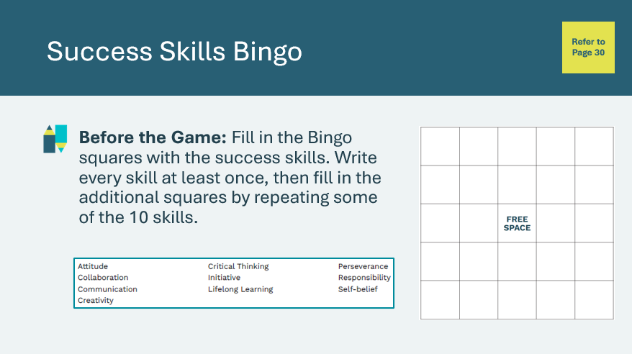  Slide 120 – Bingo  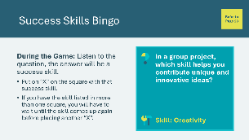 | Suggested time: 15 – 20 minutes  Ask students to set up their game board by filling in the bingo squares with the success skills in their student portfolio, page 30.  Read each question and ask the students which skill applies. They can put an “X” on one square at a time.  Play until the card is full or they get one or two lines, depending on the time available.  *Click or tap to reveal a new question. Click or tap again to reveal the answer/success skill.  Bingo statements and answers are also available in the Appendix if you need to re-read the statements.
Slide 121 – Webinars   | Additional learning and resources – Success Skills Webinars  In this three-part series, students can enhance their resilience, build confidence and learn transferable skills. The webinars can be watched in any order and can be viewed by students independently or used by educators as a classroom resource.  Additional educator and student resources can be found by following the link.  https://www.jacampus.org/success-skills-webinars/?saml=on

Appendix
Success Skills Bingo Statements
In a group project, which skill helps you contribute unique and innovative ideas? Skill: Creativity
When faced with a challenging problem, which skill involves thinking deeply and considering different perspectives? Skill: Critical thinking
Which skill involves staying determined and not giving up, even when things get tough? Skill: Perseverance
You decide to look for volunteer opportunities to gain experience for your resume, what skill are you demonstrating? Skill: Initiative
When working on a team, which skill helps you effectively listen to others and share your perspective? Skill: Communication
In a job interview, which skill is crucial for expressing confidence in your abilities? Skill: Self-belief
In a group project, which skill involves embracing different perspectives to achieve a common goal? Skill: Collaboration
What skill is essential for being open to new ideas and continuously learning throughout life? Skill: Lifelong learning (curiosity)
When working on a group project, which skill helps you fulfill your role responsibly and meet deadlines? Skill: Responsibility
Which skill involves identifying challenges and finding effective solutions? Skill: Problem-solving
Which skill is essential for taking ownership of your actions and learning from your mistakes? Skill: Responsibility
Which skill involves using logic, creativity, and resourcefulness to overcome challenges or obstacles? Skill: Problem-solving
Which soft skill involves being open to new ideas and ways of doing things? Skill: Lifelong learning (curiosity)
In writing assignments, which skill is crucial for generating unique and imaginative ideas? Skill: Creativity
What skill is demonstrated through open-mindedness and adaptability when working with others? Skill: Collaboration
Which skill involves effectively conveying your thoughts and ideas to others? Skill: Communication
When working on a group project, which skill helps you adapt to changes and find solutions when faced with obstacles? Skill: Adaptability
In a debate, which skill is essential for constructing well-reasoned arguments and responses to arguments? Skill: Critical thinking
Which skill is demonstrated by coming up with different ways to resolve an issue? Skill: Problem-solving
If you started a club at school to help clean up the community, what skill would you be demonstrating? Skill: Initiative
Which skill involves continuously seeking opportunities to expand your knowledge and skills? Skill: Lifelong learning (curiosity)
In a group discussion, which skill helps you actively listen to others and respond thoughtfully? Skill: Communication
Which skill involves respecting and trusting another person’s ability to contribute towards a common goal? Skill: Collaboration
When working on a long-term project, which skill helps you stay focused and committed to reaching the end goal? Skill: Perseverance
Which skill involves believing in your abilities and maintaining confidence in yourself? Skill: Self-belief
Which skill helps you break down a big challenge into smaller steps and figure out how to tackle it? Skill: Problem-solving
What skills is demonstrated by a team captain that sets up a training plan for everyone to help maximize their performance? Skill: Initiative
When assigned a task, which skill involves taking personal accountability for its completion? Skill: Responsibility
Which skill involves demonstrating a willingness to compromise? Skill: Collaboration

