tpppt

JA A Business of Our Own Presenter Notes
The Presenter Notes have been developed using references from the digital classroom presentation and should be used in combination with the printed Student Portfolio V10-2023.
Tips for Setting Up Your Classroom
- Arrive 15 minutes early and check in at the office.
- Connect with the teacher for the program materials and organize them as needed.
- Hand out student portfolios and name tags/cards.
- Set up presentation (check audio and internet connection are working).
- Write your name on the board.
- Ask the teacher to write student names on program certificates.
- Check in with the teacher about school schedule, tips for getting students' attention, any specific student needs & behaviours you should be aware of and ask for help with encouraging student participation, as well as monitoring and managing the class.

About the Program
Students explore how they can run a real business that sells products. They’ll learn what a business is, how to create a business canvas model, collaborate in teams and develop their entrepreneurial skills and mindset while participating in business activities.
Business Activity
After learning about important concepts, students will participate in one of the following experiential learning activities to apply what they have learned and further develop their entrepreneurial skills and mindset:
- Sales Stand
Students choose or create products for sale and set up a stand to sell them in the school.
- Discuss with the teacher whether there are class funds available to finance the business as a loan, or whether students should find no-cost ways to run the stand. Explain clearly that if a loan is made, Junior Achievement cannot guarantee it will be repaid.
- Have students get permission from school administration to have a Sales Stand at the preferred location(s) and times in the school.
- Adhere to all school and district guidelines for sales and money-handling activities.
- Plan time for teams to report to the class on a regular basis on their activities and discuss with the class whether there are any problems that the class can help resolve.
- Have the class make a wall chart showing a daily timeline leading to the sales day, listing tasks that have to be done, and when they are to be done (See sample on page 41).

- Bizcraft
Students play an online game called Bizcraft which simulates the operations of a business. Students play the role of a business owner and their goal is to try to make one million dollars by making important business decisions. See Appendix C on page 43 for more information about the game.
https://bizcraftapp.jacampus.org
- Business Pitch
In teams, students create and pitch an idea for a business.
Differentiation
Throughout the program, students are invited to work in teams on business planning activities. Depending on the students, there are multiple options for how to organize the class:
- Whole class – The whole class works together to create one business idea.
- Small groups – Split the students into teams of 4-5. Each group will brainstorm a different business idea.
Facilitator Tip: Confirm with teacher ahead of time if students can self-select teams or if the teacher would like to determine the groups.
Length of Program
The program is designed to be flexible and can be adapted to suit a variety of delivery models. Depending on school schedule and instructional needs, the program may be delivered in a single full day, across multiple days or in a condensed format.
Your local JA office will work with you to determine the most appropriate program format.

Planning Guide
GETTING STARTED (Slides 1 – 5) 5 MIN

LESSON 2 (Slides 30 – 50) 40 MIN
PRODUCTION
Activities
- How does a business make 5 min
products?
- Option 1: JA Penco Activity 30 min
- Option 2: Team Time 30 min
- Reflection 5 min
Extension Activities
- What’s Your Process? 15 min
- Careers Exploration 15 min
LESSON 1 (Slides 6 – 29) 45 MIN
STARTING THE BUSINESS CANVAS MODEL

Activities
- What does a business do? 5 min
- Business Planning 25 min
- Teamwork makes the 10 min
Dream Work
- Reflection 5 min
Extension Activities
- Team Time 15 min
- Startup Capital + Loans 15 min

LESSON 4 (Slides 63 – 76) 45 MIN
FINANCIAL RECORDKEEPING, PRICING AND TEAMWORK
Activities
- Keeping Track of Money 5 min
- Income and Expenses Projection 25 min
- Net Profit or Loss 10 min
- Reflection 5 min
Extension Activities
- Team Time 15 min
- Sales Records 10 min

BUSINESS ACTIVITY 30-60 MIN
(Slides 77 – 85)
LAUNCH
Activities Options:
- Sales Stand 30-60 min
- Bizcraft Game 30-60 min
- Business Pitch 30-60 min

CONCLUSION 5 MIN

LESSON 3 (Slides 51 – 62) 45 MIN
MARKETING AND PROMOTIONS
Activities
- Marketing: The 4 P’s 10 min
- Promote Your Business 10 min
- Marketing Messages 20 min
- Reflection 5 min
Extension Activity
- Team Time 15 min

CONCLUSION (Slides 86 – 96) 20 MIN
Activities
- Reviewing the Business Model 15 min
Canvas
- Reflection 5 min
- Congratulations 5 min

Introduction
Slide 1 – A Business of Our Own | Navigation Tips  - Navigate through the slides using the next or previous buttons (bottom right), clicking or tapping on the slide, or using the navigation menu (right).  - Look for slide specific instructions in the presenter notes below.
Slide 2 – Welcome to JA!   | Suggested time: 3 minutes  Ask: Has anyone heard of Junior Achievement before?  Play the video for students to introduce them to JA!
Slide 3 – A Business of Our Own Program | Suggested time: 2 minutes  Introduce the program and yourself!  Explain that in this program, students will explore how they can run a real business that sells products. Along the way, they will develop their entrepreneurial mindset.  An entrepreneurial mindset is a set of attitudes and skills that helps you identify opportunities, overcome challenges, and learn from mistakes.  Volunteer connection: Tell the students a little about you; your education, and your career path. Explain why you chose to volunteer in their classroom today.  Business Activity Option: Depending on the delivery format and duration, explain that students will either:  - Run a sales stand;  - Play a game to simulate running a business; or  - Create a pitch to promote a business idea.
Slide 4 – Symbol Legend  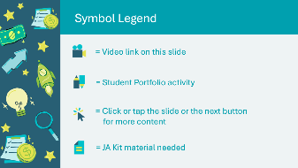 | The symbols will help guide the learning experience. Explain to students that they will see these symbols throughout the program.
Slide 5 – Main Menu  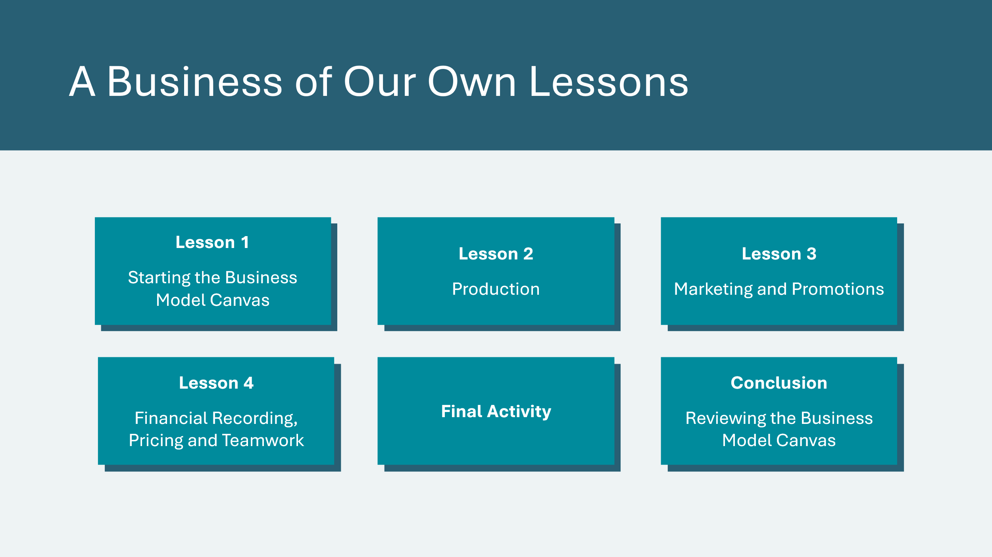 | *Select the button to navigate to the lesson.  After you have completed a lesson, you can select the Return to Main Menu button from the Lesson Activity Menu to return to this slide.

Lesson 1: Starting the Business Canvas Model
Program Kit Materials | Team Cards (Optional)  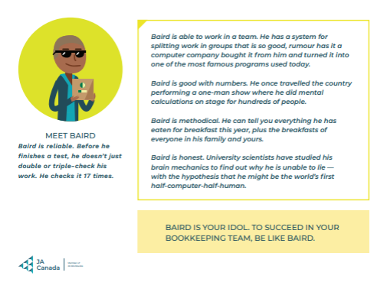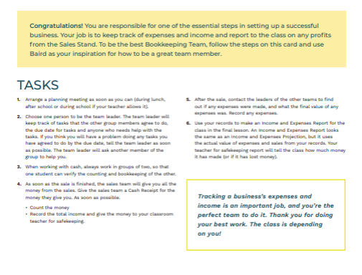  Loan Application Form (Optional)  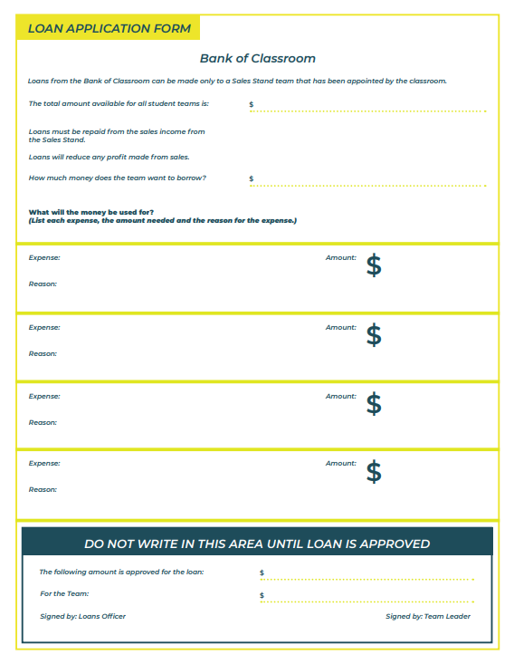
Slide 6 – Lesson 1  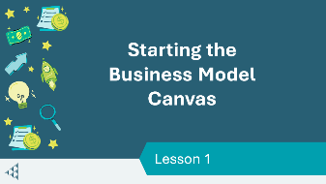 | Lesson 1: Starting the Business Canvas Model
Slide 7 – Objectives  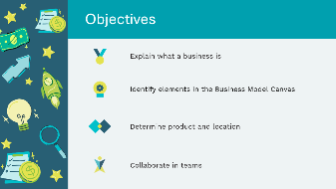 | Optional – review the learning objectives for the lesson.
Slide 8 – Introduction   | Suggested time: 2-3 minutes  Ask the class if anyone has family members or friends who work in business or if they have ever sold things to other people (e.g. lemonade stand, garage sale, or for a fundraiser).  Facilitation Tip: If necessary, prompt them with questions such as the following: ​  - Do they sell products or services?​  - Do they make products or buy them?​  - Is it an online or in a physical location?​
Slide 9 – Lesson 1 Activity Menu 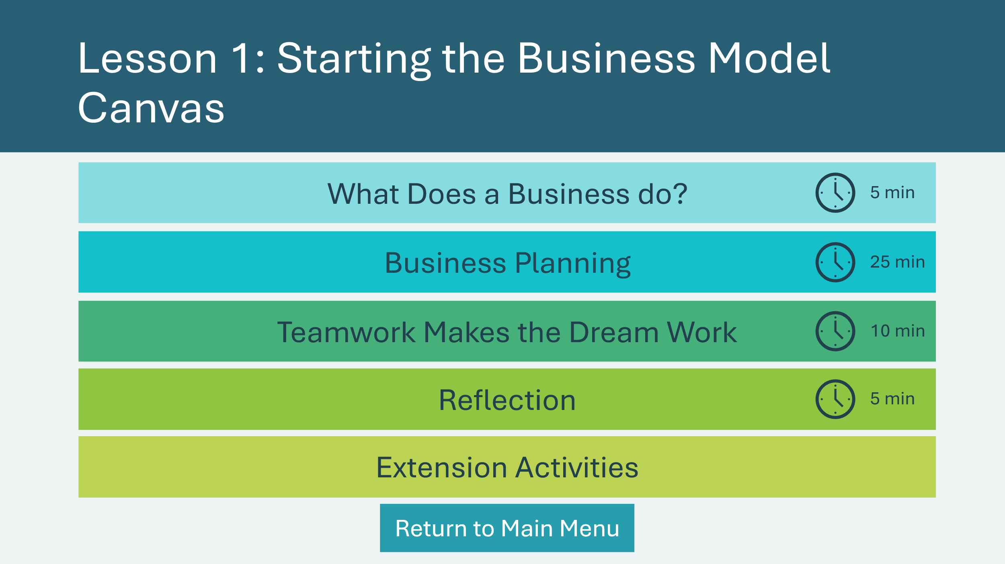 | *Select a button to navigate to the activity.  Select the buttons to jump to an activity or select next to begin the lesson.  *Click or tap the Return to Main Menu button to return to the Lessons (Slide 5)
What Does a Businesses Do? 5 min
Slide 10 – What Does a Business do?  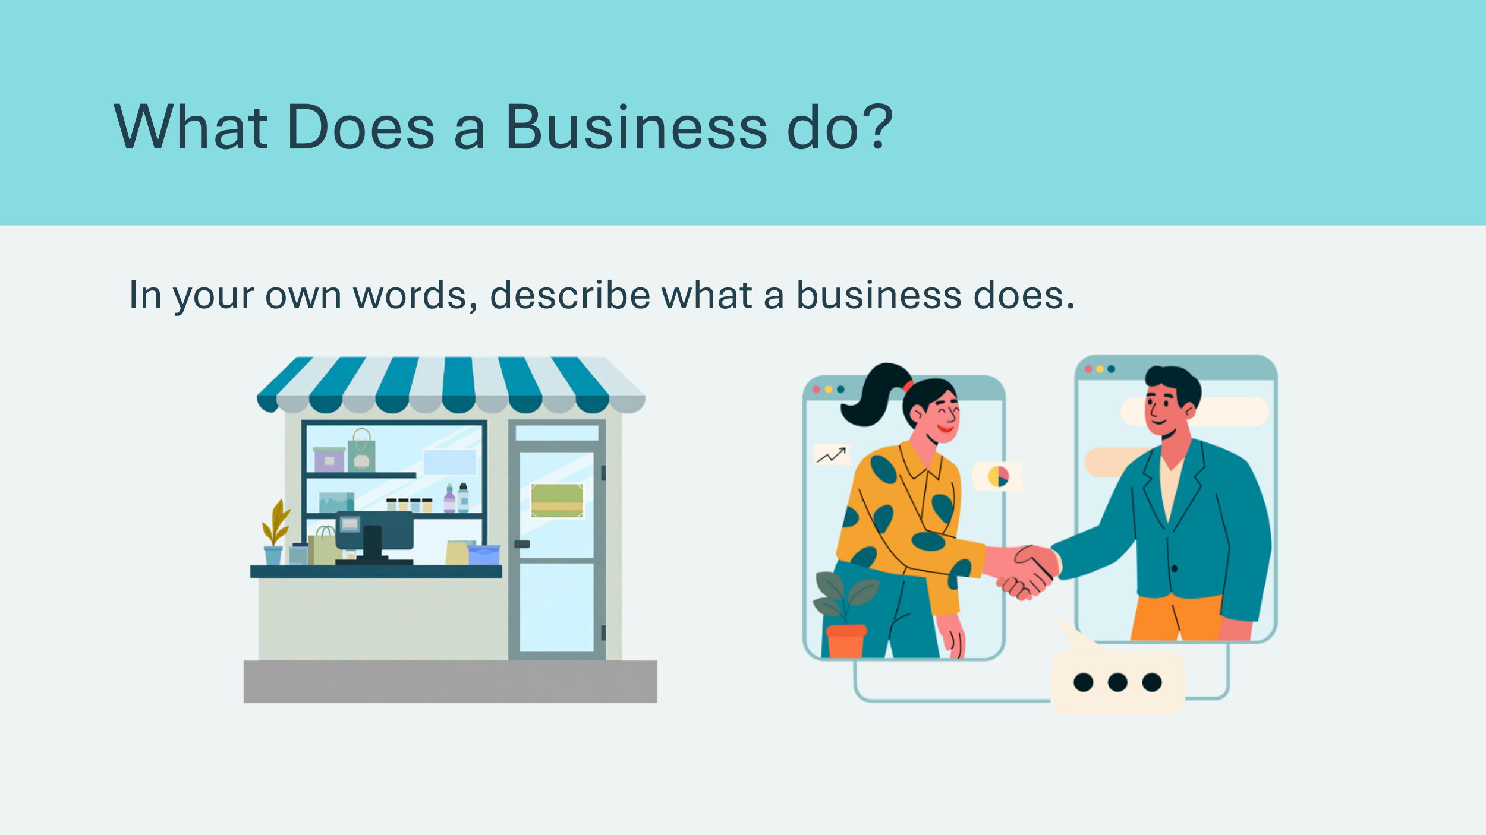 | Suggested time: 5 minutes  Based on what the students shared, ask if anyone can explain what a business does.
Slide 11 – What Does a Business do? 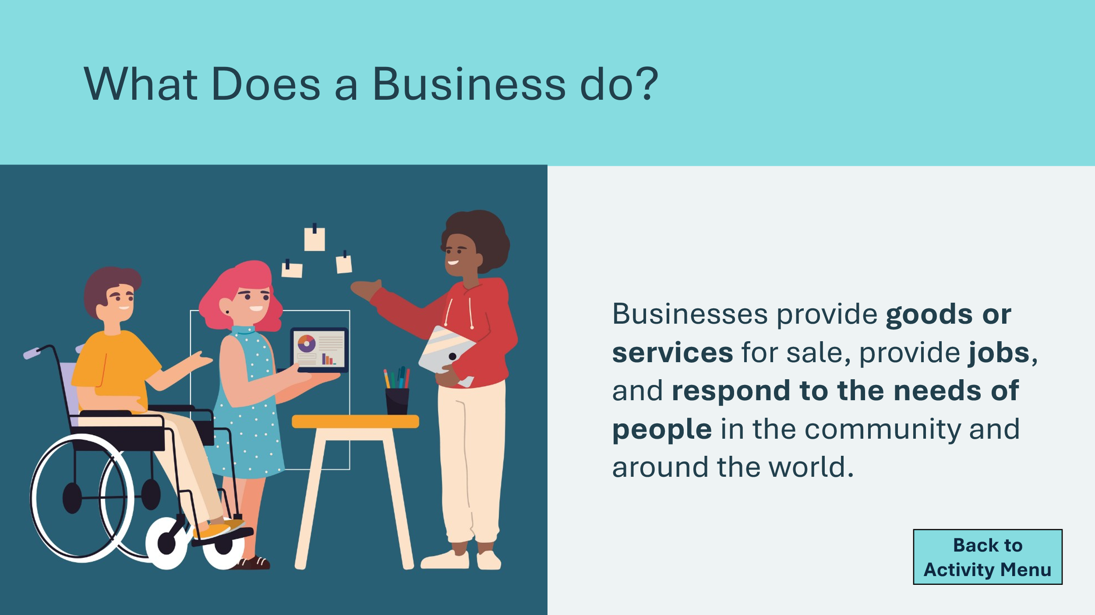 | If necessary, explain that, while there are many different types of businesses, all businesses provide goods or services for sale, provide jobs, and fill the needs of people in the community and around the world.​  Explain that the best way to learn about what businesses do is to run a business. The lessons in this program will give students a chance to apply entrepreneurial skills and mindset to run a simple business. ​
Planning for Success 5 min
Slide 12 – Planning for Success 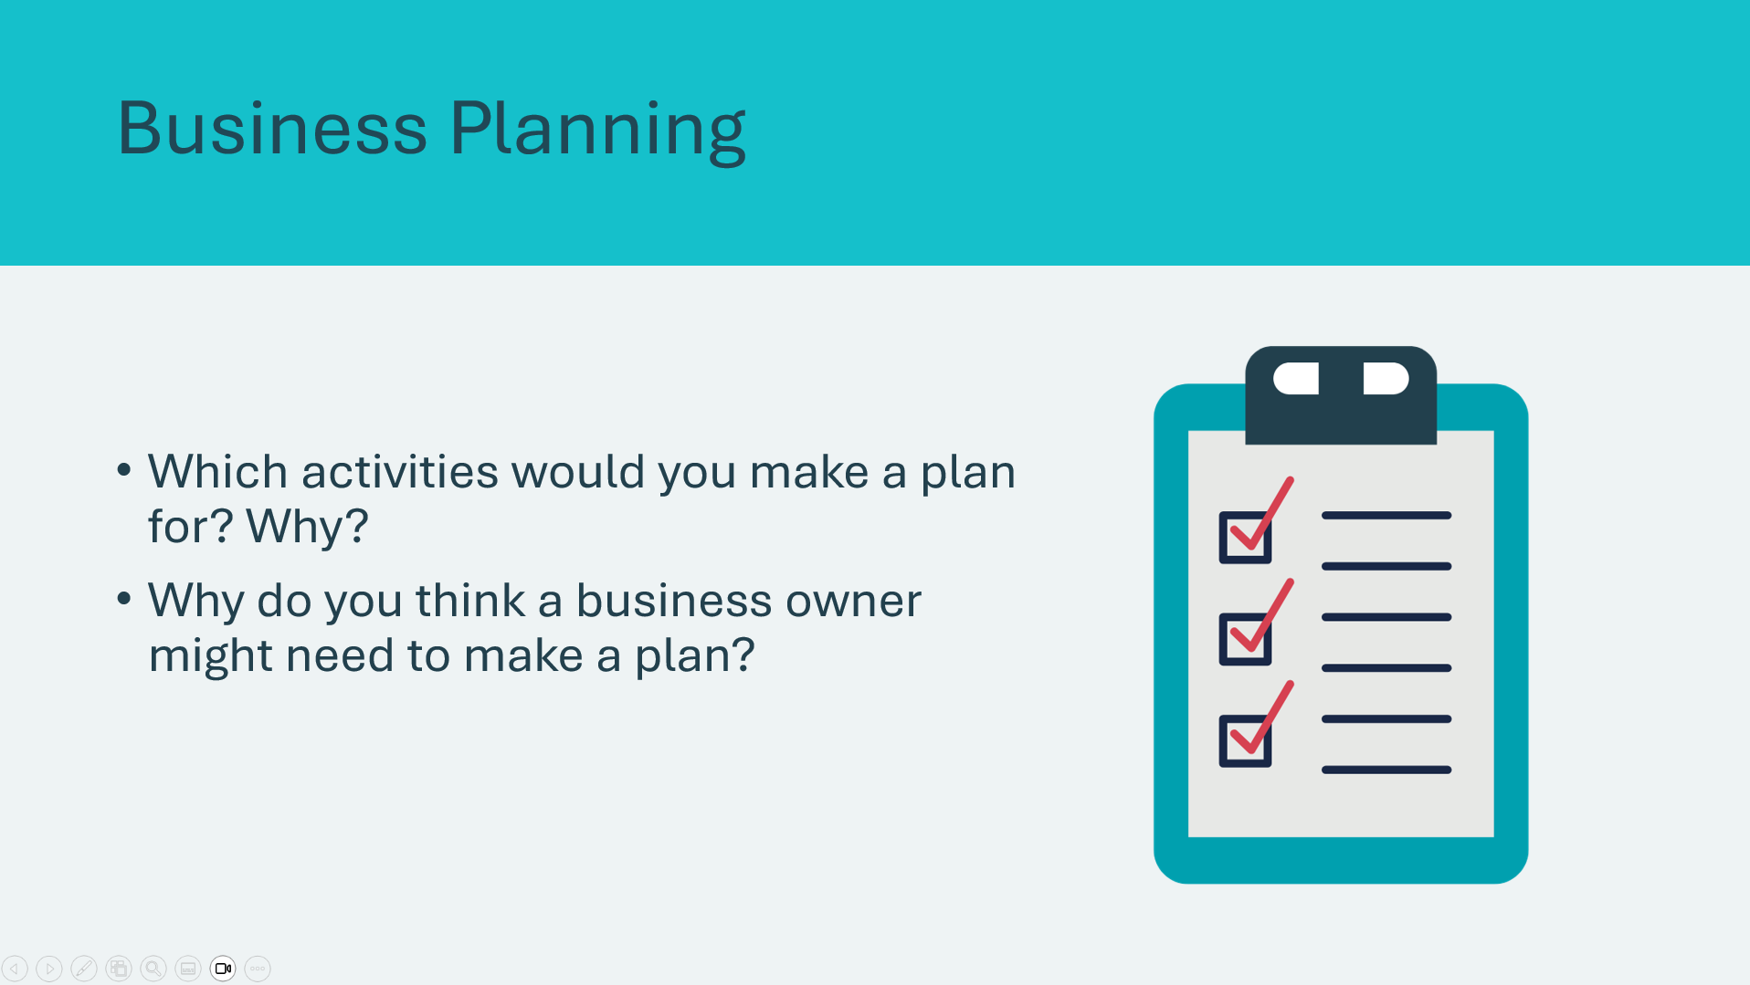 | Suggested time: 2 minutes  ​Turn and Talk: Students talk to a partner and come up with a few ideas, then share out with class.  Ask:  - What types of activities are important to plan for and how can planning help you (e.g. school assignments, sports activities or other personal goals)?  - What types of things might a business owner need to plan to run a successful business?  Point out that creating a plan is a valuable way to begin any long-term activity. Also, the skills that students learn in creating a plan will help them in other areas of their lives.  Sample answers:  - It helps the business owner think in advance about the business and what he or she will need to do to run it successfully. ​  - A business owner would need to plan materials, location, price of product, who they are selling to… etc.
Slide 13 – What is a Business Model Canvas?   | Suggested time: 3 minutes  Explain that a business model canvas includes most of the elements students identified.  A business model canvas is a basic business plan. It is a written or visual layout of what a business does and how it makes money.  Play the video.  Students can refer to their student portfolio, page 4 and 5. Explain that the rest of the lesson will be spent starting to fill in the missing information on the Business Model Canvas in their workbooks.  Multi-day delivery – Explain to students that they will completing part of the business model canvas today and the rest another day.
Business Planning 20 min
Slide 14 – Vocabulary  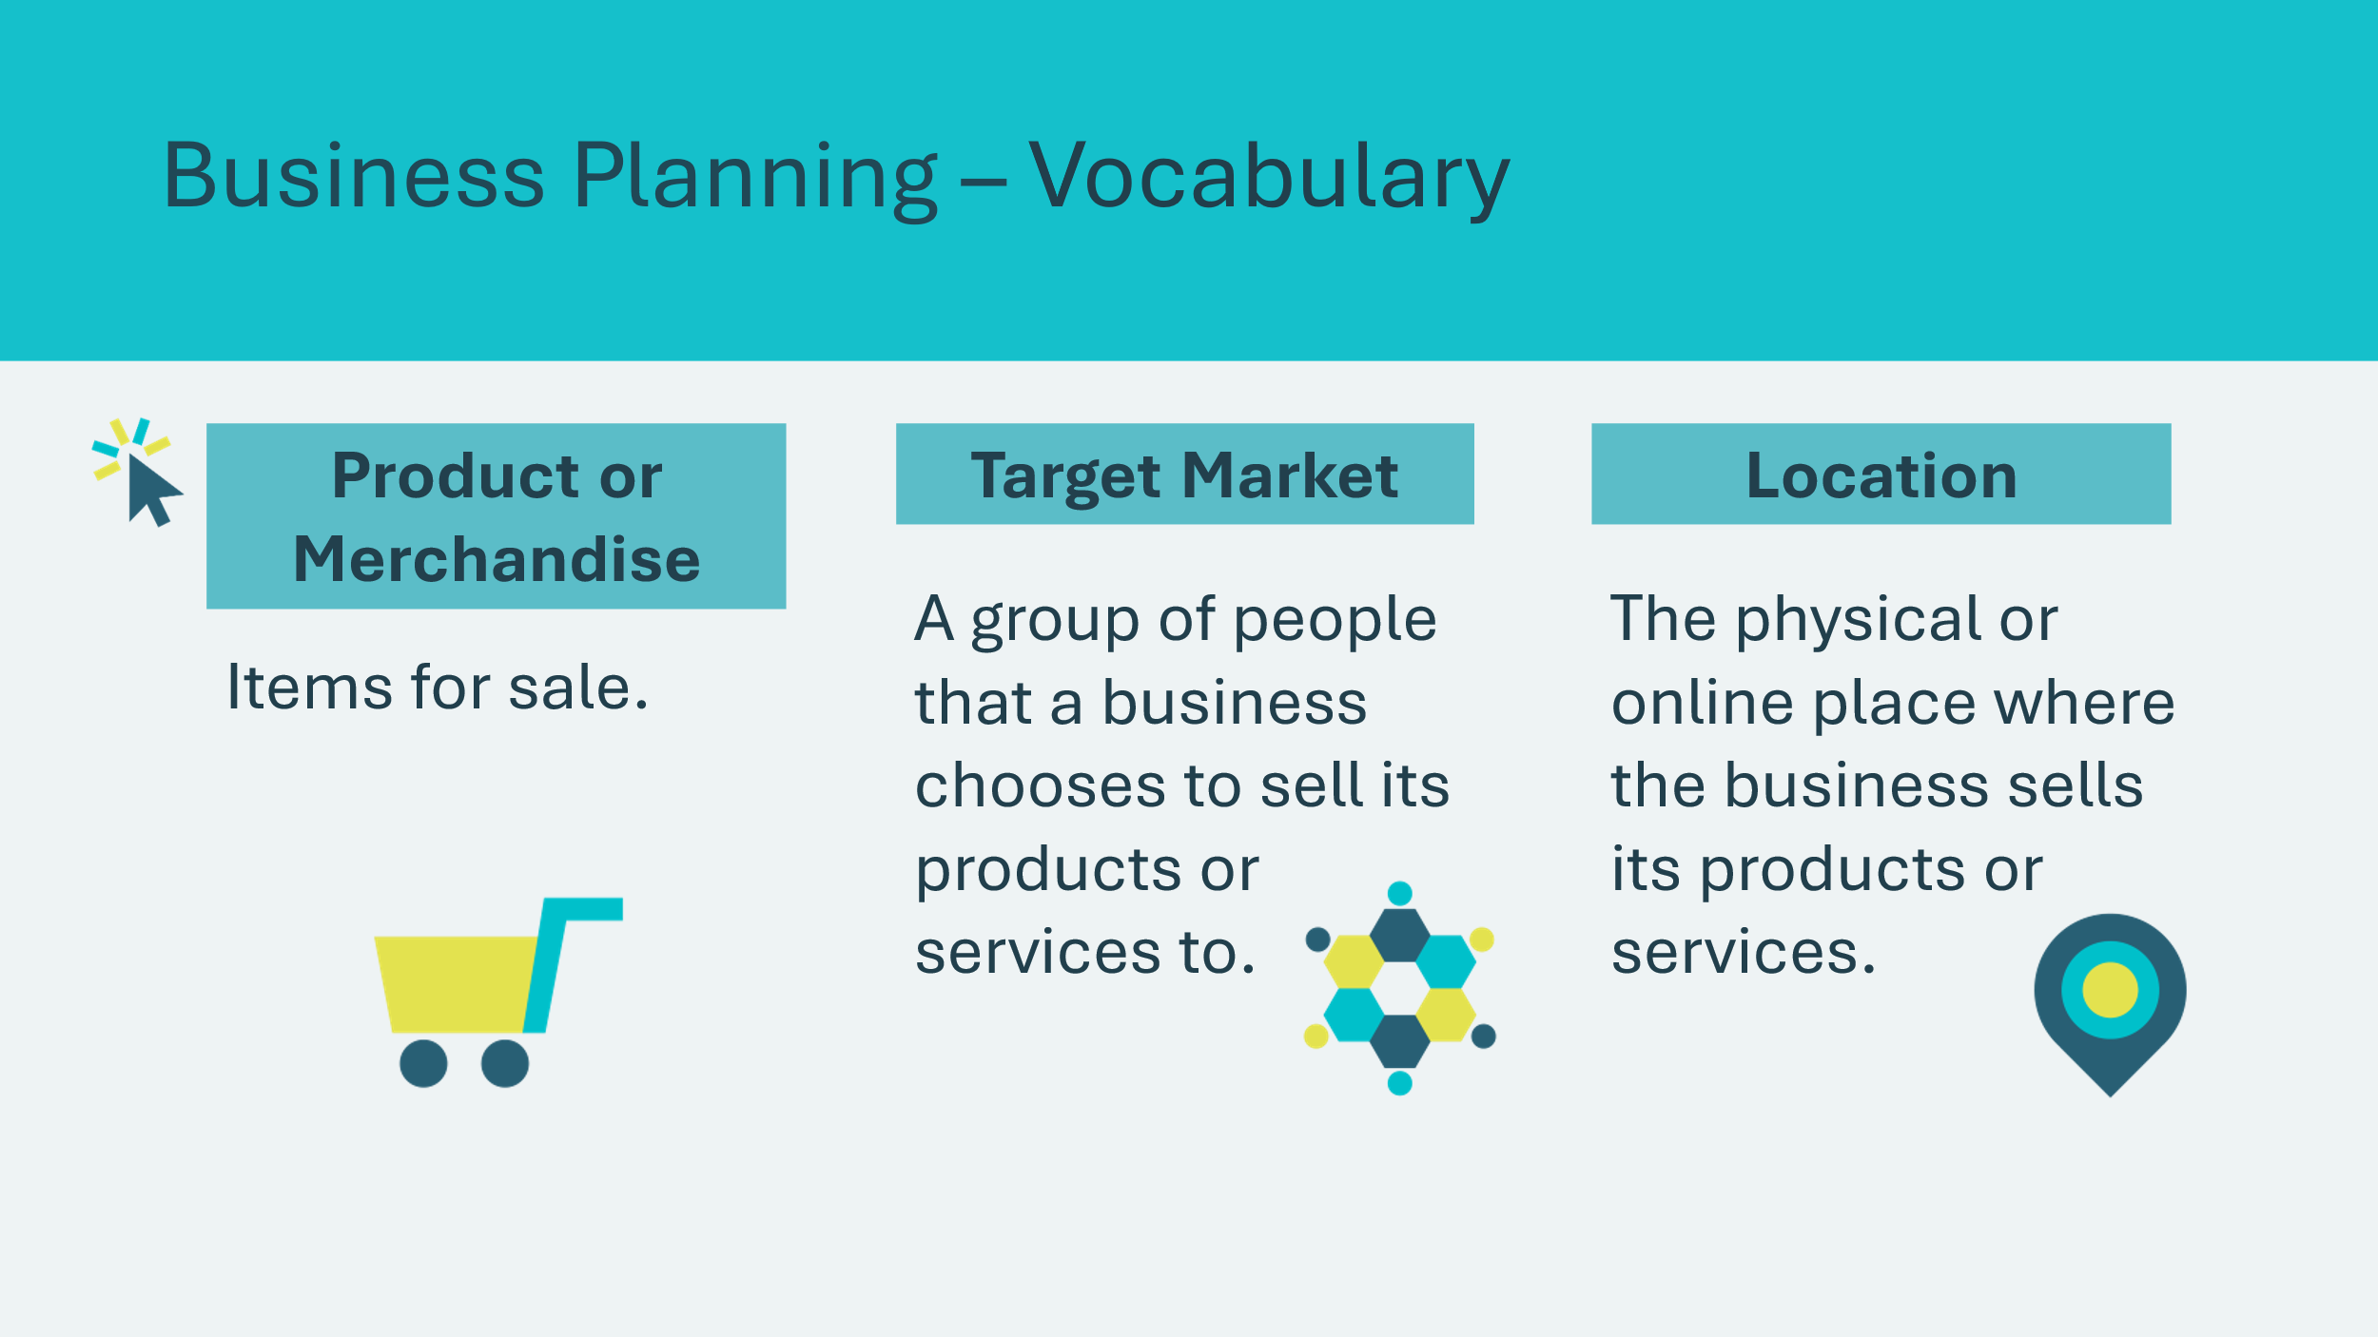  Slide 15 – Vocabulary  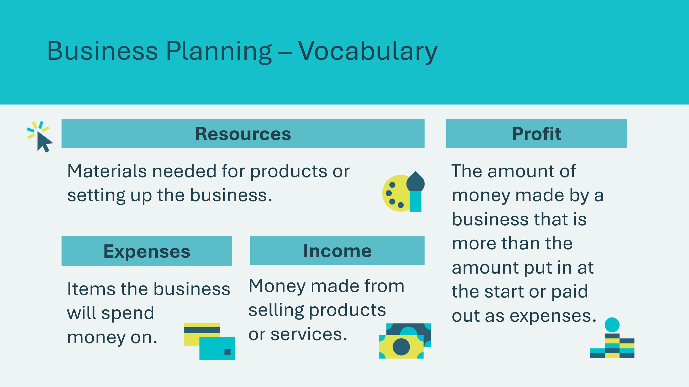 | Optional  Depending on the level or age of the students, you may choose to review a few key vocabulary terms. Otherwise, continue to the next slide.  *Click or tap to reveal each term.
Slide 16 – Business Planning  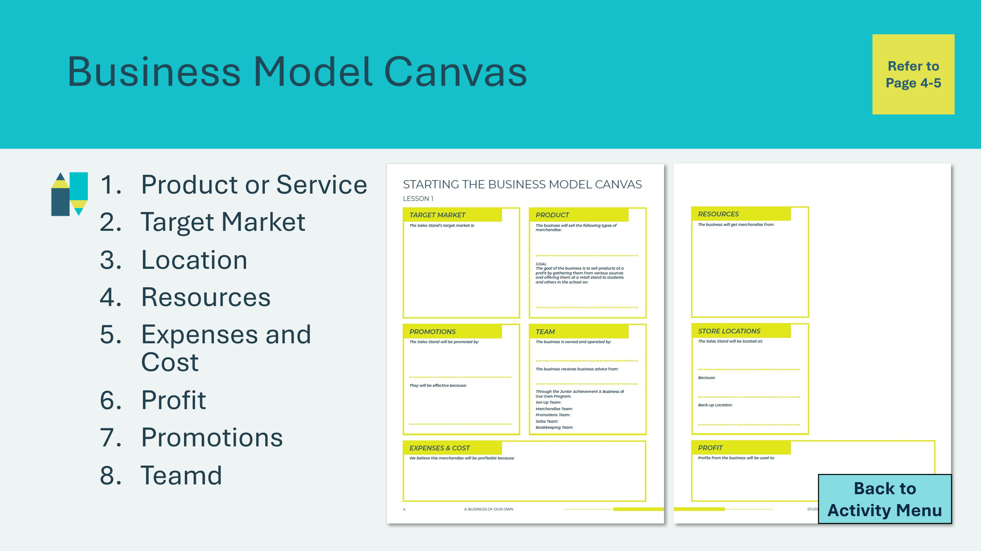 | Suggested time: 20 minutes  Explain that the students are the employers and employees of their business. They will come up with their own ideas and make decisions, and you will be their mentor by helping them to complete their business planning using the business model canvas.  1. Complete the Product section on page 4. (5 min)  Facilitator Tip: If necessary, prompt the students with suggestions, such as the following:  - Handmade crafts  - Food items  - Used toys and games  - Clothing  - School supplies  Options:  Depending on the final Business Activity:  - If playing Bizcraft or doing the Pitch activity, students could come up with more elaborate or creative business ideas.  - You may wish to rewrite the Business Goal with students. If they are doing the Sales Stand, fill in the date of the sale.  2. Complete the Target Market section on page 4. (3 min)  3. Complete the Store Locations section on page 5. (3 min)  ​Facilitator Tip: Below are some considerations you could discuss.  - Visibility – people should be able to see it easily​  - Access – the owners must be able to reach it easily with their supplies and sales items​  - Safety – it can’t block stairs or exits, or create a hazard​  - Practicality – there has to be a room to move around, display the goods, handle cash, etc.  4. Complete the Resources section on page 5. (3 min)  Ask the class where they will get the merchandise they plan to sell. If necessary, prompt them with suggestions such as the following:  - Donations from friends and family  - Purchases  - Items students make  5. Complete the Expenses and Cost section on page 4. (4 min)  - Indicate whether there are class funds available to finance the business as a loan, or whether students should find no-cost ways to run the stand (see Slide 30 for more information about loans).  - Ask students why they think the merchandise chosen will be profitable, and have the class write the reasons on their Business Model Canvas.  Option: Depending on the level or age of the students, you could ask them to estimate expenses and income. They will explore this topic further in Lesson 4. There is also an alternative simple budget worksheet on Appendix B (page 41).  Facilitator Tip: To support younger students with financial literacy/math elements, don’t use decimals in prices and set prices no more than 6$ per item.  6. Complete the Profit section on page 5. (2 min)  Ask the class what they want to do with any profits from the sales. Highlight that profits could be used to:  - Re-invest in the sales business;  - Pay off the loans used to start the business;  - Spend on a class project;  - Make a donation to charity.  Note: because the Sales Stand is a school project, dividing the profits among the owners or paying a bonus are not permitted.  7. Promotions – This section will be completed in Lesson 3.  8. Team – This section will be completed in the next section.  Additional Information: In addition, for larger businesses, a canvas describes the business to other people who may be involved, such as those who lend money to start the business, employees and suppliers.
Teamwork Makes the Dream Work 10 min
Slide 17 – Teamwork  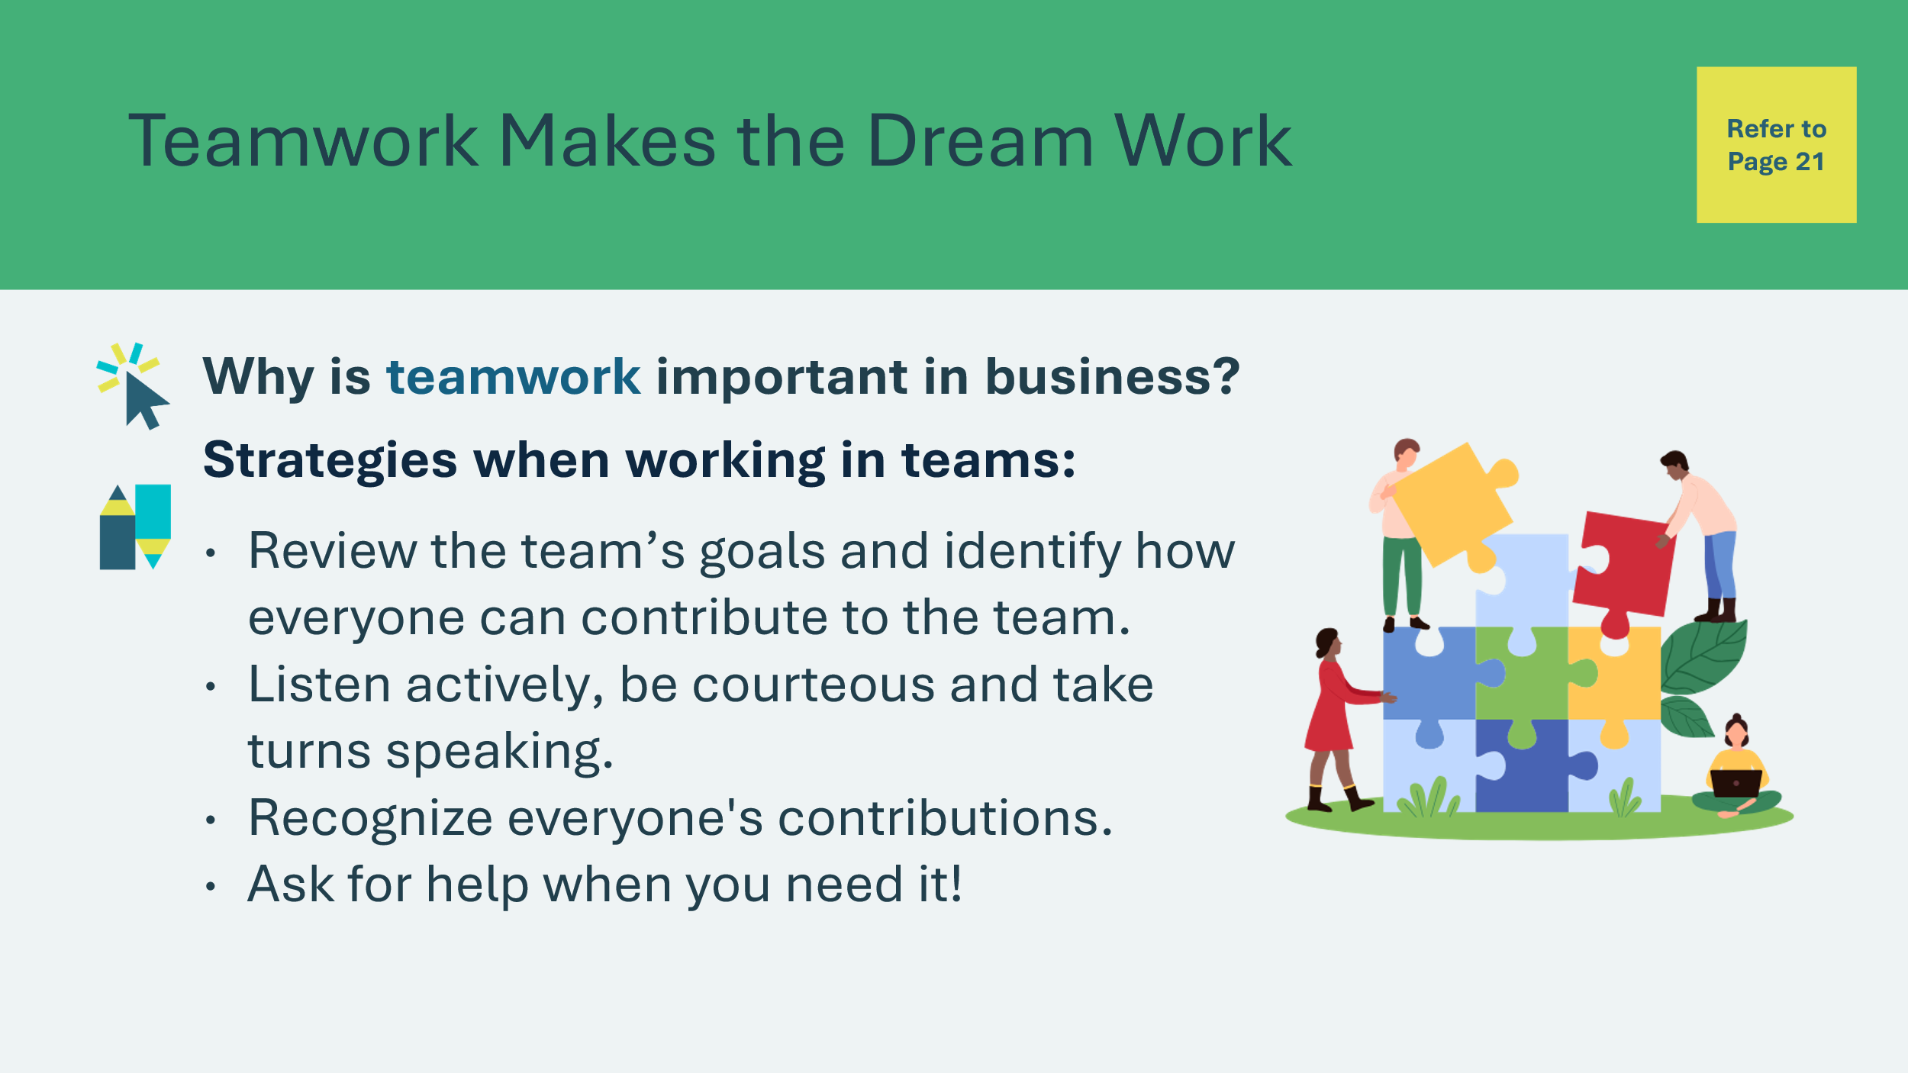 | Suggested time: 5 minutes  Ask students why teamwork is important in business. Highlight that collaboration is a key entrepreneurial skill.  Discuss a few strategies for working in teams. Students can reference their Student Portfolio, page 21.  Explain that larger businesses often divide work and responsibilities between different teams. Slides 19-23 present five different teams commonly found in a retail business:  - The Set-Up Team;  - The Sales Team;  - The Merchandise Team;  - The Promotions Team; and  - The Bookkeeping Team.  Options:  Whole class: Review slides 19-23 to present the different teams. On slide 26, students will choose or be assigned a team.  Small groups: Review slides 19-23 to present the different teams.  Explain to students that in smaller businesses or start-ups, while one person might be assigned as a leader, employees often collaborate together on many of the different tasks.
Slide 18 – Teamwork Vocabulary  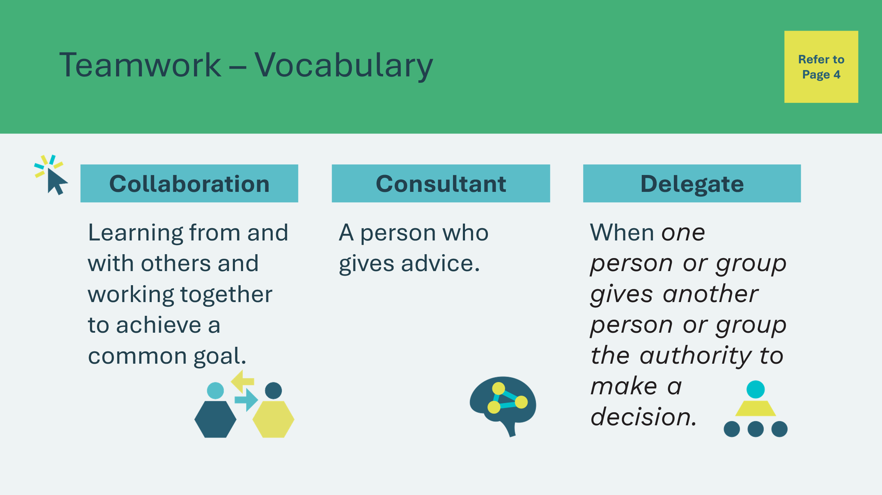 | Optional: Depending on the level or age of the students, you may choose to review a few key vocabulary terms. Otherwise, continue to the next slide.  *Click or tap to reveal each term.
Slide 19 – Team 1  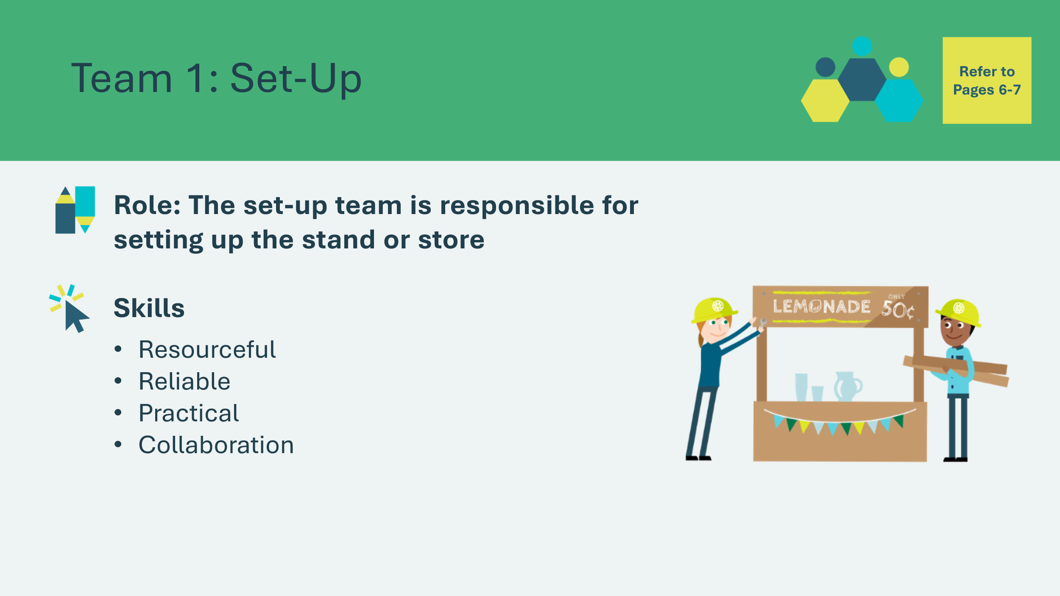 | Review the role of the team required. Ask students which skills they think would be important for this team.  *Click or tap to reveal the skills.  Skills  - Resourceful – to find supplies and equipment.  - Reliable – the stand must be set-up on time.  - Practical – understand how the stand will work & organize accordingly.  - Collaboration – share work and support others.
Slide 20 – Team 2  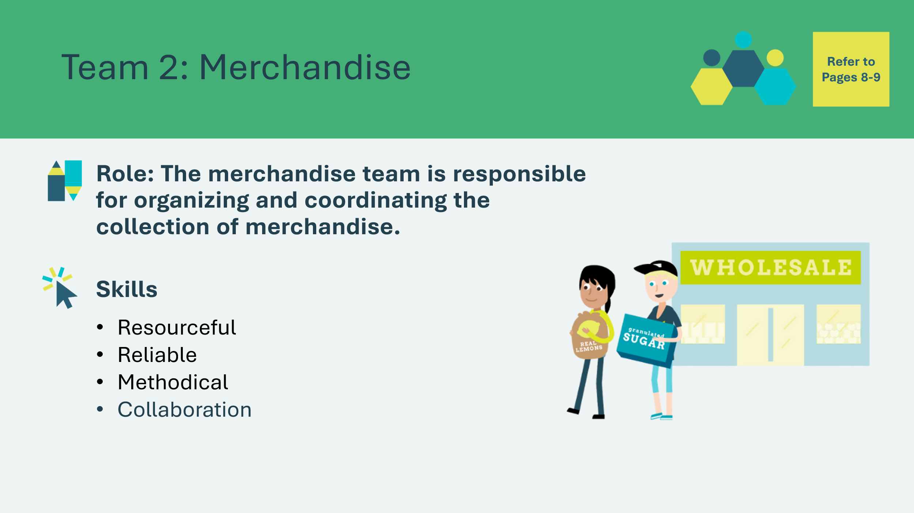 | Review the role of the team required. Ask students which skills they think would be important for this team.  *Click or tap to reveal the skills.  Skills  - Resourceful – able to find supplies for sale  - Reliable – must have supplies on time  - Methodical – can keep track of merchandise & where it is  - Collaboration – share work and support others
Slide 21 – Team 3  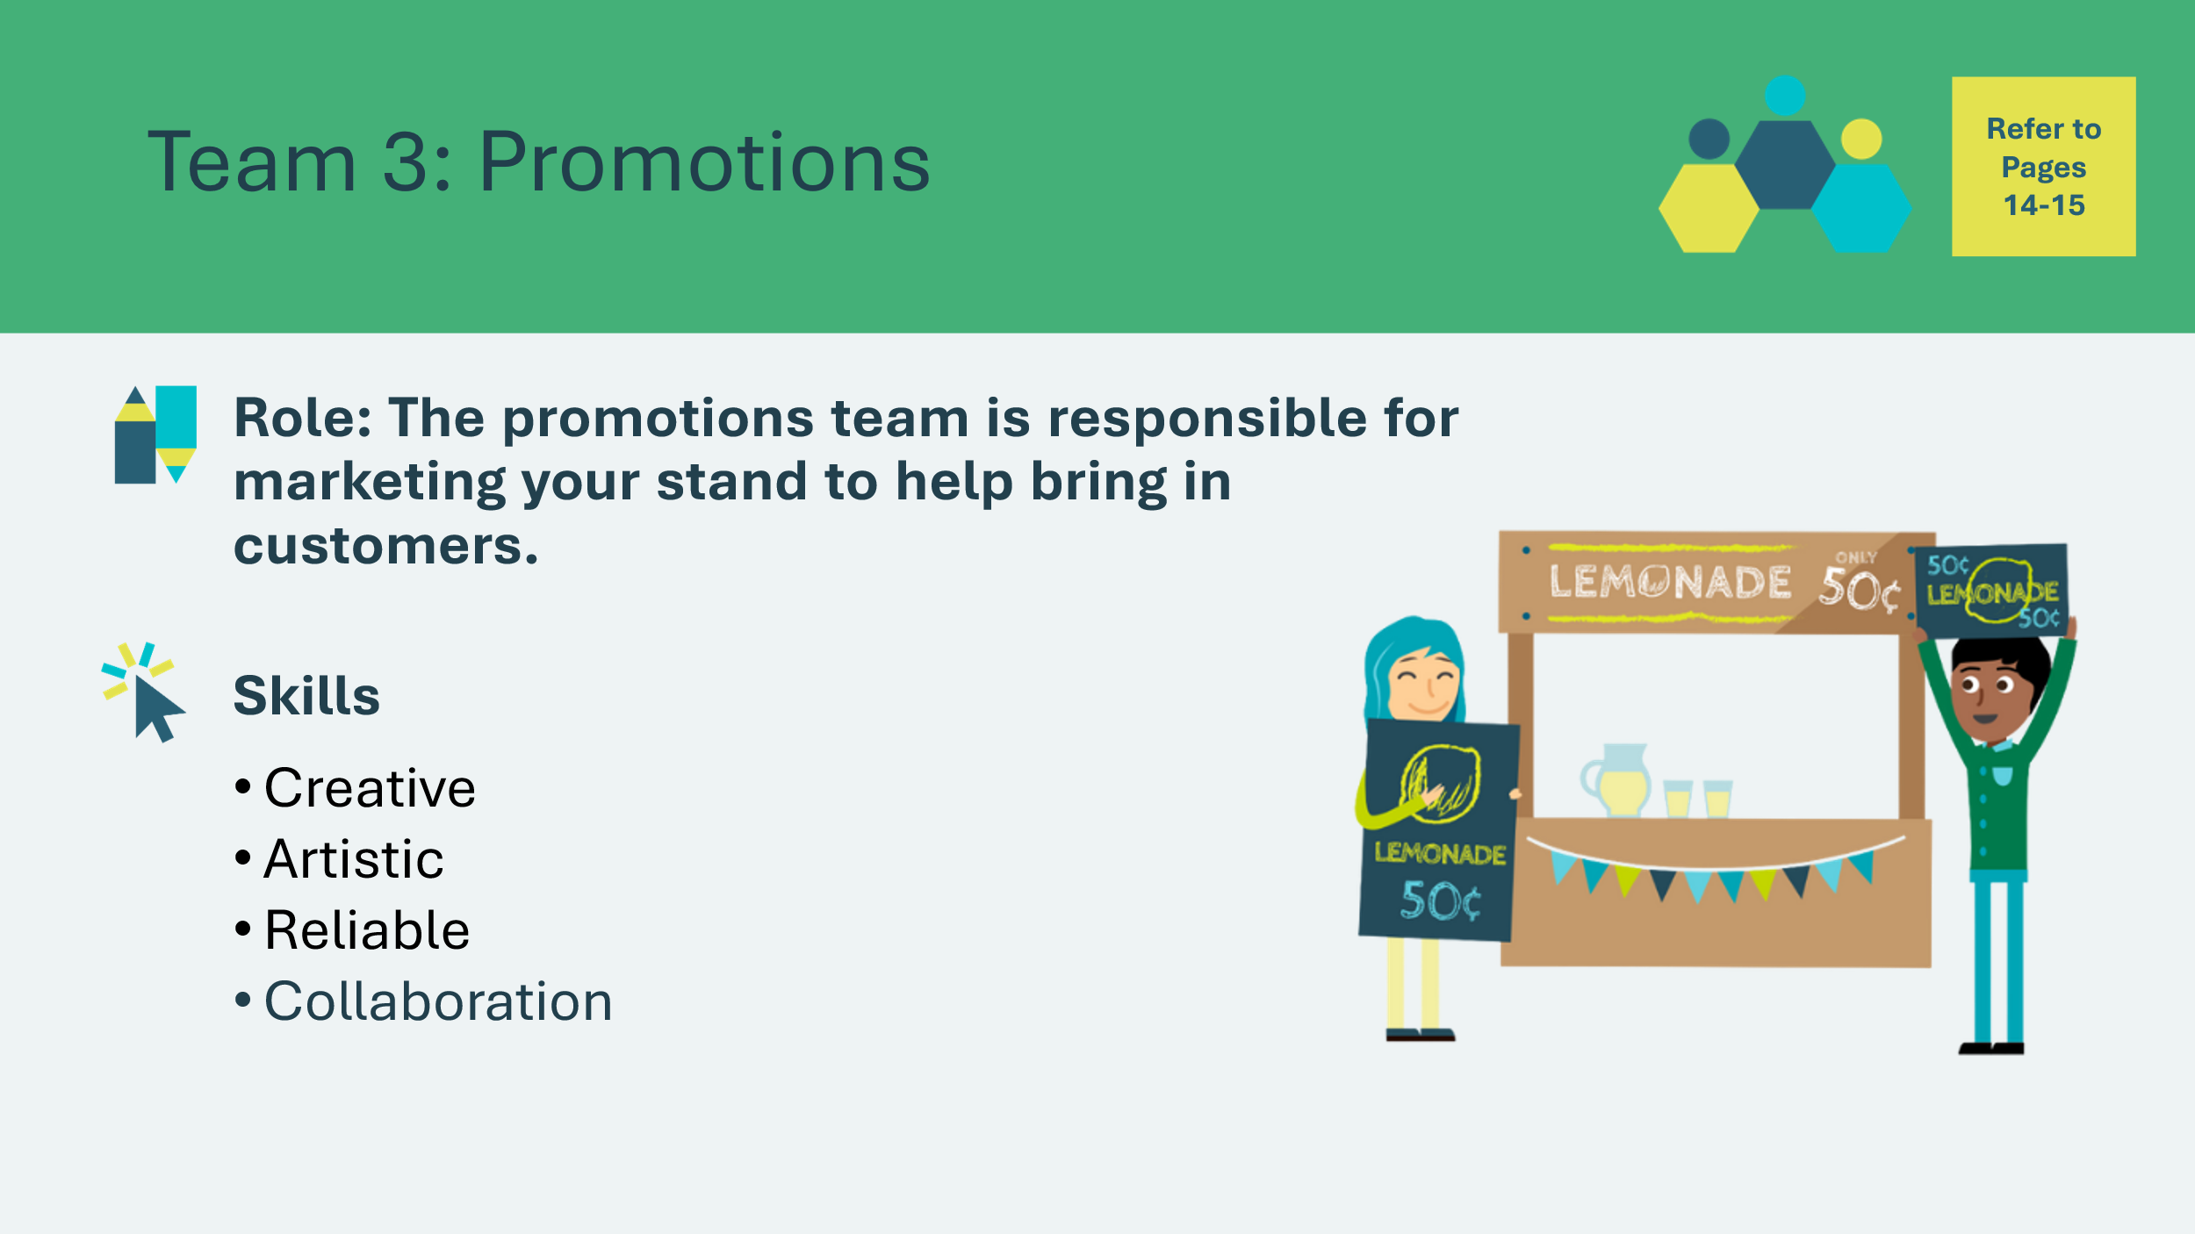 | Review the role of the team required. Ask students which skills they think would be important for this team.  *Click or tap to reveal the skills.  Skills  - Creative– able to think of interesting and new promotional ideas  - Artistic – to create attractive materials  - Reliable – a business relies on promotions to be done on time  - Collaboration – share work and support others
Slide 22 – Team 4  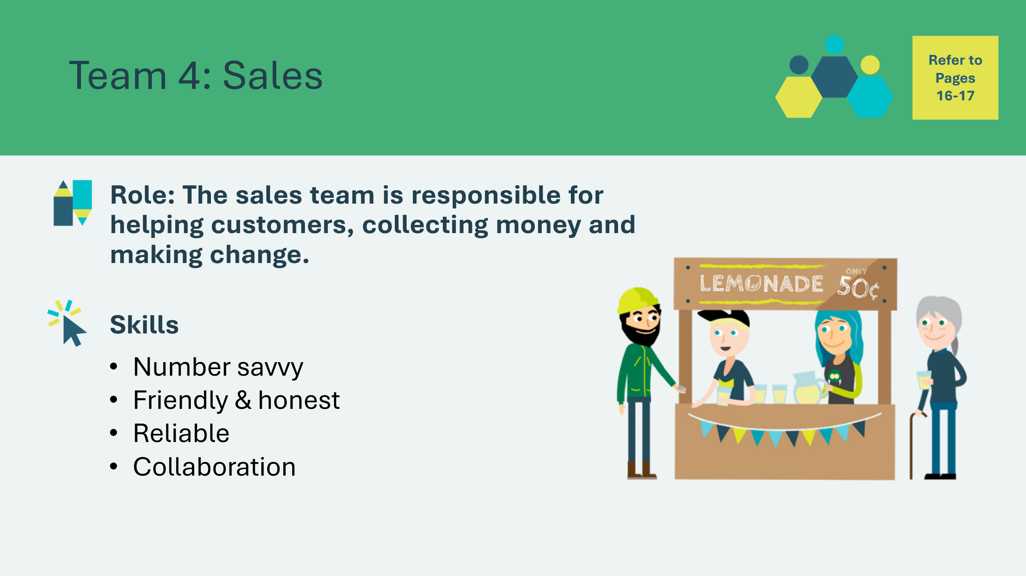 | Review the role of the team required. Ask students which skills they think would be important for this team.  *Click or tap to reveal the skills.  Skills  - Number savvy – able to calculate prices and give change  - Friendly & honest – able to work with customers and handle cash  - Reliable – must be on time for work  - Collaboration – share work and support others  Note: The Promotions and Sales Teams are interconnected. Both sales and marketing are working to grow the company. Both want more customers, more brand awareness and more profits.
Slide 23 – Team 5  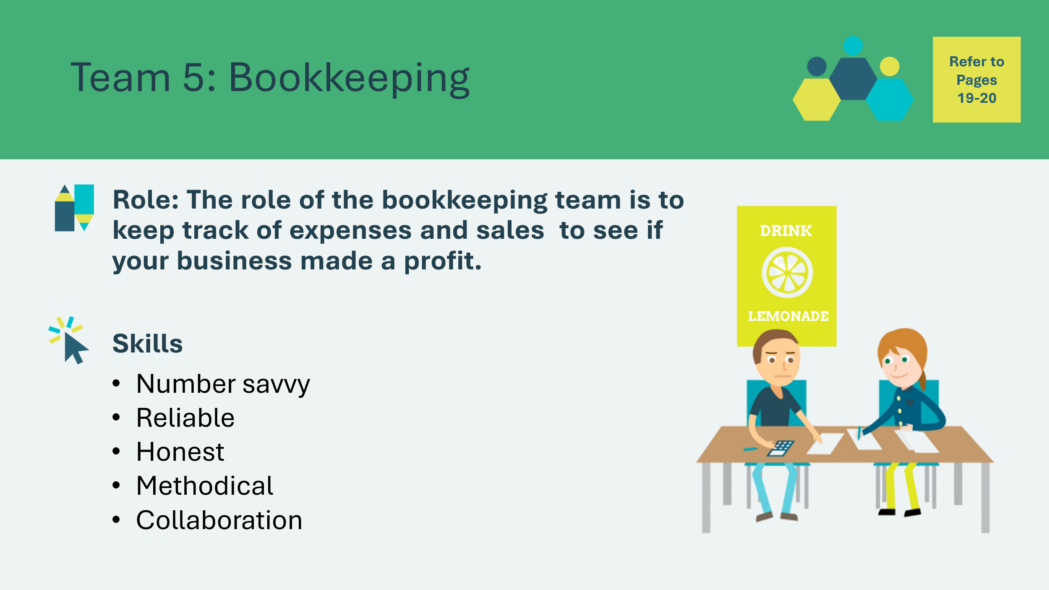 | Review the role of the team required. Ask students which skills they think would be important for this team.  *Click or tap to reveal the skills.  Skills  - Number savvy – needs to work accurately with numbers  - Reliable – the business relies on bookkeeping to be accurate  - Honest – must record information accurately and honestly  - Methodical – able to keep track of details  - Collaboration – share work and support others
Slide 24 – Choose Your Team  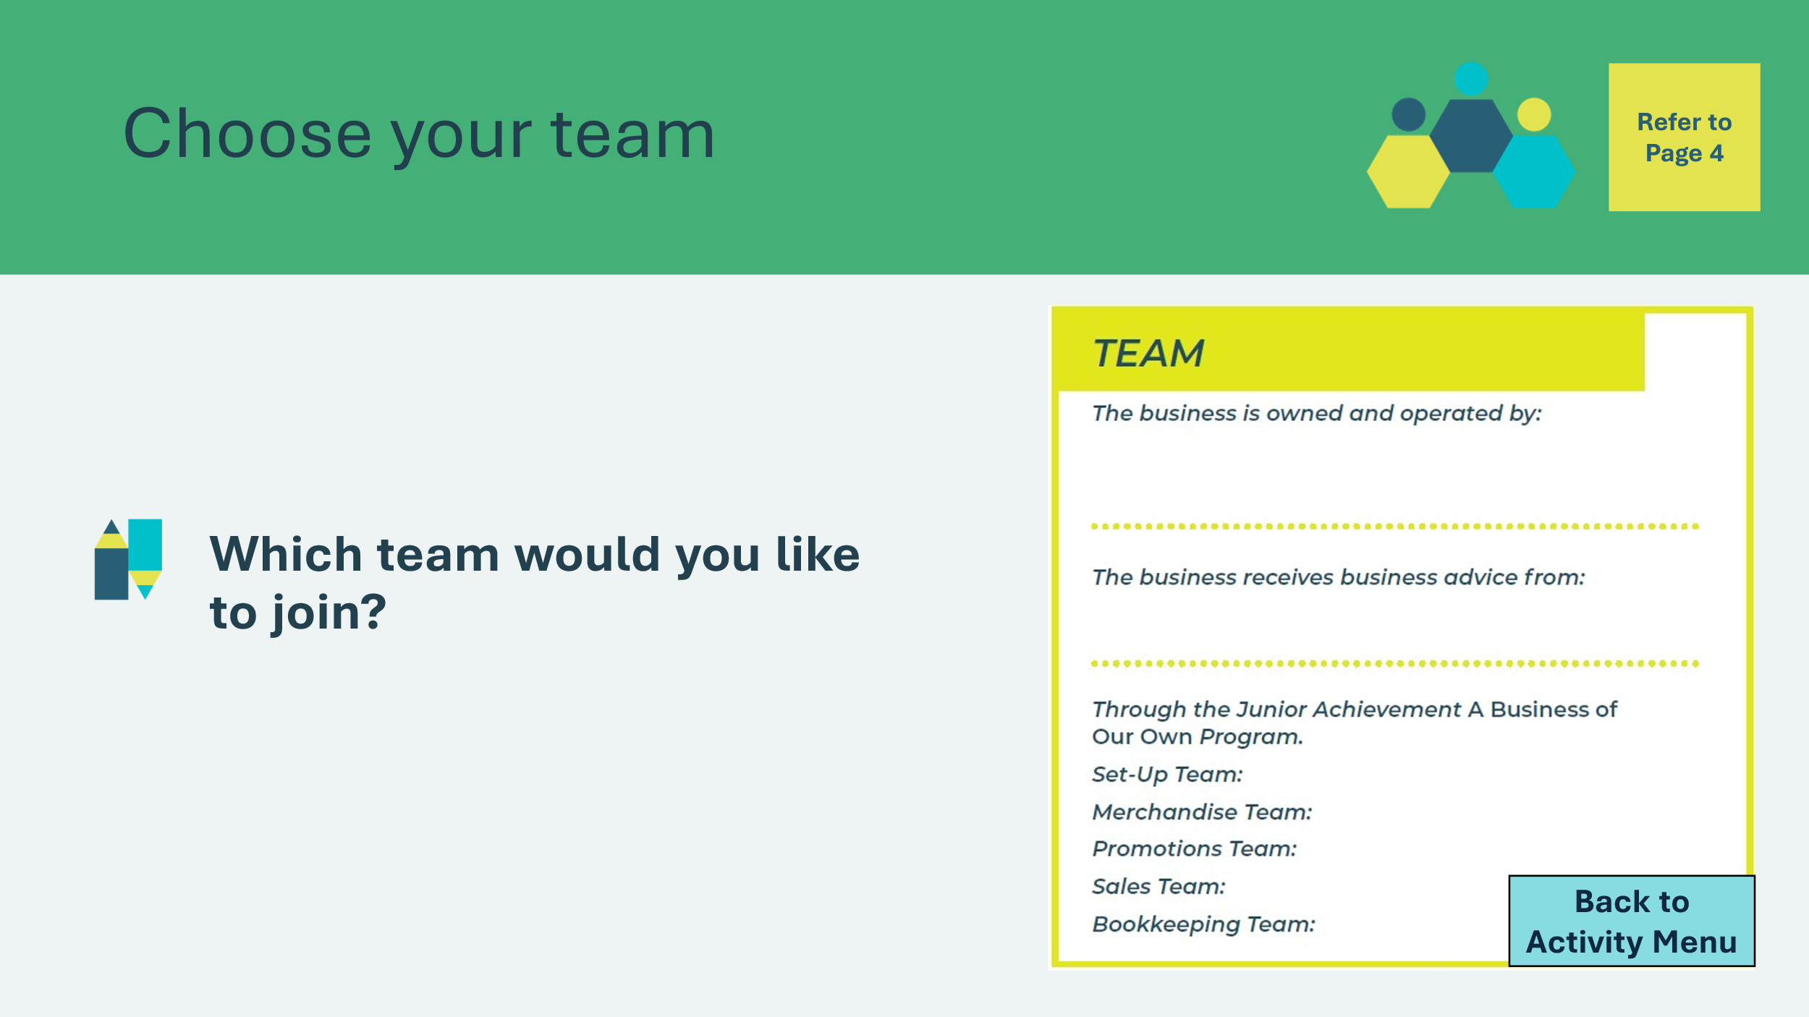 | Ask students which team they would like to be a part of.  Have the class record their names in the Teams section on page 4 of the Student Portfolio.  Facilitator Tip: Decide ahead of time if groups will be pre-determined or if students can self-select teams.  Ensure that there are roughly the same amount of students in each group.  Option:  Small groups: If students are already working in small groups on different business ideas, they could select a student to take the 'lead' for each area of business operation.
Reflection 5 min
Slide 25 – Reflection    Slide 26 – Key Ideas  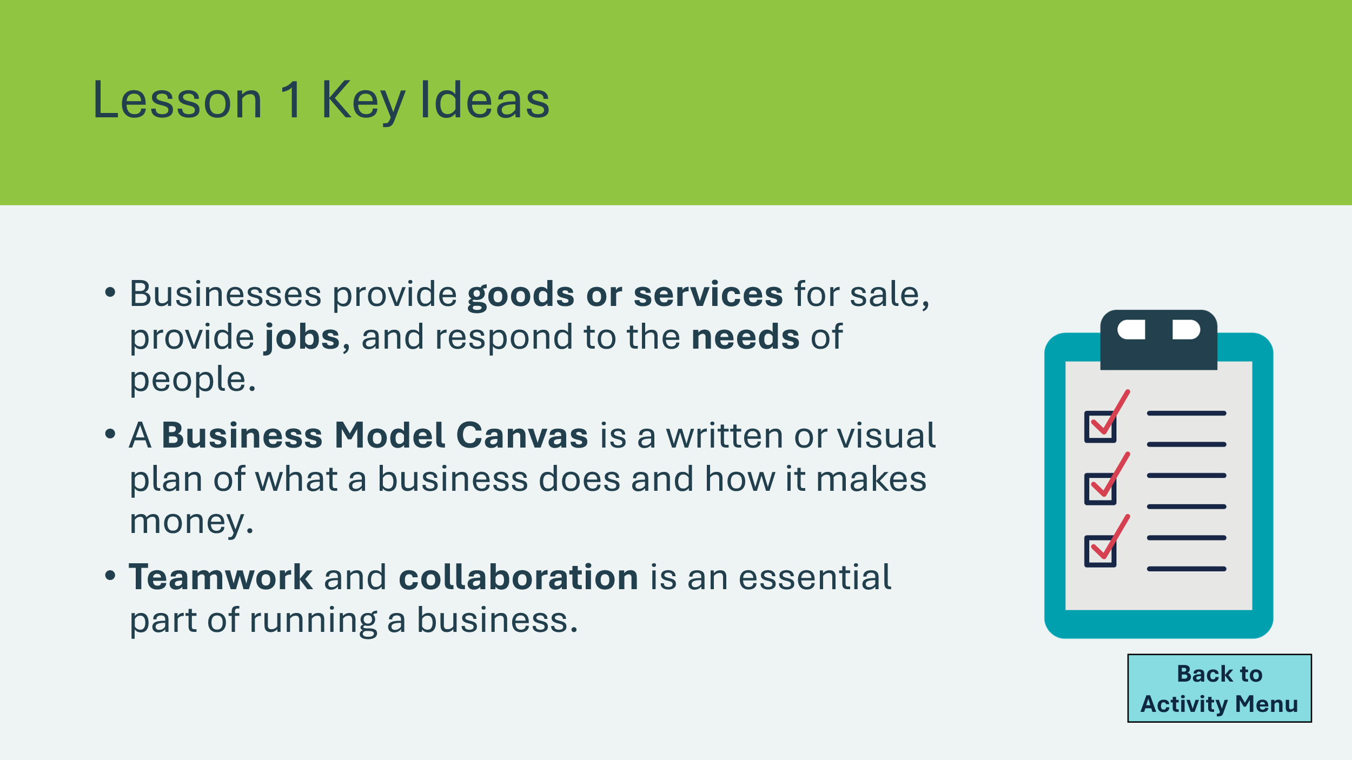 | Suggested time: 3 minutes  Ask students the reflection question on the slide. Invite a few students to share.  Suggested time: 2 minutes  Wrap up the activity by reviewing the key takeaways.
Extension Activities 20 min
Program Kit Materials | For slide 27, you could use the Team Cards from the program kit materials.
Slide 27 – Team Time  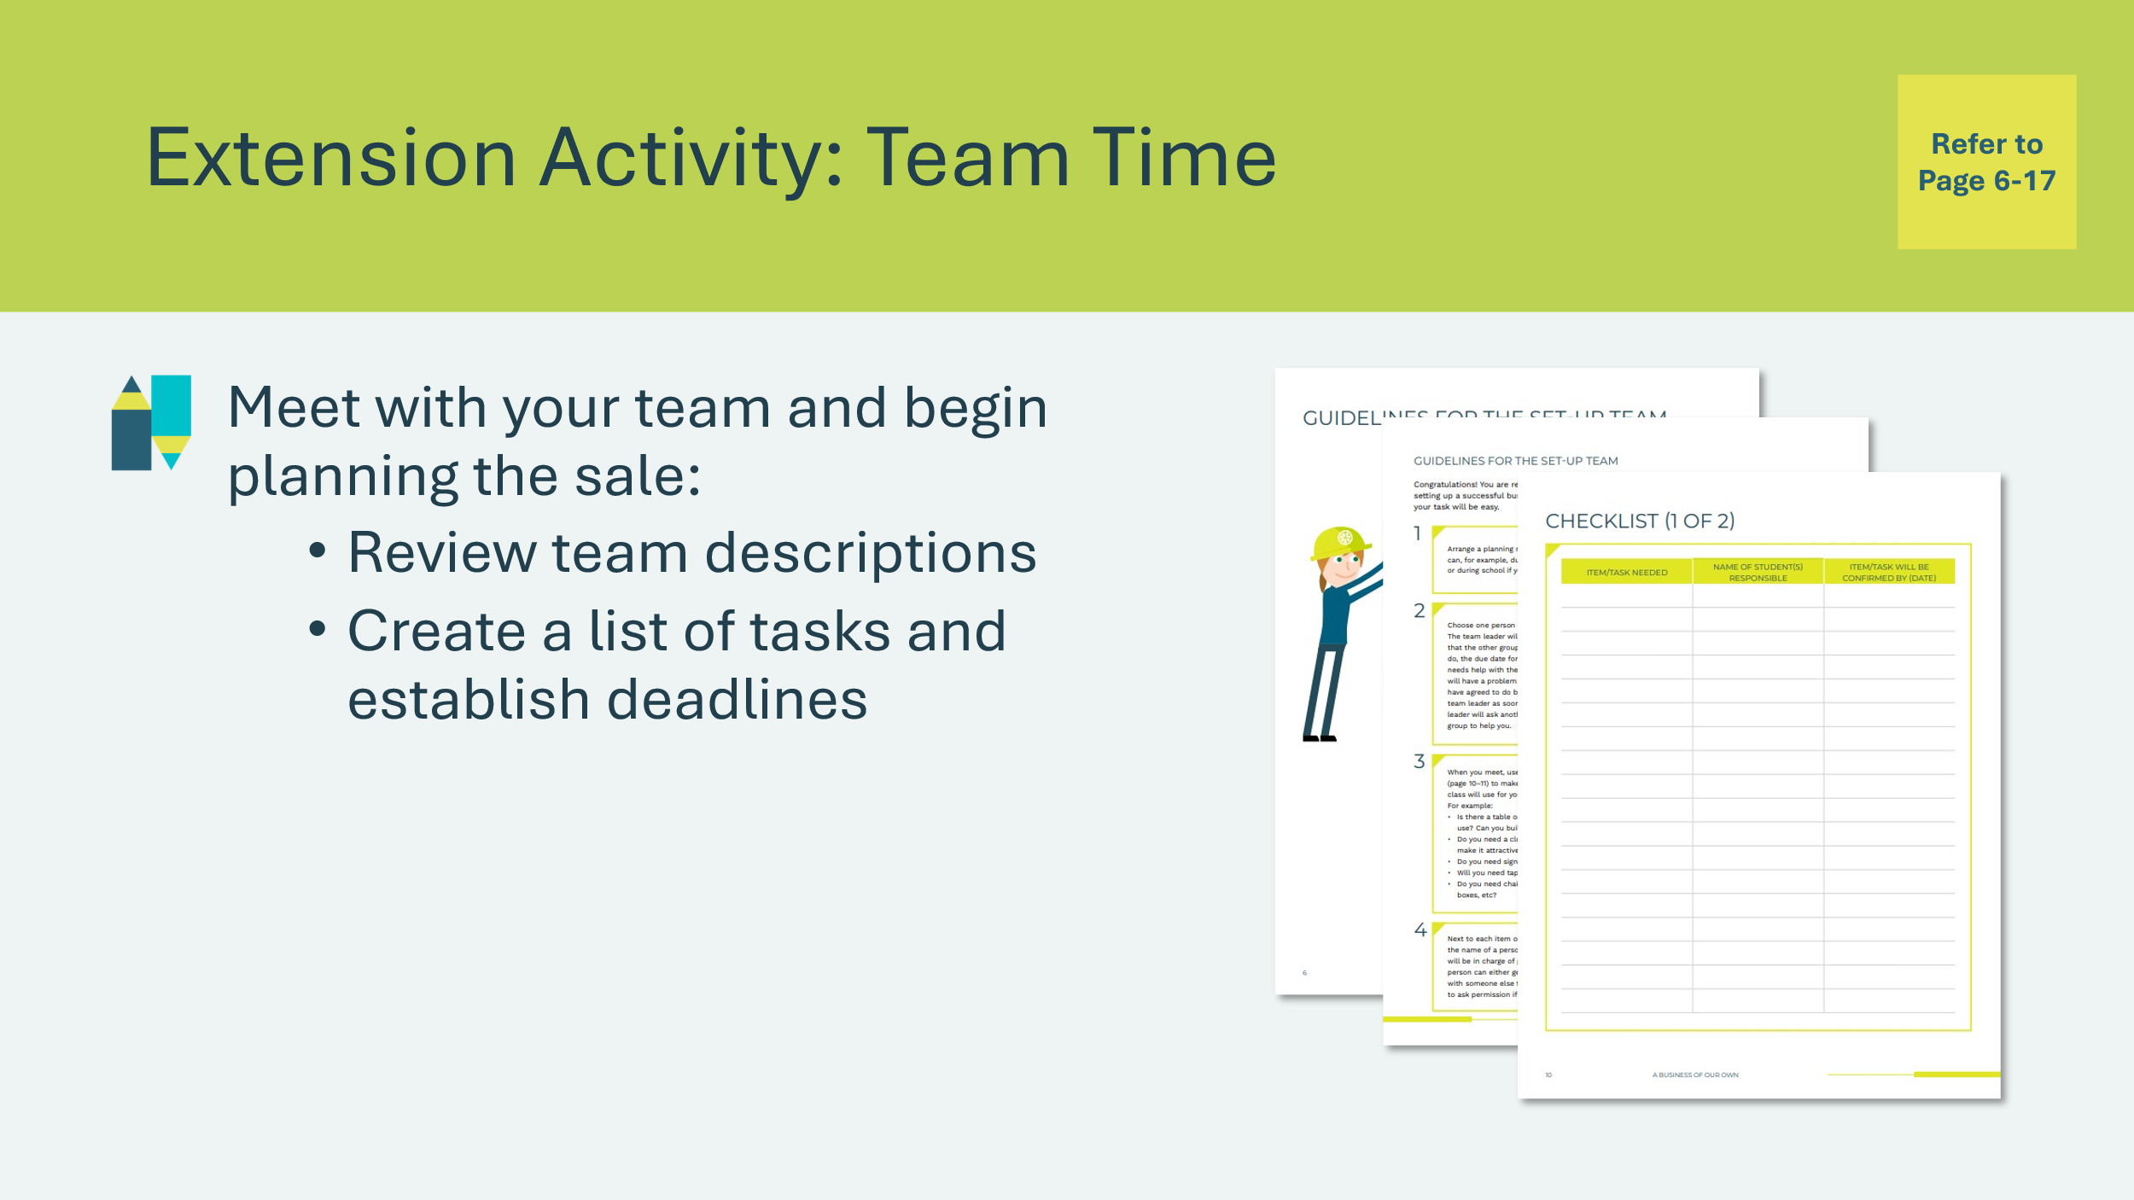 | Suggested time: 15 minutes  Team Time: Students meet with their teams start planning the sale.  Students could:  - review the team descriptions in the Student Portfolio, pages 6-9, 14-17 & 19-20. Alternatively, you can distribute the Team Cards from the Kit materials.  - create a list of tasks and establish deadlines in the Student Portfolio, pages 10-11.
Slide 28 – Start Up Capital  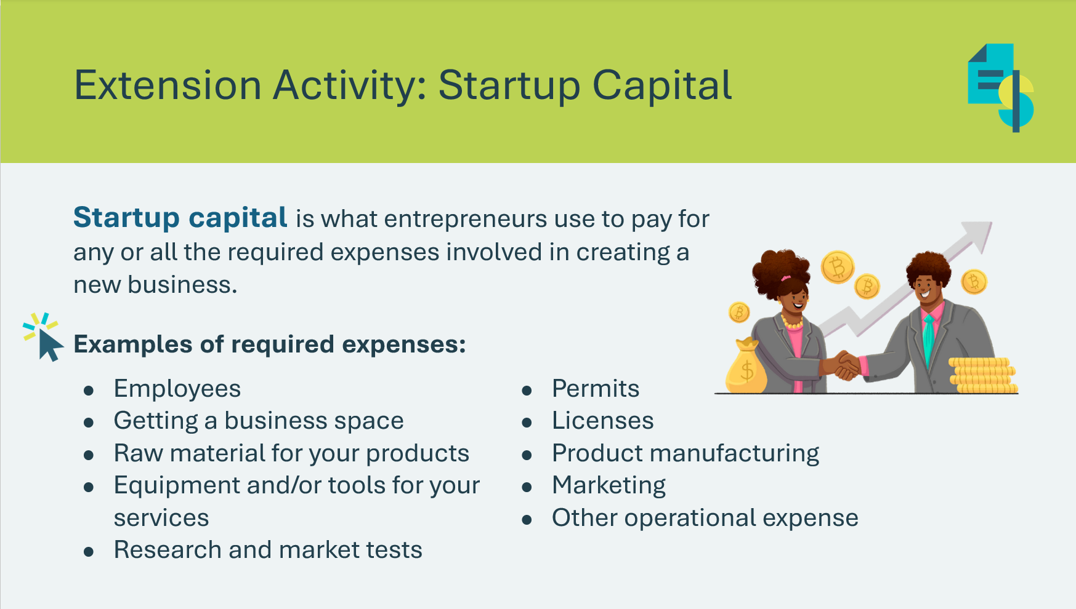 | Suggested time: 5 minutes  Review the definition of startup capital with students.  Ask students to list different startup expenses.  *Click or tap to reveal examples.
Slide 29 – Where to Get Startup Capital  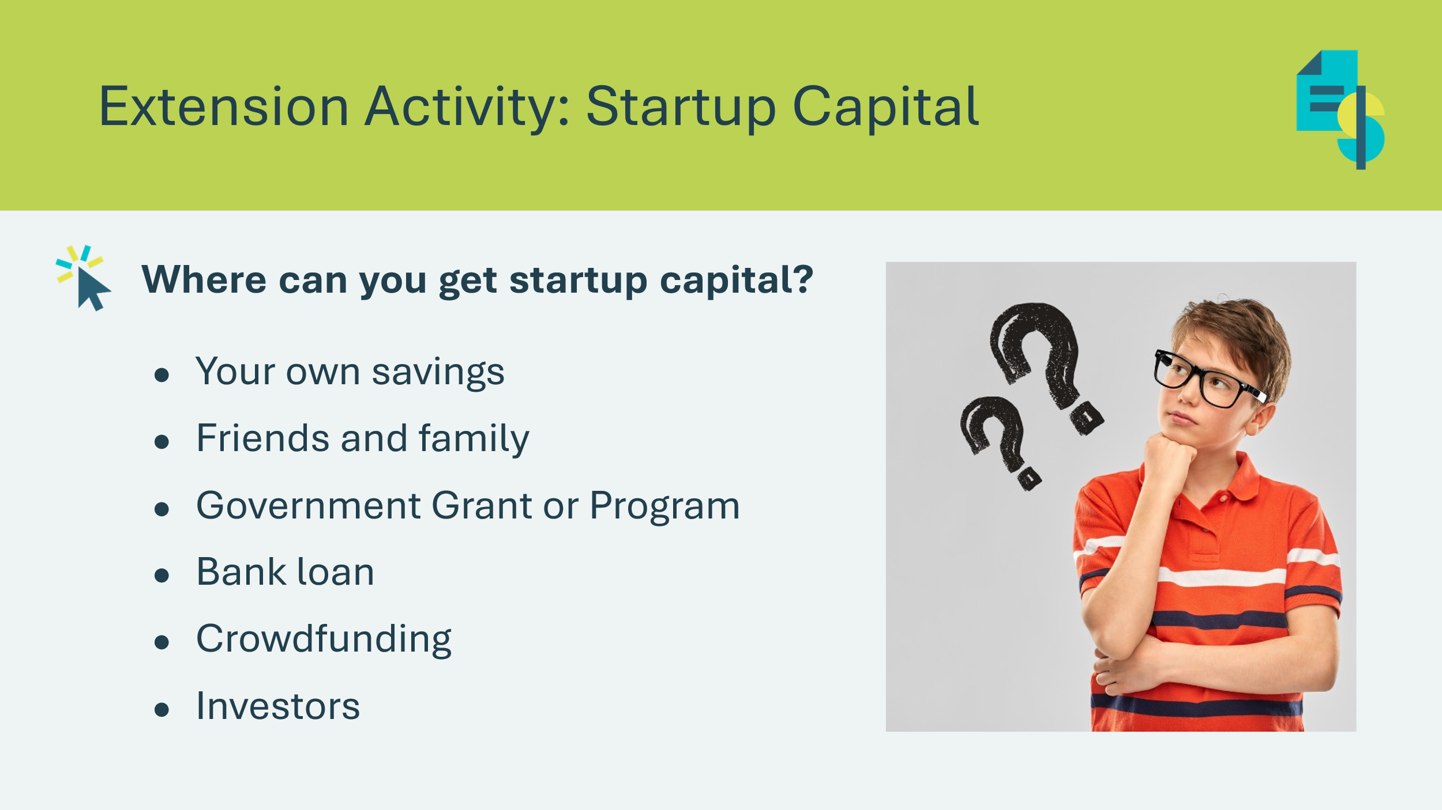 | Review the different methods of getting startup capital.  Ask students which methods would make most sense for a student-run business and explain their thinking.  Explain that businesses usually raise the money they need either from their owners or by borrowing it from banks and other lenders.  Debt: Debt is anything owed by one person to another. It can be in a form of money, items, services, favors, or other things.
Slide 30 – Loans  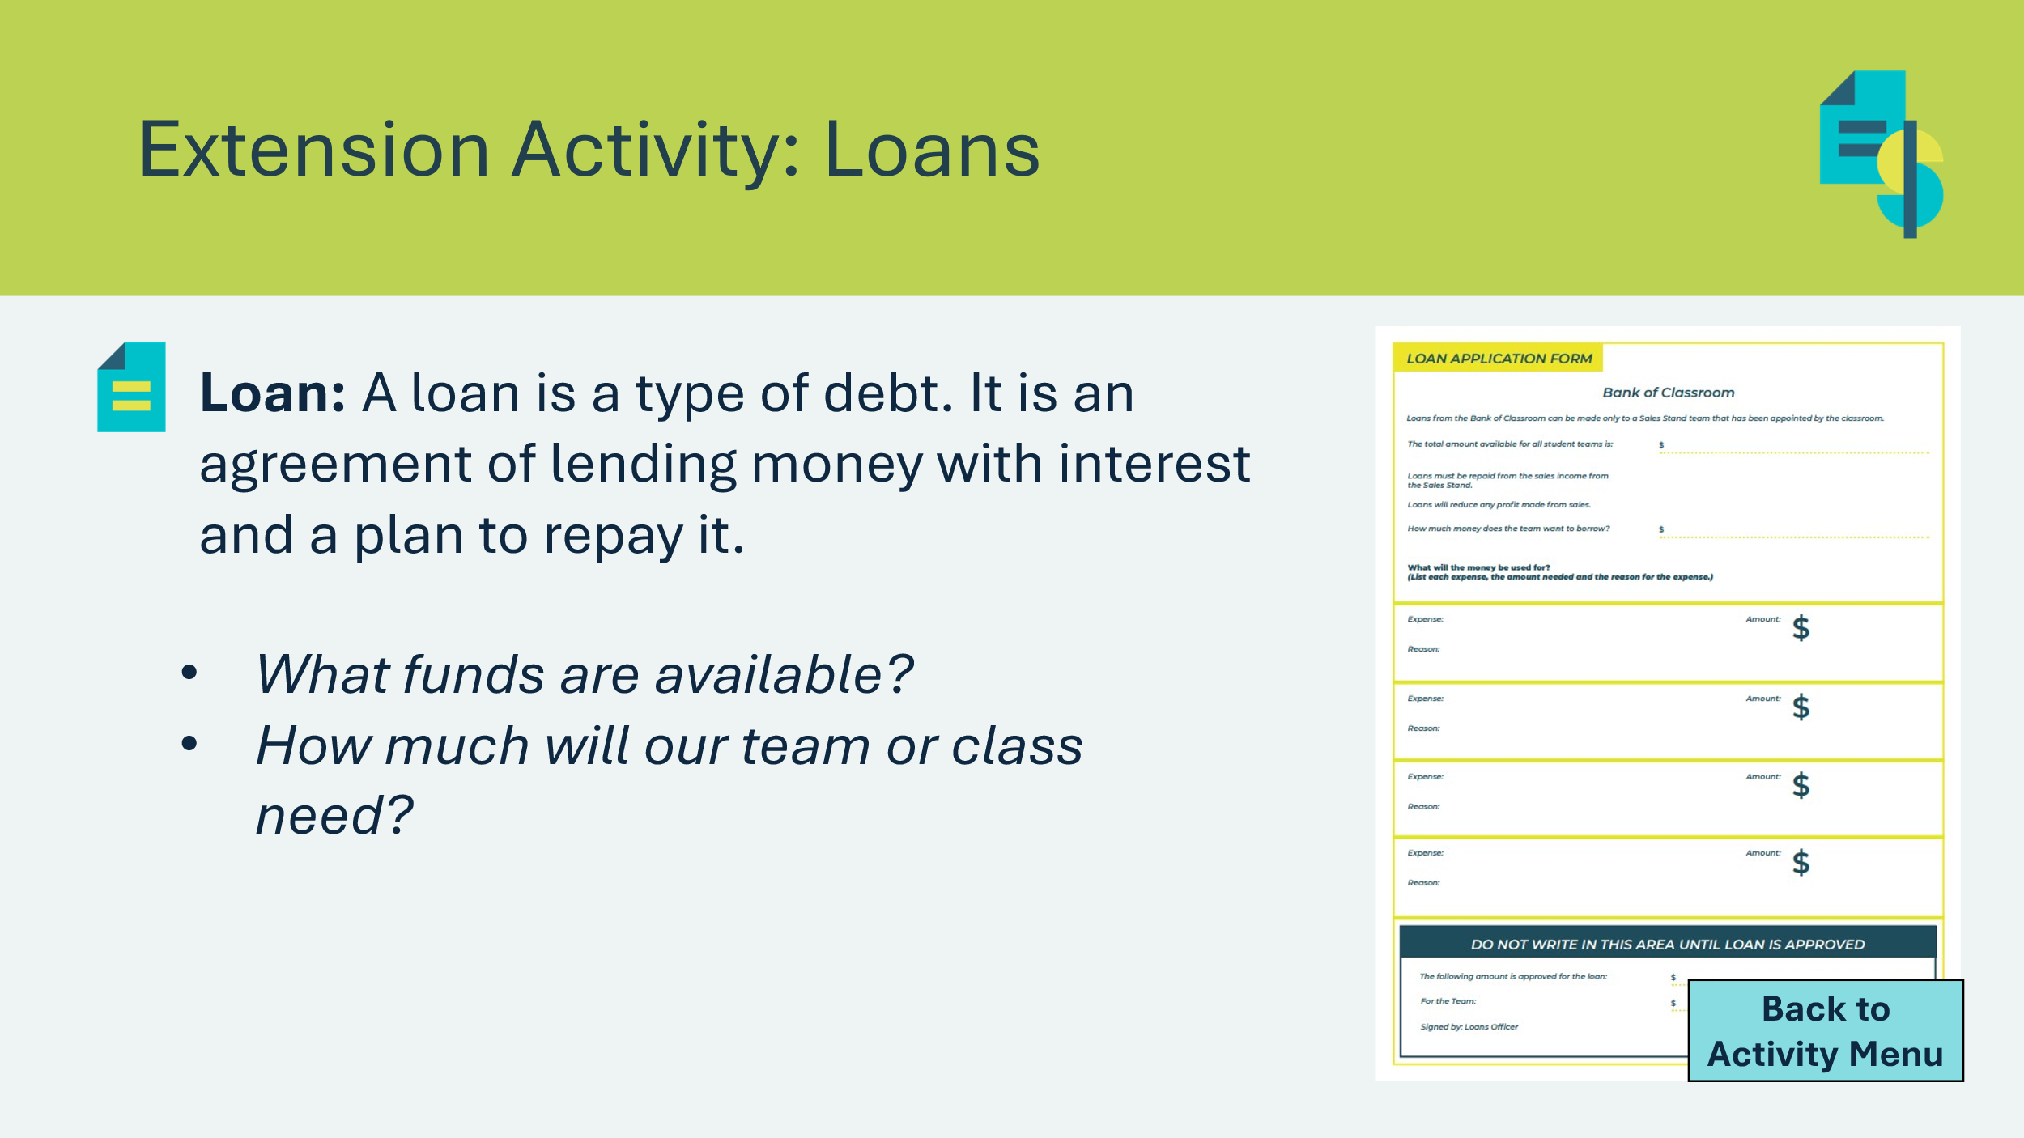 | If the class will be using class funds to pay for their materials, discuss with students:  - The total amount of funds available;  - The loans must be repaid from the sales income from the sales stand; and  - How much the class / team wants to borrow.  Students can fill out a loan application form and have it approved by the classroom teacher.  Loan: A loan is a type of debt. It is an agreement of lending money with interest and a plan to repay it.  Interest: Money paid for using someone else’s money.

Lesson 2: Production
Program Kit Materials |  | JA Pen Pieces  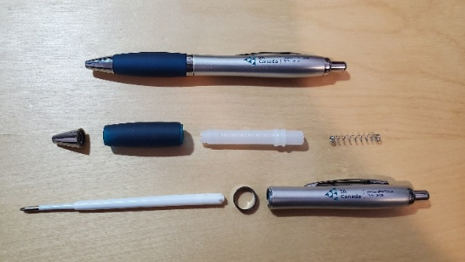  *If students participate in the JA Penco Activity, ensure pens are disassembled and separated into bins by piece prior to the beginning of the lesson OR ask students to disassemble one pen each and separate the pieces when you explain the assembly process (slide 38).
Slide 31 – Lesson 2  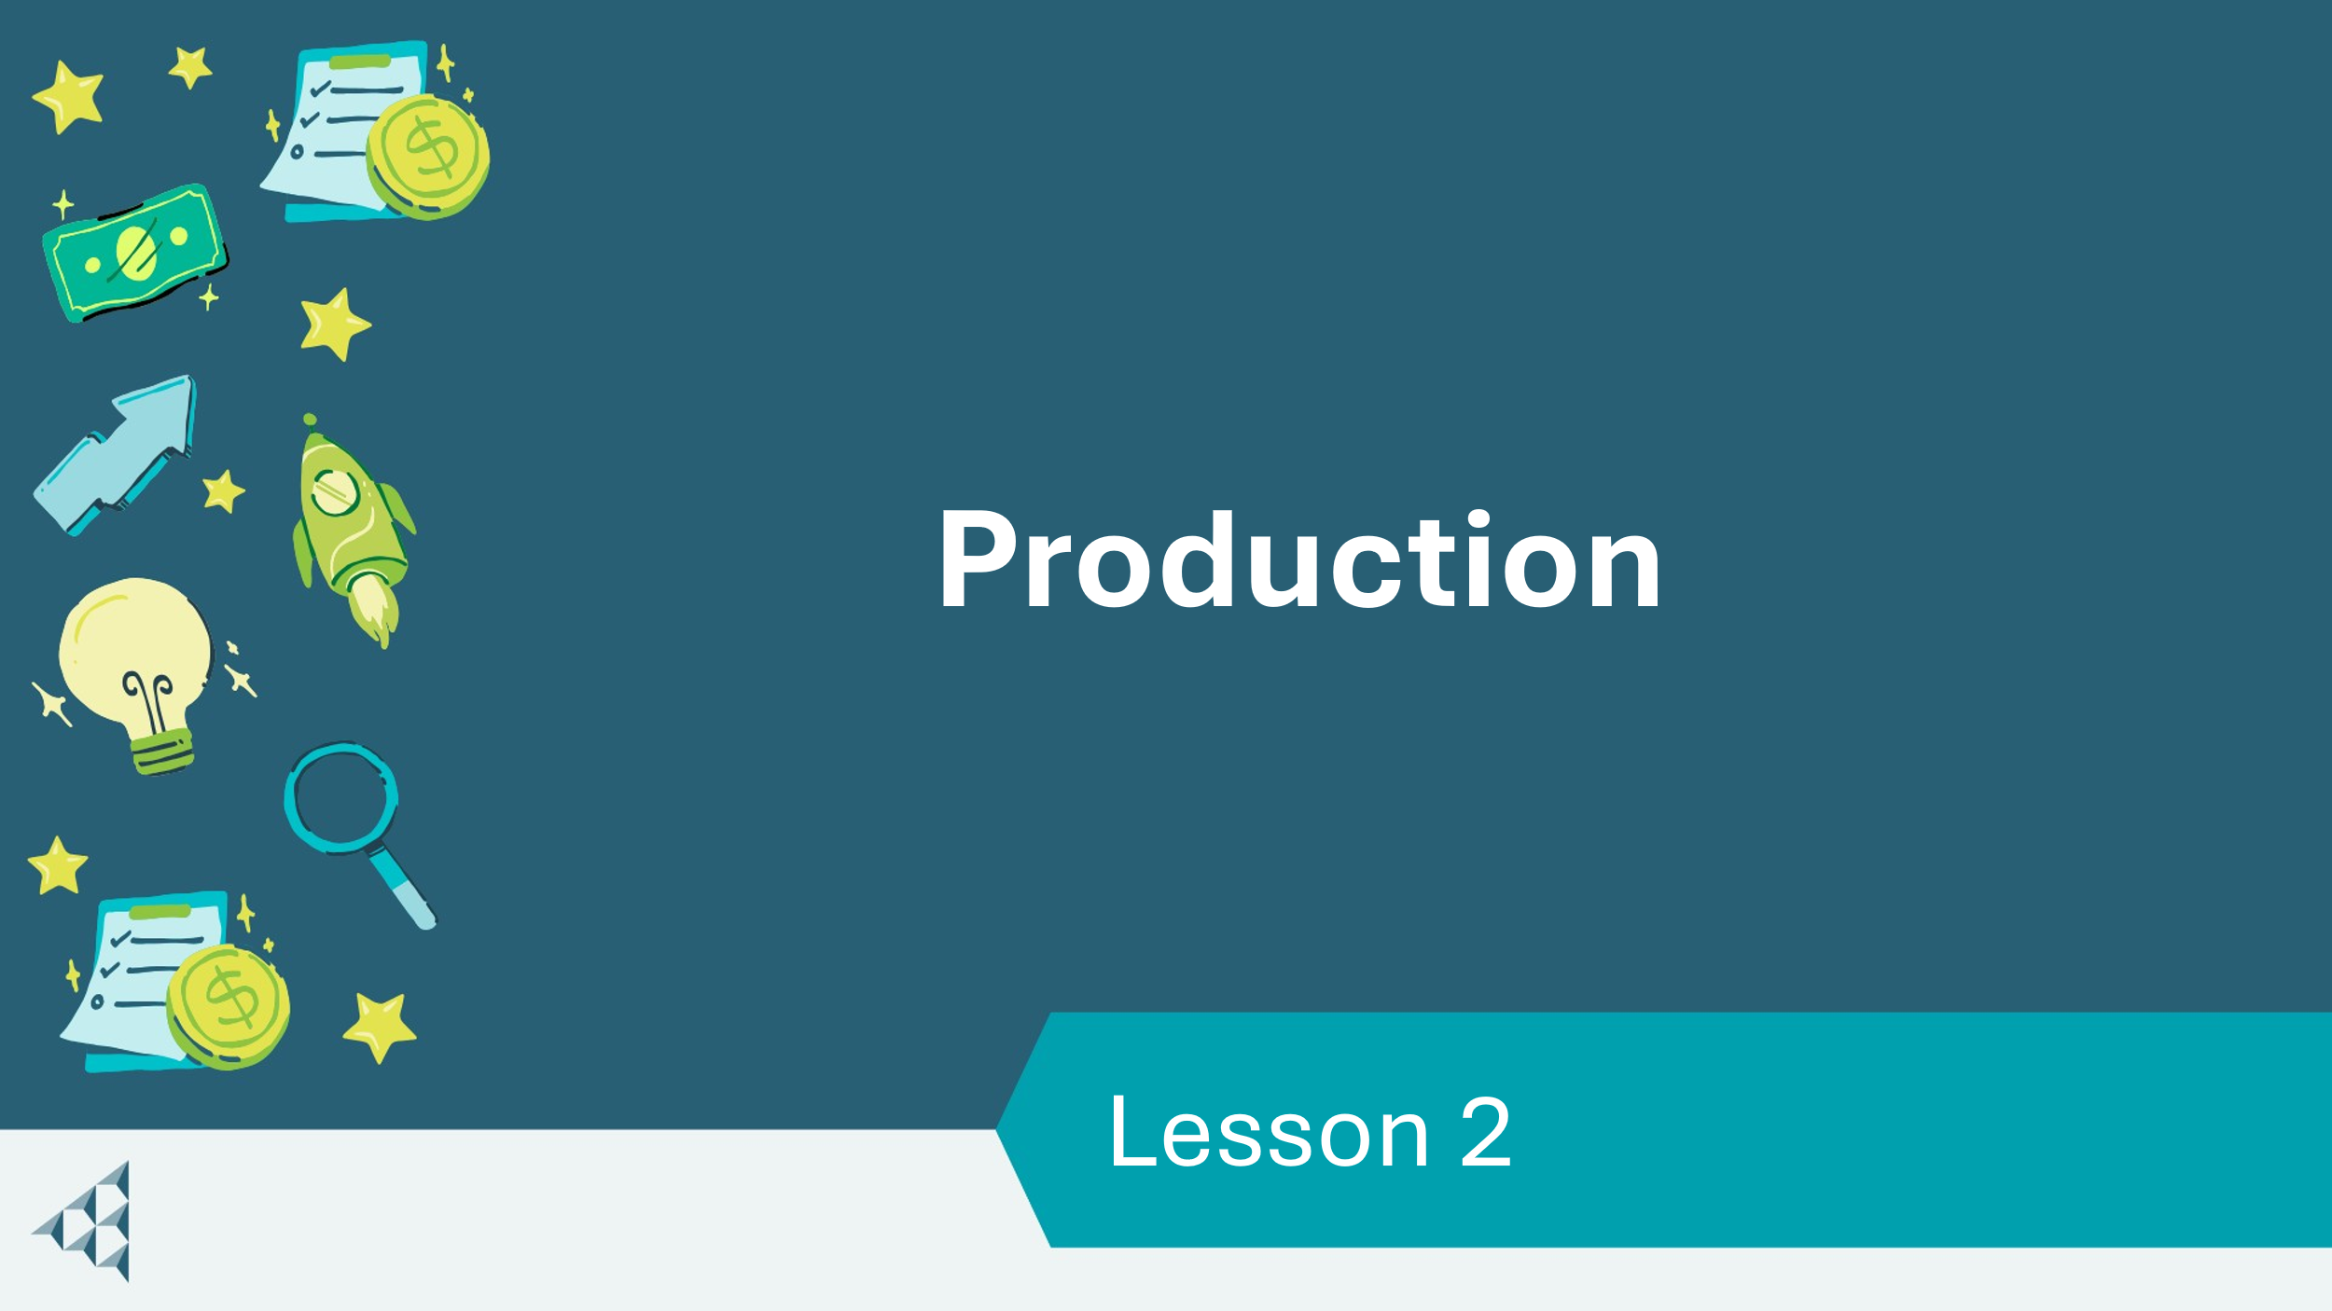 |  | Lesson 2: Production
Slide 32 – Objectives  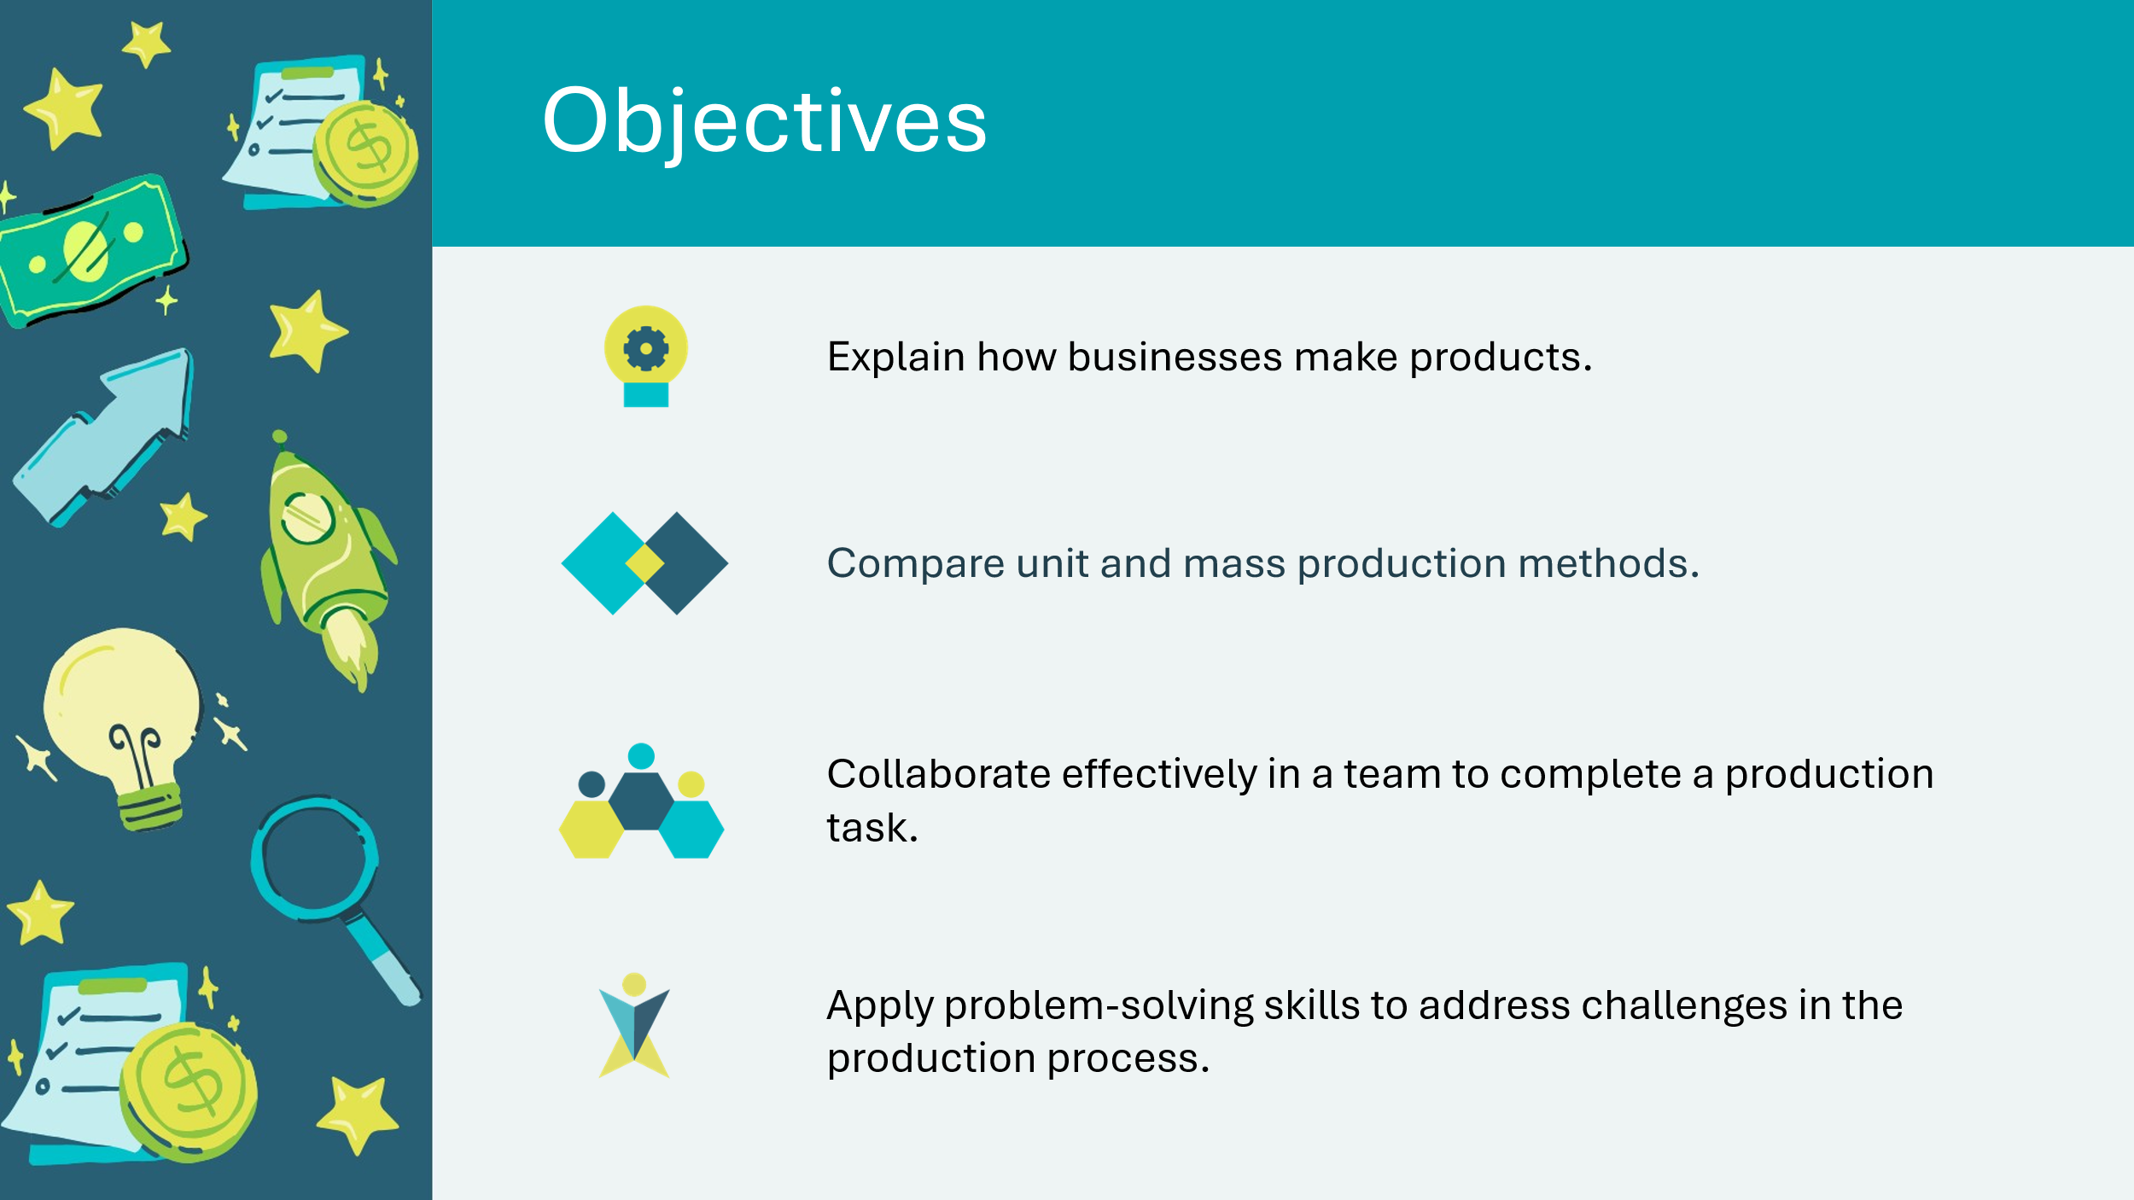 |  | Optional – review the learning objectives for the lesson.
Slide 33 – Introduction  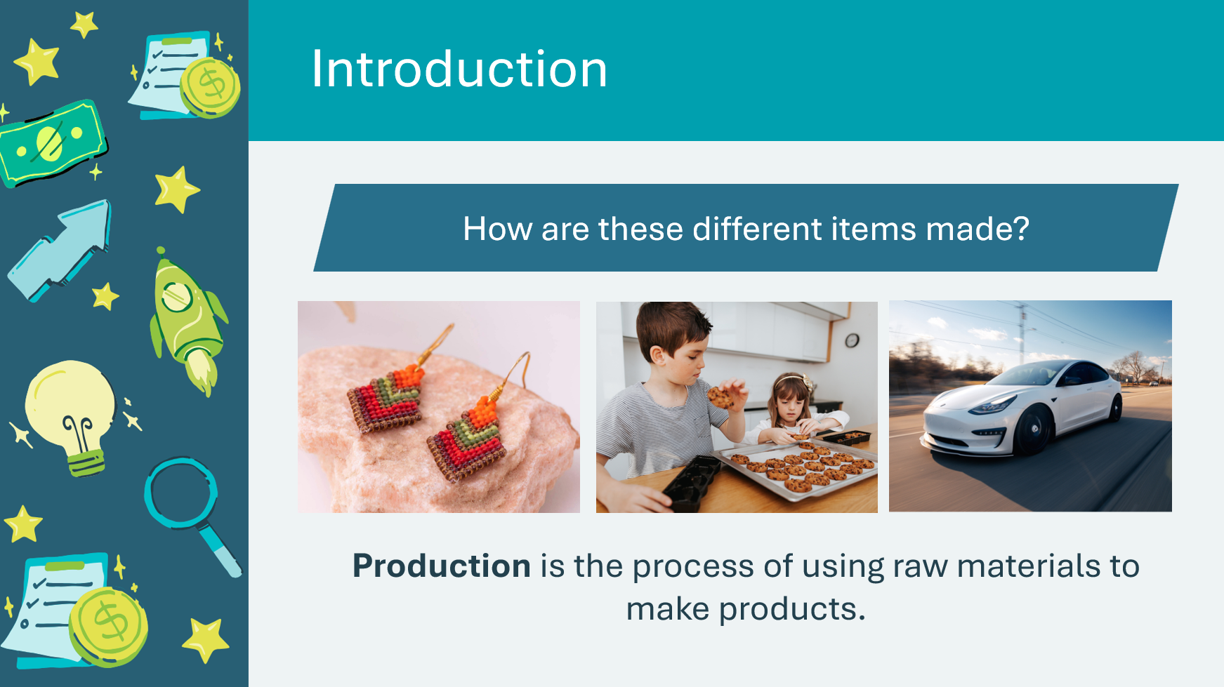 |  | Introduce the lesson by asking students how the items displayed on the slide are made.  - What materials are used?  - Are they made by hand or using technology?  - Is the item made by one person or multiple people?  Explain to students that production means making items out of raw materials.  In this lesson, students will conduct a hands-on activity to complete a production task.  Hands-on activity options:  - Pen activity  - Product creation – students work on making their product for their sales stand
Slide 34 – Activity Menu  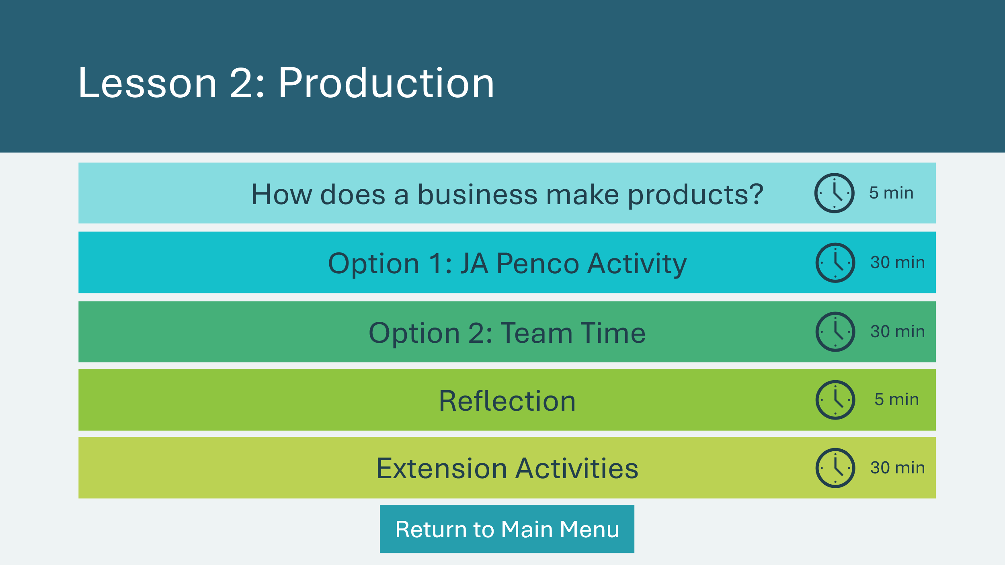 |  | *Select the button to navigate to the activity.  Select the buttons to jump to an activity or select next to begin the lesson.  *Click or tap the Return to Main Menu button to return to the Lessons (Slide 5)
How Does a Business Make Products? 5 min
Slide 35 – How Does a Business Make Products?  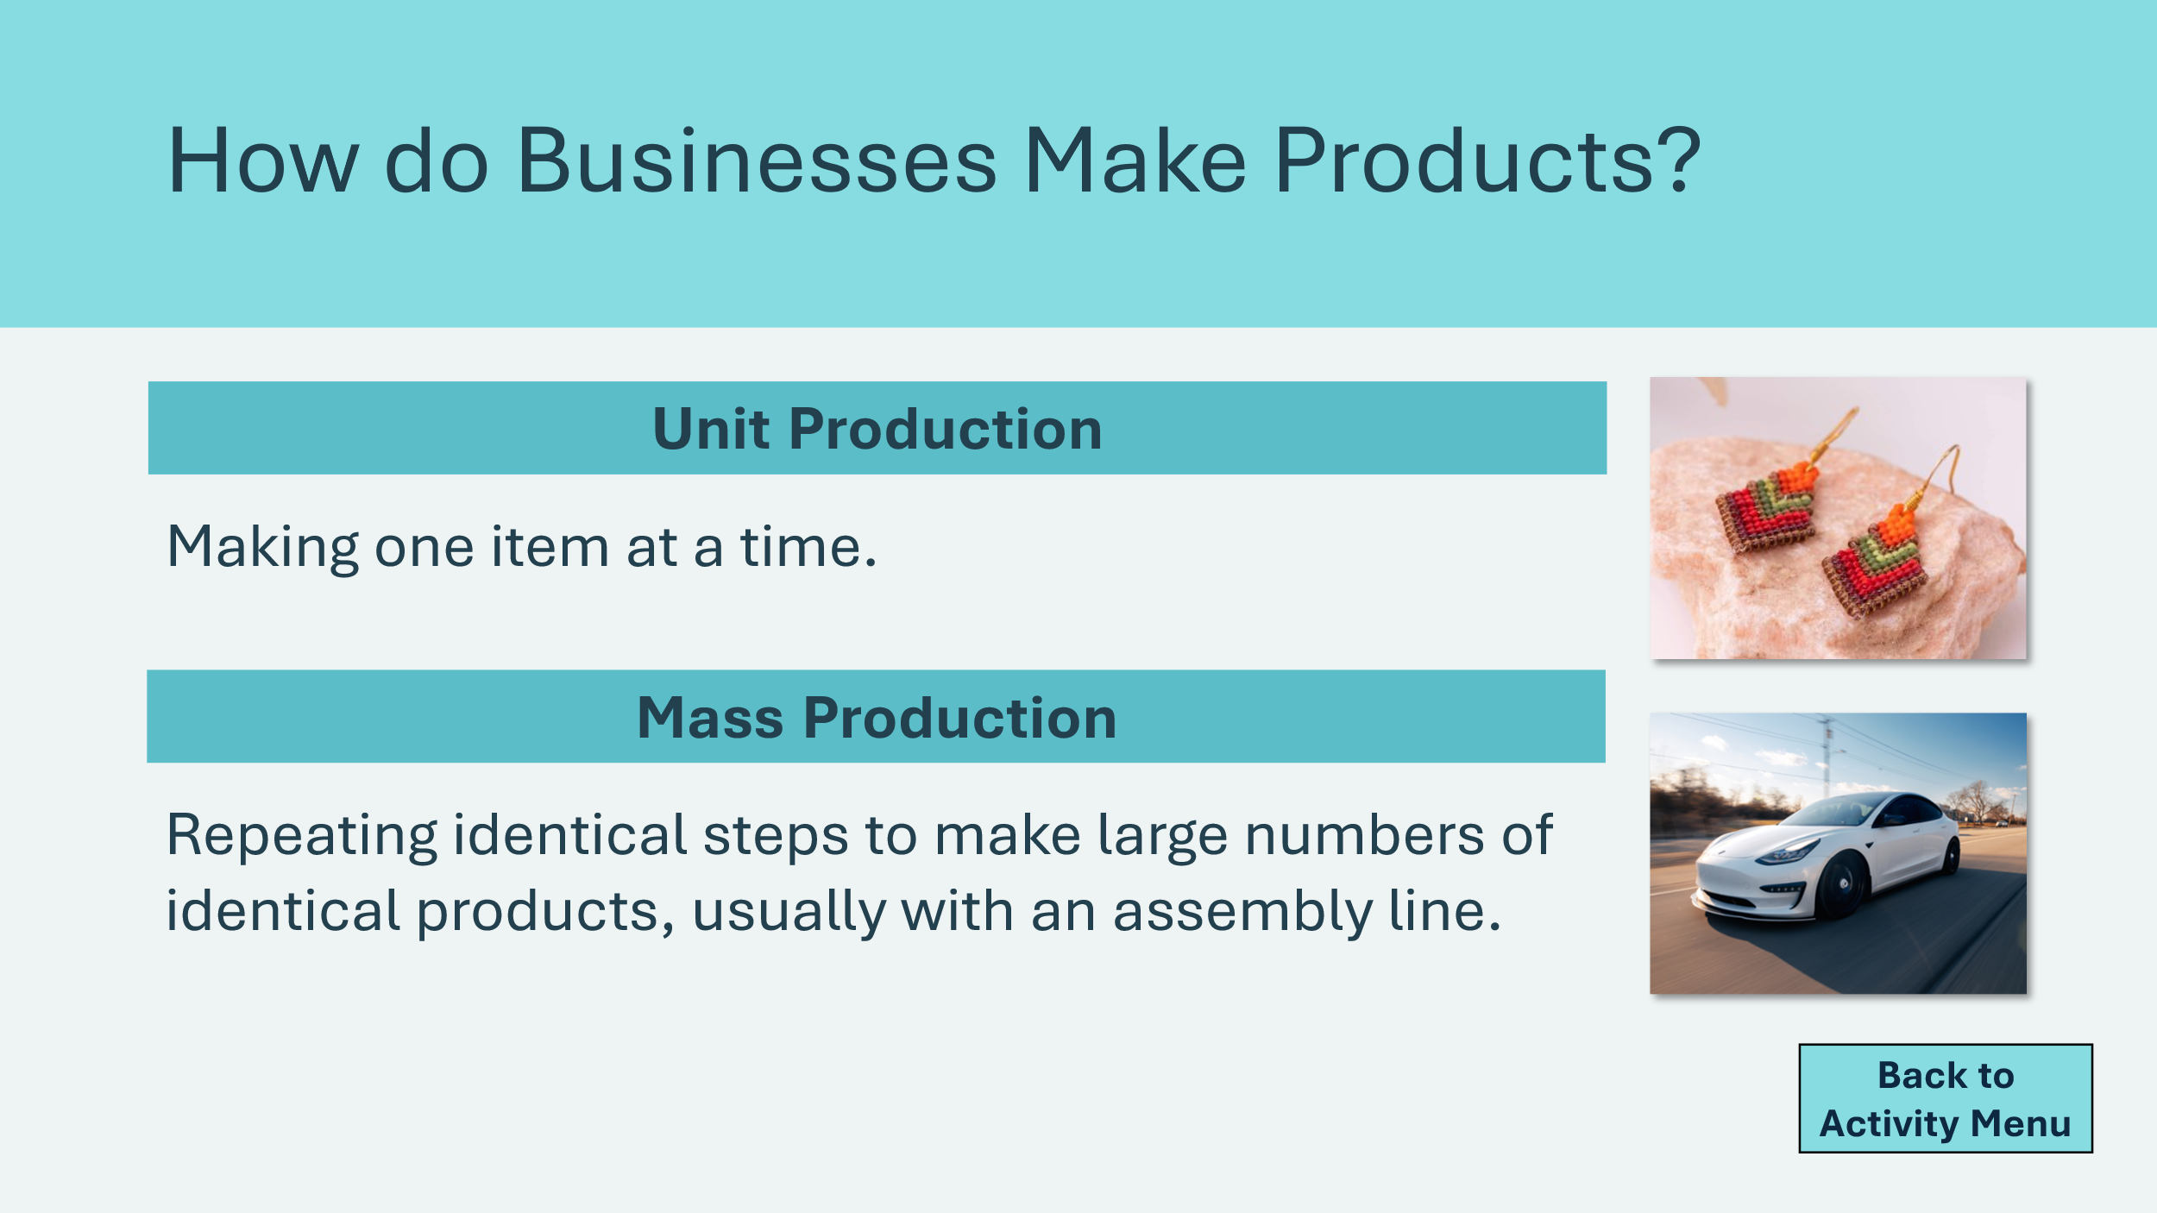 |  | Explain to students that there are two main ways that products are made: unit production and mass production.  Unit production means making one item at a time, often by hand. Imagine someone making a pair of beaded earrings. They choose each bead carefully, put them on one by one, and make sure the design looks just right.  - Pros: focuses a lot on quality, because the maker can check every tiny detail. The product might have a special cultural or personal significance, adding to its value.  - Con: it’s not the fastest way to make lots of things.  Mass production is when businesses make many identical items very quickly.  For example, a car isn’t made by just one person. Instead, it moves down an assembly line, and workers—and machines—add different parts. Factories use technology, like AI, robots and specialized tools, to make cars efficiently. This helps them produce cars faster and keeps the quality the same from one car to the next.  - Pros: fast and efficient for making many items.  - Cons: might not have as high quality as unit production, not unique.  Volunteer connection: If you run a business that manufactures products, share briefly which method of production you use and why.
Option 1: JA Penco Activity 30 min
Program Kit Materials |  | For slides 36-46, you will need to use the JA pen pieces from the program kit.  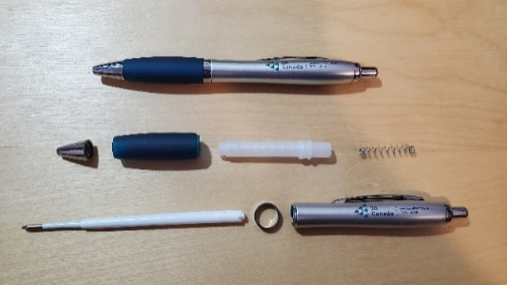
Slide 36 – Option 1: JA Penco Activity  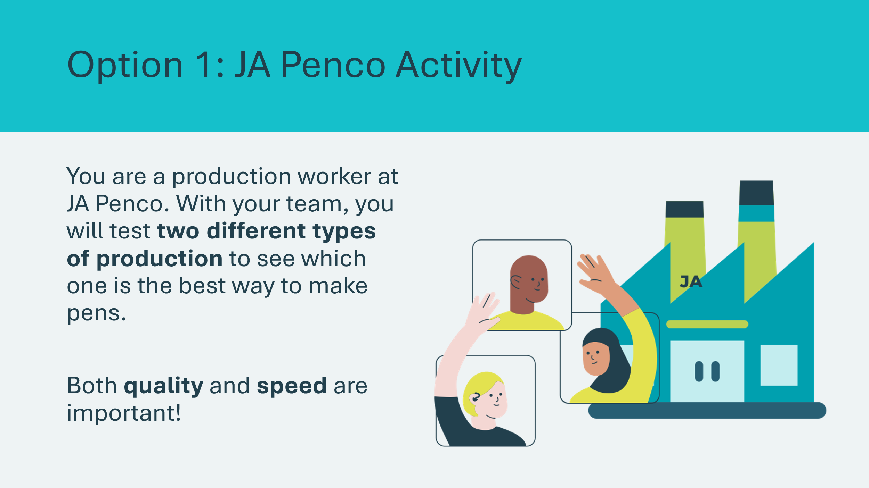 |  | Suggested time: 1 minute  Scenario: Tell the class to imagine that the classroom has been transformed into a JA Penco pen factory, and it has just received an order for thousands of JA Penco pens. The company wants to decide what is the best way to produce the pens for its customers while keeping its costs to a minimum, so it will conduct an experiment in the two types of production.  Considerations:  - Quality is as important as speed.  - Workers should watch for problems (cracked or broken pieces, missing pieces, parts that don’t work, etc.)  - The company will have an inspector for quality control.
Slide 37 – Vocabulary  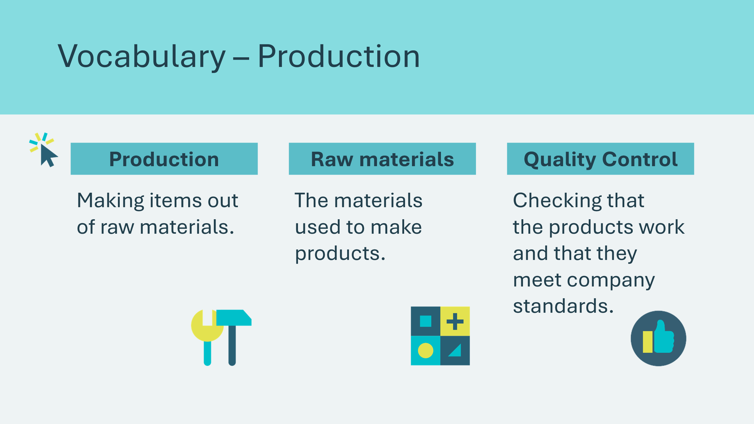 |  | Optional: Depending on the level or age of the students, you may choose to review a few key vocabulary terms. Otherwise, continue to the next slide.  *Click or tap to reveal each term.
Slide 38 – How to Assemble a Pen   |  | Suggested time: 4 minutes  Review the instructions on the slide and demonstrate how to assemble the pen.
Slide 39 – Round 1: Unit Production  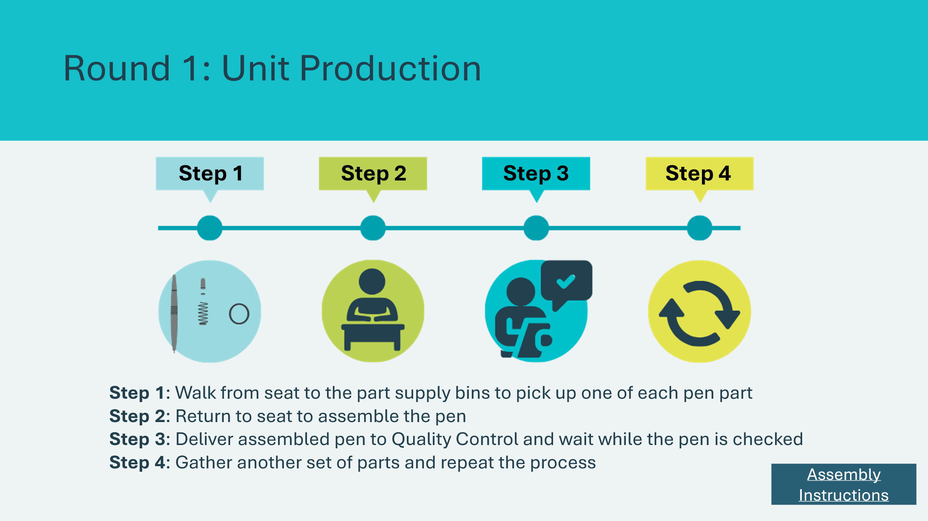 |  | Suggested time: 10 minutes  Round 1: Unit Production  1. Separate the pen parts into various containers.  2. Separate students into teams of 4-5.  3. Select a team and appoint four “workers” and one quality control expert to start the first production round. (In order to involve more students, you may wish to appoint additional volunteers for jobs such as timekeeper, safety officer, recorder, etc.)  4. Review the production steps on the slide and give the students 60 seconds to produce as many pens as possible.  5. At the end of 60 seconds, call time. Ask Quality Control to report the number of properly assembled pens.  6. Have students disassemble the pens and place the parts back in the bins while you or a student recorder writes the production on a whiteboard or chart paper.  7. Record the number of pens produced on the whiteboard and the number of pens per worker.  *Click or tap the Text instructions button if you wish to display the instructions while students are completing the activity.  Differentiation: Depends on the age and level of the students, you may wish to add more time to the round. Students with physical or vision impairments could choose to work with a partner.
Slide 40 – Calculating Worker Productivity  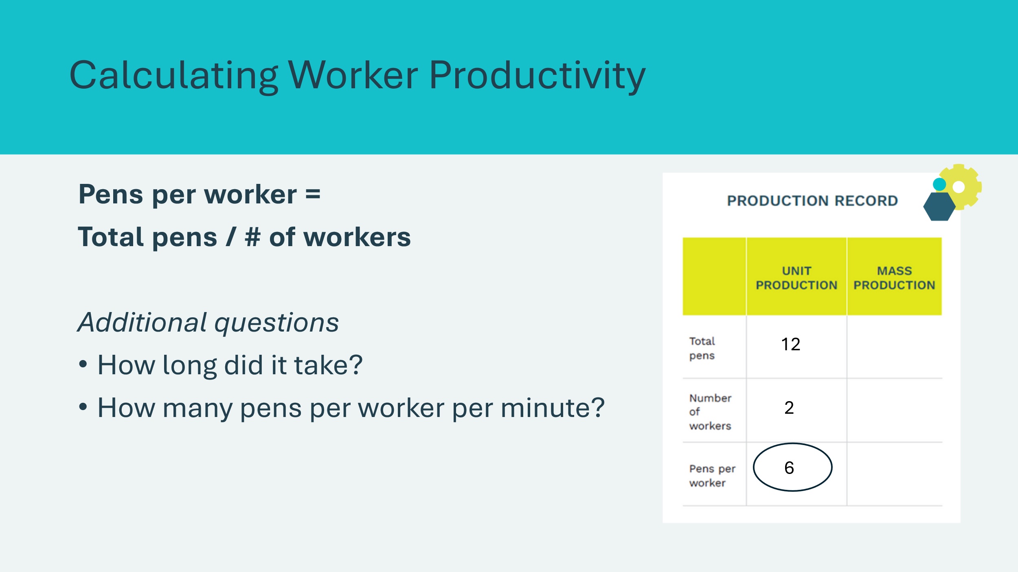 |  | After students complete Round 1, use a calculator to divide total pens by the number of workers to calculate pens per worker.  Pens per worker = Total pens / # of workers  Facilitator Tip: Depending on the age or level of students, you could calculate this or ask students to do so.
Slide 41 – Debrief: Unit Production  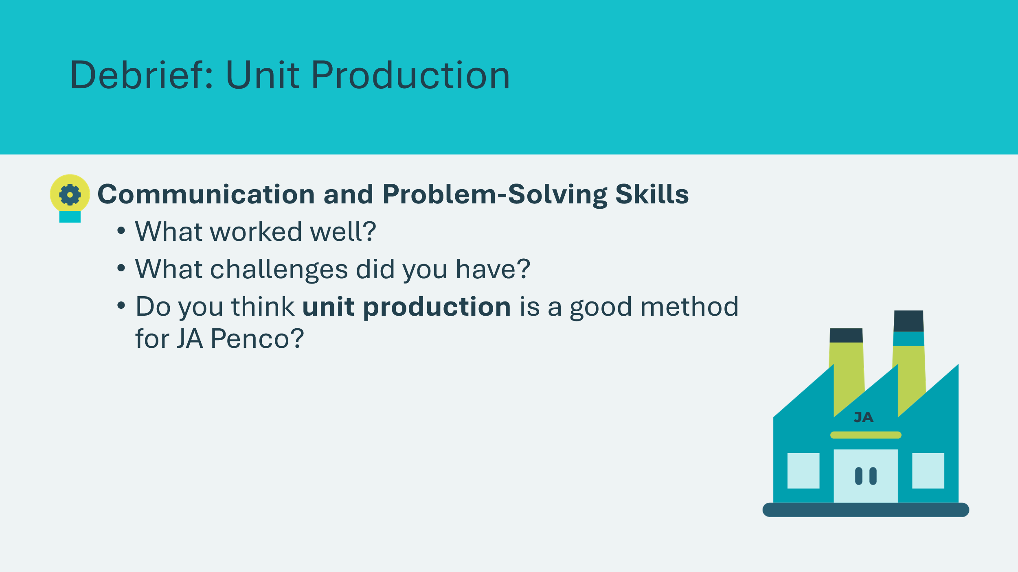 |  | Communication and Problem-solving Skills  Ask students the reflection questions on the slide. Invite a few students to briefly discuss with their teams and then share an answer.  Ask the class whether or not the production method seems to be a good one for JA Penco.  Most students may point out that it is inefficient and time-wasting.
Slide 42 – Vocabulary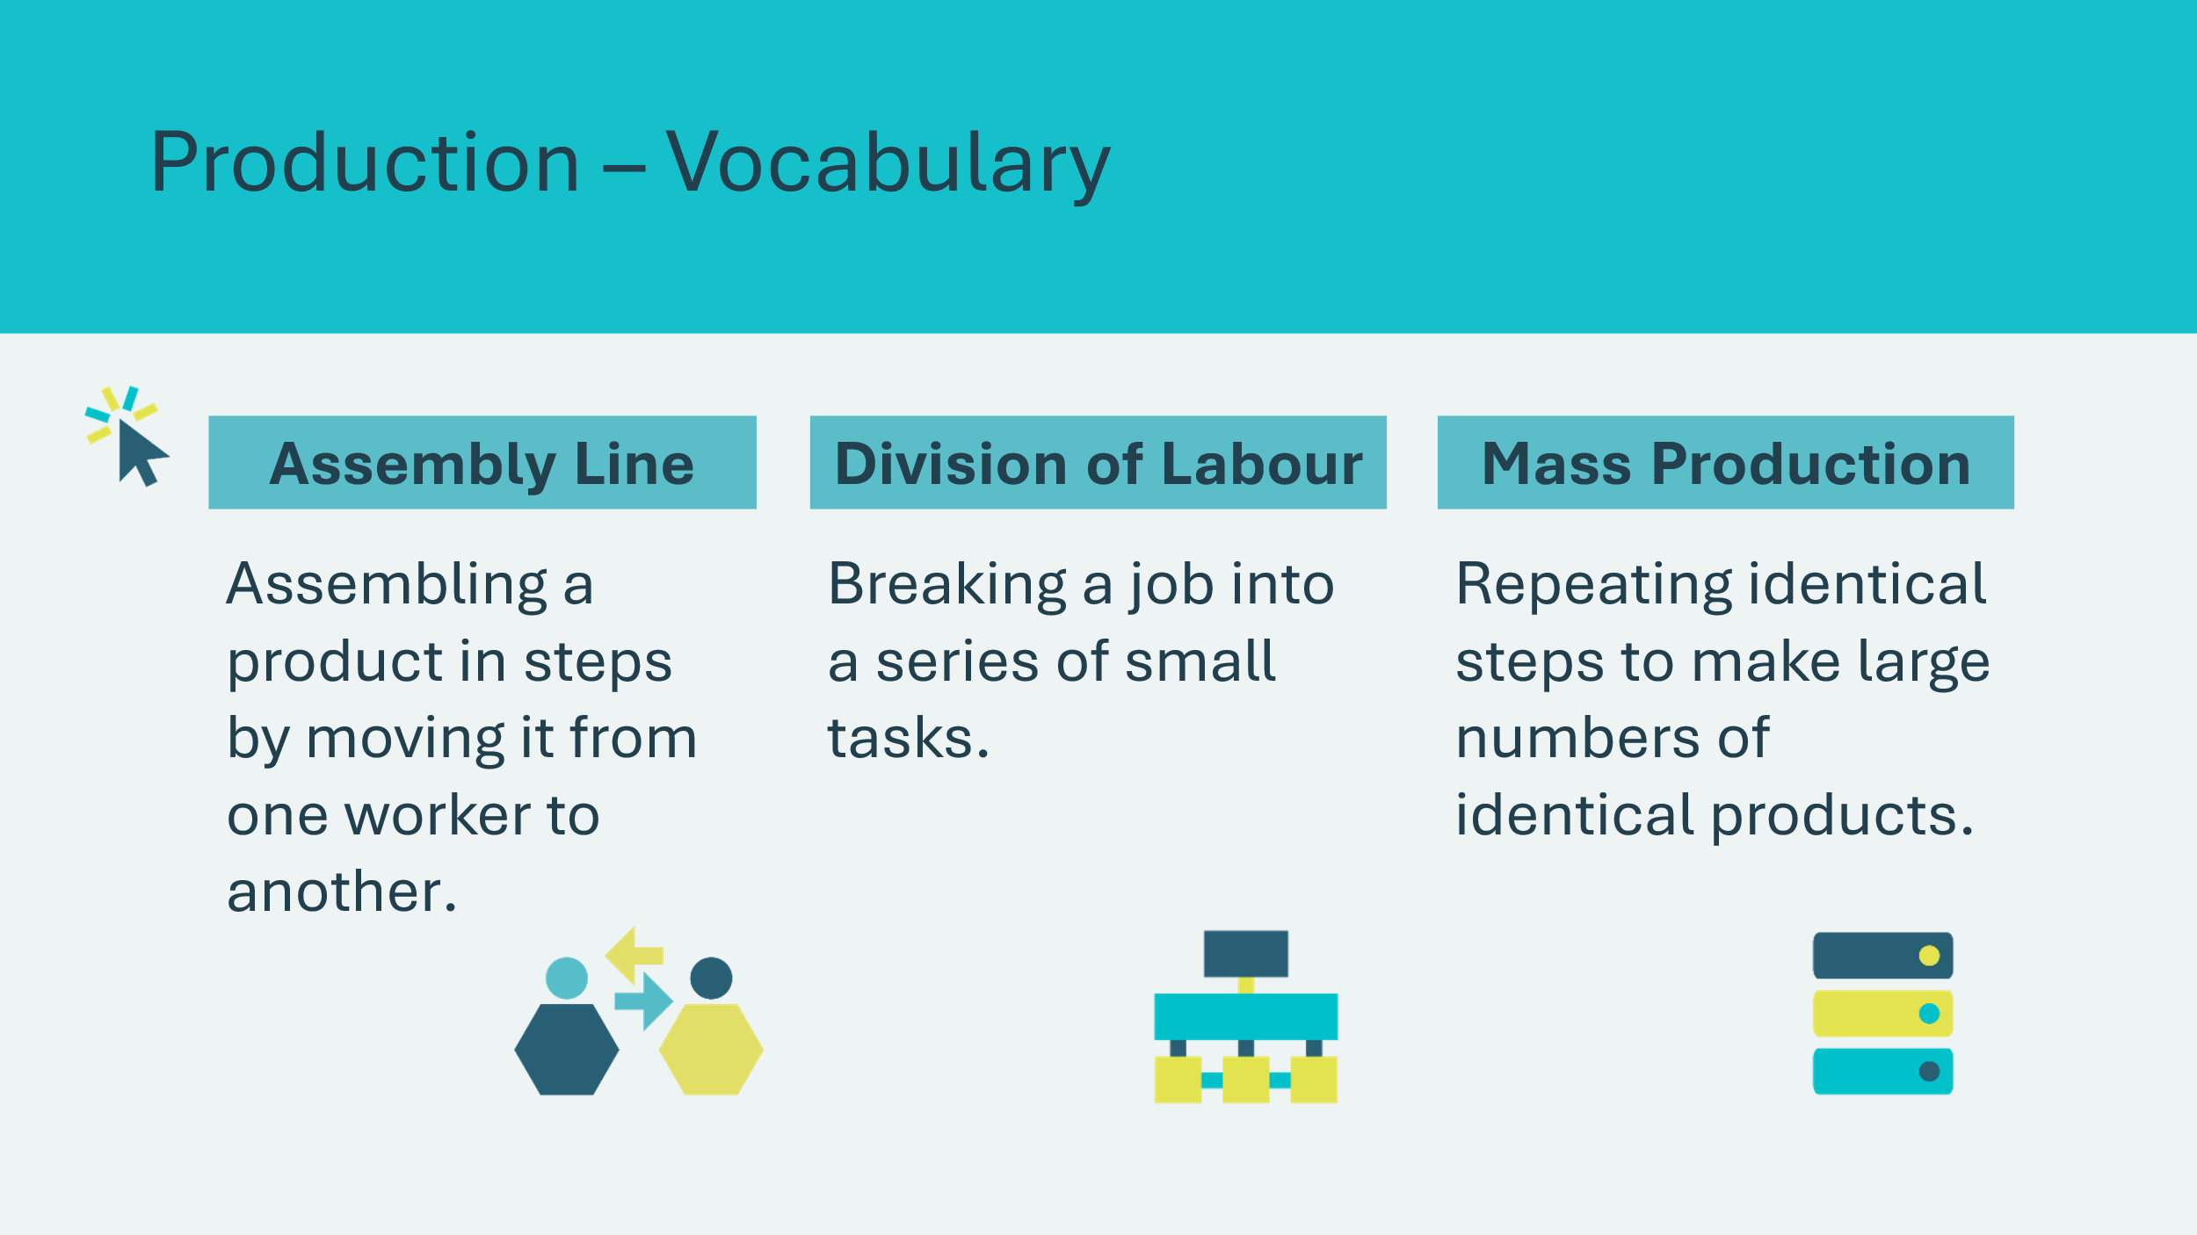 |  | Optional: Depending on the level or age of the students, you may choose to review a few key vocabulary terms. Otherwise, continue to the next slide.  *Click or tap to reveal each term.
Slide 43 – Round 2: Mass Production  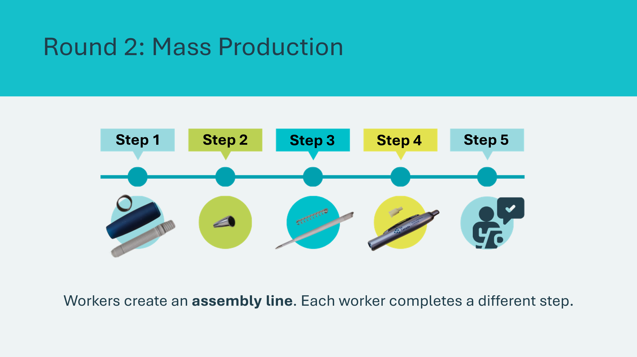 |  | Suggested time: 15 minutes  Tell the students that teams will work together on an assembly line to produce pens this round. This will simulate mass production.  Explain that the assembly line will use the following procedures:  Step 1: The first person fits the metal ring on to the end of the rubberised grip, fits the central screw column into the grip, and passes it to Person #2.  Step 2: The second person screws on the tip and passes it to Person #3.  Step 3: The third person places the spring and the ink cartridge into the central screw column and passes it to Person #4.  Step 4: The fourth person puts the internal tip into the barrel, screws the barrel onto the central column, and passes the completed pen to Quality Control.  Step 5: Quality Control ensures the pen works properly.  1. Have the teams appoint four “workers” and one quality control expert. As in Round 1, additional production teams may be organized.  2. Arrange the pen parts on the table in front of the assembly line workers and have the team practice the assembly routine (2 min).  3. Give the production team 60 seconds to produce as many pens as possible. Ask Quality Control to report production results.  4. Record the results in the appropriate column on the Production Record.  At the end of the round, ask a team to continue to assemble all the pens and give the pens to the students. Make sure every student gets a pen.
Slide 44 – What would happen if someone was…?  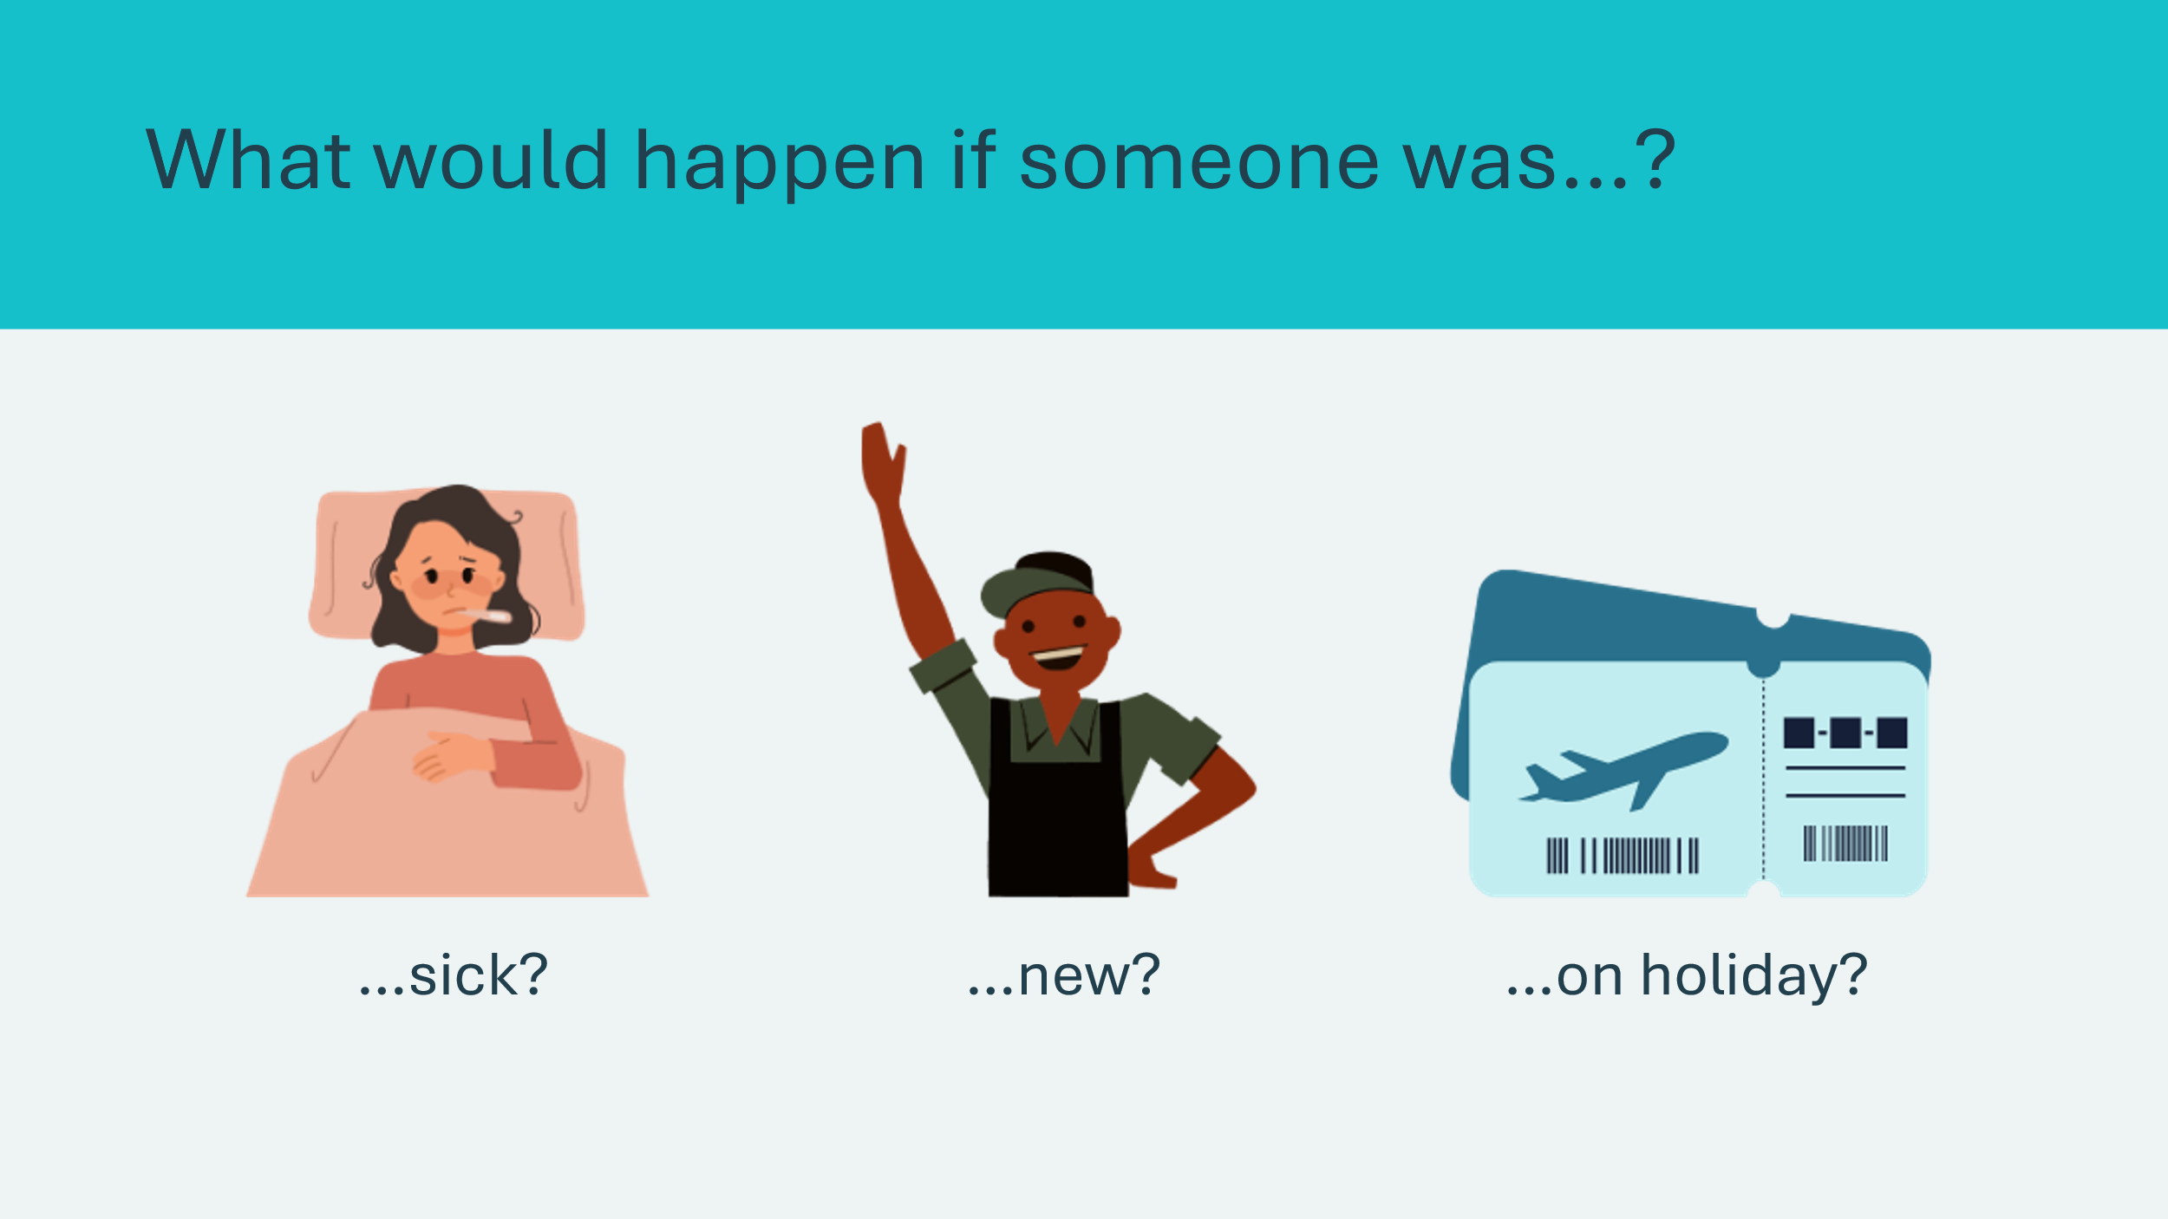 |  | Optional  If time permits, disassemble the pens and simulate how random events happen that can reduce productivity — like someone calling in sick.  Have students repeat the activity, only with one student from each team working under different conditions to simulate a challenge in productivity:  - Sick = One team member sits out  - New employee = Two team members swap roles  - On holiday = The team can’t work for the first 20 seconds  If students have suggestions to make each strategy more efficient, vary the steps to include their suggestions.  This highlights how businesses have to prepare for and adapt to changing circumstances.
Slide 45 – Comparing Methods  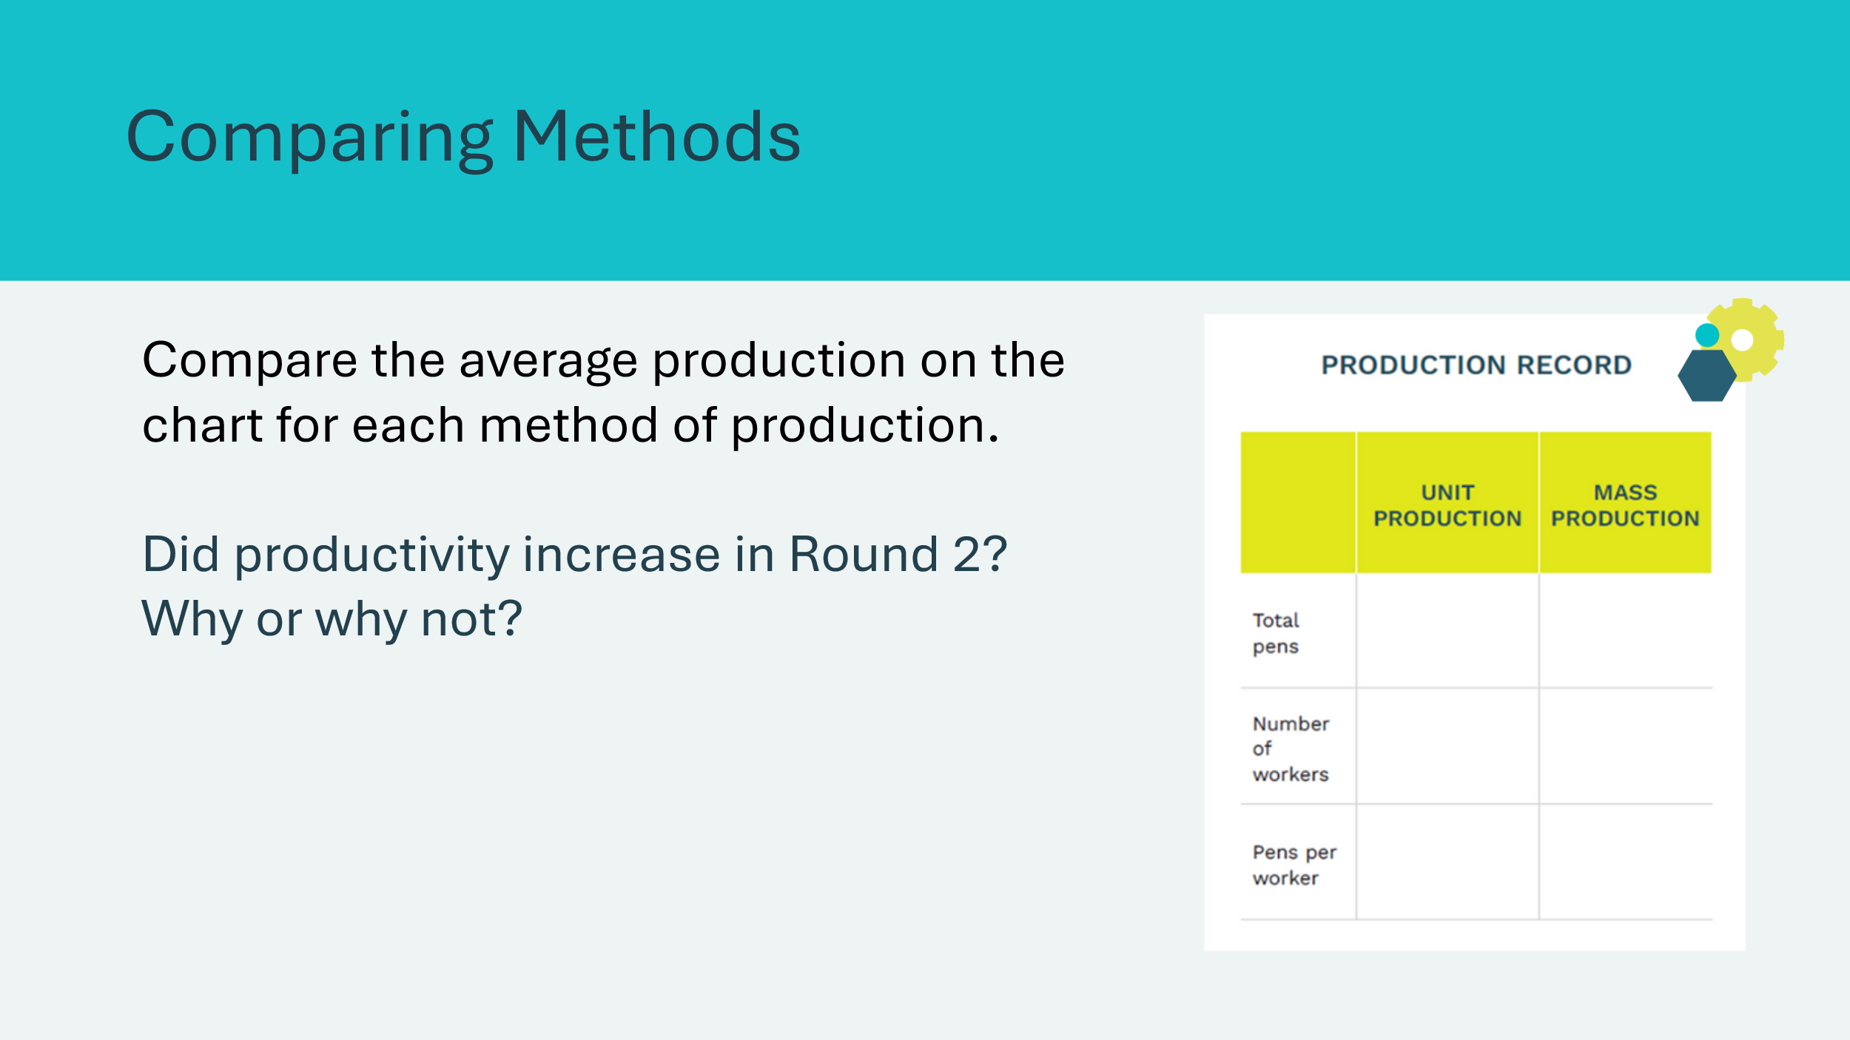 |  | Remind students the first method of production was called unit production because each worker assembled an entire unit — a pen.  Compare the average production on the chart for each method of production. Point out that this average measures worker productivity.  Explain that the assembly line used in Round 2 is an example of mass production.  Ask students to evaluate the use of mass production:  Did productivity increase in Round 2? Why or why not? (e.g., easy access to parts, cooperation, specialization, increasing efficiency)
Slide 46 – Debrief  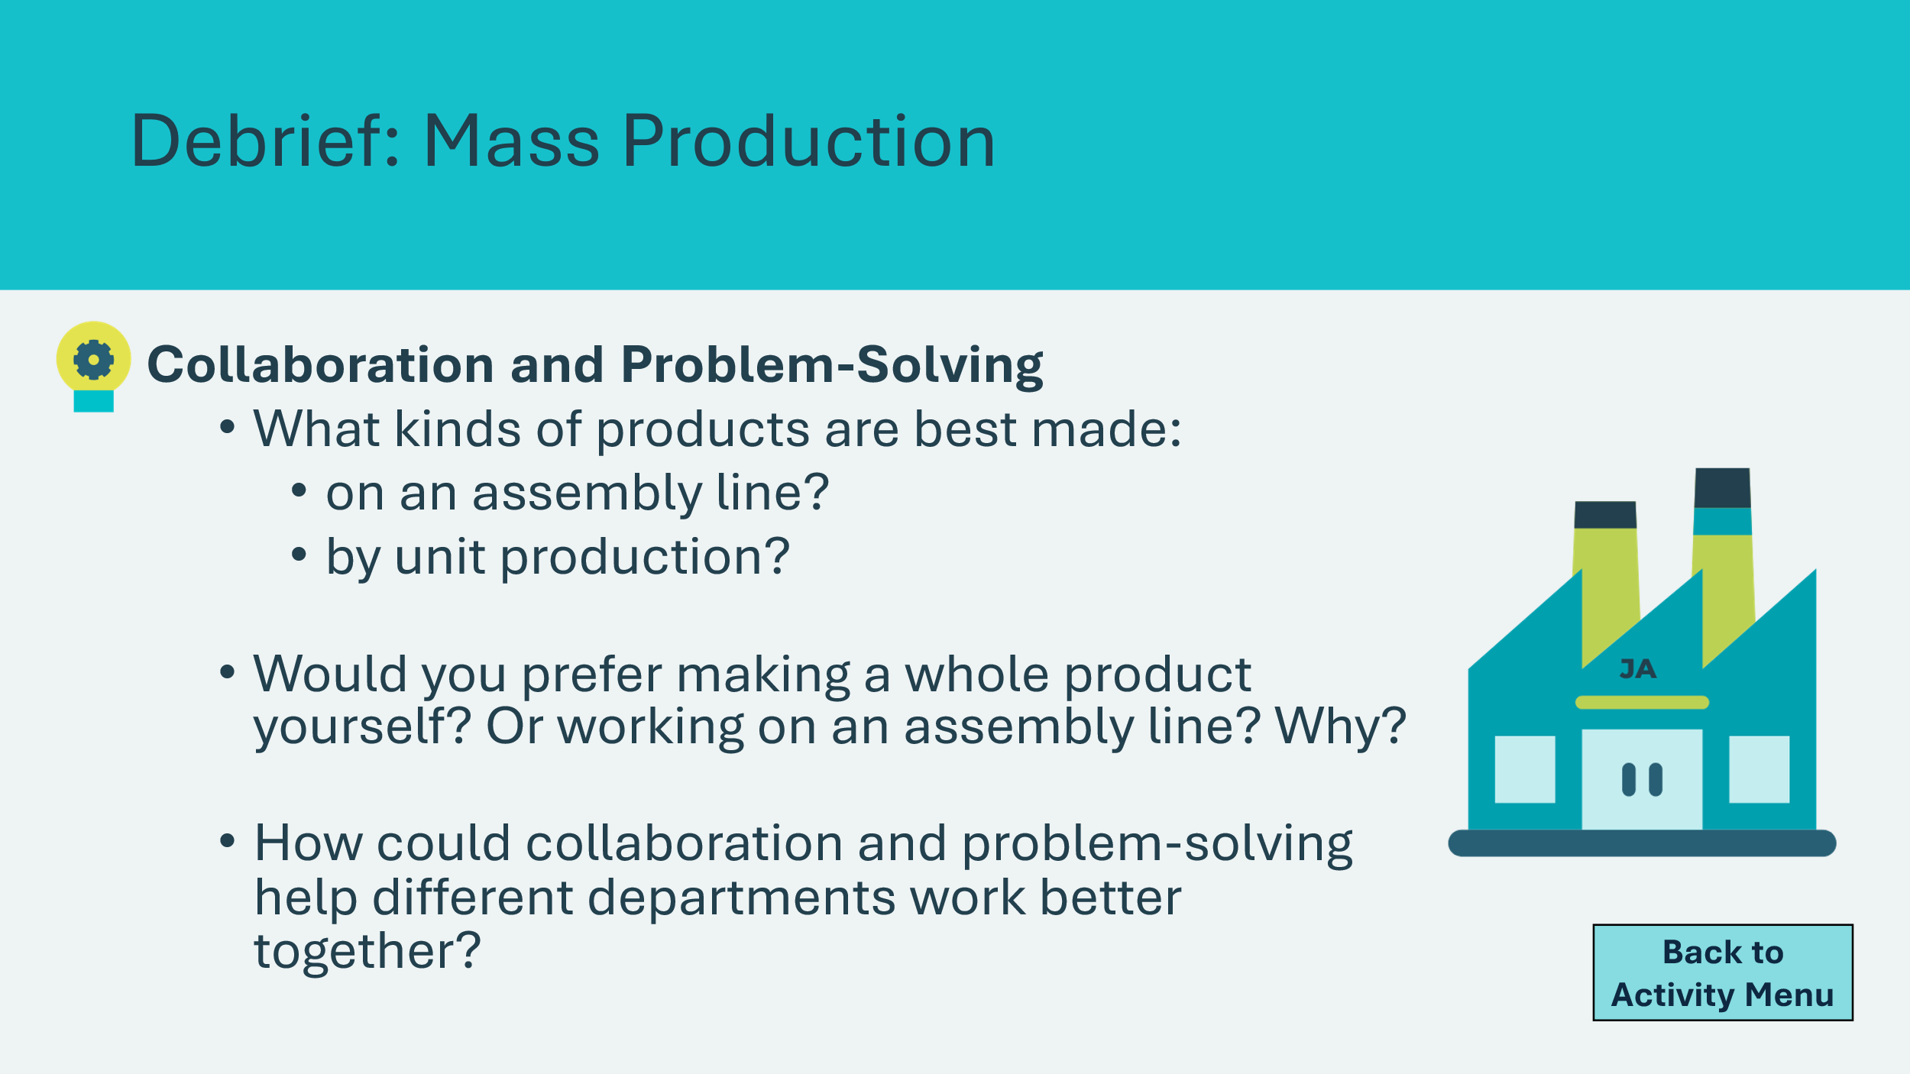 |  | Ask students one or two of the reflection questions on the slide.  Sample answers:  Question 1  Products better produced by the unit: an artist’s painting, a birthday cake, a hand-woven basket, anything requiring fine skills  Products better produced by the assembly line: items with identical parts like pens or complex machines.  Question 2  Unit: some people enjoy the variety and take pride in completing the whole job; quality of product is high.  Assembly: some people enjoy it because they like to be an expert in one task, but others may find repetition challenging.  Question 3  Collaboration helps teams share ideas so everyone knows what’s going on. If one team has a problem, like running out of supplies, another team can help fix it faster. Working together makes the whole business run more smoothly.
Option 2: Team Time 25 min
Slide 47 – Option 2: Team Time  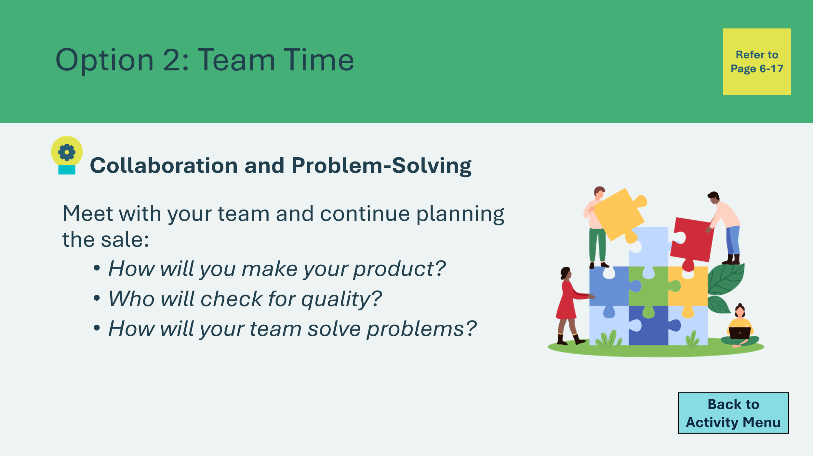 |  | Students meet with the teams formed in lesson 1. They continue planning for the sale.  If students are creating their own products for the sale, review the questions on the slide to help them plan. Then they can use the rest of the time to create their products.  If they are not creating their own products, they can use this time to continue planning in groups. The team descriptions are in the student portfolio, pages 6-20.
Reflection 5 min
Slide 48 – Reflection    Slide 49 – Key Ideas  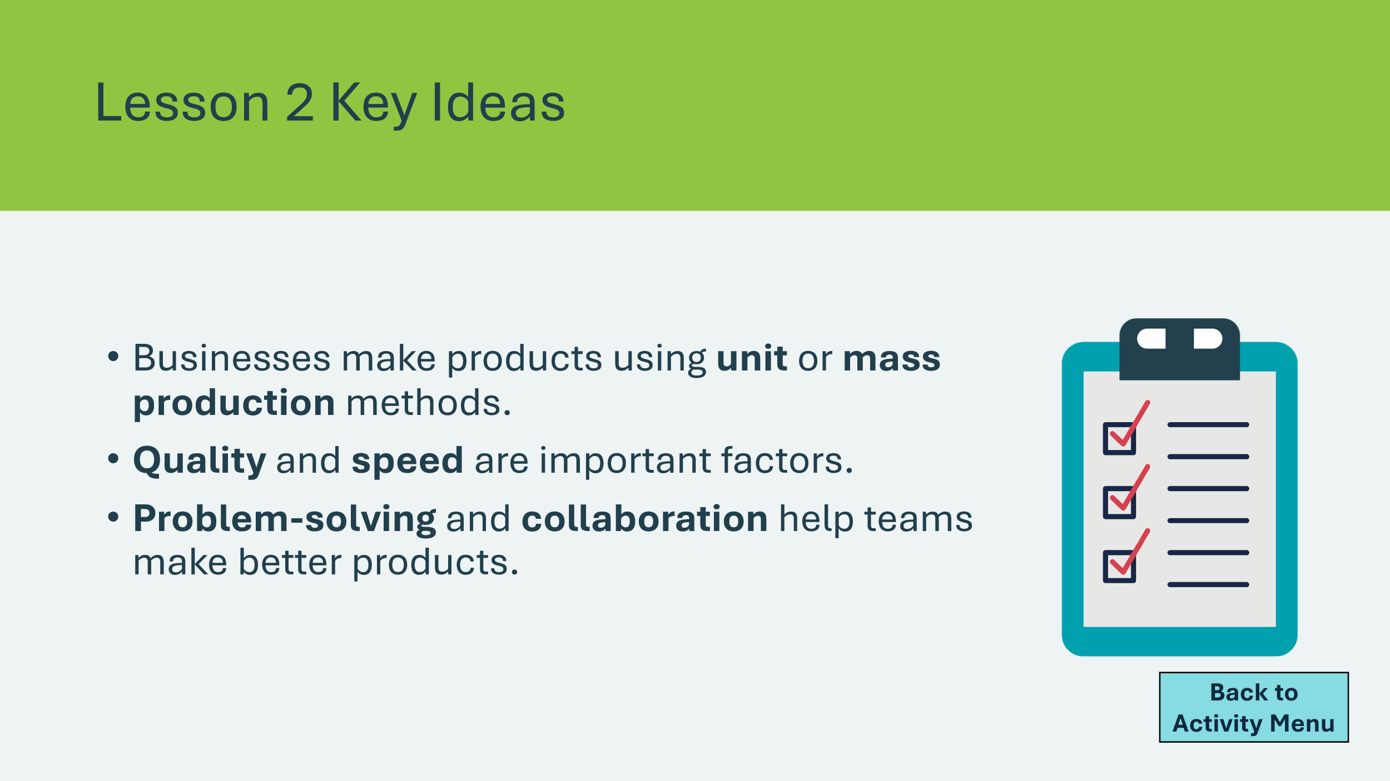 |  | Suggested time: 3 minutes  Invite students to reflect on their problem-solving and collaboration skills.  Ask students the reflection questions on the slide and invite a few students or groups to share.  Suggested time: 2 minutes  Wrap up the activity by reviewing the key takeaways.
Extension Activities 30 min
Slide 50 – What’s Your Process?  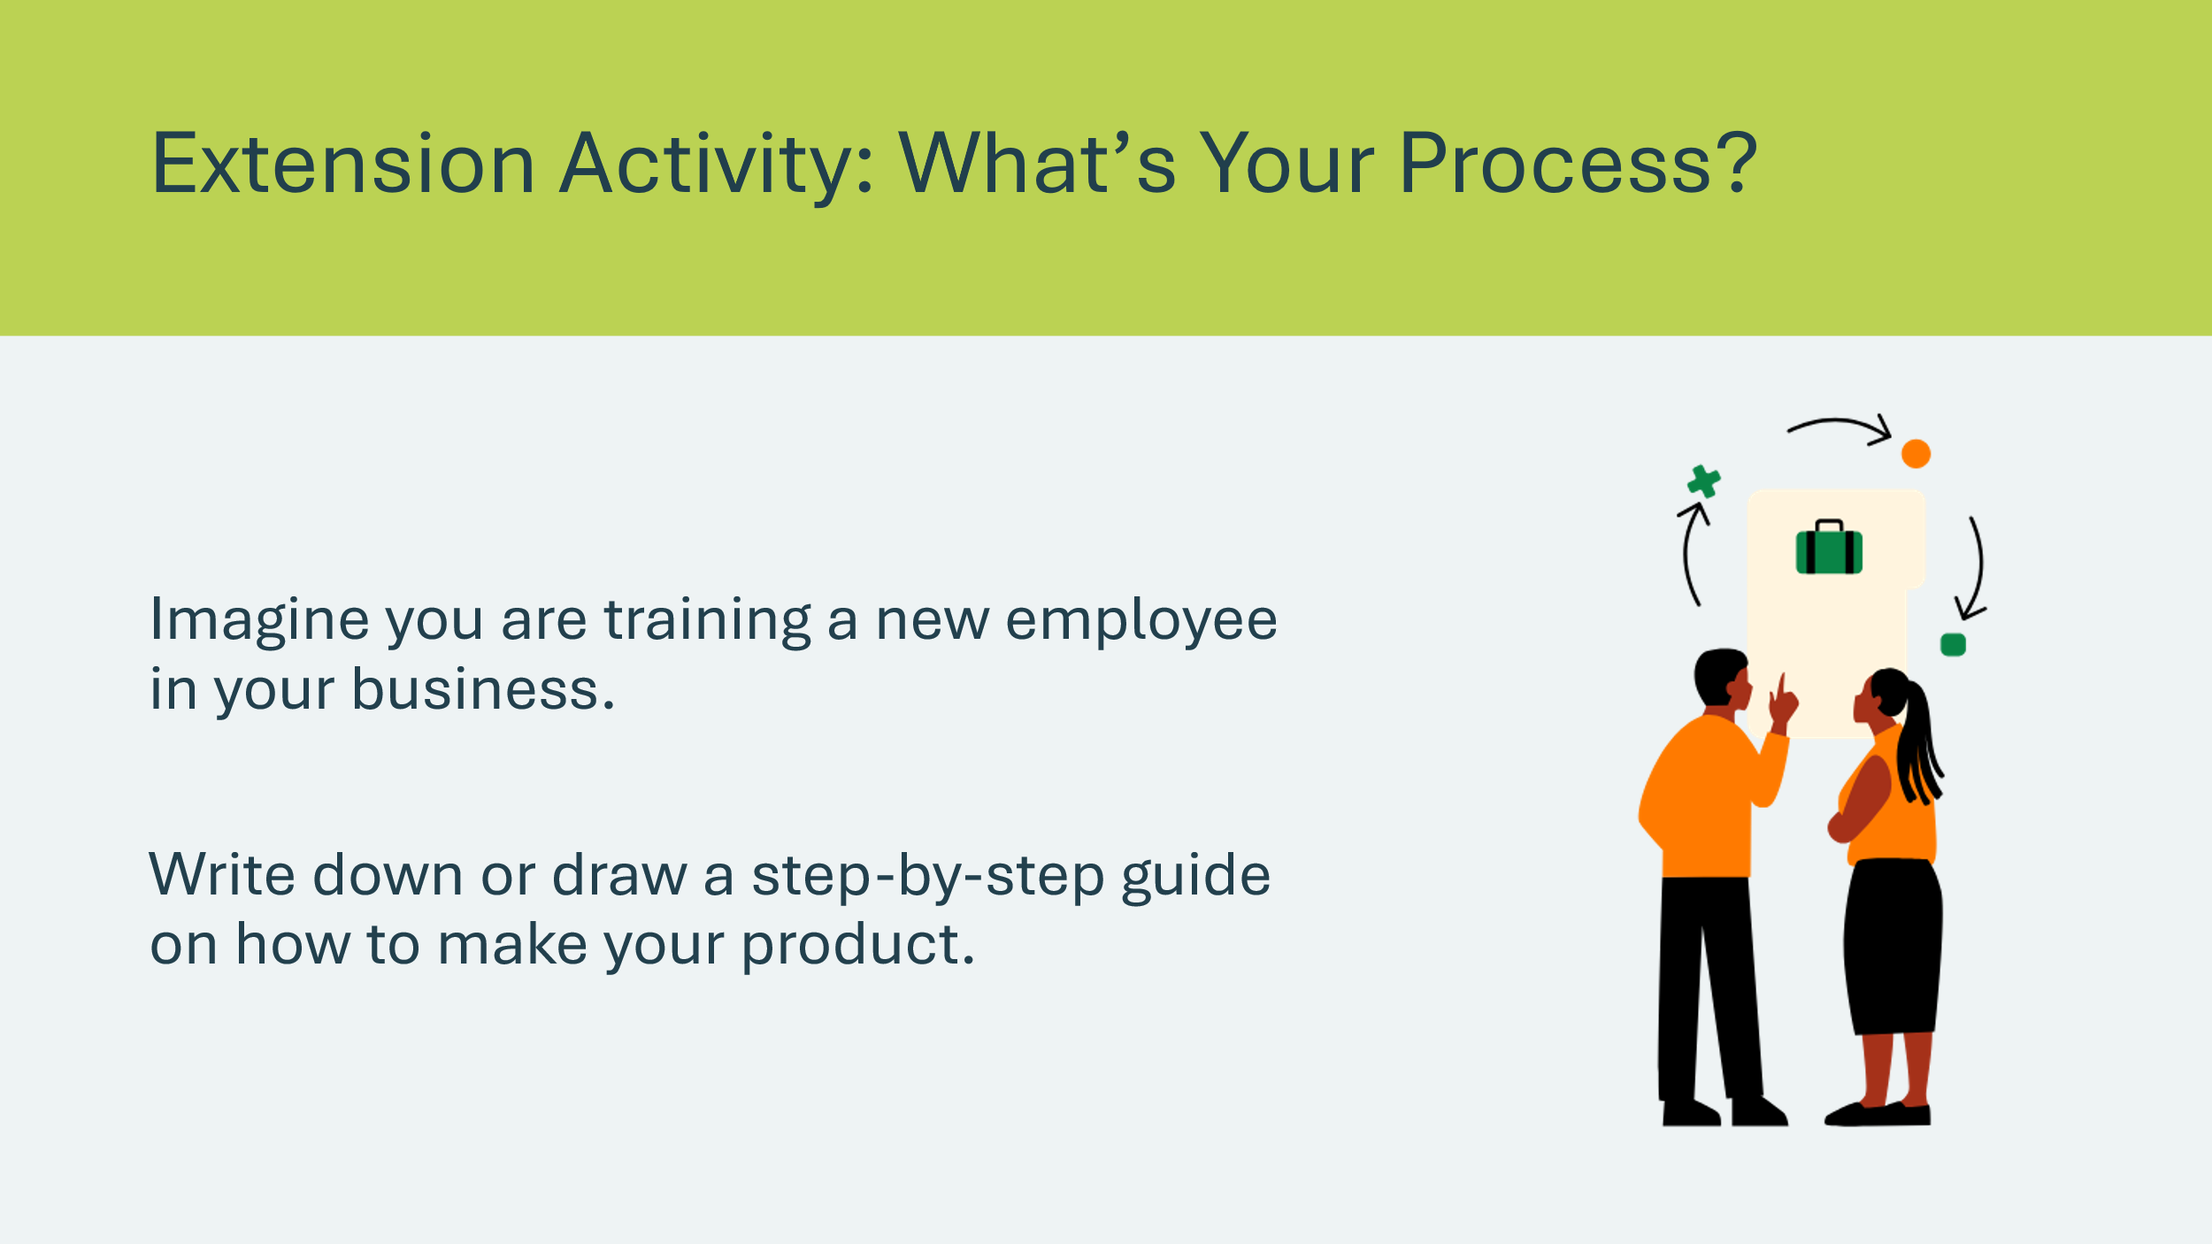 | Suggested time: 15 minutes  In groups or individually, tell students to imagine that they are training a new employee in their business.  Ask them to write down or draw a step-by-step guide on how to make your product.  Curriculum connection: language arts, procedural writing.
Slide 51 – Career Exploration   | Suggested time: 15 minutes  Students could brainstorm or research careers related to businesses or manufacturing.  Examples: Careers related to production, management, working with machines, HR, robotics  Curriculum connection: Lifelong learning; career exploration; social studies

Lesson 3: Marketing and Promotions
Slide 52 – Lesson 3  | Lesson 3: Marketing and Promotions
Slide 53 – Objectives  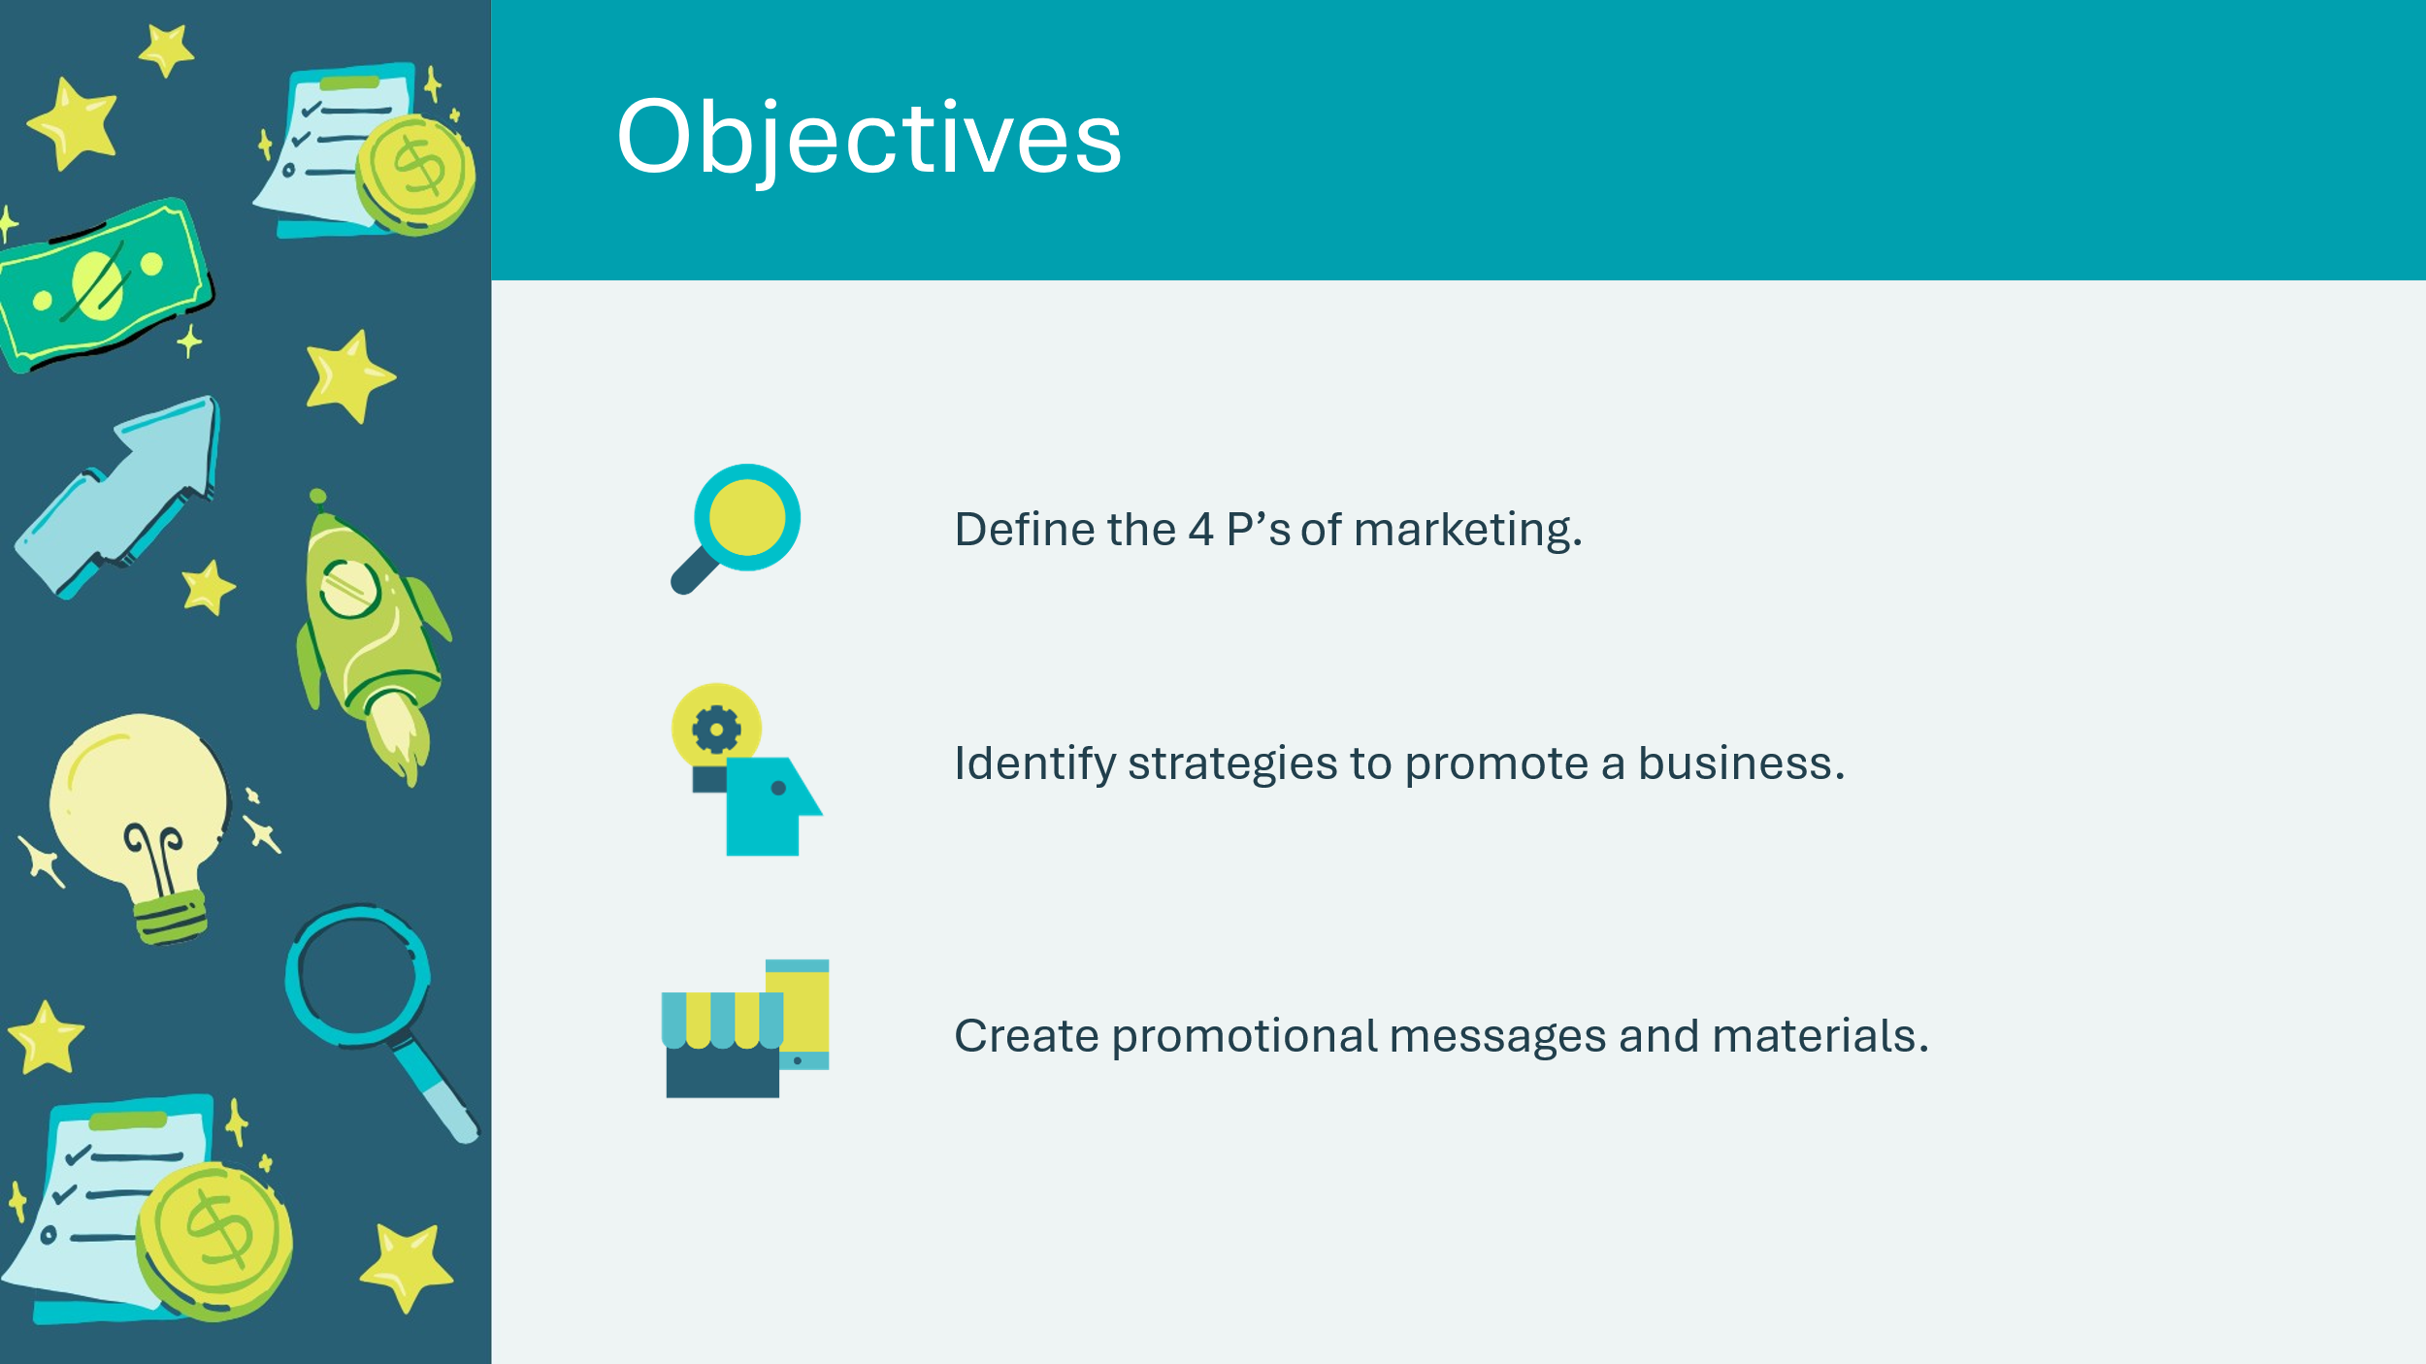 | Optional – review the learning objectives for the lesson.
Slide 54 – Introduction  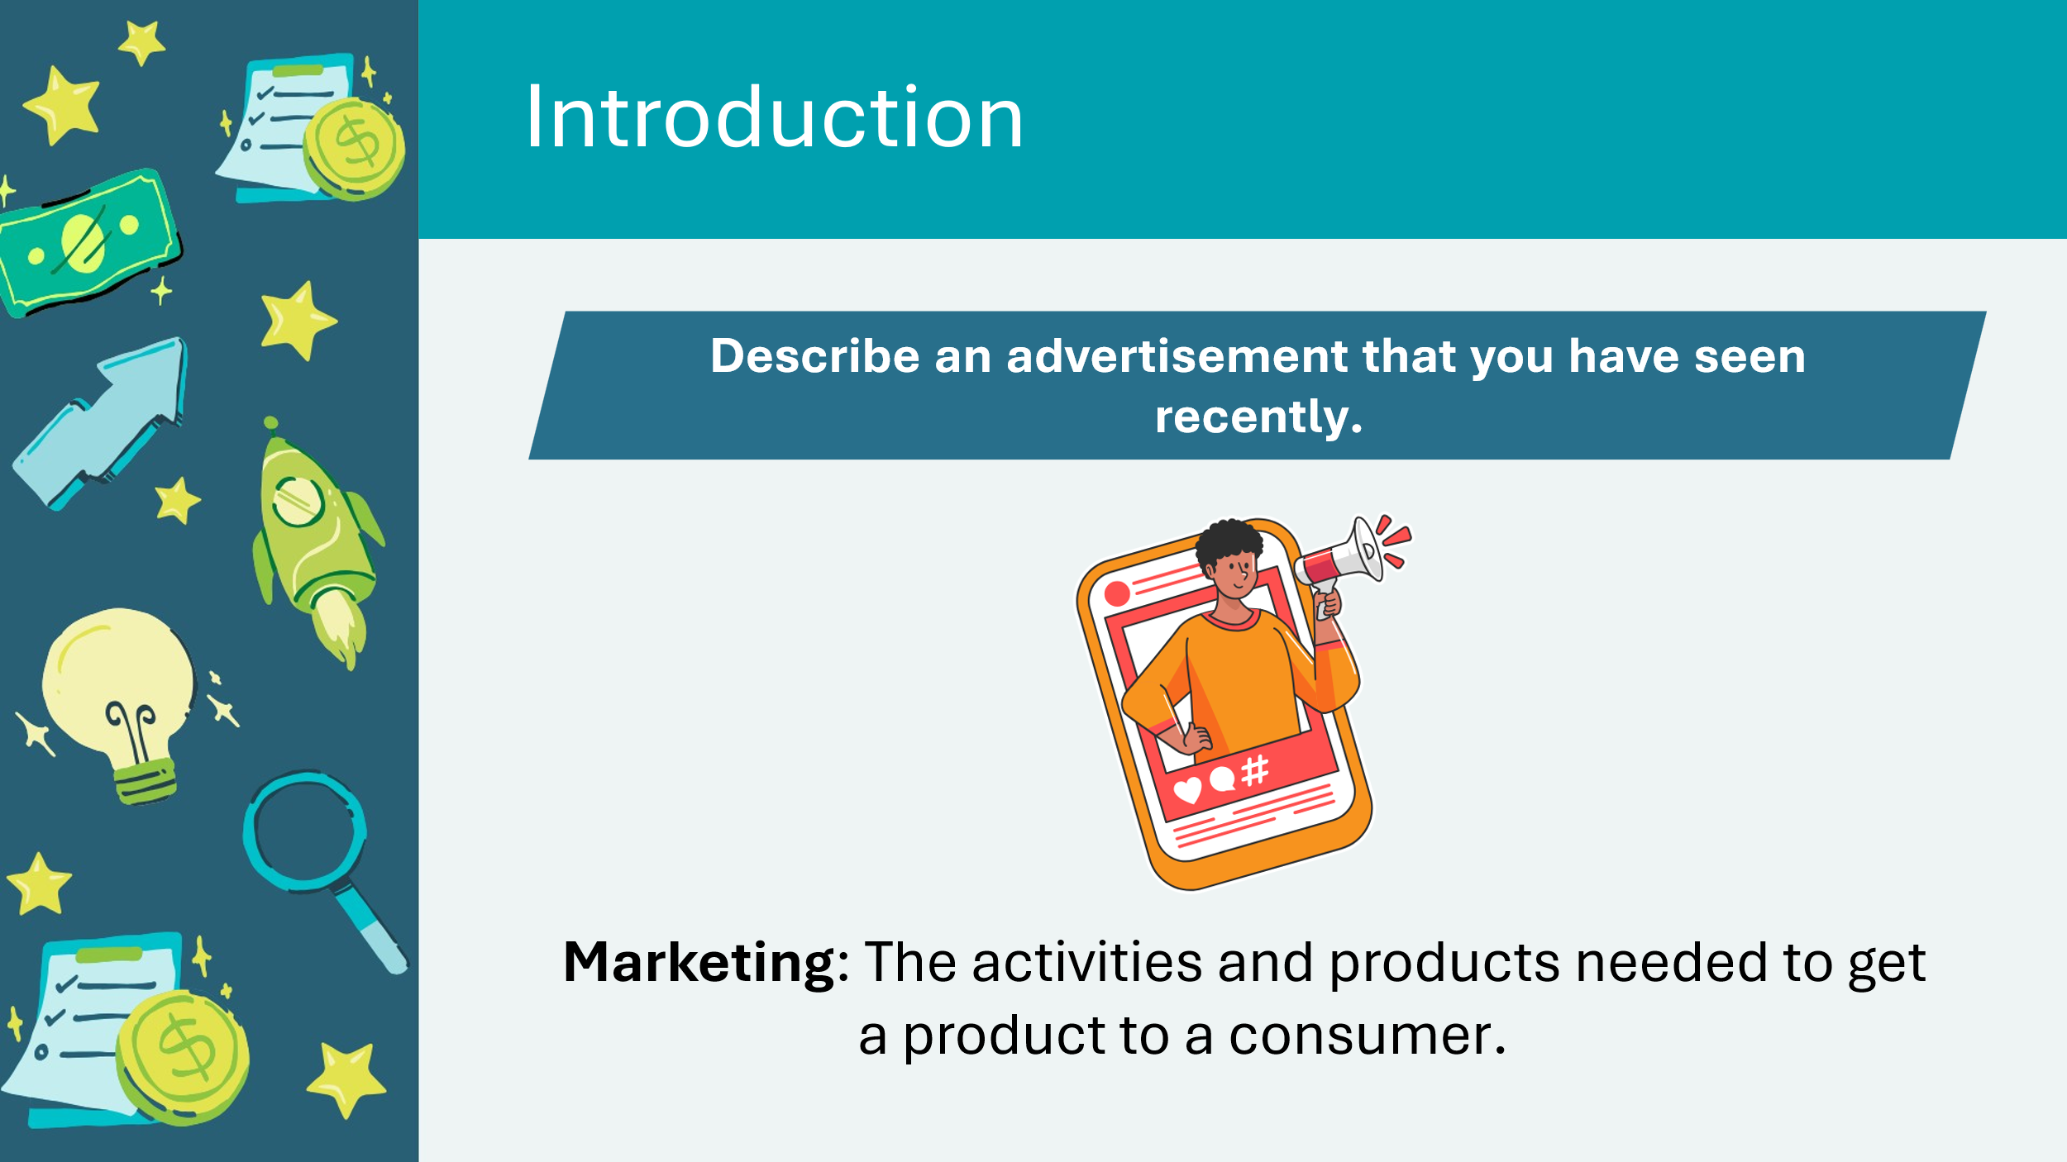 | Introduce the lesson by inviting students to describe an advertisement they have seen recently. Select a few students to share with the class.  Explain that advertisements are part of marketing.  Marketing: activities and products used to attract new customers or stimulate sales.
Slide 55 – Activity Menu  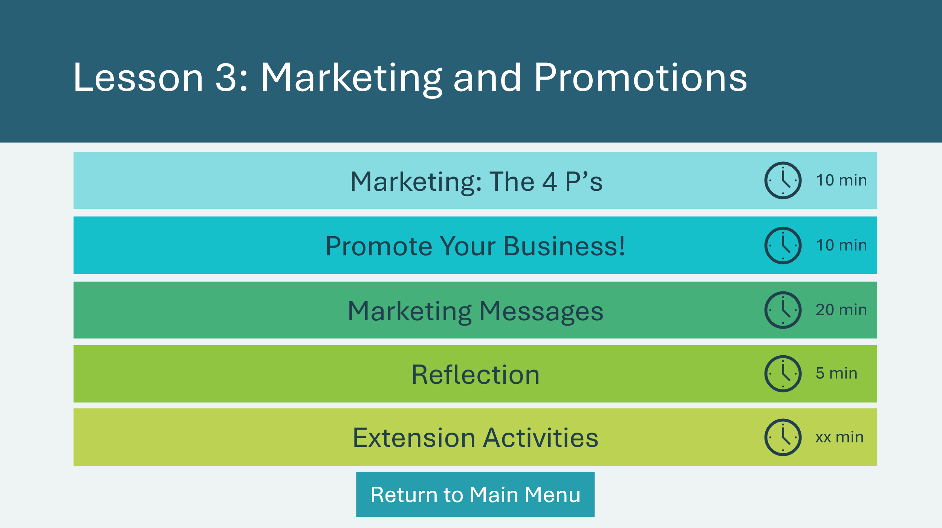 | *Select the button to navigate to the activity.  Select the buttons to jump to an activity or select next to begin the lesson.  *Click or tap the Return to Main Menu button to return to the Lessons (Slide 5)
Marketing: The 4 P’s 10 min
Slide 56 – Marketing: the 4 P’s | Suggested time: 10 minutes  Introduce the 4 P’s of marketing: Place, Product, Price and Promotion; and how employing these strategies can help find customers.  *Click or tap to reveal the definitions.  Place: the location of a store, or location within a store  - Where could you set up your stand?  - Why is location important?  Product: a product there is a need for, or having a variety of products  - How can you tell if there is a need for your product?  - What are the advantages and disadvantages of having multiple products?  Promotion: advertising and similar activities to convince customers to buy what you are offering  - What kind of promotion can you use to draw in customers?  - Where should you locate your promotions?  Pricing: setting a price that is attractive to customers while also providing a profit  - How can you find an appropriate price for your items?  Point out that the class already discussed place and product in the first lesson. In this lesson, they will focus on promotion.
Slide 56 – Target Market | Explain that a business’ marketing is directed toward their target market. ​  ​Target market is a group of people that a business chooses to sell its products or services to.​  Ask students to identify the target market for each of the products on the slide and to explain their thinking.  Sample Answers:  - Tricycle = children, still learning to ride  - Bicycle = adults, it’s a bigger size  - Unicycle = circus performers or people looking for a new hobby  Invite students to review the target market they selected during lesson 1 (Student Portfolio, page 4).
Slide 58 – Promote Your Business! | Suggested time: 10 minutes  Turn and talk  Ask: what are some ways that businesses promote products?  First, students discuss with a partner, then invite a few groups to share their ideas.  Sample Answers  - Online: Ads on YouTube, social media posts, influencers, web advertising, etc.  - Public events and on the street: Posters, contests, free samples, etc.  - Games or television shows: Commercials, product placements, etc.  - In stores: Packaging, aisle displays, store announcements, etc.  Ask the students how they can effectively promote their business.​  Invite students to complete the Marketing and Promotions section in their Student Portfolio, page 12 and write a brief summary in the Promotions section of the Business Model Canvas, page 4.  Facilitator Tip: Depending on the age of the students and the time you have, you could ask students to simply complete the Promotions section in their Student Portfolio, page 4.
Marketing Messages 15 min
Slide 59 – Marketing Messages  Slide 60 | Suggested time: 15 minutes  Review the 5 W’s on the slide.  With their teams from Lesson 1, invite students to create a Marketing Message for their business on page 13. ​Encourage them to apply the 4 C’s in their writing. Once they are finished, ask a few groups to share. Discuss which messages create the best promotion for their target market.  If necessary, prompt them with questions such as:​  - What information do people need to know about your sales stand/business?​  - Should the promotion have a slogan?​  - Do print materials need graphics?  - Do audio materials need music? Sound effects?​  - What accessibility features might you need to include (closed captions or alt text for online content)?
Reflection 5 min
Slide 61 – Reflection  Slide 62 – Key Ideas | Suggested time: 3 minutes  Read the reflection question on the slide and ask a few students to share.  Suggested time: 2 minutes  Wrap up the activity by reviewing the key takeaways.
Extension Activity 15 min
Slide 63 – Team Time | Suggested time: 15 minutes  If there’s time, have students break into their teams again.  They can either continue planning the sale or create a poster or other promotional materials for their business/sales stand.  Have the Promotions Team develop an advertisement for the Sales Stand that they can distribute via email or social media if the school will allow it.  Technology: Create an advertisement using digital tools (Canva, physical poster, video commercial, social media post, PA announcement).  Differentiation: Offer choice to students in format; different groups could create different formats using the marketing messages.  Language Arts: Use persuasive language in the creation of the promotion (persuasive text).

Lesson 4: Financial Recordkeeping, Pricing and Teamwork
Program Kit Materials |  | Cash Receipts  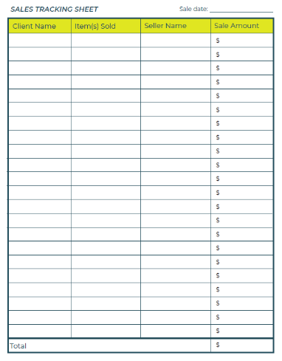  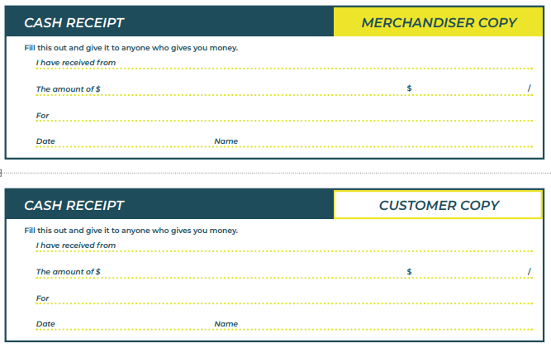  Sales Tracking Sheet  Price Tags  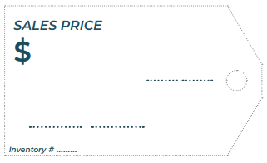
Slide 64 – Lesson 4 |  | Lesson 4: Financial recordkeeping, pricing and teamwork
Slide 65 – Objectives |  | Optional – review the learning objectives for the lesson.
Slide 66 – Introduction |  | Introduce the lesson by reminding students of the video about Ali from Lesson 1. He was selling lemonade to customers at a stand. Ask students: how would he know it he made any money?  After a few students share, explain that financial recordkeeping is writing down all the money you earn and spend so you can keep track of it easily.  In this lesson students will continue developing their Business Model Canvas by estimating expenses and income. They will learn how to set prices for merchandise and work as teams on any last-minute tasks.  Students will build on financial concepts from Lesson 1.
Slide 67 – Activity Menu  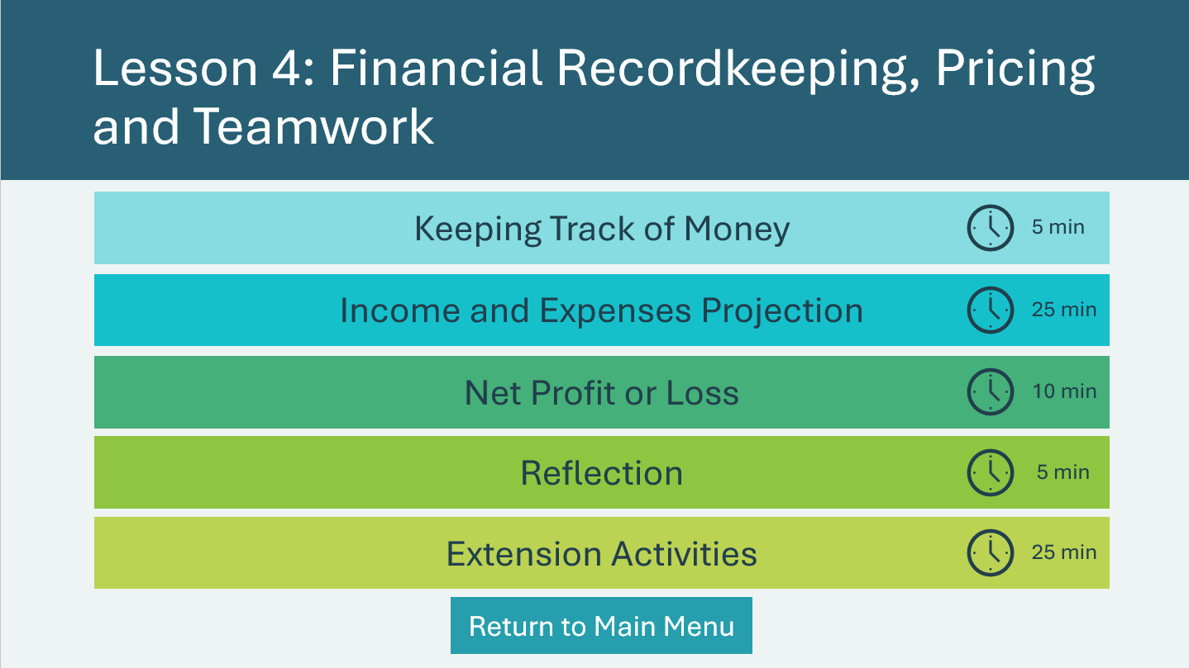 |  | *Select the button to navigate to the activity.  Select the buttons to jump to an activity or select next to begin the lesson.  *Click or tap the Return to Main Menu button to return to the Lessons (Slide 5).
Keeping Track of Money 5 min
Slide 68 – Keeping track of money |  | Suggested time: 5 minutes  In Lesson 1, students learned about expenses, income and profit.  Facilitator tip: Review vocabulary terms as necessary.  Businesses must keep records of their expenses and the money they make to calculate whether they are making a profit or not.  Businesses write down:  - Income → money they earn  - Expenses → money they spend  - Profit → the extra money left after paying expenses  Why is recordkeeping important?  - It helps you avoid losing money.  - It helps you know which ideas work.  - It allows you to make decisions based on actual figures.  While the bookkeeping team’s main responsibility is to track the money, all teams play a role in tracking their expenses.  Volunteer connection: Do you have experience in financial record keeping? In one or two sentences, share with the students what you do and how it helps your company/business.
Income & Expenses Projection 25 min
Slide 69 – Income and Expenses Projection |  | Suggested time: 2 minutes  An estimate of future income and expenses is called an Income and Expenses Projection.  Explain that businesses use projections to help find out what sales they will need to pay for their expenses.  Review the formula on the slide.  Profit or Loss = Income - Expenses  Total Income $____________  - Total Expenses - $ ____________  ----------------------------------------------  = Profit = $___________  Let’s see review how this works using Ali’s lemonade stand as an example.
Slide 70 – Expenses |  | Suggested time: 10 minutes  Projected Expenses  First, Ali listed all his expenses:  - Set-up: no expenses  - Merchandise: lemons = $10; Sugar $5  - He doesn’t have any additional expenses, as his friend is volunteering to help, and he made the poster using materials at home.  Next, he added all expenses together to get his total costs:  10$ + $5 = $15  Projected Expenses = $15  Now it’s your turn!  Have students calculate their projected expenses in their Student Portfolio, page 18.  Facilitator Tip: Depending on the age of the students, you could either lead this activity as a whole class or ask students to work in their teams to calculate the expenses. There is also an alternative simple budget worksheet on Appendix B (page 41).
Slide 71 – Pricing |  | Suggested time: 5 minutes  How much to charge?  Pricing is all about balance. You want a price that:  - Covers your costs  - Still feels fair to customers  - Helps you make a profit  Ask yourself:  - Would I pay this price?  - Would my friends pay it?  - Is it too high or too low?  A very high price might scare customers away, but a very low price might not cover costs.  When businesses choose prices, they think about what buyers want and what sellers need.  Example: Ali thought that 2$ would be a fair price for a glass of lemonade. He doesn’t have a lot of expenses, and he doesn’t think that the price is too high.  Now it’s your turn!  Ask students how much they should sell their product per unit. If they have already decided on a price during Lesson 1, ask them if they still think it’s a good price.  Facilitator Tip: Depending on the age of the students, you could either lead this activity as a whole class or ask students to work in their teams to calculate the expenses.
Slide 72 – Income |  | Suggested time: 7 minutes  Projected Income  Next, Ali guessed how many glasses of lemonade he will sell during the day. He estimated his income using this formula:  Number of units sold ___ X Price per unit $_____ = Projected Sales Income $_______  25 cups X $2 = $50  If he doesn’t make any other money, like tips or donations, his total income will be $50.  Now it’s your turn!  Ask students to estimate how many products they will sell.  Using the same formula on the slide, have students calculate their projected income and record it in their Student Portfolio, page 18.  Facilitator Tip: Depending on the age of the students, you could either lead this activity as a whole class or ask students to work in their teams to calculate the expenses.
Net Profit or Loss 10 min
Slide 73 – Profit or Loss |  | Suggested time: 10 minutes  Now Ali can estimate his profit or loss. Will he make money or lose money?  Projected Profit or Loss = Projected Income – Projected Expenses  Projected Profit = $50 - $15 = $35  His projected profit is positive, so that is great!  If it were negative, he would need to change something.  Business owners need to use critical thinking when making decisions about their business. He could spend less, sell more, or raise the price, but only if people would still buy.  During a sale, a business would record their sales and then use the same method to calculate their actual profit or loss (see Conclusion, slide 87 and Income and Expenses Statement, Student Portfolio page 22).  Now it’s your turn!  Have students calculate their estimated Net Profit or Loss in their Student Portfolio, page 18.
Reflection 5 min
Slide 74 – Reflection  Slide 75 – Key Ideas | Reflection question:  - What is one thing you learned about keeping track of money?  When we keep good records and choose smart prices, it’s easier to run a successful business. You’re not just guessing—you’re planning like real entrepreneurs!  Key Ideas:  - Keeping track of money helps you know if your business is working.  - A simple money plan helps you make smart decisions.  - Good prices balance what the buyers want and what sellers need.
Extension Activities 25 min
Slide 76 – Team Time |  | Suggested time: 15 minutes  Team Time: Students meet with their teams and continue planning the sale.  Students could:  - continue preparing for the sale;  - prepare price tags for the products; or  - continue working on the Income and Expenses Projection or other financial related activities.
Program Kit Materials |  | For slide 77, you will need to use the Cash Receipts from the program kit.  Cash Receipts  Price Tags
Slide 77 – Sales Records |  | Suggested time: 10 minutes  A cash receipt is a small paper that proves money was paid. It helps both the customer and the business keep track.  Ask: Why might a customer want a receipt?  Ask: Why might the business need a receipt?  Sample answers:  - To return or exchange something  - To know how much money was collected  What Goes on a Receipt?  Show a simple example of a cash receipt (or draw one on the board).  Explain each part:  - Received from: Who gave the money  - Amount: How much money  - For: What the money was for  - Date & Signature: When and who recorded the payment  Practice  Give each student (or pair) a blank receipt slip. Ask them to fill in a pretend sale, for example:  - A customer buys lemonade for $2  - The Sale Team gives the money to the Bookkeeping Team  Sample:  - Received from: Alex  - Amount: Two dollars ($2.00)  - For: 1 cup of lemonade  - Date + Student name  Facilitator Tip: If students will be running a sales stand, explain that the Bookkeeping Team will collect the money, give receipts, and record everything. Later, they’ll use these records to determine the real profit.

Business Activity
Sales Tracking Sheet
Program Kit Materials | Cash Receipts  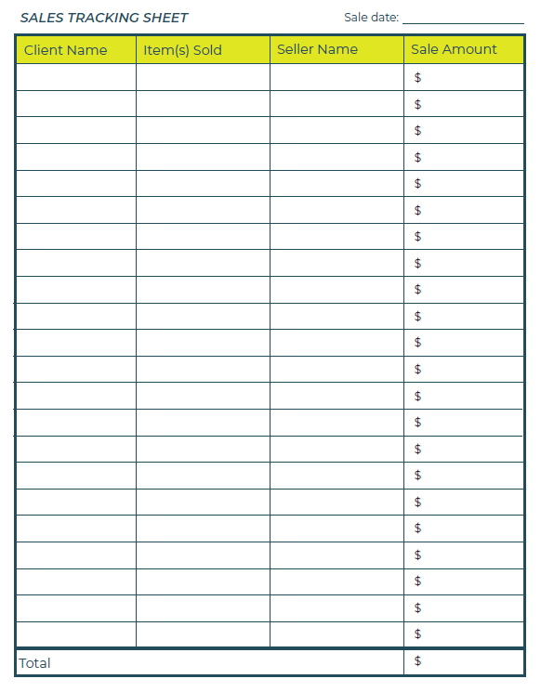  Price Tags
Slide 78 – Business Activity | Business Activity
Slide 79 – Objectives | Optional – review the learning objectives for the lesson
Slide 80 – Introduction | For their final activity, students will apply what they learned throughout the program in one of three ways:  - Sales Stand  - Bizcraft Game  - Business Pitch  Recall: An entrepreneurial mindset is a set of attitudes and skills that helps you identify opportunities, overcome challenges, and learn from mistakes (ex. Communication, collaboration, identification of opportunities, innovation, problem solving, etc.).  Entrepreneurial resiliency: the ability to adapt to changes in your business and bounce back when things are challenging.
Slide 81 – Business Activity Menu | *Select the button to navigate to the activity.  Select the buttons to jump to an activity or select next to begin the lesson.  *Click or tap the Return to Main Menu button to return to the Lessons (Slide 5)
Sales Stand 30-60 min
Program Kit Materials | For slides 81, you will need to use the Cash Receipts, Sales Tracking Sheet and the Price Tags from the program kit.  Sales Tracking Sheet  Cash Receipts  Price Tags
Slide 82 – Sales Stand | Suggested time: 30-60 minutes; adjust based on the time you have available with students.  It’s time for students to run their sales stand!  Prior to the sale, review the roles of each of the teams.  During the sale, support students and ensure that all sales are recorded. Students could record them digitally using a spreadsheet or simply on a piece of paper.  After the sale, ask the Bookkeeping team to calculate the total income and to complete the Income and Expenses Statement, Student Portfolio page 22.  Complete the Conclusion section with the entire class to finish the program.
Bizcraft 30-60 min
Slide 83 – Bizcraft | Suggested time: 30-60 minutes; adjust based on the time you have available with students.  Introduction  Explain to students that Bizcraft is an online game which simulates the operations of a business. Students play the role of a business CEO. Their goal is to try to make one million dollars by making important business decisions.  Chief executive officer (CEO): the highest-ranking person in charge of making the big decisions for a company.  They can make choices about:  - Product  - Target Market  - Pricing  - Production  - Environmental and Social Responsibility  Instructions  - Students can play individually or in pairs.  - Share the URL with students. No login is necessary. https://bizcraftapp.jacampus.org/  - After 25 minutes of game play, regroup students to reflect on the experience.  - See Appendix C on page 43 for more information about the game.  Facilitator Tip: During game play, circulate in the classroom and support students as necessary.
Business Pitch 30-60 min
Slide 84 – Business Pitch | Suggested time: 5 minutes; adjust based on the time you have available with students.  Introduction  Explain to students that a pitch is a short speech to quickly explain a business idea. Usually, the goal is to convince people to buy your product or to get money from investors to help with your expenses.  Play the Dragon’s Den video (Timestamp 0:00-3:47 min).  Prompt: Would you support this business idea? Why or why not?  URL: https://www.youtube.com/watch?v=EFAfuZKtgsQ  After watching the video, invite a few students to share their answers.  Facilitator tip: Play the video in full-screen mode and activate closed captions.
Slide 85 – The Pitch | Suggested time: 15 minutes  Review the prompts for a pitch on the slide.  - What is your company name?  - What is your product?  - Who is your target market?  - What is the problem you are trying to solve?  - How will your product help solve the problem?  - What will you do with your profits?  Ask students to work with their teams from Lesson 1.  Give students 15 min to create a brief pitch.  Students may refer to their business model canvas in their Student Portfolio, pages 4-5.  Presentations  Suggested time: 10 minutes  Invite each team to present their pitch to the class.  After each pitch ask students:​  - Would you buy this product? Why? Why not?​  - Who do you think would buy this product? Why? ​
Reflection 5 min
Slide 86 – Reflection | Suggested time: 5 minutes  Read the reflection question and invite a few students to share.  - How did participating in this activity help you develop your entrepreneurial skills and mindset?  - You can stimulate discussion by encouraging children to reflect on these entrepreneurial skills.  - Resilience and adaptability: The ability to face changes and challenges with a positive mindset and to adapt quickly.  - Problem-solving: Analyzing situations to make informed decisions and find the best solutions.  - Financial literacy: Understanding how to manage income and expenses.  - Leadership and teamwork: Motivating others and communicating effectively.  - Time management: Knowing which tasks to complete and how to prioritize them to achieve set goals.  - Social skills: Building relationships to identify opportunities and gain support.

Conclusion
Program Kit Materials | Certificates of Accomplishment  
Slide 87 – Conclusion | Conclusion
Slide 88 – Objectives | Optional – review the learning objectives for the lesson.  Review the Business Model Canvas.  Compare the activity experience to what real businesses do every day.  Reflect on developing entrepreneurial skills and mindset.
Slide 89 – Introduction | Explain to students they will be acting as the Board of Directors of their business. Their job is to review how things went, look at their plan, and suggest improvements—just like real businesses do.  Board of Directors — a group that reviews how a business is running and decides what could be improved.
Slide 90 – Activity Menu | *Select the button to navigate to the activity.  Select the buttons to jump to an activity or select next to begin the lesson.  *Click or tap the Return to Main Menu button to return to the Lessons (Slide 5)
Slide 91 – Reviewing the Business Model Canvas | Suggested time: 10 minutes  Reviewing the Business Model Canvas  Invite students to review their Business Model Canvas in their Student Portfolio, pages 4-5.  Ask students: With the experience and knowledge that you now have, what would you change or do differently?  Facilitator Tip: Focus on how the plan worked—not on individual students.  Additional prompts:  A. For students who ran the Sales Stand  - What was the most challenging part of running the stand?  - How did you solve problems when things didn’t go as planned?  - What did you learn about working with a team?  - How did you feel handling real money and real customers?  - What entrepreneurial skill (creativity, leadership, communication, teamwork, planning) did you improve the most?  B. For students who played Bizcraft  - Did your results change when you tried different strategies? Why?  - What did the simulation teach you about product, pricing, or supply and demand?  - What entrepreneurial skill did you practice most—problem solving? Strategy? Money management?  C. For students who did a business pitch  - What feedback did you get, and how would you improve your idea?  - What entrepreneurial skills did you use to convince others—creativity, confidence, speaking skills?  - What did pitching teach you about what customers want?
Slide 92 – Financial Review | Suggested time: 5 minutes  Optional: Financial Review  If students ran a sales stand in the school, ask them to review the sales results.  Have students open their Income and Expenses Projection and ask the Bookkeeping Team to present the Income and Expenses Statement.  Guiding questions:  - Were our expenses what we predicted? If not, why?  - Were our sales higher or lower than expected? Why?  - What was our final profit or loss? What caused it?  - If we were to do another sale, what changes should we make to our projections?  Profit  If applicable, review how students will use the profit (donate to charity, use to run another sale, etc.)
Slide 93 – Running a Real Business | Suggested time: 5 minutes  Ask students: What are some similarities and differences between our activity and running a real business?  Venn diagram  - First circle: Business Activity (Sales Stand/Bizcraft/Pitch)  - Second circle: Real Business  - Overlap: Similarities  Sample answers:  - Real stores pay rent, buy a building or have an online store  - Real stores buy a lot more merchandise  - Real stores use technology (cash registers, computers, scanners)  - Real businesses hire and pay employees  - Real stores run promotions over longer periods
Slide 94 – Congratulations | To conclude the program, review the learning outcomes on the slide with students.
Program Kit Materials | For slide 94, you will need to use the Certificates of Accomplishment from the program kit.
Slide 95 – Congratulations  Certificates of Accomplishment | Suggested time: 5 minutes  Wrap up the learning experience by asking students the following questions:  - What did you enjoy most about the program?  - What did you learn that you didn’t know before?  Thank the students and teacher for their participation and distribute the Certificates of Accomplishment.
Slide 96 – Bizcraft – Continue the Journey   | Invite students to apply their new entrepreneurial skills by planning Bizcraft. The game is free and available online: https://bizcraftapp.jacampus.org/
Slide 97 – JA Campus   | Tell the students you enjoyed spending the time with them and congratulate them on a job well done!  Invite students to visit jacampus.org for additional information and learning.

Sample Timeline
Create to-do list of tasks with students to help them organise the Sales Stand.

Simple Budget Sheet
Expenses
Item | Cost
TOTAL

Income
Sales | Amount
TOTAL

Profit
Income – Expenses = Profit or Loss
__________________________ - ___________________________ = __________________________

Bizcraft Game

Description
Students participate in an online simulation game as CEO to make business decisions.
URL: https://bizcraftapp.jacampus.org/
Item | Description
Grades | 3-8*  *For Grades 3-4, consider playing one game together as a class to support students and make group decisions.
Goal of game | Can your business make 1 million dollars?
Learning Objectives | Apply entrepreneurial skills and mindset to planning and running a successful business.
JA Pillars | Entrepreneurship, financial literacy, work readiness
Concepts | Business planning, business model canvas, product, production, target market, budgeting, expenses/income, pricing, corporate social responsibility/business ethics
Format | Online game; no login required
Duration | Suggested 30-60 min
Language | EN + FR
Game Play | Your Life Story  - Players choose between statements to create their avatar.  Business Canvas Model  - Players monitor and update their Business Model Canvas to try to earn more profit.  - Sections: Target Market Segments, Product, Promotions, Team, Resources and Suppliers, Locations, Expenses, Price and Daily Profit.  Resources and Suppliers  - Players can change suppliers for product materials. Different materials give bonuses or penalties (e.g., increased productivity, decreased public perception, etc.)  Scoring  - Throughout the game, the player has three different scores: Public Perception, Carbon Footprint, and Productivity.  Help  - If players need help, they can click on the Goals Button to find receive hints from a “Business Advisor”.  - Throughout the game, the Advisor will provide tips.

