
To be used in combination with the
JA Inspiration Toolkit
Be Entrepreneurial Presenter Notes
The Presenter Notes have been developed using references from the Be Entrepreneurial digital classroom presentation and should be used in combination with the digital classroom presentation and JA Inspiration Toolkit materials, including the printed JA Journal (v2027).
Tips for Setting Up the Classroom
- Arrive 15 minutes early and check in at the office.
- Connect with the teacher for the program materials and organize them as needed.
- Hand out the JA Journals and name tags/cards.
- Set up presentation (check audio and internet connection are working).
- Write your name on the board.
- Ask the teacher to write student names on program certificates.
- Check in with the teacher about school schedule, tips for getting students attention, any specific student needs & behaviors you should be aware of and ask for help with encouraging student participation, as well as monitoring and managing the class.

Planning Guide
WRAP UP (Slides 64 – 68) 20 MIN
LESSON 4 (Slides 52 – 63) 60 MIN
MOVING FORWARD WITH ENTREPRENEURSHIP
Core Activities:
- Review of Business Ideas (10 min)
- Developing the Business (20 min)
- Business Planning (15 min)
- Extended Activity (15 min)
LESSON 2 (Slide 27 – 37) 60 MIN
DETERMINING COMPETITIVE ADVANTAGE
Core Activities:
- Review of Business Ideas (10 min)
- Competitive Advantage (15 min)
- Vincenzo’s Restaurant (25 min)
- Extended Activity (10 min)

LESSON 3 (Slide 38 – 51) 80 MIN
DEFINING A TARGET MARKET
Core Activities:
- Review of Business Ideas (10 min)
- Introduction to Target Market (20 min)
- Describing a Target Market (40 min)
- Extended Activity (10 min)
LESSON 1 (Slide 7 – 26) 70 MIN
INTRODUCTION TO BE ENTREPRENEURIAL
Core Activities:
- Getting Started (5 min)
- Welcome to the Entrepreneurial Age (15 min)
- Deciding on a Product or Service (20 min)
- Businesses in the Community (20 min)
- Extended Activity (10 min)
GETTING STARTED – GETTING TO KNOW YOU (Slides 1-6) 5 MIN

Introduction
Slide 1 – Be Entrepreneurial   | Navigation Tips  - Navigate through the slides using the next or previous buttons (bottom right), clicking or tapping on the slide, or using the navigation menu (right)  - Look for slide specific instructions in the presenter notes below
Slide 2 – Welcome to JA!   | Suggested time: 3 minutes  Ask: Has anyone heard of Junior Achievement/JA before?  Play the video for students to introduce them to JA!
Slide 3 – Be Entrepreneurial Program   | Suggested time: 3-5 minutes  Introduce the program and yourself!  Volunteers, tell the students a little about you; your education, and your career path until this point. Explain why you chose to volunteer in their classroom today.
Slide 4 – Symbol Legend  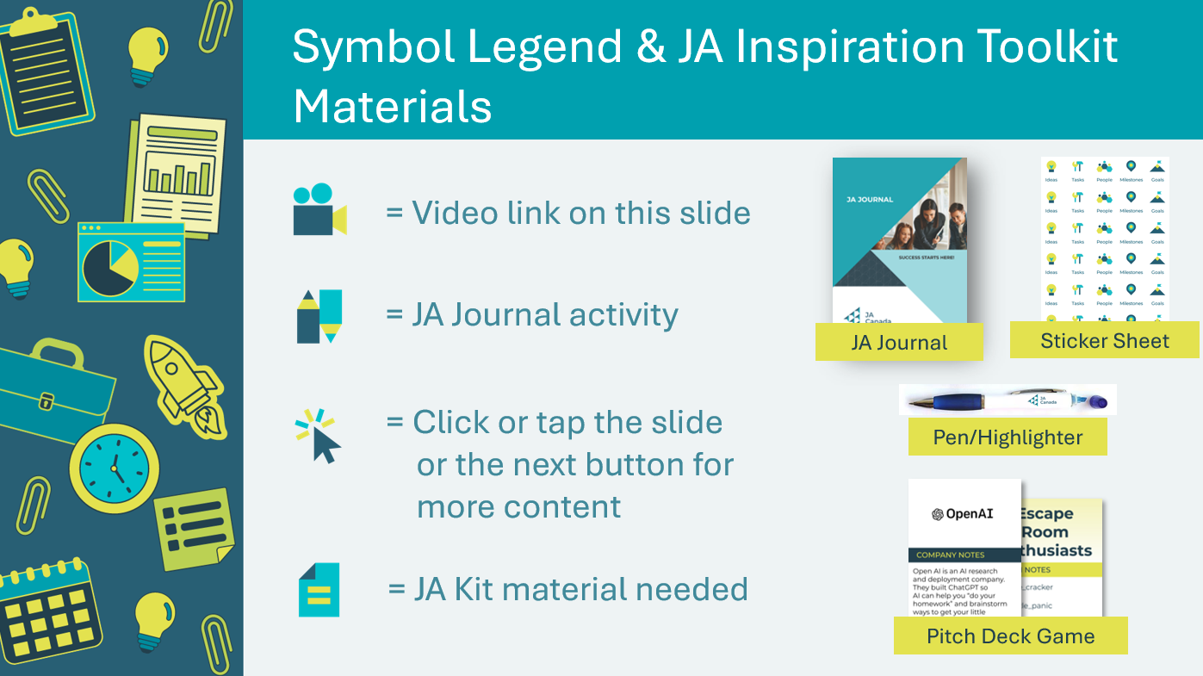 | The symbols will help guide the learning experience. Explain to students that they will see these symbols throughout the program.  Ensure the students have their JA Inspiration Toolkit materials (JA Journal, pen/highlighter and sticker sheet). Set aside the Pitch Deck game for lesson 3).
Slide 5 – JA Journal  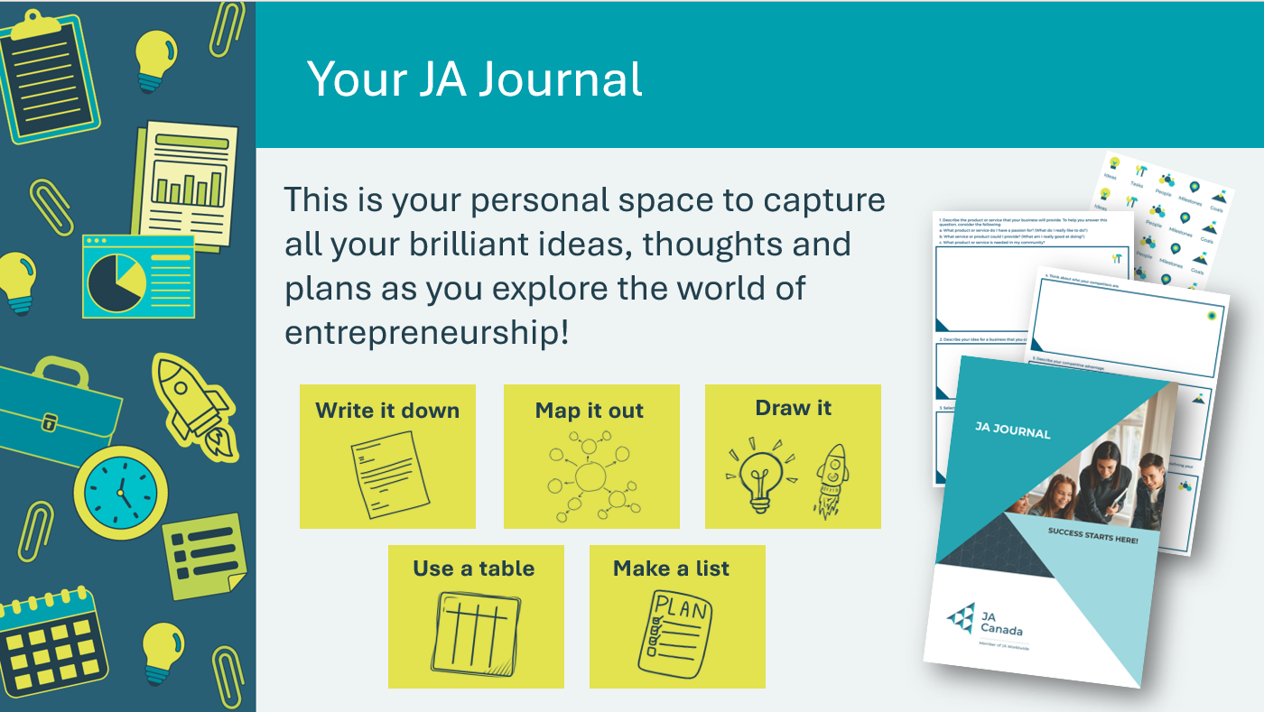 | Explain to students that they will be using their JA Journal to complete various activities throughout the program. The journal has blank pages for students to record their ideas and complete activities. It also has a business plan template for them to work through and build on in each lesson.  Review the different ways, pictured on the slide, that students can record their ideas and responses in their journal. Tell students they also have a sheet of stickers they can use in their journal to help organize their thoughts and ideas.  Remind the students they can keep this journal and continue to use it after the program is complete.
Slide 6 – Main Menu  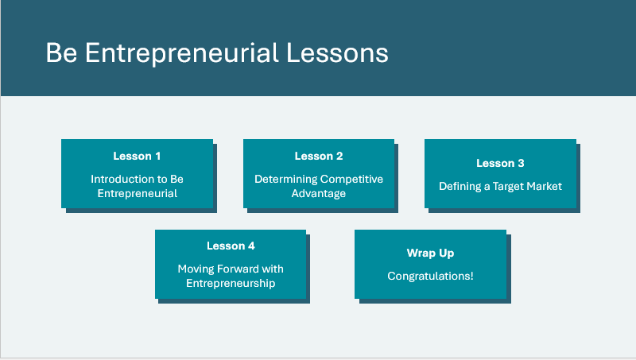 | *Select the button to navigate to the lesson.  After you have completed a lesson, you can select the Return to Main Menu button from the Lesson Activity Menu to return to this slide.

Lesson 1: Introduction to Be Entrepreneurial
Getting Started 5 min
Slide 7 – Lesson 1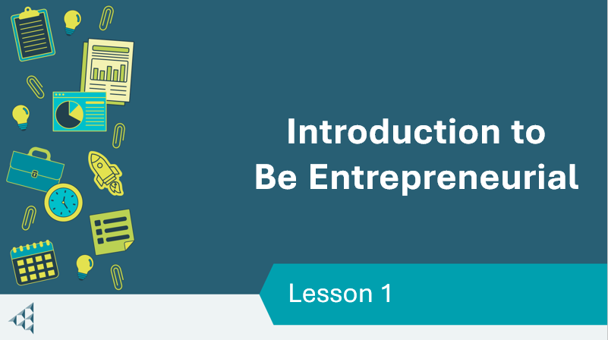 | Lesson 1: Introduction to Be Entrepreneurial
Slide 8 – Objectives  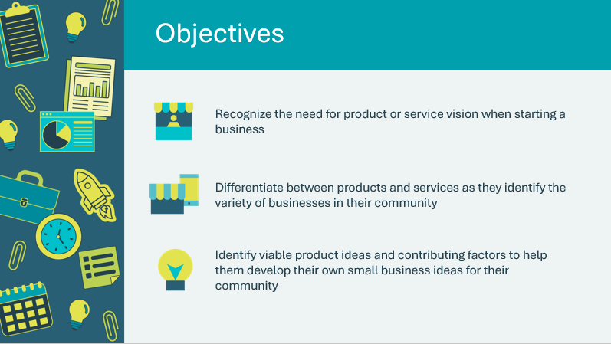 | Optional – review the learning objectives for the lesson  *The Learning Objectives have been updated. Please note there will be variance in the printed Facilitator Guide.
Slide 9 – Introduction  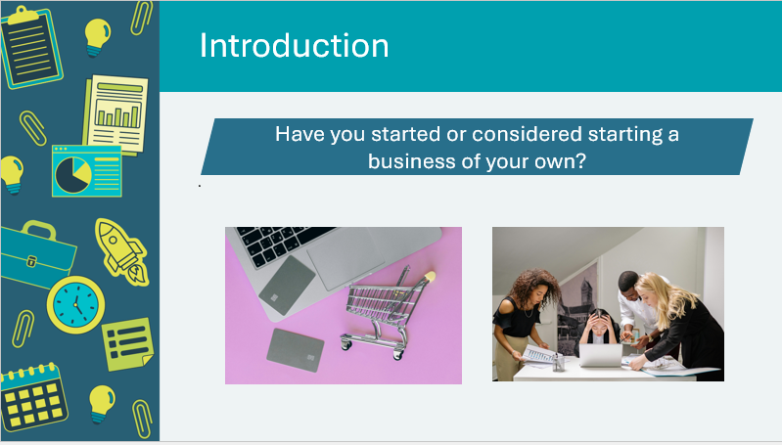 | Introduce the lesson by asking the prompt. Invite students to share ideas or understandings they have about businesses.  Explain to students that they will learn about businesses and what the key elements are to build a business plan.
Slide 10 – Lesson 1 Activity Menu  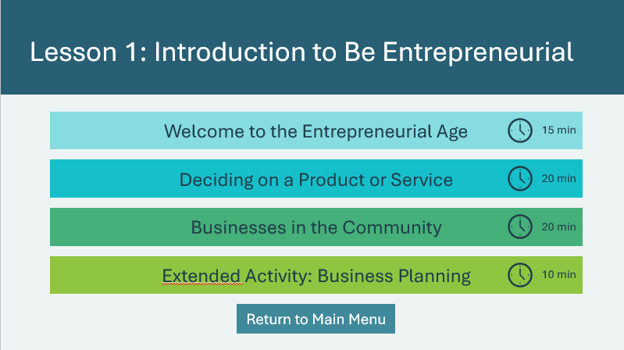 | *Select the button to navigate to the activity.  After you have completed an activity, you will be redirected back to the activity menu.  *Click or tap the Return to Main Menu button to return to the Lessons (Slide 6)
Welcome to the Entrepreneurial Age 15 min
Slide 11   | Suggested time: 3 minutes  Ask – Can you describe what an entrepreneur is?  Additional explanations can include - someone who exercises initiative by organizing a venture to take benefit of an opportunity and, as the decision maker, decides what, how, and how much of a good or service will be produced.  Remind students that even if they decide to not be an entrepreneur in the traditional sense, there are lots of opportunities to be an entrepreneur in a different career path as well. Think about an artist wanting to start up their own art gallery or coming up with innovative ideas for the company you work for (this is called an intrapreneur).
Slide 12   | Suggested time: 3 minutes  Ask - What are characteristics of entrepreneurs?  Encourage students to make suggestions before revealing possible responses.  *Click or tap to reveal each of the answers.  Explain that an entrepreneurial mindset is a set of skills and attitudes that help entrepreneurs identify opportunities, overcome challenges, learn from mistakes and grow personally and professionally.
Slide 13   | Suggested time: 3- 5 minutes  Ask - Why become an entrepreneur?  *Click or tap to reveal reasons for becoming an entrepreneur.  You may wish to use the following questions to facilitate the discussion as you review the reasons:  - What are advantages of being an entrepreneur?  - What are disadvantages of being an entrepreneur?
Slide 14   | Suggested time: 3-5 minutes  Ask - Why entrepreneurs are important to the Canadian economy?  - There are 1.1 million businesses in Canada and the vast majority (98.2%) are small (fewer than 100 employees) while medium companies (100–499 employees) account for 1.6%, according to Statistics Canada. Only 0.1% are considered large (over 500 employees).  - So, 99.9% of all Canadian companies are small or medium-sized (less than 500 employees) and they provide 90% of all private‑sector jobs in Canada, approximately10+ million people  Tell students that entrepreneurship has always been important to Canada’s economy. Share the following information to reinforce why entrepreneurship is so important today:  - According to a report called The State of Entrepreneurship in Canada by Industry Canada, entrepreneurship is alive and strong, the number of new companies is increasing at a healthy rate compared to other countries and those companies are surviving.
Slide 15   | Suggested time: 3-5 minutes  Introduce the entrepreneurial topics addressed in the lessons. Tell the students these are important topics to consider if they decide to start their own business.  - Vision for a product or service – consider a need and think of things you wished you had (I wish my school had..) and complaints you have (It really annoys me when…)  - Competitive advantage – It is important to research an idea to determine if it can translate into a viable business (prototype if possible and ensure you can produce it). If they determine that their idea is feasible, they should then continue to research the consumer and market.  - Target market - Research your consumer. It is important to research your target consumers to determine if they will buy your product or service (feedback about your idea).
Deciding on a Product or Service 20 min
Slide 16  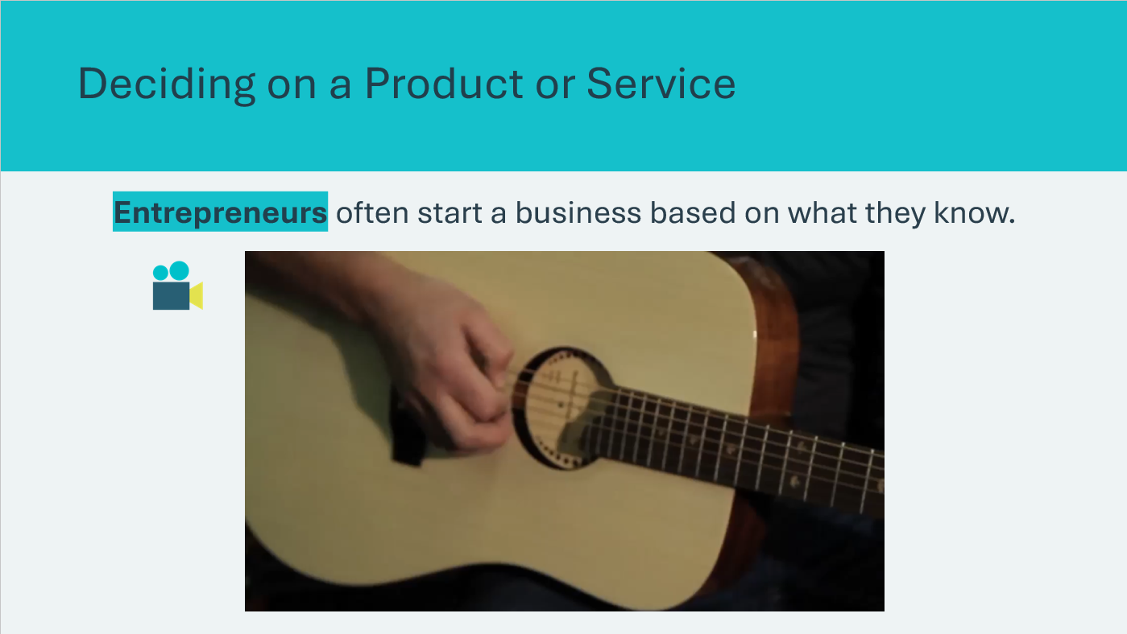 | Suggested time: 5 minutes  Tell students that entrepreneurs often start with an environment they know, or they do research on it to make sure they understand the viability of their business in a given location.  Show the video of Mike Miltimore from Riversong Guitars and have students identify what allowed him to get started in the guitar‑making business.  - Why did the guitar manufacturing business make sense for Mike Miltimore?  - How did an Internet marketing strategy help Riversong Guitars?  Facilitator tip: This activity is framed in the context of business opportunities in the students’ school, as this is a familiar environment.
Slide 17  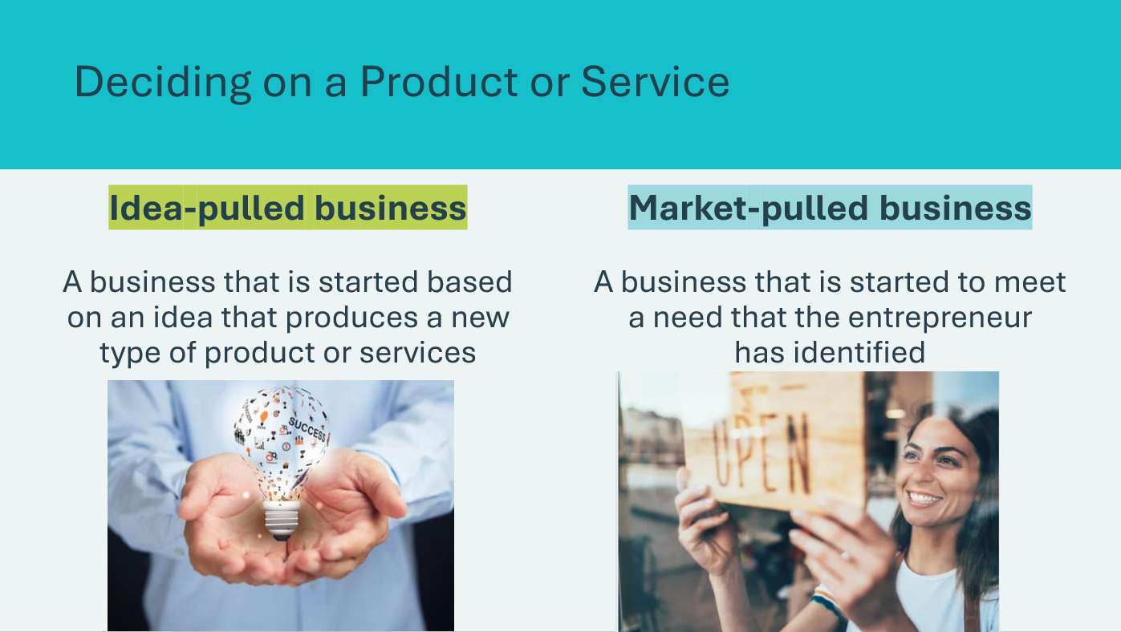 | Suggested time: 5 minutes  Explain to the students that there are two ways of looking at a need for a business. The first could be considered a basic need. This is something that a community or neighbourhood needs to make life enjoyable and to operate on a daily basis. You might not be creating a brand-new or innovative idea, but you are responding to a need. This is a market-pulled business.  Alternatively, another way of looking at a need for a business is known as an idea-pulled business. This might be a need that people have acknowledged, but they either haven’t acted on it, or they haven’t figured out how to solve it yet. It could also be a need that is more of an opportunity. An entrepreneur could see an opening (opportunity) in the market and then start a business around that. What people didn’t even realize was a need is now a booming business! Perfect examples of this are Airbnb and Uber.  Have students recall the video of Mike Miltmore and ask -  Do you think Riversong Guitars is an idea-pulled or market‑pulled business?  Volunteer connection: Share any applicable stories from your personal business experience. Give examples that illustrate idea-pulled and market-pulled businesses.
Slide 18 – 23  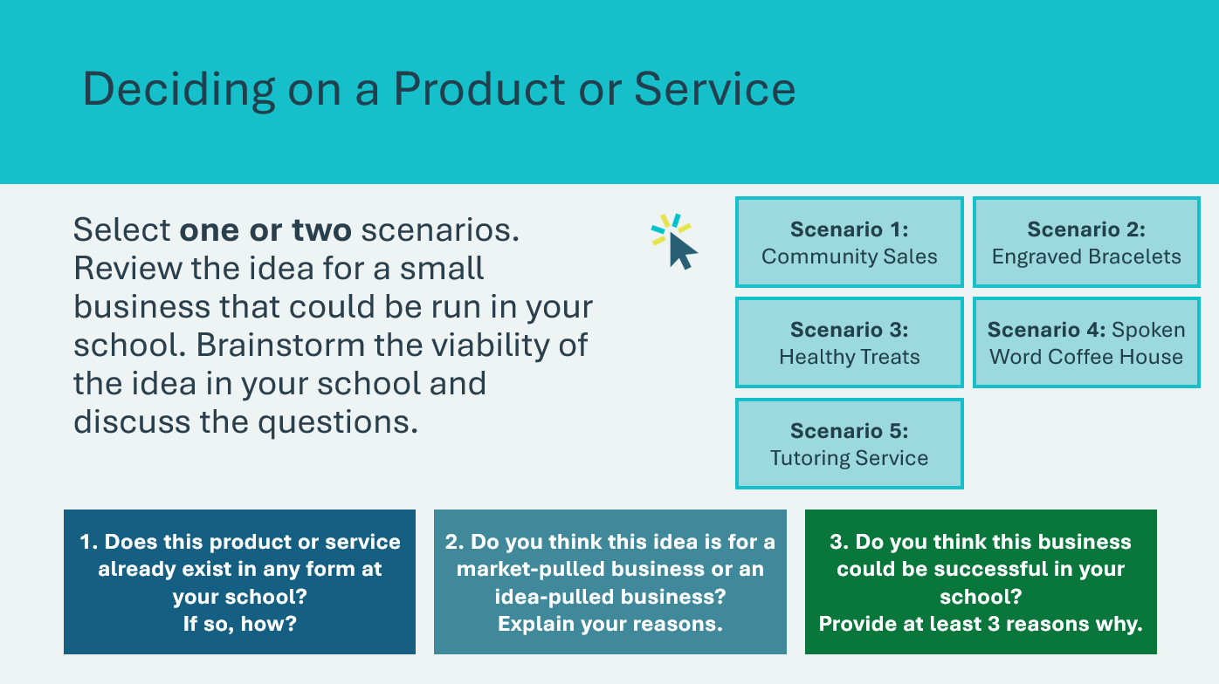 | Suggested time: 10 minutes  Select one of the scenarios by clicking or tapping the button on the slide.  - Scenario 1: Community Sales  - Scenario 2: Engraved Bracelets  - Scenario 3: Healthy Treats  - Scenario 4: Spoken Word Coffee House  - Scenario 5: Tutoring Service  Read the scenario to the class or invite a student volunteer to do so. Guide the class through a discussion using the question prompts on the slide, inviting students to share their ideas and responses.  Depending on the length of the discussion, you may wish to review a second scenario, or move on to the next slide.  *Click or tap the slide or next button to advance
Businesses in the Community 20 min
Slide 24  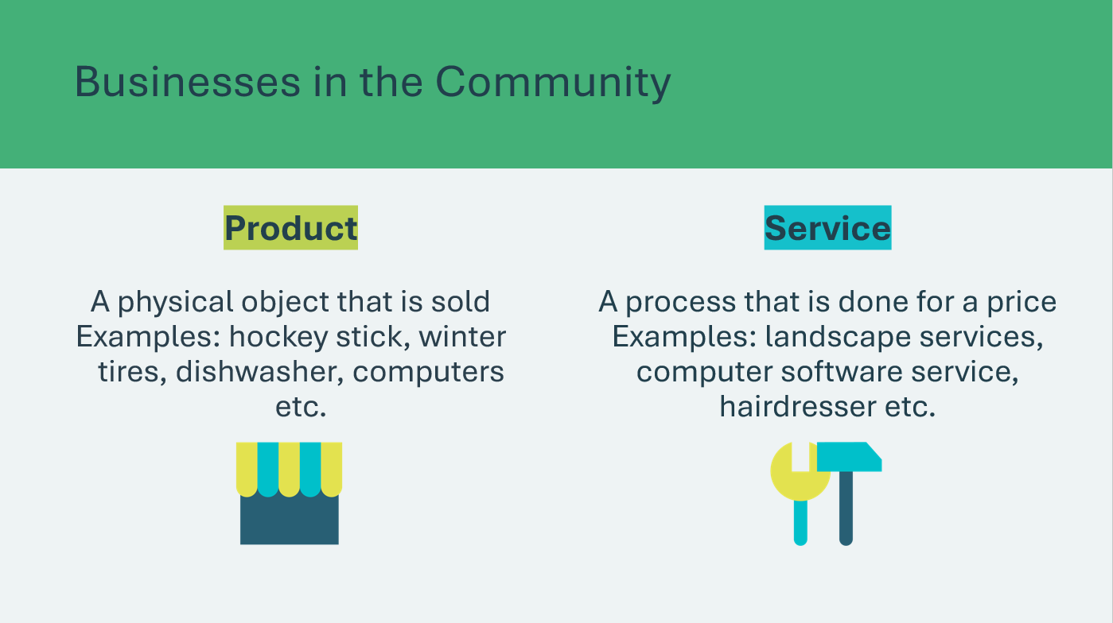  Slide 25   | Suggested time: 20 minutes  Define product and service. Tell students that this activity will help them think about the many types of businesses in their community so they can choose a business they could start.  Have students form a large circle. Explain the rules:  - Students will think of a business in their community and be ready to name it and to tell whether the business provides a product or a service  - They will listen carefully, so they do not repeat the type of business that has already been named.  Ask a student to start the game and proceed clockwise around the circle for two rounds. If a student cannot think of a business within a few seconds, move to the next person encouraging the student to respond during the next round.
Extended Activity 10 min
Slide 26  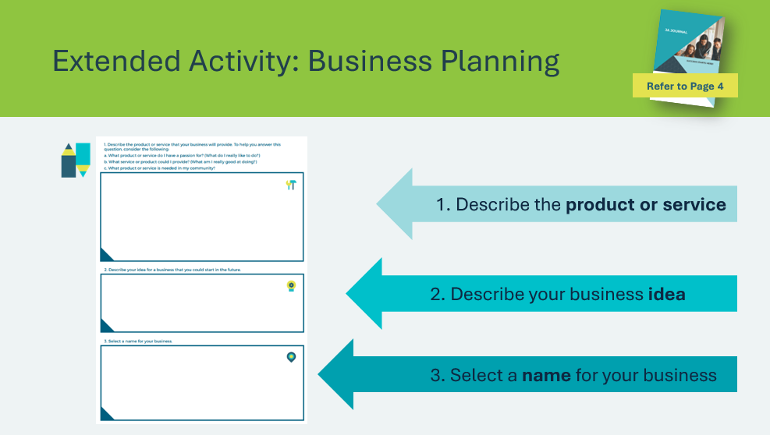 | Suggested time: 10 minutes  Introduce the six elements of business planning to students, found in their JA Journal. Tell students that they will be asked to complete the sections as they learn about the topics presented through the program lessons.  Explain that they should think of a business that they could start in their community and answer Questions 1, 2 and 3.  1. Describe the product or service your business will provide.  - What product or service do I have a passion for? (What do I really like to do?)  - What service or product could I provide? (What am I really good at doing?)  - What product or service is needed in my community?  2. Describe your idea (for a future business)  3. Select a name for your business.

Lesson 2: Determining Competitive Advantage
Slide 27 – Lesson 2   | Lesson 2: Determining Competitive Advantage
Slide 28 - Objectives  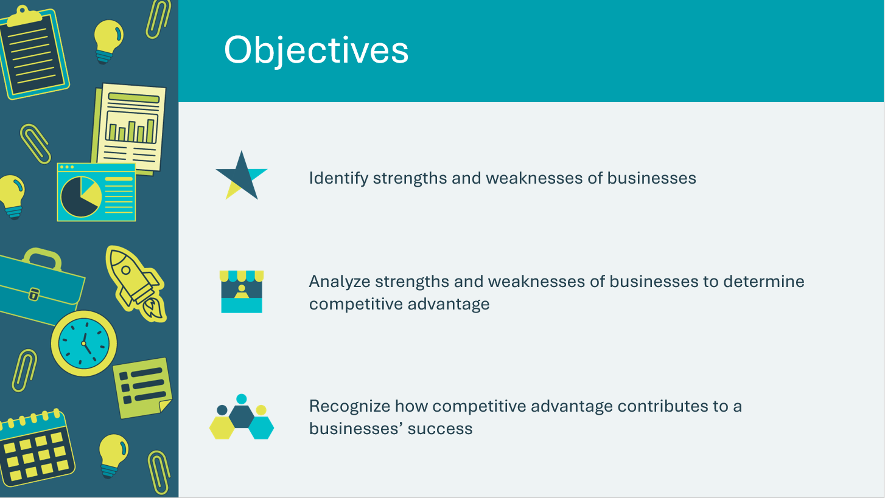 | Optional – review the learning objectives for the lesson
Slide 29 – Lesson 2 Activity Menu  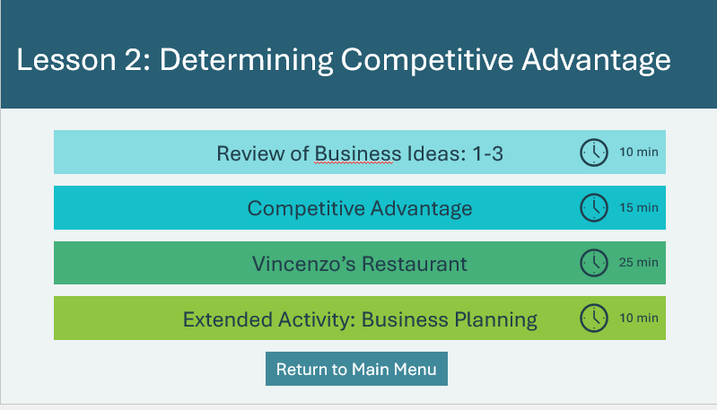 | *Select the button to navigate to the activity.  After you have completed an activity, you will be redirected back to the activity menu.  *Click or tap the Return to Main Menu button to return to the Lessons (Slide 5)
Review of Business Ideas 10 min
Slide 30   | Suggested time: 10 minutes  Introduce the lesson by asking students to share any ideas they have for businesses that they identified in Lesson 1. Write on the board or use the word cloud generator to add their business ideas/names.  Ask students to turn to the business planning questions from Lesson 1 in their JA Journal.  Ask students to describe their businesses and explain why they think their business would be successful. Invite other students to comment or ask questions.  *Click or tap the Word Cloud Generator button to open the web page in a new browser tab.
Competitive Advantage 15 min
Slide 31   Slide 32   | Suggested time: 15 minutes  Ask students to think about a product they have bought and explain why they chose that product. As students respond, list their choices under general categories such as price, features, matching their needs, etc.  Ask why they think that it would be crucial for a business to make itself different from other businesses.  *Click or tap to display the definition for Competitive Advantage  Moccasin Joe Coffee Roasters is a family-run business located in Kanesatake, a Mohawk community west of Montreal. It was founded by Walter David in 2006.  Introduce and show the video about Moccasin Joe Coffee Roasters and ask the following discussion questions:  - How does Moccasin Joe Coffee Roasters make their coffee different from their competitors?  - Do you think a business like Moccasin Joe Coffee Roasters would work in your community? Explain your thinking.  - Bonus question: Why might it be important for businesses like Moccasin Joe to prioritize relationships and values over volume and profit?  - This prompt can help students to think about values-based entrepreneurship and community-driven business models.  Moccasin Joe Coffee Roasters supply coffee to restaurants and retailers. In the video, Julie Ann and Mike David identify different ways in which Moccasin Joe Coffee Roasters makes itself different from other coffee businesses:  - Family-run business  - Buying coffee directly from farmers  - Partnering with Indigenous organizations (e.g., Campesino Committee of Highland (CCDA))  - Indigenous owned businesses throughout the whole supply chain, from farmer to roaster.  Bonus question sample answers:  - This focus allows the business to benefit the whole community, not just the owners.  - E.g., fair wages for coffee bean farmers  - E.g., supporting farming practices that are respectful to the earth and non-human life  - Building relationships with customers and suppliers means you can better understand their needs and offer better service.  - This is an example of values-based entrepreneurship and a community-driven business model.  Volunteer connection: Share any information or experience you have with a business to demonstrate competitive advantage.
Vincenzo’s Restaurant 25 min
Slide 33    Slide 34  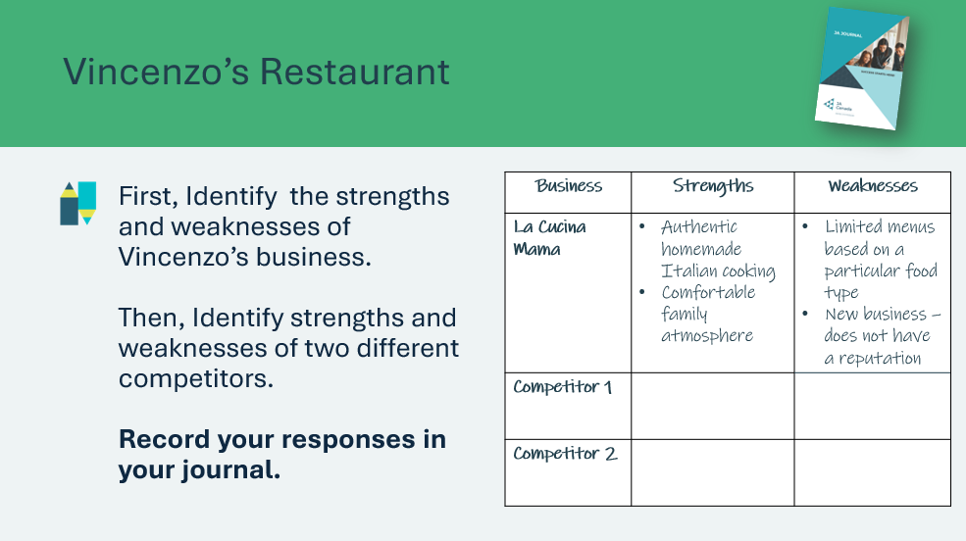 | Suggested time: 15 minutes  Play the video to introduce the scenario about Vincenzo’s restaurant. After watching, explain that Vincenzo is trying to find a place where his restaurant will be successful and has identified what he thinks are his strengths and weaknesses.  Ask students to identify Vincenzo’s business’s strengths and weaknesses by recording them in their journal. They can use the examples provided and/or come up with their own ideas. Students can record their ideas using the blank pages in their JA Journal. They may wish to use a table, as shown on the slide, or record their ideas in a different format, such as a list or mind map.  Tell the students that Vincenzo is considering opening his restaurant in their community and ask them to identify two other restaurants that might be competition for Vincenzo. Students will add the names of these restaurants to their journal page.  Organize the students into groups of four or five. Students will complete the strengths and weaknesses boxes for the two local businesses in their JA Journal.  Facilitator tip: It is important to remind students that there is not only one right answer for the strengths and weaknesses as it is a matter of opinion that can be supported by students’ knowledge of the businesses. Students will refer to these identified strengths and weaknesses to creatively suggest ways for the fictional restaurant to increase its competitive advantage.
Slide 35    Slide 36 | Suggested time: 10 minutes  Give the groups 5 minutes to think of two creative ways for Vincenzo to increase the competitive advantage of his restaurant. The group can record their ideas in their JA Journal. When 5 minutes have passed, ask each group to share one of their ideas and record it on the board. If groups have similar ideas, only record the idea once.  Facilitator tip: Use the 5 minute timer, note that an alarm sound will indicate when the time is up.  Read out each idea and using a show of hands, have students vote for their favourite idea. Tally up the votes to identify the top two ideas.  Wrap up the activity using the discussion questions.  *Click or tap to reveal each question.
Extended Activity 10 min
Slide 37  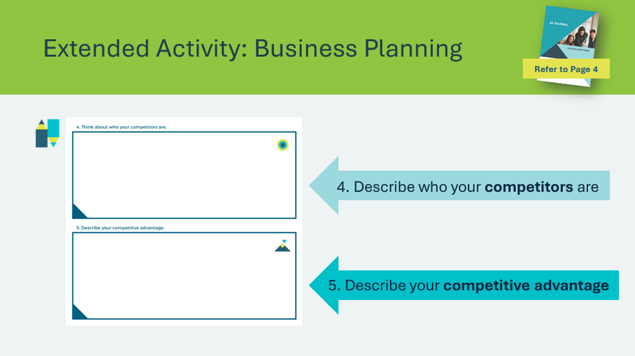 | Suggested time: 10 minutes  Ask students to complete page 6 in their JA Journal.  4. Describe who your competitors are.  5. Describe your competitive advantage.

Lesson 3: Defining a Target Market
Program Kit Materials | Pitch Deck Card Game  
Slide 38   | Lesson 3: Defining a Target Market
Slide 39  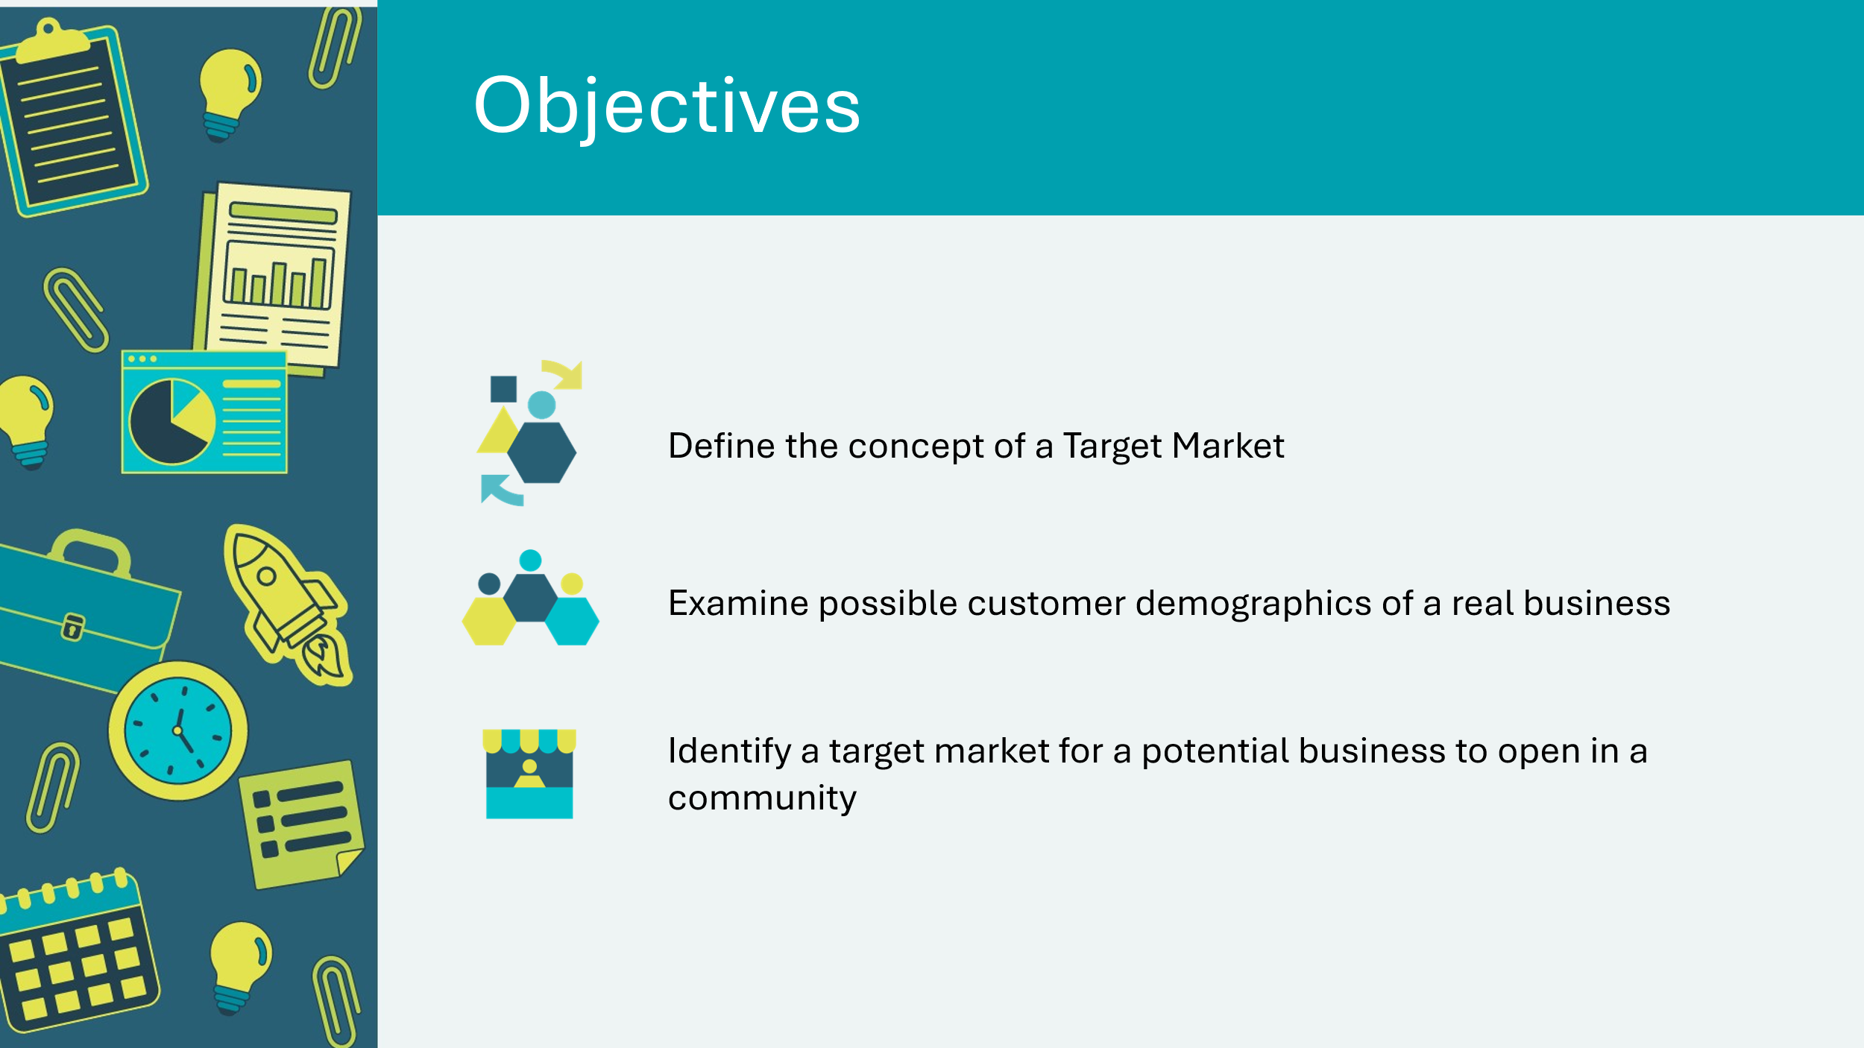 | Optional – review the learning objectives for the lesson
Slide 40 – Lesson 3 Activity Menu  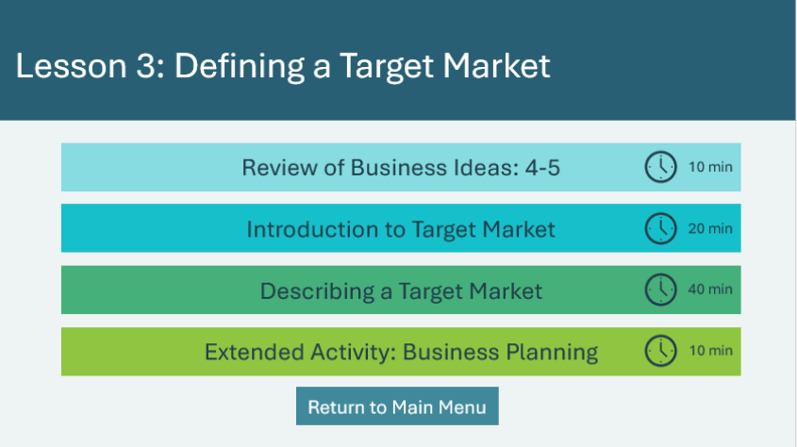 | *Select the button to navigate to the activity.  After you have completed an activity, you will be redirected back to the activity menu.  *Click or tap the Return to Main Menu button to return to the Lessons (Slide 5)
Review of Business Ideas: 4-5 10 min
Slide 41 – Introduction   | Suggested time: 10 minutes  Introduce the lesson by asking students to share any insights on what they included on page 6 of their business plan in their JA Journal. Write on the board or use the word cloud generator to display their ideas.  *Click or tap the Word Cloud Generator button to open the web page in a new browser tab.
Introduction to Target Market 20 min
Slide 42   | Suggested time: 2 minutes  Introduce the concept of target market.  Describing a target market involves identifying the most likely customer given the type of product or service being offered. However, it is important to emphasize that the product or service is available to all customers and many sales could be made outside of the target market.
Slide 43  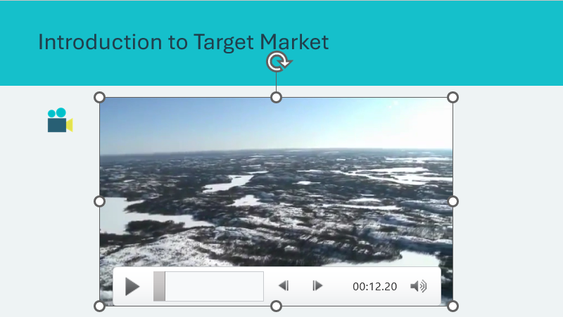 | Suggested time: 5-10 minutes  Play the Arctic Fitness video. The company featured in the video is Arctic Fitness in Yellowknife, NWT.  Ask students to identify a product or service and the characteristics of its target market. Record their suggestions on the board. Prompt responses by suggesting products and services such as:  - Music videos  - SUVs  - Building supply stores  - Laundry service  - Snow removal service  Guide their responses with question such as:  - What evidence from the video supports your identification of the target market?  - How does location fit in with Tara’s plans to establish a market?
Slide 44   | Suggested time: 5-10 minutes  Show the images of the companies and ask students to identify the target market.  *Click or tap to display the next company.  Lululemon:  Target Market: Active individuals, primarily women and men aged 18-40, who are interested in high-quality athletic apparel and accessories for yoga, running, and other fitness activities.  Tim Hortons:  Target Market: A broad demographic of coffee and fast-food consumers, including families, commuters, and students, who appreciate affordable and convenient food and beverage options.  Shopify:  Target Market: Entrepreneurs and small to medium-sized businesses looking for an easy-to-use e-commerce platform to create and manage online stores.  G Adventures:  Target Market: G Adventures primarily targets adventure-loving travelers who seek unique, small-group travel experiences. Their primary market includes young adults, young retirees and single travelers.
Describing a Target Market 15 min
Slide 45   | Suggested time: 15 minutes  Now that students have identified the target markets for each of the four companies, they will record the characteristics of each company’s target market in their journal.  Students may wish to record their responses using a mind map or a list. Allow student 10 minutes to work in their JA Journal.  Use the last 5 minutes to invite students to share the characteristics they listed for each target market.  You may wish to reference the following examples of target market characteristics to support the discussion.  Lululemon  - Health conscious or health and wellness focused  - Active and fitness oriented (yogis. Runners, gym go-ers)  - Style savvy, value performance and aesthetics  - Socially conscious, value sustainability and ethical brands  - Young professionals and those living in urban areas with busy, active lifestyles  Tim Hortons  - Wide range of customers from families to students to working professionals  - Value affordability and convenience  - Proudly Canadian  - Enjoy coffee  - Family oriented  Shopify  - Entrepreneurs and small-to-medium sized business owners  - Tech savvy and digitally driven  - May wish to sell globally  - Want to grow their business  - Passionate about e-commerce  - Like using data and marketing tools  G-Adventures  - Adventure and experience seekers  - Value immersive and cultural experiences over luxury vacations  - Young travelers looking to travel with a group  - Value sustainability and social impact  - Curious and open-minded, enjoy stepping outside their comfort zones  - Active and enjoy outdoor activities
Program Kit Materials | For slides 46-49, you will need to use the Pitch Deck Card Game from the program kit.
Slide 46    Pitch Deck Card Game  Slide 47  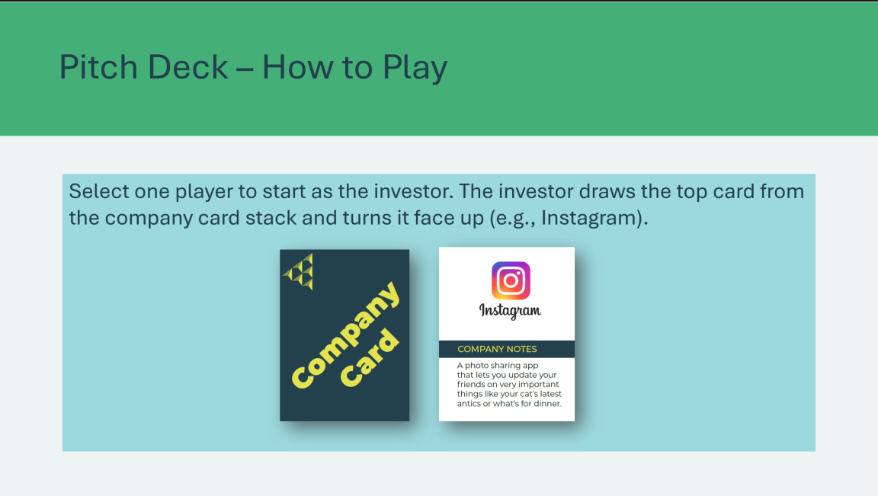  Slide 48    Slide 49  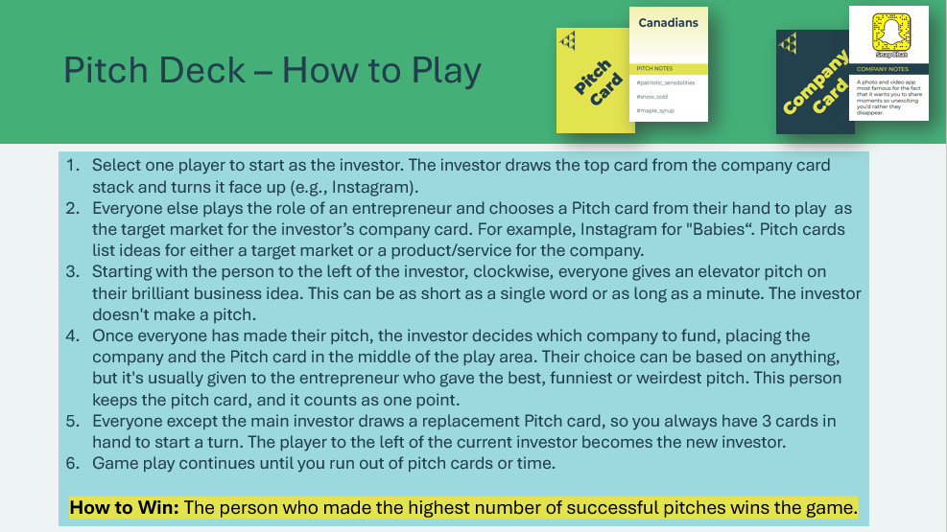 | Suggested time: 20 minutes  Explain to students they will be playing a game called pitch deck in which they will apply their knowledge of target markets and work on their pitch skills.  Let students know that Pitch Deck is a satirical game and is not affiliated with any company or service mentioned in the game. The descriptions on the company cards and the hashtags on the pitch cards are meant to be funny and may not be entirely factual.  Review the instructions for getting started on the slide. You may wish to review the rules and pitch tips on the next slides before breaking students off into groups.  Facilitator Tip: The full game rules are available for your review in the Appendix.  Review the rules for how to play and win.  *Click or tap the slide to advance through the rules.  Let students know about pivoting.  - Pivoting: Every card in Pitch Deck is hilarious and good, but if someone doesn't like the cards they're holding, once per game they can discard 3 cards and draw 3 new ones.  Depending on the group of students, you might consider the following variation:  - Co-founders: Depending on the class composition and size, you could play in 2-person teams. Each team shares one hand of pitch cards and decides collectively which cards to use. You can make pitches together or alternate (one person gives the pitch every other round).  Review the pitch tips and break students off into their groups to play. You can leave the pitch tips slide or the next slide with the rules posted for students while they play.  Allow students to play for about 15 minutes.  Facilitator tip: Circulate the room while students play and provide support as needed.
Slide 50   | Suggested time: 5 minutes  Wrap up the game by identifying winners within their groups and most successful pitches overall.  Use the discussion questions to support students in making real-world connections between their game experience and the concepts they’ve learned, such as product/service ideation, target market, and business pitches.
Extended Activity 10 min
Slide 51  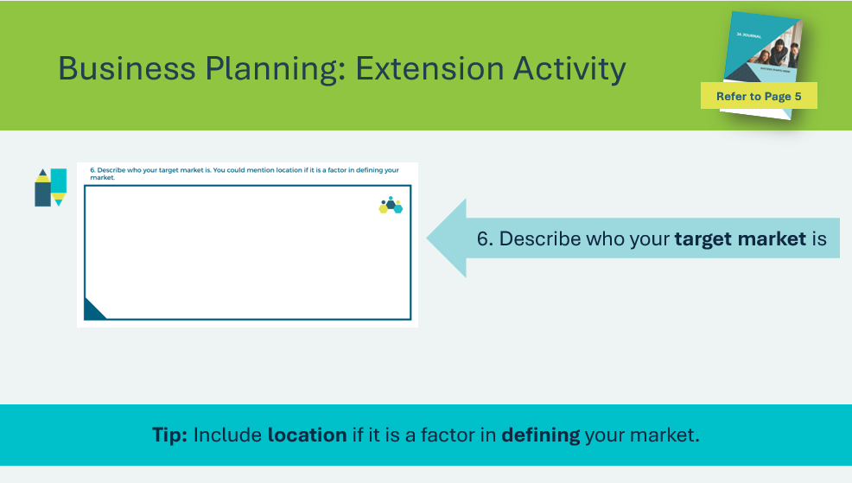 | Suggested time: 10 minutes  Ask students to complete p.7 in their JA Journal. Describe who your target market is. You could mention location if it is a factor in defining your market.

Lesson 4: Moving Forward with Entrepreneurship
Slide 52 – Lesson 4  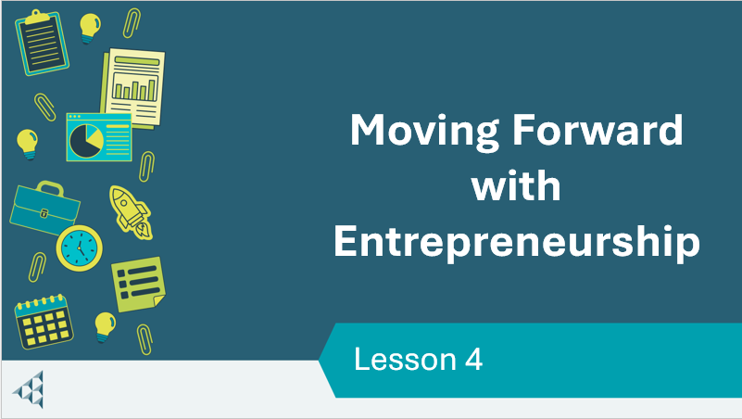 | Lesson 4: Moving Forward with Entrepreneurship
Slide 53  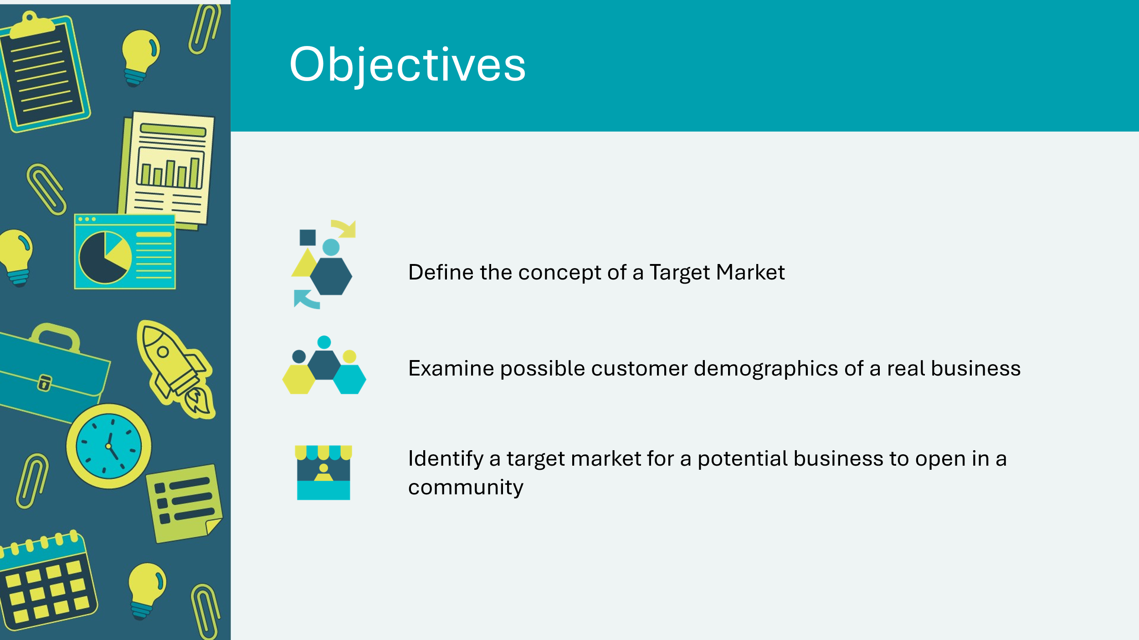 | Optional – review the learning objectives for the lesson
Slide 54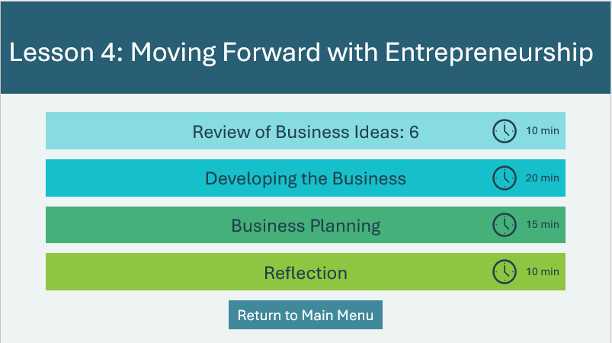 | *Select the button to navigate to the activity.  After you have completed an activity, you will be redirected back to the activity menu.  *Click or tap the Return to Main Menu button to return to the Lessons (Slide 5)
Review of Business Ideas: 6 10 min
Slide 55   | Suggested time: 10 minutes  Have students briefly share who their target market is and why. Invite other students to comment.  Introduce the lesson by asking students to share any insights on what they included in sections in their business plan. Write on the board or use the word cloud generator to display their ideas.  *Click or tap the Word Cloud Generator button to open the web page in a new browser tab.  Volunteer connection: Share any information or experience that you have to demonstrate the importance of knowing the target market for a business.
Developing the Business 20 min
Slide 56   | Suggested time: 2 minutes  Explain to students that agility in business involves the ability to quickly adapt to changes, make informed decisions, and pivot strategies as needed to respond to market demands and opportunities. This flexibility is crucial for growth and staying competitive in today’s economy.
Slide 57   | Suggested time: 10 minutes  Explain to students that in today’s economy companies often have to make decisions and change direction as they grow.  Ask the prompt and invite students to share any examples they may have.  *Click or tap to display the following examples:  - Nintendo, which started out as a card game company before branching out in to video games  - McDonald’s when they introduced McCafe or all-day breakfast.
Slide 58  Slide 59  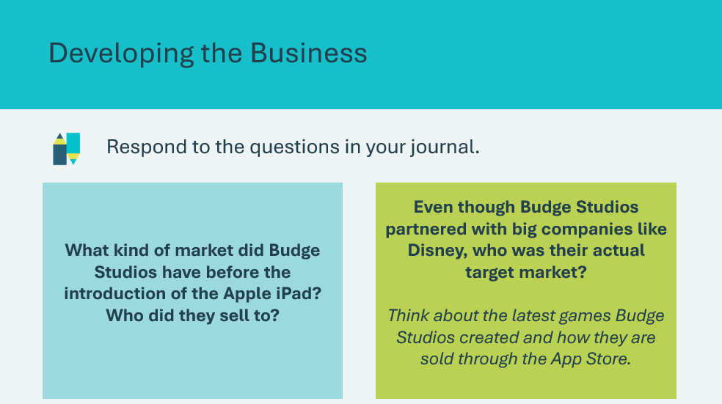 | Suggested time: 10 minutes  Show the video about Budge Studios.  Ask the students to answer the two questions about Budge Studios in their JA Journal and follow up with a discussion.  Volunteer connection: Share any stories from your personal business experience that fit with the discussion.
Business Planning 15 min
Slide 60   | Suggested time: 2 minutes  In this activity, students will review the information they identified about a business they want to start and discuss the research and resources they need to complete a full business plan.  Explain that a business plan is a summary of all aspects of a business that demonstrates the entrepreneur has done considerable research and thoroughly understands the type of business they are proposing. An entrepreneur must be able to understand and articulate all aspects of their proposed business.  The understanding of a business is often captured in a formal written document called a Business Plan. By creating a written business plan, the entrepreneur expresses understanding of the potential business. A business plan is often required to obtain funding needed to start the business.
Slide 61  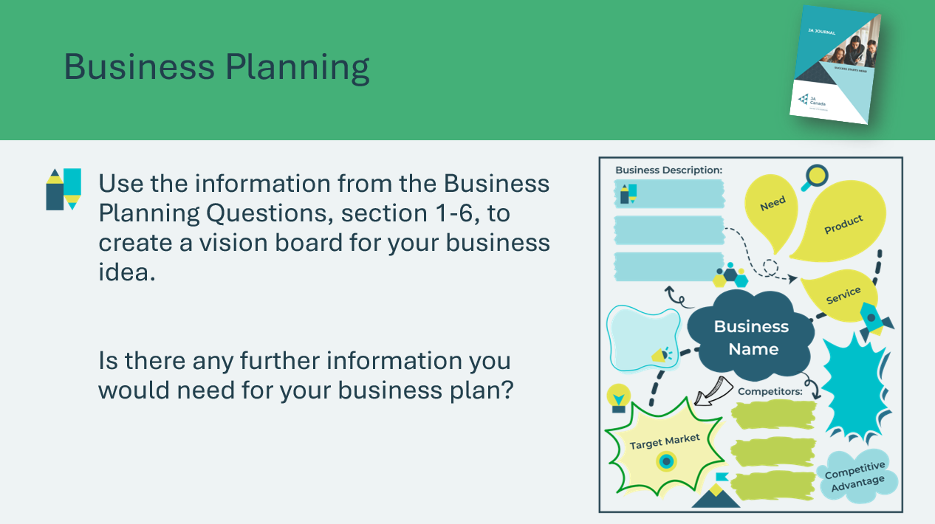  Slide 62   | Suggested time: 10-15 minutes  Tell the students that the information they identified by completing sections 1–6 in their JA Journal throughout the lessons is the beginning of a business plan.  Ask students to use this information to draw and complete a vision board for their business idea in their JA Journal. They should also identify what further information they would need in planning for their business.  Brainstorm what other information they need to complete a full business plan and where they can get that information. Supplement their ideas with information that you have.  For example, people who are starting a business should speak with a small business support person (e.g., at a financial institution) and should seek out resources in their community to help them in their planning.  Tell students that there are many tools and sources of information available for getting started with an entrepreneurial business. (e.g., government offices, Internet)
Extended Activity – Financing a Start Up 5 min
Slide 63  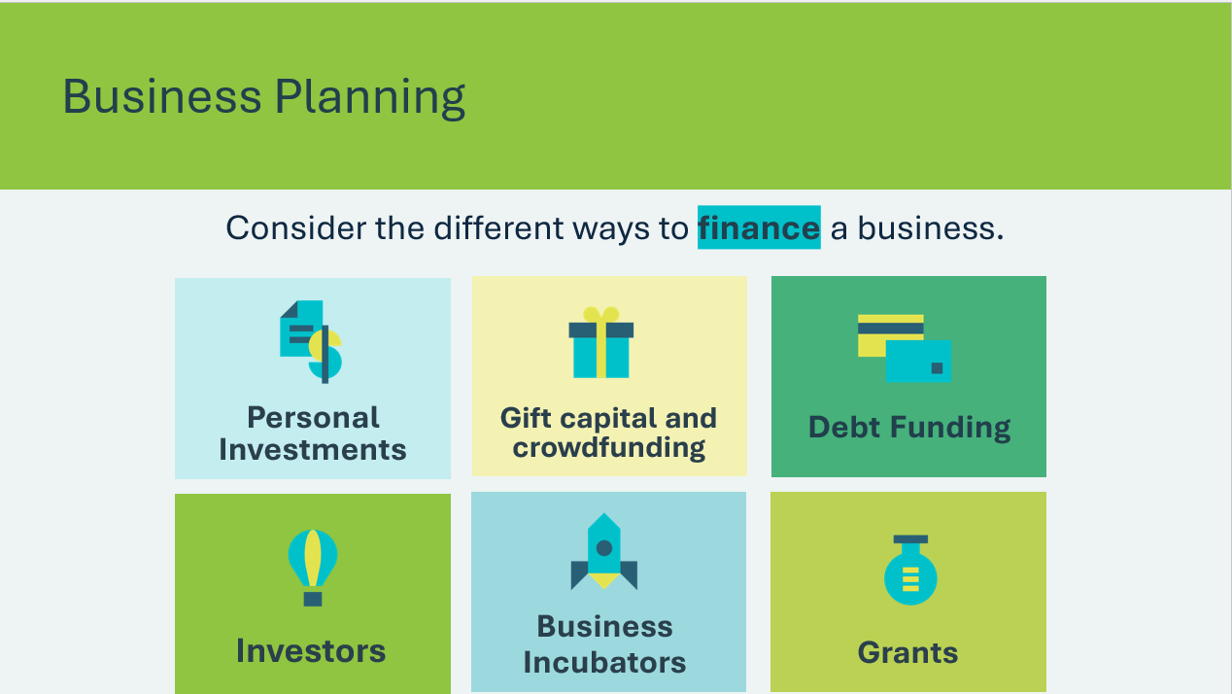 | Suggested time: 5 minutes  Explain the different ways entrepreneurs can finance their business.  Personal investment: Using your own money or assets.  Gift capital and crowdfunding: Money loaned by a partner, parents, family or friends.  Bank loans: Money borrowed from a bank or financial institution. The most commonly used source of funding for small and medium-sized businesses.  Venture Capital: Capital provided to technology-driven companies with high-growth potential. The Venture Capital investors take an equity in the business to help it carry out promising, but higher-risk projects.  Angel Investors: Angels are generally wealthy individuals or retired company executives who invest directly in small firms  owned by others. In turn for risking their money, they reserve the right to supervise the company’s management practices.  Business incubators/accelerators: They generally focus on the high-tech sector by providing support for new businesses  in various stages of development, such as office space, administrative and logistical resources and mentoring.  Grants, subsidies and tax credits: Government agencies funding. You may have access to this funding to help cover expenses, such as research and development, marketing, salaries, equipment and productivity improvement. Canada Business provides sources of financing, including government assistance.
Slide 64    Slide 65  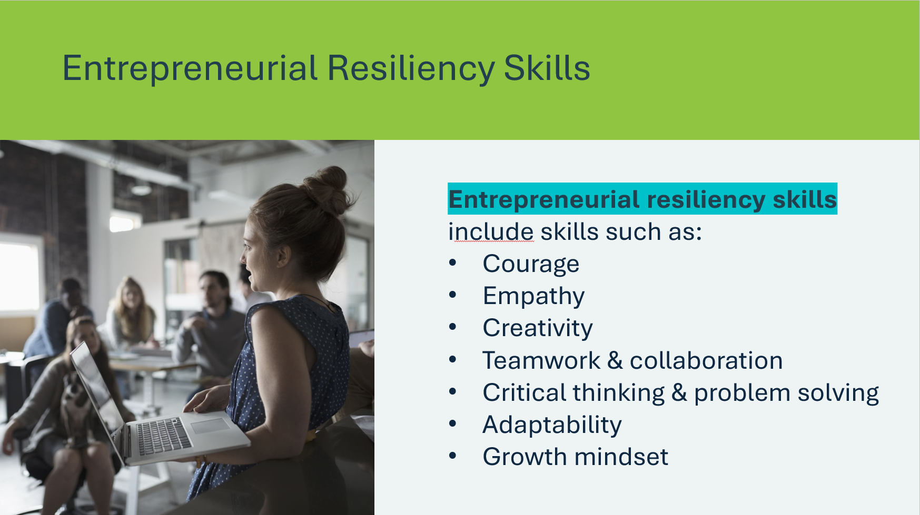 | Suggested time: 5 mins  Explain that every entrepreneur faces challenges, setbacks and failures along the way. How they respond is key to their success.  Define entrepreneurial resiliency.  Emphasize why it matters:  - Builds problem-solving skills  - Helps you bounce back from failure  - Improves ability to persevere when things are tough  - Strengthens confidence  Review some of the key skills that contribute to entrepreneurial resilience.
Slide 66  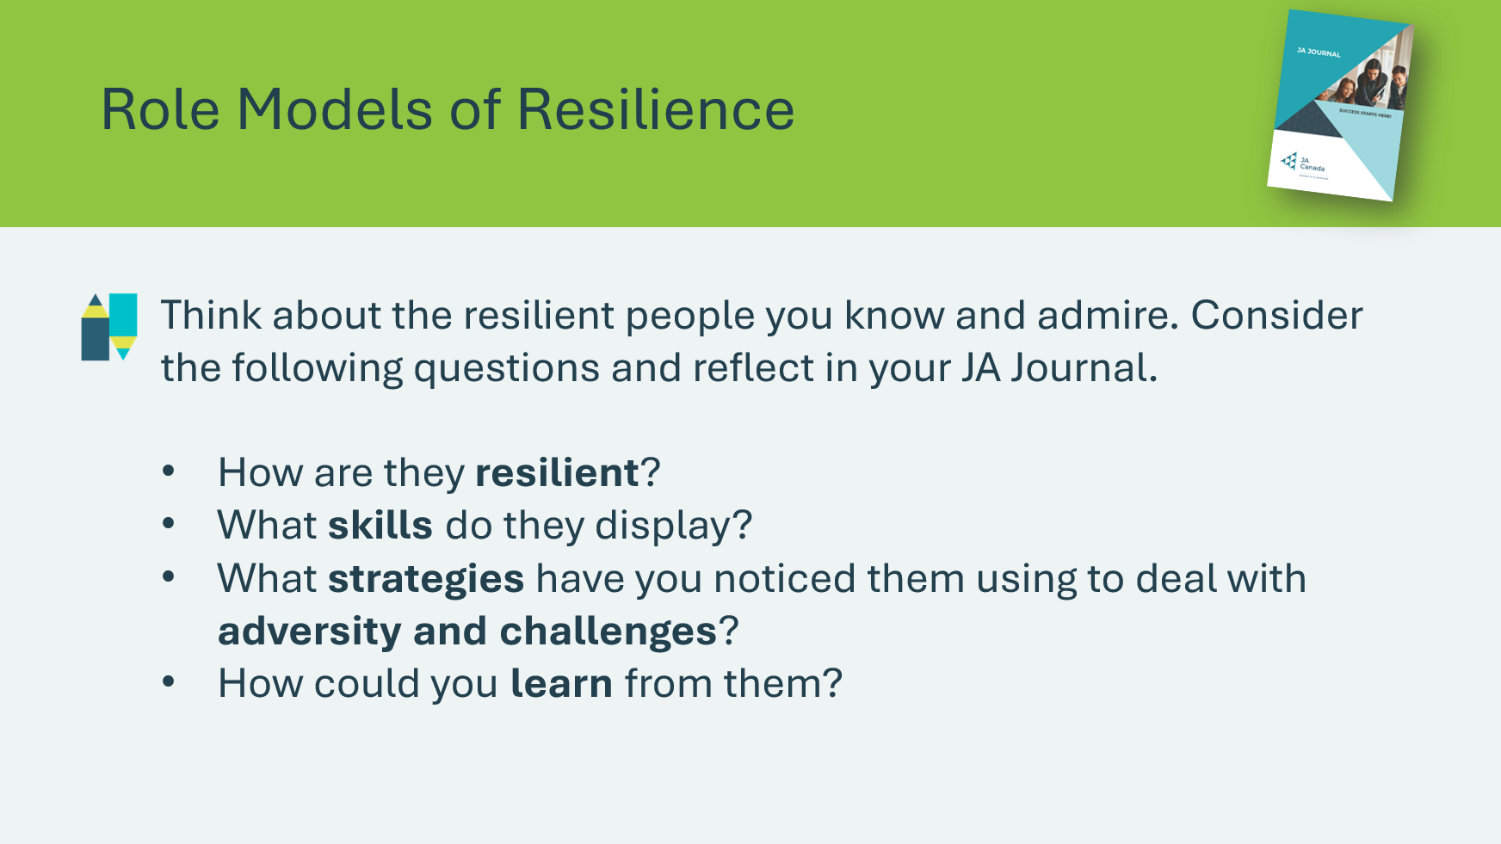 | Suggested time: 10 mins  Ask students to think about people they know or admire who demonstrate resilience. These can be public figures or individuals from their personal lives.  Provide time for students to reflect on the questions on the slide and record their ideas in their JA Journal.  Facilitator Tip: Use a Think–Pair–Share strategy to deepen reflection:  - Think: Give students a few minutes to reflect independently  - Pair: Have students share their ideas with a partner  - Share: Bring the group together to discuss insights as a class  Emphasize that resilient role models show us that setbacks are part of success, and we can learn from their experience to build our own resilience.

Wrap Up
Program Kit Materials | Certificates of Accomplishment  
Slide 64   | Wrap Up
Slide 65    Slide 66   | Suggested time: 15 minutes  Show the video about JA Alumni and Entrepreneur, Mark Cuban. In this video, Mark Cuban shares his experience with Junior Achievement and his entrepreneurship journey.  Invite students to share whether they might choose to start a business given what they have talked about in the lessons.  After a few students have shared, ask the class complete the reflection questions in their JA Journal.
Program Kit Materials | For slide 67, you will need to use the Certificates of Accomplishment from the program kit.
Slide 67  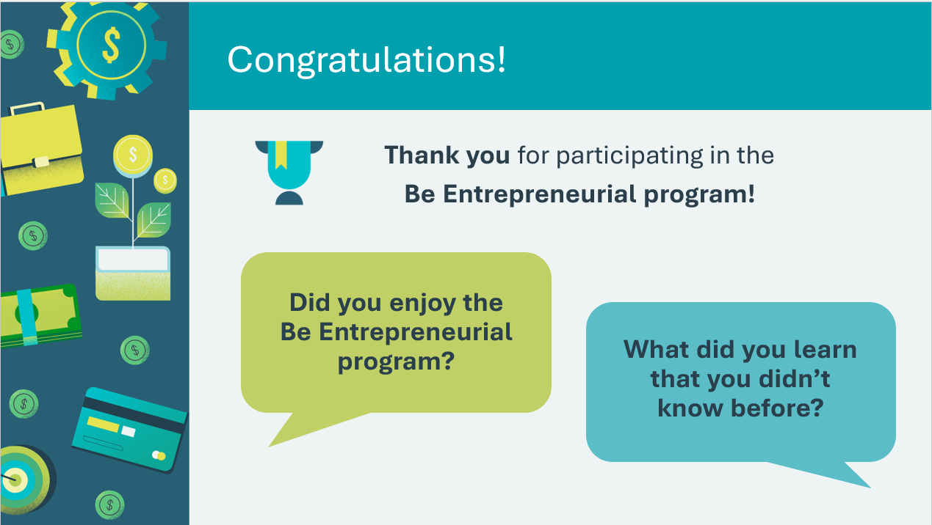 | Suggested time: 5 minutes  Tell the students and the teacher you enjoyed your time with them and thank the students for their participation.  Distribute the Certificates of Accomplishment. Encourage the students to share them with their families and include them in their portfolio of high school accomplishments.
Slide 68   | Invite students to visit jacampus.org for additional information and learning.

Appendix:

PITCH DECK GAME
CONTENTS
36 Company Cards
54 Pitch Cards
THE CONCEPT
Pitch Deck is a game about convincing your friends to invest in the most ridiculous startups imaginable. You all play entrepreneurs and investors in a world where Vampires wear Crocs, Zombies use Uber and people list their doomsday bunkers on Airbnb.
NOTE TO FACILITATOR
Let students know that Pitch Deck is a satirical game and is not affiliated with any company or service mentioned in the game. The descriptions on the company cards and the hashtags on the pitch cards are meant to be funny and may not be entirely factual.
TO START
Form groups of 4-5 students. Everyone draws a hand of 3 pitch cards. Shuffle the company cards and place them face-down in the middle of the table.
PITCH DECK GAME
- Select one player to start as the investor. The investor draws the top card from the company card stack and turns it face up (e.g., Instagram).
- Everyone else plays the role of an entrepreneur and chooses a Pitch card from their hand to associate with that company, for example, Instagram for "Babies" or Instagram for "The profoundly lazy". Pitch cards list ideas for a target market for the company.
- Starting with the person to the left of the investor, clockwise, everyone gives an elevator pitch on their brilliant business idea. This can be as short as a single word or as long as a minute. The investor doesn't make a pitch.
- Once everyone has made their pitch, the investor decides which company to fund, placing the company and the Pitch card in the middle of the table. Their choice can be based on anything, but it's usually given to the entrepreneur who gave the best,
- funniest or weirdest pitch. This person keeps the Pitch card, and it counts as one point. The other Pitch cards are discarded.
- Everyone except the main investor draws a replacement Pitch card, so you always have 3 cards in hand to start a turn. The player to the left of the current investor becomes the new investor.
- Game play continues until you run out of pitch cards or time.
- How to Win: The person who made the highest number of successful pitches wins the game.
VARIATIONS
Pivoting: Every card in Pitch Deck is hilarious and good, but if someone doesn't like the cards they're holding, once per game they can discard 3 cards and draw 3 new ones.
Co-founders: Depending on the class composition and size, you could play in 2-person teams. Each team shares one hand of pitch cards and decides collectively which cards to use. You can make pitches together or alternate (one person gives the pitch every other round).
Real-world Connections: At the end of the game, ask students to connect their experience playing the game with concepts such as product/service ideation, target market, and business pitches.
Reflection questions: When you pitched your idea during the game, what did you focus on to convince others that your product or service was a good investment? What do you think makes a business pitch successful? What was the most challenging part of the game, and what did you learn from it? How would you apply that lesson to your next business idea or pitch?
PITCH PROMPTS

What is your company idea?
What is the problem you are trying to solve?
Who is your target market? How will your product or service make life better for your target market?
How is your product or service different and/or better than others on the market?
CREDITS & INFO
Pitch Deck is produced by Fred Benenson and Alex Hague. Design and logo by Jakob Scott. Examples by Simon Abranowicz. Copyright Unlimited Liability Corporation LLC and Palm Court.
JA Canada has adapted the game from its original version to align with the Be Entrepreneurial learning content.
Pitch Deck is a satirical work and, as such, is not affiliated with or endorsed by any company or service mentioned in the game. Pitch Deck is available under a Creative Commons BY-NC-SA 4.0 license.

