

JA Dollars with Sense Presenter Notes
The Presenter Notes have been developed using references from the digital classroom presentation and should be used in combination with the printed Student Portfolio v2026.
Tips for Setting Up the Classroom
- Arrive 15 minutes early and check in at the office.
- Connect with the teacher for the program materials and organize them as needed.
- Hand out student portfolios and name tags/cards.
- Set up presentation (check audio and internet connection are working).
- Write your name on the board.
- Ask the teacher to write student names on program certificates.
- Check in with the teacher about school schedule, tips for getting students’ attention, any specific student needs & behaviors you should be aware of and ask for help with encouraging student participation, as well as monitoring and managing the class

Planning Guide
WRAP UP (Slides 141 – 144) 25 MIN
CONGRATULATIONS!
Core Activities:
- Bingo (20 min)
- Awarding certificates of accomplishment (5 min)
LESSON 5 (Slides 130 – 140) 45 MIN
USING CREDIT
Core Activities:
- Credit with Sense Game (45 min)

LESSON 4 (Slides 107 -129) 45 MIN
MAKE YOUR MONEY WORK FOR YOU
Core Activities:
- Become Investment Wise (15 min)
- Credit Reports (10 min)
- Extended learning (Optional)

LESSON 1 (Slides 6 – 42) 50 MIN
MONEY MAKES THE WORLD GO ROUND
Core Activities:
- Ready, Set, Go (10 min)
- How Will You Pay? (25 min)
- The Cost of Credit (15 min)
- Extended Activities (Optional)

LESSON 3 (Slides 74 – 106) 50 MIN
SPENDING, SAVING SHARING
Core Activities:
- Needs, Wants, and Goals (15 min)
- Making a Project Budget (25 min)
- Credit Scores (10 min)
- Extended Activities (Optional)
LESSON 2 (Slide 43 – 73) 45 MIN
SMART SHOPPING IN AN ONLINE WORLD
Core Activities:
- Why do we Buy the Things we Buy? (5 min)
- Are All Online Sites Safe? (20 min)
- Are You a SMART Consumer? (20 min)
- Extended Activities (Optional)
GETTING STARTED – GETTING TO KNOW YOU (Slides 1 – 5) 5 MIN

Introduction
Slide 1 – Dollars with Sense   | Navigation Tips  - Navigate through the slides using the next or previous buttons (bottom right), clicking or tapping on the slide, or using the navigation menu (right)  - Look for slide specific instructions in the presenter notes below
Slide 2 – Welcome to JA!   | Suggested time: 3 minutes  Ask: Has anyone heard of Junior Achievement before?  Play the video for students to introduce them to JA!
Slide 3 – Dollars with Sense Program   | Introduce the program and yourself!  Tell the students a little about you; your education, and your career path until this point. Explain why you chose to volunteer in their classroom today.
Slide 4 – Symbol Legend  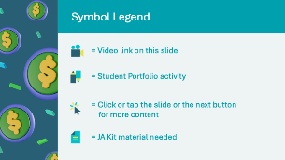 | The symbols will help guide the learning experience. Explain to students that they will see these symbols throughout the program.
Slide 5 – Main Menu  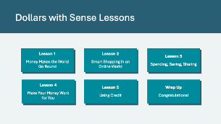 | *Select the button to navigate to the lesson.  After you have completed a lesson, you can select the Return to Main Menu button from the Lesson Activity Menu to return to this slide.

Lesson 1: Money Makes the World Go Round
Program Kit Materials | Avatar Challenge 1 Cards  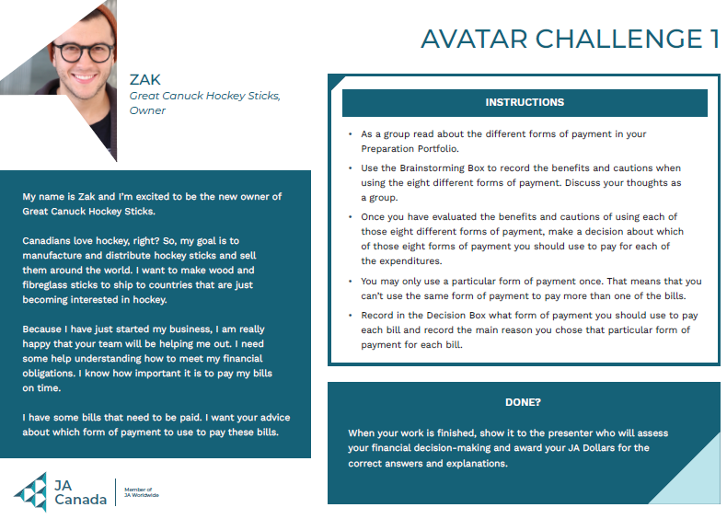
Slide 6 – Lesson 1   | Lesson 1: Money Makes the World Go Round
Slide 7 – Objectives  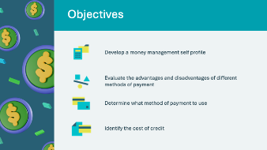 | Optional – review the learning objectives for the lesson
Slide 8 – Introduction  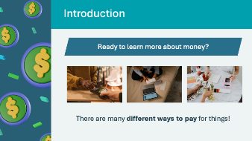 | Introduce the lesson by explaining that we use money in exchange for goods or services provided by others. Tell students they will explore the different ways to pay for things and find out which payment methods work best in different situations.
Slide 9 – Lesson 1 Activity Menu  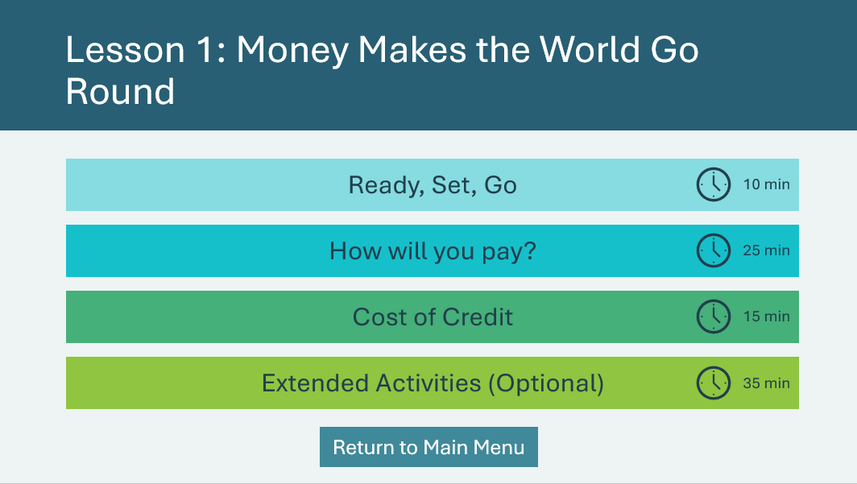 | *Select the button to navigate to the activity.  After you have completed an activity, you will be redirected back to the activity menu.  *Click or tap the Return to Main Menu button to return to the Lessons (Slide 5)
Ready, Set, Go 10 mins
Slide 10  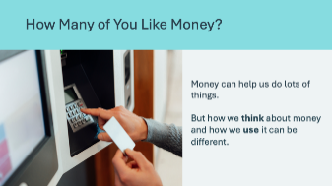 | Suggested time: 3 minutes  Ask the following discussion question:  - How many of you like money? Raise your hand if you do  Facilitator tip: You should raise your hand too and may wish to share your own insights.  Explain to students that they will figure out their money management profile in the next activity.
Slide 11  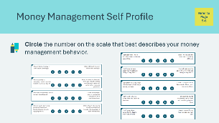 | Suggested time: 3 minutes  Ask students to complete the activity in their student portfolio, pages 5-6.  Facilitator tip: You may wish to demonstrate by rating yourself on the first statement to show students how the scale works.
Slide 12  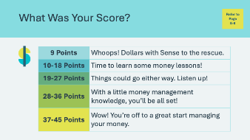 | Suggested time: 4 minutes  Invite a few volunteers to share their answers. Encourage them to consider what made them score high or low.
How Will You Pay 25 mins
Slide 13   | Video Time: 3 minutes  Now that you’ve explored how you think about money let’s explore how we use money to pay for things.  Volunteer connection: Provide examples of times you use certain payment methods. You may also wish to show students a variety of debit and credit cards that the typical person today carries in their wallet.
Slide 14  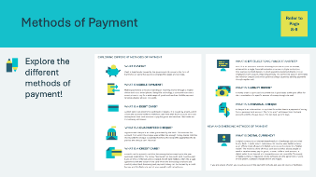 | Suggested time: 10 minutes  Introduce the next topic by telling the students to open their student portfolio, page 8-9. There are 9 different methods of payment that you’ll discuss one by one on the following slides.
Slide 15  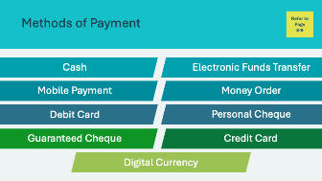 | Review the 9 methods of payments found in the student portfolio, pages 8-9.  Volunteer connection: Share your most common method of payment.  Use the following slides to discuss each method of payment with the class.  Note: Some of the definitions have been updated and may differ from the print materials.
Slide 16  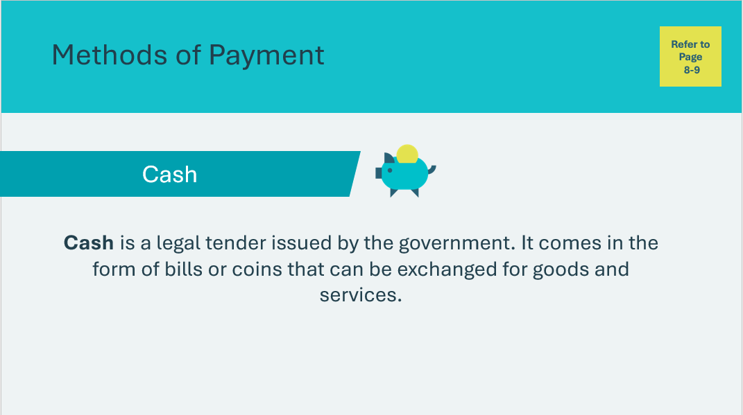 | Cash  Ask students who like to use cash to raise their hand (it may be the entire class). Ask a volunteer to read the definition aloud to the class.  Invite a student to share an example of a time they used this payment method or saw someone else using it.
Slide 17  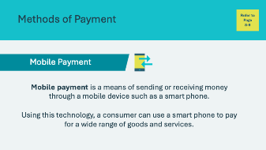 | Mobile Payment  Ask students who like to use mobile payment to raise their hand. Ask a volunteer to read the definition aloud to the class.  Invite a student to share an example of a time they used this payment method or saw someone else using it.
Slide 18  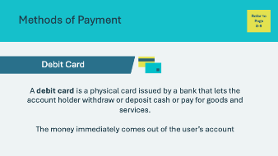 | Debit Card  Ask students who like to use a debit card to raise their hand. Ask a volunteer to read the definition aloud to the class.  Invite a student to share an example of a time they used this payment method or saw someone else using it.
Slide 19  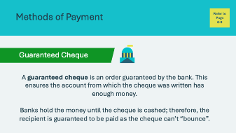 | Guaranteed Cheque  Ask students who are familiar with guaranteed cheques to raise their hand. Ask a volunteer to read the definition aloud to the class.  Invite a student to share an example of a time they used this payment method or saw someone else using it.
Slide 20  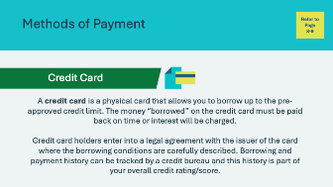 | Credit Card  Ask students who have seen their family member(s) use a credit card or if any use a supplemental credit card from their family to raise their hand. Ask a volunteer to read the definition aloud to the class.  Invite a student to share an example of a time they used this payment method or saw someone else using it.
Slide 21  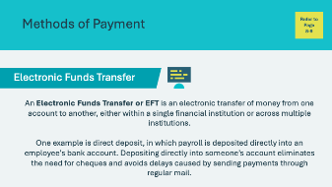 | Electronic Funds Transfer  Ask students who are familiar with electronic funds transfers to raise their hand. Ask a volunteer to read the definition aloud to the class.  You may use your own experience in using electronic funds transfer to help the students understand better. Invite a student to share an example of a time they used this payment method or saw someone else using it.
Slide 22  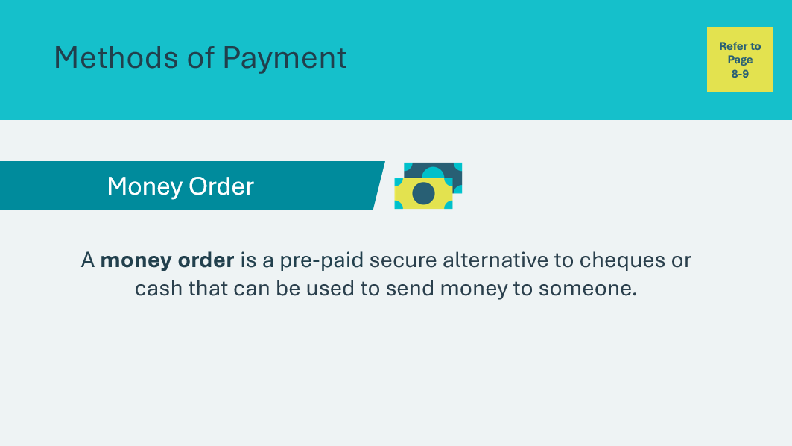 | Money Order  Ask students who are familiar with money orders to raise their hand. Ask a volunteer to read the definition aloud to the class.  You may use your own experience in using money orders to help the students understand better. Invite a student to share an example of a time they used this payment method or saw someone else using it.
Slide 23  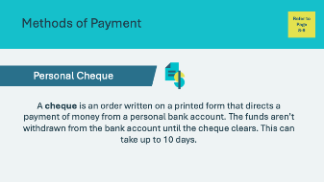 | Personal Cheque  Ask students who are familiar with personal cheques to raise their hand. Ask a volunteer to read the definition aloud to the class.  There may be some confusion regarding the difference between Guaranteed Cheques and Personal Cheques. You may help them understand by sharing your personal experience or using the descriptions below:  - Guaranteed Cheques are issued directly from the bank. The bank ensures the account that the cheque was written from has enough money. The bank holds the money until the cheque is cashed. For this reason, they are usually used for larger transactions  - Personal Cheques direct payment from a personal account. The money isn’t withdrawn until the cheque is cashed so it can take some time before the cheque clears and the funds can be deposited.  Invite a student to share an example of a time they used this payment method or saw someone else using it.
Slide 24  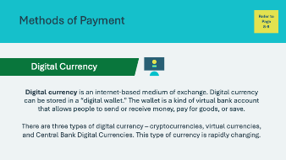 | Digital Currency  Ask students who are familiar with digital currency to raise their hand. Ask a volunteer to read the definition aloud to the class.  Invite a student to share an example of any knowledge or experience they may have with digital currency.
Slide 25  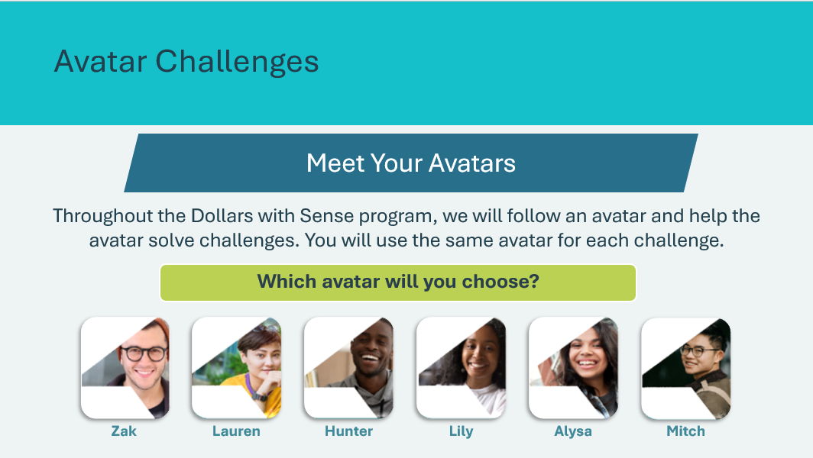 | Suggested time: 2 minutes  Help the class select one avatar they will follow throughout the Dollars with Sense Program. A vote by show of hands is one method to use when selecting an avatar. You can write the Avatar name on the board.  Once the group has selected an avatar, advance to the next slide.
Slide 26  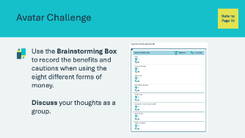 | Suggested time: 2-3 minutes  Review the instructions for the Brainstorming Box, student portfolio page 10, with students before beginning the activity.  They will begin filling in the boxes after you read the avatar challenge.
Slide 27  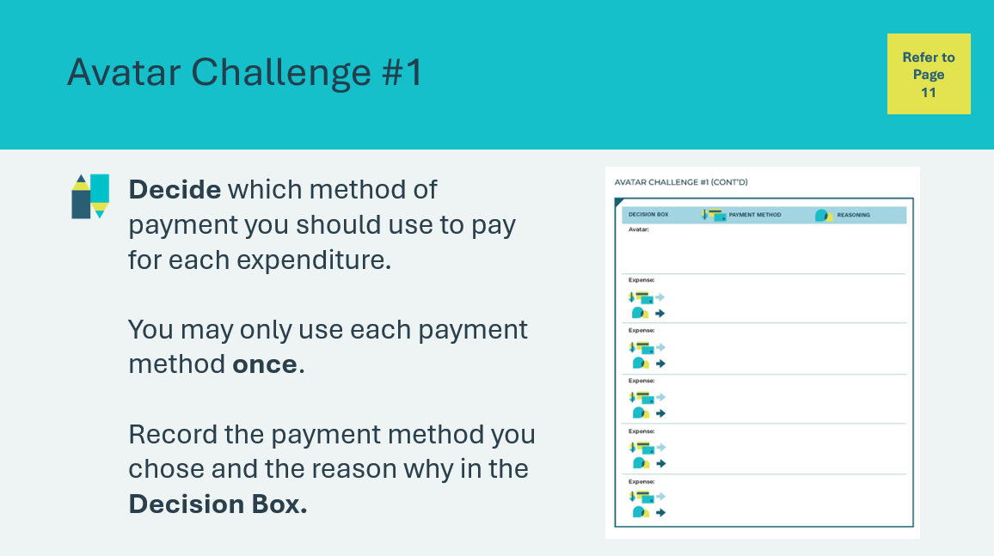 | Suggested time: 2-3 minutes  Review the instructions for the Decision Box, student portfolio page 11, with students before beginning the activity.  They will begin filling in the boxes after you read the avatar challenge.
Program Kit Material | For slides 28-34, you can reference the Avatar Challenge 1 Cards from the program kit or use the information on the slide. Reference the Avatar that the students have selected on Slide 25.
Slide 28  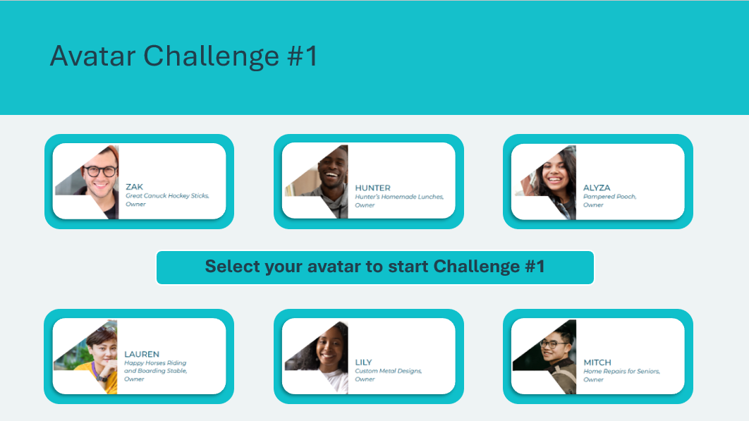 | Suggested time: 10 minutes  Once you have reviewed the instructions, select the avatar the group voted for to begin.  *Click or tap on the avatar that the class has selected and share the challenge details with students.
Slide 29  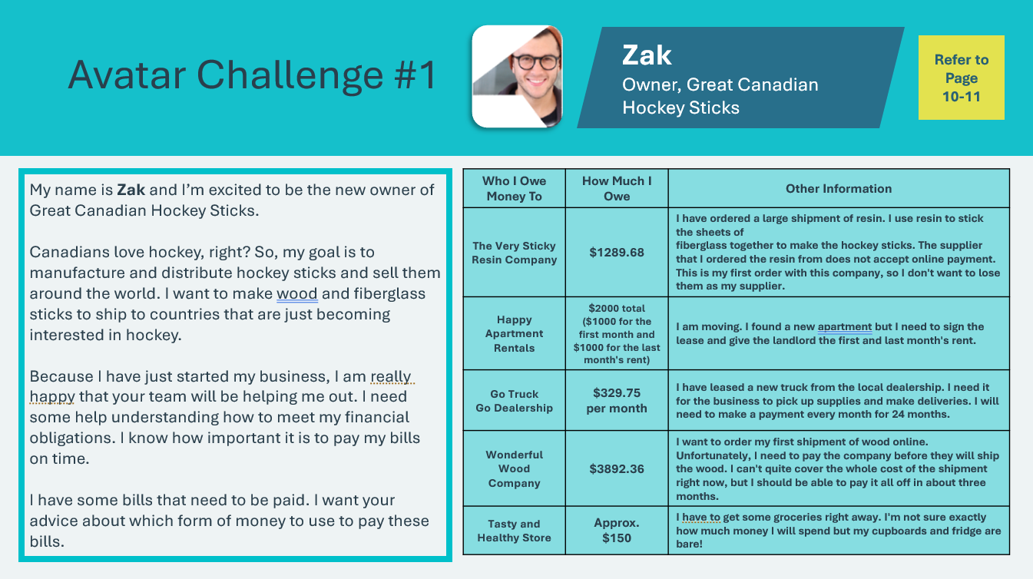  Avatar Challenge 1 Card – Zak  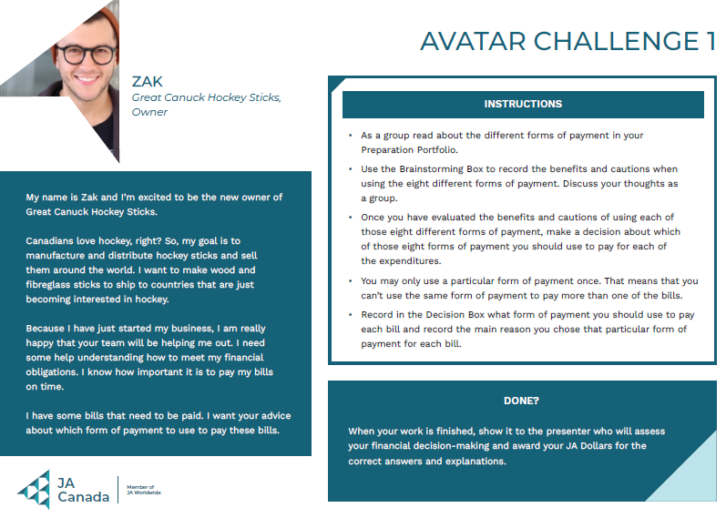 | Zak  Review the Avatar Challenge as a group. Invite students to share their thoughts and discuss the benefits and cautions related to using each method of payment. Using the Brainstorming Box, students will record their responses in their student portfolio, page 10.  Once they have completed the Brainstorming Box, invite them to make their decision about what payment method to use to pay for each expenditure. Students will record their responses in the Decision box in their student portfolio, page 11.  Facilitator tip: Circulate the room while students are working on the challenge and provide examples and support where needed. You may wish to ask the classroom teacher to do the same.  When the class has completed the activity, invite students to share their responses and rational. Following the discussion, share the correct responses with students.  Correct answers:  - Guaranteed Cheque – The Very Sticky Resin Company  - Personal Cheque (Cash is also acceptable) – Happy Apartment Rentals  - EFT – Go Truck Go Dealership  - Credit Card – Wonderful Wood Company  - Mobile Payment, Debit Card or Cash – Tasty and Healthy Store
Slide 30  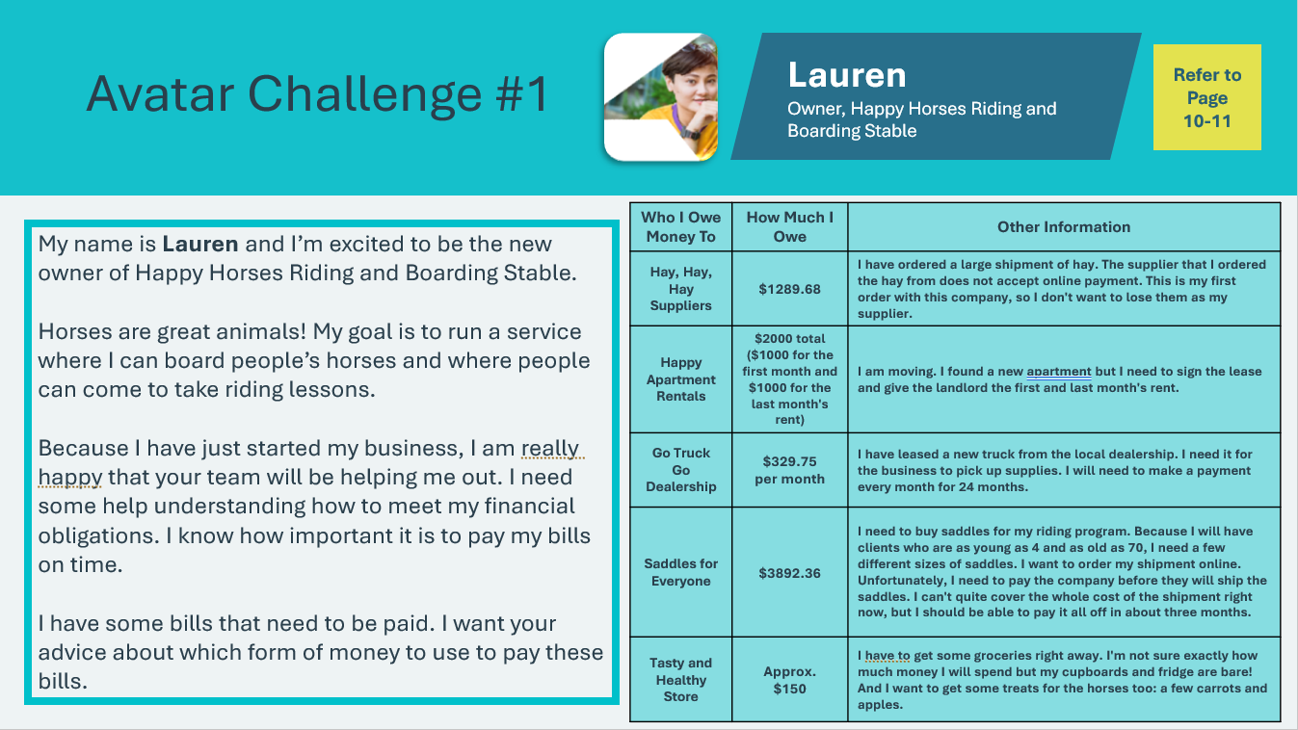  Avatar Challenge 1 Card – Lauren  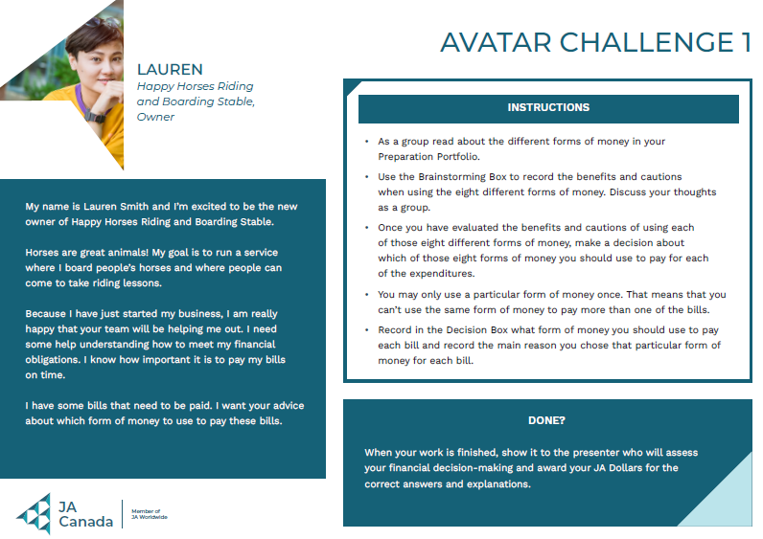 | Lauren  Review the Avatar Challenge as a group. Invite students to share their thoughts and discuss the benefits and cautions related to using each method of payment. Using the Brainstorming Box, students will record their responses in their student portfolio, page 10.  Once they have completed the Brainstorming Box, invite them to make their decision about what payment method to use to pay for each expenditure. Students will record their responses in the Decision box in their student portfolio, page 11.  Facilitator tip: Circulate the room while students are working on the challenge and provide examples and support where needed. You may wish to ask the classroom teacher to do the same.  When the class has completed the activity, invite students to share their responses and rational. Following the discussion, share the correct responses with students.  Correct answers:  - Guaranteed Cheque – Hay, Hay, Hay Suppliers  - Personal Cheque (Cash is also acceptable) – Happy Apartment Rentals  - EFT – Go Truck Go Dealership  - Credit Card – Saddles for Everyone  - Mobile Payment, Debit Card or Cash – Tasty and Healthy Store
Slide 31  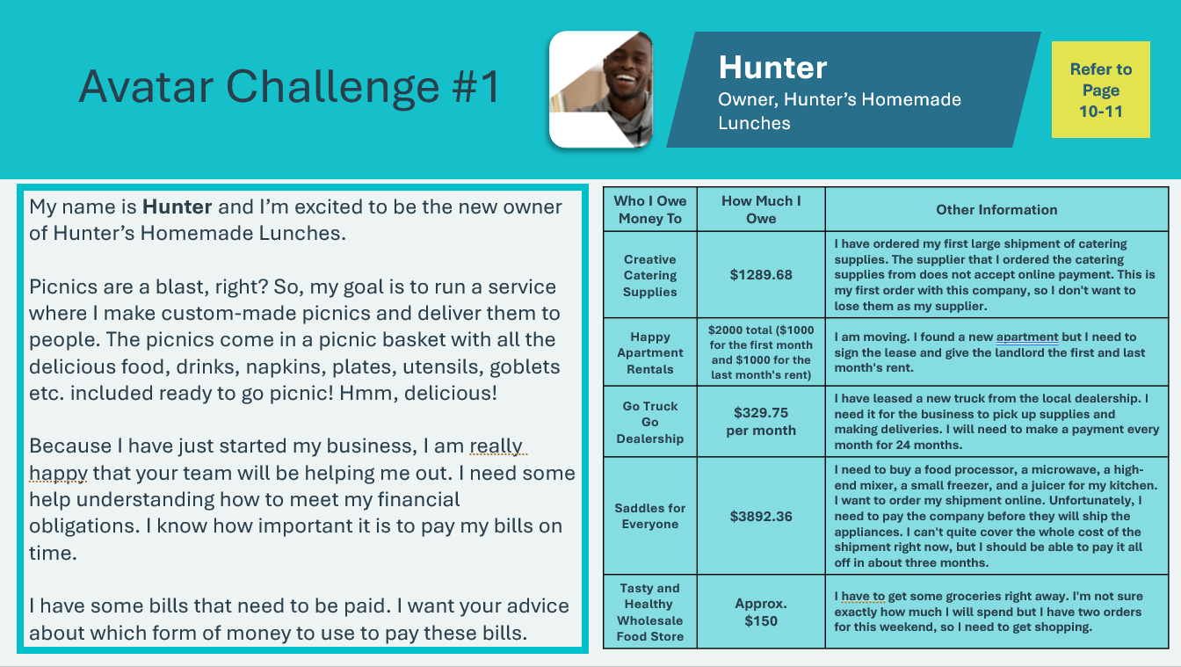  Avatar Challenge 1 Card – Hunter  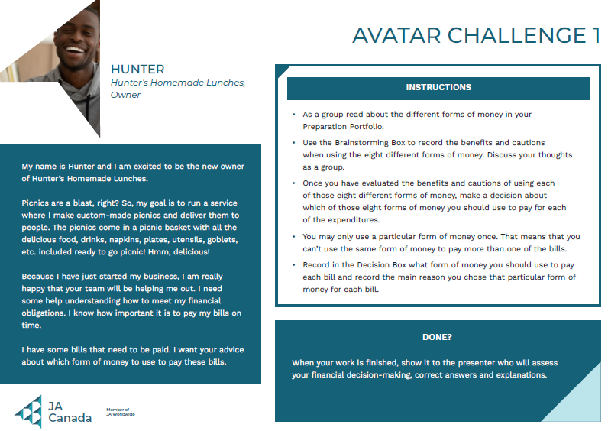 | Hunter  Review the Avatar Challenge as a group. Invite students to share their thoughts and discuss the benefits and cautions related to using each method of payment. Using the Brainstorming Box, students will record their responses in their student portfolio, page 10.  Once they have completed the Brainstorming Box, invite them to make their decision about what payment method to use to pay for each expenditure. Students will record their responses in the Decision box in their student portfolio, page 11.  Facilitator tip: Circulate the room while students are working on the challenge and provide examples and support where needed. You may wish to ask the classroom teacher to do the same.  When the class has completed the activity, invite students to share their responses and rational. Following the discussion, share the correct responses with students.  Correct answers:  - Guaranteed Cheque – Creative Catering Supplies  - Personal Cheque (Cash is also acceptable) – Happy Apartment Rentals  - EFT – Go Truck Go Dealership  - Credit Card – Saddles for Everyone  - Mobile Payment, Debit Card or Cash – Tasty and Healthy Store
Slide 32  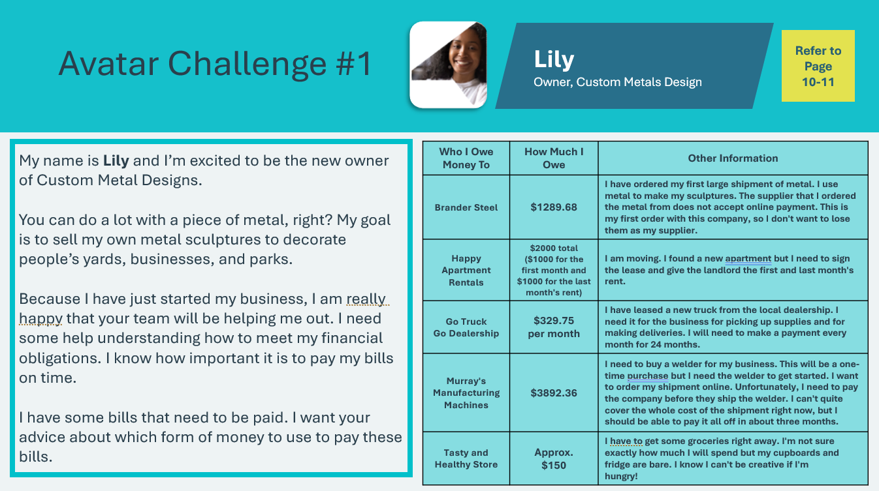  Avatar Challenge 1 Card – Lily  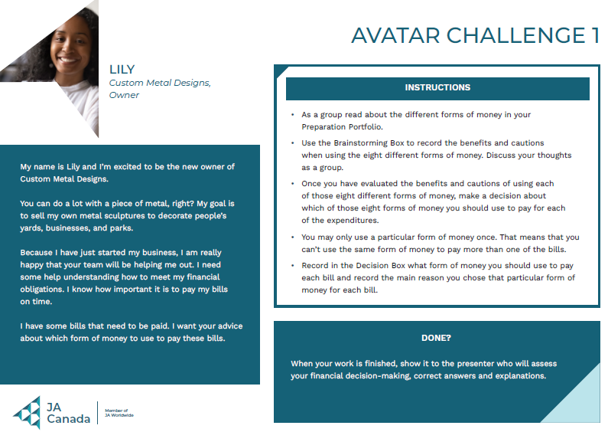 | Lily  Review the Avatar Challenge as a group. Invite students to share their thoughts and discuss the benefits and cautions related to using each method of payment. Using the Brainstorming Box, students will record their responses in their student portfolio, page 10.  Once they have completed the Brainstorming Box, invite them to make their decision about what payment method to use to pay for each expenditure. Students will record their responses in the Decision box in their student portfolio, page 11.  Facilitator tip: Circulate the room while students are working on the challenge and provide examples and support where needed. You may wish to ask the classroom teacher to do the same.  When the class has completed the activity, invite students to share their responses and rational. Following the discussion, share the correct responses with students.  Correct answers:  - Guaranteed Cheque – Brander Steel  - Personal Cheque (Cash is also acceptable) – Happy Apartment Rentals  - EFT – Go Truck Go Dealership  - Credit Card – Murray’s Manufacturing Machines  - Mobile Payment, Debit Card or Cash – Tasty and Healthy Store
Slide 33  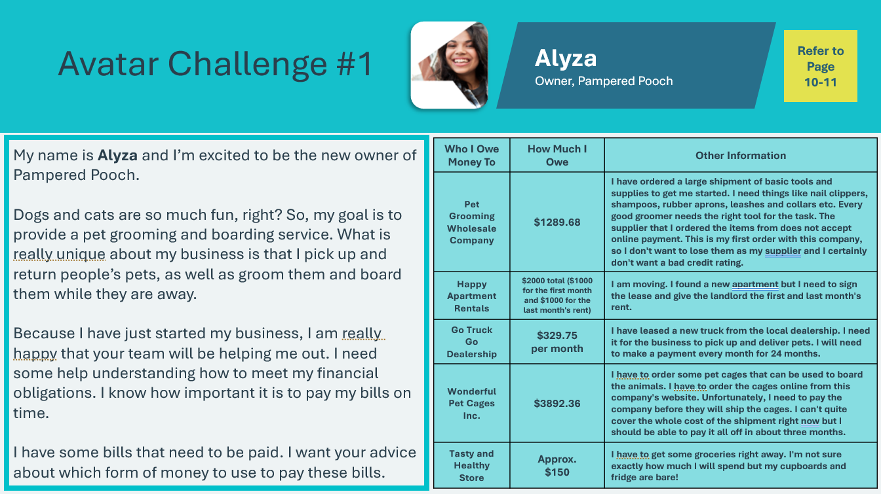  Avatar Challenge 1 Card – Alyza  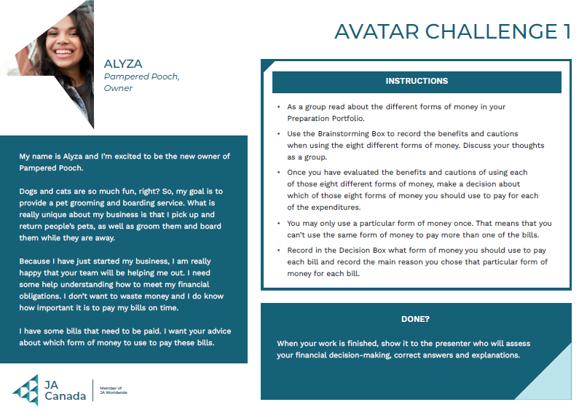 | Alyza  Review the Avatar Challenge as a group. Invite students to share their thoughts and discuss the benefits and cautions related to using each method of payment. Using the Brainstorming Box, students will record their responses in their student portfolio, page 10.  Once they have completed the Brainstorming Box, invite them to make their decision about what payment method to use to pay for each expenditure. Students will record their responses in the Decision box in their student portfolio, page 11.  Facilitator tip: Circulate the room while students are working on the challenge and provide examples and support where needed. You may wish to ask the classroom teacher to do the same.  When the class has completed the activity, invite students to share their responses and rational. Following the discussion, share the correct responses with students.  Correct answers:  - Guaranteed Cheque – Pet Grooming Wholesale Company  - Personal Cheque (Cash is also acceptable) – Happy Apartment Rentals  - EFT – Go Truck Go Dealership  - Credit Card – Wonderful Pet Cages, Inc,  - Mobile Payment, Debit Card or Cash – Tasty and Healthy Store
Slide 34  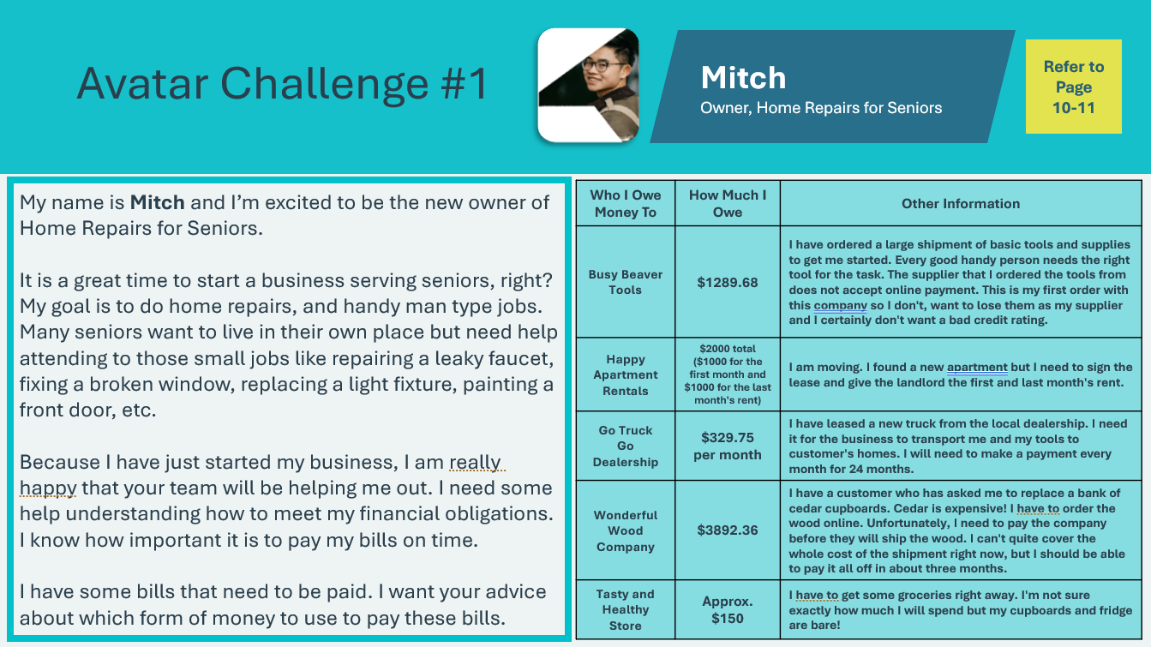  Avatar Challenge 1 Card – Mitch  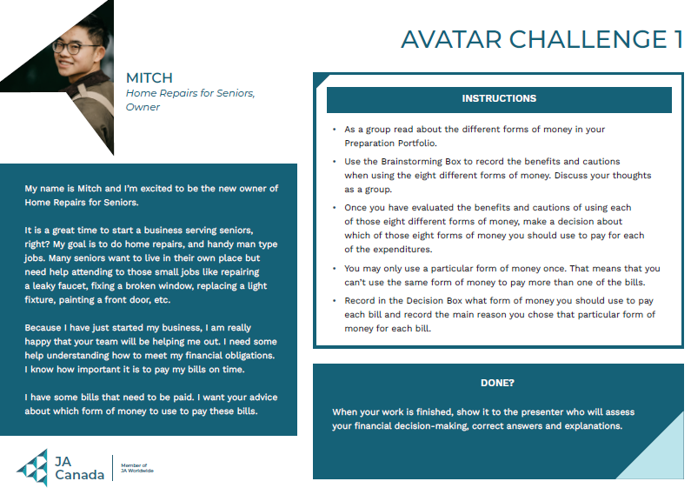 | Mitch  Review the Avatar Challenge as a group. Invite students to share their thoughts and discuss the benefits and cautions related to using each method of payment. Using the Brainstorming Box, students will record their responses in their student portfolio, page 10.  Once they have completed the Brainstorming Box, invite them to make their decision about what payment method to use to pay for each expenditure. Students will record their responses in the Decision box in their student portfolio, page 11.  Facilitator tip: Circulate the room while students are working on the challenge and provide examples and support where needed. You may wish to ask the classroom teacher to do the same.  When the class has completed the activity, invite students to share their responses and rational. Following the discussion, share the correct responses with students.  Correct answers:  - Guaranteed Cheque – Busy Beaver Tools  - Personal Cheque (Cash is also acceptable) – Happy Apartment Rentals  - EFT – Go Truck Go Dealership  - Credit Card – Wonderful Wood Company  - Mobile Payment, Debit Card or Cash – Tasty and Healthy Store
The Cost of Credit 15 mins
Slide 35  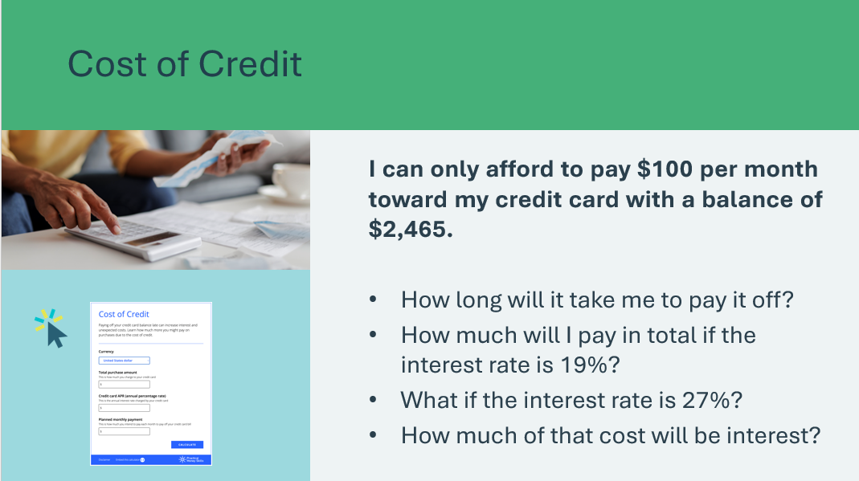 | Suggested time: 10 minutes  Review the scenario and questions listed on the slide. Use the Cost of Credit Calculator to find the answers to the question.  *Click or tap on the link or image to open the Cost of Credit Calculator in a new browser window  https://visa.practicalmoneyskills.com/en/resources/financial-calculators/credit-debt/loan-cost.html  Work with the students to explore the Calculator and find the answers to the questions listed on the previous slide.  Please note: The calculator tool uses USD. Explain to students that the concept remains the same regardless of the type of currency.
Slide 36  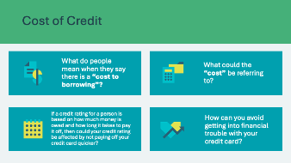 | Suggested time: 5 minutes  Wrap up the activity using the discussion questions.  Sample Answers:  - When people say there is a "cost to borrowing," they mean that when you borrow money, you usually have to pay back more than what you borrowed. This extra money you pay back is called interest, and it's the fee for using someone else's money.  - The "cost" could be referring to the interest you have to pay on the money you borrowed. It could also include fees that the lender might charge for letting you borrow the money, like loan origination fees or late payment fees if you don't pay on time.  - Yes, your credit rating could be affected by not paying off your credit card quicker. If you take a long time to pay back what you owe, it might make lenders think you're not good at managing your money. They might worry you won't pay them back on time, so they might give you a lower credit rating.  Volunteer connection: Share your own experiences and thoughts to guide students.
Extended Activities 35 mins
Slide 37  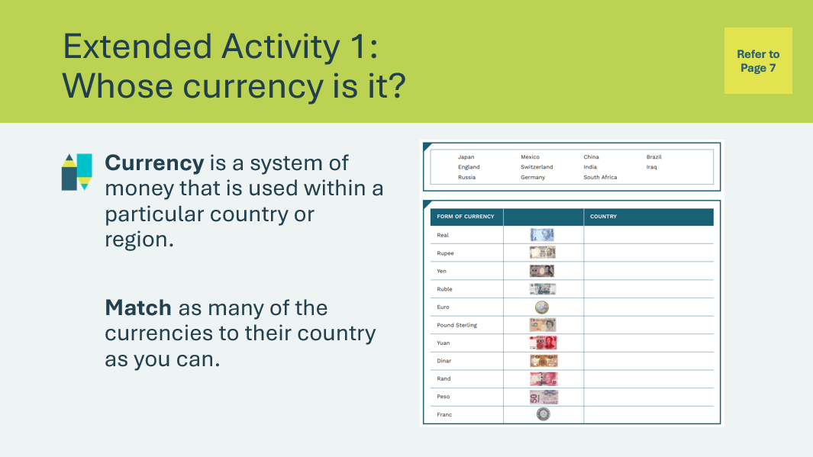 | Suggested time: 5 minutes  Ask students if they have been to other countries and if they or their parents have converted their Canadian dollars into the currency of the country they visited.  Students will use the word bank to match the form of currency with the country in their student portfolio, page 7.
Slide 38  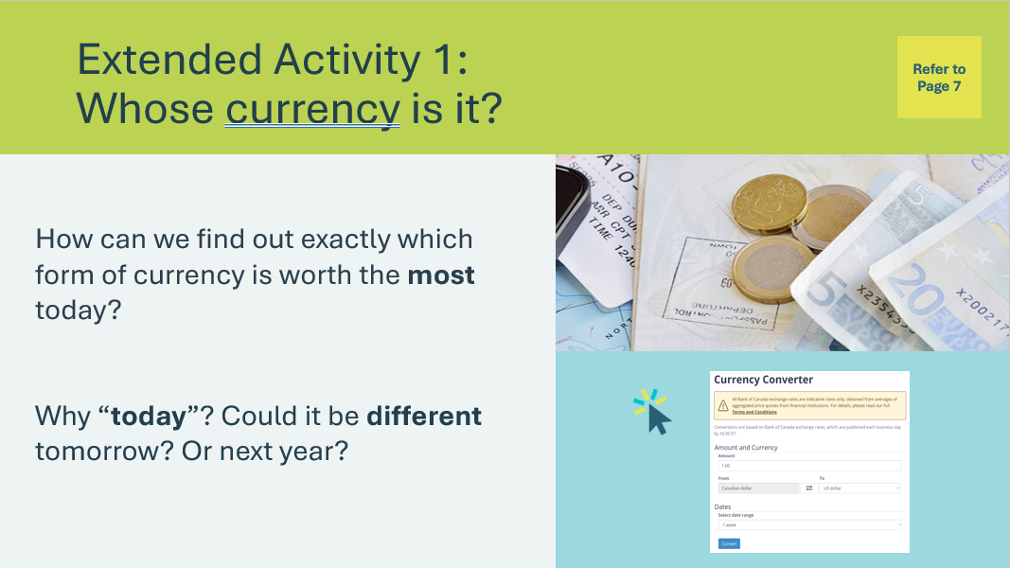 | Suggested time: 10 minutes  Once students are done, facilitate a discussion using the following questions:  - How can we find out exactly which form of currency is worth the most today?​  - Have students brainstorm. Some students may know that they could go to the bank or search online.  - Why “today”? Could it be different tomorrow? Or next year?  - Explain briefly that the value of currency fluctuates based on how much a particular form of currency is wanted or is in demand.  *Click or tap on the image to open the Currency Converter. It will open in a new browser window
Slide 39  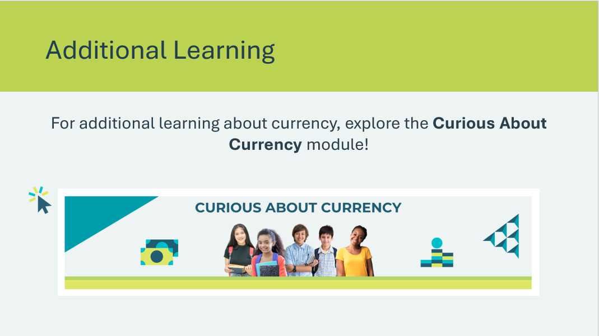 | *Click or tap on the image for additional learning from the JA Campus  https://www.jacampus.org/curious-about-currency/
Slide 40  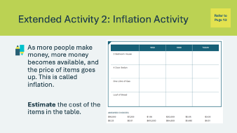 | Suggested time: 5 minutes  Discuss briefly what inflation is. Use the definition below or provide your own description.  Inflation is a rise in prices, measured over a certain amount of time. Inflation affects us because it means that over time, you can buy fewer things with the same amount of money. For example, now, you could buy 5 lollipops for $1. In five years, $5 might only get you 2 lollipops.  Share what the cost of some goods and services were 10 years ago or so compared to now. Students will estimate the cost of the items during each of the years outlined in the table in their student portfolio, page 12.
Slide 41  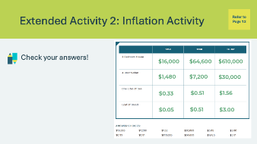 | Suggested time: 5 minutes  Once students have completed their estimates, share the actual amounts.  *Click or tap to reveal each amount  Depending where you live the costs today may vary.  Note: The costs have been updated and will appear differently than what is listed in the print materials to reflect what is more common in urban cities across Canada.
Slide 42  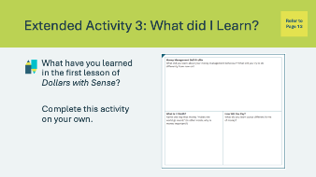 | Suggested time: Students can complete the reflections in class if time allows, or independently later on.  Encourage the students to complete the self-reflection activity in their student portfolio, page 13. Students may respond to some or all of the prompts. There is no need to discuss their self-reflections; you and the classroom teacher may review them either between lessons or later on if necessary

Lesson 2: SMART Shopping in an Online World
Program Kit Materials | Online Scenario Cards  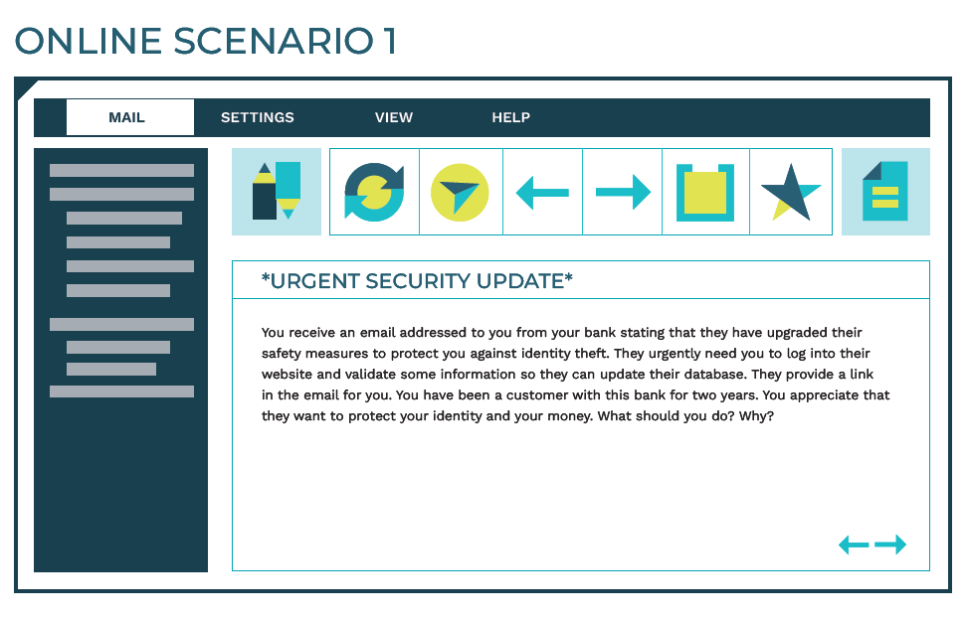  Website Whatzit Cards  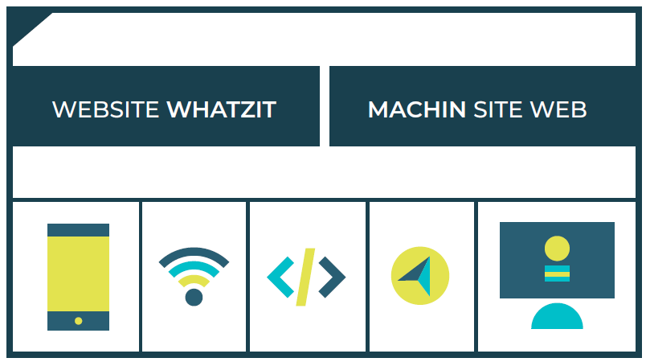  Avatar Challenge 2 Cards  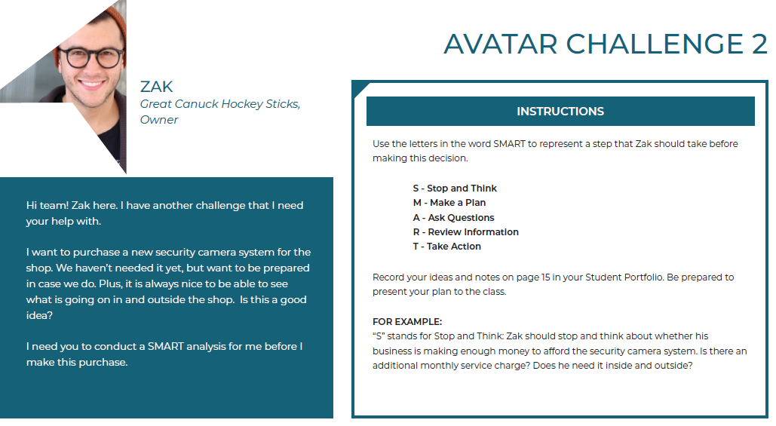
Slide 43 – Lesson 2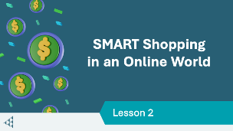 | Lesson 2: SMART Shopping in an Online World
Slide 44 – Objectives  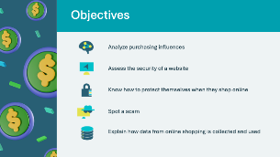 | Optional – review the learning objectives for the lesson
Slide 45 – Introduction  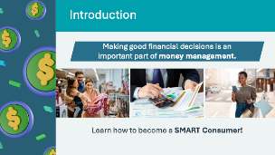 | Introduce the lesson by explaining that making good financial decisions on how you spend money is an important part of money management.  Tell the students that we will be reflecting on the different factors that influence people’s spending and purchasing of goods and services, and what it means to be a SMART consumer in the current market.
Slide 46 – Activity Menu  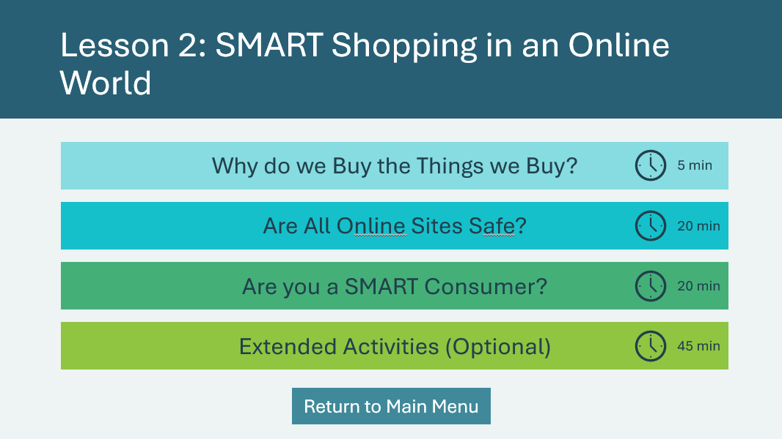 | *Select the button to navigate to the activity.  After you have completed an activity, you will be redirected back to the activity menu.  *Click or tap the Return to Main Menu button to return to the Lessons (Slide 5)
Why do we buy the Things we Buy 5 mins
Slide 47  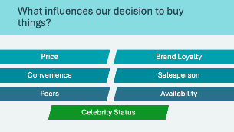 | Suggested time: 3 minutes  Introduce the lesson asking students to consider what influences them to buy something. Allow a few students to share their responses. When you are ready, *Click or tap to reveal each of the influences  Review each of the influences:  - Price – we may be influenced to make a purchase if something seems like a good deal, or if the price matches the quality.  - Convenience – we may buy things out of convenience, like ordering something online so you don’t have to make a trip to the store.  - Peers – we may be influenced to buy something because our friends have it too.  - Celebrity Status – we might be influenced to buy something because a celebrity or someone well known uses/endorses the product or services  - Brand Loyalty – we may influenced to buy a specific brand due to preference or using it for a long time.  - Sales Person – we may be influenced to buy something because a sales person has convinced or motivated us to purchase their goods or services  - Availability – we may buy certain things based on availability, like if you want a can of Pepsi but the store only sells Coca Cola.  As a group, discuss each of the factors that influence us to shop.  Invite students to share their thoughts or experiences with the influences. Reinforce their understanding by sharing your own experiences.  Facilitator tip: Be sensitive to the economic situations of students in the classroom. Some may have little or no spending money, while others may have a lot.  Volunteer connection: Describe a recent purchase you made and invite students to guess what influenced you, or simply share which of these factors have influenced you before when it comes to spending and shopping.  *Click or tap to reveal each prompt.
Slide 48  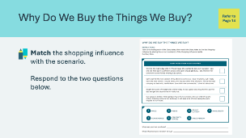 | Suggested time: 2 minutes  Students will complete the activity in their student portfolio, page 14. Students may work independently or with a partner. Circulate the classroom as they work to provide support and answer questions.  If time permits, review the answers and allow students to share their responses.
Are all online sites safe? 20 mins
Slide 49  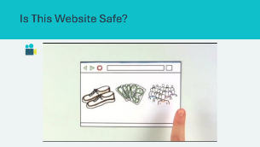 | Suggested time: 4 minutes  Introduce the coming activity by asking these questions:  - Who has made an online purchase?  - What website did you use?  - Is it easy to tell a safe website from an unsafe website?  Encourage students to share their stories and experiences. Play the video following the brief discussion.
Program Kit Materials | For slides 50-56, you can reference the Online Scenario Cards from the program kit or use the information on the slide.
Slide 50  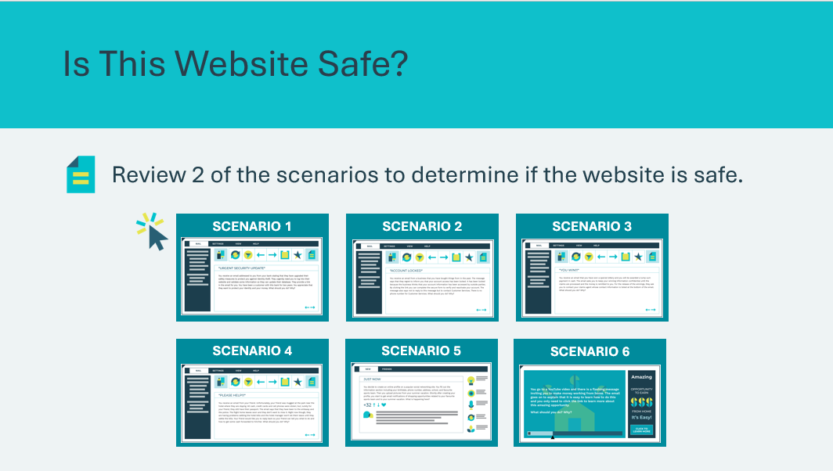 | Suggested time: 6 minutes  Dependent on time available, review no more than 2 of the Online Scenario (Is This Website Safe?) slides. There are 6 scenarios in total.  *Click or tap on each scenario card to review the details.
Slide 51  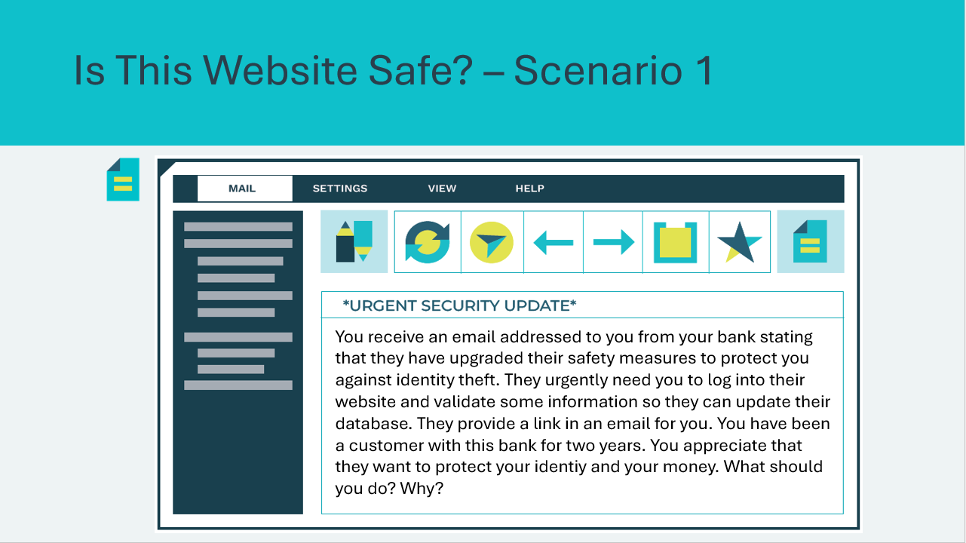 | Scenario 1  Read the scenario aloud or invite a student to do so. Facilitate the discussion by asking is the website safe or not? Encourage them to explain their thinking.
Slide 52  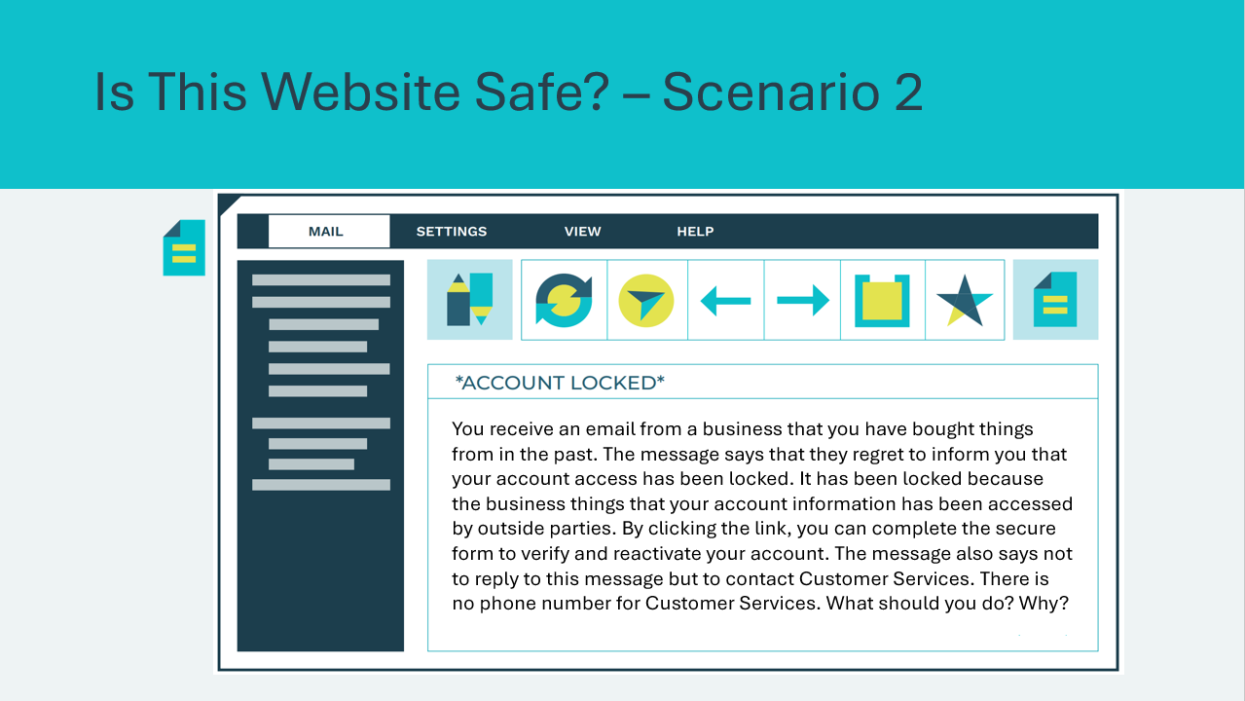 | Scenario 2  Read the scenario aloud or invite a student to do so. Facilitate the discussion by asking is the website safe or not? Encourage them to explain their thinking.
Slide 53  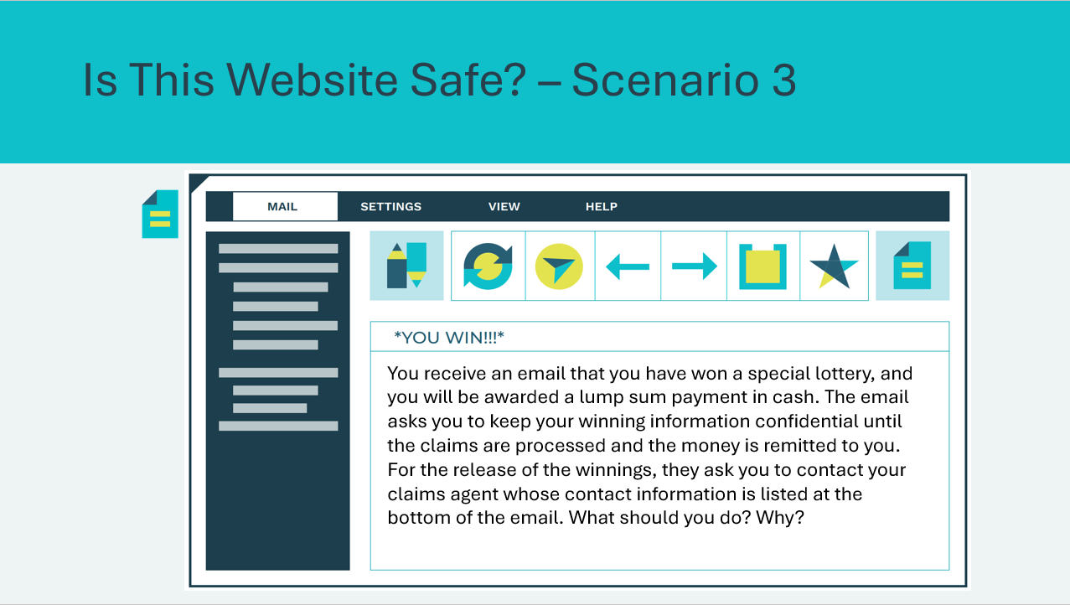 | Scenario 3  Read the scenario aloud or invite a student to do so. Facilitate the discussion by asking is the website safe or not? Encourage them to explain their thinking.
Slide 54  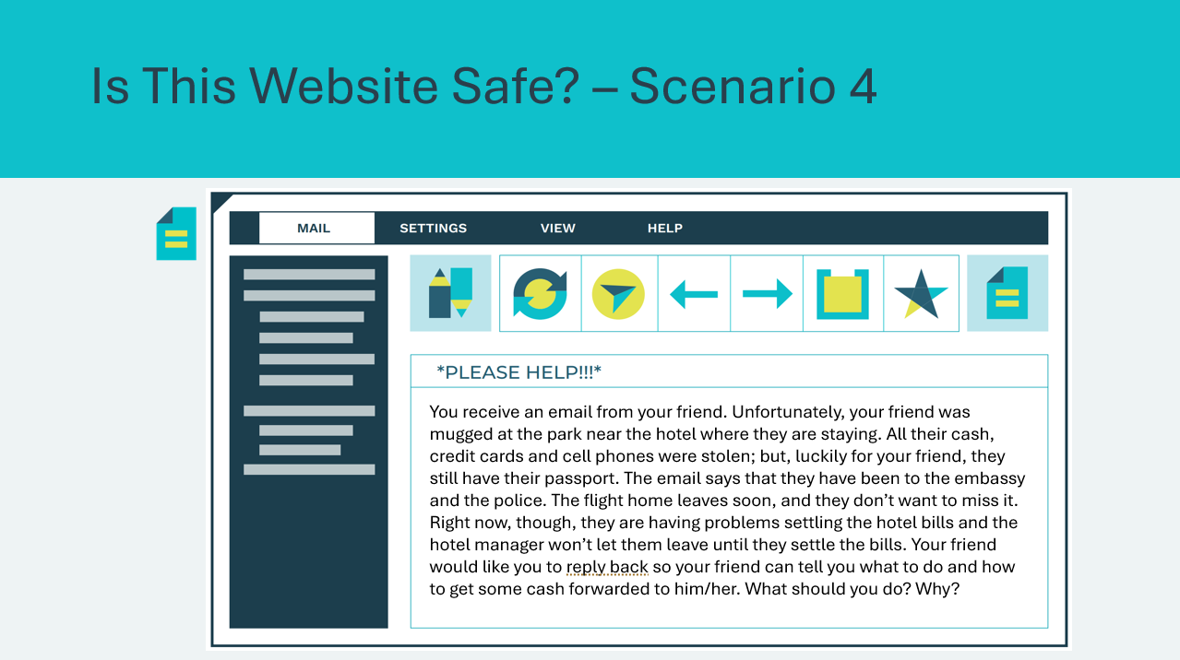 | Scenario 4  Read the scenario aloud or invite a student to do so. Facilitate the discussion by asking is the website safe or not? Encourage them to explain their thinking.
Slide 55  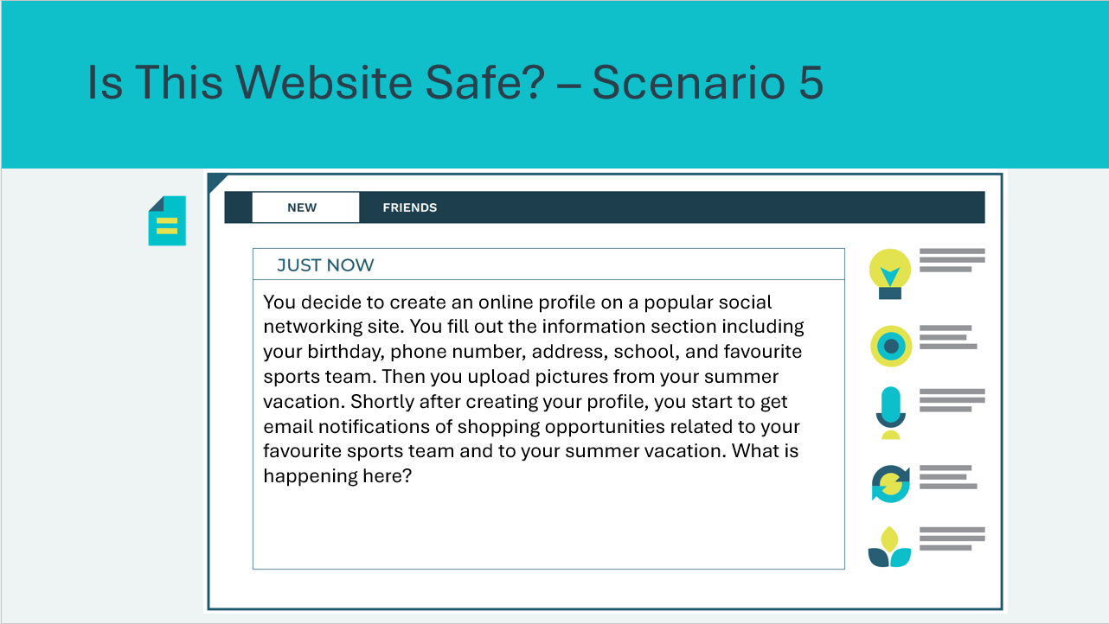 | Scenario 5  Read the scenario aloud or invite a student to do so. Facilitate the discussion by asking is the website safe or not? Encourage them to explain their thinking.
Slide 56  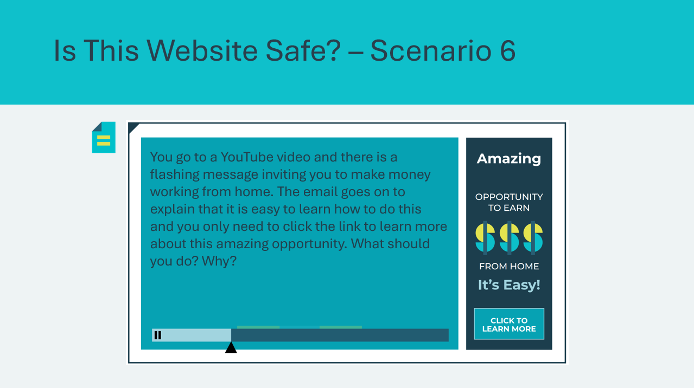 | Scenario 6  Read the scenario aloud or invite a student to do so. Facilitate the discussion by asking is the website safe or not? Encourage them to explain their thinking.
Program Kit Materials | For slide 57, you will need to use the Website Whatzit Game Cards from the program kit.
Slide 57  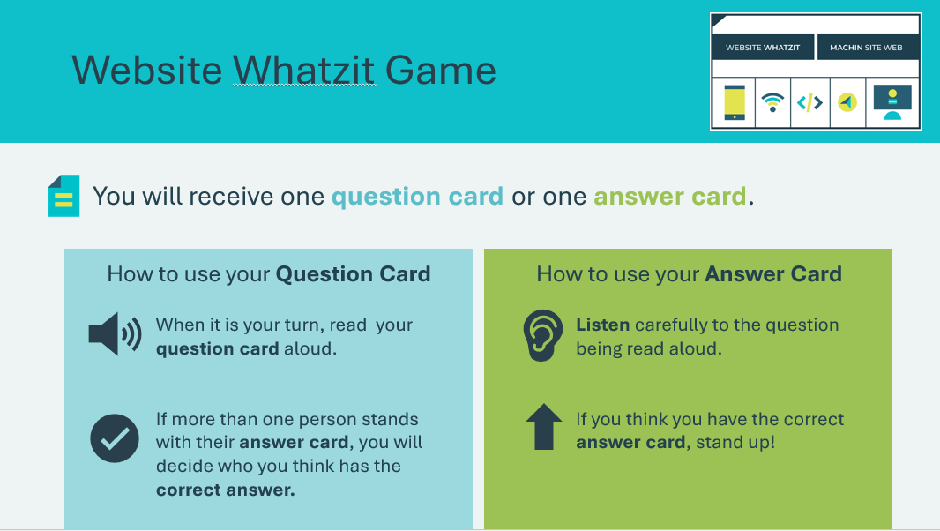  Website Whatzit Cards | Suggested time: 10 minutes  Tell students that most people have questions about online security, so we will look at some of the most common questions together by playing a game called Website Whatzit.  Website Whatzit is a Q & A card game that contains 17 question cards and 17 corresponding answer cards.  - Hand and out question and answer cards so that every student holds one card.  - Be sure to organize the cards before going into the classroom; for every question card that is handed out, the answer card should also be handed out.  - If your class is smaller than 34 students or you wish to downsize this activity, select only a small number of question cards and corresponding answer cards to hand out to students.  Students with question cards will take turns reading their question. Students with answer cards will stand up if they think they have the answer. The question-and-answer key can be found in the Appendix at the end of the Presenter Notes.  Modified version:  Dependent on the amount of time available, a modified version of this card game can be played by handing out only the answer cards. Read the question cards aloud and ask students to stand if they hold the correct answer card and to read their answer card aloud.
Are you a SMART consumer? 20 min
Slide 58  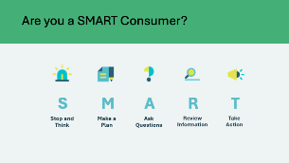 | Suggested time: 5 minutes  Ask: What do you think it means to be a SMART consumer?  Students may have a few ideas to offer. Review with students the meaning of the acronym SMART (Stop and think, make a plan, ask questions, review information, take action).  *Click or tap to reveal what each letter in the acronym stands for.  S-Stop and Think.  This is the time to stop, take a pause, and think before making a consumer decision. What are some of the things you should stop and think about? Why are impulse purchases usually not good ones?  M-Make a Plan.  At this point, consider your purchasing options. To make a plan, figure out what information is needed, how to obtain it, and when a decision needs to be made. What kinds of information should you look for? Where can you find this information? Why is this information important?  A-Ask Questions.  Asking questions helps consumers to make better decisions. What questions should you ask yourself or others before a major purchase? Who can you ask for information or advice?  R-Review Information.  Taking time to review the information with others helps consumers make better decisions. Who can help you review the information? Why is this a useful step?  T-Take Action.  Decide what payment method is best to use. Make the purchase. When making a purchase, consumers should always keep their receipt in case they need to return the item.
Slide 59  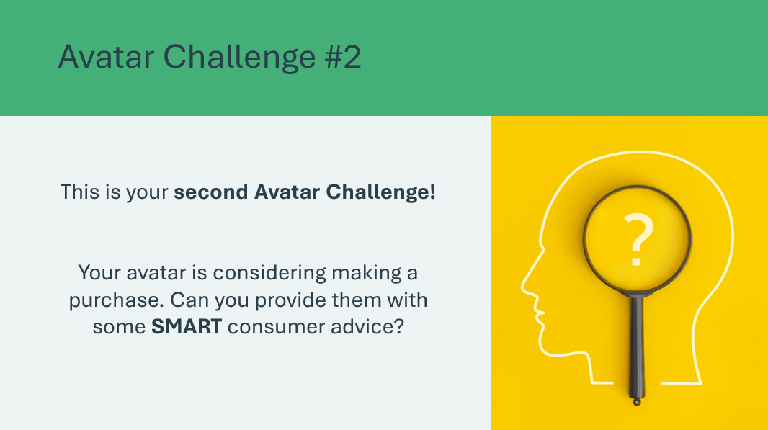 | Suggested time: 2 minutes  Introduce the second avatar challenge using the prompt. Students will use the same avatar the class selected in Lesson 1.
Slide 60  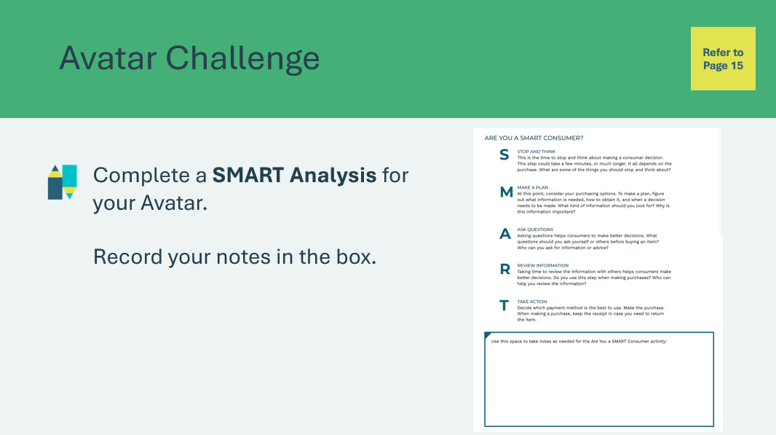 | Suggested time: 3 minutes  Explain that after you review the avatar challenge details together, they will conduct a SMART analysis for their chosen avatar using the SMART prompts in their student portfolio, page 15. Students should record their notes and ideas in the box.  Depending on available time and the dynamics of your class, instruct students to complete the task on their own, with a partner, or divide the class into small groups so that students work together to solve the very same Avatar challenge.  Advance to the next slide to select the avatar that was used in Lesson 1 and share the challenge details with students. You can also use the Avatar Challenge Cards found in your classroom materials kit.
Program Kit Materials | For slides 61-67, you can reference the Avatar Challenge 2 Cards from the program kit or use the information on the slide. Reference the same Avatar that the students previously selected.
Slide 61  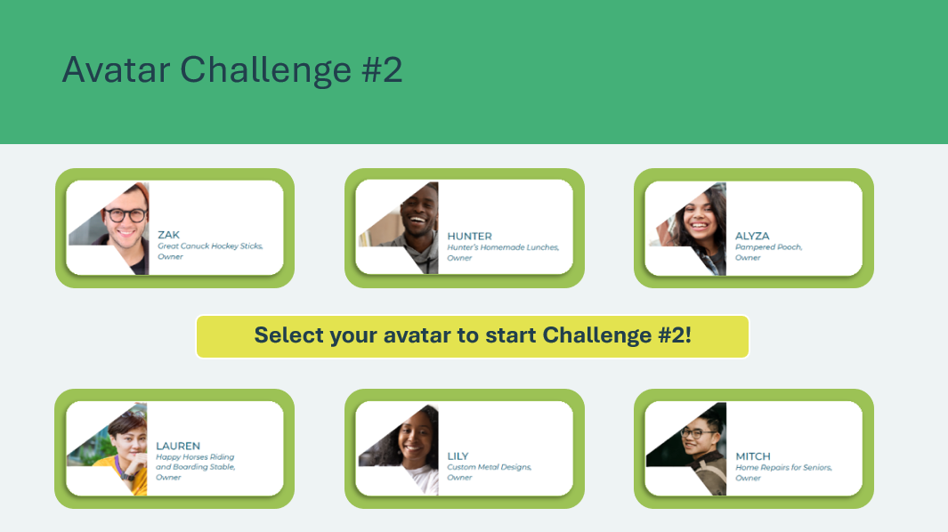 | Suggested time: 10 minutes  Once you have reviewed the instructions, select the avatar the students or the group voted for to begin.  *Click or tap on the avatar that the class has selected and share the challenge details with students.
Slide 62  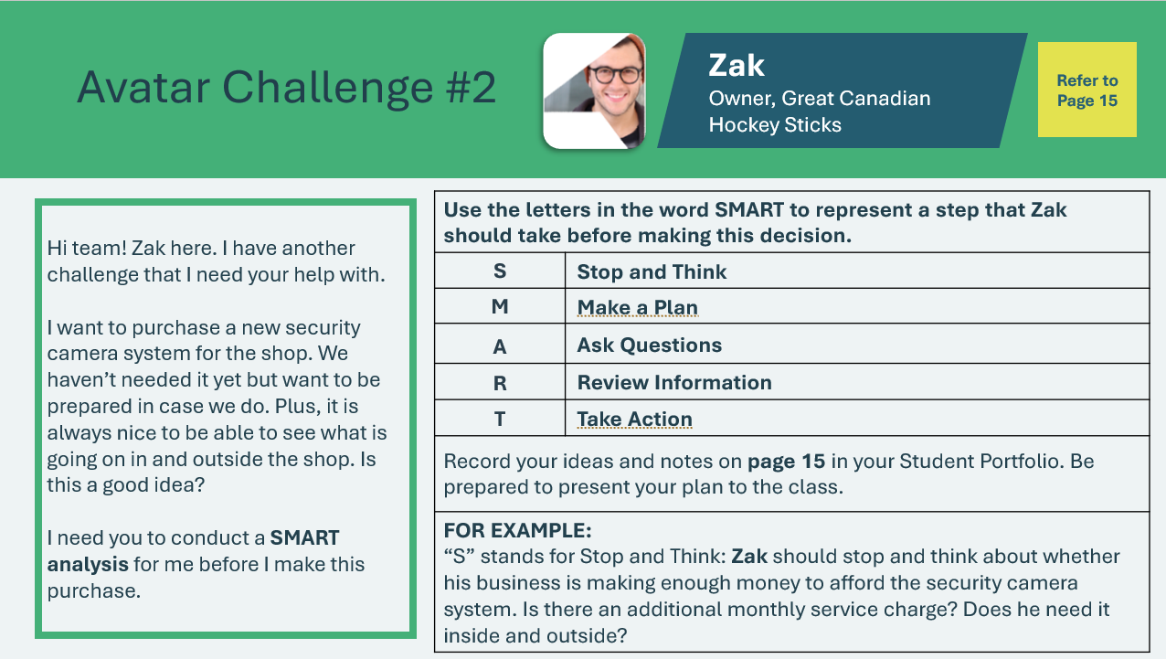  Avatar Challenge 2 Card – Zak  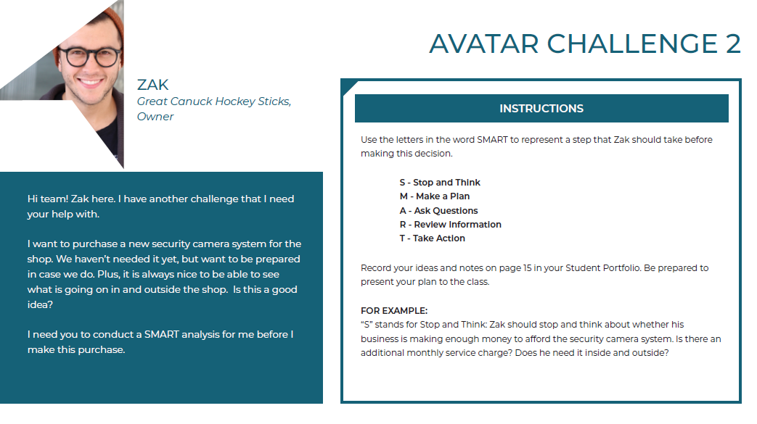 | Zak  Read the avatar’s message to the class. As a group, identify the item/product they are about to purchase.  Once students have completed their analysis, allow students to share their responses. Discuss specific examples and advice that could help their avatar.
Slide 63  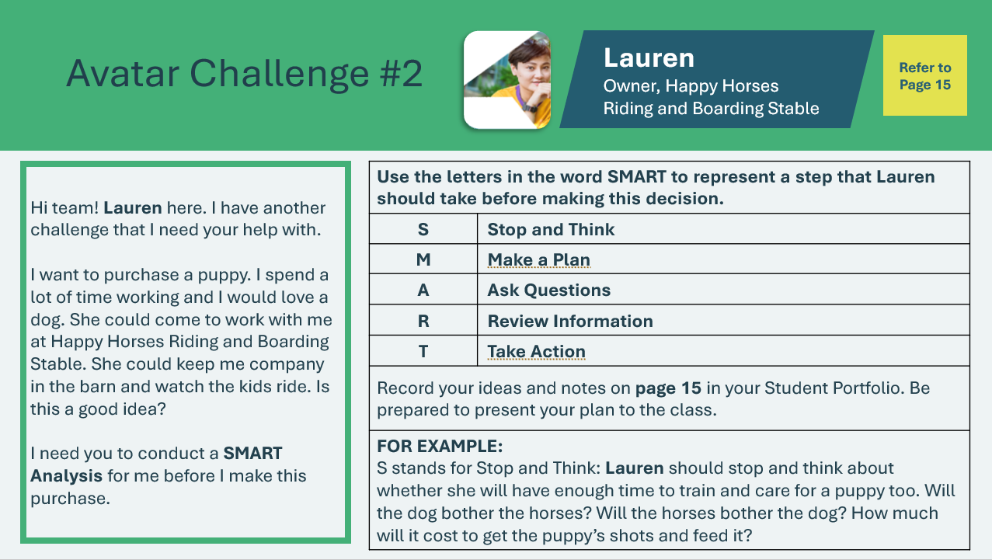  Avatar Challenge 2 Card – Lauren  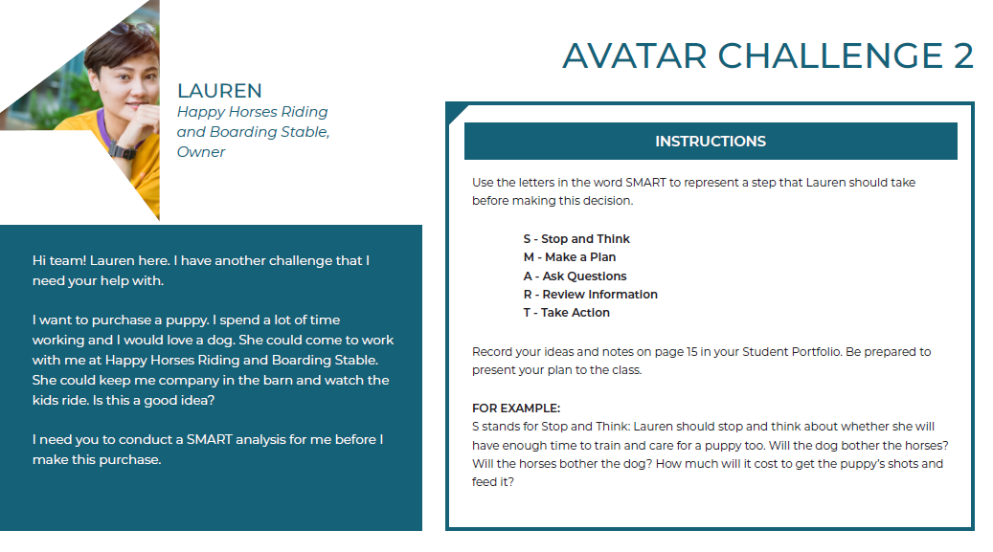 | Lauren  Read the avatar’s message to the class. As a group, identify the item/product they are about to purchase.  Once students have completed their analysis, allow students to share their responses. Discuss specific examples and advice that could help their avatar.
Slide 64  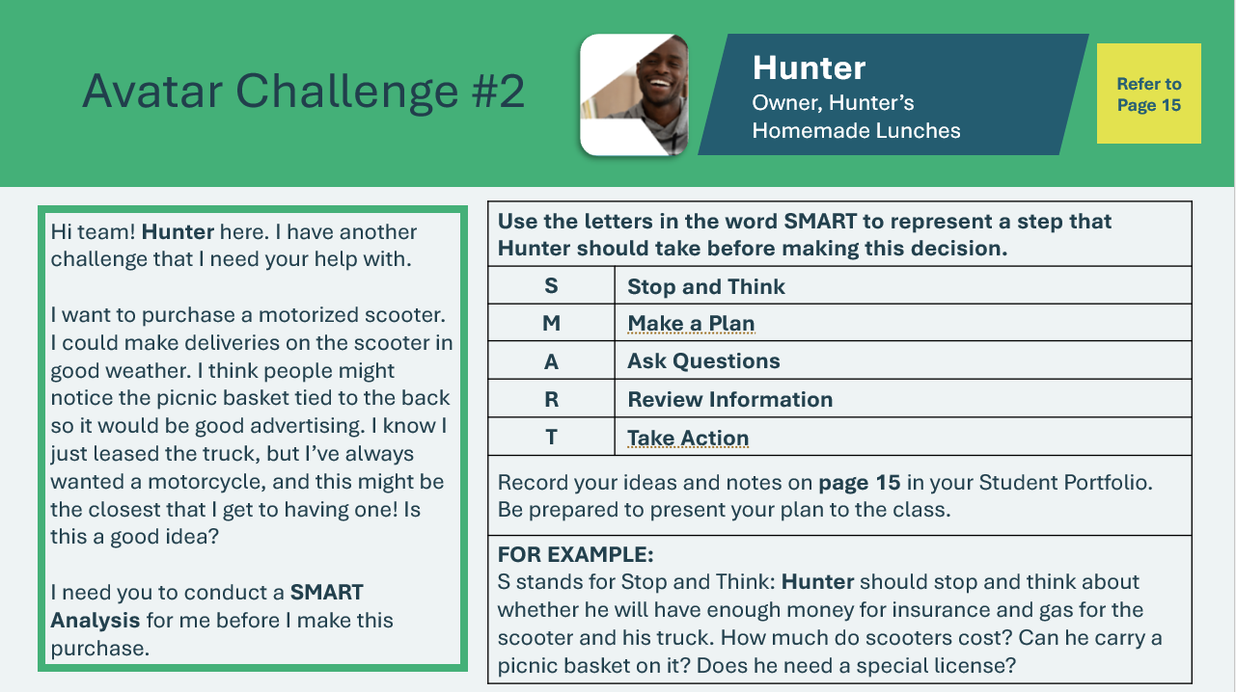  Avatar Challenge 2 Card – Hunter  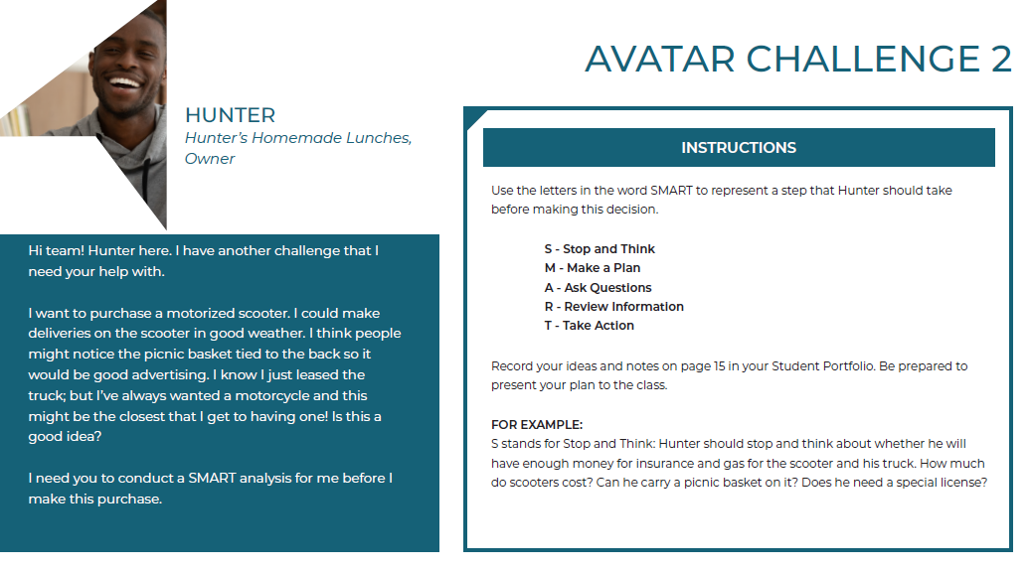 | Hunter  Read the avatar’s message to the class. As a group, identify the item/product they are about to purchase.  Once students have completed their analysis, allow students to share their responses. Discuss specific examples and advice that could help their avatar.
Slide 65  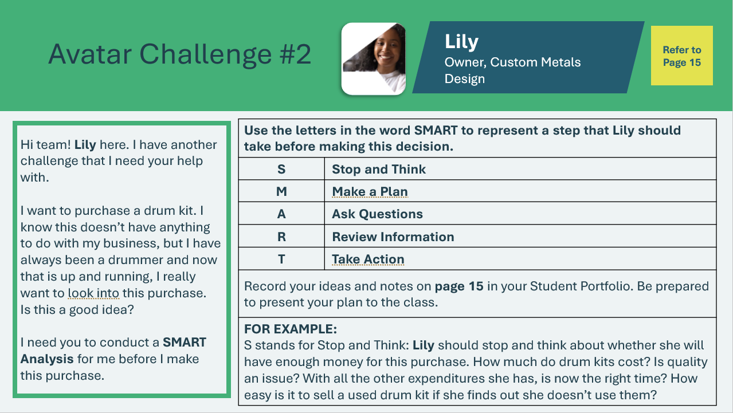  Avatar Challenge 2 Card – Lily  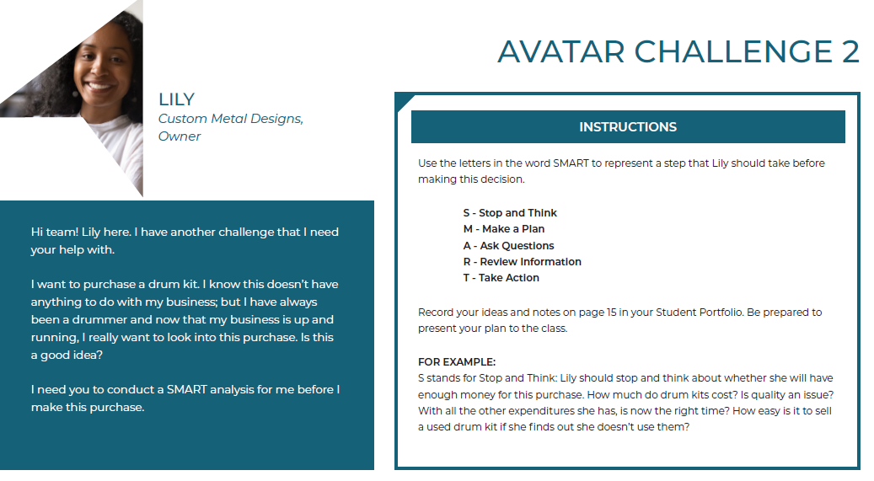 | Lily  Read the avatar’s message to the class. As a group, identify the item/product they are about to purchase.  Once students have completed their analysis, allow students to share their responses. Discuss specific examples and advice that could help their avatar.
Slide 66  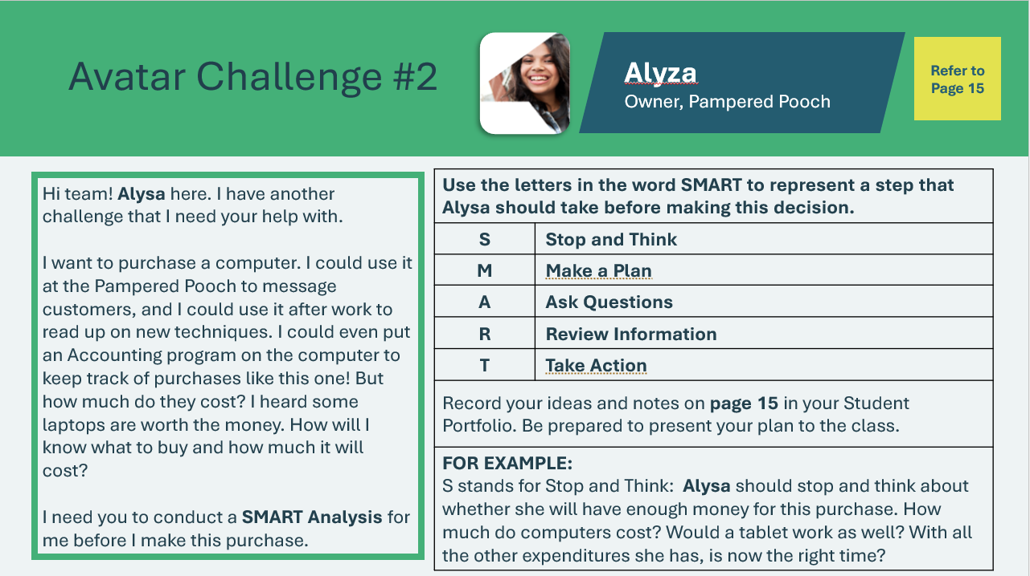  Avatar Challenge 2 Card – Alyza  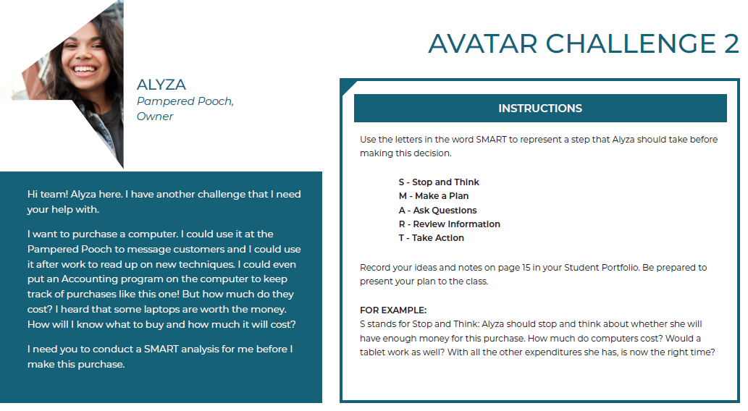 | Alyza  Read the avatar’s message to the class. As a group, identify the item/product they are about to purchase.  Once students have completed their analysis, allow students to share their responses. Discuss specific examples and advice that could help their avatar.
Slide 67  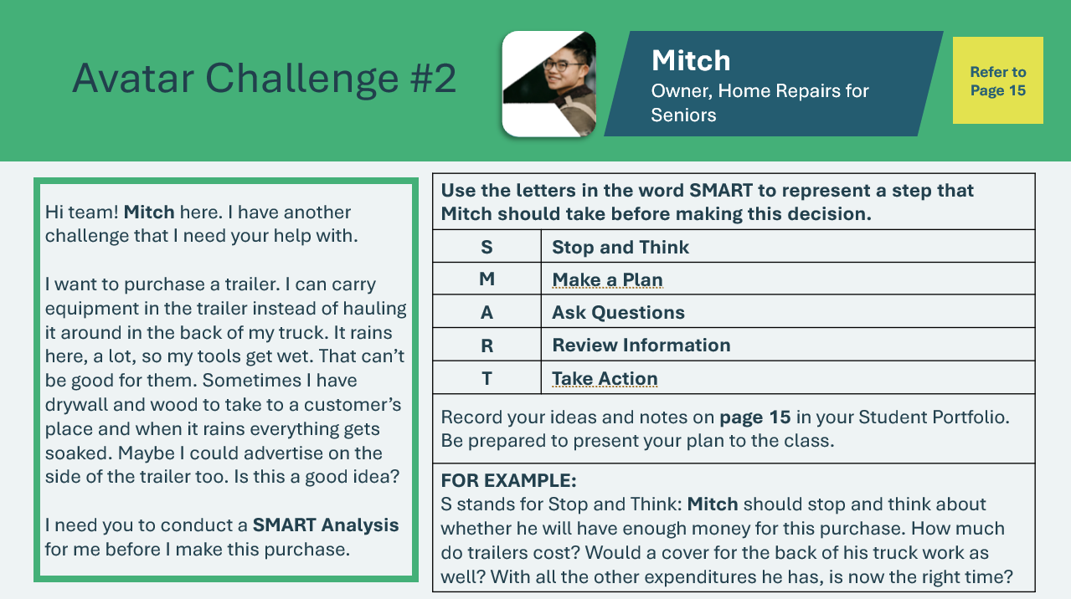  Avatar Challenge 2 Card – Mitch  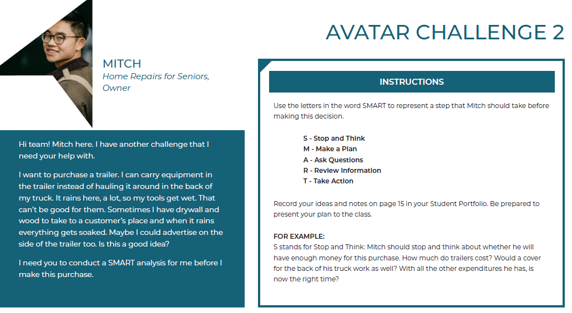 | Mitch  Read the avatar’s message to the class. As a group, identify the item/product they are about to purchase.  Once students have completed their analysis, allow students to share their responses. Discuss specific examples and advice that could help their avatar.
Extended Activities 45 mins
Slide 68  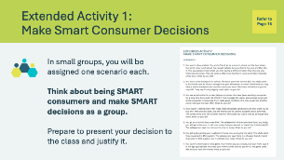 | Suggested time: 15 minutes  Divide the students into equal groups and assign each group one scenario from their student portfolio, page 16. Recall the meaning of each letter in SMART with the whole class and task each group with making SMART decisions based on their assigned scenario. Encourage the groups to engage in discussion about their scenario to make their decision.  After the group discussions and decisions, ask one student from each group to read their scenario, present their group’s decision, and justify their decision using the SMART acronym.  Encourage discussion and debate about the decisions presented by each group.
Slide 69  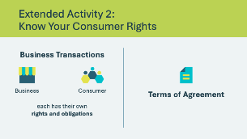 | Suggested time: 3 minutes  Explain that business transactions involve two “parties” the consumer and the business. Each has certain rights and obligations. Being a SMART consumer means knowing your consumer rights and obligations.  Explain that when you open an account with a financial institution or a store, there are specified “Terms of Agreement”.  - Terms of Agreement is a document that outlines the rights and responsibilities of both parties (business and consumer) engaging under one transaction. Accepting the Terms of Agreement means that they both come to terms with the outlined rights and responsibilities for each party.  If the time permits, ask the students if they have seen a Terms of Agreement document, or if they have none, share your own experience to help students build understanding.  Explain that it is important to always read the “Terms” very carefully to fully understand your rights and obligations and those of the business.
Slide 70  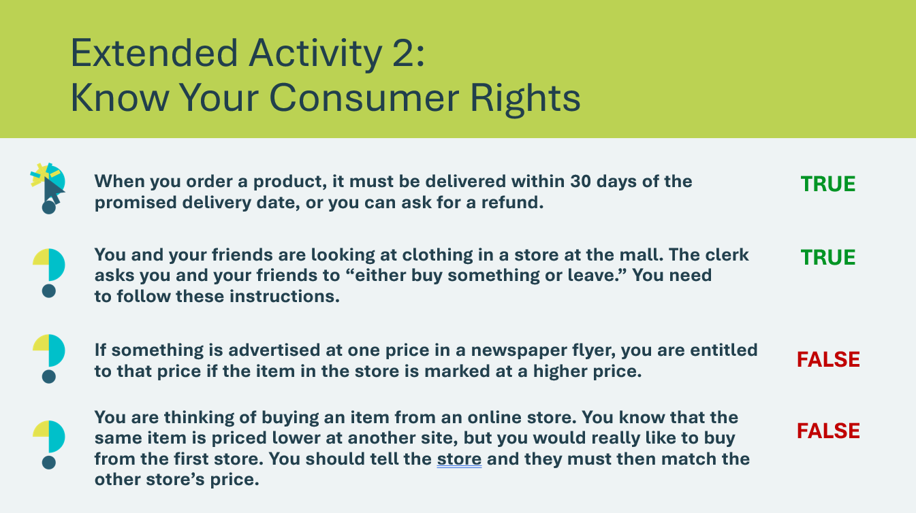 | Suggested time: 10 minutes  Review the statements and ask students to stand if they think the statement is true.  *Click or tap to reveal the correct answer.
Slide 71  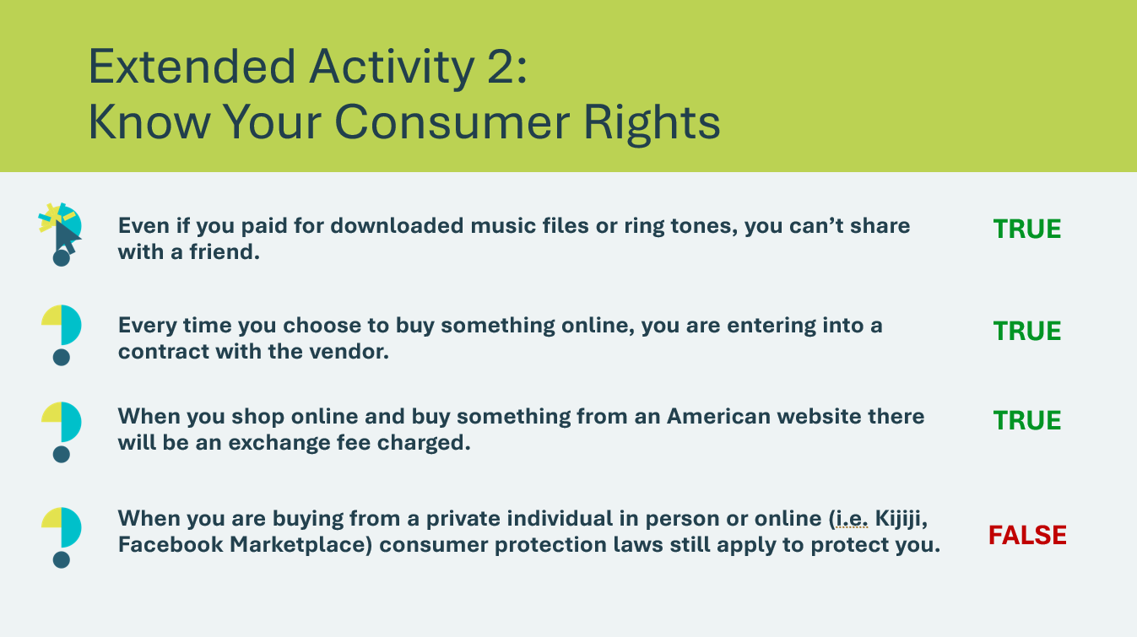 | True & False continued
Slide 72  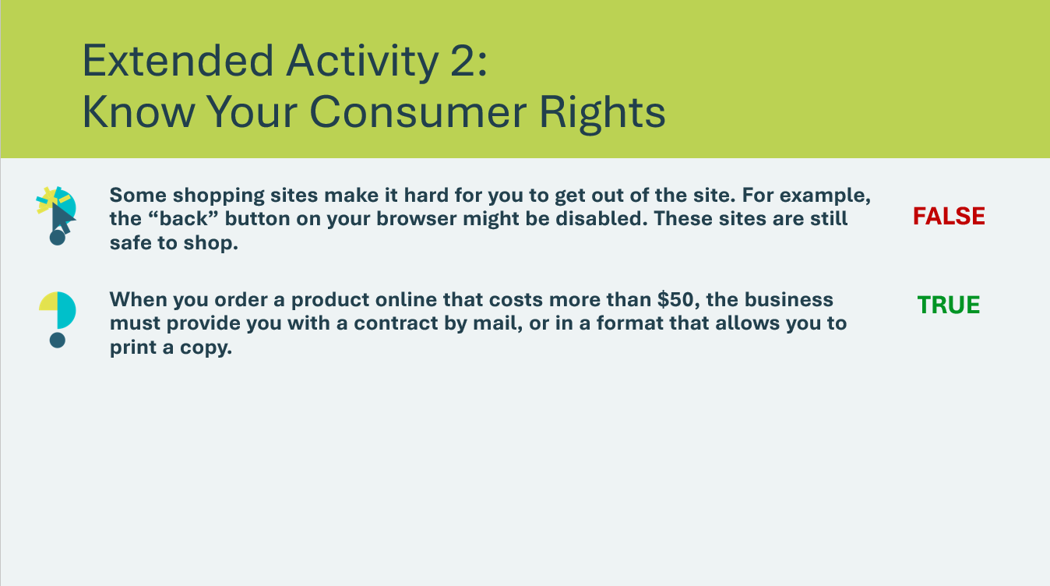 | True & False continued
Slide 73  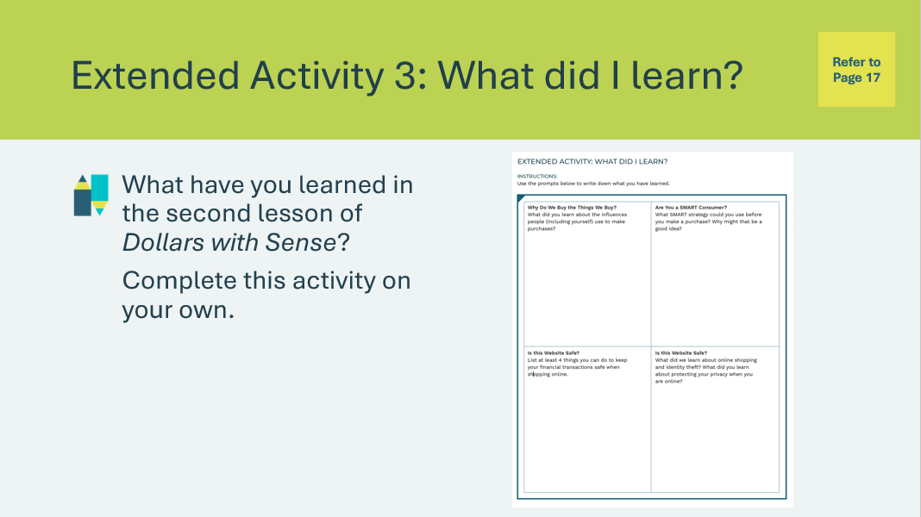 | Suggested time: Students can complete the reflections in class if time allows, or independently later on.  Students can complete the self-reflection activity in their student portfolio, page 17. Students may respond to some or all of the prompts. There is no need to discuss their self-reflections; you and the classroom teacher may review them either between lessons or later on if necessary.

Lesson 3: Spending, Saving, Sharing
Program Kit Materials | Needs/Wants Cards  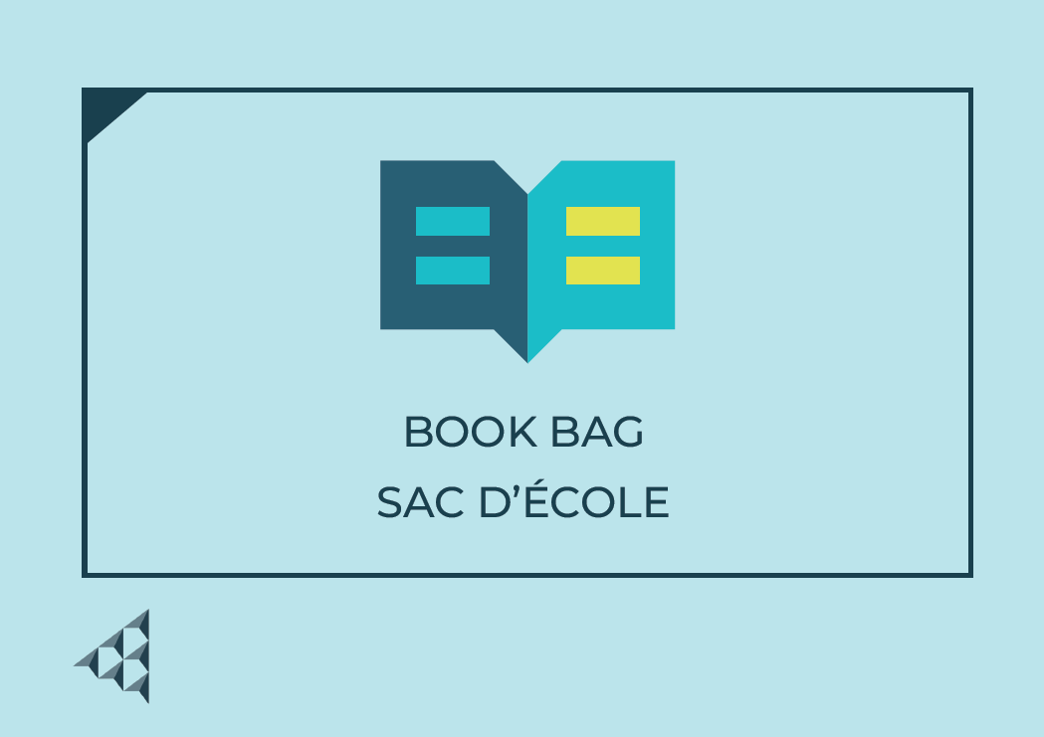  Avatar Challenge 3 Cards  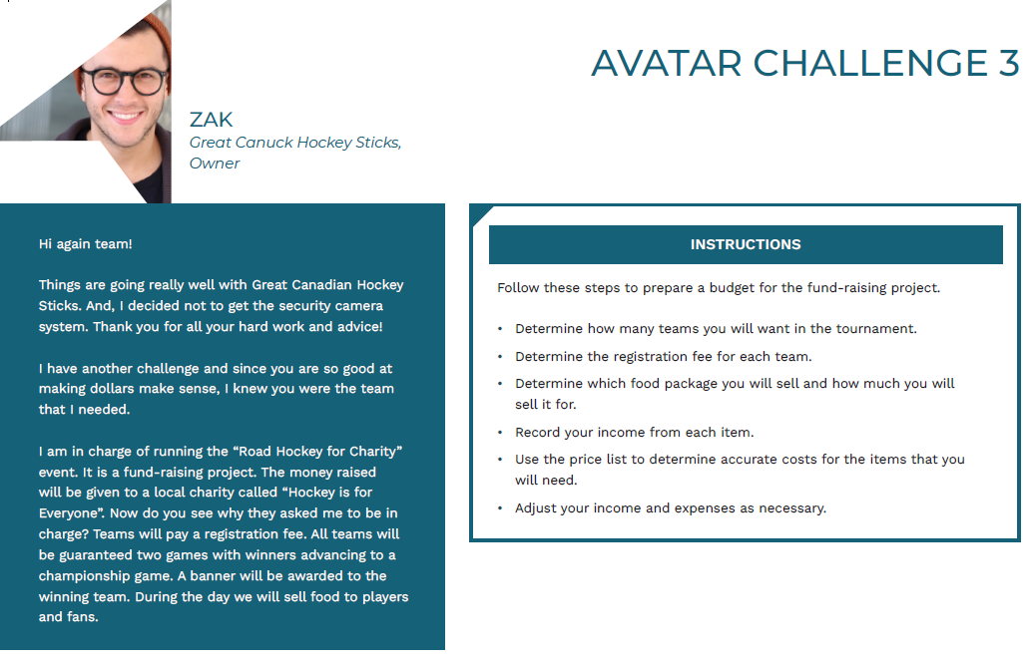
Slide 74 – Lesson 3  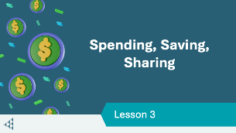 | Lesson 3: Spending, Saving, Sharing
Slide 75 – Objectives  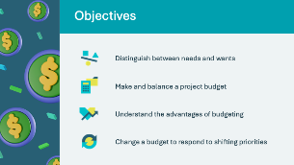 | Optional – review the learning objectives for the lesson
Slide 76 – Introduction  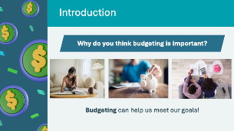 | Explain that in this lesson, the students will reflect on their needs, wants, and goals. They will explore the importance of budgeting as a way to look after their money and as a tool to help them meet their goals.  Invite a few students to share an experience they’ve had with budgeting.
Slide 77 – Activity Menu  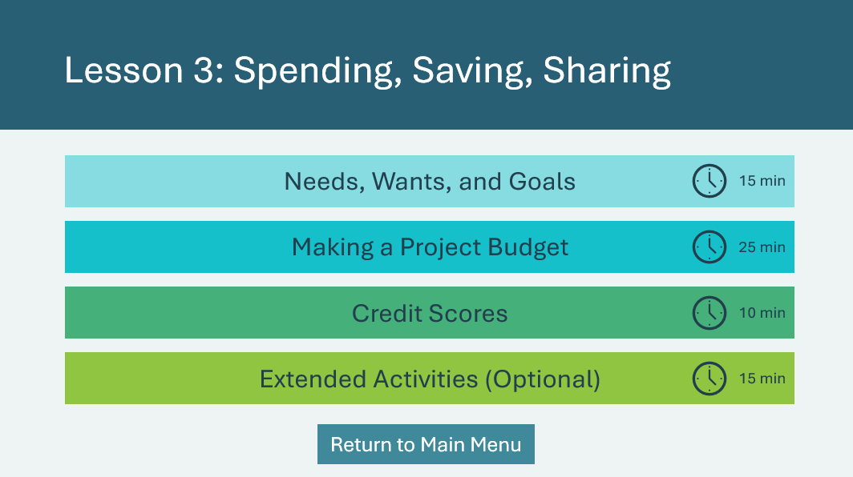 | *Select the button to navigate to the activity.  After you have completed an activity, you will be redirected back to the activity menu.  *Click or tap the Return to Main Menu button to return to the Lessons (Slide 5)
Needs, Wants, Goals 15 mins
Slide 78   | Suggested time: 4 minutes  Play the Budgeting video to introduce the activity. The video provides examples of needs and wants.  Facilitator tip: You may wish to reference the video throughout the activity, as it discusses other important concepts around budgeting.
Program Kit Materials | For slides 79-83, you can use the Needs/Wants Cards from the program kit as an alternative to the activity on the slides.
Slide 79  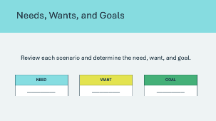  Needs/Wants Cards | Suggested time: 3 minutes  Explain to students they will look at 4 scenarios on the following slides. Each of the scenarios will include a need, a want, and a goal. Students will need to identify the need, want and goal.  After reading each scenario, invite a volunteer to identify the need, want and goal.
Slide 80  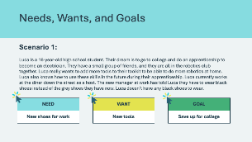 | Scenario 1  Read each scenario to the class and invite a volunteer to identify what the need, want and goal is.  *Click or tap to reveal each of the answers and advance to the next scenario.
Slide 81  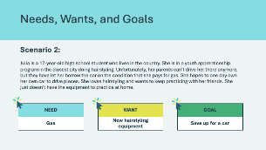 | Scenario 2  Read each scenario to the class and invite a volunteer to identify what the need, want and goal is.  *Click or tap to reveal each of the answers and advance to the next scenario.
Slide 82  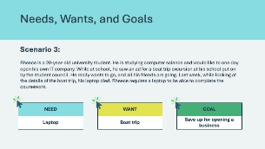 | Scenario 2  Read each scenario to the class and invite a volunteer to identify what the need, want and goal is.  *Click or tap to reveal each of the answers and advance to the next scenario.
Slide 83  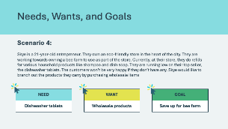 | Scenario 4  Read each scenario to the class and invite a volunteer to identify what the need, want and goal is.  *Click or tap to reveal each of the answers and advance to the next scenario.
Slide 84  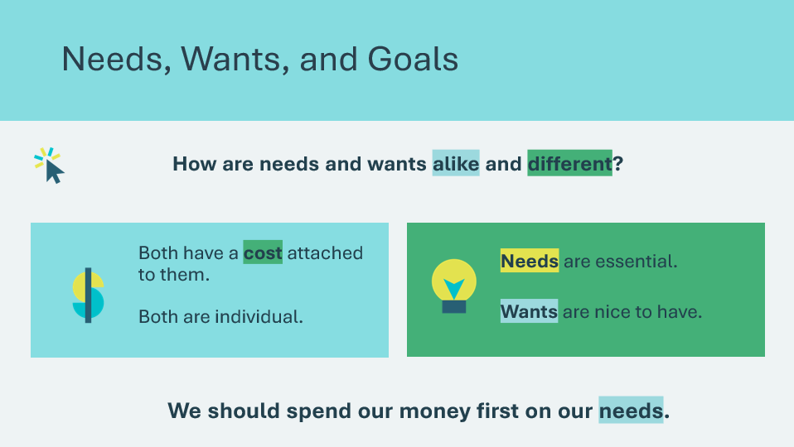 | Suggested Time: 2 minutes:  Wrap up the activity using the following discussion questions:  - How are needs and wants alike and different?  - They both have a cost attached to them and they are individual (everyone has different needs and wants)  - Needs are essential and wants are nice to have.  - Which should we spend our money on first? Needs, wants, or goals?  - Needs should always come first before wants.  Volunteer connection: share examples of needs and wants you may have or an example of when you have spent money on your needs before your wants.
Slide 85   | Suggested Time: 2 minutes  Ask students the prompt and allow a few volunteers to share their ideas.  *Click or tap to show the pie chart  Explain that a simple rule to follow is: Needs 50% Savings 20% Wants 30%. Remind the students that the majority of your budget should always go to your needs.  Volunteer connection: Based on your industry knowledge and expertise, you may wish to adjust these percentages and share it with the class, to help them better understand the concept of budgeting.  Remind students that as their priorities change throughout different phases of their lives, their needs, wants and goals can change too.
Slide 86    Slide 87  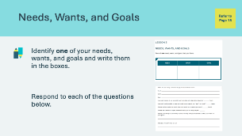 | Suggested Time: 5 minutes  Explain to the students that to be able to afford the things you want and need; you must create a financial plan called a budget.  Instruct students to complete the activity in their student portfolio, page 18, independently.  Facilitator tip: Circulate through the class while students are working on the activity. Provide examples and support where needed.
A Project Budget 25 mins
Slide 88  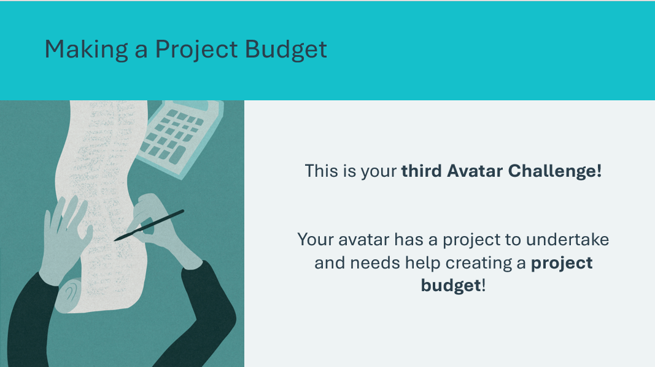 | Suggested Time: 2 minutes  Introduce the third Avatar Challenge!
Slide 89  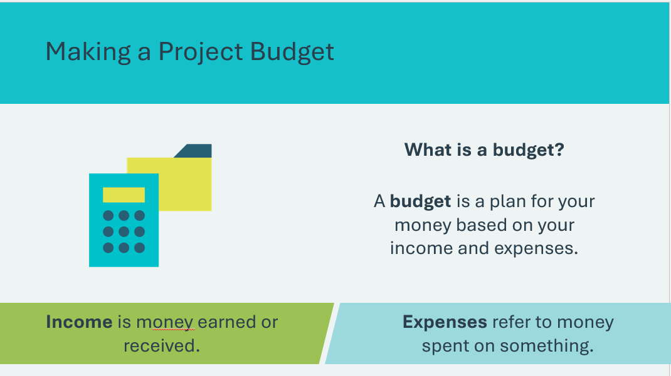 | Suggested Time: 2 minutes  Review the concept of a budget and help students distinguish between income and expenses.
Program Kit Materials | For slides 90-96, you can reference the Avatar Challenge 3 Cards from the program kit or use the information on the slide. Reference the same Avatar that the students previously selected.
Slide 90  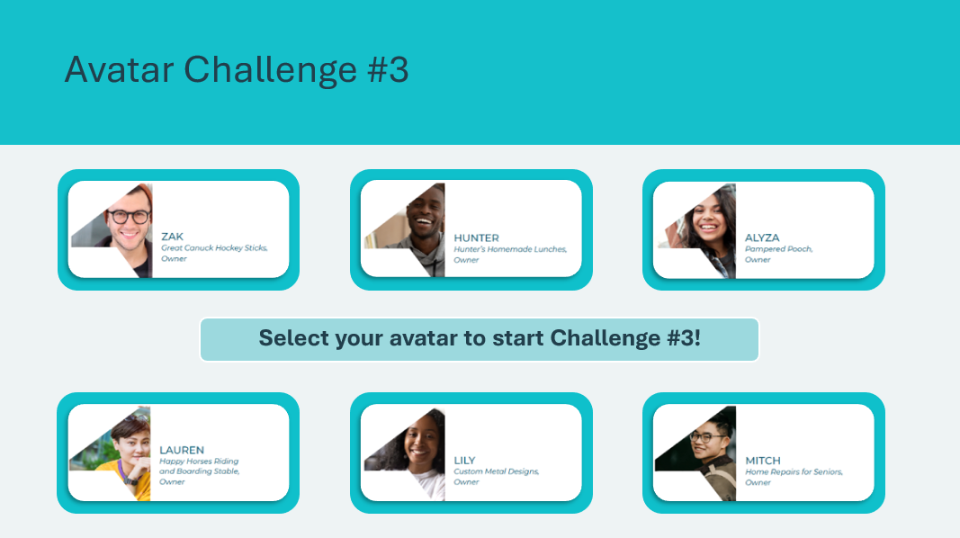 | Suggested Time: 3 minutes  Students will use the same avatar they used in Lessons 1 and 2.  *Click or tap on the avatar that the class has selected and share the challenge details with students.  Avatar cards can also be found in your JA Kit Materials.
Slide 91  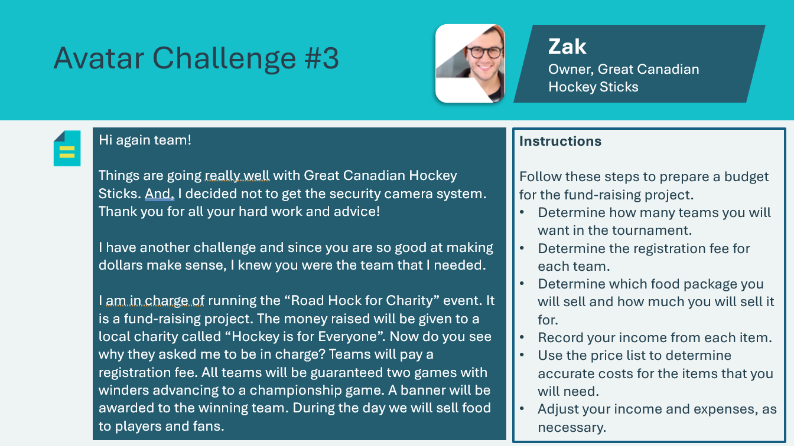  Avatar Challenge 3 Cards – Zak  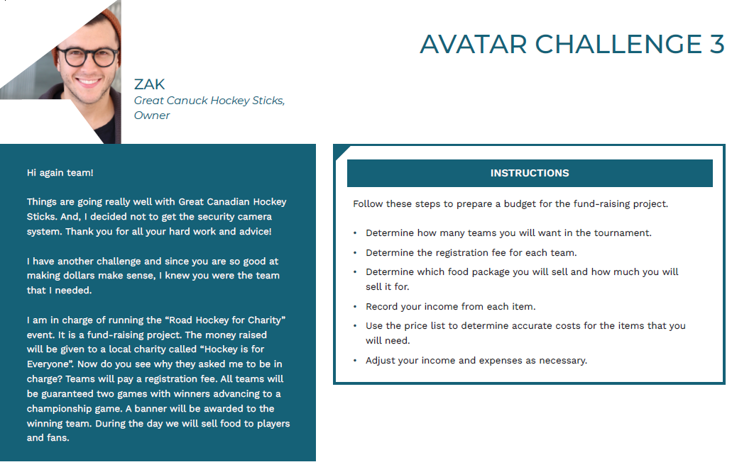 | Zak  Review the avatar challenge information and instructions with the class.
Slide 92  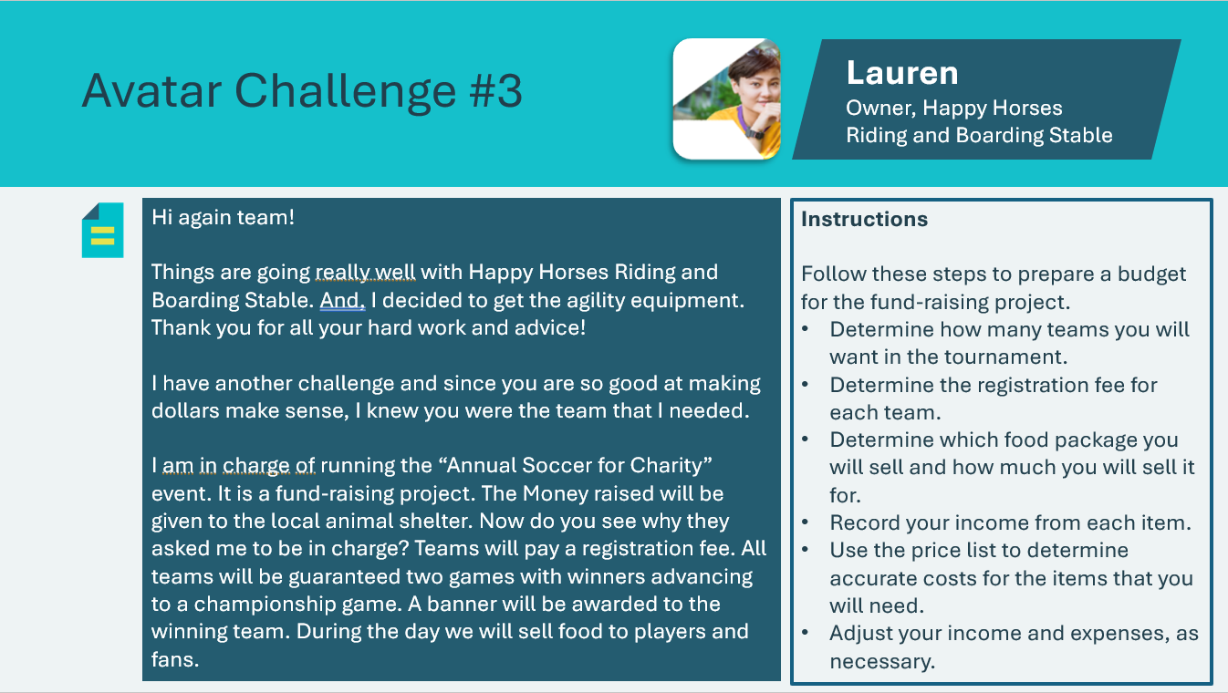  Avatar Challenge 3 Cards – Lauren  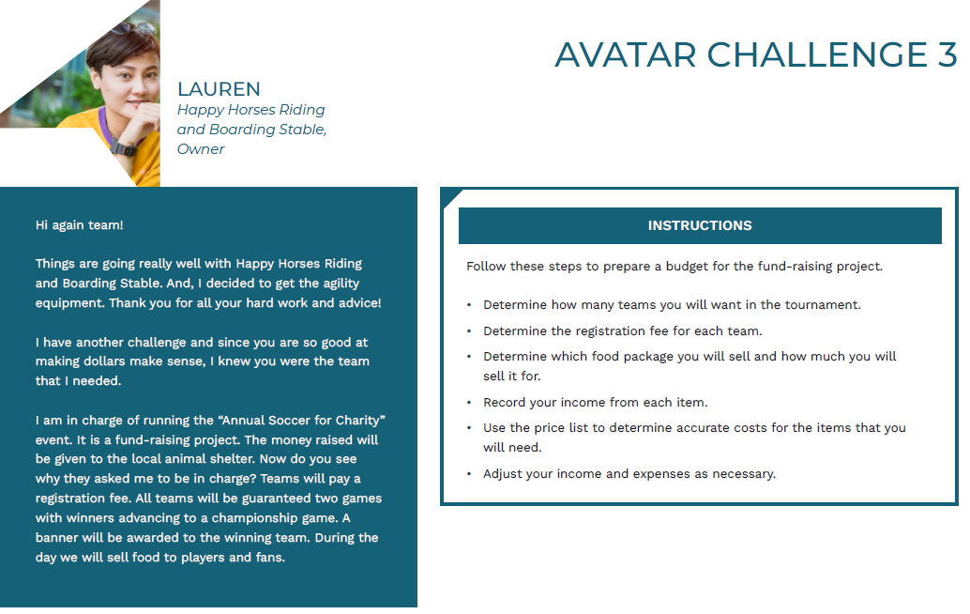 | Lauren  Review the avatar challenge information and instructions with the class.
Slide 93  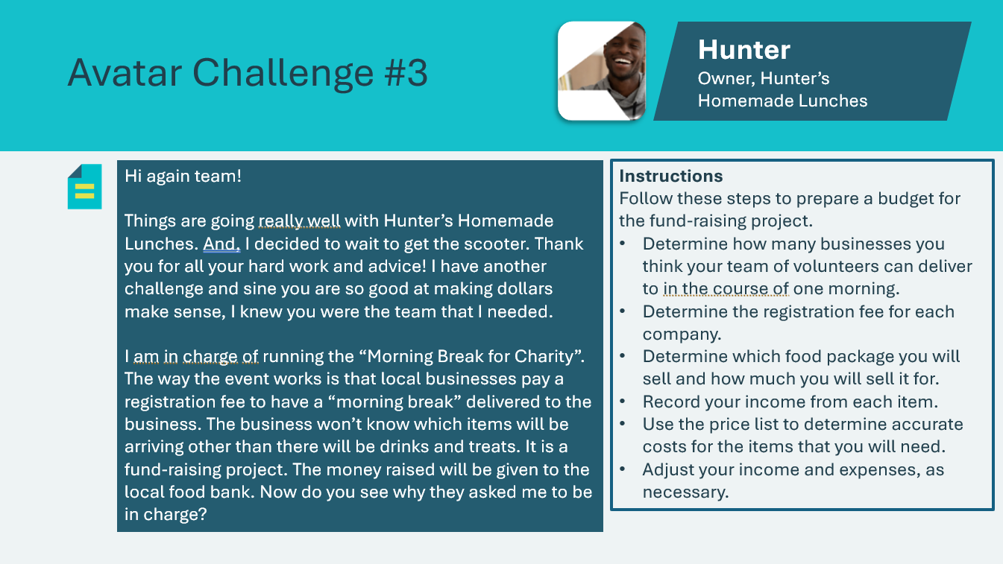  Avatar Challenge 3 Cards – Hunter  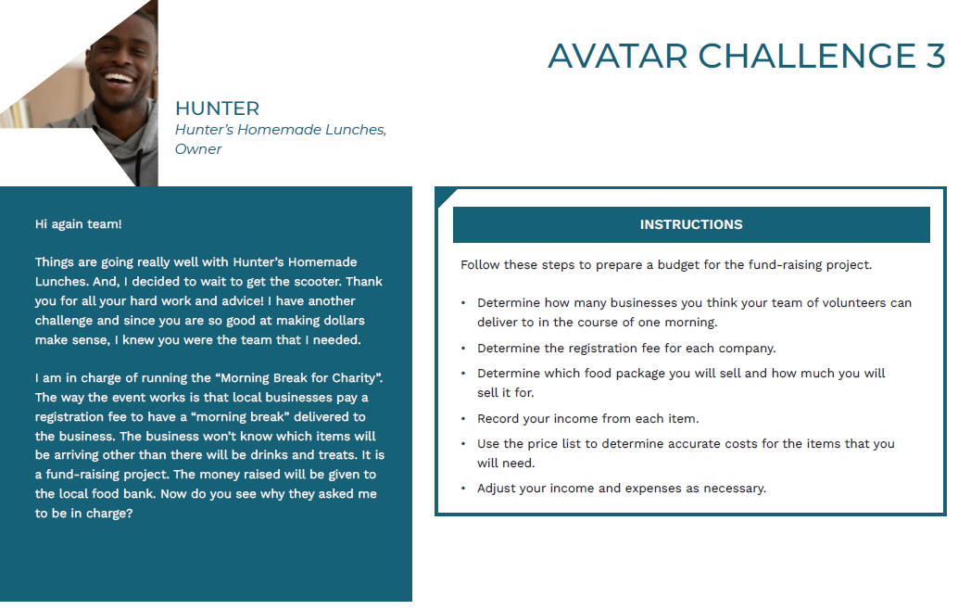 | Hunter  Review the avatar challenge information and instructions with the class.
Slide 94  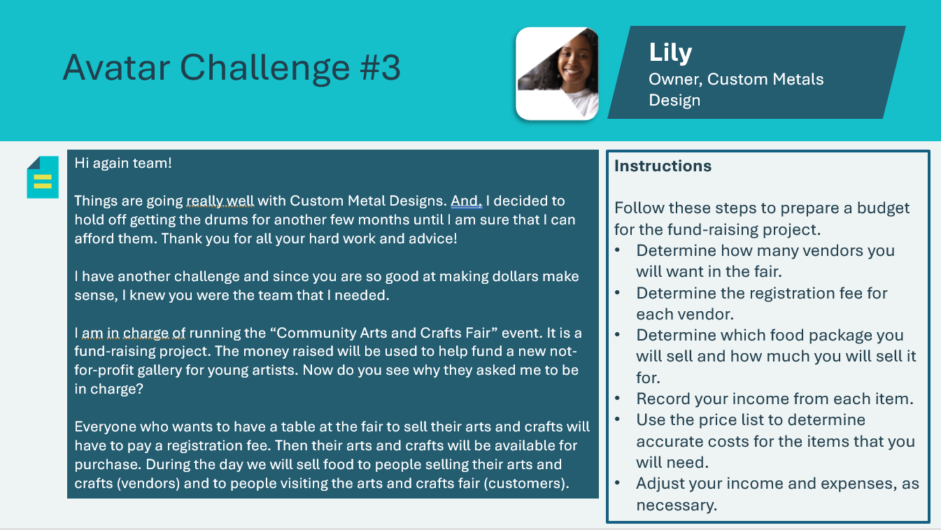  Avatar Challenge 3 Cards – Lily  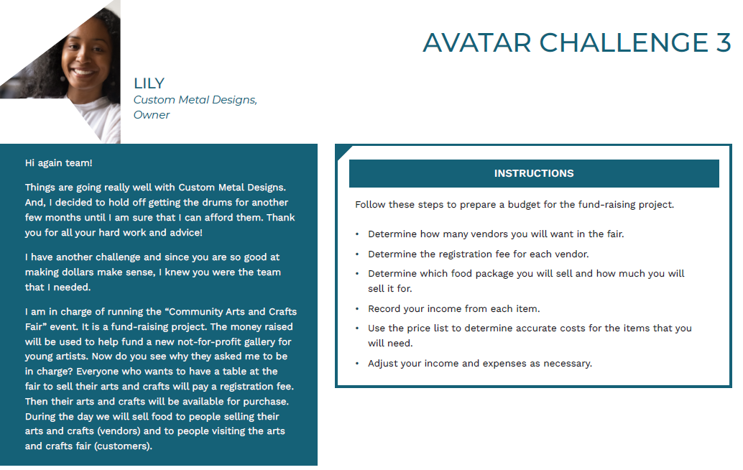 | Lily  Review the avatar challenge information and instructions with the class.
Slide 95  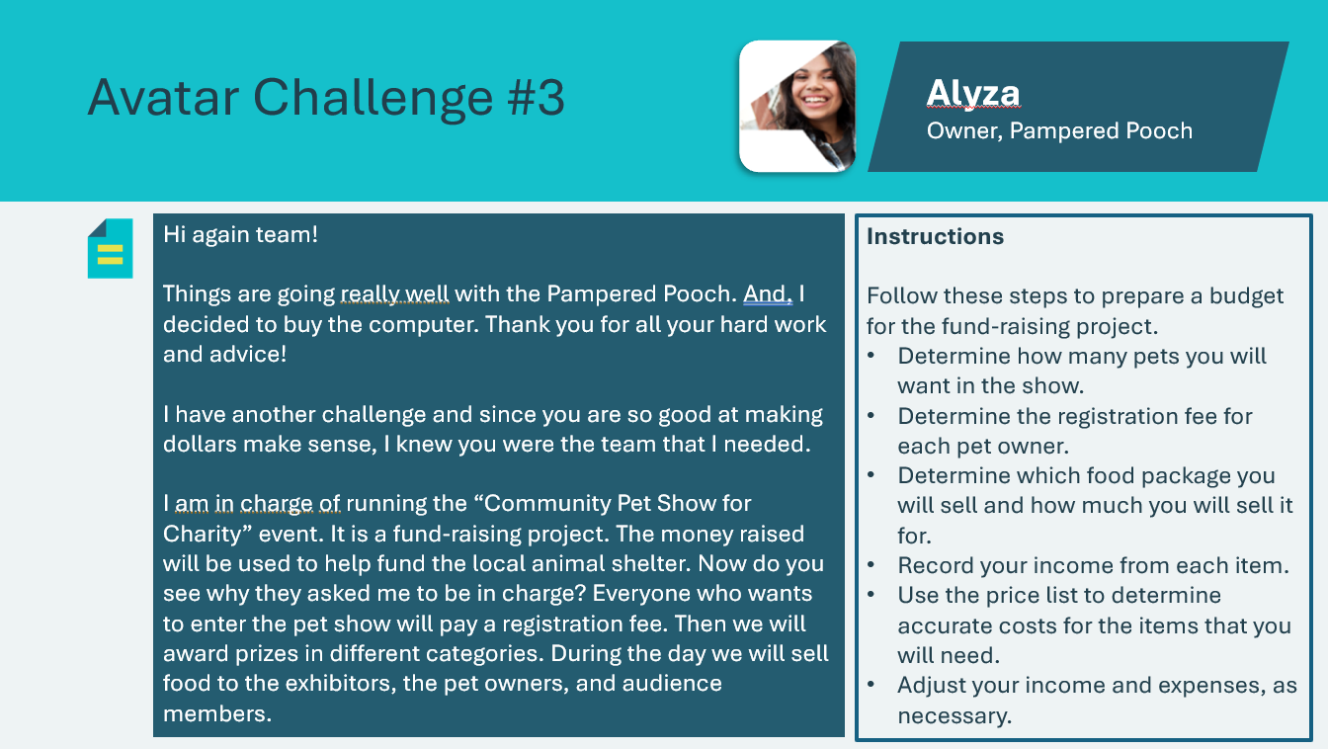  Avatar Challenge 3 Cards – Alyza  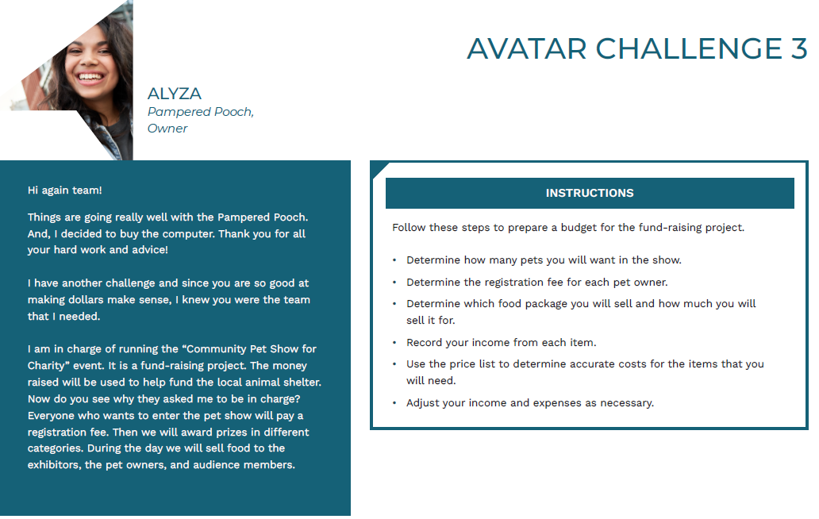 | Alyza  Review the avatar challenge information and instructions with the class.
Slide 96  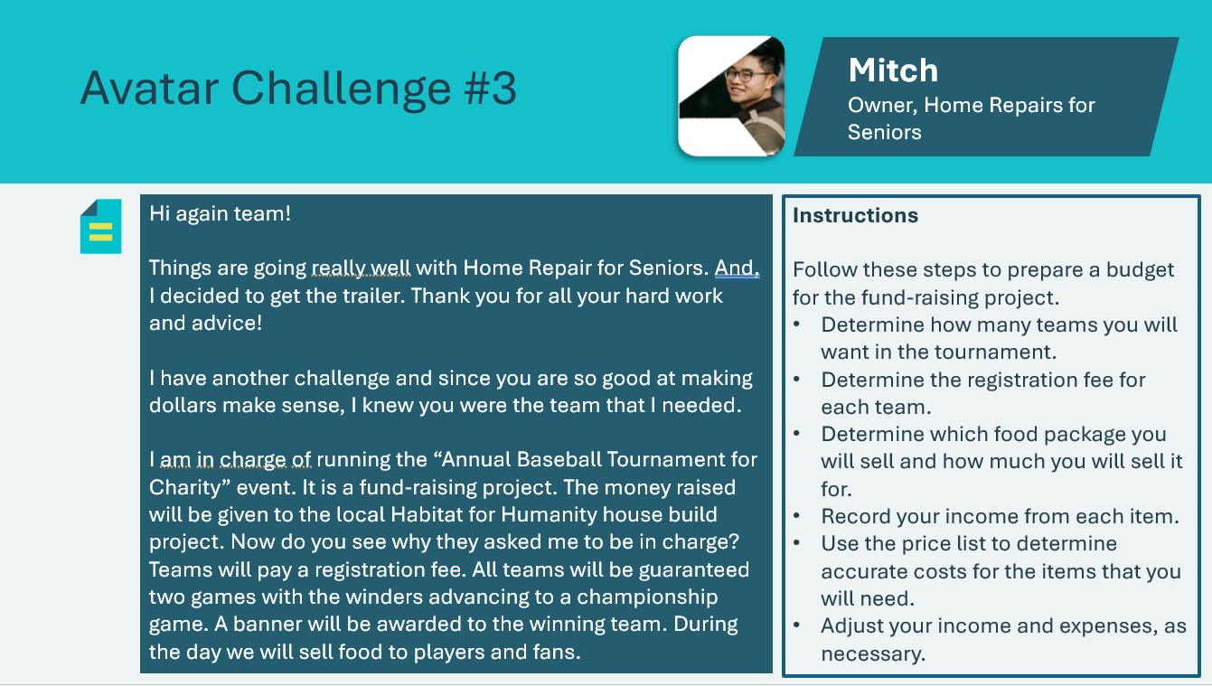  Avatar Challenge 3 Cards – Mitch  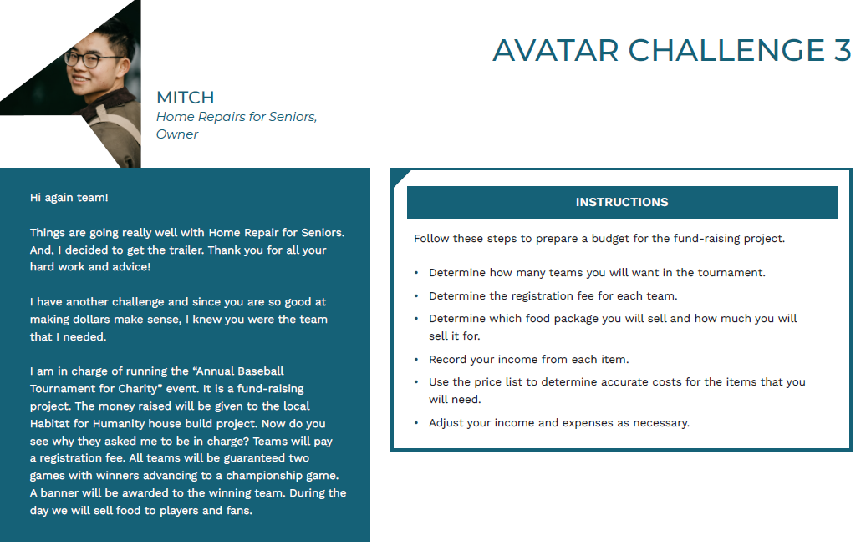 | Mitch  Review the avatar challenge information and instructions with the class.
Slide 97  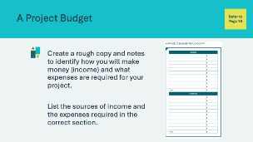 | Suggested Time: 5 minutes  Students will complete the Project Budget Rough Copy found in their student portfolio, page 19. Students may work independently or in small groups. All students should work to solve the same avatar challenge.  You may wish to display the avatar challenge on the board as students create their rough copy.  Facilitator tip: Circulate the classroom to guide the students in their activity and answer any questions.
Slide 98  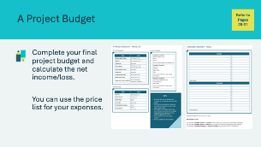 | Suggested Time: 5 minutes  Once students have completed the rough copy, they may begin compiling their final project budget in their student portfolio, page 21. An optional price list is available on page 20 if they wish to use the expense amounts. As students work on their project budget, circulate the classroom to provide support for those who may need it.  Facilitator tip: Assist students with the first few income and expense entries in their budget and then allow students to work on other entries and be creative.  Students should complete the budget and calculate the net income/loss. Once completed, review the final project budget and invite a few students to share the details of the budget they have created.  Illustrate their budget decisions and calculations on the whiteboard.  Remind students that it’s important to monitor your budget to determine if the amount of money you think you need is still the same. If not, you may have to make changes to your budget to make sure your income covers your expenses.
Slide 99  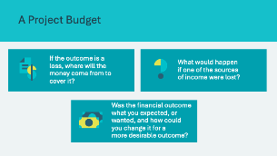 | Suggested Time: 2 minutes  Wrap up the activity using the discussion questions.  Point out that since most budgets deal with the future, there may be unexpected events that change the outcome. Ask for examples of unexpected events that could change a personal or project budget.  Sample Answers:  - Costs may be higher than expected. Ask for specific examples relating to the project  - There may be expenses that were not planned. Ask for specific examples relating to the project  - Income may be lower than expected. Ask for specific examples relating to the project.
Credit Scores 10 mins
Slide 100  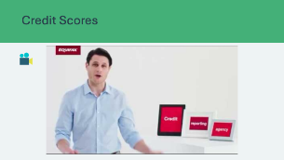 | Video Time: 3 minutes  Explain to students that sometimes if more money is needed for your project, you might consider a loan. With a loan, you will pay interest and your history with credit will affect how likely it is for you to get a loan. Credit bureaus collect information and give you a credit score based on how well you handle credit.  Play the video to introduce the concept of credit scores. You may use the information from this video as your guide for the following activities.
Slide 101  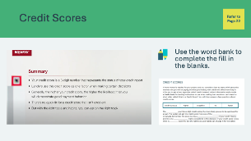 | Suggested time: 5 minutes  Discuss with the students what they learned about credit scores.  Students can use the information in the video summary to help them complete the activity.  Students will complete the fill-in-the-blanks activity in their student portfolio, page 22.
Slide 102  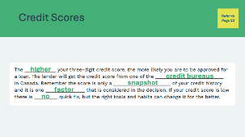 | Suggested Time: 2 minutes  Review the answers as a group. Explain that there are some factors that influence credit scores, such as:  - Paying bills on time  - Types of credit accounts  - How many credit accounts you have  - The balances of your accounts  Ask: Has anyone heard of student loans?  - Explain that student loans are a form of loan that many young people have to help them pay for post-secondary education or training. Paying these off according to the terms of the loan is an important step in building healthy credit.
Extended Activity 15 mins
Slide 103  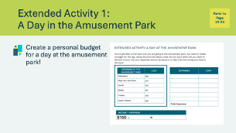 | Suggested time: 10 minutes  Students will plan their own budget for a day at the amusement park in their student portfolio, page 22.  Facilitator tip: Circulate the classroom to support students as they create their budget.
Slide 104  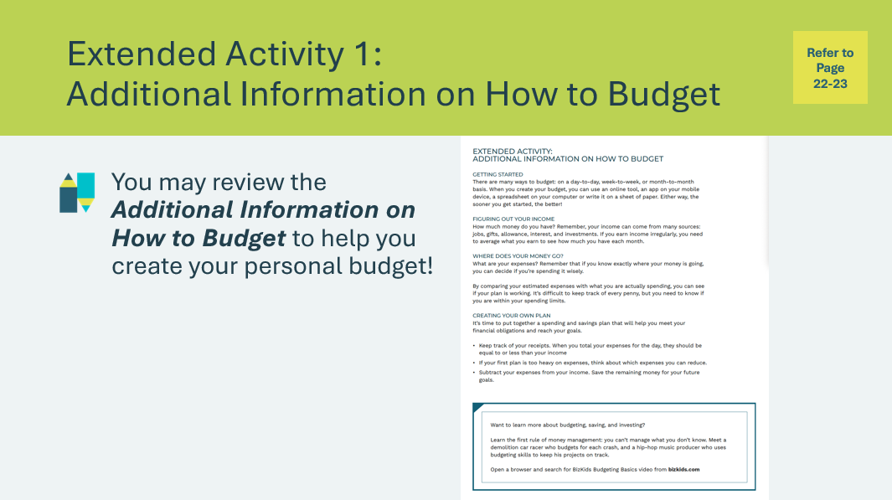 | Students may explore and use the Additional Information on How to Budget section provided in their student portfolio, page 23, to help in creating their budget in A Day in the Amusement Park, page 22.
Slide 105  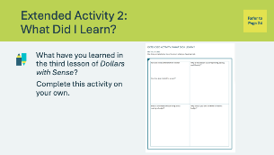 | Suggested time: Students can complete the reflections in class if time allows, or independently later on.  Students can complete the self-reflection activity in their student portfolio, page 24. Students may respond to some or all of the prompts. There is no need to discuss their self-reflections; you and the classroom teacher may review them either between lessons or later on if necessary.
Slide 106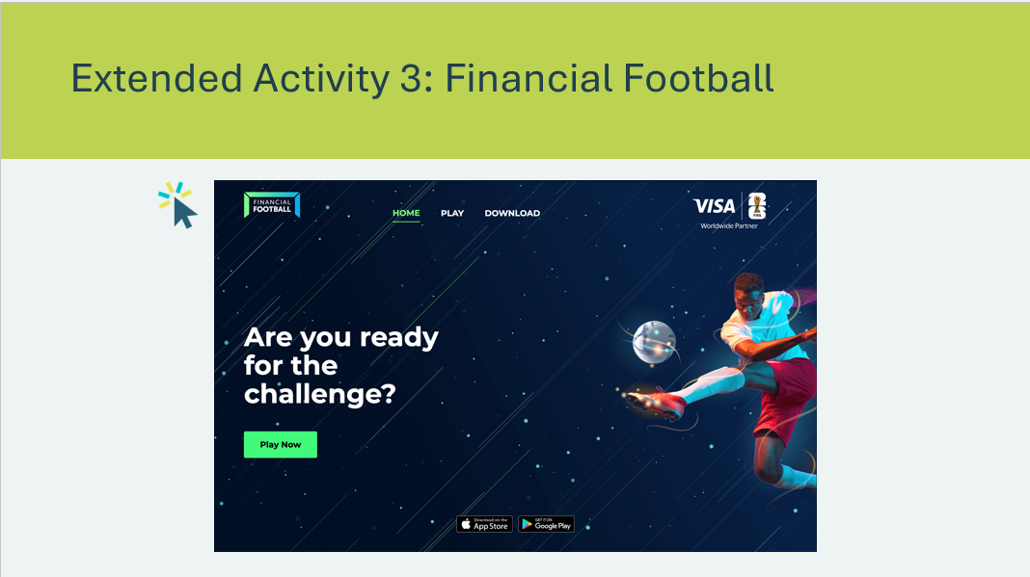 | Suggested Time: Optional  If time allows, students can join you to play Financial Football. *Click or tap the image to access the game in a new web browser.  https://financialsoccer.com/ie/play  Your browser must be WebGL enabled for you to play the game. Make sure to check your browser configuration first.

Lesson 4 – Make Your Money Work for You
Slide 107 – Lesson 4   | Lesson 4: Make Your Money Work for You
Slide 108 – Objectives  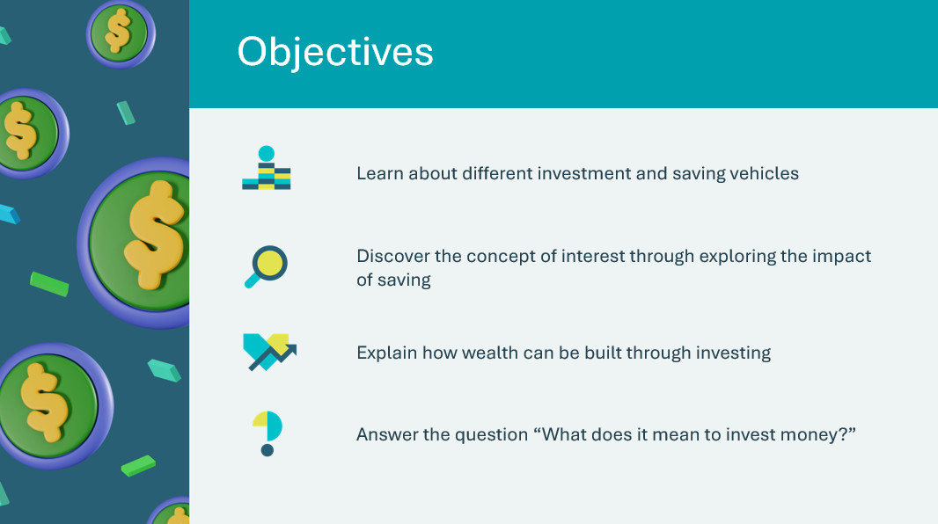 | Optional – review the learning objectives for the lesson
Slide 109 – Introduction  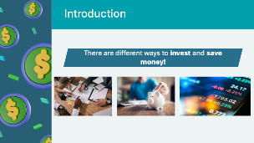 | Introduce the lesson by explaining that there are different ways to invest and save money. In this lesson, the students will learn the concept of interest and its impact on money saved.  Facilitator tip: You can ask the students how they invest or save their own money and share your own experience/practice when it comes to investing and saving.
Slide 110 – Activity Menu  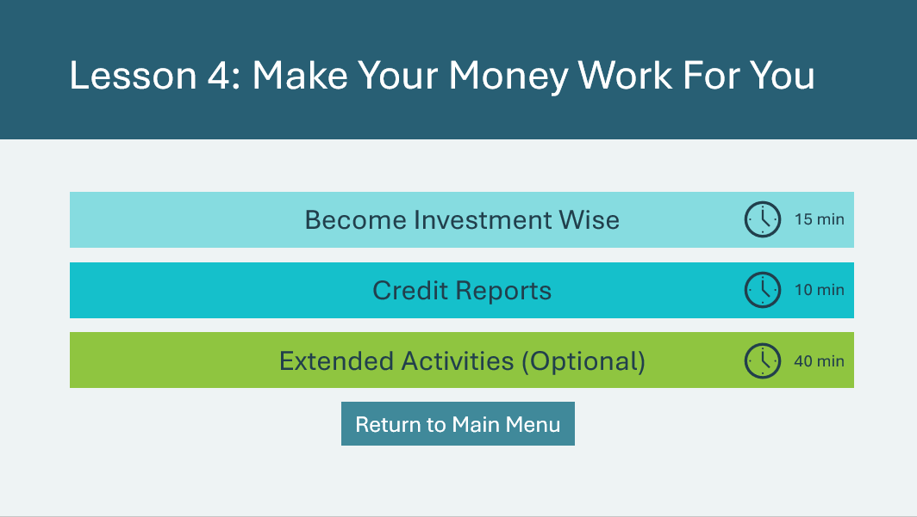 | *Select the button to navigate to the activity.  After you have completed an activity, you will be redirected back to the activity menu.  *Click or tap the Return to Main Menu button to return to the Lessons (Slide 5)
Become Investment Wise 15 mins
Slide 111    Slide 112    Slide 113  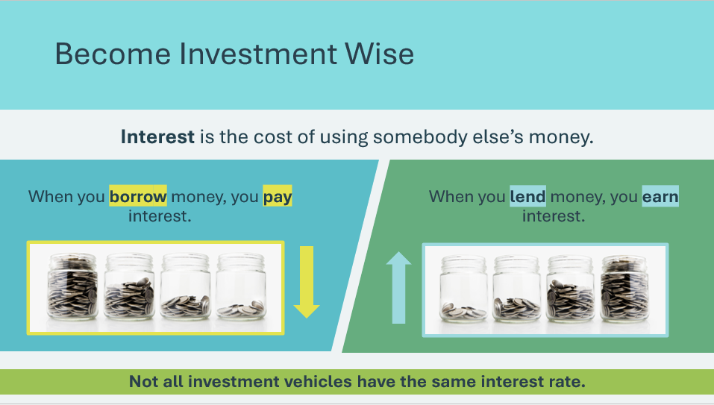 | Suggested time: 3 minutes  Introduce the activity by asking the students what it means to invest your money. Invite a few volunteers to share their thoughts and ideas.  *Click or tap to reveal the answer.  Discuss that making money work for you means that you are using the money that you have right now to generate more money.  Explain what an investment vehicle is.  Ask: What investment vehicles have you heard of?  - If students are having difficulty, return to the previous slide and use the image as a reference point.  Facilitator tip: Explain why investment options are called vehicles. They carry your money and hopefully increase its value along the way.  Review the concept of interest.  *Click or tap to reveal content  Explain that when you invest, you earn interest on your investment.
Slide 114  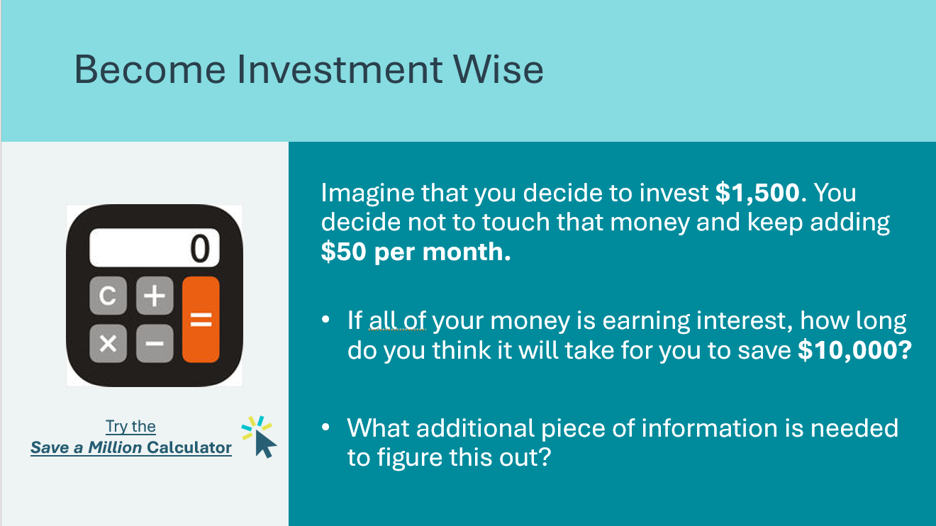 | Suggested time: 3 minutes  Read the scenario and questions to the class.  *Click or tap on the link or image to access the Calculator.  https://visa.practicalmoneyskills.com/en/resources/financial-calculators/savings-investment/save-million.html  Work with the students to explore the Calculator and find the answers to the questions:  - It will take 10 years to earn $10,000  - Additional information needed includes current age and target age to save the amount
Slide 115  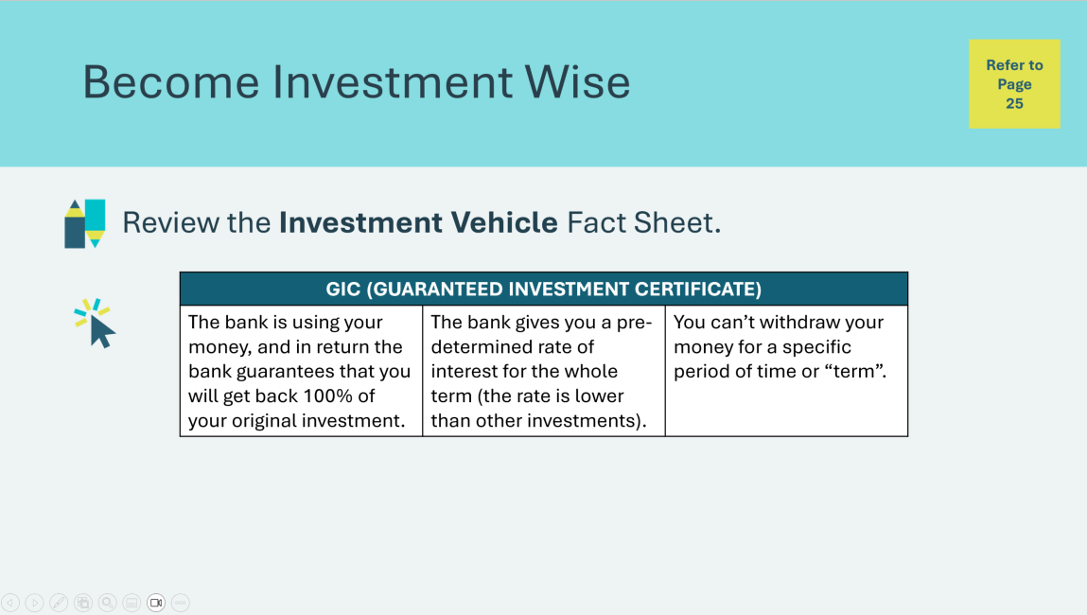 | Suggested Time: 2 minutes  Review the investment vehicles on the slide. Students may follow along using the Investment Vehicle Fact Sheet in the student portfolio, page 25.  *Click or tap to display the next investment vehicle.  Discuss the advantages and disadvantages of each.  Volunteer connection: Help the students understand better by sharing your knowledge and personal experience utilizing investment vehicle(s).
Slide 116  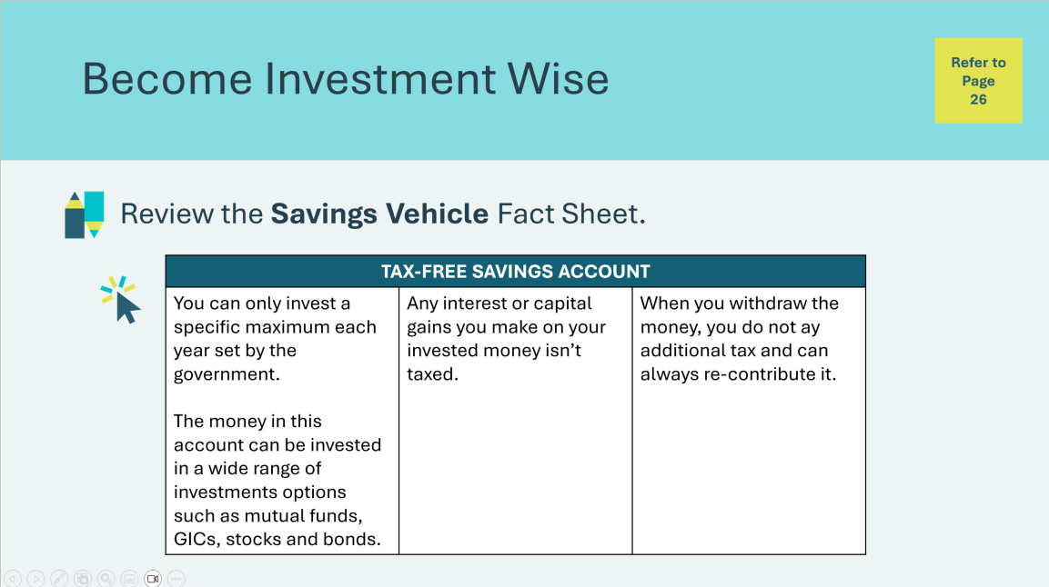 | Suggested Time: 2 minutes  Review the savings vehicles on the slide. Students may follow along using the Savings Vehicle Fact Sheet in the student portfolio, 26.  *Click or tap to display the next savings vehicle  Discuss the advantages and disadvantages of each.  Volunteer connection: Help the students understand better by sharing your knowledge and personal experience utilizing savings vehicle(s).
Slide 117  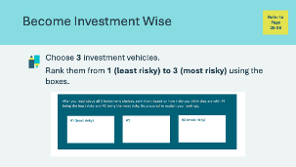 | Suggested Time: 5 minutes  Students will choose 3 investment vehicles to rank from least to most risky using the boxes in their student portfolio, page 26.  If time allows, invite a few students to share their rankings and rational.
Credit Reports 10 mins
Slide 118  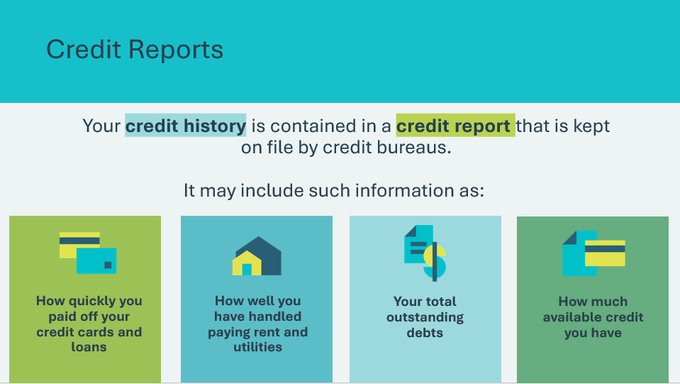 | Suggested Time: 2 minutes  Introduce the concept of credit history and credit reports.  *Click or tap to reveal content about information a credit report includes.
Slide 119  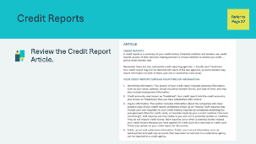 | Suggested time: 2 minutes  Students will turn to the credit report article in their student portfolio, page 27. Ask a few volunteers to take turns reading a paragraph of the article aloud.  Facilitator tip: Let students know that if they check their credit report and find information to be incorrect, they should contact the credit bureau to have it corrected.
Slide 120  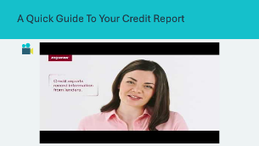 | Video time: 2 minutes  After reading the article, play the video.
Slide 121  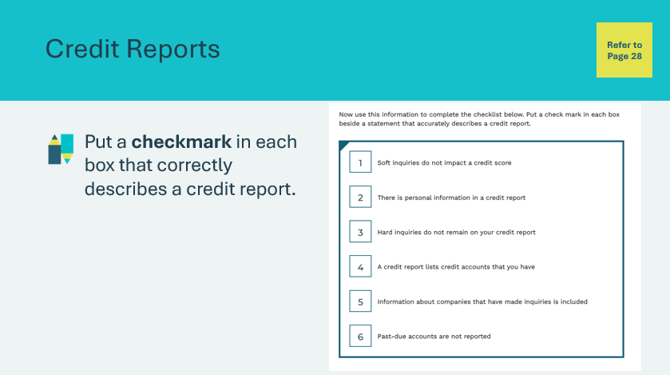 | Suggested time: 3 minutes  Students will complete the activity in their student portfolio, page 28.
Slide 122  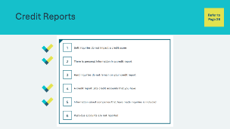 | Suggested Time: 1 minute  Review the correct answers when students have completed the activity.  *Click or tap to reveal the answers.
Extended Activities 40 mins
Slide 123  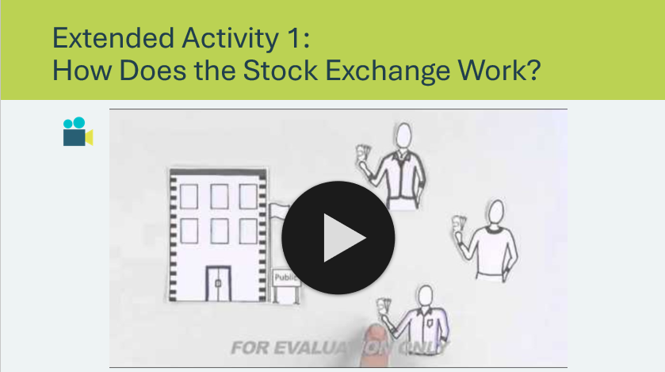 | Suggested time: 5 minutes  Play the video to introduce the concept of the stock exchange. You may wish to pause the video to further explain concepts or answer questions.
Slide 124  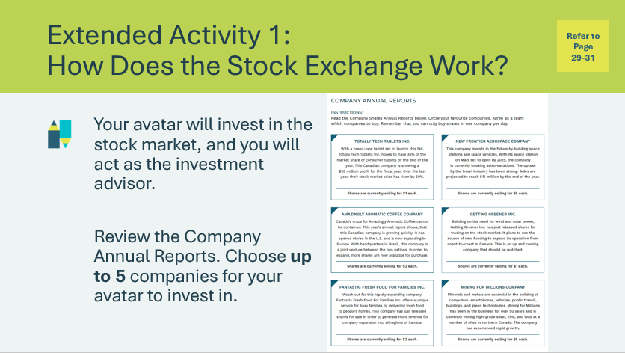 | Suggested time: 5 minutes  As a class, read and discuss the Company Annual Reports of the six companies featured in the student portfolio, page 29. As a group, choose up to five companies to advise the avatar to invest in.
Slide 125   | Suggested time: 5 minutes  Review the guidelines before beginning the activity. Use the same avatar as Lesson 1, 2, & 3 (no slide or card required).
Slide 126  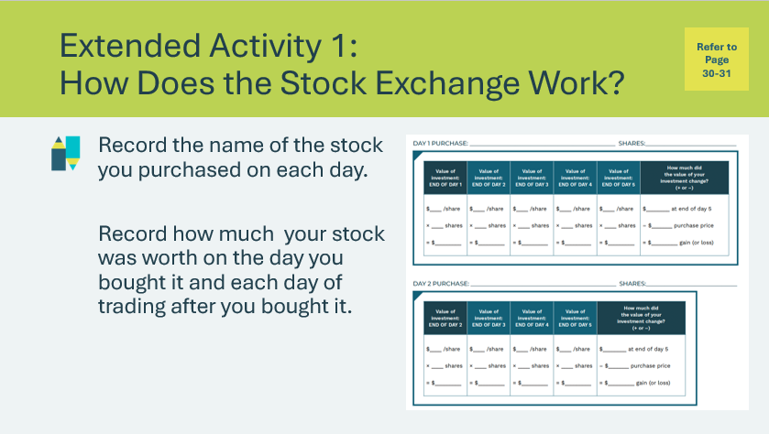 | Suggested time: 2 minutes  Review the instructions for how to use the stock exchange score sheet. If they would like, students can keep track of the stock price changes for each day in the middle columns
Slide 127  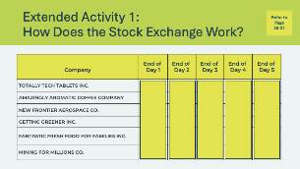 | Suggested time: 20 minutes  *Click or tap to reveal the results of each day of trading. There are 5 days in total. Ask the students to reflect after each day of trading and facilitate discussion among the class.  Day 1 Trading  - Day 1 Trading Begins  - Decide how many shares to purchase and record the transaction. Make your next decision about what to buy in day two.  - Close of Day 1 Trading  - *Click or tap to reveal the end of Day 1 prices and announce whether the value of each stock has gone up, down, or stayed the same.  Day 2 Trading  - Day 2 trading begins  - Use the End of Day One prices shown on the slide as the buying prices for day two stock purchases.  - Students may buy shares in the same company or in a different company, but the share price may have changed. Ensure students record their transaction.  - Close of Day 2 Trading  - *Click or tap to reveal the end of Day 2 prices and announce whether the value of each stock has gone up, down, or stayed the same.  Continue for all five days until the buying phase of the activity is over.  Selling Shares  Now students must sell their shares. Using today’s share prices, record how many shares you have of each company and what they are worth. You will be selling them for what they are worth at the end of day 5.  - Note: Each end of day’s prices are the selling prices for the next trading day.
Slide 128  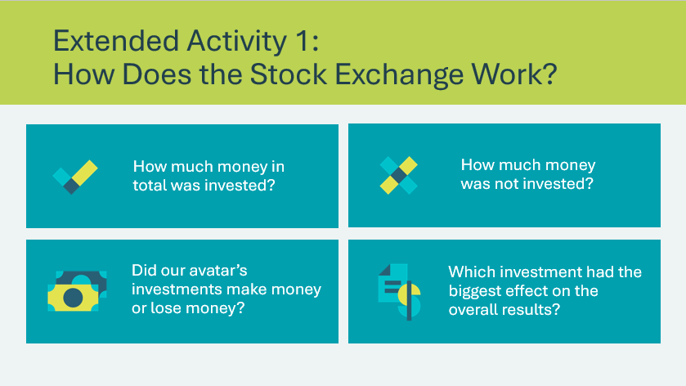 | Suggested time: 3 minutes  Wrap up the activity using the discussion questions.
Slide 129  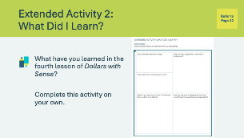 | Suggested time: Students can complete the reflections in class if time allows, or independently later on.  Students can complete the self-reflection activity in their student portfolio, page 32. Students may respond to some or all of the prompts. There is no need to discuss their self-reflections; you and the classroom teacher may review them either between lessons or later on if necessary.

Lesson 5: Using Credit
Program Kit Materials | Credit Sense Game Cards  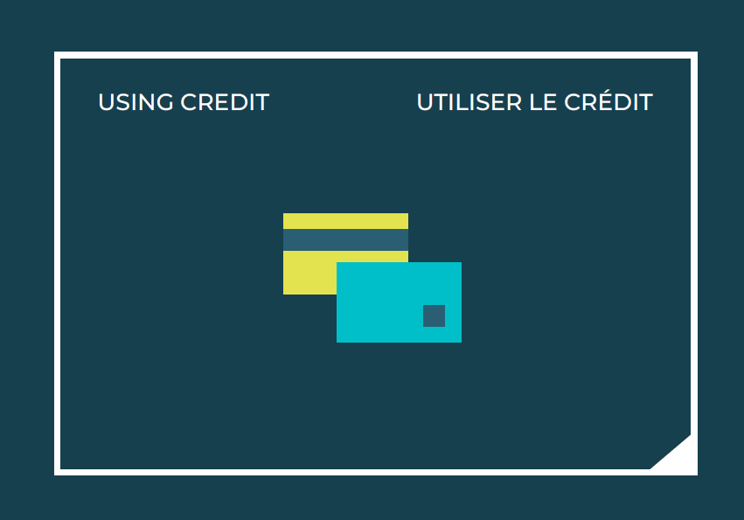
Slide 130 – Lesson 5  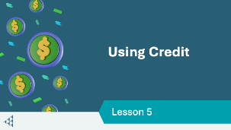 | Lesson 5 – Using Credit
Slide 131 – Objectives  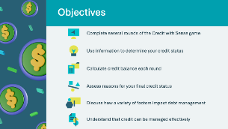 | Optional – review the learning objectives for the lesson
Slide 132 – Introduction  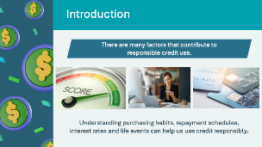 | Introduce the lesson using the prompts on the slide. Remind students that your credit score is affected by how you use credit.
Slide 133 – Activity Menu  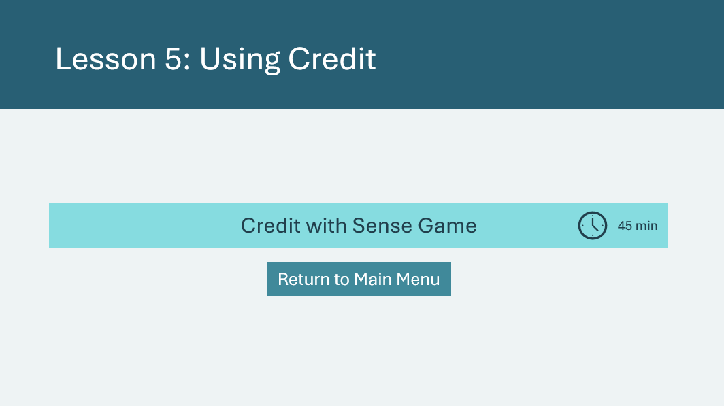 | *Select the button to navigate to the activity.  After you have completed an activity, you will be redirected back to the activity menu.  *Click or tap the Return to Main Menu button to return to the Lessons (Slide 5)
Credit with Sense Game 45 mins
Program Kit Materials | For slides 135-138, you will need to use the Credit Sense Game Cards from the program kit.
Slide 134  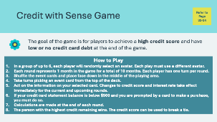 | Suggested time: 2 minutes  Tell students they will put their credit sense to the test with a game that requires them to make all kinds of credit decisions. Explain the goal of the game. Review how to play as a group. Students may reference the rules in their student portfolio, page 34.  Break students into groups of up to 6 players per group and hand out game materials.
Slide 135  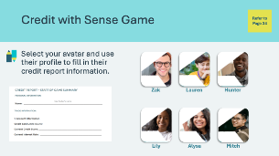 | Suggested Time: 2 minutes  Once students are in their groups and before the game begins, they will each pick an avatar at random and fill in their avatar’s credit report in their student portfolio, page 34, using the information in the avatar profiles.  Remind students that they must each use a different avatar.  *Click or tap to advance to the next slide for Avatar profiles
Slide 136  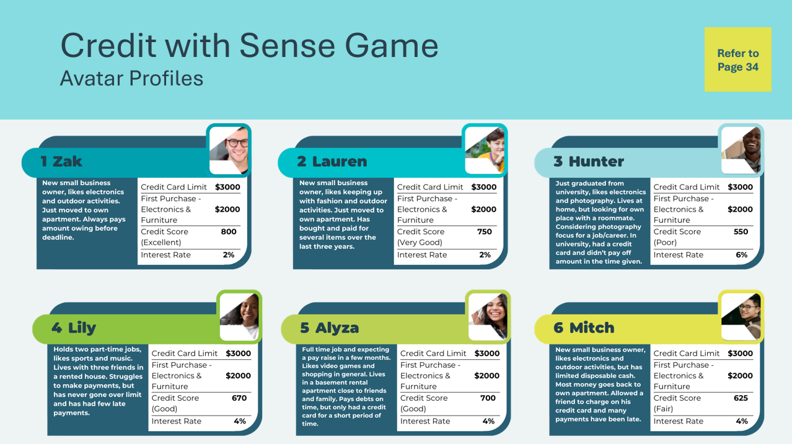 | Each player is assigned a credit score category at the start of the game, ranging from Excellent to Poor, determined by the avatar.  The starting interest rate is based on the player’s initial credit score. The interest rate will vary as the credit score changes during the game.
Slide 137  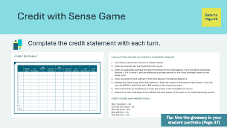  Credit Sense Game Cards | Suggested Time: 35 minutes  Review how to fill out the credit statement, student portfolio, page 35, during each round by reading the instructions on the slide for calculations. Highlight that each round represents one month in the game for a total of 10 months – or ten rounds in the game. Each student will have one turn in a round.  Facilitator tip: You may wish to demonstrate by selecting an event card, rolling the dice and filling out the credit statement so students understand how to perform the calculations based on the information they receive. Assist students with calculations, especially during the first round.  - See the sample credit statement in the Appendix for an example.  - Students may wish to use a calculator to help them  - They may also wish to use the glossary, student portfolio, page 37, to help them understand the words used in the game  There is a sample credit statement for Lauren found in the appendix.  Call time after 25- 30 minutes of play. Allow a few minutes for students to return game cards.
Slide 138  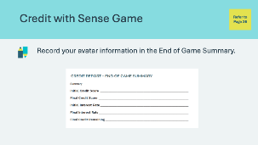 | Suggested Time: 2 minutes  Using the information from the last round of their credit statement, students will fill in their end of game summary.  The students may compare with those in their group to determine the winner. The person with the highest final credit remaining wins. Final credit score can be used to break a tie.
Slide 139  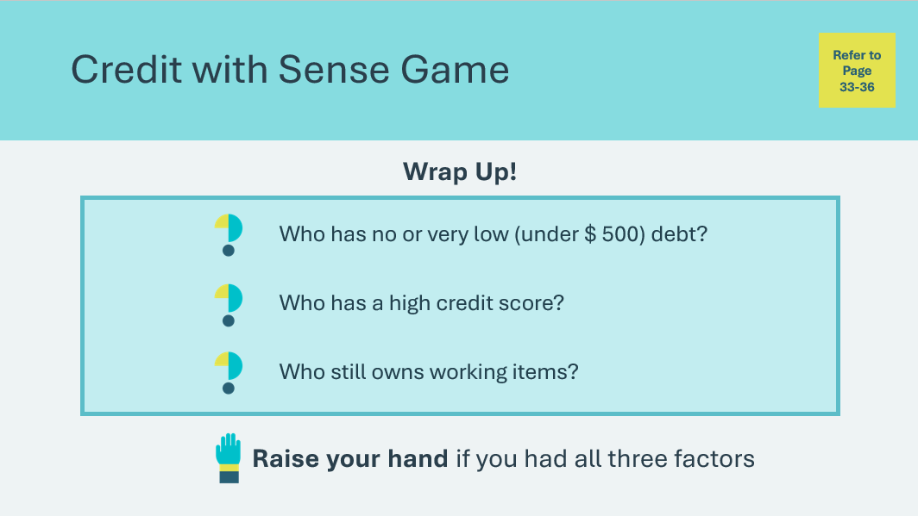 | Suggested Time: 2 minutes  Wrap up the game by asking the students the question prompts. Students may raise their hands to respond.  Discuss what helped the winners and what others needed to be aware of while playing. Guide students to a few key takeaways:  - Sometimes in life things happen that we don’t have control over, but when there is a choice it needs to be thoughtful  - The goal is not zero debt, but management of debit using planning and awareness of things like credit score and interest rates
Slide 140  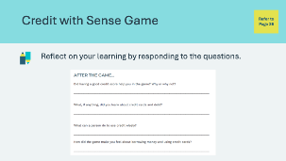 | Suggested time: 2 minutes  Students will complete the questions in their student portfolio, page 36, to reflect on their learning throughout the game.  If time allows, invite a few students to share their responses.

Wrap Up
Program Kit Materials | Bingo Caller Cards    Bingo Game Cards  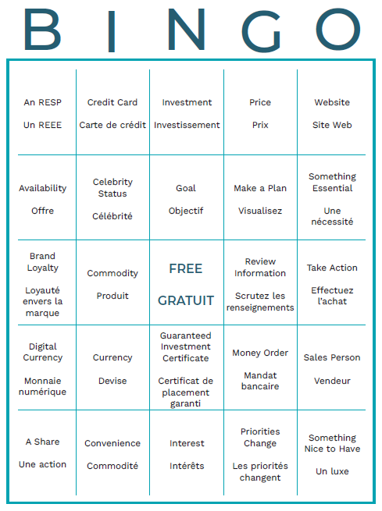  Certificates of Accomplishment
Slide 141 - Wrap Up   | Wrap Up
Slide 142 - Congratulations!   | Suggested Time: 20 minutes  Wrap up the learning experience with Dollars with Sense Bingo.
Program Kit Materials | For slide 143, you will need to use the Bingo Caller Cards and Bingo Game Cards from the program kit.
Slide 143 - Dollars with Sense Bingo  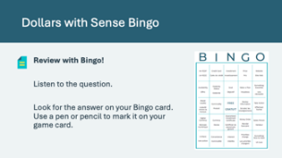  Bingo Caller Cards  Bingo Game Cards | Suggested time: 20 minutes  Play Bingo as a fun review of the terms and concepts covered.  Shuffle the pile and give each student one BINGO Game Card each. These Game Cards contain the answers to the statements on the bingo caller cards that you will draw at random and read aloud.  - The bingo caller cards and bingo game cards can be found in your JA Kit materials. The caller cards and answers can also be found in the appendix below.  - Example: “Under the letter “B” …” then read the question card. Students answer the question and try to find the correct answer under the letter “B” on their Game Card.  Depending on the amount of time available, instruct students that they must fill one or two lines, or the full card, to win the game. Students can fill in vertical, horizontal, and diagonal rows on their Game Card.
Slide 144   | Suggested time: 5 minutes  Invite students to visit jacampus.org for additional information and learning.  Thank the students and teacher for their participation and distribute the Certificates of Accomplishment.  Tell the students you enjoyed spending time with them and congratulate them on a job well done!

Appendix
Website Whatzit Game – Answer Key
What indicators tell you a website is secure?
A closed padlock icon, unbroken key in the bottom right corner of the screen, or a website address that begins with https://
With which type of Wi-Fi connection should you avoid making purchases?
Through public Wi-Fi.
How would you describe websites that ask for financial information via email or pop-ups?
Fake, fraudulent, illegitimate! Close them quickly!
What “wall” should always be activated?’
Your firewall. Windows Firewall is on by default in the latest version of Windows. Make sure you don’t turn it off.
What information should an online store keep 100% secure?
Your credit card or debit card information.
What information is easy to find about legitimate merchants where online purchases can be made?
Sales, return, and privacy policies. If they aren’t there or are hard to find, don’t shop at this site!
What information should a legitimate company include on their “contact us” page?
Name, physical address, including country and email address.
Should you accept third-party cookies?
No! If you accept, the website could sell your browsing data to third parties. Sharing your personal information with third parties without giving you any control over it could leave you vulnerable.
This secret code should NOT include any part of your name, birthdate, social insurance number, address, or phone number.
Your PIN.
What should you do if someone tries to distract you while you are using an ATM machine?
Ignore the distraction and stop what you are doing until you can focus. Never let anyone else swipe your card for you!
What are the ways that criminals can gain access to personal information through a computer or smartphone?
Phishing, smishing, vishing, and pharming.
What kind of information do legitimate organizations/ companies NEVER ask you to verify via email?
Personal information. This is called Phishing.
Why shouldn’t you respond to text messages sent to your phone by strangers?
Smishing stands for short message service and if you respond, you are verifying your phone number to others who might try to scam you.
Should you respond to live or automated callers claiming you’ve won a holiday?
No! This is called vishing. Your personal information is valuable. Keep it safe.
An email or text message that begins “Dear Valued Customer” or “You have won a prize” is probably what?
A scam!
Why would a fraudster want your personal information?
To get access to your bank account, to sell your identity, to set up a loan in your name, or to conduct illegal activity.
What should you do if you think you’ve been scammed?
Call your bank and the police; change all your online passwords and PINs.

Credit with Sense Game – Sample Credit Statement for Lauren
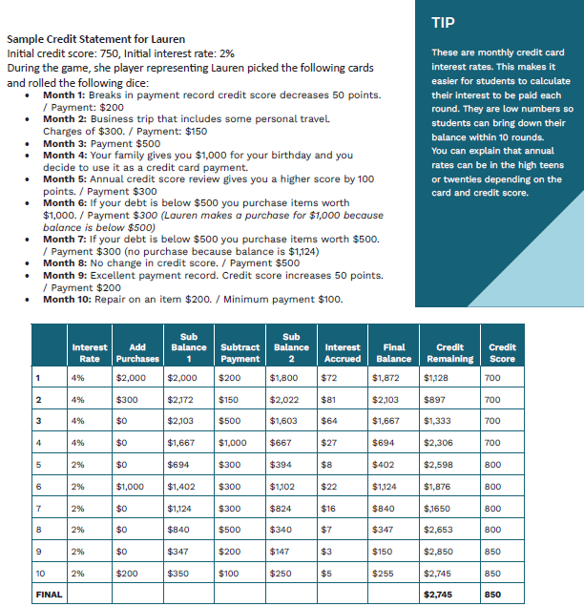

Dollars with Sense Bingo – Questions & Answers
Cross off each of the bingo caller card statements as you read them aloud to help keep track of which have been called. Read the caller statements aloud in random order.
Caller Cards (read aloud) | Answer (found on Bingo Game Cards)
B – A piece of a company. | A share
B – An investment plan for a child’s education. | A RESP
B – An investment plan for one’s retirement. | An RRSP
B – This is the meaning of A in SMART. | Ask a question
B – The shopping influence that means you bought something because it was there. | Availability
B – Another name for paper money. | Bill
B – An internet-based medium of exchange that only exists in cyberspace | Digital currency
B – When you buy something because it is made by a company you love. | Brand loyalty
I – Money in the form of coins or bills. | Cash
I – The influence that makes you buy something because you saw someone use it on TV or in a movie. | Celebrity status
I – A material or agricultural product that can be bought and sold. | Commodity
I – A person who purchases goods or services. | Consumer
I – The shopping influence that means you bought something because it was easy to buy. | Convenience
I – The ability to obtain goods or services before payment based on trust that payment will be made in the future. | Credit
I – A card issued by a financial company giving the holder an option to borrow money. | Credit card
I – A system of money in general use in a specific place. | Currency
N – A card issued by a bank allowing the holder to pay for goods and services without cash. | Debit card
N – The electronic transfer of money from one account to another, either within the same bank or across banks. | Electronic funds transfer
N – The purpose of a person’s effort; an aim or a desired result. | Goal
N – A cheque that I guaranteed by the bank to have enough money in the account from which the cheque was written. | Guaranteed Cheque
N – A certificate that allows the bank to use your money in exchange for a return with interest after a specific period of time. | Guaranteed Investment Certificate
N – A general increase in prices and fall in the purchasing value of money over time. | Inflation
N – Money paid regularly at a specific rate for the use of money lent. | Interest
N – Spending money with the expectation of achieving a profit. | Investment
G – This is the meaning of the M in SMART. | Make a plan
G – Anything that is generally accepted as payment for goods or services. | Money
G – A pre-paid document that is purchased at the post office for sending money through the mail. | Money order
G – Pooled investments in a combination of bonds, stocks, money, or precious metals. | Mutual funds
G – Connected to a computer network. | Online
G – People of the same age or status | Peers
G – The amount of money required in payment for something. | Price
G – A reason why needs, wants, and goals can change over time. | Priorities change
G – This is the meaning of the R in SMART. | Review information
O – Someone in a business who is responsible for selling merchandise or services. | Salesperson
O – The money one has accumulated over time. | Savings
O – This is the meaning of a ‘need’. | Something essential
O – This is the meaning of a ‘want’. | Something nice to have
O – Using money to buy goods or services. | Spending
O – This is the meaning of the S in SMART. | Stop and think
O – This is the meaning of the t in SMART | Take action
O – The action of a group of people, especially when effective and efficient. | Teamwork
O – One or more pages on the World Wide Web. | Website

