
live

JA Economics for Success Presenter Notes
The Presenter Notes have been developed using references from the digital classroom presentation and should be used in combination with the printed Student Portfolio v2026.
Tips for Setting Up the Classroom
- Arrive 15 minutes early and check in at the office.
- Connect with the teacher for the program materials and organize them as needed.
- Hand out student portfolios and name tags/cards.
- Set up presentation (check audio and internet connection are working).
- Write your name on the board.
- Ask the teacher to write student names on program certificates.
- Check in with the teacher about school schedule, tips for getting students' attention, any specific student needs & behaviours you should be aware of and ask for help with encouraging student participation, as well as monitoring and managing the class

Planning Guide
GETTING STARTED – GETTING TO KNOW YOU (Slides 1 – 5) 5 MIN

LESSON 2 (Slides 28 – 77) 70 MIN
FINDING BALANCE
Core Activities
- Pursuing your dreams 10 min
- Payroll pro 20 min
- You’re on your own! 35 min
- Opportunity cost of education 5 min
Extended Activities
- What did I learn? 5 min
- Guess the price 5 min
LESSON 1 (Slides 6 – 27) 55 MIN
CHOOSE YOUR OWN ADVENTURE
Core Activities
- What do I bring on the journey 20 min
- Looking for external clues 15 min
- Opening a world of possibly 20 min
Extended Activity
- What did I learn? 5 min

CONCLUSION 5 MIN

LESSON 4 (Slides 117 – 135) 55 MIN
YOU CAN DO IT!
Core Activities
- Keys to success 40 min
- Plan your success 15 min
Extended Activity
- What did I learn? 5 min

LESSON 3 (Slides 78 – 116) 60 MIN
STRATEGIES FOR SUCCESS
Core Activities
- Networking 20 min
- Being what employers want 15 min
- Personal brand 15 min
- Identifying a mentor 10 min
Extended Activities
- What did I learn? 5 min
- Do the right thing 15 min
- Interview skills 15 min

WRAP UP (Slides 136 – 138) 5 MIN

Introduction
Slide 1 –Economics For Success   | Navigation Tips  - Navigate through the slides using the next or previous buttons (bottom right), clicking, or tapping on the slide, or using the navigation menu (right)  - Look for slide specific instructions in the presenter notes below
Slide 2 – Welcome to JA!   | Suggested time: 3 minutes  Ask: Has anyone heard of Junior Achievement before?  Play the video for students to introduce them to JA!
Slide 3 – Economics for Success Program   | Suggested time: 3-5 minutes  Introduce the program and yourself!  Discovering who you are, what career paths you are suited for, what educational goals you will set, what post-secondary destinations you will pursue, how you will fund your life after high school, what strategies you should use to help you find a job, and more… these are the goals of our program today. All of it combined makes a pretty incredible adventure.  Tell the students a little about you; your education, and your career path until this point. Explain why you chose to volunteer in their classroom today.
Slide 4 – Symbol Legend  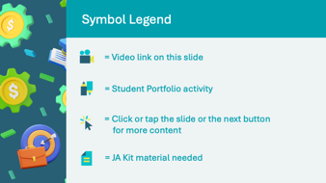 | The symbols will help guide the learning experience. Explain to students that they will see these symbols throughout the program.
Slide 5 – Main Menu  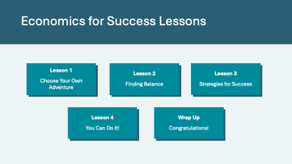 | *Select the button to navigate to the lesson.  After you have completed a lesson, you can select the Return to Main Menu button from the Lesson Activity Menu to return to this slide.

Lesson 1: Choose Your Own Adventure
Program Kit Materials | Occupation Cards  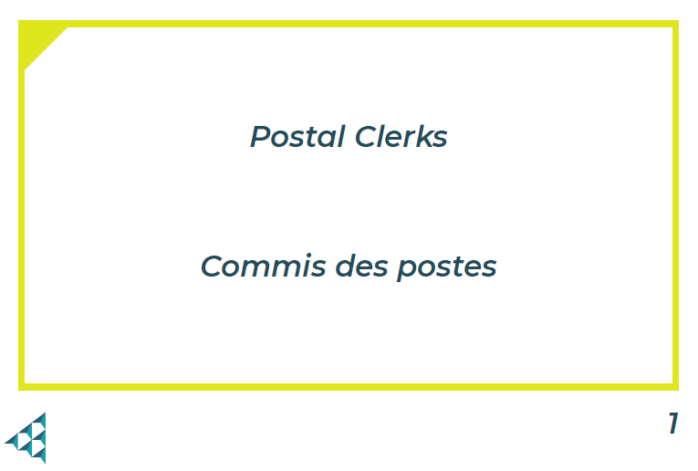
Slide 6 – Lesson 1  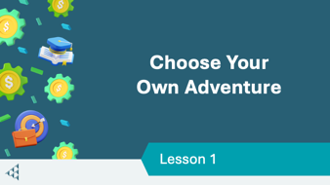 | Lesson 1: Choose Your Own Adventure
Slide 7 – Objectives   | Optional – review the learning objectives for the lesson
Slide 8 – Introduction   | Introduce the lesson by explaining that understanding how our interests and strengths align with societal trends can help shape our future goals. Students will explore how their passions can guide them in identifying education and career paths that are the best fit for them.
Slide 9 – Lesson 1 Activity Menu  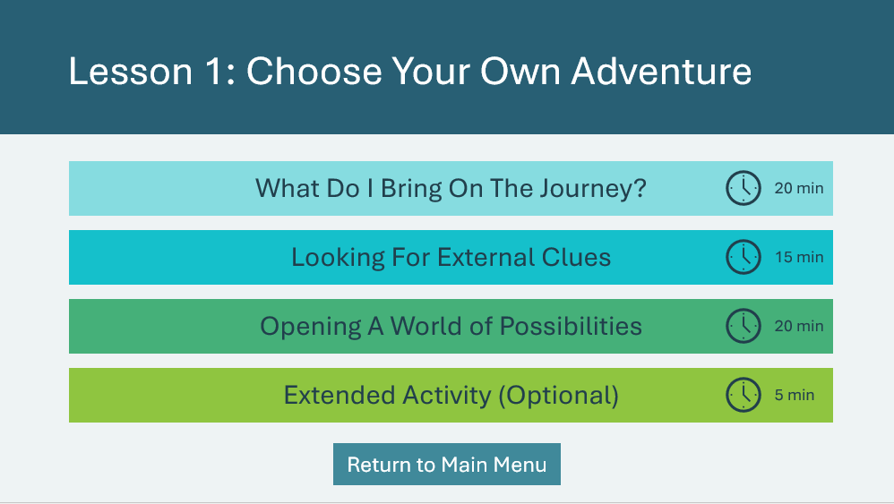 | *Select the button to navigate to the activity.  After you have completed an activity, you will be redirected back to the activity menu.  *Click or tap the Return to Main Menu button to return to the Lessons (Slide 5)
What Do I Bring on the Journey? |  | 20 mins
Slide 10   | Suggested time: 2-3 minutes  Explain that when preparing for the future, it may seem difficult to know where to begin. Setting goals can help!  Play the Goal Setting video.
Slide 11   | Suggested time: 3 minutes  Reflect on the video using the discussion questions.  *Click or tap to reveal each question.  Sample responses:  - What can we learn from this video about setting our own goals?  - Aim high, we can do anything we set our minds to  - Small steps can contribute to achieving big goals.  - Don’t give up or get discouraged.  - What should we consider to make sure our goals are clear and reachable?  - SMART goals – Specific, Measurable, Achievable, Relevant, Time-bound  - The SMART acronym helps us set better goals
Slide 12  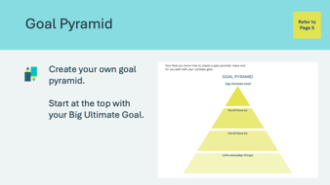 | Suggested time: 3 minutes  Describe a goal that you’ve worked toward and the steps that you’ve had to take as an example. Students will complete the goal pyramid in their student portfolio, page 5. Give them a couple of minutes to complete this individually.  Volunteer connection: While the students are working on their goals, share additional examples. Talk about situations where goal setting has been helpful for you, or maybe even when you’ve had to change your goals or redirect the steps. Examples:  - Trip outside of the country  - Educational goal  - Career goal  Once students have finished, invite a few volunteers to share what their ‘big ultimate goal’ is.
Slide 13   | Suggested time: 2 minutes  Share the prompt on the slide and explain to students that they are about to go on a journey of self-discovery. This activity is meant to help categorize their interests, skills, strengths, and passions.  Facilitator tip: You may wish to use the images to generate a discussion about skills, interests, strengths, and passions people might have.
Slide 14  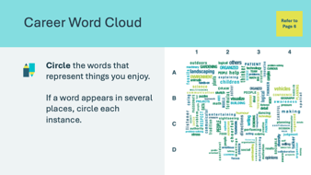 | Suggested time: 2 minutes  Students will complete the Career Word Cloud activity independently in their student portfolio, page 6, by circling any words that they connect with or which describe them.
Slide 15  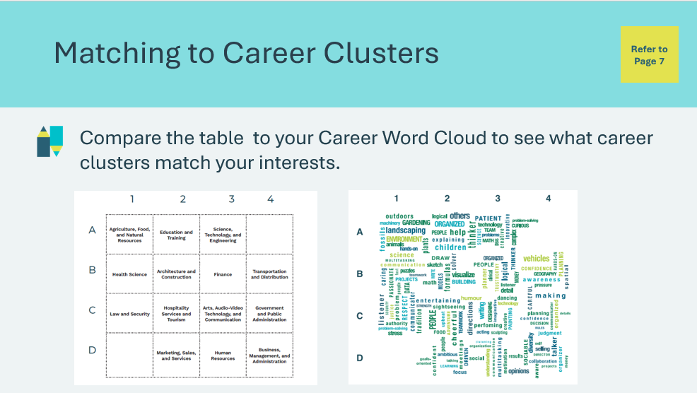 | Suggested time: 3 minutes  Explain that the words they circled within their career cloud can say something about the types of careers that might interest them.  Students can use the letters and numbers printed around the word cloud to help them match their interests to the career cluster outlined in their student portfolio, page 7. These are the career clusters that align with and are likely to best match their interests.  Additional discussion questions (optional)  - What other areas of work might exist now or in the future?  - Are there any other careers or types of work that you have heard of that interest you?
Slide 16  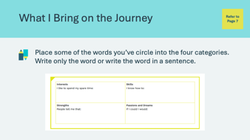 | Suggested time: 2 minutes  After the students have completed the Career Word Cloud, have them place some of the words they’ve circled into the table in the What I Bring on the Journey activity in their student portfolio, page 7.
Slide 17  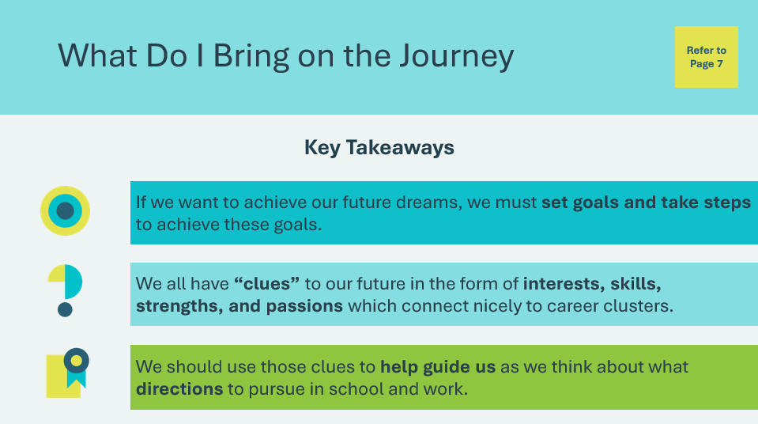 | Suggested time: 2 minutes  Wrap up the activity by reviewing the key takeaways.  *Click or tap to reveal each takeaway  Facilitator tip: Share how interests, skills and values are transferable skills and can apply to many jobs.  Volunteer connection: Share your own experience with career planning. You may wish to share about the following topics:  - How your interests, skills and values helped you be successful in your career path  - How your goals and ideas of success have evolved over time/throughout your career.  - An example illustrating the importance of having dreams and goals.  - How your occupational field has been affected by changes in the economy, technology, demographics, etc.
Looking For External Clues 15 mins
Slide 18  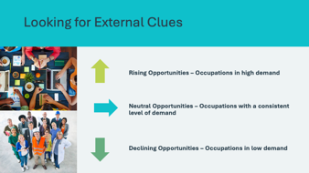 | Suggested time: 2 minutes  Explain that once we understand our strengths, interests, skills, and passions, then we need to explore which occupations are considered rising opportunities.  There are many different types of occupations in different industries. There may be differences in opportunities based on the demand or need for individuals working in these occupations. The demand or need for certain occupations can change over time.
Program Kit Materials | For slide 19, you will need to use the Occupation Cards found in the program kit.
Slide 19  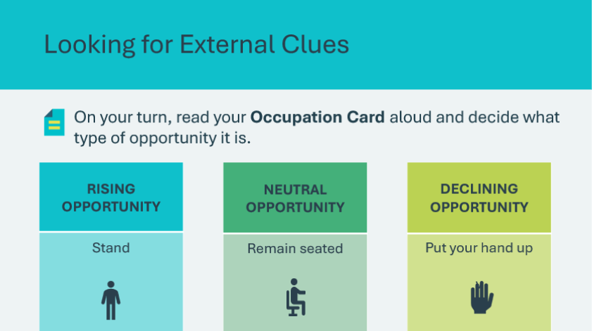  Occupation Cards | Suggested Time: 10 minutes  Shuffle and distribute the Occupation Cards found in the kit materials. Students will decide whether the career opportunities on their cards are generally rising, staying the same, or declining.  Review the actions on the board as a class. students will respond in one of these three ways depending on their opportunity card. Students will take turns reading their card and responding with one of the actions.  Accessibility tip: Instead of sitting and standing, students could use three different coloured pieces of paper to indicate their answer, either by pointing at them or by raising them.  Explain that rising opportunities may vary depending on the community or country people live in, and it doesn’t mean you shouldn’t consider occupations that aren’t noted as rising opportunities. See the appendix for the answer key and adjust as needed.  Discuss the benefits of preparing for an occupation that has rising opportunities.
Slide 20   | Suggested time: 3 minutes  Wrap up the activity using the following discussion question.  - What are the reasons that occupations trend up or down over time?  Allow students to offer various answers and encourage discussion based on reflection from the activity. Review some of the possible reasons listed on the slide. *Click or tap to reveal each reason  Volunteer connection: Share your experience of how work opportunities have changed based on these reasons.
Opening A World of Possibilities 20 mins
Slide 21   | Suggested time: 2 minutes  Explain that by combining internal clues (interests, skills, strengths, passions) with the external clues of marketplace trends, you can choose an excellent career goal.  Then, you will need to decide whether the pathway to the career you want requires an apprenticeship, college diploma, applied degree, or university degree program. All of these destinations are equally worthwhile. What is important is that you plan to continue your education after high school.  Ask the prompt on the slide and invite a few volunteers to share their ideas.  Facilitator tip: Many students will not know their destination or understand how the destinations are alike or different. Reassure students that they have time to figure this out together and will explore the different post-secondary destinations.
Slide 22   | Suggested time: 4 minutes  Play the Planning for Your Future video. Use the information from the video as a reference throughout the activity.  Following the video, let students know that they will play a Jeopardy-style game to learn about the different post-secondary pathways.
Slide 23   | Suggested Time: 2 minutes  Direct students to the information about post-secondary pathways in their student portfolio, page 8. Let them know they can use this information to help them with the answers to the Jeopardy game.
Slide 24  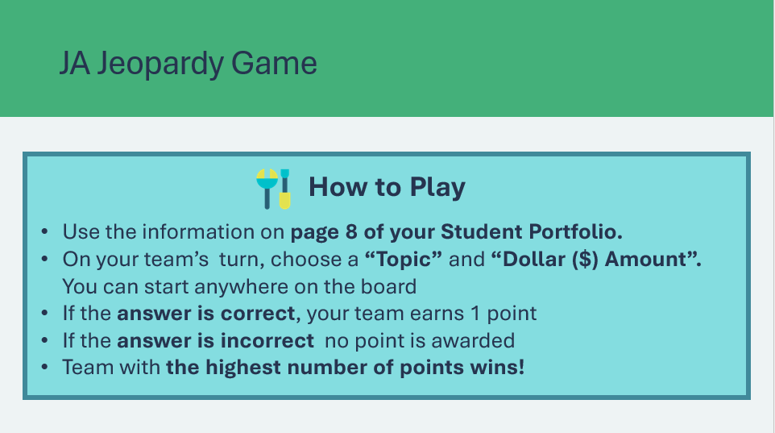 | Suggested Time: 2 minutes  Pick 1 or 2 volunteers, depending on the class, to manage the game board and keep scores. Break students into teams of 5 or 6 and allow a few moments for each team to create a name. Alternatively, you may assign each team a number.  Review the rules for playing. Remind students that, like Jeopardy, they will be given the answer, and their job is to provide the question.  Throughout the game, the volunteer scorekeeper(s) will award points to the teams that answer correctly and keep track of scores on the whiteboard or a piece of paper.
Slide 25   | Suggested time: 10 minutes  Have the student volunteer(s) manage the game board. The volunteer(s) must navigate through the question-and-answer slides. You may wish to demonstrate the first round.  - You or the student volunteer should read the question aloud and allow the team to respond with the question. *Click or tap the Show Question button to display the correct response.  - If the team got the question correct, the student volunteer can assign a point. *Click or tap Continue to return to the gameboard.  At the end of the game, the volunteer(s) will calculate the points to identify which group wins the game.
Slide 26  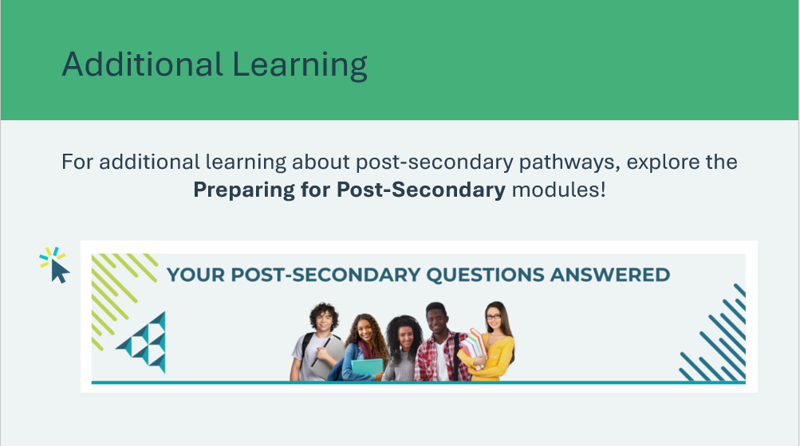 | *Click or tap on the image for additional learning from the JA Campus
Extended Activity 5 mins
Slide 27  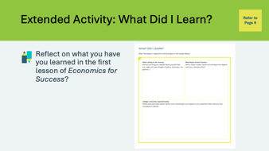 | Suggested time: 5 minutes  Students can complete the reflections in class if time allows or independently later on.  Students will complete the self-reflection activity in their student portfolio, page 9. Students may respond to some or all of the prompts. There is no need to discuss their self-reflections; you and the classroom teacher may review them either between lessons or later on if necessary.

Lesson 2: Finding Balance
Program Kit Materials |  | Money Memory Game Cards    Pay Day! Cards  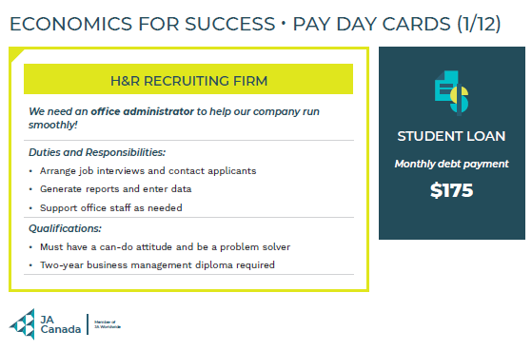
Slide 28 – Lesson 2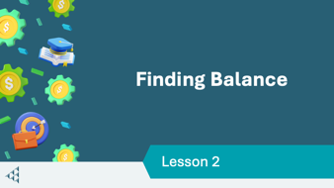 |  | Lesson 2: Finding Balance
Slide 29 – Objectives  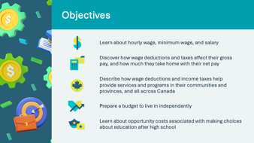 |  | Optional – review the learning objectives for the lesson
Slide 30 – Introduction  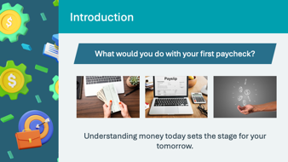 |  | Introduce the lesson by explaining that understanding how taxes and income affect our finances is important for achieving our goals.  Students will explore how different types of taxes and deductions impact their earnings and learn how to create a budget that aligns with their educational and career goals.
Slide 31 – Activity Menu  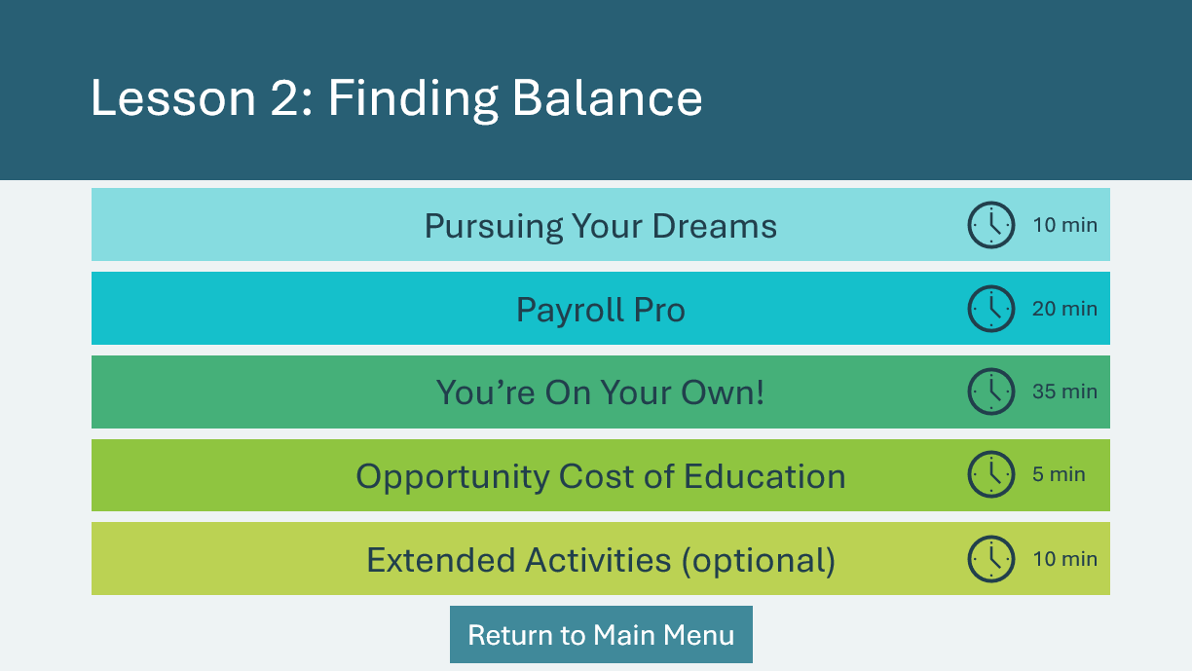 |  | *Select the button to navigate to the activity.  After you have completed an activity, you will be redirected to the activity menu.  *Click or tap the Return to Main Menu button to return to the Lessons (Slide 5)
Pursuing Your Dreams 10 mins
Slide 32   |  | Suggested time: 2 minutes  Explain that students will figure out how much it costs to live on their own while pursuing their dreams. Facilitate a discussion about considerations for living on your own using the prompts on the slide. Invite a few students to share their thoughts and ideas.  Tell students that there is more to living on your own than buying a car and a couch! Not all the money they earn will go directly into their bank account. Knowing how much of your earnings is yours to save and spend helps you set up a budget for success.
Slide 33  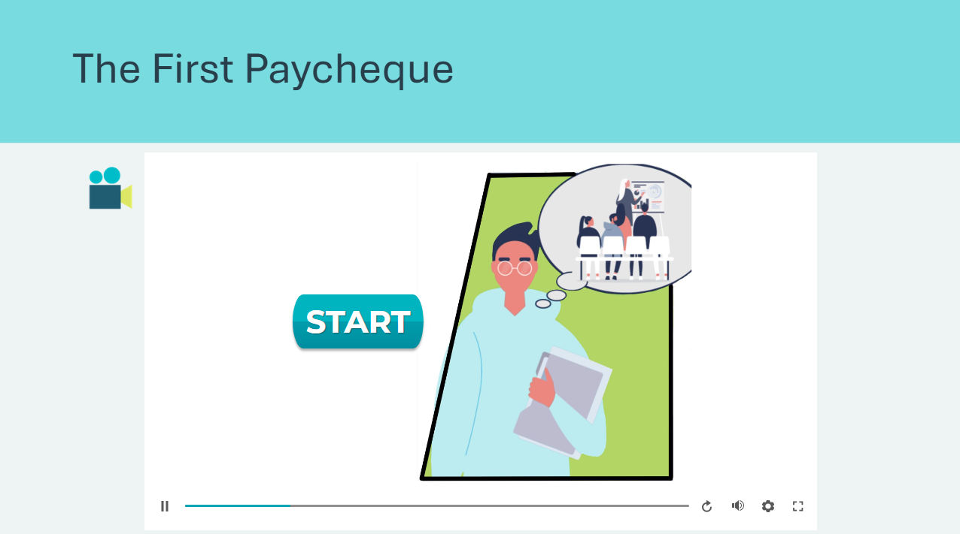 |  | Suggested time: 3 minutes  Play the The First Paycheque interactive video. In this scenario, students are introduced to the reality of paycheque deductions and taxes.
Slide 34  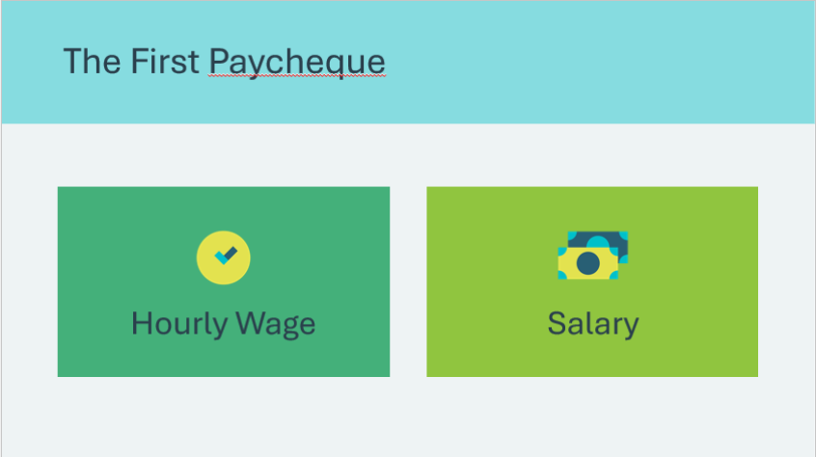 |  | Suggested time: 2 minutes  Following the scenario, ask students to raise their hand if they have heard of either term on the slide before. Explain that these are ways to pay people for work.  Ask what the difference between these terms is, allowing a few students to offer suggestions.  Advance to the next two slides to review hourly wage vs. salary.
Slide 35  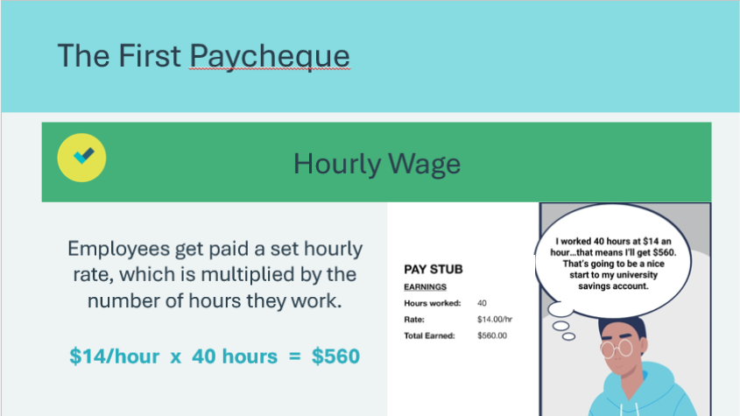 |  | Review how hourly wage works using the prompts on the slide and the example of Amit’s paystub.  Explain that hourly wages must meet at least the minimum wage as defined by each province or territory. Share with the class the current minimum wage for your province.
Slide 36  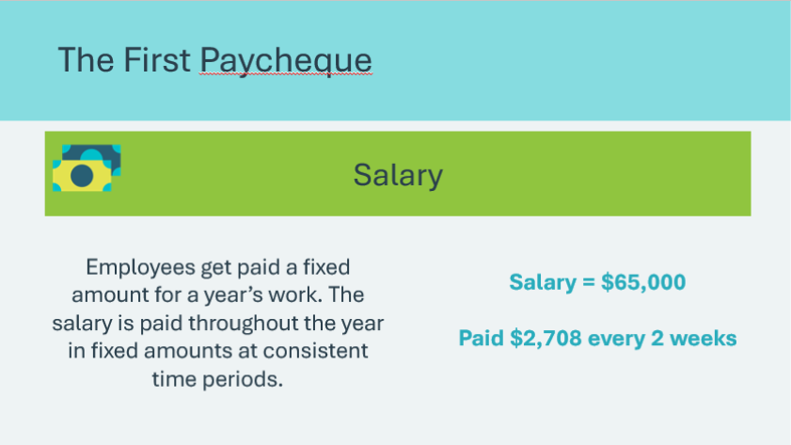 |  | Review how salary works using the prompt and example on the slide.  Volunteer connection: You may wish to share examples of jobs you have held that paid an hourly wage vs. salary.
Slide 37  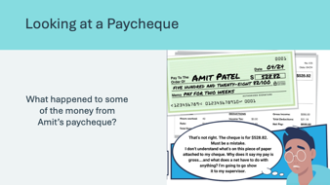 |  | Suggested Time: 2 minutes  Now that we understand how Amit is being paid, ask the students what happened to some of Amit’s paycheque. Explain that deductions are automatically taken from your paycheque by your employer.  Advance to the next slide to demonstrate what this looks like on a paystub.
Slide 38  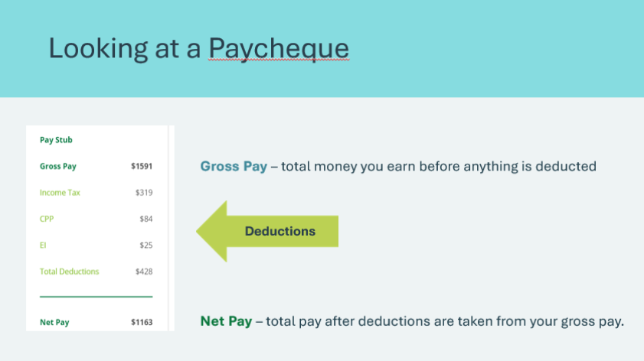 |  | Review the sample paystub and highlight the following:  - Gross Pay – is the total amount that you’ve earned after working before anything is deducted  - Deductions – are either government obligations or anything else that must be deducted from your pay  - Net Pay – is the total amount that you get paid for after deductions are taken from your gross pay  Reinforce that your net pay is the amount that is yours to spend and save.
Payroll Pro 20 mins
Slide 39  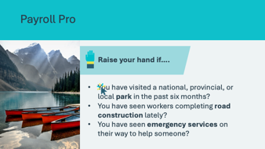 |  | Suggested time: 2 minutes  Introduce the activity using the prompts on the slide.  Ask what these services (parks, roads, emergency services) have in common. Allow a few students to share their ideas. Guide them to identify that these services make our lives better and easier.  Ask if they know who pays to keep our parks clean, repair the roads, and supply emergency services to help people. Allow a few students to share ideas. They may suggest that governments pay.  Encourage them to recall Amit’s deductions from his paycheque and help them make the connection that these deductions help pay for services and benefits like parks, roads, and emergency services.
Slide 40   |  | Suggested time: 8 minutes  Play the interactive video Where Does My Money Go? to introduce students to various taxes and deductions.  Students may have questions following the video. Answer a few questions and let students know they will learn more about deductions in the game they will play next.
Program Kit Materials |  | For slide 41, you will need to use the Money Memory Cards from the program kit materials.
Slide 41  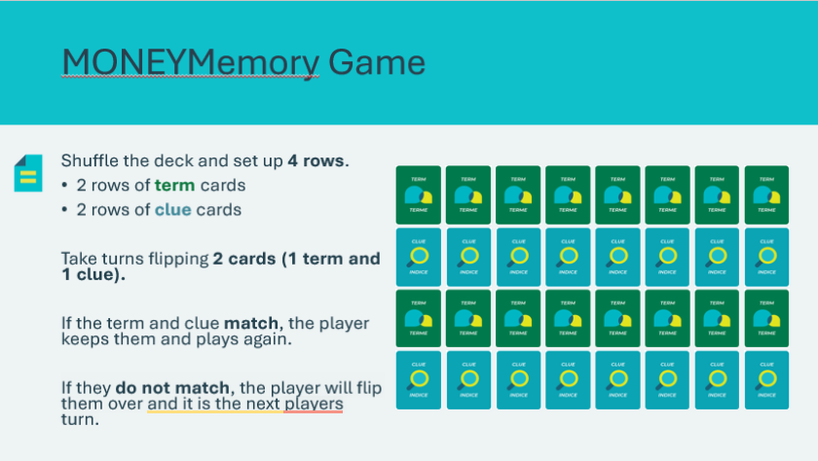  Money Memory Game Cards |  | Suggested time: 10 minutes  Tell students that they will be playing a game called MONEYMemory. Break students into groups of 4-6 students and give each group a deck of MONEYMemory cards. Review how to set up the cards (refer to slide for visual example) and the rules for play.  Facilitator tip: Offer a way for students to decide who gets to go first, such as whoever’s last name begins with a letter that is closest to the Z.  This game moves very quickly after students begin, so after about three minutes, have each group leave any remaining cards face down.  Use the answer key in the appendix to review each term. As a class, identify the matching clue. Students will get one point for each correct pair they match during the game. Identify the student with the most points as the winner.
You’re On Your Own! 35 min
Facilitator Video Instructions |  | Facilitators can watch the video using the link below for instructions on how to deliver this activity.  https://drive.jacampus.org/s/bM85gzaZEWsqqHp
Slide 42   |  | Suggested time: 2 minutes  Ask the prompt on the slide and invite a few volunteers to share their responses. Some students may have some ideas about what it would be like for them to live on their own, while others may not.  Volunteer connection: Share your personal experience of moving out and living on your own.  Explain that in this activity, students will be learning some important steps to living on their own. One important step is to create a budget!
Slide 43   |  | Suggested time: 3 minutes  Explain to students that they will imagine they will begin independent living with nothing but their clothes. They will need to create a budget for their first month of living expenses.  There are two ways to complete this activity.  - Keep Your Balance Tool (students must have access to a device to use the web tool)  - Student Portfolio (students will complete the activity on pages 10-12)  *Click or tap the button for the instructions for the method students will be using to complete the activity.
Slide 44  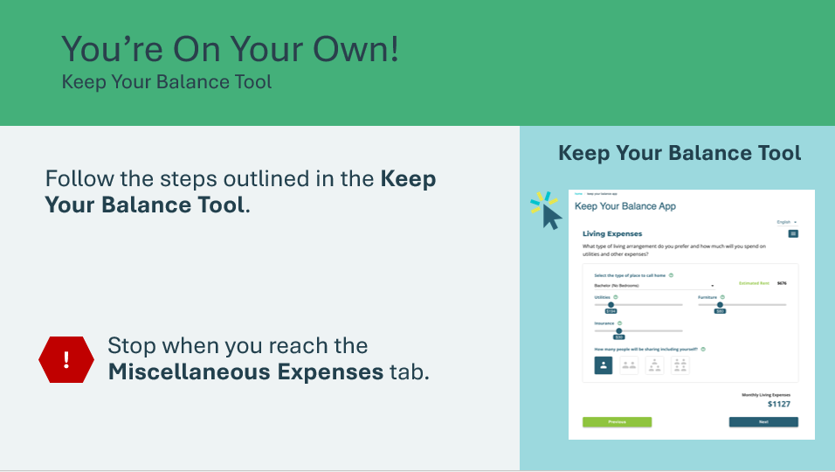 |  | Using the Keep Your Balance Tool  Suggested time: 15 minutes  Students will complete the steps in the Keep Your Balance tool, making decisions about what they think they can spend each month. Instruct students to work through each step until they reach the Miscellaneous Expenses tab.  *Click or tap on the image to open the Keep Your Balance Tool in a new browser window.  https://jacanada.org/keep-your-balance-app/
Slide 45  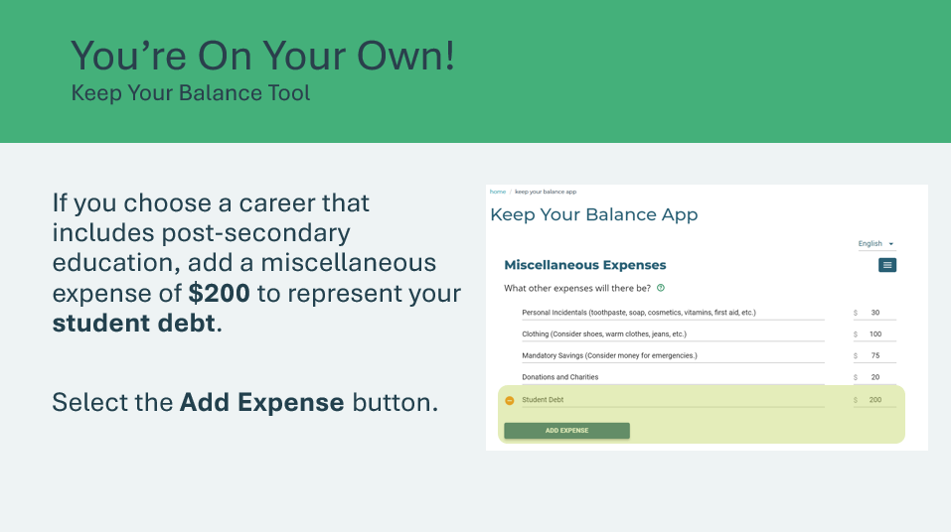 |  | Discuss how student debt is a reality for many people who attend post-secondary education. If students want to choose a career that includes post-secondary education, ask students to update the tool by including a miscellaneous expense of $200 to represent their student debt.  - To do this, they can select the “Add Expense” button.  - If students want to choose a job that does not require post-secondary, they do not need to add $200.  When ready, students can proceed to the Find a Job page. Remind them they must select a career they are interested in. They will complete the tool until they see their summary of expenses.
Slide 46  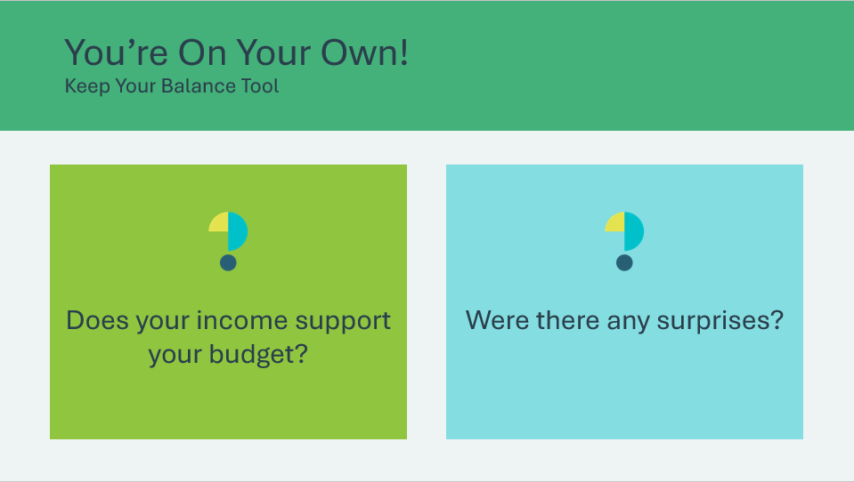 |  | Suggested time: 5 minutes  Once students have completed the tool, encourage them to reflect on the activity using the discussion questions:  - Does your income support your budget?  - Were there any surprises?  Students may be surprised about what the actual net pay is for the job they selected. Allow some time for students to explore their options, such as revising the expenses in their budget or selecting a new job.
Slide 47  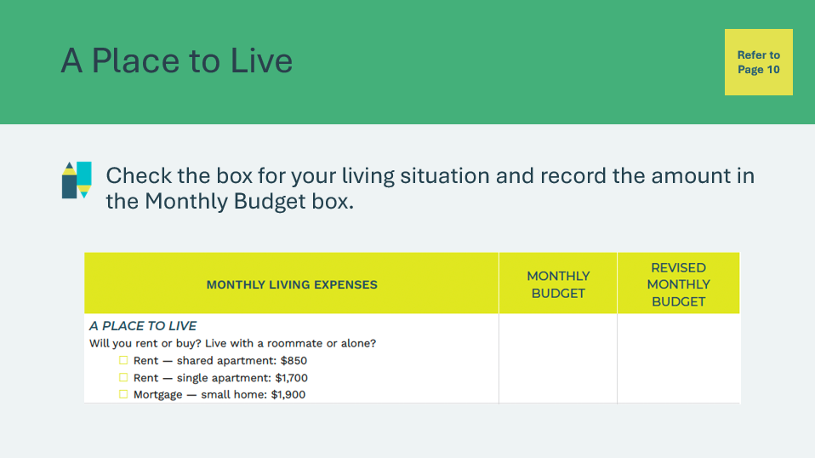 |  | Using the Student Portfolio  Suggested Time: 10 minutes  A Place to Live  Students will select a place to live from the 3 options and record the corresponding amount in the Monthly Budget box.
Slide 48   |  | Utilities + TV & Internet  Students will calculate their utilities costs (25% of their rent or mortgage) and add $140 for TV and internet service.  - Rent – shared apartment utilities ($850 x 0.25 = $212.50)  - Rent – single apartment utilities ($1,700 x 0.25 = $425.00)  - Mortgage – small home utilities ($1,900 x 0.25 = $475.00)  Facilitator tip: You may wish to provide the equations on the board and review them to ensure students have the correct amount recorded.
Slide 49  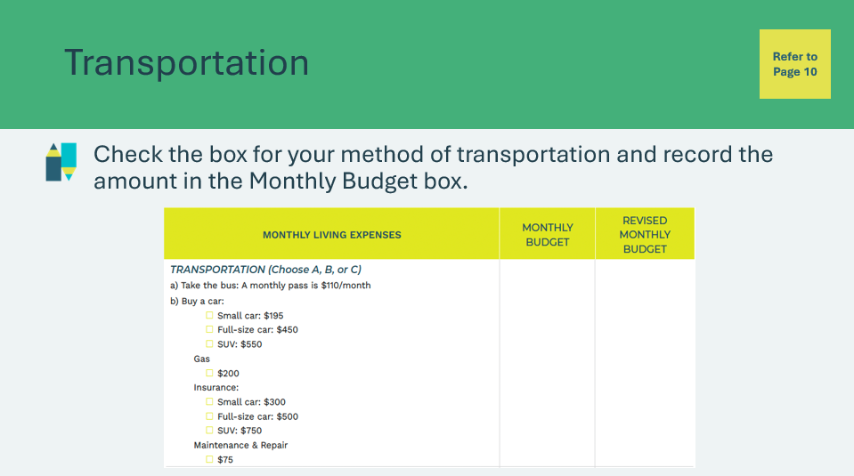 |  | Transportation  Students will choose their method of transportation and record the corresponding amount in the Monthly Budget box.  If they choose to buy a car, they must use the total for car, gas, insurance, and maintenance repair.  - Small car ($195 + $200 + $150 + $75 = $620)  - Full size car ($450 + $200 + $200 + $75 = $925)  - SUV ($550 + $200 + $250 + $75 = $1075)  Facilitator tip: Provide the equations on the board and review them to ensure students have the correct amount recorded.  Note: Insurance costs will vary based on factors such as where you live, type of vehicle, age, gender, experience and your driving record. You can adjust the numbers as needed for your region and circumstances.
Slide 50  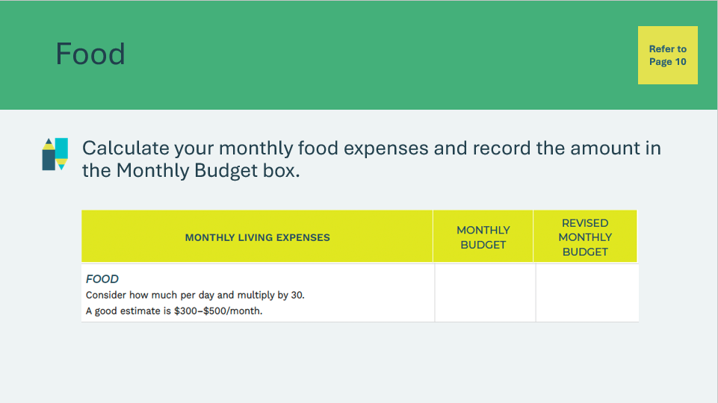 |  | Food  Students can consider their daily food budget and multiply it by 30 for their monthly food budget.  Example: $12/day x 30 days = $360/month
Slide 51  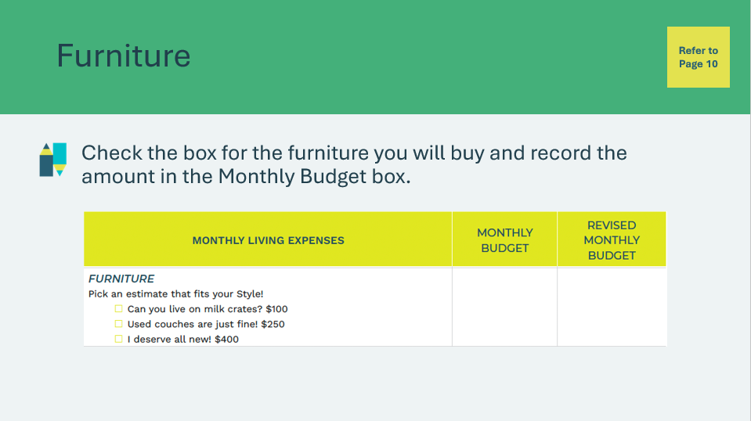 |  | Furniture  Students will select the type of furniture they will buy and record the corresponding amount in the Monthly Budget box.
Slide 52  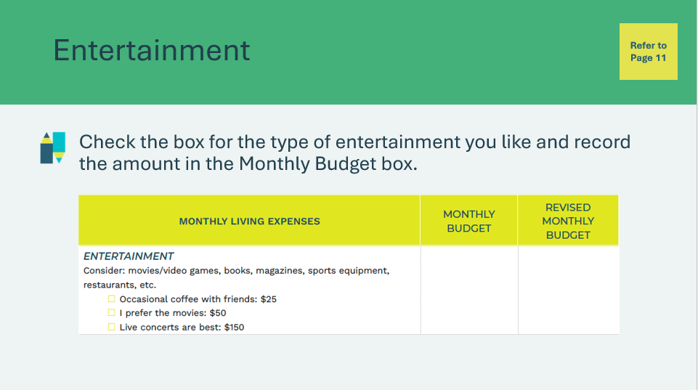 |  | Entertainment  Students will select the type of entertainment they like and record the corresponding amount in the Monthly Budget box.
Slide 53  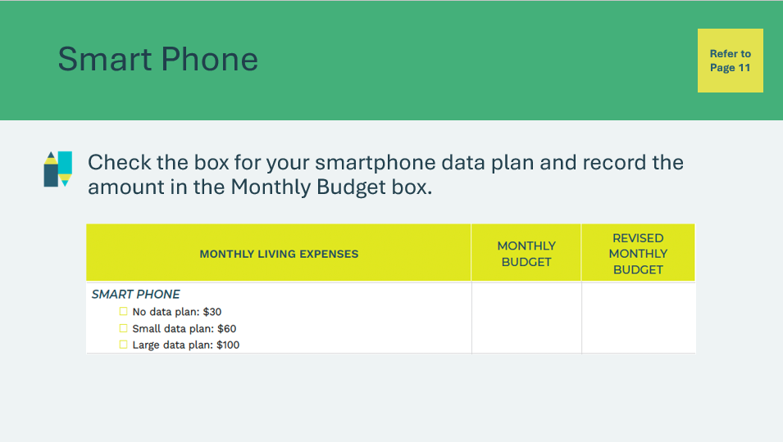 |  | Smart Phone  Students will select the type of data plan they would like to have for their smartphone.  If they do not know about data plans, explain that having a data plan means you are allocated a set amount of data you can consume within a whole month. The amount of data you are given varies upon the price of your plan.
Slide 54  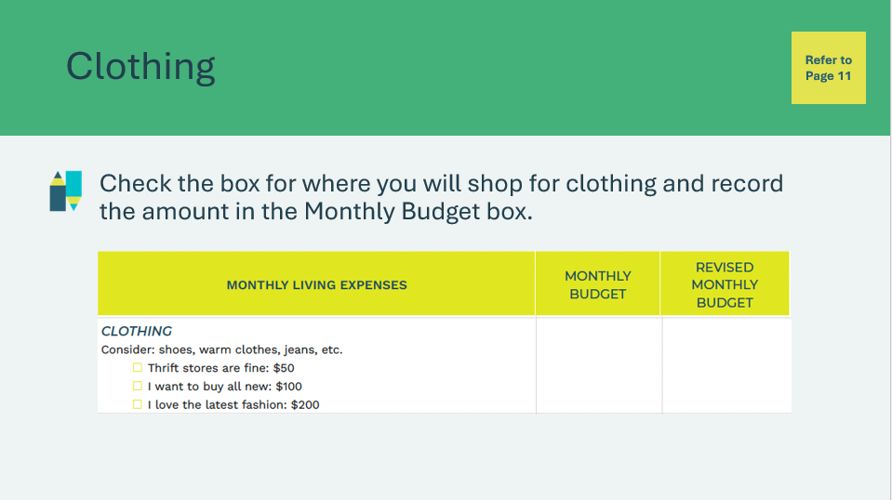 |  | Clothing  Students will select the type of clothing they will buy and record the amount in the Monthly Budget box.
Slide 55  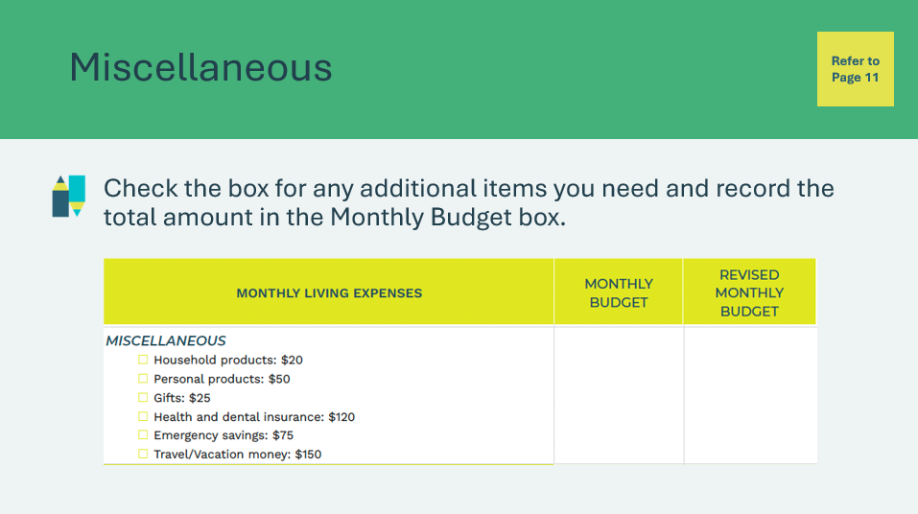 |  | Miscellaneous  Students will consider what miscellaneous items they will need to purchase and record the total amount in the Monthly Budget box.  Example: $20 (household products) + $50 (personal products) + $120 (health and dental insurance) = $190
Slide 56  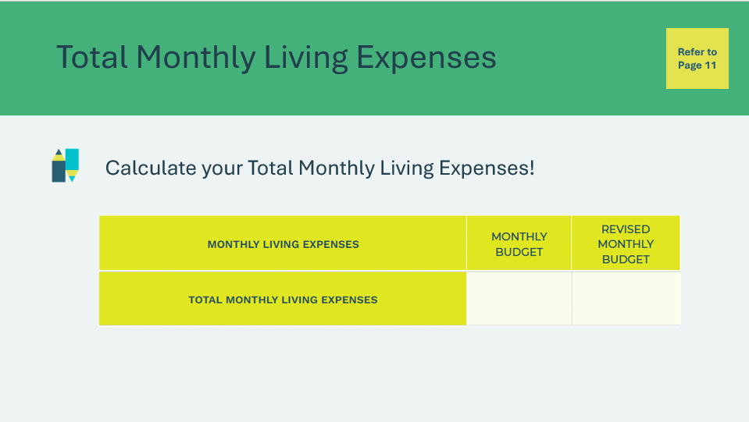 |  | Total Monthly Living Expenses  After the students have filled out all of the items in the Monthly Budget column, have them sum everything up and add it to the Total Monthly Living Expenses row in the Monthly Budget column.  Explain to the students that the total is the amount they will need to cover their expenses for the month, i.e. their monthly budget!  Invite students to reflect on the choices they made and share their thoughts before proceeding to the next part of the activity.  Ask the students to share their thoughts after the activity and have them reflect on the choices they have made.
Program Kit Materials |  | For slides 57-60, you will need to use the Pay Day! Cards from the program kit.
Slide 57  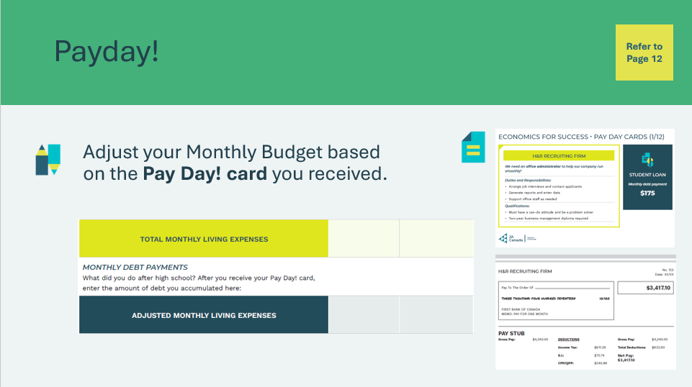  Pay Day! Cards |  | Payday!  Explain to the class that now that they’ve completed their monthly budget, they need to get a job.  Assign each student to one of the twelve Pay Day! cards, found in the kit materials, which includes a job ad and corresponding pay stub information. There can be more than one student per card.  Facilitator tip: The pay stub amounts shown on the Pay Day! cards are calculated using the Canada Revenue Agency’s Payroll Deductions Online Calculator and are only a representation of a single province (Ontario). You may wish to point this out to students and mention that Provincial Income Tax deductions vary across Canada.  Students will fill in the Monthly Debts section using the information from their Pay Day! card and recalculate their total monthly balance.  Example: Total Monthly Living Expenses + $175 (student loan) = Adjusted Monthly Living Expenses
Slide 58  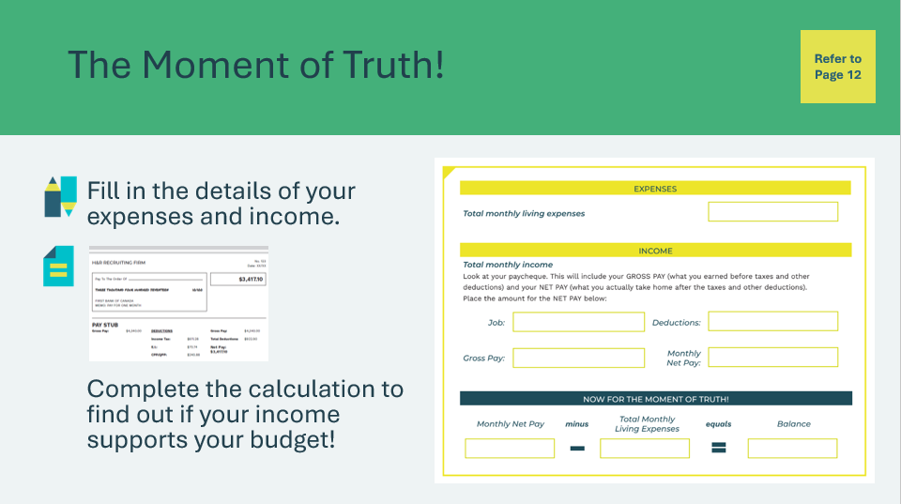  Pay Day! Cards |  | The Moment of Truth!  Students will fill in information in their student portfolio, page 12.  - In the expenses section, they will record their Adjusted Monthly Living Expenses.  - In the income section, they will record the information from their Pay Day! card.  Now for the moment of truth! Students will find out if their income supports their budget by completing the calculation.  - If they have a positive balance, they have money left over!  - If they have a negative balance, they did not earn enough income to support their budget.
Slide 59    Pay Day! Cards |  | Suggested time: 1-2 minutes  Encourage students to reflect on the activity with the discussion questions.  - Does your income support your budget?  - Were there any surprises?  Students may be surprised about what the actual net pay is for their assigned card.
Slide 60  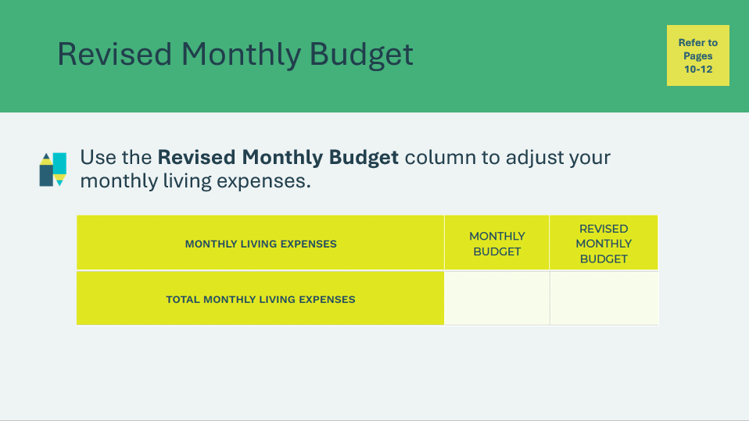  Pay Day! Cards |  | Suggested time: 2 minutes  Provide time for students to revisit their budget and adjust where necessary to ensure they are living within their means. Encourage the students who were able to balance their budgets to help their classmates who need to make adjustments.
Slide 61  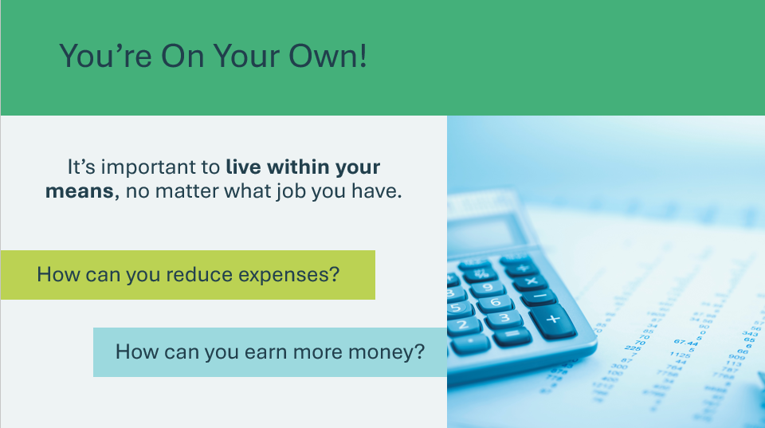 |  | Suggested time: 1-2 minutes  Facilitate a discussion about the importance of living within your means. You may need to reduce expenses or increase your income.  *Click or tap to reveal discussion questions  Sample Answers:  - Reduce expenses by getting a roommate, using a monthly transit pass, watching movies at home instead of going to the movie theatre, eating at home, etc.  - Earn more money by gaining experience or furthering your education or training
Slide 62   |  | Suggested time: 5 minutes  Wrap up the learning by explaining that various factors, such as level of post-secondary education or training, experience, and where you live, can impact the income you earn throughout your lifetime.  Use the Income Predictor Tool to explore how these factors influence earning potential.  Facilitator tip: Use the full-screen control to enlarge the activity screen.  
Opportunity Cost of Education 5 min
Slide 63   | Suggested time: 2 minutes  Now that students have an idea of what it will cost to live independently and how they might pay for it, encourage them to consider how different their lifestyle could be depending on the choices they make after high school.  Play the What’s My Opportunity Cost? interactive video.
Slide 64   | Suggested Time: 3 minutes  Facilitate a discussion about opportunity costs using the question prompts.  *Click or tap to reveal each prompt.  Facilitator tip: For each question, encourage students to think of the benefits, what they’d miss out on and the cost.  Volunteer connection: You may use your personal or industry experience to help the students understand further about opportunity costs.
Slide 65 – 68  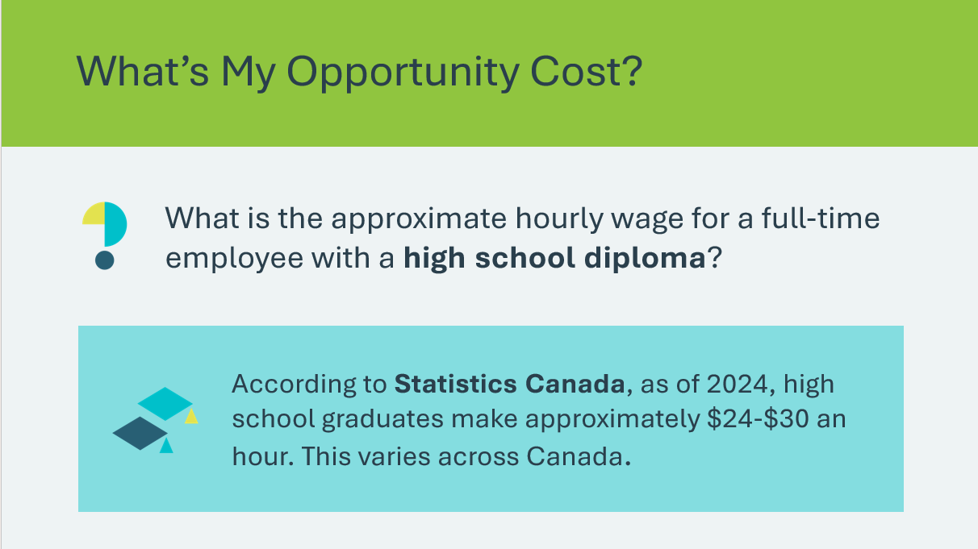 | Wrap up the activity with the questions on the following 4 slides.  *Click or tap to reveal the answer.  Explain to the students that minimum wages vary by province or territory. If the students may ask about this, follow this link:  https://www.retailcouncil. org/resources/quick-facts/ minimum-wage-by-province/).  Reinforce the value of continuing education after high school.  Highlight both traditional pathways like university, college or trades and other ways to continue learning and building skills like self-directed learning, certifications and entrepreneurship.
Extended Activities 10 mins
Slide 69  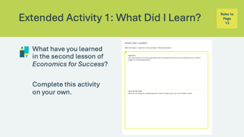 |  | Suggested time: 5 minutes  Students can complete the reflections in class if time allows or independently later on.  Encourage the students to complete the self-reflection activity in their student portfolio, page 13. Students may respond to some or all of the prompts. There is no need to discuss their self-reflections; you and the classroom teacher may review them either between lessons or later on if necessary.
Slide 70 – 77  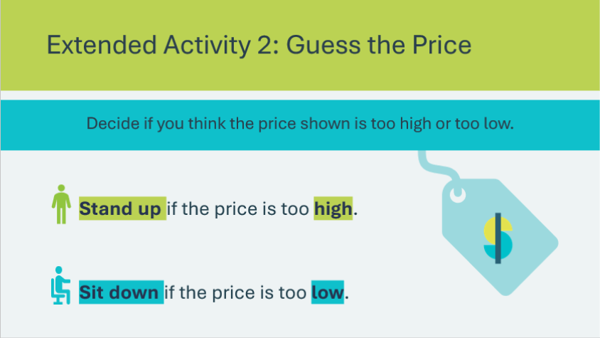 |  | Suggested time: 5 minutes  Ask students if they go grocery shopping with their family. Let them know they will play a game called ‘Guess the Price’ to test their knowledge of the cost of everyday products.  The price of an item will be displayed, and they’ll need to decide if the price shown is too high or too low. Review the instructions for how to play. Note: You may wish to have a separate tab open with a grocery flyer to display current prices (optional).  Facilitator tip: You may wish to touch on inflation. Encourage students to think of inflation as a slow-motion price hike.  - Example: A video game you saved up for a video game last year costs a bit more this year. That's because of inflation. Your money no longer stretches as far as it used to.

Lesson 3: Strategies for Success
Program Kit Materials | You Impress Me! Cards  
Slide 78 – Lesson 3   | Lesson 3: Strategies for Success
Slide 79 – Objectives   | Optional – review the learning objectives for the lesson
Slide 80 – Introduction   | Introduce the lesson by explaining that getting a job involves more than just applying—it's about making smart choices and building connections.  Students will explore valuable strategies like networking, targeting what employers want, and creating a strong personal brand to help them stand out in the job market.
Slide 81 – Activity Menu  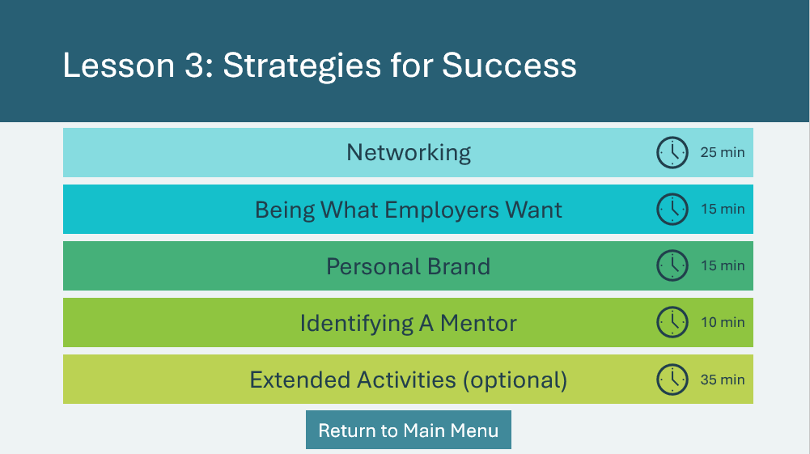 | *Select the button to navigate to the activity.  After you have completed an activity, you will be redirected back to the activity menu.  *Click or tap the Return to Main Menu button to return to the Lessons (Slide 5)
Networking 25 mins
Slide 82   | Suggested time: 5 minutes  Begin the activity by asking students the questions on the next few slides and allowing a few students to share their responses.
Slide 83   | Ask the question on the slide. Invite a few students to share their responses.
Slide 84   | Ask the question on the slide. Invite a few students to share their responses.
Slide 85   | Suggested time: 2 minutes  Tell the students that by asking the questions, you were trying to start to network with them! By asking questions, you can build connections and relationships with others.  Ask the prompt on the slide and invite a few students to share their responses.
Slide 86   | Suggested time: 2 minutes  Emphasize the importance of face-to-face networking by discussing how these interactions help build trust and create deeper connections. Mention that in-person meetings often lead to more memorable interactions and foster better collaboration.  Volunteer connection: Share a personal experience to highlight the value of networking. Provide some examples of discussion topics used in professional networking. Point out how those are different from the topics they might normally discuss.
Slide 87  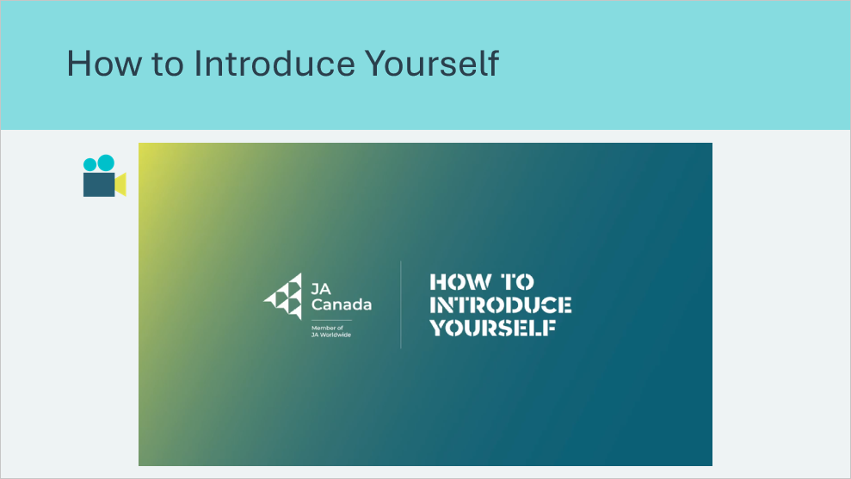 | Suggested time: 3 minutes  Play the How to Introduce Yourself video and briefly discuss the importance of a strong introduction.  Volunteer connection: Highlight the importance of first impressions. Share an experience about a time when making a strong first impression helped you or someone else.
Slide 88   | Suggested time: 2 minutes  Briefly explain the concept of an elevator pitch and how it can help you make a good impression when networking.
Slide 89   | Suggested time: 3 minutes  On a scrap piece of paper, have students write down 3 interesting things about themselves.  Once they have their three things written down, they can begin lining up in two rows, facing each other.
Program Kit Materials | For slide 90, you will need to use the You Impress Me! Cards from the program kit.
Slide 90  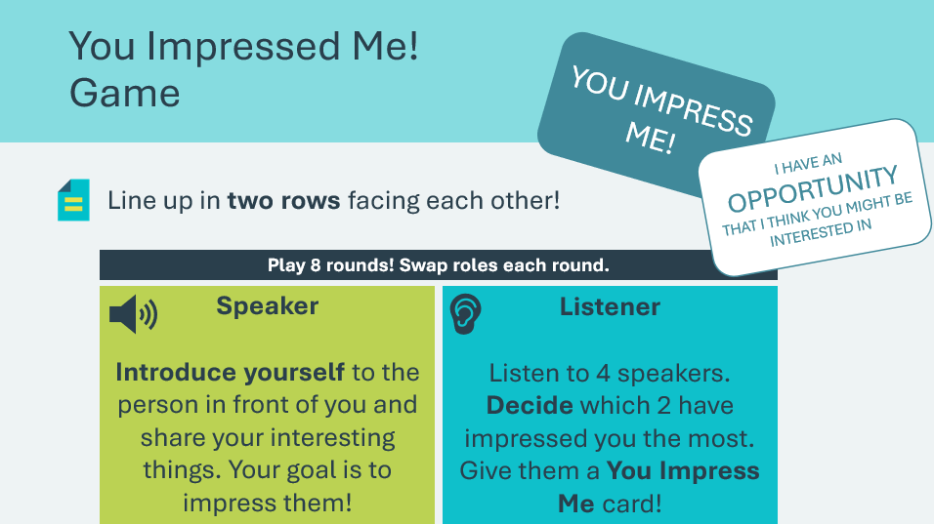  You Impress Me! Cards | Suggested time: 10 minutes  Explain that one row will be speakers while the other will be listeners. Students will imagine the person across from them is a stranger.  - Hand out 2 You Impress Me! cards, found in the kit materials, to each.  - Review what each role will do.  - Each round will be 30 seconds, and there will be 8 rounds. The speakers and listeners will switch roles each round. Shuffle the speaker row down one person each round so there are new sets of partners.  After all 8 rounds are complete, students will decide which 2 people have impressed them the most and give them one of their You Impress Me! cards.  The purpose of the game is to mimic networking with strangers. Students are trying to earn as many You Impress Me! cards as they can.
Slide 91  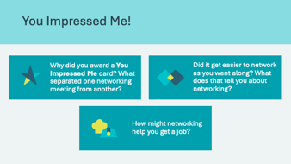 | Suggested time: 3 minutes  Wrap up the activity using the discussion questions.  Sample answers:  - Preparedness, confidence, and details of the conversation are things that stand out when networking  - Practice makes networking easier  - People you meet might have opportunities for you or might be able to tell you about opportunities they know about  Facilitator tip: Encourage discussion among the students on how they made their decisions about whom to give their cards to.
Being What Employers Want 15 mins
Slide 92   | Suggested time: 3 minutes  Recall the networking activity and remind students that everyone has qualities that make them employable. If they found themselves not receiving cards, one reason might be how they described themselves.  It’s important that what you share about yourself matches the skills that employers are looking for. Emphasize that this means problem-solving skills, communication skills, and critical thinking skills, among others.  Through emphasizing these qualities when describing yourself, you can help people see what is special about you.
Slide 93  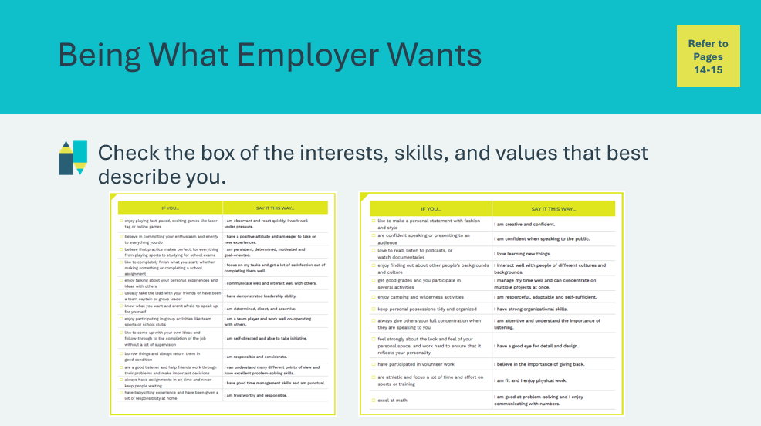 | Suggested time: 12 minutes  Ask: How can you take your interests, skills, strengths, and passions and express them so that they reflect what employers want? Allow students to share their thinking.  Volunteer connection: You may also share your answer with the students based on your personal/industry experience.  Explain that students will review the activity in their student portfolio, page 14-15, to find out how they can describe their interests, skills and values in a way that will impress employers.  Allow students time to review and check the boxes. Remind students to hang onto their student portfolio so they can use it when they create an online profile, write a resume, or apply for a job.
Personal Brand 15 minutes
Slide 94   | Suggested time: 2 minutes  Ask the prompt on the slide and invite a few students to share their thinking.  Explain that your personal brand is the way you portray yourself to others.
Slide 95  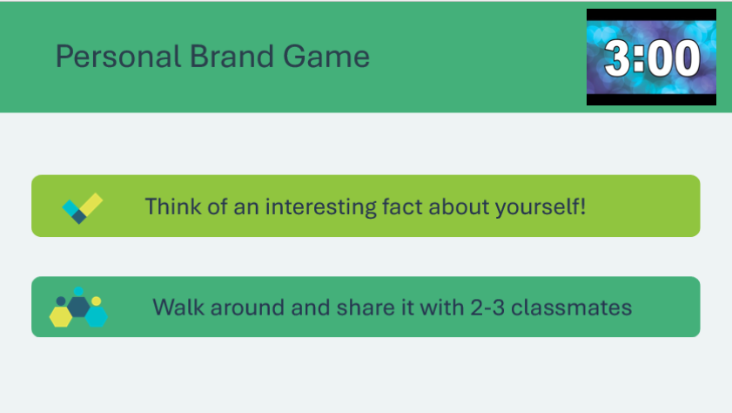 | Suggested time: 5 minutes  To help understand the importance of having a strong personal brand, explain that students will play a game to see how people are all interconnected:  - Each student will think of a fact about themselves.  - For example, do they play an instrument, did they go somewhere on vacation recently, can they speak another language?  - Start the 3-minute timer and allow students to walk around and share their fact with 2 to 3 others in the class.  - When the timer is up, ask students to return to their seats.  - Ask a small subgroup of students (such as those with a birthday in October) to stand.  - Ask everyone who told their fact to one of the standing students to stand up as well.  - Then, ask who told their fact to someone in the (now larger) group of standing students.  - Continue until every student is standing (it should happen quickly)  Explain that this activity demonstrates how they are connected to the whole group through only a small network.  Remind students of the implication of this: By consulting only a few people, someone can learn a lot about them. Make sure they are learning good things about you!
Slide 96   | Suggested time: 2 minutes  Wrap up the game with the discussion questions.  - Can you think of any bigger networks through which information about us can be shared?  - Social networks, the internet, video games, etc.  - Do you think interviewers could do an internet search for you before hiring you?  - Yes. The majority of employers say they ‘Google’ people before they hire them. They can also do social media searches.  - What things should you share on social media if you want to make yourself more attractive to potential employers?  - A professional-sounding email address, an employment-related social media account (like LinkedIn), avoid posting pictures of irresponsible behavior, avoid saying negative things about previous employers, use good spelling and grammar, etc.
Slide 97 – 102   | Suggested time: 2 minutes  Review the social media true or false slides (slides 97-102).  Facilitator tip: You may want to have students stand up or raise their hands if they think the statement is true.  *Click or tap to reveal the answer
Slide 103  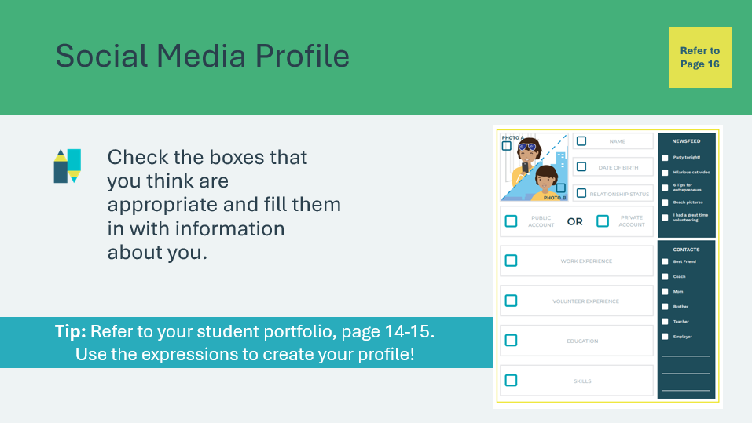 | Suggested time: 5 minutes  Students will complete the social media profile in their student portfolio, page 16, by checking the boxes for sections that are relevant and then filing those in to reflect what employers want.  Encourage students to use this activity to improve their real social media profiles.
Identifying A Mentor 10 mins
Slide 104   | Suggested Time: 2 minutes  Explain that sometimes we can meet someone who takes us under their wing, helps us learn more about ourselves, inspires us, gives us greater confidence, and provides advice about our educational goals and dreams. Mentors are great people to have around.  Volunteer Connection: Share with students the story of a mentor that you had in your life and what that mentor was able to do for you.
Slide 105  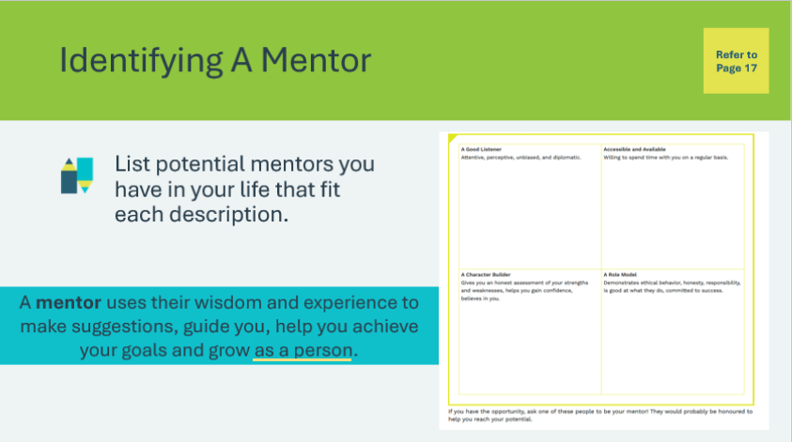 | Suggested time: 8 minutes  Students will complete the activity in their student portfolio, page 17.  - Students may write their mentor’s name in more than one box if multiple apply.  - If they do not have a mentor based on the qualities listed, they may include the name of anyone in their life with those qualities.  Wrap up the activity by reminding students that they now know three strategies: networking, building a personal brand, and working with a mentor to help them with their educational goals and career plans.
Extended Activities 35 mins
Slide 106  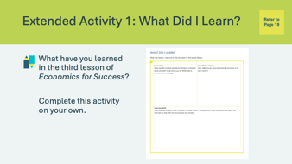 | Suggested time: 5 minutes  Students can complete the reflections in class if time allows or independently later on.  Encourage the students to complete the self-reflection activity in their student portfolio, page 19. Students may respond to some or all of the prompts. There is no need to discuss their self-reflections; you and the classroom teacher may review them either between lessons or later on if necessary.
Slide 107 – 110  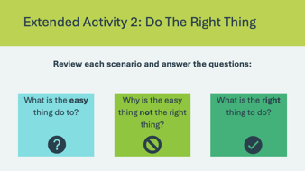 | Suggested time: 10 minutes  Students will answer the three questions for each of the following scenarios on slides 108-110.
Slide 111 – 113  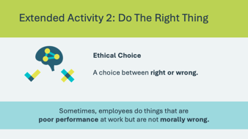 | Suggested time: 10 minutes  Explain that we refer to workplace situations that involve a choice between right and wrong as an ethical choice.  Sometimes, employees make poor choices, but they are not morally wrong. In those situations, it is up to the supervisor who is responsible for evaluating the employees’ performance to deal with the bad behaviour/poor performance.  Students will decide if the situation described in the following scenarios (slides 112 and 113) is an ethical situation or one of poor performance.  Ask a student volunteer to read the slide out loud. Facilitate a discussion about whether the situation is an example of an ethical dilemma or poor performance. Ask a few students to share their responses.  Reinforce that doing the right thing, even when it isn’t the easy thing to do, is essential to being a great employee.
Slide 114   | Suggested time: 5 minutes  Ask the classroom teacher or your fellow facilitator to help you present a mock interview. One of you should be the interviewer and the other the interviewee.  The first mock interview should give the students an example of a bad interview. Here are some tips you can share with the interviewee for the mock interview:  - The interviewee should slouch, give one-word answers or very vague answers, give an inappropriate handshake, look at their cell phone, use slang e.g. “hey you” etc., seem disinterested in getting the job, or act like the job is owed to them, and end the interview by saying something like “later”.  - The interviewer should be professional and business-like.  Ask the students how they think the interview went and if they would hire this person. Allow students to offer ideas and explain their thinking.  Then, conduct the second mock interview to provide an example of a good interview.  - The interviewee should shake hands professionally, smile, be enthusiastic, sell themselves by providing examples, incorporate mentoring, volunteering and/or networking as examples of how they heard about the job and thank the interviewer for their time.  - Once again, the interviewer should be professional and businesslike.  Again, ask the students how they think the interview went and if they would hire this person. Allow students to offer ideas and explain their thinking.  Use a few of the Interview Questions below:  - Tell me a little about yourself.  - Describe a difficult work situation/how you overcame it.  - What is your greatest strength?  - How do you handle stress or pressure?  - What is your definition of success?  - Why do you want this job?  - Why should we hire you over other candidates for the job?  - Is there anything else that you would like to add?
Slide 115  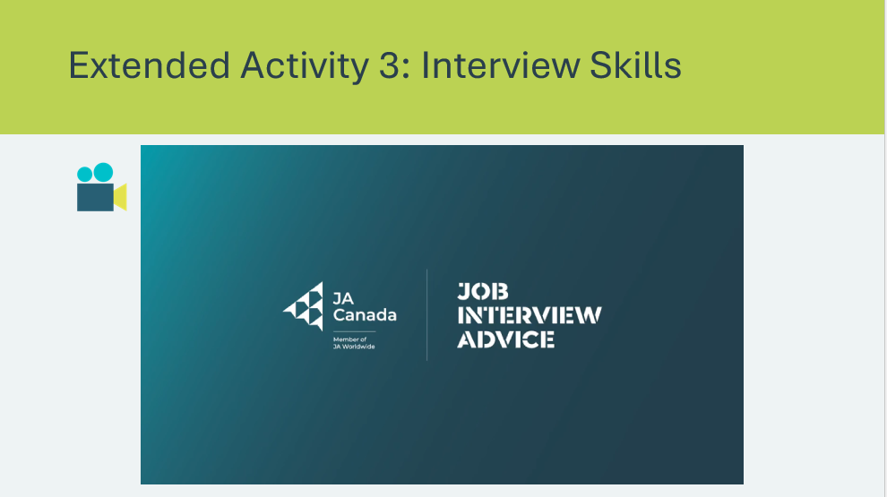 | Suggested time: 3 minutes  Play the Interview Skills video to reinforce strong interview skills.
Slide 116  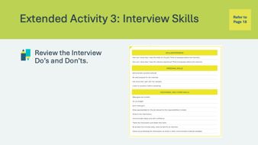 | Suggested time: 2 minutes  Students can review the Interview Do’s and Don’ts in their student portfolio, page 18. Tell them to keep their student portfolio and to refer to this list before their job interviews.

Lesson 4 –You Can Do It!
Program Kit Materials | Keys to Success Game Board, dice and playing pieces  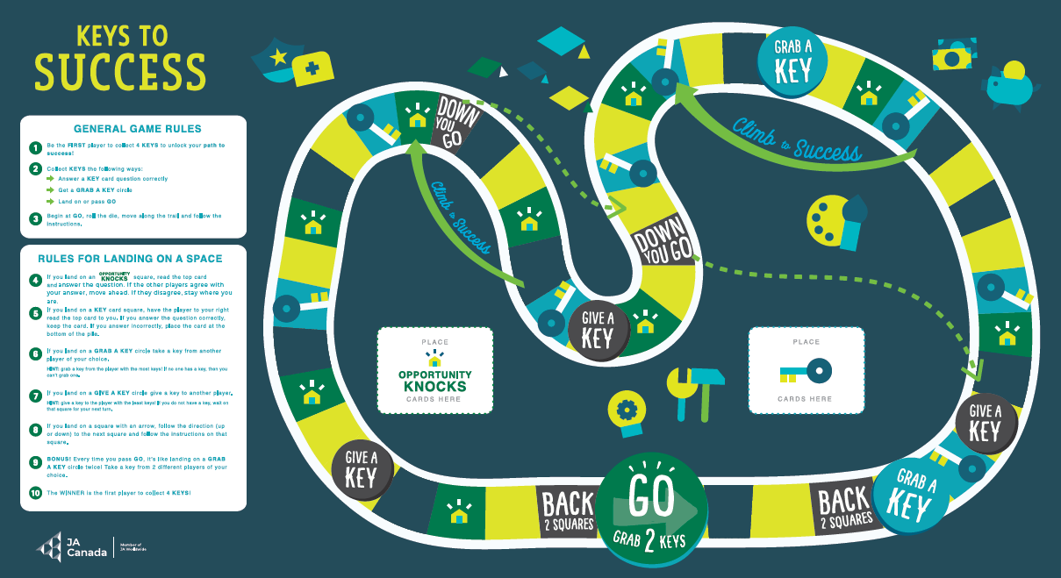  Key Cards  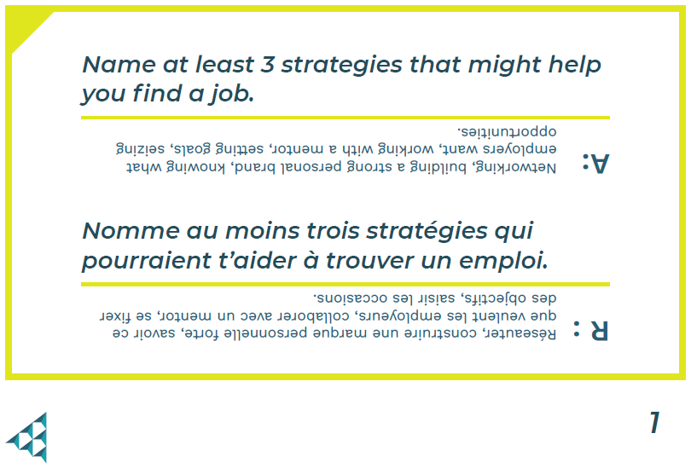  Opportunity Knocks Cards  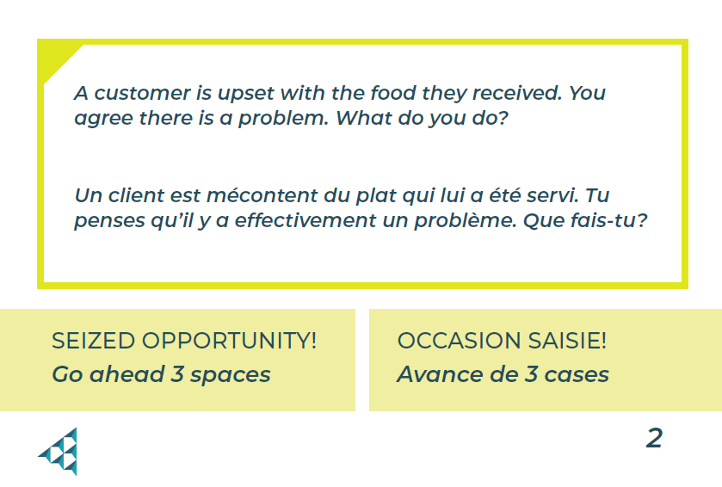
Slide 117 – Lesson 4   | Lesson 4: You Can Do It!
Slide 118 – Objectives   | Optional – review the learning objectives for the lesson
Slide 119 – Introduction   | Introduce the lesson by explaining that achieving our educational and career goals requires using various strategies. Students will explore the importance of seizing opportunities as an additional strategy and learn how it can help them succeed in different situations.
Slide 120 – Activity Menu  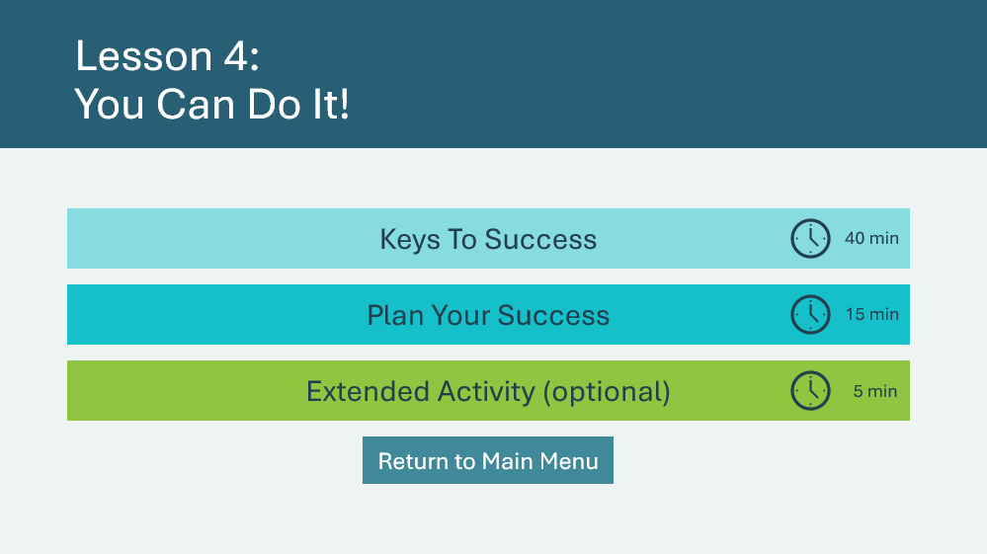 | *Select the button to navigate to the activity.  After you have completed an activity, you will be redirected to the activity menu.  *Click or tap the Return to Main Menu button to return to the Lessons (Slide 5)
Keys To Success 40 mins
Program Kit Materials | For slides 121-124, you will need to use the Keys to Success Game Board, Key Cards, dice and playing pieces from the program kit.
Slide 121  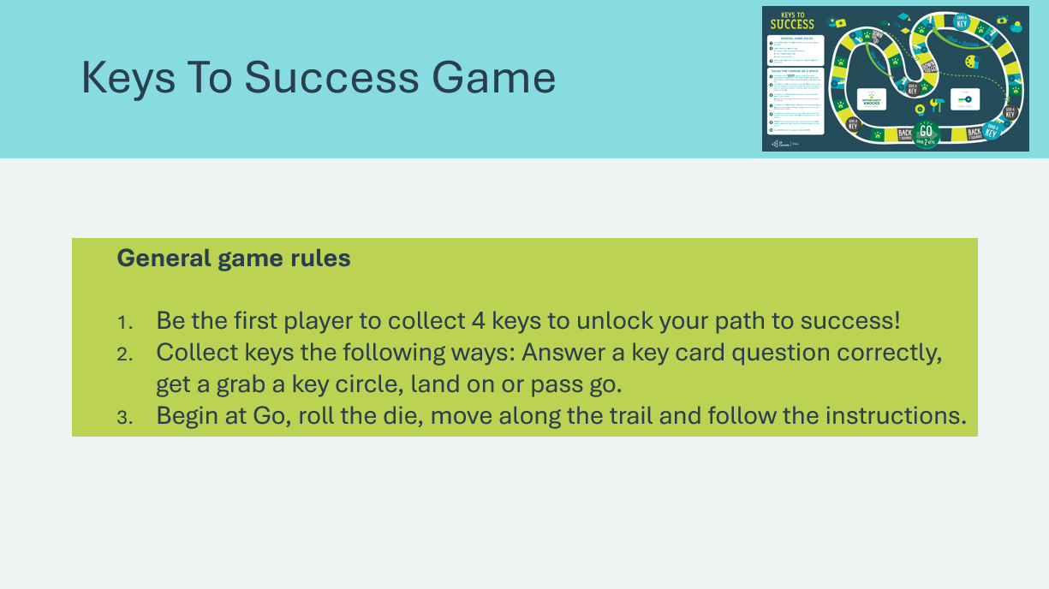 | Suggested time: 2 minutes  Let the students know they are going to play a game called Keys to Success. Review the general game rules as a class.
Slide 122  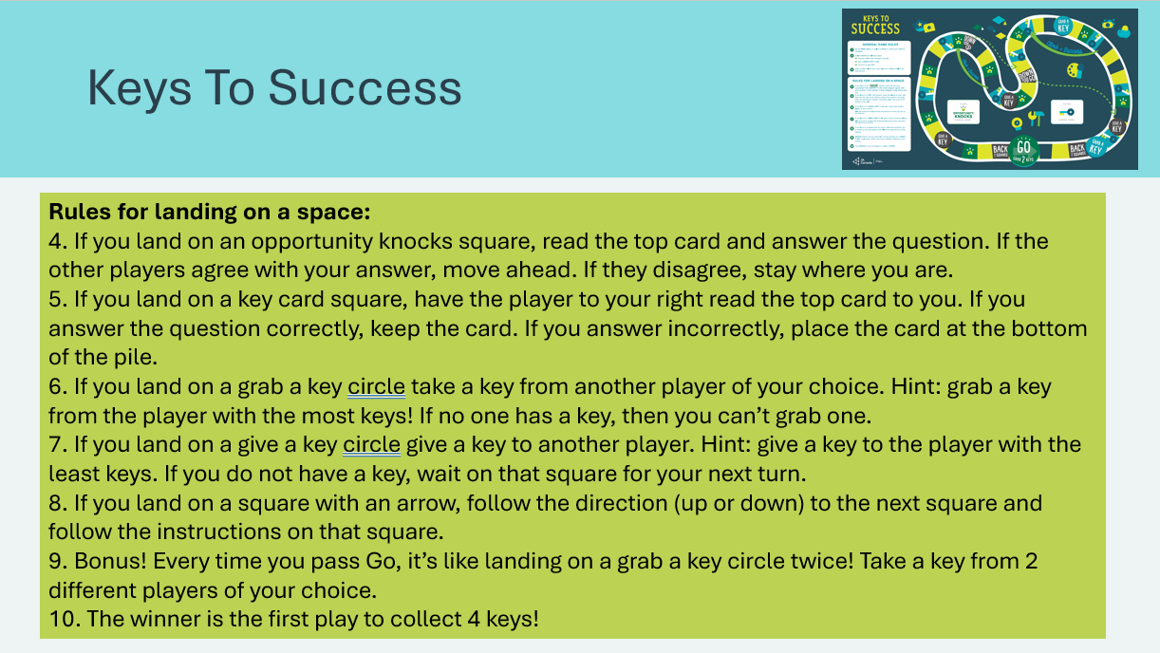  Keys to Success Game Board  Key Cards  Opportunity Knocks Cards | Suggested time: 3 minutes  Review the rules for landing on a space as a class. Once students know the rules, break them into groups of four to six students. Distribute the game board, one set of cards, one playing piece per student, and one die to each group of students.
Slide 123   | Suggested time: 30 minutes  Circulate the room while students play the game, ensuring they are following the rules, reading the cards completely, etc.  Remember to reserve a few minutes at the end of the activity to acknowledge the winners and collect the game materials.
Slide 124   | Suggested time: 5 minutes  Wrap up the game by asking students the prompt.  Students should respond with: Seize opportunities!
Plan Your Success 15 mins
Slide 125  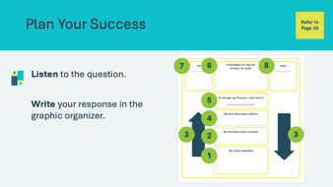 | Suggested time: 15 minutes  Students will complete the graphic organizer in their student portfolio, page 20.  As you read each question, allow students to fill in the answer on the graphic organizer. Ask students to share their answers and use the answers written in italics on the following slides to help guide the class.
Slide 126  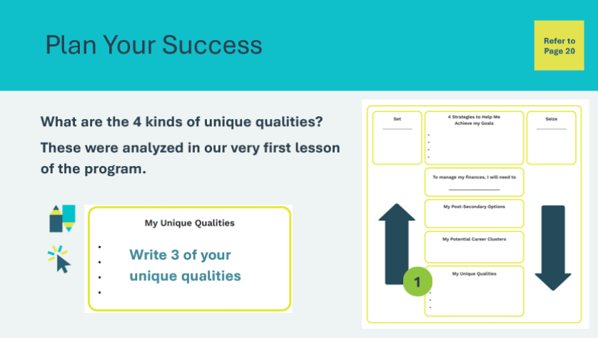 | *Click or tap to reveal what students will write.  All of us have unique qualities in the form of interests, skills, strengths and passions.  - Students will list 3 of their unique qualities.
Slide 127  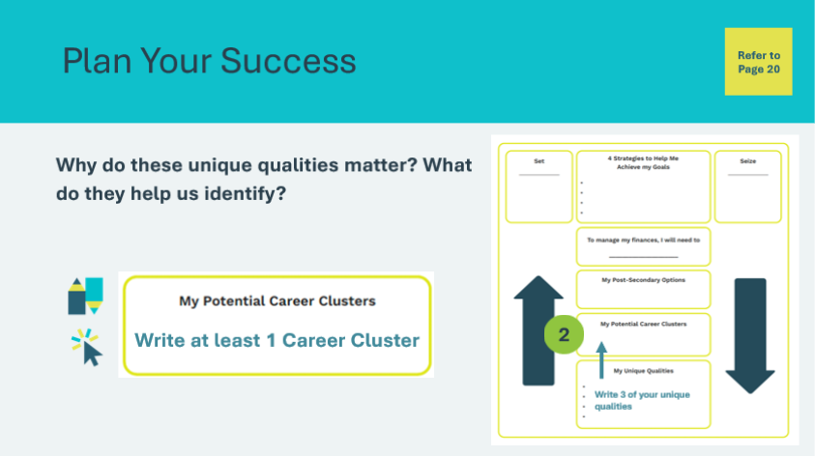 | *Click or tap to reveal what students will write.  We can use those interests, skills, strengths and passions to identify career clusters that we are well suited to.  - Students will draw an arrow from Section 1 to Section 2 and record at least 1 potential career cluster.
Slide 128  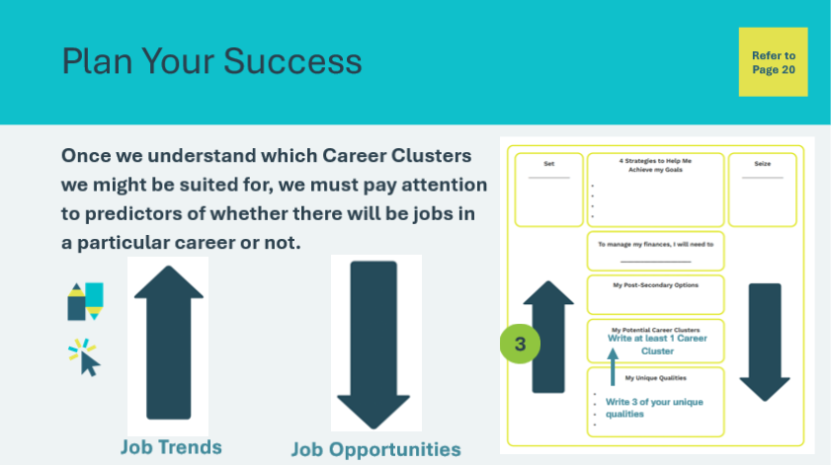 | *Click or tap to reveal what students will write.  We need to pay attention to the job trends in society and understand why certain careers are trending up or down to understand where the job opportunities will be. If you combine your own personal qualities (interests, skills, strengths, passions) with trends about occupations that are rising or declining, you can choose an excellent career journey!  - Students will label both blue arrows with these predictors (job trends and job opportunities)
Slide 129  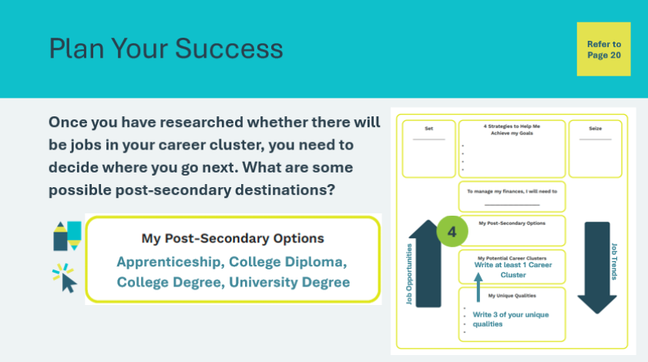 | *Click or tap to reveal what students will write.  You will need to decide whether your program is offered as an apprenticeship, college diploma, college applied degree or university degree.  - Students will fill in the possible post-secondary destinations.
Slide 130  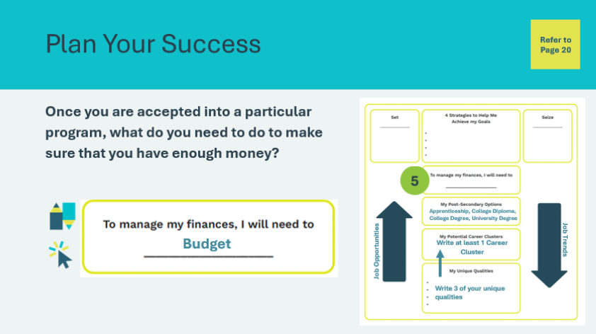 | *Click or tap to reveal what students will write.  Once you are accepted into your post-secondary program, you need to make a budget. Attending post-secondary is a financial investment that pays long-term rewards.  - Students will write “budget”.
Slide 131  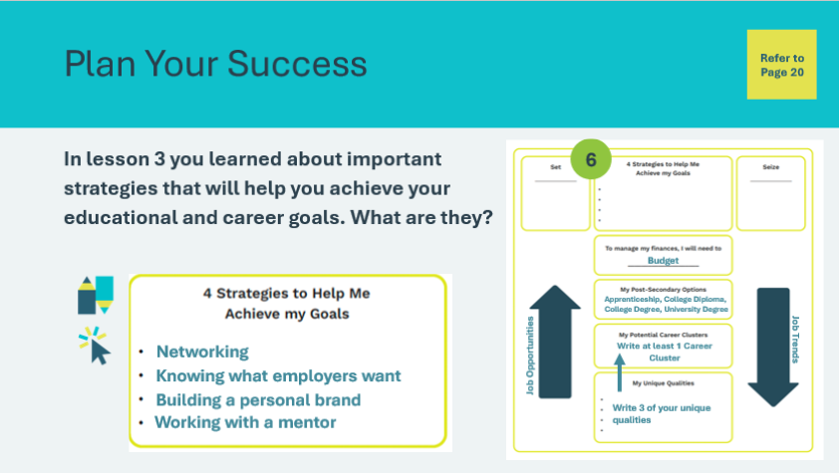 | *Click or tap to reveal what students will write.  Networking, knowing what employers want, building a personal brand, and working with a mentor are four strategies that you learned about that will help you achieve your goals.  - Students will write the 4 strategies
Slide 132  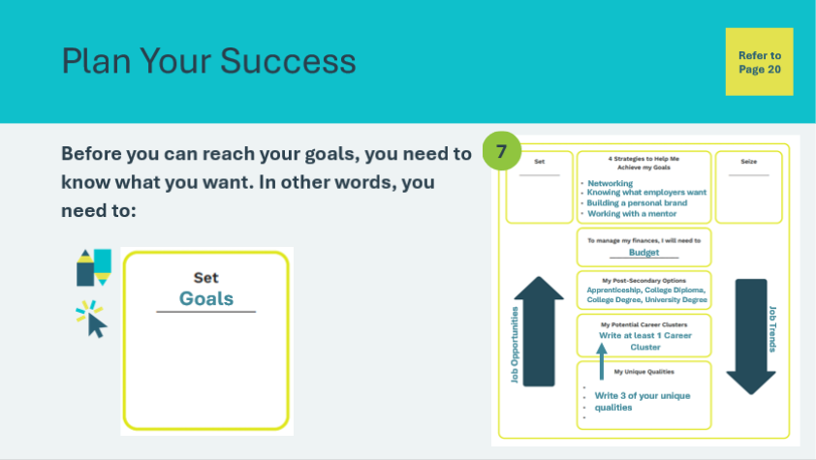 | *Click or tap to reveal what students will write.  Set goals!  - Students will write “Goals”
Slide 133  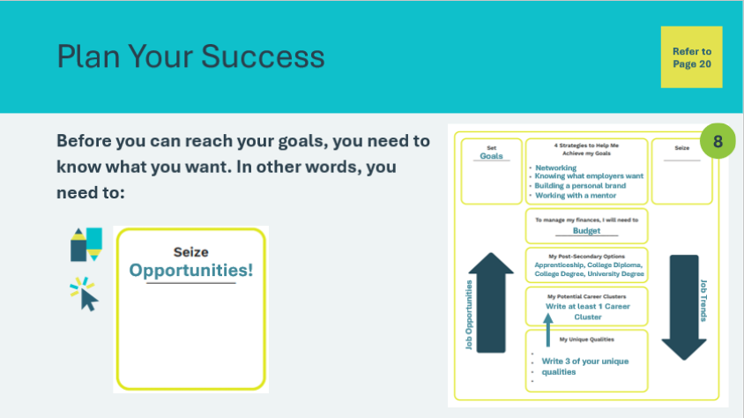 | *Click or tap to reveal what students will write.  Seize them!  - Students will write “opportunities”
Slide 134  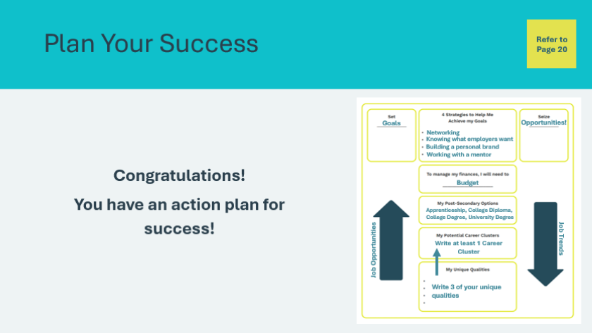 | Congratulate students on having an action plan for success!
Extended Activity 5 mins
Slide 135  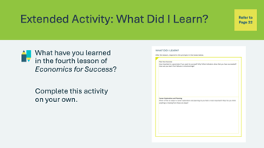 | Suggested time: 5 minutes  Students can complete the reflections in class if time allows or independently later on.  Encourage the students to complete the self-reflection activity in their student portfolio, page 22. Students may respond to some or all of the prompts. There is no need to discuss their self-reflections; you and the classroom teacher may review them either between lessons or later on if necessary.

Wrap Up
Program Kit Materials | Certificates of Accomplishment  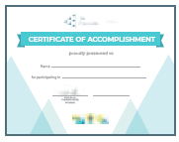
Slide 136 – Wrap Up   | Wrap Up
Program Kit Materials | For slide 137, you will need to use the Certificates of Accomplishment from the program kit.
Slide 137 – Congratulations    Certificates of Accomplishment | Suggested time: 5 minutes  Wrap up the learning experience by asking students the following questions:  - Did you enjoy the Economics for Success program?  - What did you learn that you didn’t know before?  Thank the students and teacher for their participation and distribute the Certificates of Accomplishment.
Slide 138   | Tell the students you enjoyed spending the time with them and congratulate them on a job well done!  Invite students to visit jacampus.org for additional information and learning.

Appendix
Looking for External Clues – Rising, Neutral and Declining Opportunities
The occupations should be sorted approximately as follows, although you may need to make adjustments based on your region of Canada.
Declining | Neutral | Rising
Postal Clerks | Teachers | Artificial Intelligence Specialists
Bank Tellers | Accountants | Renewable Energy Technicians
Printers and Publishers | Civil Servants | Cybersecurity Experts
Textile Workers | Mechanics | Environmental Scientists and Engineers
Telemarketers | Social Workers | Data Analysts and Scientists
Data Entry Clerks | Pharmacists | Software Developers and Engineers
Travel Agents | Electricians and Plumbers | Graphic Designers
Video Store Clerks | Chefs and Cooks | Financial Analysts and Advisors
Newspaper and Magazine Journalists | Real Estate Agents | Logistics and Supply Chain Management Professionals
Cashiers | Dental Hygienist | Social Media Managers
Disc Jockeys | Insurance Agents | Public Health Professionals
Parking Lot Attendants | Veterinarians | Biotechnology and Life Sciences Professionals
Florists | Paralegal | Robotics Technicians
In-store Retail Cashiers | Flight Attendants | User Experience (UX) Designers
Electronic Equipment Repairers | Medical Laboratory Technologists and Technicians | E-learning Specialists
Nuclear Technicians | Bus Drivers | Mental Health Professionals
 |  | Information Security Analysts
 |  | Digital Marketers

MONEYMemory Answer Key
Term | Clue
Provincial Sales Tax (PST) | This tax is applied to most products we purchase, and the amount varies from province to province.
Canada Pension Plan (CPP) | This wage deduction provides basic income to Canadian citizens outside of Québec when they retire.
Employment Insurance (EI) | This program provides temporary financial assistance to Canadian citizens when they can’t find work.
Goods and Services Tax (GST) | This 5 percent federal tax is applied to most goods and services we purchase.
Harmonized Sales Tax (HST) | This combination of Goods and Services Tax and Provincial Sales Tax is used in some provinces.
Québec Pension Plan (QPP) | This wage deduction provides basic income to Canadian citizens in Québec when they retire.
Property Tax | This yearly tax is paid by people or businesses who own property in a local area.
Gross Pay | This is your total amount of earnings before anything is deducted.
Net Pay | This is your earnings after deductions are subtracted from your gross pay.
Pay Stub | This information is provided with a paycheque and explains gross pay, deductions, and net pay.
Property Tax | This tax helps pay for services and programs in a community, such as a skateboard park or local bus services.
Income Deductions | This money is deducted (subtracted) from your gross pay to help provide services and programs across Canada.
Canada Pension Plan (CPP)/ Québec Pension Plan (QPP) | This deduction is applied to your gross pay between the ages of 18 and 65.
Employment Insurance (EI) | This deduction is applied to your gross pay no matter your age.
Taxes | This is money that people and businesses must pay to their local, provincial, and federal governments. It is used to provide services that benefit all Canadians.

