

Session 1: Introduction to JA Titan Presenter Notes
The Presenter Notes have been developed using references from the digital classroom presentation and can be used in combination with the JA Titan Simulation and Student Workbook.
This guided exploration session guides students through an introductory, overall look at the JA Titan simulation and focuses on the foundational key terms and concepts for the simulation: budget, cash-on-hand, chief executive officer, expenses, income statement, and price versus production.

The key concept for students to learn during this session is that businesses have decisions to make every day, and that the necessary trade-offs and outcomes of those decisions impact the business, employees, consumers, and the community.
This session takes approximately 60 minutes to complete.

Simulation Gameplay Setup
Decide whether students will play the JA Titan simulation in single-player or multiplayer mode. Suggested gameplay mode and settings are provided for each activity.
Single-Player Mode: Players compete as companies individually against the simulation’s artificial intelligence. Single-player mode is a learning tool designed for practice. The AI companies play at a moderately easy level.
- Players log in to the simulation and set up their own games.
- Players can analyze data for completed games in the Content Management System (CMS).
- Players choose the number of quarters (game duration) and starting cash-on-hand (difficulty level).
- Suggested gameplay settings for single-player mode are provided below to share with students for each activity.
Multiplayer Mode: Players compete as companies (either individually or in teams) against each other.
- Multiplayer games are set up in the Content Management System (CMS). Tell students the name of the game to ensure they choose the correct game in the simulation lobby.
- This mode requires players to be playing together in real time (in class or remotely). Players log in to the simulation and join their assigned game.
- Add yourself as a player in the game to demonstrate the simulation to students.
- Game creators can monitor company results and analyze the game data in the CMS after each quarter and can access comprehensive data for completed games by downloading a CSV file. Student players can view selected data for completed games in the CMS.
- Game settings for all players are determined by the game creator for Custom games and are predetermined by the simulation for Scenario games. Suggested gameplay settings for multiplayer mode are provided for each activity.

Session 1: Introduction to JA Titan

Slide 1 – JA Titan  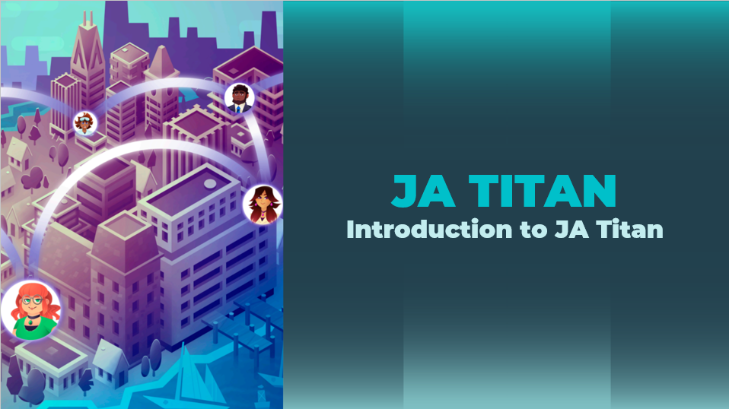 |  | Navigation Tips  - Navigate through the slides using the next or previous buttons (bottom right), clicking or tapping on the slide, or using the navigation menu (right).  - Look for slide specific instructions in the presenter notes below.
Slide 2 – Welcome to JA!  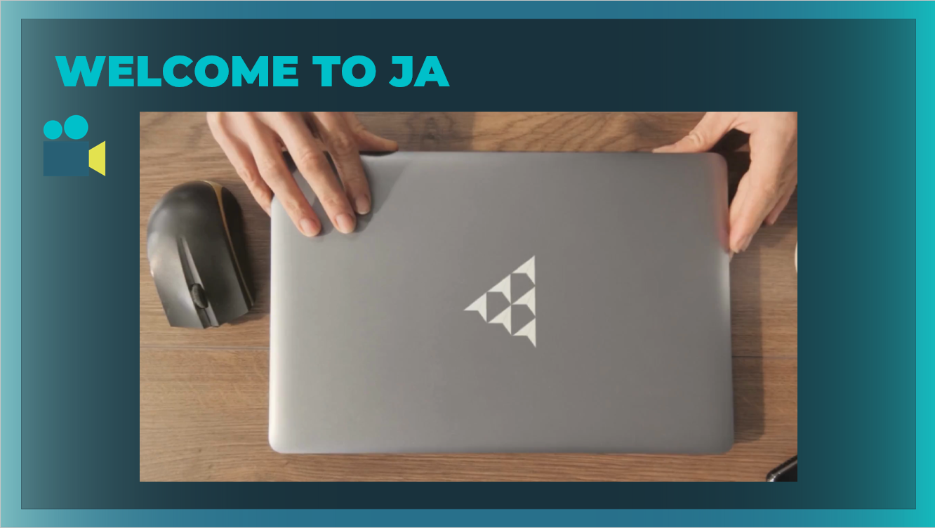 |  | Suggested time: 3 minutes  Ask: Has anyone heard of Junior Achievement before?  Play the video for students to introduce them to JA!
Slide 3 – Program Overview  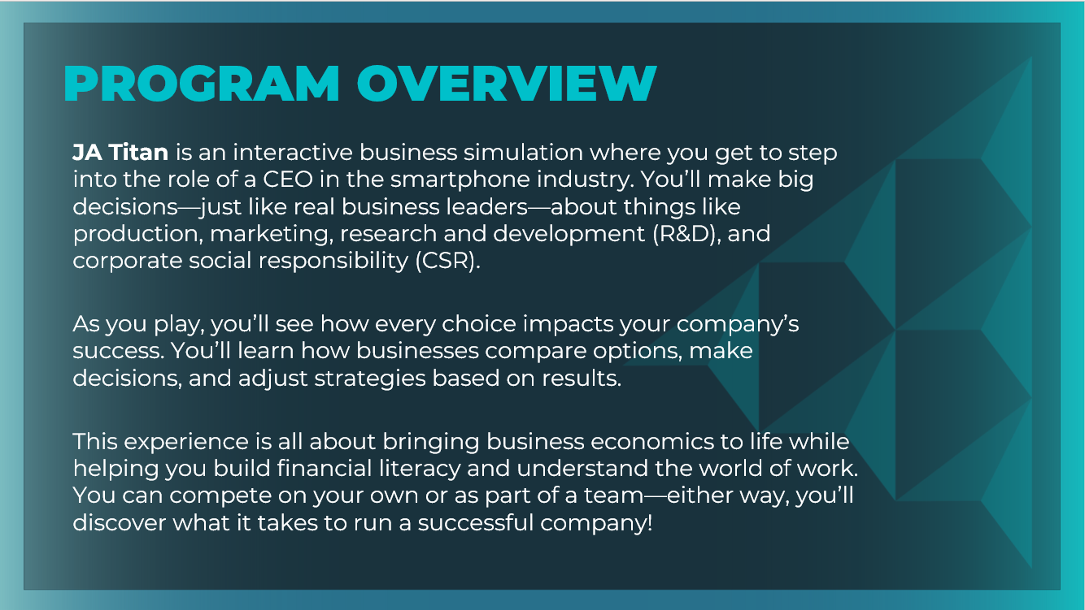 |  | Suggested time: 2 minutes  Introduce the program! Explain that in this program, they will explore how they can run a real business that sells products.
Slide 4 – Learning Objectives  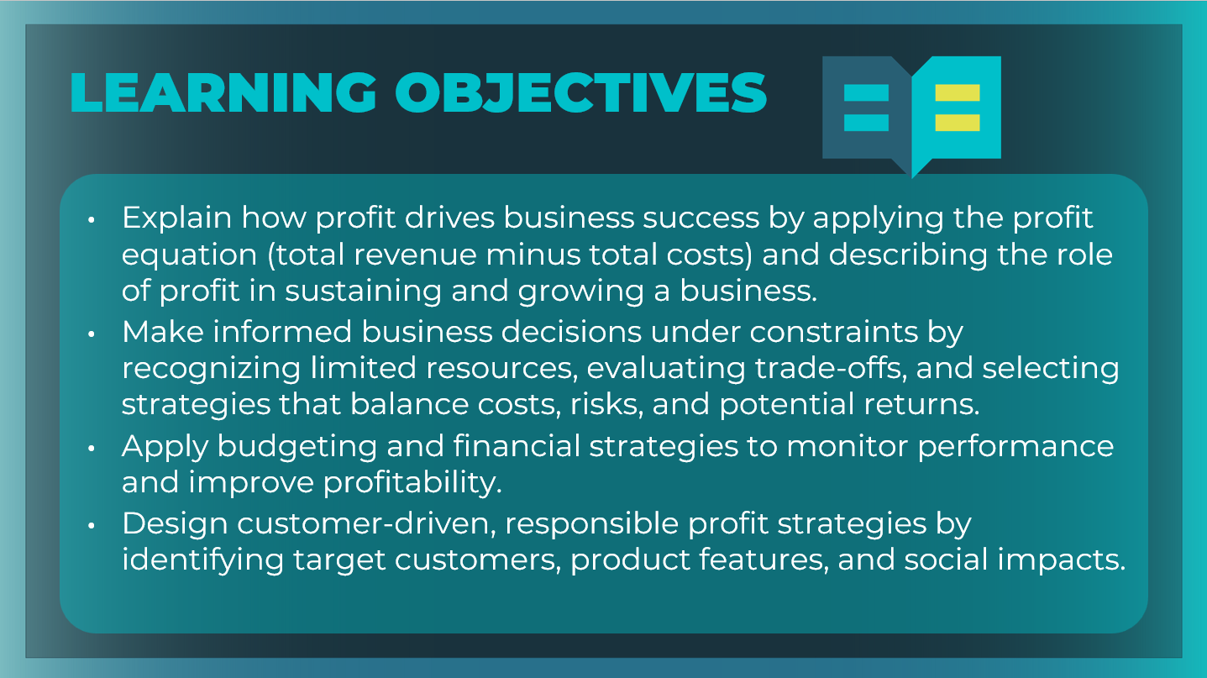 |  | Optional – review the learning objectives for the simulation.
Slide 5 – Menu  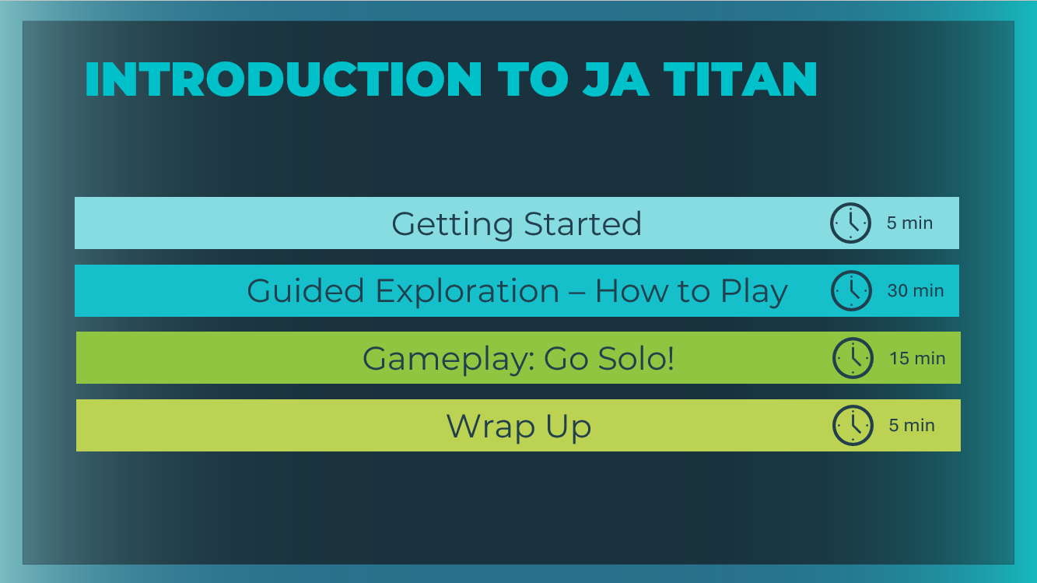 |  | *Select the button to navigate to the section.  After you have completed the section, you will be redirected to this menu.
Getting Started (5 mins)
Slide 6 – Introduction  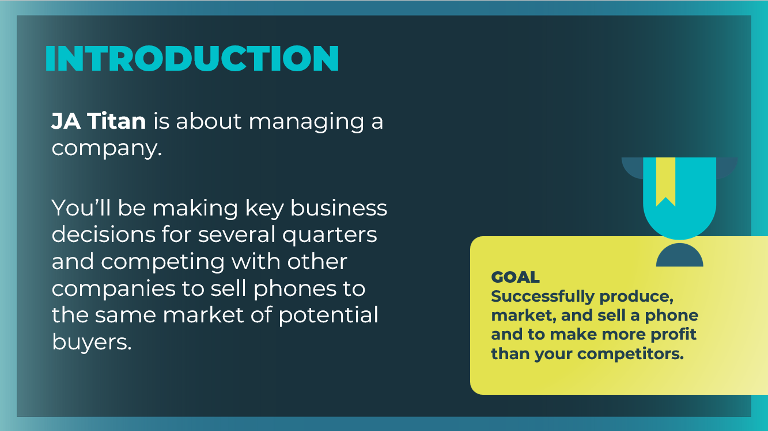 |  | Explain that students will be participating in an online simulation. Share the concept and goal of the simulation.
Slide 7 – Think About It!  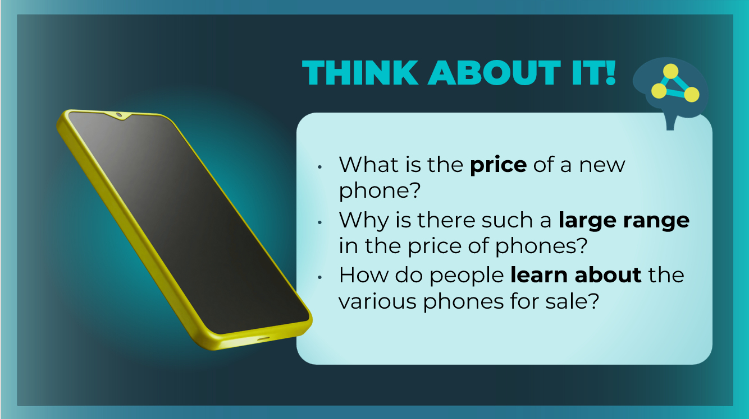 |  | Ask students to think of a store or company that sells phones and imagine that they are shopping for a new phone; then ask them to consider the following questions:  - What is the price of a new phone? Possible responses: prices vary significantly, from less than $50 to more than $1,000  - Why is there such a large range in the price of phones? Possible responses: differences between brands, features, quality  - Phones are very important to many people. Why don’t the phone makers just give them away for free to the people who need them? Answers will vary but should include that it costs money for a company to offer its product to consumers. Businesses have expenses, they must buy the materials they need to make the product, they must pay their employees, etc. In addition, businesses must make a profit in order to stay in business.  - How do people learn about the various phones for sale? Answers will vary; however, if not mentioned, explain that businesses often have Marketing & Sales departments where employees determine who buys their product or who might buy their product if they learned more about it. Companies then advertise in order to get the word out.  Explain to students that you will be introducing them to the JA Titan simulation. They will be in charge of a company that sells phones, and they will be making the kinds of decisions you just discussed.
Guided Exploration: How to Play (30 mins)
Slide 8   |  | Guided Exploration  For this guided exploration session, you may choose to use the slides 9-59 to guide students through the game play, or you may choose to log in to the simulation yourself and use the presenter notes to guide your demonstration.  Explain that JA Titan is about managing a company. Students will be making key business decisions for several quarters and competing with other companies to sell phones to the same market of potential buyers.  The key decisions to be made during the simulation include the following areas:  - Budget decisions  - Production decisions  - R&D decisions  - Marketing decisions  - CSR decisions
JA Titan Simulation:
https://jatitancanada.org/login

Suggested Game Settings
Single-Player & Multiplayer Settings
Cash-on-Hand | Duration
$4 million (easiest) | 4 quarters (1 year)

Multiplayer Only Settings
Game Name: GAME 1: EXPLORE
Quarter Completion | Game Type | Company Setup
Manual | Custom | Players as Companies

Slide 9  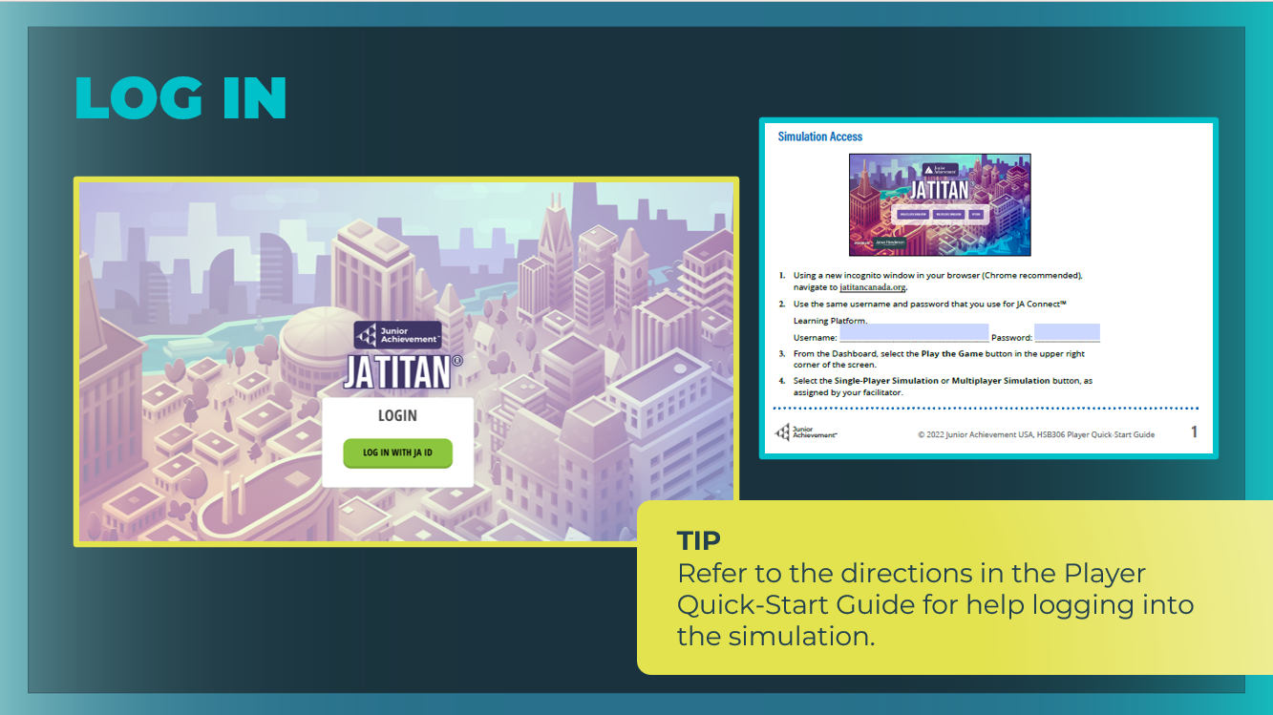 |  | Direct students to log in to the JA Titan simulation following the directions on the Player Quick-Start Guide and to refer to the guide as needed as you lead them through the guided exploration.  - If you have set up a multiplayer game, direct students to log in to Game 1: Explore from the simulation lobby.  - If students are going to play in single-player mode, share the suggested gameplay settings. Keep in mind that single-player mode is an easier version of the simulation and is provided for practice and learning purposes.  Directions for Multiplayer Mode Only  - Students will be taken to the simulation lobby to await the start of the game.  - If you selected Manual quarter advancement, you will need to start the simulation in the Content Management System (CMS) once all the students are ready. Select Game 1: Explore in the CMS, and select the Start Game button.  - If you selected Automatic quarter advancement, the game will begin at the time you designated.  Simulation Advisor and Tutorial Mode  - Because students selected the checkbox next to First Time Playing?, the simulation will open in a tutorial mode. Read the Advisor’s message and opt to take the tour.  - Complete the tour by selecting the forward arrow. The goal of this tour is to give a quick overview of the simulation interface.  Emphasize that students should stay on pace with you while you give the initial tour. Make sure they understand that they should wait to select the Next Quarter button until instructed to do so.  Make sure students understand the basic premise of the game.
Slide 10  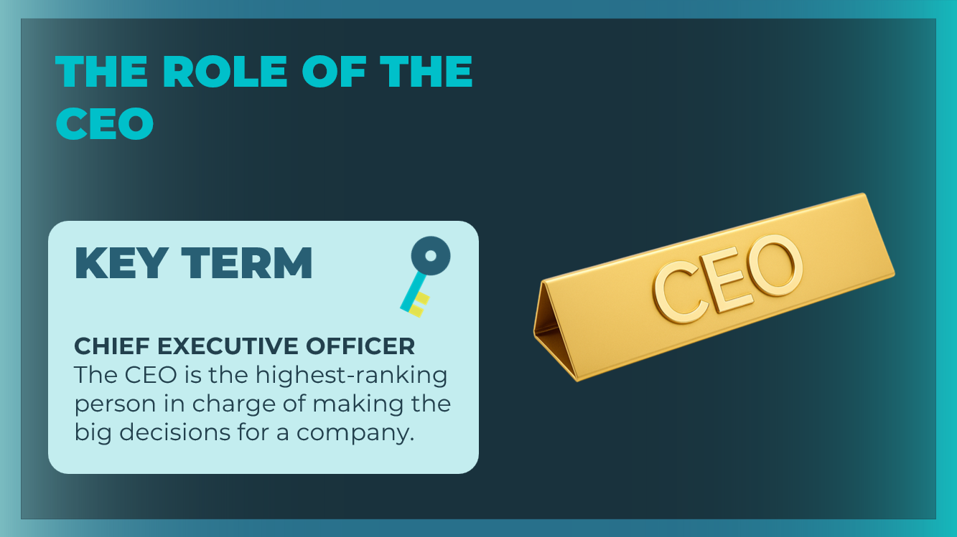 |  | Review the definition of Chief Executive Officer.  Explain that in the JA Titan simulation, each player takes on the role of CEO of a phone company.
Slide 11  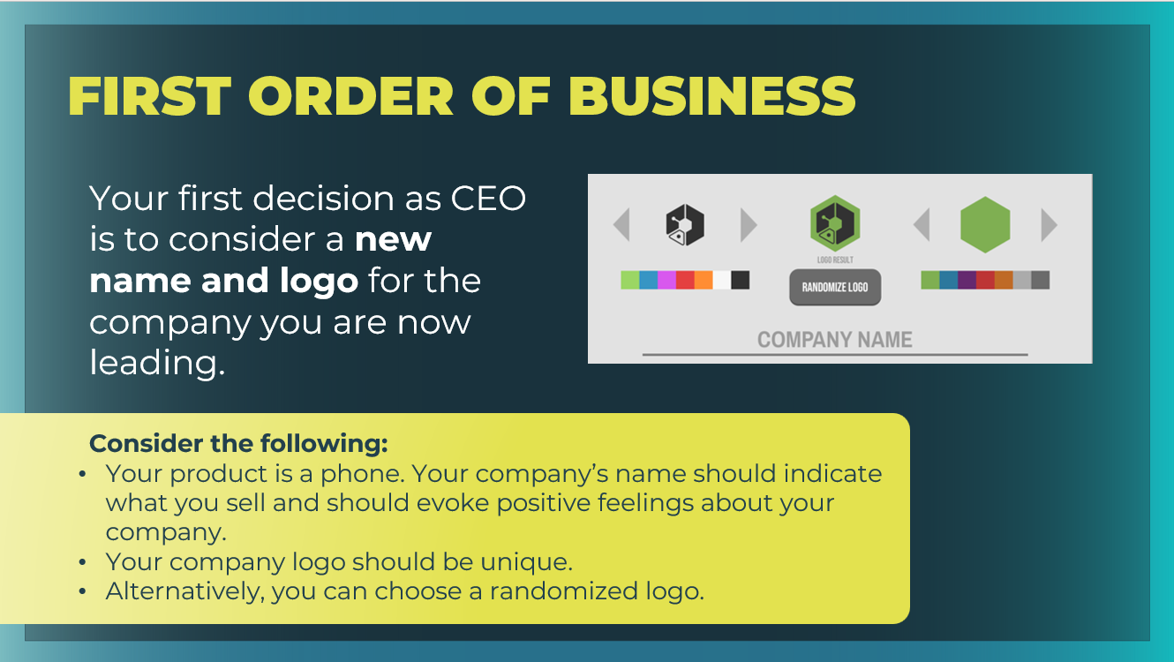 |  | Their first decision as CEO is to consider a new name and logo for the company they are now leading.  Explain that once the game is started, you cannot change the company’s name or logo, so it’s important to consider the following:  - Your product is a phone. Your company’s name should indicate what you sell and should evoke positive feelings about your company.  - Your company logo should be unique. If you select a logo or name that is already taken, you will be prompted to try again.  - Alternatively, if you want the simulation to generate a logo for your company, you can choose a randomized logo.  Students can fill in the blanks in their student workbook, page 9, in the First Order of Business section.
Slide 12  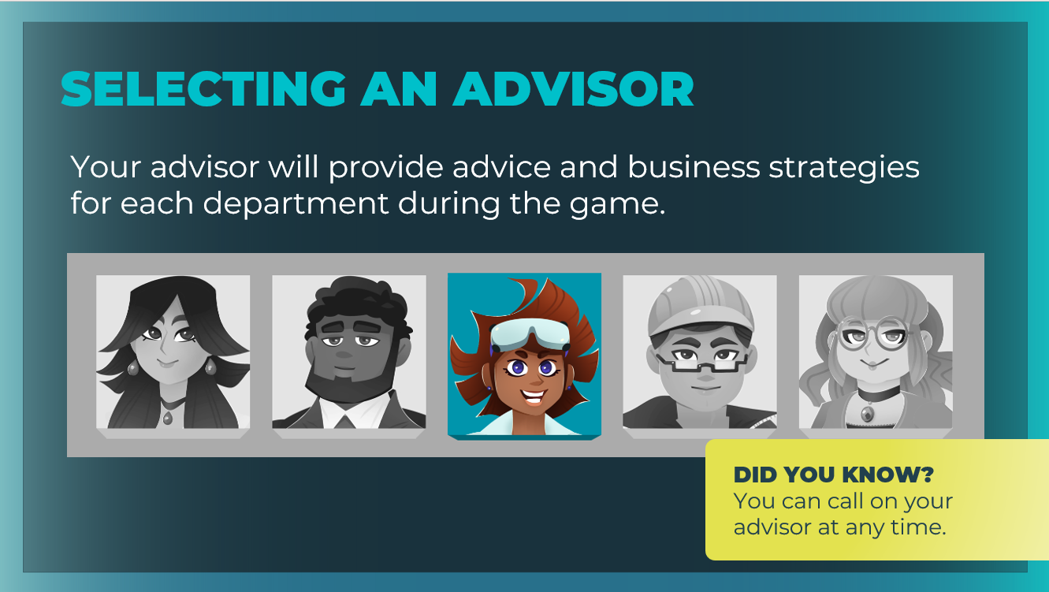 |  | Explain to students that they will have an Advisor who will provide advice and business strategies for each department during the game.  Have students choose their advisor, and make sure they select the checkbox next to First Time Playing? Then they can select Done.  As students finalize their selections and begin the simulation, remind them to wait for your instruction and not to press the Next Quarter button until told to do so.  Once they are familiar with the Advisor, students can either play without the Advisor’s assistance, use the Advisor’s strategy questions for hints about what to do next, or access the Advisor’s full strategy guide for more lengthy explanations and learning concepts.
Slide 13  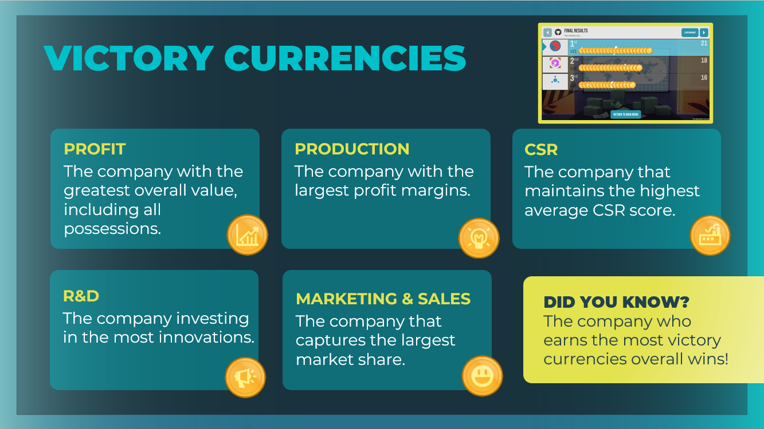 |  | Make students aware of the five Victory Currencies.  - Profit (Total Value): The company with the greatest overall value, including all possessions.  - Research & Development (R&D): The company investing in the most innovations.  - Production: The company with the largest profit margins.  - Marketing & Sales: The company that captures the largest market share.  - Corporate Social Responsibility (CSR): The company that maintains the highest average CSR score.  To win the game, your company must earn the highest total number of victory currencies (coins) across five categories. You can win in a single category, and the company who wins the most victory currencies overall wins the simulation.
Guided Exploration: Budget Decisions
Slide 14

Slide 15  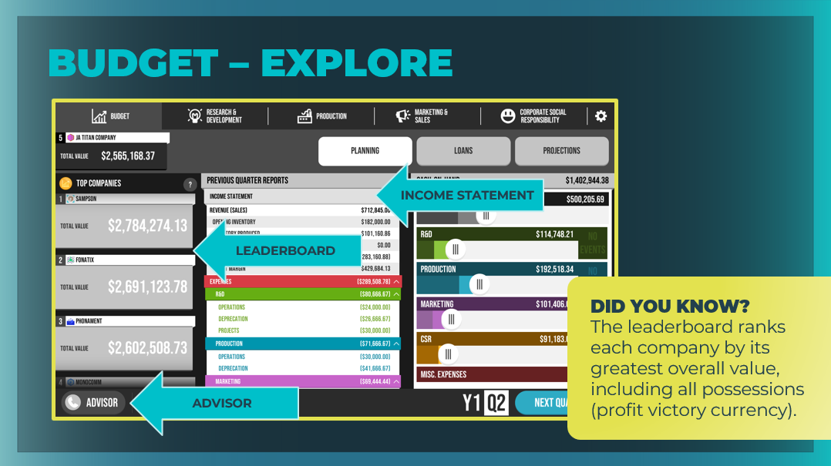 |  | Instruct students to always start on the Budget tab.  Take time to point out the main areas of the Budget tab, including the income statement, cash-on-hand, leaderboard, the Advisor, as well as the Planning, Loans, and Projections buttons.  Note that the leaderboard on this tab is ranking each company by its greatest overall value, including all possessions (Profit victory currency).
Slide 16  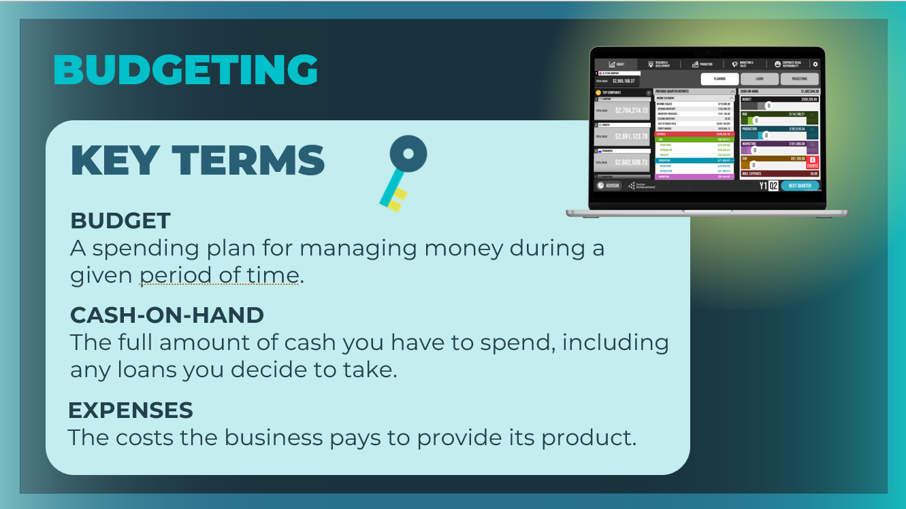 |  | Review the key terms as needed. Students can add the definitions to their student workbook, page 10.
Slide 17  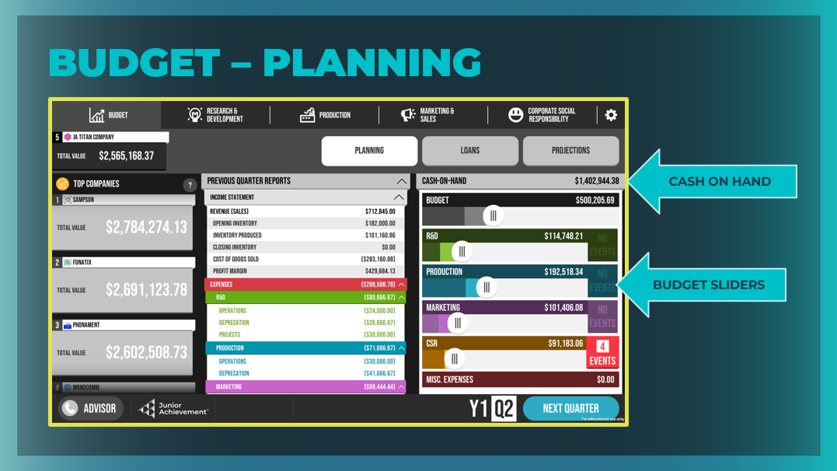 |  | Planning  Point out the cash-on-hand amount. Emphasize that this is how much money each company has to spend in total.  - Cash-on-Hand shows you the total amount of cash your company has. This is the amount of money students trying to grow, which they’ll do by investing in the various departments in your business.  - Below are five Budget sliders, which is where they control how much money their company spends on all of its expenses each quarter.  - Students can grab the budget slider, and select how much of their total cash-on-hand you think they’ll spend this quarter on expenses. Remind them they are not going to spend all of their cash the very first quarter.
Slide 18  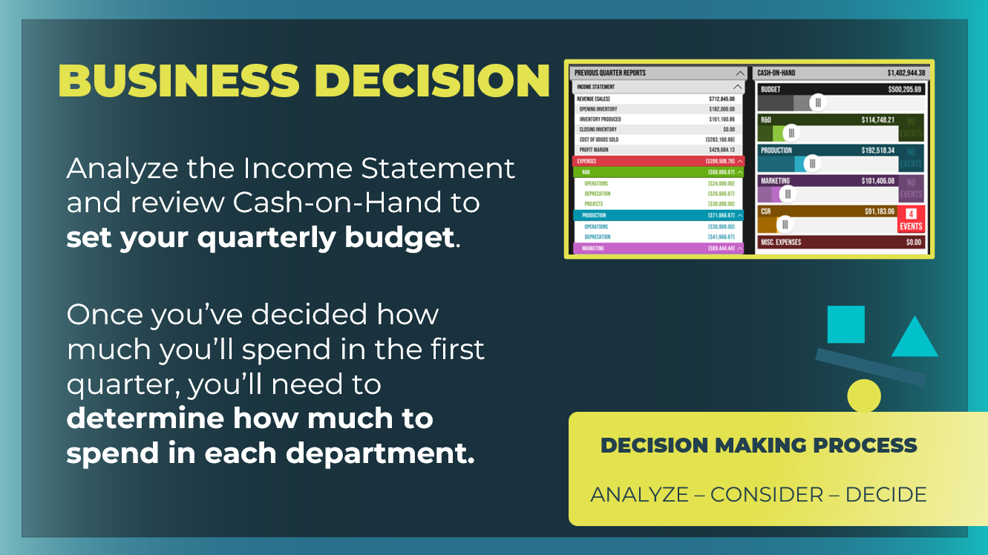 |  | Discuss with students how analyzing the income statement and cash on-hand, and setting the quarterly budget are their first key decisions for this tab.  Advise them to make these and all future game decisions as CEOs using the following thought process:  - First, analyze what you need to do. Start with the data you have available to you.  - Then, consider how to proceed with the limited resources available.  - Finally, make the decision. You can come back and adjust your decisions as you learn more information, so don't worry if you feel like you are guessing at first.  Explain the second key decision for the company budget.  Once you decide how much you’re going to spend in the first quarter, you’ll need to determine how much to spend in each department out of that limited amount.
Slide 19  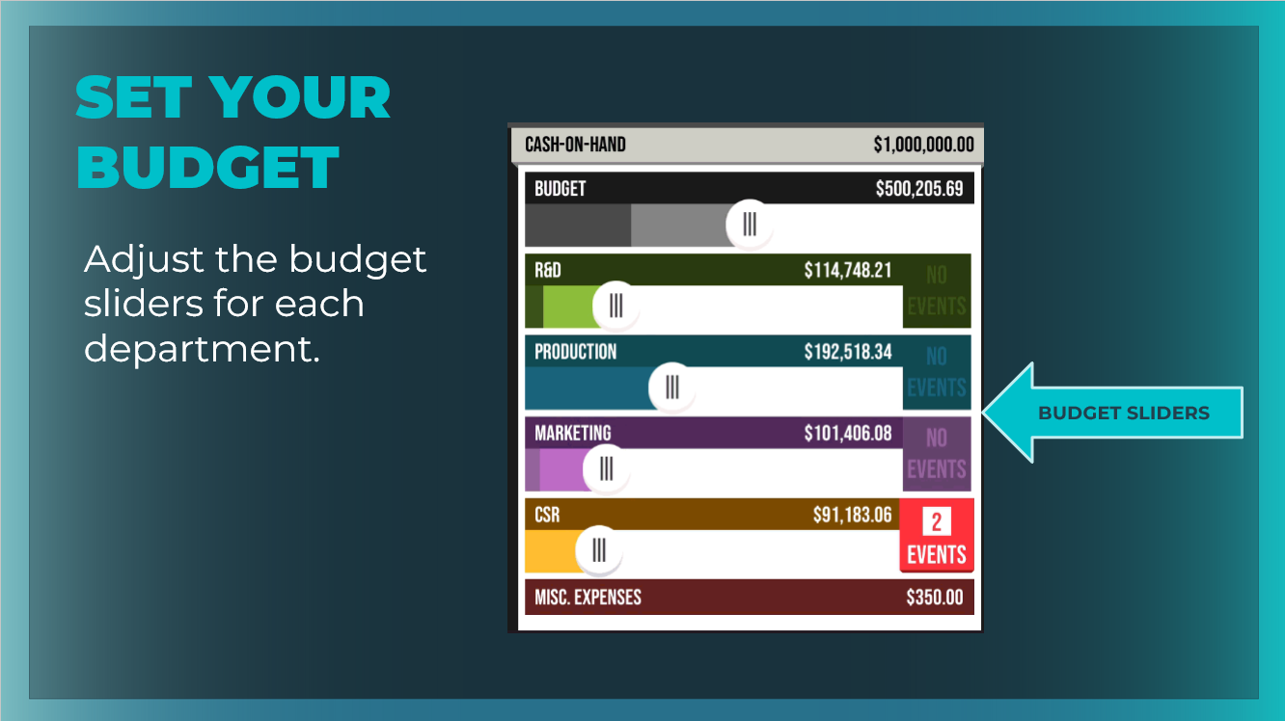 |  | Demonstrate how to adjust the sliders for each department, and distribute the allocated budget across R&D, Production, Marketing & Sales, and CSR. Reassure students that you will be taking a closer look at each department and refining this initial decision.  The amount spent in the four departments must equal the initial budget amount for the first quarter. Students will come back to adjust this later, but for now, can take their best guess.  This screen also shows accounting information in two major categories: income statement and cash-on-hand which will be used to make decisions.  Most of the line items in the income and cash-on-hand statements will be zero right now, but those numbers will fill in once they begin making decisions as CEO!
Slide 20  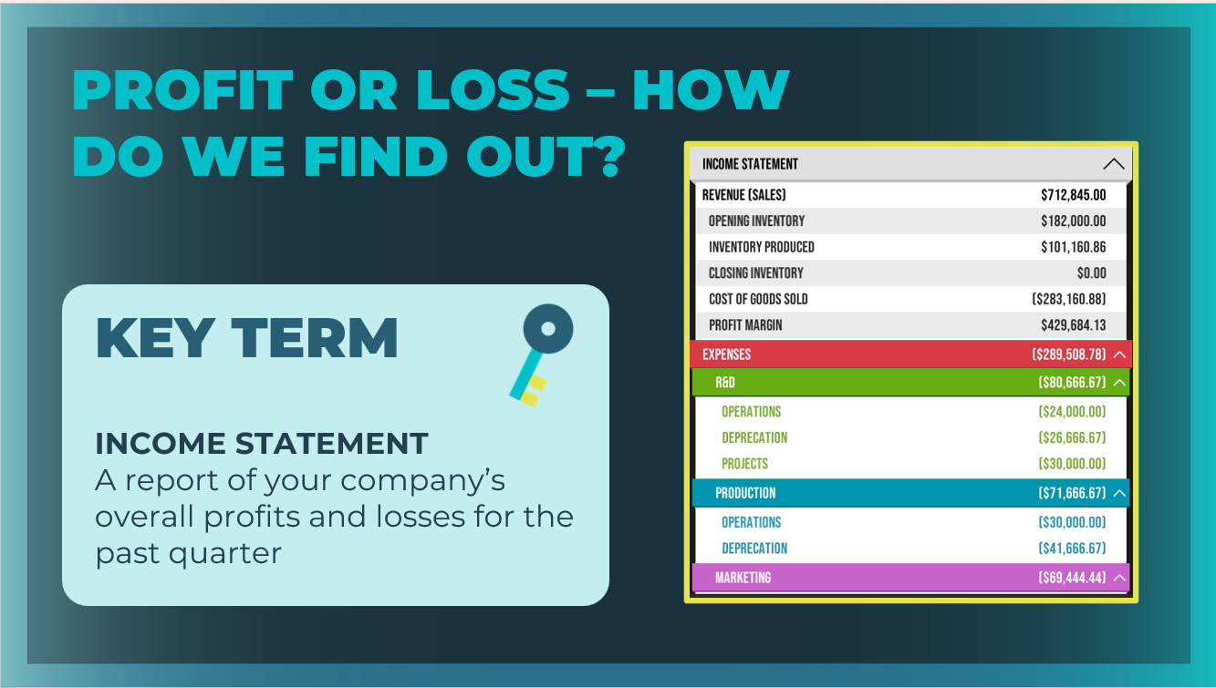 |  | Review the key term as needed. Students can add the definition to their student workbook, page 10.
Slide 21  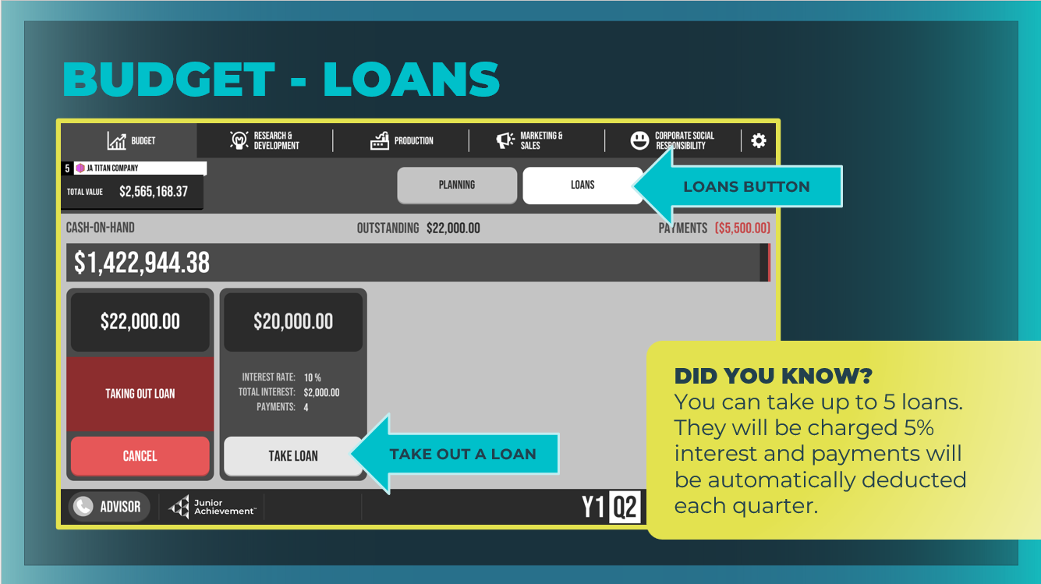 |  | Loans  Players can take up to five loans. They will be charged 5% interest, and payments will be automatically deducted each quarter.
Slide 22  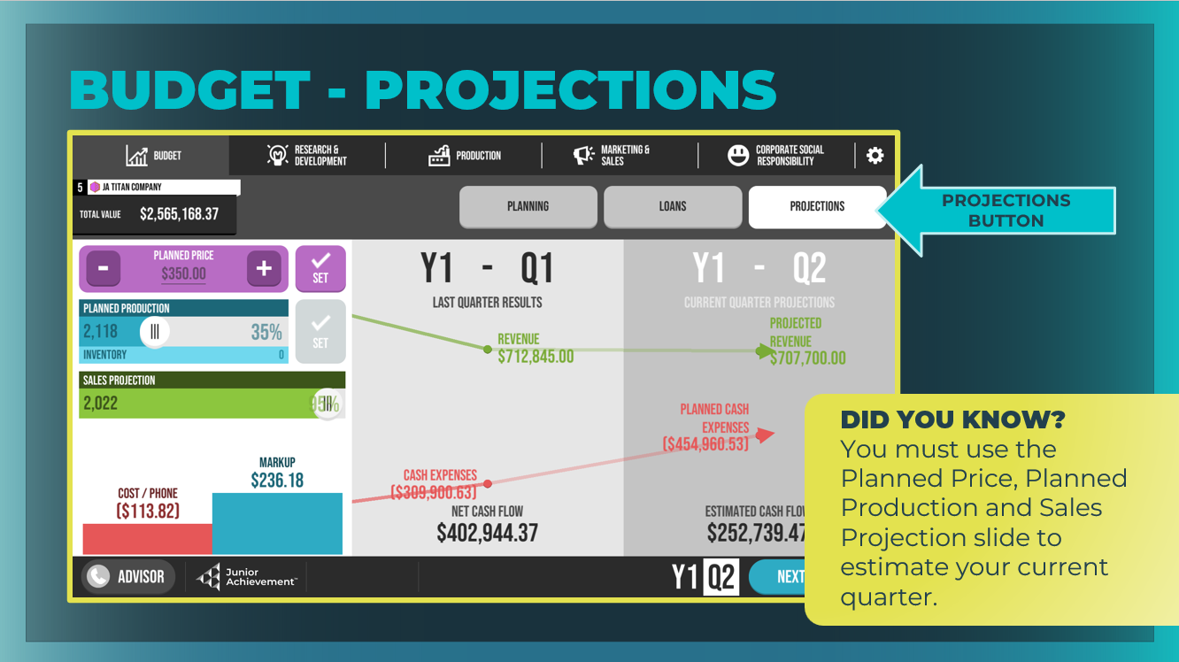 |  | Projections  This is a visual display of revenue and expenses IF buyers meet the sales projection at the set phone price. It is not a guarantee that buyers will accept the phone price and buy all the phones projected to sell.  Use the Planned Price, Planned Production and Sales Projection slider to estimate the current quarter.  Give students some time to make budget decisions and to select the buttons, move the sliders, and become familiar with this area of the business.
Slide 23  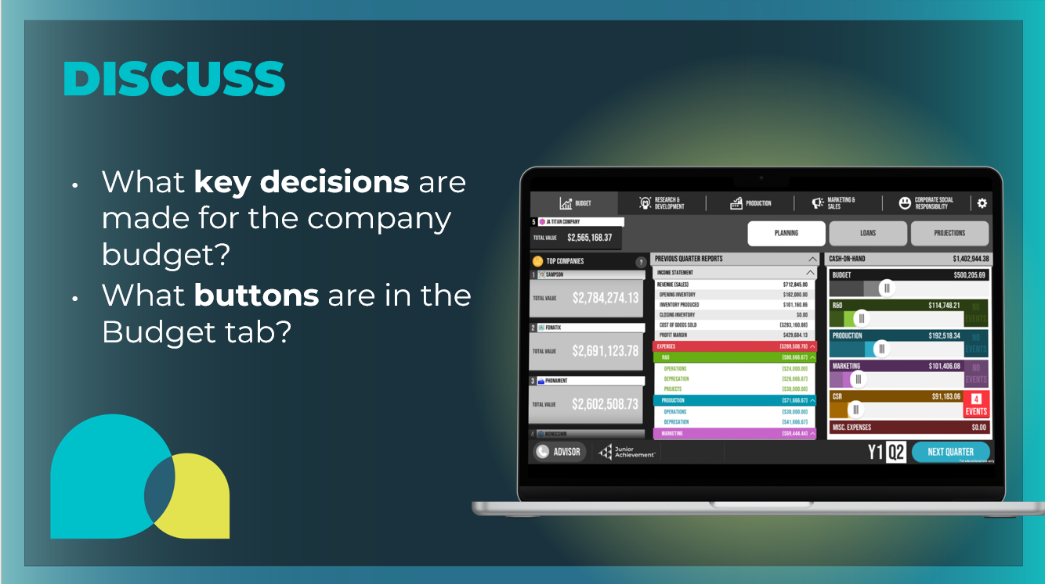 |  | Wrap up this section using the prompts on the slide.  - What key decisions are made for the company budget? Analyze your income statement and cash-on-hand, and set your overall budget and the budget for each department for the quarter.  - What buttons are in the Budget tab? Planning, Loans, Projections  Students can fill in the Budget Tab section in their student workbook, pages 9-10.
Guided Exploration: Research & Development Decisions
Slide 24

Slide 25  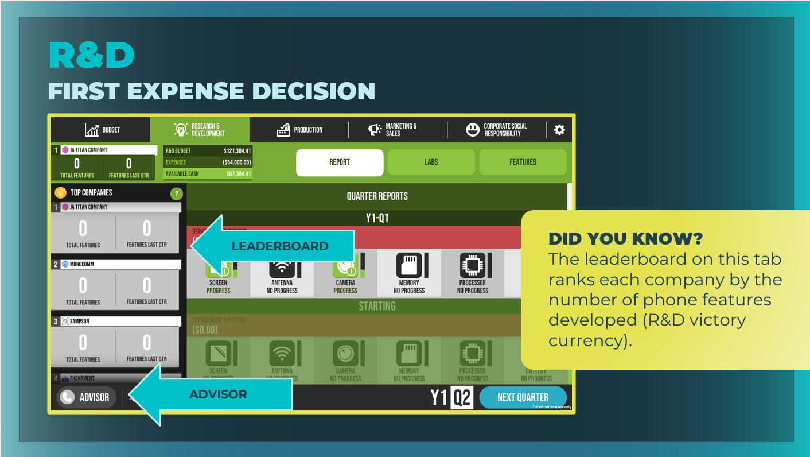 |  | Ask students to select the Research & Development tab. Give students time to inspect everything on this screen. This is where they will make business decisions about their company’s R&D department.  Point out that companies who offer new innovations can be more successful if those innovations lead to profitability. Take time to point out the main areas of the R&D tab, including the Report, Labs, and Features buttons.  Note that the leaderboard on this tab is ranking each company by the number of phone features developed (Research and Development (R&D) victory currency).
Slide 26  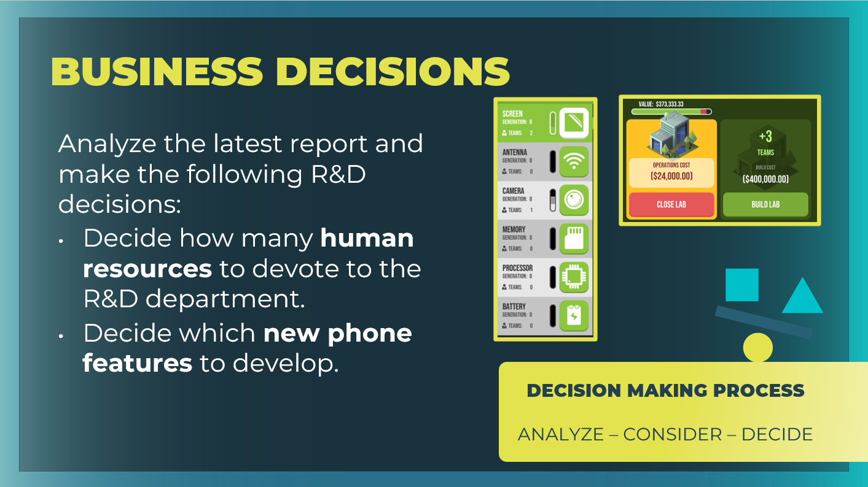 |  | Highlight the key decisions they will make regarding their human resources and phone features.  Remind students of the thought process they should follow when making these financial decisions: analyze, consider, decide.
Slide 27  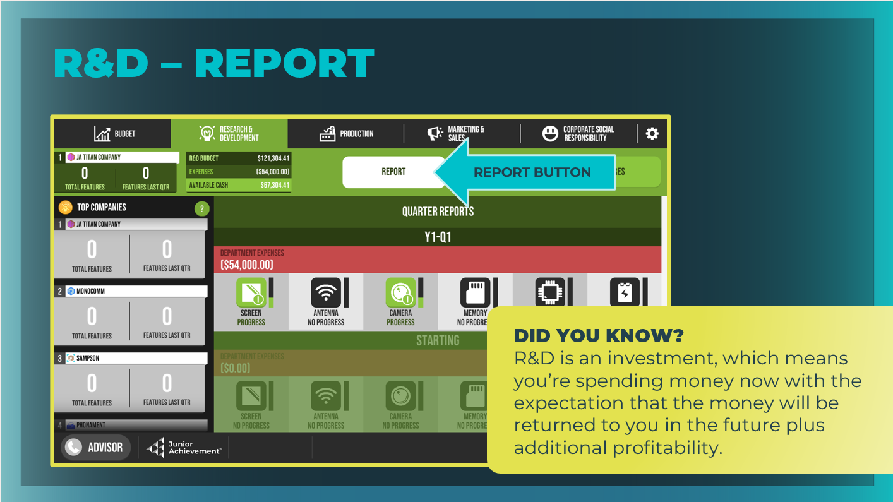 |  | Report  View your previous quarter’s results and use the data to make decisions for the current quarter. Although there are no decisions to be made on this screen, point out that it contains important data from the previous quarter that students will need to consider before making key decisions for the upcoming quarter.
Slide 28  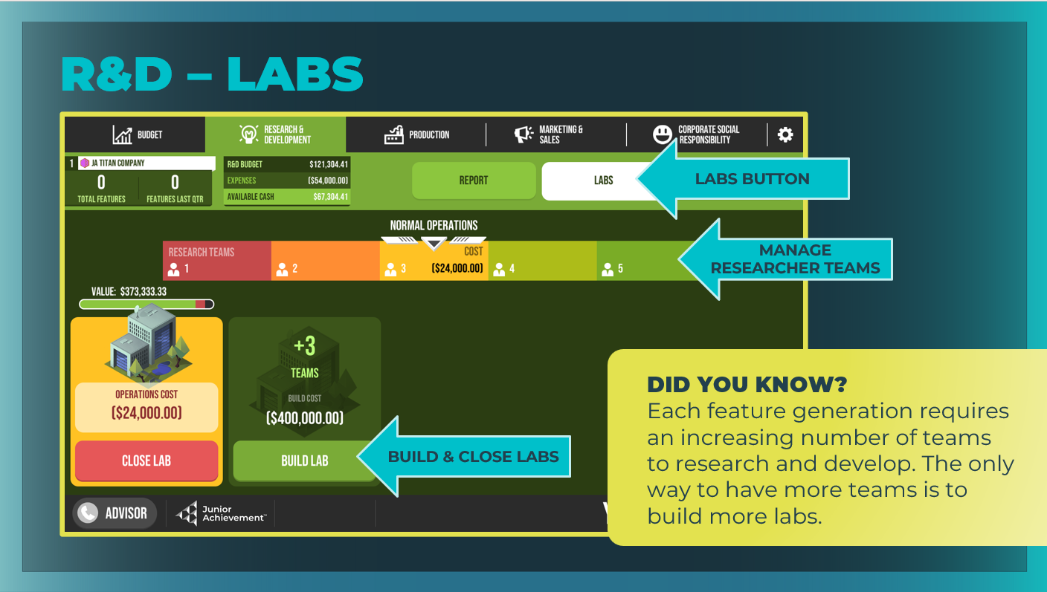 |  | Labs  Manage the capital (buildings) and decide how much labor you want to commit to each lab.  - Manage how many teams of researchers (labor) you have conducting research in each laboratory.  - Students have been given one research lab as a default.  - Use the slider to select the number of teams that will work in this lab.
Slide 29  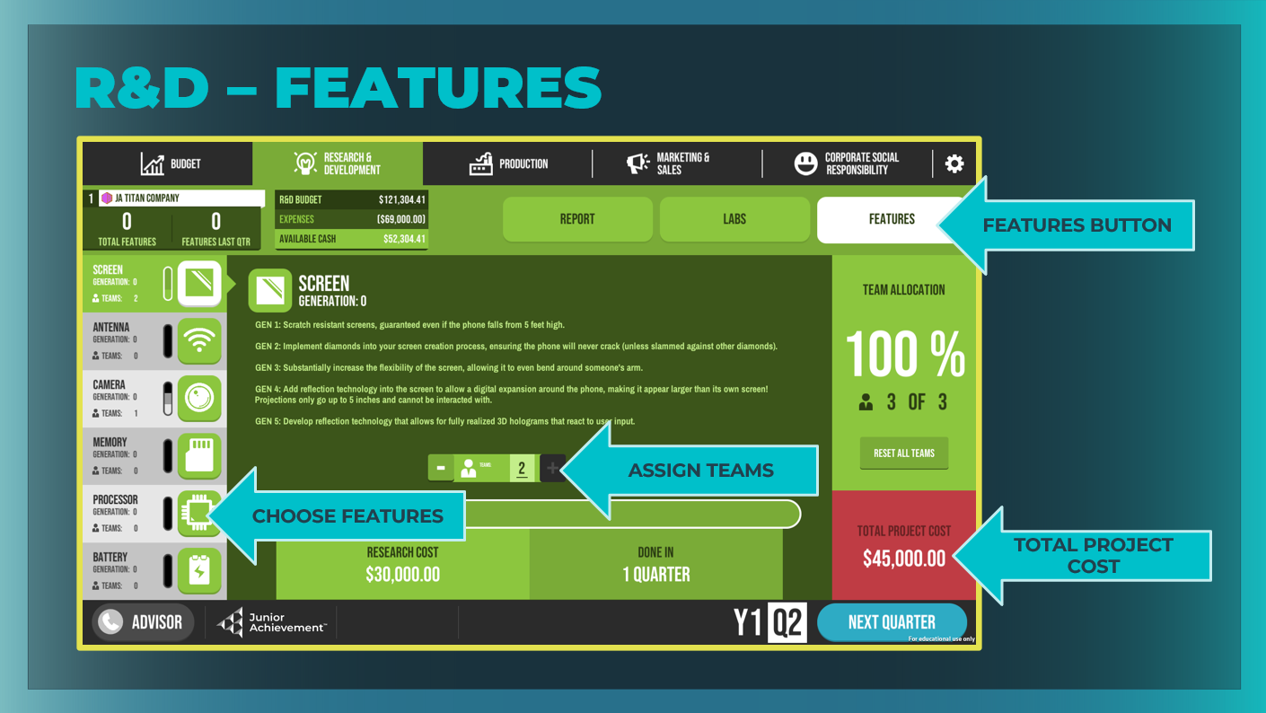 |  | Features  Decide how to use your budget for this quarter by selecting specific features and using the + and – buttons to allocate personnel to research and develop that feature. You can make decisions about adding future features and options for your phone.  Remind students that when they have finished building a feature, they need to add it to their phone in the Product area of the Production tab.
Slide 30  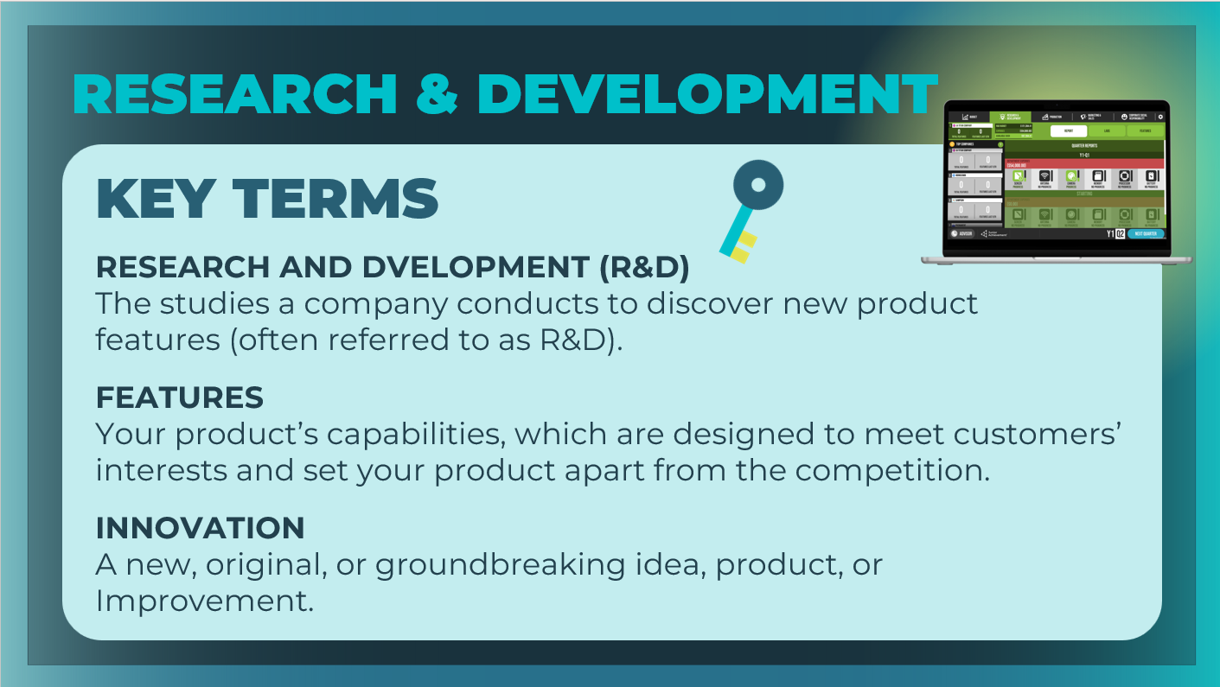 |  | Review the key terms, as needed. Students can add the definition to their student workbook, page 11.  Give students some time to make research and development decisions and to become familiar with this area of the business.
Slide 31  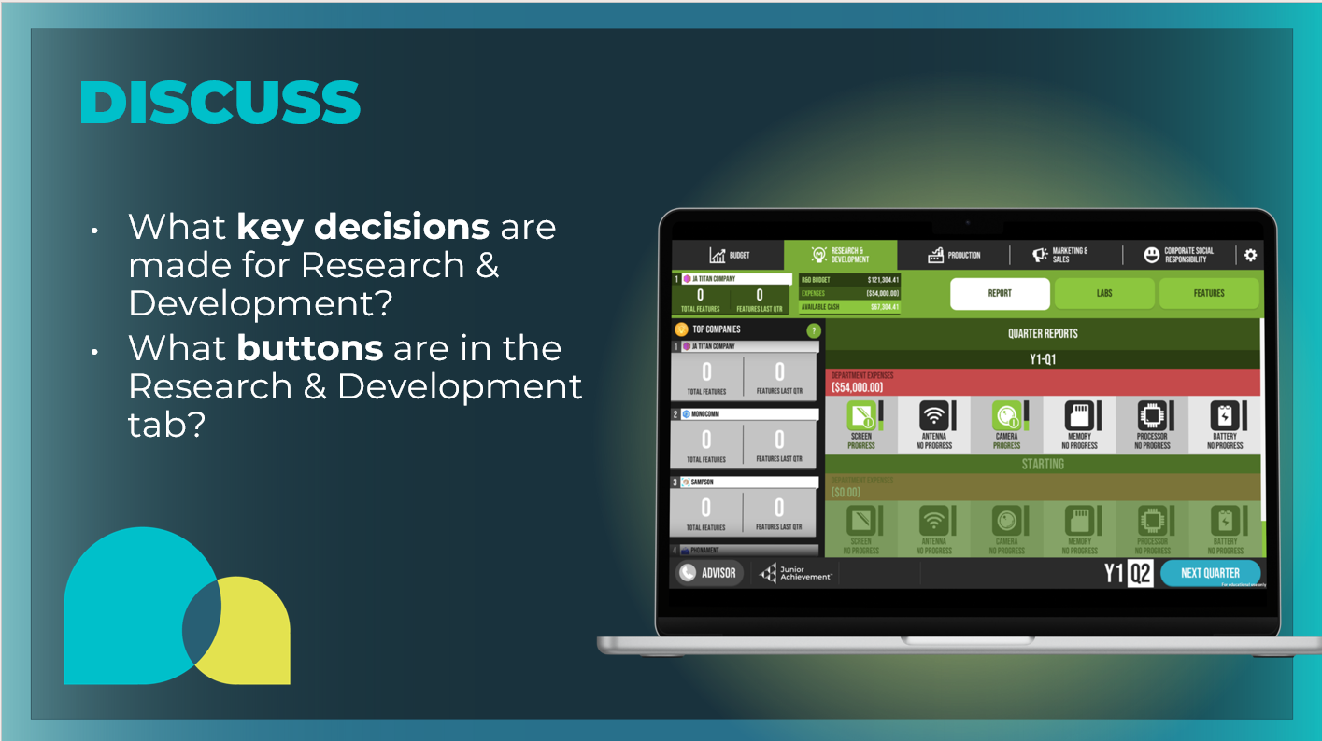 |  | Wrap up this section using the prompts on the slide.  - What key decisions are made for the company budget? Decide how many human resources to devote to the R&D department and which new phone features to develop.  - What buttons are in the Budget tab? Report, Labs, Features  Students can fill in the Research & Development Tab section in their student workbook, pages 10-11.
Guided Exploration: Production Decisions
Slide 32

Slide 33  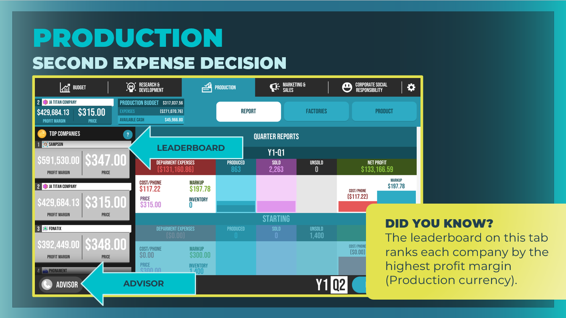 | Ask students to select the Production tab, and give them time to inspect everything on this screen. Explain that this is where they will make business decisions about their company’s phone production.  Take time to point out the main areas of the Production tab, including the Report, Factories, and Product buttons.  Note that the leaderboard ranks each company by its highest profit margin (Production victory currency). It also shows the phone price set by each company in the previous quarter.
Slide 34  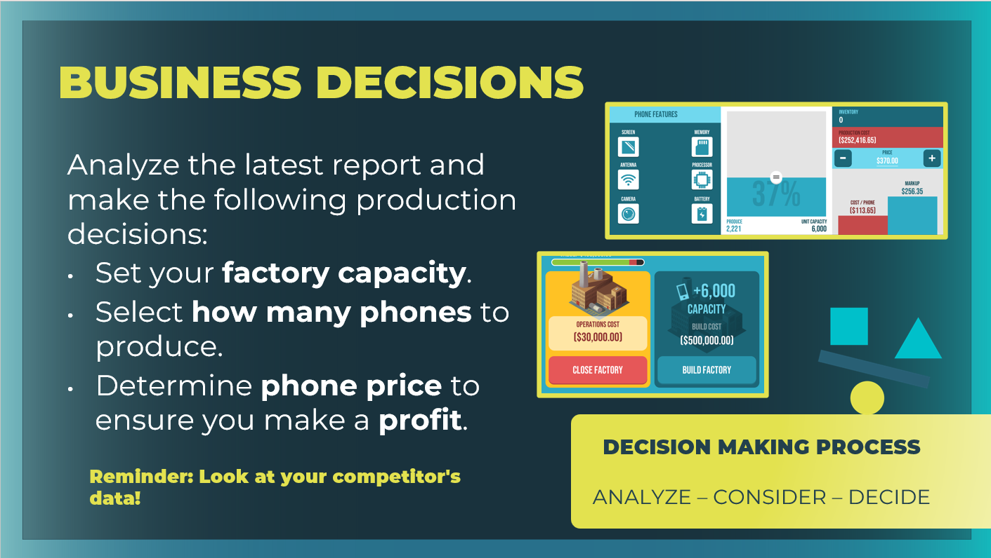 | Highlight the key decisions students will make regarding their factory capacity and their product.
Slide 35  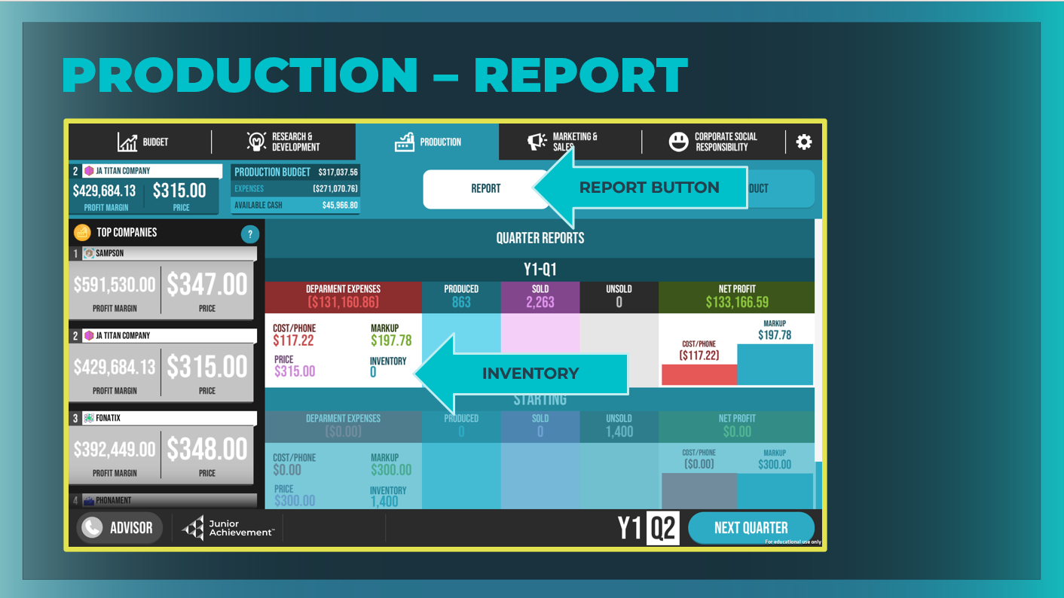 | Report  View your previous quarter’s results and data about the number of phones produced and sold for each quarter and the associated production costs.  Although there are no decisions to be made on this screen, point out that it contains important data from the previous quarter that students will need to consider before making key decisions for the upcoming quarter.  Hint to students that before they decide how many phones to produce, they should check how many phones they already have in inventory.
Slide 36  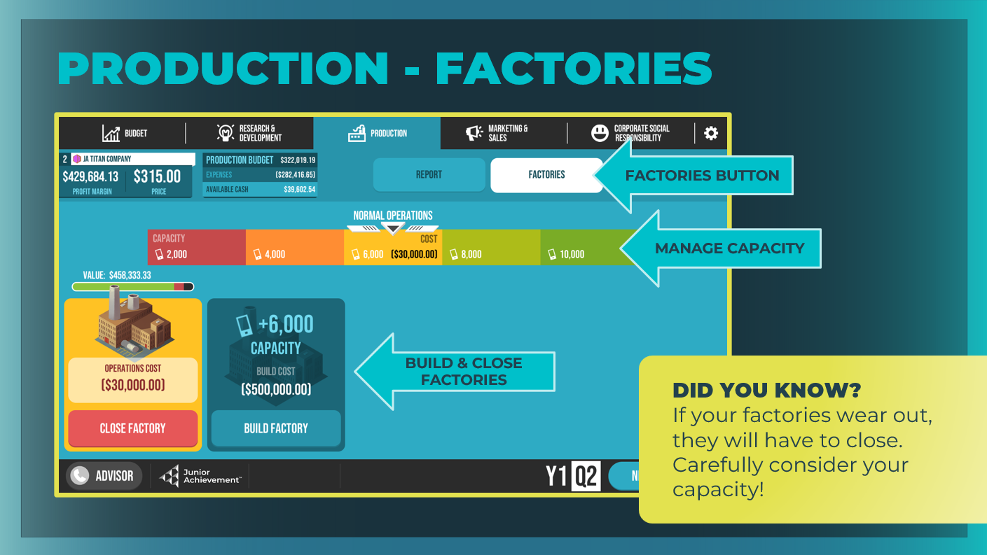 | Factories  Manage the capital and determine your factory’s maximum capacity.  - Students have been given one factory as a default.  - Use the slider to select the operation level for your factory. There are consequences for under- or overusing your factory.
Slide 37  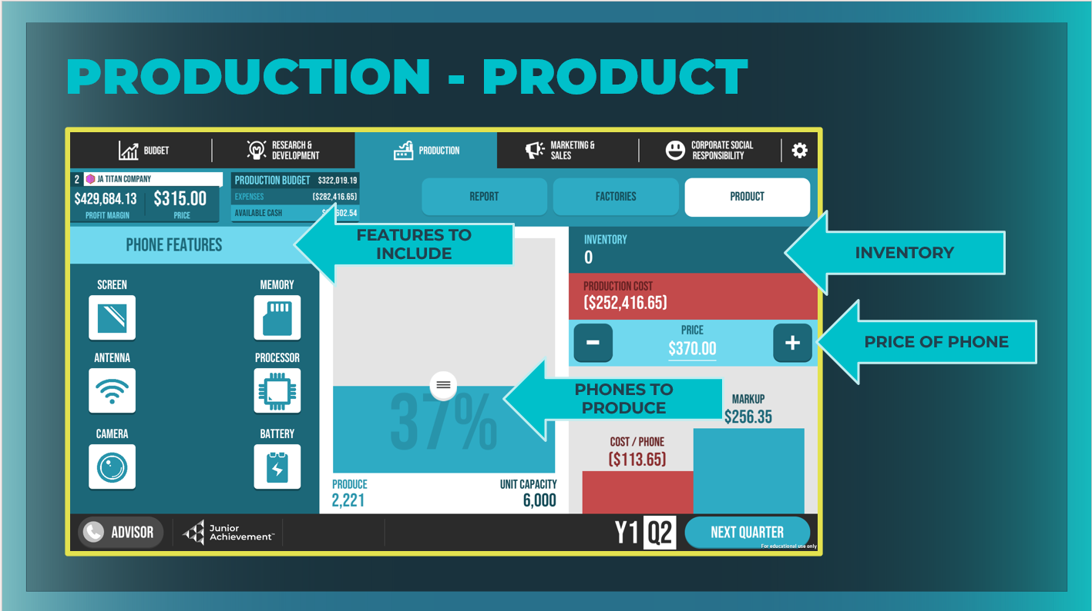 | Product  Decide how to use your budget for this quarter to produce new phones based on how much each phone costs to make.
Slide 38  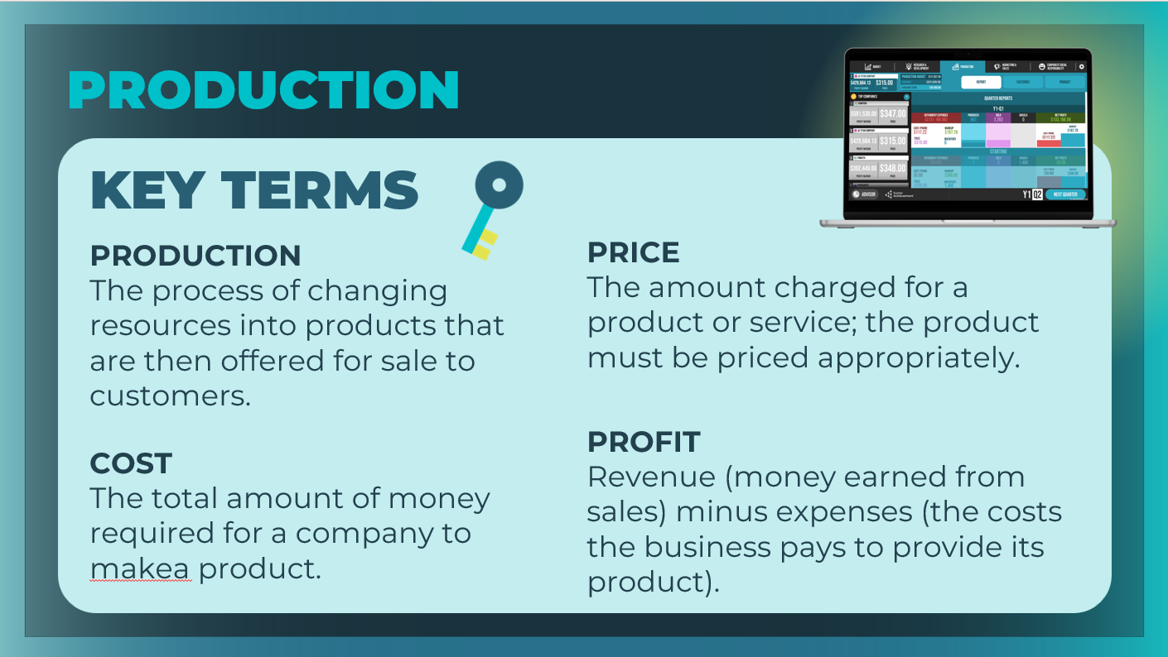  Slide 39  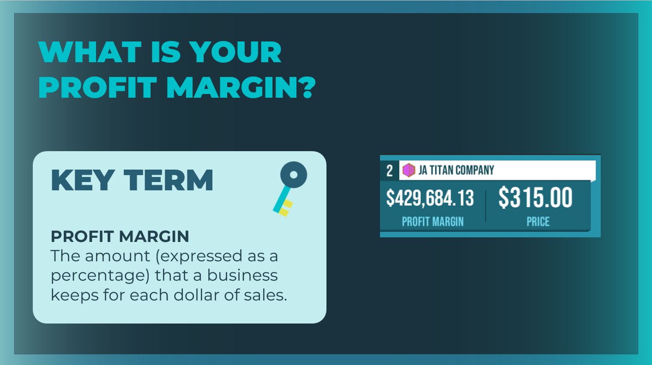 | Review the key terms, as needed. Students can add the definitions to their student workbook, page 12.  Give students some time to make research and development decisions and to become familiar with this area of the business.  Point out the phone unit price chosen by other companies in the Top Companies column on the Report tab. Ultimately, the price you set for selling your phone and the cost you incur for building your phone determines your profit margin, which is how much of every dollar you earn that you get to keep as profit.  Discuss with students that it's important for them to carefully review their price and production costs and to decide whether they are happy with the potential resulting profit margin.
Slide 40  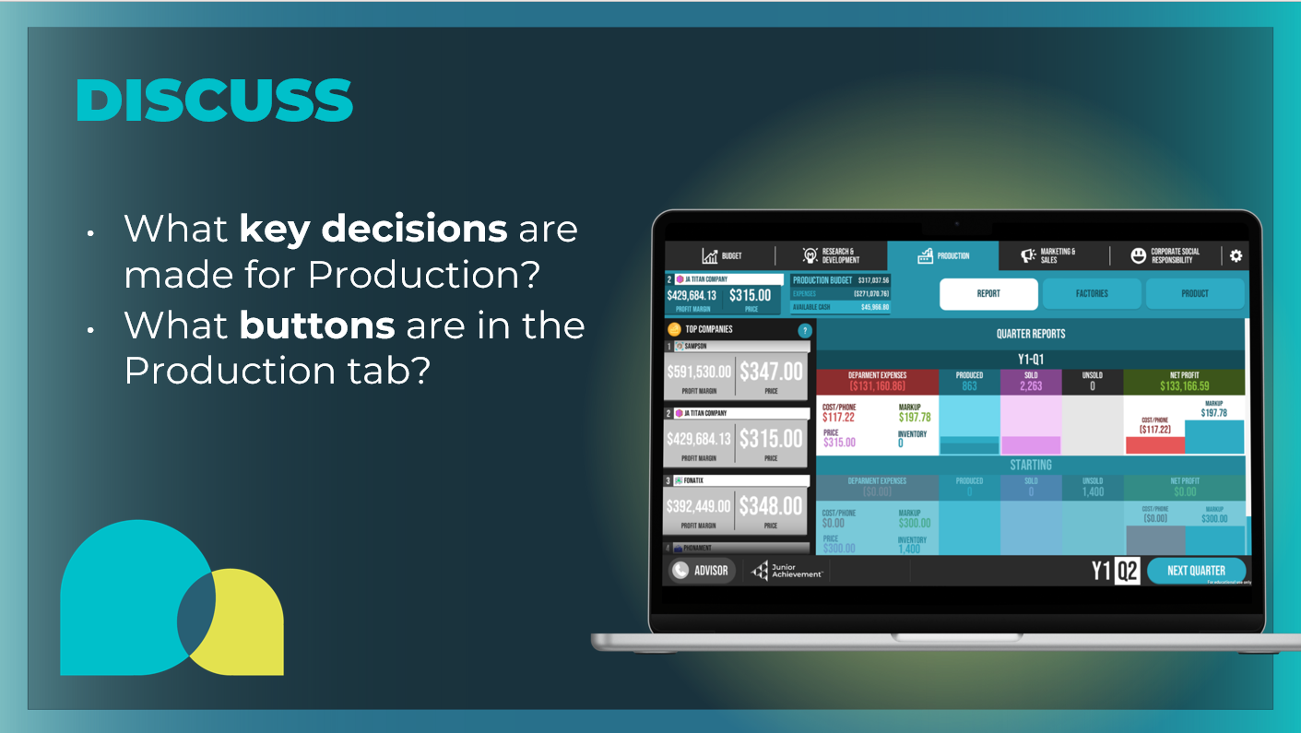 | Wrap up this section using the prompts on the slide.  - What key decisions are made for Production? Determine your factory capacity, the selling price for each phone, and how many phones to produce.  - What buttons are in the Production tab? Report, Factories, Product  Students can fill in the Production Tab section in their student workbook, page 11.
Guided Exploration: Marketing & Sales Decisions
Slide 41

Slide 42  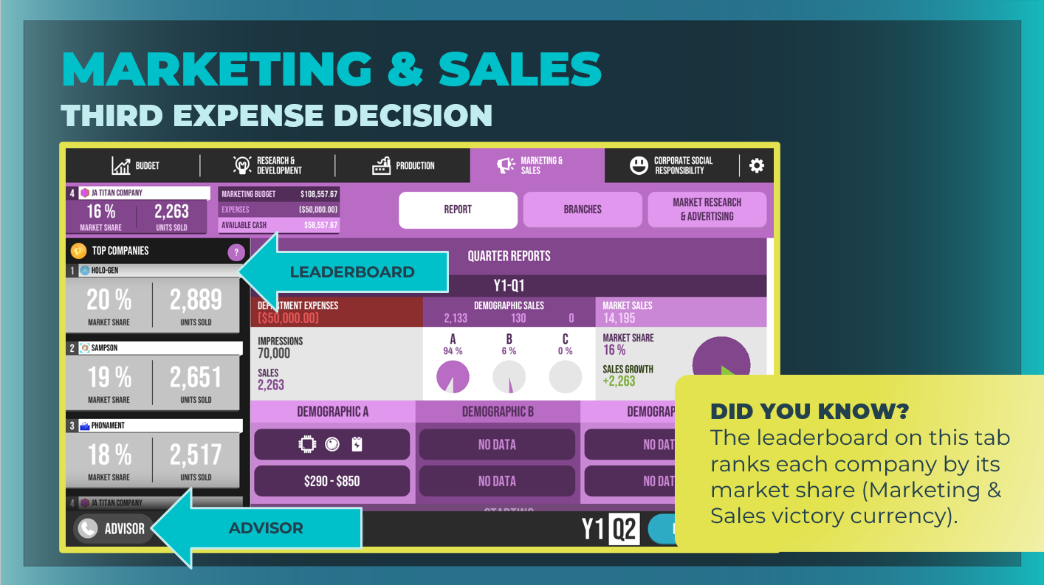 |  | Ask students to select the Marketing & Sales tab, and give them time to inspect everything on this screen. Explain that this is where they will decide how to build awareness of their product and research different customer demographics' preferred phone features and price.  Emphasize that money spent on such research could increase profitability by helping CEOs narrow their R&D toward the right features and identify the right price sooner.  Take time to point out the main areas of the Marketing & Research tab, including the Report, Branches, and Market Research & Advertising buttons.  Note that the leaderboard on this tab is ranking each company by its market share (Marketing & Sales victory currency).
Slide 43  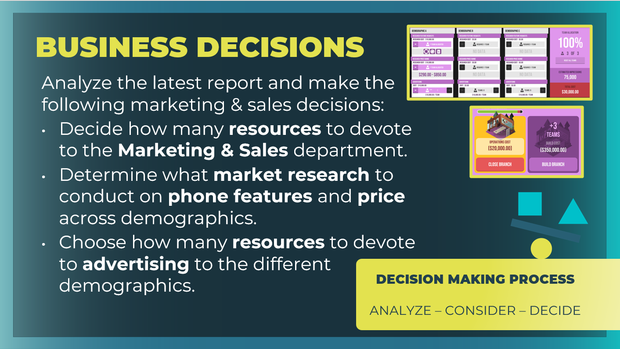 |  | Highlight the key decisions they will make regarding their human resources, marketing, and advertising.
Slide 44  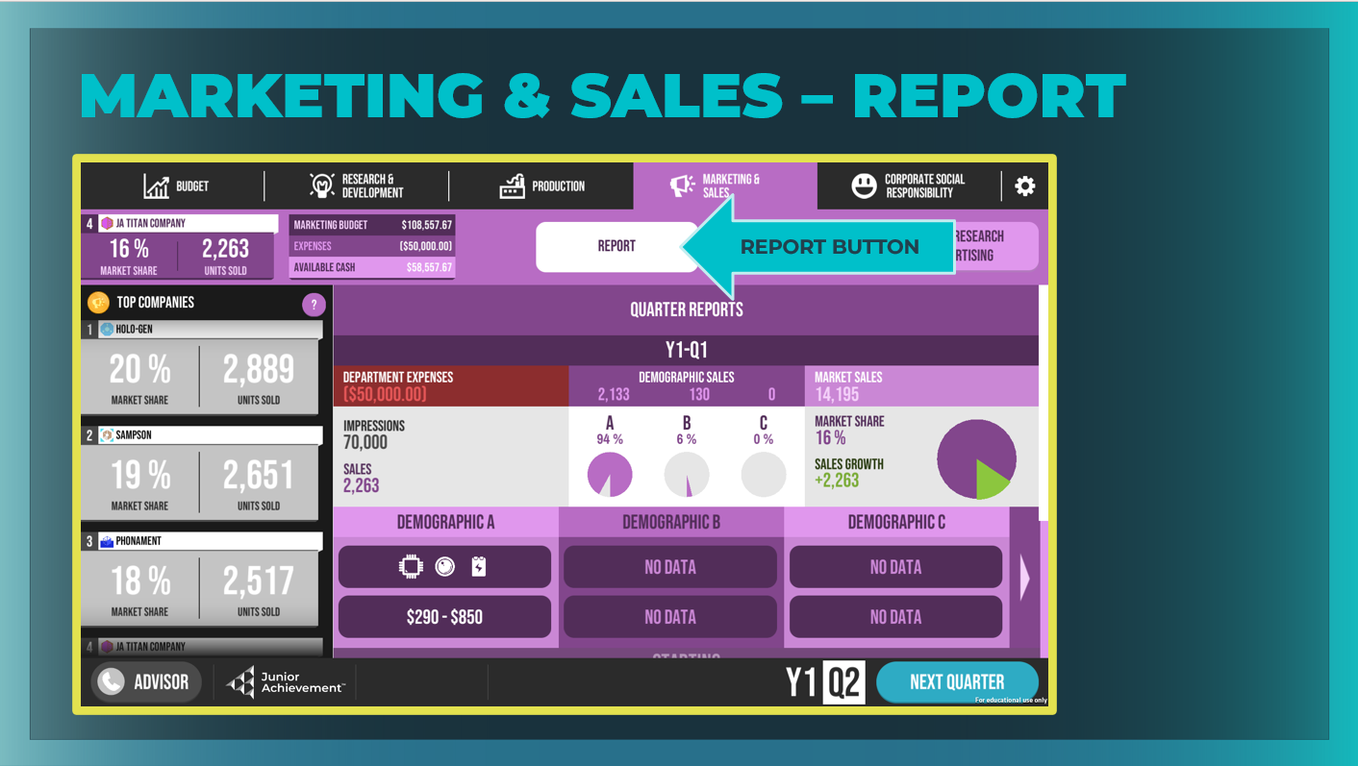 |  | Report  View your previous quarter’s results and use the data to make decisions for the current quarter.
Slide 45  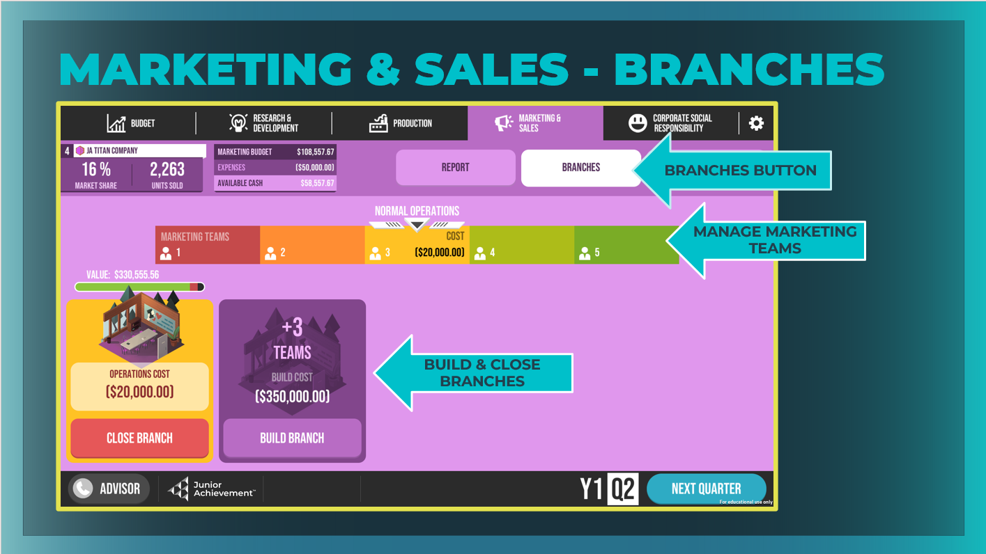 |  | Branches  Manage the capital and decide how many human resources to devote to the Marketing & Sales department.  - Students have been given one branch as a default.  - Use the slider to select the operation level for your factory. There are consequences for under- or overusing your teams.
Slide 46  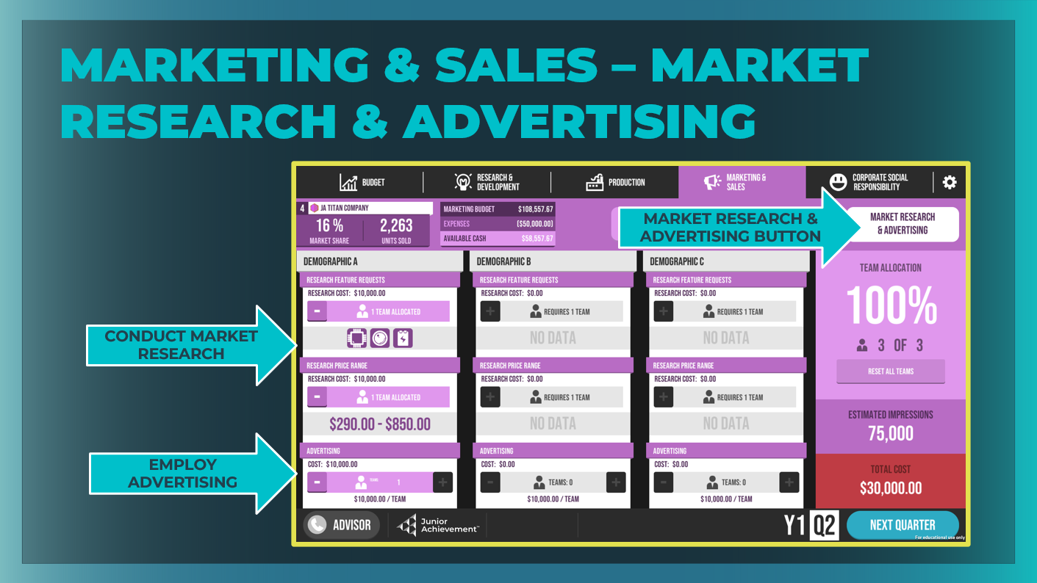 |  | Market Research & Advertising  Decide how to use your budget for this quarter to research and advertise to different demographics.  Emphasize the difference between the market research they can conduct by assigning teams in the first two rows and the advertising they can employ by assigning teams in the third row.  Market research is important, because it gives your company insight into consumers’ demands for certain features and price and can influence your decision making.
Slide 47  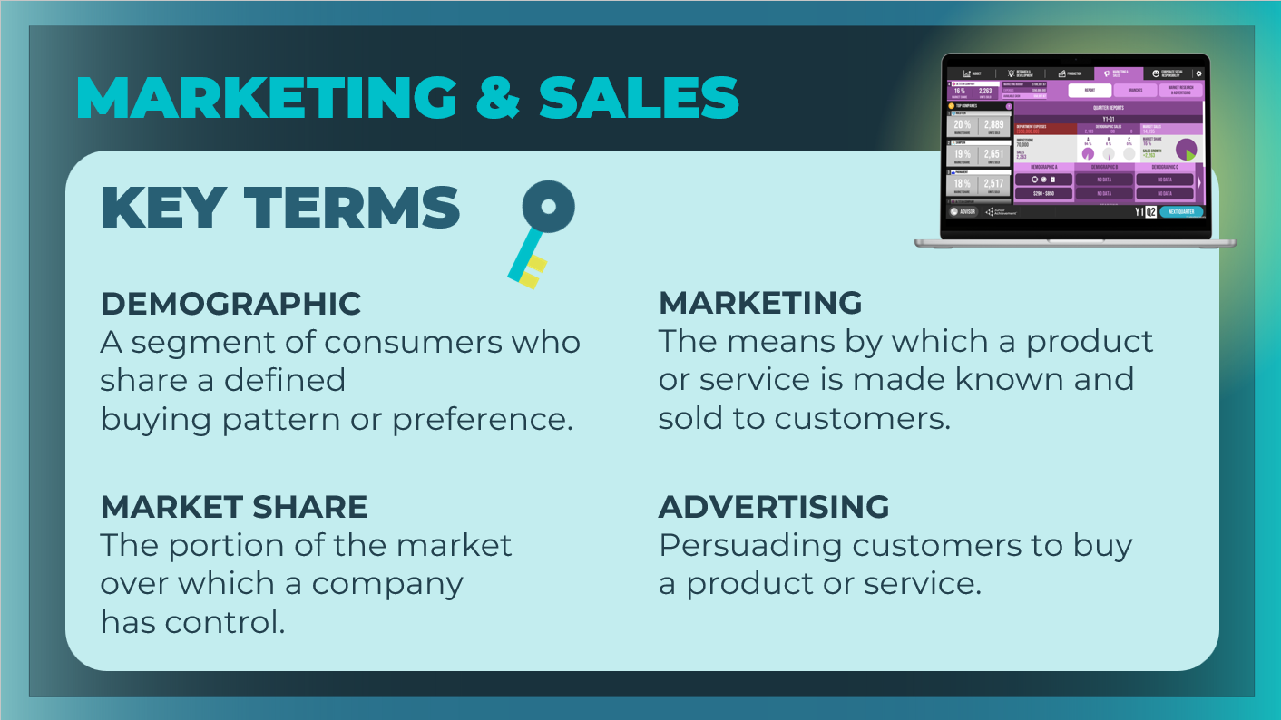 |  | Review the key terms, as needed. Students can add the definitions to their student workbook, page 13.  Give students some time to make marketing and sales decisions and to become familiar with this area of the business.
Slide 48  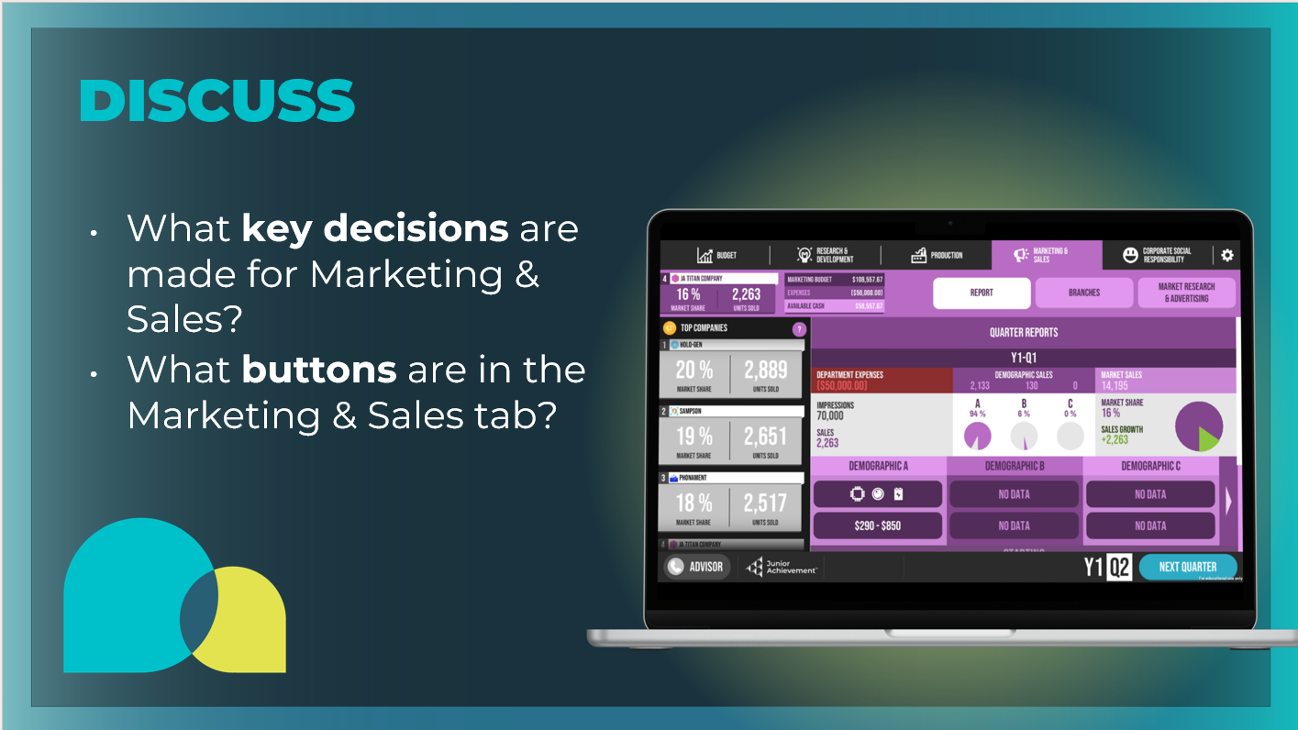 |  | Wrap up this section using the prompts on the slide.  - What key decisions are made for Marketing & Sales? Decide how many human resources to devote to the Marketing & Sales department, what market research to conduct on phone features and price across the three demographics, and how many resources to devote to advertising to the different demographics.  - What buttons are in the Marketing & Sales tab? Report, Branches, Market Research & Advertising  Students can fill in the Marketing & Sales Tab section in their student workbook, page 12.
Guided Exploration: Corporate Social Responsibility
Slide 49

Slide 50  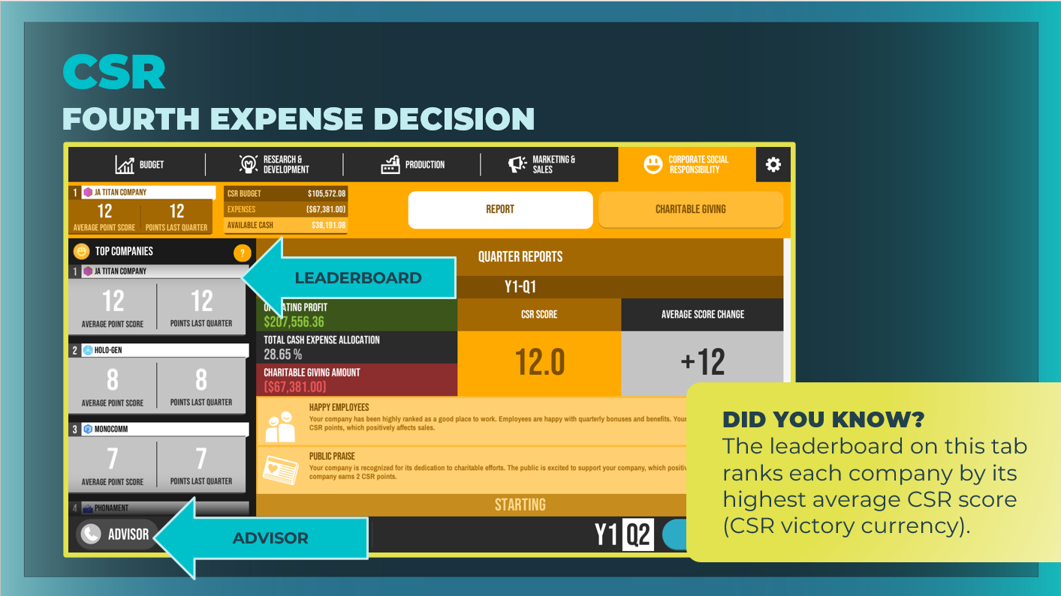 |  | Ask students to select the Corporate Social Responsibility (CSR) tab and explain that this is where they will make business decisions about how their company gives back to stakeholders.  Take time to point out the main areas of the CSR tab, including the Report and Charitable Giving buttons. Note that the leaderboard on this tab is ranking each company by its highest average corporate social responsibility (CSR) score (CSR victory currency).  The goal of corporate social responsibility is to be a good corporate citizen in the community. At the same time, though, investing in corporate social responsibility can often increase a business’s profitability, because it also increases the company’s goodwill and reputation.
Slide 51  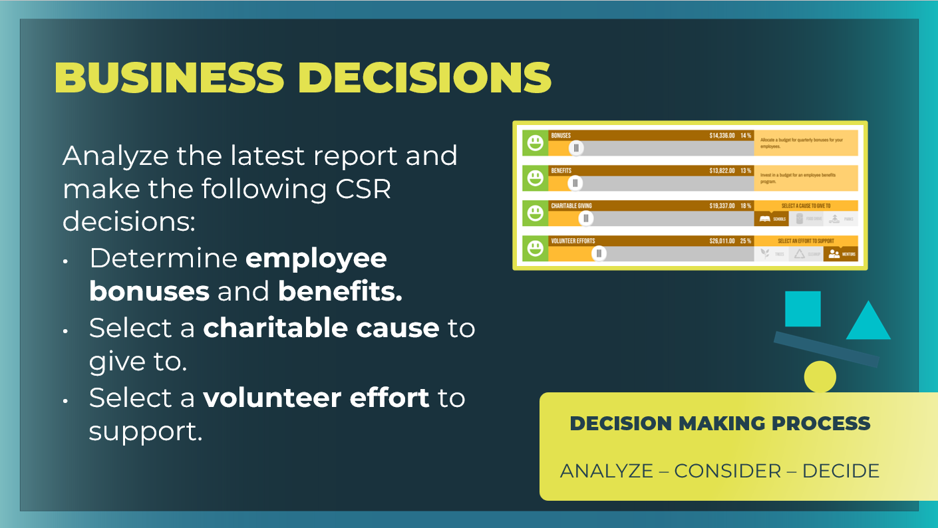 |  | Highlight the key decisions they will make regarding their human resources, marketing, and advertising.
Slide 52  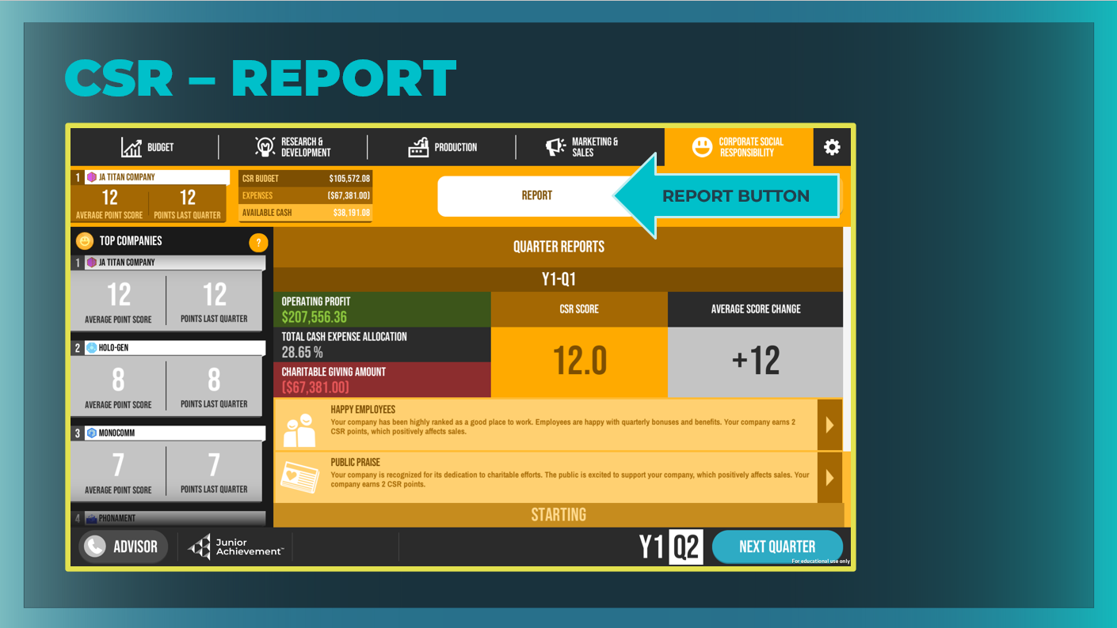 |  | Report  View your previous quarter’s results and use the data to make decisions for the current quarter.
Slide 53  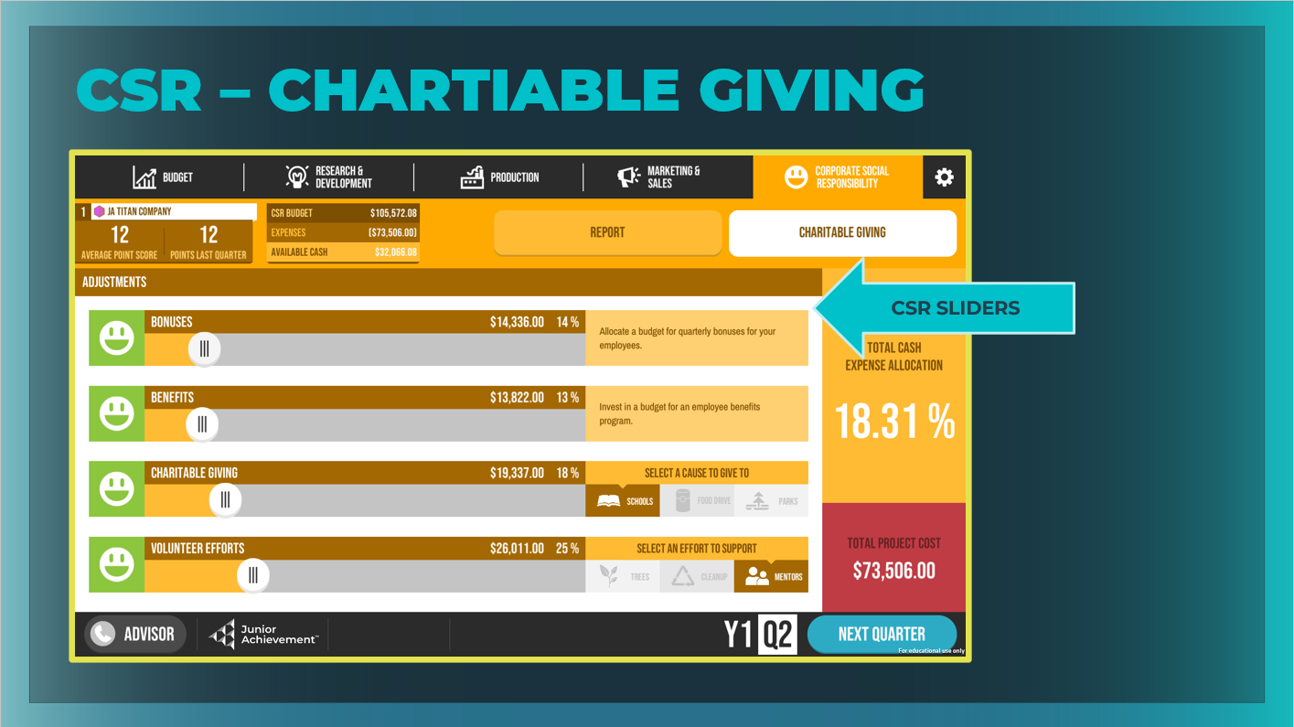 |  | Charitable Giving  Manage employee bonuses and benefits, charitable giving, and volunteer efforts.  Businesses must also make choices about benefits and monetary bonuses for their employees. These decisions can affect employee happiness and retention, as well as company morale.
Slide 54  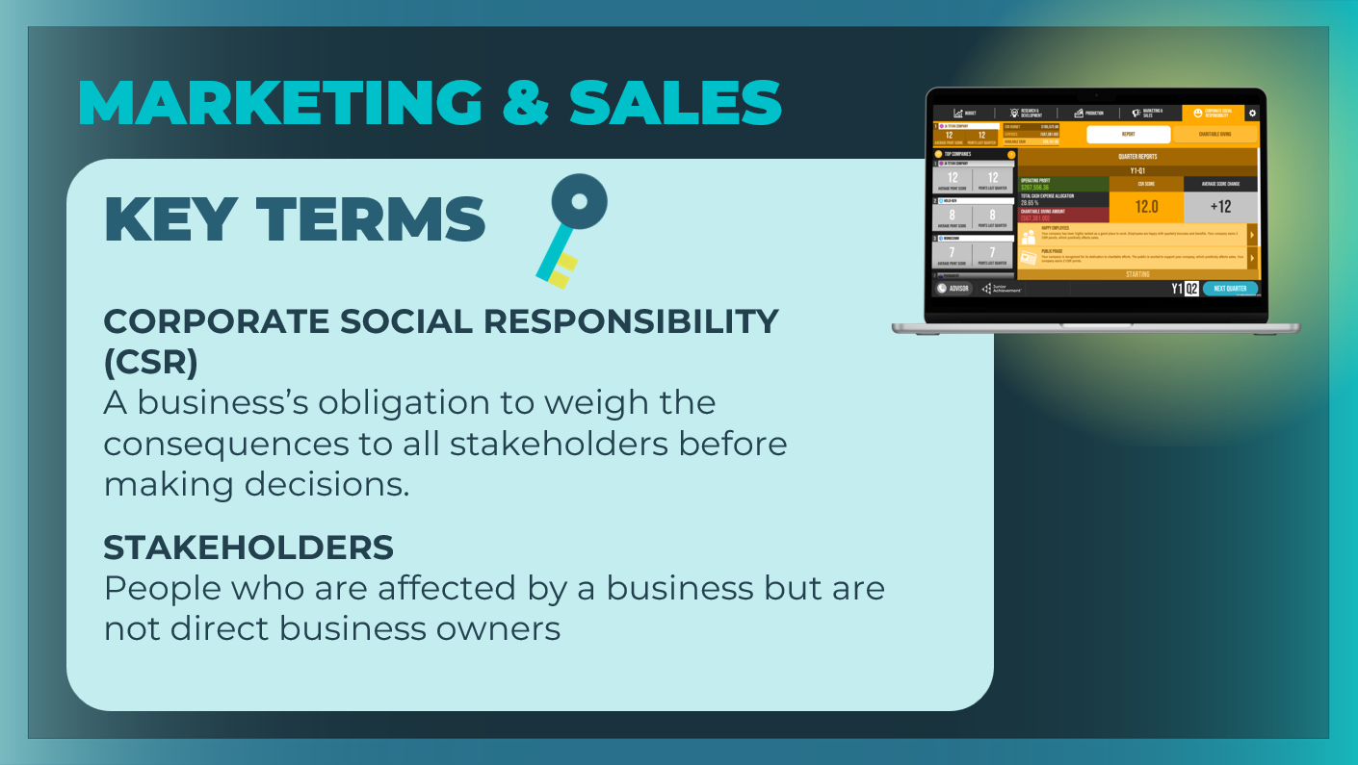 |  | Review the key terms, as needed. Students can add the definitions to their student workbook, page 14.  Give students some time to make CSR decisions and to become familiar with this area of the business. Remind them that their company’s reputation and impact on the community is important and can affect sales.
Slide 55  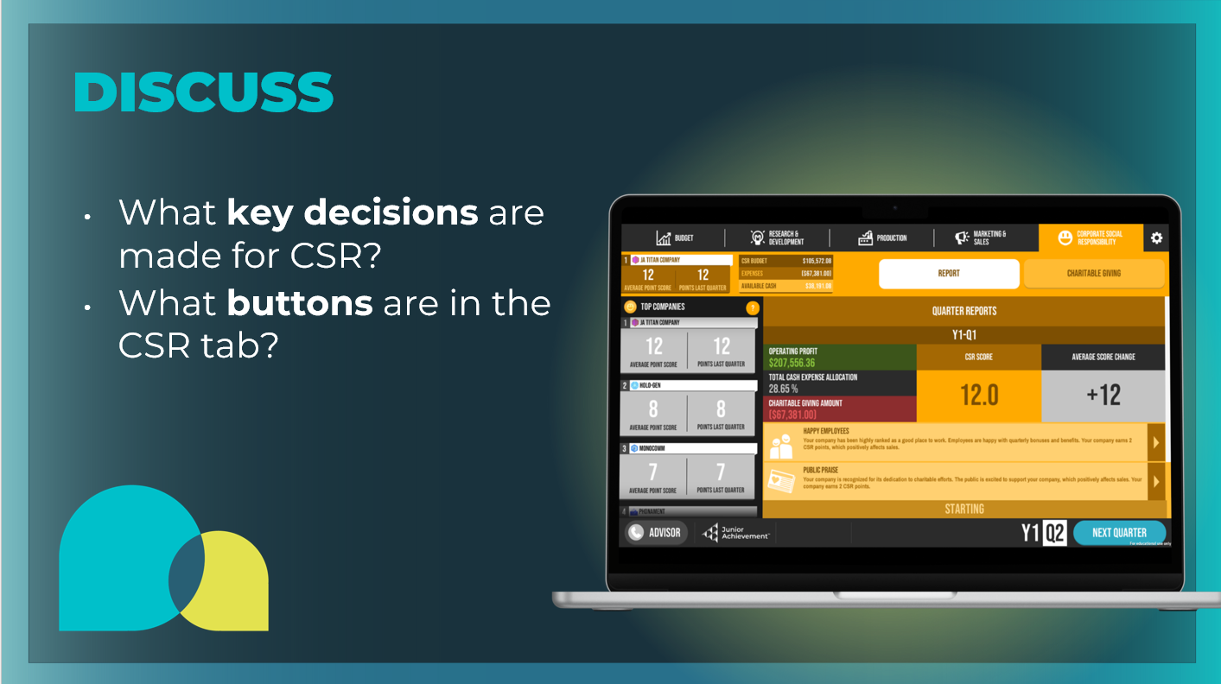 |  | Wrap up this section using the prompts on the slide.  - What key decisions are made for CSR? Manage employee bonuses and benefits and select a charitable cause to give to and a volunteer effort to support.  - What buttons are in the CSR tab? Report, Charitable Giving  Students can fill in the CSR Tab section in their student guide, page 13.
Guided Exploration: Advancing the Quarter
Slide 56

Slide 57  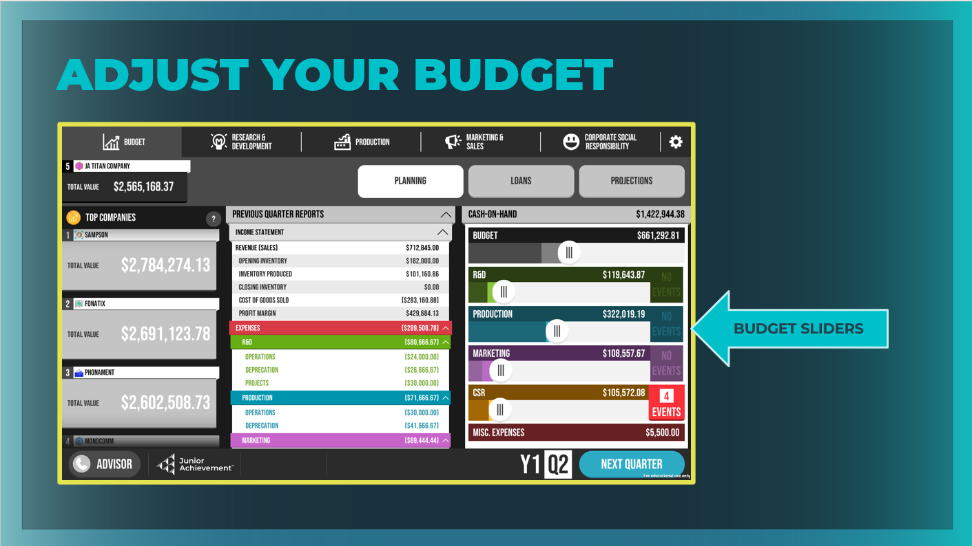 |  | Once students have considered all of their business decisions for the first quarter, it is important to they come back to their original budget and make adjustments as needed.  Explain this is the time to compare the budget amounts originally determined and the amount each department is spending based on the decisions made. CEO’s often  have to adjust their budget so it accurately reflects their selections and return to each department to adjust their spending.
Slide 58  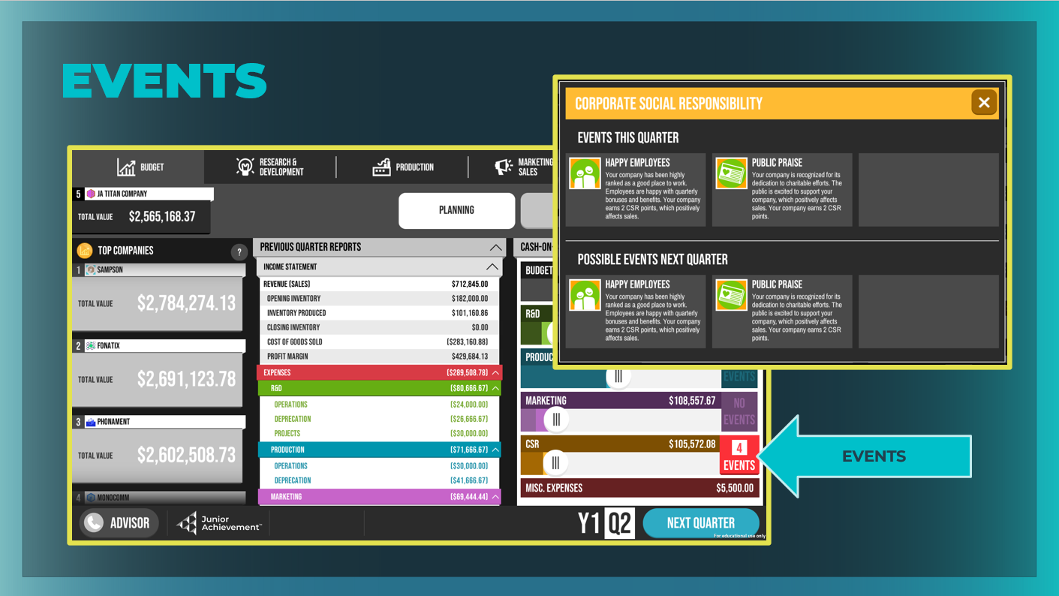 |  | Take time to point out the Events column on the right side of the Budget page. Students will receive some Events guidance during the game and will have to decide how to respond.  If there are no Events, you may wish to trigger one by selecting Very High Operations for your factory capacity so that students can see an example of what might trigger an Event.  Students can see events related to the current quarter as well as possible events that may affect them in their next quarter.
Slide 59  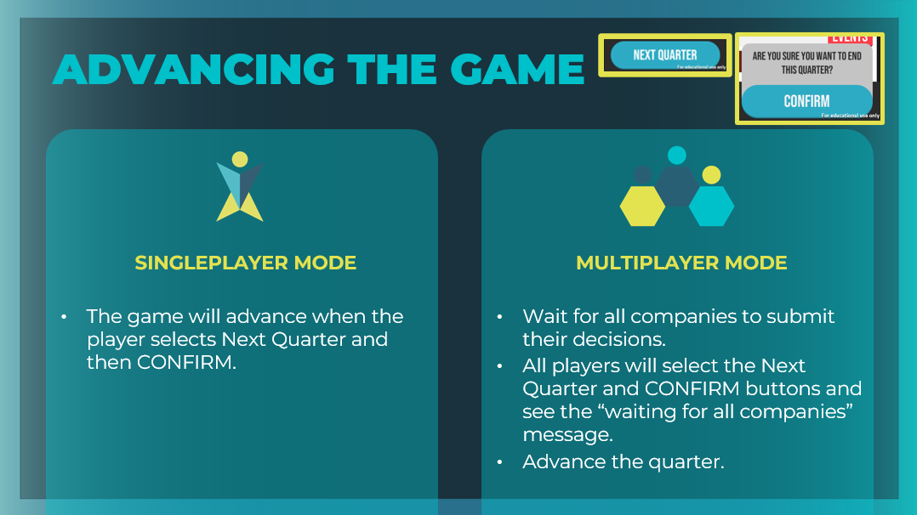 |  | Explain how to advance to the second quarter of the game. Remind students that setting the quarterly budget is their first key decision.  Highlight to students the Previous Quarter Reports and how they can use the reports to analyze how much was spent on expenses in the last quarter. Explain to students that they should use this data to help them make key decisions in this quarter.  Tell students that after they have made all of their business decisions for the first quarter, they will select the Next Quarter button in the bottom right corner of the screen.  Ensure students understand that once they select CONFIRM, they cannot go back and make changes; Their choices will be locked in, and they will have to wait until all the other teams are ready before they can continue gameplay in the next quarter.
Gameplay: Go Solo (15 mins)
Slide 60  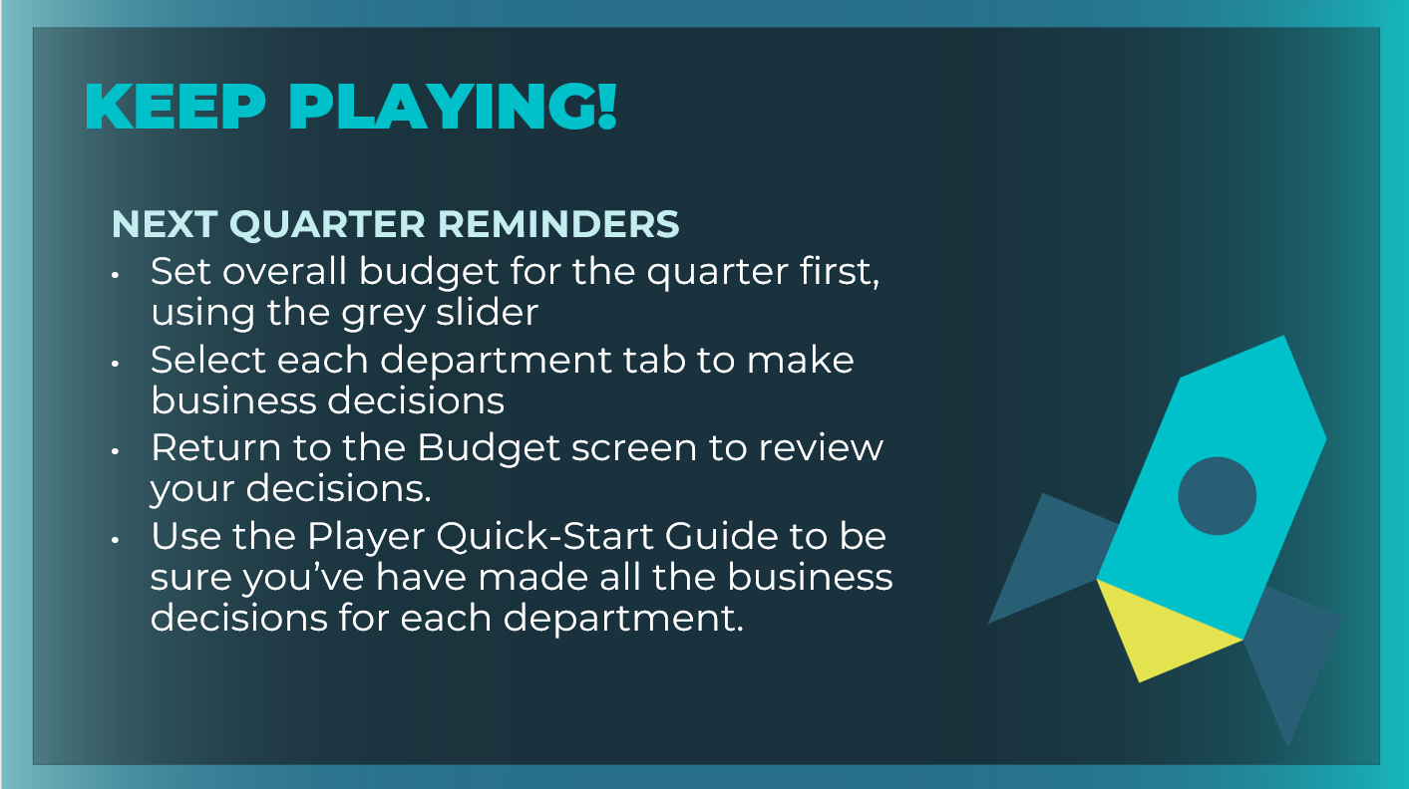 |  | Ask students to follow the onscreen instructions as they advance between the first and second quarters. They will be given their first quarter stats.  Encourage students to reflect on their profit and to note how their expenses compared to their earned revenue.  Guide students as much or as little as needed during the second  quarter. Encourage students to select all the buttons for each  department in the company and to investigate all the possible  business decisions. Remind them they will learn by playing.
Wrap Up (5 mins)
Slide 61  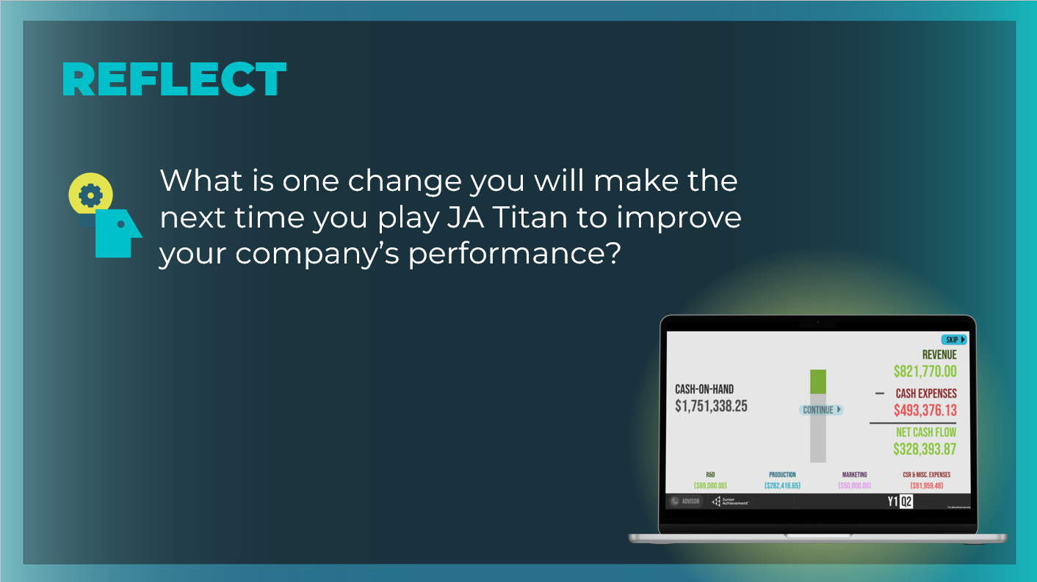 |  | Wrap up the session with the reflection prompt.  Students can respond to the reflection question in their student workbook, page 15, or discuss as a group.

