

Session 4: Research & Development Deep Dive
Presenter Notes
The Presenter Notes have been developed using references from the digital classroom presentation and can be used in combination with the Student Workbook.
This deep dive session takes an in-depth look at a vital department found in many companies: the research and development department (often referred to as R&D).

Students explore advantages and disadvantages of investing in R&D through classroom-based activities; students also explore R&D strategies, culminating in their own smartphone innovation idea and prototype. In this session, the key concept for students to learn is that investing in R&D involves risk and should only be considered when it will maintain or increase a company’s profitability.

This session does NOT require access to the JA Titan simulation.

This session takes approximately 60 minutes to complete, but times may vary based on students’ previous knowledge of business concepts.

Session 4: Research and Development Deep Dive
Slide 1

Slide 2  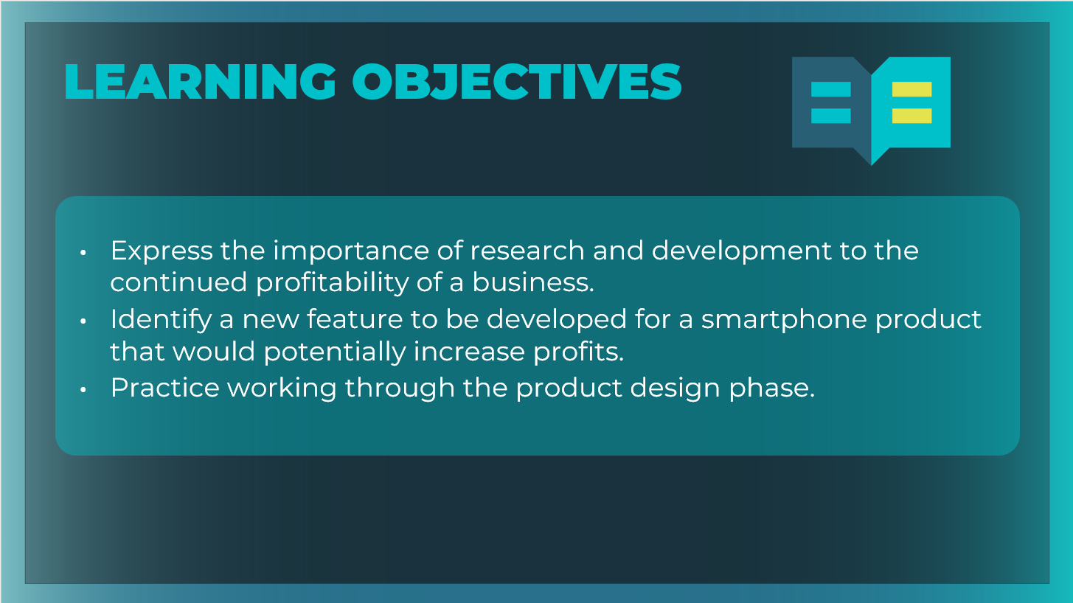 | Optional: Review the learning objectives for the session.
Slide 3  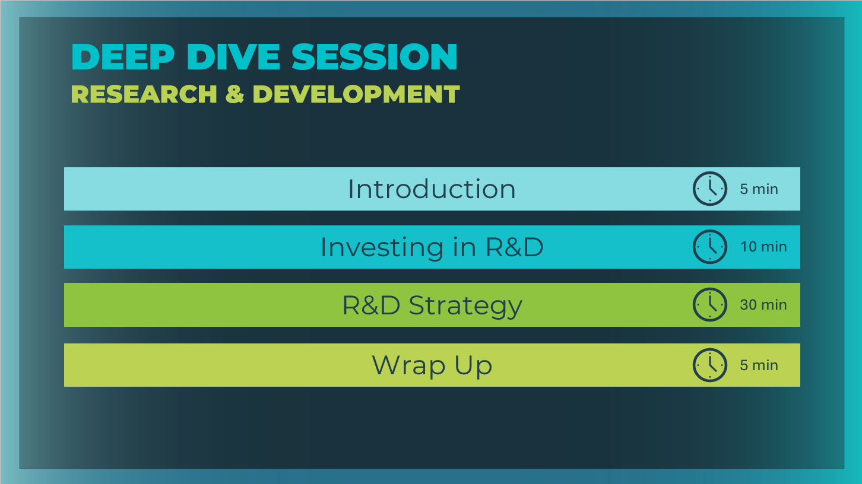 | *Select the button to navigate to the section.  After you have completed the section, you will be redirected to this menu.
Introduction (5 mins)
Slide 4  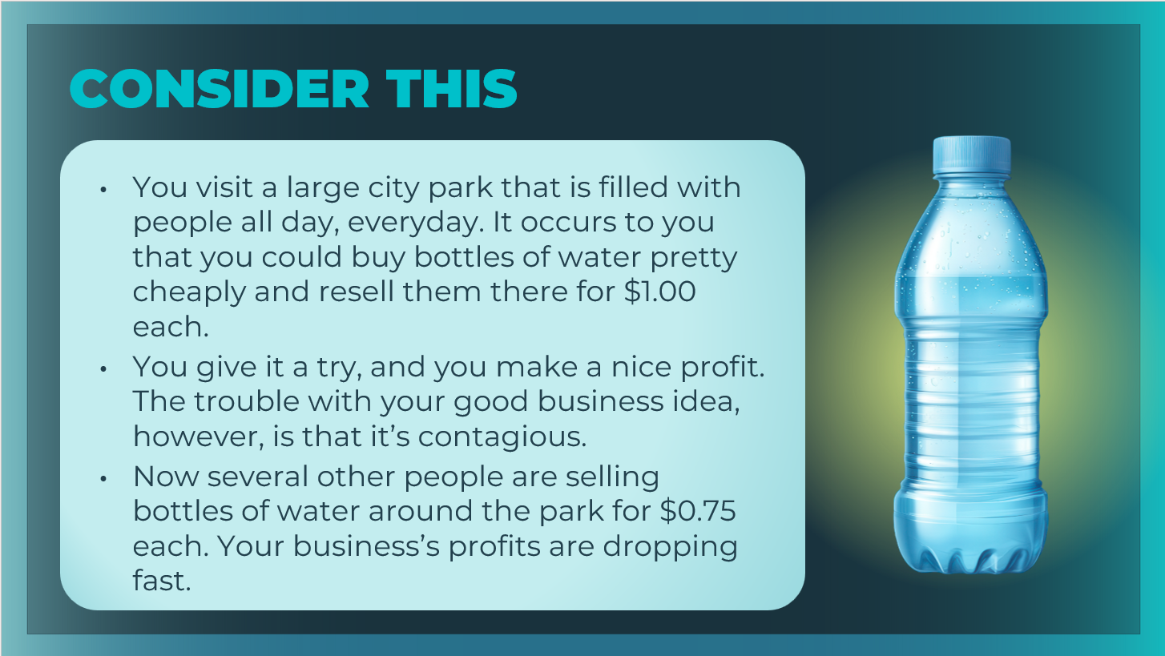 | Invite students to imagine the scenario.
Slide 5  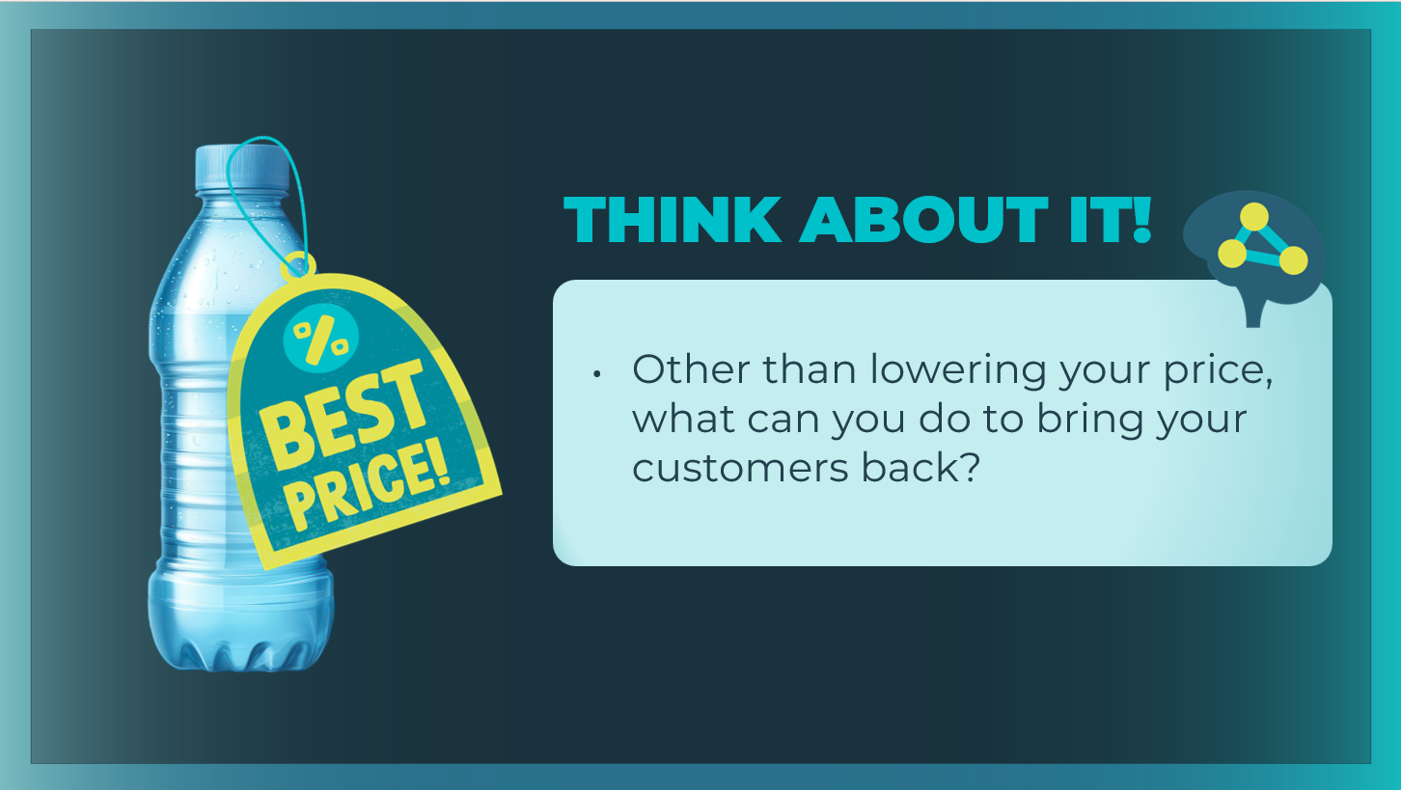 | Discuss the prompt on the slide.  Other than lowering your price, what can you do to bring your customers back? Answers will vary, but if not mentioned:  - The business could offer an improved feature, such as chilling the bottles to offer them cold.  - The business could offer a new product, such as smoothies or bottles of soda.  - The business could develop a new process for distributing the water bottles.  Help students understand why companies conduct research and development using the following talking points.  - Whether you sell simple bottles of water or a complex smartphone, you will probably have competitors—if not when you start, then definitely once people notice you’re making a profit and decide to jump into the market, too.  - Most businesses recognize that reality, so they have a department in charge of addressing it: the Research and Development department, which is more commonly referred to as R&D.
Slide 6  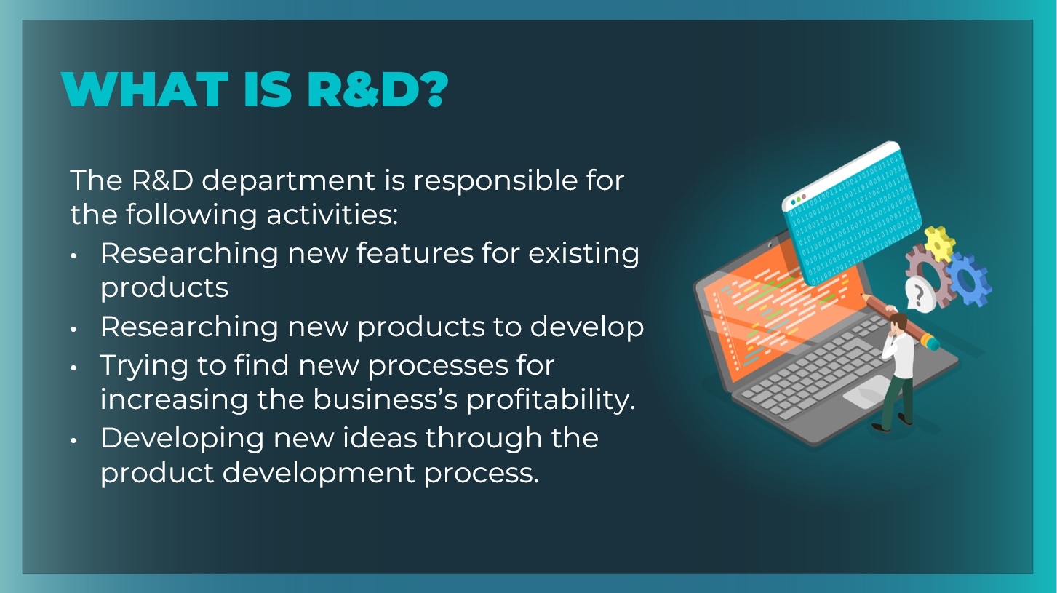 | Review the key activities the R&D department is responsible for.
Slide 7  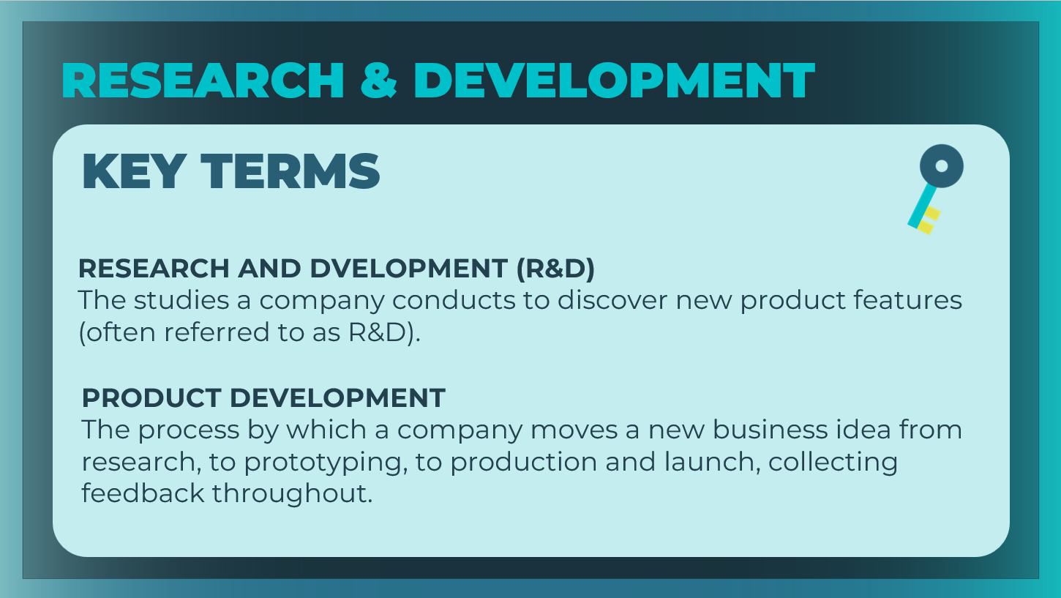 | Review the key terms, as needed. Students can record the definitions in their student workbook, pages 29-30.
Slide 8  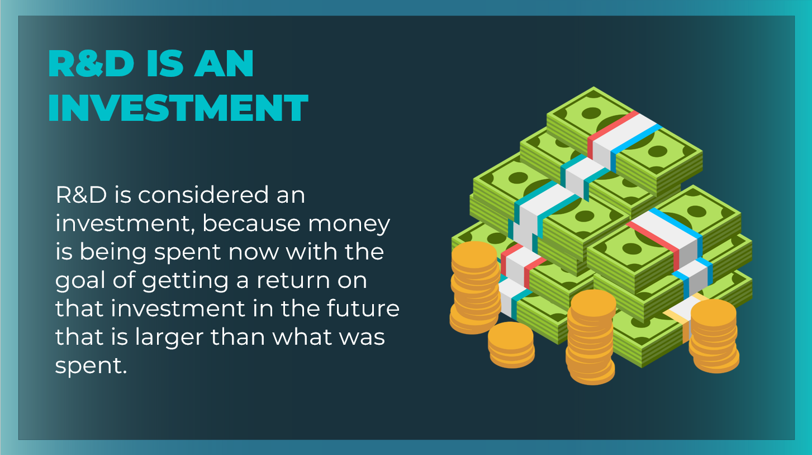 | Explain to students that money spent on R&D is an investment.
Slide 9  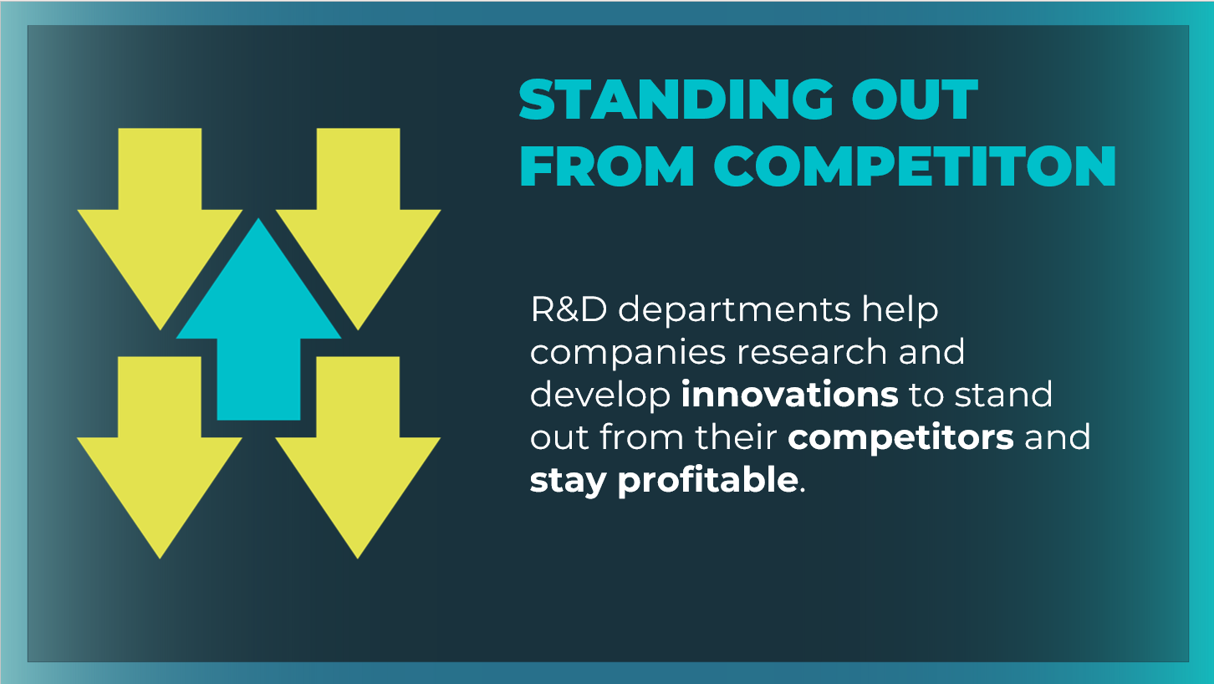 | Explain to students that most large companies have large R&D departments, because they know that they must differentiate themselves from their competitors in order to stay profitable.  Point out that companies who offer new innovations can be more successful IF those innovations lead to profitability.
Slide 10  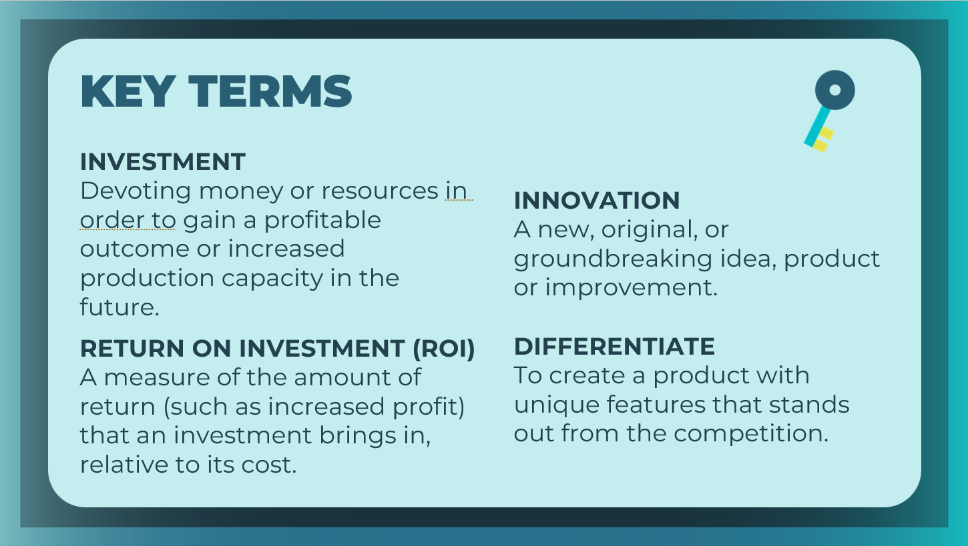 | Define the key terms as needed. Students can record the definitions in their student workbook, pages 29-30.
Slide 11  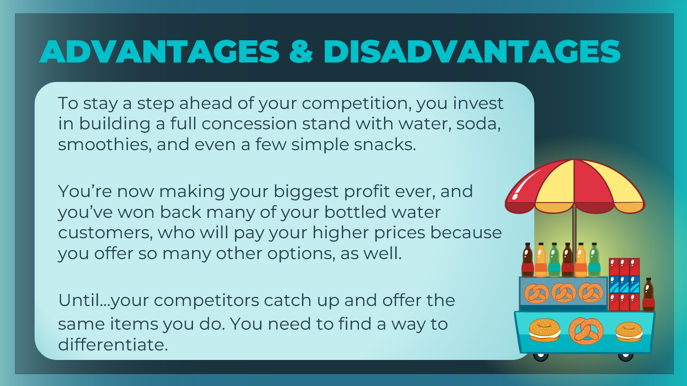 | Now, students will discuss the advantages and disadvantages to a small business of having an R&D department.  Remind students of the scenario they were given at the beginning of this session—they are entrepreneurs selling bottles of water in a big city park. Invite them to imagine this continuation of the scenario.
Slide 12  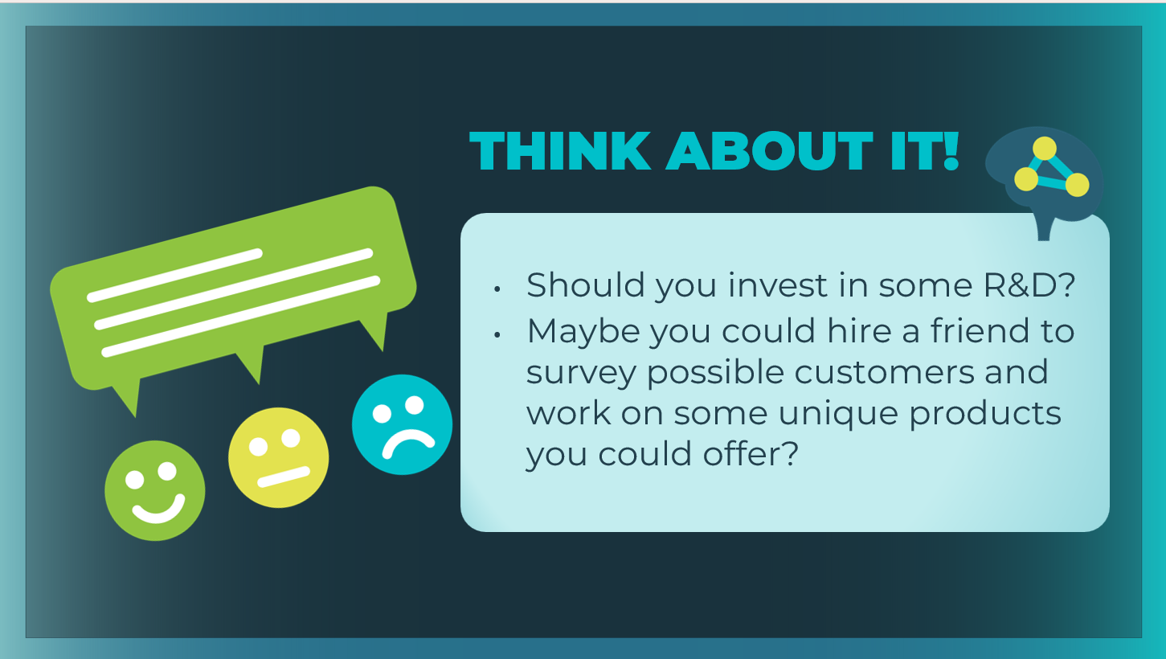 | Discuss the prompts on the slide. Encourage students to share their reasoning.
Slide 13  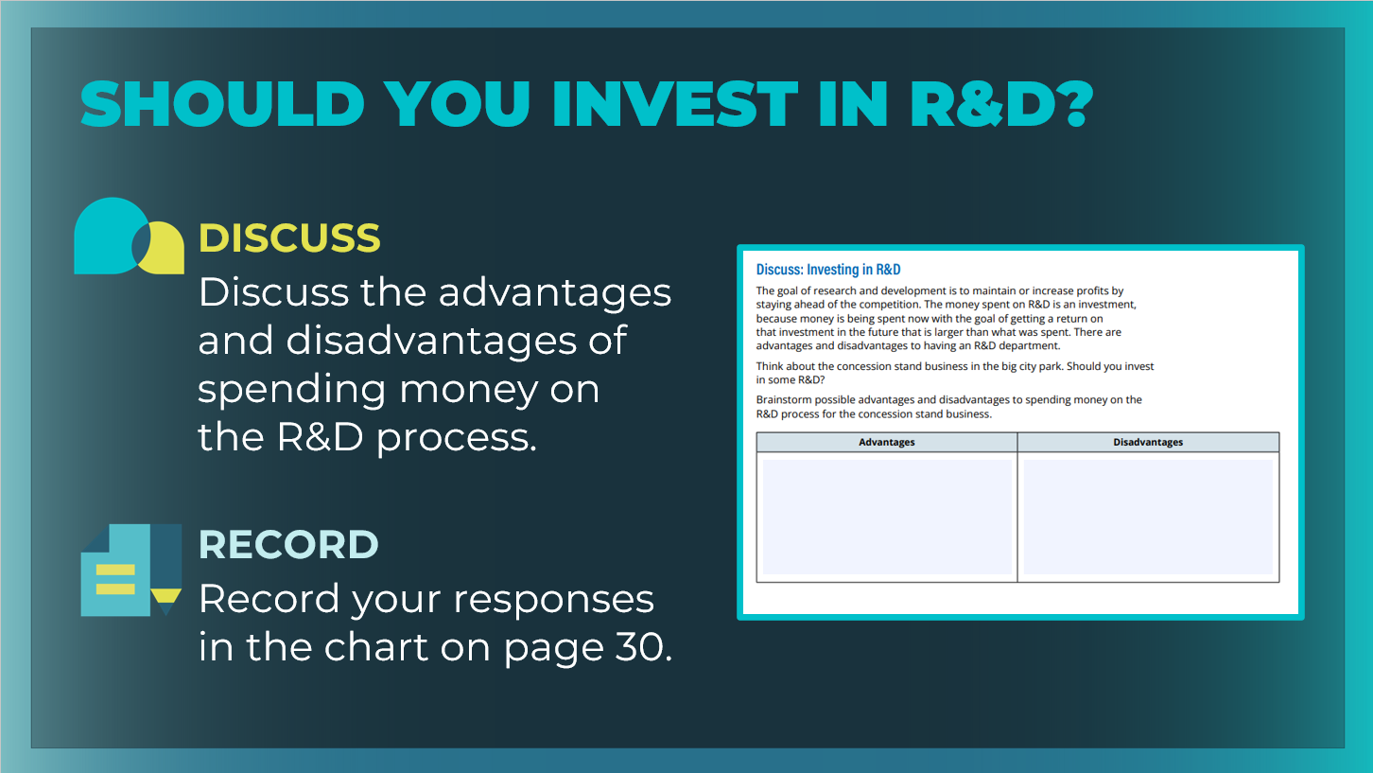 | Ask students to turn to the Discuss: Investing in R&D section of their student workbook, page 30.  Organize students into groups of 2–3; ask them to discuss the advantages and disadvantages of spending money on the R&D process for the concession stand business.  Ask students to record their responses in the chart on their activity page. Allow 5–7 minutes for discussion.  Ask student volunteers to share their responses for both the  advantages and disadvantages.
Slide 14  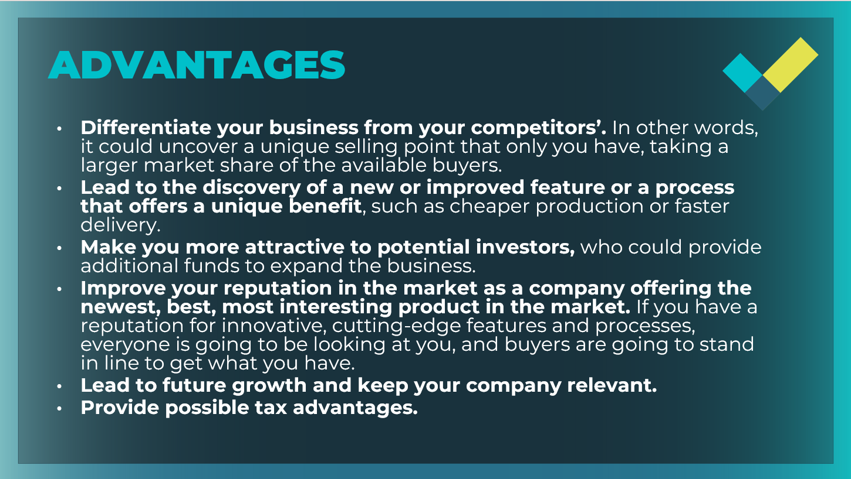 | Review the advantages of R&D, and ask students to update their notes as needed.
Slide 15  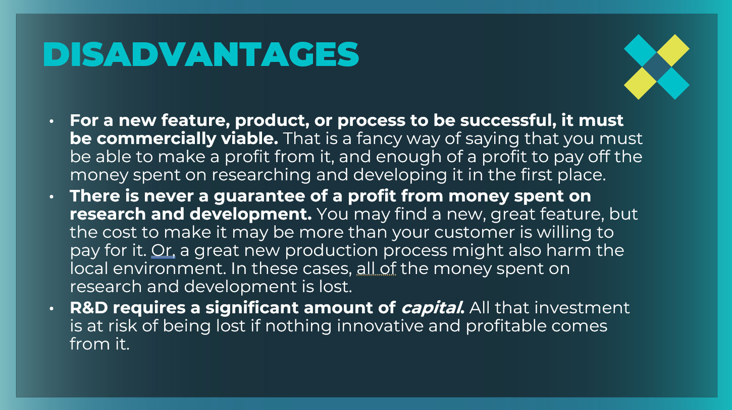  Slide 16  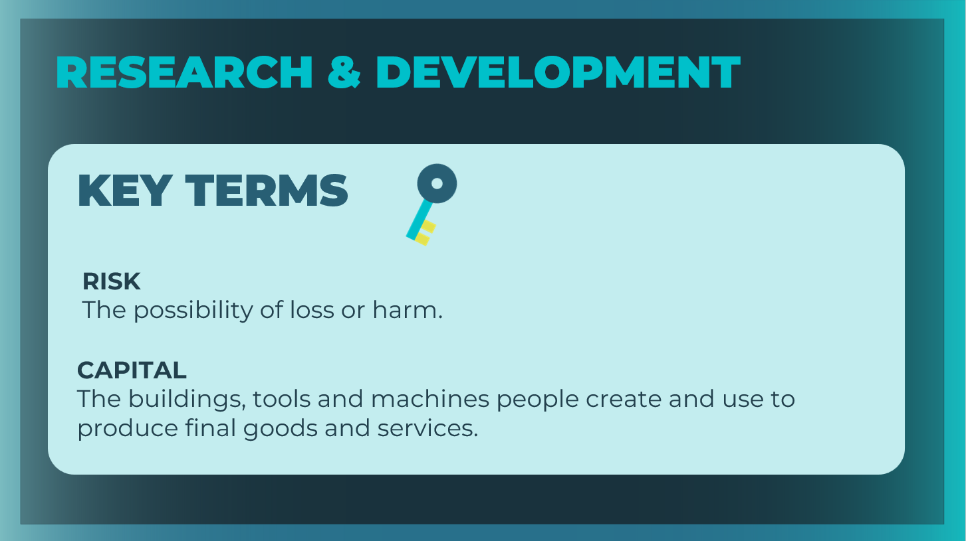 | Review the disadvantages of R&D, and ask students to update their notes as needed.  Define the key terms as needed. Students can record the definitions in their student workbook, pages 29-30.
R&D Strategy (10 mins)
Slide 17  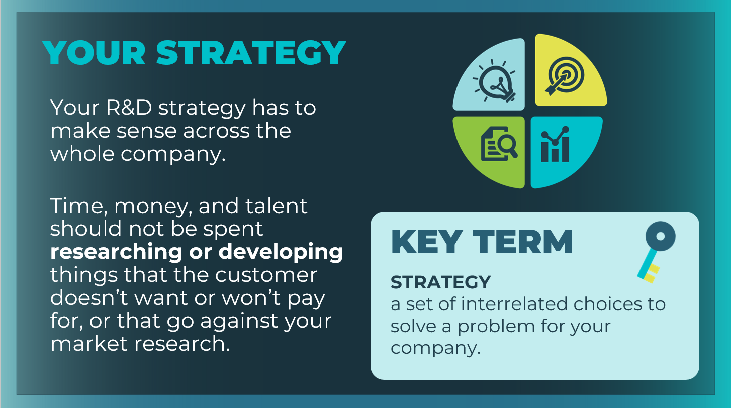 | Explain to students that companies must figure out their R&D  strategy.
Slide 18  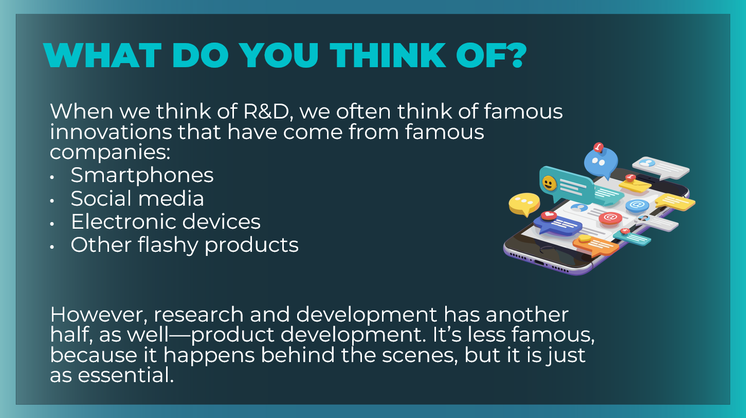 | Invite students to share what they think of when they think of R&D. Review some of the common examples on the slide.  Point out another key responsibility of R&D: product development. Explain that product development is part of an R&D strategy.
Slide 19  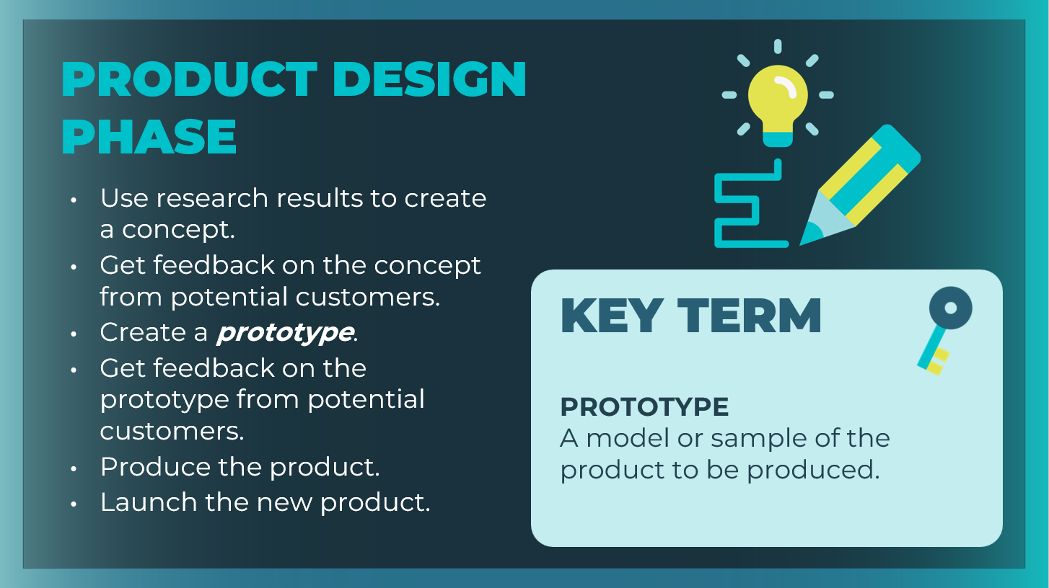 | Explain that once the research phase is complete, the product design phase begins.  Walk through the product design phase with students.
Slide 20  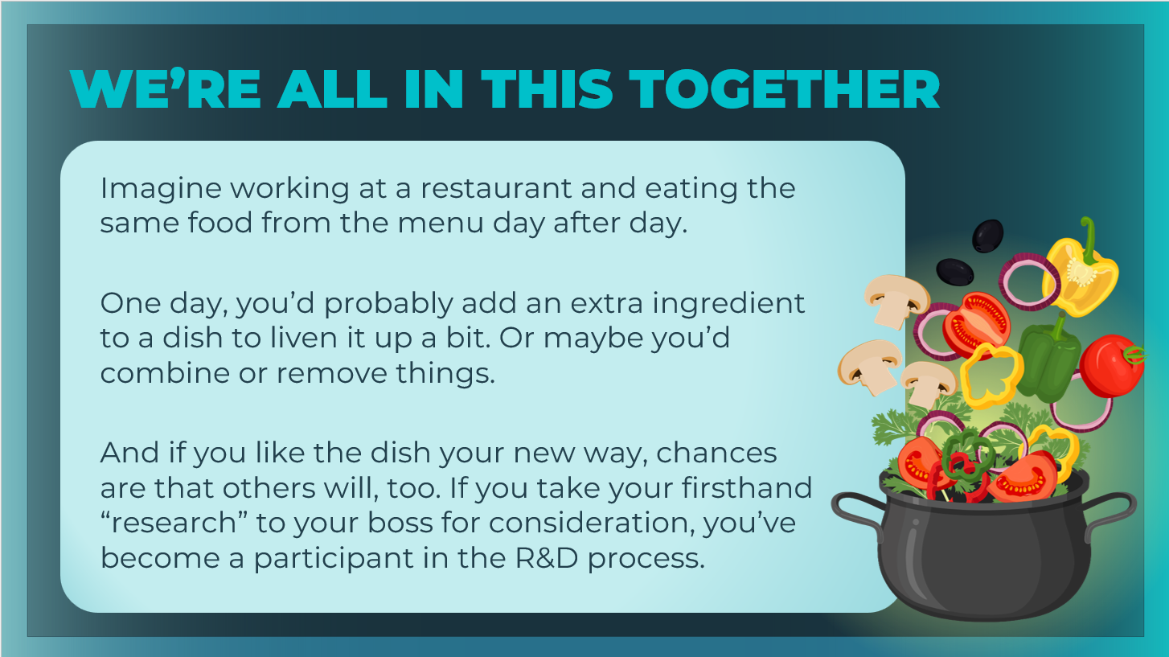 | Share that throughout history, many famous products have come from inside a company, by an employee who thought of an improvement. Which makes a lot of sense! After all, who knows a product better than the employees who live with it every day?  Review the example on the slide to illustrate the concept and explain that the last step in the R&D strategy is for everyone in the entire company to consider themselves part of the R&D department (no matter what department they are in).
Slide 21  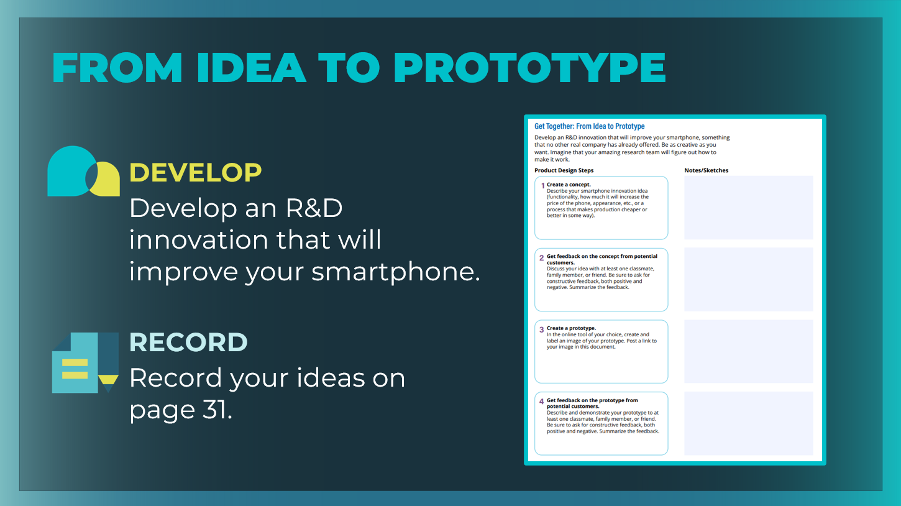 | Tell students that they will now practice taking an R&D innovation from idea to prototype.  Direct students to the From Idea to Prototype section of their student workbook, page 31 and review the instructions.  - Develop an R&D innovation that will improve your smartphone, something that no other real company has already offered.  - Be as creative as you want.  - Imagine that your amazing research team will figure out how to make it work.  - Follow the instructions for each of the product design steps and add your notes and sketches to the corresponding boxes.  Note: Students develop an innovative idea and a prototype for a  smartphone or for another product they find engaging. Students  can work together in small groups, or they can work independently inside or outside of class time.  Time permitting, when students have completed the activity, ask for volunteers to present their ideas and prototypes. Highlight student ideas that would be most likely to add to their companies’ profitability.
Wrap Up (5 mins)
Slide 22  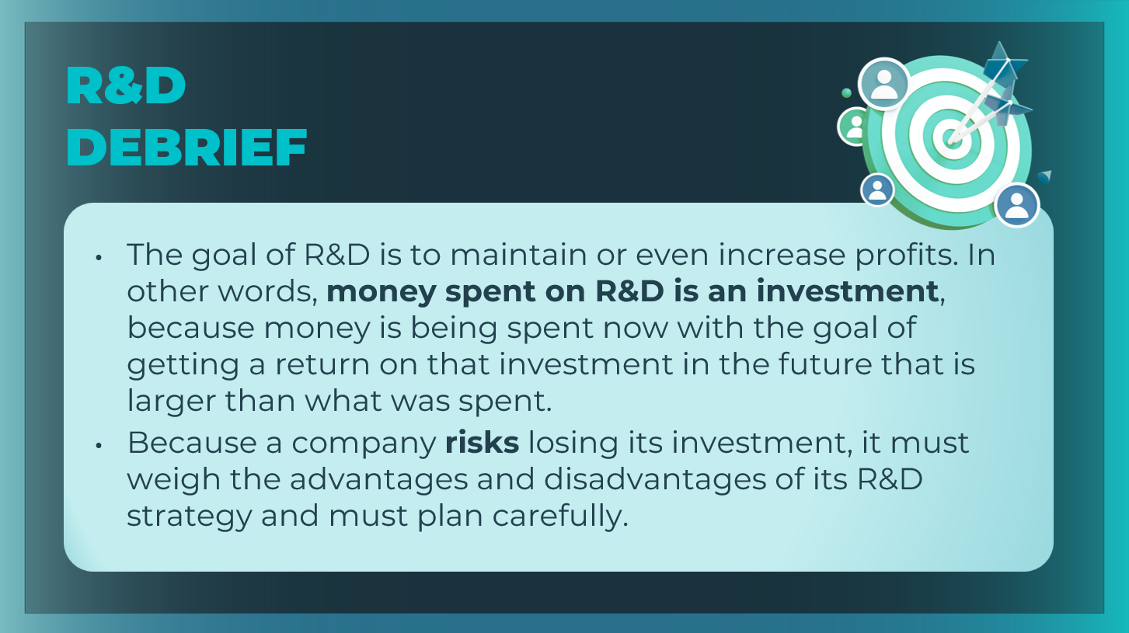 | Review the main ideas from this session with students
Slide 23  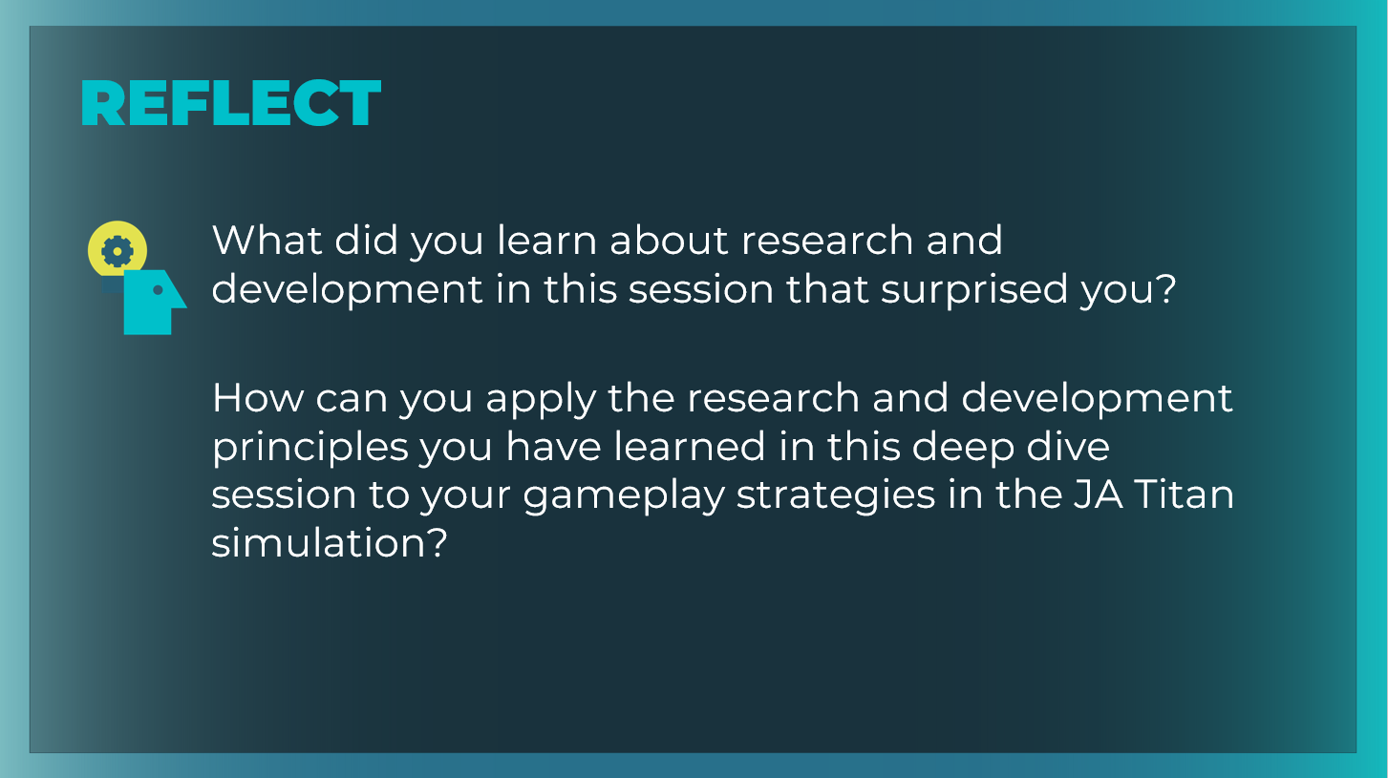 | Encourage students to reflect upon and share what they learned in the session.  What did you learn about research and development in this session that surprised you? Answers will vary. Encourage students to use specific terms and concepts from the session to support their responses.  Ask the following question of students who are also using the JA Titan simulation.  How can you apply the research and development principles you have learned in this deep dive session to your gameplay strategies in the JA Titan simulation? Answers will vary. Encourage students to relate what they have learned about R&D and the product design process to the research and development business decisions they will need to make in the simulation.  Students can record their reflections in their student workbook, page 32.

