

Session 6: Corporate Social Responsibility Deep Dive
Presenter Notes
The Presenter Notes have been developed using references from the digital classroom presentation and can be used in combination with the Student Workbook.
This deep dive session takes an in-depth look at corporate social responsibility
(commonly referred to as CSR).

Students explore the benefits and costs of operating a business that focuses on CSR. One common model for viewing CSR is Carroll’s CSR Pyramid, in which Dr. Archie B. Carroll makes the case that businesses must have a foundation established in economic responsibilities (profit), but they also have legal responsibilities and expectations of ethical behavior and philanthropy. In this session, students use a case study to explore how investing in CSR and being a good corporate citizen can affect a business and its many stakeholders.

This session does NOT require access to the JA Titan simulation.

This session takes approximately 60 minutes to complete, but times may vary based on students’ previous knowledge of marketing concepts.
Session 6: Corporate Social Responsibility Deep Dive
Slide 1
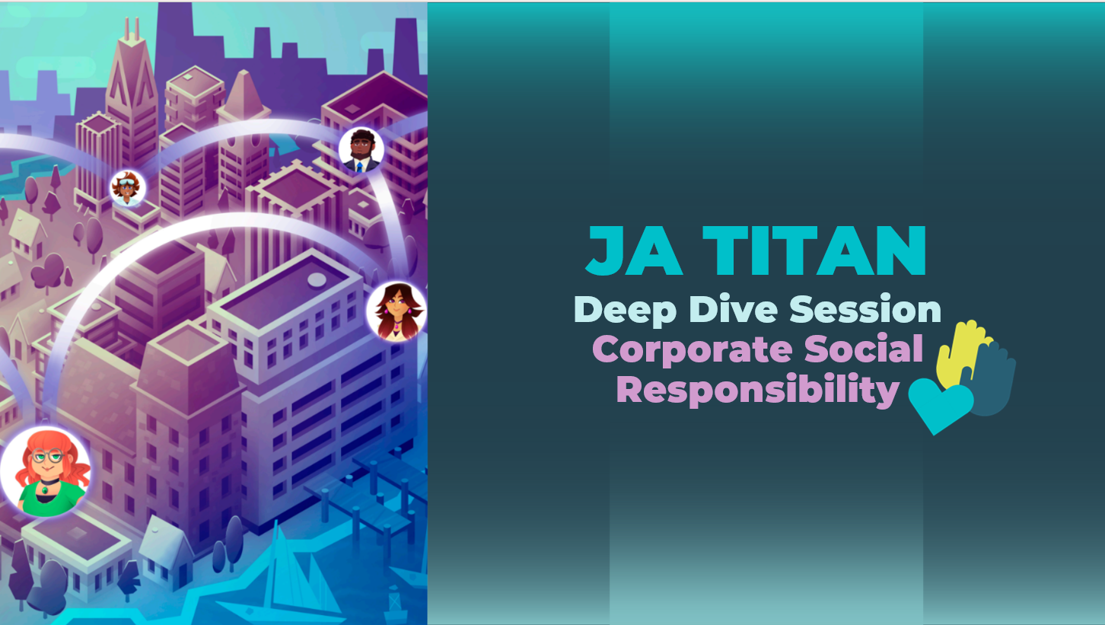
Slide 2  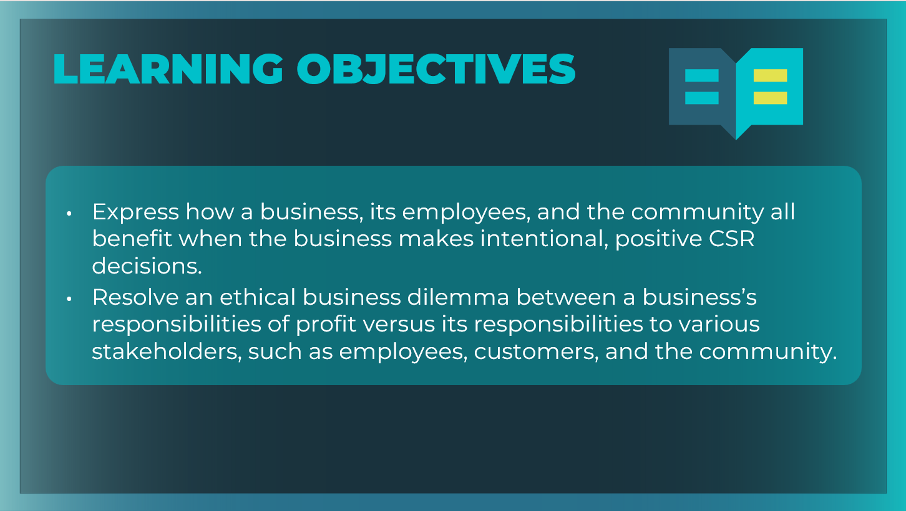 | Optional: Review the learning objectives for the session.
Slide 3  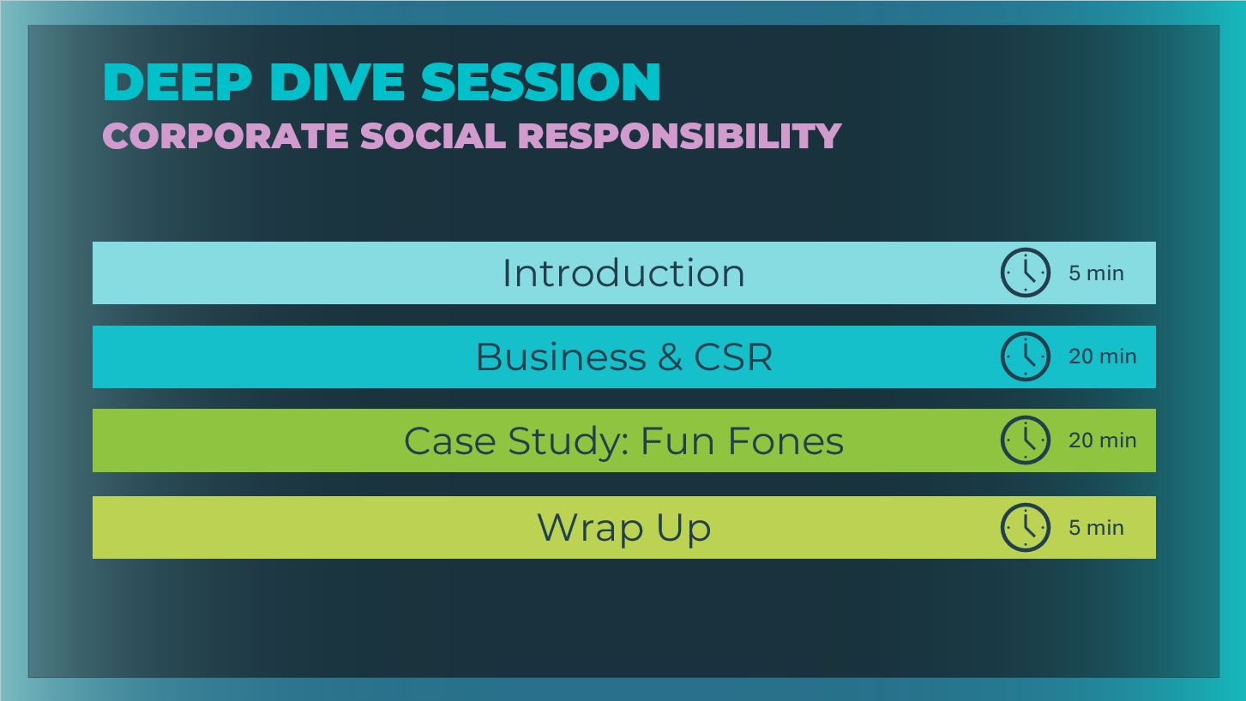 | *Select the button to navigate to the section.  After you have completed the section, you will be redirected to this menu.
Introduction (5 mins)
Slide 4  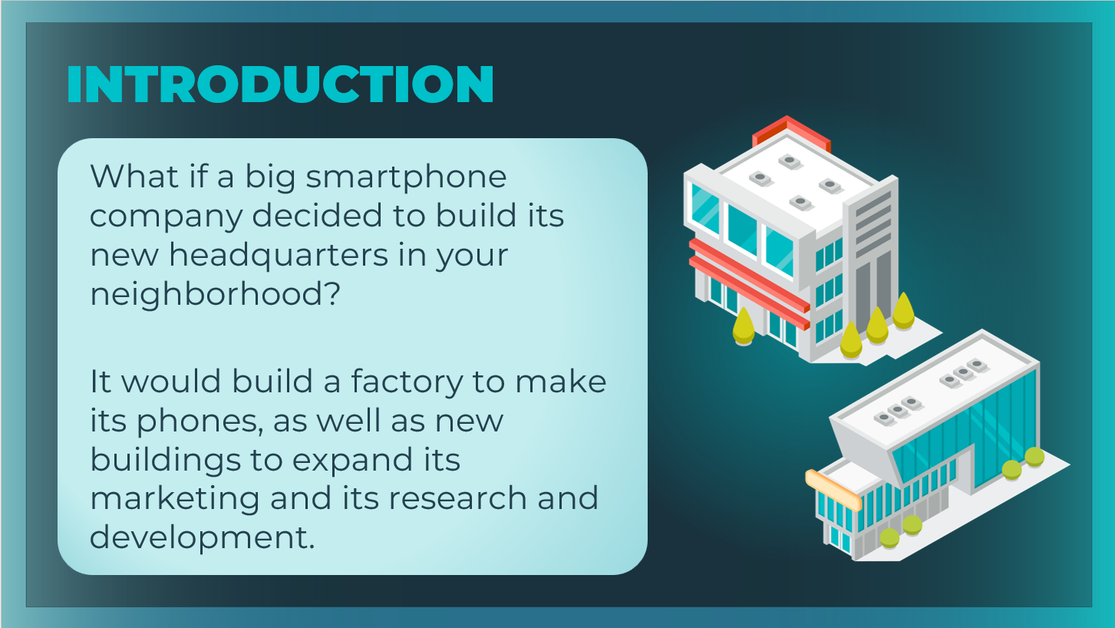 | Introduce the session by invite students to imagine the scenario.
Slide 5  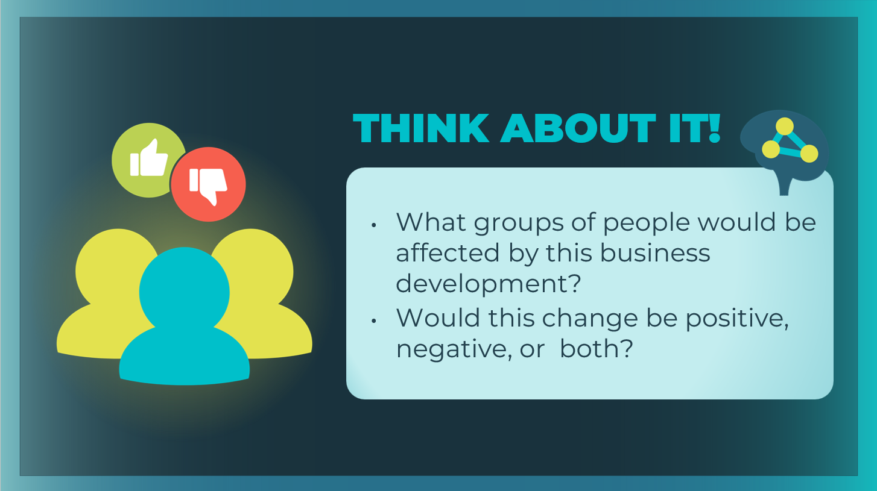 | Ask students to brainstorm the various groups of people who would be affected by this business development. For each group, ask students to predict whether this change would be positive, negative, or both.  Answers will vary, but if not mentioned: business owners; new employees; neighbors; customers; the community; the local government; the environment; people or businesses who previously lived on or used the land.
Slide 6  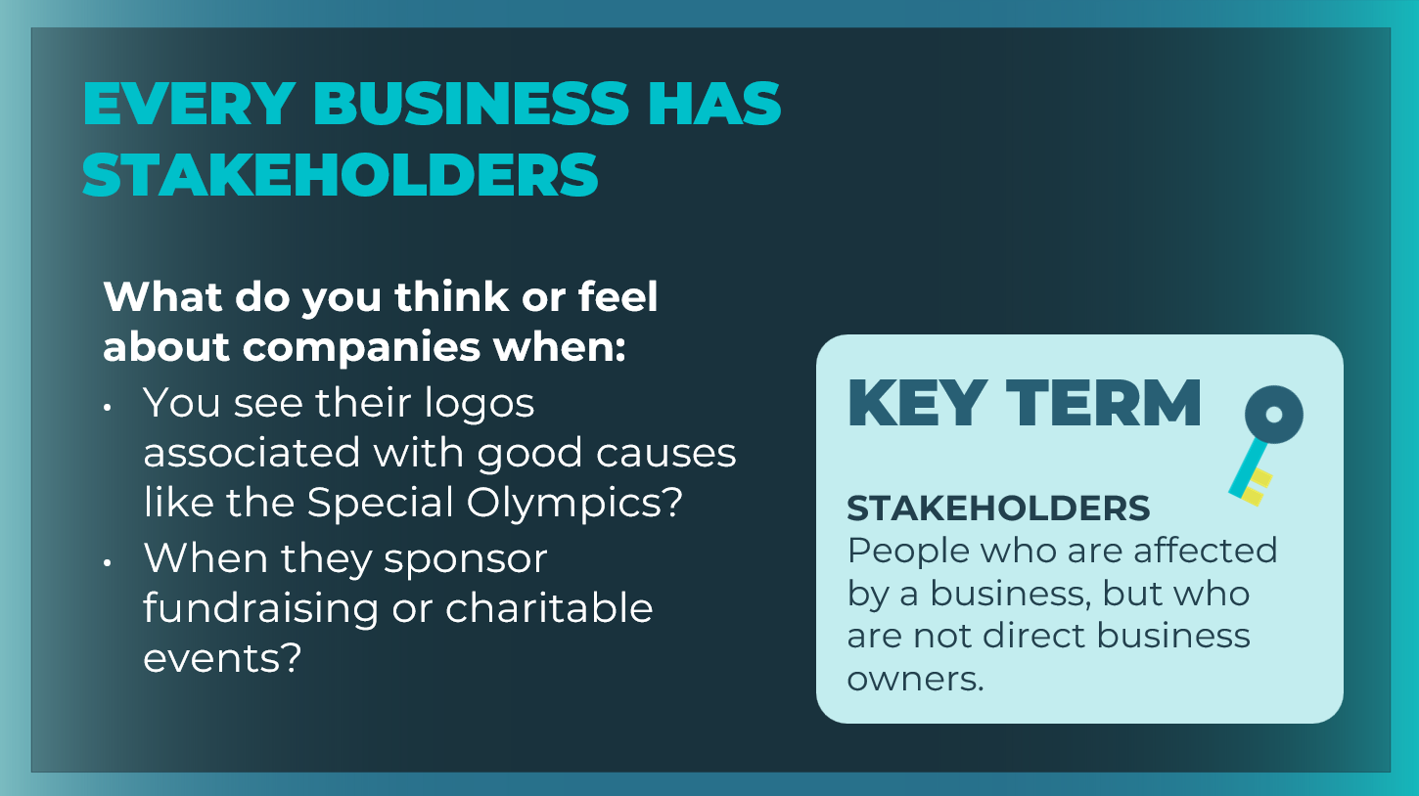 | Share with students that every business has stakeholders.  We don’t always think of a business as being part of a  community, but businesses, both big and small, have a significant effect on many people. Those people are called stakeholders.  Define the key term as needed. Students can record the definition in their student workbook, page 37.  Ask students if they have ever noticed company sponsors at charitable events and what feelings or thoughts (if any) they have had about those companies.  - What do you think or feel about companies when you see their logos associated with good causes like the Special Olympics?  - When they sponsor fundraising or charitable events?
Slide 7  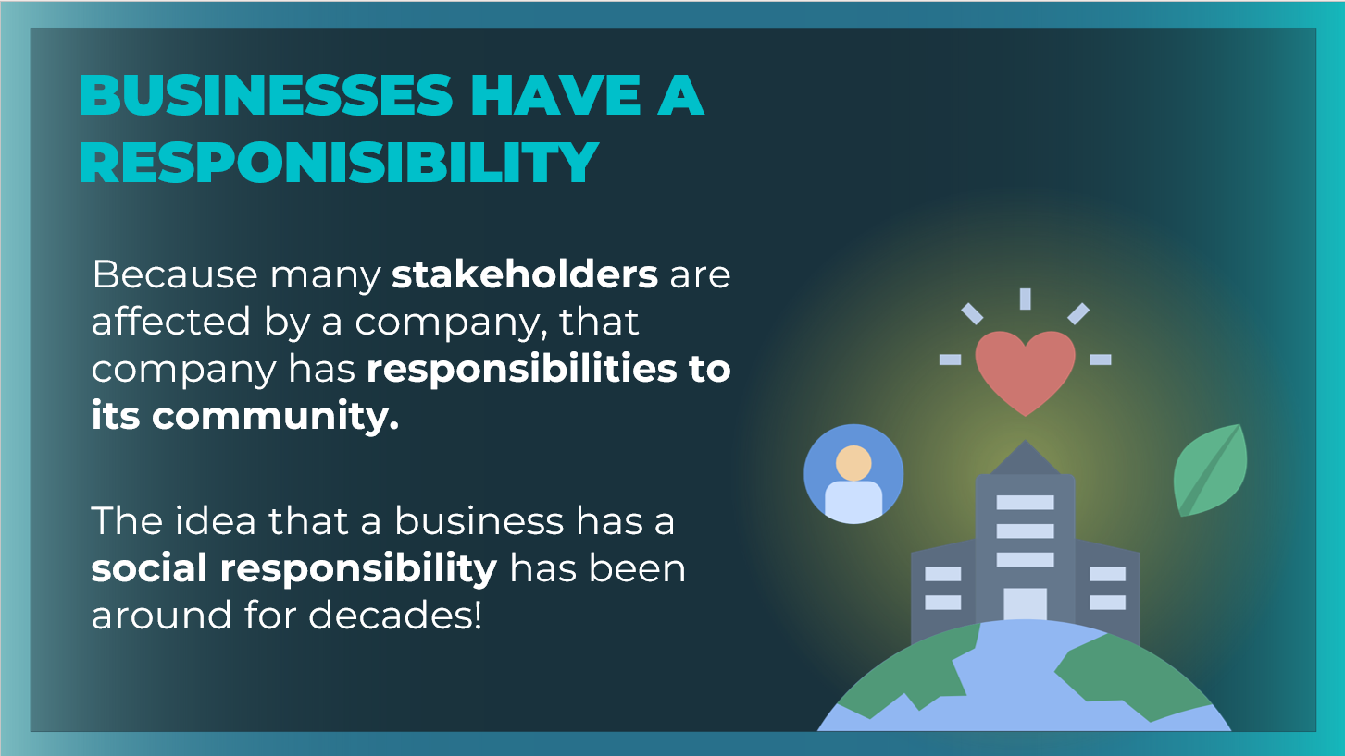 | Introduce students to the idea of corporate social responsibility and how it began.  - The specific concept that a business has a social responsibility dates back to the 1950s, following World War II, as businesses grew in size and power.  - While everyone understood that businesses had to make enough profit to survive and thrive, many people began to feel that the new, large, powerful businesses had additional obligations to society at large.
Business & CSR (20 mins)
Slide 8  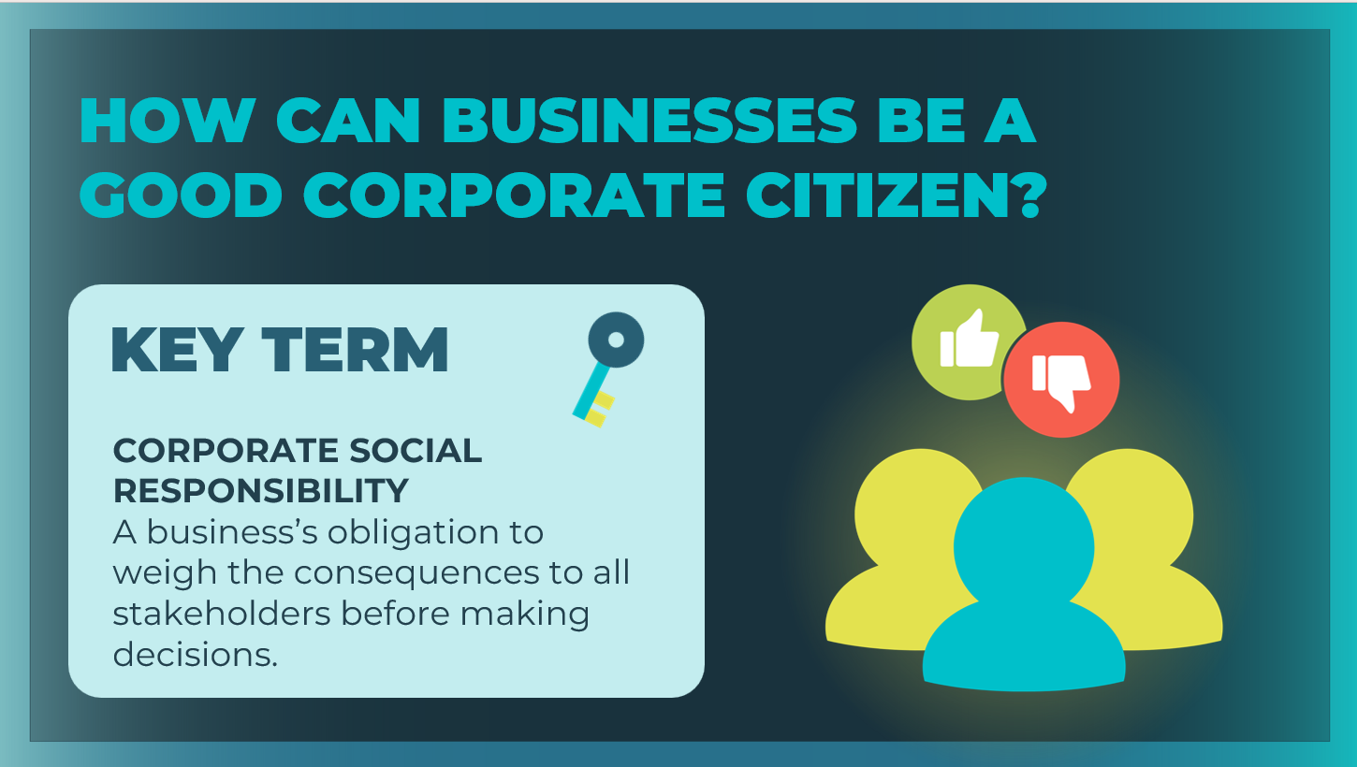 | Define the key term as needed. Students can record the definition in their student workbook, page 37.  Explain to students that all businesses want to succeed; however, smart, conscientious businesses realize that their success will be short-lived if they hurt people or communities.  Having a positive impact on the world is more than just a noble idea for businesses. It is a basic responsibility—a task that a person or group must complete.  When businesses devote resources to helping people or communities, they demonstrate corporate social responsibility (CSR).
Slide 9  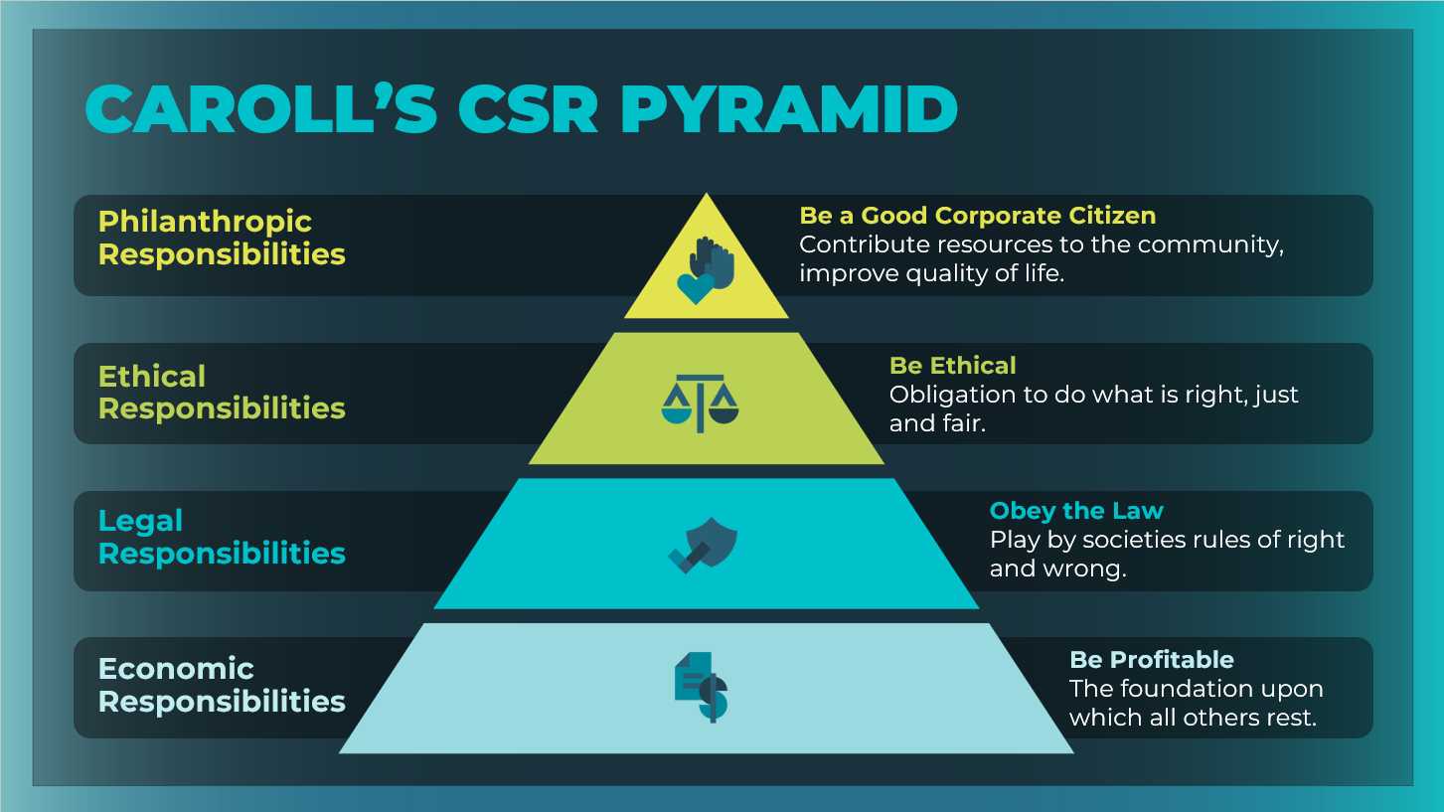 | Tell students that you are going to introduce them to one of the most recognized CSR models: Dr. Archie B. Carroll’s CSR Pyramid. The pyramid illustrates how a company can meet its social responsibilities.  Discuss the four responsibilities within the pyramid:  - Economic Responsibilities  - Legal Responsibilities  - Ethical Responsibilities  - Philanthropic Responsibilities  Students can take notes for each responsibility within the CSR pyramid in their student workbook, page 37.
Slide 10  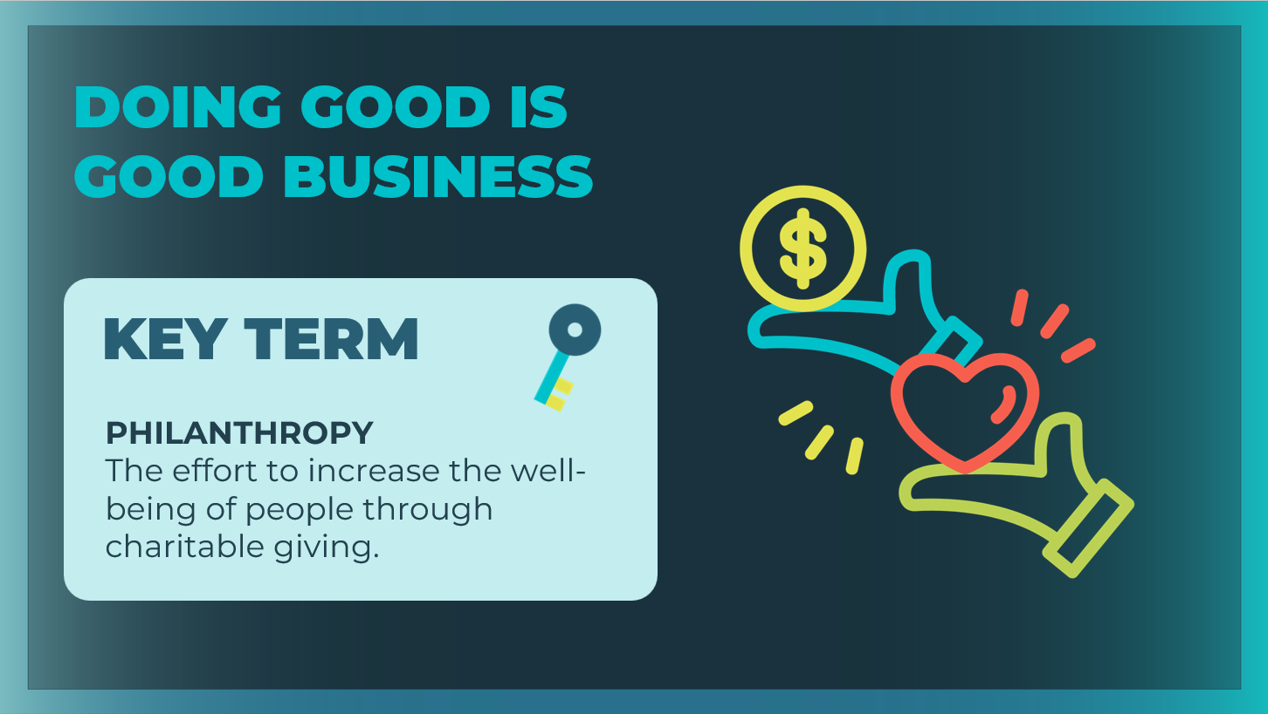 | Define the key term as needed. Students can record the definition in their student workbook, page 37.
Slide 11  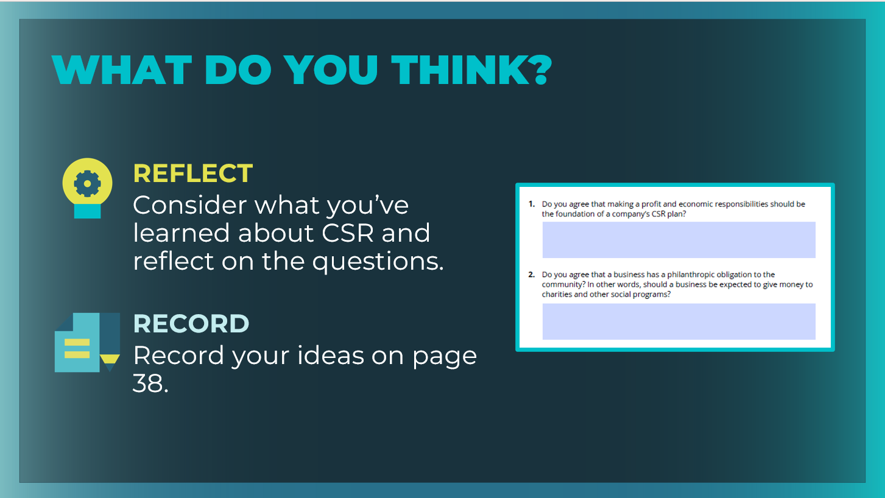 | Ask students to respond to the two questions in the Carroll’s CSR Pyramid section of their student workbook, page 38, and then ask for volunteers to share their answers.  Do you agree that making a profit and economic responsibilities should be the foundation of a company’s CSR plan? Answers will vary. Emphasize that a business provides goods and services that the community wants and needs.  - If a business does not make a profit (and enough profit to make it worthwhile for the owner), then the business will close.  - That hurts not only the business owner, but also those who rely on access to the business’s products or services, as well as any people employed by that business.  Do you agree that a business has a philanthropic obligation to the community? In other words, should a business be expected to give money to charities and other social programs? Answers will vary. This topic is hotly debated between those who believe that profit should be a business’s primary goal and those who believe that a business should “give back” to the community that supports it and allows it to exist. There are also those who say that, even though philanthropy costs money, it can actually grow a business’s profits by earning the company goodwill, which may lead to more customers.
Case Study: Fun Fones (20 mins)
Slide 12  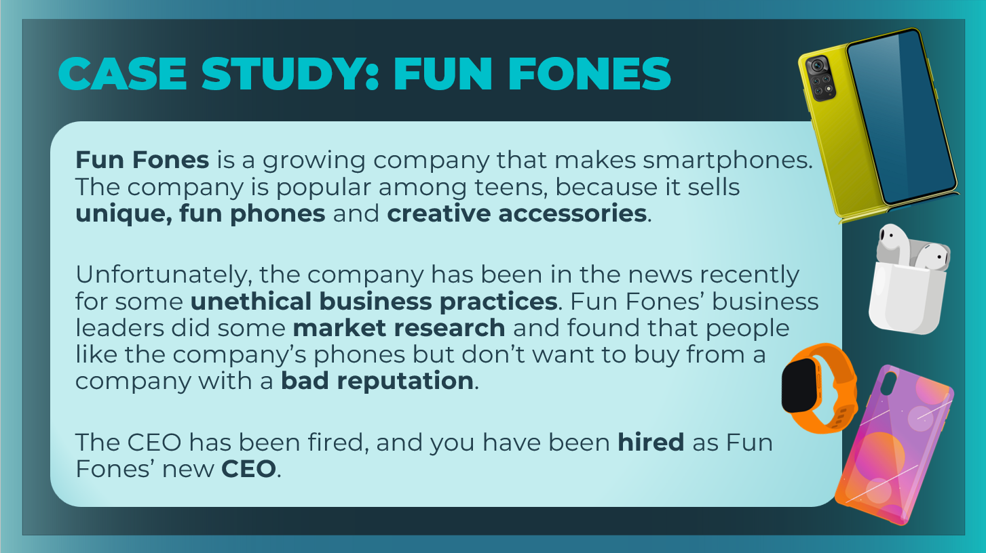  Slide 13  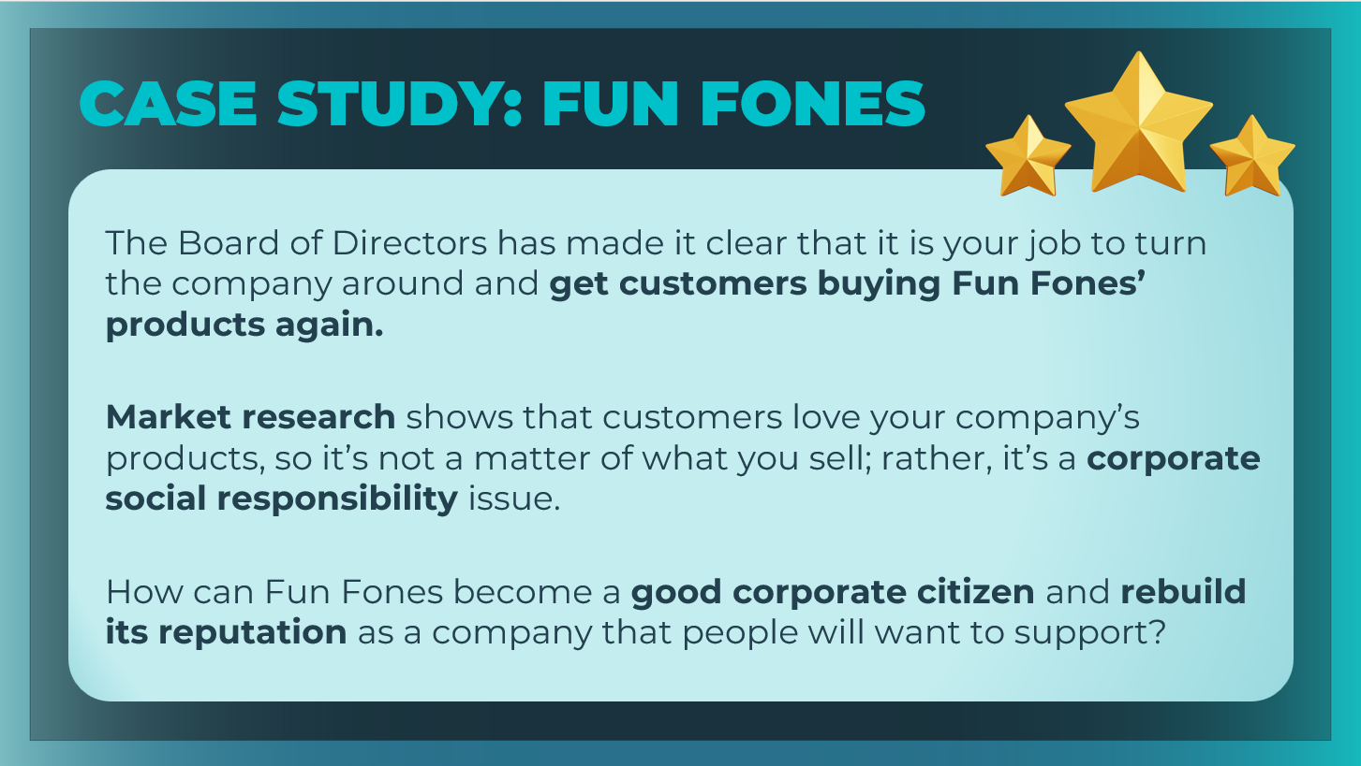 | Tell students that they will use Carroll’s CSR pyramid to help a  company that is trying to rebuild its reputation and needs a corporate social responsibility plan.  Read the Fun Fones scenario together.
Slide 14  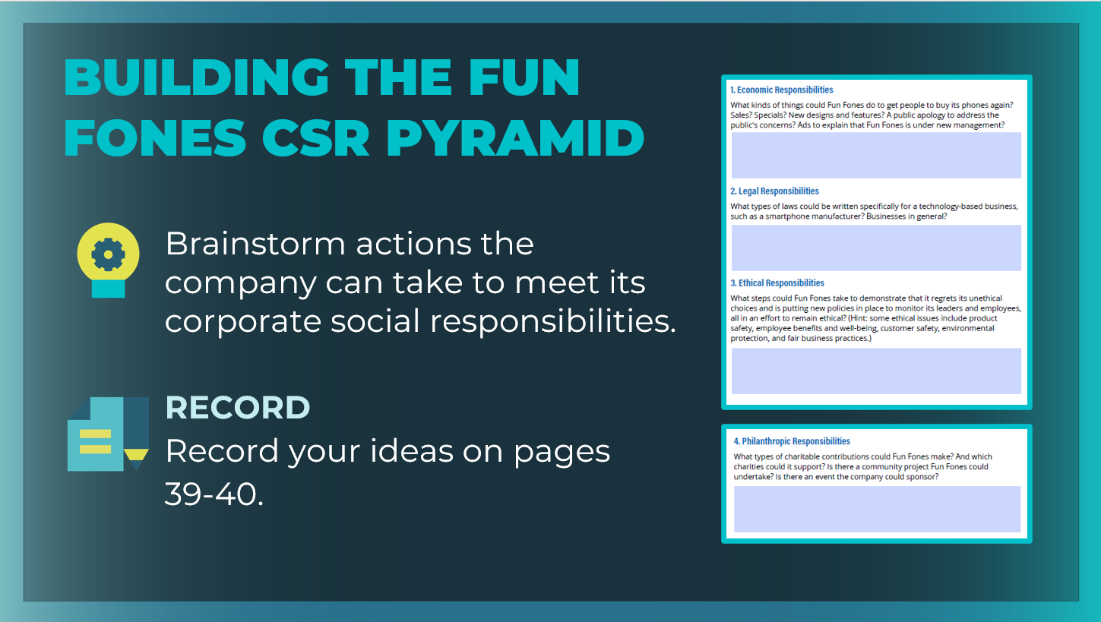 | Explain to students that the Board of Directors has presented them with a model of Carroll’s CSR Pyramid. Their task is to use the pyramid to design a CSR plan for the company.  As Fun Fones’ new CEO, brainstorm actions that the company can take to meet its corporate social responsibilities and rebuild its reputation as a good corporate citizen.  Organize students into groups of 3–4, and direct them to the  Case Study Scenario section of their student workbook, pages 39-40.  Ask each student to record the group’s suggestions on their own activity page. Allow students 10–15 minutes to complete their CSR plans.
Slide 15  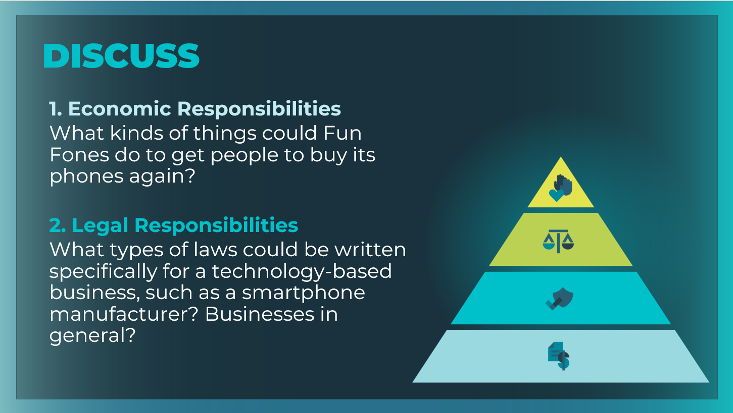  Slide 16  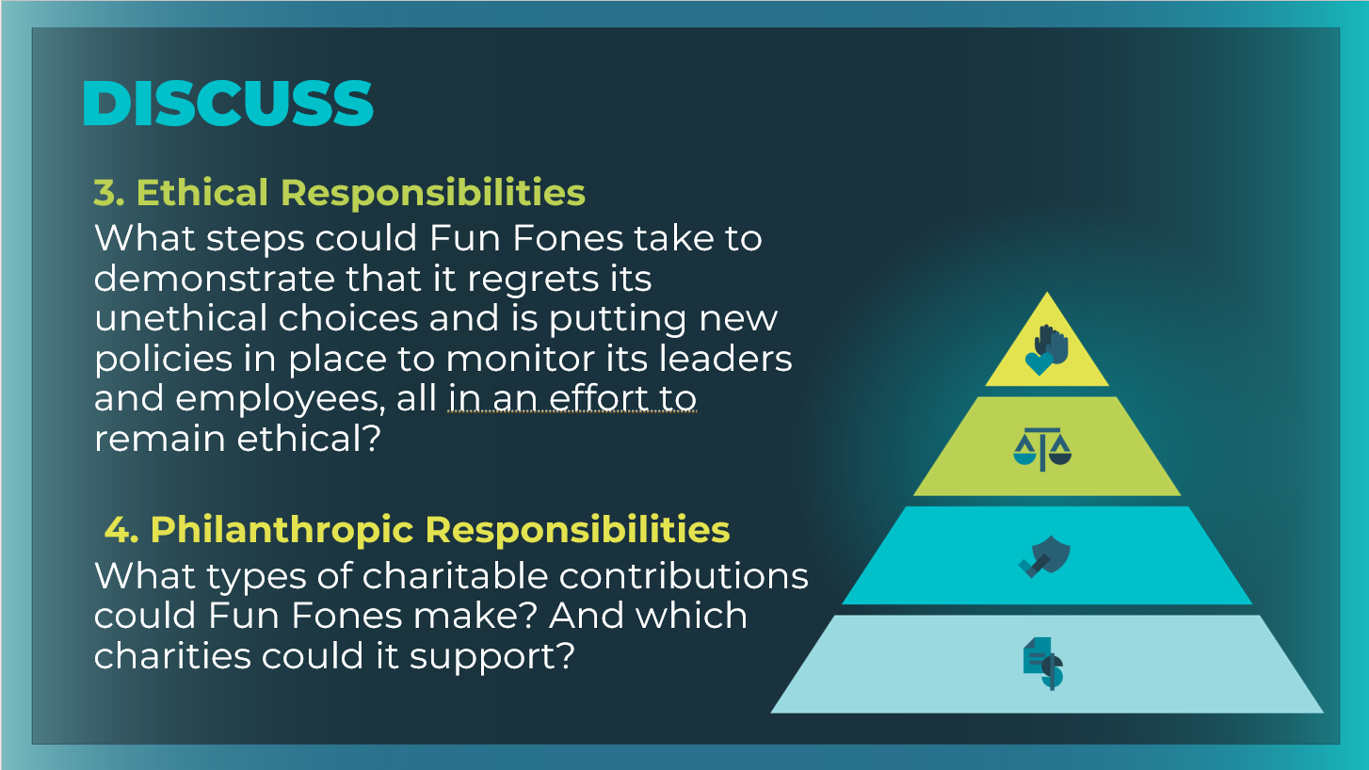 | After students have completed the activity, ask for volunteers from each group to offer suggestions for each of the four responsibilities, starting at the bottom of the pyramid with Economic Responsibilities.  Use the prompts on the slides to help guide the discussion.  Economic Responsibilities  - What kinds of things could Fun Fones do to get people to buy its phones again? Possible answers might include promotions, sales offers, an extensive marketing campaign that focuses on the positive changes Fun Fones is making to how it does business—anything to encourage customers to start buying again.  - The company might even consider issuing a public apology to address the public's concerns.  - Even though the company might make less profit per phone in the near term, it must get customers buying again, or it won’t be able to stay in business for the long term.  Legal Responsibilities  What types of laws could be written specifically for a technology-based business, such as a smartphone manufacturer? Businesses in general? Possible answers might include laws related to the safe production of electronic devices or phone batteries, Federal Communications Commission (FCC) laws, laws about protecting users’ data, and basic business-related laws (such as taxes).  Ethical Responsibilities  What steps could Fun Fones take to demonstrate that it regrets its unethical choices and is putting new policies in place to monitor its leaders and employees, all in an effort to remain ethical? Possible answers might include hiring an ethics officer to oversee the parts of the company where unethical behavior is most likely to occur: finances, employee benefits and protection, customer safety, or protecting the environment during manufacturing.  Philanthropic Responsibilities  What types of charitable contributions could Fun Fones make? And which charities could it support?  Possible answers might include contributing to a local charity or a project that shows an investment in the community (such as a new park, a fun run, or an after-school program for kids).
Wrap Up (5 mins)
Slide 24  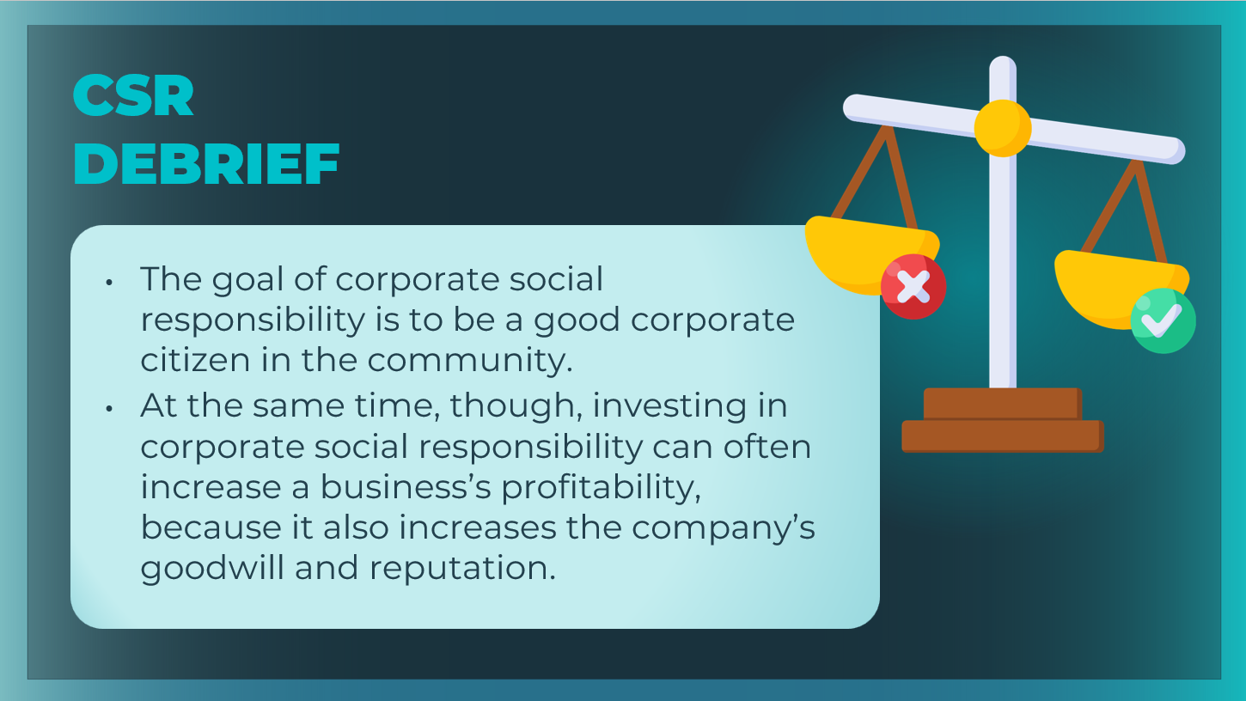 | Review the main ideas from this session with students.
Slide 25  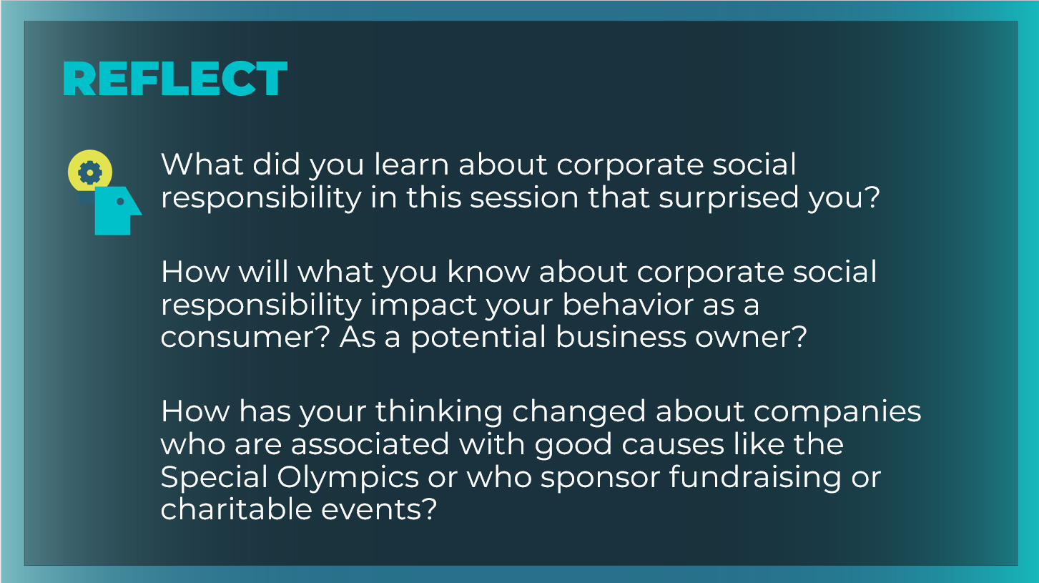 | Encourage students to reflect upon and share what they learned in the session.  What did you learn about corporate social responsibility in this session that surprised you? Answers will vary. Encourage students to use specific terms and concepts from the session to support their responses.  How will what you know about corporate social responsibility impact your behavior as a consumer? As a potential business owner? Answers will vary. Look for students to talk about whether they will now be more inclined to buy goods and services from companies who demonstrate a commitment to CSR and philanthropy and how they will approach their CSR responsibilities as future business owners.  How has your thinking changed about companies who are associated with good causes like the Special Olympics or who sponsor fundraising or charitable events? Answers will vary. Guide students to compare their responses during the Warm-Up at the beginning of the session with their thoughts now at the end of the session. Encourage students to talk about how their thinking has changed, and why.  Ask the following question of students who are also using the JA Titan simulation.  How can you apply the corporate social responsibility principles you have learned in this deep dive session to your gameplay strategies in the JA Titan simulation? Answers will vary. Encourage students to relate what they have learned about the CSR pyramid and the four responsibilities within it to the CSR business decisions they will need to make in the simulation.  Students can record their reflections in their student workbook, page 40.

