

Session 7: Considering Economic Factors Presenter Notes
The Presenter Notes have been developed using references from the digital classroom presentation and can be used in combination with the JA Titan Simulation and Student Workbook.
This gameplay session examines external economic factors that can affect the performance of a company, an industry, or an entire economy. Students explore the factors that affect companies in the JA Titan simulation and in real life.

The key concept for students to learn during this session is that companies are affected by events and situations outside of their control and even outside of their entire industry. Company decision makers will confront scenarios in which their current strategy may not work; in response, they may need to analyze the available data and pivot to a new strategy.

This session requires gameplay in multiplayer mode in the JA Titan simulation.

Refer to the Scenario Games Guide in the appendix for setting up any of the eight scenario multiplayer games and guiding questions to use with students. Select the scenario based on students' prior knowledge of economic concepts and time available to complete the preset game length.

This session takes approximately 60 minutes to complete, but times may vary based on the scenario chosen and students’ previous knowledge of business concepts.
Simulation Gameplay Setup
Decide whether students will play the JA Titan simulation in single-player or multiplayer mode. Suggested gameplay mode and settings are provided for each activity.
Single-Player Mode: Players compete as companies individually against the simulation’s artificial intelligence. Single-player mode is a learning tool designed for practice. The AI companies play at a moderately easy level.
- Players log in to the simulation and set up their own games.
- Players can analyze data for completed games in the Content Management System (CMS).
- Players choose the number of quarters (game duration) and starting cash-on-hand (difficulty level).
- Suggested gameplay settings for singleplayer mode are provided for the facilitator to share with students for each activity.
Multiplayer Mode: Players compete as companies (either individually or in teams) against each other.
- Multiplayer games are set up in the Content Management System (CMS). Tell students the name of the game to ensure they choose the correct game in the simulation lobby.
- This mode requires players to be playing together in real time (in class or remotely). Players log in to the simulation and join their assigned game.
- Add yourself as a player in the game to demonstrate the simulation to students.
- Game creators can monitor company results and analyze the game data in the CMS after each quarter and can access comprehensive data for completed games by downloading a CSV file. Student players can view selected data for completed games in the CMS.
- Game settings for all players are determined by the game creator for Custom games and are predetermined by the simulation for Scenario games. Suggested gameplay settings for multiplayer mode are provided for each activity.

Session 7: Considering Economic Factors
Slide 1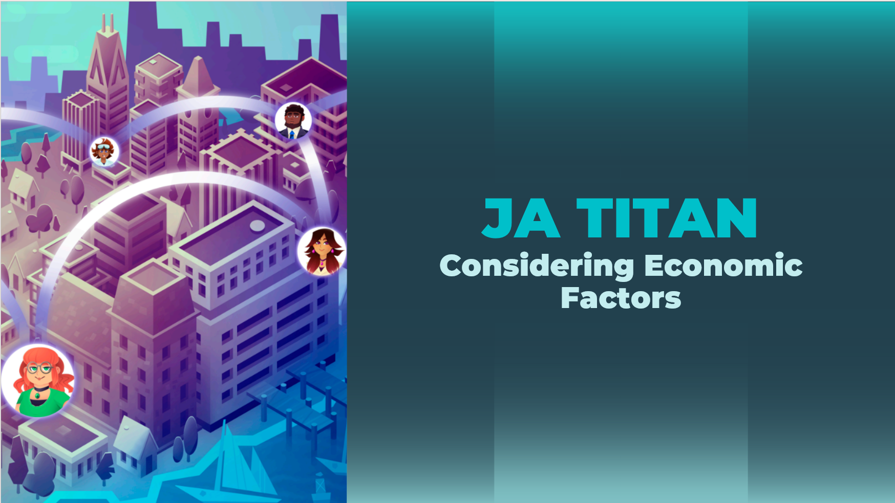
Slide 2  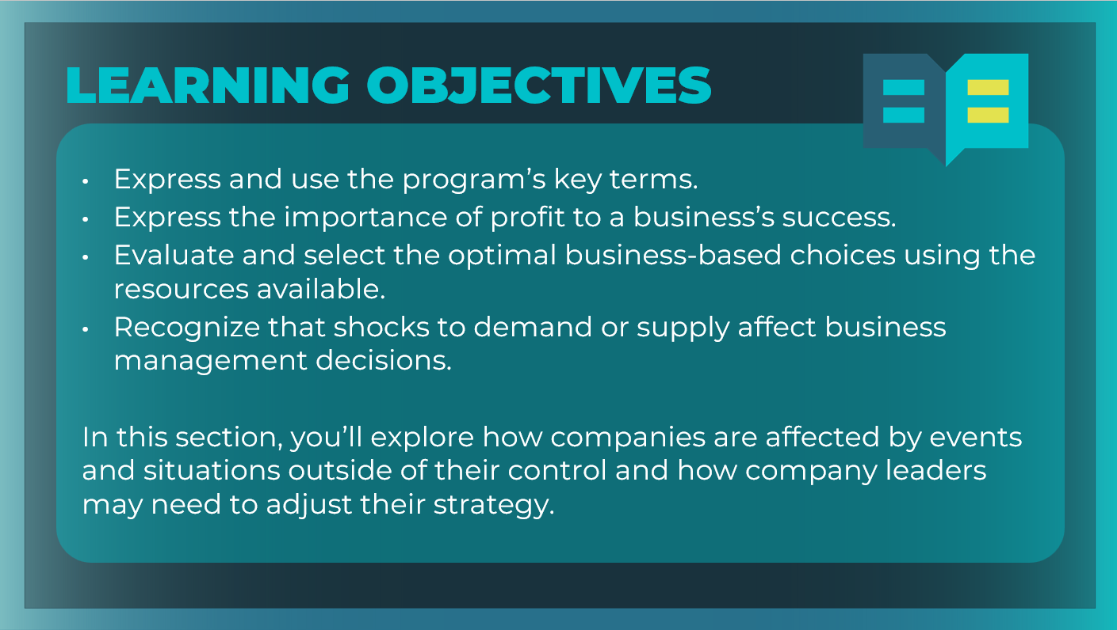 | Optional: Review the learning objectives for the session.
Slide 3  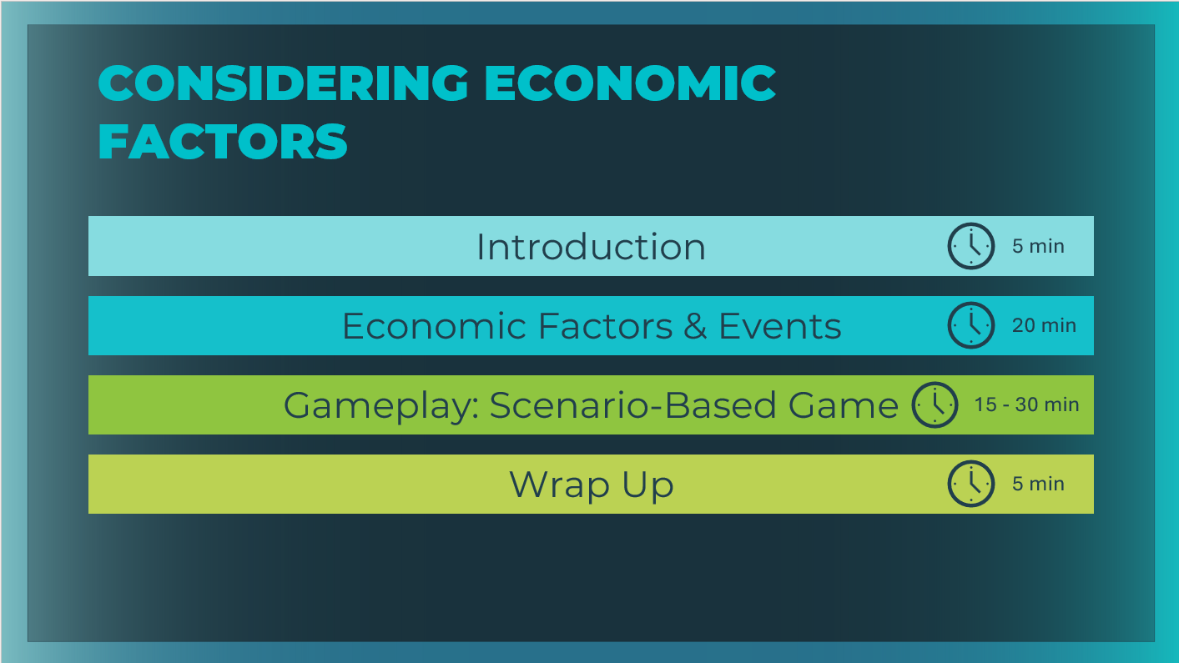 | *Select the button to navigate to the section.  After you have completed the section, you will be redirected to this menu.
Introduction (10 mins)
Slide 4  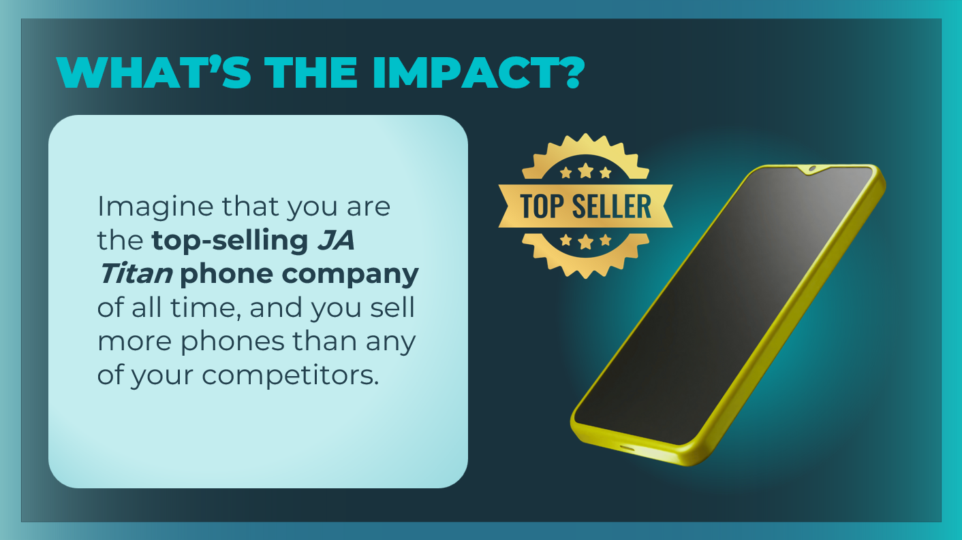 | Introduce the prompt on the slide.
Slide 5  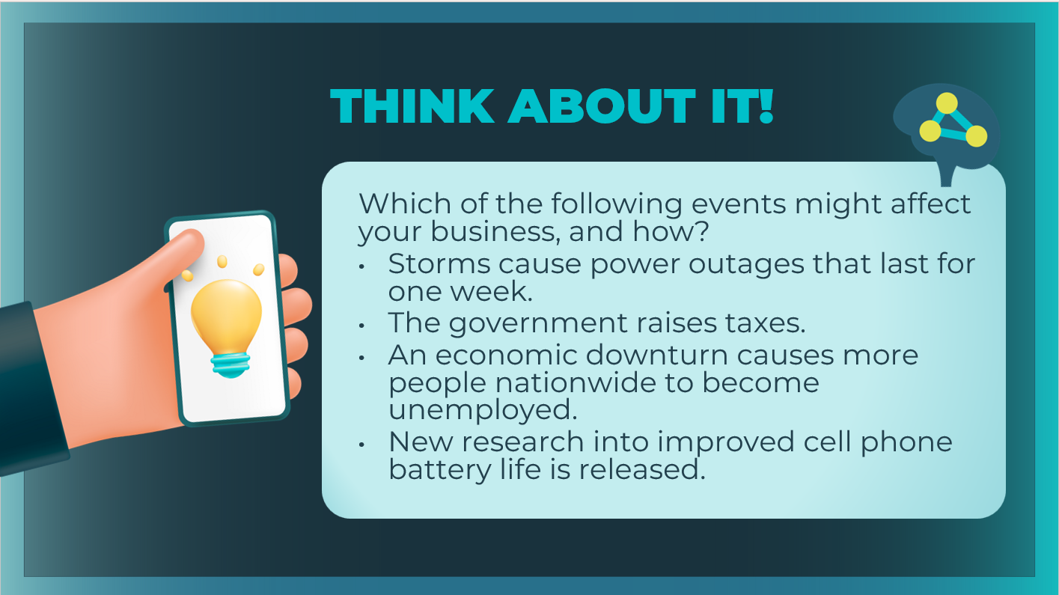 | Direct students to pair with a partner and briefly discuss and then share their thoughts on the prompt.  Possible answers: Each of these events could affect phone production, the phone market, consumers’ buying appetites, or technology research and development. Each of these events could change the cost of production, the number of customers willing and able to buy cell phones, or the technology that those customers suddenly want.  Optional – extend the discussion further with the following prompts:  - What if your company invested heavily in DVDs right before video streaming became popular?  - Or in cameras before there was one on every cell phone?  Explain that in some games in the JA Titan simulation, there might be a scenario that will require them, as CEOs, to analyze new data and adjust their business decisions on the fly.
Slide 6  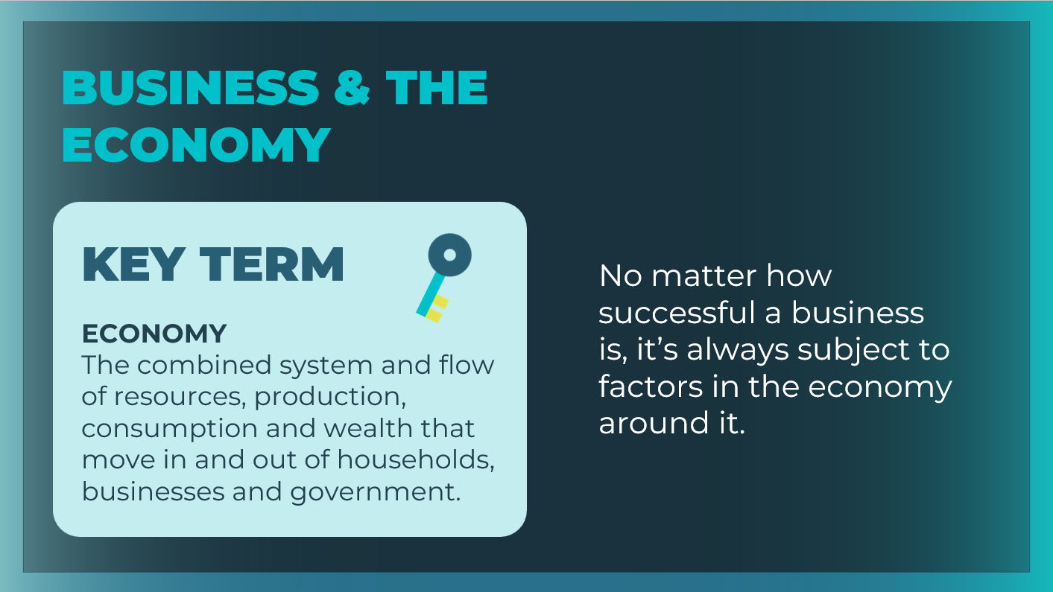 | No business is an island that can make decisions without being affected by the larger economy.  Review the definition of the key term as needed.
Economic Factors & Events (20 mins)
Slide 7  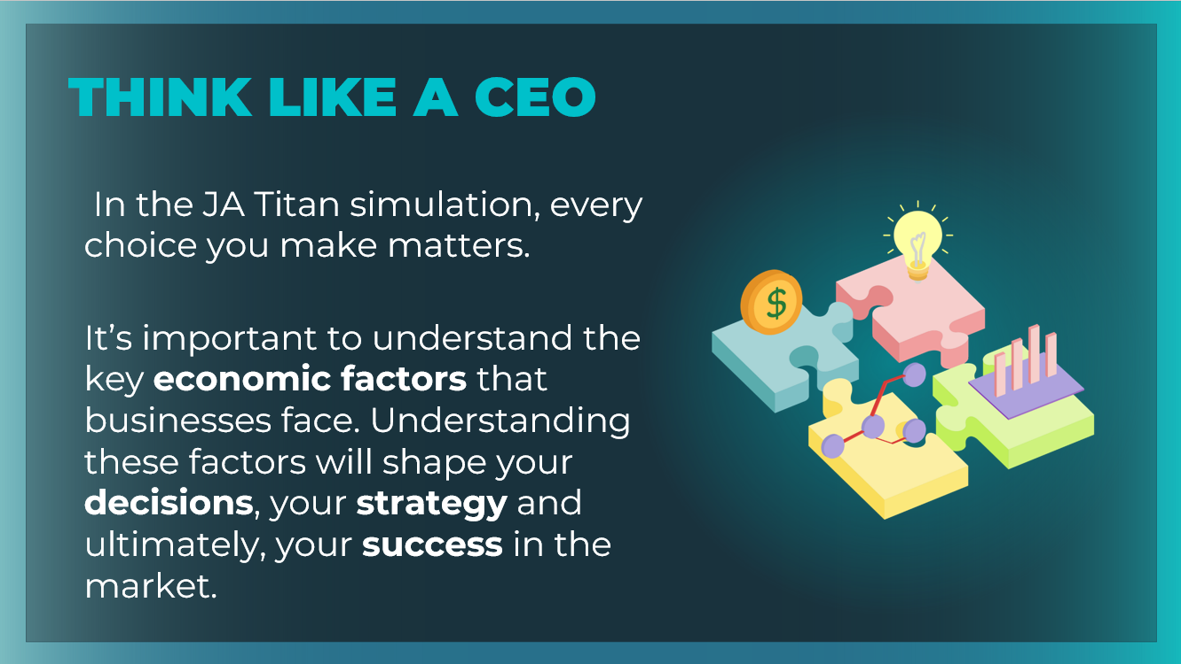 | Companies are affected by events and situations outside of their control and even outside of their entire industry. Company decision makers will confront scenarios in which their current strategy may not work; in response, they may need to analyze the available data and pivot to a new strategy.  Introduce that there are different economic factors and events that might affect them in the JA Titan simulation. Explain that you will learn about each of them in this section.
Slide 8  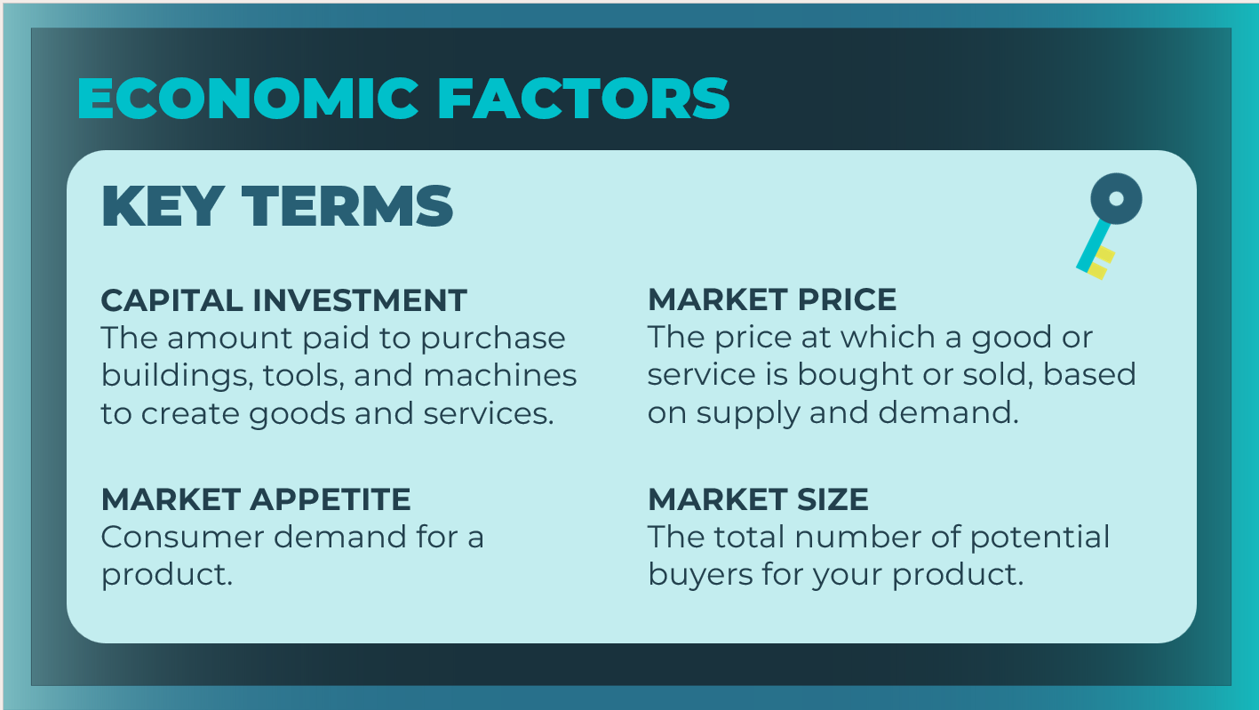  Slide 9  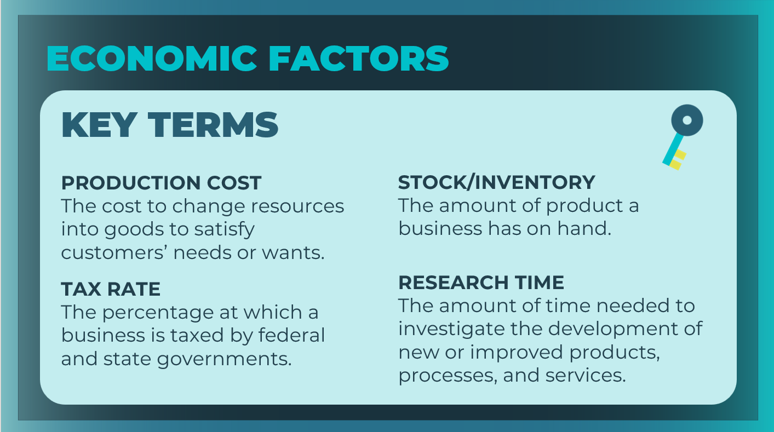 | Review the economic factors and meanings. Students can add the definitions to their student guide, page 24-25.  As you review the following slides, students fill in the possible effects for each economic factor in the table.
Slides 10 - 18  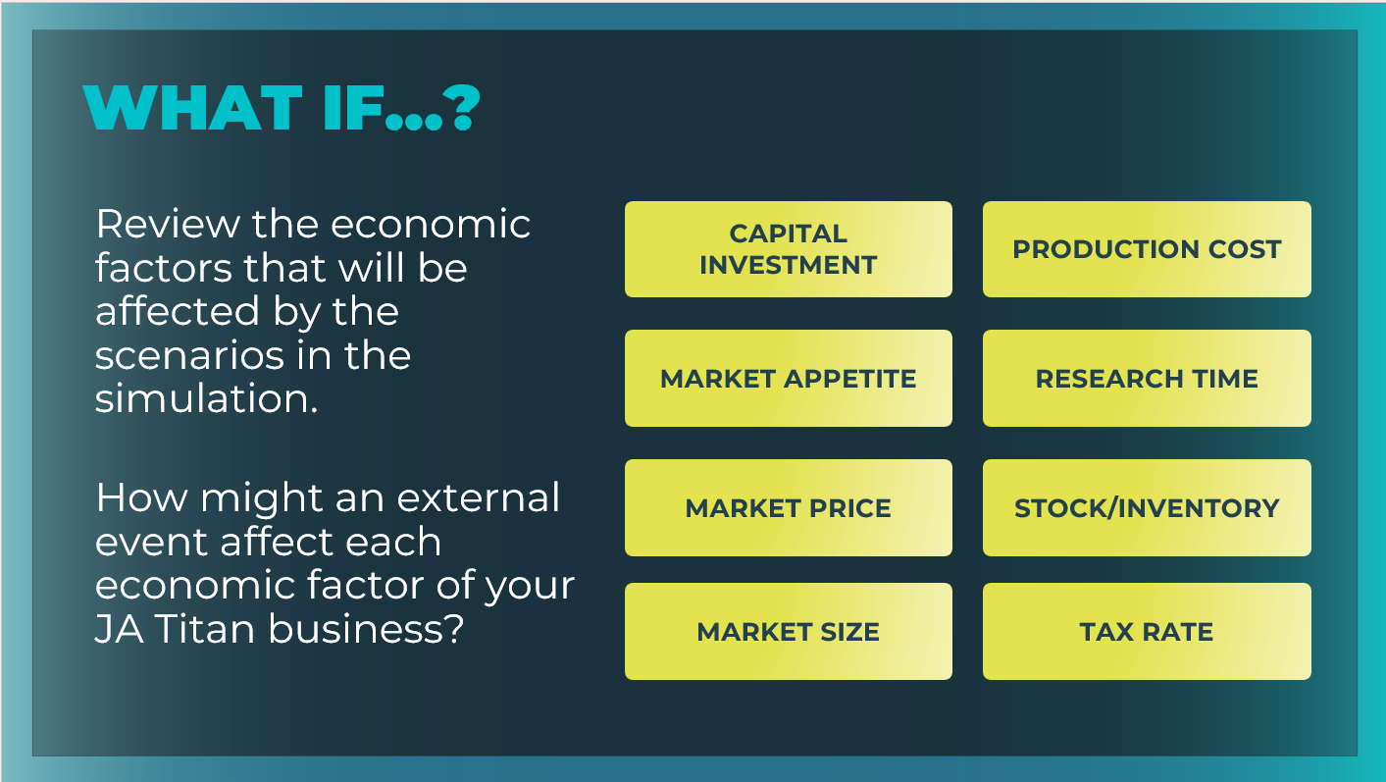 | Ask students how an external event could impact each economic factor of their JA Titan businesses. Discuss the students’ ideas and then select each factor on the slide and discuss the examples provided (click or tap to select the factors). Point out any ideas of concepts that the students did not mention.  Remind students to fill in the possible effects for each economic factor in the table in their student guide, page 24-25.  After reviewing each of the factors, encourage students to reflect by engaging students in a discussion with the following question.  Imagine you are the CEO of a phone company. Which of these factors would have the biggest impact on the company and why?  Accept answers backed by program content and ideas.  Depending on the exact circumstances, any of those economic factors could have a significant effect on a company, especially a technology-based company.
Slides 19 - 27  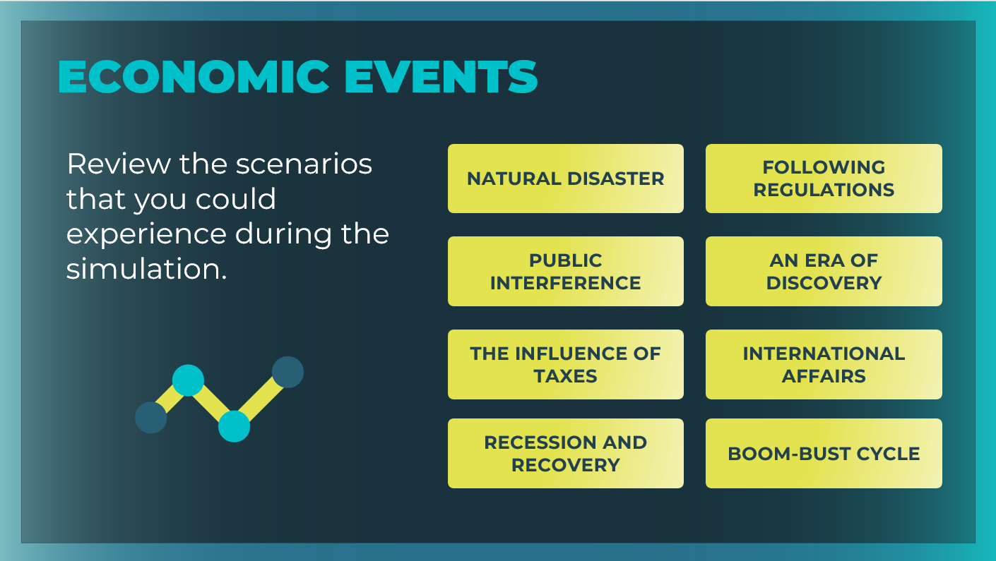 | Review each of the scenarios that students could experience during the simulation by selecting each of the economic events (click or tap to select the events).  Share with students how they will know when a scenario event is  occurring in the game. You will know that a scenario event has occurred when a pop-up message appears on screen.  Emphasize that if students are playing in teams during the scenario simulation, whoever is in the “hot seat” for the team should not close the pop-up message until the entire team has carefully read the message and noted the key details.  Encourage students to note what scenario event has occurred in their Student Activity: Considering Economic Factors.  In order to win the simulation, you will need to carefully review any economic events and adjust your business decisions accordingly.
Gameplay: Scenario-Based Game (20-30 mins)
Slide 28  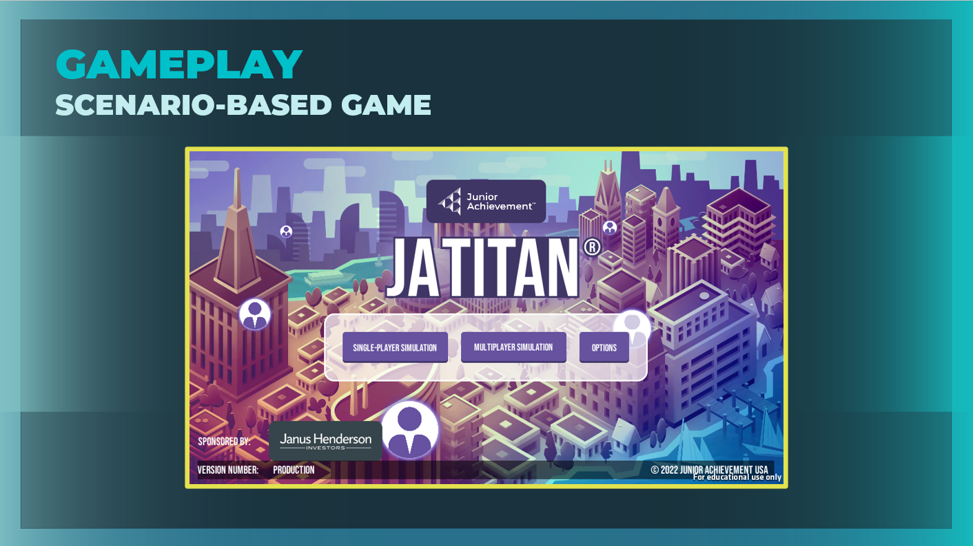 | Explain to students that they will play a scenario-based game in the JA Titan simulation.  In scenario games, special events take place during the course of the game. These events affect economic parameters across all companies within the game, requiring players to navigate the economic changes through the business decisions they make.
Scenario-Based Game
For this scenario-based game session, you will need to create a scenario multiplayer game in the CMS for this session. When selecting a scenario game, you will NOT be able to adjust the quarter duration and starting cash, because those are predetermined within each scenario.

There are eight different scenario games. This session models how to implement the Natural Disaster scenario. This session requires students to play the simulation in multiplayer mode. Players are unable to access scenario games in single-player mode.

If students will be completing this session on their own as a self-guided experience, you will need to create a Natural Disaster scenario game with Automatic quarter completion. Communicate clearly to students:
- The name of the scenario game
  - The date to play the scenario game
  - The time by which they need to have logged in, chosen their company name and logo, and selected their Advisor. If students have not completed these steps by the time the game is set to start, they will be locked out of the game.

JA Titan Simulation:
https://jatitancanada.org/login

Suggested settings for Scenario Multiplayer Game:
Quarter Settings |  | Game Settings |  | Company Setup
Quarter Completion | Game Type | Cash-on-Hand | Duration
Manual | Scenario: Natural Disaster | Scenario default ($4 million) | Scenario default (4 quarters) | Players as Companies

Refer to the appendix for additional details on running scenario games.
Wrap Up (5 mins)
Slide 29  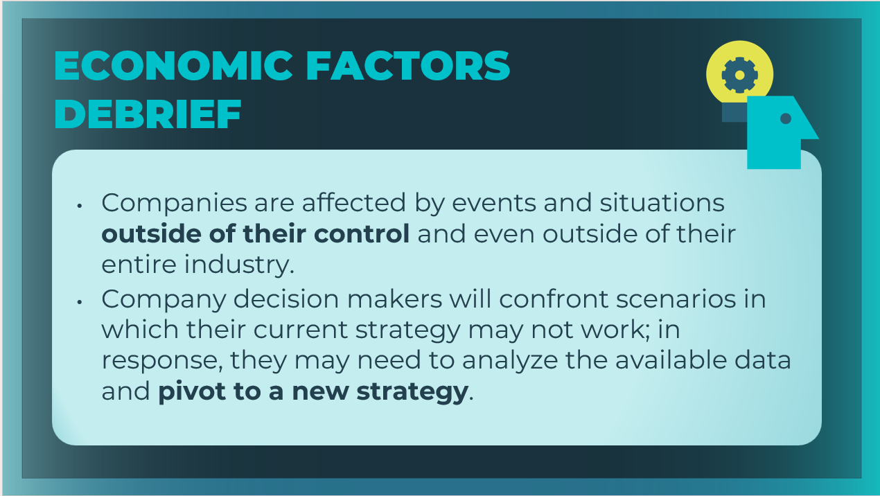 | Debrief  Review the main ideas from the session listed on the slide.
Slide 30  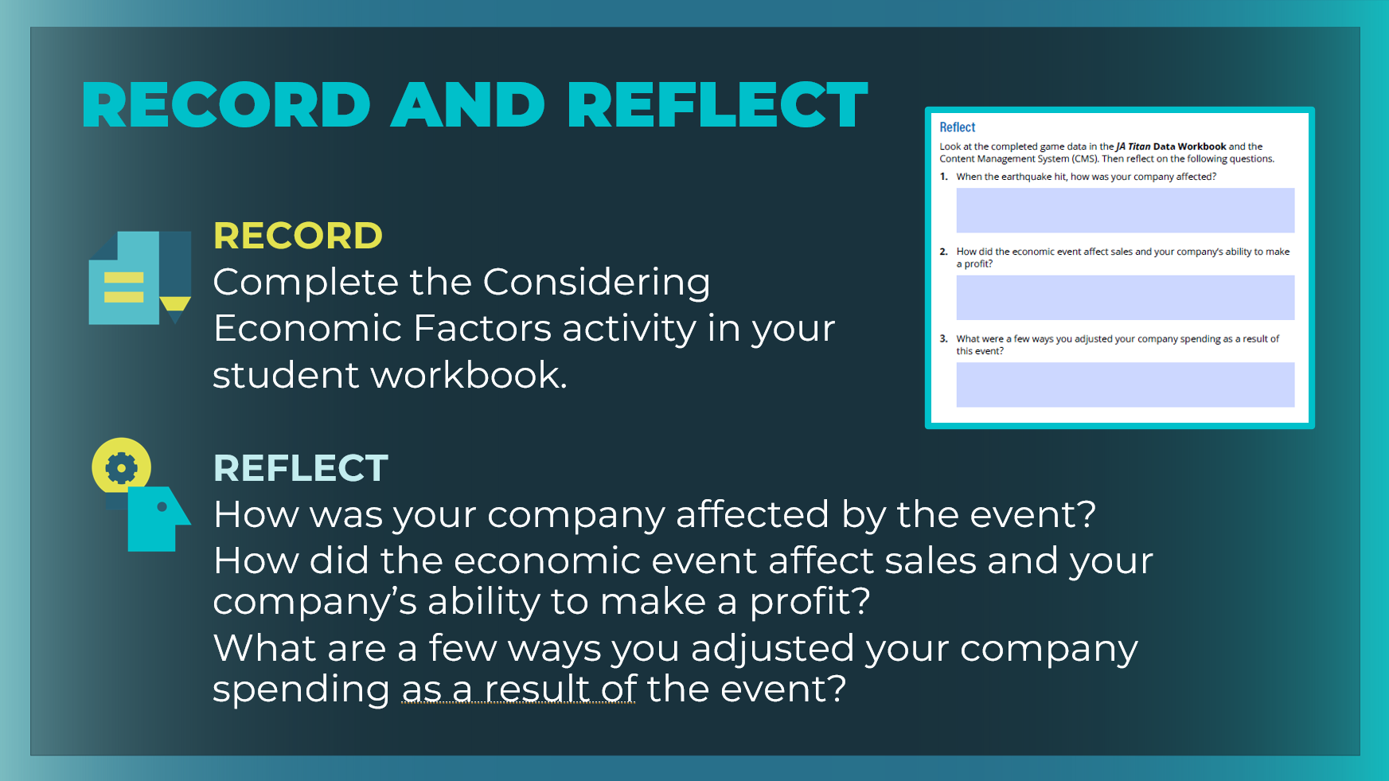 | Direct students to pages 24-26 in their student workbook and ask them to review and complete any notes and definitions for the key terms. Students can also respond to the questions to reflect on the learning from their gameplay session.  Encourage students to reflect upon and share what they experienced during the natural disaster scenario by asking one or more of the following questions:  - When the earthquake hit, how was your company affected? Companies lost a significant portion of their current phone inventory, and market appetite dropped considerably.  - How did the economic event affect sales and your company’s ability to make a profit? Answers will vary. Listen for students to talk about how they adapted their business decisions and strategies in response to reduced phone inventory and the drop in market appetite.  - What are a few ways you adjusted your company spending as a result of this event? Answers will vary. Listen for students to talk about how they made different budget decisions in response to the earthquake. Did they reduce their expenses in some areas of the business, but increase them in others? Encourage students to express reasons for their choices.

Appendix
Scenario Games Guide
In scenario games, special events take place during the course of the game. These events affect economic parameters across all companies within the game, requiring players to navigate the economic changes through the business decisions they make.
Tip: Scenario games should be reserved for games with at least three JA Titan companies. Otherwise, the expected outcomes of the scenario are not readily apparent.
Natural Disaster
In the Natural Disaster scenario, players are faced with a situation in which they lose a large percentage of their existing phone inventory to an earthquake and subsequently experience a significant drop in market appetite, meaning fewer customers are buying phones.

Players should adjust their production levels to recover the lost inventory while keeping in mind that they likely will make fewer
sales in upcoming quarters.
Natural Disaster Game Settings  • Duration: 4 Quarters  • Starting Cash: $4 million (USD)  • Difficulty Level: Easy  • Number of Scenario Events: 1 | Guiding Questions  - When the earthquake hit, how was your company affected?  - How did the earthquake affect sales and your company’s ability to make a profit?  - What are a few ways you adjusted your company’s spending as a result of this event?
Public Interference
In the Public Interference scenario, players experience how the public can affect business endeavors. Player should use their marketing teams to stay informed of emerging trends, and they should use their R&D teams to develop highly desirable phone features. Remind players that aligning their phone’s features with specific demographic groups’ desires (which they can determine by investing in market research) will help them secure sales.
In the second event, research times decrease when patents are deemed public domain, speeding up research across the board. Players should reassess their investment strategies for their Research & Development departments.
Public Interference Game Settings  - Duration: 8 Quarters  - Starting Cash: $2 million (USD)  - Difficulty: Moderately Easy  - Number of Scenario Events: 2 | Guiding Questions  - Popular trends can have a huge effect on what types of products are desired.  - How did the social media craze affect your phone sales?  - How did the decisions you made in your Marketing and Research & Development departments contribute to your ability to meet product demands?
Influence of Taxes
In The Influence of Taxes scenario, players deal with adjusted tax rates that directly affect their company’s revenue. In the first event, the tax rate is either increased or decreased. Players can see the effect of the tax rate change on their Income Statement (on the Budget tab) and should consider how the change will affect the company’s ability to make a profit.
In the second event, market appetite increases as a result of high tax refunds for consumers. Players should take advantage of this increased desire to purchase phones by expanding their production and marketing efforts.
Influence of Taxes Game Settings  - Duration: 8 Quarters  - Starting Cash: $2 million (USD)  - Difficulty: Moderately Easy  - Number of Scenario Events: 2 | Guiding Questions  - Did the tax rate change significantly affect your company’s ability to make a profit?  - How do taxes affect consumers’ spending habits? What changes did your company make to respond to these shifts?  - What business decisions did you make to capitalize on the increased market appetite?
Following Regulations
In the Following Regulations scenario, players explore the various effects that government regulations can have on businesses. In the first event, players are incentivized to make capital investments as a result of reduced construction costs for factories, laboratories, and branches.

Later in the game, players will be faced with increased costs to run their facilities and conduct research. Players should reassess the number of facilities they have built and the operations level of each. If the cost of operating many facilities is overwhelming their company, encourage students to consider closing some facilities. As always, players need to balance their expenses and revenue by adjusting their spending once their previous decisions become more costly.
Following Regulations Game Settings  - Duration: 16 Quarters  - Starting Cash: $1 million (USD)  - Difficulty: Moderately Difficult (because of the number of events)  - Number of Scenario Events: 3 | Guiding Questions  - Government regulations can have a significant effect on a company’s decision making. What is one way your company was affected during this scenario, and how did you respond?  - Did you take advantage of the decreased cost of capital investment by increasing the number of company facilities? How did that decision to expand affect your company later in the game?
An Era of Discovery
In the An Era of Discovery scenario, players learn how external research efforts
can affect their business. Within the two events of this scenario, companies will
experience both positive and negative effects as a result of research discoveries.

When investing in their Research & Development department, players should
consider changes to both the cost of research and the demand for features.

An Era of Discovery Game Settings  - Duration: 12 Quarters  - Starting Cash: $1 million (USD)  - Difficulty: Normal  - Number of Scenario Events: 2 | Guiding Questions  - How can external research discoveries affect a business?  - Did your R&D decisions change based on which features were desired and not desired?
Internal Affairs
In the International Affairs scenario, events within the global economy affect JA Titan companies. Production costs increase because of high tariffs imposed on the materials used to manufacture phones. Players should consider the increased cost to produce phones and should seek to optimize their cost per unit.

As foreign companies enter the marketplace and offer phones at a lower price, players must be vigilant in providing quality products to earn a profit on sales. Players may choose to adjust the features they add to their phones to reduce manufacturing costs.
Internal Affairs Game Settings  - Duration: 8 Quarters  - Starting Cash: $500,000 (USD)  - Difficulty: Moderately Difficult  - Number of Scenario Events: 2 | Guiding Questions  - What are some of the ways international events and businesses can affect your company?  - To meet the lower preferred market price, what adjustments did you make to your spending to ensure your company would maintain a profit?
Boom and Bust Cycle
In the Boom and Bust Cycle scenario, players navigate an economic boom
followed by an economic collapse. In both events, market appetite is greatly
altered, and players should capitalize on these shifts. When benefiting from the
high demand for phones, players are encouraged to expand their companies by
making capital investments and increasing production levels.

When the second event occurs and market appetite drops, players should reassess their spending across all departments. Encourage players to consider the number of facilities they have open and their operation costs.
Boom and Bust Cycle Game Settings  - Duration: 12 Quarters  - Starting Cash: $500,000 (USD)  - Difficulty: Moderately Difficult  - Number of Scenario Events: 2 | Guiding Questions  - During the “boom” phase of this scenario, what decisions did you make to grow your company?  - When the “bust” occurred, how did your company’s profit change? Was there a significant change in the revenue you earned per quarter?  - What are some ways you adjusted your company’s spending when the economy crashed?

