JA Central Ontario
Student Goals

Setting goals is an important part of learning and growing both personally and professionally. To get the most out of your program experience, you will need to reflect on what you want to achieve in the program. Remember to think about the SMARTER graphic below when creating your goals and to be honest and specific when it comes to what you want to achieve.

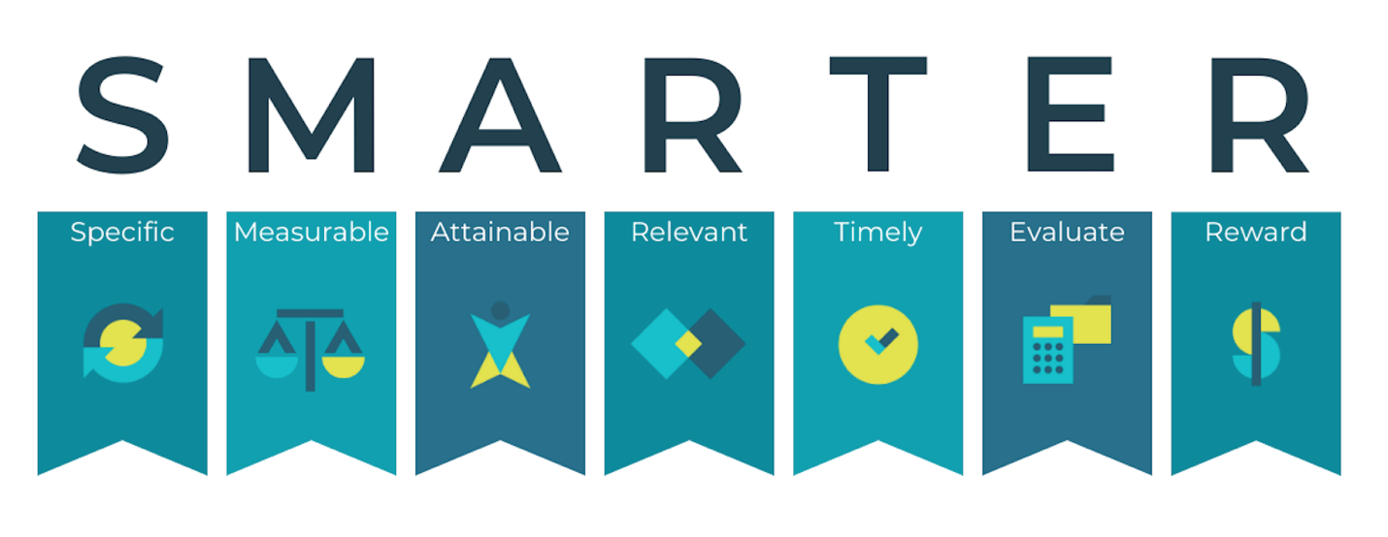

I am good at:
__________________________________________________________________________________________________________________________________________________________________________________________________________________________________________________________________________________________________

I am not so good at:
______________________________________________________________________________________________________________________________________________________________________________

I would like to improve on:
__________________________________________________________________________________________________________________________________________________________________________________________________________________________________________________________________________________________________

My personal goals in this program are:
____________________________________________________________________________________________________________________________________________________________________________________________________________________________________________________________________________________________________________________________________________________________

I am going to reach those goals by:
______________________________________________________________________________________________________________________________________________________________________________________________________________________________________________________________________________________________________________________________________________________________________________________________________________________

How can my teacher/peers help me achieve my goals?
__________________________________________________________________________________________________________________________________________________________________________________________________________________________________________________________________________________________________

If my plan to reach my goals doesn’t work, I will:
__________________________________________________________________________________________________________________________________________________________________________________________________________________________________________________________________________________________________

If I achieve my goals, my reward to myself will be:
_________________________________________________________

Signed by (you):
__________________________________________________________
Date:
__________________________________________________________

