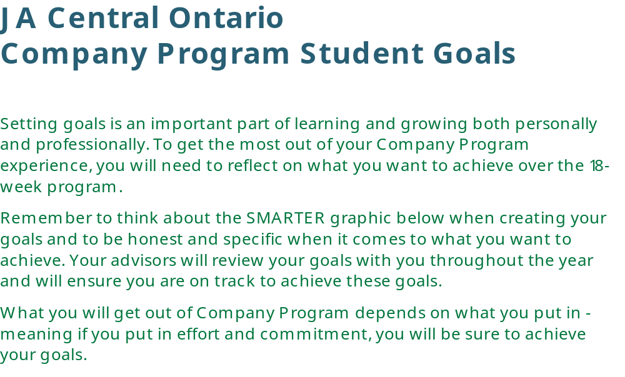
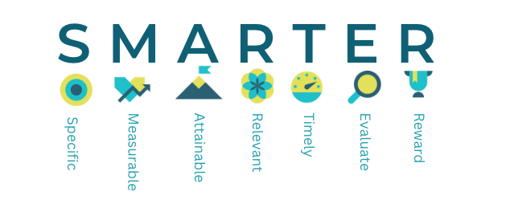
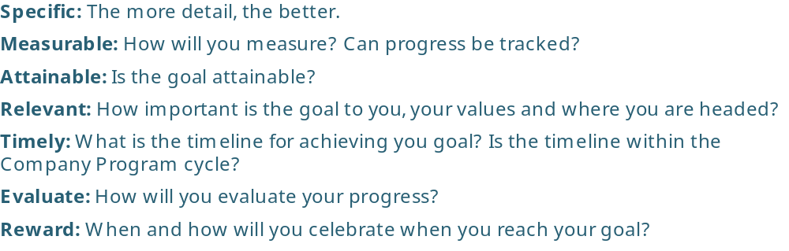

I am good at (my skills/strengths):
________________________________________________________________________________________________________________________________________________________________________________________________________________________________________________________________________________________________________________________

I would like to improve on (skills/strengths I want to develop):
________________________________________________________________________________________________________________________________________________________________________________________________________________________________________________________________________________________________________________________

My personal goals in Company Program are:
______________________________________________________________________________________________________________________________________________________________________________________________________________________________________________________________________________________________________________________________________________________________________________________________________

I am going to reach those goals by:
______________________________________________________________________________________________________________________________________________________________________________________________________________________________________________________________________________________________________________________________________________________________________________________________________

How can my advisors help me achieve my goals?
________________________________________________________________________________________________________________________________________________________________________________________________________________________________________________________________________________________________________________________

If my plan to reach my goals does not work out as planned, I will:
________________________________________________________________________________________________________________________________________________________________________________________________________________________________________________________________________________________________________________________

If I achieve my goals, my reward to myself will be:
_________________________________________________________

Signed by (you):
__________________________________________________________
Discussed with (advisor/s):
__________________________________________________________
Date:
__________________________________________________________

Company Program Mid-Year Check-in (January or February):

Am I on track to reach my goals? Yes No
Do you need to adjust or adapt any of your goals (have your goals changed)?
________________________________________________________________________________________________________________________________________________________________________________________________________________________________________________________________________________________________________________________

Does your plan to achieve your goals need to be altered? Yes No
If yes, how will you alter them?
________________________________________________________________________________________________________________________________________________________________________________________________________________________________________________________________________________________________________________________

Do you feel you are being mentored? Yes No
If not, in what areas would you like to be mentored more (personal skills, careers, business learning, etc.)?
________________________________________________________________________________________________________________________________________________________________________________________________________________________________________________________________________________________________________________________

Do you feel like a contributing member of the team?
Yes No
If yes, what are some ways you are contributing to your team?
________________________________________________________________________________________________________________________________________________________________________________________________________________________________________________________________________________________________________________________

If no, how can you and your advisors help to change this?
________________________________________________________________________________________________________________________________________________________________________________________________________________________________________________________________________________________________________________________

Write down one thing you have learned since the start of the year.
____________________________________________________________________________________________________________________________________________________________

Write down one thing you are excited for during the rest of the Company Program year.
____________________________________________________________________________________________________________________________________________________________

Signed by (you):
__________________________________________________________
Discussed with (advisor/s):
__________________________________________________________
Date:
__________________________________________________________

