

Session 2: Exploring Production Presenter Notes
The Presenter Notes have been developed using references from the digital classroom presentation and can be used in combination with the JA Titan Simulation and Student Workbook.
This gameplay session guides students deeper into the JA Titan Production department and the relevant simulation screens, features, and business decisions. This session focuses on the interconnected aspects of profit, profit margin, price, cost, competition, and market size.

The key concepts for students to learn during this session are that companies must make a profit if they want to stay in business, and they must produce a product before they can sell it. A company’s CEO must make several key decisions related to the Production department, including determining the cost of a product, deciding how much to mark up the cost of a product to set its sales price, and how many of each product to make.

This session takes approximately 60 minutes to complete, but times may vary based on students’ previous knowledge of business concepts.
Simulation Gameplay Setup
Decide whether students will play the JA Titan simulation in single-player or multiplayer mode. Suggested gameplay mode and settings are provided for each activity.
Single-Player Mode: Players compete as companies individually against the simulation’s artificial intelligence. Single-player mode is a learning tool designed for practice. The AI companies play at a moderately easy level.
- Players log in to the simulation and set up their own games.
- Players can analyze data for completed games in the Content Management System (CMS).
- Players choose the number of quarters (game duration) and starting cash-on-hand (difficulty level).
- Suggested gameplay settings for single-player mode are provided below to share with students for each activity.
Multiplayer Mode: Players compete as companies (either individually or in teams) against each other.
- Multiplayer games are set up in the Content Management System (CMS). Tell students the name of the game to ensure they choose the correct game in the simulation lobby.
- This mode requires players to be playing together in real time (in class or remotely). Players log in to the simulation and join their assigned game.
- Add yourself as a player in the game to demonstrate the simulation to students.
- Game creators can monitor company results and analyze the game data in the CMS after each quarter and can access comprehensive data for completed games by downloading a CSV file. Student players can view selected data for completed games in the CMS.
- Game settings for all players are determined by the game creator for Custom games and are predetermined by the simulation for Scenario games. Suggested gameplay settings for multiplayer mode are provided for each activity.

Session 2: Exploring Production
Slide 1   | Navigation Tips  - Navigate through the slides using the next or previous buttons (bottom right), clicking or tapping on the slide, or using the navigation menu (right).  - Look for slide specific instructions in the presenter notes below.
Slide 2  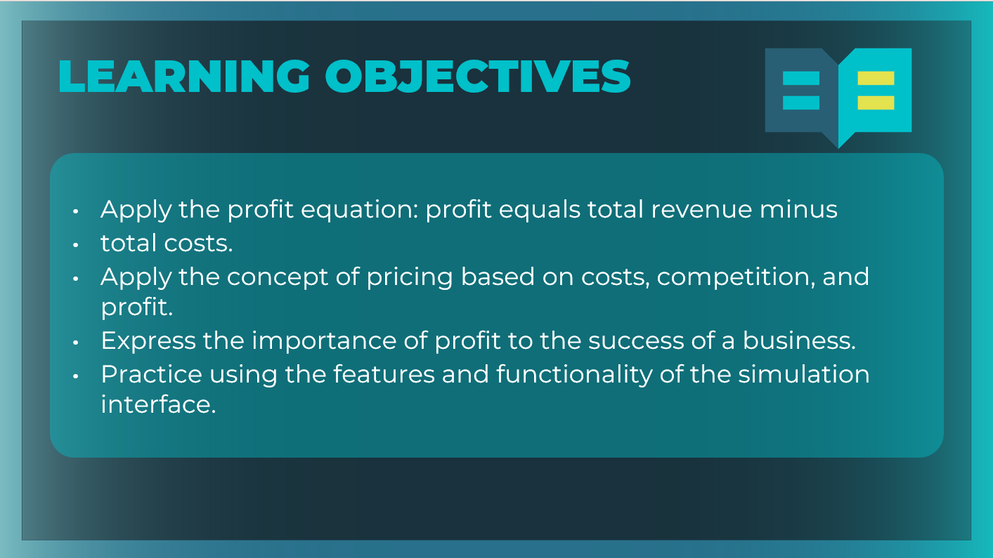 | Optional: Review the learning objectives for the session.
Slide 3  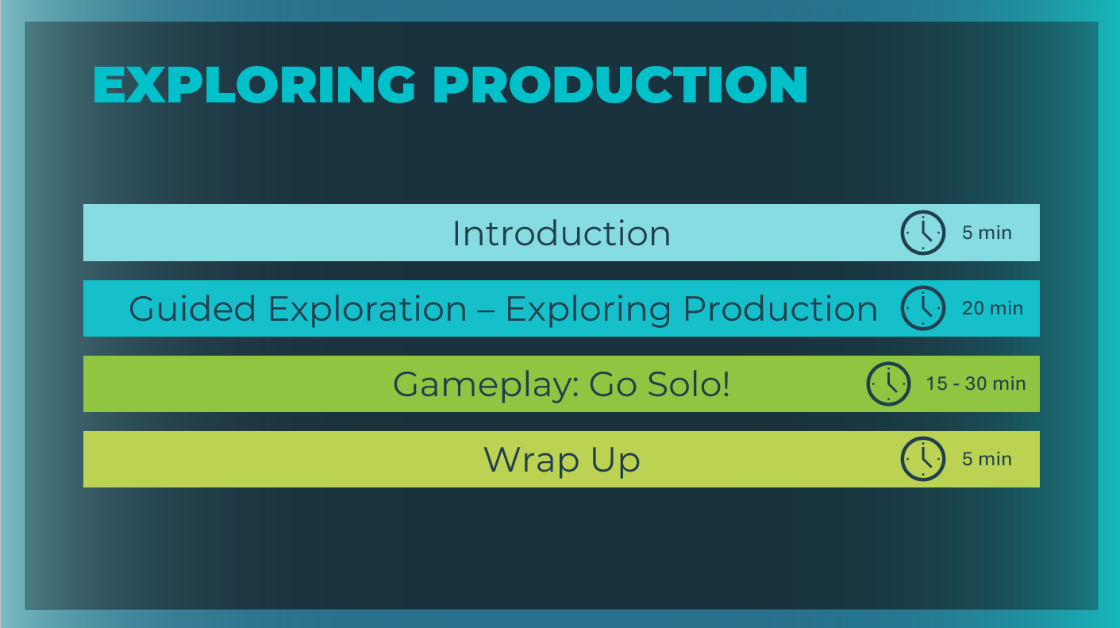 | *Select the button to navigate to the section.  After you have completed the section, you will be redirected to this menu.
Introduction (5 mins)
Slide 4  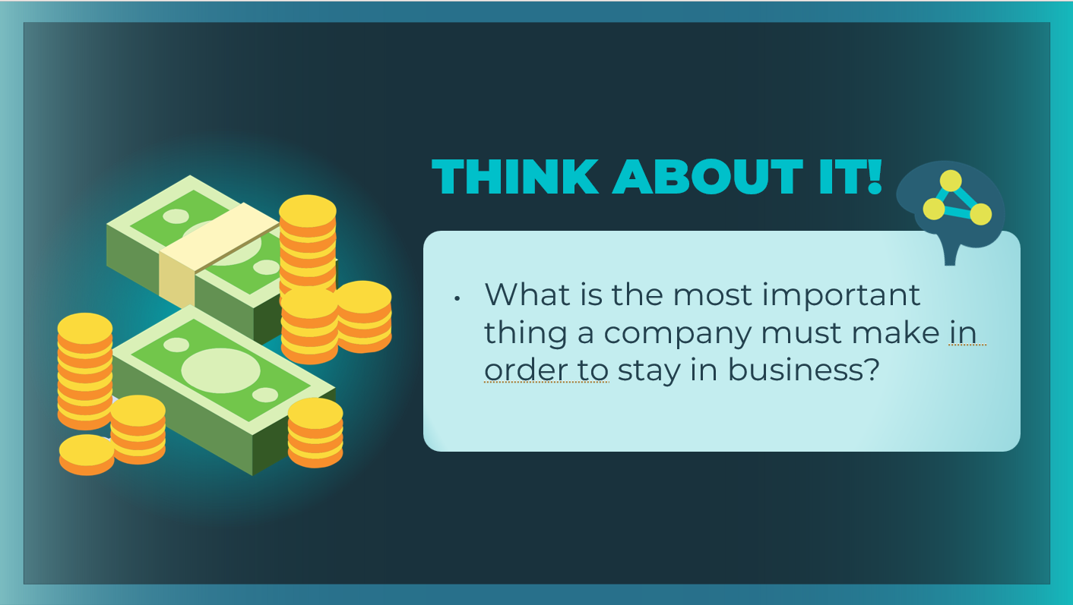 | Introduce the prompt to generate a discussion.  What is the most important thing a company must make in order to stay in business? Answers may vary. Point out that there are many essential aspects to a successful business, but in the long run, if the company is not making a profit, it will have to close its doors.
Slide 5  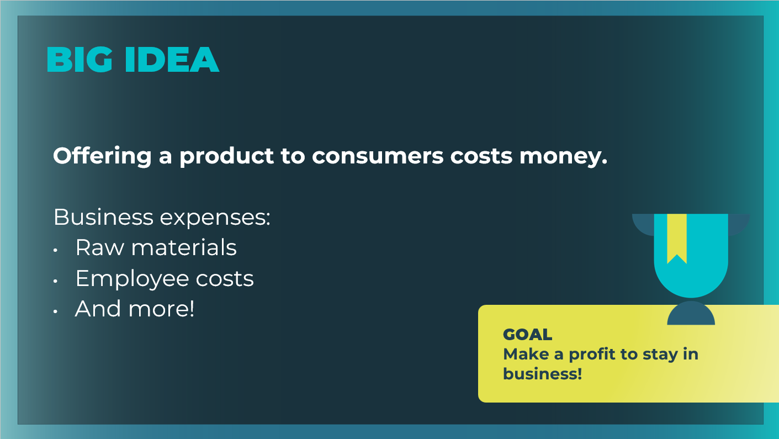 | Remind students that a business must produce a product before they can sell it, and that costs money.  Highlight that the goal is for a business to make a profit so they can continue to stay in business. Explain to students that businesses start with a very simple calculation to determine their profit.
Slide 6  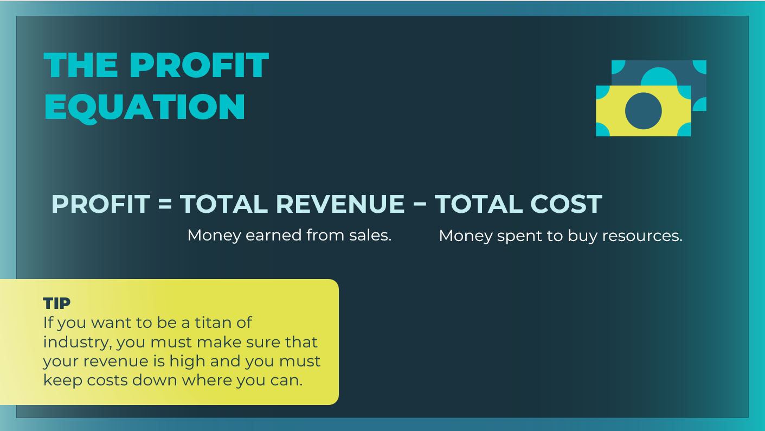 | To determine if they are making a profit, businesses use the profit equation. They add up their revenue (the money coming in) and subtract their expenses (the money going out). What’s left over is their profit.  Review the profit equation. Remember that revenue is the money earned from sales, and cost is the money spent to buy resources. If you want to be a titan of industry, you must make sure that your revenue is high, and you must keep costs down where possible.  Direct students to the Discuss: Profit Equation section of their  Student Workbook: Exploring Production and have them fill in the profit equation on page 16.
Slide 7  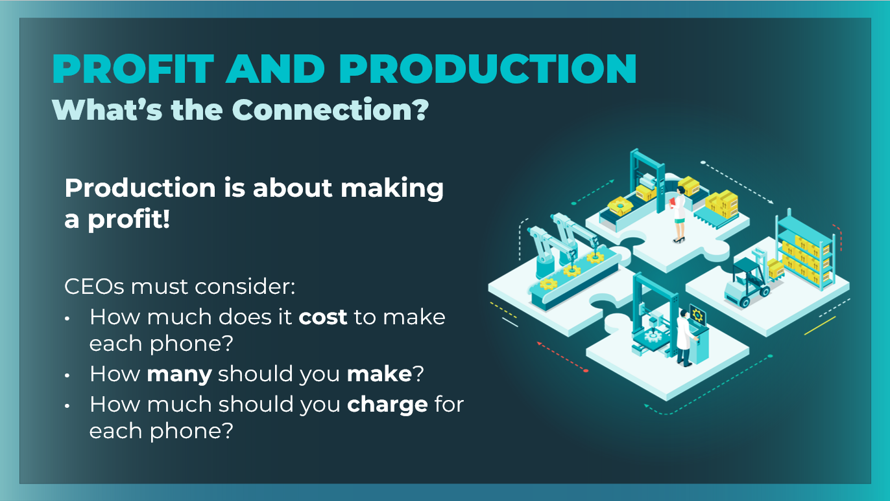 | Emphasize that production is about making a profit. And for that reason, we must pay attention to some very important data.  - How much does it cost to make each phone?  - How many should you make?  - How much should you charge for each one?  Explain that today students will be back in the JA Titan simulation. They will take a closer look at the Production department and will start thinking about the answers to some of these questions.
Slide 8  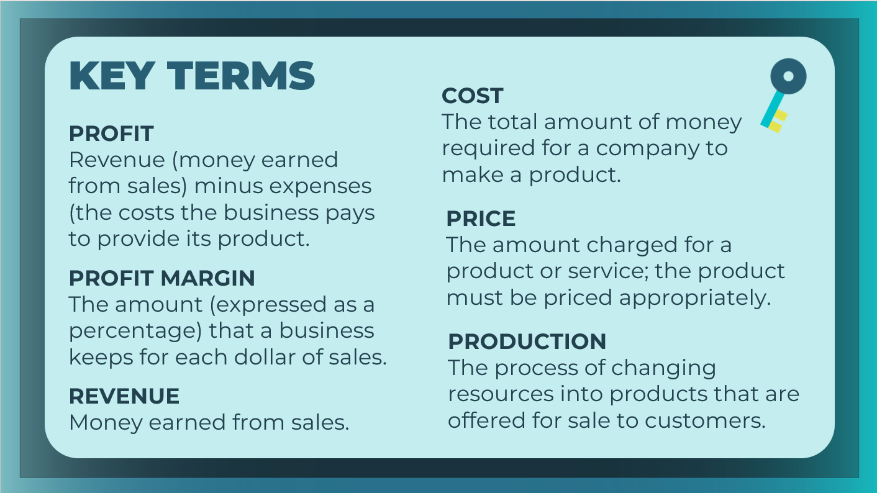 | Review the essential key terms for this session, as needed.  Students can record the definitions in their student workbook, pages 16-18.
Guided Exploration: Exploring Production (15 mins)
Guided Exploration
For this guided exploration session, you may choose to use the slides 9-24 to guide students through the game play, or you may choose to log in to the simulation yourself and use the presenter notes to guide your demonstration.

JA Titan Simulation:
https://jatitancanada.org/login

Suggested Game Settings for Game 1: Production
Single-Player & Multiplayer Settings
Cash-on-Hand | Duration
$4 million (easiest) | 4 Quarters (1 year)

Multiplayer Only Settings
Game Name: Game 1: Production
Quarter Completion | Game Type | Company Setup
Manual | Custom | Players as Companies

Slide 9  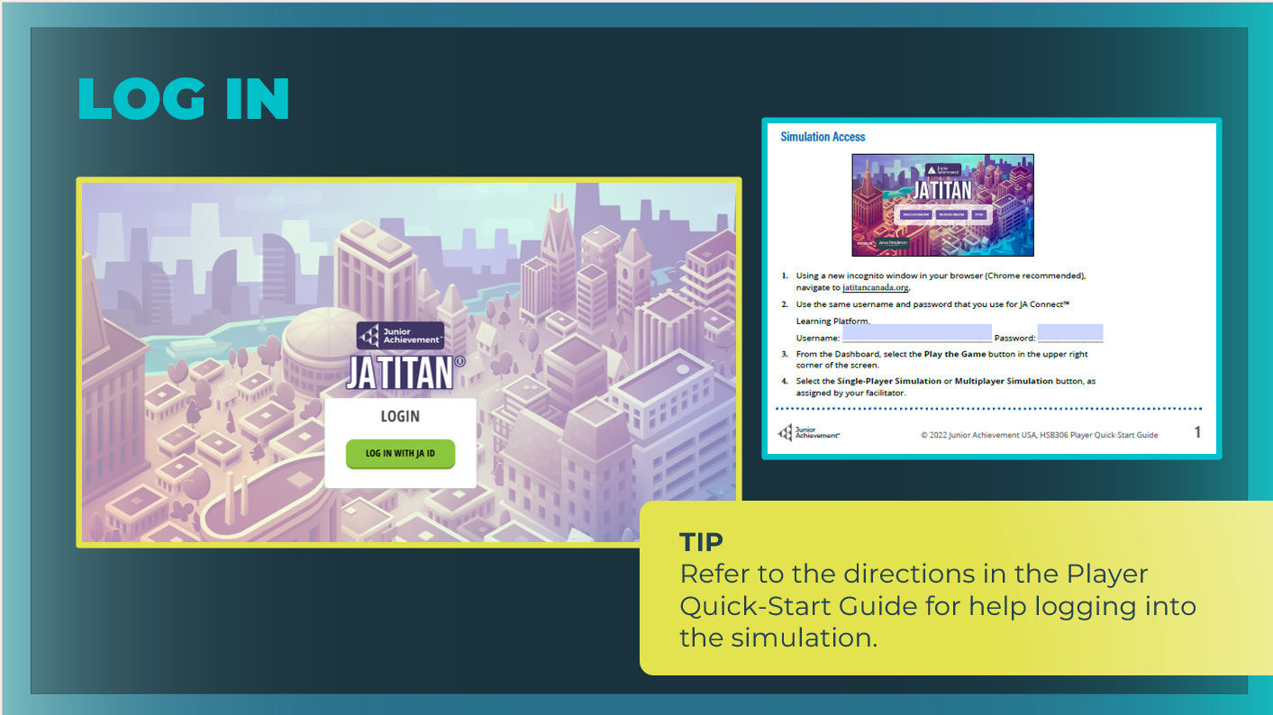 | Explain to students that you will guide them through the functionality and terminology of the Production department.  Direct students to log in to the JA Titan Simulation following the directions in the Quick Start Guide as needed. Emphasize that they stay on pace with you as you guide the session and should wait to select the Next Quarter button until instructed to do so.  Give students a minute or two to choose their company name and logo and select their advisor. This should be a quick task that they complete with each new game.
Slide 10  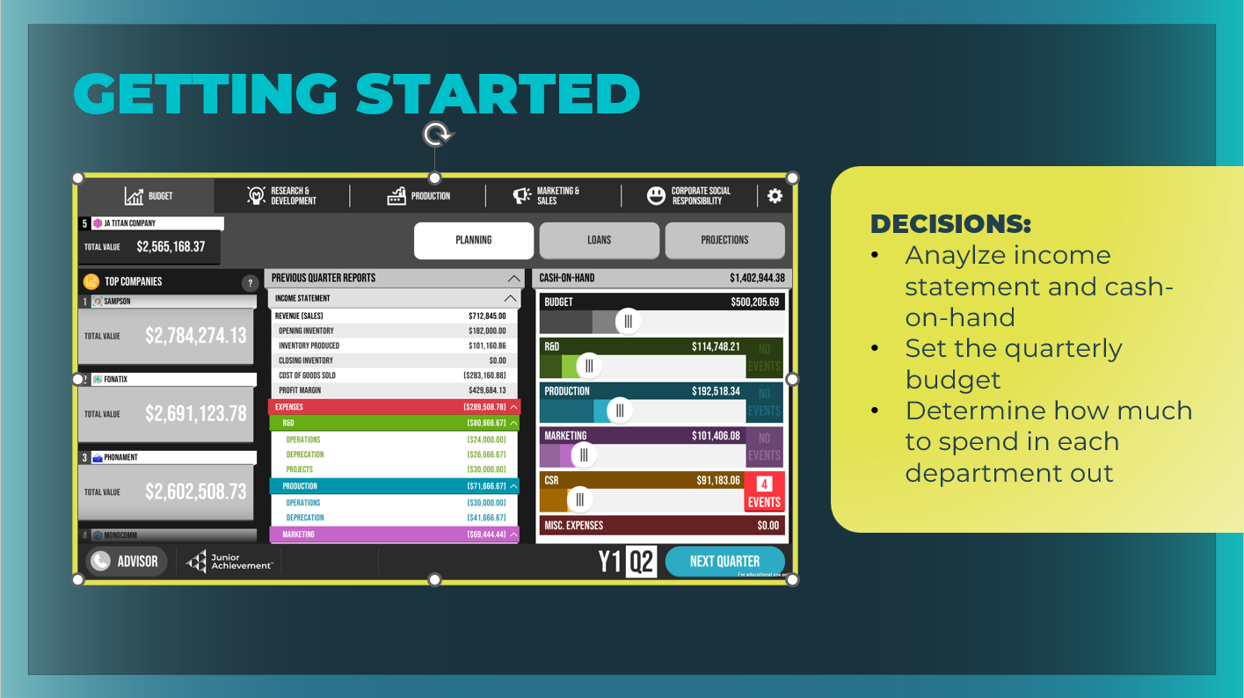 | Explain that there are two main simulation tabs that deal with  production: Budget and Production. Whenever players start the  game, they should start with the key decision of setting the company budget for the quarter.  Discuss with students the key decisions:  - Analyzing the income statement and cash- on-hand, and setting the quarterly budget are their first key decisions for this tab.  - Determine how much to spend in each department out of that limited amount.  Facilitator tip: Demonstrate how to grab the sliders for each department, and distribute the allocated budget among the R&D, Production, Marketing & Sales, and CSR departments.  Reminder: The amount spent in the four departments must equal the initial budget amount for the first quarter.  Give students some time to make decisions for their budgets.
Slide 11  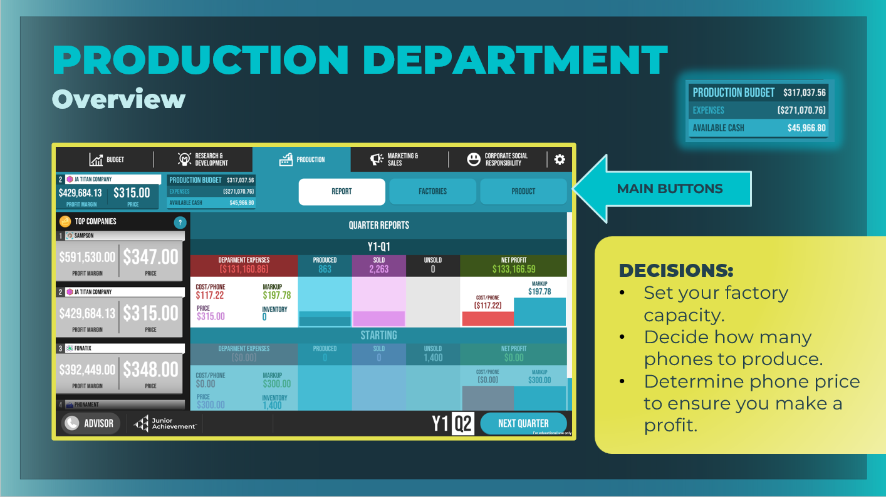 | Ask students to select the Production tab.  Remind students that making a profit is essential, so they will need to carefully consider how to maximize revenue and minimize costs.  Highlight the main areas of the Production tab, including the Report, Factories, and Product buttons and the key decisions they will make regarding their factory capacity and their product.  - Report: View your previous quarter’s results and data about the number of phones produced and sold for each quarter and the associated production costs.  - Factories: Manage the capital and decide your factory's maximum capacity.  - Product: Decide how to use your budget for this quarter to produce new phones based on how much each phone costs to make; determine how many to produce, the selling price for each phone so that you make a profit, and select the built-in features for your phone (developed by investing in R&D).  Note that the leaderboard ranks each company by its highest profit margin (Production victory currency). It also shows the phone price set by each company in the previous quarter.  Note the production budget. This is the amount that you allotted on the Budget tab minus the amount you are committed to paying this quarter for this department. Students can return to the Budget tab and change the allotted amount as needed.
Slide 12  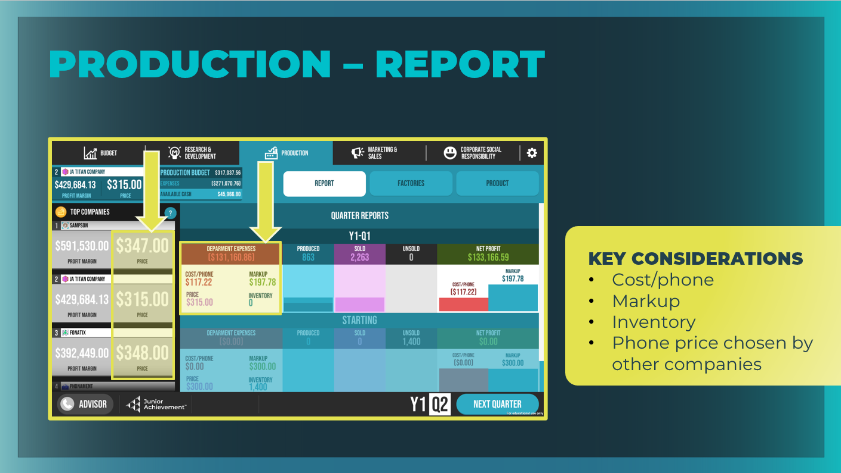  Slide 13  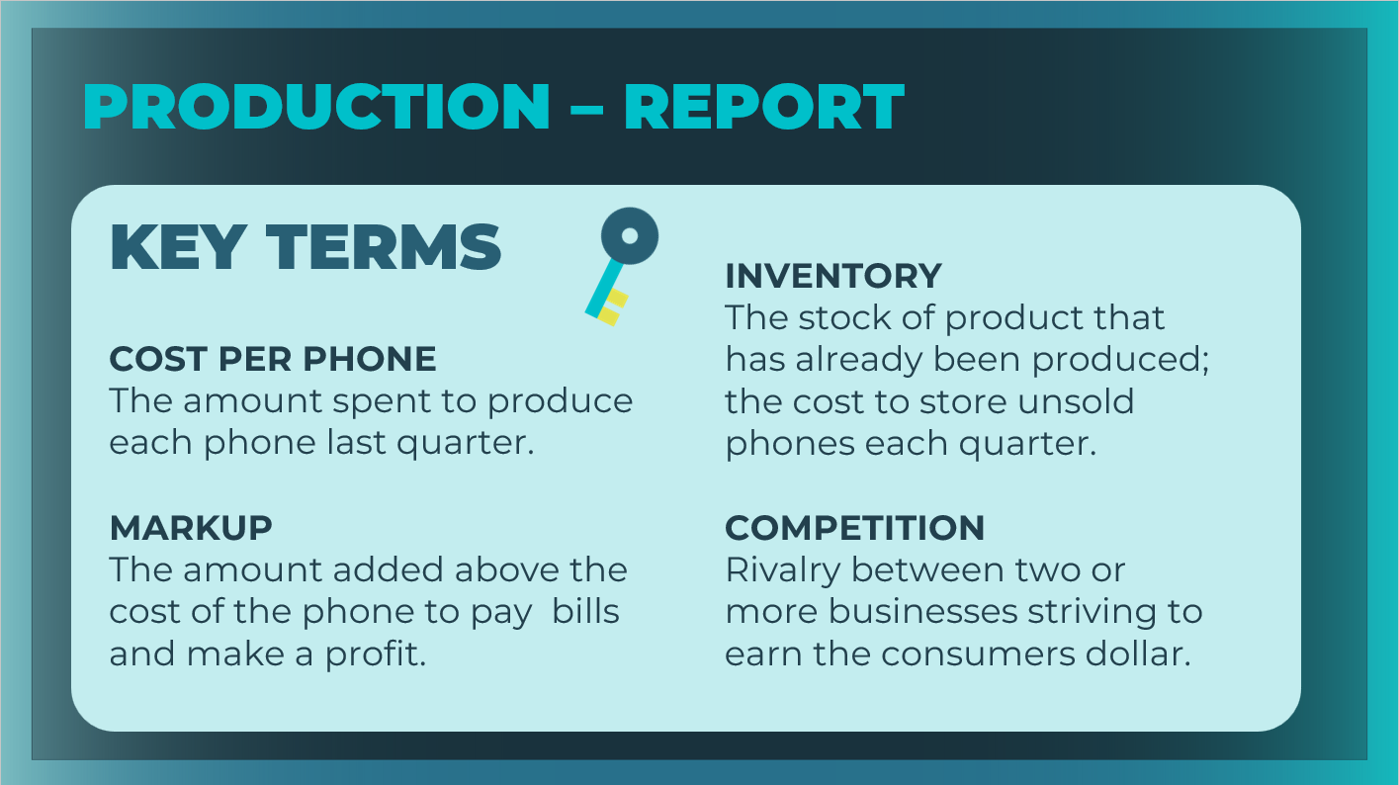 | Ask students to select the Report button. Although there are no decisions to be made on this screen, point out that it contains important data from the previous quarter that students will need to consider before making key decisions for the upcoming quarter.  Review the key areas to considers.  - Cost per phone  - Markup  - Inventory  - Phone price chosen  Hint to students that before they decide how many phones to produce, they should check how many phones they already have in inventory.  Point out the phone unit price chosen by other companies in the Top Companies column.  - Why might it be helpful to know the price your competitors are charging for their phones? Customers use price as a key factor in deciding between products that they are interested in buying. When setting your phone unit price, it is important to consider whether your competitors are willing to sell for less.  Review the key terms as needed. Students can record the definitions in their student workbook, pages 16-18.
Slide 14  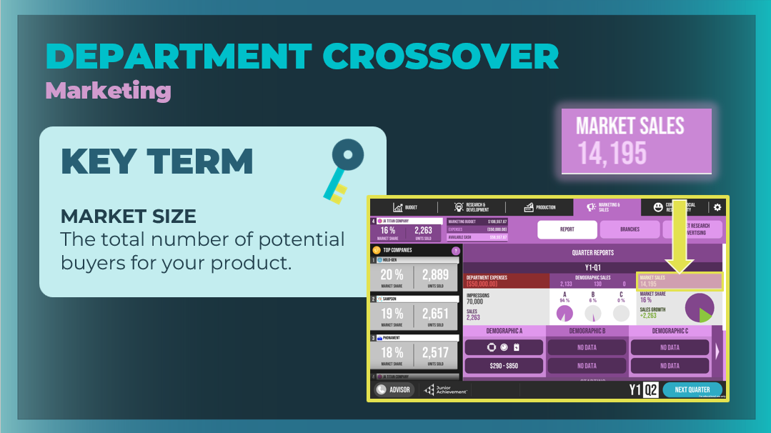 | Department Crossover – Marketing & Sales  Tell students that they have one more piece of data to collect before they make their Production decisions.  Ask them to select the Marketing & Sales tab and the Report button. Point out to students that they should look at their market size (the number listed under Market Sales) so that they know how many buyers are available to buy their phones before they determine how many phones to produce.  Review the key term as needed. Students can record the definition in their student workbook, pages 16-18.
Slide 15  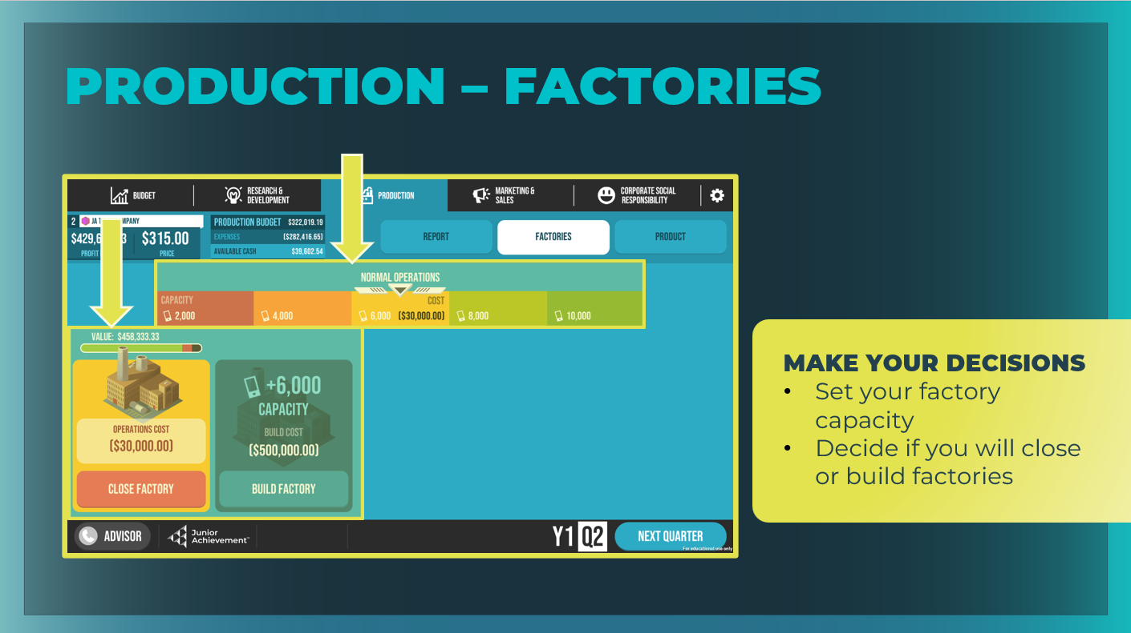  Slide 16  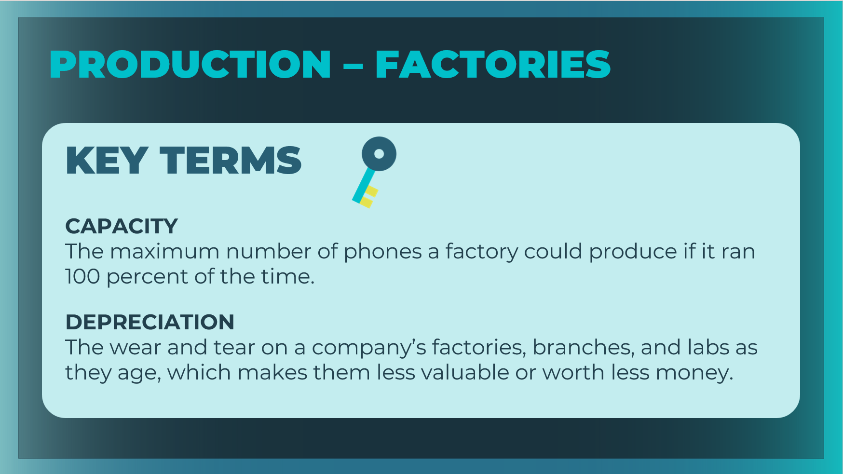 | Factories  Ask students to select the Production tab and then the Factories  button.  Review the decisions they will make here.  - Set your factory capacity  - Decide if you will open or close factories  Students will use the slider to select the operation level for their factory. There are consequences for under- or overusing a factory. Note how moving the slider to High Operations or Low Operations will generate a Possible Events Next Quarter warning.  Students can also close a factory and see the depreciation for each factory by looking at its health bar. Note the “Operations Cost” listed for their factory. This is the amount of money it costs to run the factory each quarter.  Hint to students that they should carefully consider their factory capacity. Too big and they will waste resources; too small and they will overstress their people and the factory. Explain to students that if their factories wear out, they will have to close.  If they want to make more phones than they can safely produce in their existing factor, they can build a new factory. The cost to build a factory is noted on the Factories screen. Explain that if students select the Build Factory option, they will be charged for the new factory this quarter, but it will not become operational until the next quarter.  Review the key terms as needed. Students can record the definitions in their student workbook, pages 16-18.
Slide 17  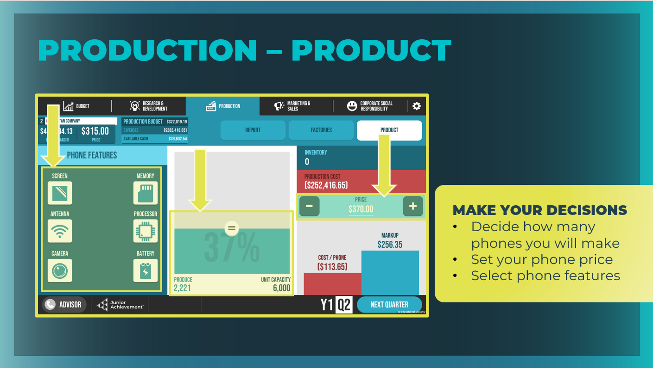  Slide 18  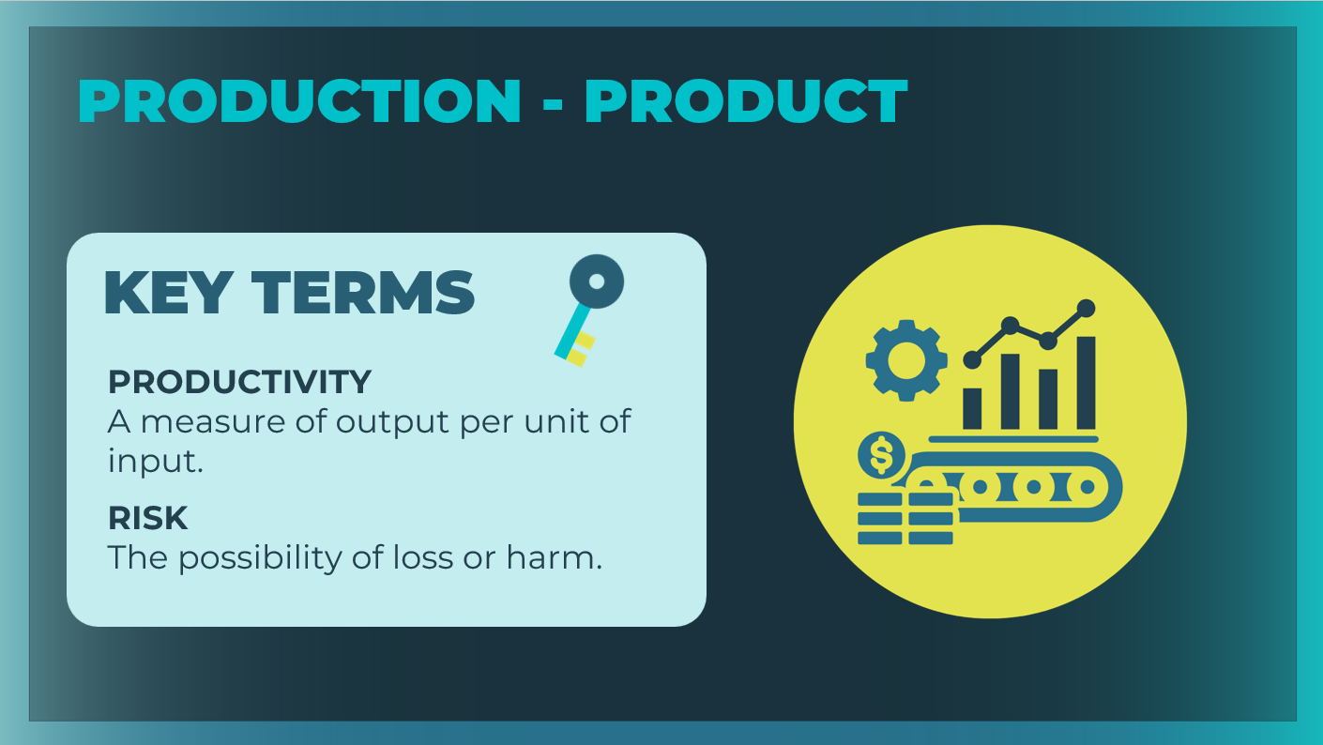 | Product  Ask students to select the Product button.  Review the decisions they will make here, keeping in mind the goal of maximizing revenue and minimizing costs.  • How many phones should you make each quarter?  • What price should you set for each phone?  • What features should be included on the phone?  Hint to students that in other program sessions and through the  Advisor's strategies, they'll learn more about how conducting market research in the Marketing & Sales department and choosing the right features in the R&D department can assist in knowing which features will increase profit.  Explain to students that the number of phones they decide to make each quarter is affected by three things:  - How many phones they currently have in inventory (phones that were not sold the previous quarter)  - The size of the market available to buy phones (found in the Marketing & Sales report)  - Their factory’s unit capacity  Ask students to move the bar in the middle of the page up and down to set the number of phones produced and watch how it affects the cost per phone.  Point out the capacity noted in the middle panel. They can change the capacity by returning to the Factories button and selecting a different capacity. Share that experts recommend that, under ideal circumstances, businesses should not exceed 80 percent capacity.  - Why do you think businesses should not exceed 80 percent capacity, when 100 percent capacity sounds logical? Systems cannot operate at 100 percent for a long period of time. If a machine is operating at 100 percent capacity, there is no time to service the machine or perform maintenance checks, which could cause the machine to break down.  Ask students to increase and decrease the price of the phone and note how that affects other information on the screen.  Highlight that they are affecting the productivity levels in their business. They will want to maximize the productivity to keep costs down.  Discuss setting prices with students.  - Ultimately, the price they set to sell your phone and the cost they accept to build your phone will set their profit margin and determine how much of every dollar they earn that they get to keep as profit.  - What risks might be involved in determining the price for your phone? Answers will vary. Encourage students to have a quick discussion about the risks involved in pricing a phone too high or too low and how they might manage those risks.  Discuss how the cost to make each phone is affected by the phone’s features.  - New features could make their phone more attractive to potential buyers, but then the phone will also cost more to produce.  Review the key terms as needed. Students can record the definitions in their student workbook, pages 16-18.
Slide 19  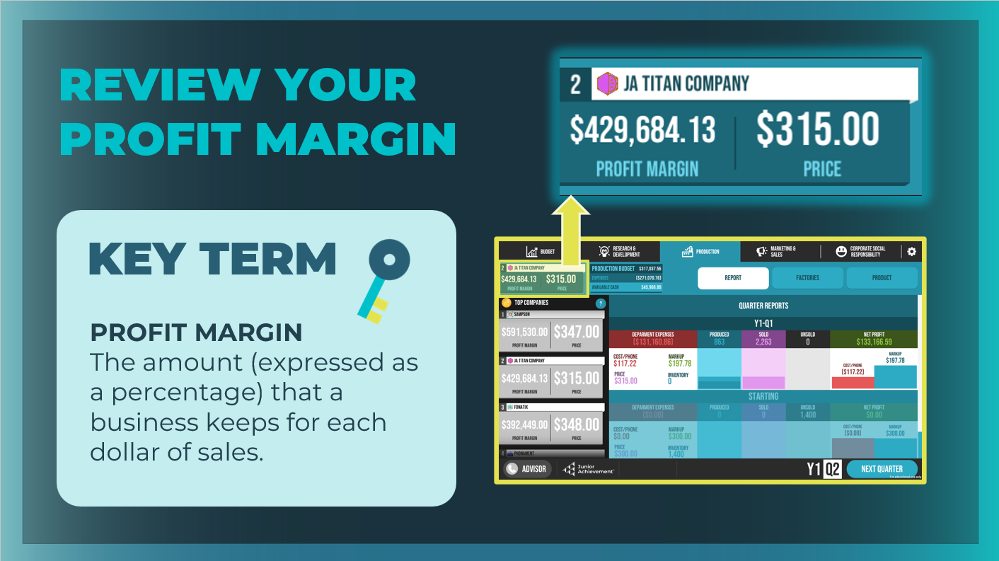 | Explain that it's important for students to review their price and production costs carefully and decide whether they are happy with the potential resulting profit margin.  Review the key term as needed. Students can record the definition in their student workbook, pages 16-18.
Slide 20  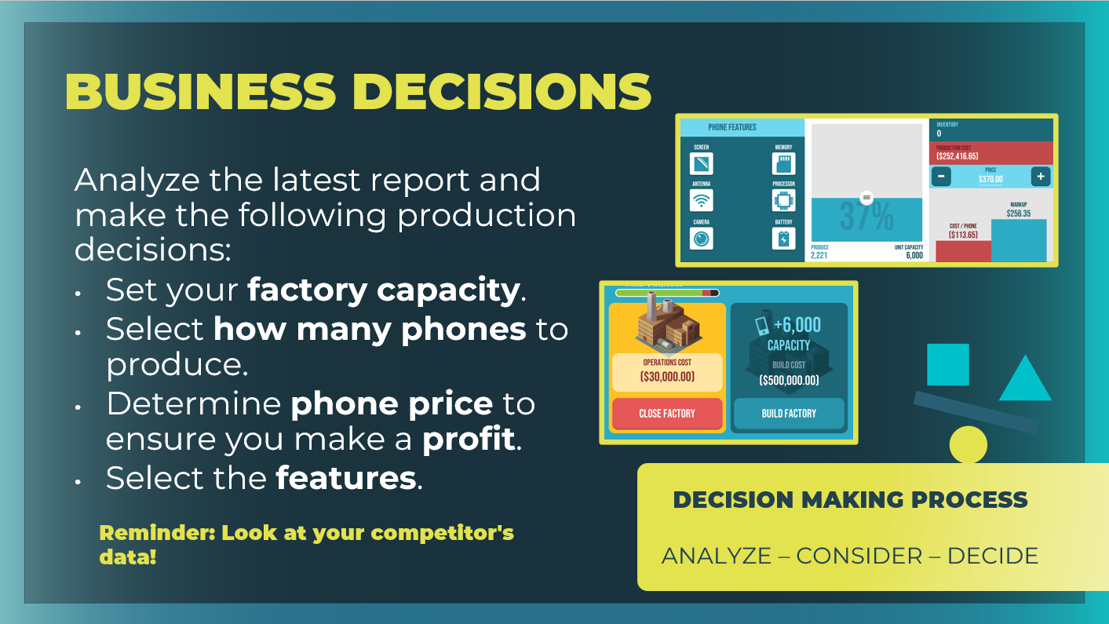 | Give students some time to analyze their latest production report, set their factory capacity, select how many phones they wish to produce this quarter, and determine their phone price. Remind students to look at their competitors’ data in the left column of the Report.  Remind students of the thought process they should follow when making these financial decisions:  - First, analyze what you need to do. Start with the data you have available to you. In this case, calculate your potential profit margin based on the price you have set for your phone and your production costs.  - Then, consider how to proceed with the limited resources available.  - Finally, make the decision.
Slide 21  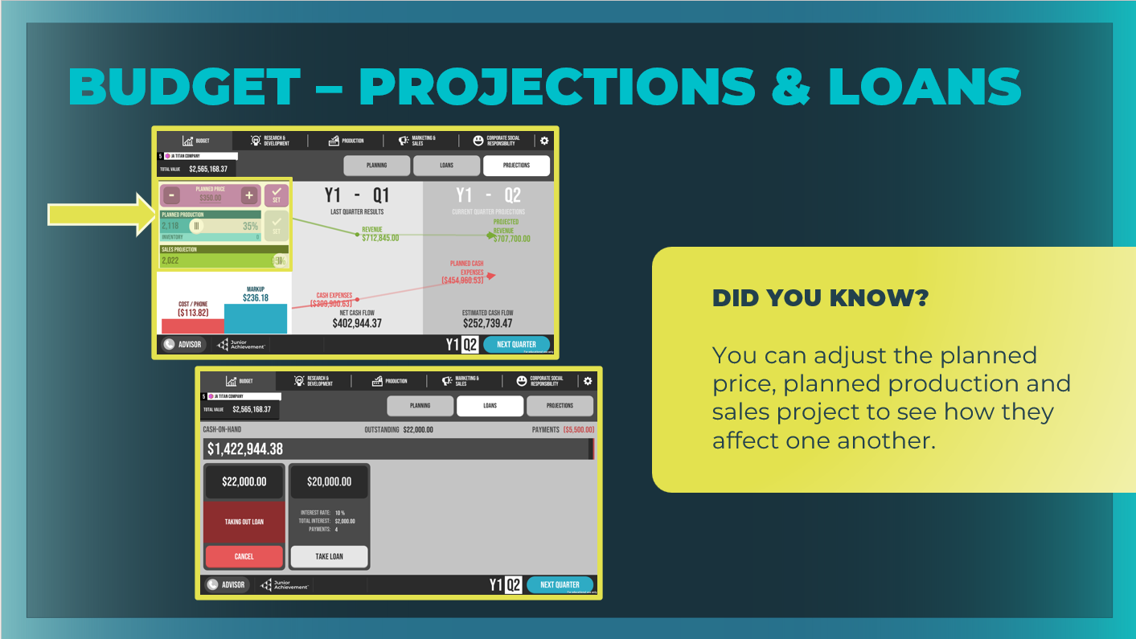 | Projections and Loans  Ask students to select the Budget tab, and then the Projections button.  Explain that businesses calculate their projections to see how the decisions they are making now will affect their company in the long term.  They are “projecting” into the future that if they sell the number of phones they make at the price they set, they can expect a certain amount of revenue.  - Projections assume that you will sell all of the phones you produce at the price you pick.  - Your actual results will be strongly affected by the same choices being made by your rivals.  - Demonstrate to students how they can adjust the planned price, planned production, and sales projection on this screen to see how those adjustments will affect one another.  One important thing to note is that their costs are also heavily  affected by their marketing and R&D decisions, which will be  discussed in another session.  Ask students why they might want to take out a loan. Make sure they understand that they must pay the loan back over time (with interest) and that it will affect their company income statement.
Slide 22  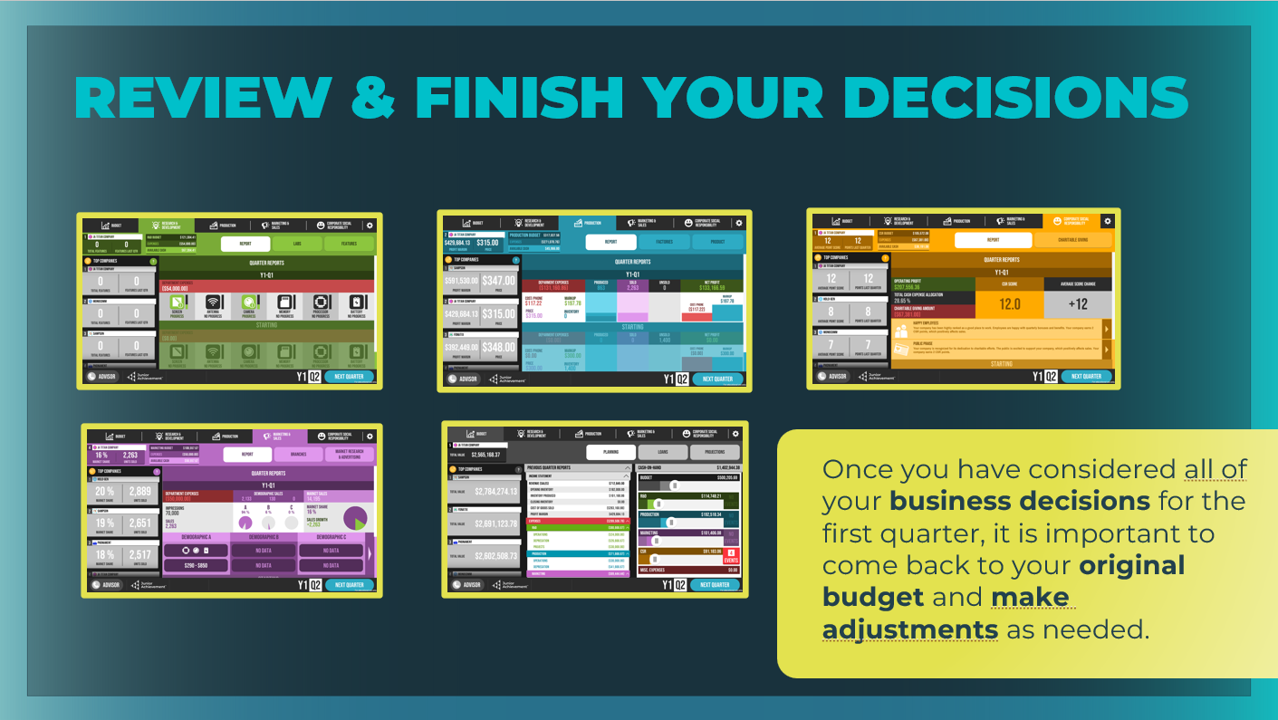 | Ask students to revisit the Production tab and review their decisions. Give students a few minutes to commit to their production decisions.  Next, give students a few minutes to explore the Research  & Development, Marketing & Sales, and Corporate Social  Responsibility tabs to familiarize themselves with the features and decisions found on those tabs. Emphasize that they may choose to guess about some decisions until they have more experience with the simulation.  Also point out that students can use their Advisor for help with game strategy, the simulation functionality, and definitions of key terms, as well as the decision checklist in the Player Quick-Start Guide.
Slide 23  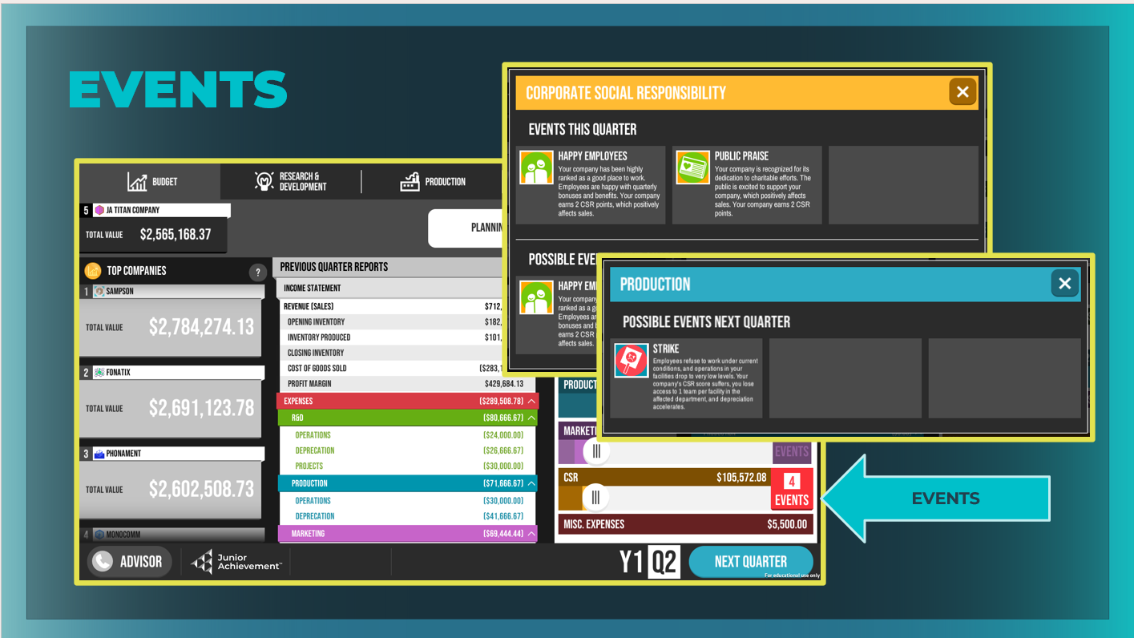 | Take time to point out the Events column on the right side of the  Planning screen, because students will receive some guidance during the game about possible events next quarter and will have to decide how to respond.  If there are no Events, you may wish to trigger an event by selecting Very High Operations for your factory capacity so that students will have a chance to see an example of what might trigger an Event.  Students can see events related to the current quarter as well as possible events that may affect them in their next quarter.
Slide 24   | Tell students that after they have made all of their business decisions for the first quarter, they will select the Next Quarter button in the bottom right corner of the screen.  Warn students that when they are competing, they should NOT select the CONFIRM button until they are satisfied with their choices. Once you select CONFIRM, you cannot go back and make changes.
Gameplay: Go Solo! (15 – 30 min)
Slide 25  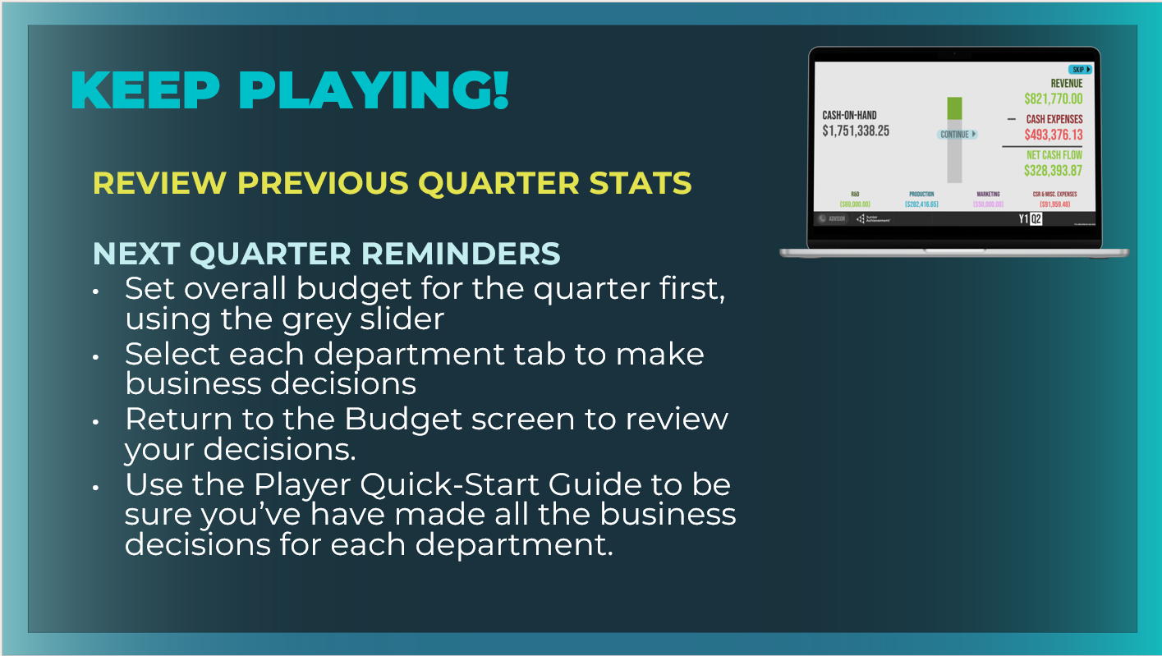 | Ask students to follow the onscreen instructions as they advance quarters. They will be given their previous quarter stats.  Students can complete pages 18-19 in the student workbook before playing the next quarter.  - What key decisions are made for Production? Determine your factory capacity, the selling price for each phone, and how many phones to produce.  - What buttons are in the Production tab? Report, Factories, Product  Point out to students how they can use the data from the Previous Quarter Reports on the Budget tab to make decisions for the next quarter.  You may want to guide students through another two quarters of the game, or you may want to end the game and invite students to play a four-quarter game in small groups or individually using single-player mode.  Allow students to continue playing as time permits.
Wrap Up (5 mins)
Slide 26  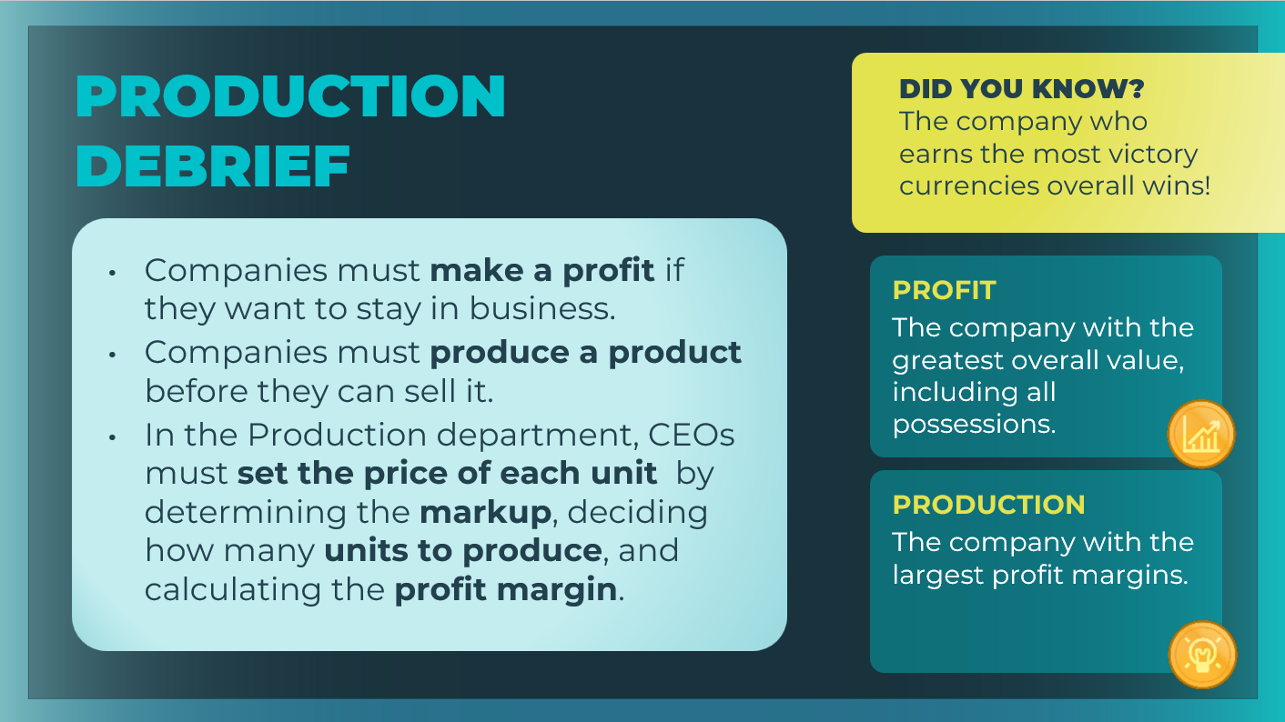 | Review the main ideas from the session with students.  Review the two victory categories related to the Production department:  - Profit (Total Value): The company with the greatest overall value, including all possessions  - Production: The company with the largest profit margins.  Students can record the victory currency descriptions in their student workbook, page 19.  Use the following prompt to support discussion:  - As the CEO of a company, what do you think might count as a possession with value? Students should recognize that their company possessions will include their current cash-on-hand; the current value of their labs, branches, and factories; and phone inventory. Students should also identify that the amount of any outstanding loans would be subtracted from the company’s overall value.  Ask student volunteers to share their Profit (Total Value) victory currencies from the games they played in this session.
Slide 27  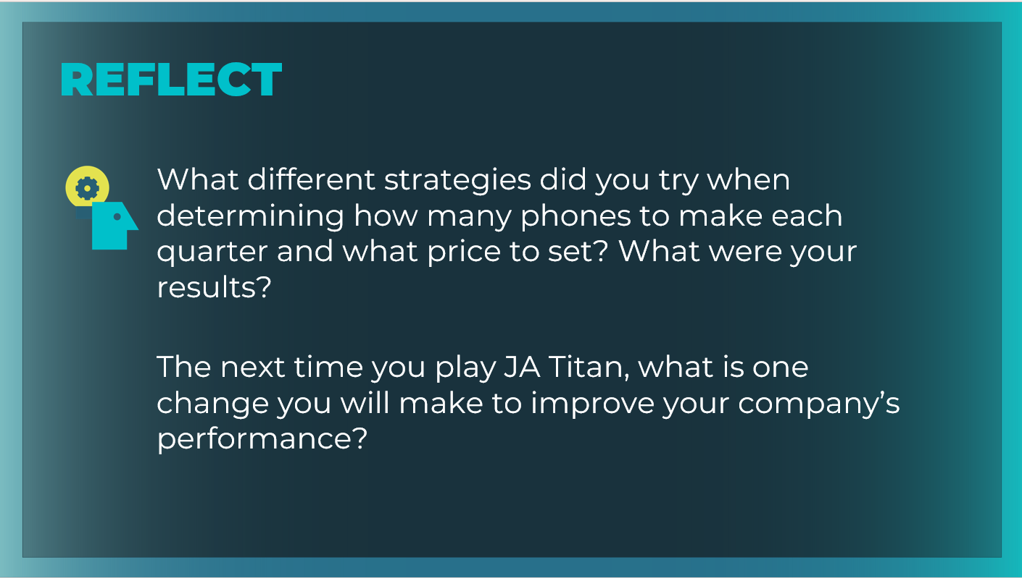 | Encourage students to reflect upon and share what they experienced during the simulation tour and while playing the game independently.  What different strategies did you try when determining how  many phones to make each quarter and what price to set? What were your results? Answers will vary. Guide students in talking about the risks involved in some of their production-related business decisions.  - Ask whether any students took out a loan to build a new factory. Encourage students to talk about the success of that strategy and the affect the loan had on their income statement.  - Ask students about the strategy alternatives they considered and the possible consequences those strategies had on company performance.  The next time you play JA Titan, what is one change you will  make to improve your company’s performance? Answers will vary. Support students in their correct use of the simulation’s key terms and concepts, and help them think through the possible consequences (both positive and negative) and risks of their strategy decisions.  Students can record their reflections in their student workbook, page 19.

