

Session 3: Examining R&D and Marketing Presenter Notes
The Presenter Notes have been developed using references from the digital classroom presentation and can be used in combination with the JA Titan Simulation and Student Workbook.
This gameplay session guides students deeper into two JA Titan company departments: Research & Development (R&D) and Marketing & Sales. In this session, students learn how selecting product features is interconnected with marketing and advertising and with a company’s efforts to improve market share and growth.

The key concepts for students to learn during this session include:
- Making investments in the R&D and Marketing & Sales departments is an investment for the future.
- In order for a company to grow its market share, it must research future innovations, understand potential customers’ feature preferences, and advertise to get the word out—all while keeping in mind that risk is inherent in any investment, and that spending money on those investments is not guaranteed to make the company more profitable.

This session takes approximately 60 minutes to complete, but times may vary based on students’ previous knowledge of business concepts.
Simulation Gameplay Setup
Decide whether students will play the JA Titan simulation in single-player or multiplayer mode. Suggested gameplay mode and settings are provided for each activity.
Single-Player Mode: Players compete as companies individually against the simulation’s artificial intelligence. Single-player mode is a learning tool designed for practice. The AI companies play at a moderately easy level.
- Players log in to the simulation and set up their own games.
- Players can analyze data for completed games in the Content Management System (CMS).
- Players choose the number of quarters (game duration) and starting cash-on-hand (difficulty level).
- Suggested gameplay settings for singleplayer mode are provided to share with students for each activity.
Multiplayer Mode: Players compete as companies (either individually or in teams) against each other.
- Multiplayer games are set up in the Content Management System (CMS). Tell students the name of the game to ensure they choose the correct game in the simulation lobby.
- This mode requires players to be playing together in real time (in class or remotely). Players log in to the simulation and join their assigned game.
- Add yourself as a player in the game to demonstrate the simulation to students.
- Game creators can monitor company results and analyze the game data in the CMS after each quarter and can access comprehensive data for completed games by downloading a CSV file. Student players can view selected data for completed games in the CMS.
- Game settings for all players are determined by the game creator for Custom games and are predetermined by the simulation for Scenario games. Suggested gameplay settings for multiplayer mode are provided for each activity.
Session 3: Examining R&D and Marketing
Slide 1   | Session 3: Examining R&D and Marketing
Slide 2  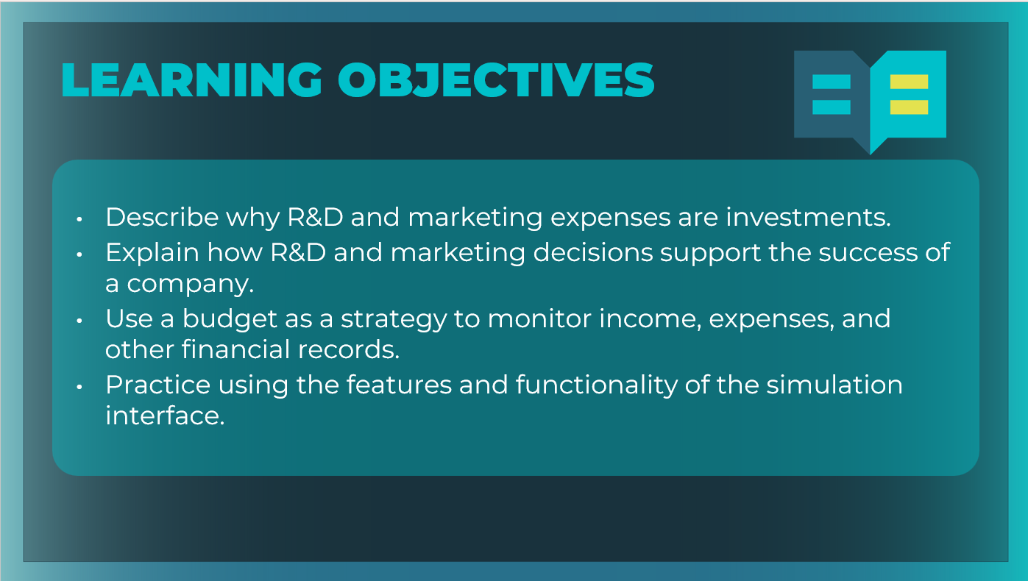 | Optional: Review the learning objectives for the session.
Slide 3  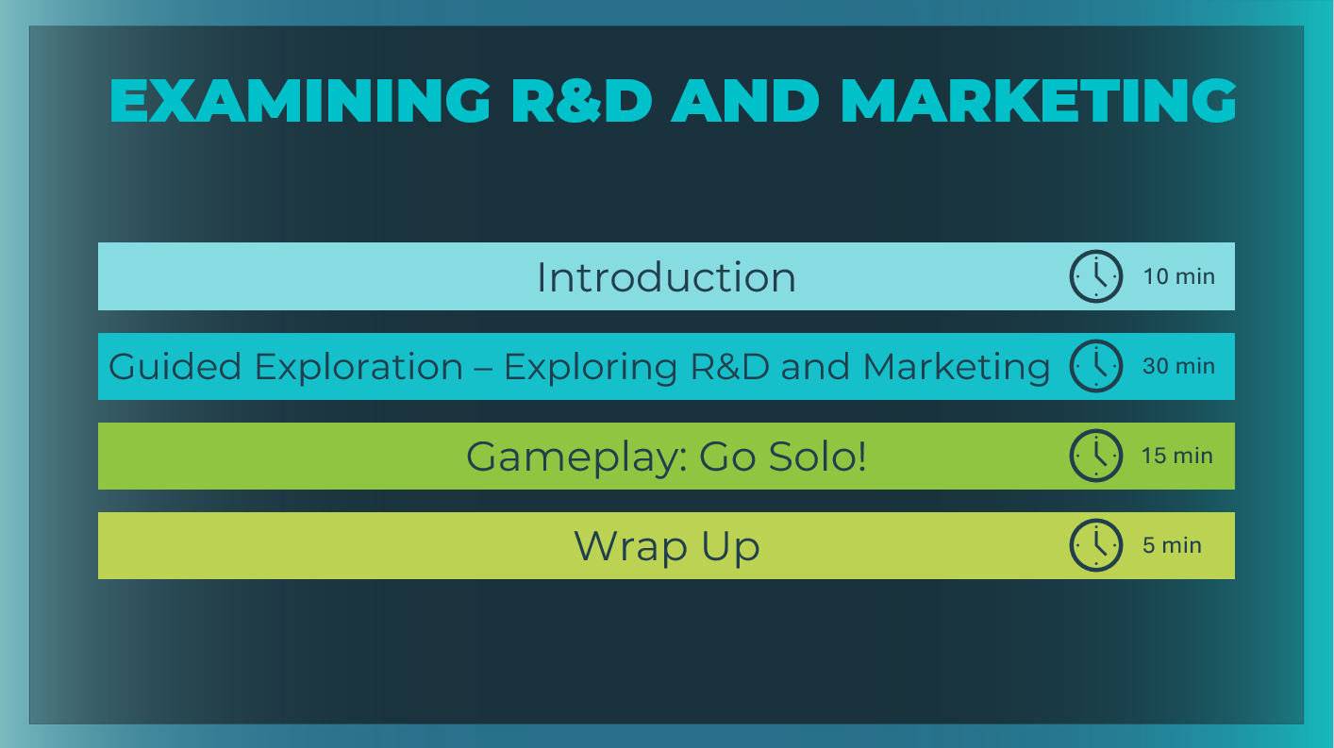 | *Select the button to navigate to the section.  After you have completed the section, you will be redirected to this menu.
Introduction (5 mins)
Slide 4   | Ask students to consider the dilemma.
Slide 5   | Encourage students to share their thinking.  What can you do to regain your previous customers or attract new ones? Answers may vary. If not mentioned, suggest developing new features for the gadget or advertising the gadget to potential consumers.  Explain to students that many companies predict that the exact situation just described will occur and try to act before it happens. They have several different approaches they can take to solve such a dilemma, including:  - Finding out what will make their product more desirable in their Research & Development department  - Conducting market research and deploying advertising in the Marketing & Sales department.
Slide 6  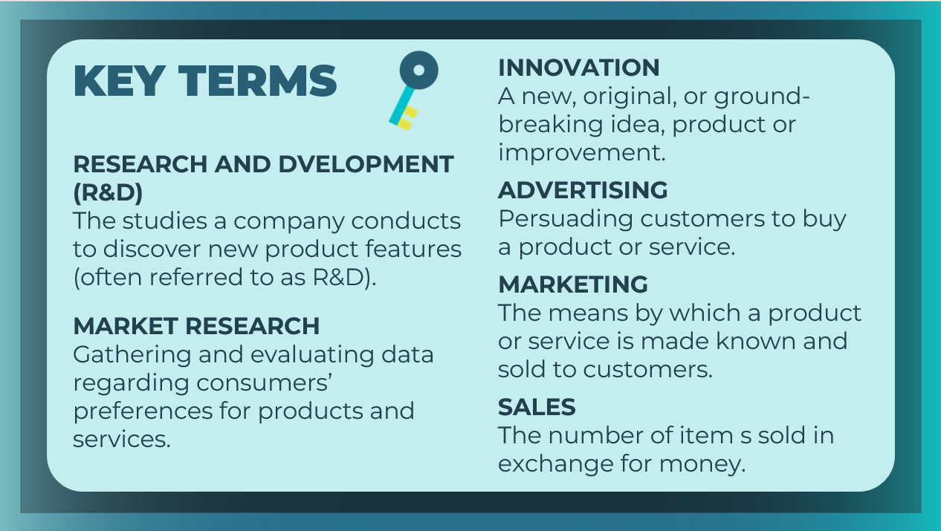 | Review the key terms as needed. Students can record the definitions in their student workbook, pages 20-21.
Slide 7  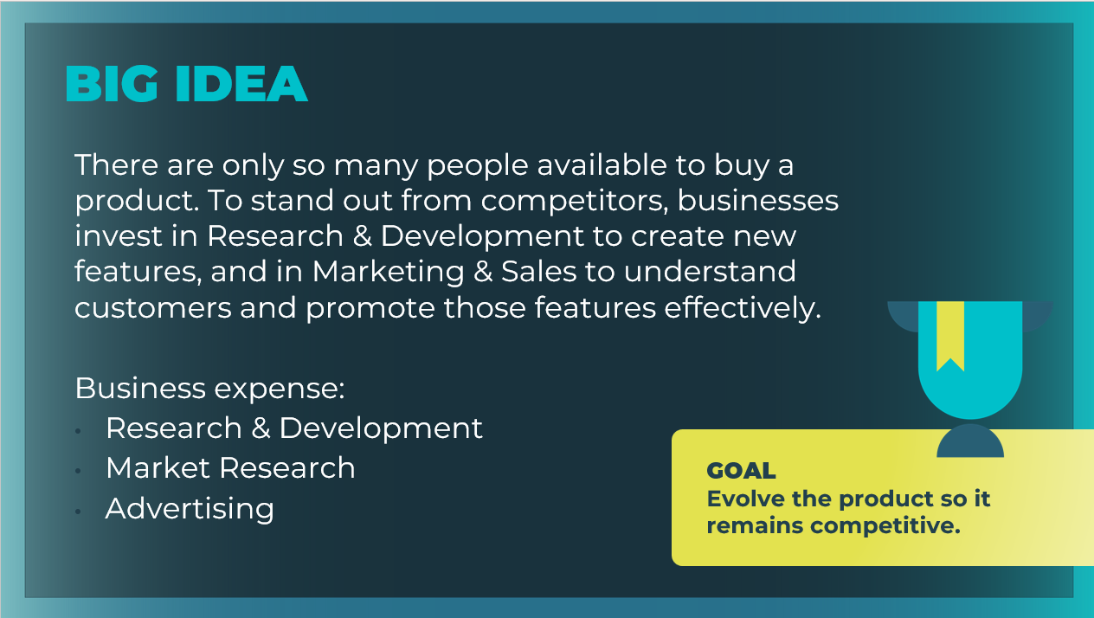 | Explain to students that the purpose of this session is to learn that making investments in the Research & Development and Marketing & Sales departments is an investment for the future.  For a company to grow its market share, it must research future innovations, learn about potential buyers’ preferences, and advertise to get the word out.
Slide 8  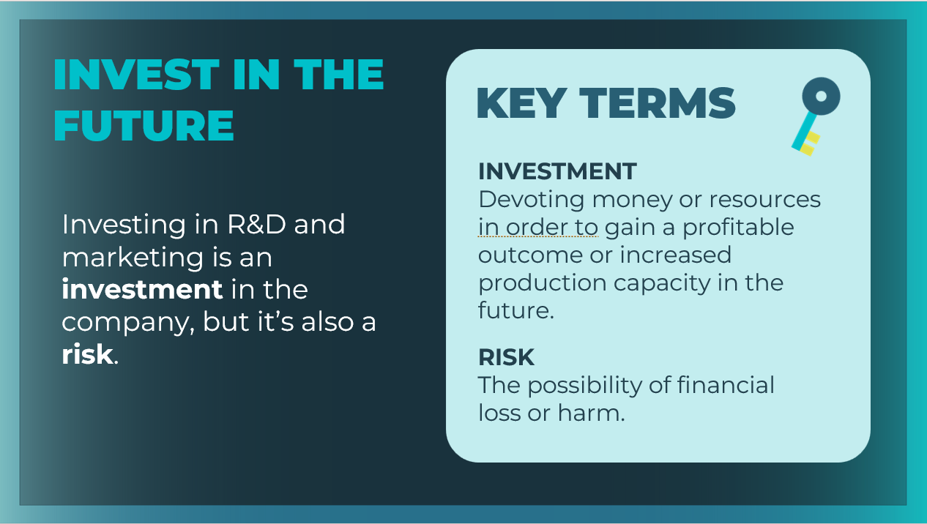 | Although they both cost money, they are investments because the company expects that the amount spent on each will not only be returned but will actually increase the company’s profits.  As with all investments, investing in R&D and marketing is a risk—it may turn out that the money spent on research or advertising does not lead to increased profits at all.  Students can record the definitions in their student workbook, pages 20-21.
Slide 9  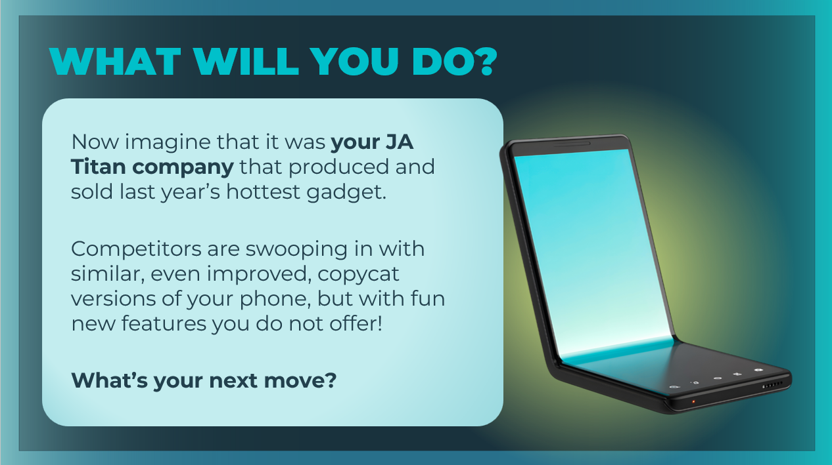 | Connect the dilemma from earlier to different gameplay strategies in the JA Titan simulation:  - Will you introduce an innovative new feature, and then use your marketing team to advertise the innovation to bring your old customers back and attract new customers?  - Or are you going to use your market research team to determine which features your potential customers want first, and then use your R&D money to develop those features?
Guided Exploration: Examining R&D and Marketing (15-30 mins)
Guided Exploration
For this guided exploration session, you may choose to use the slides 10-27 to guide students through the game play, or you may choose to log in to the simulation yourself and use the presenter notes to guide your demonstration.

JA Titan Simulation:
https://jatitancanada.org/login

Suggested Game Settings for Game 1: R&D and Marketing
Single-Player & Multiplayer Settings
Cash-on-Hand | Duration
$4 million (easiest) | 4 Quarters (1 year)

Multiplayer Only Settings
Game Name: Game 1: Production
Quarter Completion | Game Type | Company Setup
Manual | Custom | Players as Companies

Slide 10  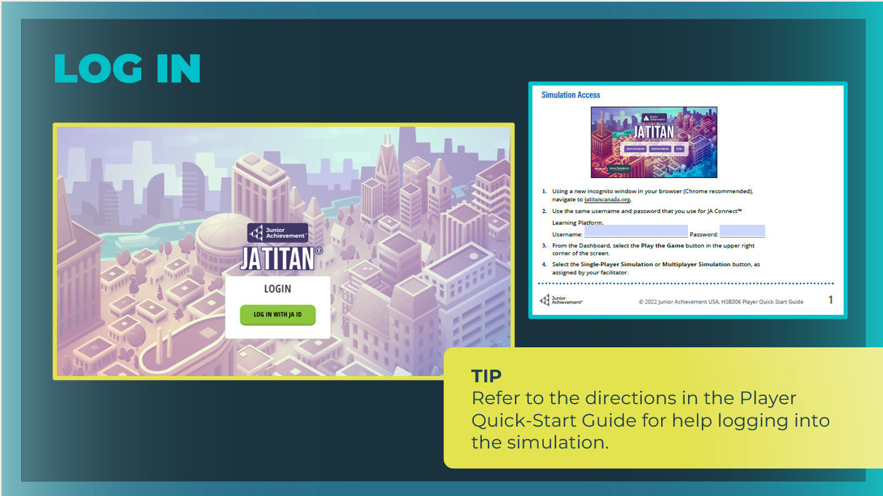 | Explain to students that you will guide them through the functionality and terminology of the Research & Development and Marketing & Sales departments in the JA Titan simulation. Direct students to log in to the JA Titan Simulation following the directions in the Quick Start Guide as needed. Emphasize that they stay on pace with you as you guide the session and should wait to select the Next Quarter button until instructed to do so.  Give students a minute or two to choose their company name and logo and select their advisor. This should be a quick task that they complete with each new game.
Slide 11  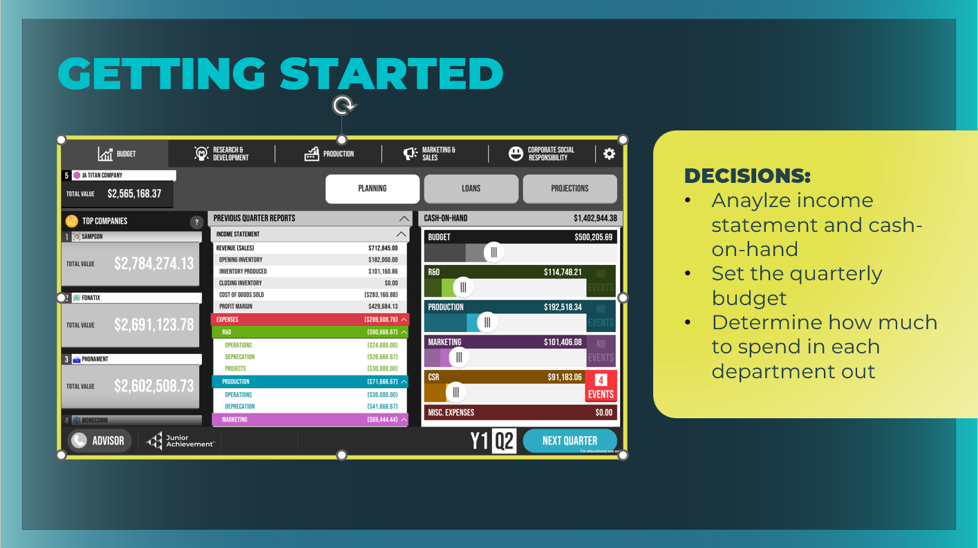 | Explain that, in addition to the actual production of the phones, CEOs can also invest in two major departments to try to increase company profits:  - Research & Development, commonly known as R&D  - Marketing & Sales  Whenever players start the game, they should start with the key decision of setting the company budget for the quarter.  Discuss with students the key decisions:  - Analyzing the income statement and cash- on-hand, and setting the quarterly budget are their first key decisions for this tab.  - Determine how much to spend in each department out of that limited amount.  Facilitator tip: Demonstrate how to grab the sliders for each department, and distribute the allocated budget among the R&D, Production, Marketing & Sales, and CSR departments.  Reminder: The amount spent in the four departments must equal the initial budget amount for the first quarter.  Give students some time to make decisions for their budgets.
Slide 12  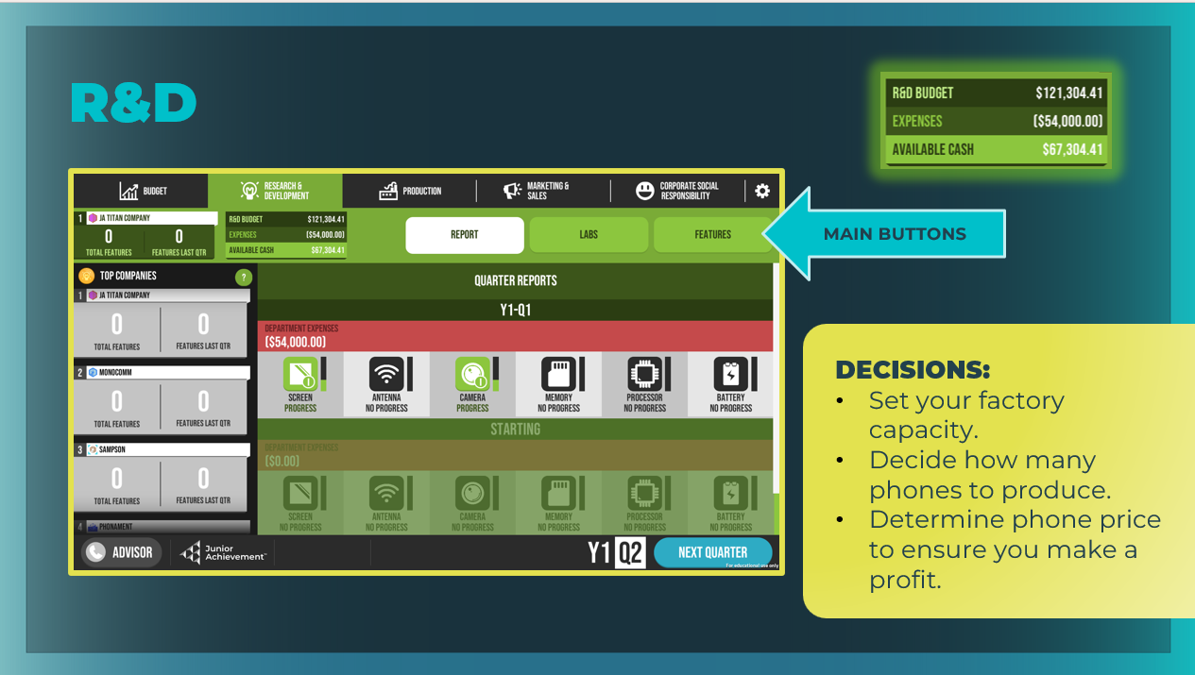 | Ask students to select the Research & Development tab.  Remind students that making a profit is essential, so they will need to carefully consider how to maximize revenue and minimize costs.  - Highlight the main areas of the Research & Development tab, including the Report, Labs, and Features buttons and review the key decisions students will make regarding their lab operation level and their product.  - Report: View your previous quarter’s results and data about the phone features your company is researching and developing.  - Labs: Manage the capital (buildings), and decide how much labor you want to commit to each lab.  - Features: Decide how to use your budget for this quarter to assign personnel to research and develop new phone features based on how long each feature takes to research and how much each costs to develop.  Note that the leaderboard ranks each company by the number of phone features developed (Research and Development (R&D) victory currency).  Note the R&D budget. This is the amount that you allotted on the Budget tab minus the amount you are committed to paying this quarter for this department. Students can return to the Budget tab and change the allotted amount as needed.
Slide 13  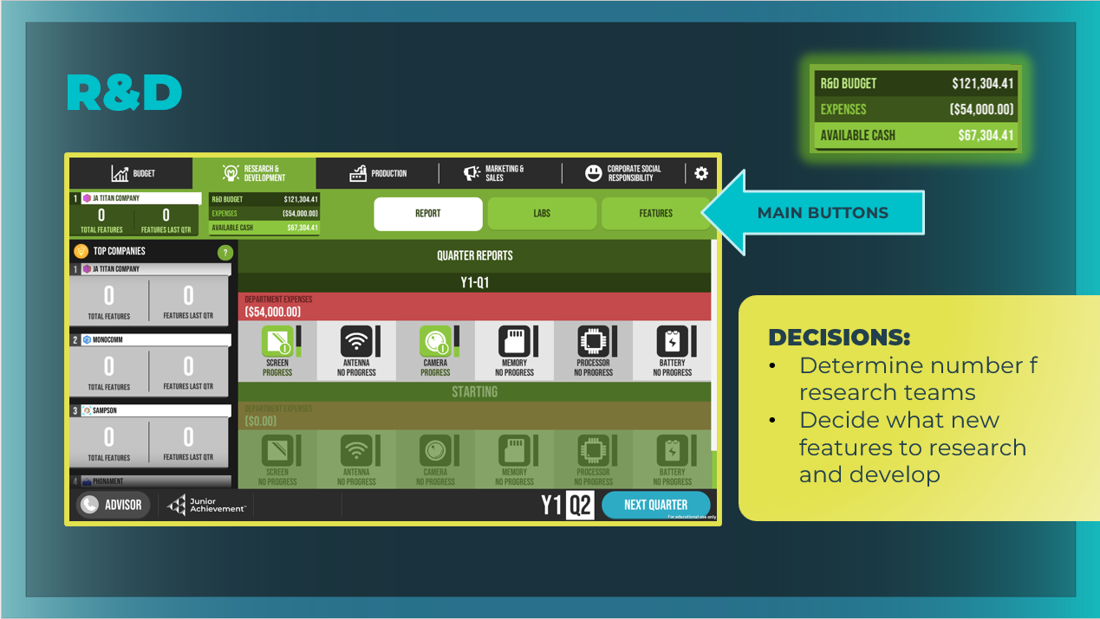 | Ask students to select the Report button. Although there are no decisions to be made on this screen, point out that it contains important data from the previous quarter that students will need to consider before making key decisions for the upcoming quarter.  Point out the phone features students will need to consider  researching each quarter before making their key decisions.  Explain to students how the costs for researching new features are incurred.  - Remind them that money spent on R&D is an investment, which means spending money now with the expectation that the money will be returned to in the future plus additional profitability.  - Accordingly, if you choose to research and develop any new features for your phone, you’ll pay for them during this quarter, but they won’t be complete until future quarters.  - The more teams you allocate to researching a feature, the faster the research will be completed. However, the cost will increase, because you’ll have to pay for additional research teams, which may limit you from researching other features.  Remember, every investment is a risk. A new feature may make  your phone more appealing to potential buyers, but it also  may not.
Slide 14  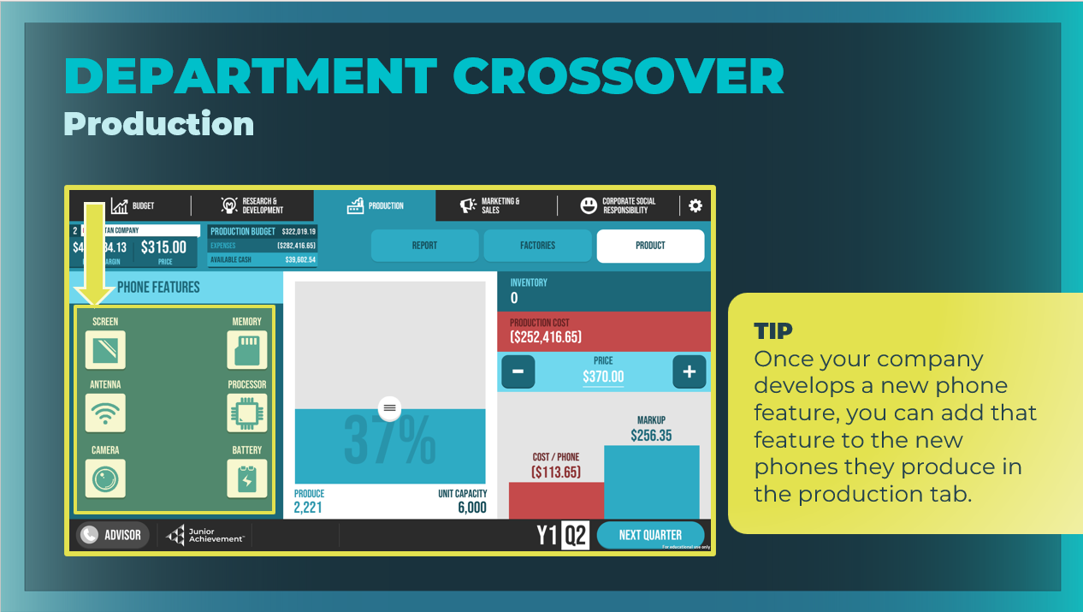 | Department Crossover – Production  Once your R&D department has completed its research and  development, select the Production tab and the Product button, and decide which of your advanced features you would like to add to your phone.  It will cost your company more money to produce phones with the additional features, but you may be able to charge a higher price for each phone, and you might be able to attract more buyers.
Slide 15  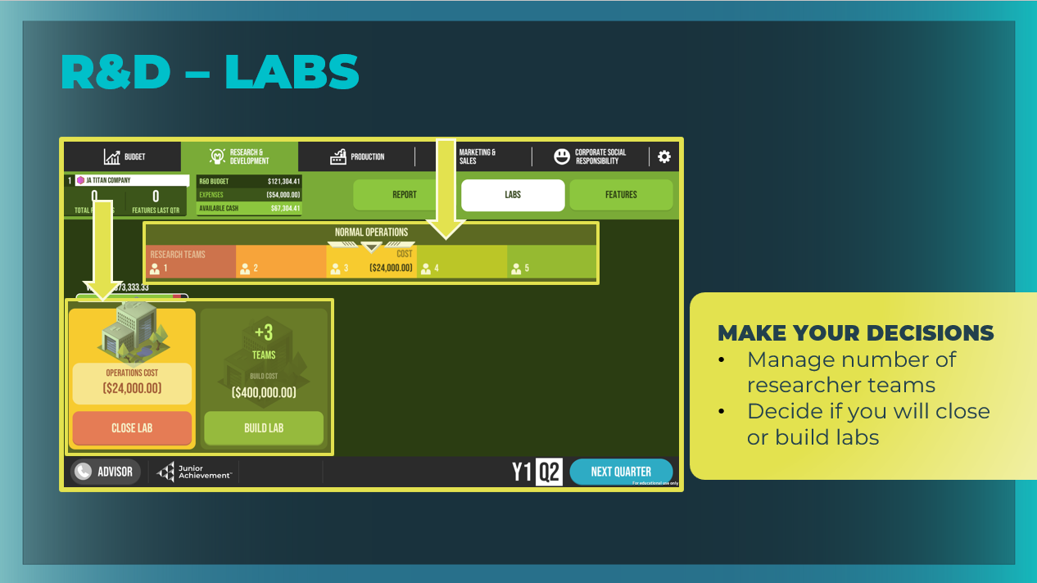  Slide 16  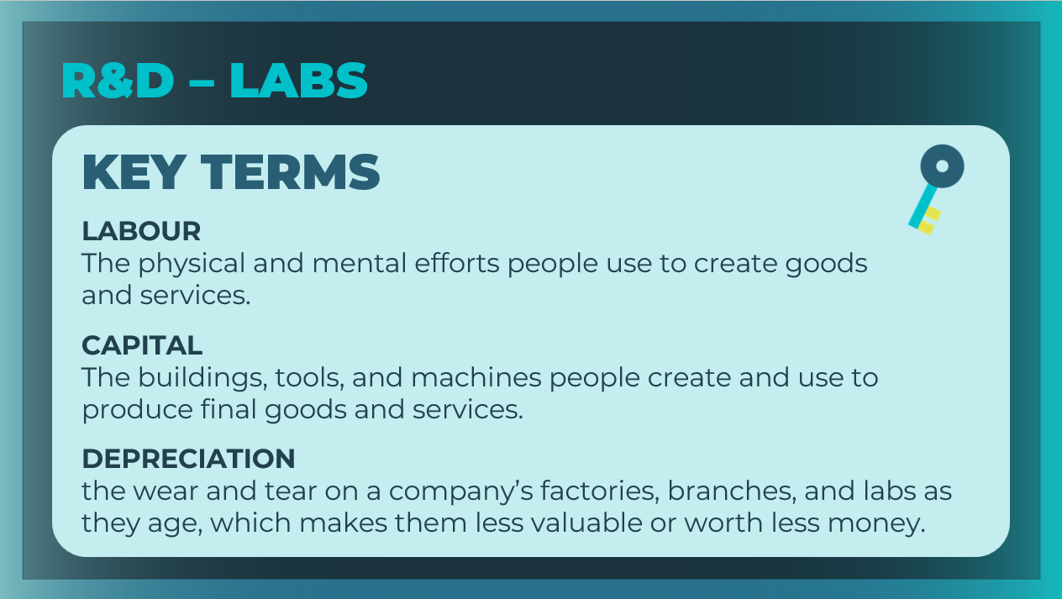 | Labs  Ask students to select the Labs button. Review the decisions they will make here.  - Manage number of researcher teams  - Decide if you will open or close labs  Students will use the slider to select the operation level for their labs. There are consequences for under- or overusing research teams. Note how moving the slider to High Operations or Low Operations will generate a Possible Events Next Quarter warning.  Students can also close a lab and see the depreciation for each lab by looking at its health bar. Note the “Operations Cost” listed for their factory. This is the amount of money it costs to run the factory each quarter.  Students can also choose to build an additional lab if they want to assign more research teams than their current lab can handle; however, they should carefully consider the risk of investing in capital that they will be paying for in this quarter but won’t be able to use until the next quarter. Point out to students that the cost to build a new lab is noted on the Build button.  Hint to students that there are six possible features to research and develop. Each feature generation requires an increasing number of teams to research and develop. The only way to have more teams is to build more labs.  Review the key terms as needed. Students can record the definitions in their student workbook, pages 20-21.
Slide 17  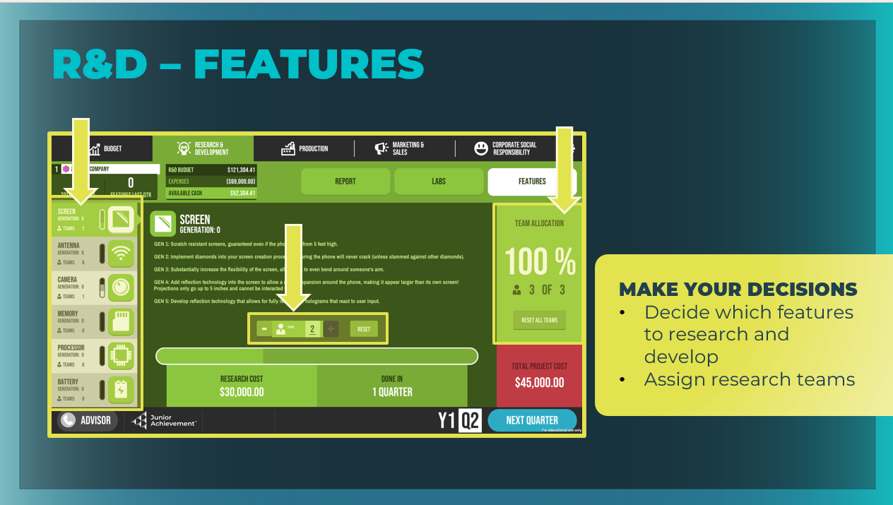 | Features  Ask students to select the Features button.  Review the decisions they will make here, using the previous quarter’s market research.  - Decide which features they want to research and develop.  - Assign research teams to research and develop those features.  There are five generations of features. Each phone has the “default” features for Year 1, Quarter 1 (Y1, Q1). This is "Gen 0." Students can keep developing their phone (if they want to!).  Point out that students can assign multiple lab teams to a single feature to speed up research time and research more features at once, but they should keep an eye on their Total Project Cost for the quarter. If they need more teams in their lab, they can go back to the Labs button and modify their decisions.  Hints:  - It doesn't help to hire teams unless they allocate them to a specific feature every quarter.  - Look at their competitors’ choices in the left-hand column on the report tab.  - When they have finished building a feature they need to add it to their phone in the Product area of the production tab.
Slide 18  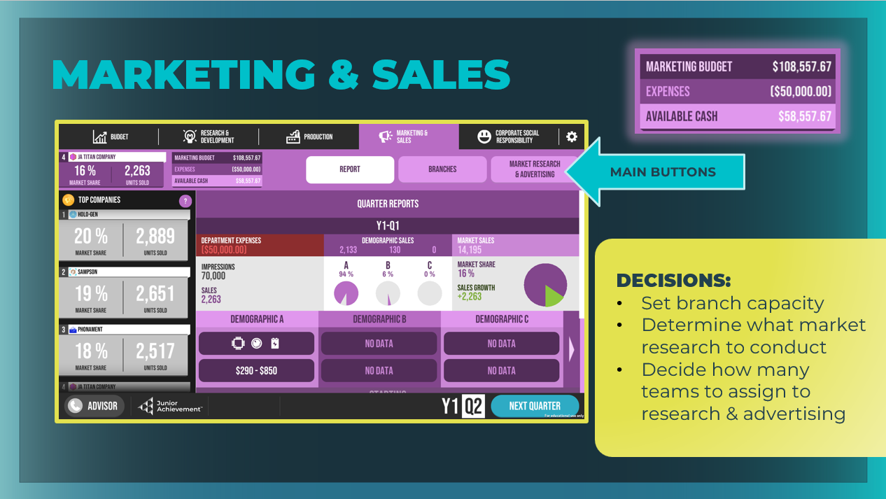 | Now ask students to shift their attention to the Marketing & Sales tab.  Review the decisions they will make here, keeping in mind the goal of maximizing revenue and minimizing costs.  - Highlight the main areas of the Marketing & Sales tab, including the Report, Branches, and Market Research & Advertising buttons and review the key decisions students will make regarding their branch capacity and their marketing and advertising.  - Report: View your previous quarter’s results and use the data on your company's sales to make decisions for the current quarter.  - Branches: Manage the capital (buildings) and decide your  marketing branch labor.  - Market Research & Advertising: Decide how to use your budget for this quarter to conduct market research and to advertise your phone to different demographics.  Note that the leaderboard ranks each company by its market share (Marketing & Sales victory currency).  Note the Marketing & Sales budget. This is the amount that you allotted on the Budget tab minus the amount you are committed to paying this quarter for this department. Students can return to the Budget tab and change the allotted amount as needed.
Slide 19  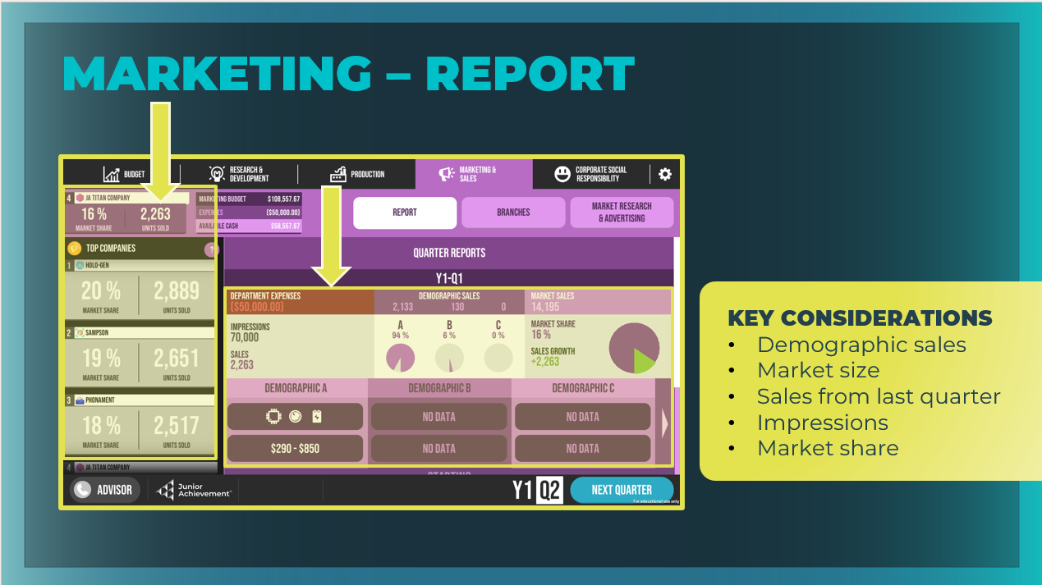 | Point out the relevant data from the previous quarter that students should take note of before making their key decisions for this quarter:  - The number of phones purchased by each demographic group during the last quarter. Who is buying your phone? Decide if you want to try to sell more phones to that demographic and/or try to expand into other demographic groups.  - The full market size (listed under Market Sales). This is the total number of buyers available. This number should influence how many phones you make in the Production department.  - The number of phone sales from the last quarter  - The number of marketing impressions received during the last quarter  - The company’s market share and growth during the last quarter  Point out the Top Companies (aka, their competitors) in Marketing & Sales.
Slide 20  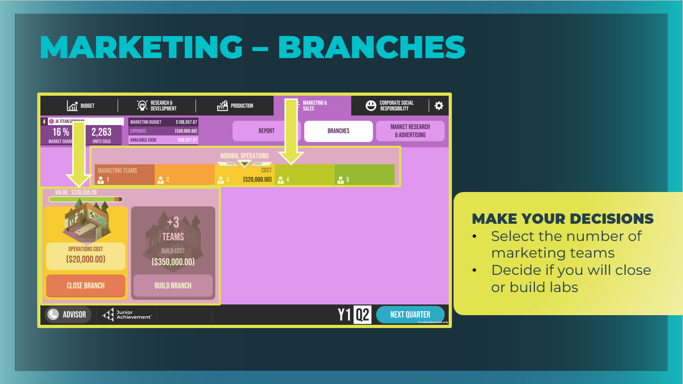 | Branches  Ask students to select the Branches button.  Review the decisions they will make here.  - Select number of marketing teams  - Decide if you will open or close branches  Students will use the slider to select the operation level for their branch. There are consequences for under- or overusing their teams. Note how moving the slider to High Operations or Low Operations will generate a Possible Events Next Quarter warning.  Point out that when more marketing teams (labor) are assigned  to a branch, the company can conduct more market research or  advertising. Students can chose to build an additional branch, but should carefully consider the risk of investing capital that they will be paying for in this quarter but won’t be able to use until the next quarter.  Call out that there are three different demographics. Each demographic has two questions that you might want to assign marketing teams to research; also, advertising to a particular demographic requires a dedicated marketing team. That's a lot of potential teams needed, and a maximum of five is the current default.  Students can also close a branch and see the depreciation for each branch by looking at its health bar. Note the “Operations Cost” listed for their factory. This is the amount of money it costs to run the factory each quarter.
Slide 21  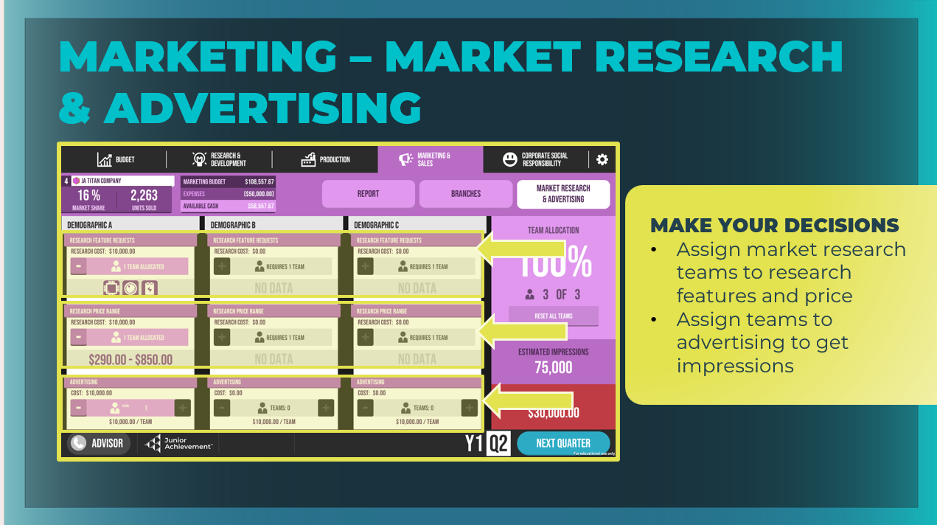  Slide 22  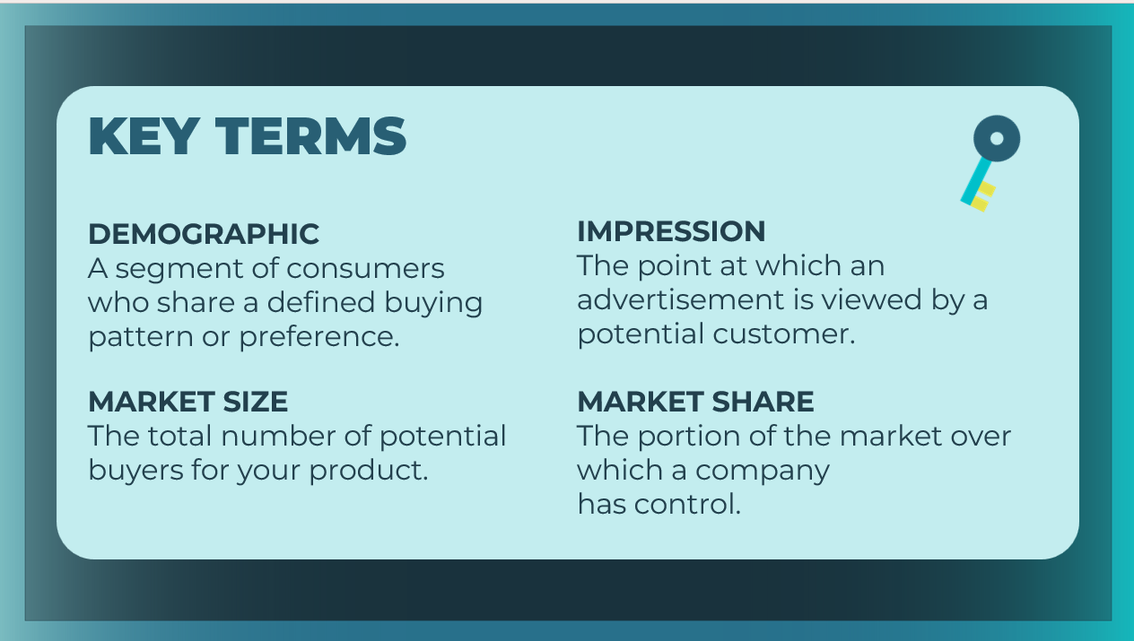 | Market Research & Advertising  Ask students to select the Market Research & Advertising button.  Review the decisions they will make here using last quarter's market research:  - Features Requests: Find out which phone features appeal to three groups of potential buyers; with this information in hand, you can be sure that you are focusing your R&D dollars in the right place.  - Price Range: Find out what price range potential buyers are willing to pay for your phone; with this information, you can decide on a low, middle, or high pricing strategy. Notice that there is an additional cost for each team you assign to market research.  - Advertising: Your future customers can’t buy something they’ve never seen and don’t know exists. To get the word out, you need impressions. Notice that there is an additional cost for each team you assign to advertising.  Hint to students that before making any investment decisions, they should ask themselves what they expect to get out of each investment and if it is worth the expense.  Students can assign multiple advertising teams to a single demographic to build up those impressions. Remind them to keep an eye on the Total Project Cost for the quarter.  If they need more teams, they can go back to the Branches button and modify your Marketing & Sales allocations. Keep in mind that, just like with R&D, market research and advertising are investments, and all investments come with risk.  Review the key terms as needed. Students can record the definitions in their student workbook, pages 20-21.
Slide 23  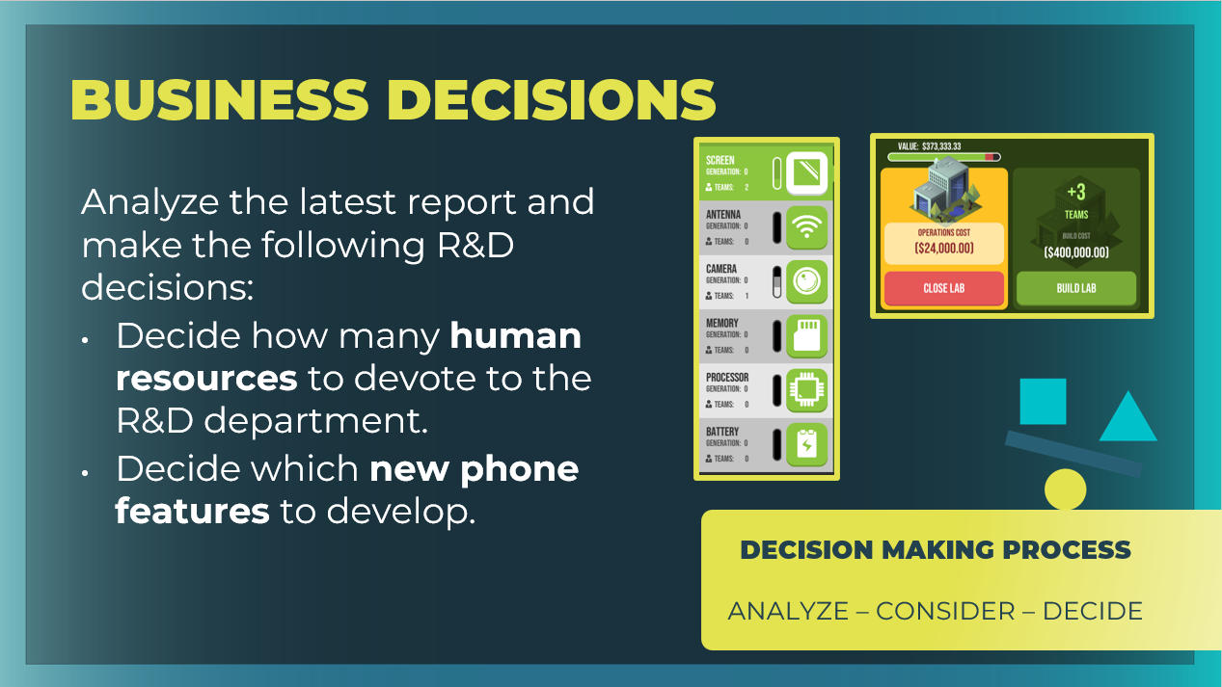  Slide 24  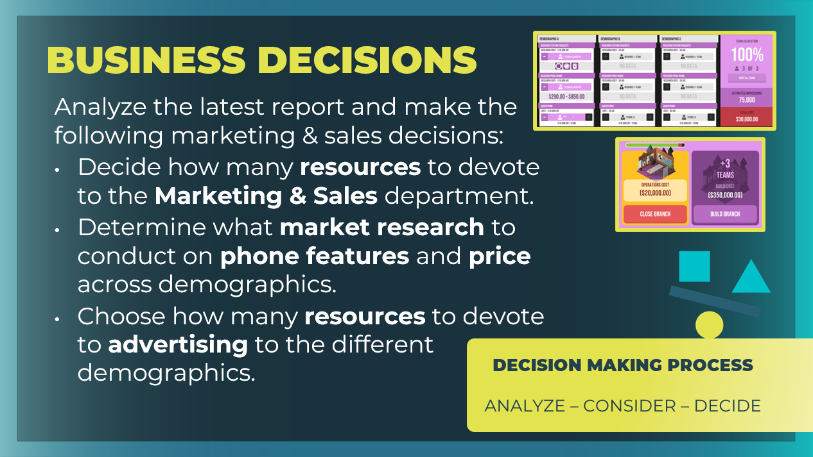 | Review business decisions for R&D and Marketing & Sales.  Ask students to revisit the Research & Development and Marketing & Sales tabs and to review their decisions. Give students a few minutes to commit to their R&D and Marketing & Sales decisions.
Slide 25  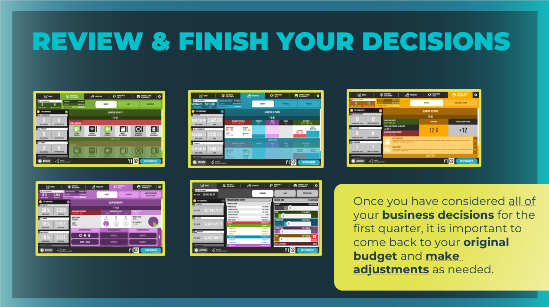 | Review & Finish Your Decisions  Next, give students a few minutes to explore the Production and Corporate Social Responsibility tabs to familiarize themselves with the features and decisions on those tabs. Emphasize that they may choose to guess about some decisions until they have more experience with the simulation. If they haven't already, remind students that to allocate money in the CSR tab, they have to first move the CSR slider in the Budget tab under the Planning button.  Explain to students that after they have made their business decisions for the first quarter, they must go back to the Budget tab. They may need to adjust their budget so it accurately reflects their selections or they might need to return to each department to adjust their spending  Also point out that students can use their Advisor for help with game strategy, the simulation functionality, and definitions for key terms, as well as the decisions checklist in the Player Quick-Start Guide.
Slide 26  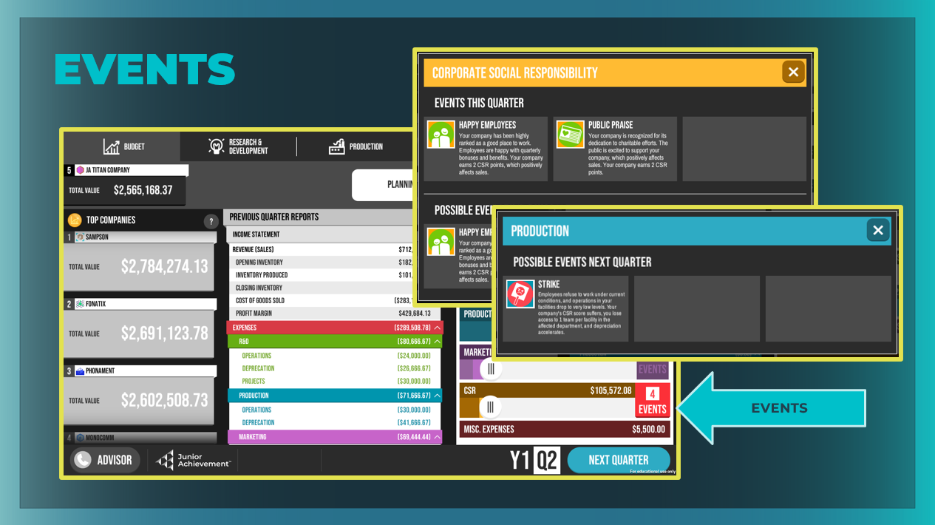 | Events  Take time to point out the Events column on the right side of the Planning screen. Students will receive some guidance during the game about possible events next quarter and will have to decide how to respond.  If there are no Events, you may wish to trigger one by selecting Very High Operations for your lab or branch capacity so that students can see an example of what might trigger an Event.  Students can see events related to the current quarter as well as possible events that may affect them in their next quarter.
Slide 27  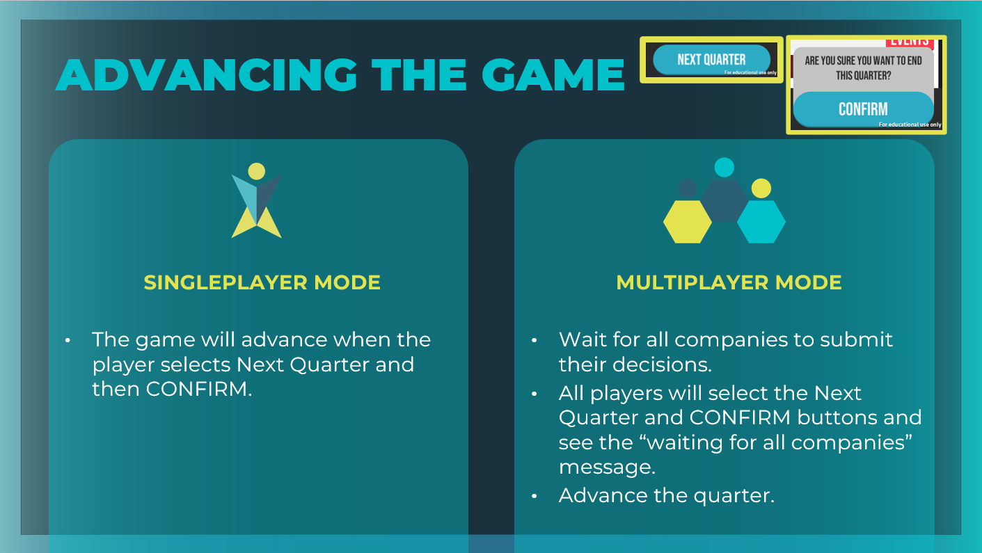 | Advance the Quarter  Tell students that after they have made all of their business decisions for the first quarter, they will select the Next Quarter button in the bottom right corner of the screen.  Warn students that when they are competing, they should NOT select the CONFIRM button until they are satisfied with their choices. Once you select CONFIRM, you cannot go back and make changes.
Gameplay: Go Solo! (15 – 30 min)
Slide 28  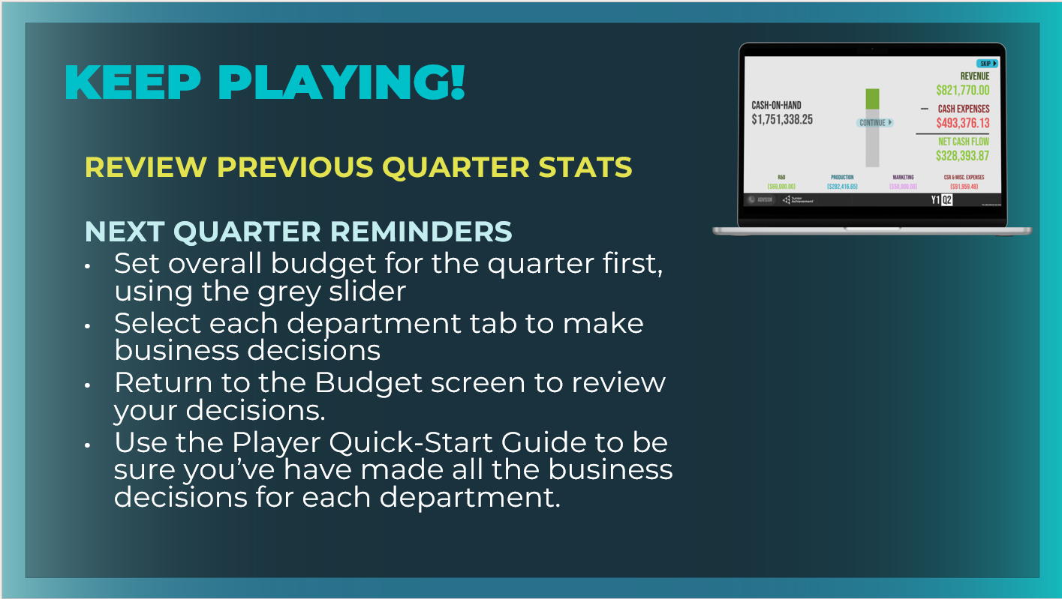 | Ask students to follow the onscreen instructions as they advance quarters. They will be given their previous quarter stats.  Students can fill in page 20 in the student workbook before playing the next quarter.  - What key decisions are made for Research & Development? Decide how many human resources to devote to the R&D department and which new phone features to develop.  - What buttons are in the Research & Development tab? Report, Labs, Features  - What key decisions are made for Marketing & Sales?  Decide how many human resources to devote to the Marketing & Sales department, what market research to conduct on phone features and price across the three demographics, and how many resources to devote to advertising to the different demographics.  - What buttons are in the Marketing & Sales tab? Report, Branches, Market Research & Advertising  Point out to students how they can use the data from the Previous Quarter Reports on the Budget tab to make decisions for the next quarter.  You may want to guide students through another two quarters of the game, or you may want to end the game and invite students to play a four-quarter game in small groups or individually using single-player mode.  Allow students to continue playing as time permits.
Wrap Up (5 mins)
Slide 29  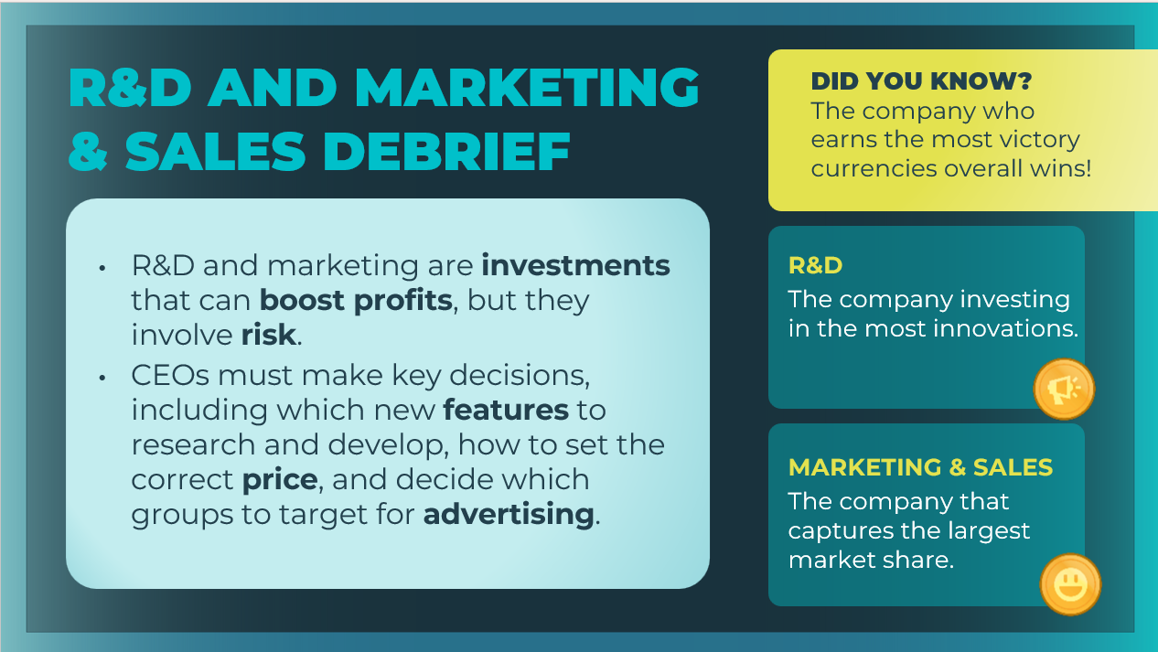 | Review the main ideas from this session with students.  Review the two victory categories related to the Production department:  - Research & Development (R&D): The company investing in the most innovations.  - Marketing & Sales: The company that captures the largest market share.  Students can record the victory currency descriptions in their student workbook, page 22-23.
Slide 30  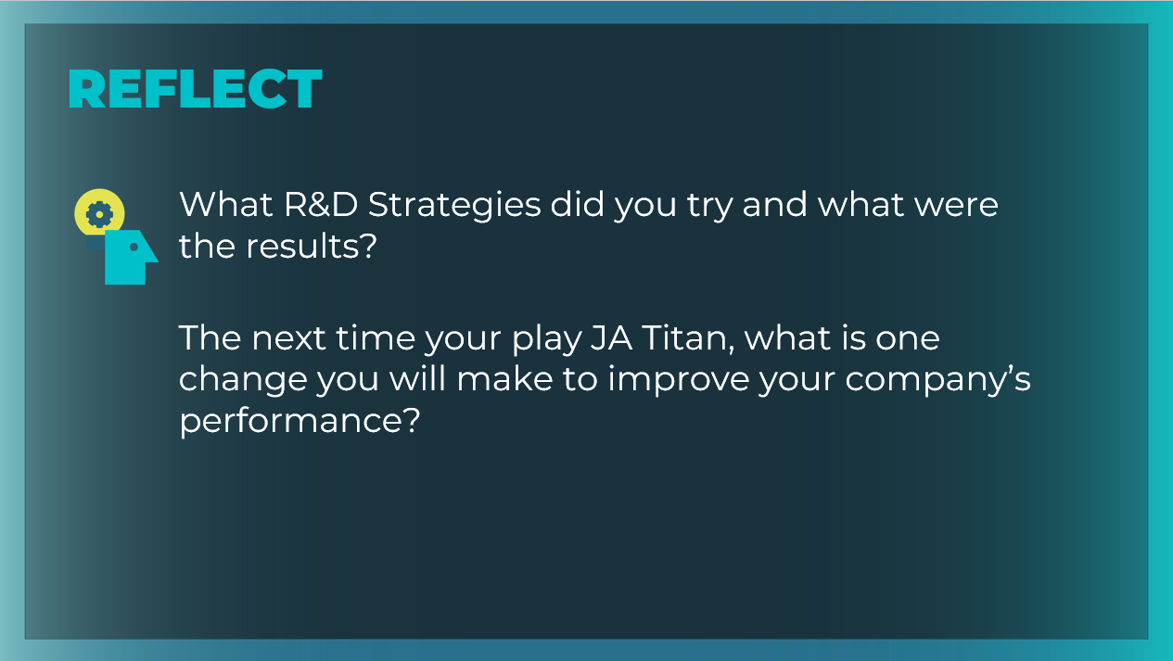 | Encourage students to reflect upon and share what they experienced during the simulation tour and while playing the game independently.  What R&D and marketing strategies did you try, and what were the results? Answers will vary. Guide students as they discuss the risks involved in some of their R&D and marketing business decisions.  - Determine whether any students took out a loan to build a new lab or branch. Encourage students to talk about the success of that strategy and the affect the loan had on their income statement.  - Ask students about the strategy alternatives they considered and the possible consequences those strategies had on company performance.  The next time you play JA Titan, what is one change you will  make to improve your company’s performance? Answers will vary. Support students in their correct use of the simulation’s key terms and concepts, and help them think through the possible consequences (both positive and negative) and risks of their strategy decisions.  Students can record their reflections in their student workbook, page 23.

