

Session 5: Marketing Deep Dive
Presenter Notes
The Presenter Notes have been developed using references from the digital classroom presentation and can be used in combination with the Student Workbook.
This deep dive session takes an in-depth look at an important department that is found in many companies: the marketing department.

Students explore the 4 Ps of Marketing (product, place, price, and promotion) through classroom-based activities, eventually culminating in the students’ drafting a marketing plan of their own. In this session, the key concept for students to learn is that, when deciding how to bring a product or service to market, businesses use the 4 Ps as an investment to maximize profitability, which often requires market research.

This session does NOT require access to the JA Titan simulation.

This session takes approximately 60 minutes to complete, but times may vary based on students’ previous knowledge of marketing concepts.
Session 5: Marketing Deep Dive
Slide 1

Slide 2  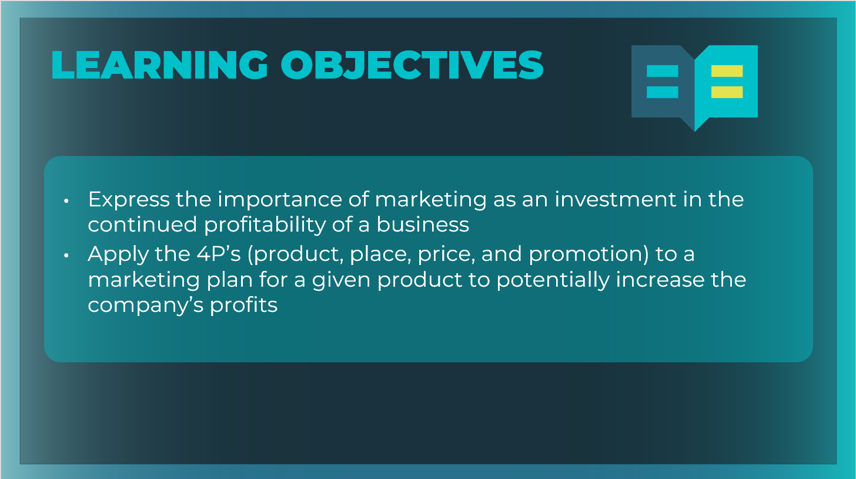 | Optional: Review the learning objectives for the session.
Slide 3  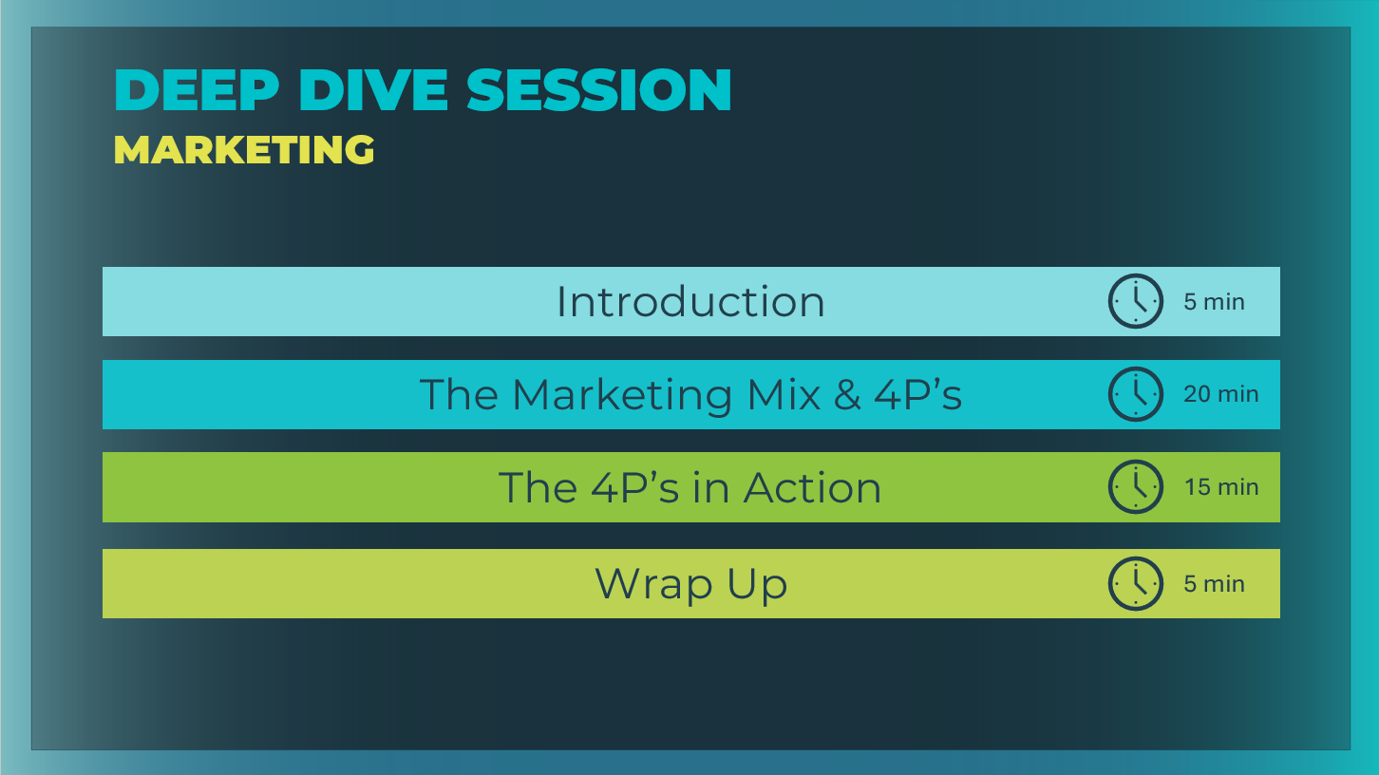 | *Select the button to navigate to the section.  After you have completed the section, you will be redirected to this menu.
Introduction (5 mins)
Slide 4   | Introduce the session using the prompt to discuss examples of advertisements and where students might see them.  What are some places you see or hear advertisements? Answers will vary; however, if not mentioned, note the various media and mediums they might see:  - Banner ads in games and Web pages  - Ads that interrupt a YouTube video or game  - Influencers in social media  - Sponsored products in Web search results  - Movie previews before a video  - TV and radio ads  - Sponsors in a podcast  - Billboards  - Magazines, newspapers, flyers and business cards  Explain that the purpose of this deep dive session is to help students understand that money spent on marketing is an investment in the company that contributes to the company’s profitability. Market research helps in making decisions about where to invest marketing dollars.
Slide 5  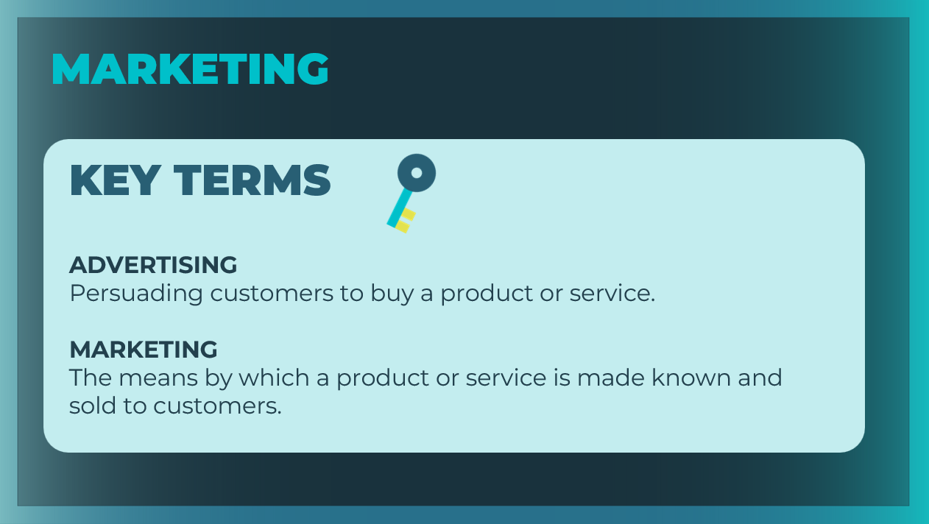 | Define the key terms as needed. Students can record the definitions in their student workbook, pages 33-34.
Slide 6  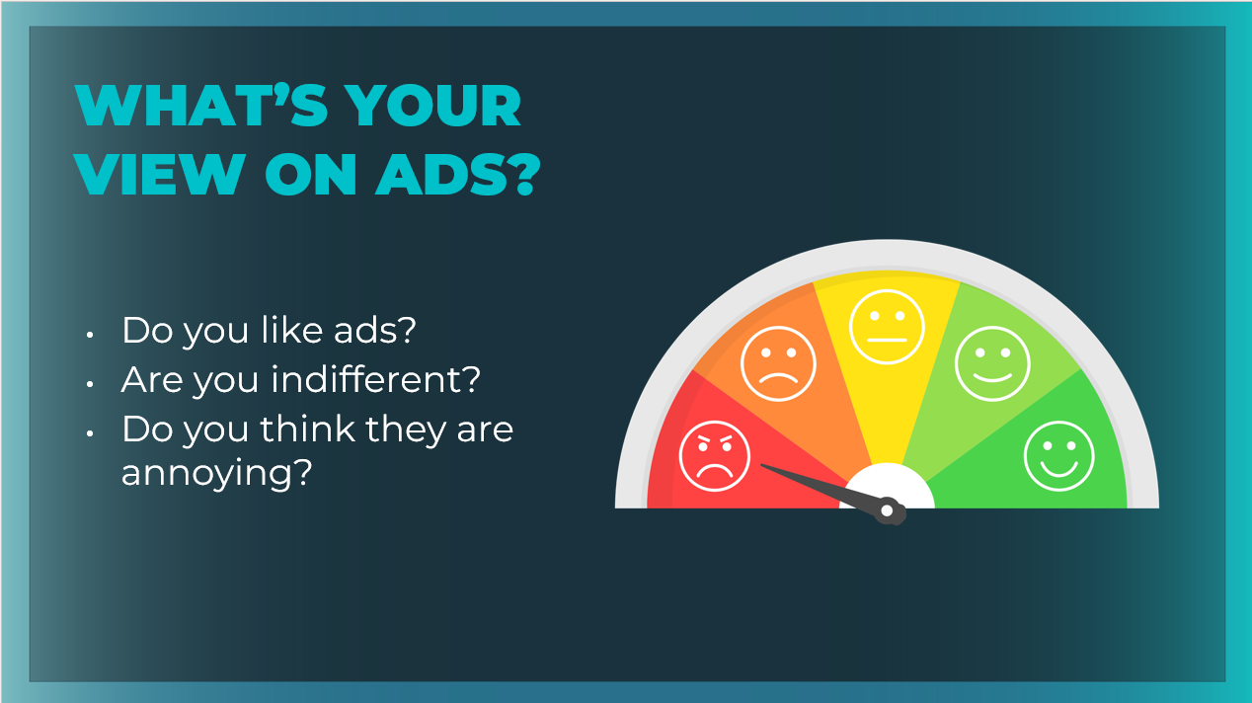 | Ask students if they generally have a positive, negative, or neutral view of advertising.  Explain that many people express a negative opinion about the advertisements they see, especially when the ad interrupts an article they’re reading or a video they’re watching.
Slide 7   | Encourage students to reflect on and discuss the questions on the slide.  So, if we all don’t like ads, why are they still everywhere we look or listen? Answers will vary; however, if not mentioned, note that:  - Consumers need to know about a product before they can buy it. A business may have the most amazing invention in the world, but if no one knows about it, the business cannot sell it.  - Therefore, companies have to find a way to put their products in front of consumers, which is also called marketing their products.  How do businesses market and advertise their products to potential buyers? Answers will vary; however, if not mentioned, explain that:  - Businesses often have a department known as the marketing and sales department. The people who work in this department use market research to try to determine who buys the company’s product or who might buy it if they learned more about it.  - Once the marketing department identifies common characteristics among potential buyers, known as demographics, it conducts research to learn where the company should place advertisements so that those people will see them.  - Then the company advertises in order to get the word out.
Slide 8  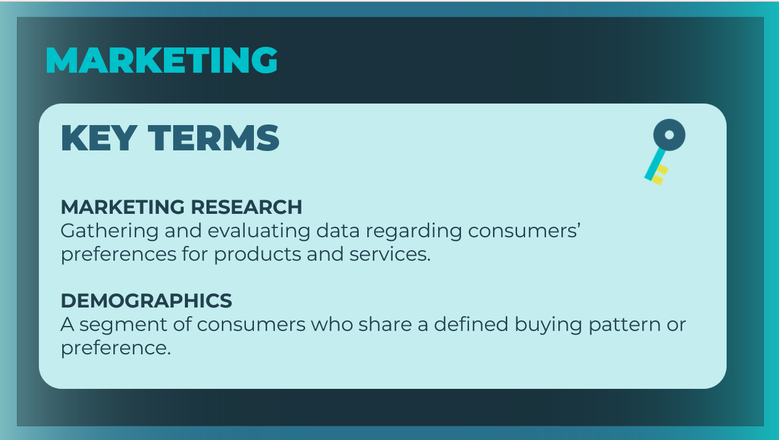 | Define the key terms as needed. Students can record the definitions in their student workbook, pages 33-34.
Slide 9  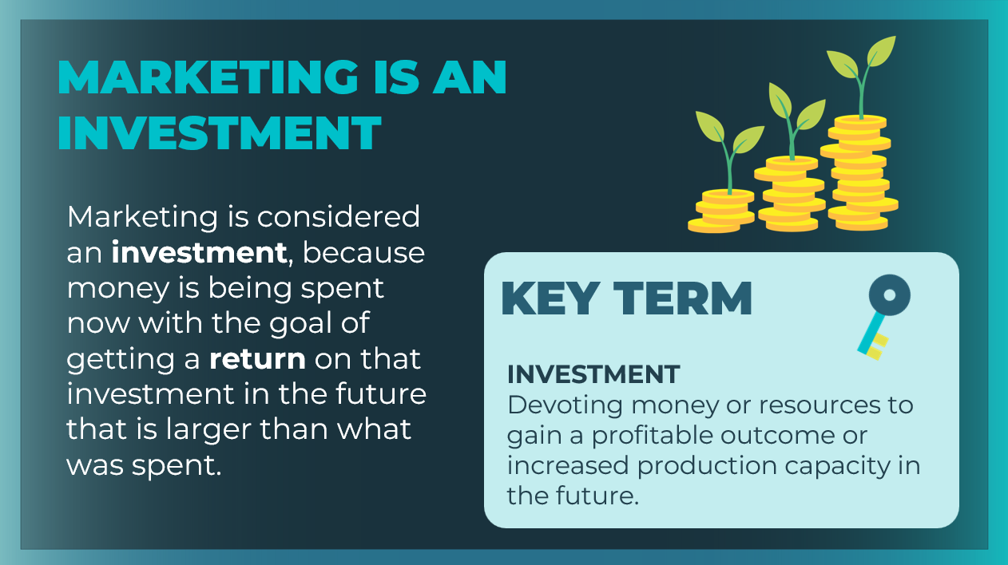 | Remind students that marketing is an investment. Companies spend money on marketing with the hope that it will increase their profits.
The Marketing Mix & 4P’s (20 mins)
Slide 10  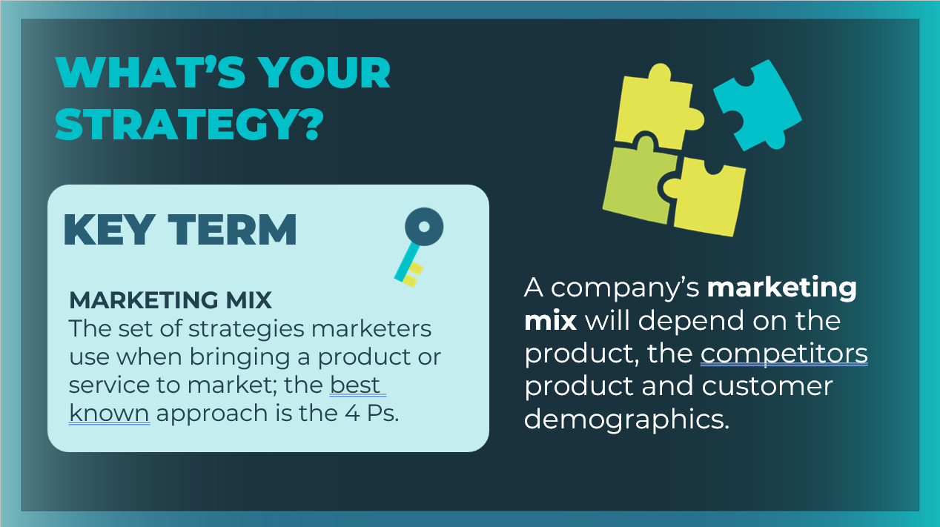 | Tell students that they will learn about the marketing mix, which includes four marketing strategies known as the 4 Ps—product, place, price, and promotion.  Define the key term as needed. Students can record the definition in their student workbook, pages 33-34.  Explain to students that they will be looking at each of the 4P’s in more detail throughout this session.  Point out that a company's marketing mix will depend on the product, the competitor's products, and customer demographics.
Slide 11  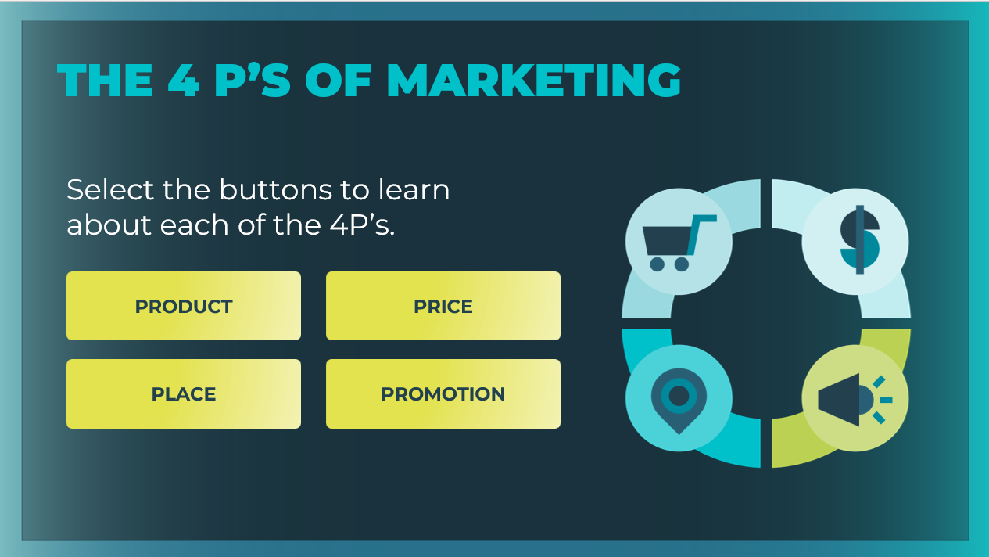 | Select the buttons to explore each of the 4P’s.
Slide 12  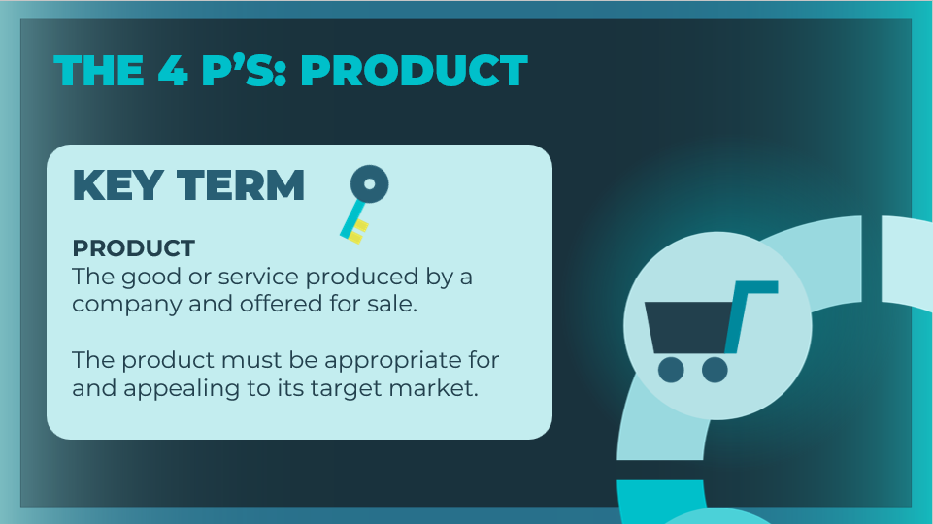  Slide 13  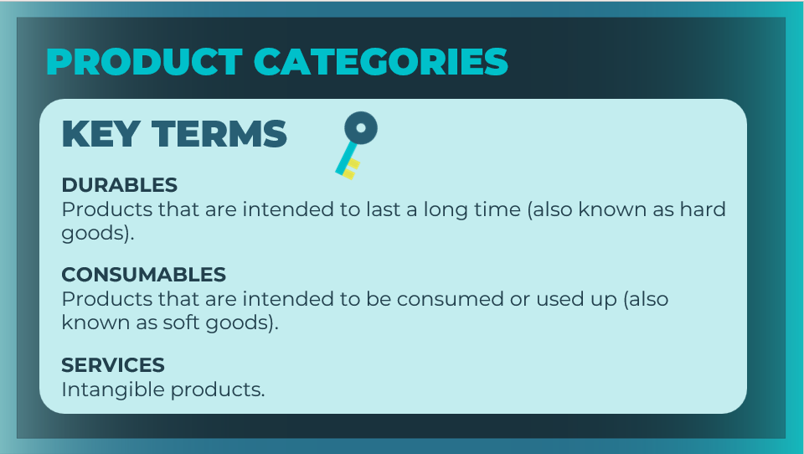 | Product  Define product. Make sure that students understand that “product” includes the quality, packaging, design, and brand.  Define the different consumer “product” categories: durables, consumables and services.  Students can record the definitions in their student workbook, pages 33-34.
Slide 14  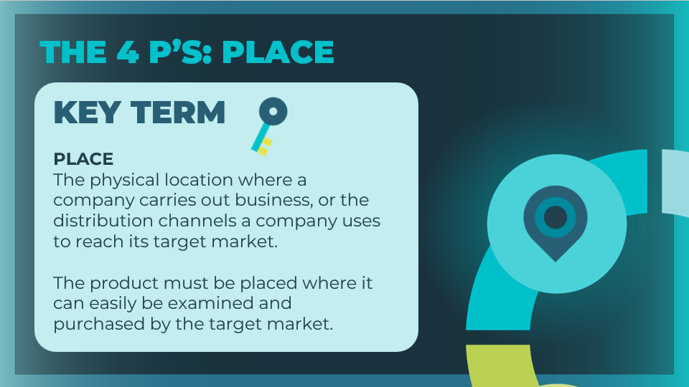 | Place  Define place. Students can record the definition in their student workbook, pages 33-34.  Explain that, in the context of the marketing mix, “place” includes where a product is sold, and where it is stored and delivered. Products can be sold in regular stores and in other ways.  Explore with students the differences between goods and services.
Slide 15  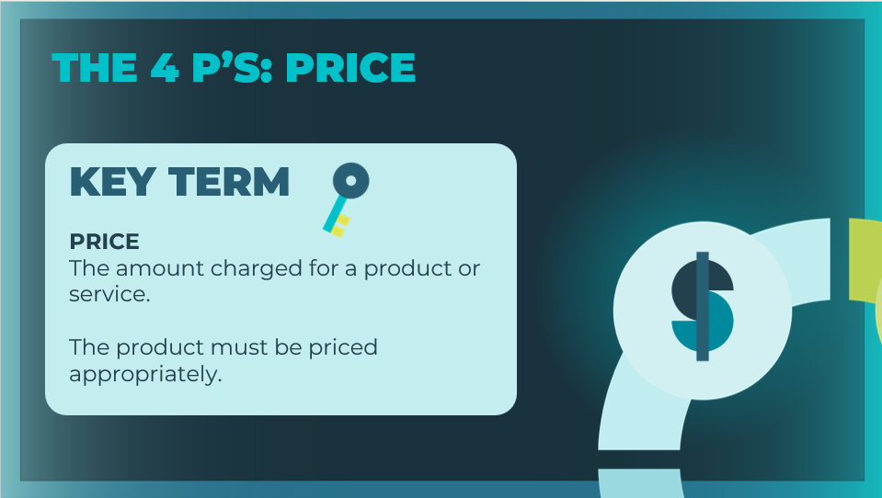 | Price  Define price. Students can record the definition in their student workbook, pages 33-34.  Describe the multiple factors for determining the right “price” for a product or service.  Explain to students that a price that is too high or too low will result in a product that is not profitable.  - If the price is too high, sales will be lost.  - If the price is too low, the company will lose money.
Slide 16  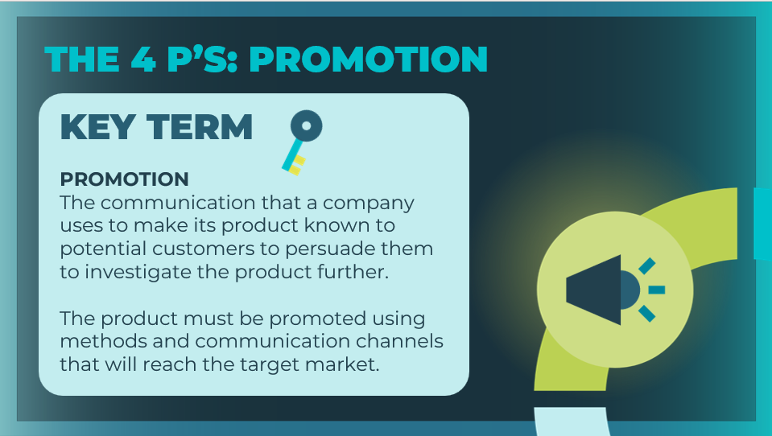 | Promotion  Define promotion. Students can record the definition in their student workbook, pages 33-34.  Describe the importance of “promotion” to marketing.  Promotion is what most people think of when they think  about marketing: getting word about the product out through  messages that target potential customers.  Explain that promotion costs money—it’s an investment. Marketers can evaluate a promotion’s effectiveness in terms of how that investment contributed to an increase in sales.  Ask: What are some examples of promotion activities? Answers include advertisements, commercials, contests, samples/giveaways, in-store marketing (displays), social media, coupons/sales, loyalty programs, customer appreciation activities and events, gifts/ branded gifts, customer referral incentives, alignment with charities, etc
Slide 17  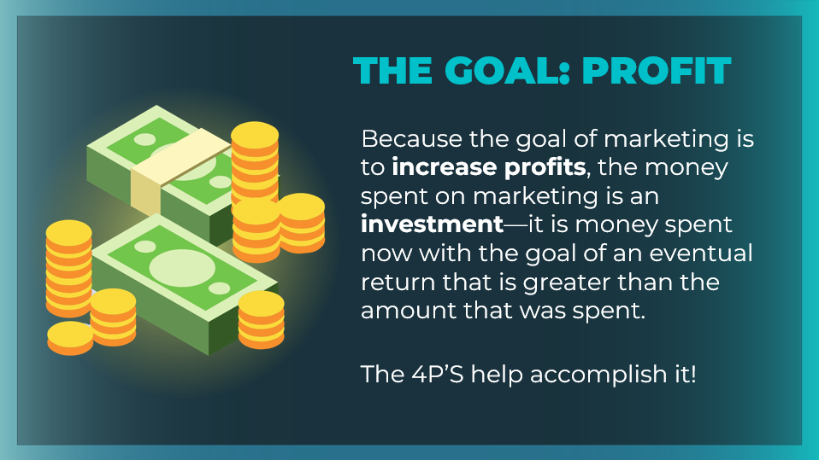 | Emphasize that each of the 4 P strategies has the same goal: to increase a company’s profitability.  Remind students that using market research to learn more about your buyers' preferences (demographics) helps in making decisions about the 4 Ps.
Slide 18  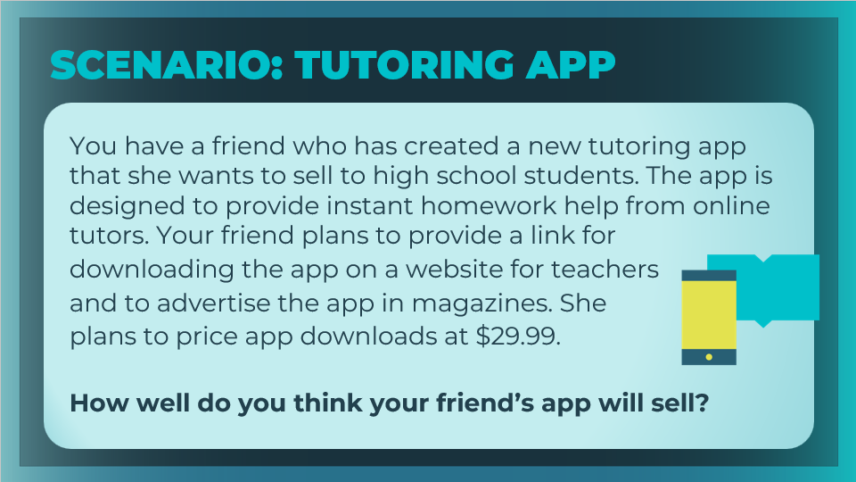 | Introduce the scenario and discuss the 4P’s.  - Product: Tutoring app designed for high school students that  - provides instant homework help from online tutors  - Place: App downloads will be available from a website for teachers  - Price: $29.99 per download  - Promotion: Advertising in magazines  Ask: How well do you think your friend’s app will sell?  Students should recognize that there are some problems with the marketing strategy shared, so the product likely will not sell very well.  Use the following slides to discuss if each of the 4P’s are being used effectively or not.
Slide 19  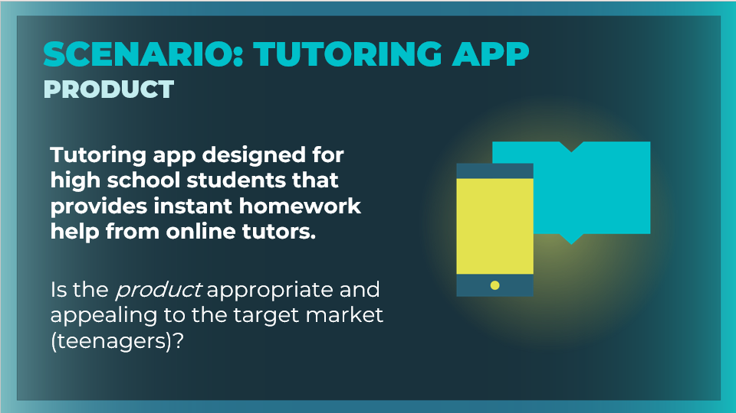  Slide 20  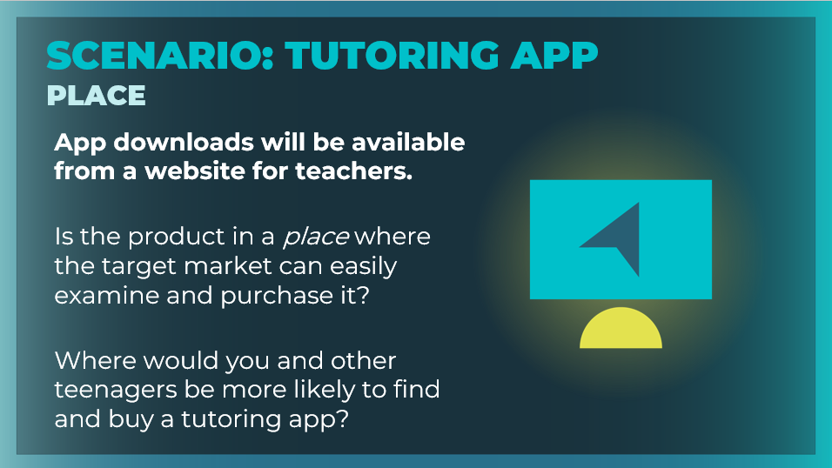  Slide 21  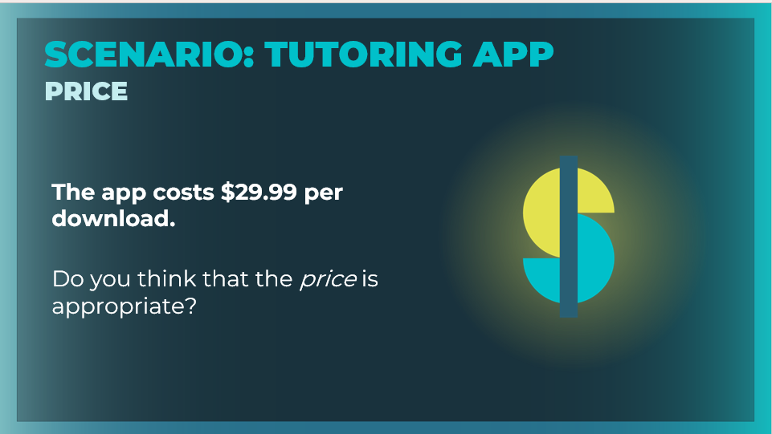  Slide 22  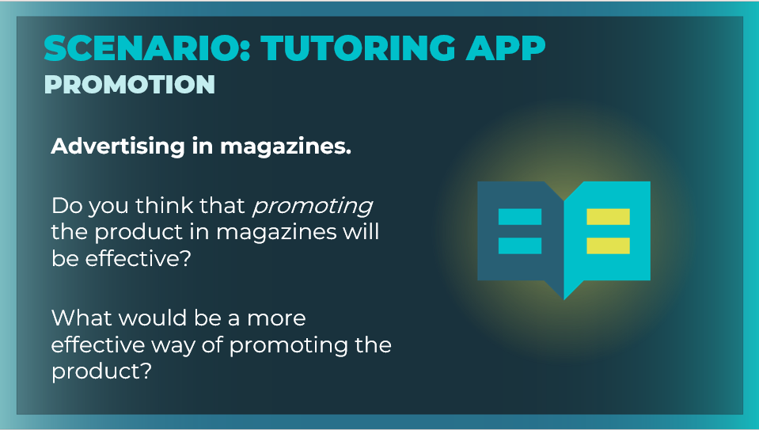 | Use the prompts to guide the discussion.  Is the product appropriate and appealing to the target market (teenagers)? Answers will vary. Accept all answers that are reasonable.  Is the product in a place where the target market can easily examine and purchase it? No, the product is placed on a website for teachers, so the target market—high school students—will not be able to find it easily.  Where would you and other teenagers be more likely to find and buy a tutoring app? Answers will vary, but students should identify online platforms where they typically look for and download apps.  Do you think that the price is appropriate? No, a cost of $29.99 is probably too expensive for an app, especially one geared toward high school students.  Do you think that promoting the product in magazines will be effective? No, most high school students are much more likely to find out about products online than in traditional print media.  What would be a more effective way of promoting the product? Answers will vary but should include that many teenagers find out about products via social media and other free platforms.
The 4 P’s in Action (15 mins)
Slide 23  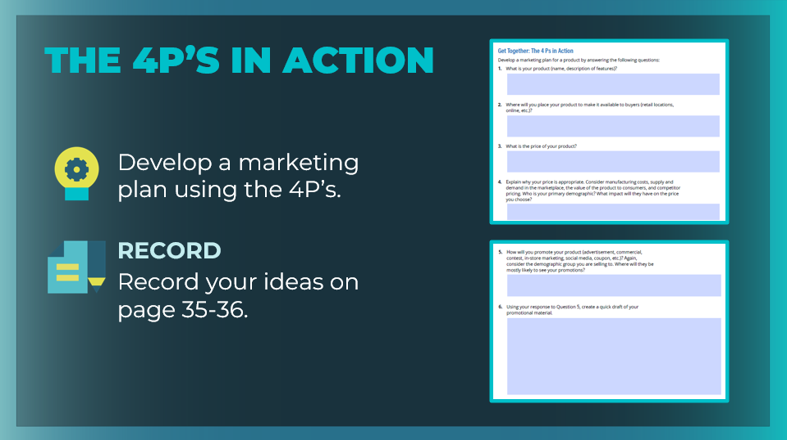 | Tell students that they will now put the 4 Ps into action by developing a marketing plan for a given product.  Direct students to the “4 Ps in Action” section of the student workbook, page 35, and review the instructions. Students will respond the each of the sections to develop their marketing plan.  Note: Students can create a marketing plan for the phone in the JA Titan simulation or for another product they find engaging. Students can work together in small groups, or they can work independently.  When students have completed the activity, ask for volunteers to present their product promotions and discuss their ideas, as time allows. Note the highest and lowest price points for similar products, and ask groups to explain why they selected those prices.  Highlight student promotions that are especially creative and well-suited to their target demographic.
Wrap Up (5 mins)
Slide 24  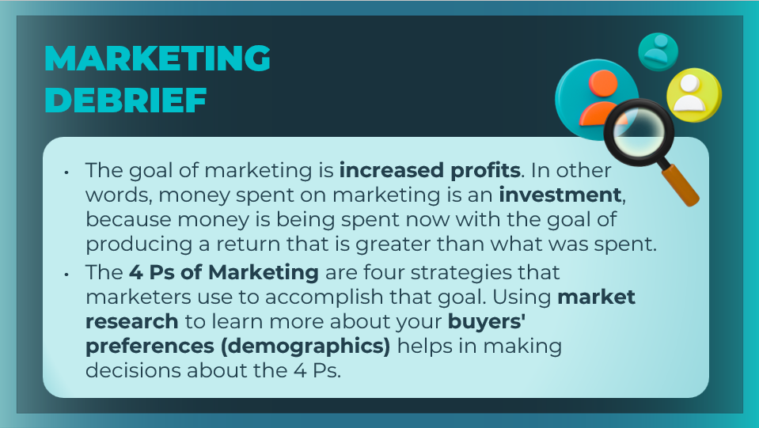 | Review the main ideas from this session with students.
Slide 25  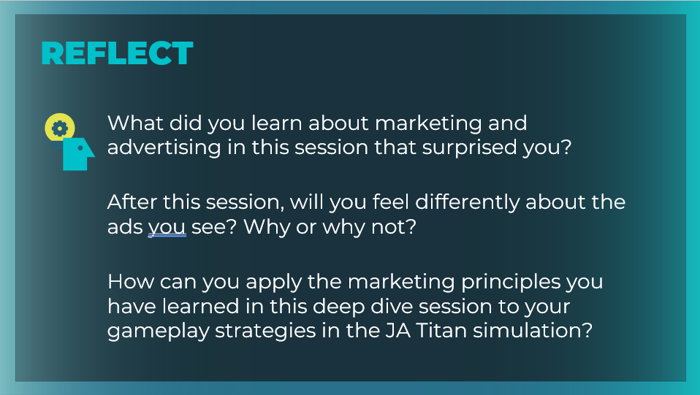 | Encourage students to reflect upon and share what they learned in the session.  What did you learn about marketing and advertising in this session that surprised you? Answers will vary. Encourage students to use specific examples of the marketing mix to support their responses.  After this session, will you feel differently about the ads you see? Why or why not? Answers will vary. Try to support students in their correct use of the session’s key terms and concepts.  Ask the following question of students who are also using the JA Titan simulation.  How can you apply the marketing principles you have learned in this deep dive session to your gameplay strategies in the JA Titan simulation? Answers will vary.  - Encourage students to relate what they have learned about product features, pricing, and promotion strategies to the marketing and sales business decisions they will need to make in the simulation.  - Emphasize the need to use market research to learn more about potential buyers' demographics.  Students can record their reflections in their student workbook, page 36.

