

Our Country: Technology and Innovation

JA Our Country Presenter Notes
The Presenter Notes have been developed using references from the digital classroom presentation and should be used in combination with the printed program kit materials.
Tips for Setting Up the Classroom
- Arrive 15 minutes early and check in at the office.
- Connect with the teacher for the program materials and organize them as needed.
- Hand out student portfolios and name tags/cards.
- Set up presentation (check audio and internet connection are working).
- Write your name on the board.
- Ask the teacher to write student names on program certificates.
- Check in with the teacher about school schedule, tips for getting students' attention, any specific student needs & behaviors you should be aware of and ask for help with encouraging student participation, as well as monitoring and managing the class.

Planning Guide
LESSON 4 (Slides 75 – 86) 55 MIN
FUTURE TECHNOLOGIES

Activities:
- Introduction (5 min)
- A Day in the Future (10 mins)
- Innovation Challenge (35 min)
- Review & Conclusion (5 min)
LESSON 3 (Slides 52 – 74) 50 MIN
MODERN TECHNOLOGIES

Activities:
- Introduction (5 min)
- Technological Advances (10 min)
- Technology Auction (20 min)
- Technology Changes in Canada (10 min)
- Review & Conclusion (5 min)
LESSON 2 (Slides 29 – 51) 35 MIN
TECHNOLOGY IN CANADA

Activities:
- Introduction (5 min)
- Canadian Technology (20 min)
- Progress in Technology (5 min)
- Review & Conclusion (5 min)
LESSON 1 (Slides 6 – 28) 50 MIN
TRADITIONAL AND MODERN TECHNOLOGIES

Activities:
- Introduction (5 min)
- Traditional Technologies (5 min)
- Definitions (15 min)
- Technology & Innovation Activity (20 min)
- Review & Conclusion (5 min)

GETTING STARTED – GETTING TO KNOW YOU (Slides 1 – 5) 5 MIN
WRAP UP (Slides 87 – 91) 10 MIN
CONGRATULATIONS!
Activities:
- Review & Certificates of accomplishment (10 min)

Introduction
Slide 1 – Our Country: Technology and Innovation   | Navigation Tips  - Navigate through the slides using the next or previous buttons (bottom right) clicking or tapping on the slide, or using the navigation menu (left)  - Look for slide specific instructions in the presenter notes below  The presentation includes interactive elements
Slide 2 – Welcome to JA!   | Suggested time: 3 minutes  Ask: Has anyone heard of Junior Achievement before?  Play the video for students to introduce them to JA!
Slide 3 – Our Country: Technology and Innovation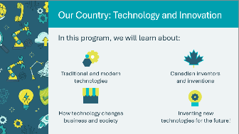 | Suggested time: 3-5 minutes  For volunteer-led sessions: Introduce yourself to the class. Tell the students a little about you; your education, and your career path until this point. Explain why you chose to volunteer in their classroom today.  For teacher-led sessions: You can move directly into the program overview or share a personal connection you have to technology and innovation.
Slide 4 – Symbol Legend  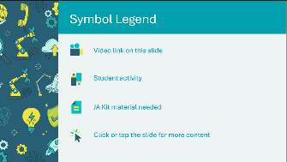 | The symbols will help guide the learning experience. Explain to students that they will see these symbols throughout the program.
Slide 5 – Our Country Lessons  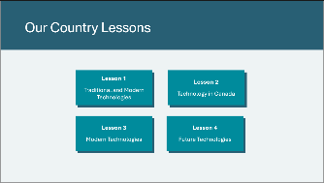 | *Select the button to navigate to the lesson.  After you have completed a lesson, you can select the Return to Main Menu button from the Lesson Activity Menu to return to this slide.

Lesson 1: Traditional and Modern Technologies
Program Kit Materials | Traditional and Modern Technologies Matching Cards (one set per group of 5-6 students)  
Slide 6 – Lesson 1   | Lesson 1: Traditional and Modern Technologies
Slide 7 – Objectives  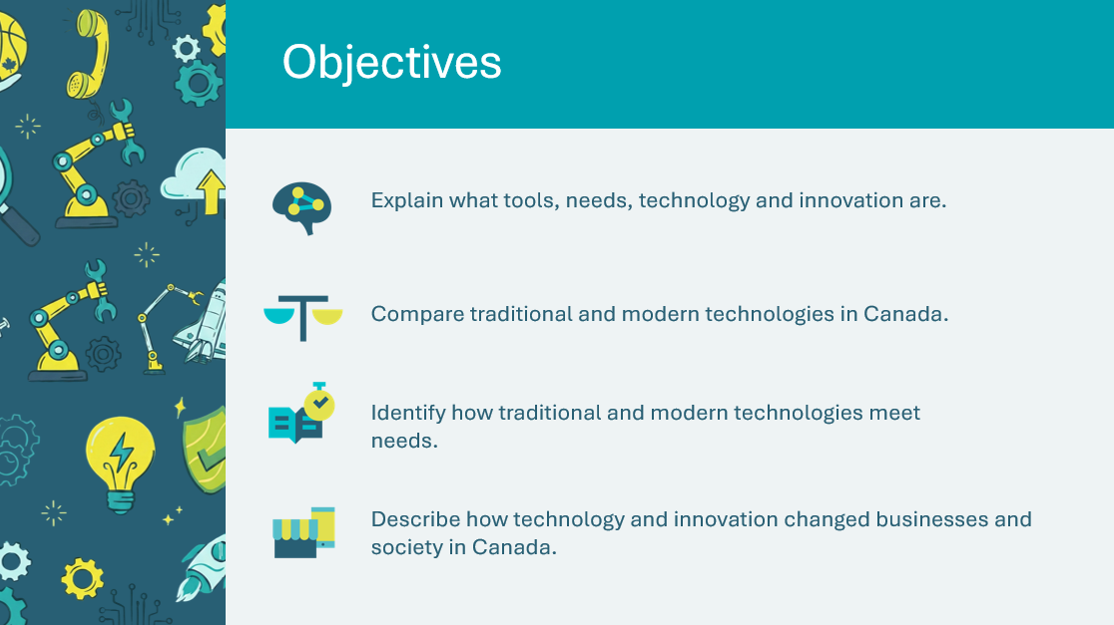 | Optional – review the learning objectives for the lesson.
Slide 8 – Introduction  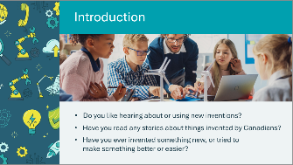 | Suggested time: 5 minutes  Facilitate a brief discussion using the prompts on the slide to introduce the lesson.
Slide 9 – Lesson 1 Then and Now: How Technology Changed Our World  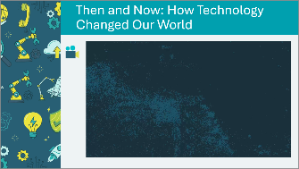 | Suggested time: 3 minutes  Play the video to introduces how technology has changed over time.  After the video, briefly discuss what students noticed using the following prompts.  - What did you see change in the video?  - Why do you think people invented new technologies?  Video transcript is available in the Appendix A if internet access is unavailable.
Slide 10 - Lesson 1: Traditional and Modern Technologies  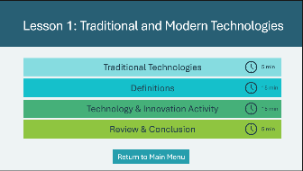 | *Select the button to navigate to the activity.  After you have completed an activity, you will be redirected back to the activity menu.  *Click or tap the Return to Main Menu button to return to the Lessons (Slide 5)
Traditional Technologies 5 min
Slide 11 - Traditional Technologies  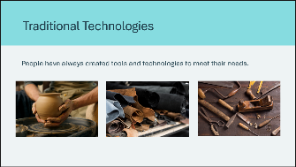 | Suggested time: 5 minutes  Introduce the concept that traditional tools and technologies have parallels to modern tools and technologies.
Slide 12 - Traditional and Modern Technologies  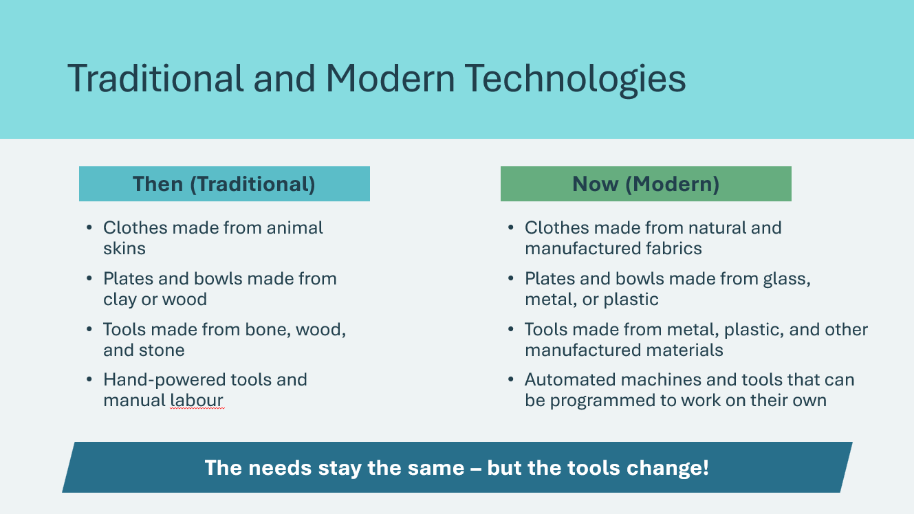 | Review the examples to highlight the parallels.  Key point: Traditionally, tools were invented to meet needs, just as modern businesses develop new technologies to meet modern needs. Today, automation means one worker can accomplish more than dozens of workers could with traditional manual tools.
Definitions 15 mins
Slide 13 - Definitions  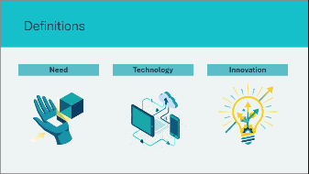 | Introduce the three key vocabulary terms that students will use throughout the program. Invite student volunteers to share what each term means.
Slide 14 - What is a Need?  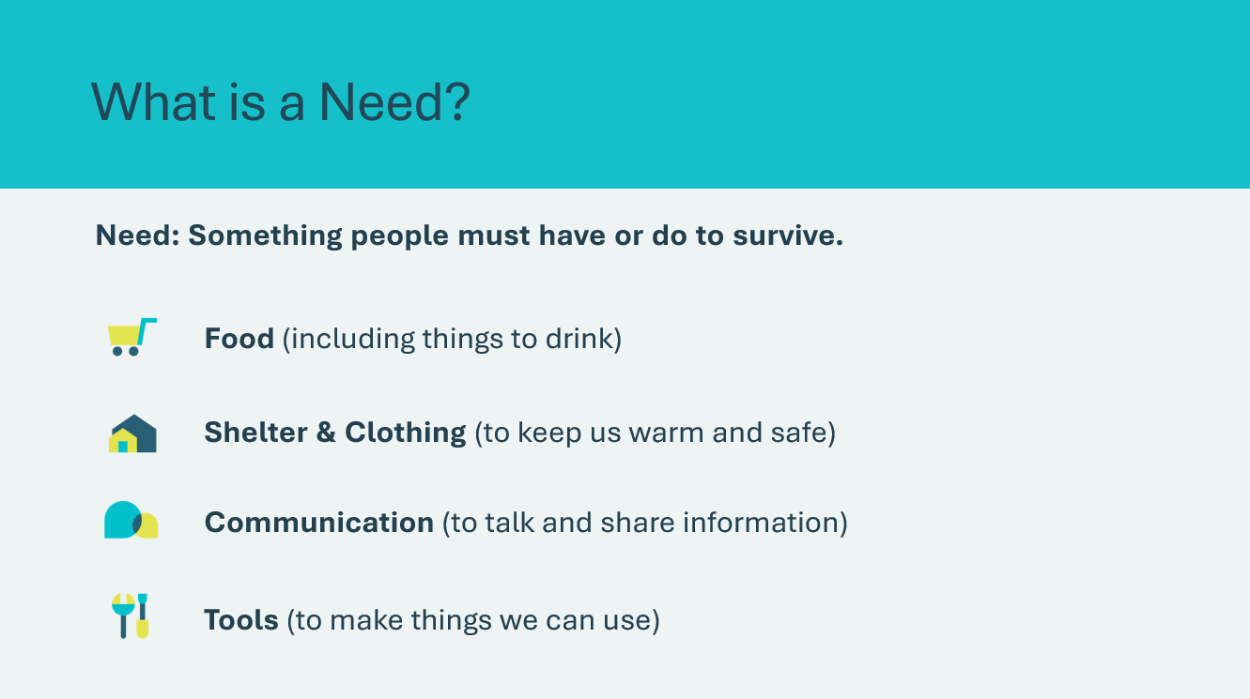 | Suggested time: 5 minutes  Review the definition for the term need.  Ask: Has the word "survive" changed over time in terms of what we need today vs. traditionally?  Review the four categories of needs:  1. Food (including things to drink)  2. Shelter and Clothing  3. Communication  4. Tools  Ask the class for examples of how people meet their needs:  - What things help us prepare food? (plates, cups, refrigerators, stoves)  - What things help keep us warm and safe? (clothes, houses, blankets, heaters)  - What things help us talk and share information? (pens, paper, telephones, computers)  - What things help us make tools? (saws, hammers, nails, glue, computers)
Slide 15 - What is Technology?  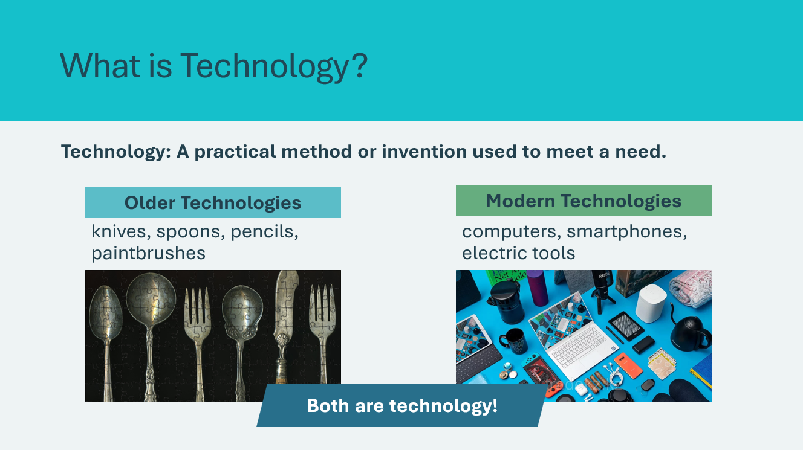 | Suggested time: 5 minutes  Review the definition for the term technology and the examples or older vs. modern technologies. Clarify that sometimes people use the word "technology" to refer to modern inventions, but it also refers to older inventions.  Help students understand that ANY tool or invention that helps meet a need is technology – it doesn't have to be electronic or modern.
Slide 16 - What is Innovation?  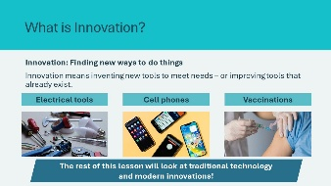 | Suggested time: 5 minutes  Review the definition for the term innovation and give examples of innovations:  - Electrical tools (innovation from hand tools)  - Cell phones (innovation from landline phones)  - Vaccinations (innovation in healthcare)  Explain that the rest of the lesson will look at traditional technology and modern innovations.
Program Kit Materials | For slides 17-18 you will need to use the Traditional and Modern Technologies Matching Cards from the program kit.
Slide 17 - Traditional and Modern Technologies  Matching Cards Activity  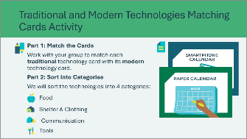  Traditional and Modern Technologies Matching Cards    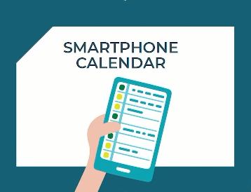 | Suggested time: 10 minutes  In this activity, students will work in groups to match traditional technologies with their modern equivalents, then categorize them into four needs categories.  Part 1: Card Matching  - Divide the class into groups of 5–6 students.  - Distribute one set of cards per group.  - Explain to students that their job is to find the traditional card that matches each modern card.  - Walk around to observe and assist as students work.
Slide 18 - Category Sorting  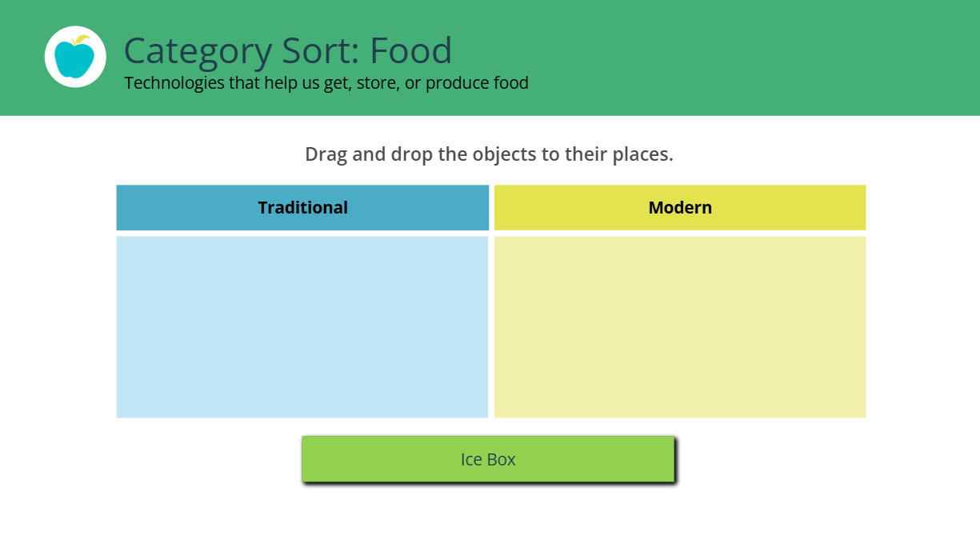 | Suggested time: 5 minutes  Part 2: Category Sorting  After about 10 minutes, bring the class back together to sort the matches by the type of need they help meet.  Use the interactive activity to sort the technologies. Each category slide shows a two-column table (Traditional | Modern) with a card bank of items to place.  Drag and drop the items into the correct column where each item belongs as students call out answers.  Facilitation Tips:  - For each example, ask: "Why does this belong under [category]?" and "Which is Traditional? Modern?"  - Note: Some items could fit multiple categories (e.g., Tractor = Tools). Accept reasonable arguments.  See Appendix B for complete Answer Key if you are unable to use the interactive activity.
Slide 24 - What Do You Notice? 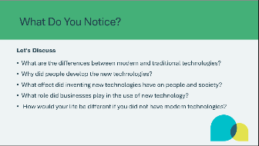 | Suggested time: 5 minutes  Facilitate a brief discussion using the prompts.  What are the differences between modern and traditional technologies?  - New technologies use complex materials (steel, plastics)  - They are often mechanized or use energy sources  - They may be more powerful or efficient  Why did people develop the new technologies?  - Made it easier to meet day-to-day needs  - Allowed producers to sell at a profit  - Resulted in increased work efficiencies  What effect did inventing new technologies have on people and society?  - More comfort, health and safety  - Higher standard of living  - Reduced human labour needed  - Systems for fast travel and communication  What role did businesses play?  - Businesses hired people to invent, manufacture and sell new technology  How would your life be different without modern technologies?  - Live in small settlements or on farms  - Work harder, less schooling  - No electronic games or entertainment  - Rarely travel far from home
Slide 25 - Takeaways   | Suggested time: 1 minute  Review the key takeaways, highlighting that both traditional and modern cultures have found ways to meet their most important needs. While there are many new technologies, people still use traditional technology today – sometimes the old ways work just fine!
Slide 26 - Indigenous Innovation   | Suggested time: 3-4 minutes  Introduce how Indigenous people have always been innovators, creating technologies perfectly suited to their environments and needs.
Slide 27 - Inuit Snow Goggles  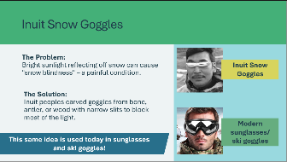 | Use the Inuit snow goggles as an example of Indigenous innovation.  The Problem: In the Arctic, sun reflecting off snow can cause "snow blindness" – a serious condition that can temporarily blind a person.  The Innovation: Inuit peoples carved goggles from, bone from animals, antler from caribou and wood (driftwood). The goggles had narrow slits to block bright light while allowing the wearer to see.  Help students make the connection to today by highlighting that same idea is used in modern sunglasses and ski goggles. This is a great example of Indigenous innovation – solving problems using available resources.
Review & Conclusion 5 min
Slide 28 - What Did We Learn?  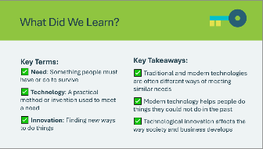 | Suggested time: 3-4 minutes  Ask the class if they have discovered anything new about the technologies they use, or that people used in the past.  Review the key terms and key takeaways for the lesson.  Tell the class that in the next lesson we are going to see how technology changed this country, discussing some important Canadian inventions.

Lesson 2: Technology in Canada
Program Kit Materials | Canadian Inventors Handout (1 per student)  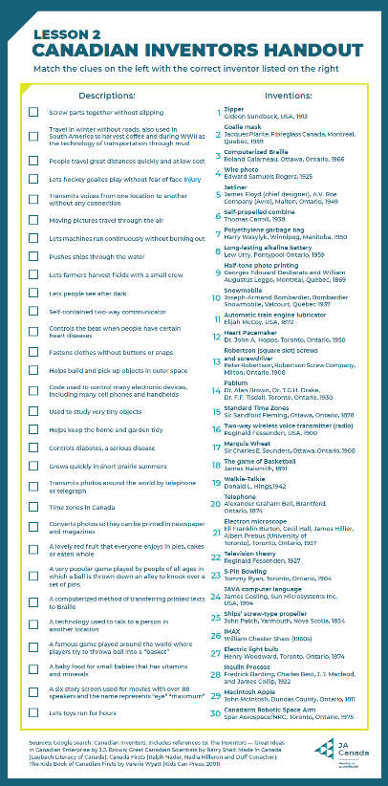
Slide 29 – Lesson 2  | Lesson 2: Technology in Canada
Slide 30 – Let’s Remember...  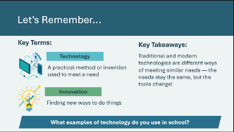 | Suggested time: 2 minutes  Optional – Quick Review  Before diving into Lesson 2, briefly review what students learned in the last lesson using the prompts.
Slide 31 – Objectives  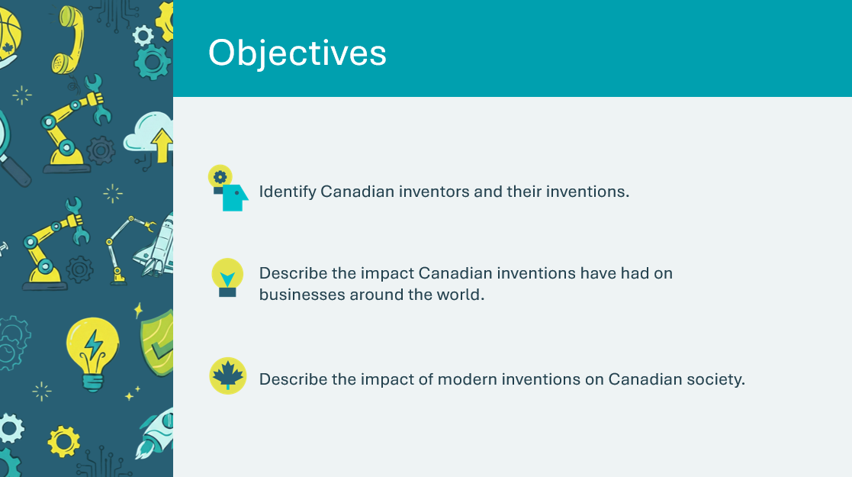 | Optional – review the learning objectives for the lesson.
Slide 32 - Introduction  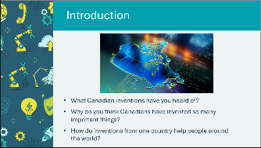 | Suggested time: 5 minutes  Facilitate a brief discussion using the prompts on the slide to introduce the lesson.  - Canadian inventions may include: telephone, basketball, insulin, Canadarm, zipper  - Encourage students to think about how inventions spread across the world and benefit everyone.
Slide 33 - Canadian Inventors Changed the World  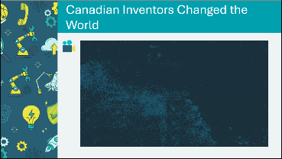 | Suggested time: 3 minutes  Play the video showcasing famous Canadian inventions including the telephone, basketball, insulin, snowmobile, and Canadarm to build excitement and Canadian pride.  After the video, facilitate a quick discussion using the prompts below.  - Which invention surprised you the most?  - Which invention were you surprised to learn was Canadian? Common surprises: basketball, insulin, garbage bags  Video transcript is available in the Appendix A if internet access is unavailable.
Slide 34 - Lesson 2: Technology in Canada  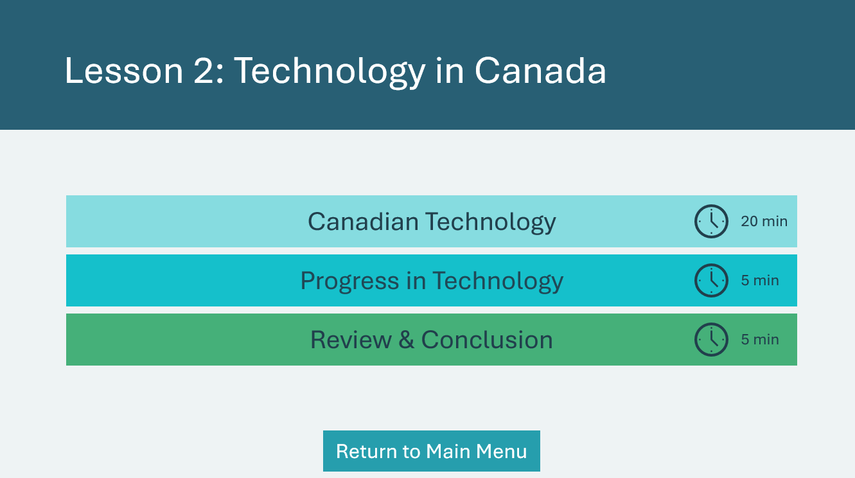 | *Select the button to navigate to the activity.  After you have completed an activity, you will be redirected back to the activity menu.  *Click or tap the Return to Main Menu button to return to the Lessons.
Canadian Technology 20 min
Slide 35 - Canadian Technology  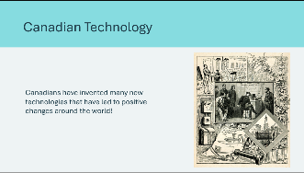 | Suggested time: 2 minutes  Introduce the activity by highlight that Canadians have made significant contributions to global innovation — inventions that are used around the world and even in space!
Slide 36 - Canadian Inventions All Around Us!  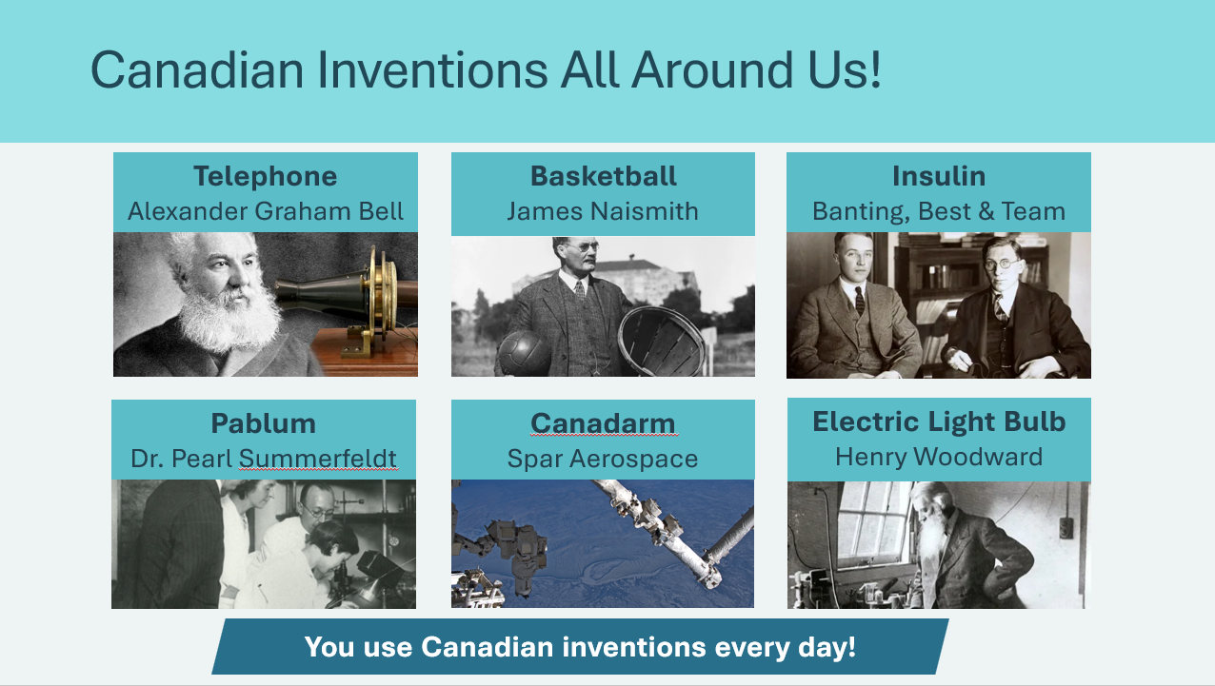 | Review each of the inventions slide.  - Telephone — Alexander Graham Bell invented this in Brantford, Ontario  - Basketball — James Naismith invented it as an indoor winter game  - Insulin — Discovered by Canadian scientists — it saves millions of lives!  - Canadarm — Canada's famous robotic space arm  - Electric Light Bulb — Henry Woodward patented it before Thomas Edison!  - Pablum — A specially formulated baby cereal invented at Toronto’s Hospital for Sick Children in 1930.  Explain to students that in this activity they will learn about 30 Canadian inventions! They will work in groups to match clues with the correct inventions.
Program Kit Materials | For slides 37-46, you will need to use the Canadian Inventors Handouts from the program kit.
Slide 37 - Canadian Inventors Matching Activity    Canadian Inventors Handout | Suggested time: 2 minutes  Explain the handout format.  Left side of handout: Clues (Descriptions)  - These are clues that tell you what the invention does  - Example: A technology used to talk to a person in another location — What invention does this describe?  Right side of handout: Inventions  - Each invention has a number, the invention name, the inventor name, and the year it was invented  - Example: “#20 Telephone — Alexander Graham Bell, Brantford, Ontario, 1874”  Student task:  - Read each clue carefully  - Find the invention that matches  - Write the invention number next to the clue  Facilitator Tip: Tell the groups they will have to work fast or they won’t have time to get all the answers. To keep the activity moving, assign 10 inventions per group.  Write the group assignments on the board so students can reference them during the activity (example below):  - Group 1: Inventions #1-10  - Group 2: Inventions #11-20  - Group 3: Inventions #21-30  - Group 4: Inventions #1-10  - Group 5: Inventions #11-20  Note: Some groups will be working on the same inventions. Adjust the number of groups and assigned inventions as needed.
Slide 38 - Match the Clues!  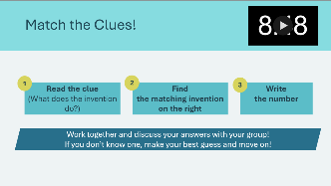 | Suggested time: 10 minutes  Organize groups and distribute handouts:  - Divide class into small groups assign inventions.  - Give each group a Canadian Inventors Handout.  Facilitator Tip: Ensure each group has at least one strong reader.  While students work, walk around the room and observe group progress, encourage discussion within groups and prompt groups to agree on answers together.  If students are stuck, provide hints:  - “Think about what the clue is saying — what does that invention DO?”  - “Look for key words in the clue that match the invention name.”  - “The telephone was invented by Alexander Graham Bell — you might know his name!”  - “Basketball has ‘basket’ right in the description!”  If a group finishes early, have them help other groups, double-check their answers or challenge them to find the oldest and newest inventions.  Use the timer on the slide to provide a visual for students. Give reminders periodically.
Slide 39 - Let’s Check Your Answers!   | Suggested time: 5 minutes  Call the groups back together and review using the following structure.  - Read one of the clues (the description).  - Ask a group: What number did you match?  - Ask: What is that invention?  - See if the rest of the class agrees.  - Reveal/confirm the correct answer (Invention + Inventor + Year).  You don’t need to review all 30. Select 8-10 key inventions to review, prioritizing well-known ones and student surprises.  Take the answers up as a class. See Appendix C for complete Answer Key.
Slide 40 - Famous Canadian Inventions  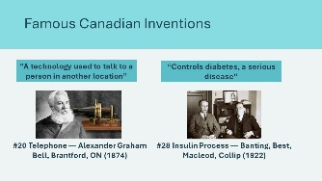 | Suggested time: 2 minutes  Highlight some of the most famous Canadian inventions.  #20 TELEPHONE:  - Clue: A technology used to talk to a person in another location.  - Alexander Graham Bell made the first long-distance call from Brantford to Paris, Ontario.  - Impact: Changed how people communicate forever!  #28 INSULIN:  - Clue: Controls diabetes, a serious disease.  - Before insulin, diabetes was often fatal. Banting won the Nobel Prize.  - Impact: Saves millions of lives around the world!
Slide 41 - Famous Canadian Inventions  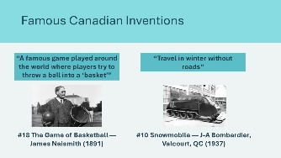 | Suggested time: 2 minutes  Highlight some of the most famous Canadian inventions:  #18 BASKETBALL:  - Clue: A famous game played around the world where players try to throw a ball into a ‘basket’.  - Naismith invented it as an indoor winter game.  - Impact: Now played by hundreds of millions of people worldwide!  #10 SNOWMOBILE:  - Clue: Travel in winter without roads.  - Also used in South America to harvest coffee and during WWII for transportation through mud.  - Impact: Used across Canada and the world for winter travel and recreation!
Slide 42 - Famous Canadian Inventions  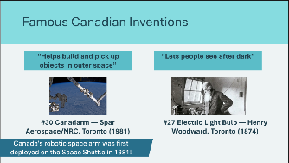 | Suggested time: 2 minutes  Continue highlighting Canadian inventions:  #30 CANADARM:  - Clue: Helps build and pick up objects in outer space.  - Canada’s famous robotic space arm has been used on the Space Shuttle and International Space Station since 1981.  - Impact: Helps astronauts build and repair the space station!  #27 ELECTRIC LIGHT BULB:  - Clue: Lets people see after dark.  - Woodward and his partner Matthew Evans patented the light bulb. They later sold their patent to Thomas Edison!
Slide 43 - Famous Canadian Inventions  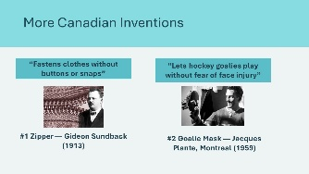 | Suggested time: 2 minutes  Continue highlighting Canadian inventions:  #1 ZIPPER:  - Clue: Fastens clothes without buttons or snaps.  - Now used on billions of jackets, bags, and pants worldwide!  #2 GOALIE MASK:  - Clue: Lets hockey goalies play without fear of face injury.  - Plante was a Montreal Canadiens goalie who invented the mask after being hit in the face by a puck. Now all goalies wear masks!
Slide 44 - More Canadian Inventions  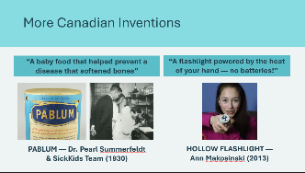 | Suggested time: 2 minutes  Continue highlighting Canadian inventions:  #1 PABLUM (BABY CEREAL):  - Clue: "A baby food that helped prevent a disease that softened children's bones"  - In the 1930s, a team at Toronto's Hospital for Sick Children — including Dr. Pearl Summerfeldt, one of Canada's first female pediatricians — invented Pablum, the first precooked baby cereal. Parents could prepare it in seconds by adding milk or water. It helped prevent rickets and saved thousands of babies' lives around the world.  #2 HOLLOW FLASHLIGHT:  - Clue: A flashlight powered by the heat of your hand — no batteries needed!  - In 2013, a 15-year-old girl from Victoria, BC named Ann Makosinski invented a flashlight that runs on the warmth of your hand — no batteries needed. She got the idea when a friend in the Philippines had no electricity to study at night. Ann won the Google Science Fair and was named one of Time magazine's top young world changers.  Key point: Inventors come from all backgrounds and all ages. Dr. Summerfeldt was a woman in a field dominated by men, and Ann Makosinski was just 15! You don't have to be a grown-up to be an inventor.
Slide 45 - Canadian Innovators: Past and Present   | Suggested time: 1-2 minutes  Highlight Elsie MacGill as a Canadian engineer and innovator who solved real problems through design and testing.  - Mention her engineering “firsts” (early woman in electrical and aeronautical engineering).  - Explain her practical innovation: helped design a trainer plane that could use wheels, skis, or floats to match Canadian landing conditions.  - Emphasize the innovation mindset: identify a need → design → test → improve (helps make things safer and work better).  Key point: Innovators come from all backgrounds—students can use the same process to improve everyday things.
Slide 46 - Canada: A Country of Innovators!  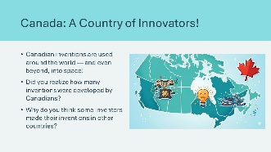 | Suggested time: 2 minutes  Wrap up the activity using the discussion prompts.  Did you realize how many inventions were developed by Canadians?  - Most students are surprised by the number and variety  - Point out that these are just 30 — there are many more!  Why do you think some inventors made their inventions in other countries?  - Looking for better opportunities  - Access to more resources or funding  - Connections with businesses or universities  - But they were still Canadian innovators!  By using the ideas of Canadian inventors, many businesses in Canada have become important around the world. Many businesses in other countries have also become very successful by making use of Canadian inventions.  Share that in the next section you’ll discuss how new technologies change the way we live and work.
Progress in Technology 5 mins
Slide 47 - Progress in Technology  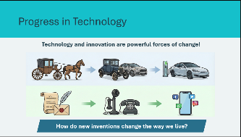 | Suggested time: 2 minutes  Point out that the Canadian inventions are just a few of the many new technologies that people have come to use in recent years and facilitate a discussion about the changes that new inventions have brought to modern society.  Highlight that technology and innovation are powerful forces that change:  - How we live our daily lives  - How businesses operate and grow  - What kinds of jobs exist  - How communities connect with each other
Slide 48 - Why Do We Switch Technologies?  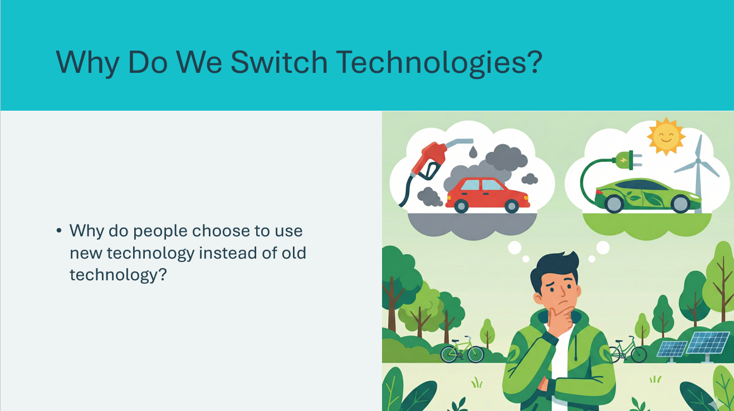 | Suggested time: 2 minutes  Continue the discussion using the prompt on the slide and ask students to share their experiences switching technologies.  Examples to prompt discussion:  - Old tablet or phone to a newer one  - Cable TV to streaming apps (Netflix, Disney+, YouTube)  - Paper books to e-readers or audiobooks  - Wired headphones to wireless earbuds  - Regular toys to smart toys or video games  Expected answers:  - Because of advantages offered by the new technology  - It’s faster — no waiting  - It’s easier to use  - It’s more convenient — access anywhere, anytime  - More choices — thousands of shows or games available instantly  - Better features — better camera, clearer screen
Slide 49 - Technology and Business  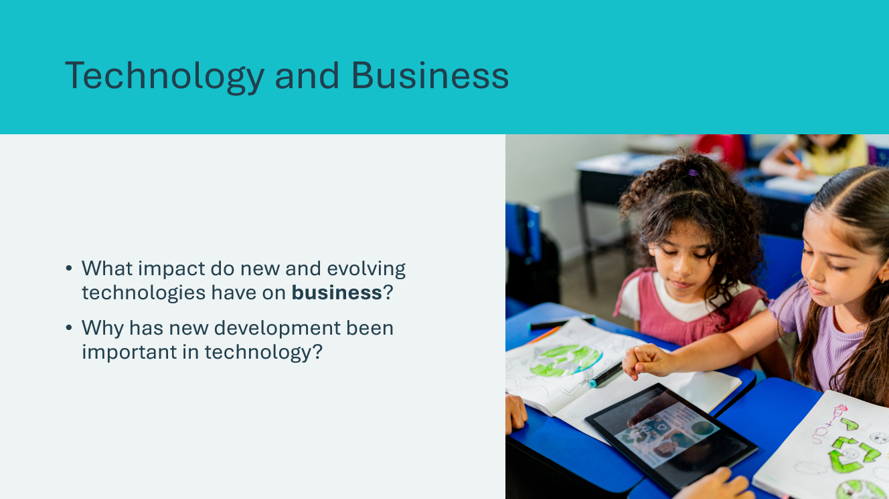 | Suggested time: 2 minutes  Continue the discussion using the prompt on the slide.  What impact would new and evolving technologies have on business?  - Creates new business opportunities: app companies, streaming services, online stores, electric car companies, drone delivery, video game studios, social media companies  - Enables faster transportation: products from Canada can reach customers worldwide through exporting and international trade.  - Changes how people work: people can work from home using computers; machines, robots, and AI help people work faster and smarter; new skills are needed for new technologies like artificial intelligence.  Why is new development important in technology?  Use specific examples students know:  - Television: Antennas → Cable → Streaming (Netflix, Disney+)  - Phones: Landlines → Flip phones → Smartphones with apps  - Gaming: Arcade games → Home consoles → Mobile games → VR headsets  Key Point: Each step made technology better, more convenient, or gave people more choices. Innovation never stops!  - Creates new business opportunities: app companies, streaming services, online stores, electric car companies, drone delivery, video game studios, social media companies  - Enables faster transportation: products from Canada can reach customers worldwide through exporting and international trade.  - Changes how people work: people can work from home using computers; machines, robots, and AI help people work faster and smarter; new skills are needed for new technologies like artificial intelligence.  Why is new development important in technology?  Use specific examples students know:  - Television: Antennas → Cable → Streaming (Netflix, Disney+)  - Phones: Landlines → Flip phones → Smartphones with apps  - Gaming: Arcade games → Home consoles → Mobile games → VR headsets  Key Point: Each step made technology better, more convenient, or gave people more choices. Innovation never stops!
Slide 50 - Technology and Jobs  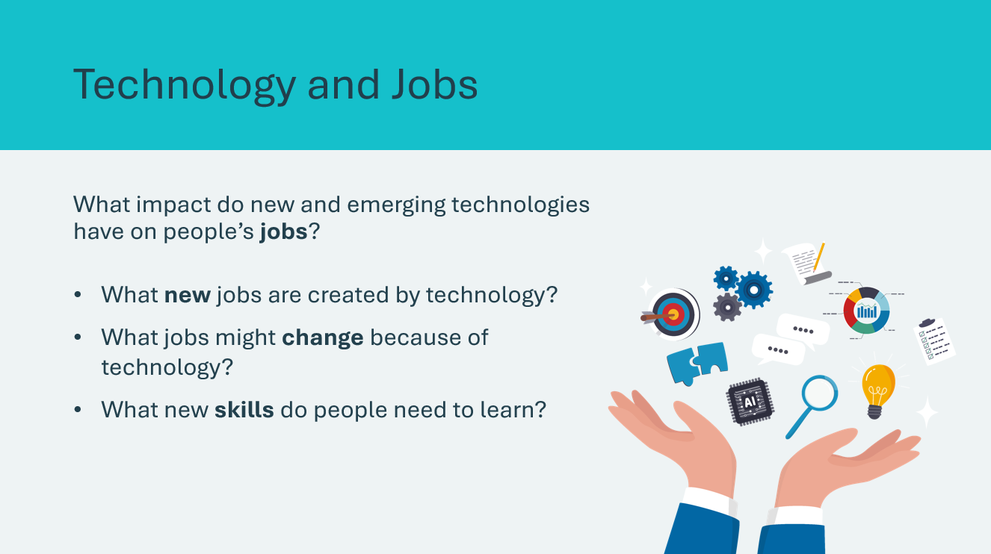 | Suggested time: 2 minutes for Question 5  Continue the discussion using the prompt on the slide.  New jobs created by technology:  - App developers and programmers, video game designers  - Social media managers, YouTubers and content creators  - Drone operators, electric car technicians  - Robotics engineers, AI specialists  Jobs that changed because of technology:  - Stores — many people now shop online  - Delivery drivers — more packages to deliver than ever  - Teachers — now use computers and tablets  - Doctors — use robots and computers to help patients  New skills people need:  - Computer and technology skills  - Ability to learn new things quickly  - Problem-solving and creativity  Share that the jobs students might have when they grow up might not even exist yet! That’s why learning about technology and innovation is so important.
Review & Conclusion 5 min
Slide 51 - What Did We Learn?  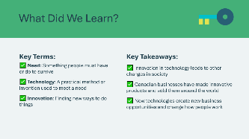 | Suggested time: 3 minutes  Review the key terms and key takeaways for the lesson.  Reinforce that technology and innovation are powerful forces that shape our world. Canada has been — and continues to be — a leader in innovation!

Lesson 3: Modern Technologies
Program Kit Materials | $20 of JA Money per student  - Two $5 bills  - Four $2 bills  - Two $1 bills  
Slide 52 - Modern Technologies   | Lesson 3: Modern Technologies
Slide 53 - Let’s Remember...  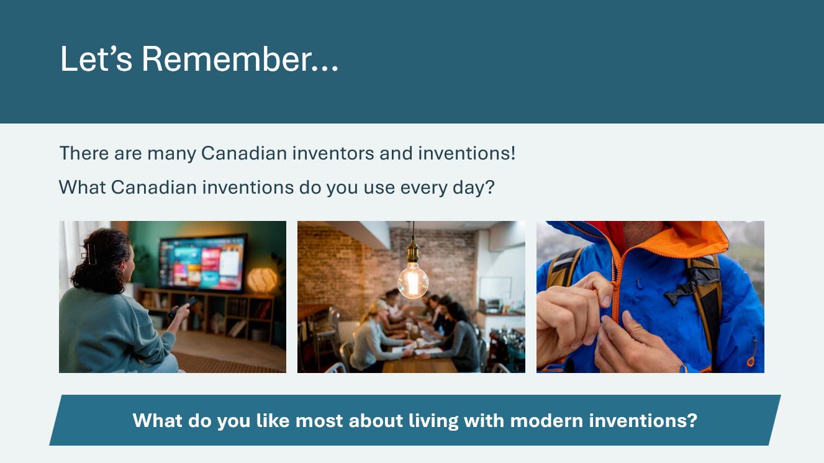 | Suggested time: 4 minutes  Optional: Briefly review some of the technologies and inventions covered in Lesson 2.  Invite students to share some of the examples of inventions by Canadians that they use every day: television (television theory) zippers, plastic garbage bags, low-cost light bulbs, two-way radios (walkie-talkies), basketball  Ask students to share what they like most about living with modern inventions.
Slide 54 - Objectives  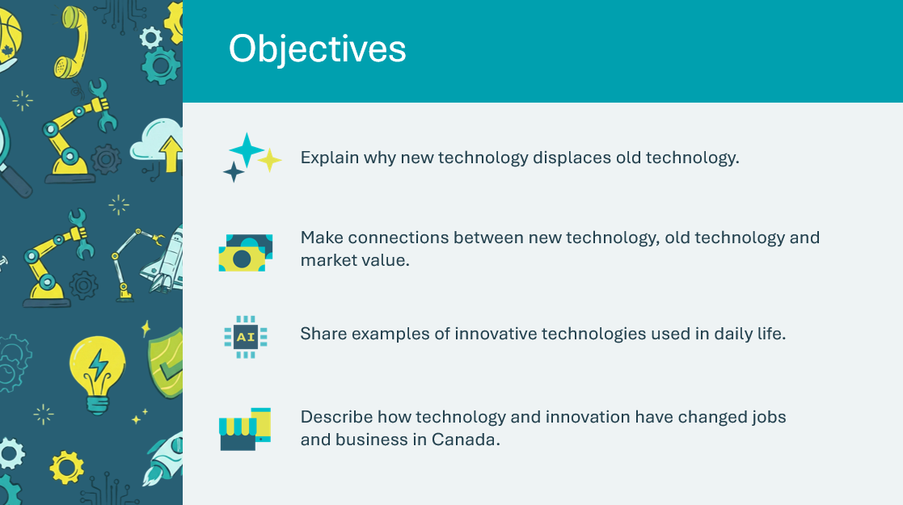 | Optional – review the learning objectives for the lesson.
Slide 55 - Introduction  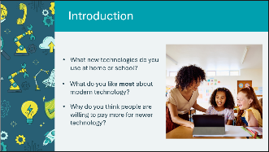 | Suggested time: 3 minutes  Facilitate a discussion using the prompts to introduce the lesson.  What new technologies do you use at home?  - Smartphones, tablets, video games, streaming, smart speakers  What do you like most about modern technology?  - Things are easier, faster, more convenient, we can communicate instantly  Why do you think people are willing to pay more for newer technology?  - Newer technology often has more features, works better, is more convenient
Slide 56 - The Sound of Change   | Suggested time: 3 minutes  Play the video showing the evolution of music playback technology from gramophone to streaming.  After the video, facilitate a quick discussion using the prompts.  - How many music players did you recognize?  - Which of these have you actually used to listen to music?  Video transcript is available in the Appendix A if internet access is unavailable.
Slide 57 - Lesson 3: Modern Technologies   | *Select the button to navigate to the activity.  After you have completed an activity, you will be redirected back to the activity menu.  *Click or tap the Return to Main Menu button to return to the lessons.
Technological Advances 10 min
Slide 58 - How We Listen to Music: Then and Now  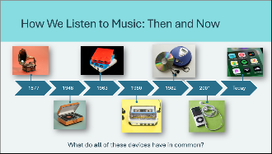 | Suggested time: 3 minutes  Ask: What do all of these devices have in common?  They are all ways that people have used to record music and other sounds.  If necessary, briefly explain what each device is:  - Gramophone — the first device to play recorded sound (1877)  - LP Record (vinyl) — flat discs that spin around (1948)  - 8-Track — big cartridges for cars (1963)  - Cassette — small tapes, portable (1980s)  - CD — shiny discs with digital sound (1982)  - MP3 Player — portable digital music, thousands of songs in your pocket (2001)  - Streaming — millions of songs on your phone or device instantly (today)  Point out how they are organized them from oldest to newest. Each new technology replaced the one before it.
Slide 59 - Why Did Each New Technology Become More Popular?  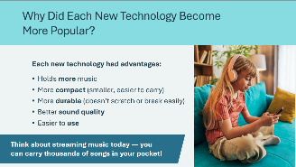 | Suggested time: 2 minutes  Facilitate a discussion about why each new music technology became more popular than the one before it. Take student answers, then review the advantages on the slide.
Slide 60 - Who Brings New Technology to You?  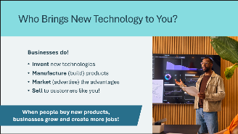 | Suggested time: 2 minutes  Emphasize that every one of these music technologies had to be invented, built, and sold by a business.  Explain the business process:  - Businesses invent new technologies — they have engineers and designers who create new products.  - Businesses manufacture products — they build them in factories.  - Businesses market the advantages — they advertise why their product is better.  - Businesses sell to customers — people like you and your families buy them.  Point out that developing and selling new technologies can be very risky. New products may cost many millions of dollars to develop and market, and sometimes people don't want to buy them — this can cause new products to fail.  So why take the risk? Businesses hope that the advantages of a new product will convince buyers to choose their product rather than existing products. When that happens, the business makes money and can hire more people!
Technology Auction 20 min
Slide 61 - Technology Auction   | Suggested time: 2 minutes (introduction)  Introduce the auction activity by asking if anyone ever been to an auction or seen one on TV. Briefly explain how an auction works.  - The auctioneer shows an item for sale.  - Buyers bid by calling out the price they are willing to pay.  - Buyers want to pay as little as possible, so they start with a low price. They only increase if someone offers a higher price.  - The person who bids the highest price purchases the item.  Explain that students will participate in a technology action using JA money!
Slide 62 - How Does an Auction Work?   | Suggested time: 2 minutes  Play the video to introduce students to the auction concept. After the video, confirm understanding using the following prompts:  - What happens if two people both want the same item? (They keep bidding higher!)  - What happens when your money is gone? (You can’t buy anything else!)  Video transcript is available in the Appendix A if internet access is unavailable.
Program Kit Materials | For slides 37-46, you will need to use the JA Money from the program kit.
Slide 63 - Auction Rules    JA Money | Suggested time: 2 minutes  Review the rules outlined on the slide.  Remind students that they have only $20 to spend, so they have to spend it carefully. They should not bid for something they do not want.  Give each student $20 of JA Money:  - Two $5 bills  - Four $2 bills  - Two $1 bills  Facilitator Tip: If students are unclear about how an auction works, hold a practice round using a popular item like a video game.
Slide 64 - Let the Bidding Begin!  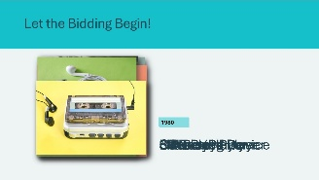 | Suggested time: 10 minutes  Conduct the auction. Click or tap to display each item on the slide. Items are ordered starting from oldest to newest.  For each item:  - Show the picture (or use a real item if available).  - Briefly describe what it is.  - Begin the auction at $2.  - Take bids until students stop bidding.  - Record the winner's name and price on the whiteboard so everyone can see.  - If no one bids, record ‘no sale’.  Suggested descriptions:  - Gramophone: One of the first ways to play recorded music!  - LP Record Player: Plays vinyl records — you might have seen these at a grandparent’s house or in a music store!  - 8-Track Player: These were popular in cars in the 1970s.  - Cassette Player: Smaller tapes — the Walkman let people listen to music while walking!  - CD Player: Crystal-clear digital sound with no scratching.  - MP3 Player: Portable digital music — carry thousands of songs in your pocket!  - Streaming Device: Listen to ANY song instantly — millions of songs in your pocket!  Track all winning bids so students can compare prices at the end.
Slide 65 - Auction Results!   | Suggested time: 3 minutes  Review the auction results with the class. Facilitate a discussion using the prompts on the slide.  Key Point: The newer technologies usually receive a higher price than older ones.  Ask: might some old items actually be valuable?  - People may want old items to collect for historical purposes.  - Vinyl records are popular again because some people like the sound.  - Old technology can be valuable to collectors.
Slide 66 - What Does This Mean for Businesses?  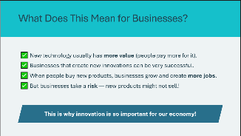 | Suggested time: 2 minutes  Connect the auction results to business concepts.  Remind students that businesses take a risk when they create new products. Not all new products succeed, but the hope of success drives businesses to keep innovating.  This is why innovation is so important for our economy!
Slide 67 - What New Technologies Do You Use?  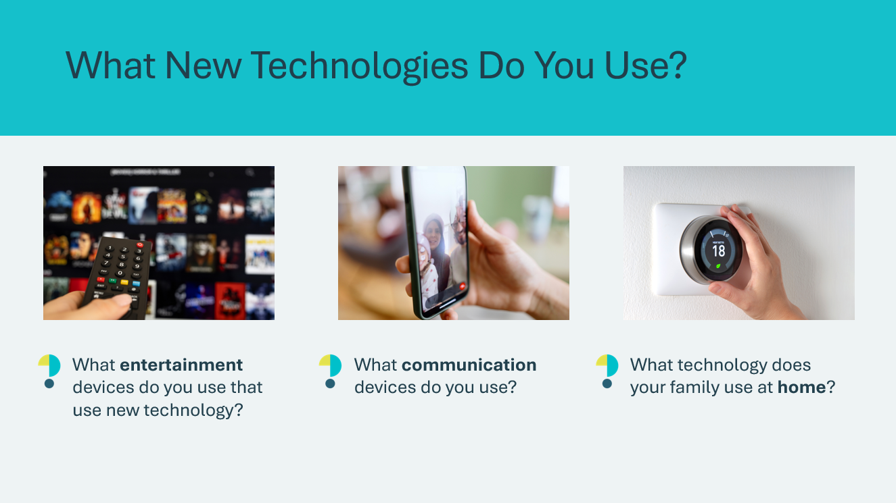 | Suggested time: 5 minutes  Wrap up the activity with a discussion around the technologies students use.  Entertainment devices: Gaming consoles (PlayStation, Xbox, Nintendo Switch), VR headsets, streaming services (Netflix, Disney+, YouTube), tablets for games and videos.  Communication devices: Smartphones, video chat (FaceTime, Zoom), messaging apps.  Household technology: smart speakers (Alexa, Google Home), smart thermostats, appliances with digital controls, robot vacuums.  Key Point: Businesses innovate to meet people's needs and solve problems. When people buy these products, the business can sell them profitably and will be successful. This leads to more jobs and encourages even more innovation!
Technology Changes in Canada 10 min
Slide 68 - Technology Changed Canada  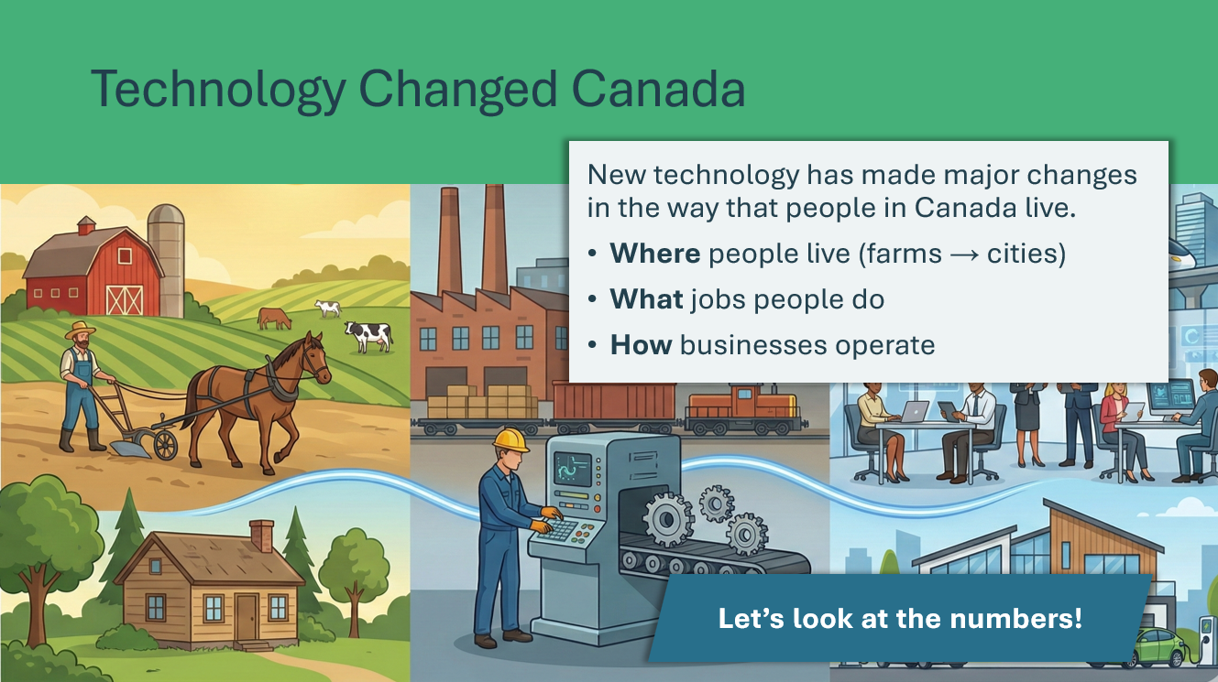 | Suggested time: 2 minutes  Share with students how new technology has made major changes in the way that people in Canada live.  Key points to introduce:  - Over the past 100 years, technology has changed where people live  - Technology has changed what jobs people have  - Technology has changed how businesses work  Highlight the three types of work in the image:  - Agriculture: Farming; the growing/raising of crops and livestock  - Manufacturing: Making things by hand or machine  - Services & technology: Communication, computers, services  Ensure students understand what these terms mean before continuing.
Slide 69 - Canada in 1921 (100+ years ago)  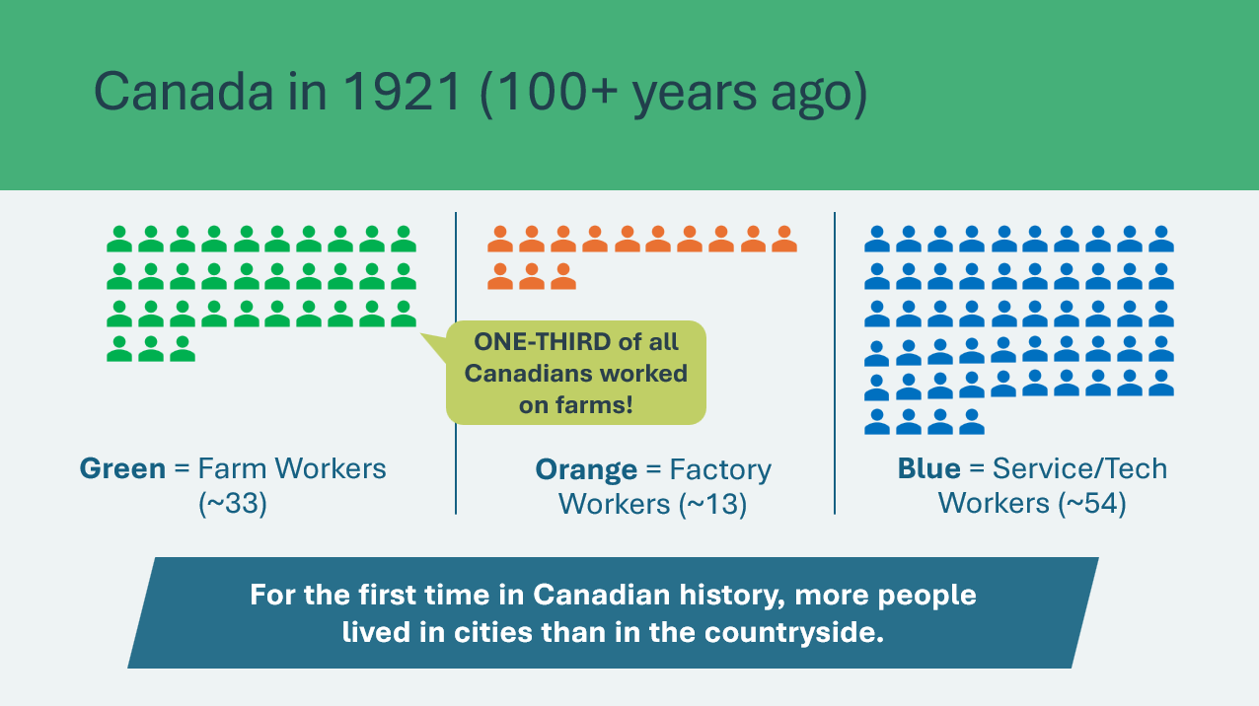 | Suggested time: 3 minutes  Optional activity: Have students start in groups at the front of the class representing each industry. As you describe the changes, have students move between groups.  Show the icon array representing Canada's workforce in 1921 (the closest census year to "100 years ago").  Explain the visualization:  - Each stick figure represents workers in Canada (100)  - Green figures = Farm workers (Agriculture)  - Orange figures = Factory workers (Manufacturing)  - Blue figures = Service/Tech workers (Communication, healthcare, trade, services)  Key points about 1921:  - About 33 out of 100 Canadians worked on farms! That's one out of every three workers!  - About 13 out of 100 worked in factories making things like textiles, food products, and machinery  - About 54 out of 100 worked in services — stores, transportation, healthcare, and other jobs  - Fun fact: 1921 was the first Canadian census where more people lived in cities than on farms — big changes were coming!  Source: Statistics Canada, 1921 Census
Slide 70 - Canada Today  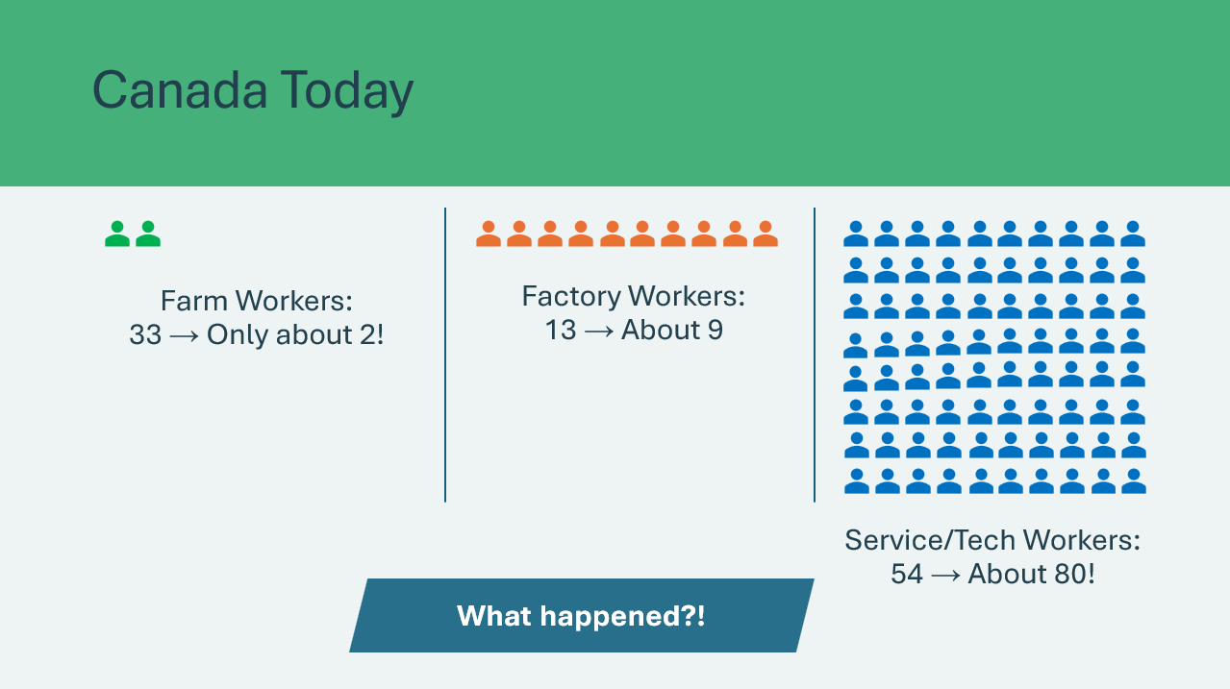 | Suggested time: 3 minutes  Show the animated transition from 1921 to today and use the prompts to facilitate a discussion.  What happened to Agriculture between 1921 and today?  - It fell dramatically — from about 33 workers to only about 2! Farming went from 1 in 3 workers to only 1 in 50!  What happened to Manufacturing?  - It also decreased — from about 13 to about 9. Robots and automation now do a lot of manufacturing work.  What happened to Services and Technology?  - It grew a lot — from 54 to about 80! Today, 8 out of 10 Canadian workers have service jobs.  - This includes healthcare workers (doctors, nurses), teachers, store workers, delivery drivers, computer programmers, and many more!  Why do you think this happened? What caused these changes?  - Technology!  Source: Statistics Canada Labour Force Survey (2022-2024).
Slide 71 - The Amazing Part!  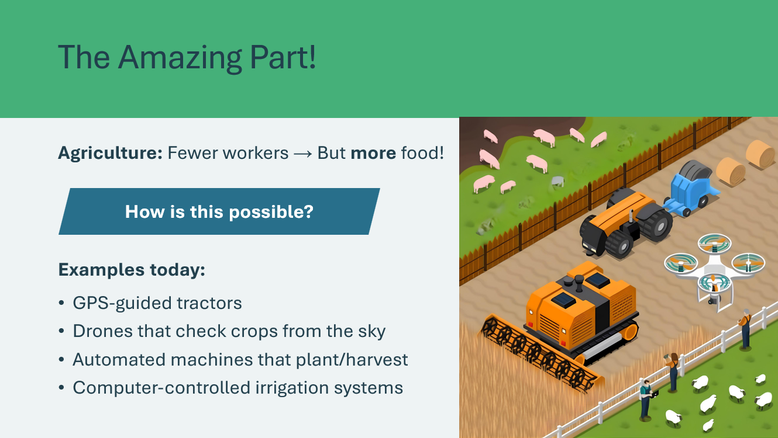 | Suggested time: 3 minutes  Emphasize that even though there are fewer farmers, Canada produces more food than ever before!  How is that possible? Take guesses from students.  Technology!  Modern farms use:  - GPS-guided tractors that drive themselves  - Drones that check on crops from the sky  - Giant machines that harvest fields automatically  - Computer-controlled irrigation systems
Slide 72 - Technology Makes Us More Productive  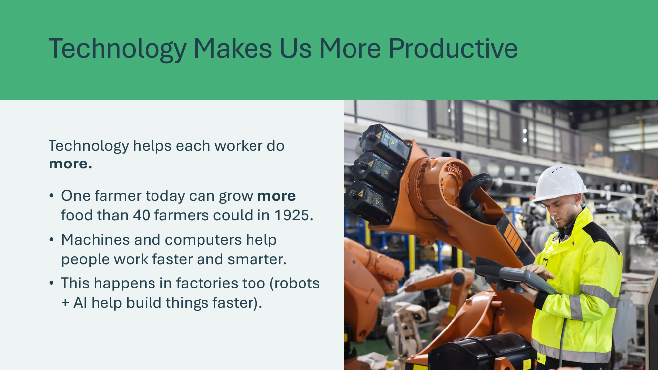 | Suggested time: 3 minutes  Review some of the ways technology makes each worker more productive.
Slide 73 - What Jobs Did Technology Create?  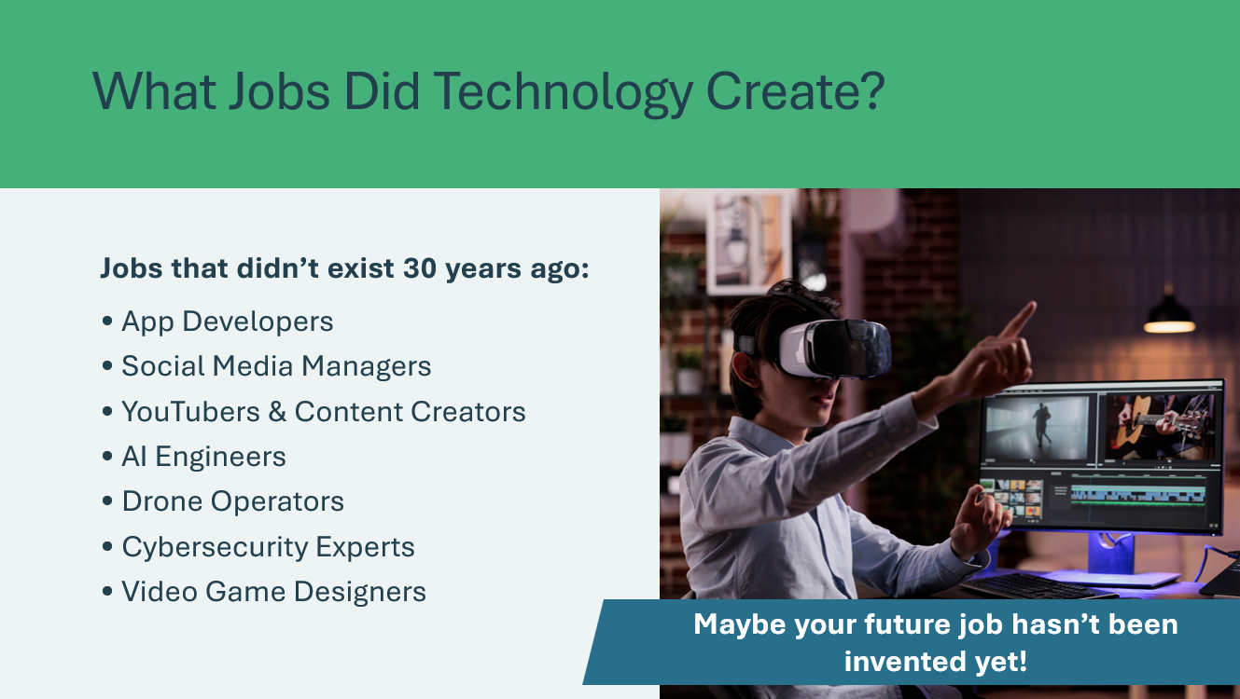 | Suggested time: 2 minutes  If farming and factory jobs decreased, where did all those workers go? Where did the new jobs come from?  Technology created brand new jobs that didn’t exist before! Thirty years ago, there were no app developers, social media managers, YouTubers, or AI engineers.  Reinforce to students that their future job might not even exist yet! It might be invented in the next 10 or 20 years.
Review & Conclusion 5 min
Slide 74 - What Did We Learn?  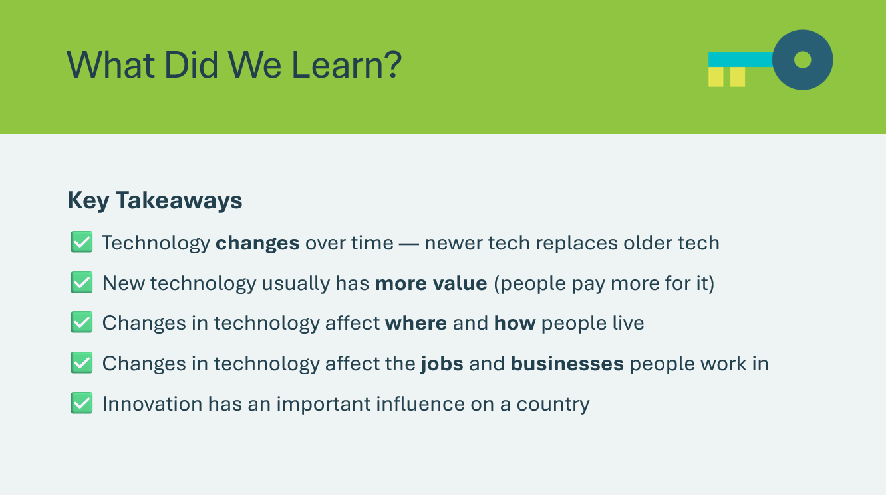 | Suggested time: 3 minutes  Review the key takeaways on slide to wrap up the lesson.

Lesson 4: Future Technologies
Program Kit Materials | Innovation Challenge Cards  
Slide 75 - Lesson 4: Future Technologies   | Lesson 4: Future Technologies
Slide 77 – Objectives  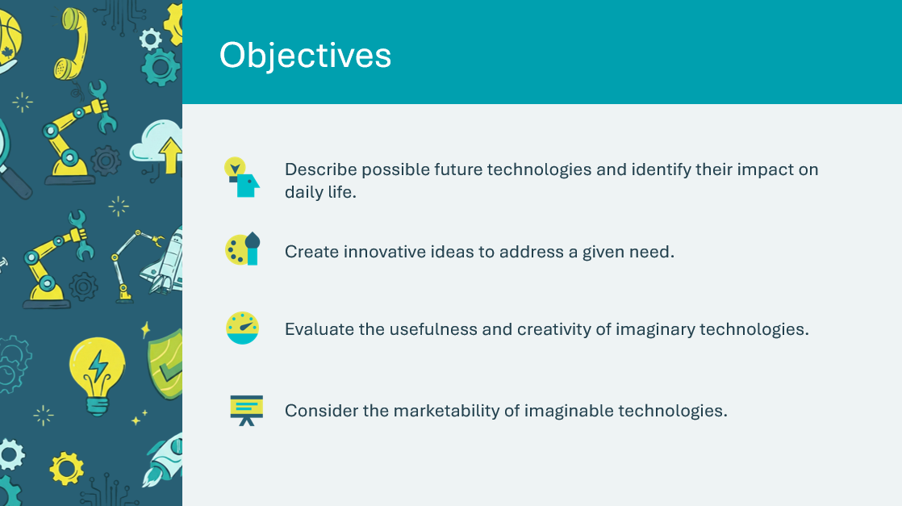 | Optional – review the learning objectives for the lesson.
Slide 78 - Introduction  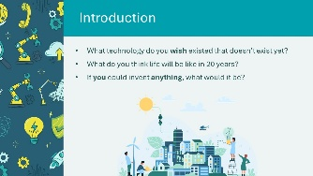 | Suggested time: 2 minutes  Introduce the lesson by facilitating a discussion with the prompts on the slide.  - Encourage creative thinking — any idea is welcome!  - How might school be different? Transportation? Communication?
Slide 79 - Lesson 4: Future Technologies  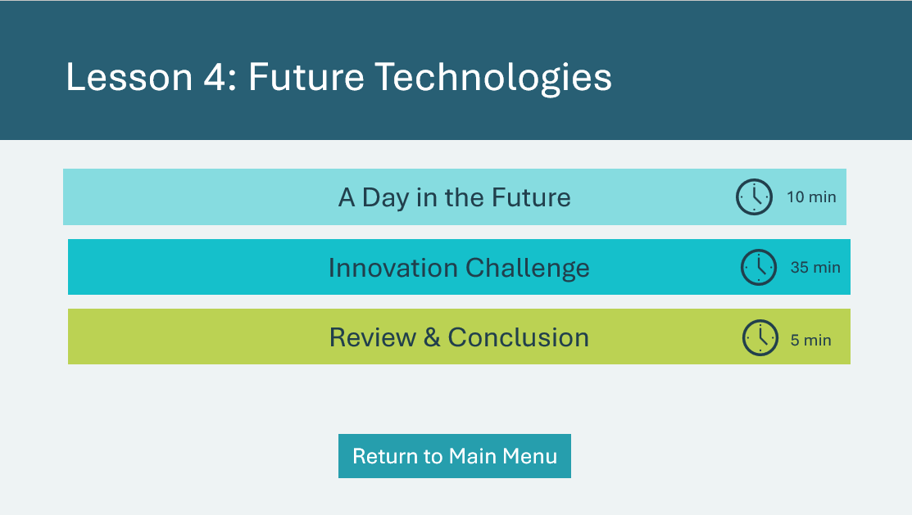 | *Select the button to navigate to the activity.  After you have completed an activity, you will be redirected back to the activity menu.  *Click or tap the Return to Main Menu button to return to the Lessons.
A Day in the Future 10 min
Slide 80 - A Day in the Future   | Play the video about a girl named Maya who lives in the future.  Encourage students to pay attention to the technologies Maya uses and think about what's similar and different from their lives today.  After the video, have a brief discussion using the following prompts.  - When do you think the video takes place? In the present, in the near future, or in the distant future?  - What was similar to a day in your life? What was different?  - What new technology/devices did you notice? Why do you think they were invented? What need to they meet? (AI companion, 3D food printer, ocean clean up drone, etc.)  - What problems do you think haven’t been solved yet in Maya's future?  Explain that each device is like a new product created by a business or organization. Businesses don't invent things randomly — they respond to problems, gaps, or frustrations people experience. Unsolved problems represent opportunities.  Entrepreneurs and businesses often look for what still doesn't work or what technology can't do yet.  Video transcript is available in the Appendix A if internet access is unavailable.
Innovation Challenge 30 min
Program Kit materials | For slides 37-46, you will need to use the Innovation Challenge Cards from the program kit.
Slide 81 - Innovation Challenge!  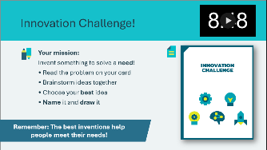  Innovation Challenge Cards   | Suggested time: 15 minutes  Tell students that they will have a chance to invent their own future devices.  Ask the students if anyone has ever invented something or tried to make something better.  - What need did it satisfy? How much might it sell for? What impact would it have on society?  Review their mission on the slide. Students will come up with an innovation to solve the problem on their challenge card. Remind them that the most useful inventions are the ones that help people meet their needs.  Students will have 10 minutes to work on the activity. Use the timer in the top right corner as a guide.  Remind students:  - Keep your drawings and descriptions short and simple  - You’ll be presenting your invention to the class!  - Be creative! There are no wrong answers  - The most important thing is that your invention helps solve the problem on your card  Facilitator Tip: Circulate the room as students work to offer help getting started and support group discussions and idea sharing. If a group is stuck, help them brainstorm or offer a different challenge.
Slide 83 - Innovation Meter!  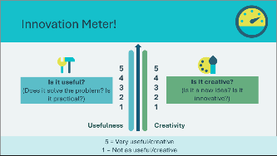 | Suggested time: 1 minute  After 10 minutes, bring the groups back together.  Review the Innovation Meter on the slide and explain that the class will use it to compare the groups' inventions.  Explain the meter:  - Left side = Usefulness  5 = Very practical, completely solves the problem  1 = Less practical, doesn't really solve it  - Right side = Creativity  5 = Very creative, I've never seen anything like this  1 = Not as creative, this already exists  Key Point: Innovative ideas may be in different positions on the left and right sides of the Innovation Meter. They may be new but not practical, or useful but not very new. The best ideas are both new and practical.
Slide 84 - Share Your Inventions!  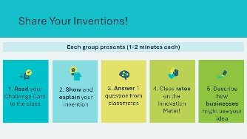 | Suggested time: 10 minutes  Groups will now present their innovations.  For each group presentation:  - Ask each group to read their Challenge Card to the class  - Have them describe their invention  - Allow 1 question from other groups  - Ask them to describe the impact on businesses  After each presentation, return to the previous slide and have the class rate the invention using the Innovation Meter.  - How useful is this invention? (Class votes 1-5)  - How creative is this invention? (Class votes 1-5)  - Ask students to explain their rankings  - Note the rating on the creativity side  Facilitator Tip: Praise at least one aspect of each idea, and assign positions on the Innovation Meter generously. If aspects of the inventions are not clear, point out that it is normal to take several years to work out all the details in a new invention.  If students are very competitive about the positions on the Innovation Meter, point out that it only shows the position at one point in time, and that all the ideas could rate highly with more development.
Slide 85 - Amazing Innovation!  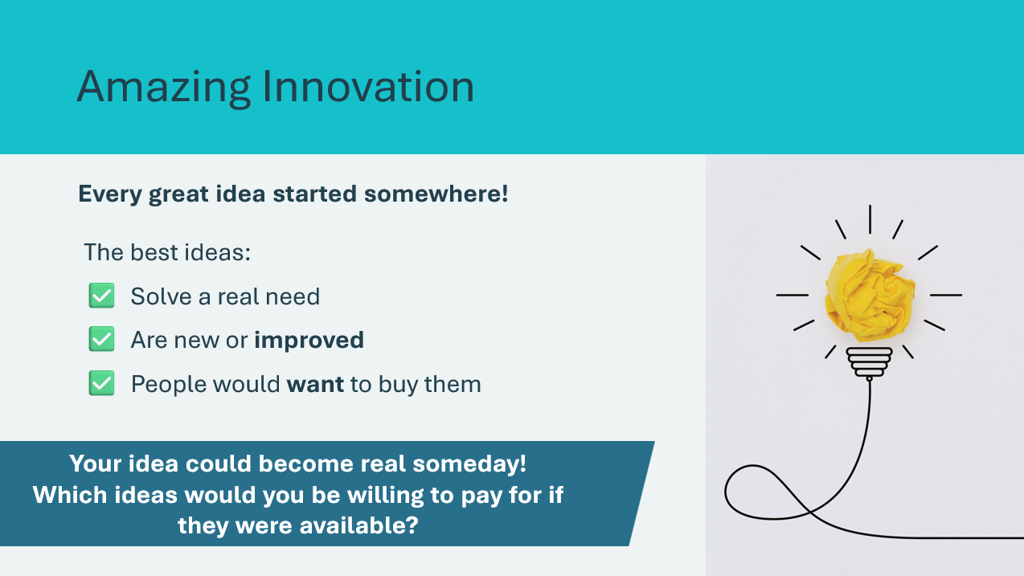 | Suggested time: 2 minutes  Lead a round of applause for all the inventors and wrap up using the following discussion prompts.  - Which ideas would you be willing to pay for if they were available for sale? Point out that new innovations have a marketable value to people.  - Discuss how businesses might be able to use the groups’ ideas (or already are using similar ideas) to bring new products to market.  Key points:  - New ideas are valuable and important for Canadian businesses.  - Canadian businesses sell their products around the world.  - When businesses sell new inventions or innovations, they create jobs for people.
Review & Conclusion 5 min
Slide 86 - What Did We Learn?  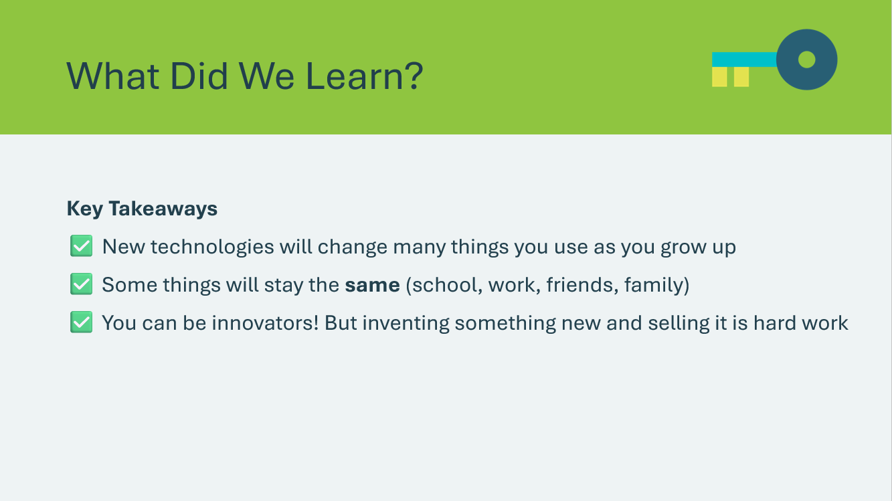 | Suggested time: 3 minutes  Review the key takeaways to wrap up the lesson.

Wrap Up
Program Kit Materials | Certificates of Accomplishment  
Slide 87 - Wrap up   | Wrap Up
Slide 88 - Review  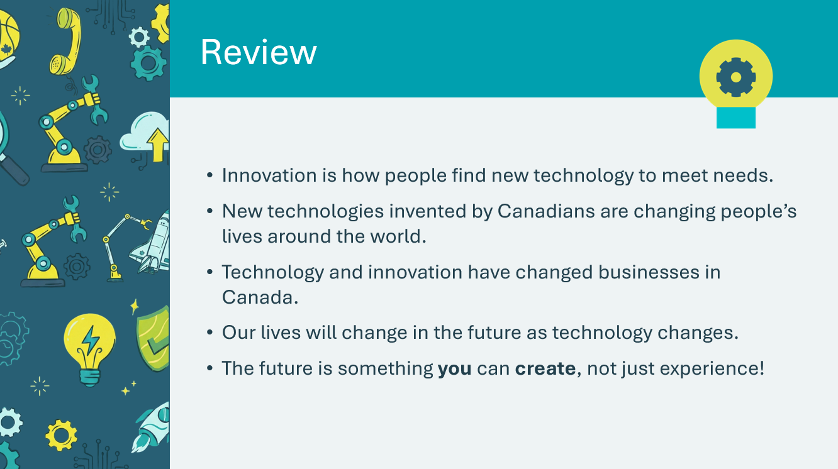 | Suggested time: 2 minutes  Remind students that they have learned a lot about technology and innovation in Canada.  Summarize what they have learned across all four lessons.
Program Kit Material | For slide 89 you will need to distribute the Certificates of Accomplishment from the program kit materials.
Slide 89 - Certificate of Accomplishment     | Suggested time: 5 minutes  Ensure the certificates are completed and signed before distributing.  Thank the students for their participation. If time permits, make this moment special by calling each student by name to receive their certificate. Invite the class to give each other a brief applause.  Congratulate them on a job well done!
Slide 90 - Congratulations!   | Suggested time: 5 minutes  Wrap up the program with the discussion prompts.  Encourage students to share what they have learned with their family or caregivers.
Slide 91 - JA Campus   | Invite students to visit jacampus.org for additional information and learning.

Appendix A: Video Transcripts

Slide 9 — Then and Now: How Technology Changed Our World
"No lights. No fridge. No phone."
"How would you start your day?"
"A long time ago, that's exactly how people lived!"
"They used candles for light..."
"Horses to travel from place to place..."
"And if they wanted to talk to someone far away? They had to write a letter... and wait weeks for a reply!"
"But people are creative! They kept inventing new things to make life easier."
"Light bulbs replaced candles."
"Cars replaced horses."
"And now... we can video call anyone in the world, instantly!"
"This is called INNOVATION - finding new and better ways to solve problems."
"And guess what? Canada has been part of this story! Canadians invented the telephone, helped create the light bulb, and even invented the snowmobile!"
"So here's the big question:"
"How did technology change the way we live?"
"And what will you invent to make the future even better?"

Slide 56 — The Sound of Change
"How do YOU listen to music? On your phone? Through a speaker? It wasn't always this easy!"
"Over 100 years ago, the only way to hear recorded music was on a gramophone - a big machine with a giant horn that played music from metal cylinders."
"Then came vinyl records - flat discs that spin around. People collected hundreds of albums!"
"In the 1970s, 8-track tapes let people play music in their cars for the first time. Then cassette tapes got even smaller - you could fit them in your pocket!"
"CDs arrived with crystal-clear digital sound. No more scratchy records!"
" "Then MP3 players changed everything — suddenly you could carry thousands of songs in your pocket!
"And NOW? You can stream millions of songs instantly on your phone. No discs, no tapes, no records - just music whenever you want it!"
"Each new technology made listening to music easier, better, and more portable. That's the power of innovation!"

Slide 80 — A Day in the Future
"Close your eyes and imagine... What will life be like in the future?"
"Maya opens her eyes. The walls of her room gently brighten, sensing that her brain waves have shifted from sleep to awake."
"She didn't need an alarm — her smart room just knows when she's ready to wake up!"
"'Good morning, Maya,' says her AI companion, Kai. 'You have a field trip today. Your backpack is ready, and I've printed your favorite breakfast — maple syrup pancakes shaped like the maple leaf — fresh from the 3D food printer!'"
"Today's field trip is special — they're visiting the Great Barrier Reef in Australia. Without leaving the classroom!"
"Maya puts on her lightweight AR glasses. Suddenly, she's swimming with sea turtles!"
"'The reef has recovered thanks to ocean cleanup drones,' her teacher explains. Maya watches tiny robots cleaning microplastics from the water."
"After school, Maya takes a transport pod home. It zooms through a transparent tube — no traffic, no pollution — and she's home in 3 minutes flat!"
"That night, Maya thinks about tomorrow. Her grandmother, who lives across the ocean, will visit as a hologram for dinner."
"They'll eat together even though they're thousands of miles apart!"
"The future is amazing, Maya thinks."
"But she wonders: What problems haven’t been solved yet?"
"What will I help invent?"
"Now it's your turn to think like Maya..."
"What would you invent to make the future even better?"
"The future isn't something that just happens to you — it's something you can create!"

Slide 33 — Canadian Inventors Changed the World
“Did you know that Canadians invented things that changed the ENTIRE world?”
“The telephone? Invented in Canada! Basketball? A Canadian idea! Even insulin — the medicine that saves millions of lives — was discovered right here in Canada!”
“From the snowmobile to the Canadarm in space, Canadians have been dreaming up incredible inventions for over 150 years.”
“So buckle up — because we’re about to meet some of the most amazing inventors this country has ever seen!”

Slide 62 — How Does an Auction Work?
“Have you ever seen an auction? It’s a special way of buying things!”
“Here’s how it works: I’ll show you something for sale. If you want it, you call out how much you’re willing to pay. That’s called a BID.”
“But here’s the exciting part — if someone else wants it too, they can bid HIGHER! And then YOU can bid even higher than THEM!”
“The person who bids the HIGHEST amount wins the item and pays that price.”
“But be careful — once you spend your money, it’s gone! So think carefully about what you really want.”
“Ready to try? Let’s auction!”

Appendix B: Category Sort Activity – Answer Key

Category Sort: Food
Technologies that help us get, store, or produce food
Traditional | Modern
Ice Box | Refrigerator
Feeding Livestock by Hand | Computerized Feeding Machines
Horse and Plough | Tractor

Category Sort: Shelter & Clothing
Technologies that help keep us warm, safe, and protected ⚠️ Note: These items are not included in the JA Kit Traditional/Modern cards — this category is on-screen only.
Traditional | Modern
Candles for light | Electric lights
Animal skin clothing | Synthetic fabrics (Gore-Tex)
Fireplace | Electric heater / Furnace

Category Sort: Communication
Technologies that help us share information
Traditional | Modern
DVD Player | Streaming Video
Encyclopedias | Internet (Research)
Face-to-Face Meetings | Conference Calls
CDs | MP3 Files
Hand-written Letters | Email
Mail Service | Courier Service
Landline Telephone | Smartphone
Polaroid Camera | Digital Camera
Telephone | Internet

Category Sort: Tools
Technologies that help us make, build, organize, or do work
Traditional | Modern
Unit Production | Assembly Line Production
Gas/Diesel Vehicles | Electric/Natural Gas Vehicles
Paperclip | Stapler
Paper Calendar | Smartphone Calendar
Carbon Paper Copying | Photocopier
Filing Cabinets | Computer Electronic Files
Electric Typewriter | Computer and Keyboard

Appendix C: Canadian Inventors Matching Activity – Answer Key
# | Invention | Inventor | Description
1 | Zipper | Gideon Sundback (USA, 1913) | Fastens clothes without buttons or snaps
2 | Goalie mask | Jacques Plante, Fibreglass Canada, Montreal, QC (1959) | Lets hockey goalies play without fear of face injury
3 | Computerized Braille | Roland Galarneau, Ottawa, ON (1966) | A computerized method of transferring printed texts to Braille
4 | Wire photo | Edward Samuels Rogers (1925) | Transmits photos around the world by telephone or telegraph
5 | Jetliner | James Floyd (chief designer), A.V. Roe Company (Avro), Malton, ON (1949) | People travel great distances quickly and at low cost
6 | Self-propelled combine | Thomas Carroll (1938) | Lets farmers harvest fields with a small crew
7 | Polyethylene garbage bag | Harry Wasylyk, Winnipeg, MB (1950) | Helps keep the home and garden tidy
8 | Long-lasting alkaline battery | Lew Urry, Pontypool, ON (1959) | Lets toys run for hours
9 | Half-tone photo printing | Georges Edouard Desbarats and William Augustus Leggo, Montreal, QC (1869) | Converts photos so they can be printed in newspapers and magazines
10 | Snowmobile | Joseph-Armand Bombardier, Bombardier Snowmobile, Valcourt, QC (1937) | Travel in winter without roads; also used in South America to harvest coffee and during WWII as the technology of transportation through mud
11 | Automatic train engine lubricator | Elijah McCoy (USA, 1872) | Lets machines run continuously without burning out
12 | Heart Pacemaker | Dr. John A. Hopps, Toronto, ON (1950) | Controls the beat when people have certain heart diseases
13 | Robertson (square slot) screws and screwdriver | Peter Robertson, Robertson Screw Company, Milton, ON (1908) | Screw parts together without slipping
14 | Pablum | Dr. Alan Brown, Dr. T.G.H. Drake, Dr. F.F. Tisdall, Toronto, ON (1930) | A baby food for small babies that has vitamins and minerals
15 | Standard Time Zones | Sir Sandford Fleming, Ottawa, ON (1878) | Time zones in Canada
16 | Two-way wireless voice transmitter (radio) | Reginald Fessenden (USA, 1900) | Transmits voices from one location to another without any connection
17 | Marquis Wheat | Sir Charles E. Saunders, Ottawa, ON (1908) | Grows quickly in short prairie summers
18 | Basketball | James Naismith (1891) | A famous game played around the world where players try to throw a ball into a "basket"
19 | Walkie-Talkie | Donald L. Hings (1942) | Self-contained two-way communicator
20 | Telephone | Alexander Graham Bell, Brantford, ON (1874) | A technology used to talk to a person in another location
21 | Electron microscope | Eli Franklin Burton, Cecil Hall, James Hillier, Albert Prebus (University of Toronto), Toronto, ON (1937) | Used to study very tiny objects
22 | Television theory | Reginald Fessenden (1927) | Moving pictures travel through the air
23 | 5-Pin Bowling | Tommy Ryan, Toronto, ON (1904) | A very popular game played by people of all ages in which a ball is thrown down an alley to knock over a set of pins
24 | JAVA computer language | James Gosling, Sun Microsystems Inc. (USA, 1994) | Code used to control many electronic devices, including many cell phones and handhelds
25 | Ships' screw-type propeller | John Patch, Yarmouth, NS (1854) | Pushes ships through the water
26 | IMAX | William Chester Shaw (1960s) | A six-story screen used for movies with over 88 speakers; the name represents "eye" + "maximum"
27 | Electric light bulb | Henry Woodward, Toronto, ON (1874) | Lets people see after dark
28 | Insulin Process | Frederick Banting, Charles Best, J.J. Macleod, and James Collip (1922) | Controls diabetes, a serious disease
29 | Macintosh Apple | John McIntosh, Dundas County, ON (1811) | A lovely red fruit that everyone enjoys in pies, cakes, or eaten whole
30 | Canadarm Robotic Space Arm | Spar Aerospace/NRC, Toronto, ON (1975) | Helps build and pick up objects in outer space

